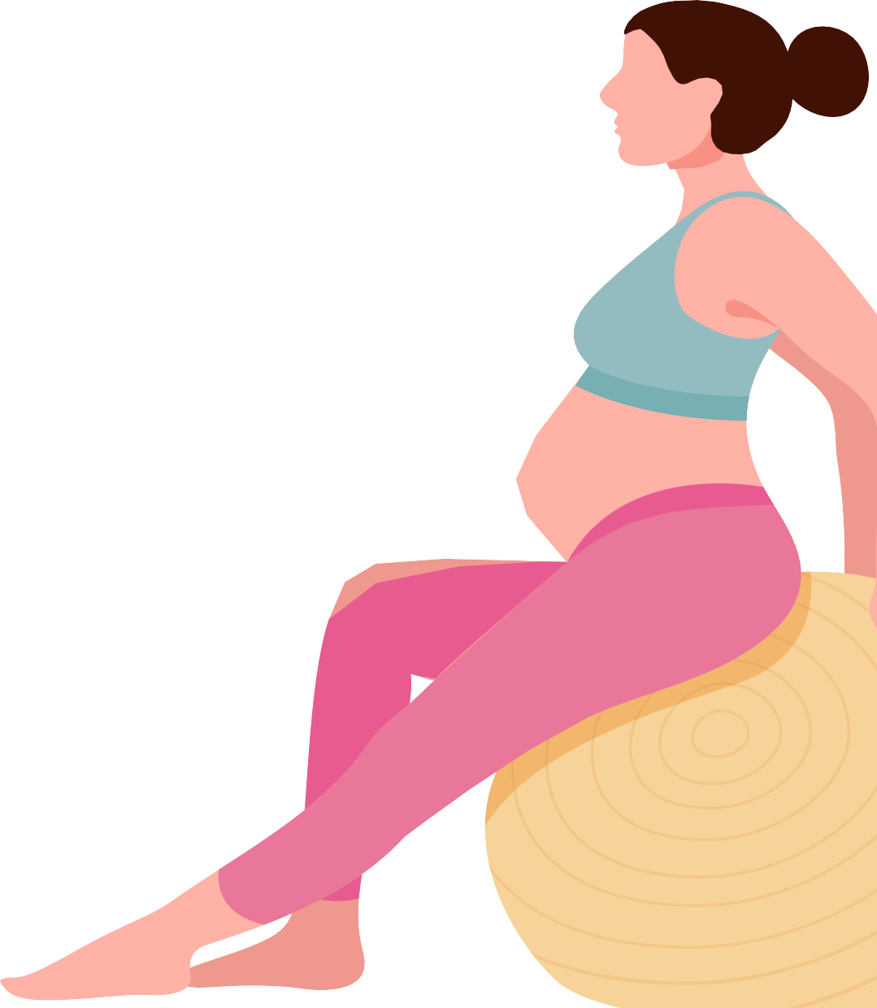


Guidelines
for physical
activity during

pregnancy



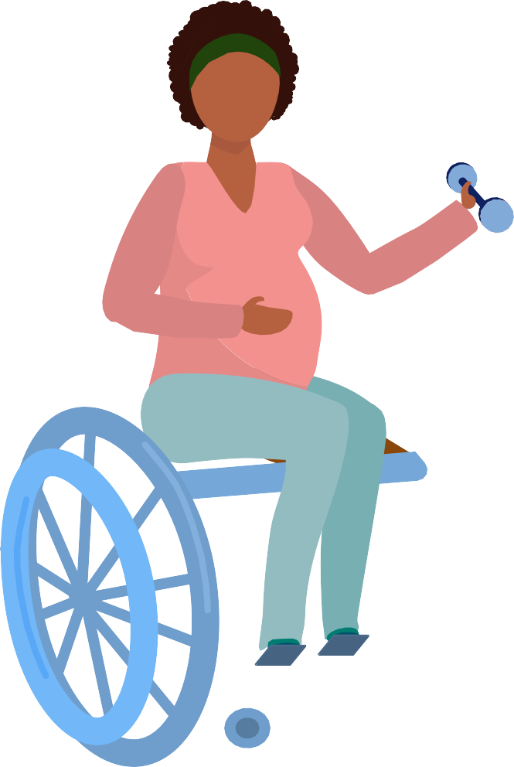
Being active during pregnancy is safe, and has health benefits for you and your baby.

Being active can reduce the risk of some pregnancy-related problems, and supports a healthy pregnancy.
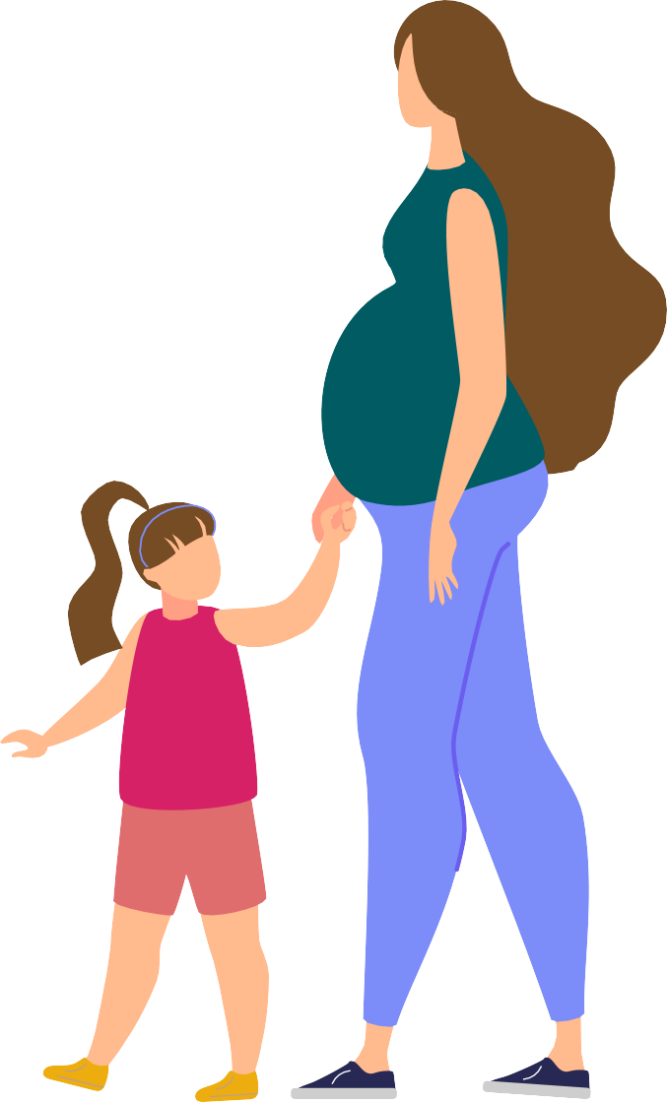
If you and your baby are healthy, and you were active before pregnancy, you can continue with physical activity during your pregnancy. If you were inactive before pregnancy, start slowly

and build up your activity to meet this advice.
As your body changes during pregnancy, you may need

to adapt your activities.

Listen
to your body and chat with your health professional for
more help.

How active should I be?
During your pregnancy aim to:

be active on most, if not all, days of the week
do moderate intensity activities for 2½ to 5 hours each week;
or vigorous intensity activities for 1¼ to 2½ hours each week
this means do 30 to 60 minutes of moderate intensity activity


or do 15 to 30 minutes of vigorous intensity activity most days do muscle strengthening activities at least 2 days each week break up long periods of sitting and standing still
Doing any physical activity is better than none,
and all physical activity (e.g. for fun, for transport, or at work) counts!
TIP
do pelvic floor exercises.
You can break down your activity into smaller segments throughout the day.
10
MIN
TIP
Type of activities
Do a combination of both aerobic and strengthening activities.

Aerobic activities help improve your cardiorespiratory fitness and help avoid excess weight gain.
Aim to do aerobic activities that use large muscle groups
– such as brisk walking, cycling, swimming, dancing, and exercise classes.
Muscle strengthening activities help maintain and/or improve your strength and can help reduce low back and pelvic pain.
Aim to do strengthening activities such as light resistance training or bodyweight exercises.

Pelvic floor exercises help strengthen and tone your pelvic floor muscles and other tissues.
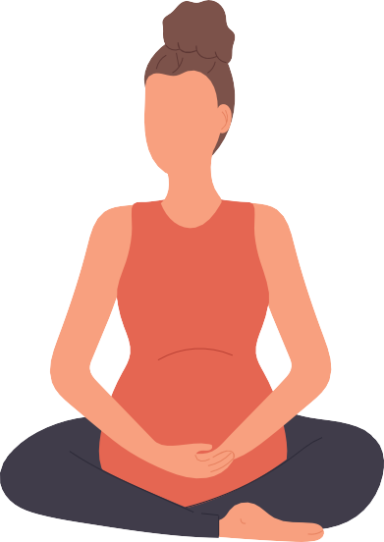
A strong pelvic floor can reduce your chance of having problems (such as incontinence) after giving birth and later in life, so it is important to learn how to do these correctly.
TIP
Try to do pelvic floor exercises every day before and during your pregnancy, and then start again as soon as possible after birth.


TIP
Do a combination of moderate and vigorous intensity activities. 10 mins of vigorous intensity activity is equal to 20 mins of moderate intensity activity.

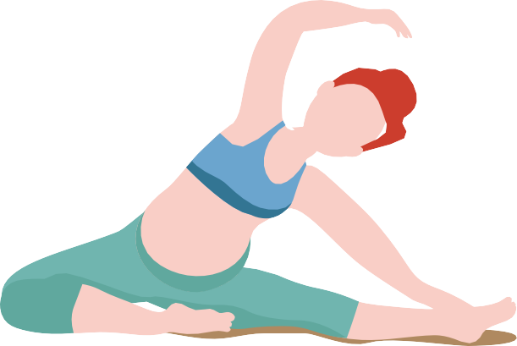
Intensity of physical activity
TIP
After 28 weeks you should not do exercises lying flat on your back. Instead, tilt your upper body to a 45-degree angle or do the exercises lying on your side.
Physical activity during pregnancy doesn’t have to be vigorous to be beneficial.
If you’re planning to be very active during your pregnancy, for example if you’re an athlete or already do more than the amount of activity recommended, get advice or supervision from an informed and appropriately qualified health professional.

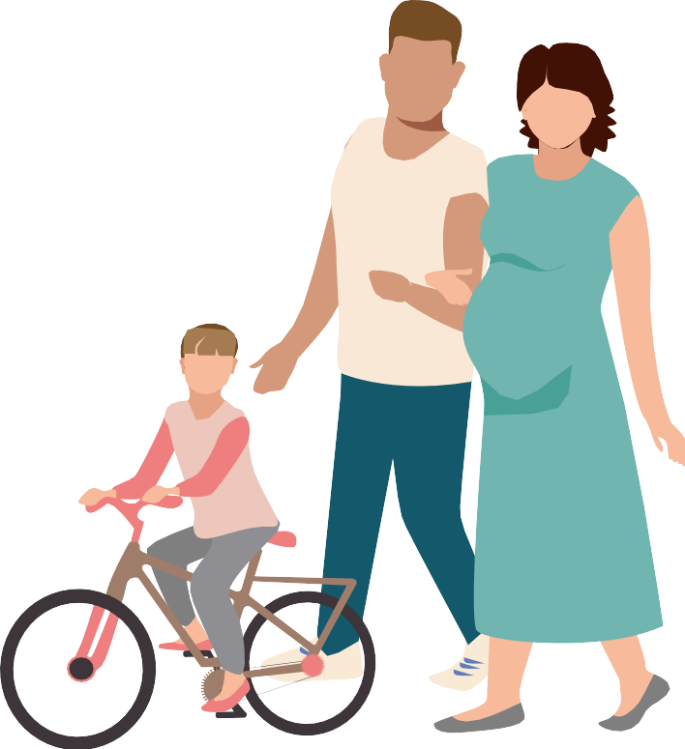
Avoid activities that involve
TIP
For a simple way to measure intensity – try the ‘Talk Test’.
You should be able to carry on a conversation during moderate intensity activities, but in vigorous intensity activities you’d find
this difficult.
risk of contact/collision
risk of falling (i.e. activities that require high levels of balance,
coordination and agility)
significant changes in pressure (e.g. sky diving, scuba diving) heavy lifting.
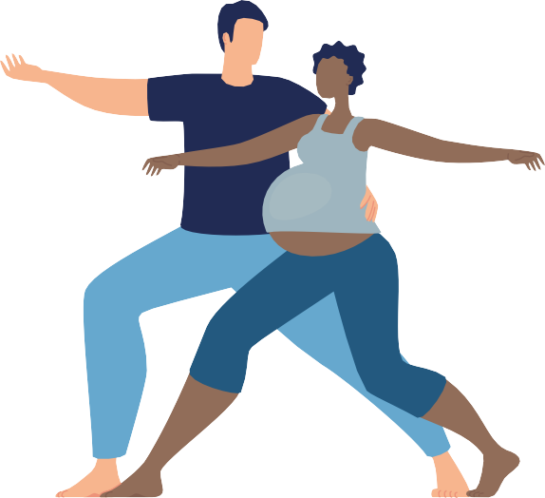

TIP
Modify activities as your body changes during pregnancy.

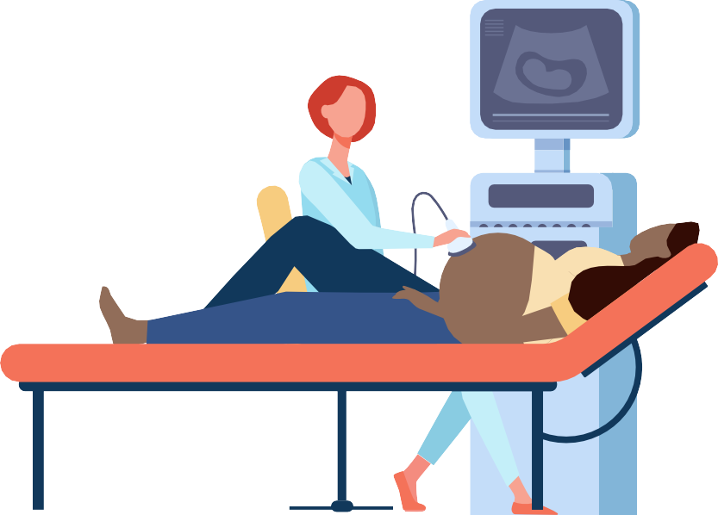
Additional safety precautions/considerations:

Drink plenty of water and ensure you meet your nutrition and energy needs.

Avoid heat stress/hyperthermia. Physical activity should preferably be done in a cool environment.


Avoid physical activities at high altitude
(above 2000m) unless acclimatised and trained for the activity before pregnancy.



TIP
Always wear appropriate shoes, non-restrictive clothing, and a supportive pregnancy-safe bra. If it is hot, wear loose clothing made from ‘breathable’ fabric.
Warning signs to stop physical activity
If you experience any of the following symptoms during physical activity, stop and
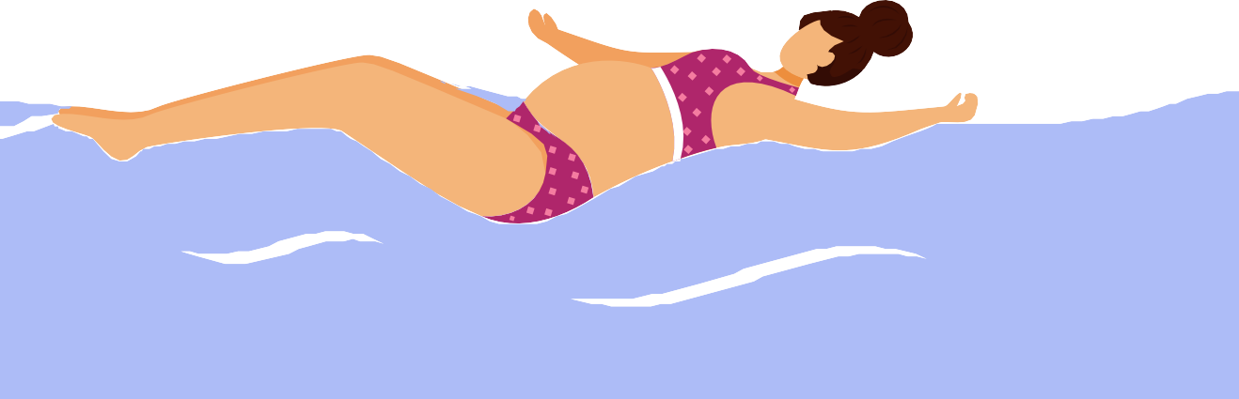
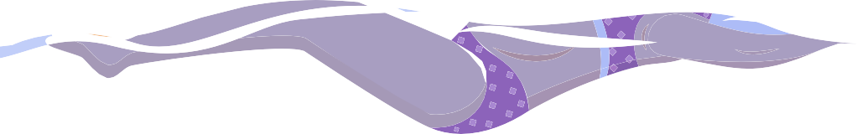
get advice from your health professional before continuing with any activity:
chest pain

Consider swimming if the weather is hot.
persistent shortness of breath that does not get better with rest
severe headache
persistent dizziness/feeling faint that does not get better with rest
regular painful uterine contractions vaginal bleeding
persistent loss of fluid from the vagina – indicating possible ruptured membranes.

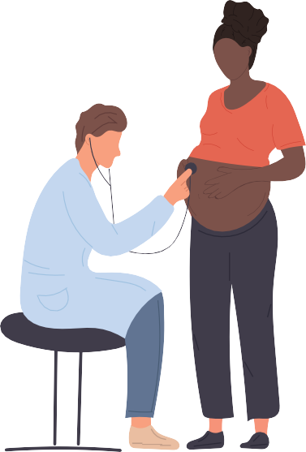
Pregnancy complications
If you have any of the following you are advised not to exercise until you get individual advice from your health professional:
incompetent cervix
ruptured membranes, preterm labour persistent bleeding in the second
or third trimester placenta previa pre-eclampsia
evidence of intrauterine growth restriction multiple gestation (triplets or higher)
poorly controlled type 1 diabetes, hypertension or thyroid disease


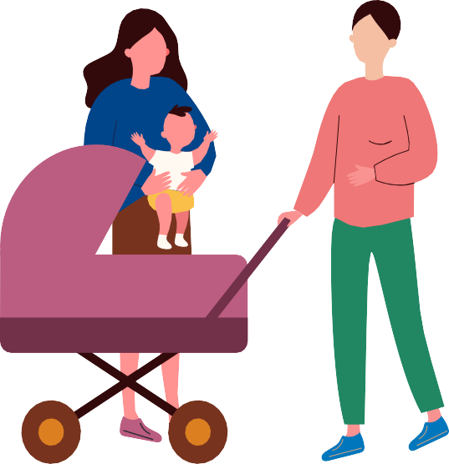
other serious cardiovascular, respiratory or systemic disorders.

TIP
If you have complications get expert advice from a health professional before starting, continuing or returning to
physical activity.

Returning to physical activity after birth
The timing of resuming physical activity after childbirth is different for everyone. A gradual return to recommended levels of activity is generally considered safe after the six-week postnatal check with your health professional, however this may differ depending on your individual circumstances.

Get expert advice from a health professional before starting or continuing physical activity if you have a history of, or develop, any of the following:
spontaneous miscarriage, preterm labour or fetal growth restriction mild/moderate cardiovascular or chronic respiratory disease pregnancy induced hypertension
poorly controlled seizure disorder type 1 diabetes
symptomatic anaemia
malnutrition, significantly underweight or eating disorder twin pregnancy after the 28th week
other significant medical conditions.

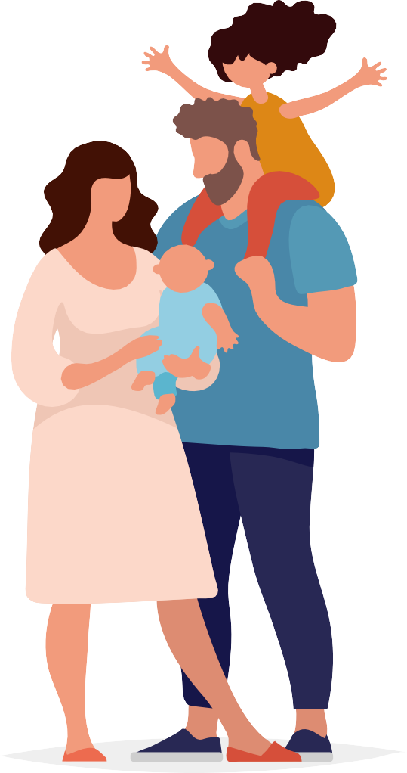

The Australian Government has worked with experts to develop guidelines to help you be active during pregnancy. These guidelines are for all pregnant Australians, regardless of gender identity, cultural or language background, geographic location or socio-economic status.

For more information go to health.gov.au

