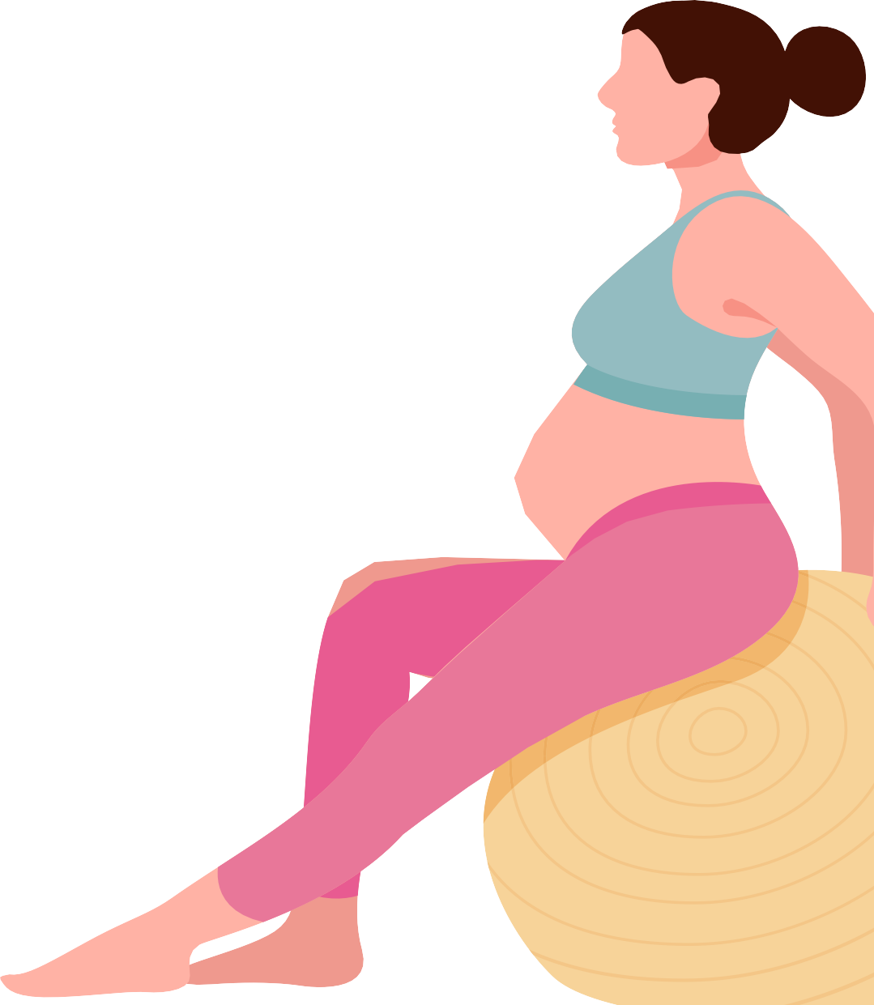

Australian Government Department of Health crestLogoGuidelines



for **physical**

**activity** during

pregnancy

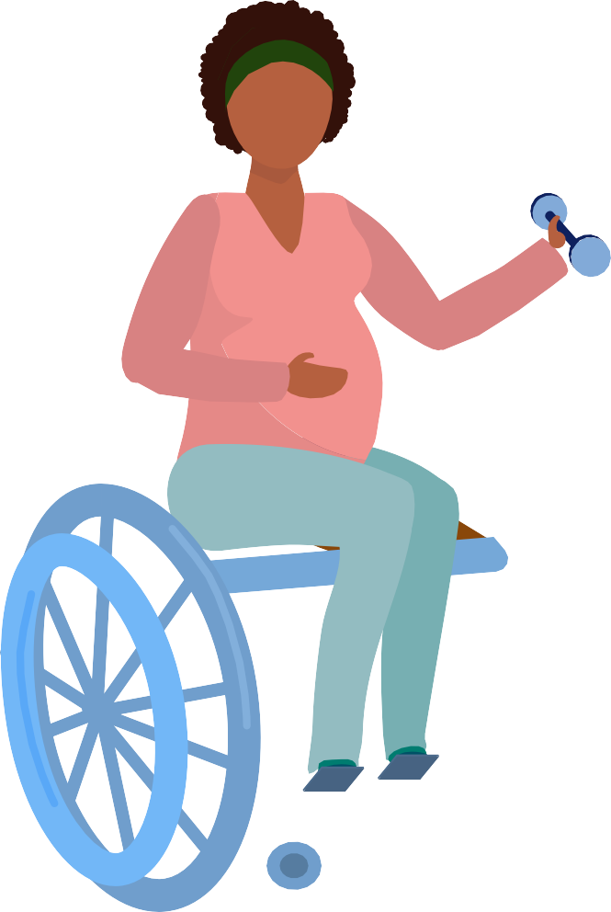

**Being active during pregnancy is safe, and has health benefits for you and your baby.**

## Being active can reduce the risk of some pregnancy-related problems, and supports a healthy pregnancy.

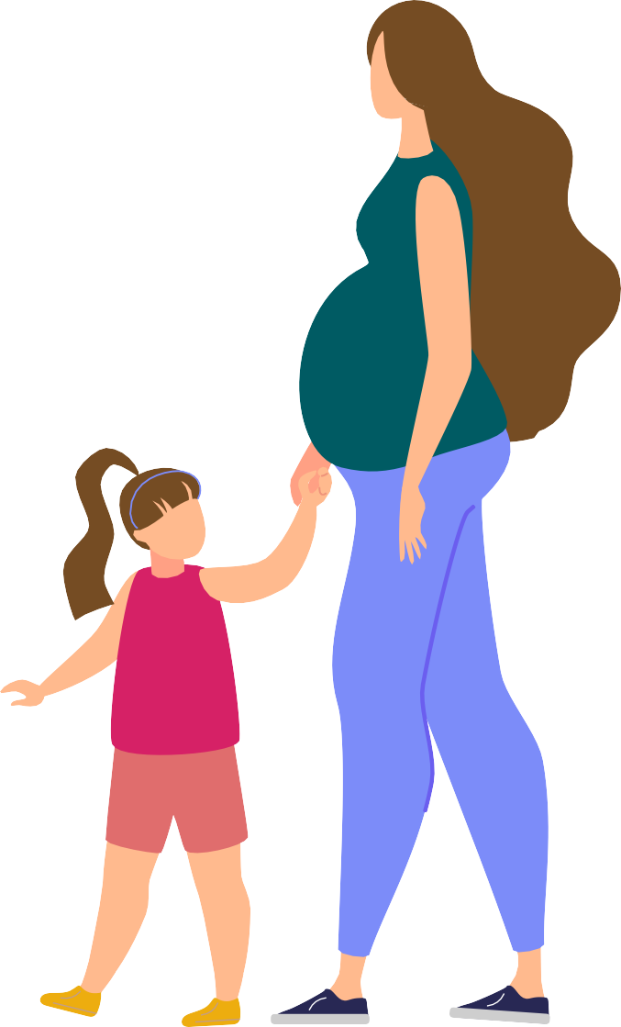If you and your baby are healthy, and you were active before pregnancy, you can continue with physical activity during your pregnancy. If you were inactive before pregnancy, start slowly

## and build up your activity to meet this advice.

As your body changes during pregnancy, you may need

## to adapt your activities.

***Listen***

**to your body and chat with your health professional for**

**more help.**

# How active should I be?

During your pregnancy aim to:

be active on most, if not all, days of the week

do moderate intensity activities for 2½ to 5 hours each week;

**or** vigorous intensity activities for 1¼ to 2½ hours each week

this means do 30 to 60 minutes of moderate intensity activity

**or** do 15 to 30 minutes of vigorous intensity activity most days do muscle strengthening activities at least 2 days each week break up long periods of sitting and standing still



**Doing any physical activity is better than none,**

**and all physical activity (e.g. for fun, for transport, or at work) counts!**

**TIP**

do pelvic floor exercises.



**You can break down your activity into smaller segments throughout the day.**

**10**

**MIN**

**TIP**

Type **of activities**

Do a combination of both aerobic and strengthening activities.

**Aerobic activities** help improve your cardiorespiratory fitness and help avoid excess weight gain.



Aim to do aerobic activities that use large muscle groups

– such as brisk walking, cycling, swimming, dancing, and exercise classes.

**Muscle strengthening activities** help maintain and/or improve your strength and can help reduce low back and pelvic pain.



Aim to do strengthening activities such as light resistance training or bodyweight exercises.

**Pelvic floor exercises** help strengthen and tone your pelvic floor muscles and other tissues.



A strong pelvic floor can reduce your chance of having problems (such as incontinence) after giving birth and later in life, so it is important to learn how to do these correctly.

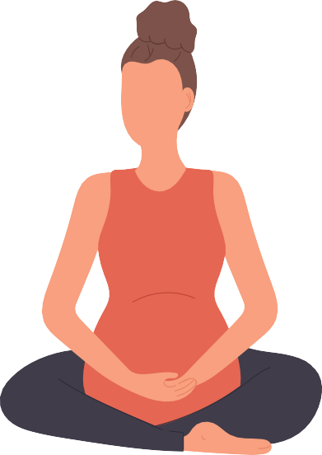

**TIP**

**Try to do pelvic floor exercises every day before and during your pregnancy, and then start again as soon as possible after birth.**



**TIP**

**Do a combination of moderate and vigorous intensity activities. 10 mins of vigorous intensity activity is equal to 20 mins of moderate intensity activity.**

Intensity **of physical activity**

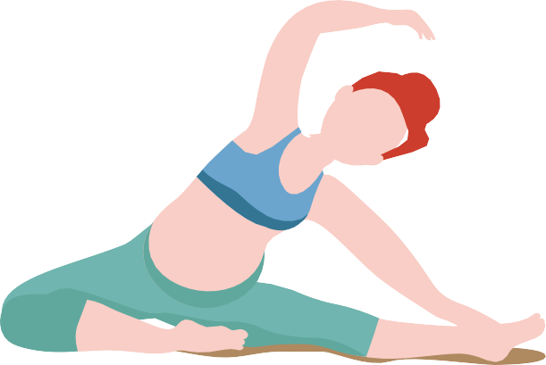

**TIP**

**After 28 weeks you should not do exercises lying flat on your back. Instead, tilt your upper body to a 45-degree angle or do the exercises lying on your side.**

Physical activity during pregnancy doesn’t have to be vigorous to be beneficial.

If you’re planning to be very active during your pregnancy, for example if you’re an athlete or already do more than the amount of activity recommended, get advice or supervision from an informed and appropriately qualified health professional.

Avoid **activities that involve**

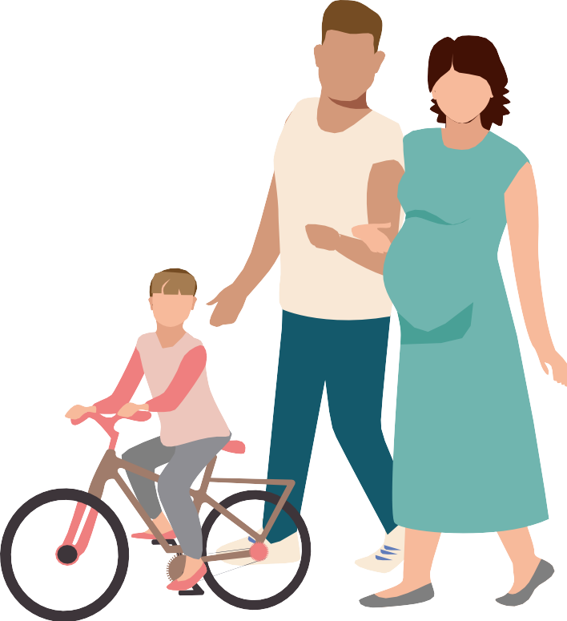

**TIP**

**For a simple way to measure intensity – try the ‘Talk Test’.**

**You should be able to carry on a conversation during moderate intensity activities, but in vigorous intensity activities you’d find**

**this difficult.**

risk of contact/collision

risk of falling (i.e. activities that require high levels of balance,

coordination and agility)

significant changes in pressure (e.g. sky diving, scuba diving) heavy lifting.

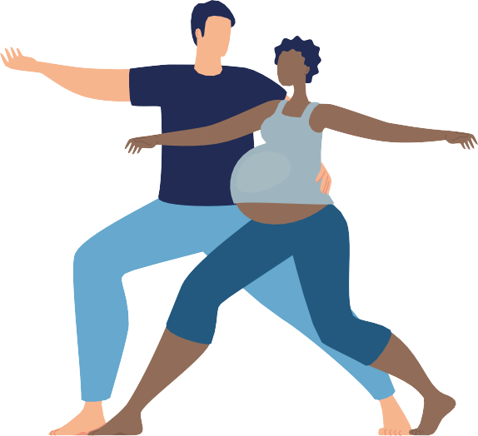

**TIP**

**Modify activities as your body changes during pregnancy.**

Additional **safety precautions/considerations:**

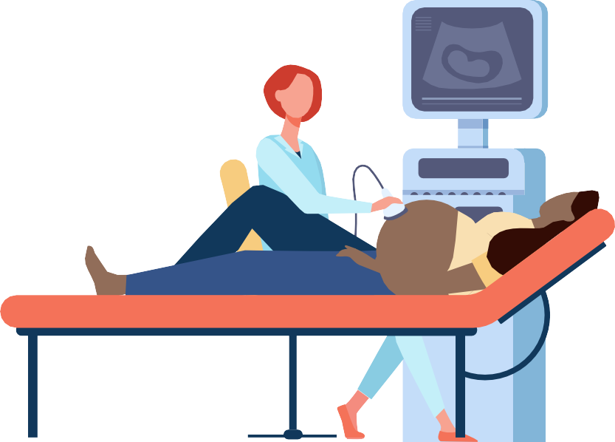

**Drink plenty of water** and ensure you meet your nutrition and energy needs.



**Avoid heat stress/hyperthermia**. Physical activity should preferably be done in a cool environment.

**Avoid physical activities at high altitude**

(above 2000m) unless acclimatised and trained for the activity before pregnancy.



**TIP**

**Always wear appropriate shoes, non-restrictive clothing, and a supportive pregnancy-safe bra.** If it is hot, wear loose clothing made from ‘breathable’ fabric.

Warning **signs to stop physical activity**

If you experience any of the following symptoms during physical activity, stop and

get advice from your health professional before continuing with any activity:

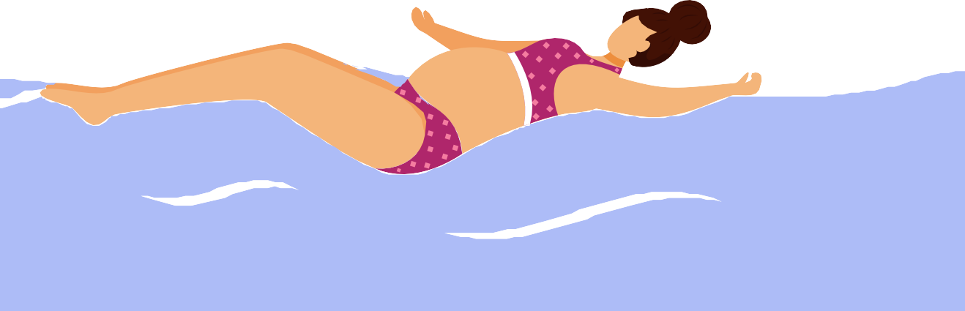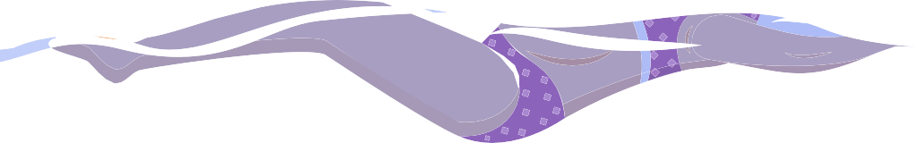

chest pain

**Consider swimming if the weather is hot.**

persistent shortness of breath that does not get better with rest

severe headache

persistent dizziness/feeling faint that does not get better with rest

regular painful uterine contractions vaginal bleeding

persistent loss of fluid from the vagina – indicating possible ruptured membranes.

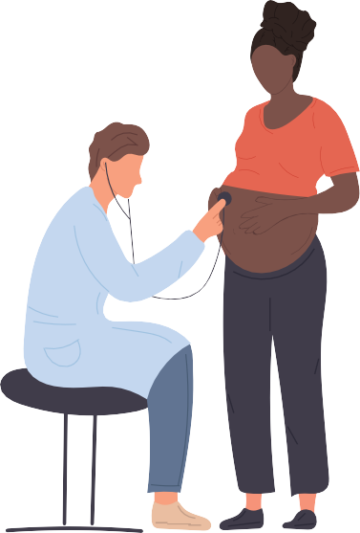Pregnancy **complications**

If you have any of the following you are advised not to exercise until you get individual advice from your health professional:

incompetent cervix

ruptured membranes, preterm labour persistent bleeding in the second

or third trimester placenta previa pre-eclampsia

evidence of intrauterine growth restriction multiple gestation (triplets or higher)

poorly controlled type 1 diabetes, hypertension or thyroid disease

other serious cardiovascular, respiratory or systemic disorders.

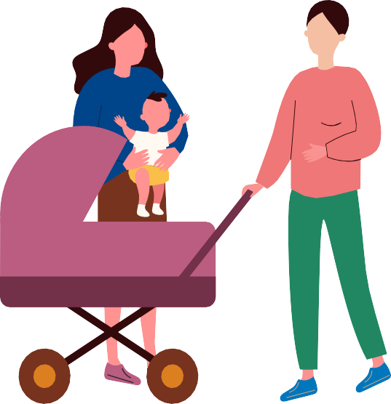

**TIP**

**If you have complications get expert advice from a health professional before starting, continuing or returning to**

**physical activity.**

Returning **to physical activity after birth**

The timing of resuming physical activity after childbirth is different for everyone. A gradual return to recommended levels of activity is generally considered safe after the six-week postnatal check with your health professional, however this may differ depending on your individual circumstances.

**Get expert advice from a health professional before starting or continuing physical activity if you have a history of, or develop, any of the following:**

**spontaneous miscarriage, preterm labour or fetal growth restriction mild/moderate cardiovascular or chronic respiratory disease pregnancy induced hypertension**

**poorly controlled seizure disorder type 1 diabetes**

**symptomatic anaemia**

**malnutrition, significantly underweight or eating disorder twin pregnancy after the 28th week**

**other significant medical conditions.**

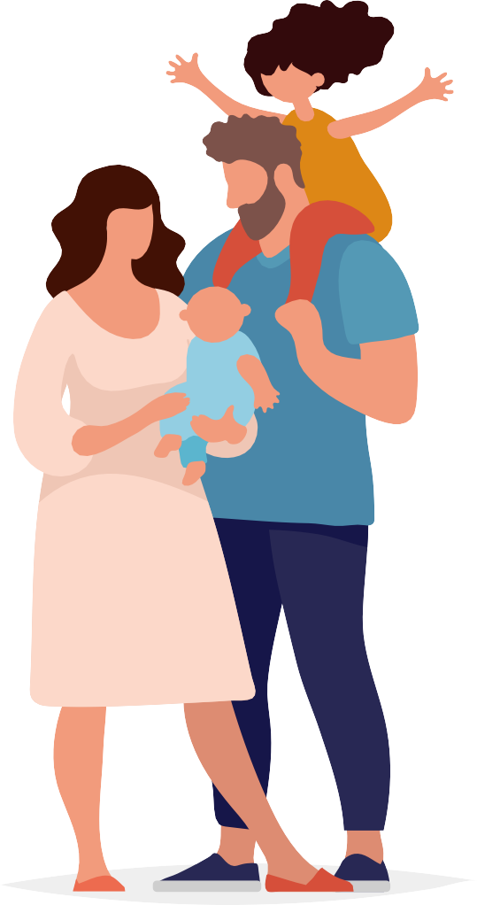

The Australian Government has worked with experts to develop guidelines to help you be active during pregnancy. These guidelines are for all pregnant Australians, regardless of gender identity, cultural or language background, geographic location or socio-economic status.

For more information go to **health.gov.au**