





National Women’s Health Policy 2010

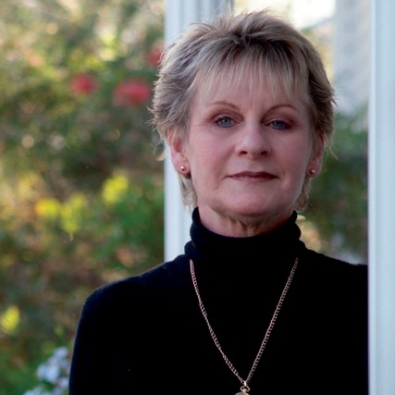
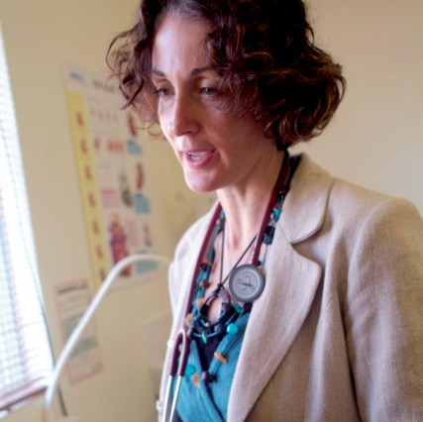
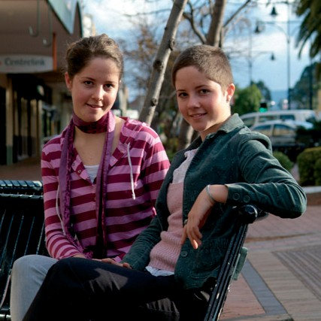
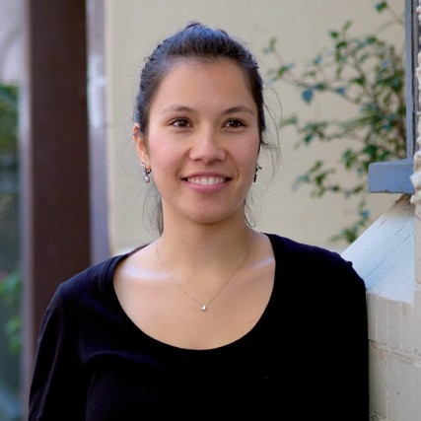



National Women's Health Policy 2010
ISBN: 978-1-74241-363-1
Online ISBN: 978-1-74241-364-8
Publications Number: D0102

Copyright Statements:
Paper-based publications
© Commonwealth of Australia 2010
This work is copyright. Apart from any use as permitted under the Copyright Act 1968, no part may be reproduced by any process without prior written permission from the Commonwealth. Requests and inquiries concerning reproduction and rights should be addressed to the Commonwealth Copyright Administration, Attorney-General's Department, Robert Garran Offices, National Circuit, Barton ACT 2600 or posted at http://www.ag.gov.au/cca

Internet sites
© Commonwealth of Australia 2010
This work is copyright. You may download, display, print and reproduce this material in unaltered form only (retaining this notice) for your personal, non-commercial use or use within your organisation.
Apart from any use as permitted under the Copyright Act 1968, all other rights are reserved.
Requests and inquiries concerning reproduction and rights should be addressed to Commonwealth Copyright Administration, Attorney-General's Department, Robert Garran Offices, National Circuit, Barton ACT 2600 or posted at http://www.ag.gov.au/cca



Contents
Ministerial Foreword | 5
Executive Summary | 7
Introduction | 11
Policy Overview | 12
Chapter One: History of the Policy and Policy Principles | 15
Development of the First National Women’s Health Policy | 15
Achievements of the First National Women’s Health Policy | 15
Development of the National Women’s Health Policy 2010 | 16
The principles | 17
Developing the goals | 22
Identifying key health issues | 22
Developing the key health ares identified in the consultations into priority health issues | 25
The social determinants of health | 26
Chapter Two: Key health challenges for Australian women today and into the future | 27
Major health issues faced by Australian Women | 27
Measures of general health | 27
Burden of disease and injury | 29
Health literacy | 29
Women and ageing: changing demographics | 30
Priority areas and targeted conditions | 33
Discussion of the four key health issues | 33
Chapter Three: Women’s experiences of health issues | 43
Prevention of chronic disease through control of risk factors | 43
Chronic diseases | 43
Lifestyle risk factors | 46
Mental health and wellbeing | 52
Impact of violence on emotional and mental health | 53
Mental health across the lifespan | 53
Marginalised women | 54
Use of mental health services | 55
Sexual and reproductive health | 56
Contraception and safe sex | 56
Violence and sexual and reproductive health | 57
Sexually transmitted infections | 58
Reproductive health | 59
Maternal health | 60
Ageing well | 63
Arthritis and other musculoskeletal conditions | 64
Dementia | 65
Older women and violence | 67
 | 3


National Women’s Health Policy 2010

Chapter Four: Current and future government action against the four priority
health issues 69
- Prevention of chronic disease through the control of risk factors 69
Current government actions on the prevention of chronic diseases through
the control of rick factors 69
Future government action on the prevention of chronic disease through the
control of risk factors 75
- Mental health and wellbeing 76
Current government action to improve mental health and wellbeing 76
Future government action to improve mental health and wellbeing 79
- Sexual and reproductive health 79
Current government action to improve women’s sexual and reproductive health 79
Future government action to improve women’s sexual and reproductive health 83
- Ageing well 83
Current government action to assist women to age well 83
Future government action to assist women to age well 84
Chapter Five: Social factors influencing women's health and wellbeing 85
Social determinants of health 86
Sex and gender 86
Life stages 87
Access to key resources 88
Diversity—ethnicity, geographic location, disability and sexuality 92
Government actions to address social determinants 95
Sex and gender 95
Access to resources 96
Diversity 99
National health reform 101
Access to health services 101
Health care reform agenda 102
Chapter Six: Goal areas 105
Goals 105
- Highlight the significance of gender as a key determinant of women’s health and wellbeing 106
- Acknowledge that women’s health needs differ according to their life stage 108
- Prioritise the needs of women with the highest risk of poor health 109
- Ensure the health system is responsive to all women, with a clear focus on illness and disease prevention and health promotion 110
- Support effective and collaborative research, data collection, monitoring, evaluation and
knowledge transfer to advance the evidence base on women’s health 112
Appendix A: List of all Submissions Received 115
References 121
4



Foreword

From the Minister for Health and Ageing


After more than twenty years since the first women’s health policy, the Gillard Government is pleased to be able to release the National Women’s Health Policy 2010.
There have been significant changes in the way women live their lives since the release of the first National Women’s Health Policy.
The first National Women’s Health Policy: Advancing Women’s Health in Australia released in 1989 was a response to some of the challenges for women of the time. The National Women’s Health Policy 2010 now provides a foundation to meet the challenges for women maintaining good health in the 21st Century.
I know there is no ‘typical’ or ‘average’ Australian woman. Each of us has our own work demands, our own family circumstance and our own health needs.
Never before have we seen such an enormous growth in chronic disease and considered how this will impact on our lives as we age. We also, unfortunately, still see large gaps in the health status for many Australian women, particularly those in low socioeconomic groups and for Aboriginal and Torres Strait Islanders.
The aim of this new National Women’s Health Policy 2010 is to guide us through the next 20 years to improve the health and wellbeing of all women in Australia, especially those at greatest risk of poor health.
This policy encourages the active participation of women managing their own health particularly through prevention and aims to promote health equity through our close attention to the social determinants of health including improvements in education and safe living conditions.
The policy recognises that immediate, medium and long-term actions can be taken by individual women, policy makers, program managers and service providers, to improve women’s health.
For a Gillard Labor Government, standing still in Health is not an option.
I am proud of this Government’s broad ranging health reform agenda which provides a great opportunity for women to continue to feature in and contribute to the future of our health system.
I wish to thank the many people that have provided input into the development of this new policy through public consultations and submission processes. With this input, the policy reflects the broad and diverse range of issues that will impact on women’s health in the next twenty years.
The National Women’s Health Policy 2010 provides us with a policy framework to guide future investments in women’s health and build the health and wellbeing of all Australian women.
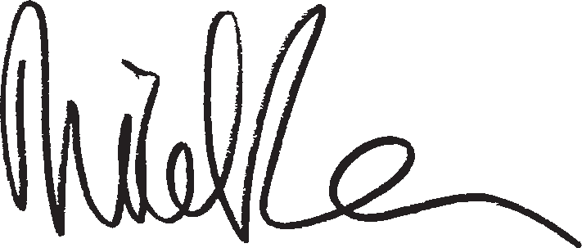

Nicola Roxon
Minister for Health and Ageing

5

National Women’s Health Policy 2010

6

Executive Summary

The purpose of the National Women’s Health Policy 2010 is to continue to improve the health and wellbeing
of all women in Australia, especially those at greatest risk of
poor health.
Purpose
The purpose of the National Women’s Health Policy 2010 is to continue to improve the health and wellbeing of all women in Australia, especially those at greatest risk of poor health.
The policy recognises the solid foundation of the first National Women’s Health Policy: Advancing Women’s Health in Australia which was released in 1989. It continues the commitment to building an environment where more can be done to ensure that all Australian women have better health and health care. This policy encourages the active participation of women in their own health and aims to promote health equity through attention to the social determinants of health.
The policy adopts a dual priority approach that recognises the importance of addressing immediate and future health challenges while also addressing the fundamental ways in which society is structured that impacts on women’s health and wellbeing. The policy reflects the equal priorities of:
- Maintaining and developing health services and prevention programs to treat and avoid disease through targeting health issues that will have the greatest impact over the next two decades; and
- Aiming to address health inequities through broader reforms addressing the social determinants of health.

Key health priorities and challenges
Since the first National Women’s Health Policy was released, women’s lives have undergone significant social, economic and technological changes. Overall, significant improvements have been made in the health of Australian women, for example in rates of cardiovascular disease, cancer and a reduction in smoking rates. However, these improvements have not been experienced equally throughout the community. Certain groups of Australia women, particularly Aboriginal and Torres Strait Islander women, experience markedly worse health than the general population. A range of socially based determinants can impact on the ability of some groups of Australian women to access the resources needed to maintain good health. A key ongoing health challenge is to address these inequalities.
Some health issues, for example, risk factors such as obesity and mental health particularly anxiety and depression have become increasing issues for women over the last two decades.
The next few decades will continue to see fundamental changes to the structure of the Australian population as a result of historic patterns of fertility, migration and changes in life expectancy. Projections indicate that women will make up an increasing proportion of the old and very old segment of the Australian population over time. The ageing of the female population will have a significant impact on the Australian health system. For example, the burden of disease associated with dementia in women is estimated to double in the next 20 years.

7

Priority health issues
Through research and consultation, a series of evidence-based health priorities have been identified that represent the major challenges associated with death and burden of disease for women in the next 20 years. These health priority areas are:
  - Prevention of chronic diseases through the control of risk factors; targeting chronic disease such as cardiovascular disease, diabetes and cancer, as well as risk factors such as obesity, nutrition, physical inactivity, alcohol and tobacco consumption. The policy also encourages a clearer understanding of the context of women’s lives, including the barriers that prevent women taking up healthier lifestyle behaviours.
  - Mental health and wellbeing; targeting anxiety, depression and suicide.
  - Sexual and reproductive health; targeting access to information and services relating to sexual health, reproductive health, safe sex practices, screening and maternal health.
The importance of the health of mothers prior to conception, during pregnancy and in the post-natal period can have a profound and long term effect on their own health and that of their children.
  - Healthy ageing; targeting musculo-skeletal conditions, disability and dementia. The policy highlights that the social, economic and environmental conditions under which women live and age can affect their experience of old age.

Action areas
Actions are drawn from existing Government responses and new actions are proposed in the following areas; prevention of chronic disease through the control of risk factors, mental health and wellbeing, sexual and reproductive health and healthy ageing.

There is a complex
relationship between physical
and social determinants of health. The policy therefore focuses on highlighting
the social determinants having the greatest impact on women’s lives.

Social determinants of health
There is a complex relationship between physical and social determinants of health. The policy therefore focuses on highlighting the social determinants having the greatest impact on women’s lives. The social determinants of health examined in the National Women’s Health Policy are:
- Sex and gender - these are major determinants of health and wellbeing, and it is important that these are considered to improve women’s access to health services and information.
- Life stages - Research has demonstrated that the health needs of women differ through stages of their lifecycle. The evidence of the past 20 years has confirmed the importance of taking a life course approach, preventing the accumulation of health risk factors and giving girls and women age-appropriate health care they require.
- Access to resources - Women’s access to key resources such as income, education, employment, social connections and safety and security, including freedom from violence, affect their health outcomes and their access to health care. These factors are in turn implicated in women’s risk behaviours, although in complex and varied ways.
- Diversity - Marginalisation and discrimination against diverse women, affect their access to resources and, therefore, impact their health and wellbeing.

National Women’s Health Policy 2010

8

Five policy goals
The policy examines longer term strategies for addressing the social determinants of health through the establishment of five policy goals. These are intended to highlight ways that gender inequality and health inequities (between women and men, and between differing groups of women) can be addressed.
The policy goals are to:
- Highlight the significance of gender as a key determinant of women’s health and wellbeing.
- Acknowledge that women’s health needs differ according to their life stage.
- Prioritise the needs of women with the highest risk of poor health.
- Ensure the health system is responsive to all women, with a clear focus on illness prevention and health promotion.
- Support effective and collaborative research, data collection, monitoring, evaluation and knowledge transfer to advance the evidence base on women’s health.
There is an opportunity to ensure that these goals are reflected in the health reform process, to develop a health system that is more responsive to the needs of Australian women.

There is an opportunity to ensure that these goals are reflected in the health reform process, to develop a health system that is more responsive to the needs of
Australian women.

9

National Women’s Health Policy 2010

1 0

Introduction
Australia has made significant gains in women’s health since the introduction of the first National Women’s Health Policy in 1989. Australian women enjoy a longer life expectancy than most women from other countries. Universal access to health care and essential pharmaceuticals means that treatment and support are generally available in times of illness.
Yet, in many important ways, women are still disadvantaged in some aspects of their health. Some groups of women do not have reasonable access to health services, or a health provider that is knowledgeable and supportive of their special health needs. Women’s health needs change throughout the course of their lives and it is important that they have the right information to optimise their health. This includes being able to prevent avoidable illness and to detect and treat any disease as early as possible.
The National Women’s Health Policy 2010 recognises the solid foundation of the first policy. It continues the commitment to building an environment where more can be done to ensure that all Australian women have better health and health care. In line with international developments and the Government’s social inclusion agenda, this policy emphasises prevention, addressing health inequalities and looking at the social determinants of those inequalities.
It takes as its starting point the first, 1989, women’s health policy. The consultations, submissions and reviews of current literature point clearly to the relevance of much of the original policy.
The issues, challenges, approaches and actions outlined 22 years ago have changed in their complexion, and are experienced and understood differently today. The 2010 policy adopts a dual priority approach that recognises the importance of addressing immediate and future health challenges while also addressing the fundamental ways in which society is structured that impacts on women’s health and wellbeing.
Through research and consultation, a series of evidence-based health priorities have been identified that represent the major challenges associated with death and burden of disease for women in the next 20 years. These health priority areas are:
- Prevention of chronic disease and control of risk factors.
- Mental health and wellbeing.
- Sexual and reproductive health.
- Healthy ageing.
The policy also examines longer-term strategies for addressing the social determinants of health through the establishment of five policy goals. These are to:
- Highlight the significance of gender as a key determinant of women’s health and wellbeing.
- Acknowledge that women’s health needs differ according to their life stage.
- Prioritise the needs of women with the highest risk of poor health.
- Ensure the health system is responsive to all women, with a clear focus on illness prevention and health promotion.
- Support effective and collaborative research, data collection, monitoring, evaluation and knowledge transfer to advance the evidence base on women’s health.

Some groups of women do not have reasonable access to health services, or a health provider that is knowledgeable and supportive of their special health needs. Women’s health needs change throughout the course of
their lives and it is important that they have the right information to optimise their health.

1 1

National Women’s Health Policy 2010



Policy overview
During 2009 and 2010, the Department of Health and Ageing coordinated the development of the National Women’s Health Policy 2010. The policy has its basis in discussions and submissions from women right across Australia who joined the
consultation process representing themselves, their families, communities, businesses or organisations. Input was collected from the National Women’s Health Policy Roundtable, written submissions and public consultations and distilled to show what women currently see as the most important issues in their health and wellbeing.
These issues have been used to inform the goals and action areas of the National Women’s Health Policy 2010. The policy also uses recent evidence on women’s health to support the strategies and, in line with the consultations, pays particular attention to the needs of marginalised groups of women.
The document is structured to reflect the equal priorities of:
  - maintaining and developing health services and prevention programs to treat and avoid disease through targeting health issues that will have the greatest impact over the next two decades; and
  - aiming to address health inequities through broader reforms addressing the social determinants of health.
Chapter One provides details on the development of the National Women’s Health Policy 2010, including the discussion papers and forums that made up the background to the policy and details of the submissions that were made as part of the consultation process.
Chapter Two provides an overview of women’s health as well as details of specific health issues and risk factors that will form the biggest challenge to the ongoing health and wellbeing of Australian women over the next 20 years. These health priorities have been identified through a strong evidence base of current research, including the Australian

1 2

Longitudinal Study of Women’s Health, as well as from the qualitative research undertaken as part of the consultation process for the development of the policy. The health priority areas include prevention of chronic disease, control of risk factors, mental health, sexual and reproductive health and ageing. Diseases and conditions such as (among others)
heart disease, diabetes, cancer, respiratory disease, chlamydia, depression and dementia are featured, as well as risk factors such as obesity, smoking, binge drinking and levels of physical exercise.
Chapter Three examines the priority health challenges identified in Chapter Two in terms of the health impacts of the issue in general, across the lifespan and the impact on women in marginalised groups. Underlying issues of gender and other social determinants of health impacting on these key health challenges are discussed.
Chapter Four provides the action areas to address the priority health challenges facing Australian women and policy makers over the next 20 years. Actions are drawn from
existing Government responses and new actions are proposed.
Chapter Five provides an exploration of the social determinants underpinning the health of Australian women today.
Chapter Six identifies five broad goals for addressing inequality, including existing government initiatives and areas for further development.
The Appendices provide a reference list and details of organisations and individuals who made submissions to the policy.

1 3

National Women’s Health Policy 2010

1 4

Chapter One:

History of the policy and policy principles

The 1989 policy aimed to improve the health and wellbeing of
all women in Australia with a focus on those most at risk and on making the
health care system more responsive to women’s needs.
Development of the First National Women’s Health Policy
In September 1985 more than 700 women attending the Adelaide conference Women’s Health in a Changing Society producing a joint resolution that a National Women’s Health Policy be developed ‘based on a clear recognition of the position of women in society and the
way this affects their health status and their access to health services appropriate to their needs.’
An extensive consultation process followed, seeking responses to the discussion paper Women’s health: a framework for change. This included meetings across all capital cities and selected rural centres and more than 300 written submissions that reinforced the clear message that women wanted decision makers to understand the reality of women’s lives and how quality of life issues impact on women’s health. In all, more than one million women contributed towards the development of the First National Women’s Health Policy.
Achievements of the First National Women’s Health Policy The 1989 policy aimed to improve the health and wellbeing of all women in Australia with a focus on those most at risk and on making the health care system more responsive to women’s needs.
Seven priority health issues for women were identified in the 1989 policy:
- reproductive health and sexuality;
- health of ageing women;
- emotional and mental health;
- violence against women;
- occupational health and safety;
- health needs of women as carers; and
- health effects of sex-role stereotyping on women.
In addition, the policy identified five key action areas in response to women’s concerns about the structures that deliver health care and information. These were:
- improvements in health services for women;
- provision of health information;
- research and data collection;
- women’s participation in decision making in health; and
- training of health care providers.

1 5

National Women’s Health Policy 2010

The 1989 policy has been used as the basis for program development and service planning for women’s health services at all levels of government over the past two decades. Under the National Women’s Health Program a number of women’s health centres were built or extended; new health information and education strategies were developed in a variety of
community languages; and specialised training on women’s health issues was developed for health providers.
The 1989 policy also resulted in the establishment of the Australian Longitudinal Study on Women’s Health. The study is a landmark longitudinal population-based survey over a 20-year period that examines the health of more than 40,000 women.
The Australian Longitudinal Study on Women’s Health provides valuable information on women’s health and wellbeing across three generations. It examines most aspects of life, including physical health, relationships, reproductive health, body weight, emotional and mental health, paid work and retirement, ageing and caring roles.
Participants have been surveyed at least four times over the past 12 years and the results of the surveys are widely used by government and academics. The Australian Longitudinal Study on Women’s Health data have been analysed for reports on topics such as reproductive health, women’s health and ageing and an upcoming report on the health of women in rural and remote Australia. Further reports are planned for release over the next two years.
Feedback through the consultation process for the development of this policy consistently recognised the main strength of the 1989 policy as being the principle that health should be understood in a social context. There is also recognition that the achievements made under the 1989 policy are a product of the power of consultation and communication and that these remain important elements in the planning and delivery of health services that are suited to the needs of women in all their diversity.
Development of the National Women’s Health Policy 2010 Listening to women has, again, been a driving force in developing this policy, and engaging with women from many different groups has helped make the policy a reflection of the needs voiced by Australian women today. What women have said through the policy consultations and submission process has been incorporated into this policy.
The consultation process began with the release of the paper Developing a Women’s Health Policy for Australia: Setting the Scene by the Minister for Health and Ageing, the Hon Nicola Roxon MP.
On 12 March 2009, 15 women’s health organisations were invited to attend a National Women’s Health Policy Roundtable in Canberra. The Development of a New National Women’s Health Policy: Consultation Discussion Paper was released at this time. These organisations were asked to consult with their members and provide submissions on what they considered the priority issues for women’s health to be, 20 years after the release of the first policy. These submissions accurately marked out the scope of the concerns that women subsequently raised through the consultation process.
In September and October 2009, community consultation meetings were held across Australia to seek feedback on the discussion paper Development of a New National Women’s Health Policy: Consultation Discussion Paper. The consultations provided an opportunity for other national groups, community organisations and individuals

1 6

to contribute to the policy and were held in all major capital cities and in rural centres including Alice Springs, Bendigo, Cairns, Fitzroy Crossing, Launceston, Port Augusta and Taree. More than 700 women attended the 15 forums to give their thoughts on the proposals in the paper.
To ensure that the views of Aboriginal women were reflected in the consultations, the Australian Government funded the Australian Women’s Health Network Aboriginal Women’s Talking Circle to hold and report on consultations with some 400 Aboriginal women throughout Australia.
When consultations closed, more than 170 organisations and individuals had put in submissions. The submissions contain valuable data about the position of women in Australia today as well as suggestions for action and models of effective action already in place. The submissions have provided a valuable basis to guide the content and principles of this policy.
The common themes from the consultations are presented in this section. The full list of those organisations and individuals that contributed to the policy is given in Appendix A. While not every idea raised in the consultations was able to be included in this policy, those issues and principles raised a number of times form the framework for this policy.
The principles
The National Women’s Health Policy discussion paper proposed five principles, drawn from the 1989 policy, that were used as the starting point for the consultation discussions and the written submissions. These principles were:
  - gender equity;
  - health equity between women;
  - a life course approach to health;
  - a focus on prevention; and
  - a strong and emerging evidence base.
Overall these principles were strongly endorsed both through the consultations and the submissions. The responses give an insight into what these principles mean for Australian women in 2010.
Across all discussions of the principles, the clear message was a desire to have a health policy that was based on the whole person and her social context. Providing holistic and integrated services for women was the most frequently supported service-delivery principle.
The following section outlines the feedback received through the consultation process that has informed the basis of the policy.

Gender equity
The principle of gender equity was strongly endorsed. Most argued that the role that gender, and gender relations, played in women’s health needed to be at the core of this policy. Many suggested that the conceptual framework for the policy should show how gender interacts with other social determinants. The following comments were typical of responses:
Opportunities for health and vulnerability to illness are shaped by the gendered material and social realities of everyday life.
(Public Health Association Australia Submission p. 6)
Listening to women has, again, been a driving force in developing this policy, and engaging with women from
many different groups has helped make the policy a reflection of the needs voiced by Australian women.

National Women’s Health Policy Setting the scene
1 7

National Women’s Health Policy 2010

While the focus of the National Women’s Health Policy is to be within the health portfolio, the achievement of a ‘level playing field’ will also involve addressing inequities in areas that stretch beyond the traditional parameters of that system…[to] champion a social determinants approach throughout the Commonwealth’s departmental portfolios.
(Australian Women’s Health Network Submission p. 17)

There was strong support for the health system as a whole to be more responsive to women’s health needs, including the need for training of health professionals on the impact of gender on health. This was identified in one submission as a serious omission from the discussion paper and an important step towards achieving equity.
We are delighted that… [you are] developing and implementing new women’s and men’s health policies. However, without adequate education and training about the impact of gender on health to health care professionals, we can expect little to change.
(Australian Women’s Coalition Submission p. 14)

Health equity between women
There was overwhelming support for the inclusion of health equity between women as a central principle of the policy. Aboriginal and Torres Strait Islander women were frequently identified as a priority because of their very high risk of poor health. The submission for a National Aboriginal Women’s Health Policy provided by the Aboriginal Women’s Talking Circle summarised the issues, and directions needed:
The issues, gaps and barriers which have been identified in this submission and which have continually impacted on and caused on-going devastation and hardship to Australia’s Aboriginal women, their extended family members and closely connected national communities, need to be addressed through the development and delivery of holistic strategies to improve the health status of Australia’s Aboriginal women and their extended families.
Many of the identified issues, gaps and barriers to services are significant. However, while some of these will require a huge re-orientation and shift in health service delivery and need to be underpinned by immense funding, other recommendations seem to be more straightforward. These latter require less funding commitment or restructuring of services and, if common sense prevails, and these recommendations are acknowledged, they would
improve the health status and lifestyle of Aboriginal women and their extended families thus lessening the burden on secondary and tertiary health care systems.
(National Aboriginal Women’s Health Policy Submission: Talking Circle: AWHN p. 5)

Other groups of women who were frequently identified in the consultations as being at greater risk of poor health included, among others, women with a disability; women in rural and remote areas; migrant and refugee women; women as carers; older women; and lesbian and bisexual women. The consultations made it clear that those with the fewest resources may be forced to make health decisions on whatever treatment they can afford or access rather than the treatment that is best for their needs. Those who are discriminated against, or who cannot find culturally appropriate services, may withdraw from seeking help altogether.
Submissions addressing health equity between women were often clear statements of fact that communicated in simple terms the lack of equity between various groups of women within Australia:

1 8

The health outcomes of rural and remote women, and their treatment options, cannot be considered in any way and by any measure as equal to that afforded women who live in metropolitan Australia. The differences between accessibility to medical services from an urban centre to that from a rural, remote centre are immense and all negative.
(Country Women’s Association of Australia Submission p. 7)

Health problems are compounded by bisexual and lesbian women frequently not accessing preventative and responsive healthcare services at all, or delaying their access… due to fear of discrimination and stigma. Those who do access services frequently receive ill or uninformed advice and inappropriate treatment… [for example] frequent instances of GPs incorrectly telling lesbian patients that they had no risk of HPV, and did not require pap smears.
(National LGBT Health Alliance Submission p. 8)

Many important health messages are not accessible to people with [a] disability from non English speaking backgrounds and/or their carers. The messages are traditionally in English and are not produced in community languages… in alternative formats such as Braille or large print.
Where information is available in other languages, it is often only available in writing and presented in formal language that is difficult to comprehend. Many culturally and
linguistically diverse women—particularly those from the emerging migrant communities from Somalia, Sudan, etc.—do not have an education and thus are still unable to make contact with a service provider.
(National Ethnic Disability Alliance Submission pp. 2–3)
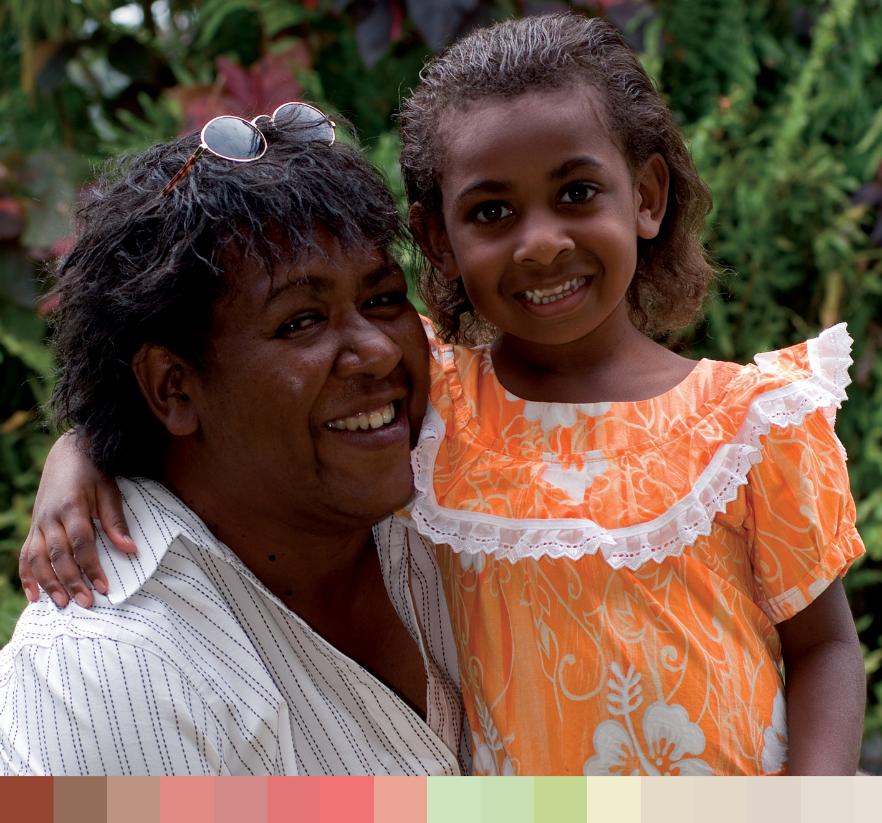

1 9

National Women’s Health Policy 2010

The consultations supported the active participation of diverse groups of women in policy design, and the implementation of the strategies that affect them, to help ensure that health services and messages are designed for the people who need them the most. The submissions strongly agreed that the expertise of women within targeted communities should be called on to help implement local programs aimed at reducing inequity between groups of women.

A life course approach to health
A focus on women’s health across the life span was supported by the submissions, particularly the emphasis on critical transition points such as puberty, pregnancy and the postnatal period, and menopause and older age. Many submissions noted that a life course approach is essential for preventative health:
The strength of such an approach in developing the new policy is the focus it brings about on the context of women’s lives and the transitions and significant events occurring at different life stages that impact on health and well being from the formative years of infancy and childhood through adolescence, into adulthood and older age.
(Public Health Association Australia Submission p. 15)

Feedback from the consultations indicated a strong belief that age-appropriate information and services across a woman’s life will help women gain and keep control of their own health-management decisions. The submissions indicated that there are gaps remaining in critical services at key points in women’s lives which could inform future policy directions. Some examples of these from the submissions are:
The RACGP supports …[the life course] approach to the policy and believes that it should be applied to preventive initiatives and assessment of risk such as the Medicare health assessment items…the cost effectiveness and utility of MBS items for risk assessment coinciding with different life stages [could be explored] e.g. adolescence/young adult, preconception, premenopausal, menopausal and older women.
(Royal Australian College of General Practitioners Submission p. 10)

Fertility education enables each woman to avoid pregnancy and maximise her chance of achieving pregnancy. It also enables her to be better equipped to make informed life
choices… Natural Fertility Australia believes there is a need for a continuum of services in fertility education; that sexual and reproductive health needs change throughout the lifespan and so too should sexual and reproductive health services.
(Natural Fertility Australia Submission p. 4)

Focus on prevention
The focus on prevention was strongly endorsed. The need to recognise the barriers facing many disadvantaged communities as well as to support women’s empowerment and control over their own health was frequently mentioned. In delivering preventative health, health services were seen as needing to consider issues such as:
    - equity and access;
    - appropriate primary health care;
    - ongoing consultation with all stakeholders;

2 0

  - community development processes;
  - consultation and advocacy; and
  - health promotion and education that is both tailored to women and well targeted for priority groups of women.
These comments were typical of submissions:
Prevention is a key theme throughout this submission. A number of suggestions are made in regard to ways in which preventive health messages can be more effectively disseminated. These include additional support and funding to introduce disease specific screening programs that take into account the most prevalent diseases/conditions at specific ages, and to identify women and populations at risk.
(The Jean Hailes Foundation for Women’s Health Submission p. 4)

We consider preventative health very important for immigrant and refugee women as they are currently missing out compared to other groups and we see the consequences.
Immigrant and refugee women are under represented in preventative health services and over represented in the acute and crisis end of health and welfare services…Ageing migrants are over represented in some diseases such as diabetes and vitamin D deficiency. There is also a lower uptake of breast screening services in immigrant and refugee women.
(The Multicultural Centre for Women’s Health Submission pp. 12–13)

There was agreement that improving the health of all Australian women is important and the broad-based preventative strategies that have already significantly improved women’s health, such as breast and cervical cancer screening, and health campaigns about smoking, must continue.

A strong and emerging evidence base
The need for more detailed research and data on women and their health was strongly endorsed. Many submissions highlighted the importance of data collection covering the full spectrum of difference in women’s lives including age, place, ethnicity, sexual
orientation, disability, cultural and linguistic background, and immigrant or refugee status. The consultations suggested that all government and government-funded data collected should include this information where possible and, at least, conform to the Australian Bureau of Statistics minimum standards on culture and language.
Some submissions suggested expanding the evidence base. This could be achieved by continuing to fund the Longitudinal Study of Women’s Health and broadening it to include social health and new cohorts. The submissions suggested the potential to link the Australian Longitudinal Study of Women’s Health with other databases such as the
Household, Income and Labour Dynamics in Australia survey and the Longitudinal Study of Australian Children.
Suggestions also included setting up a funded body to act as a national clearinghouse for women’s health information, and establishing a gender health unit in the Australian
Institute of Health and Welfare. The multi-disciplinary focus for research received strong support. Typical responses are shown below.
Further research should be done to identify and focus on current and emerging gaps in women’s health care through comprehensive needs analysis and engagement with women

2 1

and health professionals. The research effort should be multi-disciplinary, acknowledging the diversity of Australian women and the presence and impact of disease co-morbidities (such as depression and anxiety), and should also include evaluation of interventions.
(The Jean Hailes Foundation for Women’s Health Submission p. 4)

In continuing to build a strong evidence base for women’s health policy, we believe that improvements to existing routine data collections can and should be made. For example, existing data collections rely on male oriented measures of socioeconomic position, as current measures of income miss the value of women working in the home. As a result, routinely collected national surveys continue to be structured around a masculine template. Furthermore, in building a comprehensive evidence base we would like to highlight the importance of interdisciplinary research collaborations when approaching and investigating complex health problems.
(Life Course and Intergenerational Health Research Group: University of Adelaide Submission p. 4–5)

National Women’s Health Policy 2010
There were different views about which health issues should feature in the new policy, but all agreed that the new policy should lead and influence action across governments to ensure the best health outcomes
for women.

2 2
Developing the goals
Based on feedback from the consultation process and information drawn from Australian health data and recent research on the social determinants of health, the goals were developed. The goals of the National Women’s Health Policy are to:
- Highlight the significance of gender as a key determinant of women’s health and wellbeing.
- Acknowledge that women’s health needs differ according to their life stage.
- Prioritise the needs of women with the highest risk of poor health.
- Ensure the health system is responsive to all women, with a clear focus on illness prevention and health promotion.
- Support effective and collaborative research, data collection, monitoring, evaluation and knowledge transfer to advance the evidence base on women’s health.
There were different views about which health issues should feature in the new policy, but all agreed that the new policy should lead and influence action across governments to ensure the best health outcomes for women. A more detailed discussion of the priority health issue areas identified by women through the consultations and submissions are contained in Chapter Three.
Identifying key health issues
Within the submissions and consultations women raised a broad range of health issues of most concern, and focused on particular groups the policy needed to address to achieve health equity among women. The most common issues raised were:
- chronic disease prevention;
- mental and emotional health;
- sexual and reproductive health;
- maternal health;
- violence against women; and
- economic health and wellbeing.

The following section summarises the input from the consultations on priority health issues.

Chronic diseases prevention
Some felt that the national health priority areas (cardiovascular disease and stroke, cancer control, mental health (with a focus on depression), injury prevention and control, diabetes mellitus, asthma, arthritis and musculo-skeletal conditions) should be a policy priority. A number of submissions stated that substantial gains in women’s health could be achieved through gender analysis, education and health service delivery in these areas.
An increased research and policy focus, in the context of Australia’s growing rates of chronic diseases, on how the behavioural and relational aspects of a gendered existence underpin the circumstances and decisions that put individuals at varying risk of conditions such as obesity, diabetes, cancer and heart disease.
(Public Health Association of Australia p. 8)

Preventing obesity was seen as important. Reducing the use of alcohol, cigarettes and other drugs—especially among young women—were also seen as crucial preventative health measures.

Mental health
During the consultations and submissions, women again highlighted how depression, anxiety and other mental health issues affect many women. Social issues, especially
poverty and inadequate housing, were highlighted as major contributors to mental issues. Many focused on the need to see women’s mental health within the context of lower incomes, power in relationships, status in the workplace, greater caring responsibilities and experiences of harassment, violence and discrimination. The needs of some groups of
women were particularly highlighted and these included young, perinatal, lesbian, bisexual, transgender, intersex and older women.
Participants said effective responses would need to better connect those services that exist in the delivery of support. Working on a holistic basis and providing more health promotion and education was also seen as essential.

Sexual and reproductive health
Submissions noted that current policies often focus on single issues, such as sexually transmitted infections, and neglect the promotion of broader sexual and reproductive health. There is also a need to link sexual and reproductive health to interdependent strategies, such as those for mental health and substance abuse. As well as differences in legislation among states and territories, the quality of health education varies, in the absence of minimum standards.
At the consultations many highlighted the importance of reproductive autonomy, based on offering women the full range of natural and medical options. Many submissions also stated that expanding women’s choice of service was important. For the majority, this meant access to free contraceptive services, pregnancy decision-making information, and Australia-wide access to pregnancy termination. For others, this was best achieved through giving all women access to natural or educational strategies for fertility control as part of mainstream service delivery.
During the consultations and submissions, women again highlighted how depression, anxiety and other mental health
issues affect many women.

2 3

National Women’s Health Policy 2010

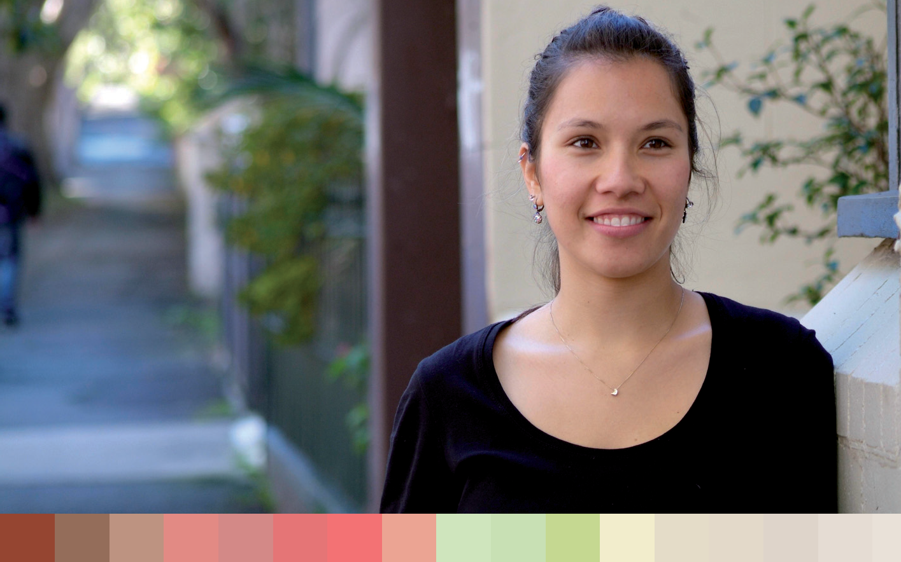

There was strong support for placing sexual and reproductive health in a relationship context, rather than taking a mechanistic medical approach. Others focused on the need for a national education curriculum, to address varying levels of knowledge about
fertility amongst young women. Some organisations highlighted how the quality of health education varies, in the absence of minimum curriculum standards.
There was less agreement on other recommendations for actions on reproductive health and sexuality. Some women wished to provide much greater support for alternatives
to termination of pregnancy. Others wished to improve women’s access to safe, legal termination of pregnancy. Many focused on the need for priority groups of women to receive more targeted health promotion material and services.

Maternal health
Maternal health figured prominently in the submissions and consultations, whether as part of sexual and reproductive health or as an issue in its own right. Women emphasised the importance of access and choice of services with support to the woman and her family before, during and after birth. They wanted maternity care to be part of the women’s health policy, rather than being dealt with solely under the Maternity Services Review. They argued maternity care should encompass pre-pregnancy, antenatal, childbirth and after birth information and support. Other issues of concern raised were breastfeeding rates and an increase in postnatal depression.
It is crucial to see adequate attention paid in the proposed policy to intra-partum and post- natal care, as well as ante-natal care.
(National Foundation for Australian Women submission p. 7)

Violence against women
Through the submissions and consultations many saw the issue of violence against women as a priority for the new policy. Some commented that it had been a priority since 1989, with

2 4

little demonstrable improvement. Addressing a number of issues was seen as necessary to achieving any significant sustained reduction in violence, including:
  - structural inequalities in society as causes of violence against women;
  - the broad cultural denial of domestic violence as a serious issue;
  - a tendency to blame the woman; and
  - stressors such as poverty and inadequate housing.
Partner violence represents a significant burden of disease and thus a concerted effort is required to establish a knowledge base of the effectiveness and cost-effectiveness of the different ways of intervening to decrease partner violence.
(WHA submission)

The impact of childhood sexual assault on women’s mental and physical health was noted by a number of organisations. Other aspects of violence discussed included the safety of women patients in the mental health sector, women with disability in care, and the safety of general practitioners and other health workers.
Many noted the importance of building the capacity of work sectors to train general practitioners, nurses, mental health, drug and alcohol services and other frontline health workers to identify and respond effectively to women experiencing violence. Some submissions thought the matter so multidimensional that a council should be established to oversee the effort over the years.

Economic health and wellbeing
Economic wellbeing was rated as the most important issue in several submissions, and as a major concern in many. Women who are socioeconomically disadvantaged suffer poor health and have a high chance of having children who also have poor health. The lack of equity in women’s pay and the gap in superannuation savings are major contributors to women’s relatively poor economic security. Their financial security is also influenced by different life stages and events such as child rearing, caring for elderly parents, retirement and the death of a partner.

Developing the key health areas identified in the consultations into priority health issues
The key health areas identified through the consultations were then examined in the context of data relating to disease prevalence, cause of death and burden of disease in Australian women. Four health priority issues were identified and these are discussed in Chapter Two and Chapter Three. Current measures and proposed action areas against these four health priority issues are discussed in Chapter Four.
The National Women’s Health Policy key priority areas are:
  - Prevention of chronic disease and the control of risk factors;
  - Mental health and wellbeing;
  - Sexual and reproductive health; and
  - Healthy ageing.

Women who are socioeconomically disadvantaged suffer poor health and have a high chance of having children who also have poor health.

2 5

National Women’s Health Policy 2010

The social determinants of health
The social determinants of health identified through the consultations have been used to inform the policy and these are discussed in detail at Chapter Five. There is a complex relationship between physical and social determinants of health. The policy therefore focuses on highlighting the social determinants having the greatest impact on women’s
lives. The social determinants of health examined in the National Women’s Health Policy are:
  - Sex and gender—these are major determinants of health and wellbeing, and it is important that these are considered to improve women’s access to health services and information.
  - Life stages—research has demonstrated that the health needs of women differ through stages of their lifecycle. The evidence of the past 20 years has confirmed the importance of taking a life course approach, preventing the accumulation of health risk factors and giving girls and women age-appropriate health care they require.
  - Access to resources—women’s access to key resources such as income, education, employment, social connections and safety and security (including freedom from violence) affect their health outcomes and their access to health care. These factors are in turn implicated in women’s risk behaviours, although in complex and varied ways.
  - Diversity—marginalisation and discrimination, against diverse women affect their access to resources and therefore impact their health and wellbeing.

2 6

Chapter Two:

Key health challenges for Australian women today and into the future
Australian women’s life expectancy at birth has shown dramatic improvements over the past century, increasing from 59 years in the early 1900s to around 87 in 2007.1 There have been remarkable
health gains overall for women in areas such as rates of cardiovascular disease and cancer and a reduction in the number of women smoking. However, many issues such as obesity and mental health remain significant problems for women, and the burden of disease associated with dementia in women is estimated to double in the next 20 years.2
This chapter provides an overview of the health of Australian women and highlights those health priorities and targeted conditions that will form the greatest challenges over the next two decades for the health system, policy makers, health professionals and individual women.

Major health issues faced by Australian women
Measures of general health
Self-assessed health is a commonly used measure of health status. In 2006, just over half of women aged 18 years and over (57.9 per cent) considered their health status to be excellent or very good. The percentage of women who rated their health as poor or fair increased with age, while those who considered their health to be excellent or very good peaked at ages 25 to 34 years and then declined with increasing age.3
The leading underlying causes of death in females are shown, grouped by age, in the table below. Across all age groups, cardiovascular disease, including heart attack, stroke and other heart and blood vessel diseases, remains the biggest killer of Australian women. This is despite a 76 per cent fall in death rates since the 1960s. Age groupings show that, despite its place as the leading underlying cause of death in women, the majority of these deaths happen in women over 65.

2 7

National Women’s Health Policy 2010

Table 1: Leading underlying broad causes of death in females by age group 4

Age group | Leading underlying broad causes of death in females by age group | % of deaths
Under 1 year | Conditions originating in the perinatal period | 46.0
 | Congenital anomalies | 28.6
 | Ill-defined conditions | 11.5
 | Injury and poisoning | 3.5
1–14 years | Injury and poisoning | 36.3
 | Cancer and other tumours | 17.9
 | Nervous system disorders | 9.4
 | Cardiovascular disease | 7.1
15–24 years | Injury and poisoning | 53.8
 | Cancer and other tumours | 14.2
 | Cardiovascular disease | 7.8
 | Ill-defined conditions | 5.6
25–44 years | Cancer and other tumours | 35.0
 | Injury and poisoning | 27.7
 | Cardiovascular disease | 11.5
 | Ill-defined conditions | 4.5
45–64 years | Cancer and other tumours | 55.8
 | Cardiovascular disease | 13.9
 | Injury and poisoning | 7.1
 | Respiratory system diseases | 5.9
65–84 years | Cancer and other tumours | 33.3
 | Cardiovascular disease | 32.4
 | Respiratory system diseases | 8.8
 | Endocrine-related disorders | 4.8
85 + years | Cardiovascular disease | 48.6
 | Cancer and other tumours | 12.1
 | Respiratory system diseases | 8.7
 | Mental disorders | 8.3
All ages | Cardiovascular disease | 36.5
 | Cancer and other tumours | 26.0
 | Respiratory system diseases | 8.2
 | Mental disorders | 5.4
2 8

Burden of disease and injury
The burden of disease and injury is measured using the ‘disability-adjusted life year’ (DALY). The DALY measures the years of life lost due to premature death coupled with years of ‘healthy’ life lost due to disability.5 One DALY is equivalent to one lost year of healthy life.
The total burden of disease and injury in Australia in 2003 was 2.63 million DALYs.6 Men accounted for more of the burden of disease and injury (1.4 million DALYs) than women (1.3 million DALYs).7
Table 2 shows sex differences in the leading specific causes of healthy life lost. Ischaemic heart disease was the leading specific cause of healthy life lost for men and anxiety and depression were the largest contributors to healthy life lost among women. Dementia, breast cancer, and asthma were in the top 10 specific causes of healthy life lost for women, but not for men. The category suicide and self-inflicted injury was ranked eighth for men, but these causes did not rank in the top 10 for women.

Table 2: Ten leading specific causes of burden of disease and injury (DALYs), by sex, Australia 2003.8

 | Male burden |  |  | Female burden
Rank | Specific cause | No. of DALYs | % of total DALYs | Specific cause | No. of DALYs | % of total DALYs
1 | Ischaemic heart disease | 151,107 | 11.1 | Anxiety and depression | 126,464 | 10.0
2 | Type 2 diabetes | 71,176 | 5.2 | Ischaemic heart disease | 112,390 | 8.9
3 | Anxiety and depression | 65,321 | 4.8 | Stroke | 65,166 | 5.1
4 | Lung cancer | 55,028 | 4.0 | Type 2 diabetes | 61,763 | 4.9
5 | Stroke | 53,296 | 3.9 | Dementia | 60,747 | 4.8
6 | Chronic obstructive pulmonary disease | 49,201 | 3.6 | Breast cancer | 60,520 | 4.8
7 | Adult-onset hearing loss | 42,653 | 3.1 | Chronic obstructive pulmonary disease | 37,550 | 3.0
8 | Suicide and self-inflicted injury | 38,717 | 2.8 | Lung cancer | 33,876 | 2.7
9 | Prostate cancer | 36,547 | 2.7 | Asthma | 33,828 | 2.7
10 | Colorectal cancer | 34,643 | 2.5 | Colorectal cancer | 28,962 | 2.3

Health literacy
Health literacy describes the ability of a person to understand essential health information that is required for them to successfully make use of all elements of the health system (preventive, diagnostic, curative and palliative services). Health literacy lies at the heart of a person being able to take control of their own health care through making informed health decisions, seeking appropriate and timely care and managing the processes of illness and wellness.
2 9

The Australian Bureau of Statistics Adult Literacy and Life Skills Survey (2006) showed that 60 per cent of Australians have less than adequate levels of literacy and health literacy, and only 6 per cent of the Australian population has ‘high’ health literacy levels.
As illustrated in Figure 1, for Australian women, health literacy levels differ according to age, with women over 65 years showing the lowest levels. As women in this group are also the highest users of a range of health services, it is likely that many of these women will have problems understanding written and verbal advice from health sources and being able to successfully navigate the health system to obtain appropriate services.
These difficulties increase where other factors such as being from a culturally and linguistically diverse (CALD) background are also impacting on health literacy. While
17.4 per cent of 65–74 year olds in the broader population have ‘adequate’ health literacy levels, only 3.4 per cent of CALD individuals in the same age group have ‘adequate’ health literacy levels.

Figure 1: Australian health literacy by age (women) Australia 2006 9

50.0%

40.0%

30.0%

20.0%

10.0%

Very Low Low Adequate High

0.0%

15-24 25-44

age range

45-64 65-74

National Women’s Health Policy 2010

In addition to health literacy, there are a number of socially-based determinants of health that impact on Australian women’s ability to control their own health or experience health equity across the lifespan. Issues such as the impact of limited resources, exposure to violence, belonging to a marginalised group and structural and political inequity are examined in detail in Chapter Five.

Women and ageing: changing demographics
The next few decades will see fundamental changes to the structure of the Australian population as a result of historic patterns of fertility, migration and changes in life expectancy. As a result, there is a significant predicted increase in the proportion of the population in the older age groups. For example, in 1971, under 1.1 million (8.3 per cent) of the Australian population were aged 65 years or older. In 2009, this has risen to over
2 million (13.3 per cent) of the population.
The ageing trend can be measured in terms of the increase in the median age of the population and by examining the age structure of the population. Figure 2 shows that the median age of men and women has increased steadily over time. Prior to 1927, the median

3 0

age of men was higher than the median age of women. Since 1929, the median age of women has been higher than the median age of men. In 2005, the median age for women was 37.4 years and the median age for men was 35.9 years.10

Figure 2: Trends in median ages of men and women, 1925–2005

38
36
34
Median Age (years)
32
30 Males
Females
28
26
24
22
20
1925
1929
1933
1937
1941
1945
1949
1953
1957
1961
1965
1969
1973
1977
1981
1985
1989
1993
1997
2001
2005

Year

A major reason for the ageing of the population has been declining fertility. At the beginning of the 20th century, the total fertility rate was approximately 3.5 babies per woman. Figure 3 shows that following a brief decline in the 1920s and 1930s, there was a large and sustained increase in Australia’s total fertility rate from the end of
World War II to the mid-1960s. Australia’s total fertility rate peaked at 3.1 in 1947 and again in 1961 at 3.5.11 Fertility declined from the mid-1960s, with a sharp fall from 2.9 in 1971 to
1.9 in 1981, and then a gradual decrease to 1.7 in 2001. In 1977, Australia’s fertility rate fell below replacement level (2.1 babies per woman) and has remained there ever since.12 Since 2001, fertility has gradually increased and, in 2005, the total fertility rate was 1.81 babies per woman, which has been the highest rate since 1995.13

Figure 3: Trends in Australia’s total fertility rate

4.0

3.5

3.0

2.5
Total Fertility Rate

2.0

1.5

1.0

0.5

0.0
1925
1929
1933
1937
1941
1945
1949
1953
1957
1961
1965
1969
1973
1977
1981
1985
1989
1993
1997
2001
2005

Year

3 1

One in two Australians is female, and the Australian female population is ageing, with important implications for Australia’s health care system. Over the last century, there has been an increase in life expectancy for both men and women. However, life expectancy has consistently been higher for women, although the gap between male and female longevity is closing (Figure 4). In 2005 the life expectancy at birth for women was 83.3 years compared to 78.5 years for men.14 This means that women, on average, live for 4.8 years longer than men. Projections indicate that women will make up an increasing proportion of the old and very old segment of the Australian population over time.

Figure 4: Trends in life expectancy at birth by sex, 1961–2001

85

80

75
Life expectancy

70 Males
65 Females

60

55

50
1961 1965 1971 1976 1981 1986 1991 1996 2001

Year

The ageing of the female population will have a significant impact on the Australian health system. During 2008 to 2009, of the 171.6 million Medicare services accessed by women, the majority (on a per capita basis) were for women in the 55 years + age group. Increasing poor health and disability among older women translates into a stronger demand for Medicare services, with per capita usage peaking in the 75 to 84 year age group. Actual Medicare services usage peaks in the 55 to 64 year age group at a total of 25,709,943 services.

Figure 5: Medicare services accessed (female) by age group 2008–09 15

30.0

25.0

20.0
total services (millions)

15.0

10.0

5.0

-
40.0

35.0

30.0

25.0

20.0

15.0

10.0

5.0

-
85+
75-84
65-74
55-64
45-54
35-44
25-34
20-24
15-19
10-14
5- 9
0- 4

Total (million)

Per capita
services per capita

National Women’s Health Policy 2010
Age

3 2

Not only do women increase their use of health services as they grow older, they also make up the majority of the health workforce and are in the majority of unpaid carer roles.
Priority areas and targeted conditions
Using the evidence base drawn from key government data sources and surveys, emerging evidence from the Australian Longitudinal Study on Women’s Health and the consolidated submissions and consultations for the development of this policy, four key challenges have been identified as crucial to improving women’s health over the next two decades. These areas are:
- prevention of chronic diseases through the control of risk factors (targeting chronic disease such as cardiovascular disease, diabetes and cancer, as well as risk factors such as obesity, nutrition, physical inactivity, alcohol and tobacco consumption);
- mental health and wellbeing (targeting anxiety, depression and suicide);
- sexual and reproductive health (targeting sexually transmitted infections, screening/vaccination and fertility control); and
- healthy ageing (targeting musculo-skeletal conditions, disability and dementia).
Each of these priority areas will be discussed in-depth, in Chapter Three, from both a lifespan perspective and according to the impact of the targeted conditions on specific groups of women. The following section provides an overview of each targeted condition under the priority areas.
Discussion of the four key health issues
- Prevention of chronic disease and control of risk factors

Chronic disease
Cardiovascular disease
Cardiovascular diseases are diseases of the heart and blood vessels, including coronary heart disease, stroke and heart failure. Cardiovascular disease is the largest cause of death among females, accounting for more than one in every three (37 per cent) female deaths. Importantly, many cardiovascular disease deaths are premature, as they occur in women aged less than 84 years, which is the current life expectancy for women.
However, the public health impact of cardiovascular disease among women is wider than the deaths it causes. About two million (20 per cent) females are living with cardiovascular disease, and even more are at risk. With prevalence rates of high blood pressure at
27 per cent, overweight and obesity at 54 per cent, high cholesterol at 48 per cent, insufficient physical activity at 76 per cent and daily smoking at 15 per cent in women, there is ample scope for prevention. Cardiovascular disease accounted for 18 per cent of the overall disease burden for females in 2003. As life expectancy rises, the burden of cardiovascular disease on women will increase.
Women’s awareness of cardiovascular disease as the leading cause of death in Australia is low (26 per cent) with 39 per cent of Australian women incorrectly believing breast cancer to be the leading cause of death.16

Cardiovascular disease is
the largest cause of death among females, accounting for more than one in every three
(37 per cent) female deaths.

3 3

National Women’s Health Policy 2010

Diabetes
The number of Australian women with diabetes is increasing with National Health Survey estimates of 3 per cent of the population reporting having received a diagnosis from a doctor or nurse. The highly preventable Type 2 diabetes makes up an estimated 88 per cent of all diabetes types and, if undiagnosed or poorly managed, can result in cardiovascular disease, stroke, peripheral vascular disease, kidney failure, nerve disease, limb amputations and blindness.
The incidence of diabetes increases with age and Type 2 diabetes is closely associated with a higher body mass index. National Health Survey data indicates higher rates of diabetes among Australians born overseas (4.2 per cent), those in the most socioeconomically disadvantaged fifth of the population and among Indigenous Australians (11 per cent) compared with the general population rates of 4 per cent.
Estimates of gestational diabetes, based on hospitalisations, indicated that during 2007–08, 5 per cent of females aged 15–49 years who gave birth in hospital had been diagnosed with gestational diabetes. More than one-third of these cases occurred in women aged 35 years and older.

Cancer
Cancer is a major cause of death in the Australian population, causing 29 per cent of all deaths and 26 per cent of women’s deaths in 2007. The leading cause of cancer deaths in Australian was lung cancer, followed by breast cancer and colorectal cancer. Overall
age-standardised death rates for cancer have fallen 16 per cent over the previous two decades with the most dramatic reduction (60 per cent) being in cervical cancer death rates, largely due to the success of the National Cancer Screening Program.
The five year relative survival rates for cancer have improved for women from 53 per cent for those diagnosed in 1982–1986 to 64 per cent for those diagnosed in 1998–2004. However, survival rates for the leading cause of cancer death, lung cancer, remain relatively poor.

Respiratory disease
Both asthma and chronic obstructive pulmonary disease (COPD) feature in the top ten leading specific causes of burden of disease and injury for Australian women. COPD is also a major cause of death for women aged 45 years and older.
Women are particularly vulnerable to COPD due to their smaller lungs and sensitive
airways.17 While genetic factors and environmental exposure play a role in the development of COPD, the single greatest cause is a history of tobacco smoking. The shortness of breath and persistent cough associated with COPD become more acute over time and will, in most cases, result in disability levels that prevent productive work and self-care.
Australia has a high prevalence of asthma by international standards, although rates in those aged 35 years and younger have decreased from 14 per cent to 11.4 per cent between 2001 and 2004–05. Women have an overall higher rate of asthma (10.9 per cent) than men (8.9 per cent) and experience higher death rates and a greater burden of disease and disability in the older age groups.

3 4

Risk factors
Obesity
The steady increase in obesity rates over the past few decades has put Australia in the worst third of Organisation for Economic Cooperation and Development (OECD) countries. This weight increase has been consistent across almost every age group and affects both women and men. Based on measured height and weight in 2007–08, 25 per cent of children aged 5–17 years were overweight or obese as were 61 per cent of adults.18
Obesity is identified by the Australian Longitudinal Study on Women’s Health as the primary cause of chronic illness in Australian women. 19
In addition to the increased rate of Type 2 diabetes and cardiovascular disease, the known consequences of obesity include mental health disorders such as depression, anxiety and social dysfunction. Each of these has been shown to increase in overweight women and decrease when women have lost weight.20
Poor nutrition is a contributing factor to obesity. The majority of Australian women do not consume the daily recommended intake of either fruits or vegetables. This remains the case regardless of whether or not they are aware of what the intake should be.
Figure 6: Percentage of population aged 16 and over consuming recommended intake of fruits and vegetables21

70

60

50

40 Males
per cent
Females
30

20

10

0
Vegetables Fruit

Physical inactivity
A lack of physical activity is linked to poor health, including many chronic diseases, injuries, excess body weight and low bone-mineral density. Out of the modifiable health risk factors, physical inactivity is the second largest contributor, after tobacco smoking, to the burden of disease and injury in Australia. 22
In 2007, equal proportions of men and women reported undertaking very low levels of physical activity (less than 100 minutes) or no physical activity in the week prior to the National Survey of Mental Health and Wellbeing. More women than men reported undertaking physical activity at low levels (100 minutes to less than 1,600 minutes), whereas more men than women undertook moderate/high levels of physical activity in the week prior to the survey (over 1,600 minutes).

3 5

National Women’s Health Policy 2010

Only 36 per cent of women exercised at sufficient levels during 2007–08. Around one-third of Australian women do not exercise at all. Increasing physical activity not only assists with control of excess weight but is also linked with reducing stress, anxiety and depression. 23

Tobacco use
Rates of cigarette smoking in Australia have been falling for decades. About 1 in 6 Australians aged 14 years and over now smoke daily, compared to around half of all adults in the 1950s. Smoking rates among children and young people have generally shown a significant drop with 1 in 18 among 12 to 19 year olds smoking daily. 24
In 2007, women (15.2 per cent) were less likely than men (18 per cent) to be daily smokers. However, this was not the case across all age groups. Australian women aged between
14 and 19 years were more likely to smoke on a daily basis than males in the same age group. 25 Smoking during pregnancy can have long term, serious effects on the baby and is associated with pregnancy complications, poor perinatal outcomes and adverse infant and childhood health outcomes.26
The Australian Longitudinal Study on Women’s Health found that 30 per cent of women who were smokers and not pregnant (at any time of being surveyed) had quit smoking over the years from 1996 to 2006. The survey also found that while at least half of the women who were smokers before pregnancy quit smoking during pregnancy, 30 per cent or more did not. 27

Excessive alcohol consumption
Levels of risky alcohol use across Australia have shown little improvement across the past decade with around 1 in 10 Australians putting their long-term health at risk through excessive drinking. Double that number drank in a way that put their short-term health at risk. 28 For women, five to six standard drinks on one occasion is considered ‘risky’ in the short term and seven or more is considered ‘high risk’.
Table 3 shows that in 2007, 30.5 per cent of Australian women aged 14 and over drank at a level considered risky or high risk for short-term alcohol-related harm. This included:
6.2 per cent of women who drank at risky or high risk levels on a weekly (at least) basis;
10.9 per cent who drank at risky or high risk levels for short-term harm at least monthly; and 13.4 per cent who drank at these levels once or more a year.
Men, in general, are more likely than women to consume alcohol at risky or high risk levels for short-term harm across all age groups, except among those aged 14 to 19 years, where nearly 3 in 10 young women put themselves at risk of short-term alcohol-related harm by binge drinking at least once a month.

3 6

Table 3: Proportion of the population by sex and age group at risk of short-term alcohol-related harm by level and frequency of risk, Australia, 2007 29

 | Abstainers | Low risk | Risky or High risk | Risky or High risk | Risky or High risk
Men |  |  | At least yearly | At least monthly | At least weekly | Total
14–19 | 29.2 | 33.4 | 12.9 | 15.7 | 8.8 | 37.4
20–29 | 11.1 | 26.1 | 19.0 | 26.6 | 17.2 | 62.8
30–39 | 10.9 | 40.6 | 21.1 | 17.5 | 10.0 | 48.6
40–49 | 10.8 | 47.0 | 18.9 | 14.5 | 8.7 | 42.1
50–59 | 9.9 | 59.4 | 12.9 | 9.5 | 8.2 | 30.6
60 and over | 17.3 | 67.8 | 6.4 | 4.5 | 4.0 | 14.9
Total | 14.0 | 47.2 | 15.1 | 14.3 | 9.3 | 38.7
Women
14–19 | 28.7 | 30.1 | 12.9 | 18.8 | 9.5 | 41.2
20–29 | 14.8 | 29.2 | 20.7 | 23.1 | 12.2 | 56.0
30–39 | 13.5 | 46.9 | 19.5 | 13.3 | 6.8 | 39.6
40–49 | 13.9 | 53.4 | 16.2 | 10.2 | 6.3 | 32.7
50–59 | 18.1 | 62.5 | 10.2 | 4.8 | 4.4 | 19.4
60 and over | 31.1 | 61.3 | 3.9 | 2.1 | 1.5 | 7.5
Total | 20.1 | 49.3 | 13.4 | 10.9 | 6.2 | 30.5

Mental health and wellbeing
The 2007 National Survey of Mental Health and Wellbeing, conducted by the Australian Bureau of Statistics, provides lifetime and 12-month prevalence estimates of mental disorders in the Australian population aged 16 to 85 years. The assessment of mental disorders is based on the definitions and diagnostic criteria of the World
Health Organization’s (WHO) International Classification of Diseases, Tenth Revision. Prevalence of mental disorders is the proportion of people in a given population who meet the diagnostic criteria of a mental disorder at a point in time.
In Australia in 2007, 43 per cent of women (3.5 million) had experienced mental illness at some time in their lives. The most common diagnosis for women was an anxiety disorder, followed by affective disorder. Anxiety and depression are the leading burden of disease for women (see Table 2).
The 2007 National Survey of Mental Health and Wellbeing indicated that, among women, 12-month anxiety disorders had the highest prevalence across all age groups, with the prevalence remaining stable at around 21 per cent between the ages of 16 and 54 years,
and then declined with age. The prevalence of affective disorders among women remained similar between the ages of 16 and 54 years (at around 8 per cent) and then declined with age. The prevalence of 12-month substance use disorders for women was highest among those aged 16 to 24 years.
3 7

Figure 7: Prevalence of lifetime mental disorders 200730

The number of hospital admissions with specialised psychiatric care was substantially higher for females during 2007–08, with a principal diagnosis of recurrent depressive disorders and specific personality disorders. 31
Suicide rates for women have shown only a small decrease over the past eight years across all age groups. The highest suicide rate in 2008 was in the 45 to 54 year age group.

Figure 8: Age specific suicide rates (female) 2000 and 200832

10.0

8.0
Rate per 100,000

6.0

4.0

2000
2008

2.0

0.0

15-24 25-34 35-44 45-54 55-64 65-74 75-84 85 and
over

Age group (years)
National Women’s Health Policy 2010

Sexual and reproductive health
Chlamydia
Chlamydia is the most notified infection within Australia. As chlamydia is often asymptomatic, it can be transmitted and left untreated without the infected person being aware of the infection. Untreated chlamydia in women may lead to infections of the
cervix, uterus and pelvis. Complications may result in pelvic pain, infertility and ectopic pregnancy.
Between 2003 and 2008, the rates of chlamydia diagnosis have almost doubled. Women are 50 per cent more likely than men to have a chlamydia infection detected. The highest rates of infection occur in the 15–19 and the 20–29 year age groups, with 80 per cent of all infections being in these groups in 2008.

3 8

Figure 9: Chlamydia notifications per 100,000 people 1995–200933

350
Males
300
Females
250

200

150

100

50

0
1995 1996 1997 1998 1999 2000 2001 2002 2003 2004 2005 2006 2007 2008 2009
Year
Human immunodeficiency virus (HIV)
Australia has a low prevalence of HIV by international standards and new notification rates have remained constant from 2004 to 2008. Around 25 per cent of notifications in this period have been attributed to heterosexual transmission. A particularly vulnerable group in this instance is women from culturally diverse backgrounds with 59 per cent of
new notifications over the past five years coming from a person from a high HIV prevalence country, or a person whose sexual partner was from a high prevalence country.

Maternal health
Maternal mortality rates in Australia are low, with a maternal mortality ratio of 8.4 deaths per 100,000 females who gave birth in 2003–05.
There has been an increase in maternal age over the past decade. The National Perinatal Data Collection shows that average age of all women giving birth was 29.9, compared with
28.9 in 1998. The average age of first time mothers was 28.2 years in 2007, an increase from 27.0 in 1998. In 2007, 4.1 per cent of all females that gave birth were aged under 20 years (compared with 5.1 per cent in 1998) and 22.3 per cent were aged 35 years or older (compared to 15.7 per cent in 1998).
Increased maternal age is associated with a range of maternal and infant risks including gestational diabetes, high blood pressure and pre-eclampsia, congenital abnormalities and an increased need for birth interventions such as induction and caesarean section.

3 9

Figure 10: Maternal age 1975–2008

180.0

160.0

140.0

120.0 20
25
100.0 30
80.0 35
40
60.0 45

40.0

20.0

0.0

1975 1978 1981

1984 1987 1990 1993 1996

1999 2002 2005 2008

National Women’s Health Policy 2010
The rate of caesarean sections being undertaken has increased significantly over the past decade from 21.1 per cent in 1998 to 30.9 per cent in 2007.

Healthy ageing
Disability
In 2003, approximately 3.9 million Australians had some degree of disability, of whom
1.2 million (6.9 per cent of the population) had severe or profound core limitations. Rates
of severe disability vary with age, increasing from 2 per cent of young adults to 12 per cent of adults aged 65 to 74 years and 58 per cent of those aged over 85 years. 34
Of long-term conditions, the most commonly reported for women are osteoarthritis and migraines.

Figure 11: Percentage of women in the population living with a disability in 2003

100%

80%

60%

40%

20%

0%
75-84
70-74
65-69
55-64
45-54
35-44
25-34
15-24
5-14
0-4

Age range (years)
85 years and over

4 0

Dementia
Dementia is a syndrome associated with a range of diseases causing general and increasing impairment of brain function such as memory, reasoning and understanding. The most common form of dementia is Alzheimer’s disease but many other causes exist such as vascular dementia, dementia with Lewy bodies, frontotemporaldementia and dementias associated with diseases such as HIV and Parkinson’s disease as well as alcohol and other substance abuse.
Dementia is not a natural part of ageing but is associated with the aged. It is estimated to be the leading burden of disease in the 75 years + age group in 2010 and accounts for 4 per cent of the total disease burden. 35
Females have higher dementia rates than males in the older age groups. The difference is greatest in the oldest age group, where an estimated 25 per cent of females had dementia compared to 17 per cent of males.

Arthritis and osteoporosis
National Health Survey data indicates 31 per cent of Australians report having arthritis or another musculoskeletal condition, such as osteoporosis. Arthritis affects over 3.1 million people with rates of osteoarthritis and rheumatoid arthritis being higher among women than men.
Osteoporosis increases with age and is closely associated with hospital presentations for minimal trauma fracture and hip fracture. There were almost 82,000 hospitalisations for minimal trauma fractures in 2007–08.

What are women’s experiences of the health issues identified under the priority areas?
While many areas of women’s health have improved, there are still areas of concern for all women and especially for women within specific groups within Australia. Chapter Three examines the priority health areas identified in Chapter Two and looks at the impact of various health issues on marginalised groups.

4 1

National Women’s Health Policy 2010

4 2

Chapter Three:

Women’s experiences of health issues
This chapter covers the health issues identified as priorities for Australian women as identified in Chapter 2. Each of these priority areas is examined in terms of current evidence on the role of sex and gender, the health impacts across the lifespan, and the impact on women in marginalised groups. Statistics for morbidity (that is, the presence of disease or illness) and mortality (death) highlight the consequences of disadvantage. A recent study showed a
32 per cent higher rate of disease for the most disadvantaged population compared to the least disadvantaged.36

Prevention of chronic disease through control of risk factors

Heart disease has traditionally been seen as a man’s disease and women have been under-represented
in studies.
Since the first women’s health policy was written in 1989, there has been an increase in the rate of chronic diseases in Australia. Chronic diseases form a large proportion of the burden of disease, led by cancer and cardiovascular disease.37
Chronic diseases
Cardiovascular disease
Cardiovascular disease (CVD) is the leading cause of death in Australia, and after cancer is the second leading burden of disease at 18 per cent (mainly due to premature death).38
The prevalence of CVD is significantly higher in females at 55 per cent, compared to 45 per cent in males.39 However, a national survey conducted on behalf of the National
Heart Foundation found that 97 per cent of Australians are unaware that heart disease is the leading cause of death for women.40
Sex and gender interact to heighten the risk of cardiovascular disease for women. Heart disease has traditionally been seen as a man’s disease and women have been under- represented in studies. However, sex differences exist in the symptoms women and men experience during a heart attack. Women are more likely to have less recognised symptoms of coronary heart disease (CHD).41 While chest pain, pressure, or tightness are leading signs of heart attack for both sexes, women are more likely to report atypical symptoms such as non-specific chest pain, mid-back pain, nausea, palpitations and indigestion which are more difficult for a physician to recognise and can therefore lead to delayed diagnosis.42
Sex differences in the size of the coronary arteries may explain women’s and men’s different experiences of heart disease. Differences in hormonal make-up may also contribute to differences in how men and women respond to stress.43
Women and men respond differently to treatment of CVD.44 To date, a significant amount of research on CVD has not included women. This has resulted in treatments being offered to women based on the research results of men.

4 3

National Women’s Health Policy 2010

The perception that CVD is more common in men affects the outcomes for women who develop CVD. Women tend to delay seeking treatment for their cardiac-related events 45, possibly leading to worse outcomes. It has also been shown that, when presented with male and female patients presenting identical symptoms, there is a tendency among physicians to ascribe women’s symptoms to psychogenic rather than organic causes.46
For Indigenous Australians the self-reported prevalence of coronary heart disease was two and a half times higher than that of the general population in major cities. This rate is even higher for Indigenous Australians living in major cities, at almost four times the rate.47
Smoking, obesity, lack of physical exercise and poor diet are individual risk factors for heart disease for which some groups of women, are at higher risk than men. Many diseases (especially lifestyle-related diseases) have in common certain risk factors, and these are closely tied to socioeconomic status.

Diabetes
Diabetes prevalence has at least doubled in the past two decades 48 and is a National Health Priority Area. While there is a higher prevalence of Type 2 diabetes amongst males (with an age-standardised rate of 7.6 per cent compared to 6.5 per cent)49, diabetes is still a major concern for women.
Gestational diabetes (a temporary form of diabetes that occurs during pregnancy) is increasingly prevalent with significant associated risks to both mother and baby.
Gestational diabetes is diagnosed in between 5 and 12 per cent of pregnant women, who then have a 50 per cent risk of developing Type 2 diabetes within five years.50
While diabetes rates have increased for the whole population, particular groups of women have higher rates. Diabetes is more common in women who are obese. The lifetime risk for diabetes for women of normal weight is 17.1 per cent, increasing to 35.4 per cent in
overweight women, 54.6 per cent in obese women and 74.7 per cent in very obese women.51

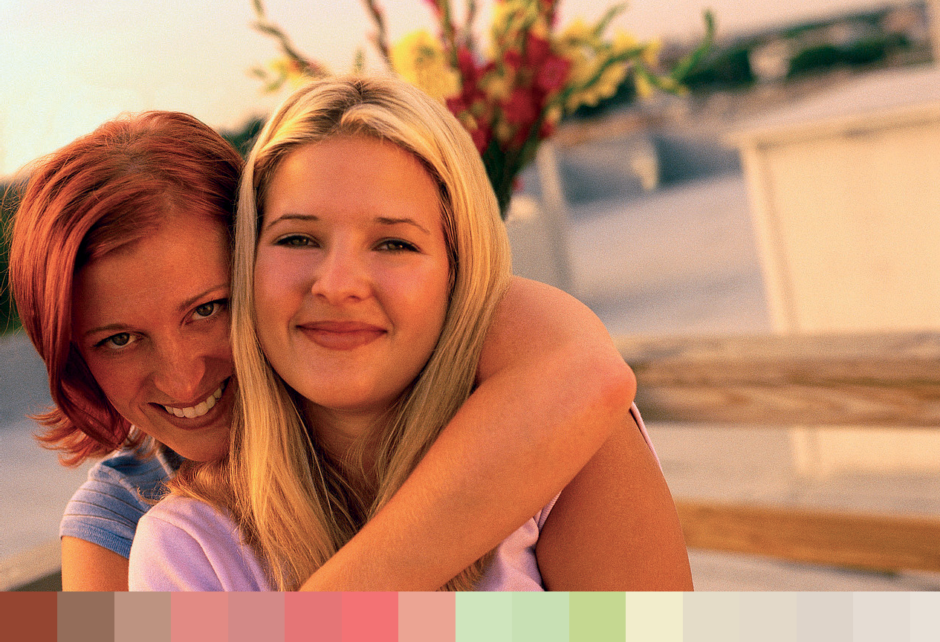

4 4

Females living in regional and remote areas were significantly more likely to report diabetes than those in major cities.52 Decreasing socioeconomic position is associated with an increasing prevalence of diabetes and a rising diabetes-related mortality rate.53
Aboriginal and Torres Strait Islander women were four times more likely to have diabetes/high sugar levels than non-Aboriginal and Torres Strait Islander women (adjusted for age differences).54 The death rate from diabetes for Aboriginal and Torres Strait Islander people was almost 12 times higher than for non-Aboriginal and Torres Strait Islander people.55
People born overseas also self-report higher rates of diabetes than those born in Australia56 , and also have a slightly higher death rate from diabetes than those born in Australia.57
Cancer
Cancer is another of the National Health Priority Areas, and is the leading cause of Australia’s disease burden at 19 per cent.58 Based on 2006 data, the risk for a female being diagnosed with cancer before age 75 was one in four, and before age 85 was one in three.59 The most common cancers in females are breast, bowel, melanoma and lung
cancers.60 In Australia, all cancer survival has increased significantly between diagnoses made in 1982–1986 and those made in 1998–2004. For women, it increased from
53 to 64 per cent.61
Breast cancer accounts for over 28 per cent of all diagnoses in females, which has more than double the number of diagnoses of the second most common cancer (bowel). In 2006, the lifetime risk of a woman developing breast cancer before the age of 85 was 1 in 9. Around 12,600 new cases of breast cancer were diagnosed in Australia in 2006. In 2007,
2,680 women died from breast cancer in Australia, making breast cancer the second highest cause of cancer deaths in women behind lung cancer (2,911 deaths). 62
Bowel cancer is the second most common cancer in women, which made up 13.3 per cent of all cancer diagnoses in women in 2005.63 The risk of developing bowel cancer increases from the age of 40 years onwards, but rises sharply and progressively from the age of 50 years. Bowel cancer is the most common cancer for women aged 76 to 95.64 Despite the trend towards better survival, bowel cancer remains an important cause of premature death in Australian women.
Differences between women and men exist in the presentation of lung cancer symptoms and this can lead to women being under-diagnosed or misdiagnosed. Women with lung cancer tend to have more asymptomatic presentations and experience a wider range of
types of lung cancer than men, making it more difficult to diagnose and provide treatment.
Each year, over 4,000 Australian women are diagnosed with a gynaecological cancer. 65 As some gynaecological cancers do not show early signs or symptoms, diagnosis and early treatment can be challenging. Gynaecological cancers were responsible for 1,502 female deaths in 2007.66 It is projected that in 2010 there will be 4,683 women diagnosed with a gynaecological cancer and 1,800 related deaths. 67
Cervical cancer incidence and mortality rates have declined by 48 per cent and 53 per cent respectively since the National Cervical Screening Program was introduced in 1991.68
In 2005, more than 1,200 new cases of ovarian cancer in Australian women were diagnosed69 and 60 per cent of women diagnosed with ovarian cancer in 1998–2004 died within five years of diagnosis.70

Breast cancer accounts for over 28 per cent of
all diagnoses in females, which has more than double the number of diagnoses of the second most common cancer (bowel).

4 5

National Women’s Health Policy 2010

Alcohol and smoking are risk factors for many cancers. In 2005, there were an estimated 11,308 new cases of cancer and 8,155 deaths from cancer that can be attributed to smoking. This represents over 11 per cent of cases and nearly 21 per cent of cancer deaths. 71 In
2001, cancer attributed to smoking accounted for 7.8 per cent of all new cases of cancer in females.72 There were an estimated 2,997 new cases of cancer and 1,376 deaths from cancer attributed to excessive alcohol consumption in 2005. This represents 3 per cent of
cases and 3.5 per cent of cancer deaths.73 In 2001, the lifetime risk of cancers attributable to alcohol consumption was 1 in 17 for females.74 Between 1991 and 2001, the rate for cancers attributed to alcohol consumption in females increased by an average of 1.2 per cent
per annum, while the male rate decreased by an average of 0.3 per cent per annum.75 The forms of cancer experienced by women also vary according to location. Women
under the age of 65 in rural and remote areas have higher rates of lung cancer, melanoma
and cervical cancer.76 77 Melanoma is responsible for 60 per cent of the excess new cases of cancer outside major cities—for example, 236 of the 258 excess new cases of cancer for
females in inner regional areas.78 There is also a higher incidence of breast cancer in the least disadvantaged areas compared to the most disadvantaged areas, and higher rates in major cities compared to very remote areas.79
Between 2000 and 2004, cancer incidence (among the most common cancers) for Aboriginal and Torres Strait Islander women was higher for lung cancer, cancers of the mouth and the throat and cancer of unknown primary site. Aboriginal and Torres Strait Islander women have more than double the occurrence of cervical cancer and more than four times the death rate from it.80 81 They access breast cancer screening less than
non-Aboriginal and Torres Strait Islander women, and, although no statistics are available, it is thought they also access screening for cervical cancer less often.82
Women with a history of partner violence are less likely to have adequate health screening. The submission from Women’s Health Australia suggested that there is a need to identify ways of encouraging women with a history of partner violence to undertake regular screening, particularly for cervical cancer.

Respiratory disease
The Australian Longitudinal Study on Women’s Health found the prevalence of asthma to be much higher in younger women than mid-aged and older women.83
Australians living in inner regional areas also have a significantly higher prevalence of asthma than those in major cities.84 Indigenous Australians in rural and remote areas were also significantly more likely to report asthma than people in major cities.85

Lifestyle risk factors
These diseases are often associated with genetic factors and other common, modifiable lifestyle risks, including obesity, physical inactivity, unhealthy diet, tobacco smoking, risky alcohol consumption, high blood pressure and high cholesterol. The Australian Government has made addressing these lifestyle risks a priority.
To do so requires understanding them in the context of the lives of Australian men and women, including the barriers that prevent people taking up healthier lifestyles. Women and men share some experiences in relation to these risk factors, but there are also significant gender differences. Various social changes have affected women’s experiences in

4 6



relation to health-promoting behaviours. For example, changes in gender social norms in recent decades have had many positive benefits for women, but may also be associated with an increase in higher-risk behaviours, such as binge drinking and smoking. Additionally, as more women participate in paid employment they now find they have less time for health- promoting activities, such as physical activity and healthy eating. This is compounded by
full-time working women spending much more of their time doing housework and looking after children than full-time working men.86
Many diseases (especially lifestyle-related diseases) have in common certain risk factors, and these are closely tied to socioeconomic status. Women living on a lower income are
typically more likely to be unemployed, under-educated and to have fewer social networks, which may in turn limit their ability to engage in healthy behaviours. Disadvantaged women are more likely to have a higher rate of health risk factors, such as being overweight or obese, having fewer or no daily serves of fruit, and smoking tobacco.87
There is a need to look at how women can be supported to reduce their exposure to risk factors for chronic disease. This needs to be done in the context of the pressures they face in their everyday lives.

Obesity
Major changes in Australians’ diet and physical activity levels has led to an increasing proportion of the population being overweight or obese. The 2007–08 National Health Survey found that 55 per cent of females (and 68 per cent of males) were overweight or obese88, up from 49 per cent of females in the 1995 survey.89
Obesity is identified by the Australian Longitudinal Study on Women’s Health as the primary cause of chronic illness in Australian women. 90 It is estimated that in Australia obesity causes 23.8 per cent of Type 2 diabetes, 21.3 per cent of cardiovascular disease,
24.5 per cent of osteoarthritis, and 20.5 per cent of colorectal, breast, uterine and kidney cancers.91

4 7

Rates of obesity increase with remoteness.
Australians also gain weight over the course of their lives, with some life stages, including pregnancy, presenting an increased risk of weight gain. There is increasing prevalence of obesity in young women92 , with the Australian Longitudinal Study on Women’s Health finding that younger women are now putting on weight at an increased rate compared to past generations, meaning they may be substantially heavier by middle age.93 This study has also found that women who have had a baby put on a greater amount of weight over a 10 year period than those who did not. This difference was not explained by differences in energy balance or sociodemographic variables.94
It is important to consider why so many Australians are finding it hard to lead physically active lives and adopt healthy dietary behaviour, which in turn impact on their weight. Australian experts have identified time pressure and car reliance as the two most important social trends underlying the rising Australian rates of obesity.95
While overweight and obesity rates have increased for the whole population, particular groups of women have higher rates. Obesity is more common among individuals facing greater social disadvantage; with the rate for the most disadvantaged women being nearly double that of the least disadvantaged women.96 Some evidence suggests that women living on a low income are more likely to live in environments that do not support healthy living. Poorer neighbourhoods generally have more fast food outlets and fewer full-sized supermarkets, fewer fitness facilities and public green spaces, which may limit physical activity.97 If women are to adopt healthier behaviours, policies and programs should consider social and financial barriers to health.
Rates of obesity increase with remoteness. Australians living in remote areas have the highest rates of obesity, compared to people in outer regional, inner regional and major city areas.98 This difference in prevalence between rural and remote women is largely explained by individual-level sociodemographic factors, such as age, number of children, country of birth, education level, employment status and marital status. 99
Aboriginal and Torres Strait Islander women are around 1.5 times more likely than non-Aboriginal and Torres Strait Islander women to be overweight or obese.100
Lesbian and same sex attracted women have higher rates of obesity and overweight (49 per cent) than in the general female population (38 per cent).101

Unhealthy eating
Health risks related to unhealthy eating include over-consumption, lack of fruit and vegetables, and saturated fat intake. In 2003, 2.1 per cent of Australia’s total burden of disease and injury was attributed to low fruit and vegetable consumption.102 Eating sufficient fruit and vegetables can help prevent cancer, ischaemic heart disease and—to a lesser extent—stroke.103
The 2004–05 National Health Survey found that females are more likely to adopt healthy dietary behaviour than males, and eat higher levels of fruit and vegetables.104 However, levels are still low, with just 16 per cent of females aged 12 years and over eating the recommended daily intake of five or more serves of vegetables.105 Fruit consumption is higher, with
60 per cent of females consuming the recommended daily intake of two or more serves of fruit.106 Fruit and vegetable consumption also differs by age, with young people consuming less than older adults.107 Lower rates of consumption are also reported for people of lower socioeconomic status.108

National Women’s Health Policy 2010
4 8

For women of low socioeconomic status, healthy eating options are often less available and sometimes less affordable. At least one-third of welfare-dependent family weekly income is needed to be allocated to food in order to eat according to public health recommendations.109 However, access to unhealthy food options are readily available
with Australian studies showing that poorer suburbs have much higher concentrations of alcohol and fast food outlets than more affluent areas.110
Australians living outside major cities were less likely than their major city counterparts to report consuming low fat or skim milk, the recommended two serves of fruit per day or five or more serves of vegetables per day. 111 Females in regional and remote areas were also
1.3 times as likely to report food insecurity than those living in major cities. 112
The rates of fruit and vegetable consumption are lower among Aboriginal and Torres Strait Islander women. In non-remote areas, 12 per cent of Aboriginal and Torres Strait Islander women reported eating the recommended daily intake of vegetables and 44 per cent the recommended daily intake of fruit.113
Time scarcity affects women’s capacity to maintain healthy eating practices. Many Australians have knowledge about how to eat healthily, but lack the time to follow this advice.114 115 116 117

Physical inactivity
The proven health benefits of physical activity include the prevention of a range of chronic diseases118, the promotion of good mental health and the maintenance of a healthy weight.119 120 121
Females report less physical activity than men.122 This trend is particularly pronounced among young girls and adolescent women. Only 30 per cent of females aged 15–24 participated in levels of physical activity that met the recommended national guidelines in 2004 (compared to 46 per cent of males). 123
Regular physical activity is vital for both women and men; however, there are differences in the barriers to participating in physical activity. Women face different barriers to being physically active than men including time, caring responsibilities124, lower socio-economic status, body image125 and concerns about personal safety. 126
Many women cite lack of time as the most common reason for not taking part in regular or organised physical activity.127 128 129 130 131 Unpaid work factors heavily in women’s lives, with many women fulfilling multiple responsibilities in care giving, meal preparation and housework. This can lead to women neglecting their own health and not having the time to participate in beneficial levels of physical activity. 132 Women’s concerns about personal safety, higher levels of traffic and crime can also inhibit their participation in walking.133
The Australian Longitudinal Study on Women’s Health found physical activity levels decrease in association with marriage and childbirth in young women and with declining health in older women. Changes in physical activity levels were also associated with stressful life events such as divorce, harassment at work, and violence.134
Women with a lower socioeconomic status may encounter a number of additional barriers to participation in physical activity. For example, they may live in areas with less access to public transport and other services; and the cost of particular activities may be prohibitive.
Regular physical activity is
vital for both women and men; however, there are differences in the barriers to participating in physical activity.

4 9

National Women’s Health Policy 2010

Females living inside and outside major cities appeared equally as likely to be sedentary.135
Over half of women from Aboriginal and Torres Strait Islander backgrounds reported their level of physical activity as ‘sedentary’ compared to a third of non-Aboriginal and Torres Strait Islander women.136 Urban Aboriginal and Torres Strait Islander Australians face other, complex barriers to participation in physical activity, including being judged by others when in public spaces and accessibility.137

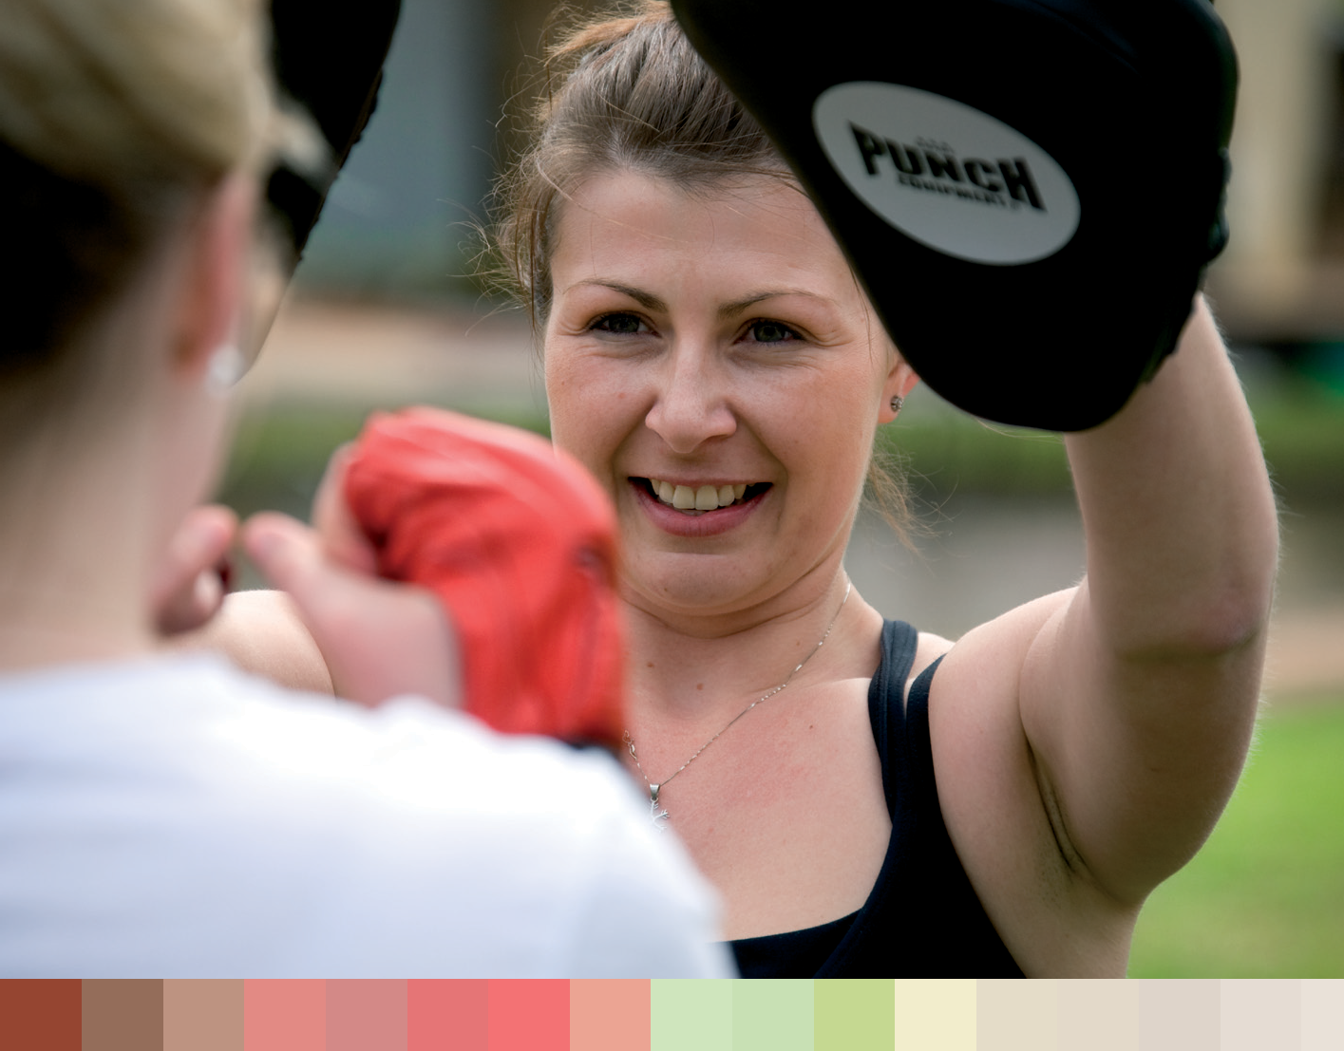

Tobacco use
The rates of smoking in Australia have declined over time; however, it remains the single most preventable cause of ill health and death in Australia.138
Tobacco smoking is a major risk factor for coronary heart disease, stroke, peripheral vascular disease, numerous cancers (including lung, mouth and cervical), and other diseases and conditions.
Young women in Australia are more likely than young men to be daily smokers.¹³⁹ Younger women also have high rates of smoking, at 17 per cent for females aged 12–24 years in 2004.140
From a biological perspective, an increasing body of evidence suggests that women’s bodies are more vulnerable than men’s to effects of tobacco and other smoke. Differences in lung anatomy, genetics and physiology between men and women may increase the harm from exposure to smoke for women. It has been suggested than women may suffer earlier and more severe effects from cigarette smoke because toxic substances accumulate in smaller airways and persist in the lungs and because their bodies metabolise smoke differently.
Women are also at increased risk of breast cancer due to smoking or exposure to smoke, particularly during adolescence.141

5 0

Gender relations between men and women may reduce women’s ability to control their exposure to passive smoking.142 Women are also more likely to use smoking as a means of coping with stress, have a harder time quitting and require more social support when quitting than men.143 144
For young and mid-age women who have experienced violence, there seems to be an association with increased smoking rates and very high rates of smoking during pregnancy for severely abused women.145
Smoking is more common amongst Australians of lower socioeconomic status and Indigenous Australians, compared to the broader population.146 Compared to non- Indigenous women, Aboriginal and Torres Strait Islander women were almost 2.5 times more likely to be current daily smokers.147 Smoking is also more likely amongst females in regional areas than those in major cities.148 This difference was particularly marked among women aged 25–44 years. 149 Lesbian and bisexual women are another group who report high rates of tobacco use. 150

Alcohol consumption
Research reveals gender differences in alcohol consumption. Generally, women drink less alcohol than men.151 For women in Australia, it is estimated that harm from alcohol
was the cause of 0.7 per cent of the burden of disease.152 This is substantially lower than for men (3.8 per cent of burden of disease).153 However, it is increasingly evident that alcohol consumption and high-risk drinking is on the rise among women, especially young women.154 Women’s rate of drinking at risky levels has been increasing at a greater rate since 1995 than that of men.155
Harmful alcohol consumption can contribute to a number of health issues including: cirrhosis of the liver; breast, oral, liver and colorectal cancer; stroke, inflammatory heart disease and hypertension; road traffic accidents; memory lapse; and falls, suicide and drowning.156
Male and female bodies may respond differently to alcohol due to differences in metabolism, blood chemistry and body fat composition. Gender analyses of alcohol consumption suggest that a range of social factors play a role in this increased consumption. It is a common theme in the research literature that women report using alcohol to challenge traditional gender roles.157 One study stated that the passivity expected of women was overturned with alcohol use and alcohol was seen as giving licence to break social norms expected of women.158
Drinking while pregnant is directly associated with poor health of mothers and babies, including maternal malnutrition and foetal alcohol spectrum disorders. Heavy alcohol use during pregnancy has also been associated with problems arising later in childhood, such as impaired learning ability and behavioural problems.159
Research into alcohol use among women from diverse population groups is limited.
Alcohol studies rarely include sex disaggregated data for diverse groups. Information that is available is often minimal or dated.
The prevalence of risky or high-risk alcohol consumption has increased in all areas over time at what appear to be broadly similar rates. Compared to 1995, people in major cities, inner regional and other areas were 1.5 to 1.7 times as likely to engage in risky or high-risk alcohol consumption in 2004–05.160

Male and female bodies may respond differently to alcohol due
to differences in metabolism,
blood chemistry and body fat composition.

5 1

National Women’s Health Policy 2010

More Aboriginal and Torres Strait Islander people are likely to abstain from drinking alcohol, but with higher levels of consumption among those who did drink than their non-Aboriginal and Torres Strait Islander counterparts.161 Aboriginal and Torres Strait Islander women were three times as likely as non-Aboriginal and Torres Strait Islander women to have drunk at short-term risky/high-risk levels at least once a week in the previous 12 months.162
Available research suggests that same sex attracted women report significantly higher levels of drug use, including alcohol, than the general population, possibly in reaction to homophobia, discrimination and rejection. 163 164
When women consume high levels of alcohol, they are more likely to experience some type of sexual aggression, including unwanted sexual contact, sexual coercion, attempted rape and rape.165
Studies also indicate evidence that intimate partner violence is also associated with hazardous alcohol use.166
Gender-sensitive programming and policy making has the potential to significantly improve these risk factors for women.

Mental health and wellbeing
Women are disproportionately affected by mental illness, and mental disorders have been estimated to represent the highest burden of illness for adult women in Australia.167 Recent research has found that:
- Females were more likely than males to have experienced mental disorders in the 12 months before the survey (22.3 per cent compared to 17.6 per cent).168
- The 12-month prevalence of depression was 6.8 per cent in women and 3.4 per cent in men.169
- The 12-month prevalence of anxiety was 12.1 per cent in women and 7.1 per cent in men.170
- Women are more likely to make suicide plans and attempt suicide than men, but males are more likely to die by suicide.171
Viewing mental health through a gender lens reveals differences in the prevalence and course of mental illness for women, and differences in the impact of social factors in the causation of illness in women and men.172 For these reasons, women’s mental health and wellbeing continues to be a key priority for this policy. A range of social factors may
contribute to women’s higher rates of anxiety and depression. These include: higher levels of socioeconomic disadvantage and poverty, lower income and lower participation in the paid workforce; higher exposure to discrimination and harassment, intimate partner and sexual violence; and the burden of caring responsibilities—all of which generally relate to gender, affecting women more than men.
Studies based on data from the Australian Longitudinal Study on Women’s Health support the reported strong association between poorer mental health and poorer socioeconomic conditions, particularly in terms of education and employment among middle-aged Australian women.173 Similarly in young women, depressive symptoms have been found to be related to low income, low educational qualification and a history of unemployment.174

5 2

Physical and sexual abuse during childhood has also been linked with a range of later mental health problems including depression, anxiety, post-traumatic stress disorder, somatisation disorders and suicide.175

Impact of violence on emotional and mental health
Violence against women can have a profound impact on a women’s emotional and mental health. Depression, anxiety and suicide together contributed to 73 per cent of the total disease burden for intimate partner violence.176
Women who have experienced intimate partner violence are twice as likely to be diagnosed with a mental illness.177 For women, depression is one of the most common consequences of sexual and physical violence and an experience of violence results in higher risk of stress and anxiety disorders, including post-traumatic stress disorder.178 Some other psychiatric disorders (for example, phobias and dissociative disorder) are more common in women reporting intimate partner violence than those who do not.179 180 Women reporting intimate partner violence are more likely to use medication for depression and anxiety.181 182

Mental health across the lifespan
Women’s mental health needs also differ at different times of their lives. Young women between the ages of 15 and 22 years are much more likely to have negative body image, or body image dissatisfaction. This has been linked to a range of physical and psychological health concerns and risk-taking behaviours, including the development of eating disorders (which are 10 times more common among women than men 183), low self-esteem, depression, self-harm and suicide.184
Pregnancy and the postnatal period is a time of vulnerability to poor mental health.
Anxiety and depressive symptoms are common during and following pregnancy, with the highest rates in the second and third trimester.¹⁸⁵ The postnatal period is a time of risk for onset of new psychotic illness, postnatal depression and relapse in women with established depressive disorders.186 187 High quality care for women is needed before, during and after birth, particularly for those with existing mental illness.
Good maternal mental health in the perinatal period impacts positively on the cognitive, emotional and behavioural consequences of children. However, it has been estimated that up to 15 per cent of women experience depression in the perinatal period. This has a profound effect on their own health and wellbeing, and on their children and families.188 Risk factors for a depressive disorder are predominately psychosocial and may include absence of social support, marital conflict, experiences of childhood abuse or a history of
anxiety and depression.189 190 Women’s mental health needs to be considered in the context of women’s extra burdens due to inequalities in income, status in the workplace, caring responsibilities, experiences of harassment, violence and discrimination.
Women in mid-life have higher prevalence of mental illness than other age groups.191 Major life changes such as divorce, involuntary unemployment, retirement, becoming grandparents, illness or disability, caring or bereavement may contribute to these higher rates.
Women’s role as the majority of primary carers can also have a significant impact on their mental health. Women’s major role in caring for both children and older parents can have negative impacts on their own mental health. Women often act as carers for others

Women’s role as the majority of primary carers can also have a significant impact on their mental health. Women’s major role in caring for both children and older parents can have negative impacts on their own mental health.

5 3

National Women’s Health Policy 2010

experiencing mental illness, and as such the increased burden of care of relatives post de-institutionalisation has a much greater impact on women.
Older women face a range of issues relating to their mental health including potential social isolation and its impacts.

Marginalised women
Those women who are marginalised, as a consequence of discrimination and disadvantage, are at particular risk of experiencing mental ill-health and often face greater barriers to accessing services.
Studies based on data from the Australian Longitudinal Study on Women’s Health indicate a strong association between poorer mental health and poorer socioeconomic conditions, particularly in terms of education and employment. Depressive symptoms have been found to be related to low income, low educational qualifications and a history of unemployment.192 193
For rural and remote women there was no significant inter-regional difference in the prevalence of anxiety in 2004–05, except for females aged 45–64 years living in other areas who were significantly less likely to experience anxiety than their major city counterparts.195
Aboriginal and Torres Strait Islander women have been found to be twice as likely as non-Aboriginal and Torres Strait Islander women to report high and very high levels of
psychological distress.196 Higher rates of mental health issues among Aboriginal and Torres Strait Islander women can be related to a cultural history of trauma and loss linked to the impact of colonisation and family removal. These women also continue to experience disadvantage, high levels of domestic violence and sexual abuse.197
For refugee and migrant women, the challenges of settling in a new country, and limited resources and financial insecurity can have a major impact on their mental health.198 For older migrant and refugee women, social isolation and difficulties in communicating outside their family circles can also affect their mental health.199
Minority sexual orientation is also associated with higher levels of mental health morbidity in Australian women. Over 34.8 per cent of lesbian and bisexual women had been diagnosed with depression by a doctor compared to 22.8 per cent of women in the general population. Almost one in five (19.3 per cent) lesbian and bisexual participants in a West Australian study reported current treatment for a mental health problem including anxiety, depression, and stress-related problems compared to 8.5 per cent of women in the general population.200 Stigmatisation, discrimination and lack of social support may play a role in explaining poorer mental health.201
Women as carers often report poorer physical, mental and emotional health and wellbeing because of their caring responsibilities. This can be associated with disturbed sleep, being physically injured while providing care, and the constant pressure of caring. Time spent caring, and coping strategies, are factors in shaping carer stress.202 Live-in carers also report lower levels of social support than non-live-in carers and non-carers. They also show poorer mental health scores, lower optimism scores, more stress, and are more likely to have seen their general practitioner than non-live-in carers or non-carers.203 Within the caring population, female carers in particular experienced much lower levels

5 4

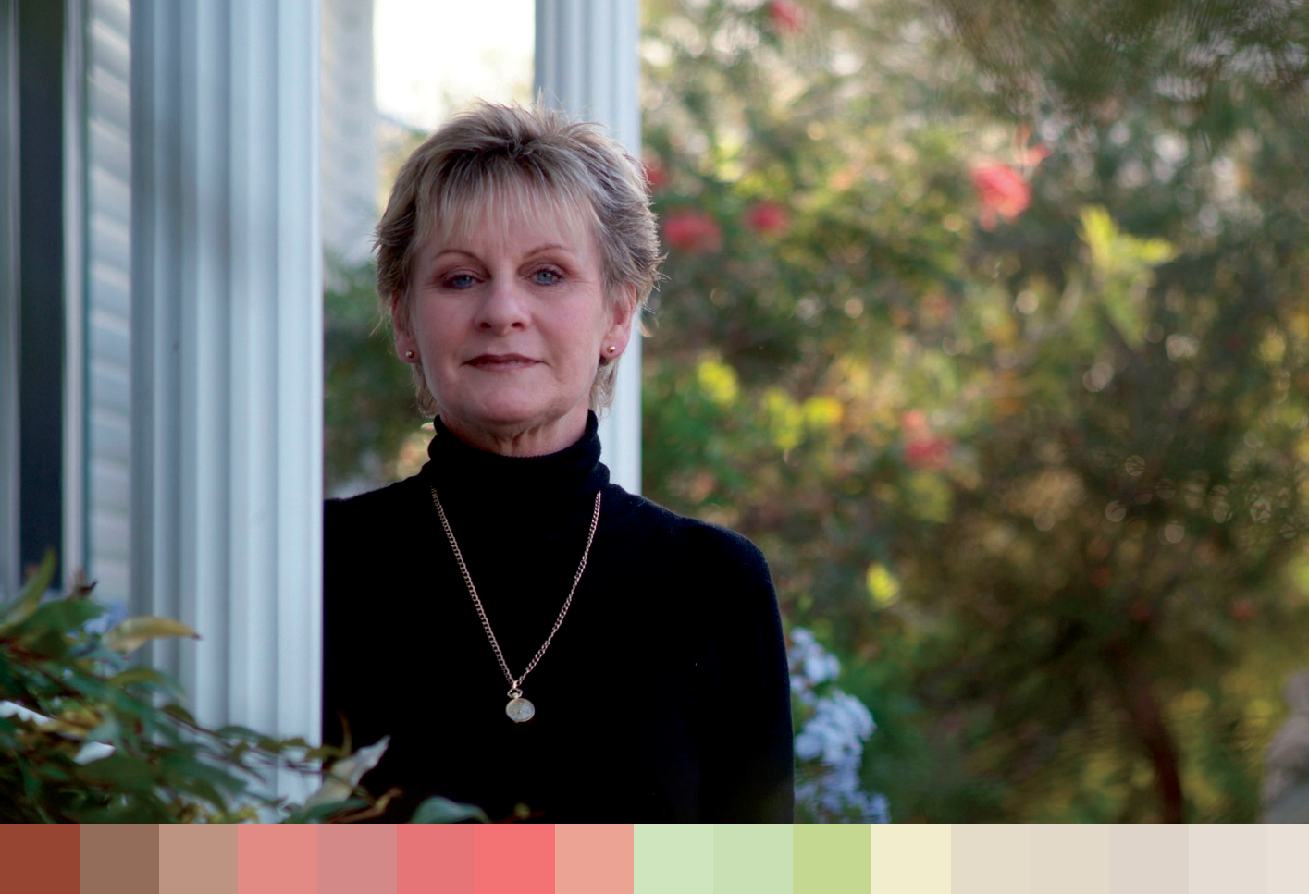

of mental health compared to both male carers and the general population. This included increased levels of clinical depression, with over 50 per cent of female carers reporting being depressed for six months or more since they started caring.204
Young women in custody and leaving custody are at particular risk of poor emotional and mental health.

Use of mental health services
Social and demographic factors also impact on service usage. Women are more likely to use services for mental health problems than men (40.7 per cent compared to 27.5 per cent) and this is true for all age groups. However, there are differences among women in their access to mental health services. Women most at risk may also be those who are least likely to know about, access and afford services. The Australian Longitudinal Study on Women’s Health found that older women who had a university education were 1.6 times more likely to seek counselling, and that women who sought counselling were twice as likely to have ancillary private health insurance as those who did not seek counselling.205
Women living in urban areas were more likely to use counselling services, as health and community services are more available in urban areas.206 In rural areas there is generally less direct access to mental health specialist services.207 Attitudinal barriers relating to perceived stigma, embarrassment and lack of confidentiality in rural areas can also be barriers to access. Aboriginal women and women from culturally and linguistically diverse backgrounds may experience language and cultural barriers, culturally inappropriate
services and difficulties navigating the health system. Access to health care services for same sex attracted women may be significantly inhibited by heterosexist attitudes among health professionals. More information is needed about who accesses services and about barriers to services for disadvantaged women.

5 5

Sexual and reproductive health, including maternal health, is a priority for
Australian women.

Sexual and reproductive health
Sexual and reproductive health, including maternal health, is a priority for Australian women. There is a need to consider sexual and reproductive health within the social and cultural context of women’s lives.
‘Sexual and reproductive health is not simply the absence of disease’.208 A complex array of factors is implicated in women’s sexual and reproductive health. Sexual and reproductive health is affected by the socioeconomic, cultural and political environment. Principal among these is the place of women in their society, particularly in terms of their control over their own bodies, reproductive choices and lifestyles. But other issues also contribute to how women experience reproductive and sexual health:
- systemic and/or structural issues, such as health service provision, privacy and confidentiality, and representations of girls and women in the media;
- risk factors, such as abuse of drugs or alcohol;
- psychosocial factors like women’s self-confidence.
Sexual and reproductive health issues overlap with many other areas of health including education, health promotion, violence prevention, socialisation of gender roles and
sexuality, and mental health issues. Sexual and reproductive health and rights are interlinked with promoting gender equality. Some of these are explored elsewhere in this policy, others below. The points here are intended to highlight the complexity of women’s health and women’s lives, rather than to provide an exhaustive list of factors. The aim
is to explore the gendered nature of sexual and reproductive experience and behavior, highlighting their importance in developing policy, education, health promotion and prevention strategies.
Some groups of women in Australia have not benefited from the overall improvements in the area of sexual and reproductive health experienced by most women. Social disadvantage greatly affects access to health services and sexual health information and resources.
Exploring women’s sexual and reproductive health demonstrates the need for targeted sexual and reproductive health education, health promotion and prevention strategies,
particularly for ‘at risk’ or marginalised population groups, such as young and older women, Aboriginal and Torres Strait Islander women, women with disabilities and lesbian and bisexual women. For example, women with a disability are subject to myths about their
sexuality, perpetuating the notion that they are non-sexual and therefore do not require sex education. The sexual and reproductive rights of women with disabilities have not been a focus of research, nor health care service delivery.

Contraception and safe sex
Whether or not women use contraceptives or have safe sex is not a straightforward matter. Women generally bear the primary responsibility for contraception but differences in gender relations mean that women do not always feel they have power to insist on male contraceptive use.209
Knowledge about contraceptive methods and access to them is important for reducing the spread of sexually transmitted infections (STIs) and risk of unplanned pregnancies.
In 2001, 71 per cent of women surveyed in the Australian Study on Health and Relationships were reported to use some form of contraception.210 The most common

National Women’s Health Policy 2010
5 6

contraceptive methods were oral contraceptives (34 per cent), tubal ligation/hysterectomy (23 per cent), condom (21 per cent) and vasectomy of partner (19 per cent).211 Whether contraception is used and the type that is then chosen varies according to age and life stage of the woman; for example, if she is single, partnered, pregnant or post-menopausal.
Education and access to sexual and reproductive health services (including contraceptives) is especially important for young women. The median age of first sexual intercourse has declined from 19 to 16 years for women.212 In 2008, 78 per cent of students (in year 10
and 12) had experienced some form of sexual activity with 43 per cent of young women having experienced sexual intercourse.213 Of the sexually active young women, 27 per cent reported having had three partners or more in the past year in 2008, up from 17 per cent in 2002.214 Same-sex attracted young people are more likely to be sexually active earlier than their heterosexual peers (often with people of the opposite sex).215
For young women, at last sexual encounter 65 per cent used a condom as the type of contraceptive method, 53.7 per cent pill, 10.8 per cent withdrawal method, 9 per cent morning after pill.216 At their most recent sexual encounter 65 per cent of young women reported having a condom available and 60 per cent reported that a condom was used.217 Trusting their partner and knowing their sexual history were the most common reasons why young women did not ask their partner to use a condom.218
The Australian Longitudinal Study on Women’s Health found that, whilst the majority of women reported their pregnancy as planned, 31 per cent of first pregnancies were recalled as unplanned, 29 per cent were unwanted at the time, and 11 per cent as resulting from contraceptive failure.219
Comprehensive support services, including skilled non-directive counselling, should be freely available and accessible to all women making decisions about unintended pregnancies, and are an essential component of effective health services for women.

Violence and sexual and reproductive health
Unsafe sex practices are exacerbated by gendered power relations, which can make women of any age less able to refuse sex and more vulnerable to sexual coercion and unwanted sex. Young women can be particularly vulnerable. The Australian Bureau of Statistics 2005 Personal Safety Survey found that, since the age of 15 years, 19.1 per cent of women and
5.5 per cent of men have experienced sexual violence (sexual assault or threat).
Rates of alcohol use and binge drinking have increased among young people. Binge drinking is associated with increased perpetration of sexual violence, coercive sexual activity and victimisation.220 For females, 22.1 per cent in year 10 at school and
27.4 per cent in year 12 reported binge drinking three or more times in the previous fortnight.221 Twenty-three per cent of sexually active secondary school students reported that they were intoxicated or under the influence of illicit drugs at their most recent sexual encounter.222 Although lower than young men, for young women this figure was up from 18 per cent in 2002 to 20 per cent in 2008.
Intimate partner violence has been shown to have significant implications for women’s reproductive and sexual health.223 These can include unplanned pregnancies, high rates of pregnancy termination, low birth weight and increased incidence of sexually transmitted diseases, including HIV.224

5 7

The reproductive years are a time when women may be more vulnerable
National Women’s Health Policy 2010
to abuse and
violence, with intimate partner violence being strongly associated with early pregnancy and adverse pregnancy outcomes.

5 8
In adolescence, key issues include dating and courtship violence and rape. Young women are at greater risk of violence—12 per cent of women aged 18–24 years experienced at least one incident of violence, compared to 6.5 per cent of women aged 35–44 years and
1.7 per cent of women aged 55 years and over. Young women who have experienced intimate partner violence are three times more likely to experience a miscarriage, report having herpes and human papillomavirus (HPV), and 11 times more likely to report hepatitis C.225 Of secondary school students, 28 per cent of sexually active females and 23 per cent of males had experienced unwanted sexual intercourse. While 13 per cent reported pressure from their partner as the reason, more reported the influence of alcohol (16 per cent). A drug or drugs other than alcohol were reported in 6 per cent of cases.226
The reproductive years are a time when women may be more vulnerable to abuse and violence, with intimate partner violence being strongly associated with early pregnancy and adverse pregnancy outcomes. The Australian Bureau of Statistics Personal Safety Survey found that, of those women who experienced violence by a previous partner, 39.5 per cent had experienced violence during pregnancy, and 16.8 per cent of the violence occurred for the first time during the pregnancy.227
Many refugee women have fled places of conflict, where rape, sexual torture and slavery are used as weapons of war. Rates of sexual violence are also high in refugee camps. This can lead to various sexual and reproductive health issues including increased risk of sexually transmitted infections, pregnancy and birth complications, and mental health issues.228

Sexually transmitted infections
Sexually transmitted infections (STIs) remain a major public health issue in Australia, particularly in regards to increasing rates of chlamydia. The Australian Study on Health and Relationships in 2001 found 16.9 per cent of Australian women have ever been diagnosed with an STI and 2.2 per cent had been diagnosed in the past year.229 Whilst similar proportions of men and women had been diagnosed with an STI in the last year, significantly more men had ever been diagnosed with an STI compared to women.230 The most common diagnosed STI for women was candida or thrush (57.6 per cent), wart virus on Pap smear (5.1 per cent), genital warts (4.4 per cent), pubic lice or crabs (4.2 per cent), chlamydia (3.1 per cent), and genital herpes (2.5 per cent).231
In 2009, chlamydia was the most frequently reported infection in Australia.232 Between 2000 and 2004 rates of chlamydia more than doubled for females, and increased by 40 per cent in 2009. 233 Overall diagnosis rates are higher for females than for males. This appears to be primarily due to significantly high rates of chlamydia in young females aged between 15–29 years.234 The sex difference then reverses for 30 years and older with rates being higher in males.235
Substantially higher rates of chlamydia are diagnosed among Aboriginal and Torres Strait Islander people, particularly those aged 15–29 years.236, 237 It is unclear if the increases in rates of chlamydia and the differences in rates across the population are due to increased testing (especially among some groups of Australians), rising infection rates, or a combination of these factors.
For gonorrhoea, the population rate of diagnosis among females increased by 36 per cent between 1999 and 2006 from 19.2 to 26.1 per 100,000 population; it then declined by
4 per cent in 2008 to 25 per 100,000 population.238 Like chlamydia, young people239 and Aboriginal and Torres Strait Islander people240 report higher rates of gonorrhoea.

Gender can affect women’s ability to insist on safe sex practices. Young women are generally at greater risk of contracting sexually transmitted infections than older women. Women who had lower levels of education and were younger had less knowledge of sexually transmitted infections.241 For example, rates of chlamydia are significantly higher among young females aged between 15 and 29 than for older women.242 In 2005 over half of the chlamydia notifications were from women (58 per cent), with 65 per cent of that group aged 16–24 years. This compares to 42 per cent of notifications from young men in the same
age group.
Education about STIs and access to condoms are important aspects of tackling the issues of increasing rates of STIs such as chlamydia.
While knowledge among students about STIs has generally improved, it remains relatively poor about some diseases such as chlamydia, hepatitis A, B and C, human papillomavirus and cervical cancer.243 244
Between 2002 and 2008 there have been improvements in the knowledge that students have about STIs.245 But for some disease areas such as chlamydia, hepatitis A, B and C, HPV, and cervical cancer, knowledge remains relatively poor.246 247
While men with chlamydia rarely experience complications, if left untreated in women it can increase the risk of pelvic inflammatory disease, tubal infertility and chronic pelvic pain.248
Rates of infection vary across the population, with some groups reporting much higher rates. Aboriginal and Torres Strait Islander women report much higher rates of STIs than other Australians, with the most common being chlamydia, gonorrhoea and syphilis.249 Among lesbian and bisexual women, nine per cent reported having been diagnosed with an STI.250

Reproductive health
As discussed in the chronic disease section, there is a range of reproductive cancers which particularly affect women including breast cancer, cervical cancer and ovarian cancer.
Up to 10 per cent of women, and 30 per cent of obese women, suffer from polycystic ovarian syndrome (PCOS).251 PCOS is associated with an increased risk of diabetes, cardiovascular disease 252 and mental health problems.253
Endometriosis—a condition when uterine tissue grows on the fallopian tubes, the ovaries or the tissue lining the pelvis—affects an estimated one in 10 females of reproductive age and up to 30 per cent of women with infertility. It has no known cure and on average takes 7 to 12 years to diagnose.254
Menopause is a significant life stage for all women. The Australian Longitudinal Study on Women’s Health found the median age of menopause to be 52 years. Natural menopausal transition was associated with hot flushes, high sweats and, to a lesser extent, stiff or painful joints, difficulty sleeping, and poor/fair self-rated health, after controlling for confounders.255 While hormone replacement treatment remains the most frequent
treatment for menopausal symptoms, the evidence remains far from clear about the effects associated with it.256 More information is needed about the risks and benefits to women at different ages and with different symptoms and family histories.

5 9

Maternal health
Pregnancy, birthing and parenthood are important life experiences, with long-term impacts on the health of mothers, children and families. The health of mothers before conception, during pregnancy and in the postnatal period can have a profound and long-term effect on their own health and that of their children.

Shifts in Australian society have brought major changes
to the lives of Australian women.
Family sizes are smaller and women are bearing children later.
Fertility and infertility
Shifts in Australian society have brought major changes to the lives of Australian women. Family sizes are smaller and women are bearing children later. In 2008 the median age of mothers at birth was 30.7 years. 257 In 2007 women aged 30–34 experienced the highest fertility of all Australian women, with 126.6 babies per 1,000 women.258 Many women are having children at an older age, often to first establish a position in the workforce and achieve material security. The shift towards delaying motherhood can have an effect on fertility, which declines with age. There is an increasing occurrence of infertility, with one in six couples experiencing fertility problems.259 The chance of having a healthy baby also decreases with age, which may soon have implications for the provision of health services.
Five per cent of young women reported having had sex which resulted in pregnancy.260 Young Aboriginal and Torres Strait Islander women also report higher rates of teenage pregnancy than non-Indigenous young women (more than five times higher in 2006).261 Rural and remote young women also have higher rates of teenage pregnancy.
The education of young women and provision of accessible contraceptive measures is necessary for the prevention of unplanned pregnancy. This is important since mothering a child at a young age is associated with poor social, economic and health outcomes.
Rates of teenage birth remain high among Aboriginal and Torres Strait Islander and disadvantaged communities. Nationally, the rate of births to teenage mothers in the Aboriginal and Torres Strait Islander population (76 per 1,000) was more than five times higher than in the non-Aboriginal and Torres Strait Islander population at 14 per 1,000 population. Teenage birth rates were eight times higher for females living in the most disadvantaged areas (32 births per 1,000 females) than in the least disadvantaged areas (4 births per 1,000 females). Teenage births are also associated with lower incomes and poorer educational attainment and employment prospects for both mother and child 262, which in turn can have negative impacts on both their physical and mental health.

Risk factors in pregnancy
There is a need to consider the range of social and cultural factors contributing to obesity in pregnancy, nutrition and women’s tobacco and alcohol use during pregnancy.
Obesity in pregnancy has trebled in the past decade and the implications are significant for women and their babies. Any pregnancy in an obese woman is high risk, requiring higher levels of obstetric and paediatric support, with much greater health care costs.263 Obese women are more likely to miscarry, to have still births and to have pregnancy complications. Babies of obese mothers are likely to have heavier birth weights and impaired foetal development.264 Table 4 outlines some of the implications of obesity at various stages of pregnancy.

National Women’s Health Policy 2010

6 0

Table 4: Implications of obesity in pregnancy 265

Stage of pregnancy | Obesity-related problem
Preconception | Menstrual disorders, infertility, polycystic ovarian syndrome
Early pregnancy | Miscarriage, foetal abnormalities, difficult ultrasound
Antenatal | Hypertension, pre-eclampsia, gestational diabetes, thrombosis
Delivery | Induction of labour, caesarean section, shoulder dystocia, perioperative complications
Postpartum | Haemorrhage, infection, thrombosis
Foetal | Macrosomia, foetal distress, perinatal morbidity and mortality, birth injuries

Maternal nutrition during pregnancy and in the peri-conception period is a key modifier of health outcomes for both mother and child in the long term. The Australian Longitudinal Study on Women’s Health research has demonstrated that, while women appear to make alterations to their diets while pregnant, many still do not obtain the nutrients they require. Australian studies indicate that the folate, fibre, iodine and iron intake of pregnant women does not meet national recommended levels.266 267 268 Many women need to increase their intake of specific nutrients before, during and after pregnancy.269
Smoking during pregnancy has many detrimental effects for both the mother and infant. There is strong evidence that smoking is associated with low birth weight, intrauterine growth restriction, prematurity, birth defects of extremities, perinatal mortality and sudden infant death syndrome.270 271 The numbers of women who smoke during pregnancy continue to be high. In 2006 about 17 per cent of pregnant Australian women smoked.272 At least half of women who were smokers before pregnancy quit smoking during pregnancy, but 30 per cent or more did not.273 The rate of pregnant women who smoke was significantly higher for teenage pregnancies at 42 per cent and 52 per cent for Aboriginal and Torres Strait Islander women’s pregnancies.274 Women with low socioeconomic status, less education and who are unmarried are more likely to smoke during pregnancy.
Aboriginal and Torres Strait Islander women are more likely to smoke during pregnancy and are less likely to access antenatal care in first trimester, when many risk factors could be addressed.275 276
Prior alcohol intake has a strong effect on alcohol intake during pregnancy277, with some 50 per cent of women having reported drinking alcohol at some time during their pregnancy.278 The Australian Longitudinal Study on Women’s Health found more than
half of the women who—before pregnancy—were drinking at levels considered risky for pregnant women stopped drinking at those levels during pregnancy. Over one-third or more did not.279 In contrast, women with higher education attainment, and older women, are less likely to consume alcohol while pregnant.280

6 1

Giving birth is much more than a physiological experience. It is a fundamental psychosocial
event.

Birth
While most births in Australia are vaginal deliveries, Australia has a comparatively high rate of caesarean section (30.3 per cent of births in 2007, compared to the OECD average of
25.7 per cent), and interventions are shown to be an increasing trend, with a rise of
4.7 per cent in caesarean sections to 2009.
Giving birth is much more than a physiological experience. It is a fundamental psychosocial event. In the context of increasing medical interventions in birth, many advocated for concepts of safety in maternity care to also embrace cultural and psychological issues.
Australia is one of the safest countries in the world in which to give birth and/or to be born. Non-Aboriginal and Torres Strait Islander Australian women have one of the lowest maternal mortality rates in the world. In 2003–05, maternal mortality rates were one in every 11,896 women giving birth. However, Aboriginal and Torres Strait Islander women have one of the highest maternal mortality rates, with five times the rate of deaths during or shortly after pregnancy than women nationally.281 Women born in non-English speaking backgrounds account for at least 22 per cent of maternal deaths.282
Australia as a whole has one of the lowest infant mortality rates in the world, at 4.1 per 1,000 live births.283 Aboriginal and Torres Strait Islander infant mortality rates are significantly higher. Compared to non-Aboriginal and Torres Strait Islander babies, Aboriginal and Torres Strait Islander babies are 1.9 times as likely to be still born and 2.6 times as likely
to die within 28 days of birth.284 Perinatal and neonatal mortality is higher amongst immigrant and refugee women in Victoria than the Victorian average.285
Low birth weight is correlated with poorer health outcomes later in life including coronary heart disease and Type 2 diabetes. The proportion of Aboriginal and Torres Strait Islander babies of low birth weight was 13.2 per cent in 2005, more than twice that of babies of
non-Aboriginal and Torres Strait Islander mothers (6.1 per cent).286

Breastfeeding
Breastfeeding is acknowledged as a key protective factor for both maternal and infant health.287 It gives the best nutritional start, provides immunological protection for infants and promotes infant bonding and attachment. Breastfeeding is associated with maternal health benefits such as promotion of recovery from childbirth and reduced risks for breast and ovarian cancer. The Australian dietary guidelines recommend exclusive breastfeeding for infants until six months of age, with the introduction of solid foods at around six months and continued breastfeeding until the age of 12 months—and beyond if both mother and infant wish.288 While breastfeeding initiation rates in Australia were reported at around
92 per cent in 2004, full breastfeeding declined each month with only 56 per cent of infants fully breastfed at three months and 14 per cent at six months. The rates of any breastfeeding were around 73 per cent at three months, 56 per cent at six months and 30 per cent at
12 months.289
Younger, less educated and more socioeconomically disadvantaged Australian women are less likely to breastfeed.290

Access to maternal health care
Access to antenatal and postnatal care is important for the health of pregnant women and their developing foetuses. Risk factors that can be addressed through antenatal care include

National Women’s Health Policy 2010
6 2

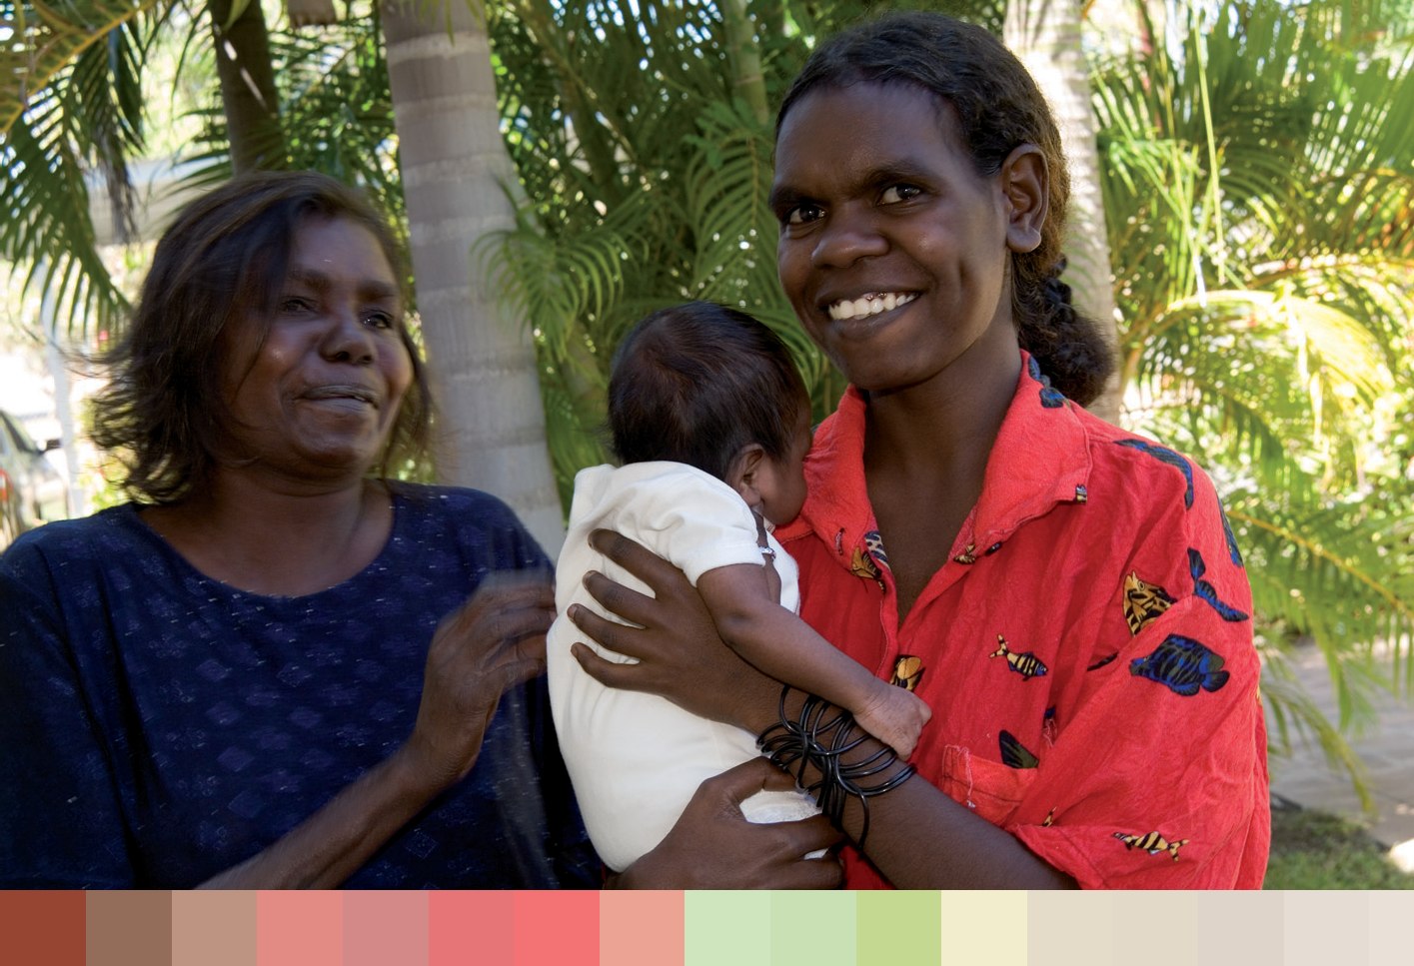

anaemia, poor nutrition, hypertension, diabetes and glucose intolerance, genital and
urinary tract infections, and smoking.291 Antenatal care can also provide an opportunity for mothers to learn about breastfeeding and to establish support networks.
Access to antenatal care is especially important for Aboriginal and Torres Strait Islander women. Compared with other women, access for Aboriginal and Torres Strait Islander women generally occurred later in pregnancy, and less frequently. Fewer Aboriginal and Torres Strait Islander mothers attend five or more antenatal sessions compared to other mothers. Aboriginal and Torres Strait Islander mothers who attended antenatal care were less likely to have low birth weight babies (13 per cent) than those who did not attend
(39 per cent).
For rural and remote communities, accessing appropriate maternity services raises particular issues. What exacerbates this is the need for ongoing care throughout the pregnancy and, for higher risk pregnancies, the requirement for a significant period of hospitalisation before and sometimes after the birth. Even in a low-risk pregnancy where a woman has access to a general practitioner, she may still have to travel a considerable distance in anticipation of the birth or for some aspects of her antenatal or postnatal care.

Ageing well
Demographic data highlights the significance of preparing for ageing of women in Australia. The Australian Bureau of Statistics projects that the number of women aged 65 and over will increase from 1.5 million in 2006 to 3.357 million by 2036, an increase of 123 per cent. In 2006, 15 per cent of women were aged 65 and over, but, by 2036,
25 per cent will be in this older age group.
For older women the leading causes of death are heart disease, stroke, dementia, breast cancer and falls.292 High blood pressure and high blood cholesterol are the leading risk factors.293

6 3

The social, economic and environmental conditions under which women live and age affects their health and their experience of old age. Gender is a key determinant of this and results in a different old age experience for women and men.
Older women are at increased risk of disability, with over 90 per cent of the gains in life expectancy being spent with a disability.294 295 Although women live longer than men, older women experience much higher rates of profound or severe disability than males of the same age (52 in 100,000 compared to 34 per 100,000 for men).296 This is partially due to the high rates of dementia and musculoskeletal diseases in older women.
The social, economic and environmental conditions under which women live and age affects their health and their experience of old age. Gender is a key determinant of this and results in a different old age experience for women and men. The way in which older women are viewed by wider society, and how this is different for men, also affects women’s experience of the ageing process.297
Women are more likely than men to be widowed, live alone or in residential care298, experience financial insecurity299, experience more chronic illness, have multiple disabilities 300 and greater health service use.301 Furthermore, older women are often marginalised or regarded as ‘socially invisible’ in Australian society.
Women’s physical and mental health, housing and care arrangements, social connectedness and financial security change as they age. Women more than men report being concerned about their dependence on others and inability to care for themselves in old age.
Results from the Australian Longitudinal Study on Women’s Health have suggested that widowed women have broad needs for practical help and advice. There needs to be
recognition of the social context in which women attempt to reconstruct their lives. This is not only restricted to the experience of bereavement and loss, but also the related challenges of daily life that include their health, financial and social circumstances.302
An examination of the common conditions that impact on older Australian women’s health and wellbeing reveal that arthritis and other musculoskeletal conditions, dementia, and violence are compounding factors.

Arthritis and other musculoskeletal conditions
In 2008, 31 per cent of Australians were affected by long-term arthritis or musculoskeletal conditions.303 However, the burden of disease from musculoskeletal diseases (primarily arthritis and osteoporosis) is much higher in older women.304
The Australian Longitudinal Study on Women’s Health found that 63 per cent of women aged 77–85 years had been diagnosed with arthritis by a doctor in 2005. 305 Osteoarthritis is far more common among women (85 per cent) than men (15 per cent) and mostly occurs in those aged 55 years and over.306 Osteoporosis is likely to be under-diagnosed as it has no symptoms and its effects are apparent mainly in fractures.307
Women are at greater risk of osteoporosis than men, particularly once they have reached menopause. Total bone mass in females is naturally lower than in males, and the normal decrease in bone mass with age is accelerated in post-menopausal women due to their decreased oestrogen levels.308
Arthritis limits mobility and can cause difficulties in carrying out daily tasks in the home or workplace. Quality of life may be affected by chronic pain, limitations in physical
functioning, and restrictions in the ability to work and interact socially. Functional limitations and disability associated with arthritis can also have a negative impact on emotional wellbeing by affecting self-esteem and self-image.309

National Women’s Health Policy 2010

6 4

The Australian Longitudinal Study on Women’s Health found women with arthritis more likely to report co-morbid conditions, have poorer health and score as depressed and
anxious. Arthritis is associated with decreased scores for physical and social function over time in older women.310
Fractures associated with osteoporosis are a concern for older Australian women, with 92 per cent of fractures in people 65 years and over being osteoporotic in nature.311 Fractures are a major cause of morbidity among older women.312 Apart from the pain and loss of function associated with the fracture event itself, there can also be more long-term impacts on physical and mental health and functioning. These may include not only ongoing pain, physical impairments and disability, but also reduced social interaction,
emotional distress, and self-limitation caused by the fear of falling and fracturing a bone.313
A number of modifiable and non-modifiable factors increase the risk of osteoporosis and osteoporotic fractures. These include older age, being physically inactive, having a family history of osteoporosis or minimal trauma fractures, poor calcium intake, vitamin D deficiency and (in women) being post-menopausal. 314 Where possible, reducing exposure to these factors can help to prevent osteoporosis.
There are also differences in prevalence between groups of women, related to socioeconomic status, labour force participation and relationship status. Higher rates of arthritis are found among women with lower income and less education.
Findings from the Australian Longitudinal Study on Women’s Health showed there were few demographic differences between women who did and did not report arthritis, except that those with arthritis were more likely to find it difficult to manage on their income.315
In all regional/remote areas, females were significantly more likely to report arthritis than those in major cities; for females this was significant for those aged between 25 and 64 years.316
Modifiable risk factors for arthritis and other musculoskeletal conditions include lack of physical activity, overweight and obesity. The Australian Longitudinal Study on Women’s Health found women who reported arthritis were more likely to be overweight or obese, to exercise less, and to be smokers, than women who did not report arthritis.317 One Australian study found that the lack of time women had for both exercise and relaxation, due to their work around caring and housework, resulted in greater musculoskeletal pain and symptoms.318
Dementia
Dementia is the leading single cause of disability in older Australians (aged 65 years or older) 319 and is more prevalent in older woman than men.320 Dementia causes high rates of profound disability and is responsible for one year in every six years of disability burden for this group. 321 322 Over the past 10 years the mortality rate for dementia has increased significantly for women.323
Dementia is the term used to describe the symptoms of a large group of illnesses which affect a person’s ability to remember, to think, and to learn. While the risk of dementia increases with age, dementia is not a natural part of ageing.324 There are more than
100 conditions that cause dementia.325
Alzheimer’s disease, the most common cause of dementia, accounts for between 50 per cent and 70 per cent of all cases; the second most common form is vascular dementia, which may be preventable. 326

Fractures associated with osteoporosis are a concern for older Australian women, with 92 per cent of fractures in people 65 years and over being osteoporotic in nature.

6 5

Alzheimer’s disease, the most common cause of dementia, accounts for between 50 per cent and 70 per cent of all cases; the second most common form is
vascular dementia, which may be preventable.

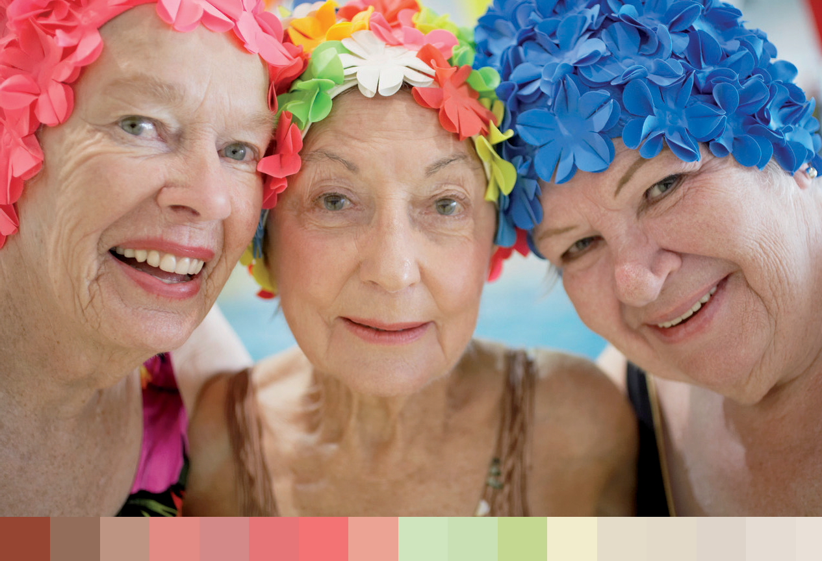

According to Access Economics, it is estimated that 245,400 people in Australia currently have dementia. 327 As Australia’s population grows and ages, more people are likely to be affected by dementia, with the number of cases of dementia expected to increase to almost 465,000 by 2031.328
Almost two-thirds of older people with dementia (65 per cent) were female because women live longer, and the age-specific rates on which the estimates are based are higher for women in the older age groups.329
Dementia affects the lives of nearly one million Australians who are involved in caring for a family member or friend with dementia.330 The majority of those with moderate to severe dementia (91 per cent) require full-time care and live in care accommodation.
Carers of people with dementia are mostly older women; however, a significant proportion of care is also provided by men. Around three-quarters of carers are married or in de facto relationships and are more likely to live in the same household with the recipient with dementia.331 Amongst carers of people with dementia, psychological morbidity and social isolation are particularly high.332
There are distinctly different dementia care needs amongst specific groups. For example, the proportion of the population who are over 80 years and from a culturally and linguistically diverse background is growing in Australia. This group is faced with additional communication difficulties with the development of dementia, as the onset of dementia generally leads to the loss of the most recently acquired language occurring first.333
The prevalence of dementia among remote Aboriginal communities is significantly higher than in the non-Aboriginal population. This is likely to be due to lower levels of education, higher prevalence of traumatic brain injury and drug and alcohol morbidity, high levels of social trauma, and a greater chance of chronic disease.334

National Women’s Health Policy 2010

6 6

Provision of dementia care is difficult for those living in rural and remote areas due to their geographical isolation, a shortage of health care providers and lower access to health
services, as well as socioeconomic disadvantage. The tendency for the children of rural and remote people moving to cities also means care from family members is not as available. 335
Whilst lesbian and bisexual women face similar issues as heterosexuals living with or caring for someone with dementia, there is a need to better recognise and address the challenges and discrimination these women may face when accessing health and residential services, including carer support.336

Older women and violence
In the post-menopausal years, violence against women, while increasing, is still under- reported.337 By 2005 the proportion of older women reporting physical violence in the past 12 months had increased to 25 per cent.338 Elder abuse is a complex issue that occurs in institutions, as well as in homes, and women in care can be abused by their formal carers. Approximately 2–3 per cent of Australian women in their early 70s experience physical abuse, and 3–8 per cent experience psychological abuse.339 Planning for the potential increase in these figures is required.340
A study of 2,620 Australian respondents aged 50 to 90 years found that, as women age, those on lower incomes were more likely than others to say they needed to learn how to discourage violence against them. The study’s findings highlight the importance of
understanding women’s fear in the context of personal and social issues, and the need to provide learning opportunities to improve safety and social engagement.341

6 7

National Women’s Health Policy 2010

6 8

Chapter Four:

Current and future government action against the four priority health issues

The government is focused on promoting and encouraging good health for all and supporting preventative action that will address the particular priority health issues raised by women through the consultative process for this policy. Detail on action the government is already undertaking and specific actions the government will undertake to address the four priority health issues of prevention of chronic disease through control of risk factors, mental health and wellbeing, sexual and reproductive health and ageing well is outlined below.
It is also critical to address the structural and systemic issues that affect women’s capacity to adopt and maintain health behaviours. These factors are explored in Chapter Five (and goals to address these are outlined in Chapter Six).

Prevention of chronic disease through the control of risk factors

Current government actions on the prevention of chronic disease through the control of risk factors
Australian Health Survey: this new survey program will incorporate the existing National Health Survey and National Aboriginal and Torres Strait Islander Health Survey in addition to two new surveys—a National Nutrition and Physical Activity Survey and
a National Health Measures Survey (a biomedical survey). The Australian Health Survey will improve our understanding of chronic diseases and their lifestyle risk factors in Australia. It will collect biomedical data as well as data on food and nutrient intake, physical activity and body measurements from participants aged 2 years and over. It will provide information for policy and program development for children, adults and Indigenous Australians.
The Jean Hailes Foundation has been funded since 1997 as an integrated model to improve women’s health in Australia. The foundation translates knowledge gained from research into strategies that assist to prevent illness, improve treatment and enhance wellbeing for women. The foundation links community and professional education
with clinical practice and research. It undertakes education and research in the areas of menopause, hormone replacement therapy, cardiovascular disease in women,
pre-menstrual syndrome and osteoporosis.

6 9

National Women’s Health Policy 2010

Taking Preventative Action—A Response to ‘Australia: The Healthiest Country by 2020’ outlines the government’s response to Australia: The Healthiest Country by 2020, the final report of the National Preventative Health Taskforce, which put forward
a range of strategies to address the growing economic and health burden associated with obesity, tobacco and alcohol. The Australian Government supports or is already taking action in 28 of the 35 recommended key action areas. This is the first step in responding to the taskforce’s final report, and further action will be taken into the future, monitoring trends, assessing outcomes, evaluating the evidence and building on recent investments.

Diabetes
The Prevention of Type 2 Diabetes program. As its contribution to the 2007 COAG measure, Reducing the Risk of Type 2 Diabetes, the Australian Government introduced a lifestyle modification initiative focused on people aged 40–49 years with the objective
of reducing or delaying their progression to Type 2 diabetes. This includes a Medicare item for general practitioners to undertake a diabetes risk evaluation and provide lifestyle advice, and referral for people at high risk of developing diabetes to a subsidised lifestyle modification program. Aboriginal and Torres Strait Islanders aged 15 to 54 years are also eligible to participate in the program.

Cancer
The government supports two evidence-based population screening programs, which contribute significantly to improved women’s health—BreastScreen Australia and the National Cervical Screening Program. Participation rates for target age ranges are
56.9 per cent 342 , and 61.2 per cent 343 respectively and mortality rates have decreased since the introduction of the programs.
BreastScreen Australia provides breast cancer screening for women in the target age group, including women from rural and remote areas, culturally and linguistically diverse backgrounds and Aboriginal and Torres Strait Islander women. BreastScreen Australia
is introducing digital mammography delivered by health professionals using specially equipped vans to increase the number of rural and remote women, including Aboriginal and Torres Strait Islanders, screened.
The Breast Cancer Nurses initiative supports the McGrath Foundation to recruit, train and place specialist breast care nurses across Australia for a four-year period. It will help improve the health outcomes for women with breast cancer, especially in rural and remote areas, by providing vital information, care, and practical and emotional support to women, their families and carers.
Building Cancer Support networks—this initiative will fund several projects focused on: key survivorship issues that are important to women with breast cancer; providing telephone support for women with ovarian cancer in rural and regional areas; and assessing the needs of lesbian and same sex attracted women affected by cancer.
The Collaborative Cancer Research Scheme is an initiative which targets research in women’s cancer to improve outcomes for all women with gynaecological and breast cancers.
The National Breast Cancer Foundation/BreastScreen Australia Cohort study will focus on over 100,000 women who attend BreastScreen and supports a range of breast cancer studies to improve prevention and treatment of breast cancer.
7 0

The National Breast and Ovarian Cancer Centre provides improved knowledge about breast and ovarian cancer control, including through the translation and dissemination of research into evidence-based information, clinical best practice, policy and health service delivery.
National Centre for Gynaecological Cancers improves outcomes for women affected by gynaecological cancers, and their families and carers, by improving their access to information and supportive care.
The Practice Incentives Program (PIP) Cervical Screening incentive was introduced in 2001–02 to increase women’s participation in the National Cervical Screening Program. It aims to increase both the overall cervical cancer screening rates and also targets women who have not had a Pap smear in the past four years. From May
2011, the screening target for the PIP Cervical Screening Incentive outcomes payment will increase from the current 50 per cent to 65 per cent of a practice’s eligible female patients. Increasing the cervical screening target aims to encourage practices to screen a higher proportion of their female patients and improve the rate of early detection of cervical cancer in Australia.
Supporting Women in Rural Areas Diagnosed with Breast Cancer. This initiative develops programs to improve supportive care for women in rural areas diagnosed with breast cancer where geographic isolation and limited contact with specialist health care workers may impede access to the full range of treatment options and support services.

Asthma
The Asthma Management Program provides funding to reduce the personal, social and economic impact in Australia of asthma and linked chronic respiratory conditions by facilitating best practice treatment of the conditions and encouraging proactive management. The program funds a range of initiatives aimed at reducing the cost of
asthma and linked chronic respiratory conditions to the Australian community, including:
- raising awareness about asthma and linked chronic respiratory conditions;
- supporting action and self-management in the community;
- providing training for primary care professionals for best practice asthma care; and
- undertaking national data monitoring and surveillance of asthma and linked chronic respiratory conditions.

Risk factors
Obesity, unhealthy eating and physical inactivity
The National Partnership Agreement on Preventive Health (NPAPH) was announced by the Council of Australian Governments (COAG) on 29 November 2008. Under the NPAPH, the Australian Government will provide $872.1 million over six years from 2009–10. This is the largest investment ever made by an Australian Government in health prevention. The NPAPH aims to address the rising prevalence of lifestyle-related chronic diseases by:
- laying the foundations for healthy behaviours in the daily lives of Australians through social marketing efforts and national programs supporting healthy lifestyles;

7 1

National Women’s Health Policy 2010

- supporting these programs and policy with infrastructure to enable evidence- based policy design and coordinated implementation.
The various initiatives funded through the National Partnership Agreement on Preventive Health are detailed below.
Healthy Communities ($72 million from 2009–10 to 2012–2013)
- This initiative will support a targeted, progressive roll out of community-based healthy lifestyle programs which will facilitate increased access to physical activity, healthy eating and healthy weight activities for disadvantaged groups and those not in the workforce. The Commonwealth will administer funding to local government organisations, provide a national quality assurance framework, the accreditation/registration of programs and service providers, and a web-based information portal.
Healthy Children ($325.5 million from 2011–12 to 2014–15)
- State and territory governments will implement a range of interventions for children 0 to 16 years of age to increase physical activity and improve nutrition through child
care centres, pre-schools, schools and within families. Programs may include intensive programs to support at-risk children and their families in achieving healthy weight through healthy eating and exercise programs in children’s settings.
Healthy Workers ($294.4 million from 2011–12 to 2014–15)
- This initiative provides funding to support implementation of healthy lifestyle programs in workplaces, targeting overweight and obesity, physical inactivity, poor diet, smoking and the excessive consumption of alcohol (including binge drinking). The states
and territories will facilitate the implementation of programs in workplaces and the Commonwealth will support these programs with national-level soft infrastructure including developing a national charter, voluntary competitive benchmarking, nationally agreed standards for workplace prevention programs, and national awards for excellence in workplace health programs.
Industry Partnership ($1 million from 2009–10 to 2012–2013)
- This initiative will develop and support partnerships between governments and various relevant industry sectors to encourage changes in their policies and practices so they are consistent with the government’s healthy living agenda. The partnerships will initially focus on the food industry, and may extend to the fitness and weight loss sectors following the establishment of the quality assurance element of the Healthy Communities initiative. The Commonwealth will manage the implementation of this initiative in consultation with the states and territories.
Social Marketing ($120 million from 2009–10 to 2012–2013)
Measure Up ($59 million)
- This initiative provides supplementary funding for Measure Up, in order to extend its duration by three years and expand its reach to high-risk groups. Activities under the campaign aim to raise awareness of healthy lifestyle choices, focusing on the importance of physical activity and nutrition, as well as the link between lifestyle behaviours and
the risk of some chronic diseases. The Commonwealth will manage and coordinate a national integrated program of social marketing activity ($41 million), whilst the states

7 2

and territories will deliver a program of activities at the local level that reinforce and extend the national campaign messages ($18 million).
Enabling Infrastructure ($59.2 million from 2009–10 to 2012–13)
National Health Risk Survey ($15 million)
- The National Health Risk Survey (HRS) will collect essential data on prevalence of chronic disease risk factors in the Australian population through a series of surveys covering all jurisdictions. Funding for an initial HRS has been provided through the National Nutrition and Physical Activity Survey Program—this survey is expected to be conducted in 2010–11 and will focus on adults. A second HRS will be conducted in 2012–13 and will focus on children.
Enhanced State and Territory Surveillance ($10 million)
- This initiative provides funding for the implementation of a complementary system of more frequent health, nutrition and physical activity monitoring surveys. The states and territories will collect and report on the agreed performance indicators and implement surveillance systems using the nationally agreed methodology.
Australian National Preventive Health Agency ($17.6 million) and research fund ($13 million)
- The Australian National Preventive Health Agency will be established to provide evidence-based policy advice to Ministers, manage national-level social marketing activities targeting obesity and tobacco, administer the preventive health research fund, and oversee the workforce audit and strategy. The Commonwealth has responsibility for these programs and will work closely with the states and territories to ensure effective implementation.
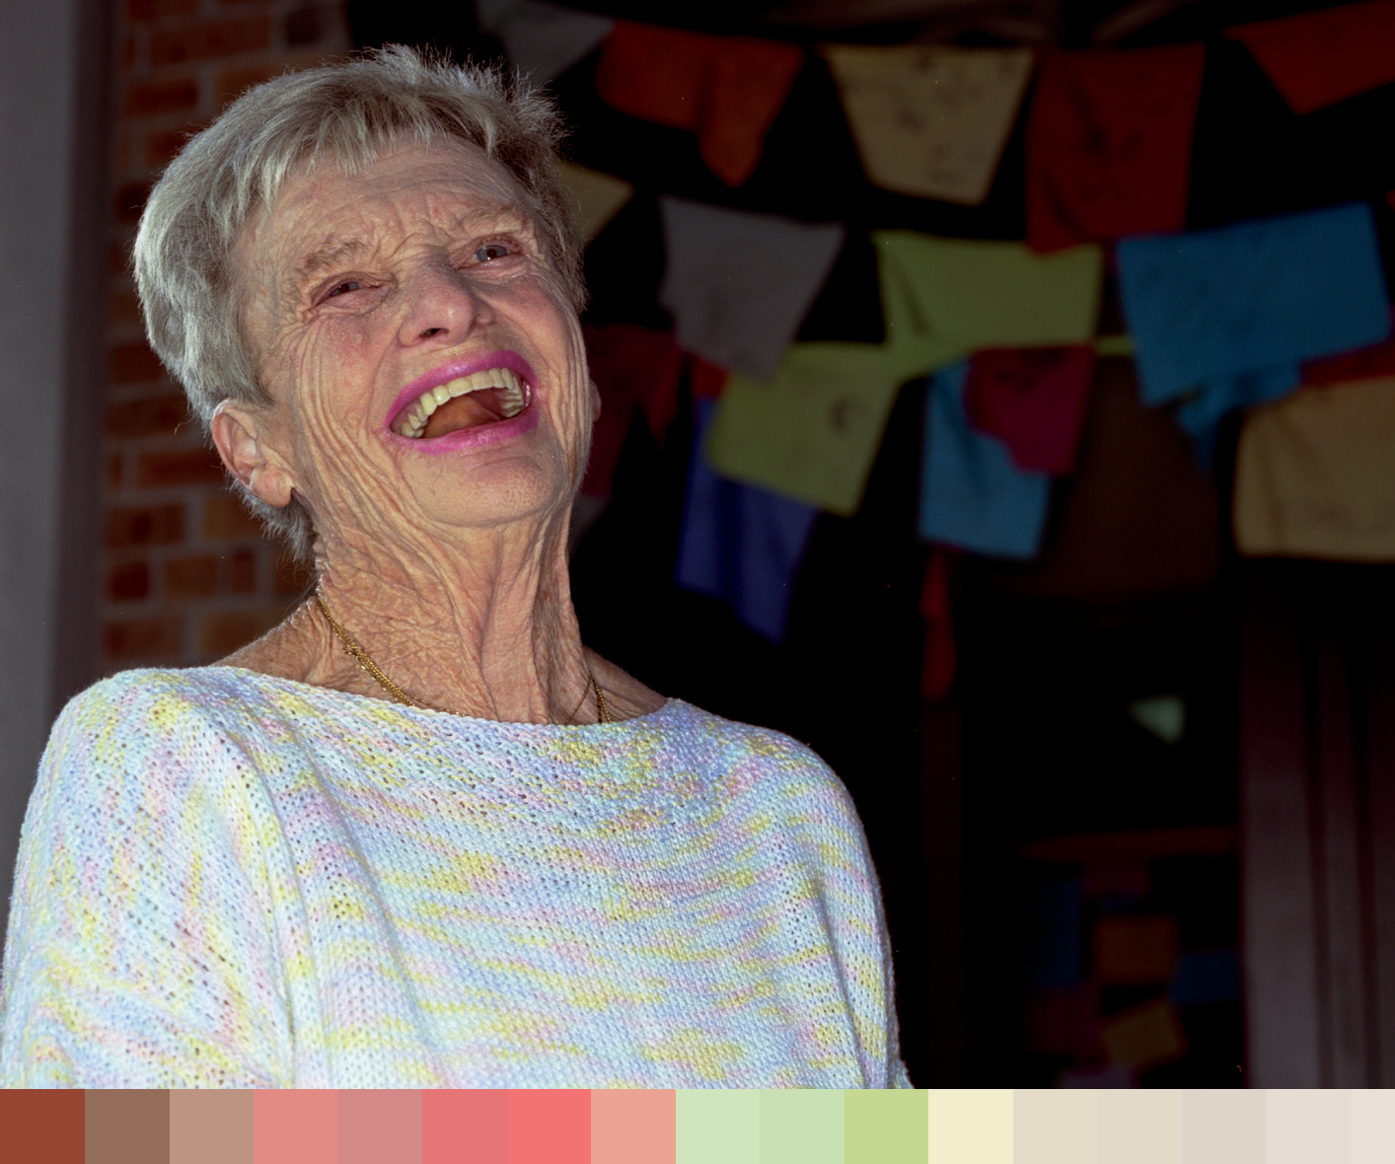

7 3

National Women’s Health Policy 2010

Workforce Audit and Strategy ($0.5 million)
  - This initiative will identify and quantify the workforce required to deliver the
settings-based initiatives funded through the prevention National Partnership (Healthy Workers, Healthy Children and Healthy Communities) and propose options to ensure there is sufficient capacity within the sector to support the roll out of activities and programs. The Commonwealth will administer the funds for this initiative.
National Eating Disorders Collaboration ($3 million)
  - The National Eating Disorders Collaboration (the Collaboration) will facilitate the implementation of a nationally consistent and comprehensive approach to
promotion and prevention, early intervention and management of eating disorders. The Collaboration will bring together experts in the field of research, education, health promotion, public health and mental health, as well as the media, to progress a coordinated national approach to eating disorders and provide information to adolescents, schools, health providers and the media. The Commonwealth will administer the funds for this initiative.
The Measure Up campaign raises awareness of healthy lifestyle choices, focusing on the importance of physical activity and nutrition, as well as the link between lifestyle
behaviours and the risk of some chronic diseases. The primary target groups are adults aged 25–50 years with children, and adults 45–65 years.
Review of the Dietary Guidelines. In partnership with the Department of Health and Ageing, the National Health and Medical Research Council (NHMRC) is undertaking a review of national nutrition recommendations including the Core Food Groups; Australian Dietary Guidelines for infants, children, adolescents, adults and older Australians; and the Australian Guide to Healthy Eating publications.
This review of Australia’s foundation nutrition recommendations provides an opportunity to ensure the resulting updated nutrition education tools are complementary, evidence- based, and provide practical recommendations. A Dietary Guidelines Working Committee (DGWC) consisting of leading Australian nutrition and population health experts has been established to oversee all aspects of the Australian Dietary Guidelines Review. The revised recommendations and new resources are anticipated to be available in mid-2011.
National Physical Activity Guidelines. Physical activity is an important factor in maintaining good health and preventing overweight and obesity. The Australian
Government provides information and guidelines regarding the levels of physical activity required to obtain a health benefit for children, adolescents, adults and older Australians. The consumer resources include information on the benefits of participation in physical activity, the types and amounts of physical activity that are beneficial across the lifespan, and ways to incorporate physical activity into everyday life.

Tobacco use
The government is addressing high rates of smoking by Indigenous Australians, including pregnant women and new mothers, through the Indigenous Tobacco Control Initiative (ITCI) ($14.5 million) and the Tackling Smoking measure ($100.6 million) which comes under the COAG National Partnership Agreement on Closing the Gap in Indigenous Health Outcomes. Eighteen ITCI projects are developing and

7 4

evaluating innovative approaches to smoking cessation. Five of the ITCI projects have a particular focus on pregnant women and new mothers. The Tackling Smoking measure is funding the rollout of Regional Tackling Smoking and Healthy Lifestyle Teams in
57 regions nationally over a three year period. The Tackling Smoking workers will work with communities to address smoking levels including through targeted social marketing activities. One important focus of their work is to support and educate girls, pregnant
women and mothers about the effects of smoking and the importance of healthy living in a smoke-free environment.
The measures funded through the National Partnership include provisions for the particular needs of socioeconomically disadvantaged Australians.
The National Partnership Agreement on Preventive Health tobacco social marketing campaign includes $61 million over four years (2009–2013) to conduct a series of national-level social marketing activities aimed at increasing awareness of the risks associated with smoking to contribute to a reduction in smoking uptake and prevalence.
In the 2010–2011 Budget, the Australian Government also provided funding of
$27.8 million for a complementary campaign The National Tobacco Campaign— More Targeted Approach which will aim to reduce smoking prevalence among high- need and hard to reach groups. These include people who are at risk, have high smoking rates, and/or for whom it is a challenge for mainstream campaigns to effectively reach, such as pregnant women and their partners, prisoners, people with mental illness, people
from culturally and linguistically diverse backgrounds, and people living in low socio-economic areas.

Excessive alcohol consumption
The Australian Guidelines to Reduce Health Risks from Drinking Alcohol (released by the National Health and Medical Research Council in 2009) provide general advice for adults, as well as specific advice for pregnant and breastfeeding women on lowering the risk of harm. Communications materials are available that promote the message of the guidelines to pregnant and breastfeeding women that not drinking is the safest option for women who are pregnant, planning a pregnancy or breastfeeding. These materials include a ‘flyer’ and poster for breastfeeding women as well as a ‘flyer’ for pregnant women. The materials are now being distributed to target audiences across Australia. To promote the guidelines among culturally and linguistically diverse groups, the pregnancy and breastfeeding flyers have been translated into nine languages (Russian, Serbian, Italian, Traditional Chinese, Vietnamese, Arabic, Korean, Turkish, and Khmer). The material can be accessed at: www.alcohol.gov.au.

Future government action on the prevention of chronic disease through the control of risk factors
There is evidence that gender and equity issues can influence behavioural risk factors for a range of diseases such as diabetes, lung cancer, arthritis and cardiovascular disease. There is a need to consider the impact of the biological and social context of women’s lives on prevention and health promotion activities.
Health messages should have a clearly identified, evidence-based target group—a group that should be involved in the development and testing of messages so that they engage the group. Different types and styles of communication, including appropriate language,
There is evidence that gender and equity issues
can influence behavioural risk factors for a range of diseases such as diabetes, lung cancer, arthritis and cardiovascular disease. There is a need to consider the impact of the biological and social context of women’s lives on prevention and health promotion activities.

7 5

National Women’s Health Policy 2010

should be used for different groups. And materials should be disseminated in settings and ways that are appropriate. Developing materials in a partnership approach with advocacy and specialist knowledge groups is encouraged.
  - Explore opportunities for programs focused on cardiovascular disease to be specifically targeted to women.
  - Consider action to address barriers that may inhibit women’s access to preventative health services; for example:
    - Explore opportunities to consider the impact of the biological and social context of women’s lives on prevention activities.
    - Health communication strategies to consider the whole population and subgroups.
    - Education strategies for communities on availability of interpreters.
    - Work with primary health workers to increase interpreter awareness and enhance cultural sensitivity.
    - Increased awareness of discrimination experienced by women with disabilities, lesbian and bi-sexual women.
    - Use of new technologies to target women who may not be reached by more traditional forms of media.
  - Identify and adapt key prevention programs in consultation with Aboriginal and Torres Strait Islander health services to ensure Aboriginal and Torres Strait Islander women have been targeted in an appropriate way.
  - Identify and adapt prevention programs through multicultural services, disability advocacy groups, lesbian and bisexual advocacy groups and carer’s networks to target women from varied communities.

Mental health and wellbeing

Current government action to improve mental health and wellbeing
The National Mental Health Policy 2008 provides an overarching vision for a mental health system that enables recovery, prevents and detects mental illness early, and ensures that all Australians with a mental illness can access effective and appropriate treatment and community support to enable them to participate fully in the community.
The Fourth National Mental Health Plan further guides mental health reform outlined in the government’s Mental Health Policy and identifies key actions for progress towards fulfilling the vision of the policy. It suggests a whole-of-government approach and acknowledges that many of the determinants of good mental health, and mental illness, are influenced by factors beyond the health system. It also has a strong focus on social inclusion.
Beyondblue: The National Depression Initiative is responsible for a range of activities, including developing resources and research about depression, anxiety and eating disorders.
Headspace is a youth-friendly service which provides holistic care across four key areas: mental health, physical health, alcohol and other drug use, and social and vocational support. There are currently 30 sites nationally with another 30 sites to become operational

7 6

over the next three years. The model provides a service platform for and entry point to existing services and also refers people to other appropriate services.
Body image initiatives, announced in June 2010, aim to build young people’s resilience to body image pressures and promote positive steps on this issue in the fashion, media and advertising industries. Initiatives include support for the Butterfly Foundation to expand its education services, the development of resources for schools and the release of a Voluntary Industry Code of Conduct on Body Image. The new initiatives were announced in response to recommendations from a National Advisory Group on Body Image established in 2009 to provide advice on this issue.
The National Eating Disorders Collaboration (NEDC) project brings together eating disorder experts in mental health, public health, health promotion, education, and research, as well as the media. The NEDC is funded $3 million over four years by the Australian Government to facilitate the implementation of a nationally consistent and comprehensive approach to prevention, early intervention and management of eating disorders including the development and promotion of evidence-based messages to schools, at-risk groups and health professionals.
Telephone Counselling, Self Help and Web-based Support Programmes support the provision of evidence-based telephone and online mental health programs to supplement or substitute for existing face-to-face services for individuals with common mental health disorders or those in psychosocial crisis. The measure particularly benefits people in rural and remote areas who face barriers in accessing face-to-face services.
Activities under this measure to date have included funding for general psychosocial telephone help lines, online counselling, online self-help and peer support resources and self-directed online treatment modules.
Improving the Capacity of Workers in Indigenous Communities initiative improves the capacity of Indigenous workers in Indigenous communities by supporting health practitioners, including Aboriginal health workers, nurses, counsellors and other clinic staff, to identify and address mental illness and associated substance abuse issues ($20.8 million).
Access to Allied Psychological Services (ATAPS) initiative engages Divisions of General Practice to allow GPs to refer patients who have been diagnosed as having a
mental disorder to an allied health professional to provide short-term focused psychological services. ATAPS primarily treats people with common mental disorders such as anxiety and depression and targets hard to reach groups. 73.1 per cent of clients accessing ATAPS services are women.
The Commonwealth’s National Suicide Prevention Strategy (NSPS) with an investment of $276.9 million over four years aims to reduce the incidence of suicide and self-harm, and to promote mental health and resilience across the Australian population by supporting broad evidence-based population health approaches as well as providing targeted assistance to groups identified at higher risk of suicide, including youth,
Indigenous Australians, people bereaved by suicide, people with a mental illness and people living in rural and remote areas. It is widely recognised that whilst completed suicide rates are generally higher for men, women are believed to account for a greater proportion of incidence of self-harm than their male counterparts.

Body image initiatives, announced in June 2010, aim to build young people’s resilience to body image pressures and promote positive steps on this issue in the fashion, media and advertising industries.

7 7

National Women’s Health Policy 2010

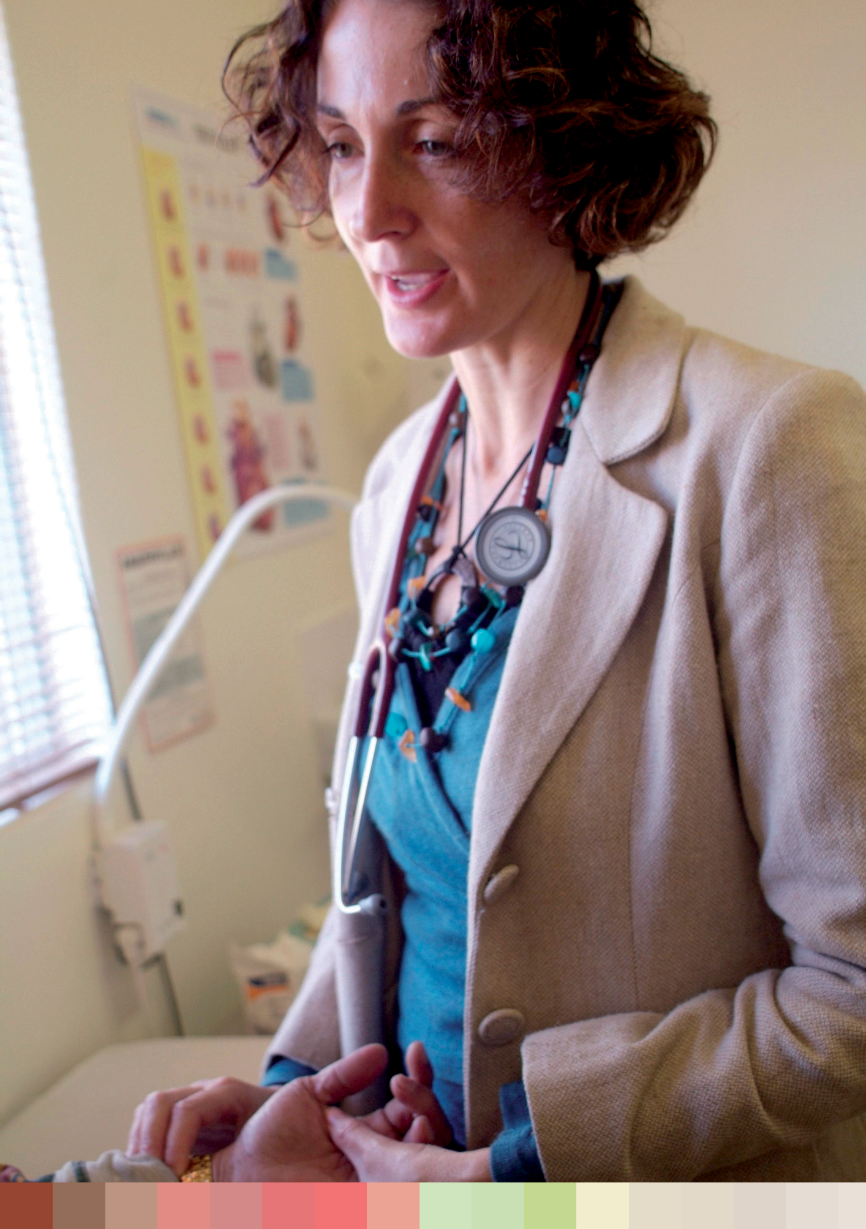

The Commonwealth is providing funding of up to $108 million from 2006/07 to 2013/14 under the Mental Health Services in Rural and Remote Areas (MHSRRA) Program to Divisions of General Practice, Aboriginal Medical Services and the Royal Flying Doctor Service to deliver mental health services by appropriately trained mental health care workers, including psychologists, social workers, occupational therapists, mental health nurses, Aboriginal health workers and Aboriginal mental health workers.
The MHSRRA Program provides funding for mental health professionals in communities that would otherwise have little or no access to mental health services. The program is designed to address inequities in access to the Medicare Benefits Schedule by targeting

7 8

areas where access to MBS subsidised mental health services is low. The MHSRRA Program also addresses workforce shortage issues by providing flexible employment models suited to local needs and conditions. This includes flexibility to accommodate geographically, culturally and linguistically diverse populations, such as Indigenous communities, in rural and remote areas of Australia.
Please note that while the MHSRRA Program does deliver services to women in rural and remote Australia, the overall program does not specifically target women in rural and remote Australia.
The Targeted Community Care (Mental Health) Program was implemented in 2007 to assist people with mental illness and their families and carers to manage the
impact of mental illness on their lives. The program is part of the COAG National Action Plan on Mental Health 2006–2011 and guided by the Fourth National Mental Health Plan. Its three initiatives (Personal Helpers and Mentors [PHaMs], Mental Health Respite, and Community Based Services) build on the strengths of individuals and communities, build partnerships through collaboration within the community mental health and clinical sector, tailor services to the needs of individuals, families and carers, and build resilience and capacity both for those affected by mental illness and services in the community mental health sector.
Since 2007 this program has been funded for $494 million. From 2007 to
30 September 2010, 55 per cent of the 12,892 PHaMs participants have been women.

Future government action on improving mental health and wellbeing
  - Continue supporting the mental health and wellbeing of Australian women through a range of programs.
  - Explore opportunities for future mental health policy to consider the role that gender plays in women’s experience of mental illness.

Sexual and reproductive health

Current government action to improve women’s sexual and reproductive health
Family planning
Six organisations are currently supported to provide information to women on family planning, support and sexual and reproductive health education and advice.

Sexually transmitted infections
New national strategies (2010–13) for HIV, sexually transmitted infections, hepatitis B, hepatitis C and Aboriginal and Torres Strait Islander blood-borne viruses (BBVs) and sexually transmitted infections (STIs) were developed during 2009–10 and have been endorsed by Australia’s Health Ministers Committee (AHMC). These strategies identify priority populations (including women) and activities to reduce the transmission and morbidity of BBVs and STIs and minimise their personal and social impacts.

7 9

National Women’s Health Policy 2010

In relation to sexual health the Department funds the following programs:
- $12.5 million for increased awareness, surveillance and pilot testing program for chlamydia (over five years—phase one and two completed) with $1.8 million for a GP pilot testing program for chlamydia (over three years) that is ongoing in 2010–11 and forms phase three of the program.
- $9.8 million to National STI Sexual Health Campaign (over four years).
- $33.2 million in a range of programs to prevent and treat STIs and BBVs (for 2010–11):
  - $6 million for community-based organisations for education and prevention;
  - $9.2 million for four national research centres; and
  - $18 million for education, prevention and surveillance activities for Aboriginal and Torres Strait Islander sexual health.

Reproductive health
Funding has been provided to support the Jean Hailes Foundation in association with the Polycystic Ovarian Syndrome Alliance to develop evidence-based guidelines and conduct an education program for health professionals and the community.
The New Structure for Assisted Reproductive Technologies initiative ensures that assisted reproductive technologies remain accessible to all women who may not otherwise be able to achieve a pregnancy.
The government provides funding for community education programs to address female genital cutting through the National Health Care agreements. The Migration Amendment (Complementary Protection) Bill 2009 was introduced in September 2009 to better protect people at risk of violation of their fundamental human rights. This may include women and girls at risk of female genital cutting.

Maternal health
In 2008–09, the Australian Government conducted a review of maternity services across Australia. The Maternity Services Review was the first step in developing a comprehensive plan for maternity services into the future, and it considered issues relevant to the full range of maternity services which included pregnancy care, birthing, postnatal care and peer and social support for women in the perinatal period. Improving Maternity Services in Australia: The Report of the Maternity Services Review (the Report), was released in February 2009.
- In response to the Report, the 2009–10 Improving Maternity Services Budget Package provides $120.5 million over four years for a maternity reform package, which delivers a range of measures aimed at providing Australian women with more choice
in their maternity care, while maintaining Australia’s strong record of safe, high quality maternity services.
- The package includes:
  - access for patients of eligible midwives to Medicare Benefits Schedule (MBS) rebates and Pharmaceutical Benefits Scheme (PBS) medicines from 1 November 2010;
  - a government-supported professional indemnity insurance scheme for eligible midwives which commenced on 1 July 2010;

8 0

    - increased services for rural and remote communities through an expansion of the successful Medical Specialist Outreach Assistance Program;
    - additional training support for GPs and midwives, particularly in rural and remote Australia;
    - the expansion and improvement of the existing National Pregnancy Telephone Counseling Helpline to deliver a 24 hour, seven days a week telephone helpline and information service, which commenced on 1 July 2010.
- To facilitate the new MBS, PBS and insurance arrangements, on 16 March 2010 the Australian Parliament passed the: Health Legislation Amendment (Midwives and Nurse Practitioners) Act 2010; Midwife Professional Indemnity (Commonwealth Contributions) Scheme Act 2010; and Midwife Professional Indemnity (Run-off Cover Support Payment) Act 2010.
- The Australian Government is also working with states and territories to develop a National Maternity Services Plan (the Plan). The overall objective of the Plan is to provide a strategic national framework, endorsed by state, territory and
Commonwealth governments for the five year period 2010–2015. It is expected to be completed shortly.
Maternity Peer Support is part of the $120.5 million 2009–10 Budget package to improve choice and access to maternity services for pregnant women and new mothers in Australia. Women and their families will have greater access to telephone support. Funding will assist a small number of specialist organisations, including the Bonnie Babes Small Miracles Foundation, SIDS and Kids Australia, and Stillbirth and Neonatal Death Support Australia (SANDS), to provide telephone-based peer support for people who are experiencing grief after the loss of a baby during pregnancy or in the first year of parenthood.
The National Perinatal Depression initiative provides $55 million over five years to improve prevention and early detection of antenatal and postnatal depression and provide better support and treatment for expectant and new mothers experiencing depression.
Under this initiative, expectant and new mothers will be screened for antenatal and postnatal depression, and women who are identified as being at risk of or experiencing depression in the perinatal period will be able to get the support and care they need, including medical treatment and counselling services.

National Breastfeeding Strategy and support for breastfeeding
In recognition of the importance of breastfeeding, the Australian National Breastfeeding Strategy 2010–2015 was endorsed by the Australian Health Ministers Conference on
13 November 2009. The strategy provides a framework for priorities and action for Australian governments at all levels to protect, promote, support and monitor breastfeeding throughout Australia.
In April 2010 Health Ministers endorsed the 2010 Implementation Plan for the Breastfeeding Strategy. Implementation of the strategy will be progressed by governments both independently and nationally, with ongoing leadership from the Commonwealth and input from community stakeholders. A progress report is anticipated to be provided to the Australian Health Ministers’ Conference in mid-2011.

8 1

National Women’s Health Policy 2010

The Implementation Plan identifies 10 action areas based on the goals and objectives of the Breastfeeding Strategy. These areas include monitoring and surveillance; health
professionals’ education and training; dietary guidelines and growth charts; breastfeeding- friendly environments (including workplaces and child care settings); support for breastfeeding in health care settings; revisiting Australia’s response to the World Health Organization’s International Code of Marketing of Breast-milk Substitutes and related World Health Assembly resolutions; exploring the evidence, quality assurance, cost- effectiveness and regulatory issues associated with the establishment and operation of milk banks; breastfeeding support for priority groups (including Aboriginal and Torres Strait Islander groups); continuity of care, referral pathways and support networks; and education and awareness, including antenatal education.
Implementation of the strategy will build on the Commonwealth’s existing commitment to breastfeeding, including funding for formal and informal support for breastfeeding women. As part of this commitment, the Australian Breastfeeding Association has been funded
$2.5 million over five years to provide a toll-free 24 hour National Breastfeeding Helpline providing breastfeeding information and peer support for mothers and their families. The helpline has received over 125,000 calls between October 2008 and the end of June 2010. The number is 1800 MUM 2 MUM (1800 686 2 686).
To address the specific needs of Aboriginal and Torres Strait Islander women, the government is investing $90 million over five years in the New Directions Mothers and Babies Services. These services seek to improve the health and wellbeing of Aboriginal and Torres Strait Islander children and their mothers via enhanced access to antenatal care; standard information about baby care; practical advice and assistance with breastfeeding, nutrition and parenting; monitoring of developmental milestones, immunisation status and infections; and health checks for Indigenous children before starting school.
New Directions Mothers and Babies Services invests $90.3 million over five years
(2007–08 to 2011–12) and since 1 July 2009 is the Australian Government’s contribution to Element 3 of the IECDNP. The program aims to improve the health and wellbeing
of Aboriginal and Torres Strait Islander children and their mothers via enhanced access to antenatal care; standard information about baby care; practical advice and assistance with breastfeeding, nutrition and parenting; monitoring of developmental milestones, immunisation status and infections; and health checks for Indigenous children before starting school.
The Australian Nurse Family Partnership program invests $37.4 million over four years (2007–08 to 2010–11) to improve health outcomes for Aboriginal and Torres Strait Islander children and their mothers by encouraging healthy behaviours for women during pregnancy, and optimal care of children up to two years of age.
The Healthy for Life Program promotes a quality improvement approach to service provision including services to Aboriginal and Torres Strait Islander women which encourage adult and child health checks, early presentation during pregnancy, healthy behaviour during pregnancy including a reduction in selected risk factors, and the promotion of good health for children in their early years ($38 million per annum).

8 2

Future government action to improve women’s sexual and reproductive health
  - Continue supporting Australian women’s sexual and reproductive health through a range of programs.
  - Monitor emerging evidence to inform any new policy directions and program development.

Ageing well
Current government action to assist women to age well The National Respite for Carers Program (NRCP) is one of several initiatives designed to support and assist relatives and friends caring at home for people who are
unable to care for themselves because of disability or frailty. In the 2003 Australian Bureau of Statistics Survey of Disability, Ageing and Carers, there were 2.6 million carers who provided some assistance to those who needed help because of disability or age. Just over half (54 per cent) of all carers were women. Women were also more likely (71 per cent) to be primary carers.
The program provides:
- information and support for carers; and
- assistance to help carers take a break from caring
Under the program there are 54 Commonwealth Respite and Carelink Centres established across Australia.
The program funds:
- more than 650 community-based Respite Services;
- Commonwealth Respite and Carelink Centres;
- the National Carer Counselling Program, and
- the Carer Advisory Service.

Dementia
The Australian Government has committed to the ongoing support of The National Dementia Initiative. The Dementia Initiative currently provides about $135 million a year to support people with dementia, their families and carers. This includes around:
- $104 million a year for Extended Aged Care at Home Dementia Packages that provide services to people with dementia in their own homes;
- $24 million a year for dementia research, prevention, early intervention and improved care initiatives, including research grants offered through the National Health and Medical Research Council and funding for three Dementia Collaborative Research Centres; and
- $7 million for training for aged and community care staff, carers and community workers including police.

8 3

National Women’s Health Policy 2010

Promote active ageing
The Australian Government has appointed an Ambassador for Ageing, Ms Noeline Brown, to positively promote active and healthy ageing, and to challenge the stereotypes held of older Australians. The Ambassador promotes respect for, and the value of, older Australians by recognising their vital and ongoing contribution and encouraging them to fully participate in all aspects of Australian life. Most of the events in which the
Ambassador participates involve speaking with older women on healthy ageing. These include media interviews (many in rural and regional areas), television appearances, health promotion events (e.g. flu vaccination for the elderly), community events and conferences. A series of active ageing posters and brochures, featuring the Ambassador for Ageing, provide sensible tips and advice on: staying physically active; eating well; keeping in touch with family, friends and community; and avoiding falls at home.
Arthritis
Arthritis and other musculoskeletal conditions—the Better Arthritis and Osteoporosis Care initiative focuses on improving the care and management of people with arthritis, osteoporosis and other musculoskeletal conditions ($14.4 million over four years, 2010–11 to 2013–14).

Future government action to assist women to age well
  - Continue supporting Australian women to age well through a range of programs.
  - Explore opportunities for older women to have a stronger consumer representative role in policy development and program design.

8 4

Chapter Five:

Social factors influencing women's health and wellbeing

Good health is ‘complete physical, mental and social wellbeing and not merely the absence of disease and infirmity’.344
Overall, significant improvements have been made in the health of Australian women in recent decades. However, these improvements have not been experienced equally throughout the community.
Certain groups of Australia women, particularly Aboriginal and Torres Strait Islander women, experience markedly worse health than the general population. A key ongoing health challenge is to address these inequalities.
This chapter explores the key social determinants which can influence women’s health and wellbeing. These social determinants are explored under the four thematic headings of:
- Sex and gender
- Life stages
- Access to resources including income, education, employment,
social connections and safety and security
- Diversity
The impact of each of these on women’s health is explored below and an outline provided of current government action to address these.
Access to health care, particularly primary health care such as general practitioners and other health care providers, is extremely important for all Australian women to allow prevention, early detection and treatment of illness, and management of chronic conditions. Some groups of women face significant barriers in accessing health care services and information. Improving access to health services is a significant contributor to improved health outcomes.
Health reform represents a strategic shift in the way in which health services are delivered. It seeks to shift the focus of our health system towards a greater focus on enhanced health promotion, preventative health and greater attention to monitoring and managing Australia’s escalating burden of chronic disease. An underlying principle of health reform is to enhance equity of access to high quality health care. These themes are explored further under the health reform section.
8 5

Health is determined by a broad range of social, cultural, environmental and economic factors, as well as the genetic and biological factors that are usually thought of as causing good and
National Women’s Health Policy 2010
ill health.

8 6
Social determinants of health
Health is determined by a broad range of social, cultural, environmental and economic factors, as well as the genetic and biological factors that are usually thought of as causing good and ill health.
This policy seeks to understand health within its social context. Women’s health can only be understood within the broader contexts in which women live and work.
The policy is based on a gendered approach that is inclusive of a social view of health, and accounts for the diversity in women’s experiences. The social model of health acknowledges the complex ways that the context of a woman’s life—including her gender, age, socio- economic status, ethnicity, sexuality, disability and geography—might shape her health outcomes; access to health care; experiences of health, wellbeing and illness; and even
her death.
Addressing these social determinants is a fundamental step towards reducing health inequalities.345

Sex and gender
Sex and gender are key social determinants of health, they can influence a person’s access to key resources such as income and workforce participation, education and social inclusion and social support 346 which in turn impact on health outcomes.

Sex
Sex refers to the biological and physiological characteristics that define women and men. Biological differences in body composition, metabolism and hormones among women and men can create differences in susceptibility to disease, disease progression and response
to treatment.

Gender
The World Health Orgainisation defines gender as ‘the socially constructed roles, behaviour, activities and attributes that a particular society considers appropriate for men and women’. 347 Gender is present, although not always visible, in all social institutions, and can result in different social, economic and political opportunities for women and men.
Gender is a key social determinant of health and wellbeing. Gender roles and gender relations can affect women’s capacity to access resources such as income, education and employment, which themselves promote health. These inequalities can create, maintain or exacerbate exposure to risk factors that endanger health. For example, gender can contribute to differences between and among women and men in financial security, paid and unpaid caring work and experiences of violence. This can result in different and sometimes inequitable patterns of exposure to health risk, in unequal access to and use
of health information, care and services, different help-seeking behaviour and, ultimately, different health outcomes.348
Gender health equity strives for equitable opportunity and access to the social and economic resources required for good health. As the World Health Orgainization Commission on Social Determinants of Health argues, ‘taking action to improve gender equity in health and to address women’s rights to health is one of the most direct and potent ways to reduce health inequities and ensure effective use of health resources’.

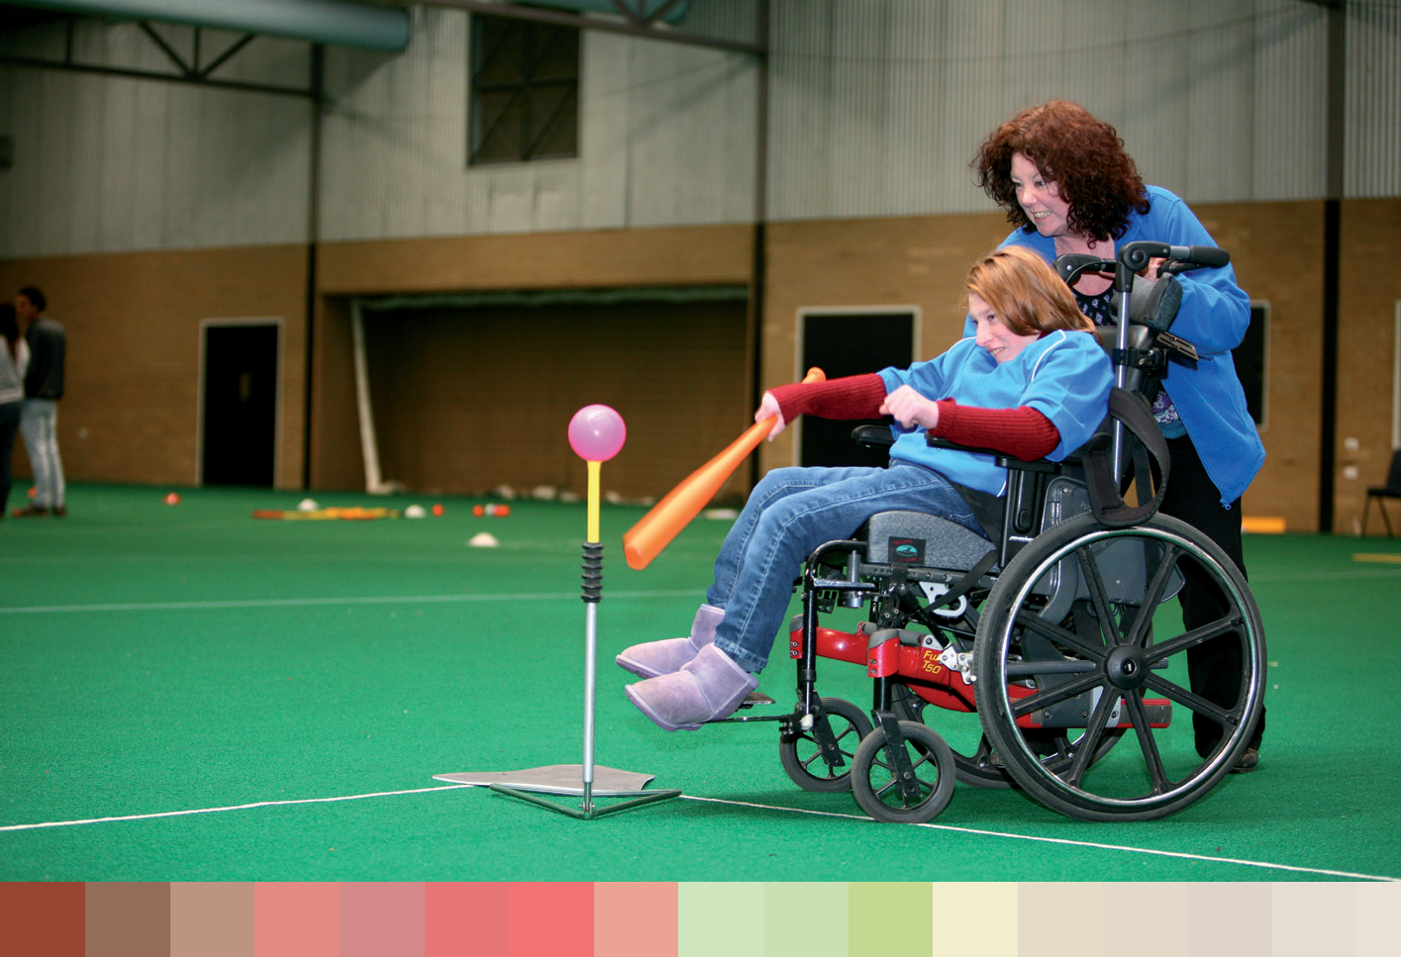

Life stages
Research has demonstrated that the health needs of women differ through stages of their lifecycle.
Physical and social circumstances, starting before birth and continuing through childhood, influence both physical health and the ability to maintain health. Key transition points
in women’s lives are important in the development of good or poor health. These include pregnancy and childbirth, school entry, puberty, workforce entry, partnering, menopause, leaving the paid workforce, and widowhood.349
Different health issues may be more relevant to women’s lives at varying life stages. For example: young women and risky behaviour; mid age women and sexual and reproductive health; and older women and recognition of how social isolation, caring role and financial insecurity can impact on health.
This makes age-appropriate health information and health promotion material particularly important. Transition points are opportunities to target health promotion material.350 351 For young women, pressures to achieve academically and socially, and to conform to
stereotypes about appearance, can push them into risky behaviour including high risk
drinking352 , unprotected sex and unhealthy body image.353 Young women are experiencing high rates of smoking and violence, as well as rates of obesity and overweight increasing amongst young women at a higher rate than past generations. The increasing rates of
sexually transmitted infections, such as chlamydia, amongst young women has the potential to impact on fertility later in life.
Mental health issues are a particular concern for young women. In 2001, over 22 per cent of young women reported high to very high psychological distress, almost twice the rate of males.354 Nearly a third of the burden of disease for this age group is due to anxiety and
depression.355 In the last 10 years self-harm requiring hospitalisation among young women increased by 51 per cent.356.

8 7

National Women’s Health Policy 2010

For women in their reproductive years, pregnancy, managing fertility and having children are prominent issues.
The age of first birth is getting older in Australia. There is a need for greater education about fertility and the reproductive system to help Australian women to understand the factors which may impact on their fertility and the health of their baby during pregnancy (such as obesity, smoking, alcohol, STIs, maternal nutrition).
Women going through the life transition of becoming a mother can experience mental health issues. Support services are particularly important at this life stage, especially in relation to antenatal support to address issues such as postnatal depression.
Challenges in balancing work and family commitments can have a significant impact on women’s physical and mental health, particular since women still take on a higher proportion of caring responsibilities.
For women in mid-life, symptoms of menopause and other life stage factors can affect women’s mental and physical health. It is a time of transition physically, and can be in other ways, with children reaching adulthood and gaining independence357 and ageing parents requiring care.
There are a number of health issues of particular importance to mid-age women, including mental disorders, musculoskeletal diseases and breast cancer.358 Anxiety and depression
is a leading burden of disease for adult women.359 360 Intimate partner violence is a leading burden for females up to 44 years of age.361
Older women are more likely than men to be widowed, live alone or in residential care, 362 experience financial insecurity363, more chronic illness, multiple disabilities 364 and greater health service use.365 Furthermore, older women are often marginalised or regarded as ‘socially invisible’ in Australian society. Violence against older women has been increasing but is still underreported.
Older women experience much higher rates of profound or severe disability than males of the same age.366 This is partially due to the high rates of dementia and musculoskeletal diseases in older women.
As health outcomes are influenced by the cumulative effects of these experiences, the policy seeks to address health throughout women’s lives. For each of the health priority issues,
this policy considers their impacts on women at their different life stages in Chapter 3. The evidence of the last 20 years has confirmed the importance of taking a life course approach, preventing the accumulation of health risk factors and giving girls and women the
age-appropriate health care they require. Access to key resources Income
There is a strong link between income and health. In all countries, at all levels of income,
health and illness follow a social gradient—the lower the socioeconomic position, the worse the health.367
The Australian Institute of Health and Welfare has found:
Areas of highest socioeconomic status have the lowest rates of avoidable mortality and areas of lowest socioeconomic status have the highest rates. For example, in both the capital cities and

8 8

rest of state/territory areas, there is an almost continuous socioeconomic gradient in the rates of avoidable death. In the capital cities and major urban centres, the overall avoidable mortality rate for the ‘worst-off’ fifth was 60 per cent higher than for the ‘best-off’ fifth.368
This has a particular bearing on women, as many are less economically secure. Some groups of women are disproportionately represented among the least well off—including Aboriginal and Torres Strait Islander women, immigrant and refugee women, women with a disability and women living in rural and remote areas. 369 Young lesbians (22–27 years) have lower personal incomes, greater difficulty in finding a job, and report more stress about economic aspects of their lives than other young women.370
Sole parent families, most of which are headed by women, are the most likely of any household to be living in poverty.371 Elderly couples and elderly people living alone comprise the three households who have the least income.372 The numbers of older people will grow substantially over the next three decades, and this is likely to increase the concentration of women in the ranks of those on the lowest incomes.
International and national research has found women with lower economic status report poorer self-assessed health status, higher rates of long-term health conditions, higher rates of tobacco consumption, lower rates of physical exercise and worse dietary habits.373 374 375 376 Women living in the most disadvantaged areas report higher numbers of visits to GPs and hospital outpatient services, but less use of preventative health services, including dental services, compared to the rest of the population.377 378.379 Women who are economically insecure are also at higher risk of poor mental health, homelessness and marginalisation.
Women from lower socioeconomic backgrounds may find it more difficult to access preventive health services and avoid lifestyle risk factors that lead to poor health.

Paid work
Over the past 20 years, Australian women have increased their involvement in paid work. However, they still have lower and more interrupted workforce participation rates than men and do more part-time and casual work. One of the most common challenges for women
to stay in paid work is because of their caring responsibilities. Women are far more likely to be working part-time than men, with almost 45 per cent of women working part-time compared with 15 per cent of men.
While women have improved their earnings relative to men over the past 20 years, a sizeable gap remains. The disparity between ordinary full-time earnings for men and women is close to 17 per cent.380 381 When part-time and casual earnings are considered, women earn around two-thirds of the amount earned by men.382 As a group, women have lower incomes even when employed full-time. They also have less superannuation.383 384 385 386
Paid employment improves health. The Australian Longitudinal Study on Women’s Health shows that there is a clear association between employment and women’s health. Women who were always in paid work had both higher mental and physical health than women who were not employed or whose labour market participation was intermittent.387 Women who did not participate in paid work had poorer mental health and a higher risk of premature mortality.388
Over the past 20 years, Australian women have increased their involvement
in paid work. However, they still have lower and more interrupted workforce participation rates than men and do more part-time and casual work.

8 9

Unpaid work—caring
Women make up 71 per cent of primary carers.389 Gender stereotypes can press women into care-giving roles, sometimes at the expense of their own health and economic security. Primary carers have lower workforce participation than non-carers (39 per cent compared to 68 per cent of non-carers).390 Over one-third (37 per cent) of primary carers report providing more than 40 hours of care each week.
Caring roles vary greatly. They can include a lifetime of caring for a child with a disability, caring for a spouse with a chronic or terminal health condition, and caring for a frail elderly person or spouse or parent with dementia. Women can move in and out of caring roles at different stages of their lives.
Carers often report poorer physical, mental and emotional health and wellbeing because of their caring responsibilities. This can be associated with disturbed sleep, being physically injured while providing care, and the constant pressure of caring. Time spent caring, and coping strategies, are factors in shaping carer stress.391
Within the caring population, female carers in particular experienced much lower levels of mental health compared to both male carers and the general population. This included
increased levels of clinical depression, with over 50 per cent of female carers reporting being depressed for six months or more since they started caring.392

Health and learning are intertwined. Higher levels of education result in better employment opportunities and higher income, and can provide the knowledge and skills necessary
to access health services and to live a healthy lifestyle.
Education
Collectively, women have made major advances in education. Australia is ranked first in the world for women’s education attainment.393 Over 80 per cent of girls now continue to year 12, and women’s participation in higher education has steadily increased.394 Women students now outnumber men in higher education: they make up 55 per cent of enrolments.395
These advances do not show that educational choices remain highly segregated on the basis of gender. Women continue to be over-represented in areas of study linked to lower-earning industries. For example, women outnumber men 3:1 in health and education courses and men outnumber women 5:1 in engineering courses.396
Also education differs greatly between groups of women. For example, while the national year 12 completion rate for Australian girls is almost 81 per cent, the completion rate is only:
- 66 per cent for socioeconomically disadvantaged girls (in the bottom 25 per cent of post codes) in 2006 397;
- 61 per cent for girls in remote areas (23 per cent in the Northern Territory) in 2006 398;
- 44 per cent for Aboriginal and Torres Strait Islander girls in 2005.399
Health and learning are intertwined. Higher levels of education result in better employment opportunities and higher income, and can provide the knowledge and skills necessary to access health services and to live a healthy lifestyle.400 For some women, particularly those
with lower levels of education and literacy, they may experience difficulties participating in decision making about their own health. 401
Social inclusion and support
Social inclusion incorporates the degree to which women feel valued, connected, empowered and able to participate within their community. Interactions of factors such as

National Women’s Health Policy 2010
9 0

poor physical or mental health, inadequate housing or homelessness, exposure to violence and economic insecurity will limit women’s ability to integrate with their community and fulfil their potential as valued citizens.
Recent research shows the impact of social networks on health outcomes. Support systems—both formal and informal—play an important role in women’s health and wellbeing. Belonging to a family, a community and a society makes people feel good. It also contributes to healthier communities.
Social support can also improve health through a variety of mechanisms including emotional assistance, care giving, support for access to treatment, and financial or physical help.
Maintaining social networks is critical to healthy ageing, and involves a mix of informal, personal networks and participation in organised community activities.402 Women’s longer lifespans contribute to social isolation later in life when women, who have often been carers themselves, may have few people to care for them. The cohort of older women in the
Australian Longitudinal Study of Women’s Health has emphasised the importance of their homes, social support and their active participation in their community as fundamental to their wellbeing.403
Women’s social connectedness can be interrupted by various factors, such as violence, safety perceptions and geographical isolation. Social isolation has been associated with poor mental health and wellbeing in older Australians.

Safety and security
Women’s access to a safe and secure environment has a significant impact on their health. Women’s safety and security can be undermined in range of settings, including their family, neighbourhood, workplace and community through experiences of verbal, physical and
sexual harassment and violence.
One in three Australian women experiences physical violence and almost one in five women experiences sexual violence in their lifetime, with most violence against women taking place in the home. In most cases the assailant is a current or previous partner, male family member or male friend.404
Violence is perpetrated against women of all socioeconomic backgrounds but some groups of women are more vulnerable to violence. These include communities affected by social and economic disadvantage—these may include some Aboriginal and Torres Strait Islander communities, refugee and new arrival communities together with established culturally and linguistically diverse communities, women with disabilities, young
women405, and some older women, particularly those in carer roles. It is important to note that not all women within these groups are marginalised. The vulnerability to violence
of these groups of women is often associated with the higher rates of unemployment and socioeconomic disadvantage in these communities.406
Violence against women has significant impact on women’s health and wellbeing, as well as on their families and communities. Intimate partner violence alone is the leading contributor to death, disability and illness in Victorian women aged 15 to 44, being
responsible for more of the disease burden than many well-known risk factors such as high blood pressure, smoking and obesity.407
Women’s social connectedness can be interrupted by various factors, such as violence, safety perceptions and geographical isolation.

9 1

National Women’s Health Policy 2010

Key health outcomes of intimate partner violence, which make up the substantial disease burden, include physical illness, mental health problems including depression and anxiety, reproductive and sexual issues, and tobacco and alcohol use.408 409 Women who have been exposed to violence report poorer physical health overall, are more likely to engage in practices that are harmful to their health, and experience difficulties in accessing health services.410
Diversity—ethnicity, geographic location, disability, sexuality This policy focuses equally on issues common to a broad range of women as well as on the needs of specific groups of women. Women are not a homogenous group. They differ by factors such as ethnicity, geographic location, (dis)ability and sexuality. Issues such
as unemployment, financial insecurity, lack of adequate housing, violence and social disconnectedness can all affect women’s health and their access to health care in particular ways.
These issues can contribute to women’s exposure to risk, their experience of illness and their attitudes towards health. They can make a difference to their access to and understanding of health information, their use of services and their perceptions of care.
While progress has been made in identifying and responding to the needs of particular groups of women, more can be done. The government is committed to continuing to reduce inequalities—this policy is one of a number of approaches to improving the health and wellbeing of all women in Australia, especially those at highest risk of poor health—and to promoting health equity between women.
Generating equity in health for women means eliminating unfair differences in opportunities for health among different groups of women based on social, economic, cultural or geographical context. To promote health equity among women we need to focus on Aboriginal and Torres Strait Islander women, culturally and linguistically diverse women, rural and remote women, women with disabilities, lesbian and bisexual women.

Aboriginal and Torres Strait Islander women
Factors that affect the health of Aboriginal and Torres Strait Islander women include: lower levels of education 411, lower incomes than other Australians, higher rates of unemployment and lower rates of home ownership 412 , and housing insecurity. An estimated 14 per cent
of Aboriginal and Torres Strait Islander households are overcrowded.413 Dispossession, racism, marginalisation, and forced removals from family and exposure to violence can also have a significant impact on Aboriginal and Torres Strait Islander women’s health. Women from Aboriginal and Torres Strait Islander backgrounds face a significantly higher risk of exposure to violence, suffering more severe forms of abuse and face particular barriers to addressing violence once it has started.414 415
Aboriginal and Torres Strait Islander women have poorer physical and mental health in almost every dimension than non-Aboriginal and Torres Strait Islander women. They are estimated to have a life expectancy 9.7 years less than that of their non-Aboriginal and Torres Strait Islander counterparts.416 Aboriginal and Torres Strait Islander status can also impact on women’s use of health services. Reduced access to primary care may contribute to fact that Indigenous Australians are twice as likely to present at hospital and outpatient services as non-Indigenous Australians. 417

9 2

Women in rural and remote areas
Approximately one-third of the Australian population lives outside metropolitan areas. Many people including women living in rural and remote areas face multiple disadvantages. In 2006 over half of all very remote areas were in the bottom quarter of Australian socioeconomic areas. In contrast, only one in 50 were in Australia’s top quartile. Education levels are lower in rural and remote areas than in major cities, with very remote areas having the lowest levels of school completion.418 Almost a quarter of people in remote areas are Aboriginal or Torres Strait Islanders, compared to 2.5 per cent in the general population.
Some rural communities have recently experienced both rapid economic and demographic change, and drought, resulting in widespread unemployment and increased poverty, which are known determinants of violence against women.
A more remote area of residence is often associated with poorer access to and lower satisfaction with general practitioner services.419 After-hours care, family planning services and counselling services are all significant problems for women in small rural centres and remote areas. 420
Many women prefer to have access to a female primary health worker. In rural and remote areas, access to female general practitioners is lower.421
Rural women are more likely than urban women to encounter particular barriers to seeking help including social and physical isolation and lack of support services. Many rural women feel unable to seek help because of confidentiality issues and conflicting relationships
within smaller communities.422
The Australian Longitudinal Study on Women’s Health found that, even after adjusting for self-rated health status, morbidity, age, smoking, Body Mass Index (BMI) and physical
activity, older rural women (born between 1921 and 1926) have a 14 per cent greater risk of dying than urban women. 423

Women from culturally and linguistically diverse backgrounds
The health needs and expectations of culturally and linguistically diverse women are based on a wide range of factors, including their cultural background, language skills, education levels, reasons for leaving their home of origin, pre-arrival experiences, experiences of trauma and displacement, post-arrival experiences, length of time in Australia, support networks, existing health, work and social opportunities. For women who have arrived in Australia on humanitarian grounds, the whereabouts and circumstances of family and friends can also affect their physical and mental health.
The health status of migrant women is generally high on arrival, relative to that of the population.424 However, this diminishes over time and converges with the health status of the local-born population.425 In contrast to migrants, refugees often arrive in Australia in poorer health. After living in Australia for five years, the health of many immigrant and refugee women deteriorates. Compared to their Australian-born and English-speaking counterparts, immigrant and refugee women often experience higher rates of illness and health disadvantages.
Socioeconomic status has consistently been shown to play a major role in health outcomes. This is especially so for women from non-English speaking countries and refugee women. A number of studies have shown high levels of unemployment or underemployment among refugee populations.426 427 428
Some rural communities have recently experienced both rapid economic and demographic change, and
drought, resulting in widespread unemployment and increased poverty, which are known determinants of violence against women.

9 3

Research suggests that women from minority ethno-cultural and language backgrounds in Australia experience unequal burdens of disease, confront cultural and language barriers in accessing appropriate health care and receive a lower level and quality of care when they do access health care services compared to the average population. 429 430 431 432 433 434

Women who identify themselves as lesbian are more likely to experience violence. A recent Victorian study found that 85 per cent of lesbian, gay, bisexual
and transgender Victorians had been subject to heterosexist harassment and violence in their lifetimes, and

70 per cent of the respondents in the past two years.
Women with a disability
One in five Australian women lives with a disability 435 and most will face many everyday challenges. Some women live with disability throughout their lives and many more face disability as they age. Disability steadily rises with age, reaching more than 90 per cent for those aged 90 years and over.
People with all types of disabilities are more likely to have lower incomes, greater financial stress, and more difficulties with transport and accessing services. They are less likely to have paid work, and will spend a greater proportion of their income on medical care and health-related expenses.436 Women with a disability are more likely to experience marriage breakdown and divorce, less likely to have children, and more likely to be single parents. They also have less daily contact with friends or family.437 Women with disabilities are
40 per cent more likely to be the victims of intimate partner violence than women without disabilities.438
The multiple disadvantages women with a disability face impacts on their mental and physical health.439 Women with disabilities are less likely to use primary preventative health care services, yet are as likely as the general population to engage in health risk behaviours. For example, forty-one per cent of women with core activity restriction disabilities in Australia aged 70–75 years have never had a mammogram and 30 per cent have never had a Pap test. Thirty-nine per cent of women who had had a Pap test had not had regular tests. 440

Lesbians and bisexual women
This policy recognises sexuality, sex and gender identity as social determinants of health. While lesbian and bisexual women are a diverse group, the discrimination, violence and marginalisation associated with homophobia and heteronormativity impacts on their health and wellbeing, albeit in different ways. These health impacts include violence, isolation, high rates of depression and high rates (and health consequences) of risky behaviour.
A 2007 report by the Human Rights and Equal Opportunities Commission highlights a lack of understanding in the community about gender diversity and describes the discrimination faced by lesbian and bisexual women in health, aged care and workplace settings.441
Women who identify themselves as lesbian are more likely to experience violence. A recent Victorian study found that 85 per cent of lesbian, gay, bisexual and transgender Victorians had been subject to heterosexist harassment and violence in their lifetimes, and
70 per cent of the respondents in the past two years. Nearly half the people in the survey reported hiding their fear of violence and harassment.442
For same sex attracted women, the fear or experience of insensitive treatment, or of blatant discrimination, can be a major barrier to accessing appropriate and acceptable health care.

National Women’s Health Policy 2010

9 4

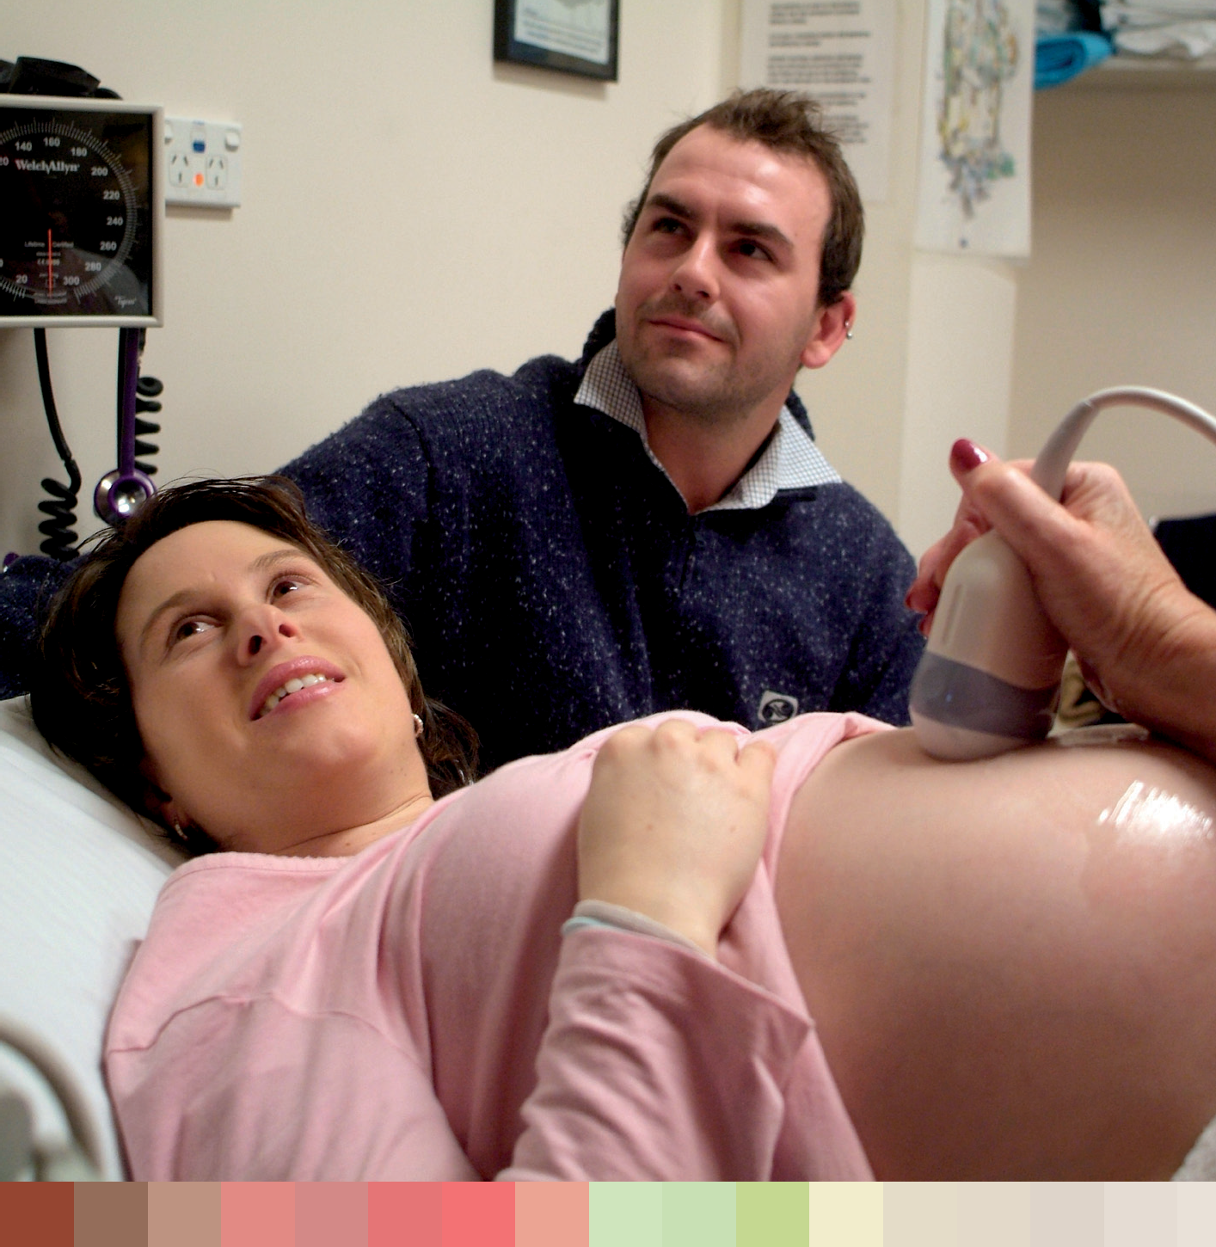

Government actions to address social determinants
Sex and gender
Stronger Sex Discrimination Act—the government has responded to the report of the Senate Legal and Constitutional Affairs Committee Inquiry into the effectiveness of the Commonwealth Sex Discrimination Act 1984 in eliminating discrimination and promoting gender equality. The amendments to the Act will ensure the protections from discrimination it provides apply equally to women and men.
In March 2010 the Australian Government announced funding of $3.6 million over three years for six National Women’s Alliances. The Alliances are made up of more than 100 women’s organisations as well as individual members, and will engage with the Australian Government on policy issues as part of a more informed and representative dialogue between women and government. The Alliances are encouraged to build broad collaborative networks to ensure representation for all women, especially those who have found it difficult to engage in advocacy and decision making in the past, and will provide the opportunity for women to work directly with government departments and agencies on policy issues affecting women. The six alliances are: Economic Security for Women, Equality Rights Alliance, Australian Women Against Violence Alliance, Australian
Immigrant and Refugee Women, National Aboriginal and Torres Strait Islander Women’s Alliance and the National Rural Women’s Coalition and Network.

9 5

National Women’s Health Policy 2010

Access to resources
Income
Pension reform—the government significantly improved the pension system through secure and sustainable pension reforms. Since the reforms began in September 2009 the maximum age pension rate has increased by around $100 a fortnight for singles and around
$76 for couples combined. The improvements focused on the adequacy, sustainability and flexibility of the pension system. For the 71.8 per cent of single age pensioners who are women, this is a major reform.

Paid work
Paid Parental Leave scheme—the government-funded scheme will provide eligible working parents with up to 18 weeks of payments at the National Minimum Wage. This scheme will help parents spend time with newborns, improving outcomes for parents and their child. It will also promote continued participation and contact with the workforce.
The Family-centred Employment Project will commence in 2010. It is designed to assist jobless families to move into education and employment. The demonstration project will be implemented in three specific sites - Broadmeadows (Vic), Goodna (Qld) and Mansfield Park (SA). The objective of the project is to test integrated family-centred service delivery models for participating families.
Review into the effectiveness of the Equal Opportunity for Women in the Workplace Act 1999 and Equal Opportunity for Women in the Workplace Agency—the purpose of the review is to examine the effectiveness and efficiency of the EOWW Act, and to consider practical ways to improve the equal opportunity framework to deliver better outcomes for Australian women.
The Fair Work Act 2009—the Act provides a framework to support women’s workforce participation, improve economic outcomes for women and parents and promote equity in the workplace. The Act enables equity to be advanced through:
- A strengthened safety net of legislated National Employment Standards (NES) and modern awards, including:
  - the right for eligible employees with responsibility for the care of a child under school age or a disabled child under the age of 18 to request flexible working arrangements;
  - unpaid parental leave giving eligible employees the right to separate periods of up to 12 months of unpaid leave associated with the birth or adoption of a child. One parent can also request an additional 12 months’ unpaid parental leave.
  - Extending equal remuneration provisions to include the right to equal pay for work of equal or comparable value;
  - The inclusion of individual flexibility clauses in all modern awards and agreements, enabling employers and employees to negotiate individual working arrangements;
  - Allowing variation of modern awards for work value reasons;
  - Access to multi-employer bargaining for the low-paid; and
  - Enhanced protections from workplace discrimination.

9 6

The Fair Work Ombudsman (FWO)—one of the main roles of the FWO is to enforce the minimum entitlement for employees including their rates of pay, leave entitlements
and hours of work. Enforcement of minimum entitlements is particularly important in protecting the economic security of women.
New strategies for people with disabilities and carers are being introduced that will support women carers and women with disability as both potential employees and as recipients of payments and users of services. These strategies include the National
Disability Strategy and the National Carer Strategy. The draft National Disability Strategy covers six broad policy areas including learning and skills and economic security. The learning and skills outcome area states an intention to increase access for people with disability to inclusive high quality education that is responsive to their needs. The Strategy also recognises that employment opportunities for people with disability as a key to improving economic security and personal wellbeing.

Unpaid work
Recognition Framework. The Carer Recognition Bill 2010 will recognise in law the role and contribution of Australia’s carers. The National Carer Strategy will shape the agenda for reform and guide policy development and delivery of services.

Education
Boosting the quality of child care and early childhood education—the Australian Government is investing more than $17.1 billion over the next four years in early childhood education and child care. This includes $14.4 billion to assist around 800,000 Australian families each year with the cost of child care, through Child Care Benefit and the Child Care Rebate. High quality, affordable child care is critical to enabling parents
with primary care of children to participate in paid work.

Safety and security

The National Plan to Reduce Violence against Women and Their Children
will be a 12 year, joint plan of action for the Australian, state and territory governments to coordinate effort to achieve significant and sustained reduction in violence against women, and will be finalised this year.
Domestic Violence Workplace Rights and Entitlement Project—the government has provided funding of $440,000 (including GST) over 18 months to the Australian Domestic and Family Violence Clearinghouse to carry out a project on
domestic violence and workplace rights and entitlements. The principle aim of the project is to improve the knowledge and capacity of unions and employer organisation to support employees experiencing domestic violence.
The Respectful Relationships Program is testing and evaluating a range of respectful relationships programs, which teach young men and young women the skills
to develop respectful relationships—with intimate partners, friends and family members. The Line primary prevention social marketing campaign, targeting young people, provides opportunities for young people to think about and discuss respectful relationship behaviours drawing on their own experiences.

9 7

The Australian Government is providing an additional $154 million over four years to enhance access to justice through increased funding for legal aid commissions, community legal centres and Aboriginal and Torres Strait Islander legal
services.
The New National Partnership Agreement for Legal Assistance improves access to legal services for vulnerable and disadvantaged Australians experiencing legal problems. The Australian Government is providing an additional $154 million over four years to enhance access to justice through increased funding for legal aid commissions, community legal centres and Aboriginal and Torres Strait Islander legal services. A key priority of the agreement is assisting women and children at risk of violence and abuse by providing family law services.
The government also funds targeted services for women through community legal centres, and culturally appropriate legal assistance services for Aboriginal and Torres Strait Islander men, women, youth and children through Aboriginal and Torres Strait Islander Legal
Services and Family Violence Prevention Legal Services.
The Family Support Program funds a range of services to help maintain and strengthen family relationships, and to minimise the effects of irreparable relationship breakdowns—particularly in relation to children. These services include:
- family relationship advice line;
- family relationships online;
- family relationship centres.
In addition, the government supports a number of programs to assist families:
- family dispute resolution;
- family counselling;
- children’s contact services;
- parenting orders program;
- post-separation cooperative parenting services;
- supporting children after separation program.
Strengthening Indigenous Communities—Community Safety Measures, to strengthen community safety in the Northern Territory, will help address violence against women.
The Domestic Violence Referral Points Project provides:
- training for practice nurses and Aboriginal health workers in Practice Incentives Program (PIP) eligible practices in rural and remote areas to act as points of referral to domestic violence support services for women experiencing domestic violence. Once a practice nurse or Aboriginal health worker has obtained competency through attending the training, their employing general practice is able to claim a payment through the PIP.
- payments through the PIP Domestic Violence Incentive to encourage PIP eligible general practices in rural and remote areas to act as a referral point to domestic violence support services for women experiencing domestic violence.
The government will provide $1.5 million in 2010–11 to continue providing incentives and support payments for practice nurses and Aboriginal health workers in rural and remote areas to undertake training to help them recognise the signs of domestic violence and provide appropriate referrals to available resources in the community.

National Women’s Health Policy 2010

9 8

Diversity
Aboriginal and Torres Strait Islander women
National Congress of Australia’s First Peoples—the new national Aboriginal and Torres Strait Islander representation body was announced in November 2009.
The National Congress of Australia’s First Peoples will ensure that Aboriginal and Torres Strait Islander people contribute to, and play a lead role in, policy and program development on issues that affect them and that an Aboriginal and Torres Strait Islander perspective
is provided on issues across government. The National Congress of Australia’s First Peoples has now been incorporated and eight founding directors have been appointed. The congress has mandated equal representation of men and women in the two co-chairs and six directors of the National Executive and in the co-chairing of the Congress’s Ethics Council.
Apology to the Stolen Generations—on 13 February 2008 the then Prime Minister, the Hon Kevin Rudd MP, formally apologised to the Aboriginal and Torres Strait Islander Stolen Generations on behalf of the Parliament of Australia. The government understands that addressing the impact of the injustices of the past and the adverse treatment of Aboriginal and Torres Strait Islander peoples by other Australians is a critical element in improving health outcomes for Indigenous people.
The Indigenous Leadership Development Program seeks to develop the leadership capacity of individuals and provides Indigenous Australians with increased skills and
knowledge to better engage within their community. The Indigenous Women’s Program is a grants program which contributes to the Australian Government’s priorities for reducing Indigenous disadvantage through supporting projects which enhance Indigenous women’s leadership, representation, safety, wellbeing and economic status.
The National Partnership Agreement on Closing the Gap in Indigenous Health Outcomes aims to close the gap in life expectancy between Indigenous and non-Indigenous Australians within a generation. The Commonwealth’s contribution to this partnership is $805.5 million over four years for an Indigenous Chronic Disease
Package which will improve the prevention, early detection and ongoing management of those chronic diseases that are the main causes of mortality for Aboriginal and Torres Strait Islander peoples.
The Indigenous Early Childhood Development National Partnership (IECD NP) Agreement is a joint Commonwealth and state and territory government commitment in response to COAG’s commitment to close the gap in Indigenous early childhood development outcomes, through improving the health and development of Indigenous children in their early years.
On 2 October 2008 COAG signed the IECD NP Agreement, comprising $564 million of Commonwealth funding over six years.
The IECD NP incorporates three elements:
  - Element One: Integration of Early Childhood Services through 38 Children and Family Centres.
  - Element Two: Increased Access to Antenatal Care, Pre-pregnancy and Teenage Sexual and Reproductive Health.

The Indigenous Leadership Development Program seeks to develop the leadership capacity of individuals and provides Indigenous
Australians with increased skills and knowledge to better engage within their community.

9 9

    - Element Three: Increased Access to, and use of, Maternal and Child Health Services by Indigenous Families.
This NP seeks to contribute to halving the gap in Indigenous child mortality within a decade by increasing access to antenatal care, teenage sexual and reproductive health services, child and maternal health services and providing integrated early childhood development and family support services.
An evaluation will be undertaken to determine the effectiveness of the IECD NP in achieving its outcomes.

In Australia, women are more frequent users of the health system.
Rural and remote women
The Rural Women’s General Practice Service (RWGPS) program aims to improve access to primary health care services for women in rural and remote Australia, who currently have little or no access to a female GP, by facilitating the travel of female GPs to these communities. The RWGPS is open to all members of the community, including men and children. The RWGPS is auspiced by the Royal Flying Doctor Service.
The Rural Primary Health Services program aims to improve access to a range of primary and allied health care services and activities for rural and remote communities. Primary health care services encompass active treatment through provision of allied health services; mental health services; screening programs; and health promotion and preventative health activities. The funded service providers are able to determine which mix of services and health professionals best suits the needs of their communities, taking into account the wishes of the community and the availability of health professionals.
The Medical Specialist Outreach Assistance Program (MSOAP) was established to improve access to medical specialist services for people living in rural and remote locations. The MSOAP complements medical specialist services provided by the state government and private providers by encouraging specialists to deliver outreach services
to targeted areas of need in rural and remote Australia. This is achieved by meeting costs associated with delivering outreach services such as travel, accommodation, and venue hire. The medical specialist disciplines supported include Obstetrics and Gynaecology (including treatment for fertility), Sexual Health, Oncology and Psychiatry. With the exception of Plastic Surgery, all other medical specialities may be supported through MSOAP.

Women with Disability and Women Carers
New strategies for people with disabilities and carers are being introduced that
will support women carers and women with disability. These strategies include the National Disability Strategy and the National Carer Strategy.
The draft National Disability Strategy will guide public policy across governments and aims to bring about change in all mainstream services and programs as well as community infrastructure. This change is important to ensuring that people with disability have the same opportunities as other Australians – health care, a quality education, a job where possible and access to buildings, transport and social activities.

National Women’s Health Policy 2010

1 0 0

National Health reform
Access to health services
In Australia, women are more frequent users of the health system. More women than men visit general practitioners, with older women visiting GPs and hospitals more often than younger women.443 Australian women accounted for 56 per cent of visits to GPs in 2006–07.444
Women are also more likely to take responsibility for the health of those around them including dependants and parents. With an ageing population and increasing life expectancies, there will be more people with disabilities and an increasing demand for carers to look after them. This has particular implications for women and their interaction with the health system. Women currently represent 71 per cent of primary carers in Australia.445 In this context, it is even more important that women have access to flexible health services that enable them to fulfil their different roles.
Access to health care, particularly primary health care such as GPs and other health care providers, is extremely important for all Australians to allow prevention, early detection and treatment of illness, and management of chronic conditions.
All Australian women regardless of their geographic location, ethnicity, sexuality or financial resources have the right to universal access to basic health care that is high quality and responsive. However, some groups of women face significant barriers in accessing
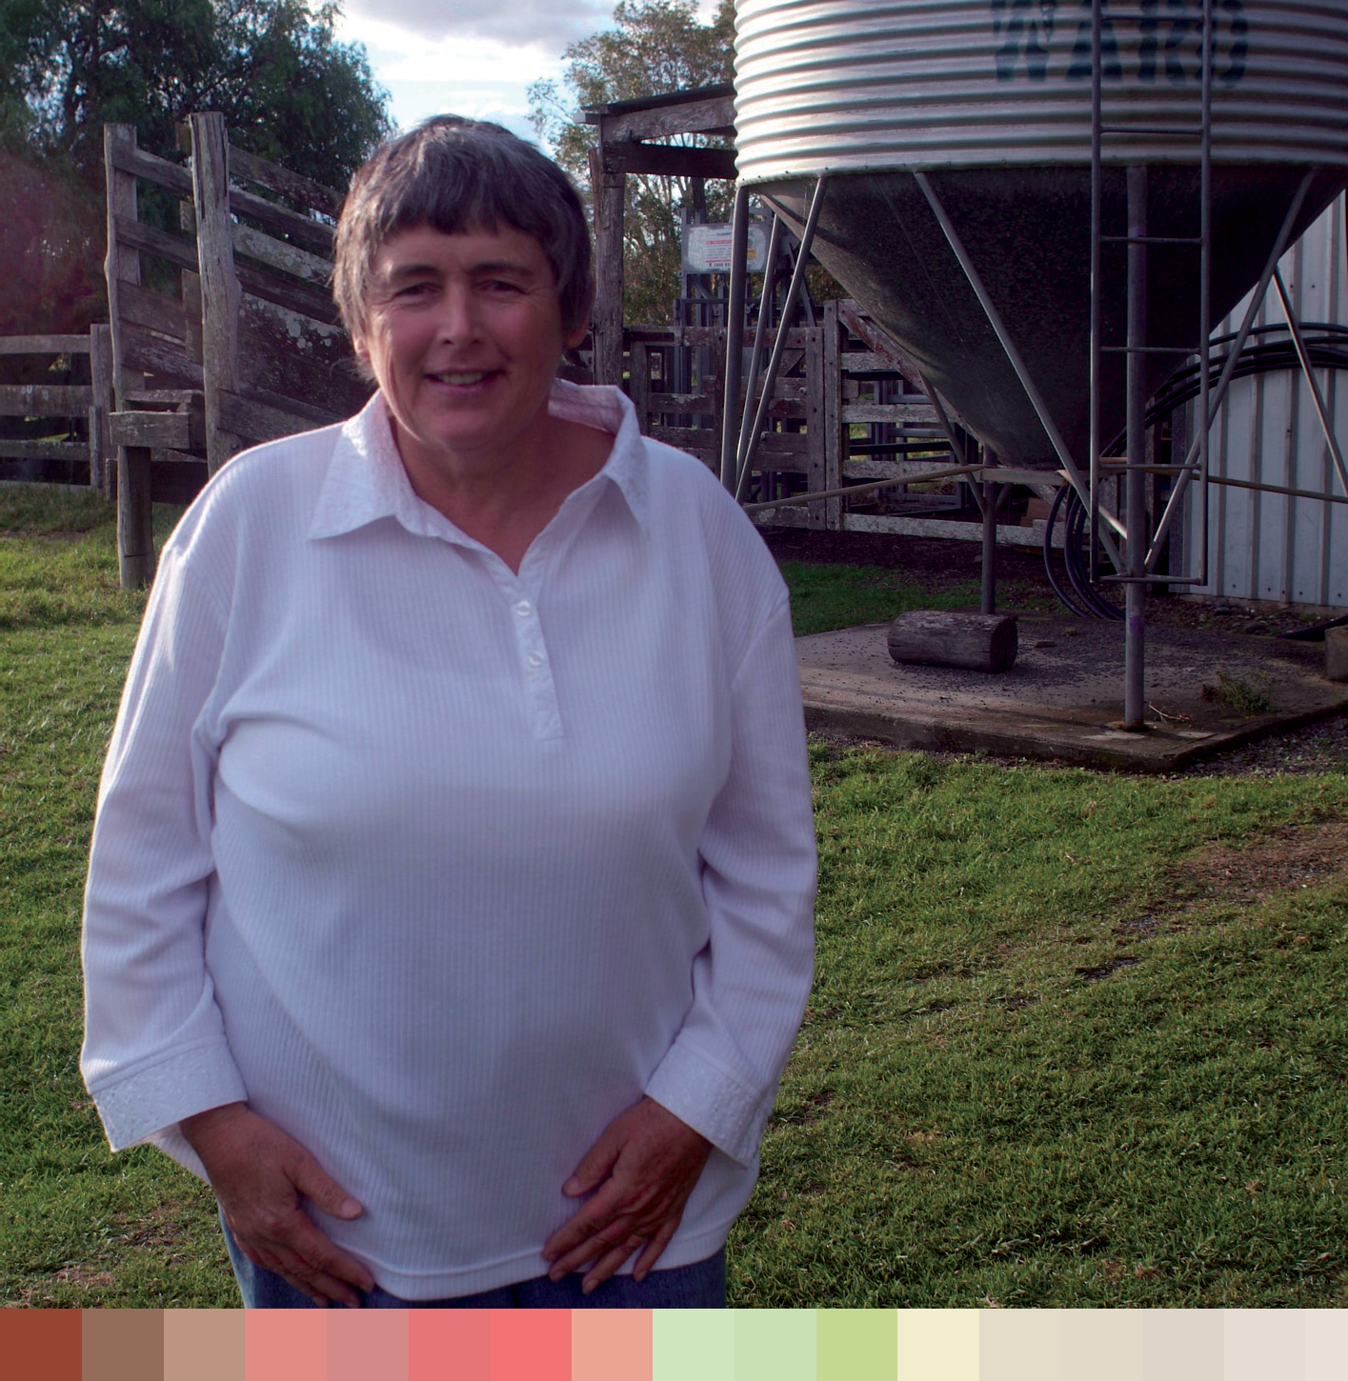

1 0 1

National Women’s Health Policy 2010

health care services and information, and these can include Aboriginal and Torres Strait Islander women, culturally and linguistically diverse women, women with disabilities and women in same sex relationships. It is important that attempts are made to understand the needs of these groups in order to reduce the barriers in accessing services. For disadvantaged and vulnerable women, improving access to health services is a significant contributor to improved health outcomes.
Key issues which can inhibit some women’s access to health care may include:
    - geographic remoteness and restrictions of service availability and cost;
    - lack of transport services;
    - a lack of culturally appropriate health services and information;
    - language barriers between patients and health care providers;
    - racism;
    - discrimination based on sexuality or the assumption of heterosexuality;
    - different conceptions of health; and
    - inaccessibility of buildings, services and information, particularly for women with a disability.
Possible consequences of these barriers may include a lack of awareness about available services, lowered expectations of the health care system and decreased satisfaction with care that can dissuade future attempts to access health care. 446 447 448

Health care reform
The government is undertaking a significant health care reform agenda which includes addressing major access and equity issues that affect Australian women. It is underpinned by the principle that Australia’s health system should promote social inclusion and reduce disadvantage.
The National Health and Hospital Network (NHHN) will deliver a strong and effective health system focused on equitable access to high quality health care. This will be achieved through the creation of a single national unified health system which is nationally funded and locally run.
The redesign of the health system will provide new ways of organising services to facilitate continuity of care for women. This will be achieved through:
    - clearer responsibilities between the Commonwealth and states;
    - the best allocation of health resources throughout the system;
    - improved quality and safety, performance and accountability; and
    - improved efficiency and local responsiveness of health and aged care services.
These changes will allow for programmes and initiatives to be better planned, coordinated and delivered to maintain the higher level of health generally of Australian women and improve the health and wellbeing of individual women who interact with the health system.

1 0 2

National
Clearer responsibilities between the Commonwealth and states
Under the National Health and Hospitals Network, the Commonwealth will become the majority funder of the Australian public hospital system. The Commonwealth will also have full policy responsibility for general practice (GP), primary health care and aged care. The Commonwealth will leverage its funding responsibility to deliver more coordination, control and accountability at the local level.
Under the National Health and Hospital Agreement, states and territories are required to meet specified financial obligations, establish Local Hospital Networks and National Health and Hospitals Network Funding Authorities, provide data to the Independent Pricing Authority, maintain their current level of effort in the delivery of GP and
primary health care services, and ensure that appropriate levels of health expenditure are maintained.
Best allocation of health resources throughout the health system
The Commonwealth Government will make significant investments including:
  - $3.5 billion to improve access to public hospital services;
  - $1.2 billion in workforce initiatives; and
  - $466.7 million in key components of the eHealth system.
Improved quality and safety, performance and accountability
A range of governance functions (performance, funding and reporting frameworks) will be established to underpin the reform process and make the system more transparent and drive improvements across all aspects of the health care system. These include the Independent Hospital Pricing Authority (IHPA), the National Performance Authority
(NPA) and the continuation and expansion of the Australian Commission on Quality and Safety in Health Care.

Local
Improved efficiency and local responsiveness of health and aged care services
The health system needs to be more responsive to the needs of individuals and of local communities. Local hospital networks will be established to manage and deliver hospital services.
The government will establish a network of new Medicare Locals across Australia. One of the functions of Medicare Locals will be to deliver health promotion and preventative health programs targeted to risk factors in their local communities. The new Medicare Locals will tailor programs and activities to meet the needs of their local communities as well as monitor outcomes more effectively. These organisations will be supported in this role by the Australian National Preventative Health Agency, which will provide national standards and guidelines to support the roll-out of effective and appropriate programs.
The establishment of primary health care organizations—funded nationally and run locally—will mean the coordination of general practitioner and allied health professional services, ensuring they are better integrated and more responsive to the needs and priorities of patients and communities.

The health system needs to be more responsive to
the needs of individuals and of local communities. Local hospital networks will
be established to manage and deliver hospital services.

1 0 3

National Women’s Health Policy 2010

Over time, in conjunction with the Australian National Preventative Health Agency, Primary Health Care organisations will be responsible for a range of functions aimed at making it easier for patients to navigate the local health care system and to provide more integrated care. These functions will include:
    - identification of groups of people missing out on GP and primary health care, or services that a local area needs, and better targeting services to respond to these gaps; and
    - delivery of health promotion and preventive health programs targeted to risk factors in communities.

1 0 4

Chapter Six:

Goal areas

Goals
The overall objective of the National Women’s Health Policy is to continue to improve the health and wellbeing of all women in
Australia. The policy outlines five key goals which are important to achieve this objective. These goals articulate long-term objectives to be adopted for improving and facilitating women’s access to health care services and information and to encourage the health system and whole of the government to be more responsive to the health needs of women.
The policy goals are intended to highlight ways that gender inequality and health inequities (between women and men, and between groups of women) can be addressed.
The five goals of the National Women’s Health Policy are to:
      - Highlight the significance of gender as a key determinant of
women’s health and wellbeing.
      - Acknowledge that women’s health needs differ according to their
life stage.
      - Prioritise the needs of women with the highest risk of poor
health.
      - Ensure the health system is responsive to all women, with a clear
focus on illness and disease prevention and health promotion.
      - Support effective and collaborative research, data collection, monitoring, evaluation and knowledge transfer to advance the evidence base on women’s health.

1 0 5

Highlight the significance of gender as a key determinant of women’s health and wellbeing
Despite significant gains in recent years, women still have lower pay, more caring responsibilities and higher overall workloads than men, especially when household work is taken into account. These factors impact on women’s wellbeing, health outcomes and mental health, and affect how they experience illness or disability. They can also impact on women’s access to and experience of the health care system.
Gender is fundamental to women’s health, and a vital consideration in the development of a health system that is more responsive to women’s health needs.
Gender health equity strives for equitable opportunity and access to the social and economic resources required for good health.
Efforts to reduce health inequities require an understanding of sex (biology) and gender (social relations) as they can exacerbate, sustain or even create health inequities.449 As the World Health Organisation Commission on Social Determinants of Health argues, ‘taking action to improve gender equity in health and to address women’s rights to health is one
of the most direct and potent ways to reduce health inequities and ensure effective use of health resources’.

Gender in policy development
Considering gender as part of policy and planning frameworks helps to ensure that women’s experiences are accounted for in planning, facilitating access to services and information and improving delivery of health services.
There is a need for broad action to raise awareness of the gendered nature of health and ageing, and prompt change towards continuing to improve the health of all women.
This policy endorses and promotes the practice of ensuring that gender is considered at all stages of planning and policy development.

National Women’s Health Policy 2010

1 0 6
Listening to women
Women should play a central role in developing initiatives that improve the health and wellbeing of their communities. Effective policies and programs are those developed in ways that incorporate the views and aspirations of the women who will be affected by them. Women must have opportunities to be involved in policy development, health planning, and health decision-making at all levels.
It is important to work towards supporting women to play a leadership role, whilst regonising that women from marginalised groups may find it more difficult to participate in meetings and other forums.
There are a number of ways to ensure women can participate in policy development processes. Policy makers, planners, and health service providers should be encouraged to:
- use a diverse range of settings and ways to invite women to talk about what is appropriate and what works;
- seek advice and support from professionals who have demonstrated their commitment and success in gender-appropriate service provision;
- work in partnership with advocacy organisations; and
- seek expert assistance in interpretation of data about women’s health.

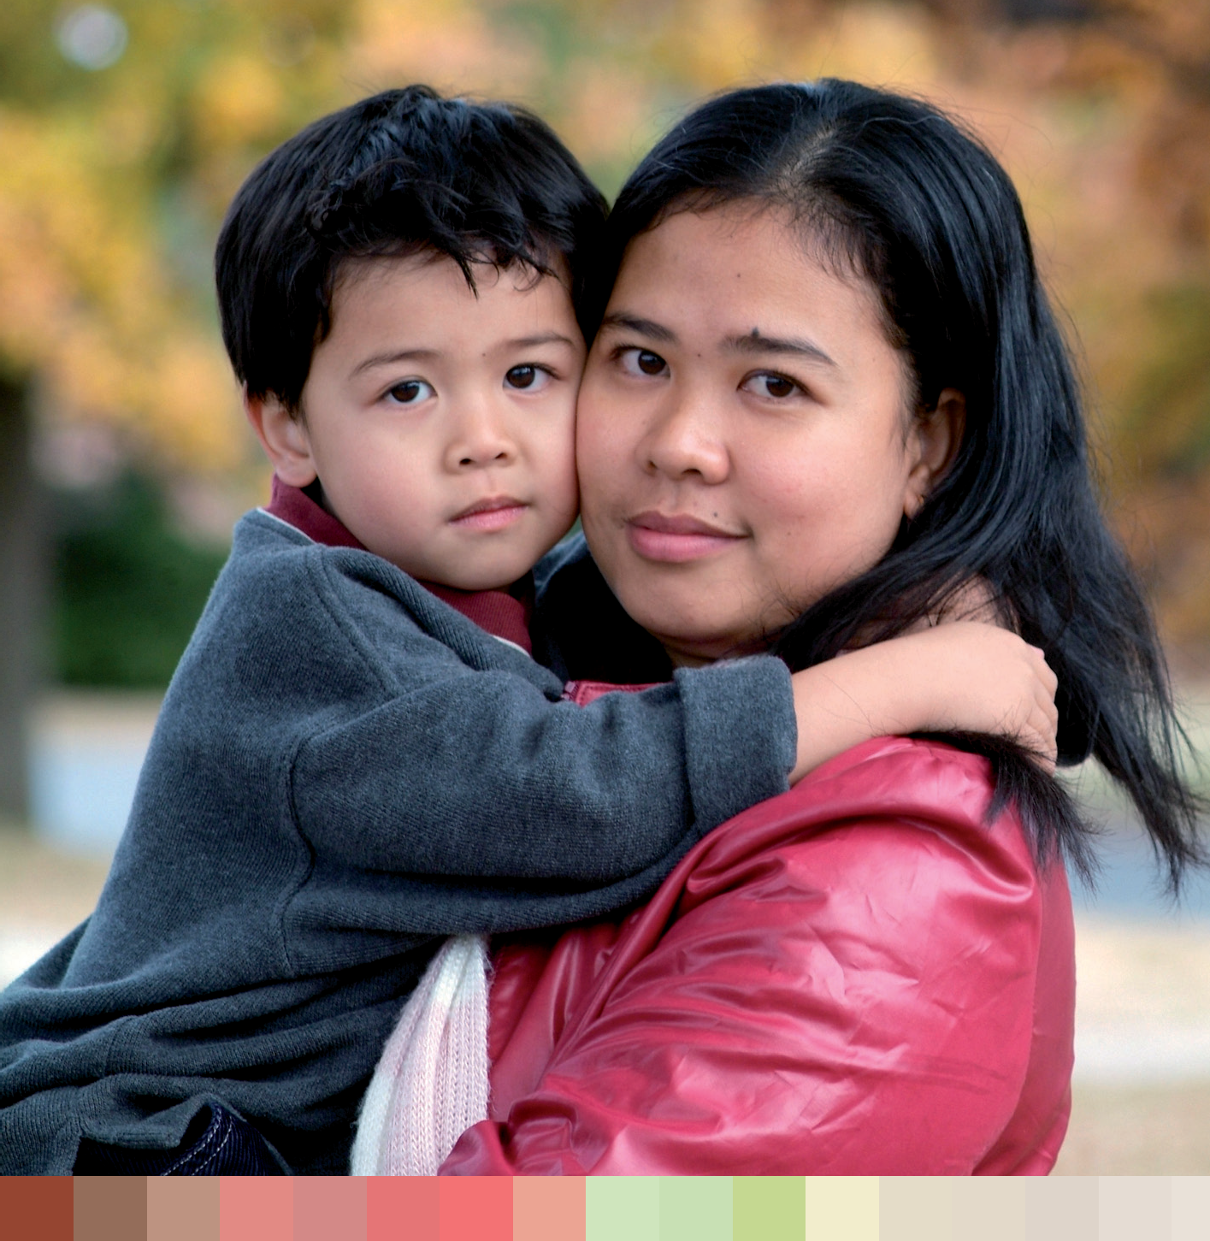

Participation by women in health decision-making can be increased by support for mentorship programs and provision of professional development opportunities to increase representation on decision-making bodies. Such decision-making bodies should have family- and carer-friendly practices—for example, meeting at times that suit women and addressing childcare needs.
  - Explore opportunities for sex and gender to be increasingly considered in policy, planning and decision making
  - Explore the introduction of gender modules into general health and medical education and training curriculum.
  - Consider opportunities to increase women’s decision making in health at all levels; for example through:
    - encouraging women to seek appointments to local boards and committees involved in managing health services;
    - exploring whether AppointWomen, the government register that gives women the opportunity to be considered for appointment to a variety of Australian boards and other decision making bodies, has strong representation from a wide range of women with health backgrounds.

1 0 7

Evidence from the past 20 years has confirmed the importance of taking a whole-
of-life approach, preventing the accumulation of health risk factors.
  - Explore opportunities to build on the gender equality assessment process being conducted by the Department of Families, Housing, Community Services and Indigenous Affairs (FaHCSIA) to analyse how gender equality is promoted through government policy and programs and to promote improvements on this.
  - Promoting the use of the relevant National Women’s Health Alliances within the Department of Health and Ageing to provide the opportunity for women to work directly with departments on health-related policy issues.

Acknowledge that women’s health needs differ according to their life stage
Evidence from the past 20 years has confirmed the importance of taking a whole-of-life approach, preventing the accumulation of health risk factors.
The establishment of the Australian Longitudinal Study on Women’s Health in 1995 has been a major advancement towards improving the evidence base on Australian women’s health. This initiative has been funded as part of the response to the 1989 National Women’s Health Policy.
The aim of the study is to collect scientifically valid information that is relevant to the development of health policy, so that government can base policy and practice in women’s health on current data and accurate information to address health issues of Australian women of all ages.
The three age cohorts of the Australian Longitudinal Study on Women’s Health allow for the study to examining women’s health and wellbeing across the lifespan. At the commencement of the study these cohorts contained young (aged 18–22 years), middle-aged (45–49 years) and older aged (70–74 years) women.
Life stage is one of the key themes of the study. It aims to identify factors that help women to maintain the highest level of health and quality of life following key events such as birth of first child, divorce, menopause, widowhood, major illness, moving house, changing job, falls and fractures in the elderly, dementia and bereavement.
Other themes that the study assesses include:
- physical and emotional health (including wellbeing, major diagnoses, symptoms);
- use of health services (general practitioner, specialist and other visits, access, satisfaction);
- health behaviours and risk factors (diet, exercise, smoking, alcohol, other drugs);
- time use (including paid and unpaid work, family roles and leisure); and
- sociodemographic factors (location, education, employment, family composition).

Using the evidence
Policies and programs should be designed to address health throughout women’s lives, without forgetting that every woman is an individual.
Different health issues can become prominent at different times in a woman’s life; therefore it is important to design age-appropriate health services and care, and provide targeted information and health promotion materials.

National Women’s Health Policy 2010

1 0 8

The government is committed to continue to build on the evidence base and proposes:
  - Exploring opportunities for the Australian Women’s Longitudinal Health Study to create a new younger women’s cohort.
  - Encouraging researchers and academics to consider gender and lifestage projects.

Prioritise the needs of women with the highest risk of poor health
Some health issues are common to many women. But they can be experienced quite differently, according to each woman’s culture, religious views, language, (dis)ability,
sexuality, age, geographical location and socioeconomic status, and interactions with the health system.
There are some groups of women who can be at significantly higher risk of poor health. Chapter Five discusses these groups which can include:
  - Aboriginal and Torres Strait Islander women;
  - women in rural and remote areas;
  - women with a disability;
  - lesbian and bisexual women; and
  - women from culturally and linguistically diverse backgrounds.
Generating equity in health for women means eliminating unnecessary, avoidable or unfair differences in health among different groups of women.
All Australian women have the right to universal access to high quality and responsive basic health care, regardless of their geographic location, ethnicity, sexuality or financial resources. However, variations in women’s access to health services remain.
Under the social model of health, variations can be due to systemic factors. For example, difficulties that rural women experience in accessing services may be attributed not to their choice of location, but rather to a lack of service options and lack of choice in health care provider. This situation is often similar for women with disabilities.
Such barriers to access for women from culturally and linguistically diverse backgrounds may include a lack of culturally responsive information about our health care system; a lack of culturally appropriate health services and information; and under-utilisation or poor
or inappropriate use of interpreter services by professionals, leading to language barriers between women and their health care providers.
Other contributing factors can include resource allocation, skills and attitudes of service providers, housing, education, and transport and communications infrastructure.
How we understand ‘health’ is influenced by our backgrounds. Some health professionals may only understand health within a Western biomedical model, and this may differ significantly from the more holistic models of many Aboriginal and Torres Strait Islander women. Consequences may include lack of awareness about available services, lowered expectations of the health care system and decreased satisfaction with care that can dissuade future attempts to access health care.450 451 452 453
Our sexuality has a significant influence too. Lesbian and bisexual women may not always feel comfortable disclosing their sexuality, and this may affect the health care they receive.

Generating equity in health for women means eliminating unnecessary, avoidable or unfair differences in health among different groups of women.

1 0 9

National Women’s Health Policy 2010

Australia is a diverse community; many women will experience multiple barriers to access, stemming from more than one form of discrimination or marginalisation. This policy promotes the practice of ensuring that equity is considered at all stages of planning, policy development and service delivery.
Any policies intended to address specific population groups also need to acknowledge the role of gender as impacting on people’s experience.
  - Explore the introduction of cultural competency modules into general health and medical education and training curriculum.
  - Consider opportunities to increase diverse women’s decision making in health at all levels; for example, through:
    - encouraging the views of diverse groups of women to be sought in health service planning and delivery, and represented on boards; and
    - ensuring language used to promote health services or provide health information is in formats accessible to diverse groups, especially those who are socially and economically disadvantaged, or for whom English is not a first language.
  - Consider reporting on Aboriginal and Torres Strait Islander women’s and other women’s participation and outcomes in women’s health services, such as cancer screening, sexually transmitted infections and blood-borne virus notifications, birth outcomes and chronic disease outcomes.

Ensure the health system is responsive to all women, with a clear focus on illness and disease prevention and health promotion
Women’s health concerns extend beyond specific health problems to include the structures that deliver health care and information, and the processes which influence women’s interactions with the health system on behalf of themselves, their families and extended networks. These structures and processes affect the quality of care women receive, their access to appropriate and acceptable services and their health outcomes.
The National Women’s Health Policy has been developed at a time of significant reform in the health system. These broader changes will make significant, ongoing contributions to women’s health outcomes.
This policy seeks to work within the framework of systemic health reform to influence health services to improve their responsiveness to all women through:
    - enhancing the skills of the health workforce;
    - building health system collaborations;
    - improving equity of access to health services for all women; and
    - promoting the empowerment and participation of women in decision making about their own health care.

Enhancing the skills of the health workforce
The consultations for this policy highlighted the need for the health workforce to be alert to the context of women’s lives.

1 1 0

Professional bodies offer a range of ongoing professional training, and should encourage participation in training for both gender and cultural awareness. Improved understanding by practitioners of women’s health issues will help to achieve better health outcomes.
Organisations should also look to innovative approaches, such as the use of e-learning in the provision of training opportunities—to increase participation and support a better- skilled workforce. Barriers that can impact on an individual’s decision to participate,
or a workplace’s decision to support participation in training, can include time out of the workplace, workload, course affordability, and extra costs such as travel and accommodation.
Women’s health and equity competencies could be included in training for all new health professionals and in professional development for existing practitioners.

Building health system collaborations
There should be a focus on fostering partnerships between different health services. For example partnerships between mainstream service providers and specialty services such as multicultural health services, Indigenous health services or carers networks. These services can play a key role in building competence and understanding and in suggesting different models of service provision within the mainstream.

Improving equity of access to health services for all women
Health service provision should be tailored to meet identified needs of communities and their members. For example, BreastScreen Australia provides women with mammography services at rural and remote sites through specially equipped vans. Outreach services— especially to rural and remote areas—can make significant differences to women’s uptake of screening and preventative care.
Outreach service planners should:
  - take into account women’s concerns for confidentiality and privacy;
  - ensure services are to be provided in consultation with the intended service users;
  - be affordable (or free);
  - incorporate language needs of specific communities; and
  - be culturally appropriate—women from specific cultural backgrounds, for example Aboriginal and Torres Strait Islander women, may prefer female providers.

Promoting the empowerment and participation of women in decision making about their own health care
Women who actively participate in decisions about their health care generally achieve better health outcomes compared to those who do not. Those most likely to participate in decisions about their own health care tend to be younger and educated.454
Not all women are equally equipped to participate in health care decisions. Increasing involvement in health decision-making places demands on women’s literacy skills to understand complex health information and articulate their preferences. For some women, particularly those with lower levels of education and literacy, they may experience difficulties participating in the process.455

1 1 1

There will be an increased need to focus on materials appropriate for older women.
Ageing causes
physical, psychological and social change, and dependence on health care services and personal health
care often increases.
All women need to be able to make informed choices about their own health and health needs, but not all are equally equipped to participate in these decisions.456 Fostering and supporting programs to increase health literacy is vital.
Policy researchers and policy makers acknowledge health literacy as an important determinant of health.
In the Australian Bureau of Statistics Survey, health literacy is defined as: the knowledge and skills required to understand and use information relating to health issues such as drugs and alcohol, disease prevention and treatment, safety and accident prevention, first aid, emergencies, and staying healthy.
Australian Bureau of Statistics data on health literacy shows that 68.5 per cent of Australians aged 15–19 did not meet the minimum level of skill required to meet the complex demands of everyday life.457
Health literacy therefore requires reading, listening and analytical skills to enable an individual to make informed health choices and to understand their impact. Health materials and information should be developed for different groups of women and support marginalised groups of women to increase their skills provided by schools, community groups and advocacy organisations.
There will be an increased need to focus on materials appropriate for older women. Ageing causes physical, psychological and social change, and dependence on health care services and personal health care often increases. The ability to effectively care for oneself, and interact and communicate with health services, requires a reasonable level of health literacy.
With a focus on illness and disease prevention and health promotion, explore opportunities within the new health reform context to support the development of health services that are responsive to all women.
  - In five years, conduct a review of and report on actions against National Women’s Health Policy that considers the impact of health reform developments on Australian women.
  - As local networks are developed, consider information and resources to support the consideration of gender and women’s diversity at the local level.
  - Explore existing programs that seek to support women’s involvement in health education and literacy, particularly women with mental illness and disability and older women, with the aim to identify best practice in this area.

Support effective and collaborative research, data collection, monitoring, evaluation and knowledge transfer to advance the evidence base on women’s health
The effectiveness of policies and programs will be improved by research that considers the relationship between gender and health, and the interaction between gender and other variables such as socioeconomic status, ethnicity, disability and sexuality.
Accurate, up-to-date data, sound research, and evaluation that records the diversity of women’s experience is required for good policy, planning and service delivery for women.

National Women’s Health Policy 2010

1 1 2

As good health includes all dimensions of wellbeing, it is critical to understand women’s own views of their health.
Women should be fully involved in setting the research agenda to ensure research looks at what women value as important contributors to their good health—acknowledging this will vary according to their life stage and social context.
The Australian Government is committed to investing in the development of a robust evidence base for women’s health policy.
The emphasis in the original policy on the need for gendered data and research to drive health policy and practice was echoed in consultations and submissions for this policy. Many submissions also emphasised the need for data collection to cover the full spectrum of difference in women’s lives: age, place, ethnicity, sexual orientation, disability and immigrant or refugee status. Ensuring that data are not only recorded by sex will improve the evidence base.
It is critical that all policy related to women’s health is grounded in a strong evidence base. Policy and program directions and the allocation of resources must be informed by research and the establishment of gender-sensitive data sets and performance indicators. An emphasis will need to be placed on the broad dissemination of research findings in women’s health as well as the translation of research into guidelines, assessment tools and innovative service-delivery models.
Information gaps remain in our understanding of women’s health in Australia. This could be achieved through better collection and disaggregation of statistics, support for
increased research on gender-based inequalities in health, and on health systems research to strengthen access and improve service quality.
Explore opportunities for research to continue to explore the circumstances of all Australian women, particular those from marginalised groups
  - Continue building the evidence base through programs such as the Australian Women’s Longitudinal Health Study and explore its capacity to further investigate aspects of women’s health.
  - Consider the feasibility of developing a new national women’s clearinghouse for women’s health information.
  - Explore the extent to which existing national surveys disaggregate according to social determinants such as socio-economic status, ethnicity, disability and sexual identity to allow for exploration of the relationship between these and gender.
  - The Department of Health and Ageing will report annually on the progress of women’s health initiatives in consultation with the Office for Women in the Gender Equality Budget Statement.

Information gaps remain in our understanding of women’s health in Australia. This could be achieved through better collection and
disaggregation of statistics, support for increased research on gender-based inequalities in health, and on health systems research to strengthen access and improve service quality.

1 1 3

National Women’s Health Policy 2010

1 1 4

Appendix A

List of all submissions received

Organisation Name
2020 Women
ACT Women’s Health Service
Aiashi, Trudi
Aids Council of New South Wales Inc. (ACON)
Australian Action on Pre-eclampsia
Australian Domestic & Family Violence Clearinghouse
Australian Federation of Medical Women
Australian Federation of University Women
Australian Indigenous HealthInfoNet
Australian Longitudinal Study on Women’s Health*
Australian Nursing Federation
Australian Reproductive Health Alliance*
Australian Women’s Coalition*
Australian Women’s Health Network*
Barwon South Western Regional Women’s Health
Beverley Walker
beyondblue
Billings Life
Bonar, Maria (WA Health)
Bowen, Amanda (Billings Life WA)
Breast Cancer Network of Australia
Burgess, Margaret (Older Women’s Network)
Butts, Margaret
Carer’s Australia
Catholic Health Australia
Catholic Women’s League (TAS)
Centre Against Sexual Violence Inc.
Cerebral Palsy League of Queensland
Cheah, Elizabeth

1 1 5

National Women’s Health Policy 2010

Children by Choice
Coalition of Activist Lesbians
Cochrane, Veena
Council of Social Service of NSW (NCOSS)
Council on the Ageing
Country Women’s Association of Australia*
Coyle, Dr Tim & Mrs Anne
De Summa, Lucy
DES Action Australia, NSW
Dr Jo Harrison
Dr Madonna Grehan & Dr Wendy Pollock
Dr Ruth McNair
Endeavour Forum Inc.
Fahy, Madge
Family Planning NSW
Family Planning WA
Federation of Ethnic Communities Council of Australia
FertilityCare and NaProTechnology
Fertility Society of Australia
Ford, Dr Carole
Fred Hollows Foundation
Gippsland Women’’s Health Service
Gold Coast Centre Against Sexual Violence Inc.
Gympie Women’’s Health Centre
Gynaecological Awareness Information Network (Gain) Inc.
Harris, Margaret T C
Heffernan, Patsy
Helen Keleher
Helena Knox
Hobart Women’s Health Centre
Home Economics Institute of Australia
Hope Alexander
Human Genetics Society of Australasia
Hunter Women’s Centre

1 1 6

Illawarra Women’s Health Centre
Janny Dijkman
Jude Comfort
Kamen, Vivien
Kelleher, Terri M
Kennealy, Merilyn
Key Centre for Women’s Health in Society
Leichhardt Women’s Community Health Centre
Les-Bi Visible Project
Life Course and Intergenerational Health Research Group
Logan Women’s Health and Wellbeing Centre
Louise Marshall
Lovering, Kerry
Loving for Life (Melbourne)
Loving for Life WA
Lucas, Margaret
Magner, Catherine
Major General WB Digger James
Marie Stopes International
Matrix Guild Victoria
McCormack, John
McManus, Louise
Midland Women’s Health Care Place
MMHA Consultations with Multicultural Agencies
MMHA National CALD Mental Health Consumer & Carer Reference Group members
Mr Fahy
Mrs Sussan Altus
Multicultural Centre for Women’s Health*
Munro, Jane
Murray, Marianne
National Association of People Living with HIV AIDS
National Breast and Ovarian Cancer Centre
National Ethnic Disability Alliance
National Foundation for Australian Women*

1 1 7

National Women’s Health Policy 2010

National LGBT Alliance
National LGBT Health Alliance
National Rural Health Alliance
National Rural Women’s Coalition*
Natural Fertility Australia*
Newman, Dr Pooja
North Queensland Combined Women’s Services
NSW FGM Education Program
NSW Rape Crisis Centre
Older Women’s Network NSW
Older Women’s Network NSW
Organisation Intersex International
Pelvic Instability Association Inc.
Phillips, Peter
Pierce, Ros
Polycystic Ovarian Syndrome Society of Australia
Pregnancy Help Australia
Public Health Association of Australia*
Queensland Health Mental Health Directorate
Queensland Nurses Union
Rauch, Mark
ROAR Collective
Royal Australian and New Zealand College of Psychiatrists
Royal Australian College of General Practitioners*
Royal Australian College of Physicians
Royal Flying Doctor Service
Royal Women’s Hospital
Rural Doctors Association of Australia*
SA Health
SA Premier’s Council for Women
Scarfe, Silvana
Seniors Social Isolation Report
Sexual Health & Family Planning Australia
Smith, Roz

1 1 8

Smith, Sam
Sussanna Scurry
Tasmanian Women’s Health Program
Terrill, Mary
Tewfik, Odette
The Jean Hailes Foundation*
Tonkin, Sue
Victoria Women with Disabilities Network
Victorian GLBTI Ministerial Advisory Committee
Victorian Health Promotion Foundation
Victorian Women and Mental Health Network
Vireo Health Promotions
Vision 2020
Wagga Women’s Health Centre
War Widows Guild of Australia NSW Ltd
WHISE National Women’s Health Policy
Whiting, Gabrielle (Endeavour Forum Inc.)
Wide Bay Women’s Health Centre
Women and Wellness (WOW)
Women With Disabilities Australia*
Women’s Action Alliance (Australia) Inc.
Women’s Centre for Health Matters
Women’s Forum Australia
Women’s Health Association of Victoria
Women’s Health East
Women’s Health Goulburn East
Women’s Health Grampians
Women’s Health in the North
Women’s Health NSW
Women’s Health Queensland Wide
Women’s Health Services Northbridge WA
Women’s Health Victoria
Women’s Health West
WOMEN’S Healthworks

1 1 9

National Women’s Health Policy 2010

Women’s Hospitals Australasia
Women’s Services Network SA
WomenSpeak*
YWCA of Adelaide
Zonta International District 24

* These refer to organisations that were funded to provide written submissions

1 2 0

References
- Australian Institute of Health and Welfare (2010) Australia’s Health 2010. AIHW, Canberra.
- Ibid.
- Australian Bureau of Statistics (2006) General Social Survey, Cat No. 4159.0. ABS, Canberra.
- Australian Institute of Health and Welfare (2010) Australia’s Health 2010. AIHW, Canberra.
- Australian Institute of Health and Welfare (2007) The burden of disease and injury in Australia 2003, Cat No. PHE
82. AIHW, Canberra.
- Ibid.
- Australian Institute of Health and Welfare (2008) Australia’s Health 2008. AIHW, Canberra.
- Australian Institute of Health and Welfare (2007) The burden of disease and injury in Australia 2003, Cat No. PHE
82. AIHW, Canberra.
- Australian Bureau of Statistics (2006) Health Literacy, Australia, 2006. 4233.0. ABS, Canberra
- Australian Bureau of Statistics (2005) Population by Age and Sex, Australian States and Territories, June 2005. Cat. No. 3201.0. ABS, Canberra.
- Australian Bureau of Statistics (2004) Australian Social Trends, 2004. Cat. No. 4102.0. ABS, Canberra.
- Australian Bureau of Statistics (2006) Australian Historical Population Statistics, 2006. Cat. No. 3105.0.65.001,
Table 39. ABS, Canberra
- Australian Bureau of Statistics (2005) Births, Australia, 2005. ABS Cat. No. 3301.0. ABS, Canberra.
- Australian Bureau of Statistics (2005) Deaths, Australia, 2005. ABS Cat. No. 3302.0. ABS, Canberra.
- Department of Health and Ageing: Medicare Statistics, table D1 <http://www.health.gov.au/internet/main/ publishing.nsf/Content/medstat-jun09-tables-d>, accessed on 14 July 2010
- Heart Watch Heart Foundation Survey (2010) unpublished.
- Petty T (1999) ‘The Rising Epidemic of COPD in Women: Why women are more susceptible; how treatment should differ.’ Women’s Health in Primary Care, 2(12).
- Australian Institute of Health and Welfare (2010) Australia’s Health 2010. AIHW, Canberra.
- Australian Longitudinal Study on Women’s Health (2009) Reproductive Health: Findings from the Australian Longitudinal Study on Women’s Health, the University of Newcastle and the University of Queensland, Australia.
- Ibid.
- Australian Institute of Health and Welfare (2010) Australia’s Health 2010. AIHW, Canberra.
- Australian Institute of Health and Welfare (2008) Australia’s Health 2008. AIHW, Canberra.
- Stear S (2003) ‘Health and fitness, Series 1. The importance of physical activity for health.’ Journal of Family Health Care, 3(1):10-13.
- Australian Institute of Health and Welfare (2010) Australia’s Health 2010. AIHW, Canberra.
- Australian Institute of Health and Welfare (2007) National Drug Strategy Household Survey: Detailed findings. Cat No. PHE 107, AIHW, Canberra.
- Australian Longitudinal Study on Women’s Health (2009) Reproductive Health: Findings from the Australian Longitudinal Study on Women’s Health, the University of Newcastle and the University of Queensland, Australia.
- Ibid.
- Australian Institute of Health and Welfare (2010) Australia’s Health 2010. AIHW, Canberra.

1 2 1

National Women’s Health Policy 2010

- Australian Institute of Health and Welfare (2008) 2007 National Drug Strategy Household Survey: First Results. Cat No. PHE 98. AIHW, Canberra.
- Australian Bureau of Statistics (2007) National Survey of Mental Health and Wellbeing, 2007, ABS, Canberra.
- Australian Institute of Health and Welfare (2010) Australia’s Health 2010. AIHW, Canberra.
- Australian Bureau of Statistics (2005) Deaths, Australia, 2005, ABS Cat. No. 3302.0. ABS, Canberra.
- Australian Institute of Health and Welfare (2010) Australia’s Health 2010. AIHW, Canberra.
- Ibid.
- Australian Institute of Health and Welfare (2008) Australia’s Health 2008. AIHW, Canberra.
- Begg S, Vos T, Barker B, Stevenson C, Stanley L & Lopex A (2007) The Burden of Disease and Injury in Australia, 2003. Australian Institute of Health and Welfare, Canberra.
- Australian Institute of Health and Welfare (2008) Australia’s Health 2008. Cat No. AUS 99. AIHW, Canberra.
- Ibid.
- Ibid.
- Pfizer Australia (2005) Healthy hearts. Pfizer Australia Health Report, Issue 13, March.
- Correa-De-Araujo R (2006) ‘Serious Gaps: How the lack of sex/gender based research impairs health’. Journal of Women’s Health. 15(10):1116-1122.
- Kudenchuk P, et al. (1996) ‘Comparison of presentation, treatment, and outcome of acute myocardial infarction in men versus women (the Myocardial Infarction Triage and Intervention Registry)’. American Journal of Cardiology. 78(1):9-14.
- Clow B, Pederson A, Haworth-Brockman M, & Bernier J (2009) Rising to the Challenge: sex and gender based analysis for health planning, policy and research in Canada. Atlantic Centre of Excellence for Women’s Health, Canada.
- Cho L, Hoogwerf B, Huang J, Brennan DM, Hazen SL (2008) ‘Gender Differences in Utilization of Effective Cardiovascular Secondary Prevention: A Cleveland Clinic Prevention Database Study’. Journal of Women’s Health. 17(4):515-521.
- Correa-De-Araujo R (2006) ‘Serious Gaps: How the lack of sex/gender based research impairs health’. Journal of Women’s Health. 15(10):1116-1122.
- Chiaramonte G & Friend R (2006) ‘Medical students’ and residents’ gender bias in the diagnosis, treatment and interpretation of coronary heart disease symptoms’. Health Psychology. 25(3):255-266.
- Australian Institute of Health and Welfare (2008) Rural, regional and remote health: Indicators of health status and determinants of health. Cat. No. PHE 97. AIHW, Canberra.
- Australian Institute of Health and Welfare (2008) Australia’s Health 2008. Cat No. AUS 99. AIHW, Canberra.
- Australian Institute of Health and Welfare 2008. Diabetes: Australian facts 2008. Diabetes series no. 8. Cat. No. CVD 40. Canberra: AIHW.
- Di Cianni G, Volpe L, Lencioni C, Miccoli R & Cuccuru I (2003) ‘Prevalence and risk factors for gestational diabetes assessed by universal screening’. Diabetes Research and Clinical Practice. 62:2
- The Jean Hailes Foundation for Women’s Health (June 2009) Submission for a new National Women’s Health Policy.
- Australian Institute of Health and Welfare (2008) Rural, regional and remote health: Indicators of health status and determinants of health. Cat. No. PHE 97. AIHW, Canberra.
- Australian Institute of Health and Welfare (2008) Diabetes: Australian facts 2008. Diabetes series no. 8. Cat. No. CVD 40. AIHW, Canberra.

1 2 2

- Australian Bureau of Statistics (2007) The health and wellbeing of Aboriginal and Torres Strait Islander women: a snapshot, 2004–05. Issue 4722.0.55.001. ABS, Canberra.
- Australian Institute of Health and Welfare (2008) Diabetes: Australian facts 2008. Diabetes series no. 8. Cat. No. CVD 40. AIHW, Canberra.
- Ibid.
- Ibid.
- Australian Institute of Health and Welfare (2008) Australia’s health 2008. Cat No. AUS 99. AIHW, Canberra.
- Australian Institute of Health and Welfare (2008) Australian Cancer Incidence and Mortality (ACIM) books, All Cancers, AIHW, Canberra.
- Australian Institute of Health and Welfare (2008) Australia’s health 2008. Cat No. AUS 99. AIHW, Canberra.
- Australian Institute of Health and Welfare, Cancer Australia & Australasian Association of Cancer Registries (2008). Cancer survival and prevalence in Australia: cancers diagnosed from 1982 to 2004. Cancer Series no. 42. Cat. no. CAN 38. AIHW. Canberra
- Australian Institute of Health and Welfare (2010) Australian Cancer Incidence and Mortality Books. AIHW: Canberra.
- Australian Institute of Health and Welfare & Australasian Association of Cancer Registries (2008) Cancer in Australia: an overview, 2008. Cancer series No. 46. Cat. no. CAN 42. Canberra: AIHW.
- Australian Institute of Health and Welfare & Australasian Association of Cancer Registries (2008) Cancer in Australia: an overview, 2008. Cancer series No. 46. Cat. no. CAN 42. Canberra: AIHW.
- Australian Institute of Health and Welfare (2010) Australian Cancer Incidence and Mortality Books. AIHW: Canberra.
- Australian Institute of Health and Welfare (2010) Australian Cancer Incidence and Mortality Books. AIHW: Canberra.
- Australian Institute of Health and Welfare (2008) Cancer in Australia: An overview. AIHW, Canberra.
- Australian Institute of Health and Welfare (2008) Cervical screening in Australia 2005–2006. Cancer series no. 41. Cat. No. CAN 36. Canberra: AIHW.
- Australian Institute of Health and Welfare (2008) Cancer in Australia: An overview 2008 AIHW Cat. No. CAN 42. AIHW, Canberra.
- Australian Institute of Health and Welfare (2008) Cancer survival and prevalence in Australia: Cancers diagnosed from 1982–2004. Cat. No. CAN 38. AIHW, Canberra.
- Australian Institute of Health and Welfare (2008) Cancer in Australia: an overview, 2008. Cancer series no.46. AIHW, Canberra.
- Australian Institute of Health and Welfare (2004) Cancer in Australia 2001. AIHW, Canberra.
- Australian Institute of Health and Welfare (2008) Cancer in Australia: an overview, 2008. Cancer series No.46. AIHW, Canberra.
- Australian Institute of Health and Welfare (2004) Cancer in Australia 2001. AIHW, Canberra.
- Australian Institute of Health and Welfare (2004) Cancer in Australia 2001. AIHW, Canberra.
- Australian Institute of Health and Welfare (2008) Australia’s health 2008. Cat No. AUS 99. AIHW, Canberra.
- Australian Institute of Health and Welfare (2008) Rural, regional and remote health: indicators of health status and determinants of health. AIHW Cat. No. PHE 97. AIHW, Canberra.
- Ibid.

1 2 3

National Women’s Health Policy 2010

- Australian Institute of Health and Welfare (2007) Cancer in Australian: an overview, 2006. Cancer series No.37. AIHW, Canberra.
- Australian Institute of Health and Welfare (2008) Australia’s health 2008. Cat No. AUS 99. AIHW, Canberra.
- Australian Institute of Health and Welfare (2008) Cervical screening in Australia 2005–2006. Cancer series No. 41 Cat. No. CAN 36. AIHW, Canberra.
- Australian Reproductive Health Alliance (2009). National Women’s Health Policy Submission by the Australian Reproductive Health Alliance (ATHA). Campbell.
- Australian Longitudinal Study on Women’s Health (2003) Chronic disease and health services in Australia. The University of Newcastle and the University of Queensland, Australia.
- Australian Institute of Health and Welfare (2008) Rural, regional and remote health: Indicators of health status and determinants of health. Cat. No. PHE 97. AIHW, Canberra.
- Ibid.
- Cassells R, Miranti R, Nepal B & Tanton R (2009) “She works hard for the money”: Australian women and the gender divide. AMP.NATSEM Income and Wealth Report Issue 22, April.
- Australian Institute of Health and Welfare (2008) Australia’s health 2008. Cat No. AUS 99. AIHW, Canberra.
- Australian Bureau of Statistics (2009) National Health Survey: Summary of results, 2007–08. No. 4364.0. ABS, Canberra.
- Ibid.
- Australian Longitudinal Study on Women’s Health (2009) Reproductive Health: Findings from the Australian Longitudinal Study on Women’s Health. The University of Newcastle and the University of Queensland, Australia.
- Access Economics (2008) The growing cost of obesity in 2008: three years on. Diabetes Australia.
- Preventative Health Taskforce (2008) Australia: the healthiest country by 2020. Technical Report No 1 Obesity in Australia: a need for urgent action. Preventative Health Taskforce. Canberra.
- Adamson, L et al. (2007) Women’s weight: findings from the Australian longitudinal study on women’s health. Women’s Health Australia. Department of Health and Ageing, Canberra.
- Brown W, Hockey R & Dobson A (2010) ‘Effects of having a baby on weight gain’. American Journal of Preventative Medicine. 38(2):163-170.
- Banwell C, Hinde S, Dixon J & Sibthorpe B (2005) ‘Reflections on expert consensus: a case study of the social trends contributing to obesity’. European Journal of Public Health. 15(6):564.
- Australian Institute of Health and Welfare (2008) Australia’s Health 2008. Cat No. AUS 99. AIHW, Canberra.
- Reidpath D, Burns C, Garrard J, Mahoney M & Townsend M (2002) ‘An ecological study of the relationship between social and environmental determinants of obesity’. Health and Place. 8(2):141-145.
- Australian Bureau of Statistics (2009) National Health Survey: Summary of results, 2007–08. No. 4364.0. ABS, Canberra.
- Cleland V, Hume C, Crawford D, Timperio A, Hesketh K, Baur L, Welch N, Salmon J & Ball K (2010) ‘Urban- rural comparison of weight status among women and children living in socioeconomically disadvantaged neighbourhoods’. MJA. 192(3):137-140.
- Australian Bureau of Statistics (2007) The health and wellbeing of Aboriginal and Torres Strait Islander women: a snapshot, 2004–05. Issue 4722.0.55.001. ABS, Canberra.
- Polimeni A, Austin S & Kavanagh A (2009) Sexual orientation and weight, body image and weight control practices among young Australian women. Journal of Women’s Health. 18(3):355-62.

1 2 4

- Begg S, Vos T, Barker B, Stevenson C, Stanley L, and Lopez AD (2007) The burden of disease and injury in Australia 2003. PHE 82. Canberra: AIHW.
- Ibid.
- Australian Bureau of Statistics (2006) National Health Survey: Summary of results, 2004–05. No. 4364.0. ABS, Canberra.
- Ibid.
- Ibid.
- Australian Institute of Health and Welfare (2008) Australia’s health 2008. Cat No. AUS 99. Canberra: AIHW.
- Ibid.
- Kettings C, Sinclair A & Voevodin M (2009) ‘A healthy diet consistent with Australian health recommendations is too expensive for welfare-dependent families’. Australian and New Zealand Journal of Public Health. 33(6):566-572.
- Reidpath D, Burns C, Garrard J, Mahoney M & Townsend M (2002) ‘An ecological study of the relationship between social and environmental determinants of obesity’. Health and Place. 8(2):141-145.
- Australian Institute of Health and Welfare (2008) Rural, regional and remote health: Indicators of health status and determinants of health. Cat. No. PHE 97. AIHW, Canberra.
- Australian Institute of Health and Welfare (2008) Rural, regional and remote health: Indicators of health status and determinants of health. Cat. No. PHE 97. AIHW, Canberra.
- Australian Bureau of Statistics (2007) The health and wellbeing of Aboriginal and Torres Strait Islander women: a snapshot, 2004–05. Issue 4722.0.55.001. ABS, Canberra.
- Lappalainen, R., Saba, A., Holm, L., Mykkanen, H., & Gibney, M. J. (1997). Difficulties in trying to eat healthier: Descriptive analysis of perceived barriers for healthy eating. European Journal of Clinical Nutrition, 51, S36.
- Australian Bureau of Statistics. (2006). 2004–05 National Health Survey: Summary of Results (Catalogue No. 4364.0). Canberra: Australian Bureau of Statistics.
- Jabs, J., & Devine, C. M. (2006). Time scarcity and food choices: an overview. Appetite, 47(2): 196-204.
- Jabs, J., Devine, C.M., Bisogni, C.A., Farrell, T.J., Jastran, M., & Wethington, E. (2007). Trying to find the quickest way: Employed mothers’ constructions of time for food. Journal of Nutrition Education and Behavior, 39(1): 18-25.
- Australian Institute of Health and Welfare. Prevention of cardiovascular disease, diabetes and chronic kidney disease: targeting risk factors. Canberra: AIHW 2009 Contract No.: Cat. no. PHE 118.
- Diabetes Australia Vic (2008) Physical activity and type 2 diabetes. Talking diabetes No.27. http://www.diabetesvic.org. au/type-2-diabetes/physical-activity
- Australian Institute of Health and Welfare (2008) Australia’s health 2008. Cat No. AUS 99. Canberra: AIHW.
- Ibid.
- Ibid.
- Australian Institute of Health and Welfare (2007) Young Australians: their health and wellbeing 2007. Cat. No. PHE
87. Canberra: AIHW.
- Armstrong T, Bauman A, Davies J (2000) Physical activity levels of Australian adults: results of the 1999 national physical activity survey. Canberra: Australian Institute of Health and Welfare.
- Eating Disorders Foundation of Victoria (20080) Body image issues for women. Better Health Channel.
- Loukaitou-Sideris A (2009) How to ease women’s fear of transportation environments: case studies and best practices. San Jose: Mineta Transport Institute.

1 2 5

National Women’s Health Policy 2010

- Sherwood NE & Jeffery RW (2000) ‘The behavioral determinants of exercise: implications for physical activity interventions’. Annual Review of Nutrition. 20:21-44.
- Ball K, Crawford D & Warren N (2004) ‘How feasible are healthy eating and physical activity for young women?’
Public Health Nutrition. 7(3):433-441.
- Australian Bureau of Statistics (2006) 2004–05 National Health Survey: Summary of Results. Cat No. 4364.0. ABS, Canberra.
- Jabs J & Devine CM (2006) ‘Time scarcity and food choices: An overview’. Appetite. 47(2):196-204.
- Jabs J, Devine CM, Bisogni CA, Farrell TJ, Jastran M & Wethington E (2007) ‘Trying to find the quickest way: Employed mothers’ constructions of time for food’. Journal of Nutrition Education and Behavior. 39(1):18-25.
- Benoit C & Shumka L (2009) Gendering the Health Determinants Framework: why girls’ and women’s health matters.
Vancouver Women’s Health Research Network, Vancouver.
- Kavanagh AM & Bentey R (2008) ‘Walking: a gender issue?’ Australian Journal of Social Issues. 43(1):45-64.
- Brown W, Heesch K & Miller Y (2009) 'Life events and changing physical activity patterns in women at different life stages'. Annals of Behavioral Medicine, 37:294-305.
- Australian Institute of Health and Welfare (2008) Rural, regional and remote health: Indicators of health status and determinants of health. Cat. No. PHE 97. AIHW, Canberra.
- Australian Bureau of Statistics (2006) National Aboriginal and Torres Strait Islander Health Survey 2004–05. ABS, Canberra.
- Hunt J, Marshall AL & Jenkins D (2008) ‘Exploring the meaning of, the barriers to and potential strategies for promoting physical activity among urban Indigenous Australians’. Health Promotion Journal of Australia. 19(2):102-8.
- Australian Institute of Health and Welfare (2008) Australia’s Health 2008. Cat No. AUS 99. AIHW, Canberra.
- Australian Institute of Health and Welfare (2008) 2007 National Drug Strategy Household Survey. Drug statistics series no.20 Cat. No. PHE 98. AIHW, Canberra
- Australian Institute of Health and Welfare (2007) Young Australians: their health and wellbeing 2007. Cat. No. PHE
87. AIHW, Canberra.
- Collishaw NE, Boyd NF, Cantor KP, Hammond SK, Johnson KC, Millar J, et al. (2009) Canadian expert panel on tobacco smoke and breast cancer risk. Ontario Tobacco Research Unit, OTRU Special Report Series, Toronto.
- Greaves L, Kalaw C & Bottorff JL (2007) ‘Case studies of power and control related to tobacco use during pregnancy’. Women’s Health Issues. 17(5):325–32.
- Office of the Surgeon General (2001) Women and smoking: A report of the Surgeon General. Washington: US Department of Health and Human Services, Public Health Services, Office of the Surgeon General.
- Greaves LJ & Richardson LA (2007) ‘Tobacco use, women, gender, and chronic obstructive pulmonary disease: are the connections being adequately made?’ Proc Am Thorac Soc. 4:675-79.
- Webster J, Chandler J & Battistutta D (1996) ‘Pregnancy outcomes and health care use: effects of abuse’. American Journal of Obstetrics and Gynecology. 174(2):760-7.
- Australian Institute of Health and Welfare (2008) Australia’s health 2008. Cat No. AUS 99. Canberra: AIHW.
- Australian Bureau of Statistics (2007) The health and wellbeing of Aboriginal and Torres Strait Islander women: a snapshot, 2004–05. Issue 4722.0.55.001. ABS, Canberra.
- Australian Institute of Health and Welfare (2008) Rural, regional and remote health: Indicators of health status and determinants of health. Cat. No. PHE 97. AIHW, Canberra.

1 2 6

- Ibid.
- Polimeni A, Austin S & Kavanagh (2009) ‘Sexual orientation and weight, body image and weight control practices among young Australian women’. Journal of Women’s Health. 18(3):355-362.
- Australian Institute of Health and Welfare (2008) 2007 National Drug Strategy household survey: first results. Drug Statistics Series number 20. Cat. No. PHE 98. AIHW, Canberra.
- Australian Institute of Health and Welfare (2008) Australia’s Health 2008. Cat No. AUS 99. AIHW, Canberra.
- Australian Institute of Health and Welfare (2008) Australia’s Health 2008. Cat No. AUS 99. AIHW, Canberra.
- De Visser R, Rissel C, Smith A & Richters J (2006) ‘Sociodemographic correlates of selected health risk behaviours in a representative sample of Australian young people’. International Journal of Behavioral Medicine. 13(2):153-162.
- Australian Bureau of Statistics (2006) Alcohol consumption in Australia: a snapshot, 2004–05. No. 4832.0.55.001. ABS, Canberra.
- Australian Institute of Health and Welfare (2004) Excessive alcohol consumption. AIHW, Canberra.
- Plant M (2008) ‘The role of alcohol in women’s lives: A review of issues and responses’. Journal of Substance Use.
13(3):155-191.
- Peralta R (2008) ‘Alcohol allows you to not be yourself ’: toward a structured understanding of alcohol use and gender difference among gay and lesbian, and heterosexual youth. The Journal of Drug Issues. 38:373-400.
- Cornelius, M, Day, N (2000) The Effects of Tobacco Use During and After Pregnancy on Exposed Children, Alcohol Research and Health: Vol 24.
- Australian Institute of Health and Welfare (2008) Rural, regional and remote health: Indicators of health status and determinants of health. Cat. No. PHE 97. AIHW, Canberra.
- Australian Drug Foundation (2004) Alcohol and other drug use by Australian Indigenous people: a snapshot. Premier’s Drug Prevention Council, Melbourne.
- Australian Health Ministers Advisory Council (2006) Aboriginal and Torres Strait Islander Health Performance Framework Report 2006. AHMAC, Canberra.
- Hiller L, Turner A & Mitchell A (2005) Writing themselves in again—six years on: The second national report on the sexuality, health and wellbeing of same sex attracted young people. Australian Research Centre in Sex Health and Society, La Trobe University, Melbourne.
- Polimeni A, Austin S & Kavanagh (2009) ‘Sexual orientation and weight, body image and weight control practices among young Australian women’. Journal of Women’s Health. 18(3):355-362.
- Testa M, VanZile-Tamsen C, Livingston A (2007) Prospective prediction of women’s sexual victimization by intimate and non-intimate male perpetrators. Journal of Consulting Clinical Psychology. 75(1):52–60.
- Australian Longitudinal Study on Women’s Health (2005) Research highlights – the first decade: Partner Violence and the Health of Australian Women. Women’s Health Australia, The Australian Longitudinal Study on Women’s Health the University of Newcastle Australia and the University of Queensland, Newcastle.
- Begg S, Vos T, Barker B, Stevenson C, Stanley L & Lopex A (2007) The Burden of Disease and Injury in Australia, 2003. Australian Institute of Health and Welfare, Canberra.
- Slade T, Johnston A, Teesson M, Whiteford H, Burgess P, Pirkis J & Saw S (2009) The Mental Health of Australians
2. Report on the 2007 National Survey of Mental Health and Wellbeing. Department of Health and Ageing, Canberra.
- Slade T, Johnston A, Teesson M, Whiteford H, Burgess P, Pirkis J & Saw S (2009) The Mental Health of Australians
2. Report on the 2007 National Survey of Mental Health and Wellbeing. Department of Health and Ageing, Canberra.

1 2 7

National Women’s Health Policy 2010

- Andrews G, Hall W, Teesson M & Henderson S (1999) The Mental Health of Australians. Mental Health Branch, Commonwealth Department of Health and Aged Care, Canberra.
- Berry J & Harrison J (2007) Hospital separations due to injury and poisoning, Australia 2003-04. Australian Institute of Health and Welfare. Canberra.
- Judd F, Armstrong S & Kulkarni J (2009) ‘Gender sensitive mental health care’. Australasian Psychiatry.
17(2):105-111.
- Outram S, Mishra G, & Schofield MJ. (2004). 'Sociodemographic and health related factors associated with poor mental health in midlife Australian women'. Women and Health, 39: 97-115.
- France C, Lee C, and Powers J. (2004) 'Correlates of depressive symptoms in a representative sample of young Australian women [online]'. Australian Psychologist, 39 (3): (228)-237
- Neumann DA, Houskamp BM, Pollack VE, Briere J (1996) ‘The long term sequelae of childhood sexual abuse in women: A meta-analytic review’. Child Maltreatment. 1:6-16.
- Vos T, Astbury J, Piers LS, Hennan M, Stanley L, Walker L & Webster K (2006) ‘Measuring the impact of intimate partner violence on the health of women in Victoria, Australia’. Bulletin of the World Health Organization, September 2006, 89(9).
- Loxton D, Schofield M & Hussain R (2006) ‘Psychological health in mid-life among women who have ever lived with a violent partner or spouse’. Journal of Interpersonal Violence. 21:1092-1097.
- Australian Longitudinal Study on Women’s Health (2005) Research highlights – the first decade: Partner Violence and the Health of Australian Women. Women’s Health Australia, The Australian Longitudinal Study on Women’s Health the University of Newcastle Australia and the University of Queensland, Newcastle.
- Roberts GL, Williams GM, Lawrence JM & Raphael B (1998) ‘How does domestic violence affect women’s mental health?’ Women and Health. 28: 117–29.
- World Health Organization (2000) Women and Mental Health: An Evidence Based Review. World Health Organisation, Geneva.
- Campbell JC (2002) ‘Health consequences of intimate partner violence’. Lancet. 359:1331–6.
- Loxton D, Schofield M & Hussain R (2006) ‘Psychological health in mid-life among women who have ever lived with a violent partner or spouse’. Journal of Interpersonal Violence. 21:1092-1097.
- Farmer A, Treasure J & Szmukler G (1986) ‘Eating disorders: A review of recent research’. Digestive Diseases.
4:13-25.
- VicHealth (2004) Parliamentary Inquiry into issues relating to the development of body image among young people and associated effects on their health and wellbeing: VicHealth Response. VicHealth, Melbourne.
- Bennett HA, Einarson A, Taddio A, Koren G & Einarson TR (2004) ‘Prevalence of depression during pregnancy: Systemic review’. Obstetrics and Gynecology. 103:698-709.
- Cohen LS, Soares CN, Vitonis AF, Otto MW & Harlow BL (2006) ‘Risk for new onset depression during the menopausal transition’. Archives of General Psychiatry. 63:385-390.
- Cohen LS, Altshuler LI, Harlow BL et al. (2006) ‘Relapse of major depression during pregnancy in women who maintain or discontinue antidepressant treatment’. Journal of the American Medical Association. 295:499-507.
- Buist A & Bilszta J (2006) The beyondblue National Postnatal Depression Program: Prevention and early Intervention 2001–2005: Vol. 1 National Screening Program. beyondblue.
- Loxton D & Lucke J (2009) Reproductive health: Findings from the Australian Longitudinal Study on women’s health. Australian Longitudinal Study on Women’s Health Report to the Office of the Status for Women, University of Newcastle, Newcastle.

1 2 8

- Australian Bureau of Statistics (2006) Mental Health in Australia: A Snapshot, 2004–05. Cat No. 4824.5.55.001. ABS, Canberra.
- Australian Institute of Health & Welfare (2006) Australia’s health 2006. AIHW, Canberra.
- Outram S, Mishra G & Schofield MJ (2004) ‘Sociodemographic and health related factors associated with poor mental health in midlife Australian women’. Women and Health. 39:97-115.
- France C, Lee C & Powers J (2004) ‘Correlates of depressive symptoms in a representative sample of young Australian women [online]’. Australian Psychologist. 39(3):228-237.
- Australian Institute of Health and Welfare (2008) Rural, regional and remote health: Indicators of health status and determinants of health. Cat. No. PHE 97. AIHW, Canberra.
- Ibid.
- Australian Bureau of Statistics (2007) The health and wellbeing of Aboriginal and Torres Strait Islander women: A snapshot, 2004–05. Cat. no. 4722.0.55.001. ABS, Canberra.
- Department of Health and Human Services (1995). Ways Forward: National Aboriginal and Torres Strait Islander Mental Health Policy National Consultancy Report, 7. Aboriginal Women and Mental Health. Australian Government. Online, available at: <http://www.health.gov.au/internet/main/publishing.nsf/Content/mental-pubs-w-
wayforward> Accessed 10 March 2010.
- Poljski C and Murdolo A (2009). To Every Woman: Money, Power, Freedom - Credit and Debt Experiences of Immigrant and Refugee women. (Full Report of the Healthy Credit Project). Multicultural Centre for Women’s Health. Melbourne.
- Multicultural Centre for Women’s Health (2009) Submission of the Multicultural Centre for Women’s Health to the National Women’s Health Policy. Collingwood.
- Hyde Z, Comfort J, Brown G, McManus A & Howat P (2007) The Health and Well-Being of Lesbian and Bisexual Women in Western Australia. Western Australian Centre for Health Promotion Research, Curtin University of Technology, Perth.
- McNair R, Kavanagh A, Agius P & Tong B (2005) ‘The mental health status of young adult and mid-life non- heterosexual Australia women’. Australian and New Zealand Journal of Public Health. 293:265-271.
- Eagar K, Owen A, Williams K, Westera A, Marosszeky N, England R & Morris D (2007) Effective Caring: A synthesis of the international evidence on carer needs and interventions: Volume two. Centre for Health Services Development, University of Wollongong, Wollongong.
- Eagar K, Owen A, Williams K, Westera A, Marosszeky N, England R & Morris D (2007) Effective Caring: A synthesis of the international evidence on carer needs and interventions: Volume two. Centre for Health Services Development, University of Wollongong, Wollongong.
- Edwards B, Higgins D, Gray M, Zmijewski N & Kingston M (2008) The nature and impact of caring for family members with a disability in Australia. Australian Institute of Family Studies, Canberra.
- Schofield MJ & Khan A (2008) ‘Australian women who seek counselling: Psychosocial, health behaviour, and demographic profile’. Counselling and Psychotherapy Research, 8(1):12-20.
- Schofield MJ & Khan,A (2008) ‘Australian women who seek counselling: Psychosocial, health behaviour, and demographic profile’. Counselling and Psychotherapy Research, 8(1):12-20.
- Outram S, Murphy B & Cockburn J (2004) ‘Factors associated with accessing professional help for psychological distress in midlife Australian women’. Journal of Mental Health. 13(2):185-195.
- Australian Reproductive Health Alliance (2009) National Women’s Health Policy Submission by the Australian Reproductive Health Alliance (ATHA). Campbell.

1 2 9

National Women’s Health Policy 2010

- Women’s Health Victoria (2009) Women’s Health Issues Paper No. 2—Women and Sexual and Reproductive Health. WHV. Melbourne
- Richters J, Grulich A, de Visser R, Smith A & Rissel C. (2003) ‘Contraceptive practice among a representative sample of women’. Australian and New Zealand Journal of Public Health. 27 (2): 210-216.
- Ibid.
- Ibid.
- Smith A, Agius P, Mitchell A, Barrett C, Pitts M (2009) Secondary Students and Sexual Health 2008, Monograph Series No. 70, Melbourne: Australian Research Centre in Sex, Health & Society, La Trobe University.
- Ibid.
- Hiller L, Turner A, & Mitchell, A. (2005) Writing themselves in again – six years on: The second national report on the sexuality, health and wellbeing of same sex attracted young people. Australian Research Centre in Sex Health and Society, La Trobe University, Melbourne.
- Smith A, Agius P, Mitchell A, Barrett C, Pitts M. (2009) Secondary Students and Sexual Health 2008, Monograph Series No. 70, Melbourne: Australian Research Centre in Sex, Health & Society, La Trobe University.
- Ibid.
- Ibid.
- Weisberg E, Bateson D, Read C & Estoesta J (2008) ‘Fertility control? Middle-aged Australian women’s retrospective reports of their pregnancies’. Australian and New Zealand Journal of Public Health 32(4):390-392.
- Taft A & Toomey L (2005) VicHealth review of links between and interventions to reduce alcohol-related interpersonal violence: An evidence-based comprehensive literature review. Victorian Health Promotion Foundation (VicHealth), Melbourne.
- Smith A, Agius P, Dyson S, et al. (2003) Secondary Students and Sexual Health 2002: Results of the 3rd National Survey of Australian Secondary Students, HIV/AIDS and Sexual Health, in Monograph Series. Australian Research Centre in Sex, Health and Society, La Trobe University: Melbourne.
- Ibid.
- Australian Longitudinal Study on Women’s Health (2005) Research highlights – the first decade: Partner Violence and the Health of Australian Women. Women’s Health Australia, The Australian Longitudinal Study on Women’s Health the University of Newcastle and the University of Queensland, Australia
- Taft A, Watson L & Lee C (2004) Health and Experiences of Violence Among Young Australian Women. The Australian Longitudinal Study on Women’s Health the University of Newcastle Australia and the University of Queensland, Newcastle.
- Australian Longitudinal Study on Women’s Health (2005) Research highlights – the first decade: Partner Violence and the Health of Australian Women. Women’s Health Australia, The Australian Longitudinal Study on Women’s Health the University of Newcastle Australia and the University of Queensland, Newcastle.
- Smith A, Agius P, Dyson S, et al. (2003) Secondary Students and Sexual Health 2002: Results of the 3rd National Survey of Australian Secondary Students, HIV/AIDS and Sexual Health, in Monograph Series. Australian Research Centre in Sex, Health and Society, La Trobe University: Melbourne.
- Australian Bureau of Statistics (2006) Personal Safety Australia, 2005. ABS Cat. No. 4906.0. ABS, Canberra.
- PATH (2002) Violence against Women: Effects on Reproductive Health, available at <http://www.path.org/files/ EOL20_1.pdf> accessed on 10 March 2010.
- Grulich A, de Visser R, Smith A, Rissel C, & Richters J. (2003) ‘Sexually transmissible infection and blood-borne virus history in a representative sample of adults’. Australian and New Zealand Journal of Public Health 27(2):
234-241.
1 3 0

- Ibid.
- Ibid.
- National Centre in HIV Epidemiology and Clinical Research (2010) HIV, viral hepatitis and sexually transmissible infections in Australia Annual Surveillance Report 2010. National Centre in HIV Epidemiology and Clinical Research, The University of New South Wales, Sydney, NSW.
- Ibid.
- Department of Health and Ageing (2009) Communicable disease intelligence. vo.33, no.2. Canberra.
- Ibid.
- National Centre in HIV Epidemiology and Clinical Research (2009) Annual surveillance report: HIV/AIDS, viral hepatitis and sexually transmissible infections in Australia. National Centre in HIV Epidemiology and Clinical Research, The University of New South Wales, Sydney, NSW.
- Ibid.
- Ibid.
- Ibid.
- Ibid.
- Kang M, Skinner R & Foran T (2007) ‘Sex, contraception and health’. Australian Family Physician. 36(8):594-600.
- National Centre in HIV Epidemiology and Clinical Research (2009) Annual surveillance report: HIV/AIDS, viral hepatitis and sexually transmissible infections in Australia. National Centre in HIV Epidemiology and Clinical Research, The University of New South Wales, Sydney, NSW.
- Smith A, Agius P, Mitchell A, Barrett C & Pitts M (2009) Secondary Students and Sexual Health 2008. Monograph Series No. 70. Australian Research Centre in Sex, Health & Society, La Trobe University, Melbourne.
- Ibid.
- Ibid.
- Ibid.
- Ibid.
- Better Health Channel (2007) Pelvic Inflammatory Disease (PID). Better Health Channel. <http:// www.betterhealth.vic.gov.au/BHCV2/BHCARTICLES.NSF/pages/Pelvic_inflammatory_ disease?OpenDocument>. Accessed March 24, 2009.
- Pink B & Allbon, P (2008) The Health and Welfare of Australia’s Aboriginal and Torres Strait Islander Peoples 2008.
AIHW cat. no. IHW 21, ABS Cat. No. 4704.0. AIHW & ABS, Canberra.
- Hiller L, Turner A & Mitchell A (2005) Writing themselves in again—six years on: The second national report on the sexuality, health and wellbeing of same sex attracted young people. Australian Research Centre in Sex Health and Society, La Trobe University, Melbourne.
- Norman RJ, Wu R & Stankiewicz MT (2004) ‘MJA Practice Essentials—Endocrinology 4: Polycystic ovary syndrome’. Medical Journal of Australia. 180:132-137.
- Meyer C, McGrath BP & Teede HJ (2005) ‘The effects of medical therapy on insulin resistance and the cardiovascular system in polycystic ovary syndrome’. Journal of Endocrinology & Metabolism. 90(10):5711-6.
- Coffey S & Mason H (2003) ‘The effect of polycystic ovary syndrome on health-related quality of life’. Gynecology Endocrinology. 17:379-386.
- The Jean Hailes Foundation for Women’s Health (2010) Endometriosis. The Jean Hailes Foundation for Women’s Health. Clayton South.

1 3 1

National Women’s Health Policy 2010

- Berecki-Gisolf J, Begum N & Dobson A (2009) ‘Symptoms reported by women in midlife: menopausal transition or aging?’ Menopause: The Journal of The North American Menopause Society. 16(5):1021-1029.
- Pines A, Sturdee D, Birkhauser M, de Villiers T, Naftolin F, Gompel A, Farmer R, Barlow D, Tan D, Maki P, Lobo R, Hodis H, et al (2008) HRT in the early menopause: scientific evidence and common perceptions. Summary of the First International Menopause Society Global Summit on menopause-related issues.
- Australian Institute of Health and Welfare (2007) Young Australians: their health and wellbeing 2007. Cat. No. PHE
87. AIHW, Canberra.
- Australian Bureau of Statistics (2009) Births Australia 2008. ABS, Canberra.
- Ibid.
- Smith A, Agius P, Mitchell A, Barrett C, Pitts M. 2009. Secondary Students and Sexual Health 2008, Monograph Series No. 70, Melbourne: Australian Research Centre in Sex, Health & Society, La Trobe University.
- Pink, B. & Allbon, P (2008) The health and welfare of Australia’s Aboriginal and Torres Strait Islander peoples. ABS & AIHW, Canberra.
- Abello A & Harding A (2004) The dynamics of child poverty in Australia. Discussion Paper No. 60. National Centre for Social and Economic Modelling, University of Canberra, Canberra.
- Callaway L, Prins J, Chang A, McIntyre D (2006) The Prevalence and Impact of Overweight and Obesity in an Australian Obstetric Population, Medical Journal of Australia. 184(2):56-9.
- Ibid.
- Ibid.
- Australian Population Health Development Principal Committee (2007) The prevalence and severity of iodine deficiency in Australia. APHDPC, Department of Health and Human Services, Tasmania.
- Loxton D & Lucke J (2009) Reproductive health: Findings from the Australian Longitudinal Study on women’s health. Australian Longitudinal Study on Women’s Health Report to the Office of the Status for Women, University of Newcastle, Newcastle.
- Hure A, Young A, Smith R & Collins C (2009) ‘Diet and pregnancy status in Australian women’. Public Health Nutrition. 12(6): 853–861.
- Loxton D & Lucke J (2009) Reproductive health: Findings from the Australian Longitudinal Study on women’s health. Australian Longitudinal Study on Women’s Health Report to the Office of the Status for Women, University of Newcastle, Newcastle.
- Walsh R, Lowe J & Hopkins P. (2001) ‘Quitting Smoking in Pregnancy’. The Medical Journal of Australia, 175:320-323.
- Laws P, Grayson N & Sullivan E. (2006) Smoking and pregnancy. Cat. No. PER 33. AIHW National Perinatal Statistics Unit. Sydney.
- Laws PJ & Hilder L (2008) Australian Mothers and Babies 2006. Perinatal statistics series no. 22. Cat. No. PERS 46. AIHW National Perinatal Statistics Unit., Sydney.
- Loxton D & Lucke J (2009) Reproductive health: Findings from the Australian Longitudinal Study on women’s health. Australian Longitudinal Study on Women’s Health Report to the Office of the Status for Women, University of Newcastle, Newcastle.
- National Preventative Health Taskforce (2009) Australia: The healthiest country by 2020: Technical Report No 2: Tobacco control in Australia: making smoking history. Prepared for the National Preventative Health Taskforce by the Tobacco Working Group, Canberra.

1 3 2

- Australian Institute of Health and Welfare (2008) Australia’s Mothers and Babies 2006. AIHW Cat. No. PER 46. AIHW, Canberra.
- Australian Health Ministers Advisory Council (2006) Aboriginal and Torres Strait Islander Health Performance Framework Report 2006. AHMAC, Canberra.
- Powers J, Loxton D, Burns L, Shakeshaft A, Ellitott E & Dunlop A (2010) ‘Assessing pregnant women’s compliance with different alcohol guidelines: an 11-year prospective study’. MJA. 192(12):690-693.
- National Preventative Health Taskforce (2008) Technical report No 3: Preventing alcohol related harm in Australia: a window of opportunity. Prepared for the National Preventative Health Taskforce by the Alcohol Working Group, Canberra.
- Loxton D & Lucke J (2009) Reproductive health: Findings from the Australian Longitudinal Study on women’s health. Australian Longitudinal Study on Women’s Health Report to the Office of the Status for Women, University of Newcastle, Newcastle.
- Laws PJ, Grayson N & Sullivan EA (2006) Smoking and Pregnancy. AIHW Cat No. PER 33. AIHW National Perinatal Statistics Unit, Sydney.
- Pink B & Allbon P (2008) The health and welfare of Australia’s Aboriginal and Torres Strait Islander peoples. ABS cat. no. 4704.0. AIHW cat. no. IHW 21. ABS & AIHW, Canberra.
- Sullivan, E and King JF (eds) (2006) Maternal deaths in Australia 2000–2002. Maternal Deaths Series no.2 Cat no. PER 32. Sydney: AIHW National Prenatal Statistics Unit.
- Australian Bureau of Statistics (2008) Deaths, Australia 2008. No. 3302.0. ABS, Canberra.
- Australian Institute of Health and Welfare (2009) Aboriginal and Torres Strait Islander Health Performance Framework 2008 report: detailed analysis. AIHW cat. no. IHW 22. AIHW, Canberra.
- Allen Consultation Group (2008) Are we there yet: indicators of inequality in health – Report to the Department of Human Services. Allen Consulting Group, Victorian Department of Human Services.
- Australian Institute of Health and Welfare (2008) Australia’s health 2008. Cat No. AUS 99. AIHW, Canberra.
- Australian Health Ministers’ Conference (2009) The Australian National Breastfeeding Strategy 2010–2015. Australian Government Department of Health and Ageing, Canberra.
- National Health and Medical Research Council (2003) Dietary Guidelines for Children and Adolescents in Australia incorporating the Infant Feeding Guidelines for Health Workers. NHMRC, Canberra.
- Australian Institute of Family Studies (2008) Growing up in Australia: the Longitudinal Study of Australian Children: 2006–07 Annual Report. Australian Institute of Family Studies, Melbourne.
- Scotts JA & Binns CW (1998) ‘Factors associated with the initiation and duration of breastfeeding: a review of the literature’. Australian Journal of Nutrition and Dietetics. 55(2):51–61.
- Australian Health Ministers Advisory Council (2006) Aboriginal and Torres Strait Islander Health Performance Framework Report 2006. AHMAC, Canberra.
- Australian Bureau of Statistics (2008) Causes of Death, Australia, 2006. Cat No. 3303.0. ABS, Canberra.
- S Begg, T Vos, B Barker, C Stevenson, L Stanley, AD Lopez, AIHW (2007) The Burden of Disease and Injury in Australia, AIHW cat. no. PHE 82, pg 75.
- Australian Institute of Health and Welfare (2008) Australia’s Health 2008. AIHW, Canberra.
- Australian Institute of Health and Welfare (2006) Life Expectancy and Disability in Australia 1988 to 2003, AIHW Cat. No. DIS 47. AIHW, Canberra.
- Australian Bureau of Statistics (2004) Disability, Ageing and Carers, Australia: Summary of findings, 2003. ABS, Cat No 4430.0. ABS, Canberra.

1 3 3

National Women’s Health Policy 2010

- Women’s Health Victoria (2009) Gender Impact Assessment no 10: Women and Ageing. Women’s Health Victoria, Melbourne.
- Eshbaugh E (2008) ‘Perceptions of living alone among older women’. Journal of Community Health Nursing. 25:125-37.
- Australian Human Rights Commission (2009) Accumulating poverty? Women’s experiences of inequality over the life cycle. Australian Human Rights Commission, Sydney.
- Boneham MA & Sixsmith J (2006) ‘The voices of older women in a disadvantaged community: issues of health and social capital’. Social Science & Medicine. 62:269-79.
- Byles J & Carroll M (2008) ‘Conference Report - Mars and Venus: does gender matter in ageing?’. MJA. 188(5):271-3.
- Feldman S, Byles J, Beaumont R, 2000, ‘‘Is anybody listening?’ The experiences of widowhood for older Australian women’, Journal of Women and Ageing, Volume 12.
- Australian Institute of Health and Welfare (2008) Australia’s health 2008. Cat no. AUS 99. Canberra: AIHW.
- Begg S, Vos T, Barker B, Stevenson C, Stanley L and Lopez A (2007) The Burden of Disease and Injury in Australia 2003. AIHW, Canberra.
- Parkinson L, Gibson R, Robinson I & Byles J (2010) ‘Older women and arthritis: Tracking impact over time’.
Australasian Journal on Ageing. doi: 10.1111/j.1741-6612.2010.00422.x
- Australian Institute of Health and Welfare (2008) Arthritis and osteoporosis in Australia. Arthritis series No.8. AIHW Cat. No. PHE 106. AIHW, Canberra.
- Australian Institute of Health and Welfare (2008) Arthritis and osteoporosis in Australia. Arthritis series No.8. AIHW Cat. No. PHE 106. AIHW, Canberra.
- Australian Institute of Health and Welfare (2008) Arthritis and osteoporosis in Australia. Arthritis series No.8. AIHW Cat. No. PHE 106. AIHW, Canberra.
- Australian Institute of Health and Welfare (2008) Arthritis and osteoporosis in Australia 2008. Arthritis series No. 8. Cat. No. PHE 106. Canberra: AIHW.
- Parkinson L, Gibson R, Robinson I & Byles J (2010) ‘Older women and arthritis: Tracking impact over time’.
Australasian Journal on Ageing. doi: 10.1111/j.1741-6612.2010.00422.x
- Australian Institute of Health and Welfare (2007) Older Australians at a glance. Cat No. AGE 52. AIHW, Canberra.
- Australian Institute of Health and Welfare (2008) Arthritis and osteoporosis in Australia. Arthritis series no.8. AIHW Cat. No. PHE 106. AIHW, Canberra.
- Australian Institute of Health and Welfare (2008) Arthritis and osteoporosis in Australia. Arthritis series no.8. AIHW Cat. No. PHE 106. AIHW, Canberra.
- Australian Institute of Health and Welfare (2008) Arthritis and osteoporosis in Australia. Arthritis series no.8. AIHW Cat. No. PHE 106. AIHW, Canberra.
- Parkinson L, Gibson R, Robinson I & Byles J (2010) ‘Older women and arthritis: Tracking impact over time’.
Australasian Journal on Ageing. doi: 10.1111/j.1741-6612.2010.00422.x
- Australian Institute of Health and Welfare (2008) Rural, regional and remote health: Indicators of health status and determinants of health. Cat. No. PHE 97. AIHW, Canberra.
- Parkinson L, Gibson R, Robinson I & Byles J (2010) ‘Older women and arthritis: Tracking impact over time’.
Australasian Journal on Ageing. doi: 10.1111/j.1741-6612.2010.00422.x
- Strazdins, L., & Bammer, G. (2004) ‘Women, work and musculoskeletal health’. Social Science and Medicine. 58(6):997-1005.

1 3 4

- Access Economics (2009) Keeping Dementia Front of Mind: Incidence and Prevalence 2009–2050. Access Economics, Canberra.
- Australian Institute of Health and Welfare (2006) Dementia in Australia: National data analysis and development. AIHW, Canberra.
- Ibid.
- Access Economics (2009) Keeping Dementia Front of Mind: Incidence and Prevalence 2009–2050. Access Economics, Canberra.
- Australian Bureau of Statistics (2008) Causes of Death, Australia, 2006. Cat No. 3303.0. ABS, Canberra.
- Alzheimer’s Australia (2008) Dementia Facts and Statistics. Alzheimer’s Australia, Canberra.
- Ibid.
- Access Economics (2009) Keeping Dementia Front of Mind: Incidence and Prevalence 2009–2050. Access Economics, Canberra.
- Access Economics (2009) Keeping Dementia Front of Mind: Incidence and Prevalence 2009–2050. Access Economics, Canberra.
- Australian Institute of Health and Welfare (2007) Dementia in Australia: National Data Analysis and Development.
Australian Institute of Health and Welfare, Canberra.
- Australian Institute of Health and Welfare (2007) Older Australians at a glance. Cat. no. AGE 52. AIHW, Canberra.
- Access Economics (2009) Keeping Dementia Front of Mind: Incidence and Prevalence 2009–2050. Access Economics, Canberra.
- Australian Institute of Health and Welfare (2006) Dementia in Australia: National data analysis and development. AIHW cat. no. AGE 53. AIHW, Canberra.
- NSW Department of Health (2010) The NSW Dementia Services Framework 2010–2015. NSW Department of Health.
- NSW Department of Health (2010) The NSW Dementia Services Framework 2010–2015. NSW Department of Health.
- Ibid.
- NSW Department of Health (2010) The NSW Dementia Services Framework 2010–2015. NSW Department of Health.
- Ibid.
- Australian Bureau of Statistics (2006) Personal Safety Australia, 2005. ABS Cat. No. 4906.0. ABS, Canberra.
- Ibid.
- Schofield MJ, Reynolds R, Mishra GD, Powers JR & Dobson AJ (2002) ‘Screening for vulnerability to abuse among older women: Women’s Health Australia study’. Journal of applied Gerontology. 21(1):24-39.
- Women’s Health Australia (2009). Submission to development of National women’s Health Policy, June 2009. Callaghan.
- Barnett K, Buys L, Lovie-Kitchin J, Boulton-Lewis, Smith D & Heffernan M (2007) ‘Older women’s fears of violence: the need for interventions that enable active ageing’. Journal of Women & Ageing. 19(3&4):179-193.
- Australian Institute of Health and Welfare (2009) BreastScreen Australia Monitoring Report 2005–06. AIHW, Canberra.
- Australian Institute of Health and Welfare (2009) Cervical Screening in Australia 2007–2008. AIHW, Canberra.
- World Health Organisation (1946) Preamble to the Constitution of the World Health Organization. WHO, Geneva.

1 3 5

National Women’s Health Policy 2010

- Commission on Social Determinants of Health (2008) Closing the gap in a generation: Health equity through action on the social determinants of health: Final report of the Commission on Social Determinants of Health. WHO, Geneva.
- Benoit C, & Shumka L (2009) Gendering the health determinants framework: Why girls’ and women’s health matters. A primer on women’s health. Women’s Health Research Network, Vancouver.
- World Health Organization (2010) What do we mean by ‘sex’ and ‘gender’? <http://www.who.int/gender/ whatisgender/en/index.html>, accessed on 27 February 2010.
- Commission on Social Determinants of Health (2008) Closing the gap in a generation: Health equity through action on the social determinants of health: Final report of the Commission on Social Determinants of Health. WHO, Geneva.
- O Hankivsky (2007) ‘More Than Age and Biology: Overhauling Lifespan Approaches to Women’s Health’ in Morrow M, Hankivsky O & Varcoe, C (Eds) (2007), Women’s Health in Canada, Critical Perspectives on Theory and Policy, University of Toronto Press, Toronto.
- Bell S, Lee C (2005) ‘Emerging adulthood and patterns of physical activity among young Australian women’.
International Journal of Behavioural Medicine, 12 (4) 227-235.
- McDermott L, Dobson A, Russell A (2004) ‘Changes in smoking behaviour among young women over life stage transitions’. Australian and New Zealand Journal of Public Health, 28 (4): 330-335.
- Jonas H, Dobson A, Brown,W (2000) ‘Patterns of alcohol consumption in young Australian women: Socio- demographic factors, health related behaviours and physical health’. Australian and New Zealand Journal of Public Health, 24(2): 185-191.
- Brown W, Mishra G, Kenardy J, Dobson A (2000) ‘Relationship between body mass index and well-being in young Australian women’. International Journal of Obesity, 24(10): 1360-1368.
- Australian Bureau of Statistics (2006) National Health Survey 2004–05. ABS, Cat. No. 4364.0. ABS, Canberra.
- Begg S, Vos T, Barker B, Stevenson C, Stanley L, Lopez AD (2007) The Burden of Disease and Injury in Australia. AIHW cat. no. PHE 82. AIHW: Canberra
- D Eldridge (2008) Injury among young Australians. AIHW Bulletin Series no. 60. Cat. no. AUS 102. Canberra.
- Jean Hailes Foundation. Fact sheet – Emotional health at mid-life. www.jeanhailesfoundation.org.au.
- Begg S, Vos T, Barker B, Stevenson C, Stanley L, Lopez AD (2007) The Burden of Disease and Injury in Australia. AIHW cat. no. PHE 82.
- Australian Bureau of Statistics (2006) National Health Survey 2004–05. ABS, Cat. No. 4364.0. ABS, Canberra.
- Begg S, Vos T, Barker B, Stevenson C, Stanley L, Lopez AD (2007) The Burden of Disease and Injury in Australia. AIHW cat. no. PHE 82. AIHW: Canberra.
- Ibid.
- Eshbaugh E (2008) ‘Perceptions of living alone among older women’. Journal of Community Health Nursing. 25:125- 37.
- Australian Human Rights Commission (2009) Accumulating poverty? Women’s experiences of inequality over the life cycle. Australian Human Rights Commission, Sydney.
- Boneham MA & Sixsmith J (2006) ‘The voices of older women in a disadvantaged community: issues of health and social capital’. Social Science & Medicine. 62:269-79.
- Byles J & Carroll M (2008) ‘Conference Report - Mars and Venus: does gender matter in ageing?’. MJA. 188(5):271-3.
- Australian Bureau of Statistics (2004) Disability, Ageing and Carers 2003: Summary of findings. Cat No 4430.0. ABS, Canberra.

1 3 6

- Commission on Social Determinants of Health (2008) Closing the gap in a generation: Health equity through action on the social determinants of health: Final report of the Commission on Social Determinants of Health. WHO, Geneva.
- Australian Institute of Health and Welfare (2008) Australia’s Health 2008. AIHW, Canberra.
- Colic-Peisker V (2005) ‘“At least you’re the right colour”: Identity and social inclusion of Bosnian refugees in Australia’. Journal of Ethnic and Migration Studies. 31(4):615-638
- Carpenter C (2008) ‘Sexual orientation, income, and non-pecuniary economic outcomes: New evidence from young lesbians in Australia.’ Review of Economics of the Household. 6(4):1569-5239.
- Australian Bureau of Statistics (2007) Australian Social Trends 2007. Cat No. 4102.0. ABS, Canberra.
- Wilkins R, Warren D & Hahn M (2009) Families, Incomes and Jobs, Volume 4: A Statistical Report on Waves 1 to 6 on the HILDA Survey. Melbourne Institute of Applied Economics and Social Research, Melbourne.
- Kawachi I (2000) ‘Income inequality and health’. In L.F Berkman & I Kawachi (eds) Social Epidemiology. Oxford University Press, Oxford, pp 76-94.
- Turrell G & Mathers C.D (2000) ‘Socioeconomic status and health in Australia’. Medical Journal of Australia. 172(9):434-438.
- Turrell G & Mathers C.D (2000) ‘Socioeconomic status and health in Australia’. Medical Journal of Australia. 172(9):434-438.
- Turrel G, Stanley L, DeLooper M & Oldenburg B (2006) Health Inequalities in Australia: Morbidity, Health behaviours, Risk Factors and Health Service Use. AIHW Cat, No PHE 72. QUT & AIHW, Canberra.
- Australian Institute of Health and Welfare (2004) Australia’s Health 2004. AIHW, Canberra.
- Australian Institute of Health and Welfare (2008) National Bowel Cancer Screening Program monitoring report 2008.
Cat. No. CAN 40. AIHW, Canberra.
- Australian Institute of Health and Welfare (2009) Australia’s welfare 2009. Australia’s welfare series No. 9. Cat. No. AUS117. AIHW, Canberra.
- Australian Bureau of Statistics (2009) Average Weekly Earnings. Cat No 6302.0. ABS, Canberra.
- Australian Bureau of Statistics (2008) Labour Statistics in Brief. Cat. No. 6104.0. ABS, Canberra.
- Ibid.
- Australian Bureau of Statistics (2009) Average Weekly Earnings. Cat. No. 6302.0. ABS, Canberra.
- Ibid.
- Australian Bureau of Statistics (2001) Superannuation: Coverage and Financial Characteristics, Australia, Jun 2000. Cat. 6360.0. Australian Bureau of Statistics, Canberra.
- Clare R (2008) Retirement Savings Update. The Association of Superannuation Funds of Australia, Sydney.
- Australian Longitudinal Study on Women’s Health. (2005) Research highlights - the first decade: Paid work and women’s health, Universities of Newcastle and Queensland, Newcastle.
- Ibid.
- Australian Bureau of Statistics (2004) Disability, Ageing and Carers 2003: Summary of findings. Cat No. 4330.0, ABS, Canberra.
- Ibid.
- Eagar K, Owen A, Williams K, Westera A, Marosszeky N, England R & Morris D (2007) Effective Caring: A synthesis of the international evidence on carer needs and interventions: Volume two. Centre for Health Services Development, University of Wollongong, Wollongong.

1 3 7

National Women’s Health Policy 2010

- Edwards B, Higgins D, Gray M, Zmijewski N & Kingston M (2008) The nature and impact of caring for family members with a disability in Australia. Australian Institute of Family Studies, Canberra.
- Hausmann R, Tyson L & Zahidi S (2008) The Global Gender Gap Report 2008. World Economic Forum, Geneva.
- Australian Bureau of Statistics (2008) Schools 2007. Catalogue No. 4221.0. ABS, Canberra.
- Department of Education and Workplace Relations (2008) 2008 Higher Education Statistics, Department of Education and Workplace Relations, Canberra.
- Department of Families, Housing, Community Services and Indigenous Affairs (2009) Women in Australia 2009. Commonwealth of Australia. Canberra.
- Marginson S (2008) Trends and Issues in Australia Higher Education Participation. The University of Melbourne Forum on Higher Education and Social Inclusion July 2008, Melbourne.
- Ibid.
- Australian Institute of Health and Welfare (2007) Aboriginal and Torres Strait Islander Health Performance Framework 2006 Report. AIHW cat. no. IHW 20. AIHW, Canberra.
- Australian Institute of Health and Welfare (2008) Australia’s health 2008. Cat no. AUS 99. AIHW, Canberra.
- Sian K. Smith A, Dixon A, Trevena, Nutbeam, D, McCaffery J(2009) ‘Exploring patient involvement in healthcare decision making across different education and functional health literacy group’. Social Science & Medicine. 69:1805–1812.
- Lee C & Russell A (2003) ‘Effects of physical activity on emotional well-being among older Australian women: Cross-sectional and longitudinal analysis’. Journal of Psychosomatic Research. 54:155-160.
- Byles J (2008) ‘Over the hill and picking up speed: Older women of the Australian Longitudinal Study on Women’s Health’. Australasian Journal on Ageing 18(S3):55-62.
- Australian Bureau of Statistics (2005) Personal Safety Survey. ABS Cat. No. 4906.0. ABS, Canberra.
- The National Council to Reduce Violence against Women and their Children (2009) Time for Action: The National Council’s Plan to Reduce Violence against Women and their Children, 2009–2021. The National Council to Reduce Violence against Women and their Children. Canberra.
- Flood M, and Pease P (2006) The Factors Influencing Community Attitudes in Relation to Violence Against Women: A Critical Review of the Literature. Victorian Health Promotion Foundation, Melbourne.
- VicHealth (2004) The health costs of violence: Measuring the burden of disease caused by intimate partner violence: A summary of findings. Victorian Health Promotion Foundation, Carlton South.
- Ibid.
- Taft A, Watson L and Lee C (2004) Health and Experiences of Violence among Young Australian Women, Australian Longitudinal Study on Women’s Health, University of Newcastle and Queensland, Newcastle.
- World Health Organization (2000) Women and mental health: An evidence based review. WHO, Geneva.
- Australian Institute of Health and Welfare (2008) Australia’s Health 2008. AIHW, Canberra.
- Ibid.
- Australian Bureau of Statistics & Australian Institute of Health and Welfare (2008) The health and welfare of Australia’s Aboriginal and Torres Strait Islander peoples 2008. ABS cat. No 4704.0; AIHW Cat. No IHW21. ABS & AIHW, Canberra.
- Mouzos J & Makkai T (2004) Women’s experiences of male violence : findings of the Australian component of the International Violence Against Women Survey (IVAWS). Australian Institute of Criminology, Canberra.
- Pink B & Allbon, P (2008) The Health and Welfare of Australia’s Aboriginal and Torres Strait Islander Peoples 2008.
AIHW cat. no. IHW 21, ABS Cat. No. 4704.0. AIHW & ABS, Canberra.

1 3 8

- Australian Bureau of Statistics (2010) The health and welfare of Australia’s Aboriginal and Torres Strait Islander Peoples, 2010. ABS. Canberra.
- Australian Institute of Health and Welfare (2008) Expenditure on health for Aboriginal and Torres Strait Islander peoples 2004–05. Cat No HWE 40 Canberra
- Australian Institute of Health and Welfare (2008) Australia’s health 2008. Cat No. AUS 99. AIHW, Canberra.
- Anne F. Young, Annette J. Dobson and Julie E. Byles (2001) ‘Determinants of general practitioner use among women in Australia’. Social Science & Medicine. 53(12):1641-1651.
- Australian Longitudinal Study on Women’s Health (2003) Chronic disease and health services in Australia. The University of Newcastle and the University of Queensland, Australia.
- Australian Institute of Health and Welfare (2005) Rural regional and remote health: Indicators of health. AIHW Cat No. PHE 59. AIHW, Canberra.
- Warner-Smith P, Lee C & the ALSWH team (2003). Health in Rural and Remote Areas of Australia. Summary report prepared for the Australian Commonwealth Department of Health and Ageing. Australian Longitudinal Study on Women’s Health, University of Newcastle & University of Queensland.
- Dobson A (2009) Australian Longitudinal Study on Women’s Health. Presentation to the 10th National Rural Health Conference: Cairns.
- Australian Institute of Health and Welfare (2008) Australia’s health 2008. Cat No. AUS 99. AIHW, Canberra.
- Australian Institute of Health and Welfare (2008) Australia’s health 2008. Cat No. AUS 99. AIHW, Canberra.
- Markovic M, Manderson L & Kelaher M (2002) ‘The health of immigrant women: Queensland women from the former Yugoslavia.’ Journal of Immigrant Health. 4(1):5-15.
- Colic-Peisker V & Tilbury F (2003) ‘“Active” and “passive” resettlement: the influence of support services and refugees’ own resources on resettlement style’. International Migration. 41(5):61-91.
- Colic-Peisker V (2005) ‘“At least you’re the right colour”: Identity and social inclusion of Bosnian refugees in Australia’. Journal of Ethnic and Migration Studies. 31(4):615-638
- Murray S, & Skull S. (2005) ‘Hurdles to health: immigrant and refugee health care in Australia’. Australian Health Review, 29(1): 25-29.
- Correa-Velez I, Gifford S, & Bice S. (2005) ‘Australian health policy on access to medical care for refuges and asylum seekers’. Australian and New Zealand Health Policy. 2(23): 1-12
- National Multicultural Mental Health Policy Steering Group (2004) Framework for the Implementation of the National Mental Health Plan 2003–2008 in Multicultural Australia: National Mental Health Strategy. Canberra: Commonwealth of Australia
- Allotey P. (2003) The health of refugees. Public health perspectives from crisis to settlement. Melbourne: Oxford University Press.
- Allotey R, Manderson L, & Reidpath D. (2002) ‘Addressing cultural diversity in Australian health services’. Health Promotion Journal of Australia, 13(2): 29-33.
- Manderson L & Allotey P. (2003) ‘Storytelling, marginality, and community in Australia: how immigrants position their difference in health care settings’. Medical Anthropology, 22(1): 1-21
- Australian Bureau of Statistics (2003) Disability, Ageing and Carers, Australia: Summary of Findings. Cat no. 4430.0. ABS, Canberra.
- Women With Disabilities Australia (2009) Submission to Inform the Development of the Framework for National Women’s Health Policy. Hobart.

1 3 9

National Women’s Health Policy 2010

- Australian Institute of Health and Welfare (2009) Australia’s welfare 2009. Australia’s welfare series No. 9. Cat. No. AUS117. AIHW, Canberra.
- Brownridge DA (2006) ‘Partner violence against women with disabilities. Prevalence, risks and explanations’.
Violence Against Women. 12(9):805-822.
- Australian Institute of Health and Welfare (2009) Australia’s welfare 2009. Australia’s welfare series No. 9. Cat. No. AUS117. AIHW, Canberra.
- Frohmader C. (2002) There is no justice: just us! The status of women with disabilities in Australia. Women with Disabilities Australia (WWDA). www.wwda.org.au/snapshot.htm
- Human Rights and Equal Opportunities Commission (2007) Stories of discrimination experienced by the gay, lesbian, bisexual, transgender and intersex community. <http://www.humanrights.gov.au/human_rights/gay_lesbian/stories. html>, accessed on 11th June 2010.
- Leonard W, Mitchell A, Fox C & Patel S (2008) Coming forward: The underreporting of heterosexist violence and same sex partner abuse in Victoria. Australian Research Centre in Sex, Health and Society, Melbourne.
- Australian Institute of Health and Welfare (2007) ‘General practice activity in Australia 2006–07’. Australian Institute of Health and Welfare. General Practice Series No. 21.
- Australian Institute of Health and Welfare (2008) Australia’s Health 2008. Cat no AUS 99. AIHW, Canberra
- Australian Bureau of Statistics (2004) Disability, Ageing and Carers, Australia: Summary of Findings, 2003. Cat No. 4430.0. ABS, Canberra.
- Shi, Leiyu, Lebrun, Lydie A. and Tsai, Jenna (2009) ‘The influence of English proficiency on access to care’,
Ethnicity & Health. 14(6):625-642.
- Murray S & Skull S. (2005) ‘Hurdles to health: immigrant and refugee health care in Australia’. Australian Health Review. 29(1):25-29.
- Warner-Smith P, Lee C & the ALSWH team (2003) Health in Rural and Remote Areas of Australia. Summary report prepared for the Australian Commonwealth Department of Health and Ageing. Australian Longitudinal Study on Women’s Health, University of Newcastle & University of Queensland.
- Clow B, Pederson A, Haworth-Brockman M, & Bernier J (2009) Rising to the Challenge: sex and gender based analysis for health planning, policy and research in Canada. Atlantic Centre of Excellence for Women’s Health, Canada.
- Shi L, Lydie L & Tsai J (2009) ‘The influence of English proficiency on access to care’. Ethnicity & Health. 14(6):625-642.
- Davidson N, Skull S, Kelly P, Raman S, Silove D, Steel Z, Vora R & Smith M (2004) ‘An issue of access: Delivering equitable health care for newly arrived refugee children in Australia’. Journal of Paediatric Child Health. 40:569-575.
- Manderson L & Allotey P (2003) ‘Storytelling, marginality, and community in Australia: How immigrants position their difference in health care settings’. Medical Anthropology. 22(1):1-21.
- Murray S & Skull S (2005) ‘Hurdles to health: Immigrant and refugee health care in Australia’. Australian Health Review. 29(1):25-29.
- Barratt A (2008) ‘Evidence based medicine and shared decision-making: The challenge of getting both evidence and preferences into health care’. Patient Education and Counselling. 73:407-412.
- Smith S, Dixon A, Trevena L, Nutbeam D & McCaffery K (2009) ‘Exploring patient involvement in healthcare decision making across different education and functional health literacy group’. Social Science & Medicine. 69:1805–1812.
- Ibid.
- Clow B, Pederson A, Haworth-Brockman M, & Bernier J (2009) Rising to the Challenge: sex and gender based analysis for health planning, policy and research in Canada. Atlantic Centre of Excellence for Women’s Health, Canada.
1 4 0

D0102 Nov 2010

www.health.gov.au

All information in this publication is correct as of November 2010

