""Shifting the focus

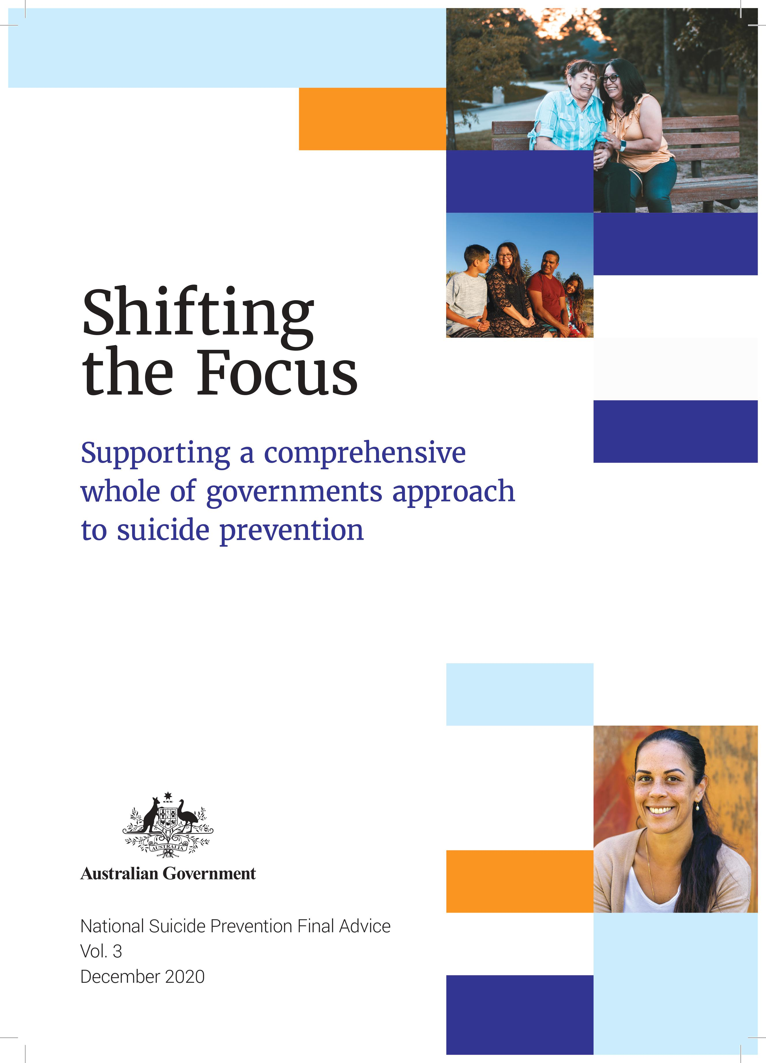

Supporting a comprehensive

whole of governments approach

to suicide prevention

Introduction

To create a genuinely effective, sustainable approach to suicide prevention, we need to […] look at how we live, how we communicate, and how we treat others, especially those who are vulnerable, and how our various systems—health, social, welfare, economic, education, and others— exacerbate or contribute to suicide.

- Statement from lived experience contributors at the Black Dog Institute

Every year, suicide and suicidal behaviour affects hundreds of thousands of Australians – with lasting impacts on individuals, families, workplaces and communities.[1]

Australia’s current responses to suicide are crisis driven and rely on the person in distress actively seeking help, usually through the health and hospital systems. However, as many of 50 per cent of people who die by suicide do not seek help through these systems, or at all.[2] [3] [4] By focusing primarily on those who are already in crisis, we miss too many opportunities to reach people with the right support to address the underlying causes of their distress and help *prevent* their escalation into suicidal crisis.

We cannot keep waiting for people to reach out for help. Instead, we need to use the many touchpoints governments have with people throughout their lives to offer services and support much earlier. Proactive early intervention – at the individual, group and population level – can help address the drivers of distress, reduce vulnerability, and build hope.

*Shifting the focus* highlights the important role that multiple sectors and government portfolios will play in delivering a new approach to suicide prevention. It provides practical guidance on the steps government agencies can take to embed suicide prevention into policy and service planning, design, implementation and evaluation.

Australia needs a more connected and compassionate approach to suicide prevention. This will be enabled by a national whole of government model of delivery – one that sees suicide prevention become a shared responsibility and priority across governments.

Traditionally, responsibility for suicide prevention has sat with health portfolios. While the health and mental health systems will continue to play a key role in suicide prevention, a broader and more connected response is needed through:

* Collective action across multiple portfolios and sectors.
* A population-based approach which addresses the social and economic drivers of distress that may increase vulnerability to suicide, and seeks to strengthen protective factors.
* Improving linkages across portfolios to enhance combined effort and impact.
* Increasing transparency across multiple portfolios and sectors to ensure the actions of one part of government do not contradict or work against the efforts of others.
* This document outlines practical steps for government agencies to deliver on this approach.

# About this document

## What is the purpose of this document?

This guide has been prepared as part of the *Final Advice* to the Australian Government prepared by the National Suicide Prevention Adviser, with the assistance of the National Suicide Prevention Taskforce. It is intended to be read together with two further documents prepared through the Adviser’s consultation and engagement over the past 18 months.

*Connected and Compassionate* outlines the National Suicide Prevention Adviser’s *Final Advice* to government, including recommendations for priority action. The accompanying *Compassion First* report provides important insights from commissioned research and engagement with people who have a lived experience of suicide. Together with this guide, these documents form the National Suicide Prevention Adviser’s complete advice on how to drive the shift towards a new approach to suicide prevention; one that maximises the reach and effectiveness of government to genuinely reduce suicide attempts and suicide deaths and to support people earlier in distress.

This guide and accompanying decision-making tool have specifically been developed to build knowledge and assist government portfolios to identify ways they can contribute to collective suicide prevention action within a national whole of government approach to suicide prevention.

## Who should use it?

All government portfolios and agencies across jurisdictions can use this guide. Community organisations and providers may also find it useful to strengthen connectivity with government agencies and assess their own activities in light of priority actions supporting a new approach to suicide prevention.

## How do I use it?

Follow the guide chapters to develop a better understanding of the factors that contribute to suicide and the actions your agency can take, also summarised in **Appendix A**. The guide can be used to identify and design targeted improvements within a current policy or service, to assist with the development of a new policy or service, to identify where cross-portfolio and non-government partnerships may be required, and to support strategic planning activities.

## What other supports are available?

The guide and tool will be updated as the work of implementing the recommendations from the National Suicide Prevention Adviser moves forward. It is also intended that it will be supported over time by strategies to build capability across government agencies and the development of additional resources and tools to assist with the shift to a whole of government delivery model for suicide prevention.

**Appendix B** to this document provides a range of resources for government agencies engaging in suicide prevention planning and activity. This includes information on appropriate training programs, communication resources and public channels for help-seeking.

# ""Shifting the focus

*Shifting the focus* seeks to drive a national whole of government approach to suicide prevention, through:

""""**Establishing a shared understanding of suicidal behaviour** – outlining the complexities and impacts of suicidal behaviour to strengthen collective understanding across all governments, sectors and communities to inform action.

""**Stepping out a comprehensive approach to suicide prevention** – identifying what all government portfolios and their agencies can do to make an impact through a whole of government approach to suicide prevention.

**Planning to** **equip workforces** – highlighting the skills and capabilities needed to deliver coordinated and compassionate suicide prevention initiatives.

**Addressing accountability through governance and data** – clarifying the role ofwhole of government leadership and how data and evaluation can be used to drive and monitor progress of a whole of government approach to suicide prevention.

""**Providing a decision making tool –** which can be used by government agencies to practically guide suicide prevention efforts.

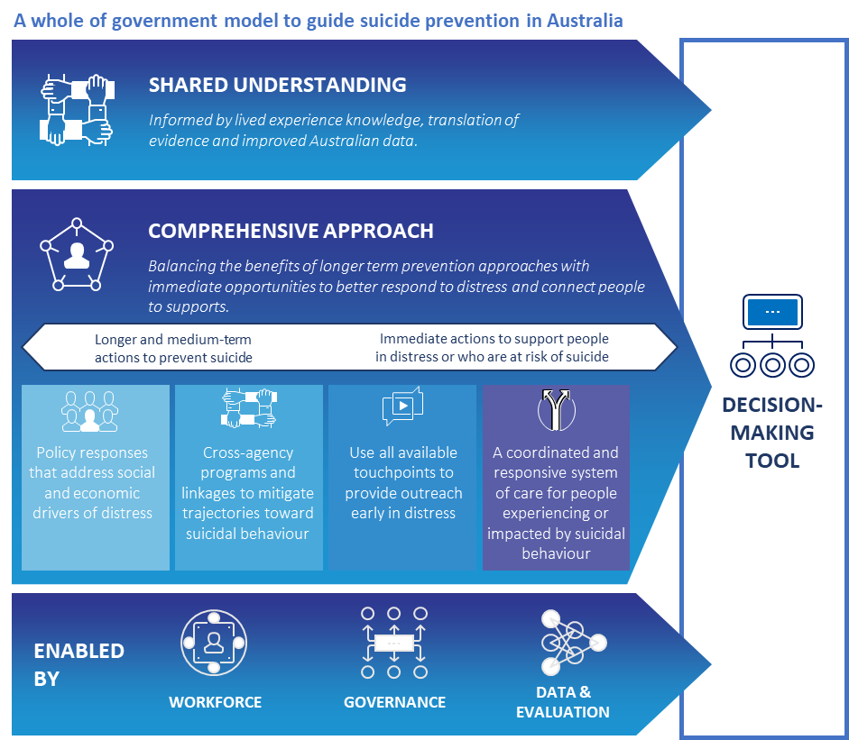

Part 1: Developing a shared understanding of suicidal behaviour

I think the most important thing is communicating that suicide is a timeline, not an act.

It's the whole play not just a scene.

- Person with lived experience

## Decision tool: Prepare

This section focuses on building an improved understanding of suicidal behaviour including some of the key risk factors for suicide and how different policies and services may relate to these risk factors. It relates to the ‘Prepare’ section of the decision-making tool provided on p.26.

Building a stronger understanding within your agency will help ensure it is ready to take the next step of assessing and identifying specific actions or interventions which can help prevent suicide.

### Suicidal behaviour is multi-factorial and deeply personal

Suicide is a complex behaviour underpinned by a range of factors and accompanied by intense distress and despair. Suicidal thoughts and behaviours can occur when people feel overwhelmed by their problems or their situation. This can happen to anyone at any time.

When people feel distressed, overwhelmed, trapped or defeated by their circumstances, they can find it hard to see a way through. People who have attempted suicide often report that they did not necessarily want to die, but were unable to cope with the pain and despair any longer.

Suicidal behaviour is not an illness or disorder, although it can co-occur with, and be exacerbated by, a range of physical and mental illnesses. It occurs because of the interaction between biological, psychological, cultural and social factors, as well as what has happened in a person’s life.

Suicidal behaviour is generally not well understood. This can result in shame, stigma, discrimination and crisis-driven service responses.

## There is no single pathway or set of factors that explain suicidal behaviour for all people

Recent Australian research, which captured thousands of first-person accounts of suicidal behaviour, highlighted that there is no simple lead up to a suicide attempt.14 People can experience a number of intersecting and compounding harms, vulnerabilities and events that can occur during their lifetime. These can operate at the societal, community, relationship or individual level and can change across the life course. Please refer to **Appendix A** for some key risk and protective factors identified through research.

People are often experiencing multiple stressors at the time that they attempt or die by suicide**.** They may become disconnected from their close relationships and social networks.Communities experiencing sudden, unexpected and/or unresolvable trauma or adversity, such as natural disasters, economic downturn, intergenerational disadvantage or clusters of suicide deaths, can also contribute to individuals’ vulnerability.

Underlying factors and life stressors need continual and long term attention across the lifespan, where efforts are aligned, multiple factors addressed simultaneously, and effort is targeted across a range of settings where people experiencing distress may be identified and supported

| Underlying factors and life stressors which can occur across the lifespan | | | |
| --- | --- | --- | --- |
| Children | "" Young People | Adult | "" Older People |
| A large proportion of people report risk factors that emerge in childhood — including sexual, verbal, psychological and physical abuse, exposure to family violence, trauma experienced during migration and settlement, and bereavement, including suicide bereavement, during childhood. | Adolescence and early adulthood is often when psychological and interpersonal risk factors emerge or are exacerbated. This includes onset of mental ill-health and alcohol and other drug problems, study and work stresses, challenges with interpersonal relationships, identity and cultural challenges for some young Lesbian, Gay, Bisexual, Transgender, Intersex and Queer (LGBTIQ+) people and those from a culturally and linguistically diverse background. | Most suicide deaths in Australia occur amongst adults (75% are males) with many experiencing multiple life stressors just prior to an attempt or death. Many people report a change in alcohol or drug use (AOD) in combination with relationship breakdown, family violence, legal and child custody issues, workplace stresses, injury or illness, unemployment and financial distress. | High rates of suicide occur among older men, however risk factors can be quite different and often include limitations on daily functioning due to illness, disability or chronic pain, social isolation, grief and bereavement. |
| Key transition points and points of disconnection across the lifespan present unique stressors and opportunities for intervention | | | |
| Disengagement and transition from school or university, discharge from hospital following a suicide attempt, discharge from the Australian Defence Force to civilian life, release from correctional facilities, divorce or a change in family structures, impacts of migration and settlement, change in work status due to unemployment, illness or injury. | | | |
| A range of factors have been identified that can impact on families and communities across the life course | | | |
| * Access to means of suicide or availability of information online * Exposure to suicidal behaviours of family, peers or through media | * Ineffective treatment for mental illness and AOD problems * Disadvantage, inequality and poverty * Homophobia and transphobia | * Stigma associated with mental illness and discrimination * Intergenerational trauma and loss of connection to culture * Cultural taboos about suicide | * Having made a previous suicide attempt * Ineffective responses to suicidal behaviour in the past |

## There can be distinct factors which transition someone from *thinking* about suicide, to *acting* on those thoughts

A proactive, national whole of government approach leverages all available government and community touchpoints to mitigate the factors that contribute to distress and suicidal behaviour.

“The extensive knowledge base of risk and protective factors have relevance. But we ask that these are used with awareness of their limitations—they do not reflect every individual’s experience of suicidal thoughts and behaviours. Our complex internal experiences and interactions with an equally complex external world cannot be reduced to variables.” *14*

Suicidal thinking can occur at any time that someone’s experiences and circumstances combine in a way that makes them feel shamed, disconnected, hopeless about the future, or a burden on others around them. It is not uncommon for people to have thoughts about suicide or more general thoughts about trying to end their pain. These thoughts can be frightening and often not easy for people to talk about. For some people, thoughts may come and go quickly, but for others they may persist for a long time.

In addition to these stressors, modern theories of suicidal behaviour[5] suggest that a different set of factors – or certain situations or experiences – have often been associated with people having the ‘capability’ to act on suicidal thoughts. These include:

* A prior suicide attempt or attempts.
* A history of self-harming behaviour (even if not associated with suicidal thoughts at the time).
* Increased alcohol or substance use (in combination with life stressors).
* History of physical abuse or violence, including violence toward others.
* Risk taking, antisocial or impulsive behaviours.
* Occupational exposure to death, dying or physical pain.
* Exposure to the suicidal behaviour of another person (through community or media).
* Access to lethal means and/or knowledge of suicide methods.

The factors that contribute to suicidal distress can vary between people and within an individual over time. While many people will experience thoughts about suicide before attempting or dying by suicide, others may not. Some people may transition quickly from acute distress in response to life stressors to suicidal behaviour.

## The experiences of some groups make them more vulnerable to suicidal behaviour than others

While suicidal behaviour can be experienced by everyone, some populations and groups can be disproportionately affected and targeted responses are required. For example:

|  |  |
| --- | --- |
| Adult and older men | Men are more than three times more likely to die by suicide than women. They are also less likely to access health services before their death. Risk factors for male suicide include relationship breakdown, separation and post-separation parenting arrangements, unemployment, financial distress, alcohol or substance use, mental health issues, legal issues, experiences of childhood abuse and social isolation and loneliness in older age. |
| Aboriginal and Torres Strait Islander Peoples | Aboriginal and Torres Strait Islander Australians are twice as likely to die by suicide as non-Indigenous Australians, with young Aboriginal and Torres Strait Islander people being four times more likely to die by suicide. Systemic factors such as discrimination, intergenerational trauma, disadvantage and cultural factors like the experience of shame can all act as barriers to people receiving appropriate support. |
| Children and Young people | Suicide is a leading cause of death for children and young people. Adverse experiences in childhood and adolescence can increase vulnerability to suicide, with 75 per cent of mental illnesses and alcohol and other drug problems occurring by early adulthood – two key underlying risk factors for suicidality. Young people also present with self-harming behaviours at higher rates than other age groups which requires dedicated attention. |
| People who identify as LGBTIQ+ | Compared to the Australian population, LGBTIQ+ people are nearly twenty times more likely to have considered suicide and ten times more likely to have attempted suicide, with particularly high rates for transgender and gender diverse people.[6] LGBTIQ+ people often report feeling judged, stigmatised and discriminated against by broader society and can experience a lack of acceptance from those around them. The importance of an inclusive environment that supports the mental health and well-being of LGBTIQ+ people must be recognised and promoted. |
| People living in rural and remote communities | The suicide rate in Australia’s rural and regional areas is 40 per cent higher than in major cities. Rural and regional communities can experience sudden and ongoing adversity, which can lead to widespread financial hardship. There are also generally fewer supports and professional services available in rural and remote communities. Lived experience research has highlighted that people in rural areas may feel less comfortable seeking help through health services, while in other areas access to services may be limited. |
| Culturally and linguistically diverse communities | While there is limited data available on rates of suicide and suicide attempts within culturally and linguistically diverse communities, these communities can face distinct risks because of cultural stigma and taboos, combined with language barriers that can prevent help seeking and effective public health communications. |
| Veterans | Particular cohorts of veterans transitioning from the Australian Defence Force (ADF) have higher rates of suicide than the general Australian population, with those who medically separate from the ADF being particularly vulnerable. Continued improvement to service delivery and enhanced support for families and carers is required. |
| People living with mental illness | Many people who die by suicide in Australia have a prior experience of a mental illness. Suicide is a prominent cause of death for people with complex mental illness, with the risk increased for people with borderline personality disorder (45 times greater), anorexia nervosa (31 times greater), major depression (20 times greater), bipolar disorder (17 times greater) and schizophrenia (13 times greater).[7] |
| Women | Women, especially young women, are more likely to engage in self-harm and attempt suicide.[8] A range of risk factors have been identified for women that require attention, especially given increasing rates of suicide among women in recent years. These include mental illness, family and relationship issues, domestic violence, cultural expectations, and eating disorders. |

A comprehensive approach to suicide prevention must focus on the whole population, as well as address the unique needs of specific groups through tailoring interventions and approaches that are most likely to proactively reach them.

**What does this mean for my agency?**

Public sector agencies and teams should apply these insights about suicide to the policy and services that you provide, and consider how the people you serve can be positively or negatively impacted by them.

It is particularly important to consider and understand how priority populations interact with your services and the specific needs they may have in relation to accessibility, cultural safety and service provision.

As a first step, agencies should seek to answer the questions identified under Prepare in the decision-making tool on p.26.

Part 2: Towards a comprehensive approach to suicide prevention

So often the services that people turn to in their most desperate moments are embedded in complex, bureaucratic systems where barriers to helpful responses – despite the best intentions and frustrations of people who work within them – are entrenched in culture, scarcity, power dynamics, risk management, and fear…

- Person with lived experience

## Decision tool: Assess and Identify

After gaining a better understanding of suicidal behaviour and risk factors and how your agency’s policies and services may impact on suicidal behaviour, the next step is to assess and identify specific opportunities for action.

This section outlines a series of key steps agencies can take to work in a coordinated way on proactive actions and interventions which will help to prevent suicide. It relates to the ‘Assess

### No single government portfolio can undertake all actions required, but each can contribute – in appropriate and context-specific ways, separately and in partnership – as part of a comprehensive approach with shared responsibility.

""

The ‘solution’ lies, not only in what will help people stay alive, but also in what will enable all people, regardless of disadvantage or disability, to want to live.”14

Traditionally, the responsibility for suicide prevention has been given to health portfolios, with a range of suicide prevention plans, frameworks and policies currently in place (please see **Appendix B**).

Effective suicide prevention not only requires health interventions and support for individuals, but also for efforts to be aligned and responsibilities shared across multiple portfolios to respond to broader contributing factors.[9]

This section provides a consistent and simple approach that will help to guide the different actions required across government. It may also be useful for other public and private organisations.

In particular, a whole of government approach must leverage existing linkages across portfolios to enhance collective actions, and to minimise the risk of some arms of government undertaking actions that contradict the efforts of others.

Suicide prevention must operate at all levels, and is best coordinated at the local level where people live, work, study and play. This means Commonwealth, State and Local Governments working together with community, non-government organisations and the private sector to coordinate prevention efforts at the regional level*.*

## It is only through a shared and comprehensive approach that the complexities of suicidal behaviour can be effectively addressed

"Suicide prevention efforts require coordination and collaboration among […] both health and non-health sectors such as education, labour, agriculture, business, justice, law, defence, politics and the media. These efforts must be comprehensive, integrated and synergistic, as no single approach can impact alone on an issue as complex as suicide.” 17

All government portfolios and agencies have opportunities to influence the wellbeing of Australians. A national whole of government suicide prevention approach must be delivered through, and link with, a range of departments, agencies, service systems and communities, as well as having defined priorities and accountabilities.

""**Policy responses that address the social and economic drivers of distress** will serve as an effective long-term suicide prevention measure. This includes investment in reducing factors that contribute to vulnerability and distress, working to increase community safety and promoting protective factors at a population level.

""**More cross-agency programs and linkages** will strengthen opportunities to intervene early across various settings and programs; particularly where key transitions, points of disconnection or underlying vulnerabilities can be targeted to mitigate a trajectory towards suicide.

""**Increased outreach in early distress** will ensure we do not wait for people to seek help in a crisis, as many never do. Identifying and using multiple government and community touchpoints where people may present in distress will enable a proactive response to link a person to support.

""**Coordinated and responsive systems of care** which work together across portfolios and jurisdictions will provide holistic and comprehensive support to people across the lifespan, ensuring people receive the right support at the right intensity at the right time.

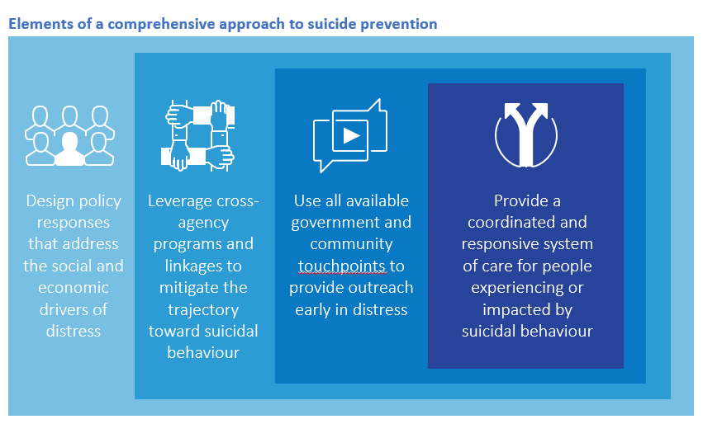

## 2.1 Design policy responses that address the social and economic drivers of distress

Effective policy responses can increase population wellbeing and safety, as well as decrease potential risks and increase protective factors at a population level.

While each experience of suicide is individual, a broader public health approach is needed to have the greatest impact on preventing suicidal behaviour and underlying distress. ‘Upstream’ suicide prevention measures require governments to be aware of the broad range of factors and experiences that contribute to population-level distress, as well as factors known to exacerbate suicidal behaviour. Responses must be through policy and population-level initiatives which:

* **Are informed by data and evidence**, meaning continuous monitoring and evaluation of initiatives, improved data collection and measurement, and timely analysis to inform policy responses. Responses must pay close and continual attention to emerging pressures that affect individual, households, localities and communities.
* **Focus on promoting protective factors and increasing general wellbeing** particularly acrossthe long term – such as improving social cohesion, connection and psychosocial wellbeing, economic participation and security, and housing and welfare provision – to ensure the most vulnerable people have access to supports that improve their wellbeing.
* **Strengthen connection to family, place, culture and land for Aboriginal and Torres Strait Islander people,** recognising that these are essential to healing – this should include policies and investments that support social, emotional and cultural wellbeing.

quote icon

I didn’t start healing until I went back to country. I went back to the brown water and then things started changing for me. We must remember how we heal.”[10]

* **Recognise and reduce factors that contribute to suicidal behaviour** through designing policies to support people and populations whose adverse life experiences and behaviours can make them vulnerable. This will reduce the number of people who experience vulnerability in the first place, and includes policies to reduce the overuse of alcohol and access to other drugs; financial and welfare support, especially during economic downturn; targeted support for people impacted by family, domestic and sexual violence; and ensuring policies provide targeted support immediately and in the longer-term for regions and populations most affected by particular adversity, including natural disasters and pandemics.
* **Ensure a suicide prevention lens is applied across all new policies and initiatives,** including considering suicide prevention outcomes as a routine undertaking by all government portfolios and agencies. Governments, through their agencies and activities, may not be able to prevent the onset of distress in a person's life, but they can and should ensure that they do not through their actions, or the administrative systems that they operate, add to a person's distress without providing ways through which those mounting distress levels can be addressed.
* **Reduce access to means** through regulation, physical barriers and partnerships with local governments and other stakeholders to respond to ‘hotspots’ within communities. This is also enhanced through reducing access to certain online and public information about suicide, including content on social media channels Safety and reduced lethality of behaviours will also be improved by considering policies and regulations to reduce harmful use of alcohol and other drugs.
* **Promote safe media reporting** that reduces the risk of further suicidal behaviour and decreases stigma. This can be achieved through regulation, guidelines and programs to increase safety online, ensuring availability of accurate information and increasing the use of lived experience stories. Portfolios must ensure all communication, public information and resources use best practice and safe language associated with suicide (please see **A**ppendix B for further information).

Recent research exploring the experiences of people who have experienced suicidal distress revealed that many of the contributing factors (e.g. social isolation, discrimination, economic stress, exposure to abuse and violence) are beyond the remit of the health system. There is good evidence that non-health policies, especially when consistently implemented, can have the greatest impact on suicidal behaviour by shifting population risk and reducing the number of people who may find themselves needing to access services.[11]

**What does this mean for my agency?**

The aim of work in this stage is to clearly identify and articulate how your agency’s policy and services connect with population-level wellbeing, particularly in relation to social and economic drivers of distress, security and safety.

Opportunities to better understand this could include co-design with people with a lived experience of suicide, expert consultation, and the commissioning of dedicated research. These inputs will help identify how your agency’s policy and services may either contribute to underlying distress or support its prevention.

Practical examples of population-level policy responses which address the social and economic drivers of distress include economic relief in hard times, housing and homelessness services and initiatives that address stigma and discrimination. The questions listed under Assess and Identify in the decision-making tool will help you identify relevant examples or areas needing attention within your own agency.

**Key considerations**

How do the services, programs or policies that you provide impact or influence people?

Does this impact or influence relate to any of the **settings or known risk factors** (identified in Appendix A) that can contribute to suicidal behaviour?

## 2.2 Leverage cross-agency programs and linkages to mitigate the trajectory toward suicidal behaviour

Targeted interventions through collaborative and cross-portfolio responses to mitigate the trajectory towards suicidal behaviours.

As people move through different stages in life, they will encounter a variety of transition points, times of disconnection and unique stressors, presenting multiple opportunities for their trajectory towards suicide to be addressed. Greater effort is required on responding early, both in a person’s life (i.e. during childhood) as well as early in a person’s journey (i.e. as early as possible when stressors or vulnerabilities are experienced). Government can use existing programs, as well as design programs in conjunction with other agencies, to enhance service provision and proactively support people and populations whose experiences leave them more vulnerable.

Programs must be tailored to the unique needs of specific groups,and pay particular attention to known transitional factors.

* **Focus on delivering evidence-based programs and services across a range of government, workplace and community settings** to reduce specific risk factors and ensure the greatest reach to people in distress. This includes justice settings, family relationship services, housing and homelessness services, social welfare services, schools and universities and children’s services, as well as focusing on reaching people who are isolated.
* **Apply targeted approaches to certain settings, industries and workplaces,** particularly where occupational risks may increase fearlessness about pain and death (e.g. male-dominated industries, emergency services, health professionals), exposure to trauma and death, workplace injury and people in prison or detention.
* **Tailor initiatives to target people and communities who are disproportionally impacted by suicidal risk and behaviour,** such as those who are socially isolated or who have multiple factors relating to adversity or disadvantage. This includes, but is not limited to, the LGBTIQ+ community, rural and remote communities and those experiencing mental illness.
* **Particular attention must be paid to targeting factors associated with the transition to suicidal behaviours,** regardless of whether people are presenting to a service. This includes being alert to self-harm, and risky or unusual behaviour including changes in a person’s use of alcohol and other drugs.

quote icon

Services located everywhere and anywhere that might help deal with social, emotional, physical, financial, or spiritual problems or needs. From the grocery store to Centrelink, General Practitioner to Emergency Department, spiritual or religious supports to sports clubs.”14

**What does this mean for my agency?**

In this stage the focus should be on combining a deep knowledge of the needs and vulnerabilities of the communities you serve, with an understanding of the diverse ways in which they interact with your agency and other arms of government.

This will support identification of potential entry, referral, transition and exit points which need to be linked up with other agencies to ensure coordinated support, and help determine roles and responsibilities in the delivery of an integrated cross-portfolio approach. Detailed service and journey mapping may be helpful at this stage to help clarify how different people use your agency’s services, and the other agencies they may be in touch with before, during or after your engagement with them.

This approach can be applied to a single existing policy or service, or during the development of new ones. It can also be applied at a strategic level across all the policies and services delivered by your agency.

The questions listed under the relevant section of *Assess and Identify* in the decision-making tool will help you identify relevant examples or areas needing attention within your own agency.

**Key considerations**

How do your services, programs or policies work or intersect with those of other portfolios, agencies or service providers?

## 2.3 Use all available government and community touchpoints to provide outreach early in distress

Improved outcomes will be achieved through ‘going to where people are’ and providing the right support for people to connect with early on.

Every point of contact a person has with a government agency when they are experiencing distress, or which may contribute to distress, is an opportunity for suicide prevention.

As suicidal behaviour is a response to acute distress often involving multiple factors in a person’s life, the role of Government extends beyond health portfolios to all touchpoints where there is an opportunity to moderate distress. Government must incorporate the ability to act proactively in these instances and provide timely support.

* **Earlier and proactive supports are needed to improve responsiveness to early signs of distress.** The overwhelming majority of people only engage with services when there is an acute need or crisis, so to enhance suicide prevention responses must focus on identifying early signs of distress and meeting people ‘where they are’ to provide effective supports. This may include considering approaches such as outreach support to anyone presenting in distress until they can be linked to the right supports for their needs, and universal responses to self-harming behaviour.
* **Identifying and providing earlier support during points of critical life stressors** – such as relationship breakdown, unemployment, workplace injury and financial distress. This can be facilitated by linking and sharing data across agencies to identify touchpoints with people in ongoing or situational distress, and ensuring service approaches and warm referrals to connect people with the supports they need when and where they need them.
* **Identifying and providing earlier support during life transitions regardless of suicidality**, including when people enter or exit government services or programs, such as discharge from the military, release from correctional facilities, entering an aged care facility, discharge from hospital following a suicidal crisis or suicide attempt, and disengagement with school. Engaging with the family court, for example, can also be an opportune transition phase to target support for fathers experiencing separation from their children and former family unit.
* **Providing outreach services across all service and community settings for people impacted by suicide attempts or deaths.** Cross-portfolio responses are needed to mitigate the impacts of suicide on communities, workplaces, schools and services.
* **Develop and expand partnerships.** Many people who become suicidal experience multiple factors of distress, meaning a multi-factorial response is needed. Clear linkages to other sectors and services must be identified to enable people to access the most effective supports in a timely and coordinated manner. Focus must be oriented to supporting service coordination, enabling the sharing of information across portfolios and jurisdictions, and removing barriers to care.

Broader understanding of the workforce involved in early outreach to ensure universal, compassionate and competent responses across settings. The core competencies and training strategies for workforces that have a role to play in reaching people and providing support early on are discussed in following sections.

**What does this mean for my agency?**

Following the previous steps, agencies should use the insights gained and service mapping work to identify opportunities for early intervention through your agency’s service touchpoints. This should take into account existing service gaps and opportunities for improvement in how services or supports link up with one another.

Agencies should particularly consider opportunities to embed early distress interventions, strengthen referral points for people needing further support, and better connect treatment and postvention services. Working collaboratively with other agencies, this will need to include warm referral pathways to ensure people are linked with other supports as required. This will be supported by co-design involving all relevant agencies, people with lived experience of suicide and expert advice.

Having identified these opportunities for outreach and early distress intervention, agencies should develop action plans outlining how suicide prevention initiatives will be delivered through these and over what timeframe. These plans may address the improvement of a single policy or service point, outline how early intervention will be incorporated into a new policy or service, or be applied at a strategic level across the range of policies and services being delivered.

The National Suicide Prevention Adviser’s Final Advice to government highlights a range of priority settings and service touchpoints for early distress intervention; these can provide a starting point for agencies seeking guidance. The questions listed under the relevant section of Assess and Identify in the decision-making tool will also help to guide internal action planning by agencies

**Key considerations**

How might you need to refine and improve services, programs or policies to better and **more proactively respond** to suicide risk?

How can the insights of **people with lived experience** help you to do this?

## 2.4 Provide a coordinated and responsive system of care for people experiencing or impacted by suicidal behaviour

Responses must be connected, coordinated and holistic to remove barriers for people to seek and receive help as they need it.

As people seek help in varying ways and at any day or time, service responses need to be clearly communicated, accessible and appropriate for people wherever they live; with Governments ensuring that there is a connected and coordinated service system operating across multiple entry points within communities.

The health and mental health sectors and services will continue to play a vital role in suicide prevention. These responses, however, need to be complemented by the support and input of other portfolios and agencies. Services and supports for caregivers and people experiencing distress, bereavement or suicidal behaviour need to be fit-for-purpose, meet their needs, and be connected across the entire service system. This does not just require policy coordination and agency collaboration, but service linkage and coordination across sectors at the local level for a coordinated approach.

A coordinated and responsive system of care means that no matter when or where a person makes contact with supports or services, they receive a timely response that is compassionately delivered.

* **A full range of services and supports need to be available to meet diverse needs,** including services to support overall health and wellbeing, early intervention services and programs, crisis care and treatment services, and coordinated aftercare and postvention supports.
* **Service coordination should happen at the local level**, so that the person receives consistent and effective care in their local community. This means that Primary Health Networks (PHNs), Local Health Districts and Areas, social services and other government agencies need to work together. In addition, funding and support must be provided for community-controlled services that are preferred providers for some populations (e.g. Aboriginal and Torres Strait Islander people or LGBTIQ+ people).
* **A diverse range of services need to be delivered in ways that are appropriate and preferred by different population groups;** for example, e-counselling or a text-in service versus in-person counselling; or outreach to workplaces versus a reliance on individuals travelling to and accessing facility-based support. Linkages between these services should be accompanied by warm referrals at the point of distress, such as crisis line links to community-based supports that are relevant to the needs of the consumer.
* **A range of clinical and non-clinical options need to be provided across prevention, intervention, aftercare and postvention**, including peer-led, non-hospital and non-medical approaches as research highlights that these are the service models strongly preferred by people. For example, this could include emergency department alternatives staffed by a mixture of clinical and peer-support workers with lived experience, with clear pathways to specialist supports as required.

**What does this mean for my agency?**

Having identified opportunities for coordinated cross-agency service delivery and proactive outreach through key touchpoints, agencies should next consider what kind of services will best meet people’s needs.

Co-design with people with a lived experience of suicide can help to identify where, when and how supports will be most accessible. Agencies will need to be open to delivering new service models where this aligns with people’s needs and preferences – including non-clinical and community-based supports or services delivered online and through peer-to-peer approaches.

Planning for the delivery of new and better connected models of support should be undertaken in line with action plans identified in the previous step, and matched with appropriate resourcing, workforce and broader agency support. Agencies should share lessons and learn from each other as new services or approaches are rolled out. The questions listed under the relevant section of Assess and Identify in the decision-making tool will also help to guide internal action planning by agencies.

**Key considerations**

How might you need to refine and improve services, programs or policies to better and **more proactively respond** to suicide risk?

How can the insights of **people with lived experience** help you to do this?

Part 3: Delivering the shifts we need

Helpful responses are those that see our humanity, offer time and a safe space to be deeply listened to and validated, provide genuine compassion, free of judgement and agendas. This empowers a person to find their own meaning and the answers to the problems in their own life.14

- Person with lived experience

## Decision tool: Assess and Identify

Workforce, governance and data are critical enablers of the shift to a connected and compassionate whole of government approach to suicide prevention.

This section addresses actions government agencies can take to build workforce capability in suicide prevention, strengthen national and cross-jurisdictional governance arrangements and harness data to drive more agile, responsive service delivery. It relates to the ‘Enablers of Action’ section of the decision-making tool provided on p.26.

Equipping government workers with the right skills and capabilities to drive this new approach to suicide prevention will be essential to its successful delivery. This applies not only for frontline workers, but right across government – including government workers engaged in policy and service planning, implementation, monitoring and evaluation. Each agency will need to consider its own workforce capability requirements, while also linking into to broader whole of government priorities to build broad workforce capability in suicide prevention.

Governance and leadership will unlock the potential of a whole of government delivery model by ensuring each individual agency has strong processes and accountabilities for delivering agreed suicide prevention initiatives, and linking into broader collaborative efforts across government. Governments will need to be open to developing new arrangements for coordinating cross-portfolio activity, to break down silos and encourage a new sense of shared responsibility.

Whole of government processes for monitoring data and outcomes will support ongoing decision-making by First Ministers and other key interagency bodies, and should be priorities. But individual agencies

should also take responsibility for monitoring their own action plans and evaluating portfolio-specific initiatives. As an immediate priority, agencies should consider how they can use current internal processes to monitor the implementation or impact of agency-level action plans, and how they can share this data with other agencies that are mutually responsible for implementation.

The National Suicide Prevention Adviser’s *Final Advice* highlights how these enablers will mutually feed and reinforce each other in underpinning the shifts we need to see across government.

quote-icon

Being suicidal is exhausting and all consuming. Most of the time, those who are suicidal are trying to keep […] life afloat. Expectations to reach out, follow up, navigate siloed services and systems, chase referrals, do extra or self-advocate are grossly unrealistic.”*[12]*

## 3.1 Equipping our workforces

All government portfolios, and the services they fund, need to develop and support their staff to enable a whole of government approach to suicide prevention

While there are some universal competencies that are required for all people, the workforce is not homogenous and therefore skills required are different

Training should be scaffolded and tailored to a person’s role and the type of interactions they may have with people experiencing distress or vulnerability to suicide

Training alone is not enough – workers need to be supported through healthy and safe workplaces, practical policies and support, and clear commitment from their leaders.

### What skills and competencies are required for the workforce?

People experiencing distress interact with workforces across various sectors, at different times and in different ways. Every contact that a person has with a department, service or individual worker is an opportunity to have a positive impact, ensuring they get the right supports at the right time in line with the objectives of this model.

Outlined below is an overview of the main categories of government and public sector agencies, the required competencies for each and the training required to support this development (both formal and on-the-job).

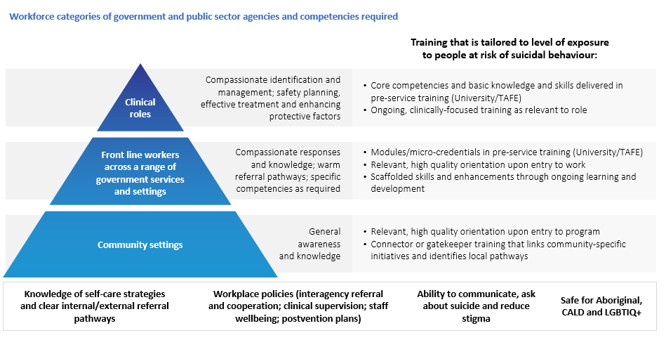

### How do we train and support these workforces?

Workforce development must be led by a commitment to the safety and support of workers who care for and respond to people in distress or who are experiencing suicidality, as workers who are supported are better able to support others. There is an opportunity to link this approach with broader mental health capability initiatives and leadership training. All government portfolios should work towards mentally healthy workplace approaches, with integration of suicide prevention, support and postvention policies and programs. Engagement of people with lived experience can have real benefits in increasing knowledge and breaking down stigma. Peer-to-peer approaches should be considered in addition to structural supports.

quote-icon

A culturally safe service environment and access to Indigenous or culturally competent staff for Indigenous people will be important”[13]

Workforces can also actively contribute to reducing stigma around suicide and increase community capability through driving public education campaigns. These outreach activities require distinct communication and organisation skills.

|  |
| --- |
| People will need particular skills and competencies related to their role – for example, those who work with men; those in rural and regional areas; people working with LGBTIQ+ people; and services connecting with Aboriginal and Torres Strait Islander people and communities. |

**What does this mean for my agency?**

Agencies should individually review their workforce needs in light of the shifts outlined in this document, and identify current gaps in capacity to deliver. This should particularly take into account action plans developed by your agency as well as key enabling capabilities like governance and data. Agencies should seek opportunities to share training, service models and staff support initiatives which strengthen suicide prevention workforce capability. This will facilitate the uptake of best practice and more rapid dissemination of effective models tailored to the Australia government and service delivery context.

The questions in the Equipping your workforce section of the decision-making tool will support your agency to identify its workforce capability needs and develop tailored initiatives to address these.

**Key considerations**

How can you build the competence of your existing workforce to deliver and focus more on distress intervention at these points?

What strategies could you consider to attract and retain new skills in your workforces that relate to your suicide prevention initiatives?

## 3.2 Accountability through governance and data

As suicide prevention is a priority across every sector at the Commonwealth, State and Local level, it is important to coordinate and cooperate with other levels of government and other government portfolios

### Whole of government leadership and governance is central to the success of a shared and coordinated approach to suicide prevention.

Each portfolio or agency should consider the governance structure that will best support its suicide prevention initiatives and how they interact with other portfolios. Mechanisms that support this include:

**Leadership** which supports cross-portfolio approaches to suicide prevention and sustains suicide prevention from the top down.

**Shared and articulated commitment** **to suicide prevention** across all parts of the portfolio and which links to other sectors, between and across Commonwealth and jurisdictional government, and throughout public and private sectors.

**Clear roles, responsibilities and accountability** for an integrated approach across the portfolio and which links to Commonwealth, State and local governments.

**Governance structures** to coordinate delivery of suicide prevention approaches within the portfolio that detail responsibilities for planning, implementing and evaluating initiatives, developing quality assurance frameworks and providing training in line with priorities.

Governance must also incorporate early input from the portfolio’s priority populations to ensure approaches are relevant, respectful and effective. This includes cultural governance inclusive of Indigenous people and integrating people with lived experience into planning and advisory stages.

### Ownership of collecting, using and sharing data is everybody’s business.

A coordinated national approach to suicide prevention requires timely, quality and relevant data to ensure actions remain current and evidence-based. This enables decision makers to act in a timely and informed manner, enables translatable research of suicide prevention activities and suicidal behaviours, and facilitates localised responses.

The ownership of collecting and using data relevant to suicide prevention must be a shared endeavour across government, community, public and private sectors; facilitated by a national system to collect and coordinate information on suicidal behaviour, risk factors and prevention activities.

quote icon

“Childhood depression led to divorce at 27, and mid-life crisis with lack of financial stability. Over time, multiple situations created a sense of despair and incompletion leaving with a sense of total failure in life. This caused dependency and extreme loneliness.”*[14]*

### Data relating to factors surrounding suicidal behaviour should be collected and used for decisions on priorities and service improvements.

It is important to continually gain a better understanding of what factors contribute to suicidal behaviour and prevention in order to drive meaningful impact.

In particular, having **robust and reliable data insights about social, health, economic and cultural factors** that may impact on suicidal behaviour is needed. This is in addition to better collection and timely reporting of suicidal ideation, suicide attempts and suicide deaths to inform policy and practice.

Consequently, government agencies should ensure that internal data collection includes information relating to service contacts with people in distress, as well as where there are suicidal behaviours or incidents occurring. This data should align to demographic classifications and standard variables, including those relating to Aboriginal and Torres Strait Islander people, LGBTIQ+ people and culturally and linguistically diverse communities.

This helps to illuminate:

* Factors preceding or co-occurring with suicidal behaviour and/or change in suicidal intent
* Service contacts and types of supports accessed
* Effective early-intervention in distress efforts, reduction of suicidal crisis and attempts, and suicide prevention
* Service mapping and system modelling.

Government should leverage methodologies that identify the needs of consumers with lived experience and other priority populations, such as journey mapping, to inform the design and delivery of initiatives to improve the experience of interacting with all supports and services.

### Consistent and timely evaluation must be a priority for anyone implementing suicide prevention initiatives. It is vital to shift the focus and look at non-health related and longer term outcomes.

Everyone can contribute to the outputs described above by having **processes and governance to collect, link and share data.** This includes conducting routine analyses and reporting against tangible goals, targets and timeframes. Consideration must be given to where existing data relating to services can be leveraged or expanded to capture information at touchpoints with people at risk of, or experiencing, suicidality. It is also possible to look to a range of settings, including communities, families and social circles, and broader public discourse, to collect relevant information.

Importantly, translation of analyses and research findings must be routinely incorporated into policy and practice. Portfolios can facilitate this by **establishing a leader or decision-making body responsible for communication and priority-setting, and monitoring and improving the quality of relevant data.** Where possible, incorporate people with lived experience, researchers and experts in clinical and non-clinical care in this decision making for a holistic perspective.

### How do we measure success?

Collecting and having access to high-quality data informs the ability to identify targeted suicide prevention initiatives for portfolios. Consistent, timely, and appropriately resourced evaluation is also key to maximising the usefulness of data. That evaluation should measure success in reducing suicidal behaviours, reducing suicidal risk or increasing protective factors by the portfolio’s targeted initiative.

Evaluation methods

This includes quantitative and qualitative methods in process and outcomes evaluation. Process evaluations may examine how the initiative was implemented, assessing whether and how well services were delivered as intended. Impact evaluations examine the extent that an initiative’s activities have produced expected changes. Monitoring and evaluation activities should bridge evidence-practice gaps, effectively assess impact and facilitate mutual learning. Some evaluation approaches, such as ‘action-research’, will enable implementation of learnings while establishing an evidence base, allowing for continuous improvement.

Shared monitoring, reporting and evaluation ****frameworks****

Suicide prevention efforts will benefit from shared monitoring, reporting and evaluation frameworks that allow organisations to report on progress, and evaluate individual efforts against collective objectives in the short, medium and long term. Measures and targets should be at the individual, community, organisational and societal levels. They should be context and population specific, while directly reflecting the underlying causes, drivers, and protective factors for suicidality at multiple levels. Targets measuring structural change can include socio-economic factors, indicators of social norms, attitudes and relevant practices that drive suicidality at an individual level.

**What does this mean for my agency?**

Agencies will need to review their existing governance arrangements in the context of action and implementation plans developed in line with this guidance. New structures and processes may be needed in some instances to link activities within your agency to those undertaken across other portfolios.

Effective internal process for data collection and use, and the monitoring and evaluation of progress against action plans, will help drive better decision-making – within agencies and across government. Your agency should have clear agreed objectives for all suicide prevention initiatives, coupled with transparent plans for monitoring and evaluation to determine if these are being achieved over time.

**Key considerations**

How is internal responsibility for design, implementation, monitoring and evaluation of your agency’s suicide prevention initiatives allocated? How do these link into broader cross-agency governance arrangements? Do you have the right mix of senior leadership and frontline insight involved in governance processes?

What data are you using to identify your specific initiatives? Do they relate to an identified suicidal behaviour or risk that you are trying to reduce, or a protective factor you are trying to improve?

What will your tangible goals, targets and timeframes be for suicide prevention programs? How will you measure them?

Can you leverage existing data? What improvements or additions to the data do you need?

Part 4: A decision making tool

This tool is intended for use by portfolios and agencies at all levels of government to assist you in developing your own action plans for specific initiatives on suicide prevention.

It does this by:

* Helping agencies to identify key themes for attention in suicide prevention that are relevant to the functions and contacts that you operate
* Providing information that can be translated into key actions, priority functions and service enhancements that will contribute to suicide prevention.

The tool comprises a number of self-assessment and directional questions which serve as a review and planning exercise for portfolios and agencies to identify **how** and **what** you can do to play your part in an effective whole of government delivery model for suicide prevention. The review process has the following steps:

**Prepare**

Reviewing and identifying risk and protective factors and behaviours of concern based on a refreshed understanding of suicidal behaviour which relates to your sector. This includes using existing data to quantify interactions with people who are vulnerable to suicidal behaviour or distress. This will support you to identify the role/s that your portfolio or agency can play in suicide prevention and distress intervention.

**Assess and Identify**

Identifying how existing policies, services and programs interact with factors relating to people’s distress levels and trajectories towards suicidal behaviour. By focusing on the four priority areas identified in this guidance, government portfolios and agencies can consider what enhancements or changes can be adopted to address those risks or behaviours. This includes recognising the resources, structures and systems needed to make change, namely workforce, governance and data accountability.

**Plan**

Developing clear action plans for suicide prevention, which provide the basis for communicating and implementing relevant initiatives.

**Monitor**

Putting in place arrangements for continuous monitoring, evaluation and reporting of results on agency efforts to reduce vulnerability to suicide, or increase and strengthen protective factors.

This tool guides portfolios and agencies to identify how you can contribute to suicide prevention in relation to each of the priority actions identified through the National Suicide Prevention Adviser’s *Final Advice*.

Following completion of an assessment using the decision making tool, government portfolios and agencies should develop clear action plans for suicide prevention initiatives. Once implemented, these should be regularly monitored and evaluated.

## Prepare

| Understand your role and influence in suicide prevention (refer to Part 1) | |
| --- | --- |
|  | How do the services, programs or policies that you provide impact or influence people? |
|  | Does this impact or influence relate to any of the known distress factors that can contribute to suicidal behaviour? |
|  | In what circumstances do your services, programs or policies engage with individuals that are vulnerable to suicidal behaviour? |
|  | What mechanisms do you have in place to identify behaviours of concern, risk factors and protective factors? |
|  | Do these mechanisms provide sufficient information to intervene? |
|  | What existing data can you leverage to quantify contact with people vulnerable to suicide? |

## Assess and Identify

| Design policy responses that address the social and economic drivers of distress (Refer to 2.1) | |
| --- | --- |
|  | Are any of your services, policies or programs potentially counterproductive to effective suicide prevention? |
|  | How can you adapt or change your services, programs or policies to mitigate this impact or influence? |
|  | How could your portfolio / organisation include a dedicated focus on suicide prevention in:   * Policy? * Priority setting and planning? * Commissioning of services and contracts? * Performance measurement (i.e., to reduce behaviours or risks or increase protective factors)? |
|  | In what ways can your services, programs or policies better identify and provide targeted support for groups who are more vulnerable to suicidal behaviour? |
|  | How can you make existing services more accessible? |

| Leverage cross-agency programs and linkages to mitigate the trajectory toward suicidal behaviour (Refer to 2.2) | |
| --- | --- |
|  | Do you provide services or programs for people that have multiple needs that may interact with other agencies and services at the same time? |
|  | What data can you use to identify these people? |
|  | How do your services, programs or policies work or intersect with those of other portfolios, agencies or service providers? |
|  | Do these need to work more closely and effectively with other portfolios and their agencies? How might you be able to do this? |
|  | Do you have any existing partnerships that can be leveraged to provide a full range of services and supports? What opportunities are there to build new partnerships? |

| Use all available government and community touchpoints to provide outreach early in distress (Refer to 2.3) | |
| --- | --- |
|  | Do your services, programs or policies need to better target key stages across a person’s life? How could they be improved to provide earlier support? |
|  | How might you need to refine and improve services, programs or policies to deliver a more targeted approach to help people manage distress and/or navigate a transition period in their life? |
|  | What existing data and information can you leverage to identify people experiencing critical life stressors or transitions? How can you use this data to intervene earlier? |

| Provide a coordinated and responsive system of care for people experiencing or impacted by suicidal behaviour (Refer to 2.4) | |
| --- | --- |
|  | Do your services and programs link with other services? Can linkages be improved to enable better service coordination at the local level? |
|  | Do existing services or programs provide a range of different options to suit individual preferences? How can delivery methods be diversified to cater for different population groups? |
|  | How can you harness the knowledge and experience of people with lived experience of suicidal behaviour, attempts or death? |

## 3. Enablers of action

| Equipping your workforce (Refer to 3.1) | |
| --- | --- |
|  | Which of your workforce/s interact with people experiencing distress and/or during points of vulnerability? Do they have the skills and capabilities to identify and provide support to people during these interactions? |
|  | How can you build the competence of your existing workforce to deliver and focus more on suicide prevention at these points? |
|  | Are there any staff that may interact with people during distress and points of vulnerability (e.g. Human Resources / People and Culture, parole officers, employment services staff) that may require additional training / capacity building? |
|  | What training can you provide to your staff? |
|  | What strategies could you consider to develop and retain new workforces to deliver your programs and other suicide prevention initiatives? |

| Governance and data (Refer to 3.2) | |
| --- | --- |
|  | How can your organisation better demonstrate a clear commitment to suicide prevention? |
|  | How can you better define governance and decision making structures to support suicide prevention policies, programs, activities and initiatives? |
|  | When working in partnership with other agencies or organisations to link into other suicide prevention programs, are there clearly defined roles, responsibilities and accountability? |
|  | How will you collect information and measure outcomes relating to your programs / activities / initiatives? |
|  | What will your tangible goals, targets and timeframes be? How will you measure them? |
|  | What improvements or additions to existing data do you need to make so you can monitor the effectiveness of your suicide prevention initiatives? |
|  | How can you increase data collection at key touchpoints? |
|  | How can you share this data and information with other agencies or sectors? |

Downward arrow / icon 

**Plan**

Develop clear action plans for specific initiatives on suicide prevention relevant to your portfolio or agency.

Downward arrow / icon 

**Monitor**

# Appendix A: Risk and protective factors

The following information is intended to be used as a tool by government portfolios and agencies to identify where a contribution can be made to suicide prevention. Key risk factors and protective factors are outlined across the four priority domains for action outlined in this guidance, providing practical and tangible suggestions for portfolios and agencies to better contribute to suicide prevention.

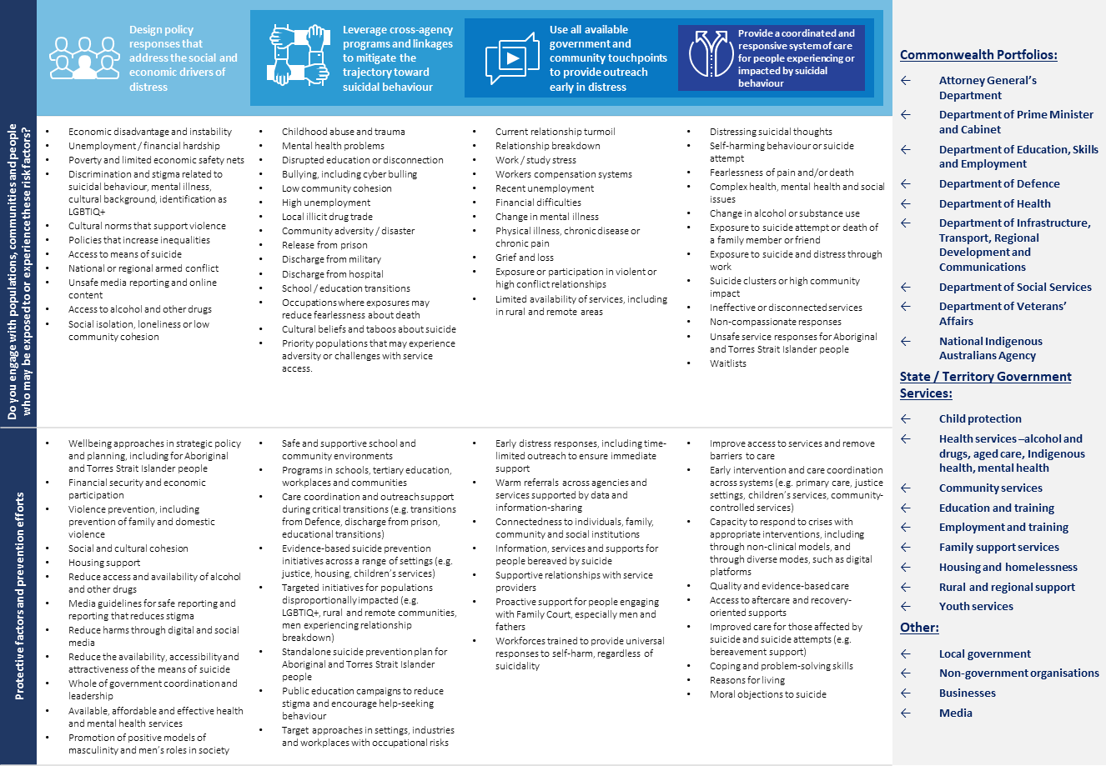

# Appendix B: Resources

There are a number of existing resources which can be leveraged by Government portfolios and agencies to drive new and existing suicide prevention activities.

|  |  |  |
| --- | --- | --- |
| Training and other programs | Communication resources | Help-seeking information |
| * There are a range of contemporary, compassion focussed training options being rolled out across Commonwealth and State and Territory portfolios. There is also mental health capability development work occurring across the Australian Public Service that supports this work. * Information on other available training for professionals and communities can be found at <https://lifeinmind.org.au/gatekeeper-training-search> | Government portfolios and other organisations should sign up to the National Communications Charter available at <https://lifeinmind.org.au/the-charter>  Those working with the media or preparing public content should refer to the Mindframe Guidelines - <https://mindframe.org.au/>   * Resources for young people communicating about suicide online are available via chatsafe - <https://www.orygen.org.au/chatsafe> | * Lifeline – 13 11 14, lifeline.org.au * Suicide Call Back Service – 1300 659 467, suicidecallbackservice.org.au * Beyond Blue – 1300 224 636, beyondblue.org.au/forums * Mensline Australia – 1300 789 978, mensline.org.au * Kids Helpline – 1800 551 800, kidshelpline.com.au * headspace – 1800 650 890, headspace.org.au * ReachOut – au.reachout.com * Head to Health mental health portal – headtohealth.gov.au * Life in Mind suicide prevention portal – lifeinmindaustralia.com.au * SANE online forums – saneforums.org * National Alcohol and Other Drugs Hotline – 1800 250 015 * LGBTIQ+ - 1800 184 527, qlife.org.au * Culturally and linguistically diverse resources – embracementalhealth.org.au, mhima.org.au * The Centre for Rural and Remote Mental Health – crrmh.com.au * Soldier On Veterans support – [soldieron.org.au](https://soldieron.org.au) * Open Arms – Veterans and Families Counselling Service - 1800 011 046, openarms.gov.au * Department of Veteran’s Affairs – [www.dva.gov.au](http://www.dva.gov.au) |
| Aboriginal and Torres Strait Islander people |
| * Aboriginal and Torres Strait Islander support services and resource – healthinfonet.ecu.edu.au * Gayaa Dhuwi (Proud Spirit) Declaration can be accessed at <https://www.gayaadhuwi.org.au/resources/the-gayaa-dhuwi-proud-spirit-declaration/> |
| National and State Suicide Prevention Policies |
| * Life in Mind - [https://lifeinmind.org.au/national-policy](https://urldefense.com/v3/__https:/lifeinmind.org.au/national-policy__;!!E1R1dd1bLLODlQ4!T1plmV7dyAfgbyfVh7dKe5wLa3PipVuATQuwfv9AHSn7xr4hnmlIShrz5m3mh_QjiQ$) |

## ENDNOTES

1. EveryMind. National Communications Charter: A unified approach to mental health and suicide prevention. EveryMind; 2020. Available at: https://lifeinmindaustralia.imgix.net/assets/src/user-uploads/EM-0046_National_Communications_Charter_230920_online_spread.pdf
2. Barnes LS. Help-seeking behavior prior to nearly lethal suicide attempts. Suicide and Life-Threatening Behavior. PubMed.gov. 2001; doi: 10.1521/suli.32.1.5.68.24217. PMID: 11924697.
3. De Leo D. Contacts with health professionals before suicide: Missed opportunities for prevention? *Comprehensive Psychiatry*. 2013; doi: 10.1016/j.comppsych.2013.05.007.
4. Black Dog Institute. New digital-first service to be developed for people at risk of suicide. Black Dog Institute; n.d. Available at: https://www.blackdoginstitute.org.au/news/new-digital-first-service-to-be-developed-for-people-at-risk-of-suicide/
5. O'Connor RC,Kirtley OJ. The integrated motivational–volitional model of suicidal behaviour. Philosophical Transactions of the Royal Society B: Biological Sciences. 2018; doi: 10.1027/0227-5910/a000120
6. Private Lives 3: The health and wellbeing of LGBTIQ people in Australia. La Trobe University, Melbourne; 2020.
7. Chesney E, et al. Risks of all-cause and suicide mortality in mental disorders: a meta-review. World Psychiatry. 2014: doi.org/10.1002/wps.20128
8. Australian Institute of Health and Welfare. Suicide and intentional self-harm. AIHW. ACT; 23 July 2020. Available at: https://www.aihw.gov.au/reports/australias-health/suicide-and-intentional-self-harm
9. Royal Commission into Victoria’s Mental Health System. Interim Report. VIC; November 2019. Available at: https://s3.ap-southeast-2.amazonaws.com/hdp.au.prod.app.vic-rcvmhs.files/4215/8104/8017/Interim_Report__FINAL_.pdf
10. Darwin, et al. We are Strong. We are Resilient. But we are Tired – Voices from the Aboriginal and Torres Strait Islander Lived Experience Centre Yarning Circles Report*.* The Seedling Group and The Lived Experience Centre, in collaboration with Black Dog Institute; 2020. Available at:

    <https://www.suicidepreventionaust.org/wp-content/uploads/2020/11/We-are-Strong.-We-are-Resilient.-But-we-are-Tired-Voices-from-the-Yarnin.pdf>
11. National Suicide Prevention Adviser. Compassion First: Designing our national approach from the lived experience of suicidal behaviour. Canberra; December 2020.
12. Mok K, et al. The lived experience of suicide: A rapid review*.* Black Dog Institute, Sydney; 2020.
13. Dudgeon P. SOLUTIONS THAT WORK: WHAT THE EVIDENCE AND OUR PEOPLE TELL US. Aboriginal and Torres Strait Islander Suicide Prevention Evaluation Project Report. University of Western Sydney; November 2016. Available at: <https://www.niaa.gov.au/sites/default/files/publications/solutions-that-work-suicide-prevention.pdf>
14. National Suicide Prevention Adviser. Compassion First: Designing our national approach from the lived experience of suicidal behaviour. Canberra; December 2020.