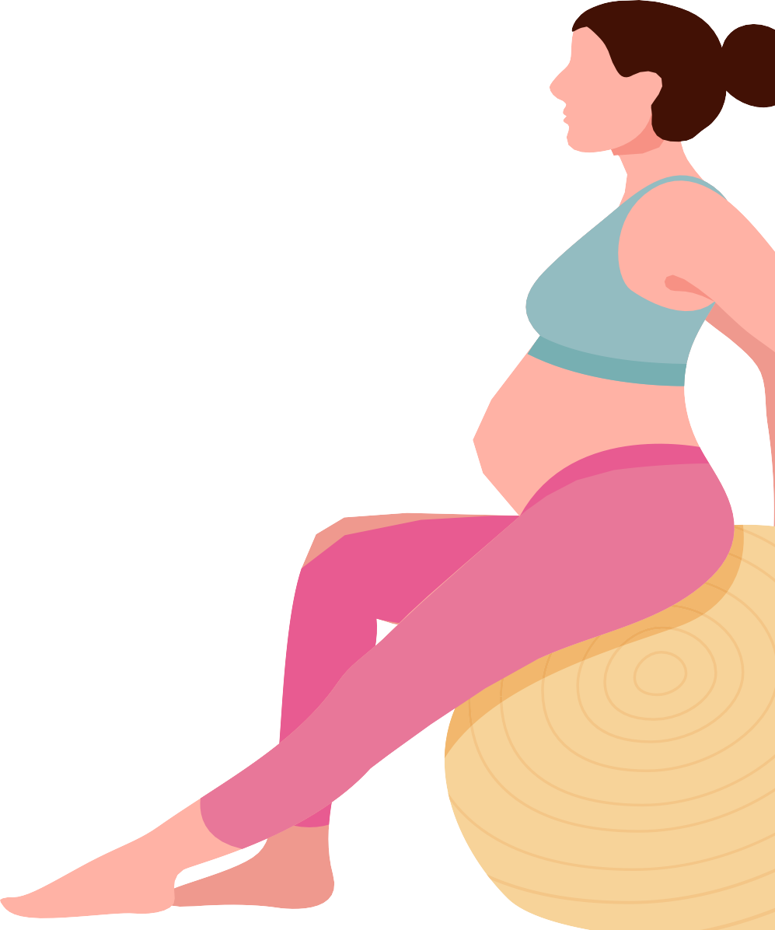
Guidelines for physical activity during pregnancy
For more information go to health.gov.au

During your pregnancy aim to:

Be active on most, if not all, days of the week.
Do 30 to 60 minutes of moderate intensity activity
or 15 to 30 minutes of vigorous intensity activity.
Do muscle strengthening activities on at least 2 days each week.
Break up long periods of sitting and standing still.
Do pelvic floor exercises.

If you have complications, seek advice from a health professional before being active.

If you have a healthy pregnancy, and you were active before pregnancy, you can continue exercising.
If you were inactive before pregnancy, start slowly and build up your activity.
Being active during pregnancy is safe and has health benefits for you and your baby. It can reduce the risk of some pregnancy-related problems, and supports a healthy pregnancy.




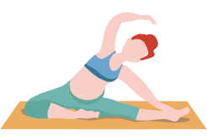

DO

Aerobic activities

Muscle strengthening activities

Pelvic floor exercises
REMEMBER
MIN
10
Drink plenty of water
Short bursts of activity work
Any physical activity is better than none
Avoid heat stress/ hyperthermia

