Guidelines for **physical activity** during **pregnancy**

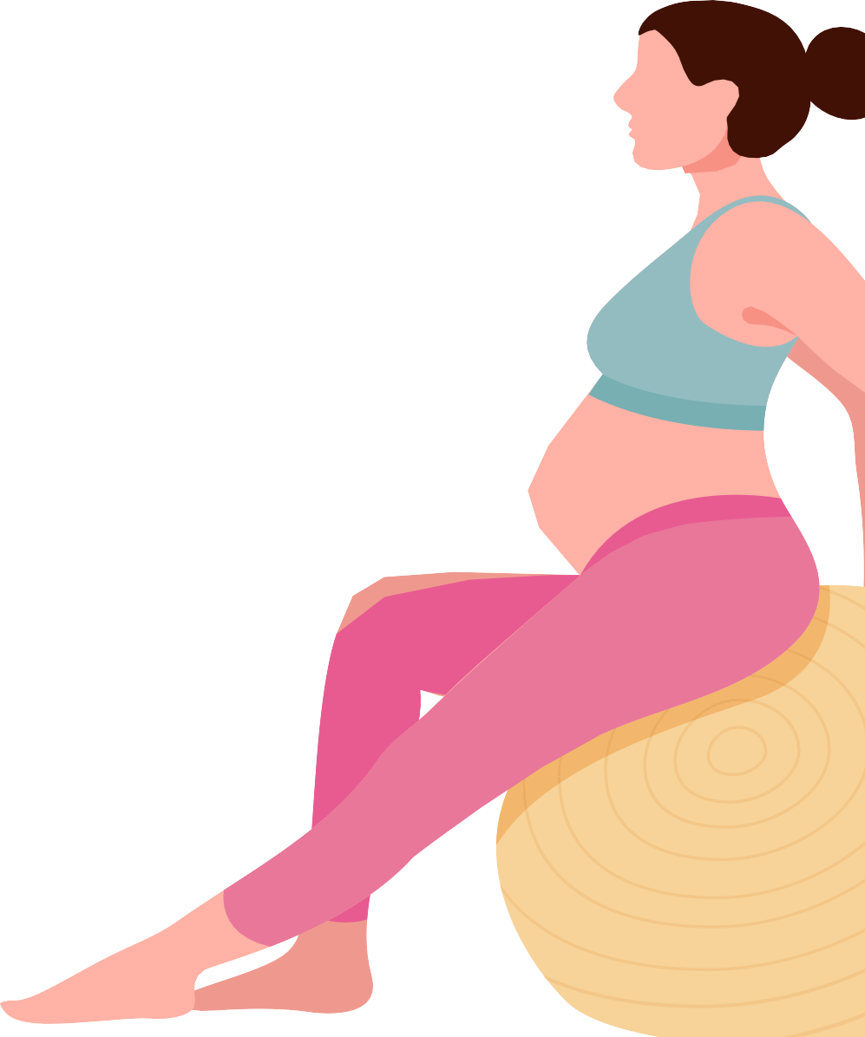

For more information go to **health.gov.au**

**During your pregnancy aim to:**

**Be active** on most, if not all, days of the week.

**Do 30 to 60 minutes of moderate** intensity activity

**or 15 to 30 minutes of vigorous** intensity activity.

**Do muscle strengthening** activities on at least 2 days each week.

**Break up** long periods of sitting and standing still.

**Do pelvic floor exercises.**

*If you have complications, seek advice from a health professional before being active.*

**If you have a healthy pregnancy**, and you were active before pregnancy, you can continue exercising.

**If you were inactive** before pregnancy, start slowly and build up your activity.

Being active during pregnancy is safe and has health benefits for you and your baby. It can reduce the risk of some pregnancy-related problems, and supports a healthy pregnancy.



**DO**

**Aerobic activities**

**Muscle strengthening activities**

**Pelvic floor exercises**

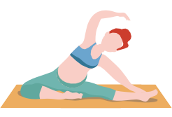

**REMEMBER**

**MIN**

**10**

**Drink plenty of water**

**Short bursts of activity work**

**Any physical activity is better than none**

**Avoid heat stress/ hyperthermia**