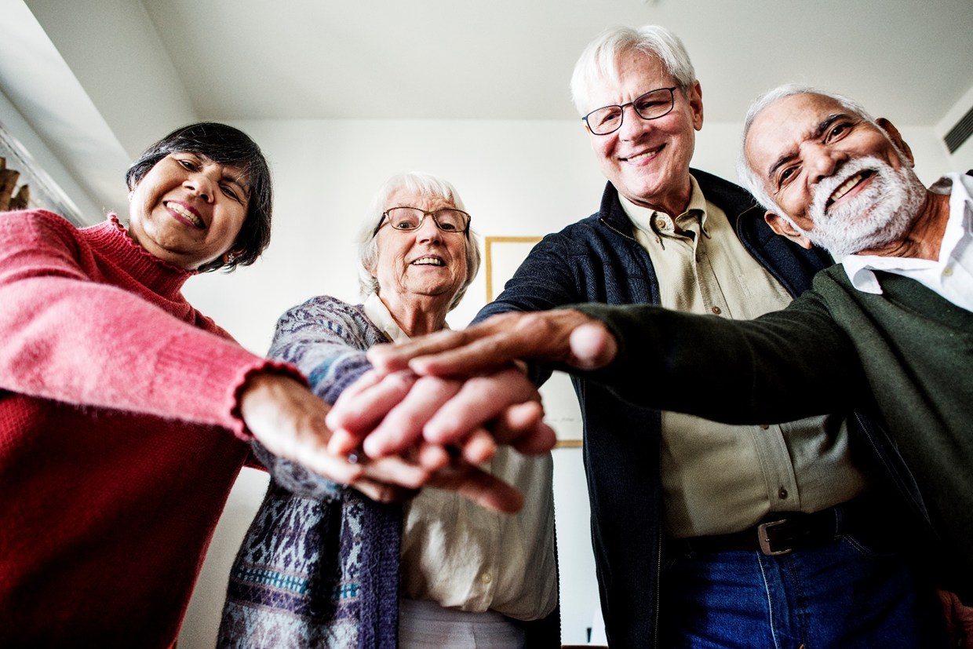

Evaluation of the Aged Care System Navigator Measure

Final Report: Appendices

for the Australian Government Department of Health

April 2021



© Commonwealth of Australia as represented by the Australian Government Department of Health 2021

Apart from uses permitted by the Copyright Act 1968 and this copyright notice, all other rights (including all commercial rights) are expressly reserved.

**Permitted Uses**

You may download, display, print, and reproduce the whole or part of this publication in unaltered form for:

* your own personal use;
* use within your organisation; or
* distribution and sharing with third parties,

but only if:

* you or your organisation do not use or reproduce the publication for any commercial purpose; and
* if reproduced, this copyright notice and all disclaimer notices are included as part of any reproduction.

This licence does not cover, and there is no permission given for, use of the Commonwealth Coat of Arms or any logos and trademarks (including the logo of the Department of Health).

**Disclaimer**

This publication has been produced independently by Australian Healthcare Associates on the request of the Department of Health.

The Australian Government accepts no responsibility for material contained in the publication. The views or recommendations expressed in this publication may include the views or recommendations of third parties and do not necessarily reflect those of the Australian Government or indicate a commitment to a particular course of action.

Providing access to the publication does not constitute an endorsement, approval or recommendation by the Australian Government of any organisation, association, entity, service, program, products or research offered by virtue of any information, material or content within the publication.

The information in this publication is provided on the basis that all persons accessing it undertake responsibility for assessing the relevance and accuracy of its content.

**Suggested Citation**

Australian Healthcare Associates, 2020, Evaluation of the Aged Care System Navigator Measure Final Report, Australian Government Department of Health.

Logo: Australian Healthcare Associates

Level 6, 140 Bourke St, Melbourne VIC 3000

Locked Bag 32005, Collins Street East, VIC 8006

1300 242 111

aha@ahaconsulting.com.au

www.ahaconsulting.com.au

Acknowledgement of Country

In the spirit of reconciliation, the authors acknowledge and pay respect to the traditional custodians of Country, the Aboriginal or Torres Strait Islander peoples, and their continuing connection to land, waters, and community.

Australian Healthcare Associates is located on the lands of the Kulin Nation. We pay respect to Elders past and present.

Abbreviations

|  |  |
| --- | --- |
| Term | Definition |
| A&S | Access and Support |
| ACAT | Aged Care Assessment Team |
| ACPR | Aged Care Planning Regions |
| ACSN | Aged Care System Navigator |
| ADAA | Aged and Disability Advocacy Australia |
| AHA | Australian Healthcare Associates |
| APS | Australian public service |
| CAC | Community and Aged Care |
| CALD | Culturally and Linguistically Diverse |
| CHSP | Commonwealth Home Support Programme |
| CoP | Communities of practice |
| CVS | Community Visitors Scheme |
| DEX | Data Exchange |
| DHS | Department of Human Services (now known as Services Australia) |
| DVA | Department of Veterans’ Affairs |
| EPOA | Enduring Power of Attorney |
| FIS | Financial Information Service |
| FTE | Full-time equivalent |
| HAAG | Housing for the Aged Action Group |
| HACC | Home and Community Care |
| HCP | Home Care Package |
| IQR | Interquartile range |
| IUIH | Institute for Urban Indigenous Health |
| KPI | Key performance indicators |
| LGBTI | Lesbian Gay Bisexual Transgender Intersex |
| MCCI | Multicultural Communities Council of Illawarra Incorporated |
| MDS | Minimum data set |
| MRC | Migrant Resource Centre |
| NACAP | National Aged Care Advocacy Program |
| NDAP | National Disability Advocacy Program |
| NDIS | National Disability Insurance Scheme |
| NHW | Northeast Health Wangaratta |
| OPAN | Older Persons Advocacy Network |
| PCAN | Positive CALD Ageing Network |
| PHN | Primary Health Network |
| PICAC | Partners in Culturally Appropriate Care |
| RACF | Residential Aged Care Facilities |
| RAS | Regional Assessment Service |
| RFT | Request for tender |
| ROI | Record of Interview |
| RSL | Returned and Services League |
| SMRC | Southern Migrant and Refugee Centre |
| SSW | Specialist Support Worker |
| the ACSN Measure | the Aged Care System Navigator Measure |
| the Department | the Australian Government Department of Health |
| TIS | Translating and Interpreting Service |

Glossary

**Aged care consumer:** a person eligible (or potentially eligible for) aged care services. For the purposes of this report, this term includes people who are seeking information about aged care services and/or their eligibility for these, as well as those who have already engaged with the aged care system through My Aged Care (i.e., awaiting assessment, assessed, and/or awaiting provision of services).

**Aged care service providers:** includes Australian Government-funded and private providers of community-based and/or residential aged care services.

**Service user:** an actual or hypothetical user, or client, of an aged care navigation service.

**Lay navigator:** a navigator without directly relevant professional experience/qualifications (could be a paid worker or volunteer).

**Peer navigator:** a navigator with lived experience relevant to the setting or target population group.

Contents

Appendix A Program logics 1

Appendix B Trial data sources 5

B.1 Data sources for the COTA Australia-led trials 5

B.2 Data sources for the FIS Officer trials 8

Appendix C COVID-19 survey results 9

C.1 Overview 9

C.2 Impact on resourcing 9

C.3 Impact on trial delivery 11

C.4 Welfare checks 24

C.5 Other comments 27

Appendix D Supplementary information from the COTA Australia data set 28

D.1 Introduction 28

Appendix E Review of other system navigator models 42

E.1 Aged care system navigator models in Australia 42

Appendix F Appropriateness: findings from the modified short-form survey 58

F.1 Survey aim 58

F.2 Survey format 59

F.3 Survey take-up 59

Tables

Table C‑1: Trials anticipating a change in in-kind support requirements, by trial type 11

Table C‑2: Estimated number of Individual trial activities to be delivered between April and June 2020, by trial type 12

Table C‑3: Estimated number of Group trial activities to be delivered between April and June 2020, by trial type 12

Table C‑4: Breakdown of Individual trial activities planned to be delivered between April and June 2020, by trial type 14

Table C‑5: Estimated number of navigator service users expected to be reached between April and June 2020, by promotional activity type 23

Table C‑6: Anticipated approach to conducting welfare checks during COVID‑19, by trial type 25

Table D‑1: Distribution of redefined trial activity types delivered between September and November 2020 28

Table D‑2: Median duration of Individual and Group trial activities, by trial type 31

Table D‑3: Paid staff and volunteer FTE levels between February and November 2019 (reported) and July 2020 and June 2021 (planned), by partner organisation 32

Table D‑4: Number of ‘target populations’ reported to have received Individual trial activities between September and November 2020, by partner organisation 34

Table D‑5: Navigator service user status 35

Table D‑6: Sex of navigator service users 35

Table D‑7: Age range of navigator service users 36

Table D‑8: Country of birth of navigator service users 36

Table D‑9: Median ‘actual’ and ‘total’ costs of the Group trial activity ‘Attended a Group’, delivered between September and November 2020, by trial type 38

Table D‑10: Median ‘total’ costs of Individual trial activity delivery between September and November 2020 per navigator service user 39

Table E‑1: Key elements of the trials undertaken as part of the ACSN Measure 43

Table E‑2: Key elements of other identified aged care system navigator models in Australia: National 45

Table E‑3: Key elements of other identified aged care system navigator models in Australia: NSW 48

Table E‑4: Key elements of other identified aged care system navigator models in Australia: QLD 50

Table E‑5: Key elements of other identified aged care system navigator models in Australia: SA 51

Table E‑5: Key elements of other identified aged care system navigator models in Australia: VIC 55

Table F‑1: Diverse groups and vulnerable populations reported by modified short-form survey respondents 62

Table F‑2: Most common diverse group and vulnerable populations reported by modified short-form survey respondents 63

Table F‑3: Language/s spoken at home, reported by modified short-form survey respondents 63

Table F‑4: Navigator service users’ responses in the modified short-form survey, reported between September and November 2020 65

Table F‑5: Distribution of positive, negative and neutral responses reported by the most common diverse group and vulnerable populations in the modified short-form survey 73

Figures

Figure A‑1: Program logic for the Information hubs 1

Figure A‑2: Program logic for the Community hubs 2

Figure A‑3: Program logic for the SSW trials 3

Figure A‑4: Program logic for the FIS Officer trials 4

Figure C‑1: Planned Individual trial activities to be delivered between April and June 2020, by mode of delivery 15

Figure C‑2: Breakdown of Group trial activities planned to be delivered between April and June 2020, by trial type 17

Figure C‑3: Proportion of navigator service users expected to receive Group trial activities between April and June 2020, by trial type 19

Figure C‑4: Proportion of navigator service users expected to be reached by promotional activities between April and June 2020, by modality 21

Figure D‑1: Distribution of trial activities (Group and Individual combined) delivered between September and November 2020, by trial type 29

Figure D‑2: Number of navigator service user attendees at original Group trial activity types, between February 2019 and August 2020 30

Figure D‑3: ‘Total’ costs of delivering the Group trial activity ‘Attended a group’, delivered between September and November 2020, per navigator service user 38

Figure D‑4: Median ‘total’ costs of Individual trial activity delivery between September and November 2020, by trial type 40

Figure D‑5: Median ‘total’ costs of Individual trial activity delivery between September and November 2020, by mode of delivery (In person and telephone) 41

Figure F‑1: Modes of delivery of the main trial activity types reported in the modified short-form survey 61

Figure F‑2: Distribution of positive, negative and neutral responses reported in the modified short-form survey, between September and November 2020 67

Figure F‑3: Positive response reporting in the modified short-form survey, reported between September and November, by diverse group 71

Figure F‑4: Positive response reporting in the modified short-form survey, between September and November, by vulnerable population 71

# Program logics

Figure A‑1: Program logic for the Information hubs

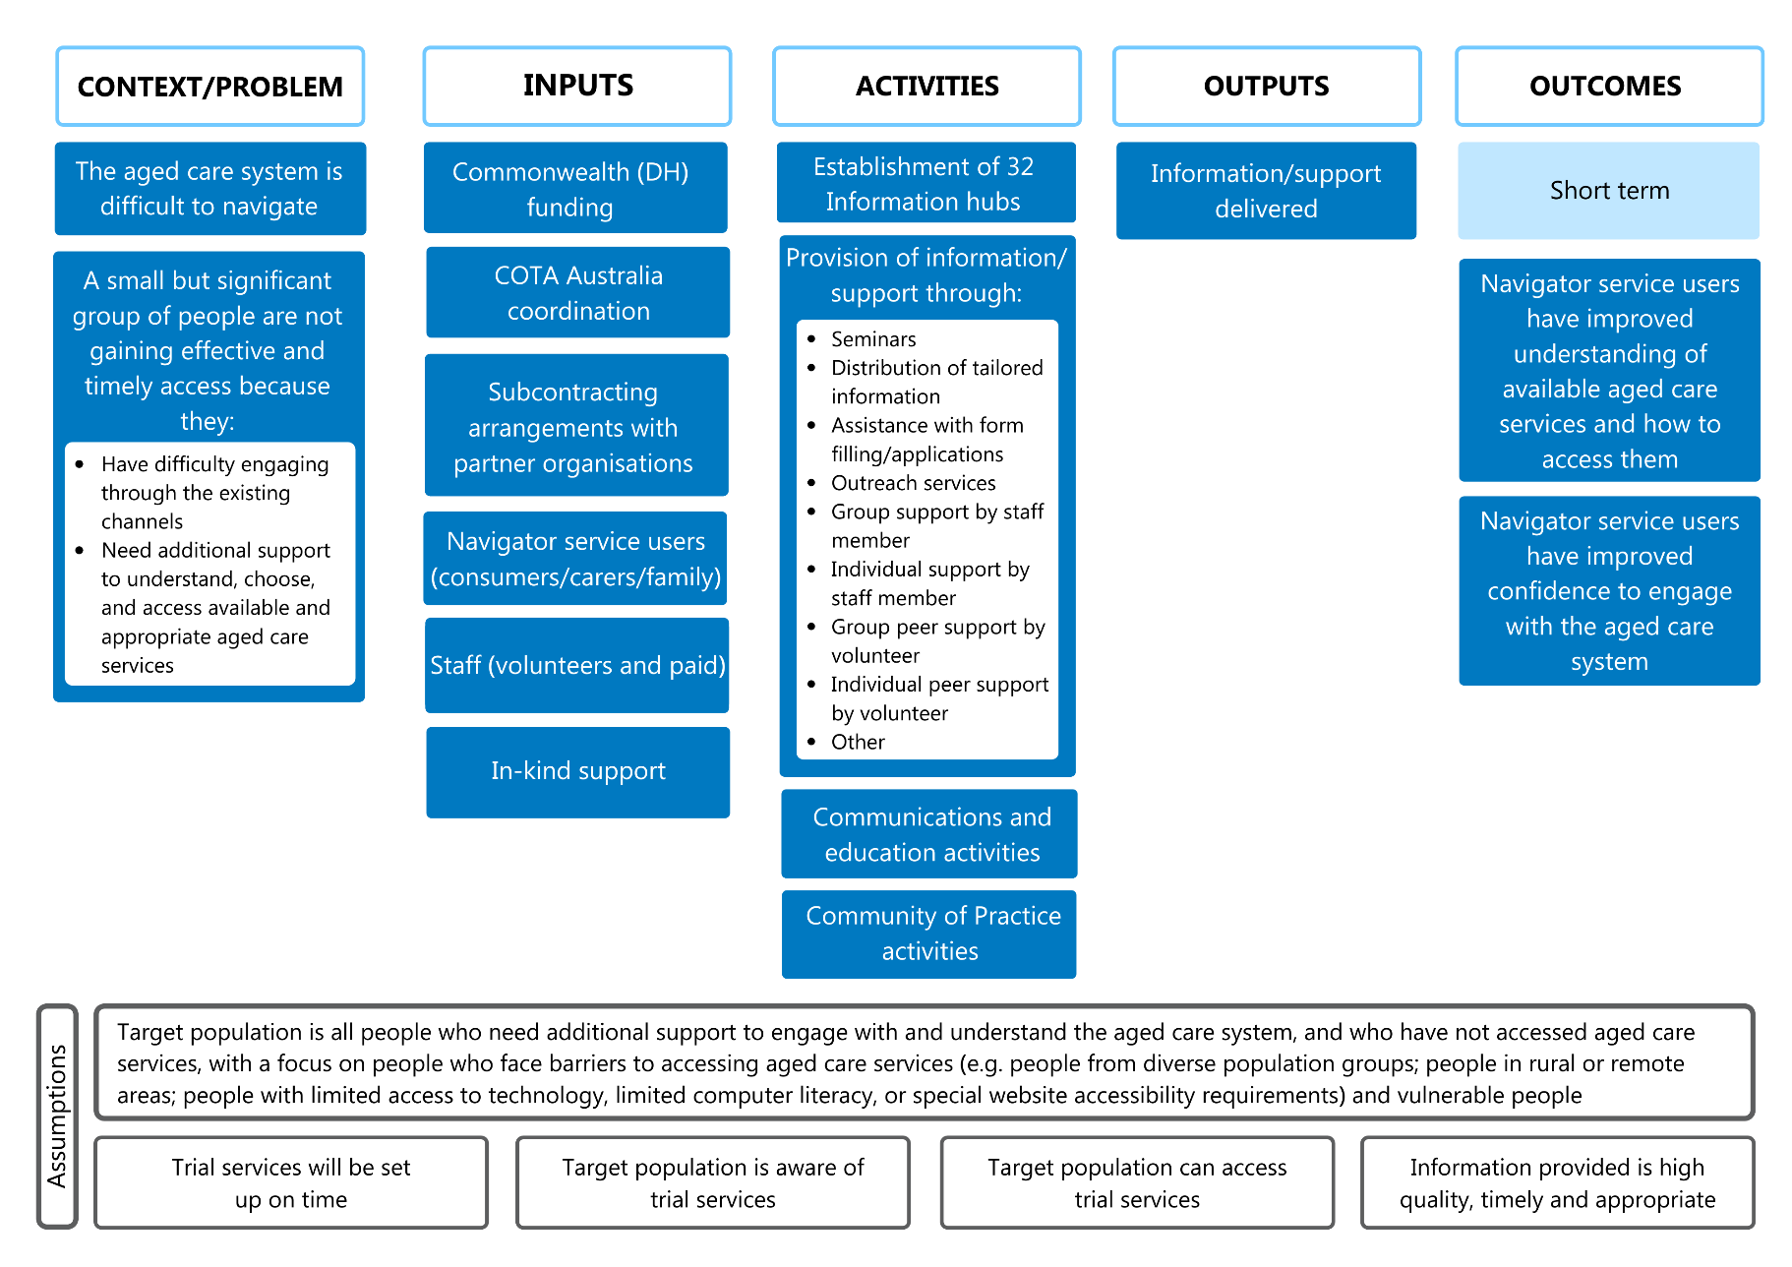

Note: Does not include the 2 Integrated Information hub/SSW trials.

Long description: The Project logic for the Information hubs is divided into 6 sections: context and problem, inputs, activities, outputs, outcomes, and assumptions (which underpin the 5 other sections). The context and problem is that the aged care system is difficult to navigate. Additionally, a small but significant group of people are not gaining effective and timely access because they have difficulty engaging through the existing channels or need additional support to understand, choose, and access available and appropriate aged care services. The inputs come from Commonwealth (DH) funding, COTA Australia coordination, subcontracting arrangements with partner organisations, navigator service users (consumers, carers and family), staff (volunteers and paid) and in-kind support. The activities comprise the establishment of 32 Information hubs and the provision of information and support through: seminars, the distribution of tailored information, assistance with form filing and applications, outreach services, group support by staff member, individual support by staff member, group peer support by volunteer, individual peer support by volunteer and others. Other activities include communication and education activities and community of practice activities. The outputs are the delivery of information and support. The outcomes section describes the short-term outcomes of the project where navigator service users have an improved understanding of available aged care services and how to access them, and improved confidence to engage with the aged care system. The assumptions are that the target population is all people who need additional support to engage with and understand the aged care system, and who have not accessed aged care services, with a focus on people who face barriers to accessing aged care services (e.g. people from diverse population groups; people in rural or remote areas; people with limited access to technology, limited computer literacy, or special website accessibility requirements) and vulnerable people. There is also the assumption that trial services will be set up on time, that the target population is aware of trial services, the target population can access trial services and the information provided is high quality, timely and appropriate.

Figure A‑2: Program logic for the Community hubs

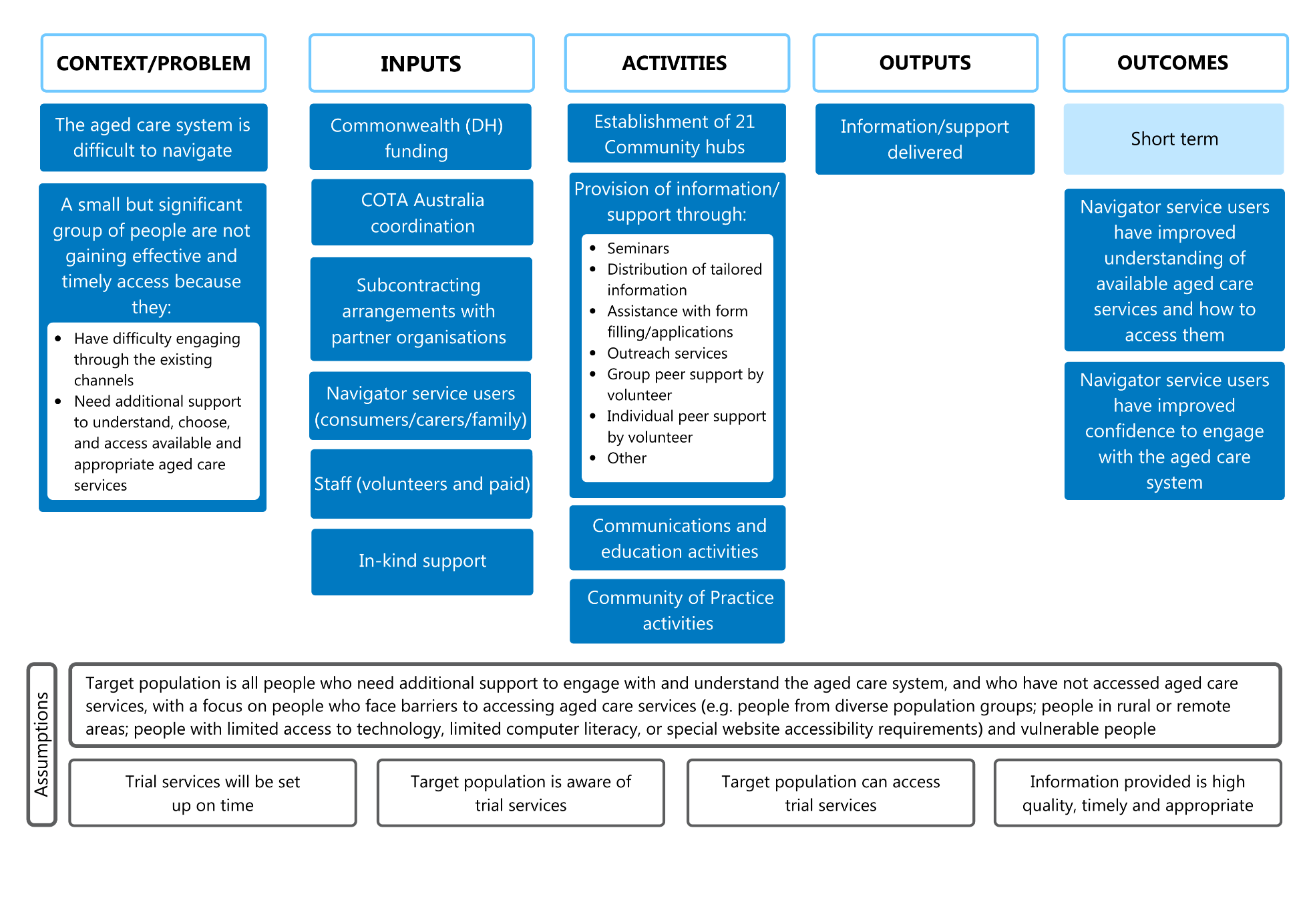

Long description: The Project logic for the Community hubs is divided into 6 sections: context and problem, inputs, activities, outputs, outcomes, and assumptions (which underpin the 5 other sections). The context and problem is that the aged care system is difficult to navigate. Additionally, a small but significant group of people are not gaining effective and timely access because they have difficulty engaging through existing channels or need additional support to understand, choose, and access available and appropriate aged care services. The inputs come from Commonwealth (DH) funding, COTA Australia coordination, subcontracting arrangements with partner organisations, navigator service users (consumers, carers and family), staff (volunteers and paid) and in-kind support. The activities involve the establishment of 21 Community hubs and the provision of information and support (through seminars, distribution of tailored information, assistance with form filing and applications, outreach services, group peer support by volunteer, individual peer support by volunteer and others). Other activities include communication and education activities and community of practice activities. The outputs are the delivery of information and support. The outcomes section describes the short-term outcomes of the project where navigator service users have an improved understanding of available aged care services and how to access them, and improved confidence to engage with the aged care system. The assumptions are that the target population is all people who need additional support to engage with and understand the aged care system, and who have not accessed aged care services, with a focus on people who face barriers to accessing aged care services (e.g. people from diverse population groups; people in rural or remote areas; people with limited access to technology, limited computer literacy, or special website accessibility requirements) and vulnerable people. There is also the assumption that trial services will be set up on time, the target population is aware of trial services, the target population can access trial services and the information provided is high quality, timely and appropriate.

Figure A‑3: Program logic for the SSW trials

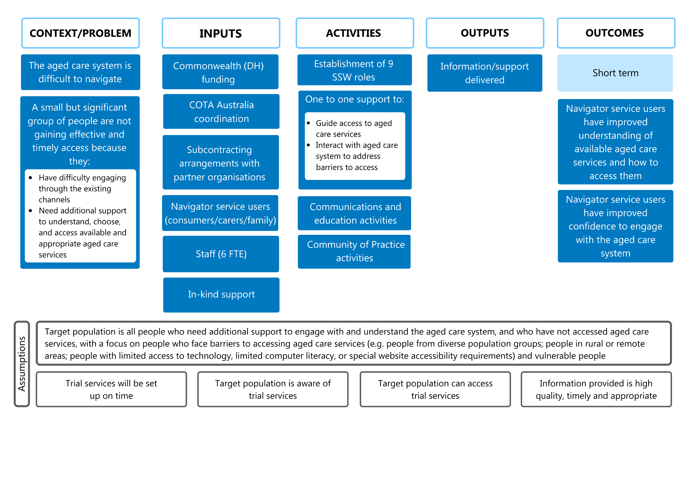

Note: Does not include the 2 Integrated Information hub/SSW trials.

Long description: The Project logic for the SSW trials is divided into 6 sections: context and problem, inputs, activities, outputs, outcomes, and assumptions (which underpin the 5 other sections). The context and problem is that the aged care system is difficult to navigate. Additionally, a small but significant group of people are not gaining effective and timely access because they have difficulty engaging through existing channels or need additional support to understand, choose, and access available and appropriate aged care services. The inputs come from Commonwealth (DH) funding, COTA Australia coordination, subcontracting arrangements with partner organisations, navigator service users (consumers, carers and family), staff (6 FTE) and in-kind support. The activities involve the establishment of 9 SSW roles and one-to-one support to guide access to aged care services and interact with aged care systems to address barriers to access. Other activities include communication and education activities and community of practice activities. The outputs are the delivery of information and support. The outcomes section describes the short-term outcomes of the project where navigator service users have an improved understanding of available aged care services and how to access them, and improved confidence to engage with the aged care system. The assumptions are that the target population is all people who need additional support to engage with and understand the aged care system, and who have not accessed aged care services, with a focus on people who face barriers to accessing aged care services (e.g. people from diverse population groups; people in rural or remote areas; people with limited access to technology, limited computer literacy, or special website accessibility requirements) and vulnerable people. There is also the assumption that trial services will be set up on time, the target population is aware of trial services, the target population can access trial services and the information provided is high quality, timely and appropriate.

Figure A‑4: Program logic for the FIS Officer trials

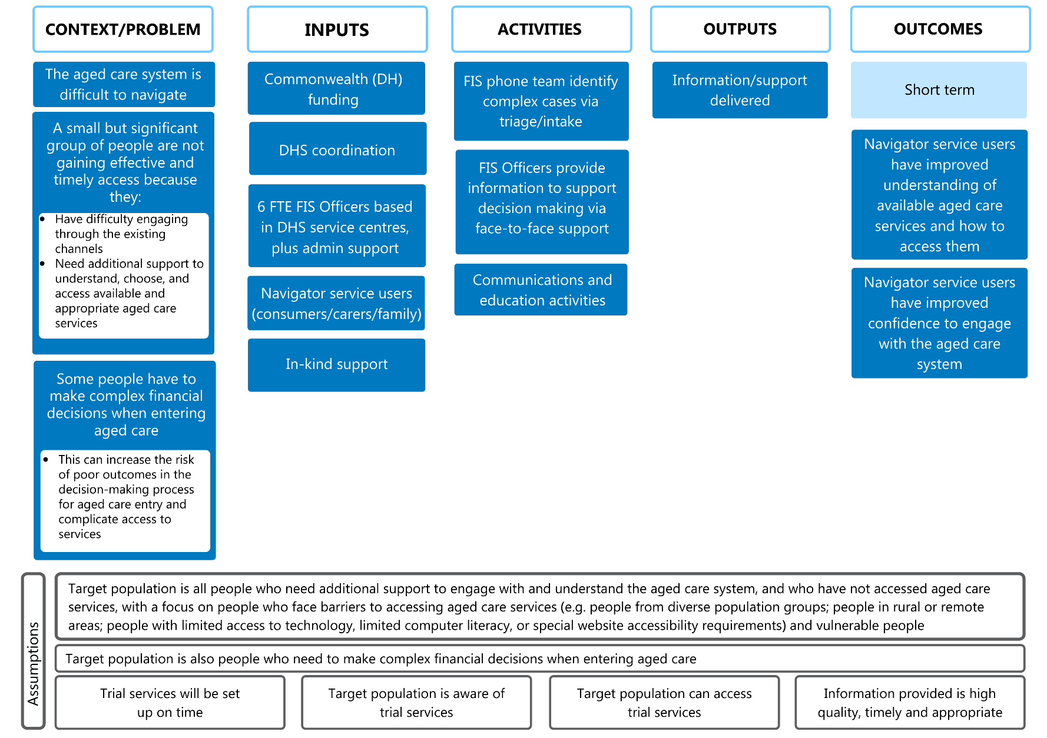

Long description: The Project logic for the FIS Officer trials is divided into 6 sections: context and problem, inputs, activities, outputs, outcomes, and assumptions (which underpin the 5 other sections). The context and problem is that the aged care system is difficult to navigate. Additionally, a small but significant group of people are not gaining effective and timely access because they have difficulty engaging through existing channels or need additional support to understand, choose, and access available and appropriate aged care services. Furthermore, some people have to make complex financial decisions when entering aged care. This can increase the risk of poor outcomes in the decision-making process for aged care entry and complicate access to services. Inputs come from Commonwealth (DH) funding, DHS coordination, 6 FTE FIS Officers based in DHS service centres, plus admin support, navigator service users (consumers, carers and family), and in-kind support. The activities involve the FIS phone team identifying complex cases via triage/intake, and FIS Officers providing information to support decision making via face-to-face support and communication and education activities. The outputs are the delivery of information and support. The outcomes section describes the short-term outcomes of the project where navigator service users have an improved understanding of available aged care services and how to access them, and improved confidence to engage with the aged care system. The assumptions are that the target population is all people who need additional support to engage with and understand the aged care system, and who have not accessed aged care services, with a focus on people who face barriers to accessing aged care services (e.g. people from diverse population groups; people in rural or remote areas; people with limited access to technology, limited computer literacy, or special website accessibility requirements) and vulnerable people. Furthermore, the target population is people who need to make complex financial decisions when entering aged care. There is also the assumption that trial services will be set up on time, the target population is aware of trial services, the target population can access trial services and the information provided is high quality, timely and appropriate.

# Trial data sources

The data sources used to inform the evaluation of the COTA Australia-led trials and the FIS Officer trials are presented below.

## Data sources for the COTA Australia-led trials

Contractual materials

* COTA Australia Aged Care System Navigator trial tender documents (redacted version received 11 January 2019)
* Trial budget information (clarification received 2 June 2020)
* Subcontractor budget template (received 17 January 2019)
* Subcontracts between COTA Australia and partner organisations, including subcontractor budget information
* Contract between the Department and COTA Australia (received 18 January 2019)
* Annexure A—Subcontractors (received 18 January 2019)
* Annexure B—Specified Personnel (received 18 January 2019)
* Aged Care System Navigator Request for Tender (RFT) documents (received 21 November 2019)
* Contract (Deed of Variation) between the Department and COTA Australia for trial extension period (received 1 August 2020).

Trial profiles

* Approved (n=58) and draft (n=6) trial profiles which describe their intended design and implementation approaches (received between January 2019 and March 2020)
* Updated trial profiles for extension phase (n=64), (received between September and October 2020).

COTA Australia governance materials

COTA Australia’s final Implementation Approach and Methodology document (dated August 2019)

* COTA Australia’s updated Implementation approach and methodology (received 22 October 2020)
* COTA Australia’s updated project plan (received 22 October 2020)
* Communities of Practice (CoP) Leads Guidelines Draft document (received June 2019)
* COTA Australia extension proposal (received 22 October 2020)
* 8 SSW CoP minutes (for 2 May 2019, 6 June 2019, 4 July 2019, 1 August 2019, 3 October 2019, 4 November 2019, 5 December 2019 and 20 October 2020 meetings)
* CoP—a professional development strategy for Specialist Support Workers in the Aged Care Navigator Trial—6 monthly review (dated 19 November 2019; received 14 February 2020)
* 2 Aboriginal or Torres Strait Islander CoP minutes (for 23 July 2019 and 27 November 2019 meetings)
* 2 CALD CoP minutes (for 26 July 2019 and 28 November 2019 meetings)
* LGBTI CoP minutes (for 28 November 2019, 16 January 2020, and 13 February 2020 meetings)
* 3 Communications and Education Group minutes (for 28 August 2019, 16 October 2019 and 28 October 2020 meetings)

5 state/territory forum minutes for WA meeting in August 2019, and meetings in Vic, NSW, SA and ACT–Tas–NT (combined) (October 2020)

* Resources uploaded to the BoostHQ platform (received ad hoc).

Consultation data

* 30 initial consultations – partner organisations (completed by October 2019)
* 27 follow-up consultations – partner organisations (completed by October 2020)
* 1 initial consultation – COTA Australia’s Governance Group member (completed November 2019)
* 2 follow-up consultations – COTA Australia’s Governance Group members (completed November 2020)
* 31 telephone interviews – Navigator service users (completed by February 2021)
* 7 on-site consultation/site visits – Partner organisations (completed November 2019 to February 2020).

Other data sources

* Partner organisation materials forwarded by COTA Australia (e.g. partner organisation promotional materials, newspaper articles, presentation slides, position descriptions, information on using HealthDirect videoconferencing) (received ad hoc)
* Qualitative insights from partner organisation (Advocare; received 21 February 2020)
* Feedback from SSW CoP on Advocates as Agents pilot
* 147 case studies (additional to those submitted as part of quarterly progress reports (received July-August 2020)
* Profit and loss statements for 29 partner organisations for 2018-19 and/or 2019-20 (received October-November 2020).

Quarterly progress reports

First progress report (received 30 Apr 2019)

* COTA Australia progress report
* Partner organisation trial progress reports
* First extract from the COTA Australia data set

Second progress report (received 24 Jun 2019)

* COTA Australia progress report
* Partner organisation trial progress reports
* Second extract from the COTA Australia data set
* COTA Australia’s partner organisation survey (“Partner Survey and Reflections”)

Third progress report (received 24 Sep 2019)

COTA Australia progress report

Partner organisation trial progress reports

Third extract from the COTA Australia data set

* Materials from partner organisations (including communication and promotional materials)

Fourth progress report (received 7 Feb – 23 March 2020)

* COTA Australia progress report
* Partner organisation trial progress reports
* Fourth extract from the COTA Australia data set – rebuilt as at 11 March 2020
* Fifteen fortnightly progress reports (covering April 2019 to November 2019)

Fifth progress report (received 18 May – 1 Jun 2020)

* Front section of COTA Australia progress report document
* Partner organisation trial progress reports
* Fifth extract from the COTA Australia data set

Sixth progress report (received 28 May – 30 Jun 2020)

* COTA Australia progress report
* Partner organisation trial progress reports
* Sixth extract from the COTA Australia data set
* Aged Care navigators video conference file
* COVID-19 Change of operations innovation webinar slides

Seventh progress report (received 2 Oct 2020)

* COTA Australia progress report
* Partner organisation trial progress reports
* Seventh extract from the COTA Australia data set

Eighth progress report (received 24 Dec 2020 – 8 Jan 2021)

COTA Australia progress report

Partner organisation trial progress reports

* Eighth extract from the COTA Australia data set.

## Data sources for the FIS Officer trials

Contractual materials

* Service offer (dated 28 November 2018; received 7 March 2020)
* (Draft) letter of agreement between the Department and DHS (date unknown).

Quarterly extracts from the DHS data set

* First data extract (received 29 March 2019)
* Second data extract (received 8 July 2019)
* Final data extract (received 14 October 2019).

Financial reports

* Summary distribution of funding document (received 20 February 2020).

Qualitative data

* Promotional flyer for the FIS Officer trials (collected on site June 2019).

Consultation data

* 6 initial consultations –FIS Officers
* 5 on-site consultation/site visit – FIS Officers/customer observation
* 4 in-depth interviews – FIS Operations team
* 17 in-depth interviews – Navigator service users.

Trial closure documents

* Financial Summary (received 25 February 2020)
* Closure Executive Summary (received 25 February 2020)
* Project Closure Report (received 25 February 2020).

# COVID-19 survey results

## Overview

In order to understand the impact of the COVID‑19 pandemic on the delivery of the Information hub, Community hub and SSW trials, COTA Australia developed and distributed an online survey (via SurveyMonkey) to partner organisations in April 2020. The survey was aimed at gathering information about how each of the 64 trials expected to be impacted by COVID‑19 during the period 1 April to 30 June 2020.

The survey included both defined and free-text response options in relation to the anticipated impact of the pandemic across 4 main domains:

* Resourcing
* Trial activity delivery
* Promotional activities
* Welfare checks.

A synthesis of findings in relation to the reported impact of COVID‑19 on each of these key domains is presented below.

## Impact on resourcing

### Staff

Partner organisations reported that in 55 of the 64 trials (85.9%) all staff had been retained at the same FTE levels compared to pre-COVID‑19 (based on November 2019 reports). This proportion was very similar across the 3 programs of trials: 85% of Information hubs, 86% of Community hubs, and 89% of SSW trials reported no changes to staff FTE levels.

The survey invited partner organisations to provide additional commentary on the staff impacts of COVID‑19, and this was provided for almost half of the trials (n=30). A common response noted was that while there was no change in staffing numbers per se, trial staff had shifted their focus – to COVID‑19 related activities and/or to prioritising wellbeing checks – or were undertaking their navigation support work remotely.

While staffing levels had remained unchanged for many trials, several partner organisations noted that the pandemic had resulted in delays in advertising for staff or challenges in filling vacancies. There was also a sense from some survey responses that staffing had been affected by unexpected increases in travel costs, with some trials having to reduce staff FTE (or increase their reliance on volunteer support) as a direct result. On the other hand, one partner organisation reported that staff FTE had increased for one of their trials, to compensate for a reduction in volunteer workforce.

### Volunteers

Survey responses from 24 trials (38%) indicated that all volunteers had ‘remained available’ during the COVID‑19 period, although 5 of these trials indicated a change in the way that volunteers were used (e.g. re-deployment to Individual rather than Group activities). Ten trials who did not anticipate volunteers being available in the pandemic provided free-text comments as to why. Responses suggested that volunteer numbers were affected by 2 key factors:

* A reduction in available volunteering opportunities due to the short-term paring back of Information and Community hub activities – in particular, the cancellation of Group trial activities (seminars and presentations) without a commensurate increase in Individual trial activities delivered (e.g. telephone enquiries and support)
* Volunteers tending to belong to older (higher risk) age groups, meaning that some were required to self-isolate due to COVID‑19 restrictions.

### In-kind support

Twenty-one trials (32.8%) anticipated that COVID‑19 would change the level and type of in-kind support they required to deliver trial activities (see Table C‑1). These partner organisations most commonly reported that their in-kind support needs would increase (n= 16), with key drivers of this increase at Information hubs, SSW and Integrated Information hub/SSW trials being the additional time required to develop new models of trial delivery, and the additional liaison required with other services.

Specific to delivery of Community hubs during COVID‑19, some partner organisations highlighted that additional in-kind support was required to meet increased demand for navigator services, and to recruit and train an expanded volunteer workforce. One partner organisation indicated that increased in-kind support needs reflected with trial-related travel for Community and Information hubs.

Only 5 trials predicted that their in-kind support requirements would decrease; reasons for this included general reductions in the quantum of trial activities delivered, the expected withdrawal of community supports required to deliver trial activities (e.g., temporary closure of council venues, such as libraries, used for Group trial activities), and reductions in volunteer workforce.

Table C‑1: Trials anticipating a change in in-kind support requirements, by trial type

|  |  |  |
| --- | --- | --- |
| Trial type | Changes n (%) | Summary of changes |
| Information hubs (n=32) | 8 (25.0%) | Predicted increase in in-kind support (n=6): travel funds, additional promotion and outreach, additional liaison with other services, adaptations to ways of working (e.g. training in use of technology)  Predicted decrease in in-kind support (n=2): council support no longer available (e.g. venues, technology), decrease in requirement or availability of volunteers |
| Community hubs (n=21) | 10 (47.6%) | Predicted increase in in-kind support (n=7): travel funds, additional promotion, managing potential increase in navigator service users due to additional referral pathways, increased recruitment and training of volunteers  Predicted decrease in in-kind support (n=3): reduced level of activity, council support no longer available (e.g. venues, technology), decrease in requirement or availability of volunteers |
| SSWs (n=9) | 1 (11.1%) | Predicted increase in in-kind support (n=1): additional liaison with other services, adaptations to ways of working (e.g. training in use of technology) |
| Integrated Information hub/‌SSW trials (n=2) | 2 (100.0%) | Predicted increase in in-kind support (n=2): additional liaison with other services, adaptations to ways of working (e.g. training in use of technology) |
| Total (n=64) | 21 (32.8%) |  |

## Impact on trial delivery

Broadly speaking, partner organisations indicated that while delivery of Individual trial activities would continue during COVID‑19, almost all trials would shift away from delivering these activities in person to navigator service users. However, for a small number of trials who were already delivering primarily phone- and/or online-based individual support, their trial delivery was expected to remain largely unaffected by COVID‑19.

In contrast, partner organisations expected the delivery of Group trial activities to be particularly impacted by COVID‑19, with around a third of trials no longer conducting any group sessions for navigator service users.

Further information about the impact of COVID‑19 on the delivery of Individual and Group trial activities is presented in Section C.3.1 below.

The impact of COVID‑19 on promotional activities conducted by partner organisations was sometimes unclear in survey responses, as partner organisations were asked to describe current promotional activities without necessarily referencing how these had changed as a result of the pandemic. However, it was apparent from some partner organisations that the negative impact of COVID‑19 on the delivery of some Group and Individual activities represented an opportunity for them to focus more heavily on promotional activities instead.

Further information about the impact of COVID‑19 on the trials’ promotional activities is presented in Section C.3.2 below.

### Trial activities

Table C‑2 and C‑3 show the estimated number of Individual and Group trial activities planned for delivery between April and June 2020, by trial type. During this period, 59 trials planned to deliver 10,234 Individual trial activities, and 39 trials planned to deliver 851 Group trial activities. Overall, around half of all Group and Individual trial activities were planned to be delivered by Information hubs, and just over a quarter by Community hubs.

Following review of COVID-19 survey responses, COTA Australia indicated that partner organisations had likely *overestimated* the number of trial activities they planned to deliver between April and June 2020. For example, when considering *actual trial activity delivery* numbers reported in the preceding 3 months (January to March 2020), partner organisations delivered 2,467 Individual trial activities and 329 Group trial activities. While this preceding period is expected to reflect a general downturn in trial activity due to Christmas/New Year, it would appear that partner organisations had indeed *substantially* *overestimated* the number of trial activities they could deliver in light of COVID-19 restrictions.

Table C‑2: Estimated number of Individual trial activities to be delivered between April and June 2020, by trial type

|  |  |  |
| --- | --- | --- |
| Trial type | Trials  n (%) | Activities n (%) |
| Information hubs (n=32) | 29 (49.2) | 5,128 (50.1) |
| Community hubs (n=21) | 19 (32.2) | 2,831 (27.7) |
| SSWs (n=9) | 9 (15.3) | 937 (9.2) |
| Integrated Information hub/​SSW trials (n=2) | 2 (3.4) | 1,338 (13.1) |
| Total (n=64) | 59 | 10,234 |

Note: Trial figures show the number of trials planning to deliver trial activities; activity figures show the number of activities planned.

Table C‑3: Estimated number of Group trial activities to be delivered between April and June 2020, by trial type

|  |  |  |
| --- | --- | --- |
| Trial type | Trials n (%) | Activities n (%) |
| Information hubs (n=32) | 22 (56.4) | 468 (55.0) |
| Community hubs (n=21) | 12 (30.8) | 245 (28.8) |
| SSWs (n=9) | 3 (7.7) | 30 (3.5) |
| Integrated Information hub/​SSW trials (n=2) | 2 (5.1) | 108 (12.7) |
| Total (n=64) | 39 | 851 |

Note: Trial figures show the number of trials planning to deliver trial activities; activity figures show the number of activities planned.

#### Individual trial activities

Table C‑4 shows the breakdown of each type of Individual trial activity partner organisations planned to deliver between April and June 2020. Most strikingly, welfare checks – introduced as a direct response to COVID‑19 – made up the highest proportion of planned Individual trial activities by far (around 4 in every 10). However, there was some variation across trial types: while Information hubs and Community hubs reported welfare checks (delivered via telephone or online) as their most frequently planned Individual trial activity, for SSW trials (and the 2 Integrated Information hub/SSW trials), the most frequently planned activity was individual support by a staff member (delivered via telephone). Perhaps tellingly, given some partner organisation feedback in relation to the value of utilising volunteers in *more general circumstances*, individual support by a volunteer was planned infrequently (just 314 sessions) during the COVID‑19 period.

Most partner organisations across all trial types indicated that they were not planning to cease Individual trial activities, but that the total number of activities would be lower due to the cessation of in-person sessions and associated difficulties with engaging some navigator service users via alternative methods. Some partner organisations also reported an expected downturn in Individual trial activity demand due to fewer inward referrals or direct requests for assistance, with some noting that the focus on COVID‑19 within the community meant that the navigator service was no longer a priority.

“People [are] focused solely on keeping safe, not trying to access new services.”

—Partner organisation representative

Table C‑4: Breakdown of Individual trial activities planned to be delivered between April and June 2020, by trial type

|  |  |  |  |  |  |
| --- | --- | --- | --- | --- | --- |
| Activities | Information hub n (%) | Community hub n (%) | SSW n (%) | Integrated Information hub/​SSW n (%) | Total n (%) |
| Seminars* | 100 (2.0) | 42 (1.5) | 14 (1.5) | 108 (8.1) | 264 (2.6) |
| Distribution of tailored information | 798 (15.6) | 273 (9.6) | 62 (6.6) | 280 (20.9) | 1,413 (13.8) |
| Assistance with forms | 198 (3.9) | 152 (5.4) | 70 (7.5) | 150 (11.2) | 570 (5.6) |
| Outreach services | 77 (1.5) | 150 (5.3) | 22 (2.3) | 150 (11.2) | 399 (3.9) |
| Group support (staff)* | 51 (1.0) | 92 (3.2) | 50 (5.3) | 120 (9.0) | 313 (3.1) |
| Individual support (staff) | 1,354 (26.4) | 293 (10.3) | 533 (56.9) | 310 (23.2) | 2,490 (24.3) |
| Group support (volunteer)* | 10 (0.2) | 86 (3.0) | 0 (0.0) | 0 (0.0) | 96 (0.9) |
| Individual support (volunteer) | 107 (2.1) | 207 (7.3) | 0 (0.0) | 0 (0.0) | 314 (3.1) |
| Welfare check (group)* | 37 (0.7) | 108 (3.8) | 14 (1.5) | 70 (5.2) | 229 (2.2) |
| Welfare check (online) | 2,396 (46.7) | 1,428 (50.4) | 172 (18.4) | 150 (11.2) | 4,146 (40.5) |
| Total | 5,128 (100.0) | 2,831 (100.0) | 937 (100.0) | 1,338 (100.0) | 10,234 (100.0) |

* Trial activity types reported as part of Individual trial activity delivery by partner organisations, but appear to be Group trial activities.

As indicated in Figure C‑1 partner organisations expected that individual support of navigator service users would be provided primarily over the telephone during the COVID‑19 period (although additional options such as video calls, SMS, email and post would also be utilised [depending on navigator service user preference]). Figure C‑1 shows the proportions of Individual trial activities planned to be delivered between April and June 2020, by mode of delivery and trial type. (Note: while similar proportions of each mode of trial activity delivery were reported for the Information hub, Community hub and SSW trials, these differed for the Integrated Information hub/SSW trials, which may reflect some data skewing caused by their comparatively low trial number).

Figure C‑1: Planned Individual trial activities to be delivered between April and June 2020, by mode of delivery

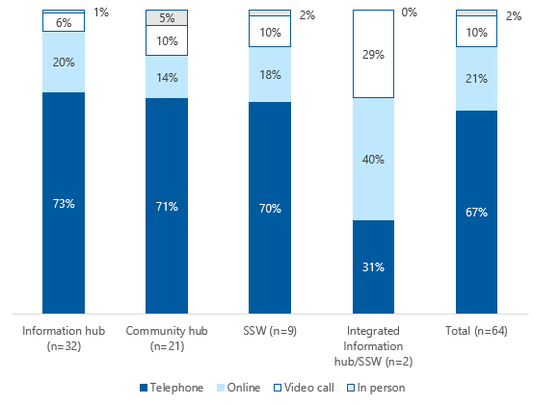

Long description: Information hub (n=32): Telephone 73%, online 20%, video call 6%, in person 1%. Community hub (n=21): Telephone 71%, online 14%, video call 10%, in person 5%. SSW (n=9): Telephone 70%, online 18%, video call 10%, in person 2%. Integrated Information hub/SSW (n=2): Telephone 31%, online 40%. Video call 29%, in person 0%. Total (n=64): Telephone 67%, online 21%, video call 10%, in person 2%.

Telephone delivery comprised around two-thirds of all Individual trial activities planned between April and June 2020, followed by online delivery (one-fifth of planned activities) (Figure C‑1).

While very few trials anticipated delivering Individual trial activities to navigator service users in person (2.0% of activities [Figure C‑1]), some partner organisations highlighted that this mode of delivery might be appropriate in some extenuating circumstances. Examples of these included when in-person support was critical to the individual’s wellbeing, and when such support could be safely delivered with appropriate precautions in place. Across trial types there was some variation in the types of Individual trial activities which might require in-person delivery. For example, partner organisations delivering Information hubs anticipated this mode would generally be limited to outreach services, Community hubs for providing individual support by a staff member, and SSWs to provide assistance with form filling.

Video calls – a new mode of ‘face-to-face’ delivery introduced in response to COVID‑19 restrictions – accounted for around 10% of Individual trial activities (Figure C‑1), with most trials planning these in order to provide individual support by a staff member.

#### Group trial activities

The breakdowns of Group trial activities planned for delivery between April and June 2020 are shown in Figure C‑2 (and as before, the information reported for the Integrated Information hub/SSW trials should be viewed with some caution due to their comparatively low trial number [n=2]).

Online seminars accounted for just over half of all Group trial activities planned, driven largely by their delivery at 19 information hubs (Figure C‑2). In contrast, few telephone seminars were planned – just 30 by 6 trials. While there was some variation reported across trial types, the remaining Group trial activities made up between 5-15% of all planned activities.

In contrast to the relatively high number of individual welfare checks planned by partner organisations (Figure C‑2), only 11 of the 64 trials indicated these checks would be conducted in a group setting. Partner organisations from these 11 trials estimated that they would conduct 125 group welfare checks, with Community hubs and the Integrated Information hub/SSW trials accounting for the majority of these (Figure C‑2).

Figure C‑2: Breakdown of Group trial activities planned to be delivered between April and June 2020, by trial type

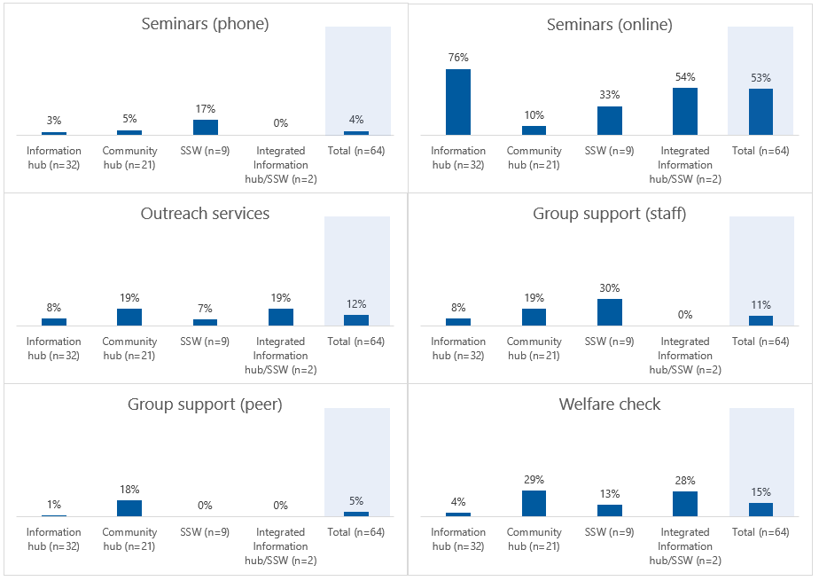

Long description: Seminars (phone): Information hub 3%, Community hub 5%, SSW 17%, Integrated Information hub/SSW 0%, Total 4%.

Seminars (online): Information hub 76%, Community hub 10%, SSW 33%, Integrated Information hub/SSW 54%, Total 53%.

Outreach services: Information hub 8%, Community hub 19%, SSW 7%, Integrated Information hub/SSW 19%, Total 12%.

Group support (staff): Information hub 8%, Community hub 19%, SSW 30%, Integrated Information hub/SSW 0%, Total 11%.

Group support (peer): Information hub 1%, Community hub 18%, SSW 0%, Integrated Information hub/SSW 0%, Total 5%.

Welfare check: Information hub 4%, Community hub 29%, SSW 13%, Integrated Information hub/SSW 28%, Total 15%.

As indicated in Figure C‑2, group support activities were more frequently planned to be delivered by paid staff (95 activities across 15 trials) compared to by volunteers (46 activities across 8 trials [of which 6 were Community hubs]).

Unlike for Individual trial activities, the survey design meant it was not possible to determine the breakdowns of all Group trial activities planned to be delivered in person, online, via telephone or video call. However, as indicated above, online appeared to be the most commonly-planned mode of delivery. Indeed, of the trials who were planning to deliver group activities, some – mostly Information hubs – were reported to already be utilising online technology (for example, Zoom), with others planning to trial this new delivery approach shortly.

While the move to online trial delivery was being embraced by many partner organisations, there was a sense from some that videoconferencing as a delivery mode was not appropriate for some target populations, and may have a negative impact on trial uptake. To mitigate this, some partner organisations were instead focusing more heavily on other types of trial activities such as distribution of information via printed newsletters, email, radio, and in community group settings (where COVID‑19 restrictions permitted).

In addition to the over 10,000 navigator service users estimated to receive individual support between April and June 2020 (Table C‑2 and Figure C‑2), partner organisations estimated that an additional 2,529 would receive support via a group activity.

As shown in Figure C‑3, the proportions of navigator service users expected to participate in each type of Group trial activity generally reflected the anticipated number of each type of activity (Figure C‑3*)*. For example, online seminars (around 50% of activities) were predicted to reach the most navigator service users – around half of the total. However, one notable difference in the pattern of group activity number versus navigator service user number was at the SSW trials, where online seminars were predicted to account for just one-third of their activities, but almost two-thirds of expected navigator service users. These trials reported a predicted mean of 11 navigator service users per online seminar, substantially more than the 2-3 attendees on average anticipated by Information hubs and Community hubs.

The reason for this disparity is unclear, however, it might reflect the fact that SSWs have tended to conduct fewer (in-person) seminars compared to other trial types, and so may have overestimated the number of navigator service users they might reach via this type of trial activity.

Figure C‑3: Proportion of navigator service users expected to receive Group trial activities between April and June 2020, by trial type

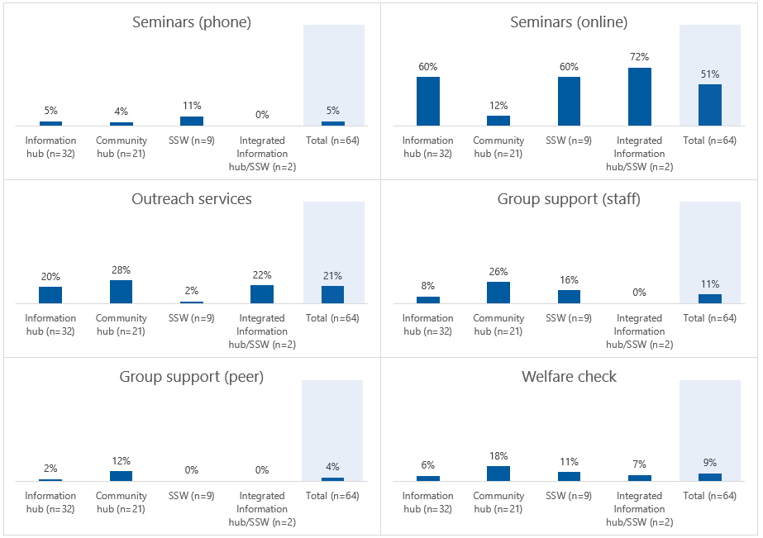

Long description:

Seminars (phone): Information hub 5%, Community hub 4%, SSW 11%, Integrated Information hub/SSW 0%, Total 5%.

Seminars (online): Information hub 60%, Community hub 12%, SSW 60%, Integrated Information hub/SSW 72%, Total 51%.

Outreach services: Information hub 20%, Community hub 28%, SSW 2%, Integrated Information hub/SSW 22%, Total 21%.

Group support (staff): Information hub 8%, Community hub 26%, SSW 16%, Integrated Information hub/SSW 0%, Total 11%.

Group support (peer): Information hub 2%, Community hub 12%, SSW 0%, Integrated Information hub/SSW 0%, Total 4%.

In the survey, partner organisations were given the opportunity to provide additional contextual information about the delivery of Group trial activities against the backdrop of COVID‑19. Across trial types, partner organisations highlighted that their target populations’ perceived limited interest, ability, and/or access to technology made remote delivery of Group trial activities a particular challenge. For some trials, the number of possible group activities delivered would be reduced due to the time required to successfully adapt to alternative delivery approached. For example, the additional time taken to translate content into a format suitable for Zoom technology, and the logistical challenges of scheduling telephone or video sessions would reduce trial capacity.

In addition to the impact of having to cancel or quickly adapt scheduled Group trial activities, some partner organisations reported that their anticipated Group trial activity outputs reflected the reclassification of some activities to reflect them as now being delivered on an individual basis to navigator service users. Elsewhere, the quantum of group sessions delivered was expected to be reduced by a partial – and temporary – shift away from the trials targeting navigator services users to referrers and other professionals coming into contact with older members of the community.

“A figure of 4 Information hub activities was chosen for this period (as opposed to the normal 9 for a 3-month period). This is due to obvious limitations of no face-to-face delivery. Delivery by phone and video takes a lot of practical organising and it can be problematic getting multiple people online together at the same time.” —*Partner organisation representative*

On the plus side, a partner organisation delivering one Community hub indicated that the impact of events such as COVID‑19 on older people with limited digital literacy had been a key learning, leading them to commence development of an alternative, multi-modal service delivery model, designed to “build the digital ability of both community members and community organisers”.

### Promotional activities

As indicated above, the impact of COVID‑19 on trial delivery was seen as an opportunity for some partner organisations to reassess and refocus their promotional efforts (). This included promoting trial services more frequently (e.g. the development of more regular newsletters), through additional modes of delivery (e.g. online content), and awareness-building of changes to trial delivery (e.g. explanation and advice about the transition from in-person navigation support to other modes).

Partner organisations from 8 trials (4 Information hubs and 4 Community hubs) explicitly stated that their planned promotional activities during COVID‑19 would increase, driven by a variety of factors, including:

* Placing greater emphasis on digital promotion (e.g. social media presence and online resources)
* More collaboration activities with their state-based COTA organisations
* Increased efforts to promote new trial delivery models (including HealthDirect).

However, some partner organisations reported anticipating no changes to their promotional activities for the trials during the COVID‑19 period, while others expected a general decrease as they restricted their existing promotional efforts to online platforms only, or intended to redirect trial resources to other activities.

Further commentary about changes in the type and/or number of promotional activities conducted by partner organisations in response to COVID‑19 is presented below.

Partner organisations were asked to estimate the number of navigator service users they expected to ‘reach’ between April and June 2020, via 6 types of promotional activities across 2 modalities – physical and digital. (Note: one promotional activity – posting links to websites with COVID‑19 news or information – was relevant to digital promotion only). Fifty-nine of the 64 trials indicated a total promotional reach of approximately half a million individuals, of whom around three-quarters were expected to be targeted via physical promotional materials.

On the face of it, this appears to be a surprisingly high number, however, it is possible that partner organisations factored in the total circulations of newspapers they planned to target etc. As such, it would be anticipated that promotional reach, as reported here, would have a somewhat limited bearing on subsequent increases in navigator service users engaging with the trials.

Some variations were identified across trial types, with the proportion of the target market reached by physical promotion expected to be much higher for the Information hub and SSW trials, while Community hubs and the 2 Integrated Information hub/SSW trials expected their physical and digital promotional activities to have a similar reach (Figure C‑4). Of the 59 trials planning promotional activities, most (n=44) were reported to be planning to conduct both physical and digital promotional activities during the COVID‑19 period, with 7 anticipating physical promotion only and 8 digital promotion only. There were no particular differences in the proportion of trials planning either, both or no promotional activities across trial types.

Figure C‑4: Proportion of navigator service users expected to be reached by promotional activities between April and June 2020, by modality

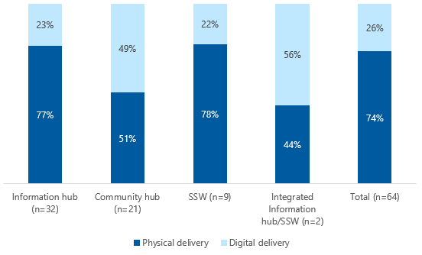

Long description: Information hub (n=32): Physical delivery 77%, digital delivery 23%. Community hub (n=21): Physical delivery 51%, digital delivery 49%. SSW : Physical delivery 78%, digital delivery 22%. Integrated Information hub/SSW : Physical delivery 44%, digital delivery 56%. Total (n=64): Physical delivery 74%, digital delivery 26%.

Looking more closely at the specific types of promotional activities being considered, partner organisations anticipated that the development of news media/articles would have the widest reach – expecting to account for approximately two-thirds of navigator service users reached overall and over 80% of those reached by physical promotion activities. Partner organisation-generated media and articles had the widest reach of physical promotion activities across all trial types – although to a lesser extent in Community hubs and the 2 Integrated Information hub/SSW trials, where it accounted for under half of potential navigator service user numbers (Figure C‑4). Physical distribution of tailored information and ‘Navigator trial’ style promotional materials were also expected to reach relatively sizeable proportions of navigator service users at Community hub and Integrated Information hub/SSW trials, respectively (Figure C‑4).

Of digital promotional activities, e-newsletters containing information and/or opinion pieces from partner organisations were predicted to have the broadest reach across all trial types other than Community hubs, which expected reaching a greater proportion of navigator service users via posting links to COVID‑19-related information (Table C‑5). In interpreting the information in relation to digital promotion, it is important to note the caveat highlighted by one Community hub trial, who indicated that the number of navigator service users reached by these activities were “complete guesses”. While similar comments were not made by other trials, it is possible that others may have also struggled to accurately predict their digital reach, which could, again, call into some question the substantial predicted outreach figure of half a million individuals (estimated from both digital and physical promotion).

In additional commentary from partner organisations, some hinted that the estimated number and reach of promotional activities reflected general reductions in the reliance on physical trial promotion. Reasons given for this included there being fewer in-person opportunities to promote trial services at hub venues or networking events, or to conduct letterbox drops in the local community. However, one trial bucked this trend, anticipating that extra flyers would be printed and distributed, thus aiming to increase the trial’s reach via physical promotion.

Partner organisations from 5 trials reported that reductions in predicted navigator service user presenting at the trials over the COVID‑19 period reflected a substantial reduction in promotional activities. Reasons for this included the reduced number of Group and Individual trial activities being conducted (i.e. leading to a commensurate reduction in the need to promote them), partner organisation concerns over the appropriateness of promoting the trials in light of COVID‑19 restrictions, and the redirection of trial resources towards other activities, such as translation of COVID‑19 key messages.

Table C‑5: Estimated number of navigator service users expected to be reached between April and June 2020, by promotional activity type

|  |  |  |  |  |  |
| --- | --- | --- | --- | --- | --- |
| Promotional activity | Information hub  n (%) | Community hub  n (%) | SSW  n (%) | Integrated Information hub/​SSW  n (%) | Total  n (%) |
| Physical delivery (total) | 243,407  (100.0) | 27,089  (100.0) | 99,765  (100.0) | 1,236  (100.0) | 371,497  (100.0) |
| Distribution of tailored information (physical delivery) | 11,499  (4.7) | 8,747  (32.3) | 6,563  (6.6) | 150  (12.1) | 26,959  (7.3) |
| Promotional materials – navigator (physical delivery) | 14,935  (6.1) | 2,315  (8.5) | 2,155  (2.2) | 300  (24.3) | 19,705  (5.3) |
| Health & welfare materials – general (physical delivery) | 6,638  (2.7) | 1,430  (5.3) | 27  (0.0) | 80  (6.5) | 8175  (2.2) |
| Newsletters (physical delivery) | 4,703  (1.9) | 1,497  (5.5) | 1,010  (1.0) | 203  (16.4) | 7,413  (2.0) |
| Media/​articles (physical delivery) | 205,632  (84.5) | 13,100  (48.4) | 90,010  (90.2) | 503  (40.7) | 309,245  (83.2) |
| Digital delivery (total) | 73,064  (100.0) | 26,013  (100.0) | 28,061  (100.0) | 1,586  (100.0) | 12,8724  (100.0) |
| Distribution of tailored information (digital delivery) | 20,485  (28.0) | 1,747  (6.7) | 234  (0.8) | 150  (9.5) | 22,616  (17.6) |
| Promotional materials – navigator (digital delivery) | 12,891  (17.6) | 2,889  (11.1) | 775  (2.8) | 200  (12.6) | 16,755  (13.0) |
| Health & welfare materials – general (digital delivery) | 4,529  (6.2) | 1,484  (5.7) | 52  (0.2) | 230  (14.5) | 6,295  (4.9) |
| Newsletters (digital delivery) | 17,778  (24.3) | 14,841  (57.1) | 20,913  (74.5) | 203  (12.8) | 53,735  (41.7) |
| Media/articles (digital delivery) | 11,654  (16.0) | 2,227  (8.6) | 6,011  (21.4) | 303  (19.1) | 20,195  (15.7) |
| Links to COVID‑19 information/​news (digital delivery) | 5,727  (7.8) | 2,825  (10.9) | 76  (0.3) | 500  (31.5) | 9,128  (7.1) |
| Total (physical + digital delivery) | 31,6471 | 53,102 | 127,826 | 2,822 | 500,221 |

## Welfare checks

Partner organisations planning to conduct welfare checks during the COVID‑19 period were asked to describe their proposed approach for conducting these checks. AHA analysed partner organisation responses in terms of the following components:

Target population/s

Responsibility for conducting the checks

Frequency of checks for each individual

Modality

* Structure (i.e. supported by specific tools and templates or conducted as part of more general support).

Table C‑6 shows an overview of the approach to welfare checks reported by trial type (where information known). Partner organisations delivering 13 Community hubs provided information on their approach to performing welfare checks. The modality of welfare checks for all 13 trials included a plan to conduct these over the phone, with 3 Community hubs also planning to use HealthDirect or other videoconferencing platforms. Where reported, the responsibility for conducting welfare checks was placed on existing trial staff members. Information about how welfare checks were planned to be conducted was provided for just 4 Community hubs, with 2 using a structured approach guided by specifically-developed resources, and 2 reporting a more general approach in which they asked about supports and unmet needs as part of conversation with navigator service users.

Consistent with the Community hubs, partner organisations from Information hubs (n=20) most commonly proposed to conduct welfare checks over the phone (information available for 14 of the 20 hubs), with a minority also planning to use videoconferencing technology including HealthDirect. Partner organisations from a minority of Information hubs provided a description of their target population/s for welfare checks – primarily indicating these were a subset of current or former navigator service users. Two hubs planned to contact those with ongoing need for aged care navigation support, while 2 simply indicated they would contact ‘selected’ individuals without providing detail on the selection process. Partner organisations from 2 other Information hubs also indicated they would use external databases (COTA membership list and Government Senior Card database) to identify potential those requiring a welfare check.

As with the Community hub trials, Information hubs appeared evenly split in terms of the level of structure planned for welfare checks. However, they generally appeared to anticipate conducting less frequent welfare checks than Community hubs, with 2 partner organisation responses highlighting that their welfare checks would only be conducted as part of Individual trial activities.

In contrast, the partner organisation delivering the 2 Integrated Information hub/SSW trials noted that welfare checks would be conducted as part of Group trial activities as well as during individual sessions of support. For these hubs, initial checks were planned to establish navigator service need, and those identified as requiring frequent (more often than weekly) or ongoing (longer than one month) welfare checks would be referred to external agencies.

Finally, information about welfare check activities at 7 of the 9 SSW trials was provided in the survey, (with one specifying that no welfare checks were anticipated as the SSW was already working at full capacity and could not take on additional tasks). One partner organisation (delivering both SSW and Information hub trials) reported that welfare checks were the responsibility of their state-based COTA organisation, with this activity both supported by, and linking back into, the trials themselves. For the remaining SSW trials, partner organisations indicated that welfare checks would be conducted over the telephone by trial staff, targeting previous navigator service users (either in general, or initially focusing on those known to have limited existing supports).

Table C‑6: Anticipated approach to conducting welfare checks during COVID‑19, by trial type

|  |  |  |  |  |
| --- | --- | --- | --- | --- |
| Component | Information hub (n=20) | Community hub (n=13) | SSW (n=6) | Integrated Information hub/SSW (n=2) |
| Target population | Selected new/​current/​former navigator service users (n=4).  External database (n=2).  Other (single responses only): All new and former navigator service users; senior citizens groups previously visited during the trial. | Individuals who have previously participated in hub activities (n=4).  Individuals contacting the hub (n=2).  COTA state/territory membership list (n=2).  Other (single responses only): Government Senior Card database. | Single responses only:  Previous navigator service users; previous navigator service users with known limited supports; expanding to broader population if capacity permits. | Current navigator service users (n=2). |
| Provider | Current staff (n=14)  Staff initially, referred to external provider (OPAN welfare check, Telecross) for clients requiring ongoing checks (n=2)  Other (single responses only): Mix of staff and volunteers; currently staff only but volunteers to assist when able to return; undertaken by state-based COTA organisation | Current staff only (n=8).  Current staff, volunteers to be considered (for some navigator service users or if workload increases) (n=2).  Other (single responses only): Volunteers only; mix of current staff and volunteers. | Current staff (n=5).  Single response only: SSW on behalf of state COTA. | Current staff (n=2). |
| Frequency | Once off (n=3).  Monthly (n=3).  When time permits (n=2).  Other (single responses only): Daily (for 2 weeks); fortnightly; as negotiated; to be confirmed (TBC) | Fortnightly (n=3).  Monthly (n=2).  Other (single responses only): twice weekly; weekly; as needs basis; in response to customer enquiry; TBC. | Single responses only:  One-off contact, with subsequent referral if needed; 1-2 times per quarter. | Single responses only:  Weekly for up to one month; referral where more frequent/longer duration required. |
| Modality | Phone (n=14).  HealthDirect/​other videoconferencing platform (n=4). | Phone (n=13).  HealthDirect/​other videoconferencing platform (n=3).  Other (single responses only): Text message. | Telephone (n=6). | Phone (n = 1) |
| Structure – Formal | Single responses only:  COVID 19 risk screening form.  Use of a guide developed by the trial in consultation with Seniors Rights Service.  Set questions being asked, surveys completed where possible, timeline for a follow-up phone call is provided. | Single responses only:  Defined questions.  Guide with questions and areas to cover. | Single response only:  Set list of questions. | No applicable information reported. |
| Structure – Informal | Single responses only:  Checking in to see how navigator service users are coping with isolation.  Ensuring individuals are managing well in the COVID‑19 period.  Enquiring about aged care need. | Single responses only:  Conversations to explore whether individuals have all required supports in place, especially My Aged Care plan. Encouragement of people to stay at home and avoid contact with others.  Enquiring about needs and offers of assistance to access aged care services. | Single responses only:  Engaging in a general discussion about welfare and wellbeing and whether supporting services have been impacted by COVID‑19.  Enquiring about contact with My Aged Care. | Conducted during delivery of Group or Individual trial activities (n=2). |
| Structure – Other comments | Welfare checks not appropriate in a group setting and so conducted as part of Individual trial activities only (n=2). | Single response only:  Volunteer team meet by video call weekly to exchange information and discuss emerging needs. | Single response only:  Where welfare checks identify additional needs, navigator service users referred back to the SSW. | No applicable information reported. |

## Other comments

The final section of the COVID‑19 survey invited partner organisations to reflect on whether there was anything else that could impact on the delivery of their trials during the COVID‑19 period. Responses relating to 44 of the 64 trials were provided, and, in most cases revisited the issues raised in previous survey items.

Across all trial types, the most prominent concern expressed was the challenge that digital trial delivery posed to navigator service user engagement. The time and resources required for trial staff and volunteers to adapt to this new way of working were also mentioned frequently, particularly by those from the Community hub trials. A number of partner organisations highlighted the impact of social distancing restrictions, although these were considered in different ways across trial types. For example, responses arising from Community hub and SSW trials indicated their primary concerns centred on the extent to which trial staff would be able to build relationships with other supporting services, and the potential difficulties for navigator service users to access these services due to closure or reduced capacity. On the other hand, social distancing concerns arising from Information hubs centred on their ability to keep delivering Group trial activities – especially seminars.

One partner organisation (delivering an Information hub) noted that the trials required translated resources to support people from CALD communities to understand the risks and restrictions associated with COVID‑19, while another pointed out that their usual messaging – which encouraged older people to be active in their community – was now at complete odds with current government advice.

A small number of partner organisations across all trial types again emphasised the impact of COVID‑19 on both demand for, and supply of, trial services. While some anticipated a general reduction in demand for aged care navigation support, others pointed to the potential heightened relevance of the SSW role, as pathways to aged care became increasingly complex (caused, in part, by reduced availability of community services). On the supply side, partner organisations delivering Information hubs discussed the loss of their volunteer workforces as a result of COVID‑19, while some from SSW trials anticipated a redirection of resources away from trial work to COVID‑19-related activities. Elsewhere, one partner organisation highlighted the impact of rising travel costs, limiting outreach to navigator service users in regional and remote communities.

Finally, general survey responses highlighted the considerable uncertainty surrounding the impact of COVID‑19 for navigator service users, trial staff and volunteers, and community services alike. For example, one partner organisation reported concerns that the pandemic may exacerbate fears about the safety of aged care and may serve to further reduce engagement among vulnerable populations (in this case, those who identify as LGBTI). There was also uncertainty raised about the likelihood and impact of a second wave of COVID‑19 and associated restrictions.

# Supplementary information from the COTA Australia data set

## Introduction

This appendix shows supplementary information from the COTA Australia data set which has been referenced in the main body of the report, including data from the modified data set which was adopted for use from quarter 8 (September 2020 onwards).

### Trial activity information

#### Redefined trial activity types (quarter 8 only)

The numbers of redefined Group and Individual trial activity types delivered in quarter 8 (September to November 2020) are shown in Table D‑1 and Figure D‑1 (the latter presented by trial type).

Table D‑1: Distribution of redefined trial activity types delivered between September and November 2020

|  |  |  |  |
| --- | --- | --- | --- |
| Trial activity | Individual  n (%) | Group  n (%) | Overall  n (%) |
| Attended a group | 121 (3.5%)* | 268 (65.5%)- | 389 (10.0%) |
| One-on-one/individual assistance | 2,376 (68.3%) | 15 (3.7%)* | 2,391 (61.5%) |
| Individual outreach | 169 (4.9%) | 5 (1.2%) | 174 (4.5%) |
| Help with filling out application forms | 51 (1.5%) | No data | 51 (1.3%) |
| Received information materials | 611 (17.6%) | 16 (3.9%) | 627 (16.1%) |
| Other activity | 148 (4.3%) | 102 (24.9%) | 250 (6.4%) |
| Not reported | 2 (0.1%) | 3 (0.7%) | 5 (0.1%) |
| Total | 3,478 | 409 | 3,887 |

Note: Data are mutually exclusive, e.g. one Group/Individual trial activity type reported per Group/individual trial activity record. *All redefined trial activity types were available for selection in the COTA Australia data set, which led to some Individual trial activity records reporting seemingly group style types of support and vice versa.

As shown above, a total of 3,887 trial activities were delivered in quarter 8: n=3,478 Individual and n=409 Group trial activities. Over two-thirds of individual support was delivered via ‘One-on-one/individual assistance’ (n=2,376), while a similar proportion of group support was via attendance at a group session (Table D‑1). (Note: in order to increase consistency of trial activity type reporting across different components of the COTA Australia data set, *all* redefined trial activity types were available for selection in the Individual and Group trial activity tabs of the modified COTA Australia data set. This led to *some* Individual trial activity records reporting seemingly group style types of support (3.5% [n=121]) and vice versa (3.7% [n=15]) (see top 2 rows in Table D‑1).

Figure D‑1: Distribution of trial activities (Group and Individual combined) delivered between September and November 2020, by trial type

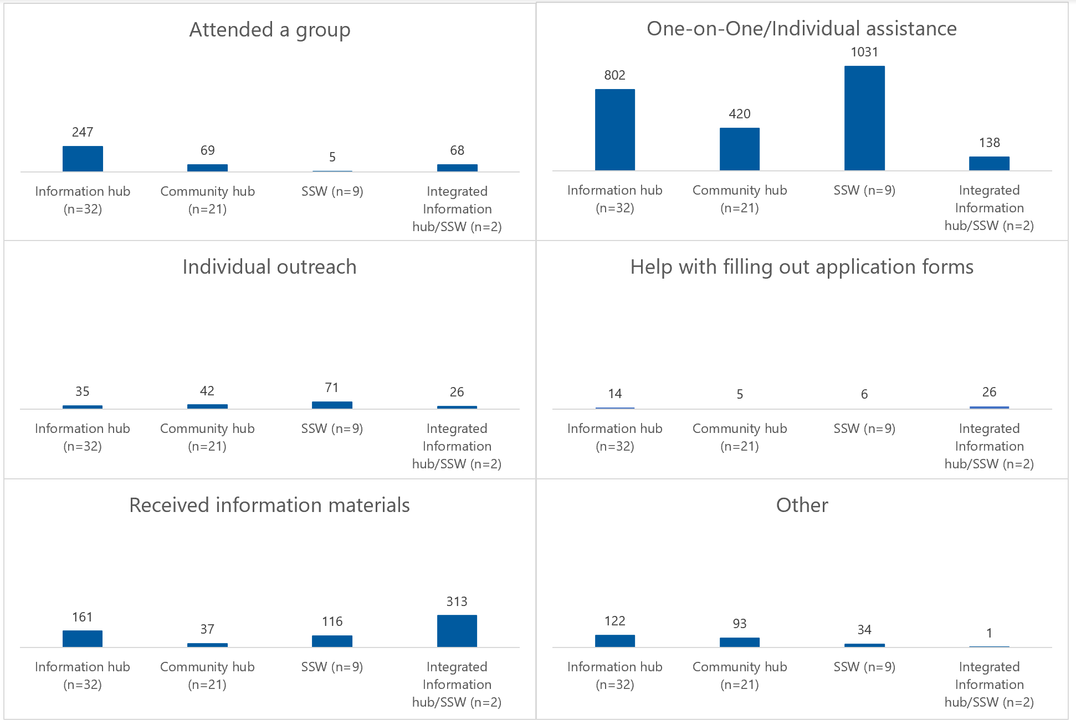

Note: Data are mutually exclusive.

Long alt text:

Attended a group: Information hub 247, Community hub 69, SSW 5, Integrated Information hub/SSW 68.

One on one/Individual assistance: Information hub 802, Community hub 420, SSW 1031, Integrated Information hub/SSW, 138.

Individual outreach: Information hub 35, Community hub 42, SSW 71, Integrated Information hub/SSW 26.

Help with filling out application forms: Information hub 14, Community hub 5, SSW 6, Integrated Information hub/SSW 26.

All trial types reported delivering every kind of redefined trial activity type in quarter 8, although the frequency/scale of some activities differed substantially across trial types. ‘One-on-one/individual assistance’ was the most commonly delivered trial activity type – by far – for the SSW trials in particular, but also for the Information hubs and Community hubs (Figure D‑1). The SSW trials also reported delivering the largest number of episodes of ‘Individual outreach’, although at a smaller scale (n=71) compared to ‘One-on-one/individual assistance’ (n=1,031)

The Integrated Information hub/SSW trials most commonly provided support via the provision of information materials (n=313).

Perhaps unsurprisingly, given previous reports of the relative number of ‘Seminars’ delivered by Information hubs compared to other trial types (see Table 3‑3 in Section 3.4), the Information hubs delivered disproportionately more ‘Attended a group’ trial activities in quarter 8: n=247 over the 3-month period (Figure D‑2).

Compared to previous reports (see Table 3-3 in Section 3.4), the overall proportion of ‘Other activities’ reported in the COTA Australia data set was reduced, now comprising 6.4% (n=250) of all redefined trial activities delivered (Table D‑1 and Figure D‑1). This may reflect the refinements made to the COTA Australia data set, where trial activity types were redefined to more accurately reflect the specific types of support being delivered by the trials. (This may also have led to the smallest proportion of trial activity records with no data reported for trial activity type in quarter 8: <0.1% (Table D‑1) compared to 0.8% reported previously (Table 3-3).

#### Navigator service user attendance and modes of trial activity delivery (all)

Between February 2019 and November 2020, a total of n=372,950 navigator service users were reported to have attended Group trial activities, a substantial increase compared to previous reports, and skewed by n=315,442 attendees reported in quarter 8 (see below). The numbers of navigator service users attending each type of *original* Group trial activity (February 2019 to August 2020) is shown in Figure D‑2 (n=57,508), with additional important commentary in relation to those attending *redefined* Group trial activity types (quarter 8; September to November 2020) shown below it.

Figure D‑2: Number of navigator service user attendees at original Group trial activity types, between February 2019 and August 2020

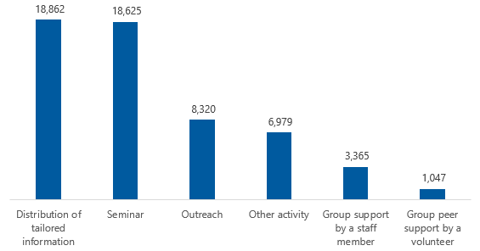

Note: A total of 57,508 navigator service users were reported to have attended original Group trial activity types (including where attendee number was estimated). Original Group trial activity type not reported for n=310 records where attendee number known (not shown in figure). Includes reported attendee numbers from Group trial activities conducted at large expos, where reported attendee number may have been artificially inflated.

For the redefined Group trial activity types delivered in quarter 8, the largest number of attendees – by far – was reported for ‘Other’ activities: n=310,978 (98.6%). By comparison, the number of attendees reported for other redefined Group trial activity types included n=3,955 (1.3%) for ‘Attended a group’ and n=378 (0.1%) for ‘Received information materials’.

However, on review, just under two-thirds (n=201,547) of all attendees (actual plus estimated) receiving group support in quarter 8 were reported to have received it via the *mass media communication* mode of ‘Information on a website or in an email’ (and all but n=38 for ‘Other’ trial activity types [see above]). It is important to note that this *passive* trial delivery mode – which navigator service users may or may not choose to engage with – had not been specifically captured in the COTA Australia data set prior to quarter 8, instead falling under the generic category of ‘online’[1] if/where it was reported.

As the inclusion of this specific mass media communication mode at quarter 8 has *substantially inflated* overall attendee numbers, it is important to note this point when considering the number of navigator service users supported via Group trial activities, overall, and when making any comparisons of the numbers receiving support pre- versus post-quarter 8.

#### Duration of trial activities (all)

The duration of all Group/Individual trial activities (delivered between February 2019 and November 2020), reported by trial type, are shown in Table D‑2 below.

Table D‑2: Median duration of Individual and Group trial activities, by trial type

|  |  |  |
| --- | --- | --- |
| Trial type | Individual trial activities (h) | Group trial activities (h) |
| Information hubs (n=5,138/531 records) | 0.5 (IQR 0.3-1.0) | 2.0 (IQR 1.0-4.0) |
| Community hubs (n=3,016/326) | 0.3 (IQR 0.2-0.5) | 3.0 (IQR 2.0-5.0) |
| SSW trials (n=4,876/16) | 0.5 (IQR 0.3-1.0) | 5.5 (IQR 3.0-10.0) |
| Integrated Information hub/SSW trials (n=1,986/162) | 0.5 (IQR 0.5-0.8) | 2.0 (IQR 1.0-3.0) |

Note: n numbers in parentheses denote number of Individual/Group trial activity records with duration reported. Duration information not reported for n=496/15,512 (3.2%) Individual trial activity and n=1,295/2,330 (55.6%) Group trial activity records. Durations reported in hours (h). IQR: interquartile range.

### Paid staff and volunteer FTE

Table D‑3: Paid staff and volunteer FTE levels between February and November 2019 (reported) and July 2020 and June 2021 (planned), by partner organisation

|  |  |  |  |  |  |  |
| --- | --- | --- | --- | --- | --- | --- |
| Partner organisation | Original trial delivery period:  Paid staff (reported) | Original trial delivery period:  Volunteers (reported) | Trial extension period:  Paid staff (planned) | Trial extension period:  Paid staff (reported) | Trial extension period:  Volunteers (planned) | Trial extension period:  Volunteers (reported) |
| Aged and Disability Advocacy Australia | 0.5 | 0.0 | 0.4 | 0.4 | 0.0 | 0.0 |
| A.C.T. Disability, Aged and Carer Advocacy Service Inc. | 4.0 | 0.3 | 0.3 | 0.0 | 0.0 | 0.0 |
| Advocare Incorporated | 3.0 | 0.0 | 5.0 | 0.0 | 0.0 | 0.0 |
| Aged Rights Advocacy Service Inc. | 1.3 | 0.0 | 2.0 | 1.8 | 0.0 | 0.0 |
| Brisbane South PHN Ltd | 5.0 | 1.6 | 3.0 | 6.9 | 6.0 | 2.5 |
| Chung Wah Association | 0.5 | 1.1 | 0.6 | 5.0 | 2.0 | 2.5 |
| Co.As.It. Italian Assistance Association | 0.5 | 3.0 | 1.0 | 0.0 | 0.0 | 0.0 |
| COTA ACT Inc. | 1.3 | 4.0 | 0.5 | 0.5 | 0.2 | 0.2 |
| COTA NT Inc. | 3.0 | 2.0 | 0.8 | 8.8 | 3.0 | 2.0 |
| COTA NSW Inc. | 0.5 | 1.4 | 0.7 | 1.1 | 0.7 | 0.3 |
| COTA Qld Inc. | 0.8 | 0.0 | 0.4 | 0.0 | 0.0 | 0.0 |
| COTA SA Inc. | 0.9 | 0.3 | 1.0 | 1.0 | 0.4 | 0.4 |
| COTA Tasmania Inc. | 0.5 | 0.1 | 0.0 | 2.6 | 0.0 | 0.4 |
| COTA Victoria Inc. | 0.8 | 0 | 1.2 | 1.2 | 6.0 | 4.0 |
| COTA WA Inc. | 9.0 | 9.0 | 1.4 | 3.0 | 0.0 | 2.0 |
| Dementia Australia Limited | 1.3 | 0.0 | 2.0 | 5.5 | 0.0 | 0.0 |
| Elder Rights Advocacy | 1.0 | 0.0 | 0.8 | 0.8 | 0.0 | 0.0 |
| UnitingSA Ltd | 0.3 | 0.0 | 0.5 | 0.5 | 0.0 | 0.0 |
| Institute for Urban Indigenous Health Ltd | 4.5 | 0.0 | 5.6 | 4.6 | 0.0 | 0.0 |
| Migrant Resource Centre (Southern Tasmania) Incorporated | 0.3 | 0.0 | 0.6 | 0.6 | 4.0 | 0.1 |
| Multicultural Communities Council of Illawarra Incorporated | 1.9 | 0.1 | 1.0 | 8.0 | 2.0 | 0.4 |
| National LGBTI Health Alliance | 0.0 | 0.0 | 1.4 | 1.5 | 5.0 | 52.0 |
| Northeast Health Wangaratta | 0.8 | 1.5 | 0.8 | 0.4 | 0.0 | 0.0 |
| OPAN | 1.2 | 0.0 | 1.5 | 2.0 | 0.0 | 0.0 |
| Seniors Rights Service Limited | 0.4 | 0.2 | 0.8 | 2.0 | 0.0 | 0.0 |
| Sunraysia Mallee Ethnic Communities Council Inc. | 0.5 | 0.0 | 0.4 | 2.0 | 0.2 | 0.2 |
| Umbrella Multicultural Community Services Inc. | 0.4 | 0.3 | 0.5 | 0.4 | 0.5 | 0.4 |
| The Housing for the Aged Action Group Inc. | 0.8 | 1.5 | 1.0 | 0.0 | 1.0 | 0.0 |
| Agelink Consulting | 0.1 | 0.0 | 0.5 | 0.3 | 0.0 | 0.9 |

### Target populations’

Table D‑4: Number of ‘target populations’ reported to have received Individual trial activities between September and November 2020, by partner organisation

|  |  |
| --- | --- |
| Partner organisation | Number of ‘target populations’ |
| Aged and Disability Advocacy Australia | 7 |
| ACT Disability, Aged and Carer Advocacy Service Inc. | 2 |
| Advocare Incorporated | 10 |
| Aged Rights Advocacy Service Inc. | 10 |
| Brisbane South PHN Ltd | 13 |
| Chung Wah Association | 4 |
| Co.As.It. Italian Assistance Association | 5 |
| COTA ACT Inc. | 2 |
| COTA NT Inc. | 11 |
| COTA NSW Inc. | 8 |
| COTA Qld Inc. | No data |
| COTA SA Inc. | 11 |
| COTA Tasmania Inc. | 7 |
| COTA Victoria Inc. | 10 |
| COTA WA Inc. | 10 |
| Dementia Australia Limited | 4 |
| Elder Rights Advocacy | 12 |
| UnitingSA Ltd | 4 |
| Institute for Urban Indigenous Health Ltd | No data |
| Migrant Resource Centre (Southern Tasmania) Inc. | 2 |
| Multicultural Communities Council of Illawarra Inc. | 5 |
| National LGBTI Health Alliance | 1 |
| Northeast Health Wangaratta | 7 |
| OPAN | No data |
| Seniors Rights Service Limited | 6 |
| Sunraysia Mallee Ethnic Communities Council Inc. | 2 |
| Umbrella Multicultural Community Services Inc. | 2 |
| The Housing for the Aged Action Group Inc. | 6 |
| Agelink Consulting | No data |

### Navigator service user information

The status, sex, age range and country of birth of navigator service users is shown in this subsection.

Table D‑5: Navigator service user status

|  |  |
| --- | --- |
| Status | n (%) |
| Self | 6,784 (43.7%) |
| Self, Family member | 29 (0.2%) |
| Self, Health care or other professional | 10 (0.1%) |
| Self, Family member with power of attorney | 3 (0.0%) |
| Self, Non-family member | 2 (0.0%) |
| Family member | 3,080 (19.9%) |
| Family member with power of attorney | 196 (1.3%) |
| Family member, Non-family member | 1 (0.0%) |
| Non-family member | 367 (2.4%) |
| Non-family member with power of attorney | 16 (0.1%) |
| Guardian | 11 (0.1%) |
| Guardian, Health care or other professional | 1 (0.0%) |
| Health care or other professional | 1,128 (7.3%) |
| No data reported | 3,884 (25.0%) |
| Total | 15,512 (100.0%) |

Table D‑6: Sex of navigator service users

|  |  |
| --- | --- |
| Sex | n (%) |
| Female | 7,937 (51.2%) |
| Male | 3,720 (24.0%) |
| Transgender | 0 (0.0%) |
| Not stated or inadequately described | 77 (0.5%) |
| No data reported | 3,778 (24.4%) |
| Total | 15,512 (100.0%) |

Table D‑7: Age range of navigator service users

|  |  |
| --- | --- |
| Age range (years) | n (%) |
| <18 | 0 (0.0%) |
| 18-36 | 55 (0.4%) |
| 36-50 | 507 (3.3%) |
| 51-59 | 894 (5.8%) |
| 60-70 | 2,955 (19.0%) |
| 71-80 | 3,803 (24.5%) |
| 81-90 | 2,636 (17.0%) |
| >90 | 367 (2.4%) |
| No data reported | 3,604 (29.9%) |
| Total | 15,512 (100.0%) |

Table D‑8: Country of birth of navigator service users

|  |  |
| --- | --- |
| Country | n (%) |
| Australia | 4,715 (39.2%) |
| Italy* | 1,021 (8.5%) |
| United Kingdom | 367 (3.0%) |
| Greece | 133 (1.1%) |
| No data reported | 4,577 (38.0%) |

Note: Country of birth reported for ≥1% of navigator service users shown; percentages are out of all navigator service user records (n=12,034). *905/1,021 records were reported by one partner organisation which is an Italian-Australian service provider. Data not collected in modified COTA Australia data set (quarter 8 [September 2020] onwards).

#### High level trial costings (quarter 8 only)

The high level information presented in this section is based on costing data reported in the Group trial activity tab and trial summary tab of the COTA Australia data set during quarter 8 (September to November 2020).

Note: Due to the adoption of redefined trial activity types from quarter 8, this latest costing information could not be readily integrated into the original cost-effectiveness analysis (as shown in Section 3.7), hence it is presented separately here.

The costing information below follows, where applicable, that presented in Section 3.7, and so it is important to note the limitations and caveats set out in Section 3.7 and apply similar caution when reviewing this section.

#### Reported costs

Note: Modifications to the COTA Australia data set – specifically to the trial summary tab –which were rolled out from quarter 8 (September 2020), also led to some changes in the way (redefined) Group and Individual trial activity costs are reported by partner organisations.

The reconfiguration of the trial summary tab was primarily aimed at improving the ease with which partner organisations are able to report the costs (and staff resourcing [hours]) associated with each trial activity type, and mode of delivery. The reporting of ‘in-kind’ costs is no longer required, and no distinction is now made between Group and Individual trial activities. Instead, ‘total’ costs reported for, say, ‘Received information materials’, may be derived from *both* Group and Individual trial activities, where applicable (as shown in Table D‑1 above).

Given the observed *cross-over* of some reported trial activity types delivered in quarter 8 – most notably, n=121/389 instances of ‘Attended a group’ as an Individual trial activity type (Table D‑1), Group trial activity costings presented below are based on *per-activity* information reported separately in the Group trial activity tab only (i.e., as per previous analyses).

As few seemingly individual style types of support were reported as Group trial activities (Table D‑1), Individual trial activity costings presented below are based on aggregated ‘total’ costs reported in the reconfigured trial summary tab.

#### Group trial activities

In quarter 8, n=19 trials (29.7%) reported ≥1 Group trial activity record with an ‘actual’ cost of ≥$0, equating to n=175 (42.8%) of Group trial activity records submitted. The median overall ‘actual’ cost of delivering a Group trial activity was $335 (interquartile range [IQR$157-750]).

The overall median ‘in-kind’ cost of delivering a Group trial activity in quarter 8 was $250 (IQR$120-550), and it is of note that of the 65 records reporting ‘in-kind’ costs, just over three-quarters (n=50) of these were from Community hub trials.

When reported ‘actual’ and ‘in-kind’ costs of Group trial activities were factored together, the overall median ‘total’ cost was $398(IQR$157-933) in quarter 8.

As expected from the distribution of (redefined) Group trial activities delivered in quarter 8 (Table D‑1), most (85.7%) of the quarter 8 Group trial activity records with costings were derived from either ‘Attended a group’ (n=81) or ‘Other’ trial activities (n=61). The ‘actual’ and ‘total’ median costs reported for these 2 main trial activity types are shown below:

* ‘Attended a group’:
  + ‘Actual’: $520 (IQR$200-933)
  + ‘Total’: $598 (IQR$335-950)

‘Other’:

* + ‘Actual’: $200 (IQR$54-647)
  + ‘Total’: $216 (IQR$101-1100).

Note: the rest of this subsection focuses on the specific Group trial activity of ‘Attended a group’.

Table D‑9 shows the estimated overall median ‘actual’ and ‘total’ costs of delivering the Group trial activity ‘Attended a group’, reported by Information hubs and Community hubs (note: no records of this activity type were submitted for the other 2 trial types).

As shown in Table D‑9, while the Community hubs reported a somewhat lower median ‘actual’ cost for this specific Group trial activity type, when their ‘in-kind’ costs were factored in, this increased costs to around $600 – very similar to the Information hubs.

Table D‑9: Median ‘actual’ and ‘total’ costs of the Group trial activity ‘Attended a Group’, delivered between September and November 2020, by trial type

|  |  |  |
| --- | --- | --- |
| Trial type | ‘Actual’ costs | ‘Total’ costs |
| Information hubs (n=41 records) | $520 (IQR $398-643) | $598 (IQR $398-754) |
| Community hubs (n=40) | $450 (IQR $118-1,500) | $600 (IQR $300-1,500) |

Note: It is important to consider the additional limitations outlined in Section 3.7 when interpreting the information in this table. Trial type ‘n’ number denotes the number of records reporting ≥1 ‘Attended a group’ Group trial activity record with an ‘actual’ cost of ≥$0. IQR: interquartile range.

Around 4 in 5 Group trial activities of ‘Attended a group’ were delivered in person during quarter 8 (n=217), at an estimated ‘total’ cost of $598 per activity (IQR$398-925). The remainder were mostly delivered via video call (n=48), at a higher estimated 'total’ cost: $642 (IQR$189-2832).

#### Navigator service users receiving Group trial activities

All 81 Group trial activity records of ‘Attended a group’ reported navigator service user attendee number (actual and/or estimated) in addition to costing information. Figure D‑3 shows the estimated ‘actual’ and ‘total’ costs per navigator service user of delivering this Group trial activity, overall and by trial type (where information was available).

The estimated overall ‘actual’ cost of delivering the Group trial activity of ‘Attended a group’ to a navigator service user was $53 – which increased to a total of $74 when ‘in-kind’ costs were factored in. While median ‘actual’ costs were very similar for Information hubs and Community hubs, the ‘in-kind’ costs reported by the former – from just n=6/41 trial activity records – may have *skewed* the data, increasing the Information hubs’ ‘total’ costs to nearer $100 per navigator service user (Figure D‑3). As such, this information should be viewed with additional caution.

Figure D‑3: ‘Total’ costs of delivering the Group trial activity ‘Attended a group’, delivered between September and November 2020, per navigator service user

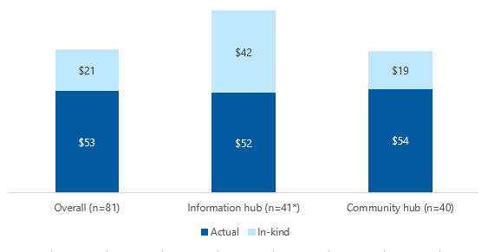Note: It is important to consider the additional limitations outlined in Section 3.7 when interpreting the information in this figure. Estimation of cost components of each trial activity type calculated from total ‘actual’ costs reported divided by associated navigator service user number plus total ‘in-kind’ costs reported divided by associated navigator service user number. *Note low n number for contributing ‘in-kind’ costs (n=6/41 records) appears to have skewed the data, meaning this information should be viewed with additional caution. Estimated costs rounded to nearest $.

#### Individual trial activities

The estimated ‘total’ costs for delivering the 4 main Individual trial activities delivered in quarter 8 (as set out in Table D‑1 above), are shown in Table D‑10 below.

Similar to previous findings, ‘Individual outreach’ was the most costly trial activity at $341 (Table D‑10), while the remaining ‘total’ costs ranged from $117 down to $78. However, it is important to note 2 points:

* A very small degree of the reported costs shown may have been attributable to Group trial activities, as shown in Table D‑1 above
* It is not possible to assess any reporting *variabilities* underpinning the median costings of each Individual trial activity type, due to how the aggregated costing data were captured in the trial summary tab.

Table D‑10: Median ‘total’ costs of Individual trial activity delivery between September and November 2020 per navigator service user

|  |  |
| --- | --- |
| Trial activity type | ‘Total’ cost per navigator service user |
| One-on-one/individual assistance (n=41 records)* | $78 |
| Individual outreach (n=23)* | $341 |
| Help with filling out application forms (n=15) | $117 |
| Received information materials (n=22)* | $78 |

Note: It is important to consider the additional limitations outlined in Section 3.7 when interpreting the information in this table. ‘Total’ costs per navigator service user for each trial activity calculated as total costs reported in all associated trial summary reports divided by total number of navigator service user records associated with each trial activity type. *A few records may include reported costs derived from Group trial activities.

Figure D‑4 shows the estimated ‘total’ costs of delivering each of the 4 main Individual trial activity types, reported by trial type. (Again, noting that a very small degree of the underpinning data may have been attributable to Group trial activities).

With one exception (the Community hubs) the distribution of estimated ‘total’ costs reported by the different trial types were broadly similar, with ‘Individual outreach’ the costliest trial activity, and particularly for the Information hubs and SSW trials: $462 and $471, respectively (Table D‑10). The remaining Individual trial costs were lower, ranging from around $125 to $40.

For the Community hubs, the costliest Individual trial activity was reported to be ‘Help with filling out application forms’ ($351), although this outlier may be an artefact of low n number (n=3 trial summary records).

Figure D‑5 shows the estimated ‘total’ costs of delivering each of the 4 main Individual trial activity types, by the 2 most common modes of delivery: telephone (around 60% of all Individual trial activities) and in-person delivery (25%). (Note: other delivery modes not shown due to low n numbers). (Again, it is important to note that a very small degree of the underpinning data may have been attributable to Group trial activities).

The costs of delivering ‘Individual outreach’ and ‘Help with filling out application forms’ did not change whether these activities were delivered in person, or via telephone (Figure D‑5).

Where navigator service users had ‘Received information materials’ in person, this was reported to cost around half that of the equivalent telephone support. Conversely for ‘One-on-one/individual assistance’, in-person delivery was reported to be considerably higher ($171) compared to via telephone ($40).

Figure D‑4: Median ‘total’ costs of Individual trial activity delivery between September and November 2020, by trial type

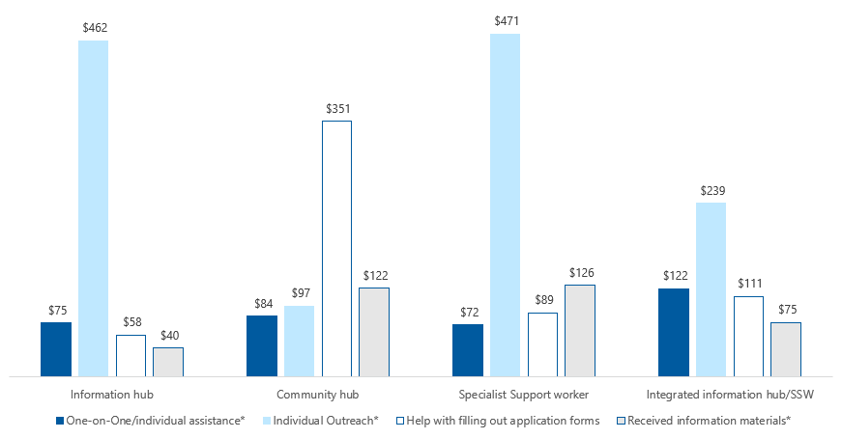

Note: It is important to consider the additional limitations outlined in Section 3.7 when interpreting the information in this figure. ‘Total’ costs calculated as those reported in all trial summary reports divided by total number of associated navigator service user records. *May include some reported costs derived from Group trial activities.

Long alt text:

Information hub: One-on-One/individual assistance $75, Individual Outreach $462, Help filling out application forms $58, Received information materials $40. Community hub: One-on-One/individual assistance $84, Individual Outreach $97, Help filling out application forms $351, Received information materials $122. Specialist Support Worker: One-on-One/individual assistance $72, Individual Outreach $471, Help filling out application forms $89, Received information materials $126. Integrated Information hub/SSW: One-on-One/individual assistance $122, Individual Outreach $239, Help filling out application forms $111, Received information materials $75.

Figure D‑5: Median ‘total’ costs of Individual trial activity delivery between September and November 2020, by mode of delivery (In person and telephone)

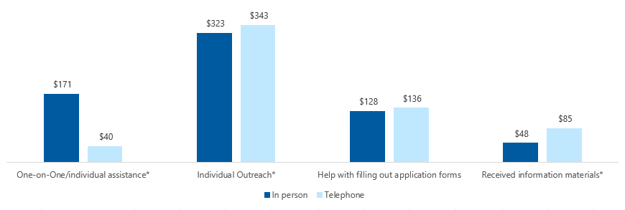

Note: It is important to consider the additional limitations outlined in in Section 3.7 when interpreting the information in this figure. ‘Total’ costs calculated as those reported in all trial summary reports divided by total number of associated navigator service user records. *May include some reported costs derived from Group trial activities.

Long description: One-on-One/individual assistance: In person $171, Telephone $40. Individual Outreach: In person $323, Telephone $343. Help filling out application forms: In person $128, Telephone $136. Received information materials: In person $48, Telephone $85.

# Review of other system navigator models

## Aged care system navigator models in Australia

This section presents key elements of the trials undertaken as part of the ACSN Measure (Table E‑1), as well as other identified aged care system navigator models in the Australian context (Tables E‑2 to Table E‑5) to highlight, where possible, some of the broad similarities and differences between these models.

Where available, the following information was extracted:

* Model or service (dates operational)
* Organisation
* Role of the navigator
* How services are delivered
* Target population
* Workforce (qualifications/​experience)
* Funding/​costs (and where the organisation also provides Commonwealth-funded aged care services)
* Data collection/​reporting requirements
* Review or evaluation undertaken.

Models are presented if they are considered in-scope of the identified models of system navigation *and* were considered relevant to the Australian aged care context.

Table E‑1: Key elements of the trials undertaken as part of the ACSN Measure

|  |  |  |  |  |  |  |  |
| --- | --- | --- | --- | --- | --- | --- | --- |
| Model or service  (dates operational) | Organisation | Role | How services are delivered | Target population | Workforce | Data collection/​reporting | Review or evaluation |
| [The ACSN Measure Information hub trial](https://www.cota.org.au/wp-content/uploads/2019/02/ACSN-Factsheet-5-About-Information-Hubs.pdf)s  (January 2019 to June 2021) | Consortium of partner organisations led by COTA Australia | Helping people to:   * Understand the aged care system * Engage with the aged care system | The trials will deliver different individual and combinations of aged care system navigator models, of varying intensity and targeting different population groups.  These may involve, but are not limited to:   * Seminars * Distribution of tailored information including drop-in information centres * Face-to-face support * Peer support * Outreach | People who have difficulty engaging through the existing channels and need additional support to understand, choose and access aged care services AND have not yet accessed aged care services.  A particular focus is people who:  Face barriers to accessing aged care services  Are vulnerable | Peer/​volunteer/​professional; may include aged care/​community care/​allied health sector experience/​qualifications | COTA Australia data set, including:  Individual trial activity records (i.e., number, location, type of activity, vulnerability/​diverse group information)  Group trial activity records (i.e., number, location, type of activity)  Trial survey records  *Trial summary* reports (i.e., trial-level costs, FTE, hours) | Yes  ([AHA – in progress](https://www.ahaconsulting.com.au/projects/aged-care-system-navigator/)) |
| [The ACSN Measure – Community hub trial](https://www.cota.org.au/wp-content/uploads/2019/02/ACSN-Factsheet-4-About-Community-Hubs.pdf)s  (January 2019 to June 2021) | Consortium of partner organisations led by COTA Australia | Helping people to:   * Understand the aged care system * Engage with the aged care system | As above | As above | Peer/​volunteer/​professional; may include aged care/​community care/​allied health sector experience/​qualifications | As above | Yes  ([this](https://www.ahaconsulting.com.au/projects/aged-care-system-navigator/) report) |
| [The ACSN Measure – SSW trial](https://www.cota.org.au/wp-content/uploads/2019/02/ACSN-Factsheet-6-About-Specialist-Support-Workers.pdf)s  (January 2019 to June 2021) | Consortium of partner organisations led by COTA Australia | Helping people to:  Understand the aged care system  Engage with and access the aged care system | As above | As above, with a greater focus on people who are vulnerable | Professional; may include aged care/​community care/​allied health sector experience/​qualifications | As above | Yes  ([this](https://www.ahaconsulting.com.au/projects/aged-care-system-navigator/) report) |
| The ACSN Measure – FIS Officer trials  (October 2018 to October 2019) | DHS | To support people making complex financial decisions when planning for and accessing aged care | Face-to-face  Outreach activities  Seminar programs | People who need to make complex financial decisions when planning for and accessing aged care | FIS Officers – usually APS Level 6 and may include accounting, finance, policy, and/or aged care qualifications | DHS data set, including:  Individual occasions of service  Customer satisfaction surveys (three time points)  Distribution of funding | Yes  ([this](https://www.ahaconsulting.com.au/projects/aged-care-system-navigator/) report) |

Table E‑2: Key elements of other identified aged care system navigator models in Australia: National

|  |  |  |  |  |  |  |  |
| --- | --- | --- | --- | --- | --- | --- | --- |
| Model or service  (dates operational) | Organisation | Role | How services are delivered | Target population | Workforce | Data collection/​reporting | Review or evaluation |
| [Care About](https://www.careabout.com.au/)  (not stated) | Care About | To provide aged care navigation:  Information about government subsidies for HCPs and residential aged care  Assistance with registering with My Aged Care and arranging assessment  Assistance with accessing HCPs and residential aged care | Online directory (postcode search function)  Online resources  Live online chat  Email  Phone  Face-to-face | People requiring assistance to navigate their aged care options | Not stated | Not stated | Not stated |
| [Legacy Navigator Service](https://www.agedcareonline.com.au/2017/09/Helping-Widows-Navigate-Care-Changes-Legacy-Navigator-Service-Supports-Ex-Service-Families)  (2016 – present) | Bolton Clarke & Legacy Australia | To provide free information on:  Types of in-home aged care, nursing and support available  Process for accessing aged care and using My Aged Care, home support options including DVA Community Nursing and Veterans’ HCPs and the CHSP programs | Telephone (Mon–Fri, 9 am–5 pm) | Legacy beneficiaries and legatees nationwide | Peer/volunteer/professionals; may include Legacy Pensions and Welfare Officers | Not stated | Not stated |
| [My CarePath](https://mycarepath.com.au/)  (not stated) | Millennium Aged Care Consultants & Aged Care Online | To provide information and assistance with understanding and accessing home and aged care services | Provision of information (packs)  Consultation  Client liaison with member service providers (provider network)  Phone and email enquiries  Fee negotiation with service providers | Not stated | Professional (health care consultants) | Not stated | Not stated |
| [Information hub](https://nationalseniors.com.au/info-hub)  (not stated) | National Seniors Australia | To provide information to help people understand financial aspects of aged care and access aged care:  Care360 online search tool  National Seniors Financial Literacy Service  Advocacy  Research articles | May include face-to-face, online, telephone, and/or email | Members of National Seniors Australia | Not stated | Not stated | Not stated |
| [Third Age Matters](https://thirdagematters.com.au/)  (not stated) | Third Age Matters | To provide information and assistance in relation to financial and aged care needs in Canberra and on the South Coast of NSW:  Understanding aged care options  Understanding option for funding aged care  Assistance with relocating  Ongoing support | Not stated | Not stated | Professional (accredited aged care qualification and financial advisor/licensed financial advisor available) | Not stated | Not stated |
| [Aged care guide](https://aushealthcareassociates.sharepoint.com/sites/EvaluationTeam/Shared%20Documents/ACSN/agedcareguide.com.au)  (not stated) | DPS | Assisting consumers to compare, choose and connect with their preferred care choice  DPS guide to aged care published for each state and territory | Online information (free) and printed information available to purchase | All potential aged care consumers, their family and carers, allied health professionals, placement providers, financial advisors, aged care facilities and government agencies | Online resources | Not stated | Not stated |
| Aged Care Prepare  (not stated) | Aged Care Prepare | To support older Australians and their families to navigate through their retirement and aged care journeys. | Online information and “[free personalised aged care summary](https://www.agedcareprepare.com.au/personalised-aged-care-summary)” | Older Australians/‌families | Team with medical, nursing, rehabilitation, aged care experience | Not stated | Not stated |

Table E‑3: Key elements of other identified aged care system navigator models in Australia: NSW

|  |  |  |  |  |  |  |  |  |
| --- | --- | --- | --- | --- | --- | --- | --- | --- |
| Model or service  (dates operational) | Organisation | Role | How services are delivered | Target population | Workforce | Data collection/​reporting | Review or evaluation | |
| [Care Navigator](https://ccnb.com.au/over-65s/)  (~2015 – present) | Community Care Northern Beaches | To provide impartial information, advice and guidance to support people over 65 years, their families and carers to navigate and access health, community, and aged care services | Face-to-face  Outreach activities  Email  Telephone | General community (over 65 years) | Peer/volunteers | Not stated | Not stated |
| [Community Care Advisor](https://www.sydneycs.org/meet-our-team-nuala-williams-community-care-advisor/)  (not stated) | Sydney Community Services | To provide free information, advocacy, and support for individuals over 65 years, their cares and families | Face-to-face  Outreach activities  Email  Telephone | People who find it challenging to navigate the aged care system | Professional; Diploma in community care coordination | Minimum data set (MDS) via the Data Exchange (DEX) system | Not stated | |
| [Home Care Advisory Service](https://upahomecare.com.au/free-home-care-advisory-service/)  (not stated) | UPA Home Care | To provide free information, advisory and support services to assist with:  Home care Packages  Registering for My Aged Care  Approval processes  Package portability  Understanding aged care rights and choices  Private support options | Not stated | People who find it challenging to navigate the aged care system | Not stated | Not stated | Not stated | |
| [The Waverton Hub](http://wavertonhub.com.au/)  (2012 – present) | The Waverton Hub | To provide members with assistance and activities involving:  Healthy ageing  Living independently | Face-to-face  Group activities  Resources | General community (Waverton, Wollstonecraft and neighbouring areas of Sydney) | Peer/members | Not stated | Not stated | |
| [GHR Financial Planning](http://www.ghr.com.au/app/uploads/Working-with-your-adviser1.pdf) (Accounting Group) | Aged Care Adviser (private) | Help to:  Plan for care needs  Set priorities  Review financial situation  Estimate fees  Advise re payment options  Advise on strategies to improve cash flow  Plan estate issues. | Presumably face-to-face | Older Australians/‌families | Staff (presumably financial advisors) | Not stated | Not stated | |

Table E‑4: Key elements of other identified aged care system navigator models in Australia: QLD

|  |  |  |  |  |  |  |  |
| --- | --- | --- | --- | --- | --- | --- | --- |
| Model or service  (dates operational) | Organisation | Role | How services are delivered | Target population | Workforce | Data collection/​reporting | Review or evaluation |
| [Seniors Enquiry Line](https://seniorsenquiryline.com.au/about/) | Operated by Uniting Care | Personalised information and inquiry line, giving Queensland seniors, grandparents, their family, friends and carers access to information on topics of interest to seniors. | Telephone | Anyone in Queensland | Not stated | Not stated | Not stated |

Table E‑5: Key elements of other identified aged care system navigator models in Australia: SA

|  |  |  |  |  |  |  |  |
| --- | --- | --- | --- | --- | --- | --- | --- |
| Model or service  (dates operational) | Organisation | Role | How services are delivered | Target population | Workforce | Data collection/​reporting | Review or evaluation |
| [Aged Care Alternatives](https://www.agedcarealternatives.net.au/)  (2010 – present) | Resthaven | To provide free information to help older people, their carers and families find and understand information about aged care services:  Help to understand their needs and the options they can choose from  Guidance to help them find the right pathway  Help to access the identified services | Face-to- face  Outreach hub  Email  Telephone | People who find it challenging to navigate the aged care system | Professional and peer/‌volunteer (“Options Guides”); may include qualifications in nursing, teaching, law, and management | MDS: Number, mode, source, and type of enquiries | Yes (internal Service Summary Report September 2019) |
| [Aged Care Navigator Service](https://achgroup.org.au/information-and-advice/aged-care-navigator-service/)  (not stated) | ACH Group | To provide assistance with:  Understanding aged care options available  Tailored aged care navigation solutions to meet individual needs  Understanding how aged care services are accessed, secured, and paid for, and legal implications  Paperwork completion | Phone  Face-to-face  In-home consultations | People who experience finding and securing aged care services complex and overwhelming | Professional (type not stated) | Not stated | Not stated |
| [Dementia Advisor](https://www.dementia.org.au/support/support-in-your-region/south-australia/dementia-advisors)  (not stated) | Dementia Australia | To provide assistance to people with dementia and their families to access specific information, resources, education and support, tailored to their individual needs | Face-to-face  Telephone  Access to dementia specific support groups  Education programs and workshops (primarily for family carers) | People 65 years living in the community with a diagnosis of dementia and their families in SA; Special needs groups including CALD and Aboriginal or Torres Strait Islander community members 50 years and over, people at risk of homelessness 50 years and over, veterans, members of the LGBTI community, and people living alone | “Specialised” | Not stated | Not stated |
| [LGBTI Connect](https://lgbticonnect.ech.asn.au/)  (not stated) | ECH Inc | To provide culturally safe access, navigation, advocacy and connection to aged care services | Not stated | LGBTI community members in South Australia | Peer/‌volunteer | Not stated | Not stated |
| [My Aged Care Support Program](https://www.cotasa.org.au/programs/my-aged-care-support.aspx) (peer champions)  (2017 present) | COTA SA  Country South PHN | To provide assistance with:  information, support and practical assistance regarding My Aged Care services  Understanding and increasing awareness about aged care options available through My Aged Care | Telephone (mobile)  Face-face-face  Group information sessions  Outreach activities  Resources | General community (over 65 years in Fleurieu, Mid-North, Murray Mallee, York Peninsula SA) | Hybrid  Peer/​volunteer  Professional (may include aged care/​community care/​allied health sector experience/​qualifications) | Not stated | Yes (Country SA PHN in progress) |
| [Navigating Aged Care](https://www.ech.asn.au/advice/navigating-aged-care/)  (not stated) | ECH Inc | To provide free information with:  Registering with My Aged Care  The assessment process | Email  Telephone | Potential customers | Not stated | Not stated | Not stated |

Table E‑5: Key elements of other identified aged care system navigator models in Australia: VIC

|  |  |  |  |  |  |  |  |
| --- | --- | --- | --- | --- | --- | --- | --- |
| Model or service  (dates operational) | Organisation | Role | How services are delivered | Target population | Workforce | Data collection/​reporting | Review or evaluation |
| [A&S Program](https://centralvicpcp.com.au/lmcca/wp-content/uploads/2018/12/2018-03-20-Access-and-Support-Guidelines-FINAL.pdf)  (2012-2022) | Auspice organisations state-wide | To provide individual support to eligible people who require assistance accessing aged care and other services due to barriers experienced or because of their diverse needs | Face-to-face  Telephone  Outreach | Vulnerable population groups  People experiencing barriers | Professional (minimum of certificate III in aged care/​community care/​allied health sectors) | MDS via the DEX system: Time (recorded in hours and minutes) | Yes  [(HDG Consulting Group 2015)](https://www2.health.vic.gov.au/Api/downloadmedia/%7B1427F286-B118-41A3-B95D-3202A9BAE1B6%7D) |
| [Aged Care Maze Consultation](https://carewithquality.com.au/faq/navigating-the-aged-care-maze/)  (not stated) | Care With Quality | To help people locate information about aged care, funding, and aged care service providers in their local area | Not stated | Frail, aged and people with disabilities | Professional (may include nursing, occupational therapy and social work) | Not stated  Free 45-minute consultations. Care with Quality also provides Commonwealth-funded aged care services | Not stated |
| My Aged Care Champions  (not stated) | Ballarat Regional Multicultural Council Inc. | To provide information to understand and assist with registering for My Aged Care | Information sheets  Face-to-face  Group interactions | People from CALD backgrounds | Peer | Not stated | Not stated |
| [Demystifying aged care](https://www.baptistcare.com.au/events/demystifying-aged-care/)  (2018 – present) | Baptist Care | To provide information and assistance about the:  Current aged care landscape in Australia  Different aged care options, fees and eligibility for funding  Processes involved in accessing My Aged Care  How to get help with financial planning and advice | Information sessions  Q&A sessions  Outreach activities | General community | Professional (aged care/financial qualifications) | Paper/pencil feedback/evaluation form | No |
| [Planning for the Next Season](https://thenextseason.com.au/tag/melissa-young/)  (2014 – present) | Melissa Young | To provide information and group support for older people, their families, and carers to:  Help people make plans to age in place  Increase their understanding of supports and services available | Workshop/group interactions  Workbook  Face-to-face consultations | General community | Peer/​professional | Not stated | No |
| [The Village Hub](https://www.connectvictoriapark.org/content.aspx?page_id=22&club_id=873726&module_id=299089)  (2018 – present) | Connect Victoria Park | To provide a central contact point to assist people with:  Healthy ageing  Living independently in Victoria Park, WA  Home care packages | Face-to-face  Group activities  Resources | General community (over 55 years in Victoria Park, WA) | Peer/​Member Services Manager | Not stated | Not stated |

# Appropriateness: findings from the modified short-form survey

The information presented in this section is based on navigator service user feedback collected via the modified short-form survey, which was rolled out for use by all 64 trials from September 2020 (quarter 8).

The first tranche of modified short-form survey data was submitted to AHA – as part of the latest update to the COTA Australia data set – in late December 2020, as planned. Following review and analysis, the *quality*, *completeness* and *representativeness* of much of the modified short-form survey data was observed to be greater compared to that collected via the previous long-form and original short-form survey tools (as presented in Section 3.5.1, ’How appropriate are the trials in meeting the needs of navigator service users?’).

As such, while the following modified short-form survey findings build on those presented in the above section – with comparisons made, where applicable – it is expected that the findings presented in this section are, arguably, more representative, robust – and therefore, reliable – compared to those presented in Section 3.5.1.

## Survey aim

Like the previous survey tools, the modified short-form survey tool is aimed at assessing *short-term* changes in navigator service users’ *knowledge*, *understanding* and *confidence* when engaging with aged care services – along with asking specific questions about their trial experiences. As such, responses collected via this survey can be used as a *proxy* for evaluating the COTA Australia-led trials’ appropriateness for meeting the needs of navigator service users.

However, as before, it has not been possible to evaluate whether navigator service user short-term outcomes, in terms of levels of satisfaction immediately following a trial interaction, actually eventuated in easier or quicker access to aged care services over the medium to longer term.

## Survey format

The modified short-form survey tool is comprised of the following sections, with the intention that responses are collected in all sections:

Navigator service user information:

* + Demographics, including diverse group and vulnerability information
  + Language/s spoken at home
* Trial activity information, including:
  + Trial activity type[2] and mode of delivery
  + Who delivered the trial activity ([paid] staff member or volunteer)

Trial outcomes:

* + 5 trial feedback questions/statements (of which 4 were carried over from the original short-form survey [as presented in Section 3.5.1])
  + 2 free-text options to allow navigator service users to provide information about how they found out about the trial, plus any additional comments about their trial experience
* Whether the navigator service user was assisted (by trial personnel) to complete the survey.

## Survey take-up

During the initial 3-month roll-out to November 2020, a total of 1,461 modified short-form survey response records had been reported, with all trials reporting one or more survey record in the COTA Australia data set:

* Information hubs: n=768 records (52.7%)
* Community hubs: n=481 (33.0%)
* SSW trials: n=83 (5.7%)
* Integrated Information hub/SSW trials: n=126 (8.6%).

(Note: a further 3 records did not report a trial code meaning trial type could not be established).

The distribution of survey response records reported was somewhat uneven across partner organisations, ranging from n=188 (12.9%) to n=8 (0.5%) for 21 of the 29 partner organisations. The remaining 8 partner organisations (delivering 7 Information hubs, 2 Community hubs and 1 SSW trial) reported only n=1 or n=2 records.

Around 9 in 10 navigator service user survey respondents had completed a printed survey (89.3% [n=1,305]), with relatively few overall reporting that assistance had been required/given (12.6% [n=184]). Most surveys had been completed following a following a trial interaction delivered by a (paid) staff member (90.1% [n=1,316]) rather than a volunteer (8.1% [n=119]).

### Trial activities and modes of delivery

Over 95% of survey respondents had received navigation support via one of 3 trial activity types, with over two-thirds having ‘Attended a group’ (n=1,018 [69.7%]). A further 18.3% (n=268) had received ‘One-on-one/individual assistance’, while 7.5% (n=109) had received ‘Individual outreach’ support. Survey responses associated with other trial activity types were reported infrequently (i.e., around 1% of survey records or less).

The *mode* of trial activity delivery was reported at much lower rates compared to other data variables in the modified short-form survey. For example, for the 3 main trial activities highlighted above, the ‘material’ reporting rates were 30.6% (‘One-on-one/individual assistance’), 10.1% (‘Individual outreach’) and just 2.0% (‘Attended a group’). This exception in data completeness levels was queried with COTA Australia in January 2021, however, the underlying explanation for this anomaly remains unclear at the time of drafting this update to the Final Report (February 2021).

However, COTA Australia was able to confirm that for responses collected via printed surveys (just under 90% of all survey records, see above), around 80% of these would have been associated with an in-person trial interaction. Roughly speaking, this would equate to *around* *70%* – i.e. the majority – of survey records originating from trial interactions delivered in person.

Where mode of trial activity delivery information was reported in the modified short-form survey, this is shown in Figure F‑1 (for 3 main trial activity types only). Surveys completed following ‘One-on-one/individual assistance’ delivered via telephone comprised the largest group by far (n=57), followed by the same trial activity delivered via ‘Information on a website or in an email (n=17) (Figure F‑1).

Figure F‑1: Modes of delivery of the main trial activity types reported in the modified short-form survey

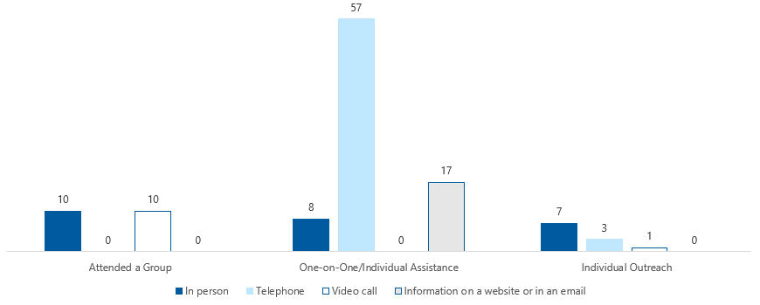

Long description: Attended a Group: In person 10, Telephone 0, Video call 10, Information on a website or in an email 0. One-on-One/individual assistance: In person 8, Telephone 57, Video call 0, Information on a website or in an email 17. Individual Outreach: In person 7, Telephone 3, Video call 1, Information on a website or in an email 0.

#### Navigator service users

Around two-thirds of survey respondents were female (65.4% (n=955]) – which mirrored the original short-form survey – while over three-quarters were aged 61 years or above (77.4% [n=1,131]).

Table F‑1 shows the diverse groups and vulnerable populations reported by navigator service users in the modified short-form survey (data not mutually exclusive).

Table F‑1: Diverse groups and vulnerable populations reported by modified short-form survey respondents

|  |  |
| --- | --- |
| Population group | n (%) |
| Do not wish to disclose | 103 (7.0%) |
| Diverse group | No group total individual groups shown below |
| Rural/remote | 407 (27.9%) |
| CALD | 298 (20.4%) |
| Accessibility (digital barrier) | 278 (19.0%) |
| Accessibility (vision/hearing impairment) | 59 (4.0%) |
| LGBTI | 53 (3.6%) |
| Aboriginal or Torres Strait Islander | 51 (3.5%) |
| Vulnerable population | No group total individual groups shown below |
| Disability | 120 (8.2%) |
| Financially and socially disadvantaged | 85 (5.8%) |
| Socially isolated or at risk of social isolation | 71 (4.9%) |
| Mental health challenges | 62 (4.2%) |
| Cognitive impairment (including dementia) | 50 (3.4%) |
| Veteran | 36 (2.5%) |
| Homeless (or at risk of homelessness) | 10 (0.7%) |
| Care leaver | 9 (0.6%) |
| Forced adoption | 5 (0.3%) |

Note: Percentages are out of all survey records (n=1,461, which included n=364 records (24.9%) with no diverse group/vulnerability information recorded). Data are not mutually exclusive.

The reporting rate for diverse group and/or vulnerability information (including responses of ‘Do not wish to disclose’) was relatively high at 75.1% (n=1,097) (Table F‑1). Further, while the *original* short-form survey primarily targeted ‘CALD’ and ‘Aboriginal or Torres Strait Islander’ populations, *all* diverse groups and vulnerable populations were represented – to varying degree – in this pool of survey respondents.

‘Rural/remote’ was the most commonly reported diverse group or vulnerable population: 27.9% (n=407), followed by ‘CALD’ (20.4% [n=298]) and ‘Accessibility (digital barrier)’ (19.0% [n=278]). The remaining groups/populations were reported somewhat less frequently, as shown in Table F‑1.

Table F‑2 shows the *most common* diverse groups and vulnerable populations – including those reported in *combination* (i.e., data are mutually exclusive).

Table F‑2: Most common diverse group and vulnerable populations reported by modified short-form survey respondents

|  |  |
| --- | --- |
| Population group | n (%) |
| Rural/remote | 228 (15.6%) |
| CALD | 190 (13.0%) |
| Accessibility (digital barrier) | 72 (4.9%) |
| Rural/remote and Accessibility (digital barrier) | 62 (4.2%) |
| CALD and Accessibility (digital barrier) | 27 (1.8%) |
| Aboriginal or Torres Strait Islander | 25 (1.7%) |
| LGBTI | 24 (1.6%) |
| Disability | 21 (1.4%) |
| Financially and socially disadvantaged | 16 (1.1%) |
| Socially isolated or at risk of social isolation | 15 (1.0%) |

Note: Diverse group and vulnerable population information reported for ≥1.0% of navigator service user respondents shown; percentages are out of all survey respondents (n=1,461). Data are mutually exclusive.

When *combinations* of diverse group and vulnerability population categories were assessed, a total of 149 different combinations were reported, which created a long tail in the data (not shown). Still, when considering the data in this way, the most populous categories remained as ‘Rural/remote’, ‘CALD’ and ‘Accessibility (digital barrier)’, i.e. reported singularly (Table F‑2).

Table F‑3 shows the most frequently reported languages that navigator service user survey respondents spoke at home. While ‘English’ (alone) was the most common language spoken (n=922, [63.1%]), a total of 69 languages/‌language combinations were reported – perhaps unsurprisingly, given around 1 in 5 navigator service users were from CALD backgrounds (Table F‑1).

Table F‑3: Language/s spoken at home, reported by modified short-form survey respondents

|  |  |
| --- | --- |
| Language | n (%) |
| English | 922 (63.1%) |
| Vietnamese | 29 (2.0%) |
| Indonesian | 24 (1.6%) |
| Spanish | 18 (1.2%) |
| Cantonese | 17 (1.2%) |
| No data reported | 271 (18.5%) |

Note: Language/s spoken at home reported for ≥1.0% of navigator service user respondents shown; percentages are out of all survey respondents (n=1,461). Data are mutually exclusive.

Compared to the original short-form survey –where Asian languages tended to predominate across responses – a greater number of European languages were reported in the modified survey (data not shown). This is likely to reflect the respective samples of partner organisations which had administered each tool (see Section 3.5.1, ‘To what extent, in what ways and why did reported satisfaction levels differ between populations’)

Overall, navigator service user feedback followed a very similar pattern compared to previous findings (see Section 3.5.1), with *high levels of positive feedback* reported following trial interactions, as shown in Table F‑4. Indeed, the positive (i.e., ‘Agree’ plus ‘Strongly agree’ responses) reporting rate for each of the 5 questions/statements ranged from 97.1% to 93.1%.

This was further underlined by additional positive feedback from navigator service users left via free-text comments in their survey responses.

As before, the vast majority of survey respondents reported that the support and information they had received from the trials was *useful* and of *assistance* to them, leaving them feeling *more* *confident* about seeking help from the aged care system, if/when required (Table F‑4).

“Marvellous! Excellent! I can breathe a sigh of relief now!”

“A very enlightening, useful session.”

—2 Navigator service users

In line with these findings, 95.9% (n=1,263) of navigator service user respondents agreed or strongly agreed that they would tell others about their trial experience and/or encourage them to book in for a trial interaction (Table F‑4).

“Can I please get more brochures to give to my friends?”

“[It] would be great to have these information sessions in as many towns as possible.”

—2 Navigator service users

Overall, negative (i.e., ‘Disagree’ or ‘Strongly disagree’) responses were rarely reported, and, reassuringly, *no* navigator service users reporting their ‘Strong disagreement’ with *any* of the questions/statements (Table F‑4). The highest negative reporting rate – still only 1.6% (n=21) – was associated with the question ‘*Do you feel that you know more about what aged care services and supports are available*?’.

#### Were navigator service users satisfied with the services?

Table F‑4 shows survey respondents’ responses to the 5 trial feedback questions/statements making up the modified short-form survey, including the overall completion rate for each question.

Table F‑4: Navigator service users’ responses in the modified short-form survey, reported between September and November 2020

|  |  |  |  |  |  |  |
| --- | --- | --- | --- | --- | --- | --- |
| Survey question/statement | Response rate | Strongly agree | Agree | Neutral | Disagree | Strongly disagree |
| 1. Did you find the information useful? | 1,322 (90.5%) | 801 (60.6%) | 483 (36.5%) | 30 (2.3%) | 8 (0.6%) | 0 (0.0%) |
| 2. Was the support of assistance to you? | 1,299 (88.9%) | 735 (56.6%) | 474 (36.5%) | 79 (6.1%) | 11 (0.8%) | 0 (0.0%) |
| 3. Do you feel that you know more about what aged care services and supports are available? | 1,321 (90.4%) | 735 (55.6%) | 510 (38.6%) | 55 (4.2%) | 21 (1.6%) | 0 (0.0%) |
| 4. I would recommend my session to others or get them to book in for a chat | 1,317 (90.1%) | 801 (60.8%) | 462 (35.1%) | 48 (3.6%) | 6 (0.5%) | 0 (0.0%) |
| 5. I feel more confident to seek help from the aged care system if I need to | 1,319 (90.3%) | 703 (53.3%) | 537 (40.7%) | 71 (5.4%) | 8 (0.6%) | 0 (0.0%) |

Note: Overall response rates (shown in second column) are calculated out of all trial survey responses (n=1,461). Response percentages (third column onwards) are calculated out of survey records with available data for each question/statement (i.e., omitting records with missing information).

Some survey respondents commented on the *large amount* of information that was provided during their trial interaction, which, presumably, may prove *overwhelming* if not conveyed to the audience appropriately. However, many responses noted that the information had been explained clearly and at an appropriate pace. Further, where printed supporting materials were available to take away from the trial session, these had been well received.

“As so much information available (it) was a bit hard to remember it all, but the take home booklet (was) helpful in recapping most items.”

“I found the information provided (verbal and written form - booklets) to have been helpful now, and into my forward journey.”

—2 Navigator service users

In order to assess any introduced reporting bias, the responses from navigator service users that had been assisted to complete their modified short-form surveys were compared with those that had completed them solo. Reassuringly, no particular differences were observed across the 5 trial feedback questions/statements. For example, the overall proportions of positive/negative responses from those that had been assisted with survey completion (n=184) were 95.2%/0.7% compared to 94.9%/0.8% for those that had not been assisted (n=1,252).

#### Trial types and trial activity delivery

Figure F‑2 shows the overall proportions of positive, negative and neutral responses reported by navigator service users, presented by trial type.

While noting the comparatively lower number of modified short-form survey responses from the SSW trials (n=83), particularly compared to the Information hubs (n=768) and Community hubs (n=481), the SSW trials were associated with a 100.0% positive reporting rate across all 5 feedback questions/‌statements (Figure F‑2).

That said – and in line with previous survey findings (see Section 3.5.1) – the other trial types reported only slightly lower rates of positive responses, with negative responses rarely reported: rates between 1.1% (Community hubs) and 0.5% (Integrated Information hub/SSW trials).

As highlighted above, the majority (95.5%) of modified short-form survey respondents had received support via one of 3 trial activity types. In line with previous findings, few meaningful differences were observed in survey responses associated with these 3 trial activities, as indicated by the *overall positive/negative* response rates shown below:

* **‘**Attended a group’ (n=1,018): 94.2%/0.9%
* ‘One-on-one/individual assistance’ (n=268): 98.4%/0.3%
* ‘Individual outreach’ (n=109) – 96.8%/0.2%.

If anything, the overall proportion of negative responses associated with the one Group trial activity (0.9%) shown above could be considered as *somewhat higher* compared to the 2 Individual trial activities (0.2-0.3%). However, this was still under 1% (and derived from n=45 responses of ‘Disagree’ across all 5 feedback questions/statements). (It may also be prudent to note the disparities in associated survey record n numbers shown above: 3 times as many survey records originated from the ‘Attended a group’ trial activity than from the 2 Individual trial activity types [combined]).

That said, it is accepted that navigation support delivered in a group setting may not suit the needs of all navigator service users, particularly those with complex and/or multiple needs. This, in turn, may have increased the negative response reporting rate for this type of trial activity.

“I would like more personalised assistance.”

—Navigator service user (‘Attended a group’)

Figure F‑2: Distribution of positive, negative and neutral responses reported in the modified short-form survey, between September and November 2020

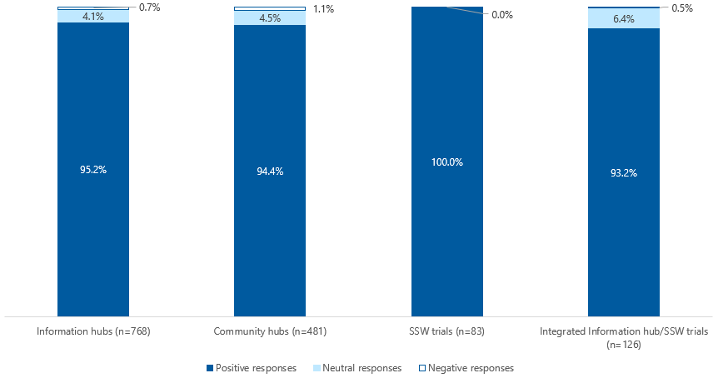

Note: Percentages calculated from total positive (‘Strongly agree’/’Agree’), negative (‘Strongly disagree’/’Disagree’) and neutral responses.

Long description: Information hub: Positive responses 95.2%, Neutral responses 4.1%, Negative responses 0.7%. Community hub: Positive responses 94.4%, Neutral responses 4.5%, Negative responses 1.1%. SSW trials: Positive responses 100%. Integrated Information hub/SSW trials: Positive responses 93.2%, Neutral responses 6.4%, Negative responses 0.5%.

However, AHA understands that attendance at a Group trial activity was often the *entry point* for navigator service users accessing trial services, with many being referred on for repeat or *higher intensity individual navigation support* – delivered either by the same, or a related trial (as indicated by referral information in Table 3-15 and Figure 3-19 of Section 3.6.1).

Any differences in navigator service user feedback attributable to the mode of trial activity delivery was not possible to reliably assess. The reason for this was because of the unusually low number of survey records which reported delivery mode (as described above and shown in Figure F‑1), very few also provided responses to the 5 feedback questions/statements, compared to overall rates.

For example, of the n=20 records which reported a mode of delivery for ‘Attended a group’, only n=9 contained any ‘feedback’ responses. It was a similar picture for the equivalent n=82 records for ‘One-on-one/individual assistance’, with only n=22 containing ‘feedback’ responses.

Additional feedback provided via free-text comments did not indicate widespread differences between different modes of delivery. However, one or 2 respondents highlighted their preference for in-person delivery, with some reporting technology issues with other ‘virtual’ modes – which, arguably, may be more associated with Group trial activity delivery.

“Not really as good as a real live person giving a presentation. The sound was insufficient and had to read the writing supplied. Hate technology.”

“5 stars (although) sound system poor.”

—2 Navigator service users

Elsewhere, while noting the disparity in n numbers, trial activities delivered by (paid) staff members (n=1,316 survey records) compared to volunteers (n=119) garnered similarly positive feedback: 94.8% and 96.0%, respectively, (and was unaffected by which type of trial activity had been delivered [data not shown]).

“Not only is [the Navigator] a very friendly and helpful lady, but she told me about services I had never heard of. Honestly, having [their] support has given me such positive outcomes which will enhance my lifestyle.”

“Very helpful, informative, professional and friendly.”

—2 Navigator service users

Olga’s story

Olga was 79 years old and from a Russian background. She and her husband had arrived in Australia 4 years ago as family sponsored entrants. As such, they had no access to income support through Centrelink, despite them becoming citizens. While they had Medicare cards and so, in theory, could access most aged care services, financial constraints limited their options.

Olga approached the Information hub and was able to discuss her issues and concerns directly with a Russian speaking Navigator. She had endured 5 surgeries on her hip which had resulted in complications and left her in severe discomfort. As a result of COVID-19 restrictions, Olga had also become less mobile and cut back on her walking and general movement, which further exacerbated her health problems.

Olga was assisted to register with My Aged Care and was referred for a RAS assessment. She asked the Russian speaking Navigator to support her through the assessment with language assistance, as she felt a little ambivalent and required reassurance.

Olga was referred for an OT assessment focusing particularly on the need for handrails throughout her home, including bed rails to support her getting in and out of bed.

Having access to language support from someone she trusted enabled Olga to communicate in a more positive and meaningful way with the RAS Assessor and My Aged Care. She was able to articulate her issues clearly and openly which resulted in a more accurate identification of her needs and circumstances.

Olga was very happy with the outcome she achieved and continued to maintain contact with the navigation service for any future additional aged care needs.

#### To what extent, in what ways and why did reported satisfaction levels differ between populations?

Figure F‑3 and Figure F‑4 show the overall proportions of positive (‘Agree’/’Strongly agree’) responses, reported by each diverse group and vulnerable population (data not mutually exclusive within, or across, the figures).

As outlined in Table F‑1 above, while all diverse groups and vulnerable populations were represented in the pool of survey respondents, the number of survey records from some groups/populations was very low. As such, Figure F‑3 and Figure F‑4 are ordered from highest n numbers of submitted surveys on the left to lowest numbers on the right.

For the diverse groups, overall positive response rates ranged from 95.6% for survey respondents from ‘CALD’ backgrounds (n=298 survey records) down to 86.2% for those identifying as ‘LGBTI’ (n=53) (Figure F‑3).

“It was really useful the lady that came to see me also spoke my language, so it was easy to understand. I would never be able to contact My Aged Care [by myself]”

—CALD Navigator service user

Interestingly, there appeared to be a slight split in the diverse group data, with the positive reporting rates of those from the 3 most populous groups (shown to the left of Figure F‑3) higher (>94%) compared to those of the least populous groups (<90%; shown to the right).

The main driver of these differences was the higher levels of reporting of *neutral* responses in the latter group (ranging from 8.0% to 12.3%), compared to the former group (3.2% to 4.6%). It would be interesting to see whether, over time, these reporting rates change as the quantum of survey data from the less well represented diverse groups increases.

“I marked neutral as I already had a good understanding of the system. Most issues (with My Aged Care) lie with the government.”

—Navigator service user

Negative reporting rates were relatively low across all diverse groups, ranging from 3.3% (‘Accessibility [vision/hearing impairment] [n=59 survey records]) to just 0.9% (‘Rural/remote’) (data not shown).

For the vulnerable populations, overall positive response rates ranged from 96.7% for ‘Veterans’ (n=36 survey records) down to 80.0% for those who had experienced ‘Forced adoption’ (n=5) (Figure F‑3 and Figure F‑4). However, in the latter case it is again important to acknowledge the very low number of surveys submitted by this population group.

“A very informative and reassuring experience that there is help available (for) dealing with dementia in a loved one. This service should be more widely advertised.”

—Navigator service user

The ‘Forced adoption’ group aside, negative reporting rates were observed to be just 2.6% (‘Socially isolated or at risk of social isolation’ [n=71 survey records]), or lower. Further, ‘Veterans’ (n=36) and ‘Care leavers’ (n=9*) reported *no* negative responses to any of the 5 feedback questions/statements (*while again, noting low n number) (data not shown).

Figure F‑3: Positive response reporting in the modified short-form survey, reported between September and November, by diverse group

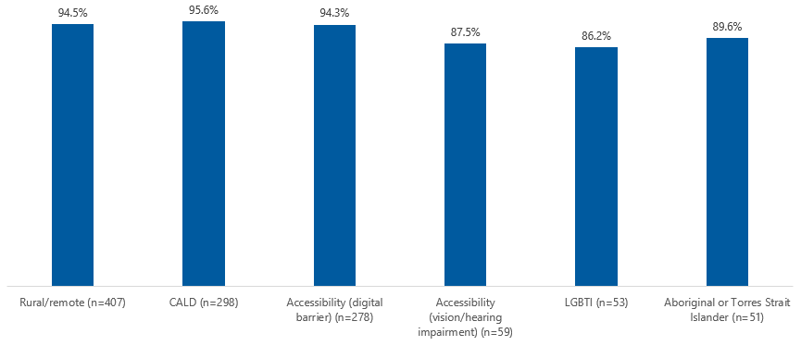

Note: Percentages calculated from total positive (‘Strongly agree’/’Agree’), negative (‘Strongly disagree’/’Disagree’) and neutral responses. Diverse group data are not mutually exclusive.

Long description: Rural remote 94.5%, CALD 95.6%. Accessibility (digital barrier) 94.3%, Accessibility (vision/hearing impairment) 87.5%, LGBTI 86.2%, Aboriginal or Torres Strait Islander 89.6%.

Figure F‑4: Positive response reporting in the modified short-form survey, between September and November, by vulnerable population

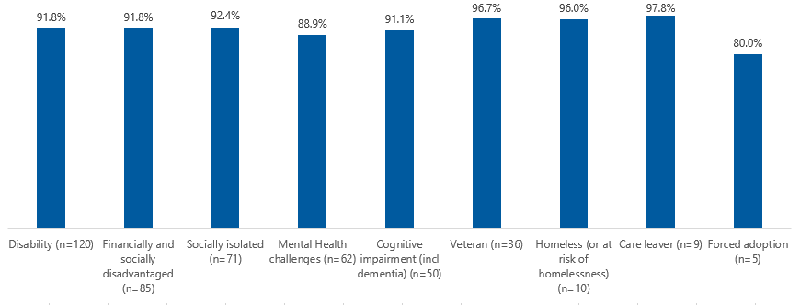

Note: Percentages calculated from total positive (‘Strongly agree’/’Agree’), negative (‘Strongly disagree’/’Disagree’) and neutral responses. Vulnerable population data are not mutually exclusive.

Long description Disability (n=120): 91.8%, Financially and socially disadvantaged (n=85) 91.8%, Socially isolated (n=71) 92.4%, Mental health challenges (n=62) 88.9%, Cognitive impairment (incl dementia) (n=50) 91.1%, Veteran (n=36) 96.7%, Homeless (or at risk of homelessness) (n=10) 96.0%, Care leaver (n=9) 97.8%, Forced adoption (n=5) 80.0%.

Laura’s story

Laura identified as a Forgotten Australian. Her mother relinquished her to an orphanage in Adelaide at the age of 2 due to poverty. From that age, Laura suffered various forms of extreme abuse in this institution, and was denied education, which resulted in literacy issues.

She lived alone in her own unit and was a carer for her son who had a significant mental health condition. Like so many Forgotten Australians, Laura was prematurely aged and had her own long-term chronic health conditions, as well as a recent brain tumour diagnosis.

She had been referred to the trial through the SA Forgotten Australian Project Officer, who reported that Forgotten Australians are in desperate need of in-person home visitation to support them to navigate the aged care system.

Laura, herself, expressed that the prospect of needing aged care support services can provoke negative feelings, including feeling truly frightened due to past experiences. For this reason, trust was not easily won, and so working with a trusted person such as an Aged Care Navigator was paramount to achieving good outcomes for Forgotten Australians.

The Navigator met with Laura in her home, with the initial introductory meeting an important opportunity to start building mutual rapport. The second meeting was again at Laura’s home, this time to register her with My Aged Care, through the Advocates as Agents pilot. This enabled the Navigator to speak on Laura’s behalf and become her liaison, which was requested by Laura, due to her not feeling confident or comfortable to deal directly with My Aged Care.

At the Navigator’s third home visit, Laura’s ACAT assessment occurred. 2 months on, the Navigator has continued to liaise with various service providers on Laura’s behalf, in order to engage interim CHSP services (domestic support, home maintenance and transport) before her Level 3 HCP was assigned.

Laura regularly phones the Navigator to discuss her services and how they are going. Through this ongoing connection, they have built an excellent relationship through trust and mutual respect, which is vitally important for Forgotten Australians when engaging with the aged care system.

As indicated above, a large degree of diverse group and vulnerable population *intersectionality* was observed in the pool of survey respondents. Table F‑5 shows the proportions of positive, negative and neutral trial feedback responses reported by those from the most commonly reported groups (i.e., those shown in Table F‑2 above) (diverse group/vulnerable population data are mutually exclusive).

As shown below, very high levels of positive feedback were generally observed across the most common groups. The positive response rates ranged from a maximum of 98.9% for survey respondents reporting ‘Accessibility (digital barriers)’ (as a single diverse group, [n=72 survey records]), down to 87.2% for those from ‘Aboriginal or Torres Strait Islander’ backgrounds’ (again, as a single diverse group [n=25]) (Table F‑5). However, in the latter group, the reporting rate for neutral responses was relatively high (12.8%), with no negative responses reported (which was similar to findings from the original short-form survey [as presented in Section 3.5.1]).

Table F‑5: Distribution of positive, negative and neutral responses reported by the most common diverse group and vulnerable populations in the modified short-form survey

|  |  |  |  |
| --- | --- | --- | --- |
| Group | Positive responses % | Negative responses % | Neutral responses % |
| Rural/remote (n=228) | 95.2% | 0.2% | 4.7% |
| CALD (n=190) | 95.9% | 0.9% | 3.2% |
| Accessibility (digital barrier) (n=72) | 98.9% | 0.0% | 1.1% |
| Rural/remote and Accessibility (digital barrier) (n=62) | 96.7% | 0.3% | 3.0% |
| CALD and Accessibility (digital barrier) (n=27) | 97.8% | 0.0% | 2.2% |
| Aboriginal or Torres Strait Islander (n=25) | 87.2% | 0.0% | 12.8% |
| LGBTI (n=24) | 91.7% | 0.0% | 8.3% |
| Disability (n=21) | 95.9% | 0.0% | 4.1% |
| Financially and socially disadvantaged (n=16) | 93.8% | 0.0% | 6.3% |
| Socially isolated or at risk of social isolation (n=15) | 92.0% | 2.7% | 5.3% |

Note: Most common diverse group and vulnerable populations were reported in ≥1.0% of navigator service user respondents (data are mutually exclusive). Percentages calculated from total positive (‘Strongly agree’/’Agree’), negative (‘Strongly disagree’/’Disagree’) and neutral responses reported in each group shown; percentages have been rounded to one decimal place so may not total 100.0%.

Indeed, as before, few negative responses were reported overall in relation to trial feedback, although the negative reporting rate for those who were ‘Socially isolated or at risk of social isolation’ was observed to be somewhat of an outlier at 2.7% (Table F‑2). However, it is important to note that this was based on only n=15 survey records, and so should be interpreted with caution.

The negative reporting rate of 0.9% from the ‘CALD’ group was also *comparatively* high relative to other groups – and given it was based on n=190 survey records – could be considered to be a more reliable finding.

On review, the negative reporting rate of ‘CALD’ survey respondents was not driven by any particular trial feedback question/statement. However, one or 2 free-text responses – not necessarily from those from ‘CALD’ backgrounds – highlighted the importance of the trials providing appropriate language supports.

“Talks need to be language appropriate and information (written) in foreign languages supplied.”

“The language barrier is a big obstacle.”

—2 Navigator service user

Further, in line with *some* feedback from partner organisations follow-up consultations (see Section 3.4.2), one survey respondent (from a Greek background) commented that the survey tool itself was *“completely inappropriate”* for CALD people.

That single item of negative feedback aside, the trial-wide roll-out of the modified short-form survey has proved to be an important opportunity to build on – and strengthen – previously presented findings in relation to the COTA Australia-led trials’ appropriateness.

As described above, navigator service users presenting at the trials reported generally similar levels of positive outcomes via the modified short-form survey, indicating high levels of satisfaction with their trial experiences.

Navigator service user feedback associated with *typically higher intensity* *supports –* that is, Individual trial activities and all activities delivered by the SSW trials – was observed to be particularly positive.

Further, while it was not possible to reliably assess navigator service user outcomes in relation to different modes of trial activity delivery, some comments suggested that *in-person delivery* was preferable. As well as this delivery mode being more likely to be associated with higher intensity support, it also avoids the requirement for technology and/or technical know-how – which some navigator service users raised as concerns.

Importantly, the adoption of the modified short-form survey by all 64 trials led to all diverse groups and vulnerable populations being represented in the pool of survey respondents, albeit to a varying degree. Generally speaking, the different groups reported similarly high levels of positive feedback, with few negative responses reported.

Where *some* lower levels of positive response reporting were observed across groups, these tended to be driven by higher levels of neutral, rather than negative, response reporting (for example, in responses from ‘Aboriginal or Torres Strait Islander’ people).

It is also important to note that very few survey records were submitted for some groups – particularly those affected by ‘Forced adoption’ and ‘Care leavers’ – meaning this information should be viewed with caution.

Interestingly, one of the most highly represented groups – ‘CALD’ – reported proportionately more negative responses compared to other similarly sized groups. While this still represented <1% of ‘CALD’ feedback responses, it does indicate that a handful of these navigator service users were somewhat dissatisfied with their trial experience.

As mentioned above, it would be interesting to see whether the reporting rates for different groups change over time, as the quantum of associated survey responses increases, and particularly in groups with few survey records reported to date.

Cited references

Australian Government Department of Health 2020, Ensuring senior Australians can access the support they need, viewed 11 November 2020, <https://www.health.gov.au/ministers/senator-the-hon-richard-colbeck/media/ensuring-senior-australians-can-access-the-support-they-need>.

Department of Health 2017, Legislated review of aged care 2017, Commonwealth of Australia, Canberra.

The University of Melbourne 2020, Specialist certificate in service navigation, viewed 16 November 2020, <https://study.unimelb.edu.au/find/courses/graduate/specialist-certificate-in-service-navigation/>.

1. The options of ‘online’ and ‘face-to-face’ trial activity delivery were replaced by ‘information on a website or in an email’ and ‘video call’, and ‘in person’ in the modified COTA Australia data set (i.e., from 8th round of reporting [September 2020 onwards]),
2. Note: The trial activity type options in the modified short-form survey were in line with those introduced across the revised COTA Australia data set (as rolled out in September 2020 [quarter 8]).