Don’t fall for it.

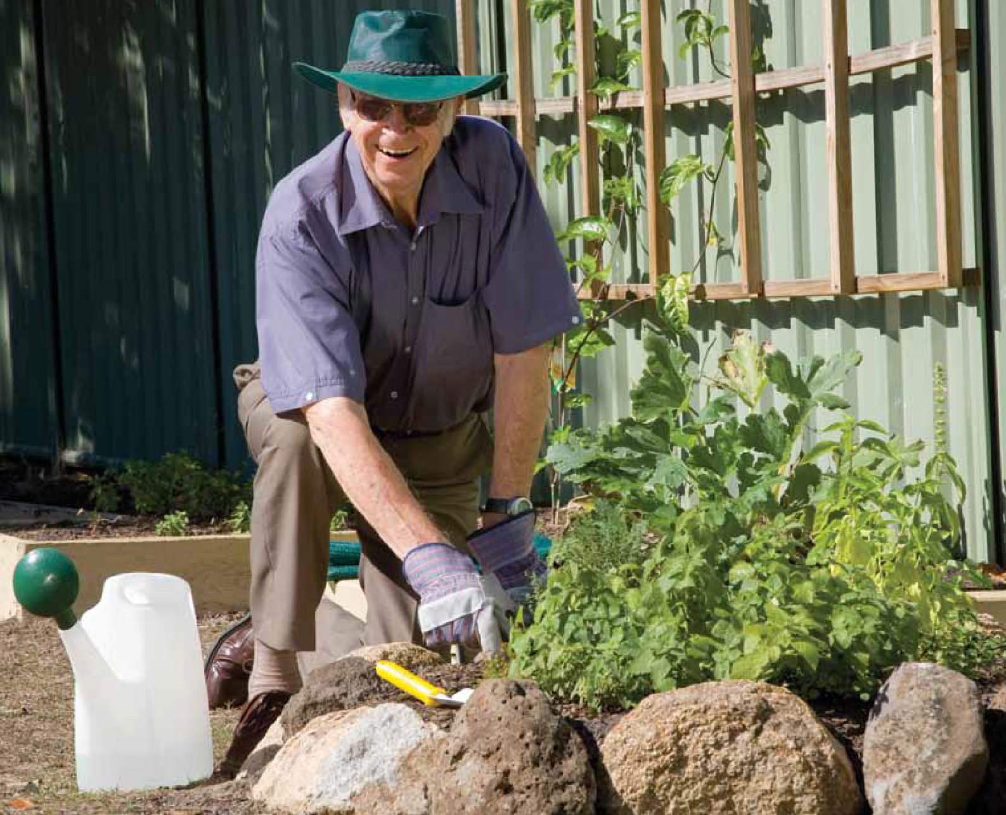Falls can be prevented!

A guide to preventing falls

for older people



Published by the State Government of South Australia 2004:

**Stay on Your Feet - Adelaide West**

Published by the Commonwealth of Australia 2010:

**Don’t Fall For It- A guide to preventing falls for older people**

Revised and re-published by the Commonwealth of Australia 2011:

**Don’t Fall For It- A guide to preventing falls for older people**

ISBN: 978-1-74241-483-6

Online ISBN: 978-1-74241-484-3

Publications Approval Number: D0427 Copyright Statements:

Paper-based publications

© Commonwealth of Australia 2011

This work is copyright. You may reproduce the whole or part of this work in unaltered form for your own personal use or, if you are part of an organisation, for internal use within your organisation, but only if you or your organisation do not use the reproduction for any commercial purpose and retain this copyright notice and all

disclaimer notices as part of that reproduction. Apart from rights to use as permitted by the Copyright Act 1968 or allowed by this copyright notice, all other rights are reserved and you are not allowed to reproduce the whole or any part of this work in any way (electronic or otherwise) without first being given the specific written permission from the Commonwealth to do so. Requests and inquiries concerning reproduction and rights are to be sent to the Communications Branch, Department of Health and Ageing, GPO Box 9848, Canberra ACT 2601, or via e-mail to [copyright@health.gov.au.](mailto:copyright@health.gov.au)

Internet sites

© Commonwealth of Australia 2011

This work is copyright. You may download, display, print and reproduce the whole or part of this work in unaltered form for your own personal use or, if you are part of an organisation, for internal use within your organisation, but only if you or your organisation do not use the reproduction for any commercial purpose and retain this copyright notice and all disclaimer notices as part of that reproduction. Apart from rights to use as permitted by the Copyright Act 1968 or allowed by this copyright notice, all other rights are reserved and you are not allowed to reproduce

the whole or any part of this work in any way (electronic or otherwise) without first being given the specific written permission from the Commonwealth to do so. Requests and inquiries concerning reproduction and rights are to be sent to the Communications Branch, Department of Health and Ageing, GPO Box 9848, Canberra ACT 2601, or via e-mail to [copyright@health.gov.au.](mailto:copyright@health.gov.au)

National Library of Australia Cataloguing-in-Publication entry

Title: Don’t fall for it, falls can be prevented! : a guide to preventing falls for older people. Subjects: Falls (Accidents) in old age

Other Authors/Contributors:

Dewey Number: 613.0438099423

Copyright Commonwealth of Australia, 2008. Reproduced by permission.

Developed by the project team of ‘Stay on Your Feet - Adelaide West’ 2002-2004 (Michele Sutherland,

Megan Watson and Pamela Dean) and the National Ageing Research Institute (Dr Keith Hill, Freda Vrantsidis and Dr Lindy Clemson, Advisor, University of Sydney), and the material was based on material from the

“Helpful Home Front Hints” booklet developed for the Department of Veterans’ Affairs. Stay On Your Feet® is now a registered trademark of the Department of Health WA.

Graphics and captions reproduced with the kind permission of the following –

* SA Health
* Rheumatology Unit, Royal Adelaide Hospital, Adelaide, SA
* Stay On Your Feet – Adelaide West, SA
* Queensland Health

## Contents

Introduction 2

Using this booklet 3

Fall-proofing yourself

Reducing your Personal Risk Factors 4

Health problems 5

Keeping yourself mobile 7

Medicines 8

Making the most of your eyesight 9

Falls prevention from the ground up - feet and footwear 10

Managing worries about falling 11

Fall-proofing your surroundings

Reducing your Environmental Risk Factors 12

Your home and garden 13

How to be safe in your home and surroundings 14

Planning ahead when building or renovating 19

Just in case...

How to reduce injury 20

Making a plan to get help 22

Knowing how to get up from the floor by yourself 24

Knowing how to safely help someone else get up 26

Summary, support services, notes and plans

The main messages 28

List of support services 29

My notes 30

My plan, if I should fall 32

page 1

## Introduction

##### Slips, trips and falls can happen to anyone, but they are more common and more significant as we get older, because we are more likely to injure ourselves.

People often dismiss falls as ‘part of getting older’ or ‘just not concentrating’ but they are often a warning sign that something is not right, so it is important to discuss any fall with your doctor.

Did you know?

Falls are a common problem for older people and are often the reason people are admitted to hospital or move to a nursing home or hostel.

The likelihood of a fall increases partly because of the natural changes that happen as our bodies age.

The good news.

* Many falls are preventable.
* Injury from falls can be minimised.
* Ageing does not have to mean a loss of independence.

People fall for a variety of reasons. In some cases a number of things combine to cause a fall.

The reasons or causes for falls are known as

risk factors.

Some older people are more likely to fall than others. This is because they have more risk factors. These can result from illness or a less healthy lifestyle. The more risk factors a person has, the more likely they are to fall.

If you know your risk factors and deal with as many as possible, you can greatly reduce your risk of falling. This booklet will give you some ideas about how to do this.

There are many things you can do to reduce your risk of falling.

page 2

## Using this booklet

This booklet has something for all older people. It can help you, or someone you care for, and can assist you to plan for the future. Even if you do not experience falls now, preventing them is one of the most important things you can do to maintain your independence as you get older.

This booklet will talk about:

* ‘Personal Risk Factors’ or things about you
* ‘Environmental Risk Factors’ or things about your surroundings, either at home or when you go out.

It will give you some ideas about how to reduce any risks you may have, and

suggestions about where to go for help or further information.

A detailed list of support services is provided on page 29.

This booklet will also discuss the benefits of having an emergency plan and things you can do to minimise the harm done to your body if you do have a fall. You can make a plan for yourself on page 32.

Each section will include:

* Information about how a risk factor increases your risk of falling
* Ideas about things you can do to reduce your risk of falling
* Where you can find help or advice.

On pages 30 and 31 there are ‘Note pages’ for you to make notes for yourself about anything you need further

information on, or things you plan to do to reduce your risk of falling.

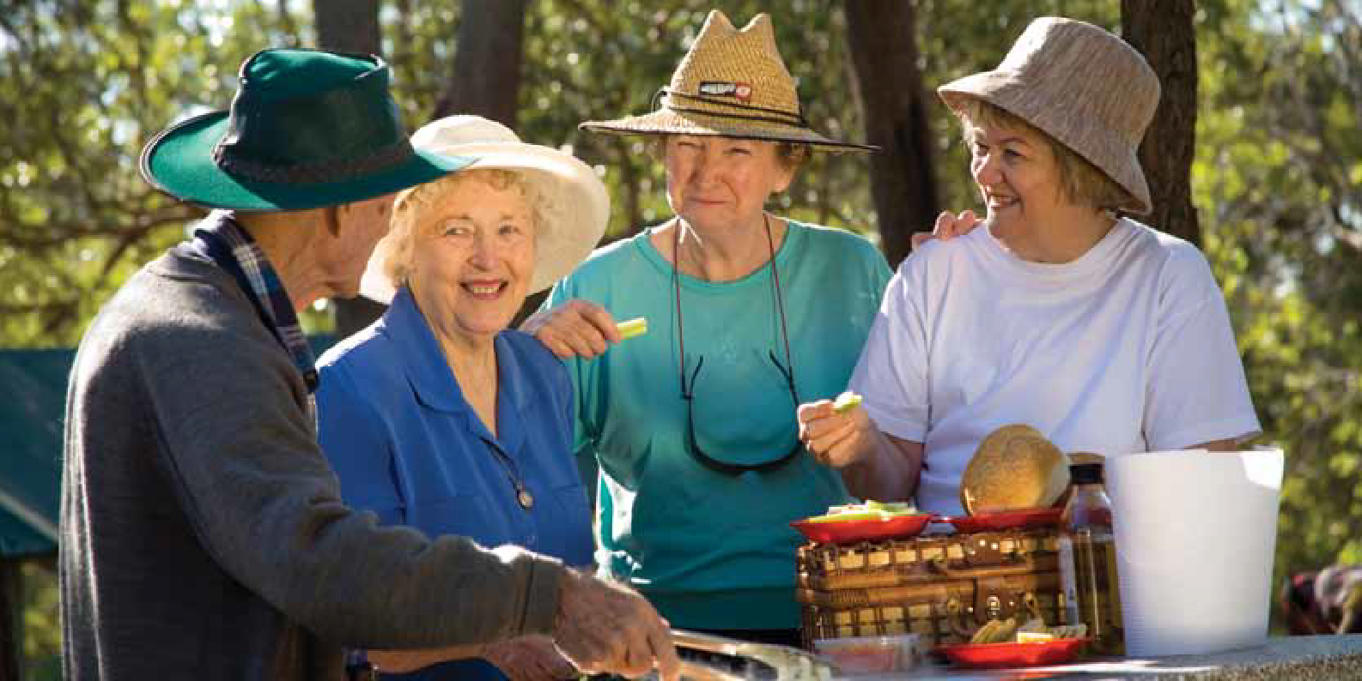

page 3

# Fall-proofing yourself

# Reducing your Personal Risk Factors

Our bodies change constantly throughout our lives. Normal ageing involves:

* + Poorer eyesight - we may find we can’t see quite as clearly, are less able to judge distances and depth or can’t cope with sudden changes in light levels or glare.
  + Worse balance, weaker muscles and stiffer joints, which change the way we walk and move around.
  + Less feeling in the feet and legs, increased likelihood of pain and even changes to the shape and flexibility of our feet.
  + Slower reaction times and more difficulty concentrating on several things at the one time.

We often don’t notice these normal changes as they happen very slowly over the years.

For example, you may find it’s harder to get out of that lounge chair you’ve had for 20 years. The lounge chair hasn’t changed - you

have! Your muscles have got a bit weaker and your joints a bit stiffer.

Or you may trip over a mat that has been in the same place for years. Maybe you are

not lifting your feet as high when you walk, causing you to trip over the mat, or perhaps you can’t see the mat as clearly any more.

If you have fallen more than once in the past six months, you are more likely to fall again.

It is important to talk to your doctor about any falls you have. Don’t just dismiss them as ‘not concentrating’ or ‘clumsiness’. Falls can be a sign of a new medical problem, muscle weakness, balance problems, medication side effects or a combination of these and other problems.

It will help your doctor if you give him or her information about the time of day you fell, what you were doing and how you were feeling just before the fall. Your family may be able to fill in the details if you can’t remember.

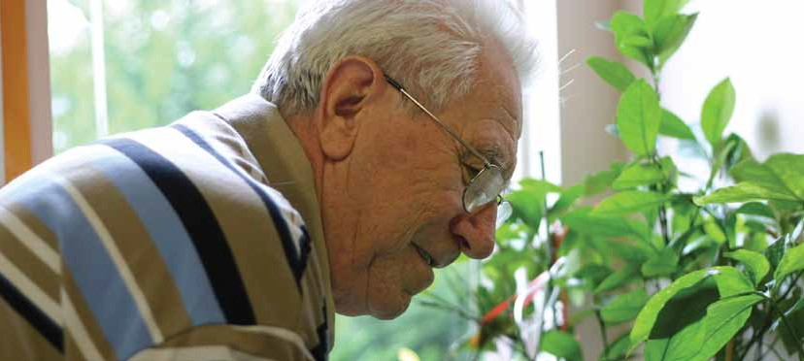

page 4

*Had a fall, slip or trip?*

*Speak to your doctor even if you feel fine*

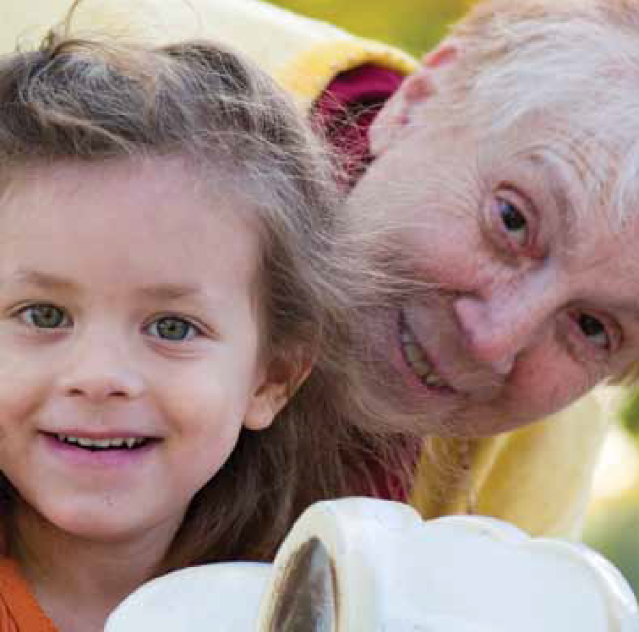*With a little care you can get on with enjoying life’s journey*

## Health problems

Some health problems make it more likely you will fall. The most common of these are:

* + Stroke
  + Parkinson’s disease
  + Arthritis
  + Postural hypotension (low blood pressure)
  + Dizziness
  + Diabetes
  + Depression
  + Dementia, Alzheimers
  + Incontinence (problems with your ‘waterworks’ or bowels)
  + Poor nutrition (not eating enough, not eating a balanced diet or not drinking enough water).

Even short-term illnesses (such as the flu and other infections) or surgery can temporarily increase your risk of falling.

#### How do these increase your risk of falling?

* Stroke, Parkinson’s disease and arthritis can affect your ability to move and make it more difficult to react quickly and save yourself if you stumble.
* If you have diabetes with unstable blood sugar levels you may feel faint. Diabetes can also cause problems with eyesight, and reduce feeling in the feet and legs. These make it more difficult to move around safely.
* Depression and dementia can make you less aware of your immediate surroundings and less able to react quickly.
* Postural hypotension can make you light- headed, dizzy or unsteady when you stand up quickly.
* Dizziness can make you very unsteady.
* If you have incontinence, you may need to hurry to the toilet. This can increase the risk of a fall, especially at night.
* Not eating well and not drinking enough can mean you don’t have the strength to move safely or manage daily activities easily.
* Drinking more than a small amount of alcohol can slow your reactions and make you unsteady.
* Short-term illnesses can cause dizziness, confusion and difficulty walking while you are sick – and even for a few days after.

Osteoporosis can make things worse.

If you have osteoporosis (thin, weak bones) you are more likely to break or fracture a bone if you fall.

## Health problems...

What you can do:

 Have regular check-ups with your doctor to ensure your medical conditions are well managed. Discuss any concerns you have with your doctor before they become big problems.

 Keep as active as possible (see page 7 for more information).

 Eat a wide variety of foods and drink plenty of water, especially in hot weather. Sometimes food supplements are recommended if you are very thin – ask your doctor or a dietitian.

 Stand up slowly after lying down or sitting. Take care when bending down and make sure you are steady before walking. Be especially careful when you are ill, for example with the flu.

 Keep yourself up to date with information about your medical conditions. Some support groups and libraries have easy-to-read information.

 If you have osteoporosis, your doctor may advise calcium and vitamin D

Remember that:

* Some causes of memory loss and confusion are treatable.
* Some causes of dizziness are easily treatable.

For more information about your medical condition and information about support organisations in your area contact:

* Commonwealth Carelink
* Nutrition Australia
* Diabetes Australia
* Your local library
* Your local council
* National Continence Helpline
* Arthritis Association

See page 29 for contact details.

*All bodies need good nutrition and drinks*

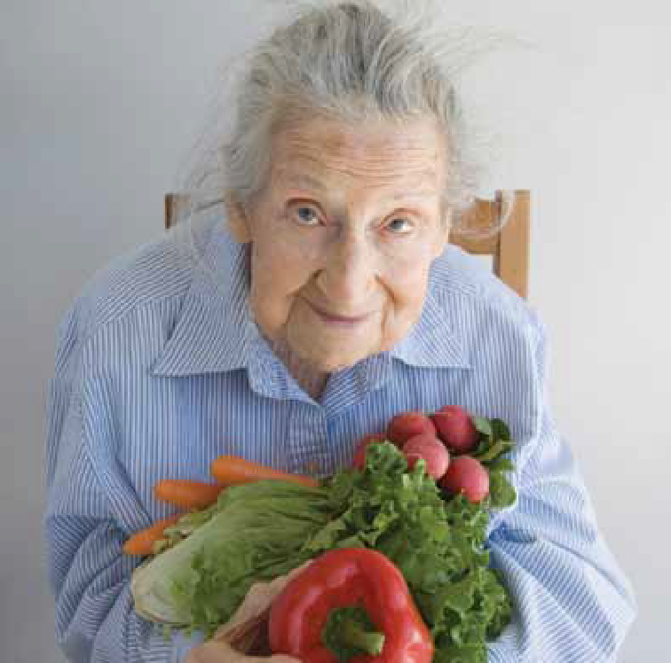

tablets, other medicines, exercise or dietary changes. Also see page 20-21 for information about how to reduce the chance of injury from a fall.

On page 30 there is a Notes page for you to jot down things you can do to reduce your risk of falling.

page 6

## Keeping yourself mobile

Inactive or unfit people tend to have poorer balance and weaker muscles and can be unsteady when walking. These can all increase the risk of falling. It is common

for people who feel unsteady to do less walking. Over time this actually makes you more likely to fall because your muscles get weaker, your joints stiffer and your balance gets worse.

Our bodies were designed to move. Physical activity keeps us healthy and reduces the risk of falls. It can also:

* + Improve balance
  + Improve muscle strength and flexibility
  + Keep bones strong
  + Increase energy levels
  + Help with sleeping problems
  + Help to control blood pressure, blood sugar levels and weight
  + Help you to feel good about life

What you can do:

 Be physically active every day. Whatever your age, aim to do at least 30 minutes of activity, at least 5 times a week.

 The activity should make you breathe a bit faster and your heart pump a bit harder, but you should still be able to talk while doing the activity.

 Exercises and activities that make you both stronger and improve your balance lower the risk of having a fall.

 Some examples are Tai Chi, dancing or group exercise programs that include balance and muscle strengthening.

 Talk to a physiotherapist about which balance and strengthening exercises or activities will best suit you, and how to manage any pain you might have.

 A physiotherapist can also advise you about whether a walking aid, such as a stick or frame, would help you. Using a walking aid can increase your steadiness and confidence to walk more. It is important that walking aids are

properly adjusted for you, and that

they are properly maintained (eg replace worn stoppers).

 Talk to your doctor if your health problems or pain make you worried about attempting more activity.

 If you have arthritis, being active helps to control pain, weakness and stiffness.

Where you can find help or advice:

* Commonwealth Carelink, for help finding physiotherapists, accredited exercise or fitness instructors and physical activities in your area
* Your local council, for information on activities in your area
* Community Health Centres and Day Therapy Centres for physiotherapy services
* Your local library, for booklets or videos on exercise for older people
* Arthritis Association, for information about exercising with arthritis

See page 29 for a list of support services for older people.

page 7

## Medicines

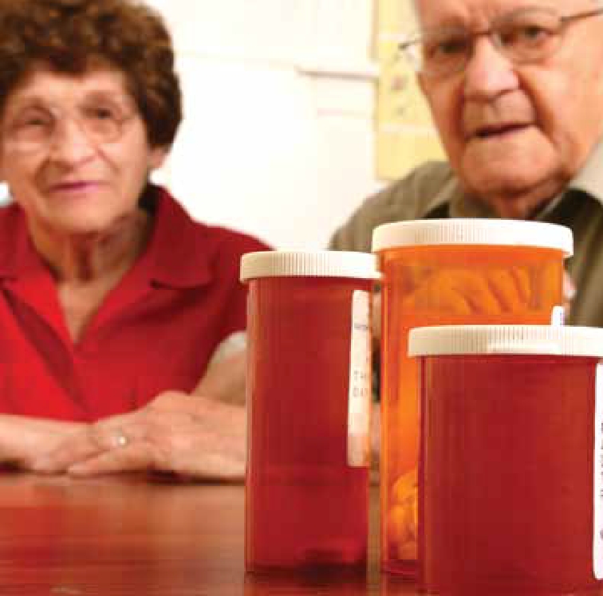

page 8

Some types of medicines can increase your risk of falling. You may also be at greater risk simply because you take four or more different medications. Medicines include those prescribed by your doctor, bought over the counter and herbal remedies.

The types of medicines which can be a problem include those taken for anxiety, depression or difficulty sleeping. This is because of possible side effects such as:

* + Drowsiness
  + Confusion
  + Unsteadiness
  + Dizziness

What you can do:

 Tell your doctor if you are concerned or have felt any of the side effects listed above, especially if you are starting a new medicine. Your doctor can then review your medicines to see if changes are needed. This is important because medicines affect different people in different ways.

 Keep a list of all your prescription and non-prescription medicines, and always take this to any appointments with doctors.

 Talk to your doctor if you are taking, or thinking about taking, any alternative, natural or herbal remedies as they

may interact badly with your other medicines.

 To get the most from your medicines, follow the instructions on the label and any other instructions given by your doctor or pharmacist. Never take someone else’s medicine.

 Alcohol can react with medicines - check the labels or ask your doctor or pharmacist.

 Ask your pharmacist about using a special pack such as a ‘dosette box’ or ‘webster pack’ to help you keep track of what medicines you take and when. If you take many different medicines, ask your doctor about a Home Medicines Review at home with your pharmacist, to help sort out all your medicines.

 The doctor is the only one who should change your medicines.

 Ask your doctor about ways to deal with sleep problems without using sleeping tablets. Also, you can try avoiding coffee and tea before bed, doing more exercise, taking only short naps during the day and using quiet music at bedtime to improve your sleep.

Where you can find help or advice:

* Your local pharmacist
* Your doctor

*Ask questions about your medications*

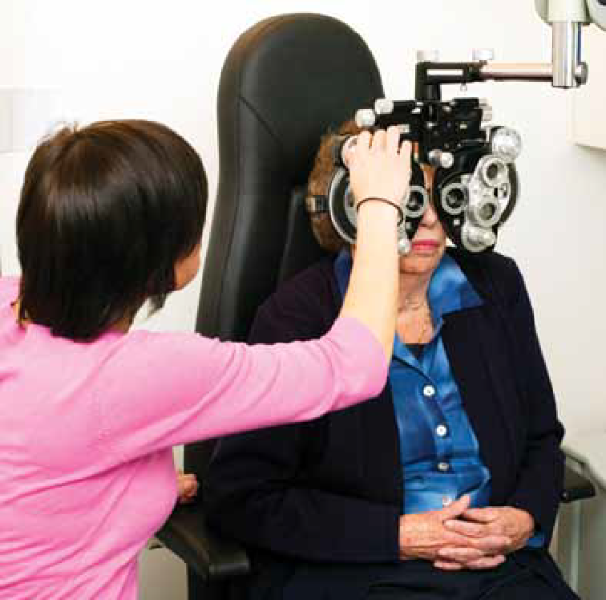*Have your eyes and glasses checked every two years*

## Making the most of your eyesight

Your eyes not only allow you to see obstacles and judge steps, they help you to keep your balance.

But from the age of 40, your eyesight gradually worsens and this can lead to an increased risk of falling. By the age of 65 we all need three times more light to see than we did at 20 and our eyes:

* + Take longer to adjust to sudden changes in light and dark.
  + Are more sensitive to glare.
  + Are less able to judge distance and depth, for example on steps.

It is important for safety, as well as daily activities, to make the most of your eyesight.

What you can do:

 Have your eyesight and glasses checked by an optometrist at least once every two years and yearly by your doctor.

 If you notice changes in your eyesight, make an appointment with your doctor or optometrist. Early detection of eye problems can stop them getting worse.

 Keep your glasses clean and always wear the correct glasses - reading glasses are for reading and distance glasses are for walking around.

 Take extra care on steps if you wear bifocals or multi-focals - they can make it difficult to judge where to put your feet.

 Wear sun glasses and a hat outside.

 Avoid sudden changes in light. If you go from light to dark, or the other way around, stop and give your eyes time to adjust before moving.

 Refer to the lighting section of this booklet (page 14) for ideas about things you can do in and around your home.

Where you can find more help or advice:

* Vision Australia
* Occupational therapists (OT) (Commonwealth Carelink or OT Australia can provide details of services in your area)
* Optometrists Association Australia

See page 29 for contact details.

page 9

## Falls prevention from the ground up - feet and footwear

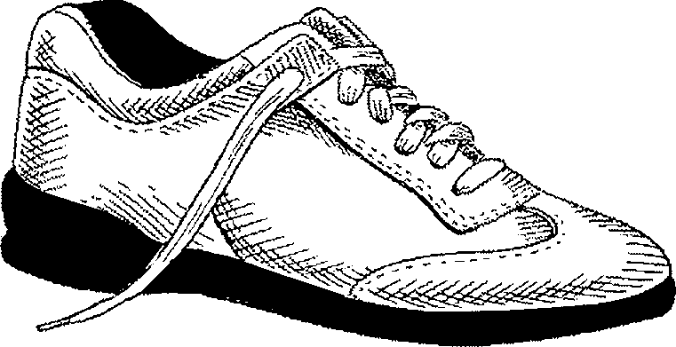

#### Prevent falls with safe shoes.

Laces, buckles or velcro fastenings hold

As we age, our feet can change shape and lose some feeling and flexibility. This changes the way we walk and affects balance. Painful or swollen feet can make

Firm heel cup provides support when walking.

the foot more firmly.

Wide and deep toe box allows plenty of room for

it difficult to walk. Also, some shoes or slippers can make you more likely to slip, trip or stumble, leading to a fall.

toe movement and comfort.

What you can do:



 See a podiatrist or doctor if you have painful or swollen feet, tingling or pins and needles in your feet or if you have any changes in the shape of your feet (for example, bunions).

 Choose comfortable, firm-fitting, flat shoes with a low broad heel and soles that grip (see picture).

 Don’t wear poorly fitted slippers or walk in socks.

 If you have difficulty finding suitable

Correct length allows normal foot function.

Low, wide heel with rounded edges provides more contact with the ground and

prevents slipping.

Thin sole with tread enables your feet to ‘read’ the underlying surface and prevents slipping.

shoes because of foot problems, ask your podiatrist for the names of specialist shoe stores.

 Ask your podiatrist or physiotherapist to suggest ways to improve circulation, decrease swelling and reduce pain in the legs and feet.

Where you can find help or advice:

* + Commonwealth Carelink
  + Australian Podiatry Association can provide names of podiatrists in your area
  + Local Community Health Centres and Day Therapy Centres often have podiatrists

See page 29 for contact details.

## Managing worries about falling

If you have had a bad fall it is natural to feel worried about falling again. Some

people become fearful of falling even if they haven’t fallen. This fear may be because of unsteadiness or the thought of the possible injuries from a fall.

People who are worried about falling tend to restrict their activity, gradually doing less and less. For some people this can mean less social activity. As discussed in the ‘Keeping yourself mobile’ section (see

page 7), this can lead to an increased risk of falling over time.

What you can do:

 Talk to your doctor about your feelings or concerns about falling.

 Talk to a physiotherapist about whether you need a walking aid, such as a stick or frame. This can make you more stable and improve confidence when walking. You may only need an aid for a while until you get stronger and feel steadier.

 Talk to a physiotherapist or accredited exercise or fitness instructor about how to improve your strength and balance. After building up your strength and balance you are likely to have more confidence in your abilities.

 Make your home and surroundings safer to move around in. See pages 12-19.

 Make a plan for getting help in an emergency or in the event of a fall. See pages 20-27. This will help you, your family and your friends feel confident that you can get help if you need it.

 Talking with a clinical psychologist, social worker or counsellor can also help you regain your confidence, particularly if your fear is very strong or you are lonely or isolated.

Where you can find more help or advice:

* Commonwealth Carelink, for counselling, physiotherapy and clinical psychology services in your area
* Your local hospital or Community Health Centre may have physiotherapists and psychologists on staff
* Australian Psychological Society
* Australian Association of Social Workers

See page 29 for a list of support services for older people.

# Fall-proofing your surroundings

# Reducing your Environmental Risk Factors

Making your home and surroundings as safe as possible is another important thing that can be done to reduce the likelihood of a fall.

Making these areas safer not only reduces the number of falls and accidents, but can make it easier for you to manage your daily activities as you get older.

In this section we look at common hazards that increase your chance of a fall, both in and around your home and in public places.

We also talk about planning ahead when building or renovating. On page 31 there is a Notes page for you to jot down things you can do to make your surroundings safer.

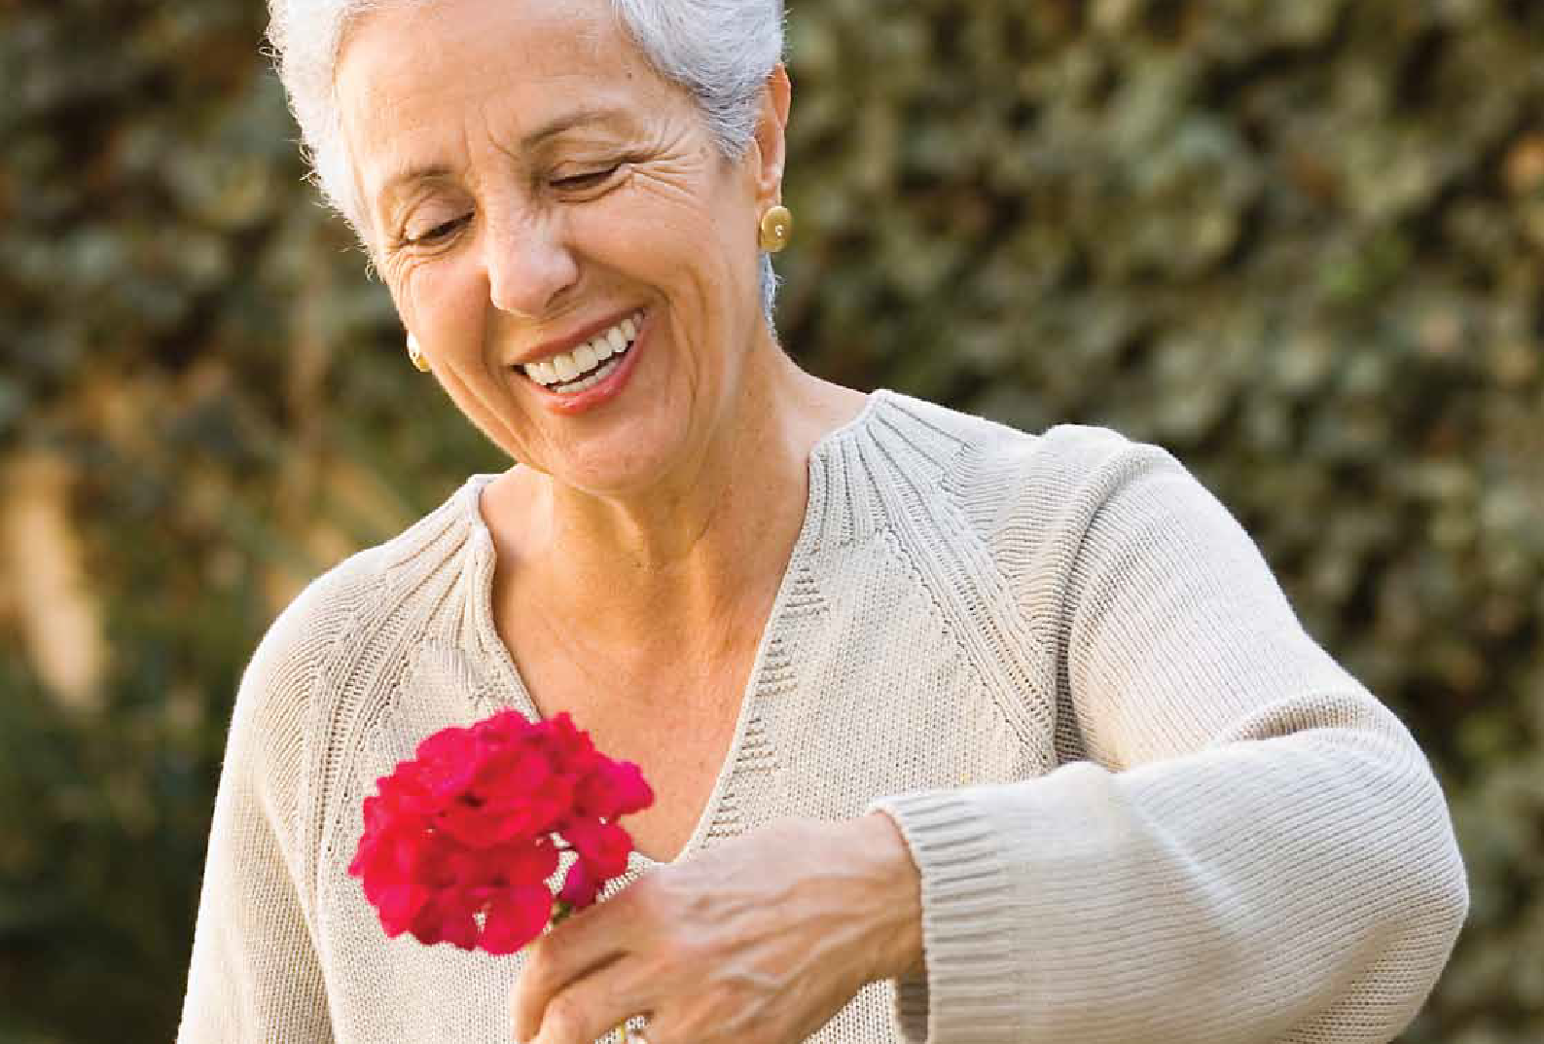

page 12

## Your home and garden

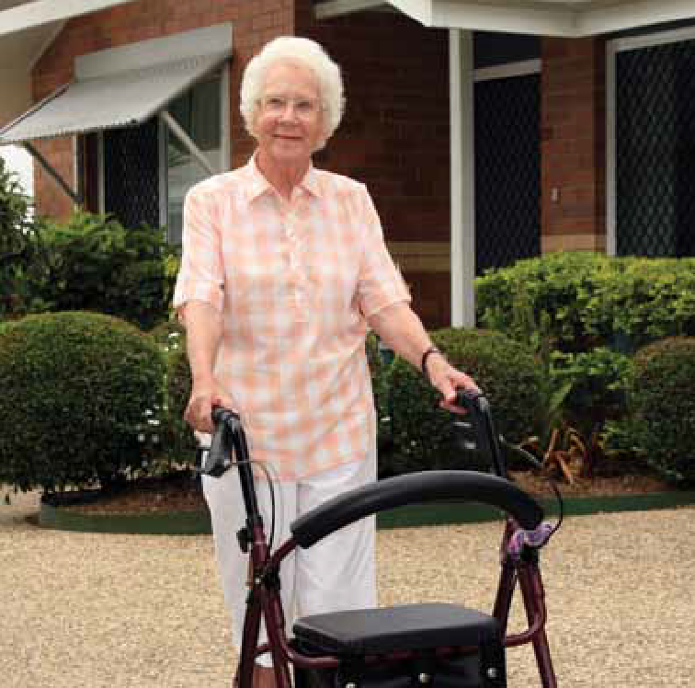

* Keep the item in a place that is easier to reach.

Another example is not turning the light on so you can see clearly where you are going and what you are doing.

These things may have been fine when you were younger, but are no longer safe.

page 13

##### Did you know that 60% of falls happen in and around the home?

Some of the problem lies with us, and some with our houses and gardens.

As we get older our abilities change, increasing the chances of us slipping and tripping.

And our homes age too, through general ‘wear and tear’ or lack of maintenance, making them less safe. Often we don’t notice this because we have lived there for many years without any problems.

It is important to check your surroundings and take steps to make them safer.

Safe and unsafe ways to do things.

Apart from hazards in the surroundings, some of the dangers can result from the way you choose to do things.

For example, climbing onto a kitchen chair to reach into a high cupboard puts you in danger. Instead, you could:

* + Ask someone else to reach up for you, or

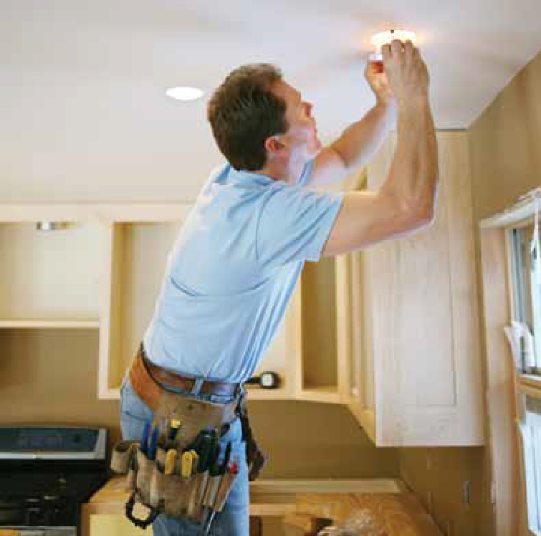*Avoid climbing. Arrange help for jobs that are at height*

You can also increase the risk of falls by wearing clothes or dressing gowns that are too long and loose and can catch on things.

Think about different and safer ways of doing things. Use your head to save yourself a possible injury!

*Smooth paths make it easy to keep on the go*

## How to be safer in your home and surroundings

The following section lists some common changes to your surroundings that will help increase safety. When you are checking your home for these, it is a good idea to get help from somebody who has not seen your home before. They may spot problems that you may not notice, having lived with them for so long.

#### Remove general hazards

General hazards are things like an electric cord across a walkway. They are dangerous for young and old. Removing general hazards will benefit all people who use that area, not only you.

Common problem areas are lighting, tripping, slipping and structural hazards.

1. Lighting

Changes to our eyesight with age were discussed earlier in the booklet (page 9). These changes mean that it is important to make it easy for your eyes to do their best.

What you can do:

 Increase the amount of light, particularly in frequently used areas and at night.

Don’t forget to turn lights on before you walk around. (Low energy light globes will help to keep the power cost down.)

 At night, leave lights on in the passage way and other places you might walk.

 Light switches should be easy to reach.

Two way light switches can help in corridors or rooms where there is more than one entry, and on stairs.

 Decrease daytime glare with net curtains or blinds in your windows.

 Make obstacles or hazards stand out. For example, highlight the edges of steps with brightly coloured tape or paint; have your furniture a contrasting colour to the walls and floor (for example dark blue chairs, off-white wall, and light blue floor).

 Avoid heavily patterned floor coverings as they can make it hard to see small obstacles or the edges of steps, because they ‘blend in’.

 Outside, try to remove anything that throws shadows across paths.

Where you can find help or advice:

* Commonwealth Carelink
* An occupational therapist (OT)
* Vision Australia
* Independent Living Centre
* The Department of Veterans’ Affairs

See page 29 for contact details.

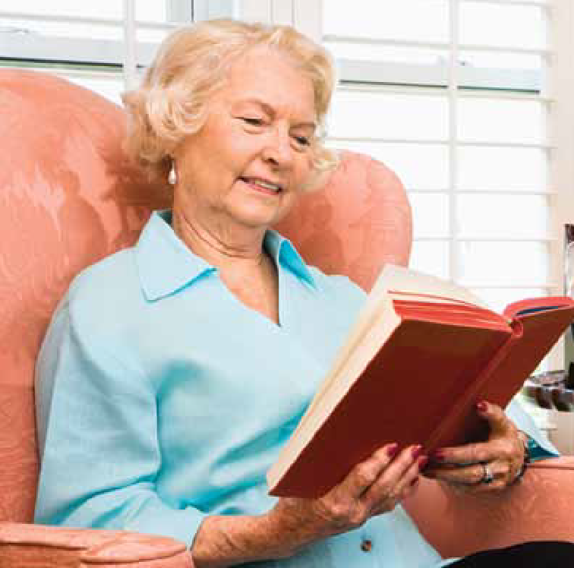

*Good lighting is important throughout the house*

page 14

1. 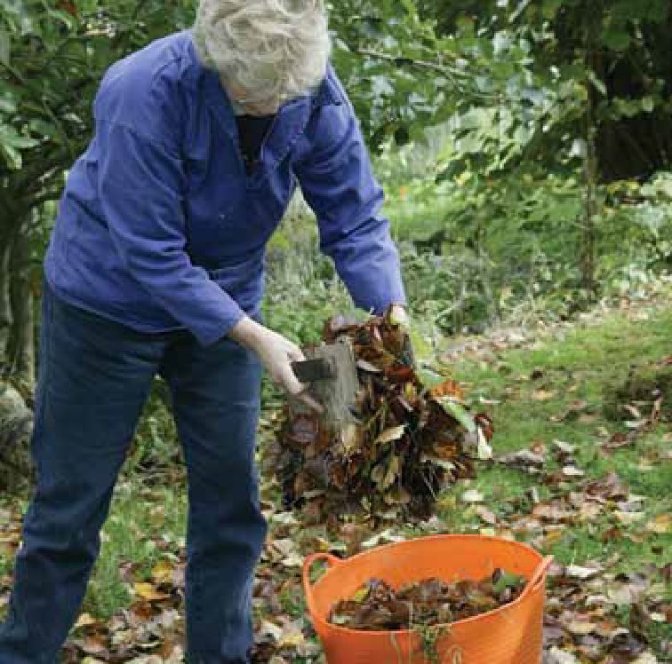Slipping

Slipping can be caused by:

* + unsafe footwear, such as loose slippers or narrow heels
  + slippery surfaces such as wet or polished floor, or spills of fat or food

What you can do:

 Wear safe shoes (refer to page 10).

 Use non-slip mats in wet areas, such as the shower and bathroom.

 For larger wet areas it may be better to have the whole floor/bath/shower treated to make it non-slip, or replace the floor with non-slip material.

 Use a hand rail or a seat in the shower or bath.

 Avoid talcum powder on tiles, vinyl or wooden floors - it makes them very slippery.

 In the kitchen or eating areas, pick up dropped food and mop up spills as soon as they happen.

 Do not polish floors.

 Non-skid tape is very useful both for highlighting edges, and providing extra grip on steps and stairs.

 Remove mats and rugs or make sure they have either non-slip backing or are secured with double sided tape.

 Keep outside paths clear of moss, slime and fallen leaves.

 Make sure the walking surfaces in and around the home have non-slip surfaces.

Where you can find help or advice

* Look in the Yellow Pages under ‘Floor Treatment Products’
* Non-slip paint and backing is available from hardware stores
* Contact the Independent Living Centre
* Talk to an occupational therapist (OT)
* The Department of Veterans’ Affairs

See page 29 for contact details.

1. 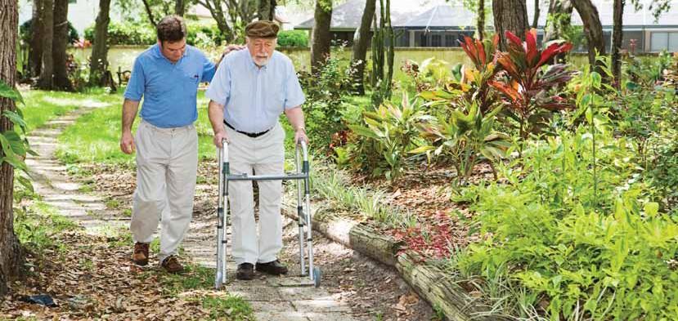Tripping

As we lose the ‘spring in our step’ we don’t pick up our feet as much when moving around, so we are more inclined to trip over even small things.

What you can do:

 Keep walkways clear – remove clutter.

 Tuck electric cords under furniture or around skirting boards. Tape them down. A power board can reduce the number of long cords around a room.

 Fit a ‘draught excluder’ to the bottom of the door, rather than use a ‘door sausage’ that can be tripped over.

 Remove, or mark, even small changes in floor level with contrasting colour or tape so they are easily seen.

 Check outdoor paths for cracks and uneven areas.

 Make sure quilts, bed-spreads and curtains do not fall across the floor.

 Remove mats and rugs, or have them well secured. Get rid of mats that curl or fold over easily.

 Remove or repair torn or stretched carpet.

 Choose outside door mats with sloping edges.

 Don’t leave things lying around the garden – roll up the hose.

 Dogs and cats like to be close. Check where your pet is before you move.

1. Change structural hazards

These are built-in features of the home that can be a danger. An example is a step at the entrance to the shower that you have to step over with wet feet when getting out of the shower.

Other structural hazards develop because the house is not maintained, for example a broken step.

Think about changes or additions to the structure of the house that may make it safer and easier to manage.

What you can do:

 Plan to keep your home well maintained.

 Think about the safest and most convenient place in your home for each thing you do. For example it may be better to move the bedroom to the spare room so that it is nearer to the toilet for when you get up at night, or consider a commode chair.

Another example is to have all the items you need to make a cup of tea or coffee near the kettle and in a convenient place between waist and shoulder height.

 Re-hang the bathroom and toilet doors so that they open outwards (if you fall, someone can reach you).

 Install rails in the bathroom and toilet, and near front and back door and any steps.

 Have soap holders recessed so that you will not hit them if you slip in the shower/bath.

 Consult an occupational therapist about eliminating the “hob” or step into the shower if possible.

 Talk to an occupational therapist about equipment that may make things easier and safer. For example, using a bath board or bath seat if your shower is over the bath, or using blocks to raise the bed height.

Where you can find help or advice

* Your local council may be able to assist you with home maintenance through a Home and Community Care (HACC) program
* The Independent Living Centre
* An occupational therapist (OT)
* Get a home safety checklist from an occupational therapist

See page 29 for a list of support services for older people.

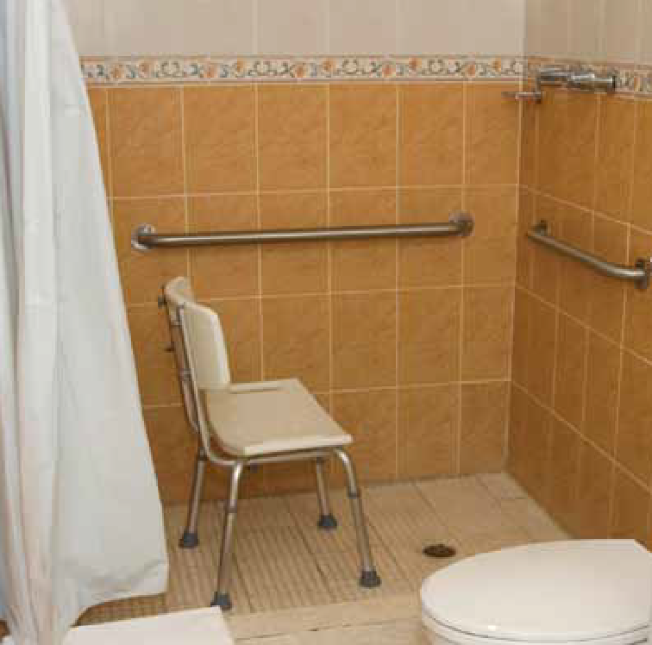

page 17

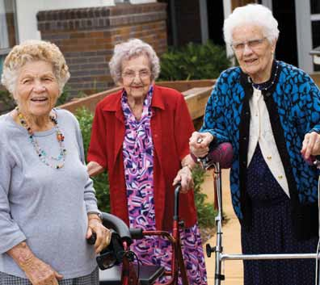*Enjoy your shopping, go when it is not so busy*

1. Remove personal hazards

Apart from general hazards that are a problem for most people, there are also personal hazards. These are things that affect a person because of their particular health problems.

For example, someone with cataracts can be troubled by glare that is not a problem for other people. People with arthritic knees find low chairs and sofas a particular problem.

Changing things in the environment can often make the person not only safer, but more independent. To cater for a person’s particular needs it is wise to get some expert advice.

Where you can find help or advice:

* + Contact an occupational therapist
  + The Independent Living Centre

See page 29 for a list of support services for older people.

*Take a walking stick on an outing*

1. Public Places

Hazards also exist in environments away from your home. These include uneven, broken, loose or wet footpaths and poor lighting.

To keep yourself as safe as possible:

 Don’t rush, take your time.

 Pay attention to your surroundings, including unsafe surfaces, obstacles, animals, children or cyclists. Scan the area before walking.

 If you use a walking aid, glasses or hearing aid, always remember to take them with you.

 Wear safe shoes (see page 10).

 Take extra care on buses, trams and trains. Have your fare or ticket ready before getting on and ask the driver not to move off until you are seated.

 If you notice a hazard in a public place (e.g. footpath or shopping centre) you should consider reporting it to the appropriate authority.

Many councils and shopping centres are grateful to be informed. This may prevent someone else from falling.

 A walking aid can remind others to be more careful and considerate of you.

6) Public places

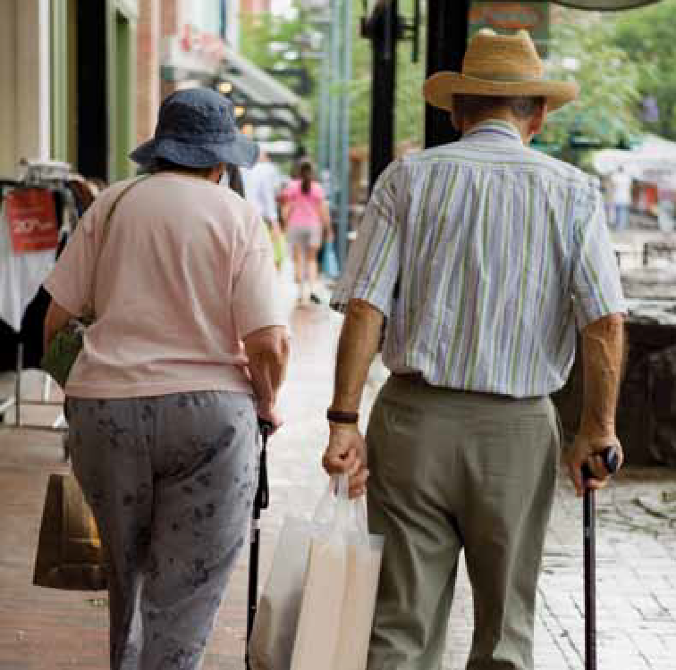

page 18

## Planning ahead when building or renovating

If you are building or renovating, no matter what your age, it makes good sense to think about safety and ease of access in and around the home, if not for yourself, then for others who may be less able. It is easier (and more cost effective) to include these features in your building or renovation plans, than to make structural changes later.

#### What you can do:

Walkways

 Floor surfaces should be level and slip resistant.

 Outdoor pathways should be level and have slip resistant firm surfaces with good drainage.

 Allow extra width in corridors, doorways, bathrooms, toilets and car parks for easier movement.

 Avoid steps and stairs or have handrails next to them.

Bathrooms

 Doors into the bathroom and toilet should be hung to open outwards for better access.

 Have soap holders recessed (set in) so that you will not hit them if you slip.

 Design the shower so that it is spacious and you don’t have to step over anything or down to get into it.

Lighting

 Ensure you have good lighting for security and moving around.

 Install two-way light switches at each end of corridors, stairs, in living areas with more than one entry and bedrooms (with the additional switch located alongside the bed).

Other considerations

 Keep walking distances as short as possible. For example, from where the car is parked to the entrance and from the toilet to the bedrooms. Avoid long corridors.

 Telephone connections, electric plugs, fixtures and controls should be able to be reached from a seated position (1 metre off the floor) and 500mm from internal corners.

 Good house and garden design, and selection of materials, can eliminate much external maintenance.

 Build in features that will make your home easily modified if the need should arise. An example is having the wall cavity reinforced behind the shower, bath and toilet so that grab rails can easily be attached.

Where you can find help or advice:

* Independent Living Centre
* The Master Builders Association have a booklet titled “Building For Life” which can be obtained from an Independent Living Centre

See page 29 for a list of support services for older people.

page 19

## Just in case...

How to reduce injury

It is not possible to predict if, how, where and when you might fall, or how little or much you might be injured. Even though most falls don’t result in serious injury, you may be unable to get up without help.

Therefore, it is important to think ahead and make a plan of things you can do to safeguard yourself. This will help you to feel not only safer, but more confident and in control.

You can make an emergency plan for yourself on page 32.

The damage done by any fall depends on how, where and when we land, how strong our bones and skin are, and how quickly help comes.

#### How, where and when we land

Most falls happen from standing height. The damage done by a fall increases if the fall is from any extra height, even

a single step. It is also increased if you hit something on the way down. Falling outside in very hot, cold or bad weather can also stress our bodies, especially if it is not possible to get help for a while.

What you can do:

 Remove clutter, particularly things that can hurt you badly, such as a glass coffee table.

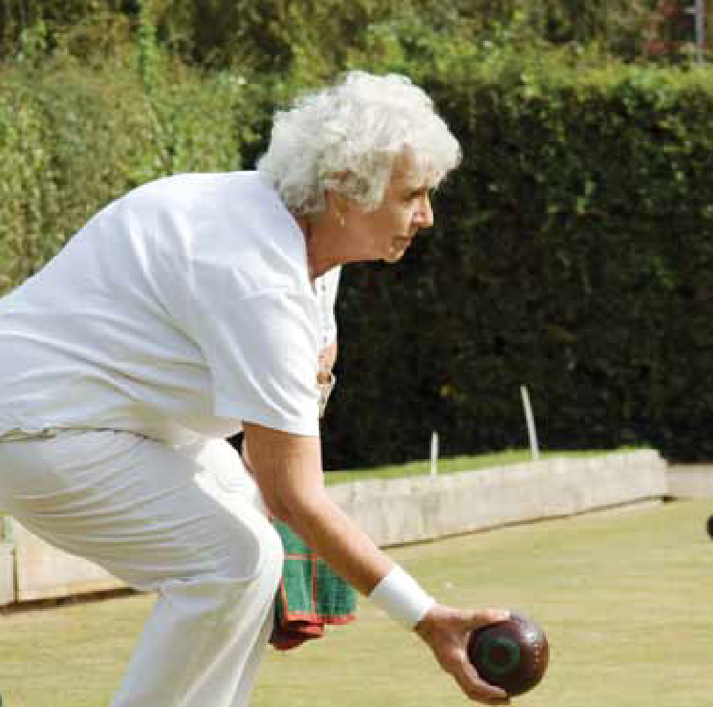

 Realistically consider what chores are now too risky for you to do and arrange for someone else to do them.

In particular, avoid anything that involves you getting up higher than floor level. Don’t put pride before a fall!

page 20

#### How strong our bones and skin are

People with osteoporosis (weak or thin bones) are more likely to break a bone as a result of a fall than those with healthy bones.

Similarly, people who have skin that is easily bruised or torn are more likely to need medical help after a fall.

What you can do:

 Talk to your doctor, physiotherapist or occupational therapist about

hip protectors

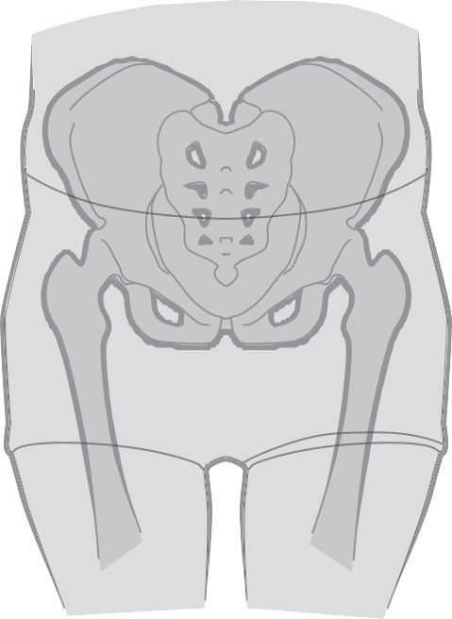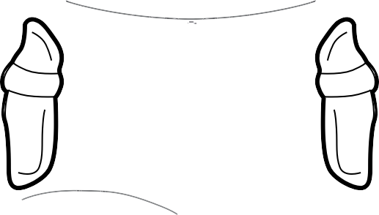

 Consider whether you need limb protectors. Limb protectors are like thick sleeves or footless leggings and are designed to protect thin skin from tears and grazes.

 Talk to your doctor about how to keep your bones strong. This may involve calcium and vitamin D supplements, other medications, eating calcium rich foods, exercise and/or exposure to a little sunshine (up to 15 minutes on most days).

Where you can find help or advice:

* Independent Living Centre
* Local council for help with household maintenance and chores
* Commonwealth Carelink

See page 29 for a list of support services for older people.

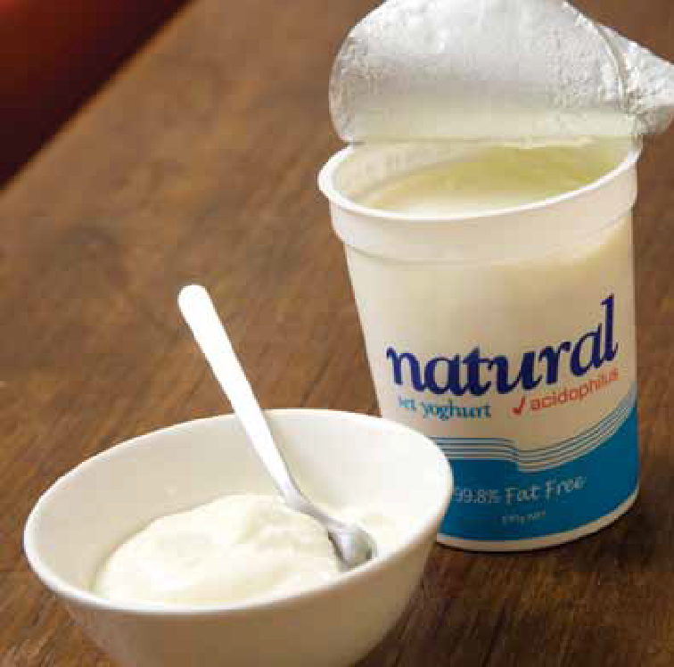

A serious injury from a fall in older people is a broken hip. There are ‘hip protectors’ available. These are placed inside special underwear and positioned over the hip to protect it in the event

of a fall. They can reduce the chance of a broken hip and are particularly recommended for people who are thin, osteoporotic (have thin bones) or who are falling frequently.

page 21

## Making a plan to get help

Lying on the floor or ground for some time can lead to additional problems, such as pressure sores, dehydration or going

without usual medicines. An experience like this can also be quite distressing, both at the time and afterwards.

If you live alone, or are alone for long periods, you need a plan to get help quickly.

Having a good plan will also be reassuring to your family and friends. Involve them in your plans so that they know what you have done, how they can help, and what

they may need to do for you in the event of an emergency.

What you can do:

 Make a plan of what to do in the event of a fall or another emergency.

A good plan will involve how to call help (see ‘Raising the alarm’ on this page) and how the help will get to you (see ‘Letting help in’ on the next page).

#### Raising the alarm

There are many ways to raise the alarm.

* + Cordless and mobile phones – carried on a belt clip or in a pocket, with

pre-programmed numbers.

* + Autodiallers – pendant worn around the neck, and linked to the telephone. When activated, it automatically dials certain pre-programmed numbers until it gets an answer.
  + Intercom systems – baby monitors or

two-way intercoms between houses/flats.

* Neighbour-to-neighbour alarms – sirens and flashing lights outside the house or in a neighbour’s home, activated by a pendant or wristband transmitter.
* Telstra Delayed Hotline – automatic connection to a relative’s or friend’s number when the telephone receiver is removed.
* Telecross – a daily phone call from a Red Cross volunteer.
* Person-to-person alarms – one person carries the transmitter and the other carries the receiver.
* Portable alarms – anything that makes a noise, for example a whistle, bell or battery-operated alarm.
* Monitored emergency call system

– the most common system is a

24-hour monitored response service or personal alarm.

Your choice of device will depend on many things, such as who can come to help, the distance over which the device works, how easy it is for you to carry and use the device and cost.

As you can not anticipate a fall, people who have these alarms should wear them at all times, including when getting up at night, or when showering.

* You might also have an arrangement with a neighbour/friend/family member to contact them at a certain time each day to ensure all is well.

#### This is how a personal alarm works:

Press button.

Contact made with base station.

Staff arrange help.

Help arrives.

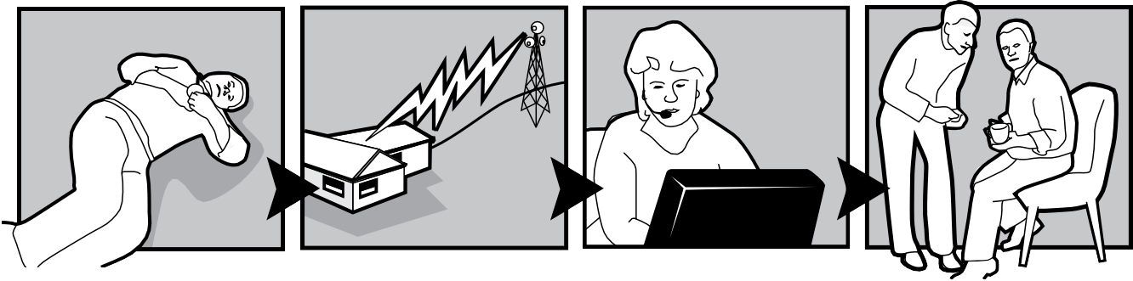

The person who has fallen presses a

button on a pendant or wristband.

The unit sends a message to the monitored base station.

Staff at the base station contact the people prearranged to respond to the emergency.

The contact person responds to the emergency. He/she must have a key to enter the house.

The ambulance service may be listed as the last contact.

#### Letting the help in

The person who comes to help you needs to be able to get in. Leave a spare key with a friend, neighbour or relative who lives nearby.

Some people leave a spare key in a box outside with a combination lock.

It is also a good idea to make contact with someone daily.

Where you can find help or advice:

* + Independent Living Centre
  + Commonwealth Carelink
  + Seniors Information Service
  + Information on where to buy personal alarms can be found in Yellow Pages under ‘Alerting systems’.

See page 29 for a list of support services for older people.

page 23

## Knowing how to get up from the floor by yourself

It is important that you practise getting down to the floor and back up again. If it is a long time since you have tried this, wait until someone is with you to help you up if needed.

You may be more out of practice than you think.

These pictures show a common way to get up from the floor that will suit most people. People with knee problems may find it uncomfortable to kneel. Physiotherapists can teach you other ways to get up, that may suit you better, and also exercises to regain your strength and flexibility.

If you have fallen:

1. Calm down. Catch your breath and compose yourself after the shock.
2. Check your body. If you are not badly injured you can think about getting up. If you are injured, for example with a broken bone, you need to stay where you are and put your plan to get help into action.
3. If you are not injured, look around for a sturdy piece of furniture (preferably

a chair).

1. Roll onto your side.

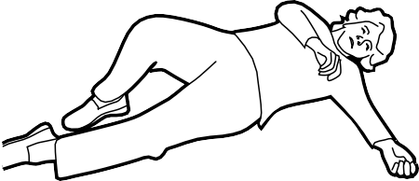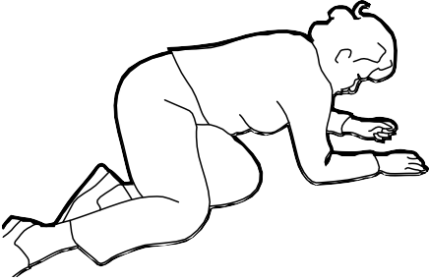

1. Crawl or drag yourself over to the chair.

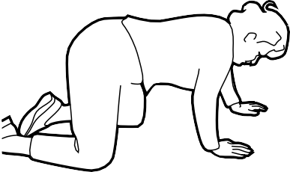

1. From a kneeling position, put your arms up onto the seat of the chair.

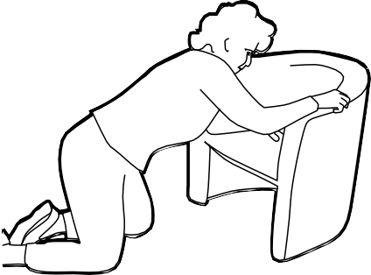

page 24

1. Bring one knee forward and put that foot on the floor.

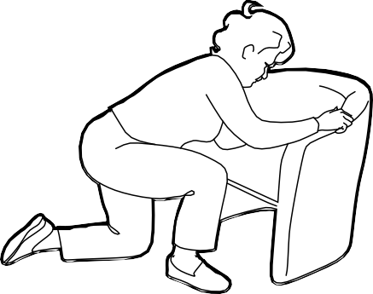

1. Push up with your arms and legs, pivot your bottom around.

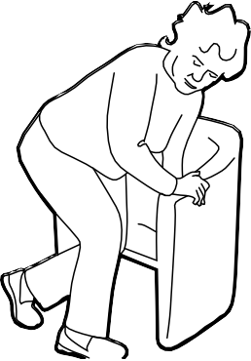

1. Sit down. Rest before trying to move.

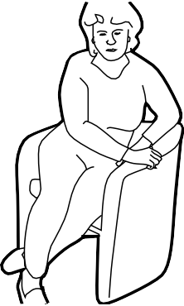

Practise this until you feel confident about the steps involved. It is recommended you do this once a month or so.

If you cannot get up:

* Do not panic
* Use one of the strategies mentioned earlier. Think through all possibilities for raising the alarm and getting up
* Try to stay warm
* Gently move around to stop one part of your body getting too much pressure

After a fall

It is important to talk to your doctor about your fall and the possible causes, and to tell someone else (family, friend or neighbour) that you have fallen.

Where you can find help or advice

* A physiotherapist or occupational therapist can help you learn ways to get up

See page 29 for a list of support services for older people.

Rest at any time, and if you do

not succeed the first time, rest and try again.

page 25

## Knowing how to safely help someone to get up

If you are a carer or friend, it is important to know how to help so you can avoid injury to the person who has fallen and to yourself.

Do not hurry, and let them rest as often as they need to. If they get stuck at any time, make them comfortable and call the ambulance.

1. Do NOT try to get the person up straight away!
2. Calm the person and yourself. Get them to take deep slow breaths.
3. Check for injuries. If they are badly injured, such as with a broken bone, they need to stay where they are. Make them as comfortable as possible and call an ambulance. Keep them warm while you wait for the ambulance.
4. If they are not badly injured and feel they could get up, get two sturdy chairs and place one near the person’s head and one near their feet.

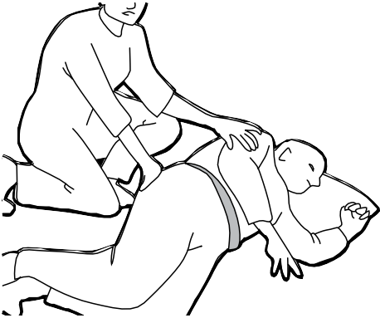

1. It is important that the fallen person does the work. The helper should only guide lightly, helping the person to roll onto their side.

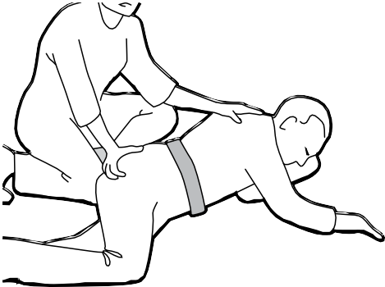

1. Help the person to kneel. If they have sore knees, place a towel underneath as cushioning.
2. Ask the person to lean on the seat of the chair and bring one leg forward and put that foot on the floor.

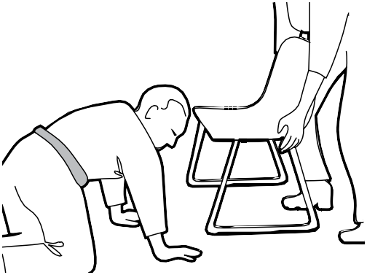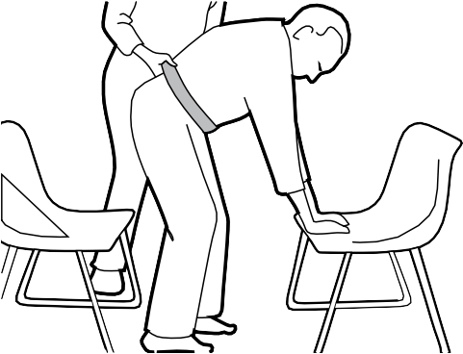

7. Place one chair in front of the kneeling person.

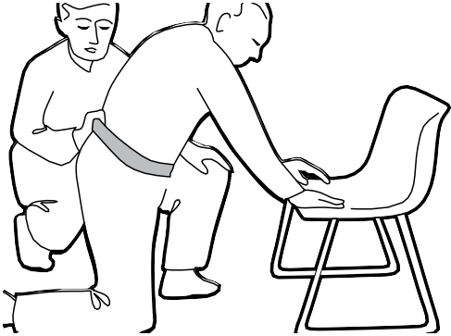

1. Place the second chair behind the person. Ask them to push up with their arms and legs and then sit back in the chair behind them. Guide them up and back into the seat, remembering not to lift them – they should be doing the work. Keep your back upright.

Let the person’s doctor know that they have had a fall.

Summary, contacts, notes and plans

# The main messages

#### Healthy ageing involves physical activity, healthy eating and a little sunshine.

* 1. Keep actively involved with friends, family and

#### the community. The more you do, the more you can do.

* 1. Be sensible, and recognise your limitations. Do things safely and don’t be too proud to ask for help.

#### Manage your health problems and medicines well.

Speak to your doctor about how you can do this together.

#### Make your home and its surroundings as safe as possible.

* 1. Have a plan of how to get help in an emergency.

#### Take steps to minimise any harm done in the event of a fall.

Don’t fall for it, falls can be prevented!

page 28

|  |  |  |  |  |
| --- | --- | --- | --- | --- |
| **List of contacts** |  |  |  |  |
| **Arthritis Australia** | **1800 111 041** | **Optometrists’ Association Australia** | | |
| **Australian Association of Social Workers** | |  | NSW & ACT | **02 9712 2199** |
|  | **02 6232 3900** |  | [www.oaansw.com.au](http://www.oaansw.com.au/) |  |
| **Australian Physiotherapy Association** | |  | QLD & NT | **07 3839 4411** |
| [www.physiotherapy.asn.au](http://www.physiotherapy.asn.au/) | **03 9092 0888** |  | [www.optometrists.asn.au/queensland](http://www.optometrists.asn.au/queensland) |  |
| NSW and ACT | **02 8748 1555** |  | SA | **08 8338 3100** |
| NT and SA | **08 8362 1355** | [www.optometrists.asn.au/southaustralia](http://www.optometrists.asn.au/southaustralia) | | |
| QLD | **07 3423 1553** |  | TAS | **03 6224 3360** |
| TAS | **03 6224 9444** |  | [www.optometrists.asn.au/tasmania](http://www.optometrists.asn.au/tasmania) |  |
| VIC | **03 9092 0888** |  | VIC | **03 9652 9100** |
| WA | **08 9389 9211** |  | [www.optometrists.asn.au/victoria](http://www.optometrists.asn.au/victoria) |  |
| **Aust Psychological Society** | **1800 333 497** |  | **Osteoporosis Society NSW** | **1800 242 141** |
| **Commonwealth Carelink: 1800 052 222**  Commonwealth Carelink provides free information about the services available in your area, how to contact them, who is eligible and whether there are any costs associated with the service. | |  | [www.arthritisnsw.org.au](http://www.arthritisnsw.org.au/) |  |
|  | **Occupational Therapy Australia** |  |
|  | [www.ausot.com.au](http://www.ausot.com.au/) | **03 9415 2900** |
|  | ACT | **1300 682 878** |
|  | NSW [www.otnsw.com.au](http://www.otnsw.com.au/) | **02 9648 3225** |
|  | QLD [www.otqld.org.au](http://www.otqld.org.au/) | **07 3397 6744** |
| **Nat. Continence Helpline** | **1800 330 066** |  | NT [www.ausot.com.au](http://www.ausot.com.au/) | **0408 448 080** |
| **Independent Living Centres** |  |  | SA [www.otsa.org.au](http://www.otsa.org.au/) | **08 8342 0022** |
| ACT [www.ilcaustralia.org](http://www.ilcaustralia.org/) | **02 6205 1900** |  | VIC [www.otausvic.com.au](http://www.otausvic.com.au/) | **03 9415 2900** |
| NSW (country) | **1300 885 886** |  | TAS [www.ausot.com.au](http://www.ausot.com.au/) | **03 6267 2540** |
| [www.ilcnsw.asn.au](http://www.ilcnsw.asn.au/) | **02 9890 0940** |  | WA [www.otauswa.com.au](http://www.otauswa.com.au/) | **08 9388 1490** |
| QLD (country) | **1300 885 886** |  | **Australasian Podiatry Council** | **03 9416 3111** |
| [www.lifetec.org.au](http://www.lifetec.org.au/) | **07 3552 9000** | **Australasian Podiatry Association** | | |
| SA (country) | **1300 885 886** |  | NSW & ACT [www.podiatry.asn.au](http://www.podiatry.asn.au/) | **02 9698 3751** |
| [www.sa.gov.au/disability](http://www.sa.gov.au/disability) | **08 8266 5260** |  | QLD [www.apodc.com.au](http://www.apodc.com.au/) | **07 3371 5800** |
| TAS (country) | **1300 885 886** |  | SA [www.podiatrysa.net.au](http://www.podiatrysa.net.au/) | **08 8332 2755** |
| [www.ilctas.asn.au](http://www.ilctas.asn.au/) | **03 6334 5899** |  | TAS [www.taspod.com](http://www.taspod.com/) | **03 6344 2613** |
| VIC (country) | **1300 885 886** |  | VIC [www.podiatryvic.com.au](http://www.podiatryvic.com.au/) | **03 9286 1885** |
| [www.yooralla.com.au](http://www.yooralla.com.au/) | **03 9362 6111** |  | WA [www.podiatrywa.com.au](http://www.podiatrywa.com.au/) | **08 6389 0225** |
| WA (country) | **1300 885 886** | **Veteran’s Affairs**: [www.dva.gov.au](http://www.dva.gov.au/) **133 254** For those people eligible for the Department of Veteran’s Affairs assistance please ring the  Department or visit the website.  page 29 | | |
| [www.ilc.com.au](http://www.ilc.com.au/) | **08 9381 0600** |
| Vision Australia | **1300 847 466** |

My Notes

Use this page to make a list of things to do for yourself.

....................................................................

....................................................................

....................................................................

....................................................................

....................................................................

....................................................................

....................................................................

....................................................................

....................................................................

....................................................................

....................................................................

....................................................................

....................................................................

....................................................................

....................................................................

....................................................................

....................................................................

....................................................................

....................................................................

....................................................................

....................................................................

....................................................................

....................................................................

....................................................................

....................................................................

....................................................................

....................................................................

....................................................................

....................................................................

....................................................................

....................................................................

....................................................................

....................................................................

....................................................................

....................................................................

....................................................................

....................................................................

....................................................................

....................................................................

....................................................................

People to CONTACT

................................................................................................................................................

................................................................................................................................................

................................................................................................................................................

................................................................................................................................................

page 30

Use this page to make a list of things to do to make your home and surroundings safer.

#### My concerns

Example 1: *I feel a bit unsteady in the shower.*

Example 2: *The slate paths are slippery.*

Things to do

*Buy a non-slip bath mat from the chemist or hardware store.*

*Ring the council to see if they can put a rail in the shower.*

### Arrange to have the path cleaned (look in the Yellow Pages for Cleaning Services).

....................................................................

....................................................................

....................................................................

....................................................................

....................................................................

....................................................................

....................................................................

....................................................................

....................................................................

....................................................................

....................................................................

....................................................................

....................................................................

....................................................................

....................................................................

....................................................................

....................................................................

....................................................................

....................................................................

....................................................................

....................................................................

....................................................................

....................................................................

....................................................................

People to CONTACT

................................................................................................................................................

................................................................................................................................................

................................................................................................................................................

................................................................................................................................................

page 31

## My plan, if I should fall

Use this page to make a plan about getting help after a fall or other emergency.

How will anyone know I need help?

### For example will I use a personal alarm or other device or arrange for a friend to call at a set time each day?

................................................................................................................................................

................................................................................................................................................

................................................................................................................................................

................................................................................................................................................

................................................................................................................................................

Who will I contact in the event of an emergency?

Name Contact Details

................................................... ..........................................................................................

................................................... ..........................................................................................

................................................... ..........................................................................................

................................................... ..........................................................................................

How will they get in to the house to help me?

### For example will I leave a spare key with a trusted neighbour or in a safe place outside the house?

................................................................................................................................................

................................................................................................................................................

................................................................................................................................................

................................................................................................................................................

Things to do

### Practise getting up and down off the floor.

................................................................................................................................................

................................................................................................................................................

................................................................................................................................................

page 32

[**www.health.gov.au**](http://www.health.gov.au/)

D0427 June 2011

All information in this publication is correct as at June 2011