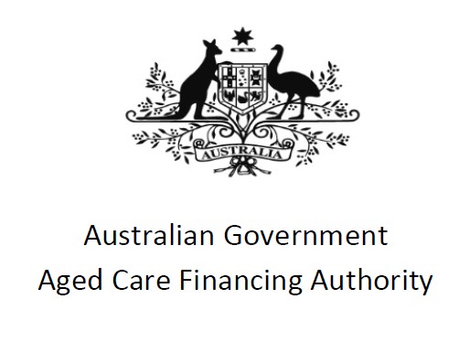

The role of the Basic Daily Fee in Residential Aged Care

March 2021

Contents

1. Introduction 2

The project and terms of reference 2

The review process 2

2. The basic daily fee – origins and purpose 3

3. Adequacy of the basic daily fee as a funding source 6

4. Principles for evaluating reform proposals 12

5. Reform options and analysis 13

Option A – Status Quo 13

Option B – the 2017 Legislated Review recommendation 15

Option C – The Royal Commission proposal 17

Other funding streams 19

Additional Service Fees 19

Transparency for consumers 19

Accountability 20

6. Conclusions 21

# Introduction

The Aged Care Financing Authority (ACFA) is a statutory committee whose role is to provide independent, transparent advice to the Australian Government (the Government) on financing and funding issues in the aged care industry.

## The project and terms of reference

In February 2020, the then Minister for Aged Care and Senior Australians, Senator the Hon Richard Colbeck, asked ACFA to undertake a piece of work on the role of the basic daily fee (BDF), which is commonly associated with payment for hotel services in residential aged care. The aim of this project was to provide greater analysis and understanding of the issues, including what role the BDF should have in the future.

## The review process

In its 2020 report on the funding and financing of the aged care industry, ACFA noted that costs were growing faster than revenue for residential aged care providers. Between 2017‑18 and 2018-19 total revenue per resident per day grew by 4.2 percent, while expenses grew by 5.3 per cent on the same basis.

With the Government providing 67.4 per cent of revenue and regulating what may be charged for the BDF (which is paid by residents and represents a further 18 per cent of revenue), the options for providers to increase their revenue may be somewhat limited. The BDF is capped at 85% of the single rate of the basic aged pension, currently approximately $52.25 per day (or just over $19,000 per annum). The BDF is not means tested, though financial hardship assistance may be available for those who are unable to pay.

In reporting outcomes for residential aged care providers, ACFA follows the longstanding practice in the industry of breaking down care revenue and expenditure into the following components:

* Care
* Living
* Accommodation, and
* Other

While this is common practice it is not a legislative requirement. Under the *Aged Care Act 1997*, most funding (apart from restrictions on the use of lump sum accommodation payments) is ‘pooled’. This allows providers to use all sources of funding in a flexible way to deliver care and support across all residents.

In this report, ACFA considers the origins and purpose of the BDF, analyses its adequacy as a funding source, proposes principles that should guide consideration of any changes to current arrangements, assesses options for reform, considers related issues and puts forward a set of conclusions.

# The basic daily fee – origins and purpose

## Living costs

The BDF is a charge paid by residents directly to providers and is an important component of revenue for residential aged care providers. In 2018-19, consumers paid just over $3.4 billion in BDF to providers, representing 18 per cent of total provider revenue.

The origins of a capped BDF can be traced back to the period before nursing homes and hostels were integrated into a single residential aged care program in 1997. During the 1980s, there was concern that differing regulatory and funding arrangements for nursing homes and hostels were creating incentives for nursing home providers to admit individuals who did not need high levels of care (as there was no independent assessment of care need). This resulted in the Government paying expensive nursing home rates for individuals who could have received the care they needed in hostels. As a result, reforms were introduced to better align incentives as well as regulatory and funding arrangements.

Alongside these reforms there were concerns that nursing homes, which were in receipt of a Commonwealth Nursing Home Benefit paid for each resident, were charging residents excessive fees. The *Community Services and Health Legislation Amendment Act 1988* contained provisions to ensure that by July 1991, no nursing home resident would be paying more than the statutory contribution of 87.5 per cent of the combined pension and rent assistance allowance in nursing home fees (although up to 6 per cent of nursing home beds in each State were exempt from the rule, allowing those who were able to pay for it to receive a higher level of accommodation).[1] This measure to link fee control to the age pension and rent assistance in nursing homes was an extension of similar arrangements previously introduced for hostels.

While the concept of a fee that is set as a proportion of the maximum value of the aged pension can be linked to a concern to limit excessive fees for consumers, there is less clarity around the types of items or services that the standard fee was designed to cover. The exemption from the fee cap for a certain number of nursing home beds in each State, to allow those who were willing and able to pay for a higher level of accommodation, suggests that the BDF may have been seen at that time as at least in part a contribution towards accommodation costs.

The funding model for nursing homes introduced from 1987 partitioned costs into care costs (Care Aggregated Module, CAM) that needed to be acquitted to the Department and other costs (Standard Aggregated module, SAM), for which no acquittal was required, with providers being able to retain any surplus; there was no capital component in the model. The structure of this model adds weight to the idea that the BDF may have been intended in part as a contribution towards accommodation costs.

In the Review of the structure of nursing home funding arrangements (1994), ANU Professor Robert Gregory says the policy rationale for SAM was to cover “infrastructure costs”. Professor Gregory writes “*The SAM component is a uniform grant which is not directly related to the costs of each individual home. Proprietors of nursing homes must now meet costs such as food, fuel, administration, and the salaries of the cook and the domestic staff from the uniform SAM component.*” The costs that Professor Gregory identifies as being covered by the government-funded SAM component of funding are those that would today be considered as everyday living, which suggests that the capped fees paid by individuals at that time (the precursor to the BDF) were seen as a contribution towards accommodation, rather than everyday living expenses.

ACFA notes that individuals who live in a private residence are expected to use their income (including the age pension) to cover the costs of their meals, cleaning and utilities, and it is reasonable that those who are living in residential aged care continue to meet these costs privately. Therefore, ACFA considers that the current common understanding of the BDF as a payment towards the costs of everyday living is appropriate.

ACFA also notes that there are often costs associated with increasing physical frailty or cognitive decline that it is not possible for individuals to control or reduce and, in the main, are not covered by the age pension. Due to frailty, for example, an individual may need assistance with cleaning and preparing their meals. The Government recognises these costs as additional to those associated with everyday living and provides subsidised assistance through Home Care Packages and the Commonwealth Home Support Program for those who need it. Those living in residential aged care often do not have a choice in relation to costs such as meal preparation, as these are generally packaged with residential care. Accordingly, there may be a case for some additional government assistance to be provided in relation to these costs, while noting that the Aged Care Funding Instrument (ACFI) already targets the care-related costs associated with frailty-related issues such as mobility, personal hygiene, toileting and eating through the Activities of Daily Living domain.

## Accommodation costs

Over time, specific accommodation payments have been introduced for residential aged care. These payments operate alongside the BDF and can take the form of a lump-sum deposit (Refundable Accommodation Deposit, RAD), rent (Daily Accommodation Payment, DAP), or a combination of the two, and accommodation supplements paid on behalf of supported residents. ACFA has recently completed a separate project in relation to RADs.

Given the introduction of separate accommodation payments and the decision to no longer pay rent assistance to those in residential aged care (and the consequent removal of rent assistance from the calculation of the capped BDF), it is no longer reasonable to think of the BDF as a contribution towards accommodation costs.

## Care costs

Funding for care costs incurred by providers is currently aligned to the needs of current residents through the application of the ACFI. An alternative model has been under consideration, including by the Royal Commission into Aged Care Quality and Safety.

**Box 1: Definitions**

As ACFA has based the analysis in this report on data provided by StewartBrown, much of the terminology in the report also aligns with that used by StewartBrown (see for example the data in Table 1). In particular:

**Care –** care revenue consists largely of ACFI revenue from Government, with costs associated with the delivery of care and support to residents

**Everyday Living –** everyday livingrevenues are from the BDF and Additional service fees. Everyday living costs consist of the costs of providing *hoteling services* such as food and linen, *utilities* (heating and cooling) and *maintenance*.

**Accommodation** – accommodation revenues include revenues from individuals (DAPs, interest on RADs and bonds) and government (accommodation supplements). Costs include rent and interest on loans.

**Administration** – administration costs are not separately funded by either government or individuals. In this report administration costs are allocated proportionally between the other cost streams in line with StewartBrown advice:

Care – 25%

Everyday living – 30%, consisting of:

Hotel services – 20%

Utilities – 5%

Property – 5%

Accommodation – 45%

## In summary

There is no legislative requirement or expectation that the BDF will be used to cover particular items or costs, and the distinctions that are commonly made in relation to ‘care’, ‘everyday living’ and ‘accommodation’ are based on convention rather than historical precedent.

However, ACFA considers that there is merit in the partitioning of costs in this way for the purposes of analysis and informing co-contribution policies. ACFA also supports the common proposition that the BDF should be considered as an individual’s contribution towards meeting the cost of providing everyday living needs such as food, cooking, utility costs and maintenance, while noting that it may not be equitable to require all residents to cover the full cost of delivering these services.

In considering the BDF and its adequacy, the analysis in the remainder of this report has been conducted on the principle that, as far as possible, individuals should meet the costs of their own everyday living expenses.

# Adequacy of the BDF as a funding source

Representations to the 2017 Legislated Review of Aged Care (the Tune Review) suggested that revenue from the BDF was insufficient to cover the costs of delivering everyday living services.

The financial data regularly obtained by ACFA through the Aged Care Financial Reports is not sufficiently segmented to analyse providers’ costs and revenues associated with daily living, utilities or maintenance. As a result, ACFA obtained detailed financial data from StewartBrown for the period up to the financial year ending 30 June 2020.

StewartBrown data provides financial data for 1113 services across all MMM regions. Consistent with the distribution of aged care facilities more generally, the majority of these services are MMM1 (66%). While several large for-profit services are not included in the data, and there is an under-representation of MMM6 and MMM7 services, overall the StewartBrown data can be considered to be broadly representative of the sector as a whole.

In its annual reports ACFA breaks down providers’ revenues into the following categories: care related; living related; accommodation related and other. Providers’ expenses are categorized as: care; accommodation; hotel; administration; financing; and other. While this approach is appropriate for considering the overall profitability of providers, it is not well‑suited to considering the adequacy of the BDF.

In particular, ACFA notes that providers do not have a separate revenue source to cover administration costs, which represented 11.8 per cent of total provider expenses in 2018‑19. Instead, administration costs are expected to be funded from within the other sources of revenue, namely care revenue (ACFI), everyday living revenues (BDF, additional service fees), accommodation revenues (DAPs, combinations and supplements) and/or other revenue (interest – including interest on RADs - and fundraising).

Unless administration costs are to be completely covered by care revenue, accommodation revenue or other revenue, the BDF must be sufficient to cover both everyday living expenses incurred by providers and that proportion of providers’ administration expenses which relate to the expenses covered by the BDF.

On this basis, the data presented in this report for care costs, everyday living costs and accommodation costs include an amount for administration costs (allocated on a value proportional basis – noting that this may not be an exact reflection of relative administrative costs incurred under each).

Table 1 shows that in 2019-20 care revenues exceeded the costs of delivering care (a positive ACFI result (row (C)) even after taking account an allocation of administration costs. In contrast, the everyday living result was negative (row (F)), with the BDF and revenue from additional services only sufficient to cover hoteling costs (such as food and cooking) in metropolitan areas. In more regional areas lower additional services revenue means that hoteling costs were not always covered by contributions from residents.

In aggregate, providers are spending less on delivering care than they receive through the ACFI and that surplus partially offsets the deficits associated with providing everyday living needs such as food, cooking, utility costs and maintenance, as well as the deficit for accommodation services.

**Table 1**

|  |  |  |  |  |  |
| --- | --- | --- | --- | --- | --- |
| **StewartBrown Survey ($ per bed per day)** | MMM1 | MMM2 | MMM3 | MMM4 | MMM5 |
| **Care** | | | | | |
| ACFI Revenue (A) | 183.59 | 179.47 | 177.29 | 172.98 | 172.49 |
| ACFI Services Costs (B) | 167.23 | 166.05 | 163.07 | 160.02 | 165.23 |
| ACFI Result (A - B) (C) | 16.36 | 13.41 | 14.22 | 12.96 | 7.27 |
| **Everyday Living – Revenue** | | | | | |
| Basic Daily Fee | 51.67 | 51.53 | 51.71 | 51.85 | 51.79 |
| Additional | 2.94 | 1.04 | 0.43 | 0.45 | 0.36 |
| Everyday Living Revenue (D) | 54.61 | 52.56 | 52.14 | 52.30 | 52.15 |
| **Everyday Living – Expenses** | | | | | |
| Hoteling | 52.66 | 52.81 | 52.55 | 53.74 | 52.13 |
| Utilities | 8.57 | 10.52 | 8.96 | 9.02 | 9.62 |
| Maintenance | 12.26 | 13.50 | 11.79 | 13.21 | 13.82 |
| *Everyday Living Expenses (E)* | 73.50 | 76.83 | 73.30 | 75.98 | 75.56 |
| **Everyday Living Result (D - E) (F)** | (18.89) | (24.27) | (21.16) | (23.68) | (23.40) |
| **Cost of Care (B + E)** | 240.73 | 242.88 | 236.37 | 236.00 | 240.78 |
| **Care Result (C + F) (G)** | (2.53) | (10.85) | (6.94) | (10.72) | (16.13) |
| **Accommodation Result (H)** | (5.55) | (0.83) | (4.38) | (4.78) | (3.24) |
| **Aged Care Home Result (G + H)** | (8.08) | (11.69) | (11.32) | (15.50) | (19.37) |
| Net COVID Result | 2.36 | 3.95 | 4.32 | 4.33 | 4.60 |
| **Aged Care Home Result including  COVID Result** | (5.73) | (7.74) | (7.00) | (11.17) | (14.77) |

ACFA also considered trends in care costs and revenue, everyday living costs and the BDF. The data show that:

* Care costs and ACFI revenues grew at similar rates between 2009 and 2018 (Chart 1a). More recently a significant gap has opened up, with costs rising faster than revenue. ACFA has previously noted the pressure that this is placing on residential aged care providers.
* Initially, the BDF grew faster than the cost of delivering hotel services (Chart 1b). Hotel costs, however, have been growing faster than revenue for some time and cumulative growth in costs caught up to cumulative BDF growth in the last quarter of the 2019-20 financial year. Other components of everyday living expenses - property maintenance and motor vehicle expenses, and particularly utility costs, have grown more quickly than the BDF.

**Chart 1a: Increases in costs and revenue - care**

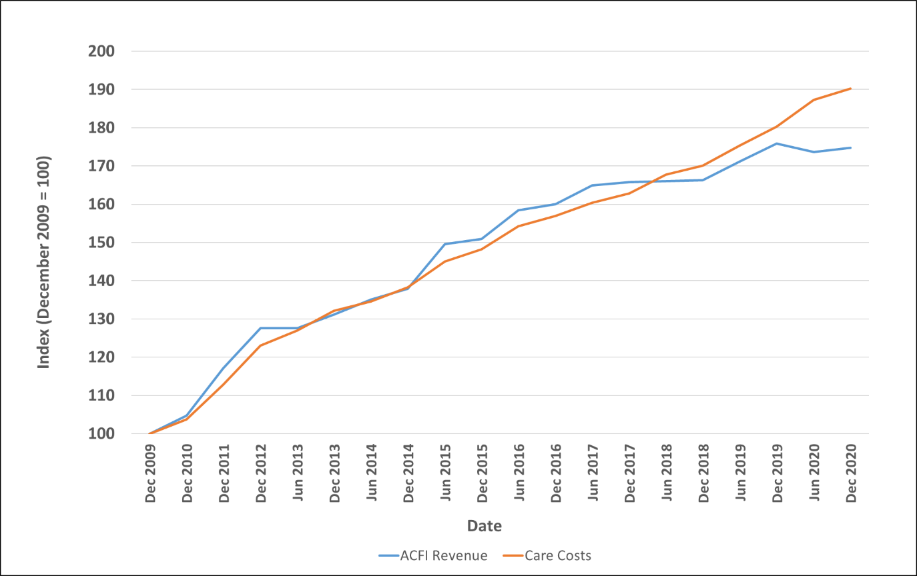

Source: Unpublished StewartBrown data. Note December 2020 data excludes COVID subsidies and expenses.

**Chart 1b: Increases in costs and revenue – everyday living**

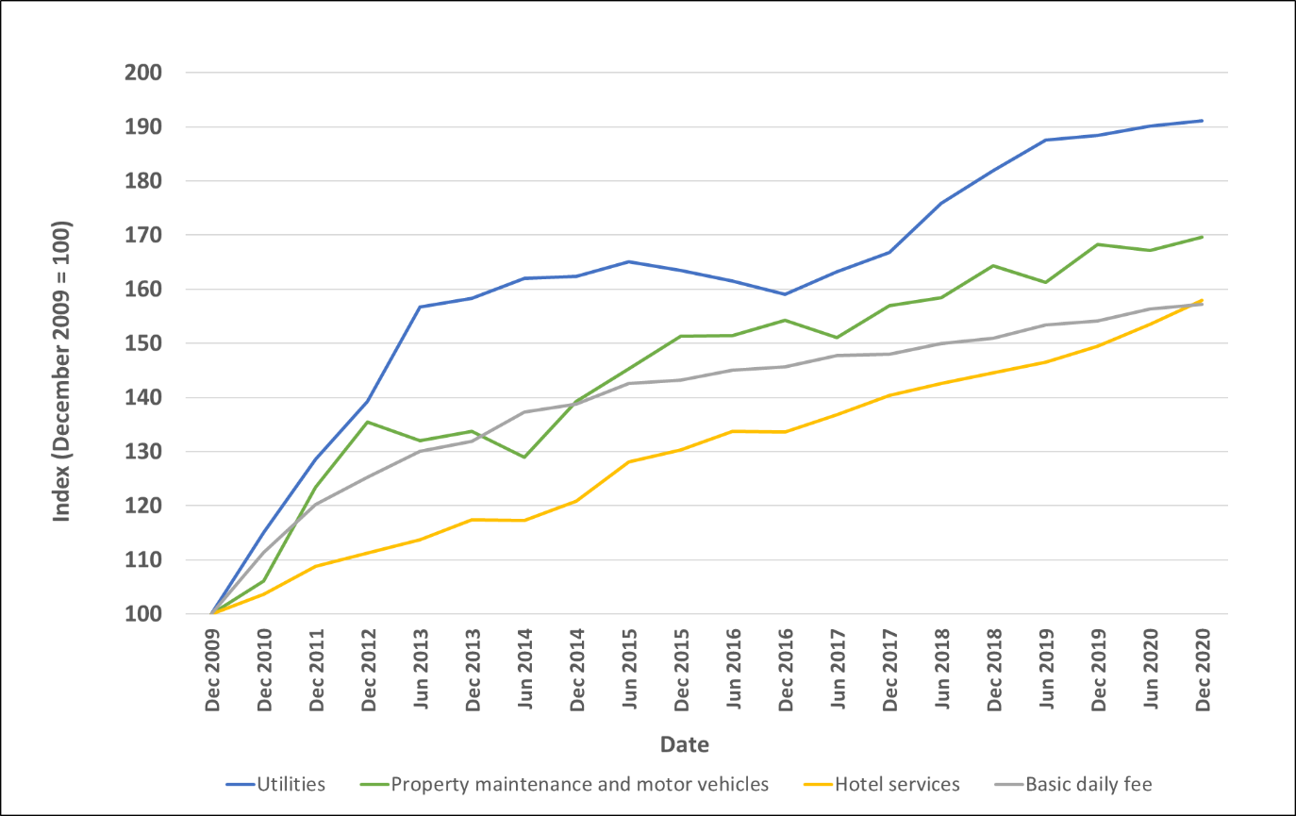

Source: Unpublished StewartBrown data.

There has been a deficit in everyday living for the entire period – depicted as the gap between the two lines in Chart 2. Overall, the everyday living result marginally improved between 2009 and 2014 (a smaller gap between the two lines). Since then, however, everyday living result has consistently deteriorated, mainly driven by increasing hoteling and utility costs.

**Chart 2: Everyday Living Deficit**

Line chart shows the every day living deficit costs bewteen December 2009 to December 2020 in dollars per bed per day. The everyday living deficit is the difference between the basic daily fee minus hotelling costs, and the utilities, maintenance and vehicles costs.

The chart shows two lines, one for utilities, maintenance and vehicles costs, the other is the Baisic Daily Fee revenue minus hoteling costs. The utilities, maintenance and vehicles line, starting from $12 a day in December 2009, gradually increases to over $20 by December 2020. The Basic Daily Fee minus hoteling costs line, starting from just under zero, increases up to around $6 by June 2014, before gradually decliding until it is just below zero again by December 2020, which results in a $22.39 difference between the two lines in December 2020.

Source: Unpublished StewartBrown data.

As noted earlier, under the *Aged Care Act 1997*, most residential aged care funding is pooled, which allows cross-subsidisation between funding streams. ACFA also notes that, in a residential aged care facility, care cannot be delivered without also providing food and a suitable environment (such as warm rooms in winter, facility maintenance etc.) in which residents can live.

With this in mind, ACFA considered whether the care and everyday living funding streams could be merged to create a single stream that was designed to cover all of the costs of looking after an individual in residential aged care (apart from their accommodation costs).

On balance, ACFA does not support this approach to residential aged care funding and considers there is merit in continuing to conduct analysis on the basis of separate funding streams. In particular, merging funding streams may blur the distinction between living costs that are considered to be a private responsibility (food, utilities etc.) and those costs that have traditionally been free or heavily subsidised by government (care).

Keeping funding streams separate allows more detailed analysis of each component of residential aged care operations, including making comparisons between the funding of everyday living activities in residential care and those delivered in the home, and will assist in provider accountability for ensuring that care funding is being spent on care. It also allows for the consideration of the appropriateness of funding for the everyday living and accommodation streams.

ACFA also notes that many providers find it valuable to separately measure and account for care and everyday living revenues and expenses, and that this approach may become more prevalent and necessary in the future as residential aged care continues to evolve (for example, to become less institutional, with scope for care to be delivered in apartment-style accommodation where individuals have more control about who prepares and delivers their food).

As a result, ACFA considers that the current three streams of residential aged care funding (care, everyday living and accommodation) are broadly appropriate and should be retained. However, ACFA notes that the benefits of conducting analysis on separate funding streams requires that data is available on providers’ costs and expenses for each stream to allow the degree of cross-subsidisation to be measured, monitored and taken into account by decision makers.

With this in mind, ACFA considers that it would be beneficial to make changes to ensure the revenue that providers receive for everyday living expenses more closely matches the cost of providing those services. However, before reform proposals can be analysed there needs to be agreement on what the objectives of reform should be. This is discussed in more detail in the next section.

# Principles for evaluating reform proposals

In order to effectively analyse any proposal for reform, ACFA considered the objectives of the BDF within the context of consumer and government contributions to the cost of delivering care and everyday living services and the revenue sources available to residential aged care providers. In developing these principles, ACFA had regard to the principles it previously set out in its report “Attributes for Sustainable Aged Care”. ACFA considers that:

1. Funding for residential aged care should consist of streams. Funding arrangements should ensure that consumers in need are able to access affordable quality residential aged care and that providers receive predictable funding for each service stream that is adequate in aggregate. The three streams are as follows, and include an allowance for the administration of each of them:
   1. Care
   2. Everyday Living
   3. Accommodation
2. Subject to individual means, funding the costs of everyday living services should primarily be a personal responsibility, though some Government supplementation may be required to the extent that frailty or cognition-related everyday living costs exceed those contemplated under the Age Pension.
3. Pricing and funding arrangements for everyday living services should:
   1. be transparent
   2. ensure that low means consumers are able to access affordable everyday living services that are of at least a quality standard that meets community expectations and personal appropriateness
   3. enable consumers to make informed and voluntary choices among a range of broader and higher quality everyday living services, with fees charged for higher quality services being voluntary, transparent and reasonable
   4. embed incentives for providers to deliver everyday living services efficiently.
4. Providers should be accountable for the quality of the everyday living services they deliver.

# Reform options and analysis

## Option A – Status Quo

The current approach to the BDF is highly regulatory and ensures that all residents pay no more than a maximum capped amount regardless of their preferences, income, or the costs incurred in providing services. This approach protects access to care for those on lower incomes and recognises that other avenues – such as the ability to generate revenue through providing ‘extra services’ and ‘additional services’ to those who are willing to pay for them – are available for providers, with limitations, to meet market demand for higher quality everyday living services (see Box 2 for a discussion of extra service places and additional service fees).

A key disadvantage of the current approach to the BDF is that while it is very predictable, the amount of revenue generated from the BDF is not adequate to cover the cost of providing the services that are required under the Aged Care Act.

ACFA does not support Option A. It considers that changes to the BDF are required and that they should be accompanied with clarification around the requirements for charging for additional services and the future role of extra services places.

**Box 2: Extra service places and Additional service fees**

There are two distinct options for providers who wish to cater for consumer demand for higher quality care and everyday living services – Extra service places and Additional service fees.

Extra service places are granted to residential aged care providers that provide a significantly higher than average standard of services, including accommodation, range and quality of food, and non-core services such as recreational and personal interest activities. Providers that have been granted extra service status apply to the Aged Care Pricing Commissioner for approval of their proposed extra service fees, including proposed increases to current extra service fees.

The number of Extra service places has fallen from 17,390 on 30 June 2014 to 10,766 on 30 June 2019. The reasons for this decline are discussed in ACFA’s 2020 Annual Report on the Funding and Financing of the Aged Care Industry and includes the impacts of the Living Longer Living Better (LLLB) reforms which extended lump sum accommodation deposits to high care residents, highlighted that providers in non-Extra Service homes may charge fees for optional additional services, and that no new extra service places have been released since the LLLB reforms. ACFA notes that there are currently no plans for new Extra service places to be released through future Aged Care Approval Rounds.

ACFA noted in the 2020 Annual Report that ongoing uncertainty around the regulation of additional service fees may be behind a recent stabilisation in the number of Extra service places.

Additional services fees are negotiated between a provider and a resident. Providers and consumers agree an additional fee for care and services over and above those that they are required to supply under aged care legislation (Quality of Care Principles 2014 Schedule 1 – Care and services for residential care services). Additional services vary greatly but may include items such as the provision of pay TV, hairdressing, additional beverage offerings (e.g. wine and beer) and access to a gym.

While there has been some increased revenue from additional services, particularly for facilities operating in metropolitan areas, it remains relatively low. In practice there is a lack of clarity and transparency around additional service fees for both consumers and providers. In 2019, the Department of Health released a consultation paper, “Additional service fees in residential aged care”, although the Government is yet to settle on a final position.

## Option B – the 2017 Legislated Review recommendation

The 2017 Legislated Review of Aged Care (Tune Review) noted evidence that the BDF was insufficient to cover the costs of providing everyday living services to residents and recommended that the Government:

* require that providers charge the minimum BDF in residential care (it is not mandatory though the great majority do charge)
* retain the cap on the value of the BDF in residential care for low-means (fully and partially supported) residents
* allow providers to charge a higher BDF to non-low-means residents, with amounts over $100 to be approved by the Aged Care Pricing Commissioner, and
* require that the maximum BDF be published on the My Aged Care website, the provider’s website and in written materials to be given to prospective residents.

This option recognizes that those with higher income and/or assets have the ability to contribute more towards the cost of their everyday living services. As the structure of current arrangements would be largely unchanged, it would also be relatively easy to implement. In effect the group that is already liable to pay a means tested care fee and agreed accommodation payment could now be charged the higher BDF. Additional payments would be collected from residents directly by providers in the same way that the current BDF is collected, meaning that – other than a need for providers to keep a record of the amount to be paid by each resident – there would be limited need for change to government or provider IT systems.

Consideration would need to be given as to whether a higher BDF could be charged to those who are currently in care. Allowing providers to charge a higher fee to all current and future non-supported residents would generate the largest potential increase in revenue to meet the costs of everyday living expenses. Under this approach, however, existing residents would not be in a strong position to negotiate, and may feel compelled to pay a higher fee rather than face the upheaval and potential trauma of finding and moving to a new service provider. While it would be possible to introduce higher fees for existing residents after a notice period (for example, two years), this would still disadvantage residents who did not wish to move from a facility that opted to charge a higher BDF to non-low-means residents.

ACFA considers that an increase would therefore best be introduced only for residents who enter a facility after any change in policy was announced, while noting that this approach limits the increase in funding available to cover the costs of providing everyday living services in the short to medium term.

An advantage of Option B is that it maintains the conceptual linkage between the responsibility of individuals to cover their own costs of everyday living and the BDF. It would generate additional revenue from consumers, not government, and has the advantage of relative administrative simplicity (although there would be some additional burden for those wishing to charge more than $100 per day).

A risk with this option is that providers could start charging the higher fee to non-low-means residents without any obvious improvement in the services being offered. In effect, non-low-means residents would be directly cross-subsidising all other residents, rather than the redistribution occurring through the broader Budgetary tax and transfer system. ACFA notes that this risk would be highest where there is little or no competition between providers.

The risks could be reduced by ensuring that existing residents are not able to be levied higher charges, and by implementing other policies to enhance competition (such as assigning subsidy entitlements to the consumer and eliminating the need for providers to apply for additional aged care beds through the Aged Care Approvals Round process, and removing the cap on the supply of subsidised residential places).

While it could be argued that additional consumer charges may be appropriate for the current level of service (because the costs of providing those services generally already exceeds the current fee) it nevertheless would be sensitive, including in relation to cross-subsidisation. This highlights the need, whatever option may be chosen, to ensure there is sufficient transparency, accountability and communications with residents about the fees being charged and what they are being charged for. As noted above, ACFA considers that there are already opportunities (albeit somewhat unclear) for residents and providers to agree on higher fees in return for additional or a higher level of services where both parties agree.

There is also a risk that this proposal may increase incentives for providers to “cherry pick” residents, giving preferential access to those with higher means in order to maximize their revenues and minimize the costs associated with delivering additional services. As a minimum this would need to be closely monitored.

Accordingly, ACFA considers that Option B provides a mix of both benefits and risks.

## Option C – The Royal Commission proposal

Consistent with the Tune Review and ACFA’s findings, the Royal Commission heard evidence that there was a gap between the costs of providing everyday living services and funding received through the BDF. In responding to this evidence the Royal Commission proposed:

* The Australian Government should, no later than 1 July 2021, offer to provide additional funding to each approved provider of residential aged care by adding to the base amount for the BDF by $10 per resident per day, for all residents. The Royal Commission proposed an extensive list of requirements around the proposed payment, including an annual review of the adequacy of the goods and services provided to residents in relation to their everyday living needs (particularly nutrition) [Recommendation 112]; and
* In conjunction with the introduction of a new Aged Care Act, the maximum amount that providers could be paid for services that are associated with “the ordinary costs of living” should be determined by the Aged Care Pricing Authority [Recommendation 127]. Providers could charge up to this maximum, comprised of:
  + a basic fee paid by the resident equal to 85% of the maximum amount of the basic age pension;
  + a means tested fee paid by the resident; and
  + a subsidy paid by the Australian Government to make up any gap.

In considering the approach recommended by Royal Commission it is useful to consider the recommendations as two separate proposals – an immediate boost in funding, followed by a longer term reform.

ACFA notes that the initial funding increase is proposed to be completely funded by Government, which is at odds with ACFA’s Principle 2 that, subject to means, funding the costs of everyday living services should be primarily a personal responsibility.

It would, however, explicitly recognise that the revenue being sourced from the BDF is currently insufficient to meet the cost of delivering everyday living services.

It would also recognise that many individuals may not be able to completely meet the additional everyday living costs associated with increasing frailty. As noted above, individuals are able to access subsidised assistance through Home Care Packages and the Commonwealth Home Support Program to meet these same costs when they live at home and therefore some Government contribution/support can be seen as appropriate for age care residents where such costs are not already covered by ACFI.

The key advantage of this approach is that it immediately addresses the issue that funding received by providers from the BDF is insufficient to cover the costs of delivering everyday living services. That is, it addresses ACFA’s first principle that funding in residential aged care should be predictable and adequate. It does not change incentives for providers to deliver services to those with low means and given that existing funding levels are insufficient to cover costs, it should assist in ensuring that all residents have access to affordable everyday living services that are of at least an acceptable quality. Importantly it would also reduce the need for providers to cross-subsidise everyday living services with care revenue.

It would, however, require the introduction of a new and separate payment from Government to providers, adding further complexity to the overall residential aged care funding model. A $10 per day increase as suggested by the Royal Commission would likely cost in the order of $760 million per annum.

The Royal Commission’s proposed introduction of a means tested resident contribution alongside the introduction of a new Aged Care Act would more closely align with ACFA’s Principle 2 that these costs should be a personal responsibility.

The Royal Commission further recommends that the maximum amount a provider could charge for the delivery of everyday living expenses be set by an independent body (a proposed Aged Care Pricing Authority).

The key advantage of the latter approach is that it would ensure that adequate funding was available on an ongoing basis to deliver everyday living services to those in residential aged care. This meets ACFA’s Principle 1 (reliable and adequate funding stream) and Principle 3.2 (access to affordable everyday living services of an acceptable quality). ACFA notes that under this approach consumers who wished to voluntarily purchase services of a higher quality would continue to be able to do so through existing additional service arrangements (which, as noted below, requires further policy and administrative clarity to encourage further uptake).

As a variation to the proposal by the Royal Commission, ACFA notes that the current BDF cap is set as a proportion of the basic pension but does not include supplements that are typically payable with the Age Pension such as the Energy Supplement and the Pension Supplement. There does not appear to be a compelling policy reason why these supplements should be excluded from the cap. Historically the cap included Rent Assistance (which is no longer payable for residential aged care as it has been replaced by the separate accommodation supplements), which lends weight to the proposition that supplements to the Age Pension should be included when calculating the maximum BDF.

ACFA estimates that considering both the Energy Supplement and the Pension Supplement as part of the 85 per cent cap would require full pensioners to pay approximately an additional $5 per day in BDF, which would generate in the order of $380 million (approximately half the recommended funding increase), if it were paid by all those receiving residential aged care, without requiring Government to introduce a new payment to providers.

However, it may be seen as inequitable to change the maximum BDF for those who are currently receiving care as they would have negotiated arrangements with providers – potentially including Daily Accommodation Payments or Additional Service Fees – on the basis of the current cap. For this reason, were the Government to consider increasing the maximum BDF, ACFA considers that current arrangements should continue to apply to all existing residents.

It would also be open to Government to consider alternate changes to means testing arrangements to secure a larger contribution from those with means, which could be used to partially or fully offset the cost of any remaining government contribution towards the BDF.

ACFA considers that Option C delivers the best overall balance between costs and risks.

## Other funding streams

While ACFA supports continuation of a separate identifiable funding stream for everyday living services, ACFA is also conscious that these funding arrangements need to be considered in the context of the broader funding arrangements for residential care. How well the everyday living funding works in conjunction with funding of care and accommodation, together with the adequacy of the overall arrangements, are crucial to ensuring there is adequate funding from government and consumers to support a high quality and safe level of care, services and accommodation.

Interaction with other policies, such as competition-enhancing reform of the Aged Care Approvals Round process, should also be taken into consideration. The costs and revenues associated with the care and accommodation components of residential aged care funding were not part of ACFA’s remit for this project but ACFA considers Government should consider them together holistically when considering future reform.

### Additional Service Fees

As noted earlier, ACFA considers there is scope to improve the clarity and operation of the rules relating to Additional service fees. ACFA considers that where consumers have the means and wish to do so, they should be able to obtain a higher quality of services for an appropriate fee. This should be subject to consumer protections to ensure there is transparency and that fees are not charged for services which providers are required to provide in any event, or that residents are not able to benefit from. Greater clarity in this area is required to support and complement changes to the BDF arrangements.

While noting that there was no clear consensus on any of the proposals in the Department’s consultation paper on additional service fees, in ACFA’s view there would be merit in further consideration of these proposals, particularly in relation to disclosure of fees and ensuring that agreements are reviewed periodically so that the services provided continue to be appropriate and provide benefit to the person who is purchasing them.

* Mandatory disclosure would ensure that additional service fees are listed on My Aged Care and the provider’s website, including a clear description of the services offered, the price(s) and whether all residents entering the home who can benefit from the services are expected to purchase them, or if they are voluntary.
* Periodic review of agreements will ensure that residents and/or their representatives have the opportunity to assess whether they are receiving benefit from the services they are paying for and whether they still wish to purchase them.

### Transparency for consumers

ACFA recognises that the funding arrangements for residential care can be confusing for consumers and their families. From a consumer perspective, ACFA considers it is important and essential that any changes to the BDF (and fees for additional services) are properly communicated, residents understand what they are being charged for and there is clear reporting in their monthly fee statements. Improving disclosure of additional service fees would assist in improving transparency (Principle 3.1).

### Accountability

Appropriate transparency should be a feature of any reformed system. Improvements to financial reporting to better enable Government to monitor the adequacy of funding against different funding streams on a system-wide basis would be appropriate. ACFA does not, however, support overly prescriptive regulation and seeks an appropriate balance between provider accountability for each service stream (Principle 4) and overall operational efficiency.

# Conclusions

Having examined the history and purpose of the BDF and considered possible options for reform, ACFA is of the view that funding arrangements for everyday living services should:

* remain separate from care and accommodation
* be predominantly funded by individuals (subject to means), recognising that they are costs that individuals would normally be responsible for during their life
* continue to limit contributions by those on lower means to a capped amount
* be transparent and enable consumers to make informed and voluntary choices among a range of broader and higher quality everyday living services where offered by providers, and
* not provide an overly prescriptive regulatory approach but ensure there is sufficient reporting to enable the Government to monitor at a system level the appropriateness of funding arrangements and to balance provider accountability for each service stream with overall operational efficiency.

In the context of the reform of broader funding arrangements for residential aged care, the government may wish to consider:

* increasing the BDF capped amount to 85% of the basic pension, inclusive of the pension and energy supplements, an increase of approximately $5 per resident per day (with existing arrangements continuing to apply for those currently in care)
* supplementing the increase in the BDF cap with a Government payment to help address the gap between everyday living revenue and costs, and
* introducing a means test on the new Government payment as part of any review of means testing arrangements following the Royal Commission report to ensure that those with sufficient financial resources continue to pay for their everyday living services.

Whatever arrangements are ultimately implemented for the BDF, ACFA is of the view that there is considerable merit in more clearly articulating the policy and administrative arrangements for charging Additional service fees for everyday living services over and above that which a provider is required to provide, including mandatory disclosure of additional service fees on My Aged Care and on the providers’ websites.

1. Parliamentary Research Service Background Paper Number 32 1993 - *Residential Care for the Aged: An Overview of Government Policy from 1962 to 1993*