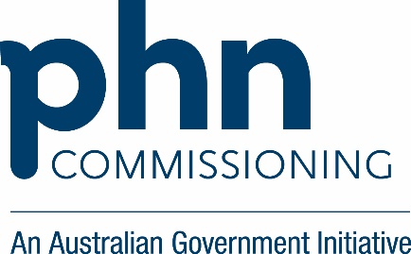

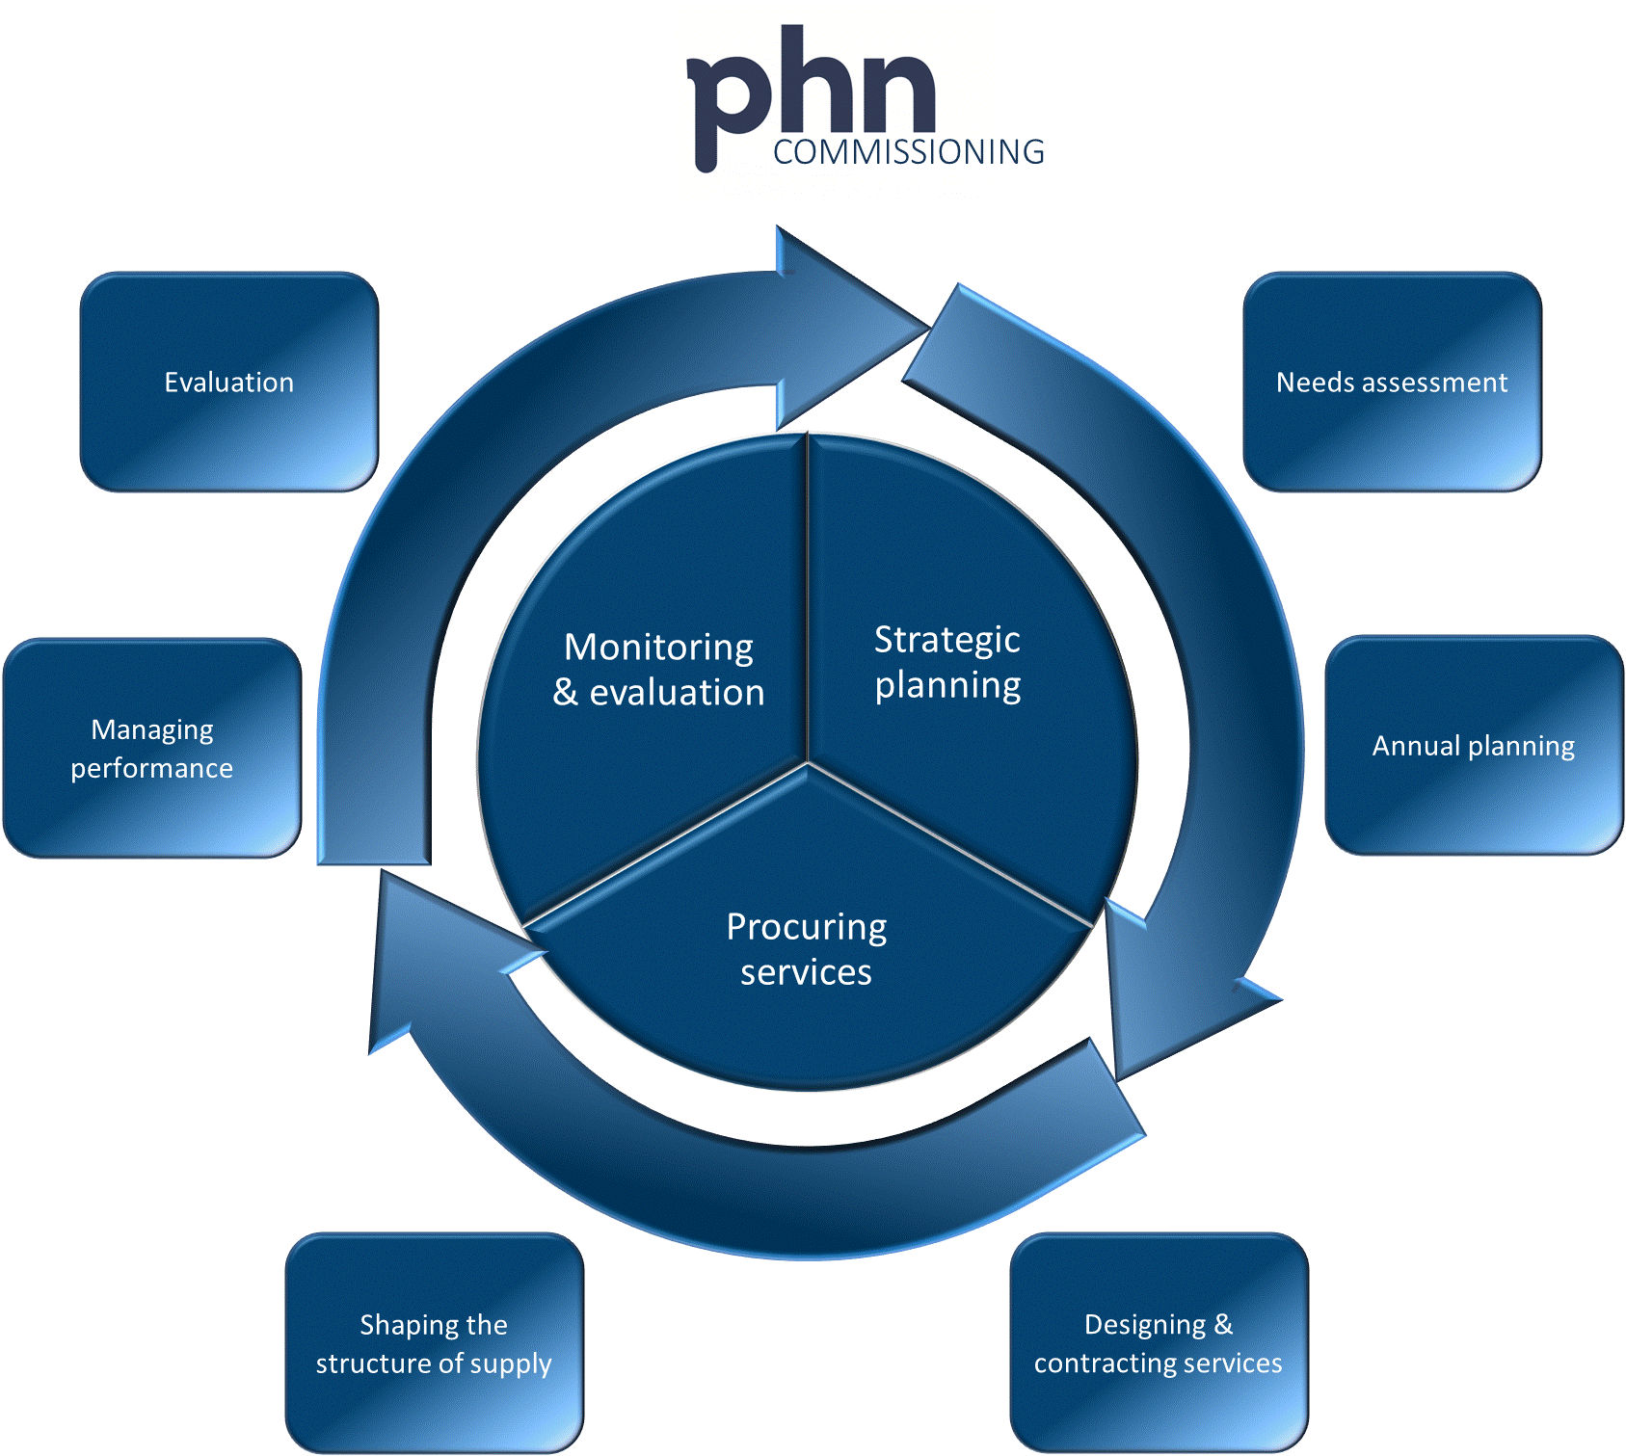

Designing and Contracting Services Guidance
Version 1.0 - June 2016
Acknowledgement

This document has been developed by the Australian Government Department of Health and PricewaterhouseCoopers (PwC) as part of a project funded by the Department to develop guidance and resources for Primary Health Networks (PHNs) on commissioning. It has been informed by a literature and evidence review on commissioning by The King’s Fund and the University of Melbourne, and by the results of an online survey of all PHNs by PwC, both undertaken in 2016 as part of this project.

The input of the Primary Health Networks Commissioning Working Group in the development of this guide is appreciated.

Note

This guide does not override the requirements set out in the PHN Funding Agreement.

Contents
1. INTRODUCTION 1
1.1 The PHN Commissioning Framework 1
1.2 This guidance 2
1.3 Working with State and Territory governments 3
2. DESIGNING AND CONTRACTING SERVICES 3
2.1 Where designing and contracting fits 3
3. SOME KEY CONSIDERATIONS 4
3.1 The scope of the designing and contracting phase 4
3.2 Is ‘services’ the right word? 4
3.3 Joint commissioning 6
3.4 Working with LHNs 7
3.5 Working with Aboriginal Community Controlled Health Organisations (ACCHOs) 8
3.6 Governance structure and accountability 8
3.7 Conflicts of interest 9
3.8 The PHN Grant Programme Guidelines, the PHN Funding Agreement and considerations relating to Aboriginal and Torres Strait Islander people 10
3.9 Outcomes Based Commissioning (OBC) 11
3.10 Commissioning by PHNs 11
3.11 Specifying requirements 13
3.12 The role of providers 14
3.13 The role of the community/consumers 15
3.14 Types of ‘procurement approach’ 15
3.15 Social impact investment 16
3.16 Types of contracting 16
3.17 Risk management 17
3.18 Unsolicited proposals 18
4. BEING READY TO COMMISSION/DESIGN/CONTRACT 19
4.1 Commissioning scope and packaging 19
4.2 Evaluation criteria and approach 20
5. COMMISSIONING APPROACHES 23
6. DESIGNING/CONTRACTING TOOLBOX 25
6.1. Designing services, including co-creation 25
6.2. Decommissioning services 29
6.3. Contract variation or extension and overarching contracting considerations 31
6.4. Contracting – Service-specification based 34
6.5. Contracting – Competitive dialogue 37
6.6. Contracting – Most Capable Provider (MCP) or single provider 40
7. PROVIDER MARKET ASSESSMENT AND MARKET MAKING 45
7.1 Definition 45
8. PROVIDER CAPABILITIES 46
9. SUMMARY OF LEADING PRACTICE ROLES, RESPONSIBILITIES AND SKILLSETS OF A COMMISSIONING PHN 48
10. APPENDICES 52
APPENDIX I – Outline of a Service-based commissioning approach 53
APPENDIX II – Outline of a Competitive Dialogue based commissioning approach 63
APPENDIX III – Outline of a Most Capable Provider, Collaborative or Single Tenderer- based commissioning approach 75

Page
List of Figures

Figure 1: The PHN Commissioning Framework 1
Figure 2: The flow from identifying needs through to designing and contracting. 3
Figure 3: Some considerations for commissioners 5
Figure 4: Outcome based commissioning features 12
Figure 5: Innovations in contracting models 17
Figure 6: Flow chart to assist in determining commissioning approaches 23
Figure 7: PHN procurement decision making process flow chart 24
Figure 8: PHN procurement decision making process flow chart – illustrative example shown with blue shading. 24
Figure 9: The design continuum 25
Figure 10: Service specification based commissioning timeline 35
Figure 11: Competitive dialogue based commissioning timeline 38
Figure 12: MCP based commissioning timeline 42
Figure 13: Market assessment and market making process 45

List of Tables

Table 1: Factors in determining commissioning approaches 26
Table 2: Features of a co-design approach prior to any procurement process 27
Table 3: Deciding on whether to use single (most capable) or competitive (multiple) provider approaches 33
Table 4: Service specification based commissioning - risks and issues 36
Table 5: Competitive dialogue based commissioning - risks and issues 39
Table 6: MCP based commissioning - risks and issues 44
Table 7: Features of leading commissioning practice 48

ACRONYMNS USED IN THIS GUIDANCE

ACCHOs Aboriginal Community Controlled Health Organisations
ACOs (American) Accountable Care Organisations
BAFO Best and Final Offer
CALD Culturally and linguistically diverse
CD Competitive Dialogue
COI Conflict of Interest
DD Due Diligence
EOI Expression of Interest
EU European Union
IM Information Memorandum
IP Intellectual property
KPIs Key Performance Indicators
LHNs Local Hospital Networks
MCP Most Capable Provider
ML Medicare Local(s)
MoI Memorandum of Information
MoU Memorandum of Understanding
OBC Outcomes Based Commissioning
PB Preferred Bidder
PHN Primary Health Network(s)
PSC Public sector comparator
PwC PricewaterhouseCoopers
RFP Request for Proposal
SMART Specific, Measurable, Agreed, Realistic, Time-bound
UK United Kingdom
VFM Value for Money

INTRODUCTION

1.1 The PHN Commissioning Framework
Primary Health Networks (PHNs) were established in July 2015, with the objectives of:
- increasing the efficiency and effectiveness of medical services for patients, particularly those at risk of poor health outcomes; and
- improving coordination of care to ensure patients receive the right care in the right place at the right time.
The PHN Grant Programme Guidelines state that:
PHNs will achieve these objectives by:
understanding the health care needs of their PHN communities through analysis and annual planning. They will know what services are available and help to identify and address service gaps where needed, including in rural and remote areas, while getting value for money;…

Figure 1: The PHN Commissioning Framework

Figure 1 depicts the PHN Commissioning Framework. There are three phases in the cycle – strategic planning, procuring services, and monitoring and evaluation.
This commissioning framework has been developed so that PHNs can ensure that their commissioning approach is consistent with the approach adopted for the program as a whole and that the process results in consistent, comparable and measurable outputs and outcomes.
It is important to keep in mind that commissioning is a holistic approach to enable PHNs to work as strategic organisations at the system level. It is not merely a process. It is expected that PHNs may well be engaged in different parts of the cycle throughout the year (such as monitoring contracts).
While PHNs are required to undertake a review and update of the needs assessment annually, in practice the needs assessment should be under continual review as new information, data and experience become available.
‘Commissioning’ is a continual and iterative cycle involving the development and implementation of services based on planning, procurement, monitoring, and evaluation. While a commissioning approach is used in a number of sectors other than health care it has been a key feature of the health system in the UK since the 1990s and is also a feature of health systems in New Zealand and the United States of America. Commissioning describes a broad set of linked activities, including needs assessment, priority setting, procurement through contracts, monitoring of service delivery, and review and evaluation.
A key characteristic of commissioning is that procuring or purchasing decisions occur within a broader conceptual framework. The difference between purchasing and commissioning in the health care context has been described as follows:
Commissioning is a term used most in the UK context and tends to denote a proactive strategic role in planning, designing and implementing the range of services required, rather than a more passive purchasing role. A commissioner decides which services or healthcare interventions should be provided, who should provide them and how they should be paid for, and may work closely with the provider in implementing changes. A purchaser buys what is on offer or reimburses the provider on the basis of usage.
As the health systems are different, PHN commissioning will of course differ from the experiences of other countries. However, the fundamental elements remain valid in the Australian context.

1.2 This guidance
As the title suggests, this document provides ‘guidance’ that PHNs should have regard for in the context of other requirements such as the PHN Grant Programme Guidelines. It cannot hope, nor is it intended, to provide comprehensive instructions or requirements. PHNs need to come to their own views as to how the guidance is applied. The guidance will be updated and augmented over time, particularly with case studies or Australian leading practice as these evolve and emerge.

1.3 Working with State and Territory governments
PHNs are increasingly working with State and Territory governments and their health agencies and Local Hospital Networks (LHNs) or equivalents, in planning and undertaking commissioning.
PHNs are commissioning into an existing environment and collaboration will be important in ensuring that funding is leveraged and utilised to achieve optimal outcomes. PHNs may also need to have regard for State and Territory governments and agencies’ requirements if they are jointly commissioning with them.

DESIGNING AND CONTRACTING SERVICES

2.1 Where designing and contracting fits
As shown in the PHN Commissioning Framework, the designing and contracting stage typically follows the needs assessment and annual planning processes. This is depicted in Figure 2, below.
Figure 2: The flow from identifying needs through to designing and contracting.
Overview
Designing and contracting services has traditionally been referred to as ‘procurement’ and many PHNs and their Medicare Local (ML) predecessors will have experience of this. There are, however, a number of key differences in this role when it is conducted under a commissioning umbrella:
- Contracting should be for the priority areas that have been derived through the needs assessment and annual planning phases; this is the next logical step.
- PHNs may need to consider contract durations, having regard to the timeframe of the PHN Funding Agreement. Longer term contracts may provide greater value for money and efficacy, particularly where ‘interventions’ take time to deliver results, but these could only be effected within the context and requirements of the
PHN Funding Agreement.
- Commissioning or contracting can be for outcomes as well as services – more details are provided below.
- Contracting may be done by one body, the PHN, or multiple bodies (say for example, the PHN and LHN) under a joint commissioning approach – see below.
- PHNs will need to consider how far they ‘design services’ and how far they leave this to the market to respond to broadly based requirements. There are international examples of both approaches.
- Co-design is an important aspect of this stage and this may involve potential providers and/or consumers.
- Different ‘procurement’ approaches may be adopted from those that were ‘traditionally’ used by MLs, and some example approaches are set out below.
- It is a part of commissioners’ responsibilities to develop the market and ensure that there is a ‘flourishing provider community’; this is touched on below.
- Under the PHN Grant Programme Guidelines, service delivery by the PHNs is only an option where there is absolute market failure, and agreement to undertake direct service provision must be obtained from the Department of Health.
- Commissioning approaches will develop over time. It is unlikely that the most advanced of thinking or techniques will be deployed from day one.

SOME KEY CONSIDERATIONS
The following sub-sections provide details of some key considerations and enablers to effectively designing and contracting services. PHNs should review these as well as the specific ‘Toolbox’ guidance provided at Section 6 below. Many of them apply to all approaches or types of commissioning.

3.1 The scope of the designing and contracting phase
This phase begins with the outcomes from the annual planning process – the prioritised set of services or interventions to be delivered. The purpose of this phase is to design what these would be like and secure their delivery through contracting or commissioning of third parties. The PHN will only be in a position to deliver the services itself where there is market failure; that is, if no appropriate service provider is available and the PHN cannot reasonably facilitate new service providers; and where the Department’s approval has been obtained.

3.2 Is ‘services’ the right word?
This guidance refers to designing and contracting services but some would argue that that is an inappropriate expression in some cases. ‘Public services’ tends to include or reference traditional service delivery, where the provider is responsible for determining what the service is and how it is delivered. Some are now using the expression ‘interventions’ as this encompasses provider responses that go beyond traditional services. These interventions may be a response to a commissioning request, in particular relating to the securing of certain outcomes. As an example, in order to better keep people well (the outcome), providers may consider that ‘nudging behaviour’ (lifestyle choices, self-management etc.) might be an appropriate intervention. This is not a traditional ‘public service’ but may be very effective in securing the outcomes. Commissioners need to take a broader view than seeing themselves as delivering services or as just arranging for services to be delivered.
Developments in commissioning
The four box model set out below depicts some of the considerations that commissioners or PHNs will need to take into account.
Figure 3: Some considerations for commissioners
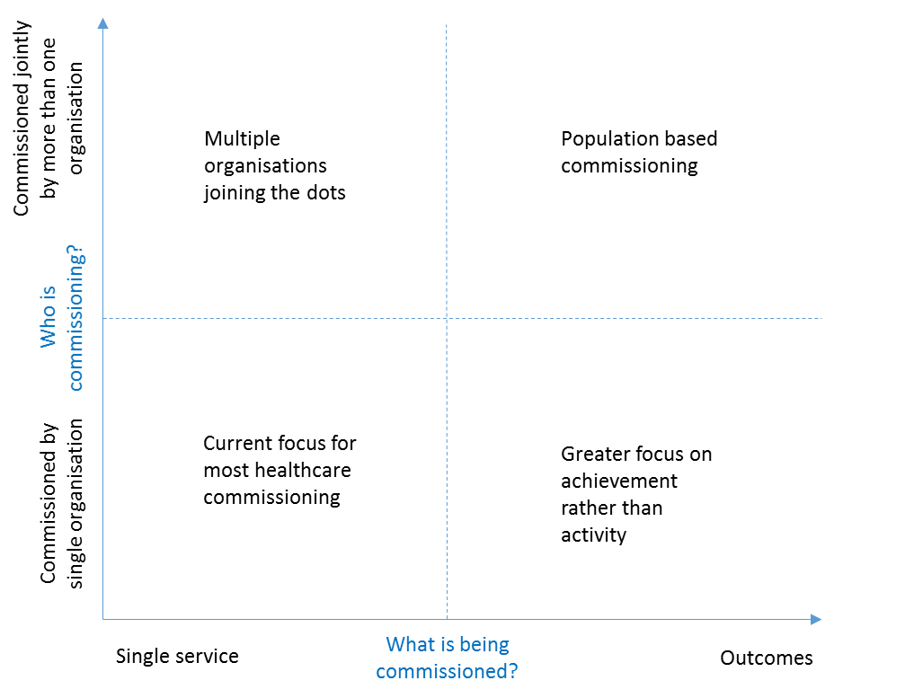
The ‘what is being commissioned’ axis shows the spectrum of potential commissioning requirements from single services (such as providing a particular allied health service in a particular region) through to securing a set of outcomes (such as reducing the number of aged people needing to attend emergency departments as a result of diabetes). MLs had tended to focus on the left hand side of this spectrum but international experience and trends (for example, American Accountable Care Organisations (ACOs)) point to a migration towards commissioning outcomes. Such an approach is more challenging but has the advantages of securing greater innovation from providers (because they are more free to suggest different solutions to problems/challenges) and transferring demand risk (because commissioners are not specifying activity units, they are specifying outcomes). Under this approach, it is for providers to estimate and submit bids based on the activity they believe is required, and no further payment is due for performing more activity, but further payments may be available for delivering greater outcomes.

The vertical axis ‘who is commissioning’ shows the spectrum from single organisations through to multiple or joint commissioning organisations. Again, MLs had tended, like many international health bodies, to commission or procure as single entities. This will probably continue with the advent of PHNs but it is likely that in due course there will be a greater movement to joint, sometimes referred to as place based, commissioning. This is happening in parts of the UK (for example the London Borough or Richmond).
The King’s Fund has identified a number of other ‘population health based’ examples in its recent publication. These examples take both an outcome and a joint-commissioning approach.
An extension to the joint commissioning approach would include place based commissioning. Here, all commissioners operating in a particular place or geographic area could work together to define the outcomes required for that place and commission these together, typically deploying outcomes based commissioning approaches. Examples would include the Devolution Manchester approach adopted in the UK.
It is important to stress here that there is no ‘right’ and ‘wrong’ answer to what approach is used or where PHNs should be on this four box model. In some cases it is perfectly acceptable to be in the ‘bottom left hand corner’ whereas in others a greater focus on outcomes and joint commissioning will be appropriate.

3.3 Joint commissioning
Sometimes referred to as co-commissioning or collaborative commissioning, this is a process that is very much in evolution in Australia. Professor Helen Dickinson from
The University of Melbourne describes it as:
The ways in which relevant organizations might work together and with their communities to make the best use of limited resources. This will often involve using a pooled or aligned budget.
In the PHN case, joint commissioning would be the process by which two or more organisations would commission or procure services or outcomes that they had collectively agreed as being important. This might be from joint, pooled or bundled funding and would typically be underpinned by a single contract with common performance and payment arrangements. Such an arrangement is likely to reflect an agreement by the bodies on a common interest/purpose/need for which outcomes or services would be commissioned. It could also seek to address overlaps in responsibilities for, say, consumers or cohorts that would be better addressed collectively rather than individually. An example might include mental health where both PHNs and LHNs have responsibilities for similar consumers or cohorts.
Joint commissioning is more complicated and demanding, and requires PHNs to give due consideration to, amongst other factors:
- legal rights and obligations of the organisations involved;
- governance arrangements;
- funding;
- performance management;
- procurement processes (which may have different regulatory frameworks for different organisations involved);
- resource and cost implications; and
- managing the complexities.
The terms joint commissioning and co-commissioning are probably interchangeable. Some commentators have referred to alliance commissioning, which is more likely to refer to alliance contracting, a method used in the construction industry and in some health systems to jointly bind multiple providers together for them to be mutually incentivised to deliver a set of outcomes. An example here might be building a sports stadium for a particular event. The completed stadium is the required outcome that all providers need to work to – not just that the individual provider’s contribution is completed (the lighting or heating for example). Only by completing the overall outcome will individual provider payments be made in full. The same could apply to multiple interventions to secure, say, avoidable hospital emergency department presentations.
PHNs need to be cognisant of the complexities involved, and consult with stakeholders, including the Australian Government Department of Health. Given these complexities, PHNs may also need to seek professional advice before commencing a joint commissioning process.

3.4 Working with LHNs
PHNs and LHNs can together have a greater impact on local health outcomes than either body working alone. While the different funding mechanisms will have an impact, all States and the Australian Government have a strong commitment to integrating care. LHNs also have much greater operational budgets than PHNs (sometimes, based on overall revenue budgets, a factor of 100 to 200:1). Therefore, it makes sense, where appropriate, to try to pool resources, thinking and commissioning activity. This is likely to take some time but PHNs should be giving consideration in the longer term to how they can more effectively work with LHNs and jointly commission outcomes that matter to the ‘place’ rather than to individual bodies.

3.5 Working with Aboriginal Community Controlled Health Organisations (ACCHOs)
In accordance with its commitment to achieving the Closing the Gap targets and the goal of realising health equality for Aboriginal and Torres Strait Islander people by 2031, in 2015 the Australian Government released the Implementation Plan for the National Aboriginal and Torres Strait Islander Health Plan 2013–2023.
The Implementation Plan identifies that PHNs and ACCHOs will work together to advance the vision of the National Aboriginal and Torres Strait Islander Health Plan 2013–23, and to ensure that there is full and ongoing participation by Aboriginal and Torres Strait Islander people and organisations in all levels of decision-making affecting their health needs.
At the regional level, ACCHOs, PHNs and the Regional Network Offices of the Department of the Prime Minister and Cabinet Regional Network have an important role in improving local planning and coordination and reducing fragmentation between the mainstream and private health sectors.
At every contact point with the health system, the opportunity exists to provide care that is culturally safe, high quality, responsive and accessible for all Aboriginal and Torres Strait Islander people. All services delivering primary health care at the local, regional and state levels should seek to optimise their engagement and involvement with Aboriginal and Torres Strait Islander people to improve health outcomes.
PHNs should take into account the PHN and ACCHO Guiding Principles which recognise the commitment by PHNs and ACCHOs to work together to improve access to health services and improve health outcomes for Aboriginal and Torres Strait Islander people. The Guiding Principles were developed in consultation with ACCHOs and PHNs. The Guiding Principles provide guidance for actions to be taken by each party across six key domains: Closing the Gap, cultural competency, commissioning, engagement and representation, accountability, data and reporting, service delivery, and research. The Guiding Principles document is available on the Department’s PHN website.

3.6 Governance structure and accountability
Overall, governance approaches will be informed by where on the four-box-model the PHN is operating/acting; in particular whether the PHN is commissioning purely as the PHN or as a joint commissioner. PHNs need to work with partners (where relevant) to establish governance arrangements that ensure:
- accountability;
- transparency;
- probity; and
- a focus on the sustainable success of the PHN over the longer term.
Working with partners under joint commissioning arrangements will further complicate requirements. Joint commissioners often establish joint commissioning governance boards, sometimes underpinned by a memorandum of understanding or similar agreement that establishes the ways in which they will work together. PHNs need to establish appropriate governance arrangements, having regard to the PHN Funding Agreement.

3.7 Conflicts of interest
One big challenge in managing conflicts relates to the ‘design’ part of this process and guidance. That is, how do PHNs get input from potential providers to help co-create better solutions, while avoiding conflicts or giving preference to those that participate in that process? This is also highly relevant to some of the more ‘advanced’ approaches to procurement in commissioning such as the European Union (EU) Procurement-derived Competitive Dialogue approach. Here, ‘bidders’ work with the commissioner as part of the procurement process to co-design solutions.
Care therefore needs to be taken to extract maximum value from this approach (which has been used to good effect in Europe over many years) and at the same time avoid conflicts or ‘leakage’ between bidders, where the intellectual property (IP) of one is leaked to another. This is highly achievable but needs to be built into processes to be effective – see below and the European Commission’s Explanatory Note on its Directive on Competitive Dialogue. (Further information is available on the EU procurement site more generally).
PHNs might effect protocols to ensure or promote appropriate behaviours and avoid problems with issues such as IP ‘leakage’ or conflicts of interest. Such protocols could include issues such as:
- governance arrangements;
- adherence to commissioning strategies or other requirements;
- dealing with and reporting actual or potential conflicts of interest;
- arrangements for handling/engaging with bidders;
- confidentiality;
- protection of bidder IP;
- team roles and responsibilities;
- division of duties and internal check;
- involvement of third parties such as subject matter experts, clinicians, community representatives and workforce organisations; and
- escalation and dispute resolution.

3.8 The PHN Grant Programme Guidelines, the PHN Funding Agreement and considerations relating to Aboriginal and Torres Strait Islander people
In undertaking their commissioning roles, PHNs must abide by the requirements in the
PHN Funding Agreement, and will need to seek their own independent legal advice on company law etc. Specific legal advice is not provided expressly or implicitly by this guidance and no legal reliance should be placed upon it.
The PHN Grant Programme Guidelines (section 1.6.1) include the following requirements in relation to securing value for money (VFM):
Achieving value for money is a core requirement of purchasing and commissioning by PHNs. Value for money requires:
- encouraging competitive and non-discriminatory procurement/purchasing processes;
- using resources provided by the Commonwealth in an efficient, effective, economical and ethical manner in line with programme objectives;
- wherever practicable not duplicating efforts of other private or public sector entities;
- making decisions in an accountable and transparent manner;
- considering and appropriately managing risk;
- managing conflicts of interest; and
- conducting a process that is commensurate with the scale and scope of the procurement.
Price is not the sole determining factor in assessing value for money. A comparative analysis of the relevant financial and non-financial costs and benefits of alternative solutions throughout the procurement will inform a value for money assessment. Factors to consider include, but are not limited to:
- fitness for purpose;
- a potential supplier’s experience and performance history;
- flexibility, including innovation and adaptability; and
- whole of life costs.
The department reserves the right to review PHN procurement decisions on the basis of the value for money parameters outlined above. In the event that value for money cannot be demonstrated, the PHN may be subject to further audits and action in line with contractual obligations.
PHNs should also consider commissioning Indigenous-specific health programs and services that adhere to the PHN Grant Programme Guidelines, the Indigenous Australians’ Health Programme Guidelines, and that align with the Implementation Plan for the National Aboriginal and Torres Strait Islander Health Plan 2013-23 and the ongoing needs assessments developed and maintained by PHNs.

3.9 Outcomes Based Commissioning (OBC)
Outcomes based commissioning is a way of paying for health and care services based on rewarding the outcomes that are important to the people using them, not simply organisational activity or individual organisational performance. Outcomes based commissioning typically involves the use of a fixed or ‘bundled’ budget for the care of a particular population group, with aligned incentives for care providers to work together to deliver services which meet the outcomes required within the fixed budget. Outcomes based commissioning aims to achieve better outcomes through more integrated, person-centred services and ultimately provide better value for every dollar spent on medical and health services. Outcomes should be aligned to the overall PHN Programme objectives and reporting against the PHN Performance Framework.
Traditional commissioning in Australia has tended to focus on processes and activity (numbers of patient appointments, attendances, operations and procedures), individual organisations and single inputs of care. This approach has often inadvertently helped sustain a fragmented approach to the way care is delivered, acting as a barrier to the development of more integrated services and models of care. It can also incentivise activity rather than outcomes. There is a strong case for commissioning differently.

3.10 Commissioning by PHNs
There are a number of types of commissioning, so a threshold question will be what kind of commissioning are PHNs undertaking? There is a legitimate interest in the concept of ‘outcomes based commissioning’, though it is a term that is not consistently understood. In the UK it is seen as the latest step in a long process of movement from commissioning per se, to ‘strategic’ commissioning and only recently to ‘outcomes based’ commissioning.
The Nuffield Trust’s research into commissioning high quality care for people with long-term conditions found that there was a striking lack of clarity about anticipated outcomes from commissioning activity, and hence the difficulty in judging how far commissioning intentions had been realised.
It has been argued by some commentators that outcomes based commissioning can improve the level of achievement of outcomes in a number of ways:
- it allows service providers to suggest different approaches for achieving the desired result rather than having to demonstrate specific activities, tasks or assets;
- it allows potential providers to offer new and innovative service delivery methods and helps to encourage a diverse range of potential providers;
- it ensures that providers focus on the outcomes that are important to users;
- it creates powerful incentives to achieve outcomes; and
- it gives providers flexibility, incentives to innovate, and the ability to personalise services.
A recent study of commissioning and contracting mental health services in Australia argues that a move to outcomes based contracting needs to be considered, gradual and flexible, and that outcomes based payment arrangements are most suitable for relatively simple situations where the link between inputs, outputs and outcomes is straightforward or where one or two simple outcomes can be agreed as fulfilling policy objectives.
If used appropriately, and with the right outcomes based specifications, price performance mechanisms (to incentivise the right behaviours) and contracts, outcomes based commissioning can incentivise:
- high-value interventions – delivering care in settings where the best outcomes can be delivered at the right cost;
- shifting resources to services in the community – delivering high-value care will likely mean more services provided in the community and at home, where appropriate, rather than in hospital;
- a focus on keeping people healthy and in their own homes – investing in services to prevent costly emergency admissions to hospital, support people to return home as soon as possible after a hospital admission, and support older people to stay independent and in their own homes;
- delivering outcomes that matter to people using the services – focusing on the experience of people using the services and achieving the outcomes that matter to them; and
- coordinated care – working in collaboration to provide a coordinated service across organisational boundaries and care settings.
Figure 4 below summarises some dimensions of outcomes based approaches to commissioning and how they differ from traditional approaches.

Figure 4: Outcome based commissioning features
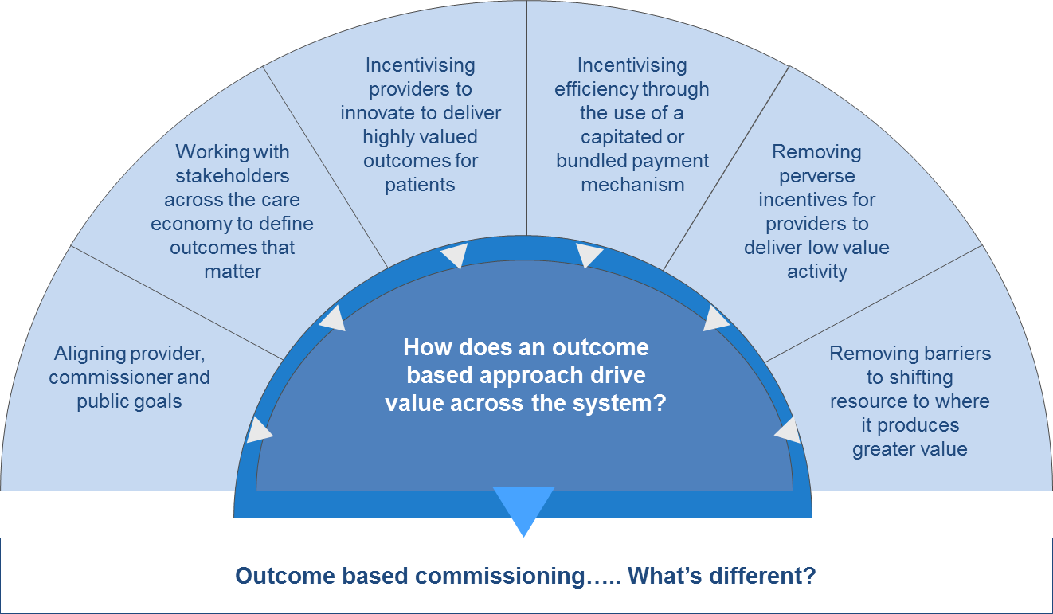
Source: Outcome Based Commissioning Alliance (OBC Alliance) formed of PwC, Wragge & Co, Cobic and Beacon

PHNs have said in responses to a survey conducted in January 2016 as part of this project, that they anticipate migrating to more outcomes based commissioning over the next three years. Such approaches have the potential to improve the focus of delivery from activity to outcomes – or from means to ends – but they are not without challenges. Outcomes based commissioning is still a relatively new approach and will need to be developed progressively in Australia.

3.11 Specifying requirements
This is the process of commissioners stipulating what is to be delivered either as services or outcomes. Service specifications will be familiar to PHNs but they are likely to have less experience in specifying outcomes. More guidance is provided below.
There is a critical balance to be struck between how to specify what you want to commission and dictating the way in which it is to be delivered, versus inviting innovation from the market. Regardless of the approach, PHNs should not stifle innovation. Commissioning is about saying what is to be achieved not what is to be done. Commissioners are unlikely to know fully what the market’s approach might be, and in any event, the job of commissioners should be to invite proposals not dictate them.
This is not to suggest that commissioners are not entitled to say what should be delivered. Rather, it is a balancing act between dictating what needs to be dictated (e.g. adherence to statutory requirements) while allowing space for innovation (e.g. in terms of what interventions can best deliver the outcomes, rather than how they have always been addressed in the past).
Commissioners should specify requirements for bidders/potential service providers to demonstrate their cultural competency and capacity to deliver culturally appropriate services, for example for Aboriginal and Torres Strait Islander people. This is important in ensuring that PHNs’ commissioning activities are responsive to consumer diversity.
One final comment on specifications. Experience suggests that commissioners can over-specify (meaning setting more prescriptive or elaborate requirements than are perhaps necessary) – effectively saying what they would like to be done based on what has been done before, and critically, what has been budgeted to be done. While commissioners should be ambitious and not be led by the past, they should check that their ambitions are not beyond what is really needed. There is also a significant potential affordability implication to such approaches – the higher level of specification can cost much more and this could exceed the budget available.
This leads to two further points that commissioners should consider:
- Developing a public sector comparator (PSC) may help. A PSC is effectively a costing of what the specification would be expected to cost if delivered by the public sector. If, for example, PHNs have always delivered a particular service for 5 days a week and 7 hours a day, how much more would it cost the PHN if the service were commissioned on the basis of 24/7 delivery? If that has significant affordability implications, it is also likely to have such affordability implications for the commissioned providers. A PSC can therefore help PHNs test the affordability of solutions before testing the market. The key thing here is to be alert to what is driving cost – can the PHN afford that? PSCs also allow/facilitate a value for money (VFM) conversation/comparison – what is the market offering and how does that compare with what the public sector could provide? Risk transfer and its evaluation is a key component in this process.
- Value engineering is a process that can help commissioners improve affordability. The acid test question is ‘what is of low value to the PHN, the commissioners, but of high cost to providers?’ If PHNs know this they can ‘adjust’ specifications to reduce the element of high cost, low value proposition to improve affordability. This is a useful negotiation approach where bids are unaffordable.

3.12 The role of providers
International evidence suggests that the role of providers in commissioning is often given insufficient attention leading to sub-optimal commissioning outcomes.
Providers have a role in terms of:
- Innovating in how things are done – much innovation will come from providers and commissioners need to be aware of the latest industry or provider thinking and capability when specifying what is to be delivered, particularly where they are specifying services rather than outcomes. Providers are often incentivised to innovate through pricing and performance mechanisms – effectively to deliver better care outcomes and experience at lower cost. Telehealth and remote monitoring would be good examples.
- Helping co-design models of care or services – commissioners should engage early with providers in the co-design process. This may take place before any formal procurement process is launched or as part of that process – say in the case of competitive dialogue based approaches.
- Responding to commissioning requests – providers must be able to do that effectively and commissioners have a responsibility to understand and build capacity in provider communities.
- Being there – commissioners need providers that can be present and effective in service delivery – this means them being willing to operate in commissioners’ markets or geographies. They may not be there currently and commissioners need to understand why that is (sometimes referred to as ‘barriers to entry’) and what can be done to overcome these.
- Delivery – providers need to have the capacity and capability to do this. Again, capacity building may be required as part of commissioners’ roles.
- Providing feedback – conducting a procurement exercise and effecting contracts is the beginning of a process that must include delivery but also should include mechanisms to get on-going feedback from providers: How are thing going? Are there any barriers or impediments to delivery? What is the relationship with stakeholders like? Are there opportunities to improve the way things are being done?
Commissioners therefore need to put in place arrangements to reflect the above points on an on-going rather than ‘procurement exercise-specific’ basis.

3.13 The role of the community/consumers
International evidence suggests that the role of the community and consumers in commissioning is often given insufficient attention, leading to sub-optimal commissioning outcomes.
PHNs will need to consider the role of their Community Advisory Committees in having input to, and being consulted upon, what and how the PHN commissions. In this, and broader contexts, community and consumers’ roles can be thought of in terms of:
- bringing together diverse perspectives across a range of population and disease groups to bring a different (more patient-centred) perspective to issues;
- representing broader communities and consumers including networking with colleagues and others to ensure good understanding of local health care needs and disseminating information to colleagues and community members;
- helping articulate need through the needs assessment process;
- inputting to co-design processes as a precursor to procurement processes;
- helping to ensure that all stages in the discharge of PHN responsibilities reflect views other than those of commissioners and providers, and that they are patient-centred and aligned to local expectations; and
- increasing consumer participation in health.
For example, Aboriginal and Torres Strait Islander community engagement in developing needs assessments and in the design, delivery and evaluation of appropriate services (including through participation in PHN governance structures) is particularly important to support full and ongoing participation by Aboriginal and Torres Strait Islander people and organisations in all levels of decision-making affecting their health.

3.14 Types of ‘procurement approach’
There are many types of procurement approach, some of which PHNs will be familiar with and will have used in the past. This guidance encourages innovation in procurement approaches to get better outcomes. It cannot cover all approaches, and procurement internationally is evolving. In determining which approach to utilise, commissioners will need to consider issues such as:
- The needs of the process – what is to be procured – can that be easily specified or is co-creation required?
- Will services or outcomes be specified?
- How much time is available?
- How much resource is available?
- What is the value of the potential contract?
- How well developed is the provider community?
- Is there likely to be competition or contestability or is there really only one provider?
- Do services target a vulnerable community group and therefore require additional considerations? (for example, cultural safety, working with children checks, CALD)
This guidance covers three main types of procurement approach:
- Service based
- Competitive dialogue based
- Single provider based
Further guidance on process selection is provided below.
Where PHNs are considering joint commissioning, say with LHNs, they may also need to have regard for State government procurement rules.

3.15 Social impact investment
Some jurisdictions in Australia are beginning to explore the use of social impact or benefit bonds as a funding source for primary care, and other, activity that can deliver social and health benefits over a period of time (including most recently New South Wales and Queensland.

3.16 Types of contracting
Much commissioning will result in a straightforward legal contract between the two parties – commissioner and provider. However, with the advent of more innovation, in particular in relation to consortium based providers, more innovative contracting structures are emerging including:
- Lead providers with sub-contractors
- Joint venture arrangements
- Alliance contracting arrangements
PHNs will need to take the appropriate legal advice to determine the most appropriate contractual structures to effect commissioning arrangements but an overview is provided in Figure 5, below.

Figure 5: Innovations in contracting models
The Prime Contractor Model: In a prime contractor model, contracts are awarded to a single organisation (or consortium) which then sub-contracts other providers. The prime contractor takes responsibility for the design and delivery of care and uses a range of sub-contracts and incentives as it wishes. Commissioners tend to use a mix of capitation and pay for outcomes.
The Alliance Contractor Model: In an alliance contract, a set of providers enters into a single arrangement with a commissioner to deliver services and are legally bound together (i.e. share the risk) for achieving outcomes. Incentives are set based on system goals and outcomes. The system requires high trust and is mutually governed through a shared board of directors.
Joint Venture Model: A joint venture agreement establishes a joint venture between two or more companies. The agreement may establish a business purpose, governance structure and operational rules for the joint venture. The agreement should also set forth the terms and conditions under which the joint venture may be terminated, as well as identifying the venue and relevant law for resolving any disputes.

3.17 Risk management
Commissioners need to effect appropriate risk management arrangements including dealing with:
- Maintenance of a commissioning risk matrix showing the nature of the risk, its likelihood and impact and how it will be mitigated or managed
- Appropriate clinical risk management and governance and how this will be dealt with in a commissioning environment
- Management of probity risks in accordance with overall PHN policies
- Commissioner specific risks – is the PHN able to discharge its functions and responsibilities and are there risks associated with that? This might include staffing and technology issues
- Provider specific risks – what are the risks of provider failure and how would they be dealt with?
- Market risks – in the longer term there is a risk of consolidation / conglomeration of providers over time, and the associated risk of costs then increasing i.e. potential risk that once the ‘market’ has been captured or substantially captured by a narrower set of providers, prices are increased to exploit their market dominance.

3.18 Unsolicited proposals
PHNs will be continually seeking to capture value, and unique and innovative ideas from providers or other relevant sectors, that would provide real and tangible benefits to the people in their PHN regions, and accord with the outcomes of the needs assessment and annual planning processes. Some PHNs may be prepared to receive what are referred to as ‘unsolicited proposals’. These are proposals brought by potential providers to commissioners outside of an approach to market such as a Request for Proposal (RFP) or invitation to submit an Expression of Interest (EOI).
The opportunity to put forward unsolicited proposals allows potential providers to present innovative infrastructure or service delivery solutions, where the PHN has not requested a proposal and the proponent may be uniquely placed to provide a value for money solution.
Some State governments also adopt similar approaches, for example the NSW Government has a dedicated website on its unsolicited proposals process.
PHNs need to determine their own approaches to dealing with unsolicited proposals, but some factors they may wish to reflect upon will include:
- How these proposals are invited – many government bodies do this through their websites.
- What process they would adopt for receiving and evaluating proposals – this may include a multi-stage approach that allows potential providers to have initial dialogue with the PHN to establish whether solutions would be appropriate, all before making significant investment on both sides in submitting and evaluating proposals.
- Adoption of a number of principles that unsolicited proposals must satisfy in order to be considered – these are important to set unsolicited proposals aside from the normal commissioning and procurement process. Such principles may include:
  - That the proposals are outcome related rather than simply service delivery related – the latter is likely to be covered in the PHN’s normal commissioning process.
  - To what extent proposals should be ‘self-financing’ – should there be an expectation of savings in other areas of the PHN’s spending?
  - That proposals offer something different that is unique – the PHN will need to satisfy itself that the potential provider is bringing something that could not be secured or be competed for under ‘normal’ commissioning processes.
  - That proposals will be assessed in accordance with a published set of evaluation criteria.
  - How PHNs will interact with potential providers – PHNs will need to draw on other principles around probity (see below) and reflect on their approaches to co-creation.
  - How the proposals fit with the PHN Funding Agreement and overarching principles, aims and objectives, for example, are the proposals promoting integration or reducing potentially preventable hospitalisation?
  - How proposals address the needs of Aboriginal and Torres Strait Islander people.
  - Whether the proposal would render existing arrangements or services unnecessary or in need of decommissioning and what implications this would have.
  - Probity – how PHNs will ensure this in what is a less ‘normal’ process – some may want to make special provisions like the use of probity advisors. This includes the management of conflicts of interest, intellectual property and confidentiality.
  - How the PHN will commit resources to the process, and how providers would be expected to do so.
  - How the process is governed and reported to or approved by the Board.
- PHNs will need to consider how any such approach will fit with its needs assessment and annual planning timelines – are these proposals acceptable at any time, or in specific windows?
- PHNs may wish to collaborate amongst themselves or with LHNs or others in how they deal with such proposals – particularly given their expectation of moving to more joint and outcomes based commissioning.
Given that this is a relatively new concept for PHNs, they may wish to consult the Australian Government Department of Health before fully adopting an approach or progressing significant unsolicited proposals.

BEING READY TO COMMISSION/DESIGN/CONTRACT
Commissioning, designing and contracting services or outcomes should not be taken lightly and there are a number of prerequisites that commissioners should consider. This is not an exhaustive list, nor is the content under each prerequisite exhaustive, but they are key areas that need to be given careful consideration. Similarly, PHNs’ capability in the areas discussed under these headings will grow. Lastly, these areas take time and resources, and commissioners will need to plan accordingly. This list could be thought of as a check-list of things to have in place before commissioning commences.

4.1 Commissioning scope and packaging
What will be commissioned and how will things be bundled together or packaged?
What to commission should be driven by the annual planning process. Ensure, therefore, that the scope of commissioning is consistent with the outcomes of the annual planning process, which in itself will be driven by the needs assessment.
Packaging is about how things to be commissioned are presented to the market – each could be presented separately or the whole lot could be packaged together. The reality is that neither approach will secure best value or best market response because:
- Packages that are too small will cost too much to administer, will not stimulate or interest market demand (especially from larger players), and will result in fragmentation and complexities of interdependencies between packages.
- Packages that are too large will also not stimulate market demand (especially from smaller players), not maximise synergies between what is to be done, will be overly complex in interdependencies within the package, and will not secure ‘best of breed’ solutions.
In reality, neither packaging approach will ensure that value for money is maximised.
Points to consider include:
- How things fit together – are there natural synergies?
- Are there dependencies which mean that requirements would be better bundled together? Where there are key dependencies, commissioners want to avoid one provider blaming another
- How would providers package things together – would a particular grouping or bundling of options deter providers or encourage them?
- The package should be complementary – from both the delivery and commercial perspectives
- What is the market and what would best attract this market?
- What has been done before? This is not the only consideration, but one that will have conditioned the market.

4.2 Evaluation criteria and approach
Good commissioning practice suggests that commissioners should prepare and publish their evaluation criteria as soon as possible. These criteria should be:
- driven by the outcomes being sought;
- consistent with any commissioning principles the PHN has adopted;
- consistently applied;
- both qualitative and quantitative; and
- ideally focused more on outcomes and outputs rather than requiring certain inputs and processes which may stifle innovation.
PHNs need to establish arrangements to effect tender evaluation, including having:
- the right governance;
- defined processes for how the evaluation will be done;
- protocols relating to approach, conduct etc;
- agreed reporting arrangements; and
- agreed involvement of community and clinical representatives.
Business case
Commissioners would ideally prepare business cases for the priority areas derived from the annual planning process. Fundamentally, these business cases would demonstrate the rationale for a particular focus area, its strategic fit with overall PHN direction, options for delivery, with a chosen preference, the budget available and how these priority areas might be taken forward as part of a commissioning process. Further guidance on business planning is available in the ‘PHN planning in a commissioning environment – Resources’ document.
Public sector comparator
As described in section 3 above, commissioners, perhaps as part of the business planning process, should consider preparing a PSC to assist in the assessment of value for money and affordability.
Co-design approaches
Co-design (sometimes referred to as co-creation) is the process by which parties can work together to derive a solution that is better than any that they could have derived alone. It also secures different perspectives, challenges traditional approaches and secures better stakeholder buy-in. Further details are provided in the Toolbox.
Organising for success
To maximise the prospect of success, PHNs need to make the right arrangements before commencing a designing and contracting exercise. Typical things to consider include:
- governance arrangements, decision points/approaches;
- the roles to be performed, resourcing and the allocation of responsibilities;
- measures of performance/success;
- external support required, if any;
- stakeholder engagement plan, including with State Governments and the Australian Government;
- project plan, including dependencies and critical path;
- approach to managing conflicts of interest;
- communications plan;
- change management plan;
- staff involvement / engagement plan;
- supplier engagement approach;
- consumer and community engagement approach; and
- responsiveness to consumer diversity.

Market engagement
Shaping the structure of supply is a key phase of the commissioning framework. Without a flourishing supplier community, PHNs will not be able to maximise the innovation or delivery of interventions or services that meet the needs of the people in their PHN regions, or secure contestability or competitive tension that leads to better value for money. Failure to develop and maintain markets will lead to commissioning failure.
Market engagement typically involves:
- understanding and assessing the market;
- using care design co-creation to work with markets to derive better solutions;
- understanding and overcoming barriers to market entry;
- making markets and building capacity to respond to needs; and
- maintaining markets.
Such approaches will help to ensure that:
- markets are assessed against agreed criteria and that market barriers to entry are identified, and where possible, overcome to ensure successful delivery;
- an established market exists with a variety of providers who have the capability, capacity, willingness and availability to deliver services that are affordable and which meet the identified needs of the population; and
- where this is not possible, PHNs are aware and able to manage the consequences.
Procurement approach to adopt
The following sections provide guidance on the options available for how the procurement might be run. There are many options and the selection will be governed by factors including:
- What is being commissioned – goods, services, outcomes
- Are these currently delivered and if so, by whom?
- By whom will they be commissioned – the PHN alone or with partners?
- Whether and how the involvement of providers would assist
- Whether there is a strong provider community, or just one potential provider
- Given the above, what is the best fit approach?
The following sections explore how to make these decisions, what the options mean and how they can be effected.

COMMISSIONING APPROACHES
A working level discussion paper provided to PHNs by the Department of Health in December 2015, ‘PHN Commissioning – Procuring services and shaping supply’ included a flow chart to assist with deciding how to commission. Whilst this chart (Figure 6, below) remains relevant to informing decisions on commissioning approaches, the following charts (Figures 7 and 8) about key questions build upon this thinking. The key point here is that the choice of commissioning or designing/contracting approach is unlikely to be binary; it is more likely to be a balancing of views or positions that lead commissioners to a range of options.
Figure 6: Flow chart to assist in determining commissioning approaches
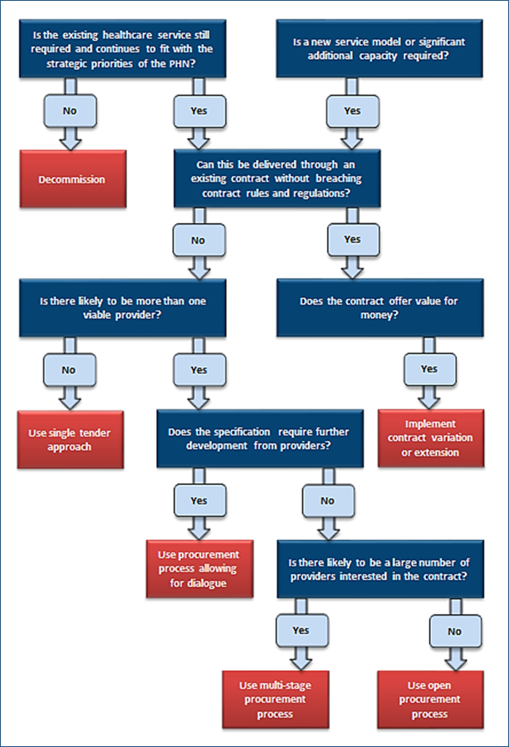

To assist in this balancing of views, the illustrations below provide a framework for informing thinking. Figure 7 illustrates five key questions that commissioners might address and
Figure 8 provides a ‘worked’ example.
Figure 7: PHN procurement decision making process flow chart
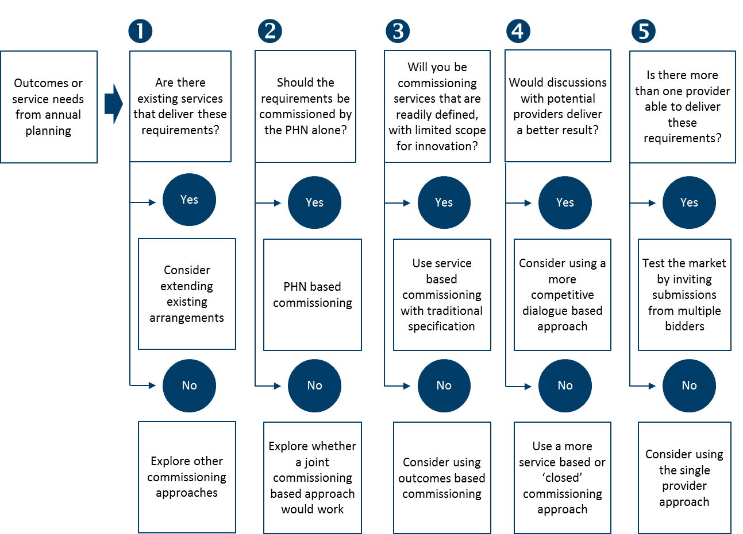

Figure 8: PHN procurement decision making process flow chart – illustrative example shown with blue shading.
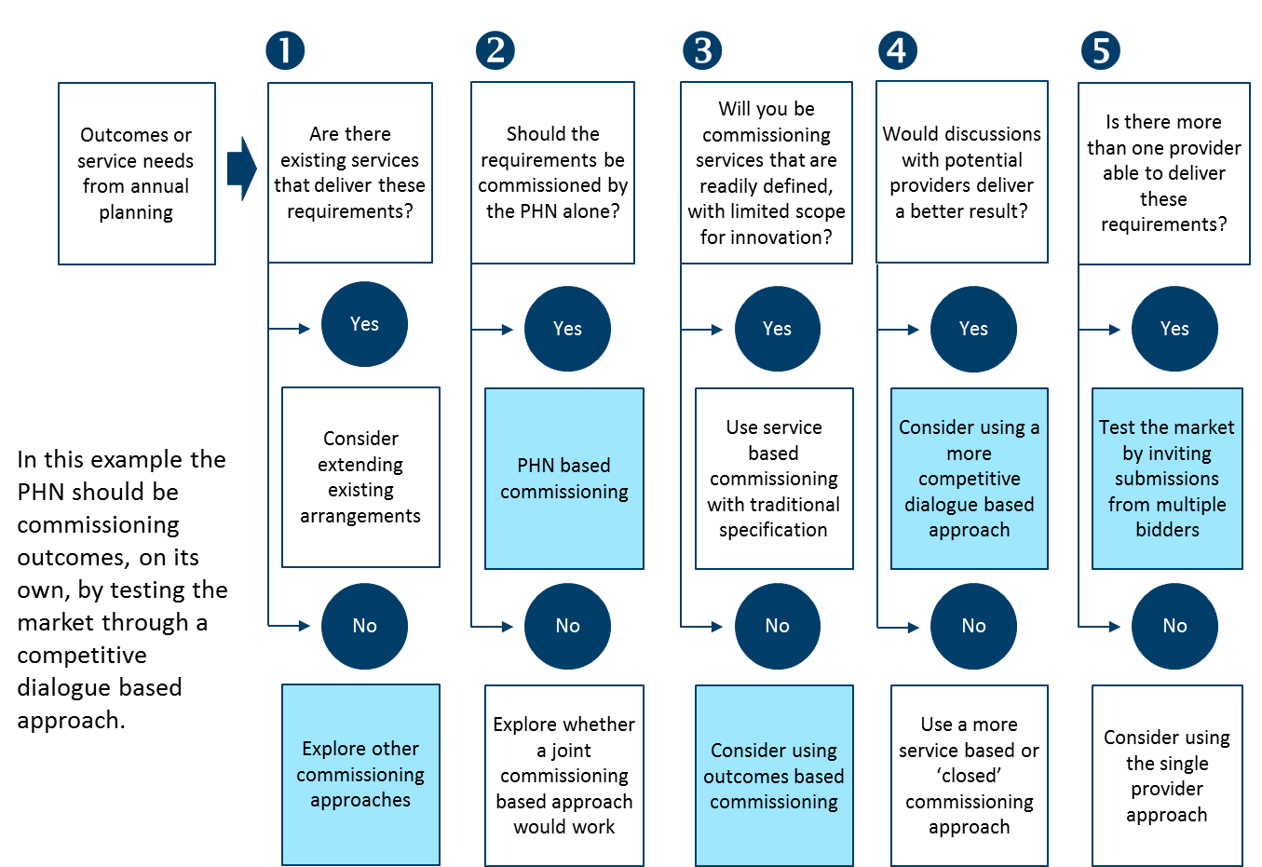
This kind of ‘decision tree or approach’ leads commissioners to a set of parameters that will inform which designing/contracting approaches might be appropriate.
As noted above, there are many approaches to designing and contracting but this guidance focuses on six key ‘tool sets’ that commissioners can draw upon.
- Designing services, including co-creation
- Decommissioning services
- Contract variation or extension and overarching contracting considerations
- Contracting – Service specification based
- Contracting – Competitive Dialogue
- Contracting – Most Capable Provider (MCP) or Single Provider

DESIGNING/CONTRACTING TOOLBOX

6.1. Designing services, including co-creation
Introduction
Service design and co-creation can cover three key situations:
- Involvement of potential providers and consumers in the development of high level specifications of need – what are the headline outcomes to be achieved?
- Prior to commencing a procurement process, working with potential providers and consumers to develop this specification into potential solutions – what might be an appropriate response to the specification, where could innovation be introduced, can the specification be improved?
- Co-designing solutions during the procurement process, perhaps as part of a competitive dialogue process

As noted above, there is a trade-off between design and allowing innovation and this can be thought of as a spectrum:
Figure 9: The design continuum
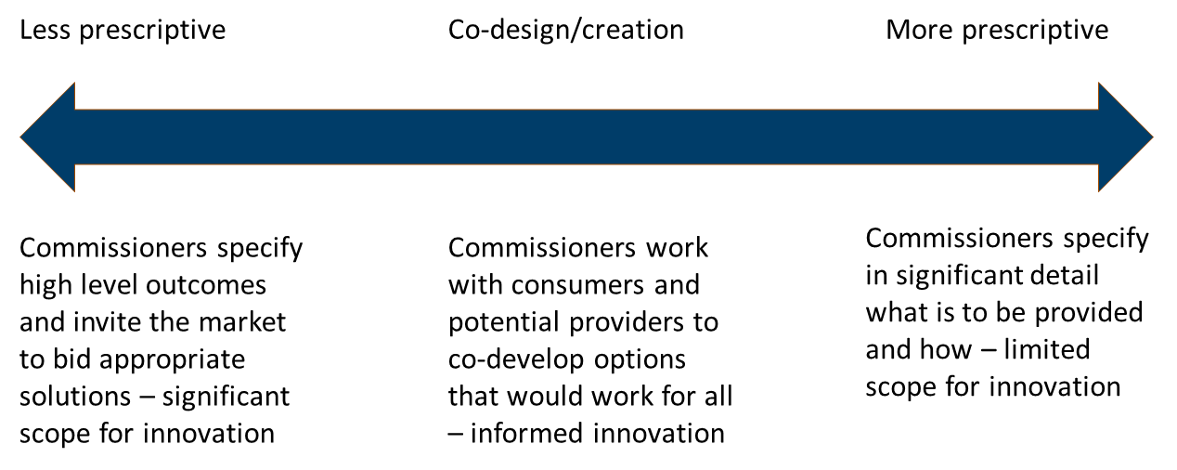

Commissioners need to find solutions that work in the circumstances; there is no right or wrong answer to this. A major factor influencing this decision will be whether the scope of the commissioning is more service based or outcome based. In general, there is likely to be more scope for a less prescriptive approach where outcomes are being commissioned, rather than services.

When might PHNs use these approaches?
As covered above, the extent to which services are ‘designed’ will depend upon a number of factors. The following table provides some guidance on the approaches to be adopted.
Table 1: Factors in determining commissioning approaches
Factor | More likely to be suited to a less prescriptive (innovative/open) approach | More likely to be suited to a more prescriptive specified approach
Outcomes or services being commissioned? | Where outcomes based commissioning is the approach being adopted and there is scope for different approaches from bidders. | Where there is more of a service based approach and bidders will need to deliver services in accordance with commissioners’ requirements – this may include certain regulatory requirements or approved models of care.
User involvement | Users can be involved in the development of the outcomes to be commissioned and high level models of care. Bidders may include consumer consultation as part of their bidding process. | Service based specifications have traditionally tended to be more provider-driven, but good practice would suggest that even in these circumstances, consumers should be consulted.
Market | Requires a market that is capable of innovating around solutions that will satisfy the outcomes based specification. May require market capacity that does not currently exist. | May direct the market more in terms of what is required (which might be a good thing), but may also stifle new or fresh thinking and discourage innovative thinking by market entrants, who may see that only traditional approaches would be acceptable.
Scope for innovation | Significant | More limited

What is involved?
Co-design prior to any procurement process
Co-design at this stage is typically aimed at developing thinking around what will be commissioned. This could sit on a spectrum from the definition of high level outcomes to be achieved, through to the much more detailed specification of services to be delivered. This guidance covers how these different positions on the spectrum can be used in procurement i.e. more service or outcome based commissioning, and the pros and cons of each.
Typically, this kind of co-design will be followed by a procurement process but there are examples from the UK in which commissioners have continued to work with the same providers as were involved in co-design, as the ‘most capable provider’. Such an approach needs to be managed very carefully and appropriate legal advice sought to avoid anti-competitive practices.
Table 2 below summarises some of the key aspects of this approach.
Table 2: Features of a co-design approach prior to any procurement process
Issue | Potential approaches
Who might be involved? | - Commissioners  - GPs  - Other interested parties (potentially co-commissioners)  e.g. LHNs  - Potential providers  - Community and patient representatives  - Others – Academics, specialists, experts and peak bodies
How might these stakeholders be selected to avoid issues? | Commissioners would typically organise these events or processes. They may select bodies to be involved (where there are no potential conflict of interest issues), or could invite expressions of interest to be involved. (See also the role of soft market soundings below).
What is the process? | Participants come together based on an agreed scope and agenda, for example, ‘We are here today to agree the outcomes to be delivered for the aged cohort (of this specified place) and develop a high level model of care that would better deliver against those outcomes’.  Events are typically facilitated and require input in terms of leading international practice and evidence, to inform alternative solutions. Analytics assistance can also add value in terms of better understanding cohorts and issues.  Participants work together to develop, test and refine thinking and solutions. In the above example, what are the outcomes? What are potential models of care?  The process may run over several sessions with ‘homework’ or further analysis required between each.
What are the intended outcomes? | This will vary according to the agreed objectives but could include:  - Outcomes and associated measures  - High level model of care  - A ‘blueprint’ of potential interventions  - More informed and involved stakeholders  - Arrangements for ‘socialising’ these outcomes  - Agreed next steps
Ground rules – are there key issues to manage or be aware of? | Participants should come with the authority of their sponsoring organisation as appropriate.  Participants should be organisationally ‘agnostic’; they are there to work together with fellow participants to derive solutions that work for the beneficiaries, not to represent themselves or their organisations’ views.  Strong facilitation is required.
Managing conflicts of interest | Participant selection processes will help – see above.  Facilitators have a role in ensuring that participants are acting appropriately.  Results of the events should be readily available to others, where appropriate.
Informing or replacing the specification process? | Co-design should inform the process of commissioners specifying what is to be commissioned; it should not replace that process.
How are the outcomes used in the commissioning process? | Outcomes would typically be used to inform the specification of requirements, as part of the procurement or contracting approaches being deployed.

Co-design as part of the procurement process
Some procurement processes will allow co-design as part of the process. This might take two forms:
- As part of bidders’ days. These are typically organised at the beginning of a procurement process and are designed to allow bidders (or potential bidders) to come together with commissioners to discuss requirements in an open forum. Experience suggests that bidders are reluctant to discuss things openly in front of competitors. Therefore, in terms of co-design, bidders’ days are of limited value.
- As part of the actual procurement process – especially in approaches like competitive dialogue – see below.
The role of soft market soundings
Soft market soundings are a way of getting initial market views on commissioners’ requirements. They can be conducted in a number of ways including by:
- Broad based public advertisements inviting participation, where national or international interest is being sought
- More focused public advertisements inviting participation, where regional or national interest is being sought
- Direct approaches to certain delivery or provider organisations where these are known, but note that this involves some risk of challenges around the openness of the opportunity
There are different ways to conduct soft market soundings but the process might typically involve:
- Advertising to invite expressions of interest to take part in the process
- Acceptance of these EOIs
- Asking a series of structured questions of the organisations that have expressed interest
- Receiving and reviewing responses
- Potentially interviewing all or some of the respondents to build on the information submitted
- Summarising responses received
- Considering how responses might be used to inform the procurement process and specification of requirements
- Considering what responses mean for the maturity of the market and whether any capacity issues need to be addressed.
Good practice would suggest that commissioners should not divulge the content of individual responses as part of the procurement process, and they should not use certain responses to dictate in absolute terms, what is being procured, as this might favour a particular provider. If interesting responses are received, commissioners should use these to inform open questions about the particular issue.

6.2. Decommissioning services
Introduction
Decommissioning is a situation where a service is discontinued, rather than where an alternative provider is found. Needs assessment and annual planning will help inform the identification of services that may need to be decommissioned; effectively those that are currently delivered but are not required or justified based on prioritised need or action required. The ability to decommission will be governed by factors such as contract duration and ‘break clauses’ and continuity where consumers are relying on existing arrangements.
When might you use this approach?
Decommissioning would be deployed where a service or outcome is no longer required, typically because it is not achieving the outcomes identified in the needs assessment or no longer aligns with the PHN’s strategic direction.
What is involved?
PHNs should establish a framework or approach on how to make decommissioning decisions as part of their annual planning process.

Typical decommissioning or exit arrangements will include:
- Communication and consultation arrangements – agree with whom this needs to take place and how. PHNs should also ensure that they communicate early with the Australian Government Department of Health in relation to any decommissioning decisions that are made.
- Contractual provisions – what do they allow in terms of break-clauses or termination?
- Specific termination provisions in contracts – some contracts will have these and they must be understood and adhered to
- How any built-in or pre-existing intellectual property (IP) would be dealt with
- Investments made – if providers have made investments that would have a benefit beyond the termination point, they may seek recompense for unrecovered costs
- Staffing issues – what will happen to staff who are currently being employed in service delivery?
- Service continuity and transition – a critical issue that needs to be managed carefully, for example, transfer of client records, transitioning ways of working or particular systems that have been used
- Dispute resolution in the event of unresolved issues
- Governance to be applied to the process
- Stakeholder engagement – where they are impacted by the decommissioning of services or activity
- Market implications – commissioners need to carefully consider the market or provider implications, including potential unforeseen consequences
- Giving the affected organisations sufficient notice of changes to allow them to respond appropriately.

Further information about decommissioning can be found on the NHS Commissioning Handbook website.

6.3. Contract variation or extension and overarching contracting considerations
Introduction
This provides an alternative to commissioning or designing and contracting from scratch. Commissioners look at what needs to be commissioned and compare this with what is being delivered now, and by whom. They may then come to a view that it is better to extend an existing contract than to re-contract for the new requirements.
Such an approach may be appropriate where the change required in the contract does not materially alter the nature of the contract as originally procured, such that it amounts to a new contract.
There are a number of other factors that commissioners should take into account when deciding to pursue this option and these are covered below.
When might you use this approach?
The following factors might dissuade or prevent commissioners from extending an existing arrangement:
- There is little synergy between the new and existing requirements
- The contract makes extension difficult
- The provider has not performed existing services satisfactorily
- The provider has no unique insight that positions them better than another new provider
- Timing is less critical and you have time to go to market
- There is a strong provider market for the new requirements – would any of these providers challenge a decision to extend?
- The provider is unwilling to reflect the economy of scale that the new arrangements afford in the overall pricing
- The provider is seeking an unwarranted contract extension period
- Other providers would have been interested in bidding for the contract if the change had originally been part of the specification when the service was originally procured
- The contract would (probably) have been awarded to a different provider if the change had originally been included in the original service specification
- The change involves genuinely new services that were not originally within the scope of the specification covered by the contract
- There is a significant change in the value of the contract.
What is involved?
PHNs will need to take appropriate legal advice in relation to contract variation or extension.

Overarching contracting considerations
Before moving on to the guidance on the other designing and contracting approaches, PHNs should be aware of two generic considerations that apply:
- the objectives of contracting ; and
- considerations for which contracting approach to use.
Common objectives of contracting approaches
PHNs need to be clear about what they hope to achieve from contracting and the context within which that is done. Provided below are some common objectives that PHNs should consider and agree based on local circumstances:
Strategy and approach
- Agreeing the overall commissioning strategy – what are the guiding principles that commissioners should be following? This strategy must have regard for the PHN Funding Agreement.
- Adopting the right contracting approach (see further details on this below).
Overall desired outcomes
- Delivering overall desired outcomes including value for money, governance, effective solutions, and affordability
Competitive tension
- Maximising the benefit of ‘competitive tension’ even where a single provider is involved
- Getting to the point of acceptability of bids and offers – using the process to refine solutions
- Selecting a provider that will work for you and you for them – a sustainable option, not a short term gain
- Securing a win-win i.e for the commissioner and the provider. This will also build sustainability and avoid conflicts later
The market
- ‘Selling’ the opportunity to the market – getting the right market interest
- Keeping the market engaged
- Ensuring the market has the right impression of commissioners
- Securing a provider that is ‘in it’ for the long run
The process
- Having the right governance in place
- Ensuring probity and legality
- Ensuring a level playing field and fairness in the process – avoiding and managing conflicts of interest
- Agreeing evaluation approaches upfront and conducting evaluation appropriately
- Securing transparency of process
- Avoiding challenges

Deciding whether to use a competitive (multiple provider) or single (most capable provider) solution
There are also some key considerations when debating whether to use a competitive process as opposed to a most capable or single provider based model.
Table 3: Deciding on whether to use single (most capable) or competitive (multiple) provider approaches
Competitive approach | Factors to take into account | Single Provider approach
Used extensively elsewhere – allows some standardisation. | Timescales | Has the propensity to be quicker but in reality may take longer. Less experience to dictate timelines.
Both approaches are driven by the competitive process and inherent competitive tension | Securing outcomes and Value for Money (VFM) | Relies much more on co-creation than competitive tension  Less price leverage
New interventions needed that do not currently exist and require new providers to bring the innovation | Outcomes / services to commission | Less clarity of need – requires  co-creating  Building on existing services
Well-developed market that can compete for new opportunities | Market maturity | More suited to under-developed markets where there is a relatively small supplier base
Secured through competition but protocols are still required | Probity | More challenging to secure – needs careful consideration
More sense of level playing field, provided the process is run effectively | Level playing field, supporting new entrants | Less sense of level playing field but EOI process could assist with this
Procurement process challenges – but possible through competitive dialogue based approach | Co-creating solutions | Part of approach
More tension and potentially more innovation, depending on market maturity and the procurement approach | Competitive tension / innovation | Less tension and potentially less innovation, but this can be built into co-design
Clarity needed for market from the outset? | Clarity on needs | Co-create as you ‘go along’

6.4. Contracting – Service-specification based
Introduction
Service-specification based tendering or contracting is a procurement method that has been used by many parts of the public sector (including the former MLs). This approach:
- starts from a position of known requirements – there is less need to co-create or develop these before or as part of the process;
- is more ‘transactional’ – the commissioner says what they want and potential providers bid against that;
- is often service based rather than outcome based;
- typically involves a competition between two or more potential providers;
- may include a pre-qualification process; and
- will be well-defined in terms of timing and process.
When might PHNs use this approach?
Generally, this approach is suitable when:
- there may be existing services that are being recommissioned – but this is not essential;
- services are well defined and can be specified as such;
- the requirement may be commissioned by the PHN alone or with partners under a joint commissioning approach;
- there is less benefit to be had from co-creation or dialogue with providers in order to develop more innovative solutions i.e. the PHN knows what it wants and (broadly speaking) how that could be delivered;
- time is more of the essence – these approaches can be run over a very short time in the case of ‘urgent’ requirements; or
- there are multiple potential providers that could deliver against the specification.

What is involved?
For illustration purposes, the process can be summarised as shown in Figure 10 below (note that timescales are indicative only):
Figure 10: Service specification based commissioning timeline
The steps involved (which are described more fully in Appendix I) include:
- preparing the commissioning strategy and documentation, including business case;
- advertising to invite EOIs;
- receiving and evaluating EOIs;
- issuing the RFP;
- receiving submissions;
- evaluating submissions and clarifying any issues;
- refining the evaluation;
- evaluation sign off;
- due diligence – both parties;
- negotiating the contract with the Preferred Bidder (PB); and
- awarding the contract and debriefing bidders.
Advantages
The service specification based approach has the following advantages:
- there is more clarity about what is being procured, hence selection and pricing comparisons are more straightforward;
- PHNs are likely to have staff who have procured in this way before, so there may be less need to build capacity;
- these processes are less likely to be challenged in terms of probity and potential conflicts of interest;
- where a pre-qualification or EOI process is used, the number of quotations received is limited to the number of bidders from whom quotations were sought, so the time involved in the selection process is also reduced;
- the PHN would usually have a good sense of where, and from whom the goods, services or works can be procured, so there is a higher probability of responses to the request for quotations; and
- this can make the process more manageable and reduce costs both for PHN and for the bidders.
Disadvantages
The service specification based approach has the following disadvantages:
- limited (if any) co-creation or provider and consumer involvement – very commissioner orientated;
- not outcomes orientated;
- less opportunity for innovation because commissioners typically stipulate what they want to be delivered and how;
- this may deter new market entrants who might bring more innovative ideas;
- pricing may be higher or lower than expected due to the limited time, and because the quality of the brief affects the offers; and
- if a more ‘restricted approach’ is adopted, this may introduce conflicts because the procuring entity decides which suppliers, contractors or service providers to send request for quotations to, and competition is very limited.
Potential risks and their management and mitigation options
Note that many of the risks associated with the service specification process are similar across the three approaches, but each is covered under the relevant section for the purposes of completeness.

Table 4: Service specification based commissioning - risks and issues
Risk | Management / mitigation
Insufficient market interest; bidders put off by inability to innovate | Warm up the market; market assessment and creation; make the opportunity commercially attractive; highlight innovation opportunities
Insufficient innovation in solutions | Try to allow scope for innovation even in defined service type procurements
Inadequate resourcing | Resource effectively; have contingency plans; not business as usual
Insufficient skills | Get the right people on board internally and externally; learning and development; leadership
Timescales slippage | Try to avoid – bidder impact; project management resources; flexibility
Governance challenges | Brief from the outset; keep on board
Industrial relations challenges | Agree involvement in the process
Unaffordable submissions | Clarity on affordability envelope; share with bidders; ‘value engineering’, public sector comparators
Commissioner disagreement | Invest in joint agreement up front; manage the Board; key issues; take ‘the pulse’
Probity issues | Potentially appoint an independence auditor or advisor
Bidder withdrawal from the process | Invest in bidder relationship management; understand the key issues
Assumptions / due diligence issues | Commissioner due diligence upfront; gather price sensitive assumptions
Surprises | Check in regularly

6.5. Contracting – Competitive dialogue
Introduction
Competitive dialogue is a tendering option that allows for bidders to develop alternative proposals in response to a client’s outline of requirements. Following initial selection of bidders, it provides the opportunity for parallel but separate dialogue sessions between bidders and commissioners in which solutions and supporting enablers can be discussed and co-developed.
Only when their proposals are developed to a sufficient level of detail, are tenderers invited to submit final competitive bids.
The aims are to increase value by encouraging innovation, and to maintain competitive pressure in bidding for complex contracts. Competitive dialogue has been used extensively in Europe for complex infrastructure and strategic partnering contracts.
Competitive dialogue is therefore a procurement method that:
- is appropriate for more complex procurements, or where commissioners are seeking innovative solutions or need to work with the providers to develop the service model;
- may be more appropriate because it allows for a dialogue (or co-creation) with bidders, rather than just asking for bids in response to a defined specification;
- is well-suited to outcomes based commissioning;
- starts from a position of less known requirements – there is more need to co-create or develop these before or as part of the process;
- typically involves a competition between two or more potential providers;
- may include a pre-qualification process;
- will be well-defined in terms of timing and process (but note that the actual dialogue process is demanding and can be time consuming); and
- is demanding in terms of capacity and capability.

When might PHNs use this approach?
Generally, the competitive dialogue approach is suitable when:
- adopting a more outcomes orientated approach, and when commissioners need innovation around solutions to achieve those outcomes;
- services are less well defined and cannot be specified as such;
- the requirement may be commissioned by the PHN alone or with partners under a joint commissioning approach;
- it is less clear how the market might respond;
- the requirement is significant – bidders have complained in other jurisdictions that competitive dialogue is a protracted and expensive process that would not be worthwhile if commissioners were not serious about innovation or for small opportunities;
- there is more benefit to be had from co-creation or dialogue with providers in order to develop more innovative solutions i.e. where commissioners are not sure what they want nor how it could/might be delivered; and
- there are multiple potential providers that could deliver against the specification.
What is involved?
For illustration purposes the process can be summarised as shown in Figure 11 below (note that timescales are indicative only).

Figure 11: Competitive dialogue based commissioning timeline
Process steps and timelines
The steps involved (which are described more fully in Appendix II) include:
- preparing the commissioning strategy and documentation, including business case;
- advertising to invite EOIs;
- receiving and evaluating EOIs;
- inviting participation in dialogue;
- conducting dialogue – co-creation;
- receiving submissions;
- evaluating submissions and clarifying any issues;
- refining the evaluation;
- refining bidder numbers;
- best and final offer – invitation, submission, evaluation;
- evaluation sign off;
- due diligence – both parties;
- negotiating the contract with the PB; and
- awarding the contract award and debriefing bidders.
Advantages
The competitive dialogue approach has the following advantages:
- it is more focused on the outcomes being sought than on commissioners’ perspectives of what should be done;
- for the commissioner, competitive dialogue makes it easier to confirm that ’all necessary elements’ are in place before bids are submitted, resulting in more robust tenders;
- active dialogue should prevent the possibility of misinterpretation by either the tenderer or the client, and hence, cost escalation later in the contract; it allows the parties to test thinking and ideas before committing;
- for bidders, the process provides better information flow, together with the opportunity to test the client’s requirements through a progressive development of their proposal;
- it allows for the development of innovative solutions or the development of service models;
- effective procurement will identify a project’s target market and package up the opportunity to appeal to that market;
- effective procurement will also focus on securing a deliverable and affordable solution that best meets the commissioner’s needs, and on providing a firm contractual basis against which delivery and performance can be assessed; legal and financial dialogue should support this; and
- can encourage new market entrants who have fresh thinking about how requirements can be met.
Disadvantages
The competitive dialogue approach has the following disadvantages:
- competitive dialogue is resource intensive for bidders and commissioners;
- it requires new skills and capabilities that the PHN may not have access to;
- it can result in ‘IP leakage’ that undermines the process i.e. where the ideas or innovations of one bidder are inadvertently shared with other bidders; this is unethical and poor practice;
- it can be more time consuming;
- the resourcing requirements may dissuade bidders from participating; and
- there can be perceived conflicts of interest.
Potential risks and their management and mitigation options
Table 5: Competitive dialogue based commissioning - risks and issues
Risk | Management/ mitigation
Insufficient market interest | Warm up the market; market assessment and creation; make the opportunity commercially attractive
Bidders dissuaded by the resourcing implications of the competitive dialogue process | Use competitive dialogue only in appropriate circumstances; teams need to be kept well organised right through the process; be ‘bidder empathetic’
Inadequate resourcing | Resource effectively; have contingency plans; not business as usual
Insufficient skills | Get the right people on board internally and externally; learning and development; leadership – this may require specific skills development or external support for the competitive dialogue process
Timescales slippage | Try to avoid – bidder impact; project management resources; flexibility – focus on the competitive dialogue elements – likely to result in slippage
Governance challenges | Brief from the outset; keep on board
Industrial relations challenges | Agree involvement in the process
Unaffordable submissions | Clarity on affordability envelope; share with bidders; ‘value engineering’, public sector comparators
Commissioner disagreement | Invest in joint agreement up front; manage the Board; key issues; take ‘the pulse’
Probity issues | Consider the use of an independent probity advisor. Take particular care around the competitive dialogue sessions. Develop and stick to protocols.
Bidder withdrawal | Invest in bidder relationship management; understand the key issues
Assumptions / Due diligence issues | Commissioner due diligence upfront; gather price sensitive assumptions
Surprises | Check in regularly

6.6. Contracting – Most Capable Provider (MCP) or single provider
Introduction
When PHNs determine (through analysis of the market and proportionate and transparent engagement with potential providers) that the services can only be provided by one particular provider (or consortium thereof), or when there is an urgent need, a single source procurement approach may be the most appropriate method.
Single source procurement refers to acquiring goods and services from only one source. It may, however, include a competitive EOI process to establish who the single source providers might be.
This is a non-competitive method that is often collaborative in approach.
Having regard to the requirements of the PHN Funding Agreement, the method should only be used after very careful consideration, as articulated in the decision making process, and also after ensuring that the rationale for the decision is documented.

MCP or single provider based tendering or contracting is a procurement method that:
- is based on pre-selection of a MCP – this can be through an EOI process that injects some sense of competition and avoids challenges from excluded parties;
- is appropriate for more complex procurements or where a PHN is seeking innovative solutions or needs to work with the MCP to develop the service model;
- is suitable for less well-developed markets where there are fewer providers;
- may be suitable where a bidder consortium based approach is the preferred solution – encouraging would-be providers to collaborate rather than compete;
- can include gateways that check progress on key issues, while still reserving the right to go to a fully competitive model if progress is unsatisfactory;
- is well-suited to outcomes based commissioning; and
- will be less well-defined in terms of timing and process.
When might PHNs use this approach?
Generally, this approach is suitable when:
- markets are under-developed and there would be no real competition for provision;
- there is a clear most capable (single or group of) providers;
- the requirement may be commissioned by the PHN alone or with partners under a joint commissioning approach;
- there is more benefit to be had from collaborative co-creation with providers in order to develop more innovative solutions;
- commissioners are not sure what they want or how that could be delivered; and
- it is better to work with one group of providers than get limited response to a competitive process.
Securing value for money (VFM) in such approaches
Without the competitive tension that contestability would introduce, PHNs may be concerned with securing VFM in this approach. There are a number of ways that this can be managed:
- the use of a public sector comparator to act as a ‘yardstick’ against which to compare bids – see above;
- ensuring openness and transparency of the ‘bidder’ cost base by:
  - specifying and requiring the use of a detailed financial model that bidders must complete and maintain/update;
  - having a clear understanding of what is driving cost and the key cost sensitive assumptions;
  - understanding what bidders have included in, and excluded from, their submissions;
  - understanding how any costs change over time;
  - the use of techniques like ‘value engineering’ to reduce the cost of lower value components;
- benchmarking against other industries, bids and PHNs; and
- ensuring that the PHN has the right VFM focused skills and capacity in place.
What is involved?
For illustration purposes the process can be summarised as shown in Figure 12 below (note that timescales are indicative only).
Figure 12: MCP based commissioning timeline
Process steps and timelines
The steps involved in the MCP approach (which are described more fully in
Appendix III) include:
- preparing the commissioning strategy and documentation, including business case;
- advertising to invite EOIs for MCP appointment;
- receiving and evaluating EOIs and appointing the MCP;
- issuing further memorandum of information (MOI) detail (unless already covered), and governance memorandum of understanding (MoU) requirements;
- receiving and evaluating governance submissions;
- finessing governance submissions or ‘go to competition’;
- releasing MCP dialogue documents;
- dialogue and response submission;
- interim check in;
- evaluating submission, clarification;
- evaluation sign off;
- finalising negotiation;
- due diligence – both parties; and
- awarding the contract.

Advantages
The MCP or single provider approach has the following advantages:
- allows a process to go ahead in the face of insufficient competition;
- provides the opportunity for intense collaboration and co-creation;
- encourages consortium members to work together rather than against each other, and is therefore better for integrated solutions; and
- PHNs only need to approve and manage one supplier (although this is offset by the complexities).
Disadvantages
The MCP or single provider approach has the following disadvantages:
- the lack of competitive tension can result in poorer value for money;
- there is the potential for the process to progress too slowly because the natural competitive tension does not exist and it is more difficult for commissioners to apply pressure to the ‘single bidder’;
- potential challenges from external parties;
- there may be challenges in getting agreement to the approach (which is very different from traditional approaches) from the Australian Government or PHN Boards, and commissioners should consult early if they propose to use this approach;
- the potential supplier may become complacent, therefore gateways are needed to check and avoid this; and
- risks of financial problems, affordability and price increases because competitive tension does not exist, and – there is less concern from the MCP that they need to offer better value for money than a competitor. (The use of public sector comparisons as benchmarks or yardsticks could be appropriate).

Potential risks and their management/ mitigation options
Table 6: MCP based commissioning - risks and issues
Risk | Management/ mitigation
Government approval not forthcoming | Engage early, be prepared to address the potential risks and challenges with objective evidence – why is an MCP approach being advocated?
Insufficient market interest in initial EOI process | Prepare the market; market assessment and creation; make the opportunity commercially attractive
Inadequate resourcing | Resource effectively; have contingency plans; recognise that this is not business as usual
Insufficient skills | Get the right people on board internally and externally; learning and development; leadership
Timescales slippage | Try to avoid – bidder impact; project management resources; flexibility
Governance challenges | Brief from the outset; keep on board
Staffing and people | Communications, involvement, impact analysis, change management
Poor cultural fit | Build into the procurement and evaluation processes – throughout
Industrial relations challenges | Agree involvement in the process
Unaffordable submissions | Clarity on affordability envelope; share with bidders; ‘value engineering’
Commissioner disagreement | Invest in joint agreement up front; manage the Board; key issues; take the pulse
Probity issues | Independent advisor or – independent auditor
MCP withdrawal | Invest in bidder relationship management; understand the key issues
Assumptions / due diligence issues | Commissioner due diligence up front; gather price sensitive assumptions
Surprises! | Check in regularly

PROVIDER MARKET ASSESSMENT AND MARKET MAKING

7.1 Definition
In this context a market can be thought of as a collection or number of providers that have the capacity and capability, are willing and are available to deliver something that commissioners need or want to secure at an affordable price and in the right way.
This definition includes some important points:
- Collection or number – these are important from the contestability, joint-working and innovation perspectives
- Capacity – how big is the provider? Is it big enough to have impact and operate at scale?
- Capability – what can the provider do, and what have they done?
- Willingness – are they willing to engage and be part of what needs to be done? Are any barriers to entry insignificant or can they be overcome?
- Availability – where do they operate?
- Delivery – what is their operating model?
- Affordability – can they deliver at an economical price?
- Right way – working with others; co-delivery; with commissioners?
Market assessment and market making process
The following chart (Figure 12) briefly summarises the typical steps involved in market assessment and market making (which are also covered in the ‘PHN planning in a commissioning environment – a Guide’ document).
Figure 13: Market assessment and market making process
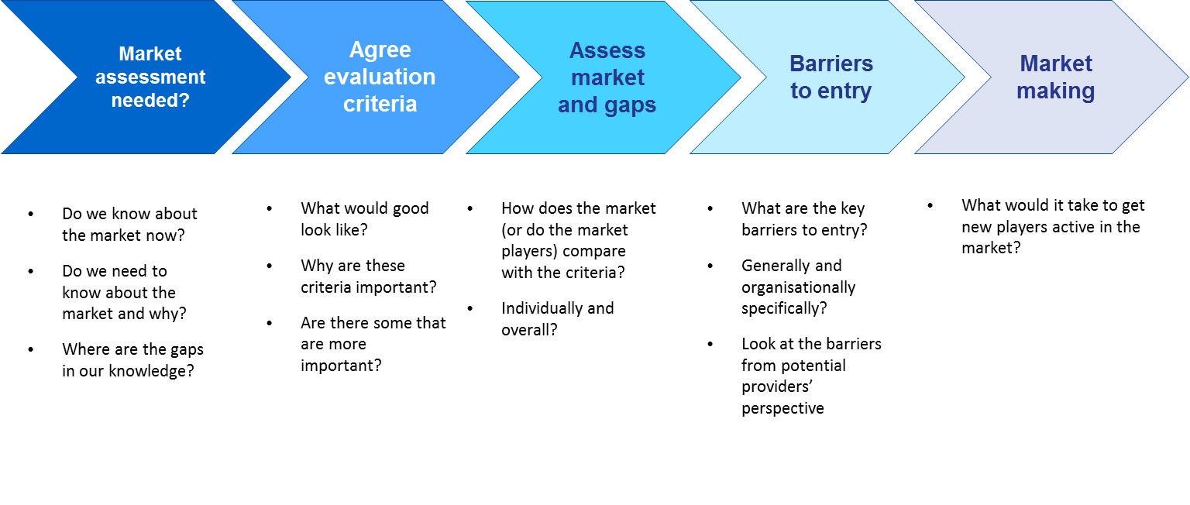

PROVIDER CAPABILITIES
Much has been written about the need for commissioners to think in new ways and build the right skills and capacity. As important, however, is provider capacity and capabilities. Indeed, if these are not in place, commissioning will fail because providers will not be able to respond effectively.
Regardless of the form that providers take, there are a number of common characteristics that are likely to evolve over time:
- overall, an ability to respond to commissioners’ requirements in cogent and persuasive ways – expressing what could be delivered and how this would work, what it would cost and how its efficacy could be measured;
- multiple organisations involved in delivering health services within a single contract;
- a focus on integration and collaboration, resulting in more multi-disciplinary working;
- ability to manage and co-ordinate the care of individuals along the full length of clinical pathways;
- proactive management of population groups to inform early intervention and prevention;
- integrated IT solutions to support collaboration and sharing of information and continuous quality improvement;
- treating and supporting patients in different, more appropriate, settings as a result of improved co-ordination and flexibility within the contracts; and
- increased involvement and engagement of patients/ service users in the design, delivery and improvement of services.
Each of these evolutions has developmental and capacity implications, and requires new competencies within the provider community.
Work conducted by PwC in the USA has focused on accountable care organisations (very much seen as a precursor for how providers will need to respond to commissioners), and has highlighted eight key competencies that providers need, as set out in Figure 14, below.

Figure 14: Components of the provider competency framework
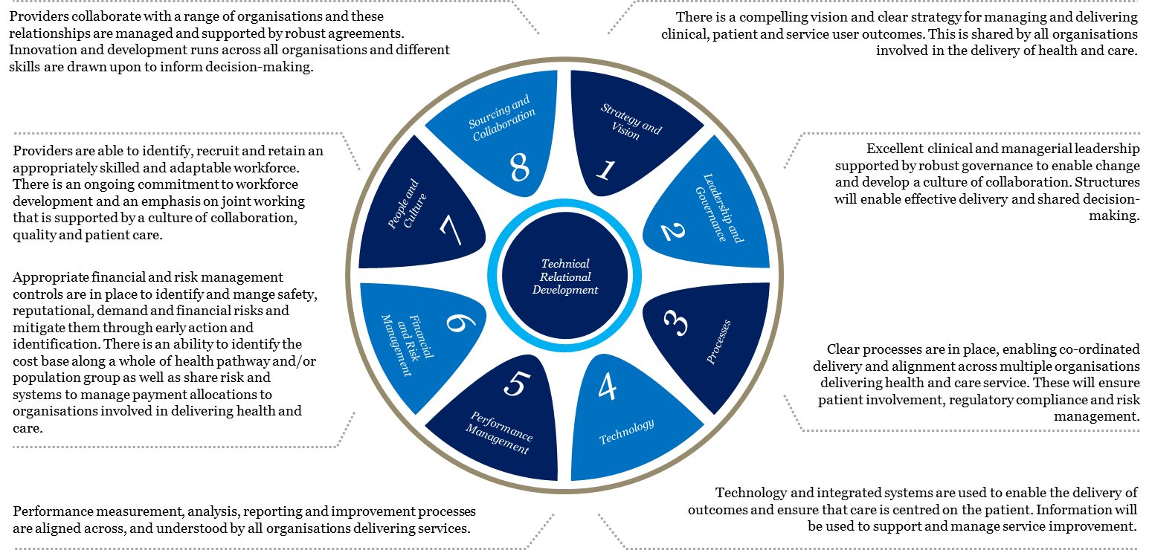
The PHNs-ACCHOs Working Together – Guiding Principles identifies the need for PHNs to develop commissioning processes that build capacity and support Aboriginal and Torres Strait Islander organisations and which minimise the fragmentation and lack of coordination caused by competitive tendering processes. This can include engaging to:
- ascertain the capacity of ACCHOs prior to commissioning to inform the process for commissioning Indigenous-specific health programmes and services. This may involve ACCHOs providing the service or collaborating in consortia either with other Indigenous-specific primary health care service providers or with mainstream health providers (a combination of private and public State/Territory providers);
- ensure commissioning processes take the needs of ACCHOs into account, are not unnecessarily burdensome and are communicated well in advance to ACCHOs; and
- develop strategies to overcome barriers for ACCHOs to competitively tender for funds.

SUMMARY OF LEADING PRACTICE ROLES, RESPONSIBILITIES AND SKILLSETS OF A COMMISSIONING PHN
Table 7 below provides some leading commissioning practice features, drawn from PwC research and experience.

Table 7: Features of leading commissioning practice
Outcome setting | Outcome measurement | Contract set up | Contract management | Market capacity | Organisational capacity
Whole of population needs assessment and gap analysis informs outcomes to be commissioned  Outcomes defined in an outcomes framework  Outcomes are user driven rather than provider driven  Outcomes are defined by all bodies with responsibility for them (joint commissioning)  Outcomes are expressed in ‘whole person’ terms rather than relating to particular issues  Outcomes have been co-created with external stakeholders  Significant scope for how outcomes would be delivered  Commissioning Strategy integrated with legislation and policy guidance and requirements, including the PHN Funding Agreement  Outcomes set strategically- with reference to organisational aims/ambitions  Outcomes take account of deliverability – co-creation with suppliers/potential suppliers | Outcome framework includes SMART outcome KPIs  Evaluation framework has been prepared and agreed reflecting program logic  Outcome capture is operationalised  Outcomes measured independently / or measured by providers and checked independently  Means established to deal with causality/exogenous factors – such as randomised control groups  Feedback loop established to review outcomes and act accordingly  Sourcing & demand management  - Procurement categories are defined purely from a supplier set perspective with limited constraints from internal structures  - Demand is aggregated, and clear forecasting of demand over long term with a number of potential scenarios described to take variance into account | Co-creation with suppliers explored/deployed subject to conflicts of interest.  Procurement approach is outcome orientated – allowing for the development of innovative solutions/responses to the delivery of outcomes – competitive dialogue like approach.  Multiple suppliers mutually incentivised through (say) alliance contracting.  Price performance mechanism aligns with outcomes sought  Advanced negotiation strategy  - Multi-period negotiation strategies developed and rehearsed  - Multiple rounds of negotiations with suppliers eliminated at each stage  - Discussions on solutions and price are separated (price discussed last)  - Price discussions focus on areas of variance in supplier submissions  Select vendor and contract  - Close involvement of stakeholder group in selection process  - Assessment criteria agreed with stakeholder group up front  - Detailed feedback provided to unsuccessful bidders  - Yes/No criteria used to shortlist suppliers and price taken into consideration once the final short list is established  - Price reviews happen in line with changes to supplier inputs and risk (may be spot pricing)  - Where possible, incentives are used to align supplier performance with company strategy and hedge risk where appropriate  Pricing strategy and financial model  - Standard form financial model allows comparisons  - Full cost up pricing is provided by suppliers including profit margin  Significant effort made to alter product and service requirements to minimise price | Focus on supplier relationships and partnership health as much as contractual delivery  Planned, agreed and delivered meetings with the supplier(s) on a monthly basis.  Monitoring supplier performance  - Limited outcome based KPIs required due to aligned incentives in contract  - KPIs change over time to reflect changing business conditions  - Non-compliance behaviour identified by both supplier and business and resolved quickly  Managing leakage  - Processes are in place that minimise the opportunity for leakage e.g., on-line ordering platform – where this is appropriate  - Leakage is reported on a real time basis  - Leakage issues addressed in a collaborative manner at the source  Managing costs and pricing  - Opportunity to rebase overall costs reflecting solution refinement  - Suppliers incentivised to reduce costs over time.  - Price changes not only change to underlying economics but also to continuous improvements on the part of the supplier (driven by incentives) and industry paradigm shifts  Supplier systems automatically link in and update catalogues with authorised price changes | Market assessment/reviews undertaken  Limited market and provider development  Limited capacity building undertaken to help build market capacity  Barriers to entry understood  Buying arrangements seek to recognise the supply community but may not be acted upon  Managing provider relationships  - Supplier management framework  Close relationships with suppliers (i.e. localised partnerships) used to create competition | Organisational recognition of where commissioning capability needs to sit – and embedded as a core management skill  Outcomes whole is seen as more important than service parts  Commissioning capacity requirements clear for different board/staffing groups.  Resource analysis and gap identification undertaken  Board and workforce development plan tailored to requirements and identified gaps  Pooled / flexible resources  Predisposition towards plurality of supply / mixed economy / fitness for purpose

APPENDICES
Appendix I: Contracting – Service-specification based
Appendix II: Contracting – Competitive Dialogue (CD)
Appendix III: Contracting – Most Capable Provider (MCP) (or single provider)

APPENDIX I – Outline of a Service-based commissioning approach

Overview of the process and timeline
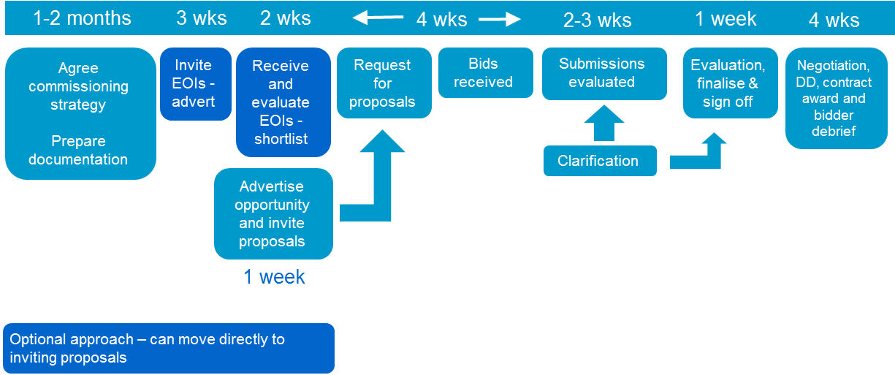

Summary of the typical process stages:
- Commissioning strategy, documentation preparation, including business case
- Advertising to invite EOIs
- Receiving and evaluating EOIs
- Issue request for proposals (RFP)
- Receiving submissions
- Evaluating submissions / clarification issues
- Clarifications and evaluation refinement
- Evaluation sign off
- Due diligence – both parties
- Contractual negotiations – Preferred Bidder (PB)
- Contract award and bidder debrief

Stage 1: Commissioning strategy, documentation preparation, including business case

Purpose and objectives
- To agree the overall strategy and approach for the commissioning exercise
- To be clear about the business case for change – as a ‘yard stick’ against which to make later comparisons
- To agree the hierarchy / congruence from/of aims through to KPIs / measures, pricing and evaluation
- To plan what documentation is required and begin its preparation – the sooner the better

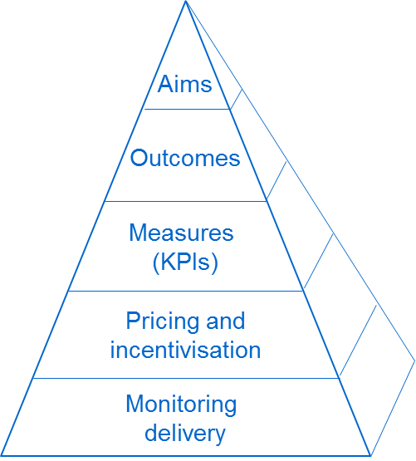
Key features / tasks
- Agreeing strategy within the context of the agreed Framework
- Ensuring there is a flow from the aims and outcomes through to the specification and contractual documentation – see the pyramid here
- Prepare business case for change – this requires significant input
- Build the hierarchy – again, see pyramid shown here
- Develop documentation schedule and commence preparation – see below

Timescales
- See overall timeline – 1-2 months

Documentation
- Strategy
- Business case
- ‘Prior information notice’ (or equivalent) / advert / e-tendering approach
- Information Memorandum (IM) – including evaluation approach (where appropriate)
- Expression of Interest (EOI) questionnaire (where appropriate)
- Evaluation guidance
- Beginnings of invitation (RFP) document

Resource implications
- These are significant and need to be planned carefully.

Stage 2: Advertising to invite EOIs

Purpose and objectives
- Generate market interest
- Set out the opportunity clearly to market
- Invite expressions of interest that can be assessed / evaluated
- Commence the procurement process

Key features / tasks
- Prepare IM and other documentation
- Remember that this is a sales process as well as a procurement process – they are qualifying you
- Organise resources – consider conflicts of interest (COIs) and how they will be managed
- Consider probity issues
- Comply with governance requirements

Timescales
- Period from prior information notice / advertisement (where appropriate)
- Period for responses

Documentation
- EOI advertisement (where appropriate)
- IM – including evaluation approach (where appropriate)
- EOI questionnaire (where appropriate)
- Evaluation criteria and guidance – key to have these before commencing the process
- Continue to develop invitation document

Resource implications
- Team separation needs to be considered carefully to avoid COIs
- Resources to prepare documentation, agree through governance arrangements and action

Stage 3: Receiving and evaluating EOIs

Purpose and objectives
- To receive the expressions of interest
- To understand which best satisfy your evaluation criteria – PHNs may use hurdles (the things that have to be met and weighted criteria – important to have and that should be compared between those expressing interest based on the criteria)
- To select those able to move forward to the next stage

Key features / tasks
- Organise teams
- Brief them
- Make arrangements for receipt (including for use of e-tendering, if applicable)
- Consider and provide guidance around confidentiality
- Ensure transparency and objectivity are maintained
- Scoring and moderation
- Approval
- Notification of successful and unsuccessful bidders
- Consider any changes necessary for consortia based approaches (eg. are you assessing each member or the whole consortium as one?)
- Updating for changes – making sure you adjust ratings or qualification agreement if consortia or potential bidders change

Timescales
- Typically takes three weeks
- Will be subject to governance

Documentation
- EOIs received
- Evaluation guidance
- Scoring templates
- Specialist input – eg. finance and legal
- Summary report

Resource implications
- Teams to undertake the evaluation
- Specialists in particular areas / questions

Stage 4: Request for proposals

Purpose and objectives
- Invite pre-qualified bidders (those that were successful in the EOI process, where this has been used) to enter into the bidding
- process based on the services to be delivered and outcomes to be secured
- Soliciting solutions to the specification in accordance with commissioners’ requirements
- Securing a submission that meets requirements

Key features / tasks
- Finalisation of documentation including evaluation approach and protocols
- Data room and access to individuals
- Inviting bids
- Bidders’ day (where appropriate)
- Ensuring clarity on issues like ‘instructions to tenderers’ and bidders meeting their own costs

Timescales
- Immediately following qualification, sign off if possible (where appropriate)
- Endeavour to stick to the timetable to avoid giving bidders the wrong impression of the preparedness of the PHN to commission

Documentation
- Invitation
- Instructions to bidders / protocols etc
- Specification
- Indicative model of care as appropriate
- Method statement requirements?
- Draft contract
- Price/performance mechanism (where appropriate)
- Submission requirements

Resource implications
- Documentation preparation and despatch

Stage 5: Receiving submissions

Purpose and objectives
- To receive and distribute bids to teams, ready for evaluation

Key features / tasks
- Receipt of submissions in accordance with the invitation and following dialogue
- Main/core and variant bids allowed?
- Submission approach – e-tendering or paper-based?
- Distribution to allow evaluation – make it easier by anticipating how things may need to be divided up

Timescales
- Typically 3-4 weeks after invitation

Documentation
- Registry of bids received
- Evaluation approach and templates at the ready

Resource implications
- Distribution and ‘getting going’ are the most significant factors

Stage 6: Evaluating submissions / clarification issues

Purpose and objectives
- To evaluate bids in accordance with the evaluation framework
- To identify issues that require clarification
- To moderate scoring and agree initial standings

Key features / tasks
- Separation of evaluation teams – care solution, legal, financial, commercial, technical?
- Lots of reading
- Scoring in accordance with the evaluation approach
- Identification of written clarification questions
- Moderation of scoring as appropriate
- Initial scoring completed – pre-clarification

Timescales
- Say 2-3 weeks

Documentation
- Evaluation approach / methodology
- Scoring templates
- Clarification question templates

Resource implications
- This is a significant stage
- Evaluation teams
- ‘Specialist’ resources
- Stick to the timetable

Stage 7: Clarifications and evaluation refinements

Purpose and objectives
- To seek and receive clarifications from bidders
- To refine scoring based on the responses received

Key features / tasks
- Document clarification questions
- Ideally, rationalise to avoid duplication
- Send to bidders with definite timescales / instructions for responses
- Make it clear these will be used to refine scoring
- Receive responses – further clarify if needed
- Revisit scoring and moderate post-clarification final assessment

Timescales
- Allow an appropriate time for responses – say 1-2 weeks

Documentation
- Questions
- Evaluation re-scoring

Resource implications
- Evaluation teams
- Allocated question drafters

Stage 8: Evaluation sign off

Purpose and objectives
- To finalise and secure sign off of the preferred bidder (PB)

Key features / tasks
- Depends on governance arrangements
- Prepare and present report
- Advise bidders of the outcome
- PB letter – this is important (cover all assumptions and what is non-negotiable going forward)
- Reserve bidders may be appointed

Timescales
- Will depend on governance arrangements
- Need to complete ASAP

Documentation
- Final evaluation report
- Governance reporting requirements

Resource implications
- Completion of reporting

Stage 9: Due diligence – both parties

Purpose and objectives
- Allowing the PB to firm up on their assumptions and pricing and risk allocation
- Informing contractual negotiations

Key features / tasks
- Desk and site based
- PB: typical issues:
- Staffing issues and costs
- KPIs and measures – starting position / baseline
- Budgets and affordability; pooling etc
- Outcome specifications and model of care
- Dependencies / enablers – can they be relied upon?
- Assets – state, condition, fit for purpose?
- Contracts and leases to be novated
- Update risk allocation matrix
- Financial – price/performance mechanism, budgets, arrangements
- Commissioner:
- Being satisfied as to the commitments made by the PB
- Dealing with implications – cost/price

Timescales
- Varies – 4-5 weeks

Documentation
- Queries to be addressed according to protocol
- Record keeping
- Access to commissioner documentation

Resource implications
- Access arrangements – carefully controlled and co-ordinated
- ‘Buddying’ system?
- Teams – may depend upon PB’s approach
- Duration dependent

Stage 10: Contractual negotiations – with Preferred Bidder (PB)

Purpose and objectives
- To conclude the issues required to effect the new arrangements
- To deal with all issues in the PB letter (such as outstanding assumptions)

Key features / tasks
- Resolution of contractual ‘mark-ups’ (the bidder’s suggested amendments)
- Resolution of outstanding PB issues
- Eradication of bidder assumptions
- Impacts on risk allocation / price need to be considered carefully
- Reporting for governance purposes

Timescales
- Varies – can be weeks, but in the worst case, months

Documentation
- Contract updated on the basis of negotiation outcomes

Resource implications
- Specialist resources
- Knock-on effect on others (where they are required to support the process):
- Care/clinicians
- Finance
- Operations
- Contract / procurement

Stage 11: Contract award and bidder debrief

Purpose and objectives
- To award the contract based on negotiated outcomes
- To debrief unsuccessful bidders

Key features / tasks
- Establishing that legal advisers and decision-makers are comfortable to progress
- Governance approval required?
- Media / communications issues, including key stakeholders / staff etc
- Debrief unsuccessful bidders

Timescales
- 2 weeks

Documentation
- Contract
- Governance requirements – reporting
- Communications strategy / approach
- Media releases

Resource implications
- Commissioning team
- Legal advisers

Generic issues to consider
- Resourcing appropriately – not business as usual (BAU)
- Governance and approval processes – ensure that the process used for this procurement approach ‘fits’ with agreed arrangements
- ‘Health checks’ should be included along the way – how are we going?
- Delegated authority will need to be considered carefully at each stage – agree what can be agreed by what level of staff, and what needs to be ‘signed off’ by the CEO or Board
- Consider the role of, and consultation requirements with, staff representatives and unions – where will they be involved and how?
- Probity considerations are critical – consider using internal audit (IA), an independent advisor or other role to support this process

APPENDIX II – Outline of a Competitive Dialogue based commissioning approach

Overview of the process and timeline
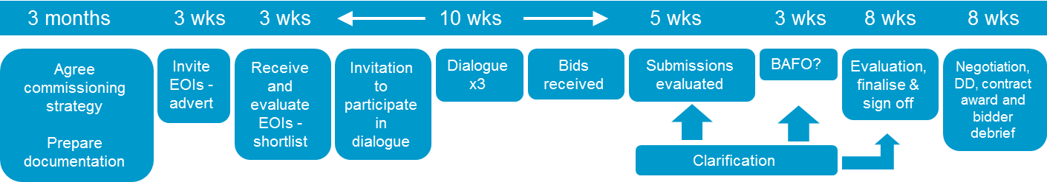

Summary of the typical process stages:
- Commissioning strategy, documentation preparation, including business case
- Advertising to invite EOIs
- Receiving and evaluating EOIs
- Invitation to participate in dialogue
- Conducting dialogue – co-creation
- Receiving submissions
- Evaluating submissions / clarification issues
- Clarifications and evaluation refinement
- Refine bidder numbers
- Best and final offer – invitation, submission, evaluation
- Evaluation sign off
- Due diligence – both parties
- Contractual negotiations – Preferred Bidder (PB)
- Contract award and bidder debrief

Stage 1: Commissioning strategy, documentation preparation, including business case

Purpose and objectives
- To agree the overall strategy and approach for the commissioning exercise
- To be clear about the business case for change – as a ‘yard stick’ against which to make later comparisons
- To agree the hierarchy / congruence from/of aims through to KPIs / measures, pricing and evaluation
- To plan what documentation is required and begin its preparation

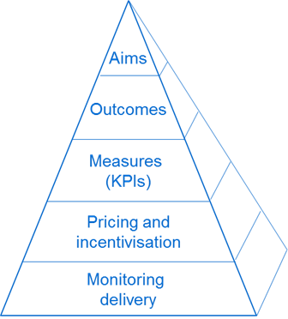
Key features / tasks
- Agreeing strategy within the context of the agreed Framework
- Ensuring there is a flow from the aims and outcomes through to the specification and contractual documentation – see the pyramid here
- Prepare business case for change – significant
- Develop documentation schedule and commence preparation – see below

Timescales
- See overall timeline – 3 months

Documentation
- Strategy
- Business case
- Prior information notice (or equivalent) / advertisement / e-tendering approach
- Information Memorandum (IM) – including evaluation approach
- Expression of Interest (EOI) questionnaire
- Evaluation guidance
- Beginnings of invitation i.e. Request for Proposal (RFP) document

Resource implications
- These are significant and need to be planned carefully.

Stage 2: Advertising to invite EOIs

Purpose and objectives
- Generate market interest
- Set out the opportunity clearly to market
- Invite EOIs that can be assessed / evaluated
- Commence the procurement process

Key features / tasks
- Prepare IM and other documentation
- Remember that this is a ‘sales’ process as well as a procurement process – they are qualifying the PHN
- Organise resources – consider conflicts of interest (COIs) and how they will be managed
- Consider probity issues
- Comply with governance requirements

Timescales
- Period from prior information notice
- Period for responses

Documentation
- EOI advertisement
- IM – including evaluation approach
- EOI questionnaire
- Evaluation criteria and guidance – key to have these before commencing the process
- Continue to develop invitation document

Resource implications
- Team separation
- Resources to prepare documentation, agree through governance arrangements and action

Stage 3: Receiving and evaluating EOIs

Purpose and objectives
- To receive the EOIs
- To understand which best satisfy your evaluation criteria (including the things that have to be met and weighted criteria for things that are important to have, and which should be compared between those expressing interest)
- To select those able to move forward to the next stage

Key features / tasks
- Organise teams
- Brief them
- Make arrangements for receipt, including use of e-tendering arrangements, if applicable
- Confidentiality
- Objectivity
- Scoring and moderation
- Approval
- Notification of successful/unsuccessful bidders
- Consider any changes necessary for consortia based approaches (eg. assessing each member or the whole consortium as one?)
- Updating for changes – making sure you adjust ratings or qualification agreement if consortia or potential bidders change

Timescales
- Typically takes 3 weeks
- Will be subject to governance

Documentation
- EOIs received
- Evaluation guidance
- Scoring templates
- Specialist input (eg. finance)
- Summary report

Resource implications
- Teams to undertake the evaluation
- Specialists in particular areas / questions

Stage 4: Invitation to participate in dialogue

Purpose and objectives
- Similar to a more traditional RFP process but with the next stage addition
- Invite pre-qualified bidders to enter into the bidding / dialogue process based on the outcomes to be secured
- Soliciting solutions to the outcome specification in accordance with commissioners’ requirements
- Securing a submission (post-dialogue) that meets requirements

Key features / tasks
- Finalisation of documentation including evaluation approach and ‘protocols’
- Data room and access to individuals?
- Inviting participation in dialogue (supported by appropriate documentation)
- Consider holding a bidders’ day
- Ensure that bidders are aware that their involvement is at their own cost and will not be reimbursed by commissioners

Timescales
- Immediately following qualification sign off
- Endeavour to stick to the timetable to avoid giving bidders the wrong impression of the preparedness of the PHN to commission

Documentation
- Invitation
- Instructions to bidders / protocols etc / dialogue
- Outcome specification
- Indicative model of care
- Method statement requirements
- Draft contract
- Price / performance mechanism
- Submission requirements

Resource implications
- Documentation preparation and dispatch.

Stage 5: Conducting dialogue – co-creation, clarification

Purpose and objectives
- To provide the opportunity for bidders to work with the PHN to co-develop and test solutions that meet the requirements
- Also to act as a ‘sounding board’ – what would or would not be acceptable to the PHN – effectively a co-creation process
- Clarification of any uncertainties or ambiguities
- Covering all aspects of the requirements: (Note that commissioners sometimes organise separate meetings with bidders to cover each of these three areas)
- Care solution
- Legal, structural and governance
- Financial

Key features / tasks
- Very structured meetings between bidders and the PHN’s teams to cover agreed areas
- Ideally, team separation – getting the right people can, however, be difficult in smaller organisations
- In parallel – resource implications
- Avoiding ‘leading bidders’ and ‘leakage’; confidentiality requires a protocol to cover how these meetings are conducted
- Testing out thinking, refining solutions
- Clarification questions and responses

Timescales
- Typically over a 6-8 week period – allow enough time before and after
- An intense period that requires significant resourcing and planning

Documentation
- Bidders’ agendas
- Protocols – what can and cannot happen
- Record of questions/ answers – sharing needs to be considered – it is suggested that only non-commercial and bidder-non-specific issues be considered for sharing
- Record of meetings to be made

Resource implications
- Significant:
- Accommodation
- Separate teams
- Parallel sessions
- Call on ‘experts’ around care, commercial considerations, legal, finance
- Authorisation to act / advise bidders etc needs to be clarified (i.e. constantly needing to refer to higher authority will not create a good impression with bidders – team seniority needs to be carefully considered)

Stage 6: Receiving submissions

Purpose and objectives
- To receive and distribute bids ready for evaluation

Key features / tasks
- Receipt of submissions in accordance with the invitation and following dialogue
- Main/core and variant bids allowed?
- Submission approach – e-tendering or paper-based?
- Distribution to allow evaluation – make it easier by anticipating how things may need to be divided up and sent to teams

Timescales
- Typically 10-12 weeks after invitation and 2-3 weeks after final dialogue

Documentation
- Registry of bids received
- Evaluation approach and templates at the ready

Resource implications
- Distribution is the most significant factor – this needs to be pre-planned and availability of key people considered

Stage 7: Evaluating submissions / clarification issues

Purpose and objectives
- To evaluate bids in accordance with the evaluation framework
- To identify issues that require clarification
- To moderate scoring and agree initial standings

Key features / tasks
- Separation of evaluation teams – care solution, legal, financial, commercial, technical?
- Lots of reading
- Scoring in accordance with the evaluation approach
- Identification of written clarification questions
- Moderation
- Initial scoring – pre-clarification

Timescales
- About 5 weeks

Documentation
- Evaluation approach / methodology
- Scoring templates
- Clarification question templates

Resource implications
- Significant in relation to:
- evaluation teams
- ‘specialist’ resources
- Stick to the timetable, as indicated above

Stage 8: Clarifications and evaluation refinements

Purpose and objectives
- To seek and receive clarifications from bidders
- To refine scoring based on the responses received

Key features / tasks
- Document clarification questions
- Ideally, rationalise to avoid duplication
- Send to bidders with definite timescales and instructions for responses
- Make it clear these will be used to refine scoring
- Receive responses and further clarify if needed
- Revisit scoring and moderate post-clarification final assessment

Timescales
- Allow an appropriate time for responses – say 1-2 weeks

Documentation
- Questions
- Evaluation re-scoring

Resource implications
- Evaluation teams
- Allocated question drafters

Stage 9: Refine bidder numbers

Purpose and objectives
- To reduce the number of bidders typically down to two

Key features / tasks
- Assessment of overall scoring
- Agreement as to who to ‘take forward’ to best and final offers (BAFO)
- Approvals required?
- Reserve bidders?

Timescales
- Say 1-2 weeks

Documentation
- Evaluation report
- Requirements for governance?

Resource implications
- Evaluation teams / leader
- Supporting governance process

Stage 10: Best and final offer (BAFO) – invitation, submission, evaluation

Purpose and objectives
- Optional – allows you the opportunity for the final (typically) two bidders to refine their solutions and costing to the final value whilst competition still remains
- Invite, receive and evaluate bids
- Select preferred bidder (PB) – including complete clarification of agreed points and any outstanding issues or assumptions.

Key features / tasks
- Draft BAFO request – may be generic or more likely focused on key unclear areas
- Issue BAFO
- Provide support through any clarifications
- Receive BAFO submissions
- Evaluate – updating original scoring
- Clarifications
- Update evaluation scoring/outcomes

Timescales
- Try to make short and focused
- Say 3-4 weeks overall

Documentation
- BAFO request
- Evaluation

Resource implications
- Preparation of BAFO request
- Evaluation update
- Evaluation report

Stage 11: Evaluation sign off

Purpose and objectives
- To finalise and secure sign off of PB

Key features / tasks
- Depends on governance arrangements
- Prepare and present report
- Advise bidders of the outcome
- PB letter – this is important (cover all assumptions and what is non-negotiable going forward)
- Reserve bidders may be appointed

Timescales
- Will depend on governance arrangements
- Need to complete as soon as possible

Documentation
- Final evaluation report
- Governance reporting requirements

Resource implications
- Completion of reporting

Stage 12: Due diligence – both parties

Purpose and objectives
- Allowing the PB to firm up on their assumptions and pricing and risk allocation
- Informing contractual negotiations

Key features / tasks
- Desk and site based
- PB: typical issues:
- Staffing issues and costs
- KPIs and measures – starting position / baseline
- Budgets and affordability; pooling etc
- Outcome specifications and model of care – to what extent are things there now or need to be effected afresh?
- Dependencies / enablers – can they be relied upon?
- Assets – state, condition, fit for purpose?
- Contracts and leases to be novated
- Update risk allocation matrix?
- Financial – price/performance mechanism, budgets, arrangements
- PHN satisfying itself as to the commitments made by the PB
- Dealing with implications – cost/price need to be considered carefully

Timescales
- Varies – 4-5 weeks

Documentation
- Queries to be addressed according to protocol
- Record keeping
- Access to commissioner documentation

Resource implications
- Access arrangements – carefully controlled and co-ordinated
- Buddying system?
- Teams – may depend upon PB’s approach
- Duration dependent

Stage 13: Contractual negotiations – Preferred Bidder (PB)

Purpose and objectives
- To conclude the issues required to effect the new arrangements
- To deal with all issues in the PB letter (such as outstanding assumptions)

Key features / tasks
- Resolution of contractual ‘mark-ups’ (the bidder’s suggested amendments)
- Resolution of outstanding PB issues
- Eradication of bidder assumptions
- Impacts on risk allocation / price need to be considered carefully
- Reporting for governance purposes

Timescales
- Varies – can be weeks, but in the worst case, months

Documentation
- Contract updated on the basis of negotiated outcomes

Resource implications
- Specialist resources
- Knock-on effect on others (where they are required to support the process):
- Care/clinicians
- Finance
- Operations
- Contract / procurement

Stage 14: Contract award and bidder debrief

Purpose and objectives
- To award the contract based on negotiated outcomes
- To debrief unsuccessful bidders

Key features / tasks
- Establishing that lawyers are comfortable to progress
- Governance approval
- Media
- Debrief

Timescales
- 2 weeks

Documentation
- Contract
- Governance requirements – reporting
- Media releases

Resource implications
- Commissioning team
- Legal advisers

Generic issues
- Resourcing appropriately – not business as usual (BAU)
- Governance and approval processes – ensure that the process used for this procurement approach ‘fits’ with agreed arrangements
- ‘Health checks’ should be included along the way – how are we going?
- Delegated authority will need to be considered carefully at each stage – agree what can be agreed by what level of staff and what needs to be ‘signed off’ by the likes of the CEO or Board
- Consider the role of, and consultation requirements with, Trades unions / staff representatives – where will they be involved and how?
- Probity considerations are critical – consider using internal audit (IA), an independent advisor or other role to support this process / requirement

APPENDIX III – Outline of a Most Capable Provider, Collaborative or Single Tenderer-based commissioning approach

Introduction
Some objectives and key features for a ‘Most Capable Provider’, ‘Collaborative’ or ‘Single Tenderer’ approach will include:

Strategy and approach
- Agreeing the overall commissioning strategy
- Being certain that this single provider approach is the right one to adopt i.e. PHNs need to be certain that any alternatives that are more competitive in nature are not appropriate in the circumstances.
- Adopting the right sub-approach, within the context of this overall mechanism

Overall desired outcomes
- Agreeing a most capable provider – casting the net widely to ensure that all potential ‘players’ are identified
- Testing / agreeing governance arrangements
- Delivering overall desired outcomes including value for money, solution and affordability
- Securing an outcome that echoes what might have been achieved competitively
- Getting to the point of acceptability of bids / offers
- Working with a provider that will work for you
- Win-win – commissioner and provider

The market
- ‘Selling’ the opportunity to the market – getting the right market interest
- Selecting the right provider as part of the EOI process
- A provider that the PHN can work with over a trial period or much longer

The process
- Ensuring probity and compliance with key governance frameworks
- Ensuring a level playing field and fairness in the process – managing conflicts of interest
- Agreeing EOI evaluation approaches and conducting evaluation appropriately
- Getting the right contract
- Agreeing headline measures for each objective

Overview of the potential process and timeline

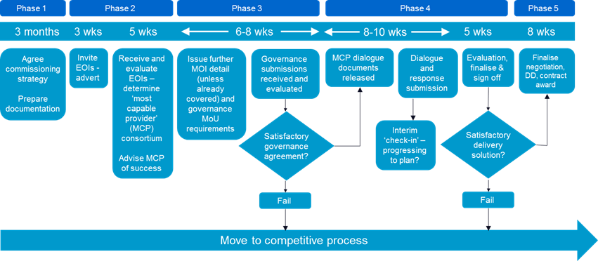

Summary of the typical process stages:
- Summary of the indicative process stages:
- Commissioning strategy, documentation preparation, including business case
- Advertising to invite EOIs for MCP appointment
- Receiving and evaluating EOIs, appointing MCP
- Issue further MOI detail (unless already covered) and governance MoU requirements
- Governance submissions received and evaluated
- Finesse governance submission or ‘go to competition’
- MCP dialogue documents released
- Dialogue and response submission
- Interim check in
- Evaluation of submission, clarification
- Evaluation sign off
- Finalise negotiation
- Due diligence – both parties
- Contract award

Stage 1: Commissioning strategy, documentation preparation, including business case

Purpose and objectives
- To agree the overall strategy and approach for the commissioning exercise
- To be clear about the business case for change – as a yard stick against which to make later comparisons
- To agree the hierarchy / congruence from/of aims through to KPIs / measures, pricing and evaluation
- To plan what documentation is required and begin its preparation – sooner the better

Key features / tasks
- Agreeing strategy within the context of the agreed Framework – consider consortia issues
- Prepare business case for change – significant
- Ensuring there is a flow from the aims and outcomes through to the specification and contractual documentation – see the pyramid above
- Develop documentation schedule and commence preparation – see below

Timescales
- See overall timeline – 3 months

Documentation
- Strategy
- Business case
- Prior information notice / advert
- Information memorandum (IM) – including MCP evaluation approach
- EOI questionnaire
- Evaluation guidance
- Beginnings of the MCP dialogue document – governance and solution

Resource implications
- These are significant

Stage 2: Advertising to invite EOIs for MCP appointment

Purpose and objectives
- Generate market interest
- Set out the opportunity clearly to market
- Convey the importance of what the PHN is seeking – probably a consortium to develop/deliver the new approach
- Invite expressions of interest that can be assessed and evaluated – recognise consortia likelihood
- Ensure that all potential players have the opportunity to participate

Key features / tasks
- Prepare IM and other documentation – clarity on what the PHN is looking for
- Remember that this is a ‘sales’ process as well as a procurement process – they are ‘qualifying’ the PHN
- Organise resources – consider conflicts of interest (COIs) and how they will be managed
- Consider probity issues
- Comply with governance requirements

Timescales
- Period for responses – depends on ‘warmth’ of market

Documentation
- Expression of interest (EOI) advert
- IM – including evaluation approach
- EOI questionnaire
- Evaluation criteria and guidance – important to get these right before commencing the process
- This could include minimum requirements (eg. insurances) that must be met
- Capacity – general and financial sustainability
- Capability
- Experience
- Indicative coherence / commitment
- Partnership assessment?
- Continue to develop dialogue document

Resource implications
- Team separation where possible
- Resources to prepare documentation, agree through governance arrangements and action

Stage 3: Receiving and evaluating EOIs to determine MCP

Purpose and objectives
- To receive the EOIs
- To understand which EOIs best satisfy your evaluation criteria – minimum requirements and weighted criteria
- To select your MCP

Key features / tasks
- Organise teams
- Brief them
- Make arrangements for receipt, including e-tendering if applicable
- Confidentiality
- Objectivity
- Scoring and moderation
- Approval
- Notification
- Consider how to deal with consortia submissions – evaluated as one or in parts?
- Updating for changes in the consortium

Timescales
- Typically takes 3-5 weeks given importance of MCP
- Will be subject to governance

Documentation
- EOIs received
- Evaluation guidance
- Scoring templates
- Specialist input – eg. finance, legal
- Summary report

Resource implications
- Teams to evaluate
- Specialise in particular areas / questions

Stage 4: Issue further MOI detail (unless already covered) and governance memorandum of understanding (MoU) requirements

Purpose and objectives
- Expand upon MOI if this is not already covered – with a particular emphasis on governance outcomes
- Solicit MCP proposals for governance
- Solicit MoU draft in accordance with instructions

Key features / tasks
- Update MOI with governance outcomes requirements such as:
- strong leadership at all levels of the entity, with a focus on ethical behaviour and continuous improvement
- Maintaining governance systems and processes that are fit for purpose
- Optimising performance through planning, engaging with risk, innovation, and performance monitoring, evaluation and review
- Openness, transparency and integrity, engaging constructively with stakeholders and promoting accountability through clear reporting on performance and operations
- Where appropriate, participating in collaborative partnerships to more effectively deliver programs and services, including partnerships outside government
- Financial, structural, legal arrangements
- Health / care specifics
- Prepare submission instructions to MCP
- Governance sign off
- Issue requirements

Timescales
- As soon as possible after MCP selection sign off

Documentation
- Updated MOI and invitation / requirements

Resource implications
- Documentation preparation
- Governance sign off

Stage 5: Governance submissions received and evaluated

Purpose and objectives
- To receive MoU and explanatory responses
- To evaluate those against the PHN’s requirements
- To identify issues that require further refinement

Key features / tasks
- Receive submission
- Organise and brief teams (if appropriate)
- Ensure objectivity
- Scoring and moderation
- Identification of issues requiring further clarification or development
- Reporting and approval

Timescales
- Commence immediately
- May take 2-3 weeks

Documentation
- Submission made
- Criteria for evaluation
- Key issues outstanding / clarification points
- Evaluation report

Resource implications
- Documentation
- Undertaking the process – as one team or as multiple teams

Stage 6: Finesse governance submission or ‘go to competition’

Purpose and objectives
- To finesse the governance submission to a point of PHN satisfaction, reflecting the assessment made
- To engage with the MCP to achieve this
- Alternatively, explore the option of opening up to competition (where that would be possible)

Key features / tasks
- Understand issues to finesse from previous stage
- Structured meetings with MCP
- Co-create / finesse solution

Timescales
- Over 2-3 weeks

Documentation
- MCP submission
- Revised submission

Resource implications
- Conducting the process
- Alternative approach (note that this is challenging)

Stage 7: MCP dialogue documents released

Purpose and objectives
- Focus shifts to the solution to the outcomes framework
- Some similarities with more traditional RFP process but with the next stage addition
- MCP enters into the bidding / dialogue process based on the outcomes framework to be secured
- Soliciting solutions to the outcome specification in accordance with the PHN’s requirements
- Securing a submission (post-dialogue) that meets requirements

Key features / tasks
- Finalisation of documentation including ‘evaluation approach’ and ‘protocols’
- Affordability and other essential requirements
- Data room and access to individuals?
- Inviting participation
- Clarity over the fact that bidders should stand their own costs

Timescales
- Immediately following governance agreement

Documentation
- MCP dialogue documents
- Instructions to MCP / protocols etc / dialogue
- Outcomes framework / specification
- Indicative model of care
- Method statement requirements
- Draft contract
- Price / performance mechanism (ideally)
- Submission requirements

Resource implications
- Documentation preparation and despatch

Stage 8: Dialogue – co-creation, clarification, response submission

Purpose and objectives
- To provide the opportunity for the MCP to work with the commissioner to co-develop and test solutions that meet the requirements
- Also to act as a sounding board
- Clarification
- Covering all aspects of the requirements:
- Care solution
- Legal, structural and governance – any further finessing
- Financial

Key features / tasks
- Structured meetings between MCP and the PHN’s teams to cover agreed areas
- Testing out thinking, refining solutions
- Clarification questions
- MCP prepares / submits response

Timescales
- Typically over a 8-10 week period
- Intense

Documentation
- MCP agendas
- Protocols – what can and cannot happen
- Record of questions and answers – sharing
- Record of meetings to be made

Resource implications
- Significant:
- Accommodation
- Call on ‘experts’ around care, commercials, legal, finance
- Authorisation to act / advise etc needs clarification – team seniority will be important

Stage 9: Interim check-in

Purpose and objectives
- To check-in to establish whether things are going according to plan
- Any issues from the MCP and the PHN’s perspective

Key features / tasks
- Pre-plan meetings and the process
- Meet based on agreed agenda
- Agree any action points on both sides
- Act – effect changes or consider implications of a poor outcome

Timescales
- Part way through dialogue / submission period

Documentation
- The PHN and MCP agendas
- Minutes / action points
- Action records

Resource implications
- Meetings
- Any actions agreed

Stage 10: Evaluating submission / clarification

Purpose and objectives
- To evaluate MCP submission in accordance with the evaluation framework
- To identify issues that require clarification

Key features / tasks
- Separation of evaluation team – care solution, legal, financial, commercial, technical?
- Lots of reading
- Scoring in accordance with the evaluation approach
- Identification of written clarification questions
- Moderation
- Initial scoring – pre-clarification
- Clarifications sought – responses received
- Evaluation updated

Timescales
- Say 5 weeks

Documentation
- Evaluation approach and methodology
- Scoring templates
- Clarification question templates
- Evaluation reporting

Resource implications
- Significant
- Evaluation teams
- ‘Specialist’ resources

Stage 11: Evaluation sign off

Purpose and objectives
- To finalise and secure sign off of MCP; or
- Explore alternatives

Key features / tasks
- Depends on governance arrangements
- Prepare and present report
- Advise MCP of the outcome
- MCP notification of outstanding issues is important
- Consider alternatives if appropriate

Timescales
- Will depend on governance arrangements
- Need to complete as soon as possible

Documentation
- Final evaluation report
- Governance reporting requirements

Resource implications
- Completion of reporting

Stage 12: Finalise negotiation

Purpose and objectives
- To negotiate any outstanding points that remain after stage 11
- To reach a point that could be contracted upon

Key features / tasks
- Use stage 11 outcomes as agenda for clarification and agreements needed
- Meetings / negotiation / resolution
- Capture agreed positions
- Update contractual or other documentation
- Sign off and reporting

Timescales
- Can vary dramatically

Documentation
- Stage 11 outcomes position statement
- Update affected documentation

Resource implications
- Various – depends on outstanding issues

Stage 13: Due diligence – both parties

Purpose and objectives
- Allowing the MCP to firm up on their assumptions and pricing and risk allocation
- Informing contractual negotiations

Key features / tasks
- Desk and site based
- MCP: typical issues:
- Staffing issues and costs
- KPIs and measures – starting position / baseline
- Budgets and affordability; pooling etc
- Outcome specifications and model of care
- Dependencies / enablers– can they be relied upon?
- Assets – state, condition, fit for purpose?
- Contracts and leases to be novated
- Update risk allocation matrix
- Financial – payment mechanism, budgets, arrangements
- PHN satisfying itself as to the commitments made by the MCP
- Dealing with implications – cost/price

Timescales
- Varies – 4-5 weeks

Documentation
- Queries to be addressed according to protocol
- Record keeping
- Access to commissioner documentation

Resource implications
- Access arrangements – carefully controlled and co-ordinated
- Buddying system?
- Teams – may depend upon MCP’s approach
- Duration dependent

Stage 14: Contract award

Purpose and objectives
- To award the contract based on negotiated outcomes

Key features / tasks
- Are legal advisers comfortable to progress?
- Governance approval
- Media / communications approach

Timescales
- 2 weeks

Documentation
- Contract
- Governance requirements – reporting
- Media releases

Resource implications
- Commissioning team
- Legal advisers

Generic issues
- This is a relatively ‘untrodden path’ in Australia; issues can be complex and specialist advice is probably required
- Resourcing appropriately – not business as usual (BAU)
- Governance and approval processes – ensure that the process used for this procurement approach ‘fits’ with agreed arrangements
- Progress checks should be included along the way
- Delegated authority will need to be considered carefully at each stage – agree what can be agreed by what level of staff and what needs to be ‘signed off’ by the CEO or Board
- Consider the role of, and consultation requirements with, staff representatives – where will they be involved and how?
- Probity considerations are critical – consider using internal audit, an independent advisor or other role to support this process

Australian Government Department of Health. Primary Health Networks Grant Programme Guidelines February 2016 – Version 1.2. Click here to visit the Australian Government Department of Health website to view the publication ‘PHN Programme Guidelines’
Smith J, Curry N, Mays N, Dixon J. Where next for commissioning in the England NHS? The Nuffield Trust and the King’s Fund 2010, p.12. Also see Øvretveit J. Purchasing for health: a multidisciplinary introduction to the theory and practice of health purchasing. Open University Press 1995.
Australian Government Department of Health. Primary Health Networks Grant Programme Guidelines February 2016 – Version 1.2. Click here to visit the Australian Government Department of Health website to view the publication ‘PHN Programme Guidelines’
Alderwick, H, Ham C, and Buck D. The King’s Fund. Population health systems: Going beyond integrated care. (2015). Available at: Click here to visit The Kings Fund organisation website to view the publication ‘Population health systems’
Greater Manchester Combined Authority website at Click here to visit the Greater Manchester Combined Authority website to view the journal ‘Devolution’
Dickinson H. (2015). Commissioning public services evidence review: Lessons for Australian public services (see pg 15). Available at Click here to visit the Melbourne School of Government website to view the publication ‘Lessons for Australian public services’
PHN and Aboriginal Community Controlled Health Organisations (ACCHOs) - Guiding Principles. 2015. Available at: Click here to visit the Australian Government Department of Health website to view the publication ‘Primary Health Networks and ACCHO – Guiding Principles’
European Commission – Directorate General and Internal and Market Services. Explanatory Note – Competitive Dialogue – Classic Directive. Available at: Click here to visit the European Commission Directorate General and Internal and Market Services website to view the publication ‘Explanatory Note – Competitive Dialogue – Classic Directive’
European Commission. Growth – Internal Market, Industry, Entrepreneurship and SMEs. Available at: Click here to visit the European Commission Growth Internal Market, Industry, Enterpreneurship and SMEs website to view the publication ‘Public Procurement’
Australian Government Department of Health. Primary Health Networks Grant Programme Guidelines February 2016 – Version 1.2. Available at: Click here to visit the Australian Government Department of Health website to view the publication ‘PHN Programme Guidelines’
Smith J, Porter A and Shaw S. Commissioning high-quality care for people with long-term conditions. Nuffield Trust 2013. Available at: Click here to visit the nuffieldtrust website to view the publication ‘Commissioning high-quality care for people with long-term conditions’
Commissioning and Contracting for Better Mental Health Outcomes. Report prepared by Rooftop Social, for Mental Health Australia, October 2015. Available at: Click here to visit the Mental Health Australia website to view the article ‘Commissioning and Contracting for Better Mental Health Outcomes Report’
Partnerships Victoria – Public Sector Comparator: Technical Note - Guidance Material, June 2001. Victorian Government Department of Treasury and Finance. Available at: Click here to visit the Partnerships Victoria website to view the publication ‘Public Sector Comparator a technical note’
NSW Government Office of Social Impact Investment. Available at: Click here to visit the NSW Government website to view the publication ‘Office of Social Impact Investment’
Queensland Government Department of Treasury. Social Benefit Bonds Pilot Program. Available at: Click here to visit the Queensland Government website to view the publication ‘Social benefit bonds pilot program’
NSW Government - Unsolicited Proposals page. Available at: Click here to visit the New South Wales Government website to view the publication ‘Unsolicited Proposals’
NHS Commissioning Handbook. Available at: Click here to visit The Commissioning Handbook for Librarians website to view the publication ‘Disinvestment’
PHNs-ACCHOs Working Together – Guiding Principles was developed in 2016 in consultation with the PHNs and ACCHOs and is available at: Click here to visit the Australian Government Department of Health website to view the publication ‘Primary Health Networks and ACCHO – Guiding Principles’

