PHN Program Performance and Quality Framework

September 2018

Table of contents

1 Introduction 4

1.1 The Primary Health Networks Program 4

1.2 Purpose of the PHN Program Performance and Quality Framework 5

1.3 Principles 6

2 Conceptual Framework 7

2.1 Outcome themes 7

2.2 Outcomes 8

2.3 Indicators 12

2.4 Alignment to other frameworks 12

3 Performance Indicators 14

3.1 Indicator selection 14

3.2 Aspirational indicators 15

3.3 Indicator tables 15

4 Capable Organisations 27

5 Interpreting Indicators 30

5.1 Review of performance criteria 30

5.2 Peer grouping 30

6 Performance and Quality Reporting 31

6.1 PHN Deliverables 31

6.2 PHN Performance Reports 33

7 Assessment 33

7.1 Assessing individual PHN performance 33

7.2 PHN Program Performance and Quality Report 42

8 Review of the Framework 42

9 Acronyms and Abbreviations 43

10 Version History 44

List of figures

Figure 1: Capable Organisation Aspects 27

Figure 2: Deliverables and Framework 32

List of tables

Table 1: PHN Program objectives and priority areas 4

Table 2: Outcome themes 7

Table 3: Outcomes and outcome themes 9

Table 4: Alignment between outcome themes and AHPF and Quadruple Aim 13

Table 5: PHN Program indicators 15

Table 6: Mental Health indicators 18

Table 7:Aboriginal and Torres Strait Islander Health indicators 19

Table 8: Population Health indicators 21

Table 9: Workforce indicators 22

Table 10: Digital Health indicators 24

Table 11: Aged Care indicators 25

Table 12: Alcohol and Other Drugs indicators 26

Table 13: Capable Organisations indicators 28

Table 14: Performance rubric for individual PHN assessment 35

# Introduction

## The Primary Health Networks Program

The Primary Health Networks Program (PHN Program) commenced in 2015 with the establishment of 31 Primary Health Networks (PHNs). Individual PHNs are responsible for identifying and addressing the primary health needs in their region through strategic planning, commissioning services, supporting general practices and other health care providers and supporting the integration of local health care services.

The PHN Program has two objectives and seven priority areas for targeted work:

Table 1: PHN Program objectives and priority areas

| PHN Program Objectives | PHN priority areas for targeted work |
| --- | --- |
| Increase the efficiency and effectiveness of medical services, particularly for patients at risk of poor health outcomes.  Improve coordination of care to ensure patients receive the right care in the right place at the right time. | Mental Health  Aboriginal and Torres Strait Islander Health  Population Health  Workforce  Digital Health  Aged Care  Alcohol and Other Drugs |

PHNs are expected to respond to the health needs of their region while being guided by the priority areas for targeted work and National priorities as decided by the Government.

PHNs receive funding from the Australian Government for a range of activities and functions:

* Commissioning health services to meet local service needs – this includes analysing relevant health data; prioritising local health needs; working with providers, clinicians and communities to co-design services to meet those needs; and monitoring and evaluating service delivery to inform future needs. PHNs are provided with specific funding to commission services for core primary health care activities, as well as mental health treatment services, drug and alcohol treatment services, and Indigenous-specific health services.
* Health systems improvement – with the alignment of PHN and Local Hospital Networks (LHN) boundaries, PHNs are in a position to support joint planning, collaborative commissioning and health service integration between Commonwealth and state and territory funded health services. PHNs are working closely with service providers to agree referral pathways and support secure sharing of patient information.
* Sector support activities – PHNs play an important role in providing support to general practice, as a key part of strengthening the primary health care system. PHNs’ work in this area includes: supporting general practice and other health care providers with quality improvement and accreditation; cultural awareness and competency; workforce development; digital health systems; and patient centred care and best practice service delivery models.
* Operational functions – including the administration, governance (including the establishment and maintenance of Clinical Councils and Community Advisory Committees) and core functions of PHNs.

Some PHNs also receive other Australian Government funding, for specific activities such as Health Care Homes, Palliative Care or Per- and poly-fluoroalkyl substances (PFAS). In addition, PHNs may deliver activities funded by State and Territory Governments or other funding bodies.

## Purpose of the PHN Program Performance and Quality Framework

The PHN Program Performance and Quality Framework (the Framework) aims to consider how the broad range of activities and functions delivered by PHNs contribute towards achieving the Program’s objectives.

PHNs determine where to direct their activities and resources as a result of the needs assessment of their region. The Framework does not intend to change this approach or direct PHNs to undertake work in priority areas that are not relevant to their region.

The Framework has three purposes:

* providing opportunities to identify areas for improvement for individual PHNs and the PHN Program;
* supporting individual PHNs in measuring their performance and quality against tangible outcomes; and
* measuring the PHN Program’s progress towards achieving its objectives of improving efficiency and effectiveness of medical services for patients and improving coordination of care to ensure patients receive the right care, in the right place, at the right time.

In addition, individual PHN performance against the Framework will be used to inform Department of Health (the Department) decisions concerning eligibility for future contract extensions, as well as any associated negotiations with individual PHNs.

The Framework encompasses the activities that are delivered by all PHNs from 1 July 2018. It offers a structure which can accommodate additional activities and functions, should the Australian Government seek to deliver these through PHNs in the future.

The Framework is effective from 1 July 2018 and supersedes the PHN Performance Framework Version 1 (March 2016 – June 2018).

## Principles

The following principles underpin the Framework:

* Minimise burden – the Framework should focus on minimising reporting requirements for PHNs and gathering information that is useful for assessing performance and quality.
* Transparent – the Framework should be clear about what it is measuring and how it will assess performance.
* Outcomes based – the Framework should measure progress towards outcomes and program objectives, to build a strong picture of the impact of the PHN Program.
* Quality – the Framework should provide an opportunity to identify continuous quality improvement for the PHN Program and individual PHNs.
* Holistic – the Framework should consider the performance of the PHN Program as a whole and any future functions of the Program.
* Alignment – the Framework should align with the PHN Program objectives, national performance frameworks in health, and the health priorities of the Australian Government.
* Flexibility – the Framework needs to accommodate the different priorities of PHNs depending on the health needs of their region.

# Conceptual Framework

Version 1 of the Framework primarily reflected program performance monitoring under the PHN Program’s Core Schedule. The new Framework has been designed to provide a structure for monitoring and assessing PHNs’ individual performance and progress towards achieving outcomes under all Funding Schedules of the PHN Program.

The conceptual framework consists of the following four components:

* PHN Program Objectives – describe what the PHN Program is intended to achieve
* Outcome Themes – five themes which link the outcomes to the PHN Program objectives
* Outcomes – drawn from the program logic models which describe the activities, outputs and outcomes for the PHN Program
* Indicators – for assessing progress towards the outcomes

## Outcome themes

There are five outcome themes which link to the PHN Program’s objectives. This grouping helps explain how different activities contribute to the overall PHN Program objectives.

Table 2: Outcome themes

| Outcome theme | Outcomes |
| --- | --- |
| Addressing Needs | Activities conducted by PHNs to address the needs of people in their local region, including an equity focus |
| Quality Care | Activities and support offered by PHNs to general practices and other health care providers to improve quality of care for patients |
| Improving Access | Activities by PHNs to improve access to primary health care by patients |
| Coordinated Care | Activities and support by PHNs to improve coordination of care for patients and integration of health services in their region |
| Capable Organisations | Operational activities of PHNs which support the successful delivery of the PHN Program |

## Outcomes

The primary health care system is a complex mix of service delivery with many interdependencies and stakeholders. Consideration also needs to be given to social determinants of health, individual behaviour and personal circumstances. There are a large number of determinants at play which produce changes in outcomes.

Program logics for the PHN Program and the seven priority areas have been developed to simply describe the activities and outputs PHNs deliver (including by commissioning) and the outcomes these activities are designed to achieve. While there are a number of contextual and environmental factors at play, the program logics attempt to reflect outcomes which are most closely aligned to the actions of individual PHNs. The PHN Program and priority area program logics are set out in Appendix A - Program Logics.

The Framework acknowledges that PHNs are individual organisations using different approaches to address the needs of their region. PHNs may find that they have few activities against some outcomes due to the different priorities of their region. The Framework offers a way to consider how different activities can contribute to broader outcomes.

The Framework reflects that PHNs are working towards intermediate outcomes, which can be expected to be achieved in the near future, and longer term outcomes, which accord with both the PHN Program’s objectives and PHN’s strategic visions.

In addition, PHNs aim to meet organisational capability outcomes to demonstrate their ongoing viability as commissioning organisations.

Table 3 on the next page maps the outcomes to four of the outcome themes, and to the PHN Program’s priority areas. Longer term outcomes are also included in a separate column. The outcomes for the Capable Organisations outcome theme can be found in Table 13.

Table 3: Outcomes and outcome themes

| **Areas** | Addressing Needs | Quality Care | Improving Access | Coordinated Care | Longer Term |
| --- | --- | --- | --- | --- | --- |
| Program | PHN activities and initiatives address local needs | PHNs support general practices and other health care providers to provide quality care to patients | People in the PHN region are able to access general practices and other services as appropriate  PHNs support general practices and other health care providers to provide appropriate after hours access | People in the PHN region receive coordinated, culturally appropriate services from local health care providers | PHNs support local primary health care services to be efficient and effective, meeting the needs of patients at risk of poor health outcomes  Patients in local region receive the right care in the right place at the right time |
| Mental Health | -Not Applicable | PHN commissioned mental health services improve outcomes for patients | People in PHN region access mental health services appropriate to their individual needs | Health care providers in PHN region have an integrated approach to mental health care and suicide prevention | People in PHN region enjoy better mental health and social and emotional wellbeing |
| Aboriginal and Torres Strait Islander health | PHNs address needs of Aboriginal and Torres Strait Islander people in their region | Local health care providers provide culturally appropriate services to Aboriginal and Torres Strait Islander people  Aboriginal and Torres Strait Islander identified health workforce capability and capacity matches needs of region | Aboriginal and Torres Strait Islander people are able to access primary health care services as required | Aboriginal and Torres Strait Islander people with chronic conditions receive coordinated care | PHNs contribute to closing the gap and Aboriginal and Torres Strait Islander people experience improved emotional, social and physical wellbeing |
| Population Health | Fewer preventable hospitalisations in PHN region for people with chronic and vaccine preventable diseases | PHNs support health care providers to address factors impacting population health | -Not Applicable | -Not Applicable | Improved health outcomes for all population groups in the PHN region |
| Workforce | -Not Applicable | Local workforce has suitable cultural and clinical skills to address health needs of PHN region  PHNs support general practices and other health care providers to provide quality care to patients | -Not Applicable | -Not Applicable | People in PHN region are able to access a high quality, culturally safe and appropriately trained workforce |
| Digital Health | -Not Applicable | PHNs support health care providers to use digital health systems to improve patient care and communication  General practices and other health care providers use data to improve care | -Not Applicable | Health care providers are aware of digital health systems and technologies | Digital health enables better coordinated care and better informed treatment decisions |
| Aged Care | -Not Applicable | Fewer preventable hospitalisations in PHN region for older people  Local health and other care providers are supported to deliver coordinated, effective and appropriate care to older people in the PHN region | Older people in the PHN region are supported to access primary health care services that meet their needs including self-care in the home | -Not Applicable | Older people in the PHN region are supported to enjoy a greater quality of life  Local health care system provides coordinated, quality care to older people |
| Alcohol and Other Drugs | -Not Applicable | -Not Applicable | People in PHN region are able to access appropriate drug and alcohol treatment services | Health care providers in PHN region have an integrated approach to drug and alcohol treatment services | Decrease in harm to population in PHN region from drug and alcohol misuse |

## Indicators

Indicators have been selected to monitor and assess progress towards achieving the outcomes for the Program, each priority area and organisational capability. All of the indicators will be used to measure the performance of the PHN Program as a whole and a subset of the indicators will be used to assess individual PHN performance. See Table 14 for the subset of indicators for individual PHN performance.

The indicators selected are a mix of output/process indicators, existing health outcome indicators, existing performance indicators from PHN Schedules and qualitative statements of activities and expected change. The mix of indicators reflects that measuring outcomes under the PHN Program is new. As the Program continues to mature, the Framework’s indicators will be reviewed and updated to reflect the progress to achieving Program outcomes. This includes a review of performance criteria of indicators.

## Alignment to other frameworks

The outcome themes of the Framework can be used to align the PHN Program outcomes, activities and functions against other existing health Frameworks. The two most relevant for PHNs are the new Australian Health Performance Framework (AHPF), which seeks to support system-wide reporting of Australia’s health and health care performance, and the Quadruple Aim[1], which many PHNs use as a tool for measuring their progress towards achieving optimal health system performance.

Table 4 on the next page shows how the outcome themes are aligned to the AHPF and the Quadruple Aim.

Table 4: Alignment between outcome themes and AHPF and Quadruple Aim

| Framework | Elements of Framework | Addressing Needs | Quality Care | Improving Access | Coordinated Care | Capable Organisations |
| --- | --- | --- | --- | --- | --- | --- |
| AHPF Health System Dimensions | Effectiveness | ✓ Yes | Ye✓ Yes | ✓ Yes | ✓ Yes | ✓ Yes |
| Safety | Not—Applicable | ✓ Yes | Not—Applicable | Not—Applicable | Not—Applicable |
| Appropriateness | ✓ Yes | ✓ Yes | Not—Applicable | Not—Applicable | Not—Applicable |
| Continuity of Care | Not—Applicable | Not—Applicable | Not—Applicable | ✓ Yes | Not—Applicable |
| Accessibility | Not—Applicable | Not—Applicable | ✓ Yes | Not—Applicable | Not—Applicable |
| Efficiency and Sustainability | ✓ Yes | ✓ Yes | ✓ Yes | ✓ Yes | ✓ Yes |
| Quadruple Aim | Improving patient experience | ✓ Yes | ✓ Yes | ✓ Yes | ✓ Yes | Not—Applicable |
| Improved population health outcomes | ✓ Yes | ✓ Yes | ✓ Yes | ✓ Yes | Not—Applicable |
| Reducing the per capita cost of health care[2] | ✓ Yes | ✓ Yes | ✓ Yes | ✓ Yes | ✓ Yes |
| Improved clinician experience | Not—Applicable | ✓ Yes | ✓ Yes | ✓ Yes | ✓ Yes |

# Performance Indicators

The Framework contains 54 indicators:

* 39 performance indicators – which are used to measure performance towards PHN Program and priority area outcomes
* 15 organisational indicators – which are used to measure performance towards the capable organisations outcomes[3].

PHNs will provide information against individual Schedule performance indicators and an additional 24 indicators. The amount of information or data that a PHN provides against each indicator will vary depending on the activities it has undertaken to address prioritised needs in that area. For some indicators PHNs may have no or limited input. The Framework includes sufficient flexibility to ensure where this occurs a PHN’s performance assessment will not be negatively impacted.

PHNs will be individually assessed against a sub-set of 39 indicators, which consists of all of the organisational indicators and 24 of the performance indicators. Indicators have been selected which reflect areas where PHNs can and should have influence (see Table 14). Section 7 explores how PHNs will be assessed on their performance. Appendix B - Indicator Specifications provides the necessary details for reporting against each indicator.

## Indicator selection

Each outcome has been assigned at least one indicator. In some cases, multiple indicators have been used to account for the different factors that contribute to achieving outcomes.

Indicators have been selected by considering:

* Alignment – does the indicator assist in measuring progress towards the relevant outcome, either independently or in consideration with other indicators?
* Practicality – do the data already exist, or could they be derived from existing data sets or by PHN activity data?
* Availability – are the data frequently available, with limited time lags?
* Reliability – are the data sourced from reliable and stable sources?

Wherever possible indicators have been selected using measures that already exist within the Australian health care system. This includes data reported by the Australian Institute of Health and Welfare (AIHW) and the Australian Bureau of Statistics (ABS), along with Medicare Benefits Schedule (MBS) and Pharmaceutical Benefits Scheme (PBS) data which is collected by the Department of Human Services and provided to the Department. The use of this data has been prioritised as a way to minimise the burden on PHNs.

In addition, existing performance indicators for specific programs of work, contained in the Primary Mental Health and Suicide Prevention (MH) Schedule, the Drug and Alcohol Treatment Information Strategy (DATIS) and the My Health Record Expansion Program (MHREP) Schedule (managed by the Australian Digital Health Agency (ADHA)) have been selected for inclusion in the Framework.

## Aspirational indicators

There are a number of outcomes in the Framework where no suitable indicator is currently available. Instead, an aspirational indicator has been included which describes what could be collected as part of future versions of the Framework. This includes potential indicators for assessing progress towards the longer-term outcomes.

## Indicator tables

The tables on the following pages contain the outcome, the selected indicators and where the data for each indicator will be obtained from. The same indicator may be used to report against several outcomes.

Table 5: PHN Program indicators

| Outcomes | Indicators | Data Provision |
| --- | --- | --- |
| Addressing Needs:  PHN activities and initiatives address local needs | P1 PHN activities address prioritised needs | PHN |
| P2 Health system improvement and innovation | PHN |
| To be developed: an indicator of health literacy in each PHN region | TBD |
| Quality Care:  PHNs support general practices and other health care providers to provide quality care to patients | P3 Rate of general practice accreditation | PHN |
| P4 Support provided to general practices and other health care providers | PHN |
| P5 Rate of regular uploads to My Health Record | ADHA |
| To be developed: an indicator of use of Patient Reported Experience Measures in determining provision of quality care | TBD |
| Improving Access:  People in the PHN region are able to access general practices and other services as appropriate  PHNs support general practices and other health care providers to provide appropriate after hours access | P6 Rate of general practices receiving payment for after hours services. | DHS |
| P7 Rate of GP style emergency department presentations | AIHW |
| P8 Measure of patient experience of access to GP | ABS |
| Coordinated Care:  People in the PHN region receive coordinated, culturally appropriate services from local health providers | P9 Rate of GP team care arrangements/ case conferences | DoH / ABS |
| P10 Cross views of My Health Record (MHREP indicators 9-10) | MHREP reporting |
| P11 Rate of discharge summaries uploaded to My Health Record | AIHW / ADHA |
| To be developed: indicator on cultural appropriateness | TBD |
| Longer Term:  Patients in local region receive the right care in the right place at the right time | P12 Rate of potentially preventable hospitalisations | AIHW / ABS |
| P13 Numbers of health professionals available | PHN / National Health Workforce Dataset / healthdirect |
| Longer Term:  PHNs support local primary health care services to be efficient and effective, meeting the needs of patients at risk of poor health outcomes | To be developed: indicators on system integration and impact on health outcomes for patients | TBD |

Table 6: Mental Health indicators

(Note: all indicators are drawn from the MH Schedule item B.3 5)

| Outcomes | Indicators | Data Provision |
| --- | --- | --- |
| Improving Access:  People in PHN region access mental health services appropriate to their individual needs | MH1 Rate of regional population receiving PHN commissioned low intensity psychological interventions (MH indicator Acc-1) | MH reporting |
| MH2 Rate of regional population receiving PHN commissioned psychological therapies delivered by mental health professionals (MH indicator Acc-2) | MH reporting |
| Coordinated Care:  Health care providers in PHN region have an integrated approach to mental health care and suicide prevention | MH3 Rate of regional population receiving PHN commissioned clinical care coordination services for people with severe and complex mental illness (MH indicator Acc-3) | MH reporting |
| MH4 Formalised partnerships with other regional service providers to support integrated regional planning and service delivery (MH indicator regional integration) | MH reporting |
| MH5 Proportion of people referred to PHN commissioned services due to a recent suicide attempt or because they were at risk of suicide followed up within 7 days of referral (MH indicator App-3) | MH reporting |
| Quality Care:  PHN commissioned mental health services improve outcomes for patients | MH6 Outcomes Readiness - Completion rates for clinical outcome measures (MH Indicator Out-3) | MH reporting |
| Longer term outcome:  People in PHN region enjoy better mental health and social and emotional wellbeing | - Not Applicable | - Not Applicable |

Table 7: Aboriginal and Torres Strait Islander Health indicators

(Note: some indicators drawn from MH Schedule and DATIS)

| Outcomes | Indicators | Data Provision |
| --- | --- | --- |
| Addressing Needs:  PHNs address needs of Aboriginal and Torres Strait Islander people in their region | IH1 Numbers of ITC services delivered by PHN | ITC reporting |
| IH2 Types of organisations delivering ITC services | ITC reporting |
| Quality Care:  Local health care providers provide culturally appropriate services to Aboriginal and Torres Strait Islander people | IH3 Evidence that all drug and alcohol commissioned services are culturally appropriate for Aboriginal and Torres Strait Islander people (DATIS indicator 4.2) | DATIS reporting |
| IH4 Proportion of PHN commissioned mental health services delivered to the regional Aboriginal and Torres Strait Islander population that were culturally appropriate (MH indicator App-2) | MH reporting |
| IH5 ITC improves the cultural competency of mainstream primary health care services | ITC reporting |
| To be developed: indicator on patient experience of cultural appropriateness | TBD |
| Quality Care:  Aboriginal and Torres Strait Islander identified health workforce capability and capacity matches needs of regions | IH6 PHN provides support for Aboriginal and Torres Strait Islander identified health workforce | PHN |
| Coordinated Care:  Aboriginal and Torres Strait Islander people with chronic conditions receive coordinated care | IH7 ITC processes support Aboriginal and Torres Strait Islander people enrolled in the program to access coordinated care | ITC reporting |
| P9 Rate of GP team care arrangements/ case conferences | P9 |
| P12 Rate of potentially preventable hospitalisations for Aboriginal and Torres Strait Islander people | P12 |
| Improving Access:  Aboriginal and Torres Strait Islander people are able to access primary health care services as required | IH8 Rate of Aboriginal and Torres Strait Islander population receiving specific health assessments | MBS / ABS |
| Longer term outcome:  PHNs contribute to closing the gap and Aboriginal and Torres Strait Islander people experience improved emotional, social and physical wellbeing | To be developed: indicators on contribution to closing the gap and Aboriginal and Torres Strait Islander experiences of care | TBD |

Table 8: Population Health indicators

| Outcomes | Indicators | Data Provision |
| --- | --- | --- |
| Addressing Needs:  Fewer preventable hospitalisations in PHN region for people with chronic and vaccine preventable diseases | P12 Rate of potentially preventable hospitalisations - for specific chronic diseases | P12 |
| Quality Care:  PHNs support health care providers to address factors impacting population health | PH1 Rate of children fully immunised at 5 years | DoH – Australian Immunisation Register |
| PH2 Cancer screening rates for cervical, bowel and breast cancer | DoH – screening programs |
| P4 Support provided to general practices and other health care providers – population health | P4 |
| Longer term outcome:  Improved health outcomes for all population groups in the PHN region | To be developed: indicators on improving health outcomes for all population groups | TBD |

Table 9: Workforce indicators

(Note: some indicators drawn from MH Schedule and DATIS)

| Outcomes | Indicators | Data Provision |
| --- | --- | --- |
| Quality Care:  Local workforce has suitable cultural and clinical skills to address health needs of PHN region | W1 Rate of drug and alcohol treatment service providers with suitable accreditation (DATIS indicator 3.2) | DATIS reporting |
| W2 PHN support for drug and alcohol commissioned health professionals (DATIS indicator 3.1) | DATIS reporting |
| W3 PHN Commissioning Framework | PHN |
| IH3 Evidence that all drug and alcohol commissioned services are culturally appropriate for Aboriginal and Torres Strait Islander people (DATIS indicator 4.2) | IH3 |
| IH4 Rate of PHN commissioned mental health services for the Aboriginal and Torres Strait Islander people that are culturally appropriate (MH indicator App-2) | IH4 |
| IH5 ITC improves the cultural competency of mainstream primary health care services | IH5 |
| P4 Support provided to general practices and other health care providers - workforce | P4 |
| To be developed: indicator on patient experience of cultural appropriateness | TBD |
| Quality Care:  PHNs support general practices and other health care providers to provide quality care to patients | P3 Rate of general practice accreditation | PHN |
| P4 Support provided to general practices and other health care providers | PHN |
| P5 Rate of regular uploads to My Health Record | ADHA |
| Longer term outcome:  People are able to access a high quality, culturally safe and appropriately trained workforce | To be developed: indicators on improved access, delivery of culturally appropriate services and skill levels of workforce | TBD |

Table 10: Digital Health indicators

(Note: some drawn from MHREP Schedule section 1.13)

| Outcomes | Indicators | Data Provision |
| --- | --- | --- |
| Coordinated Care:  Health care providers are aware of digital health systems and technologies | DH1 Rate of health care providers informed about My Health Record (MHREP indicators 1-4) | MHREP reporting |
| Quality Care:  PHNs support health care providers to use digital health systems to improve patient care and communication | DH2 Rate of health care providers using specific digital health systems | PHN |
| P4 Support provided to general practices and other health care providers – digital health | P4 |
| P5 Rate of regular uploads to My Health Record | P5 |
| P10 Cross views of My Health Record | MHREP reporting |
| Quality Care:  General practices and other health care providers use data to improve care | DH3 Rate of accredited general practices sharing data with PHN | PHN |
| Longer term outcome:  Digital health enables better coordinated care and better informed treatment decisions | To be developed: indicator on improvements to health outcomes from use of digital health | TBD |

Table 11: Aged Care indicators

| Outcomes | Indicators | Data Provision |
| --- | --- | --- |
| Improving Access:  Older people in the PHN region are supported to access primary health care services that meet their needs including self-care in the home | AC1 Rate of MBS services provided by primary care providers in residential aged care facilities | DoH |
| AC2 Rate of people aged 75 and over with a GP health assessment | DoH / ABS |
| Quality care:  Fewer preventable hospitalisations in the PHN region for older people  Local health and other care providers are supported to deliver coordinated, effective and appropriate care to older people in the PHN region | P4 Support provided to general practices and other health care providers – aged care | P4 |
| P12 Rate of potentially preventable hospitalisations - for older people | P12 |
| Longer term:  Older people in the PHN region are supported to enjoy a greater quality of life | To be developed: indicator on improved quality of life for older people | TBD |
| Longer term outcome:  Local health care system provides coordinated, quality care to older people | To be developed: indicator on improvements to health care system to support quality care for older people | TBD |

Table 12: Alcohol and Other Drugs indicators

(Note: all indicators are drawn from DATIS section 3)

| Outcomes | Indicators | Data Provision |
| --- | --- | --- |
| Improving Access:  People in PHN region are able to access appropriate drug and alcohol treatment services | AOD1 Rate of drug and alcohol commissioned providers actively delivering services (bi-monthly AOD reporting) | AOD reporting |
| Coordinated Care:  Health care providers in PHN region have an integrated approach to drug and alcohol treatment services | AOD2 Partnerships established with local key stakeholders for drug and alcohol treatment services (DATIS 1.3 and 1.4) | DATIS reporting |
| Longer term outcome:  Decrease in harm to population in PHN region from drug and alcohol misuse | To be developed: indicators on impact of services on health outcomes for patients | TBD |

# Capable Organisations

The Framework has identified six aspects that contribute to a PHN being a successful and capable commissioning organisation. Outcomes have been developed for each aspect along with indicators to measure progress towards achieving the outcome. These indicators will all be used to measure an individual PHN’s performance.

Figure 1: Aspects of the Capable Organisations outcome theme

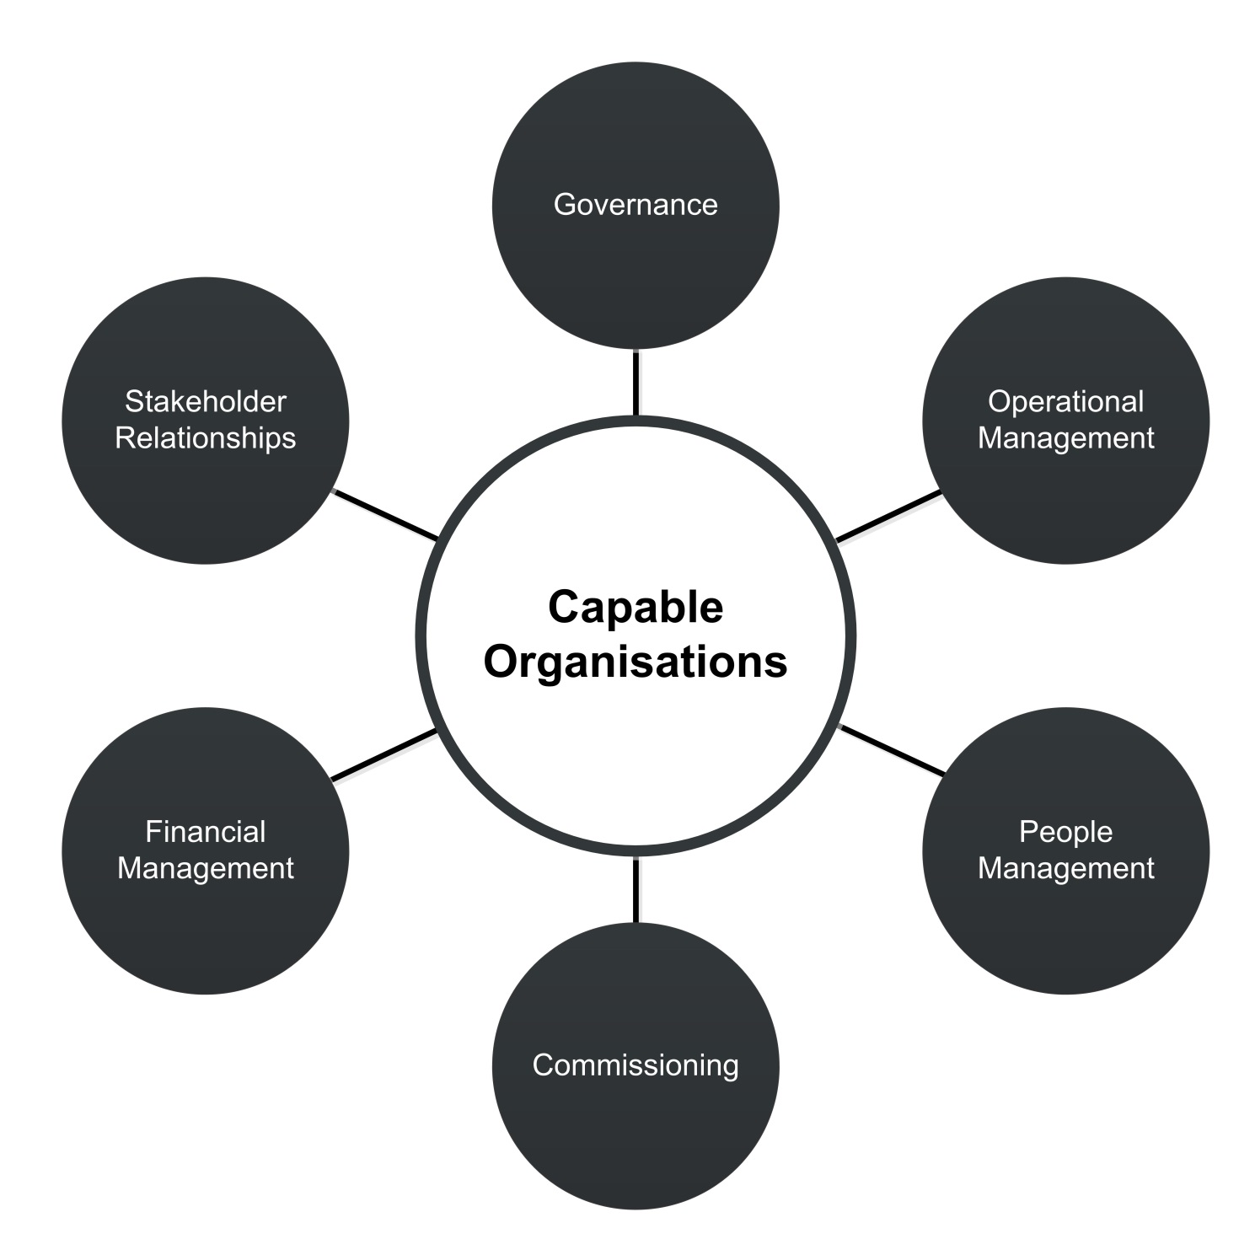

Table 13 below lists the outcomes for each aspect and the indicators being used to measure performance towards achieving that outcome.

Table 13: Organisational indicators

| Outcomes | Indicator | Data Provision |
| --- | --- | --- |
| Governance  The PHN’s governance structures support the delivery of the organisation’s objectives through providing oversight and direction | O1 PHN has an independent and diverse skills based Board | PHN |
| O2 PHN Clinical Council and Community Advisory Committee membership | PHN |
| O3 PHN Board considers input from committees | PHN |
| O4 Record of PHN Board member attendance at meetings | PHN |
| O5 PHN Board has a regular review of its performance | PHN |
| O6 PHN Board approves strategic plan | PHN |
| Operational Management  The PHN has policies and processes which support the effective and efficient delivery of the organisation’s objectives | O7 Variance report of scheduled activities | PHN |
| O8 Quality Management System | PHN |
| People Management  The PHN has a well-trained and supported workforce that is able to deliver to a high standard to meet the needs of the organisation, stakeholders and region | O9 Staff satisfaction | PHN |
| O10 Performance management process | PHN |
| O11 Cultural awareness training | PHN |
| Commissioning  The PHN uses commissioning cycle processes to plan, procure, monitor and evaluate services to respond to the prioritised health needs of its region | P1 PHN activities address identified needs | P1 |
| W3 PHN Commissioning Framework | W3 |
| O12 Rate of contracts for commissioned health services that include both output and outcome performance indicators | PHN |
| Financial Management  The PHN manages its finances in a manner that maximises efficiency without compromising effectiveness | O13 Annual Report and audited financial statements | PHN |
| Stakeholder relationships  The PHN creates and maintains relationships that facilitate the improvement of the health care system within its region | O14 PHN stakeholder engagement | PHN |
| O15 Engaging with complaints | DoH and PHN |
| P4 Support provided to general practices and other health care providers | P4 |

# Interpreting Indicators

Each indicator has a one page indicator specification (found in the Indicator Specifications document at Appendix B) which provides details about the purpose of the indicator, the outcome it relates to, what data will be collected and importantly, what the performance criteria is for each indicator. The performance criteria helps to interpret the information or data collected for the indicator.

The performance criteria may require qualitative or data based input. Where an indicator uses qualitative information the Department will assess the information supplied and determine whether it meets the specification. For indicators which use data, the performance criteria may require an improvement over time or may require a specific benchmark or target to be met.

## Review of performance criteria

The performance criteria for each indicator will be reviewed as part of the regular review of the Framework. In particular, consideration will be given to whether the performance criteria continue to be relevant or if they need to be amended to reflect changes in activities or expected standards. Quality standards, benchmarks or agreed targets may be introduced as the Framework matures and more data is collected against the indicators. PHNs will be consulted as part of this review.

## Peer grouping

Over time, PHN performance peer groups will be established in order to share results across different indicators. Sharing successes and challenges can help drive improvements.

Comparison between individual PHNs presents challenges due to the demographic, geographic and other differences in the regions that PHNs cover. Establishing peer groups as measurement criteria can address this issue. PHNs will be informed of their peer group and encouraged to work within their peer group to share information.

PHN peer groups will initially be based on:

* geographic characteristics
* demographic characteristics
* baseline health status on a range of indicators
* sophistication of the health system in the region
* density of general practices and other health care providers

PHN peer grouping will be used in three ways:

* peer group best practice sharing – where best practice ideas and strategies are shared, with permission, between PHNs in the same peer group; and
* peer group trends – where individual PHNs will compare against trends within their group; and
* peer group benchmarking – as the Program continues to mature, internal peer group benchmarks can be established.

In the early stages of the Framework’s implementation the best practice sharing will be the prime focus of peer grouping. As the PHN Program and the Framework matures, trend analysis and benchmarking will be introduced.

The Department will continue to review performance information and data to establish a robust peer grouping process.

# Performance and Quality Reporting

## PHN Deliverables

PHNs will continue to submit the deliverables required in their contracts: a Needs Assessment, Activity Work Plan and six and twelve month performance reports. The Activity Work Plan should continue to be based on the needs identified and prioritised through the Needs Assessment process. The Framework’s outcomes and indicators should not be used to frame or guide Needs Assessments or Activity Work Plans.

The Framework uses information supplied in the six and twelve month performance reports, along with other data, to prepare individual PHN and PHN program performance assessments.

The diagram on the following page (Figure 2) demonstrates the links between the Framework and deliverables.

Figure 2: Deliverables and Framework

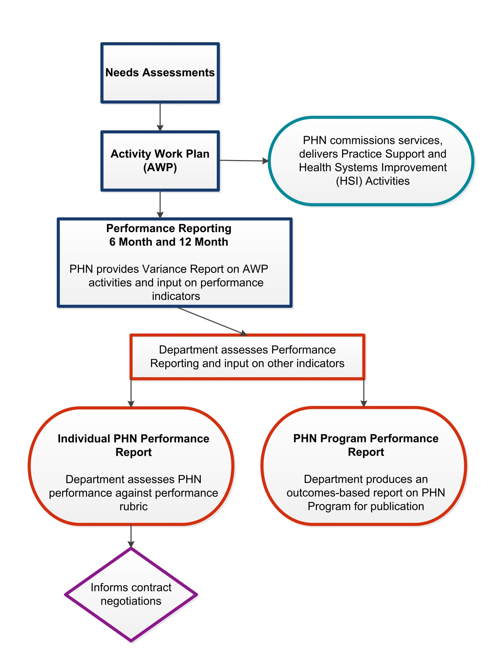

## PHN Performance Reports

The six month performance reports will consist of:

* a Variance Report for all activities in approved AWPs for all Schedules;
* input for other indicators specified in Funding Schedules and any other documentation.

The twelve month performance reports will consist of:

* a Variance Report for all activities in approved AWPs for all Schedules;
* input for Framework performance indicators requiring information from PHNs;
* contextual information for performance indicators used for PHN Program assessment (optional);
* input for other indicators specified in Funding Schedules and any other documentation.

The Variance Report will track progress for delivery of scheduled activities, including spend, meeting milestones and stakeholder engagement. PHNs will be able to flag where there are issues with delivery of an activity and what strategies they have in place to address these issues.

PHNs can choose to provide contextual information for 13 of the performance indicators that are used to measure the performance of the PHN Program (excluding indicators which are drawn from existing PHN Schedule reporting). This may include information on PHN activities, contextual information about the region or a statement explaining that the outcome is not a priority. This additional information will be used in the PHN Program performance report.

# Assessment

## Assessing individual PHN performance

The Department will use the information provided by PHNs in their six and twelve month reporting to assess individual PHN performance. This can include additional information PHNs supply as part of PHN Schedule reporting. PHNs will be assessed against all of the organisational indicators and 24 of the other performance indicators which reflect areas where PHNs can and should have influence. For some of these indicators PHNs may have limited input as the area may not be a priority for their region. This will not negatively affect their performance assessment.

Each outcome theme will be reported separately in the individual assessment. The input for each indicator will be assessed against the performance criteria and then an overall assessment for the outcome theme made based on a performance rubric. The performance rubric can be found in Table 14. The performance rubric contains three assessment standards: *On Track, Progressing and Initial.*

The Department will work closely with any PHNs which rate as Initial for an outcome theme, with the intention to improve their assessment in following years. It is expected over time that PHNs will rate as On Track for all outcome themes. The Department will communicate performance expectations to PHNs as part of reviewing their performance under the Framework.

A performance report for each PHN will be produced annually. PHNs will have an opportunity to comment on their draft report before it is finalised. The performance report will identify achievements and areas where the PHN could make improvements. This report will be supplied to each PHN but not publicly shared.  The report will also be considered during contract extension negotiations

Table 14: Performance rubric for individual PHN assessment

| **Outcome Theme** | **Indicators** | **Performance criteria** | **Assessment standards** |
| --- | --- | --- | --- |
| **Addressing Needs** | P1 PHN activities address prioritised needs | 100% of delivered activities address prioritised needs and/or national priorities | * Initial: PHN has met performance criteria for one indicator * Progressing: PHN has met performance criteria for two indicators and is working towards meeting the other indicators * On Track: PHN has met performance criteria for all indicators |
| P2 Health system improvement and innovation | At least one example of a health system improvement, innovation or commissioning best practice |
| IH1 Numbers of ITC services delivered by PHN | Services are being delivered across the range of services allowed within ITC Guidelines |
| IH2 Types of organisations delivering ITC services | A range of organisations are engaging in ITC program |
| **Quality Care** | P4 Support provided to general practices and other health care providers | PHN delivers a range of support activities to general practices and other health care providers | * Initial: PHN has met performance criteria for one indicator * Progressing: PHN has met performance criteria for at least half of the indicators and is working towards meeting the other indicators * On Track: PHN has met performance criteria for all indicators |
| MH6 Outcomes Readiness - Completion rates for clinical outcome measures | 70% of completed episodes of care have recorded valid outcome measures at Episode Start and Episode End |
| IH3 Evidence that all drug and alcohol commissioned services are culturally appropriate for Aboriginal and Torres Strait Islander people | PHN supplies evidence that commissioned drug and alcohol services are culturally appropriate |
| IH4 Proportion of PHN commissioned mental health services delivered to the regional Aboriginal and Torres Strait islander population that were culturally appropriate | At least 5% growth on proportion of previous year or where all services were culturally appropriate, maintenance of this |
| IH5 ITC improves the cultural competency of mainstream primary health care services | PHN provides evidence that as part of ITC it is working to improve cultural competency of mainstream primary health care services |
| IH6 PHN provides support for Aboriginal and Torres Strait Islander identified health workforce | PHN supplies evidence of support provided to Aboriginal and Torres Strait Islander identified workforce in its region |
| W1 Rate of drug and alcohol treatment service providers with suitable accreditation | All specialist drug and alcohol treatment service providers have or are working towards accreditation |
| W2 PHN support for drug and alcohol commissioned health professionals | PHN supplies evidence of support provided to drug and alcohol commissioned health professionals |
| W3 PHN Commissioning Framework | The PHN has a Commissioning Framework which includes strategic planning, procuring services and monitoring and evaluation phases, with cultural appropriateness and stakeholder engagement considered throughout the process |
| DH2 Rate of health care providers using specific digital health systems | Increase in the rate of health care providers using smart forms, e-referrals and/or telehealth  Where the rate has been stable for at least 3 years, the performance criteria is to maintain the existing rate of using specific digital health systems |
| DH3 Rate of accredited general practices sharing data with PHN | At least 5% growth on rate of accredited general practices sharing data with the PHN each year  Where the rate is over 60%, the performance criteria is to maintain the existing rate |
| **Improving Access** | MH1 Rate of regional population receiving PHN commissioned low intensity psychological interventions | At least 5% growth in number of people accessing Low Intensity episodes compared with previous year, or where service capacity has been reached, a maintenance of the previous year's rate | * Initial: PHN has met performance criteria for one indicator * Progressing: PHN has met performance criteria for at least half of the indicators and is working towards meeting the other indicators * On Track: PHN has met performance criteria for all indicators |
| MH2 Rate of regional population receiving PHN commissioned psychological therapies delivered by mental health professionals | At least 5% growth in number of people accessing Psychological Therapy episodes compared with previous year, or where service capacity has been reached, a maintenance of the previous year's rate |
| AOD1 Rate of drug and alcohol commissioned providers actively delivering services | Rate of drug and alcohol commissioned providers actively delivering services increases or remains the same |
| **Coordinated Care** | MH3 Rate of regional population receiving PHN commissioned clinical care coordination services for people with severe and complex mental illness | At least 5% growth in number of people accessing Care Coordination episodes compared with previous year, or where service capacity has been reached, a maintenance of the previous year's rate | * Initial: PHN has met performance criteria for one indicator * Progressing: PHN has met performance criteria for at least three of the indicators and is working towards meeting the other indicators * On Track: PHN has met performance criteria for all indicators |
| MH4 Formalised partnerships with other regional service providers to support integrated regional planning and service delivery | Comprehensive regional mental health and suicide prevention plans to be jointly developed with LHNs by mid 2020 |
| MH5 Proportion of people referred to PHN commissioned services due to a recent suicide attempt or because they were at risk of suicide followed up within 7 days of referral | 100% of people referred are followed up within 7 days |
| IH7 ITC processes support Aboriginal and Torres Strait Islander people enrolled in the program to access coordinated care | PHN provides evidence of its ITC processes |
| DH1 Rate of health care providers informed about My Health Record | 100% of general practices are aware of and provided with access to My Health Record education |
| AOD2 Partnerships established with local key stakeholders for drug and alcohol treatment services | A range of organisations are involved in delivering drug and alcohol treatment services |
| **Capable Organisations** | O1 PHN has an independent and diverse skills based Board | PHN has an independent and diverse skills based Board | * Initial: PHN has met performance criteria for one indicator * Progressing: PHN has met performance criteria for at least half of the indicators and is working towards meeting the other indicators * On Track: PHN has met performance criteria for all indicators |
| O2 PHN Clinical Council and Community Advisory Committee membership | PHN has at least one Clinical Council and Community Advisory Committee |
| O3 PHN Board considers input from committees | PHN Board considers input from committees |
| O4 Record of PHN Board member attendance at meetings | Board members meet the minimum attendance requirement defined under their PHN Board constitution or where a PHN does not have a minimum attendance requirement, attended at least 50% of meetings. |
| O5 PHN Board has a regular review of its performance | PHN Board is reviewed every three years |
| O6 PHN Board approves strategic plan | PHN Board approves strategic plan |
| O7 Variance report of scheduled activities | All variations are accounted for by PHN |
| O8 Quality Management System | PHN has or is moving towards a fit-for-purpose quality management system |
| O9 Staff satisfaction | PHN has a fit for purpose process to measure staff satisfaction at least every two years |
| O10 Performance management process | PHN has a fit for purpose process to measure staff satisfaction at least every two years |
| O11 Cultural awareness training | PHN conducts or offers cultural awareness training to staff at least every two years |
| P1 PHN activities meet identified needs | 100% of delivered activities address prioritised needs and/or national priorities |
| W3 PHN Commissioning Framework | PHN has a Commissioning Framework which includes strategic planning, procuring services and monitoring and evaluation phases, with cultural appropriateness and stakeholder engagement considered throughout the process |
| O12 Rate of contracts that include both output and outcome performance indicators | Increase in the number of contracts containing both output and outcome performance indicators |
| O13 Annual Report and audited financial statements | Annual Report meets requirements. Audited financial reports have unqualified auditor statement. |
| O14 PHN stakeholder engagement | PHN engages with a broad range of stakeholders in its region |
| O15 Engaging with complaints | PHN attempts to address all complaints referred to it by the Department |
| P4 Support provided to general practices and other health care providers | PHN delivers a range of support activities to general practices and other health care providers |

## PHN Program Performance and Quality Report

The Department will produce an annual PHN Program Performance and Quality Report. All indicators will be used to assess progress towards achieving Program outcomes. Each outcome will then be considered as part of its outcome theme, to provide an overall assessment of the PHN Program’s performance in meeting its objectives.

The report will draw on the contextual information provided by PHNs and identify opportunities for improvement for the Program. The report will not discuss individual PHN performance except in a generalised aggregated way. Individual examples of best practice in commissioning or achievement may be included with the agreement of the PHN.

# Review of the Framework

The Framework will be reviewed every two years. The review will consider whether:

* program logics and outcomes remain relevant;
* new outcomes should be included in the Framework;
* the indicator specifications, including performance criteria, require amendment;
* new indicators should be included to assess outcomes; and
* indicators that are no longer fit for purpose should be removed

# Acronyms and Abbreviations

Below is a list of acronyms and abbreviations utilised in this document, and its corresponding documents Appendix A – Program Logics and Appendix B – Indicator Specifications, with their names, titles or descriptions spelled out in full.

| Acronym and/or Abbreviation | Explanation |
| --- | --- |
| ABS | Australian Bureau of Statistics |
| ADHA | Australian Digital Health Agency |
| AHPF | Australian Health Performance Framework |
| AIHW | Australian Institute of Health and Welfare |
| AOD | Alcohol and Other Drugs |
| AWP | Activity Work Plan |
| CAC | Community Advisory Committee |
| CC | Clinical Council |
| DATIS | Drug and Alcohol Treatment Information Strategy |
| HSI | Health System Improvement |
| ITC | Integrated Team Care |
| LHN | Local Hospital Network |
| MBS | Medicare Benefits Schedule |
| MH Schedule | Primary Mental Health Care Schedule |
| MHREP | My Health Record Expansion Program |
| PBS | Pharmaceutical Benefits Scheme |
| PFAS | Per- and poly-fluoroalkyl substances |
| PHN | Primary Health Network |
| the Department / DoH | Commonwealth Department of Health |
| the Framework | PHN Program Performance and Quality Framework |

# Version History

| **Version** | **Description of change** | **Author** | **Effective date** |
| --- | --- | --- | --- |
| 1.0 | Initial release version | Department of Health | 1 / 7 / 18 |
| 1.1 | Addition of Version History, Creative Commons licence notification, clarification of performance criteria wording for indicators MH1, MH2 & MH3, and the collapse of Mental Health indicators MH6 and MH7 into a single performance indicator. | Department of Health | 1 / 9 / 18 |

© Commonwealth of Australia as represented by the Department of Health 2018

**Creative Commons Licence**

cid:image001.png@01D10CD1.33FE7F70

This publication is licensed under the Creative Commons Attribution 4.0 International Public License available from <https://creativecommons.org/licenses/by/4.0/legalcode> (“Licence”). You must read and understand the Licence before using any material from this publication.

Restrictions

The Licence may not give you all the permissions necessary for your intended use. For example, other rights (such as publicity, privacy and moral rights) may limit how you use the material found in this publication.

The Licence does not cover, and there is no permission given for, use of any of the following material found in this publication:

* the Commonwealth Coat of Arms. (by way of information, the terms under which the Coat of Arms may be used can be found on the Department of Prime Minister and Cabinet website http://www.dpmc.gov.au/government/commonwealth-coat-arms);
* any logos and trademarks;
* any photographs and images;
* any signatures; and
* any material belonging to third parties.

Attribution

Without limiting your obligations under the Licence, the Department of Health requests that you attribute this publication in your work. Any reasonable form of words may be used provided that you:

* include a reference to this publication and where, practicable, the relevant page numbers;
* make it clear that you have permission to use the material under the Creative Commons Attribution 4.0 International Public License;
* make it clear whether or not you have changed the material used from this publication;
* include a copyright notice in relation to the material used. In the case of no change to the material, the words “© Commonwealth of Australia (Department of Health) 2018” may be used. In the case where the material has been changed or adapted, the words: “Based on Commonwealth of Australia (Department of Health) material” may be used; and
* do not suggest that the Department of Health endorses you or your use of the material.

Enquiries

Enquiries regarding any other use of this publication should be addressed to the Branch Manager, Communication Branch, Department of Health, GPO Box 9848, Canberra ACT 2601, or via e-mail to [copyright@health.gov.au](mailto:copyright@health.gov.au)

1. Bodenheimer T and Sinsky C. 2014 From Triple to Quadruple Aim: Care of the Patient Requires Care of the Provider. Ann Fam Med November/December 12:573-576; doi:10.1370/afm.1713
2. Many PHNs are adapting this aim to ensure a focus on the importance of achieving value for money
3. Note that three indicators from the PHN Program and priority area outcomes are also used to assess organisational capability