PHN Program Performance and Quality Framework

Appendix A – Program Logics

July 2018

Table of contents

PHN Program program logic 3

Mental Health program logic 4

Aboriginal and Torres Strait Islander Health program logic 5

Population Health program logic 6

Workforce program logic 7

Digital Health program logic 8

Aged Care program logic 9

Alcohol and Other Drugs program logic 10

Version History 11

PHN Program program logic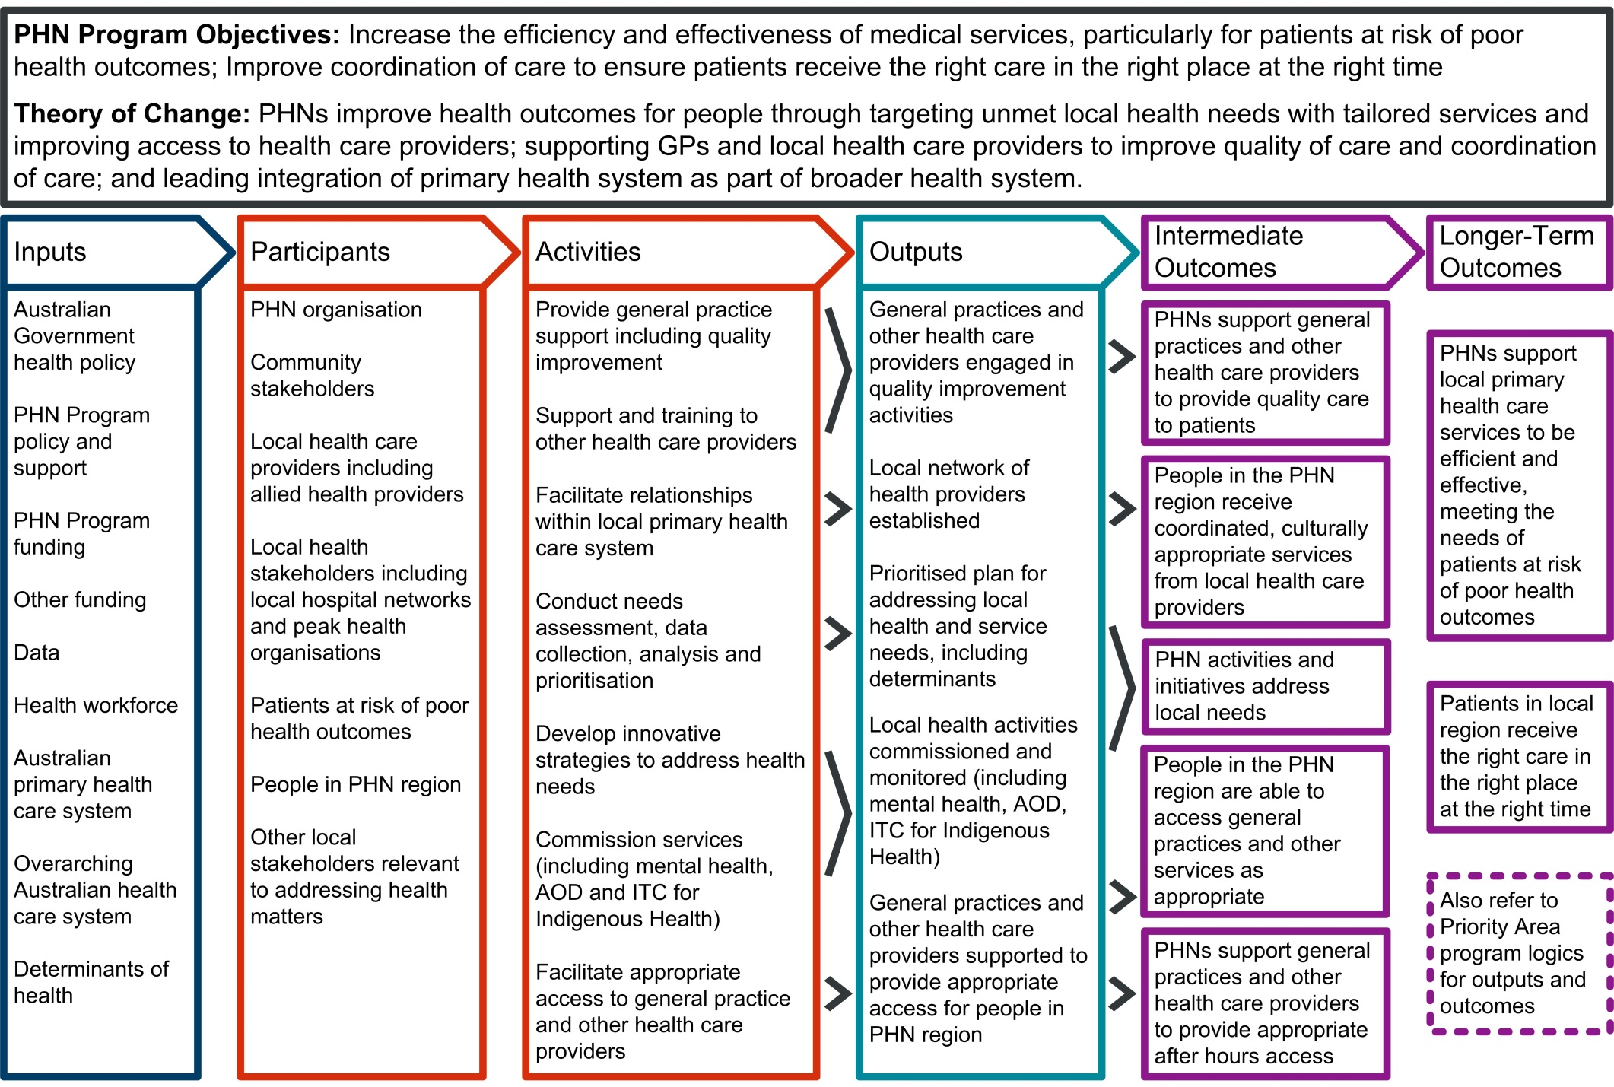

Mental Health program logic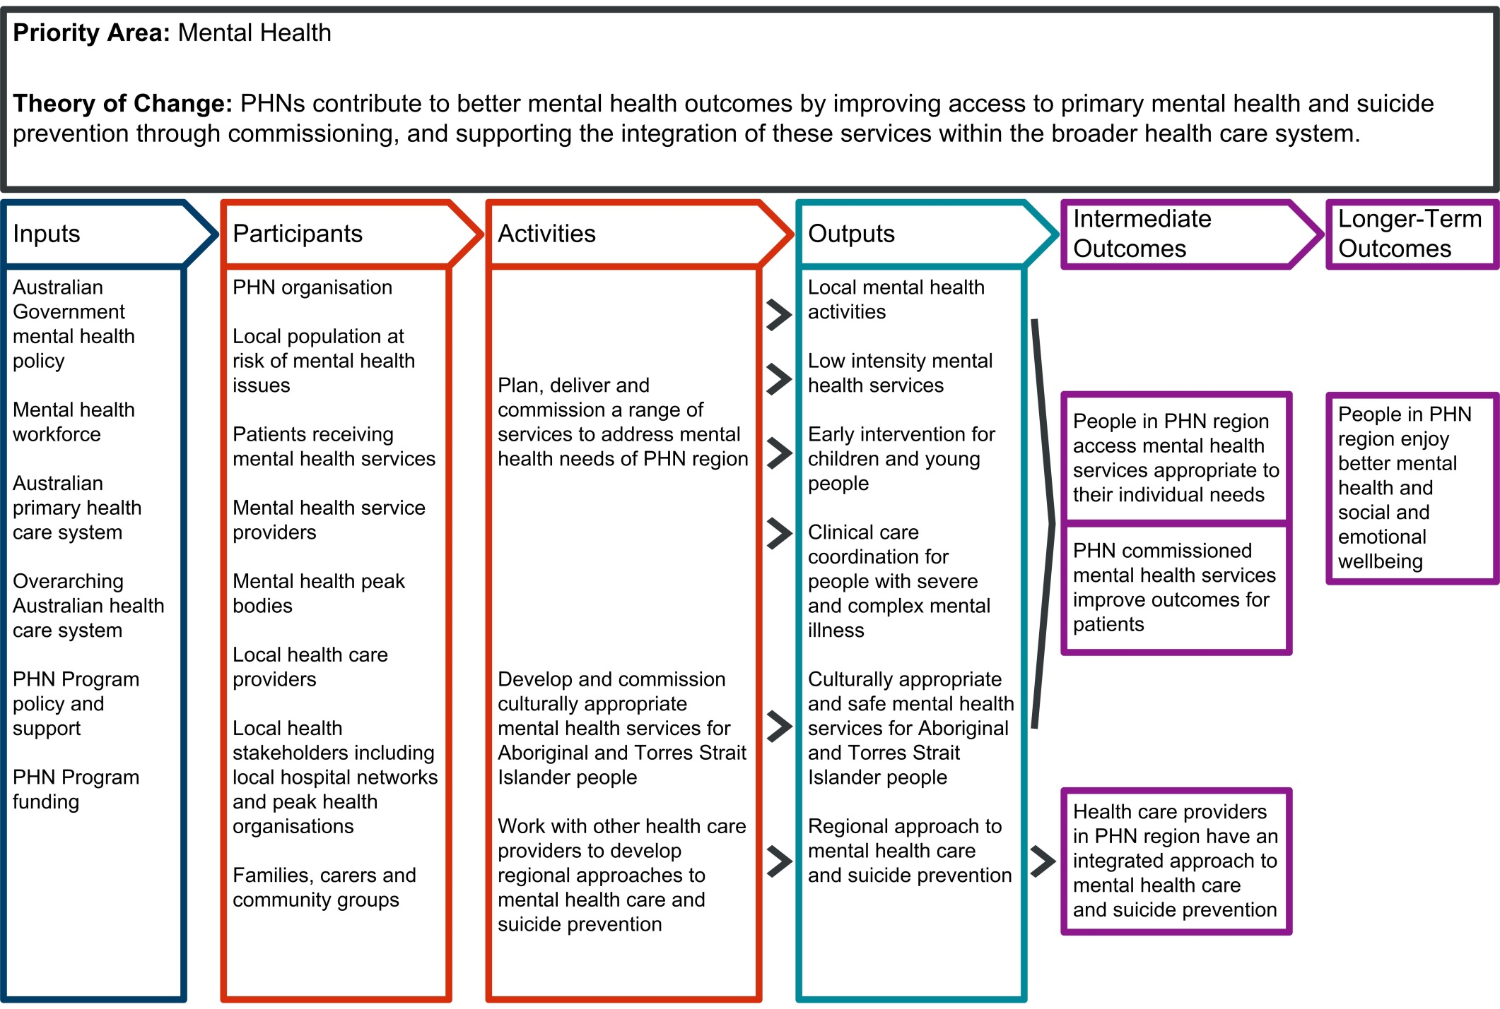

Aboriginal and Torres Strait Islander HealthThe program logic is a diagram showing the relationship of PHN inputs, participatnts and activities to outputs, and the outputs to Intermediate and Longer Term Outcomes.  The Intermediate and Longer Term Outcomes are listed in the PHN Program Performance and Quality Framework. 
 program logic

Population Health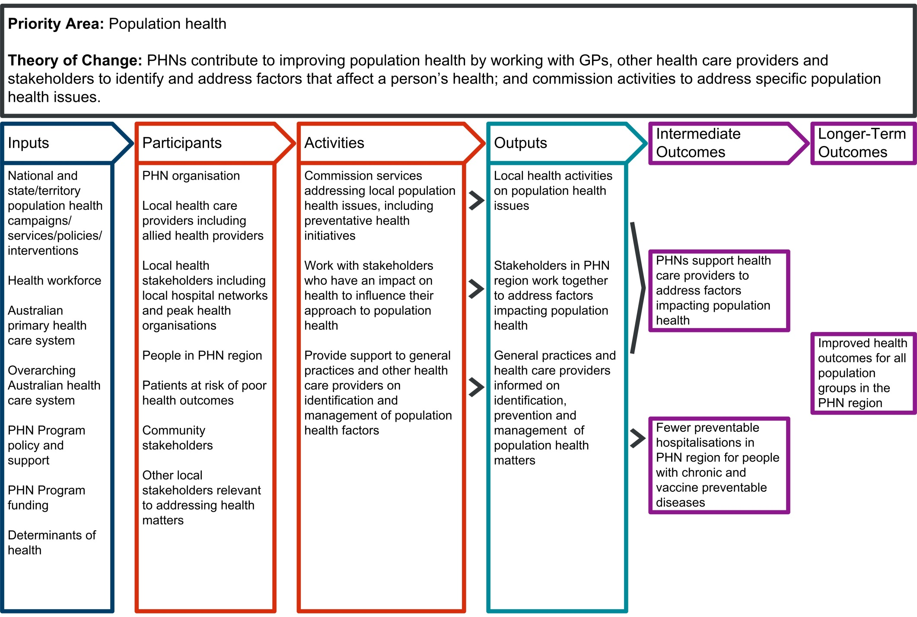 program logic

Workforce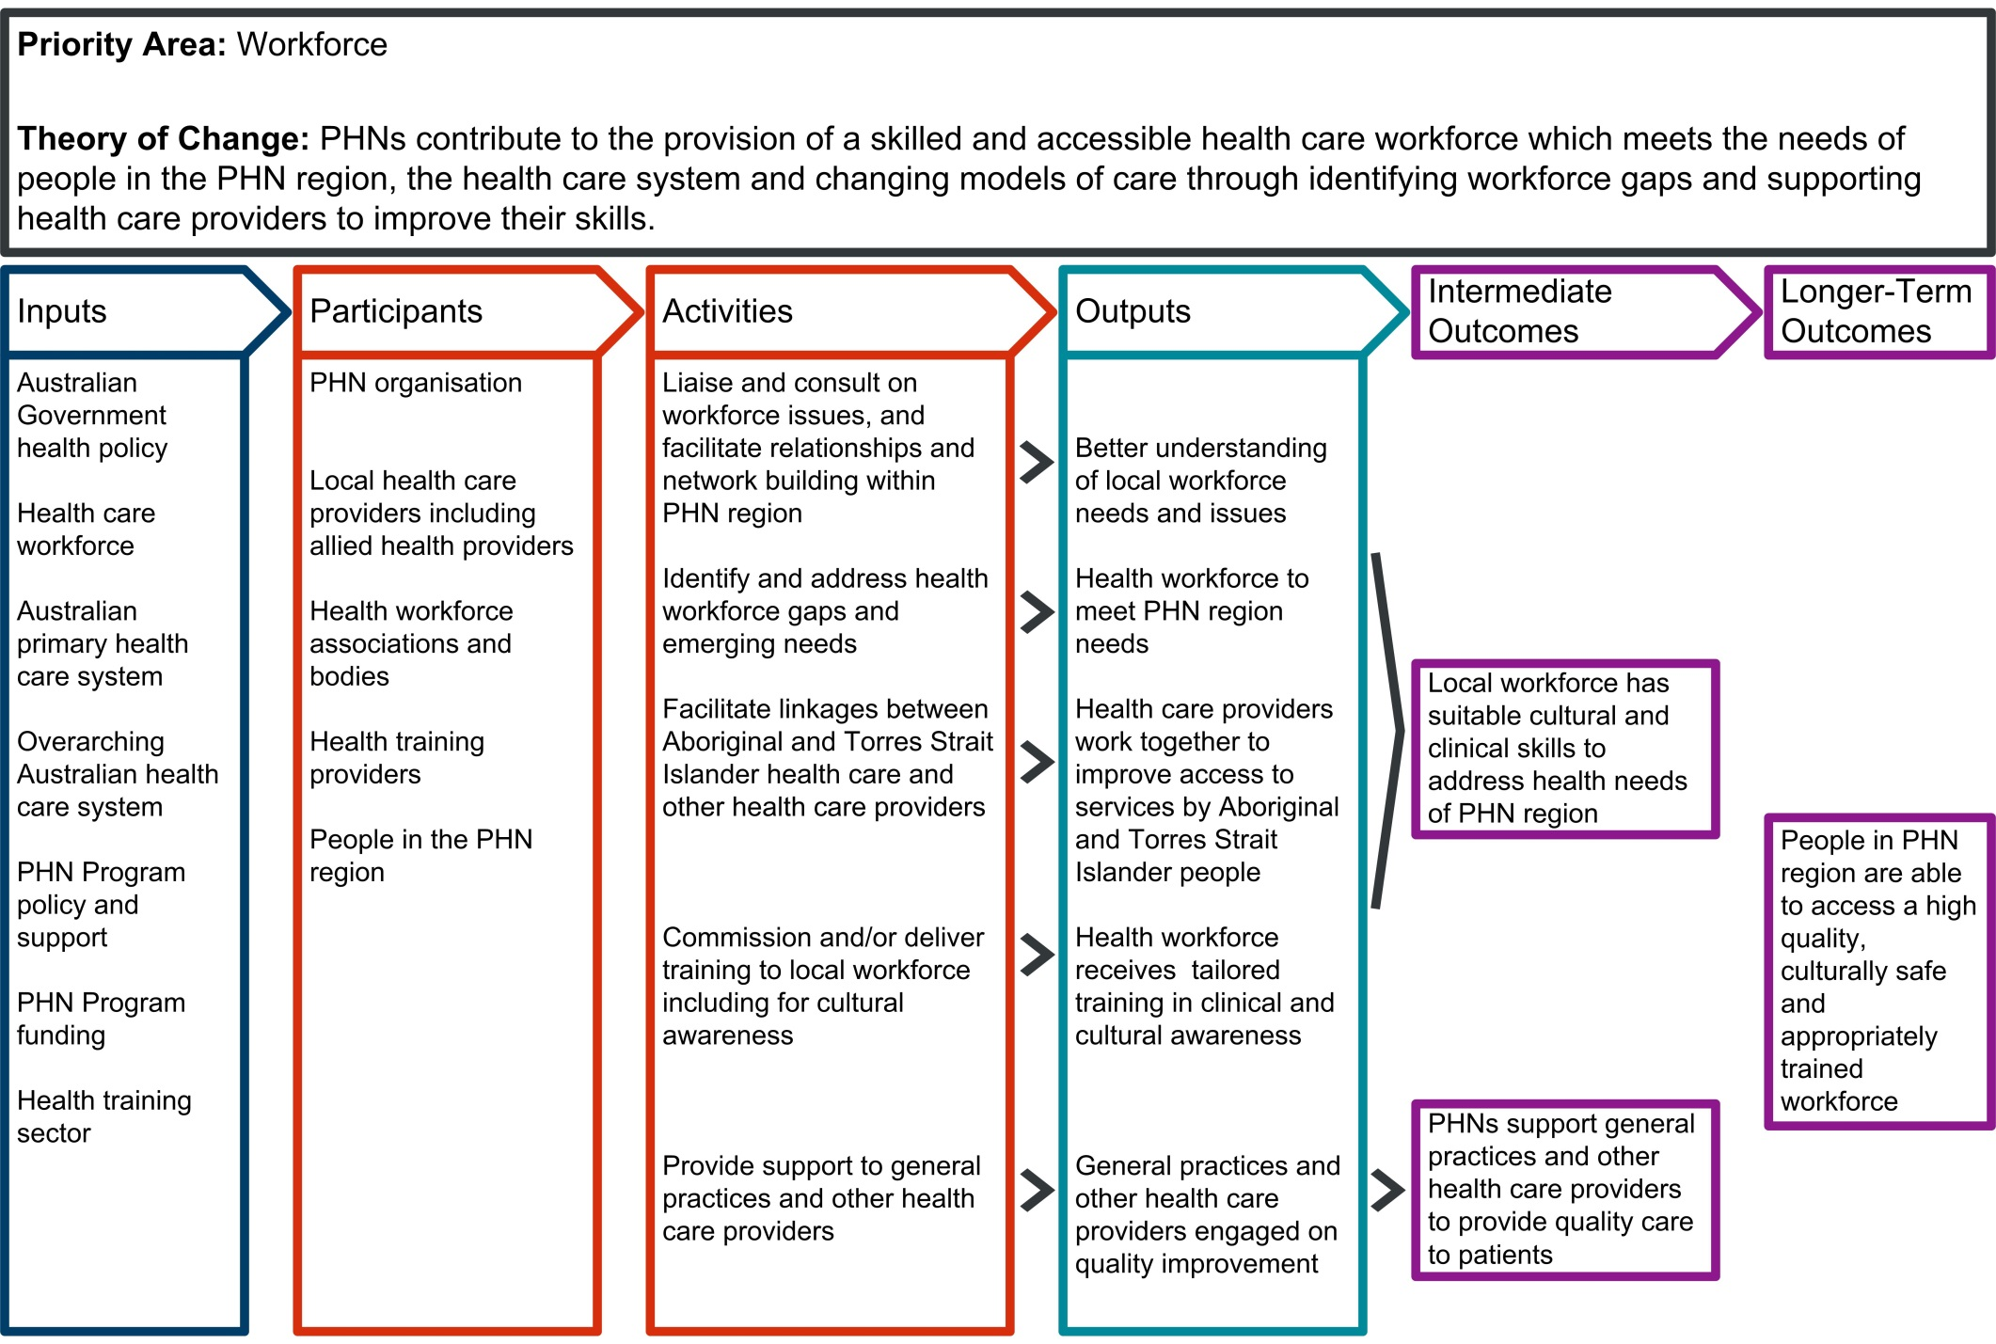 program logic

Digital Health program logic 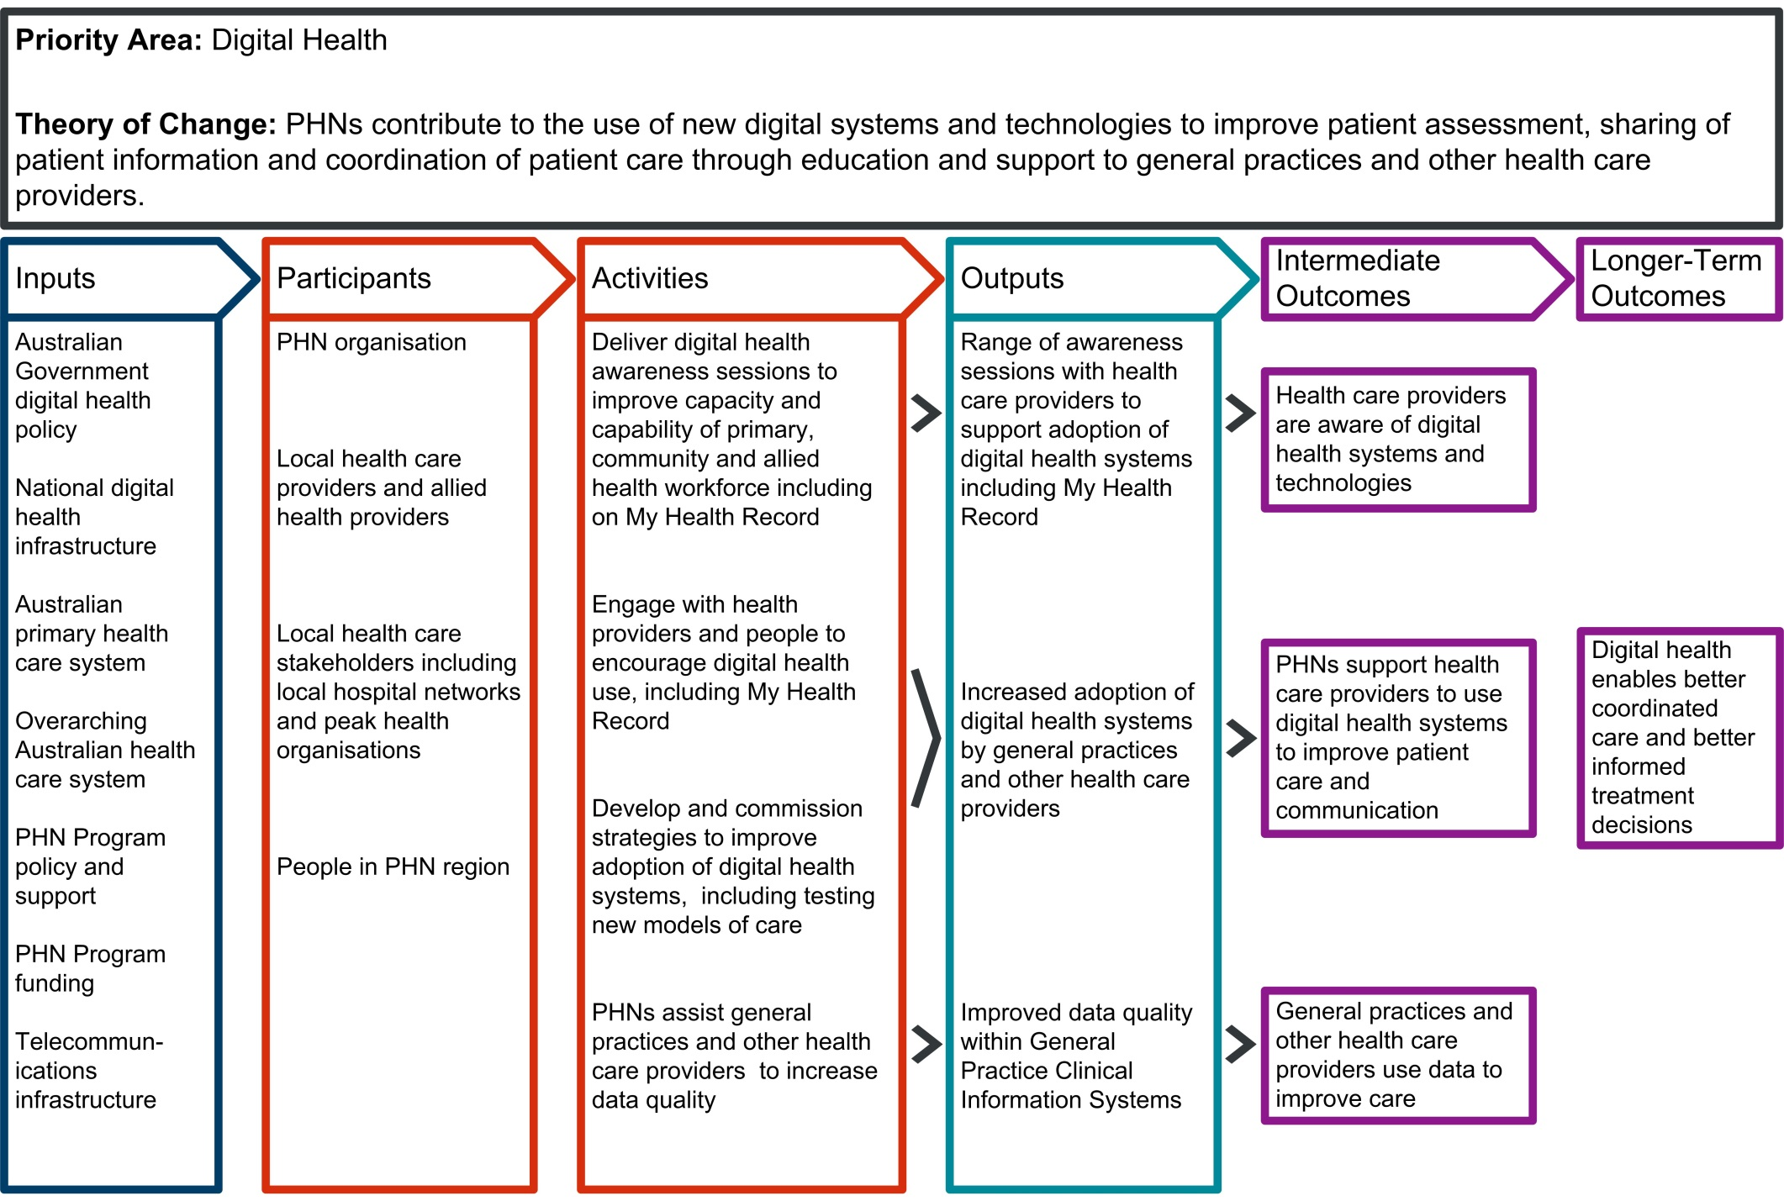

Aged Care program logic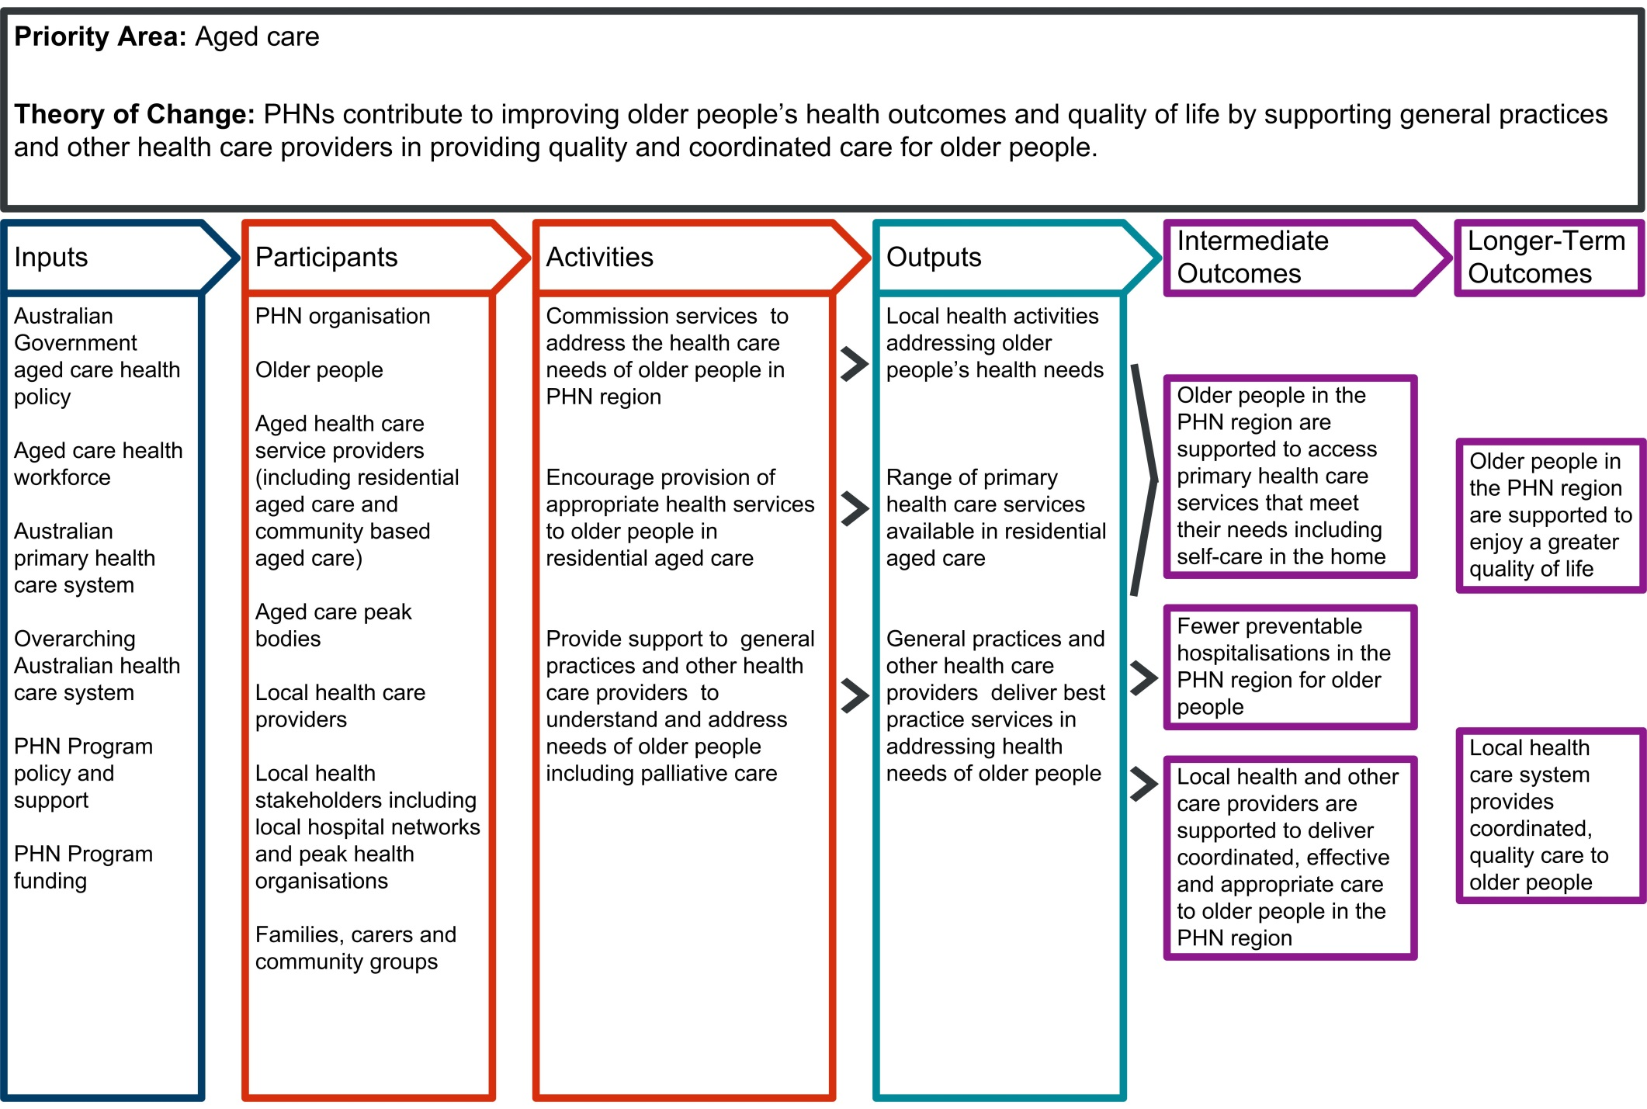

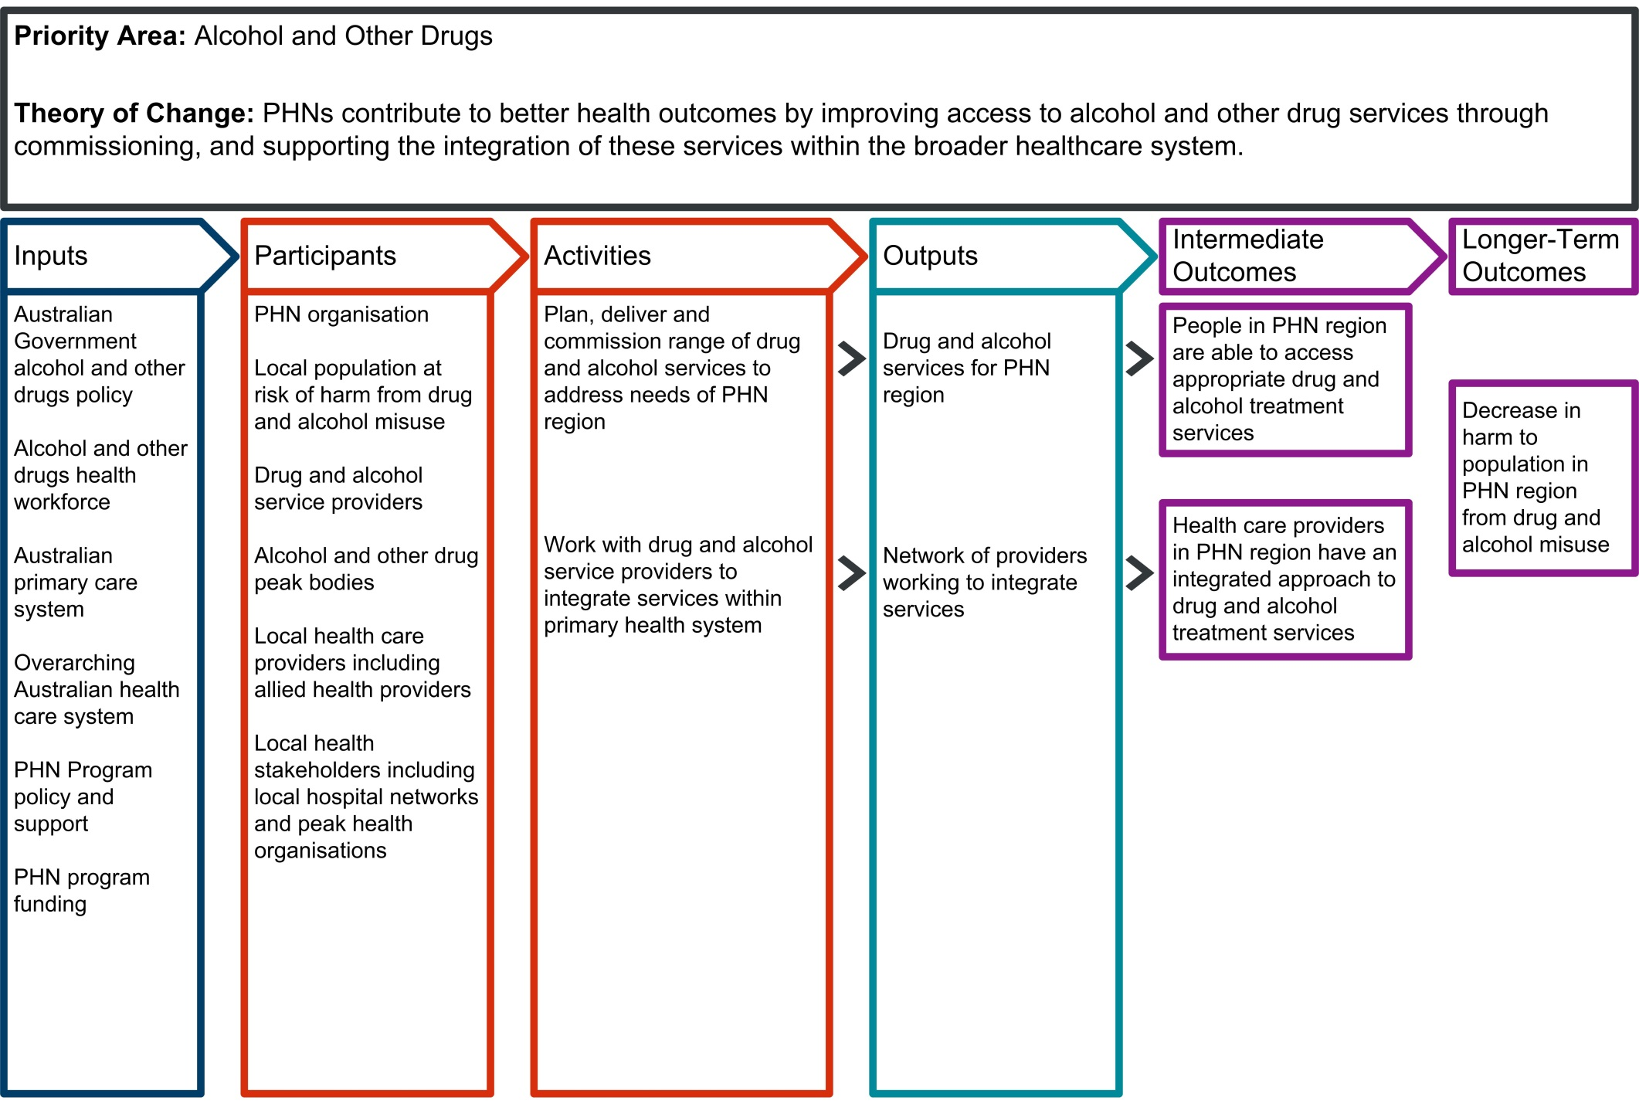Alcohol and Other Drugs program logic

# Version History

| **Version** | **Description of change** | **Author** | **Effective date** |
| --- | --- | --- | --- |
| 1.0 | Initial release | Department of Health | 1 / 7 / 18 |

© Commonwealth of Australia as represented by the Department of Health 2018

**Creative Commons Licence**

cid:image001.png@01D10CD1.33FE7F70

This publication is licensed under the Creative Commons Attribution 4.0 International Public License available from <https://creativecommons.org/licenses/by/4.0/legalcode> (“Licence”). You must read and understand the Licence before using any material from this publication.

Restrictions

The Licence may not give you all the permissions necessary for your intended use. For example, other rights (such as publicity, privacy and moral rights) may limit how you use the material found in this publication.

The Licence does not cover, and there is no permission given for, use of any of the following material found in this publication:

* the Commonwealth Coat of Arms. (by way of information, the terms under which the Coat of Arms may be used can be found on the Department of Prime Minister and Cabinet website http://www.dpmc.gov.au/government/commonwealth-coat-arms);
* any logos and trademarks;
* any photographs and images;
* any signatures; and
* any material belonging to third parties.

Attribution

Without limiting your obligations under the Licence, the Department of Health requests that you attribute this publication in your work. Any reasonable form of words may be used provided that you:

* include a reference to this publication and where, practicable, the relevant page numbers;
* make it clear that you have permission to use the material under the Creative Commons Attribution 4.0 International Public License;
* make it clear whether or not you have changed the material used from this publication;
* include a copyright notice in relation to the material used. In the case of no change to the material, the words “© Commonwealth of Australia (Department of Health) 2018” may be used. In the case where the material has been changed or adapted, the words: “Based on Commonwealth of Australia (Department of Health) material” may be used; and
* do not suggest that the Department of Health endorses you or your use of the material.

Enquiries

Enquiries regarding any other use of this publication should be addressed to the Branch Manager, Communication Branch, Department of Health, GPO Box 9848, Canberra ACT 2601, or via e-mail to [copyright@health.gov.au](mailto:copyright@health.gov.au)