Primary Health Networks

Grant Programme Guidelines

Grant Programme Process Flowchart 4
1. Introduction & Programme Details 6
1.1. Programme Background 6
1.2. Programme Objectives 7
1.3. PHN Governance Arrangements 7
1.3.1. Clinical Councils 8
1.3.2. Community Advisory Committees 8
1.3.3. Interaction with Local Hospital Networks 8
1.4. Boundaries 9
1.5. Funding 9
1.5.1. Operational Funding 9
1.5.2. Flexible Funding 9
1.5.3. Programme Funding 9
1.5.4. Innovation and Incentive Funding 10
1.6. Purchasing/Commissioning 10
1.6.1. Value for Money in Purchasing / Commissioning 10
1.6.2. Subcontracting 11
1.7. Direct Service Provision by PHNs 11
1.8. National Priorities and Performance Management 11
1.8.1. National Headline Indicators 11
1.8.2. Local Indicators 12
1.8.3. Organisational Indicators 12
1.8.4. Data and Reporting 12
1.8.5. Incentivising Performance 12
1.9. National Support 13
1.9.1. National Direction and Support 13
1.9.2. National Infrastructure 13
2. PHN Programme Management 15
2.1. Information Gathering Sessions with Stakeholders 15
2.2. Relevant Legislation 15
2.3. Roles and Responsibilities 15
2.4. Risk Management 16
2.5. Programme Timeframes 16
3. Eligibility 18
3.1. What is Eligible for Funding? 18
3.2. What is not Eligible for Funding? 18
3.3. Taxation and Insurance 18
3.3.1. Goods and Services Tax (GST) 18
3.3.2. Insurance 18
4. Probity 20
4.1. Conflict of Interest 20
4.2. Privacy - Confidentiality and Protection of Personal Information 21
5. Governance and Accountability 23
5.1. Contracting Arrangements 23
5.2. Payment Arrangements 23
5.3. Reporting Requirements 23
5.4. Monitoring 23
5.5. Evaluation 23
5.6. Branding 23

Grant Programme Process Flowchart

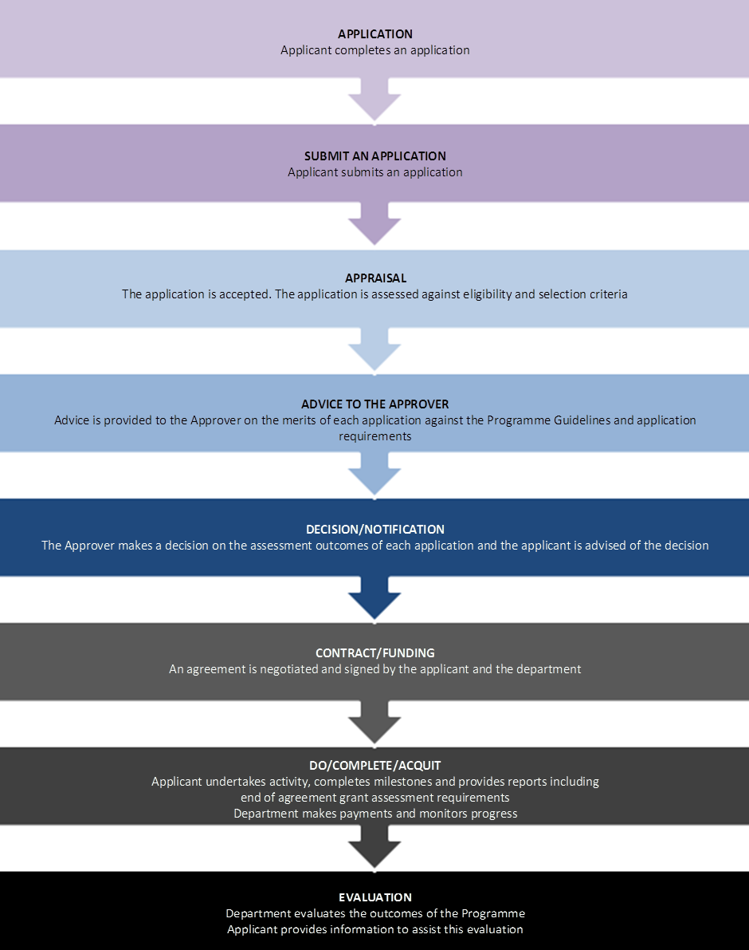
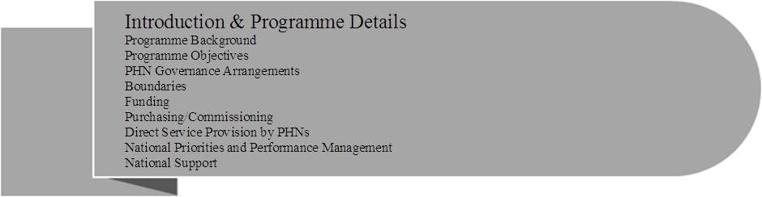

Introduction & Programme Details
These guidelines provide an overview of the operation of Primary Health Networks (PHNs). The guidelines may be updated during the course of the PHN Programme to reflect further details of the PHN Programme as it evolves.
In 2014-15 the Australian Government selected organisations to establish and operate 31 PHNs through an open competitive funding round. Funding has been allocated across the 31 PHNs with the total amount of grant funding for each PHN based on a number of factors, including population, rurality and socio-economic factors.
The total amount of operational and flexible funding that has been allocated to PHNs is $852 million over three years from 2015-16.
PHNs may also be eligible to receive innovation and/or incentive funding. Additional programme funding is provided for other primary health care activities including after hours and Indigenous health. PHNs will also receive additional flexible funding for mental health and drug and alcohol treatment services (see Annexures A and B). Further funding for specific programmes may also be provided depending on decisions of government.
For further information on the streams of funding available to PHNs, refer to Section 1.5 , Annexure A and Annexure B.
Further information relating to the operations of PHNs is available on the Department of Health’s (the department) website.

Programme Background

Review of Medicare Locals
The Australian Government is committed to rebuilding the primary health care system through efficient and innovative models of funding and delivery of health and medical services, to improve the coordination of patient care. A key activity was the Government’s commitment to a review of Medicare Locals’ structures, operations and functions (the Review) so as to inform options for future direction. The Review was conducted by Professor John Horvath, a former Commonwealth Chief Medical Officer, who submitted his report to Government on 4 March 2014.
The report contained 12 key findings and 10 recommendations which are available on the department’s website.
The Government accepted all the Review’s recommendations and in the 2014-15 Budget announced that new PHNs would replace Medicare Locals and commence from 1 July 2015.

Programme Objectives
PHNs were established with the key objectives of:
- increasing the efficiency and effectiveness of medical services for patients, particularly those at risk of poor health outcomes; and
- improving coordination of care to ensure patients receive the right care in the right place at the right time.
PHNs will achieve these objectives by:
- understanding the health care needs of their PHN communities through analysis and planning. They will know what services are available and help to identify and address service gaps where needed, including in rural and remote areas, while getting value for money;
- providing practice support services so that GPs are better placed to provide care to patients subsidised through the Medicare Benefits Schedule (MBS) and Pharmaceutical Benefits Scheme (PBS), and help patients to avoid having to go to emergency departments or being admitted to hospital for conditions that can be effectively managed outside of hospitals;
- supporting general practices in attaining the highest standards in safety and quality through showcasing and disseminating research and evidence of best practice. This includes collecting and reporting data to support continuous improvement;
- assisting general practices in understanding and making meaningful use of eHealth systems, in order to streamline the flow of relevant patient information across the local health provider community; and
- working with other funders of services and purchasing or commissioning health and medical/clinical services for local groups most in need, including, for example, patients with complex chronic conditions or mental illness.

PHN Governance Arrangements
The governance of PHNs should reflect sound corporate governance principles . They should operate efficiently and effectively and deliver against national outcomes and locally relevant primary health care needs, minimising administrative overheads.
At a minimum, Boards should be skills-based and managers and staff should be appropriately qualified and experienced. Boards will have accountability for the performance of the PHN in relation to outcomes, as well as clinical, financial, risk, planning, legal and business management systems. PHNs should be structured to avoid, or actively and appropriately manage conflicts of interest, particularly in relation to purchasing, commissioning (refer to Section 1.6) and providing services (refer to Section 1.7).
PHNs are required to have GP-led Clinical Councils and representative Community Advisory Committees to report to the Board on locally relevant clinical and consumer issues. PHNs must have broad engagement across their region including with Local Hospital Networks (LHNs) (or equivalent), public and private hospitals, Aboriginal Medical Services, nurses, allied health providers, health training coordinators, state and territory government health services, aged care providers and private health insurers.
In addition, where patient flows cross state and territory borders, PHNs are expected to develop cross-border cooperative relationships and shared Clinical Councils and Community Advisory Committees where appropriate.

Clinical Councils
PHNs must establish and maintain GP-led Clinical Councils that will report on clinical issues to influence PHN Board decisions on the unique needs of their respective communities, including in rural and remote areas.
While GP-led, it is expected that Clinical Councils will comprise other health professionals, including but not limited to nurses, allied and community health, Aboriginal health workers, specialists and hospital representatives. Clinical Councils will assist PHNs to develop local strategies to improve the operation of the health care system for patients in the PHN, facilitating effective primary health care provision to reduce avoidable hospital presentations and admissions. Clinical Councils will be expected to work in partnership with LHNs in this regard.
Clinical Councils are also expected to report to and influence their PHN Boards on opportunities to improve medical and health care services through strategic, cost-effective investment and innovation. They will act as the regional champions of locally relevant clinical care pathways designed to streamline patient care, improve the quality of care and utilise existing health resources efficiently to improve health outcomes. This will include pathways between hospital and general practice that influence the follow-up treatment of patients.
Pathways to be prioritised will be those that align with national or PHN specific priorities, including ensuring population cohorts experiencing chronic and complex conditions are better and more efficiently managed within the primary health care system. Where relevant, Clinical Councils in neighbouring PHNs will be expected to work together to ensure that pathways follow patient flows including across PHN boundaries.
In cross border regions, it is expected that there are formal relationships between Clinical Councils and Community Advisory Committees, for example, the Australian Capital Territory and Queanbeyan.
Clinical Councils will work in tandem with Community Advisory Committees.

Community Advisory Committees
Community Advisory Committees will provide the community perspective to PHN Boards to ensure that decisions, investments, and innovations are patient centred, cost-effective locally relevant and aligned to local care experiences and expectations. PHNs are expected to ensure that Community Advisory Committee members have the necessary skills to participate in a committee environment and are representative of the PHN.

Interaction with Local Hospital Networks
PHNs are expected to develop collaborative working relationships with LHNs and public and private hospitals to reduce duplication of effort and resources, and to increase the PHN’s ability to purchase or commission medical and health care services. PHNs will undertake population health planning in conjunction with LHNs and jurisdictional organisations. This will identify key PHN priorities to improve health outcomes and reduce hospital pressure without duplicating efforts and initiatives of LHNs or state and territory governments.

Boundaries
Thirty-one PHNs were established at a regional level across Australia. Their boundaries align with LHN boundaries (or equivalent).
In determining boundaries, a number of factors were considered, including population size, LHN alignment, state and territory borders, patient flow, stakeholder input and administrative efficiencies.
PHN profiles and a map locator, are available on the department’s website.
As PHN boundaries align with the boundaries of LHNs, there may be a future requirement to revise PHN boundaries should LHN (or equivalent) boundaries be changed by a state or territory government. Provisions for potential boundary changes are included in the funding agreement between the Commonwealth and PHNs.
While PHNs are responsible for activity within their geographic area, all PHNs are expected to develop cooperative relationships with other PHNs when the need arises, for example, when identified patient flows cross into another PHN region.

Funding
Funding for PHNs takes into account a number of factors, including population, rurality and socio-economic factors. Where the Australian Government determines that additional policy outcomes can best be achieved by PHNs, the department may directly allocate additional funding through non-application based processes based on these factors as well as any policy specific considerations.
PHN funding is provided through four streams of funding as follows:
- operational funding – refer to Section 1.5.1;
- flexible funding – refer to Section 1.5.2;
- programme funding – refer to Section 1.5.3; and
- innovation and incentive funding – refer to Section 1.5.4.

Operational Funding
From 2015-16, operational funding is provided for the administrative, governance and core functions of PHNs. This funding is to be used efficiently to support the operations and maintenance of PHNs including: premises; governance; board; core staff; and office administrative costs including IT requirements. It will enable PHNs to conduct needs assessments and associated population health planning. It will also provide funding for the establishment and maintenance of Clinical Councils and Community Advisory Committees and for stakeholder management and engagement and practice support activities in their regions. For information on activities that are not eligible for funding, refer to Section 3.2.

Flexible Funding
Flexible funding is provided to enable PHNs to respond to identified national priorities as determined by Government, and to respond to PHN specific priorities by purchasing/commissioning required services. For further information on purchasing/commissioning, refer to Section 1.6.
Flexible funding is used to achieve health outcomes that will be measured by key performance indicators (KPIs) in the PHN Performance Framework. For further information on national priorities and KPIs, refer to Section 1.8.

Programme Funding
In 2015-16, programmes previously managed by Medicare Locals that were in scope transferred to PHNs to ensure continuity of priority frontline services in the establishment phase.
Depending on decisions of government, it is expected that over time PHNs will deliver a broader range of activities in their regions.
From 2016-17, it is anticipated that PHNs will have greater flexibility to commission programme specific services, having completed the regional needs assessments for their regions and associated population health planning.

Innovation and Incentive Funding
Innovation funding may be provided to PHNs to enable the Government to invest in new innovative models of primary health care delivery that, if successful, can be rolled out across PHNs.
Incentive funding will be made available for high performing PHNs that are able to meet specific performance targets.
Additional information regarding innovation and incentive funding will be provided through updates to these guidelines.

Purchasing/Commissioning
In the context of the PHN Programme, purchasing refers to the procurement of medical and health care services in a transitional context to maintain service continuity. Purchasing of new services by PHNs will be limited in 2015-16, with the focus being on frontline medical and health care service continuity and a smooth transition from Medicare Locals. PHN purchasing decisions must be cognisant of local patient needs and the efficacy and cost-effectiveness of services so as to avoid duplicating initiatives and efforts of LHNs and state and territory governments.
During this period (2015-16), PHNs will undertake baseline PHN needs assessments that will draw upon relevant data, including information and transition plans developed by Medicare Locals and data collected by LHNs.
PHNs will be supported to move to commissioning models as far as possible commencing in the second year of operation (2016-17) or sooner for PHNs with demonstrated capacity. Unlike purchasing models, in the context of the PHN Programme, commissioning is characterised by a strategic approach to procurement that is informed by the baseline needs assessment and associated market analysis undertaken in 2015-16. Commissioning will enable a more holistic approach in which PHNs can plan and contract medical and health care services that are appropriate and relevant to the needs of their communities. Commissioning is further characterised by ongoing assessment to monitor the quality of services and ensure that relevant contractual standards are fulfilled. It is expected that PHN commissioning capabilities will continue to develop over time.

Value for Money in Purchasing / Commissioning
Achieving value for money is a core requirement of purchasing and commissioning by PHNs. Value for money requires:
- encouraging competitive and non-discriminatory procurement/purchasing processes;
- using resources provided by the Commonwealth in an efficient, effective, economical and ethical manner in line with programme objectives;
- wherever practicable not duplicating efforts of other private or public sector entities;
- making decisions in an accountable and transparent manner;
- considering and appropriately managing risk;
- managing conflicts of interest; and
- conducting a process that is commensurate with the scale and scope of the procurement.
Price is not the sole determining factor in assessing value for money. A comparative analysis of the relevant financial and non-financial costs and benefits of alternative solutions throughout the procurement will inform a value for money assessment. Factors to consider include, but are not limited to:
- fitness for purpose;
- a potential supplier’s experience and performance history;
- flexibility, including innovation and adaptability; and
- whole of life costs.
The department reserves the right to review PHN procurement decisions on the basis of the value for money parameters outlined above. In the event that value for money cannot be demonstrated, the PHN may be subject to further audits and action in line with contractual obligations.

Subcontracting
Subcontracting is a defined term in the funding agreement. A PHN is considered to be subcontracting where core functions such as the needs assessment or data collection and analysis are outsourced.
The purchasing and commissioning of services with flexible funding is not considered to be subcontracting.
There are certain core functions a PHN will not be permitted to subcontract. These are:
- governance structures including Clinical Councils and Community Advisory Committees;
- stakeholder relationship management and engagement; and
- supporting general practice.

Direct Service Provision by PHNs
In order to ensure continuity of service following the transition from Medicare Locals, PHNs may need to utilise flexible funding to continue to deliver services directly during the first year of operation (2015-16). These arrangements must be reviewed during 2015-16 as part of the baseline needs assessments and where appropriate, transitioned to a purchasing arrangement.
As a general rule, the PHN’s role in primary health care service provision in the second year of operation (2016-17) as far as possible will be as a commissioner, rather than a provider of services. If the PHN's needs assessment identifies a specific population cohort or area with a lack of, or inequitable access to medical and health care services, PHNs must take reasonable steps to utilise existing service providers within their PHN. Where local services do not exist, PHNs will work to stimulate the market through investment in health and medical services to attract new providers, including from outside of the PHN.
In the event that no appropriate service provider is available and the PHN cannot reasonably facilitate new providers, a PHN must seek the department’s approval to directly provide services either as an interim or longer term arrangement. In these instances, the PHN must demonstrate to the department that the region is lacking appropriate services and the PHN has investigated alternative avenues for service delivery.

National Priorities and Performance Management
PHNs are expected to work to improve health outcomes for their communities. A core set of priorities has been set at a national level by Government. Initial priorities include reduced avoidable hospitalisations and emergency department presentations, and improved health outcomes for people with complex chronic conditions. Such priorities are likely to continue to be set over a number of years and adjusted as required.
The monitoring and assessment of PHN performance will be outlined in a PHN Performance Framework that encompasses three tiers of performance: national, local and organisational.

National Headline Indicators
The first tier of the PHN Performance Framework is national headline indicators. These indicators reflect government priorities and were selected because of their alignment with PHN objectives, the availability of existing data sources, and feasibility of PHNs to influence change. The national headline indicators include:
- potentially preventable hospitalisations;
- childhood immunisation rates;
- cancer screening rates (cervical, breast, bowel); and
- mental health treatment rates (including for children and adolescents).

Local Indicators
PHNs are required to analyse the health needs of their populations through formal planning processes to enable better targeting of available resources and services. As part of these planning processes, PHNs are expected to select, periodically review and revise local priorities and indicators that will allow measurement of PHN priorities and drive quality improvement activity in their region.

Organisational Indicators
The PHN Performance Framework also includes organisational performance. The organisational measures for 2015-16 include:
- establishment of skills-based Boards, GP-led Clinical Councils and Community Advisory Committees;
- development of population needs assessments and annual plans; and
- development of annual budgets and provision of audited financial statements.

Data and Reporting
Data required to monitor and assess PHNs against national and local indicators will be accessed from a range of existing data collections where possible (including clinical data sets and patient surveys). Reporting by PHNs on organisational indicators will be via standardised reports and may be facilitated by a standardised data exchange portal. Refer to Section 1.9.2 for further details on national infrastructure.
The PHN Performance Framework will provide for the benchmarking of PHNs and the identification of high and poor performers. Performance information on all PHNs will be made publicly available. It will also: facilitate the early identification of issues; enable risks to be managed; and enable assessment of eligibility for incentive payments.
In 2015-16, performance measurement will focus on organisational performance (associated with establishment and the transition from Medicare Locals) and developing baseline data from which to measure outcome attainment. In 2015-16 there will also be some monitoring and assessment of performance in delivering programmes that transition to PHNs from Medicare Locals.

Incentivising Performance
Creating a high performing environment in which PHNs will operate is a key design component of the PHN programme. High performing PHNs will be identified through performance measurement processes, including benchmarking and through PHNs contribution to system development and the sharing of innovations and best practice.
High performance may attract various financial and non-financial rewards such as:
- incentive funding;
- increased contract length;
- the opportunity to take over contracts for those regions with poor performers; and/or
- public recognition of performance.

National Support

National Direction and Support
The department will carry out a range of support functions for PHNs to provide national direction and to support high performance of PHNs. These functions include developing and implementing a PHN Performance Framework, as well as a National Primary Health Care Performance Framework, determining benchmarks, and implementing measures to encourage innovation and incentivise performance.
National systems will be developed to encourage the sharing of information, improve administrative efficiencies and minimise infrastructure costs across PHNs. The department will also encourage continuous improvement through collaboration, assist in the analysis of needs assessments to inform national priorities and ensure PHNs have access to best practice research.

National Infrastructure
National infrastructure will support PHNs to operate efficiently and effectively thereby allowing more funding to be directed to frontline services. Initial infrastructure may include:
- National Health Services Directory (NHSD) – providing a consistent directory of key primary health services, including after hours services;
- Primary Health Map – providing the capability to view health needs, overlaid with the location of the health services identified from the NHSD;
- PHN websites with centralised content and reporting dashboard – providing a template website solution to support centralised reporting and sharing of content and service information with in-built capability from the NHSD, video consulting, symptom checkers and clinically governed health information;

- Video conferencing and consulting – providing cost-effective communication for the establishment stage and for ongoing practice support;
- Clinical pathways – integrating NHSD functionality into a range of existing clinical pathway tools to support appropriate referrals;
- e-Referral – supporting secure messaging between health professionals; and
- myHealth Record integration – providing integration to the myHealth Record to upload patient information.
There may also be opportunities for centralised procurement of some functions and services to ensure consistent service delivery and economies of scale. These would be delivered through collaborative arrangements with PHNs.
It is expected that some elements will form mandatory requirements, while others could be used by PHNs if relevant to business needs.



PHN Programme Management

Information Gathering Sessions with Stakeholders
A number of information gathering sessions with state and territory governments, Medicare Locals and peak bodies were undertaken during June and July 2014. These sessions informed the policy development leading to these programme guidelines.

Relevant Legislation
The PHN Programme draws its administrative authority from the Commonwealth Grants Rules and Guidelines (CGRGs) that are issued by the Minister for Finance under the Public Governance, Performance and Accountability Act 2013 (PGPA Act). The legal authority for the grant is Section 32(b) of the Financial Framework (Supplementary Powers) Act 1997 and Financial Framework (Supplementary Powers) Regulations 1997, Schedule 1AB Part 4 section 57 Primary Health Networks.
Department of Health staff involved in grant administration are accountable for complying with the CGRGs, and other policies and legislation that interact with grants administration.

Roles and Responsibilities

Department of Health
The department manages the PHN Programme. It is responsible for the development and dissemination of all documentation regarding funding under the PHN Programme and for ensuring that documentation is in accordance with the PHN Programme’s objectives. The department is also responsible for notifying applicants of the outcome of any funding process, responding to queries in relation to the funding process, and for resolving any uncertainties that may arise in relation to funding requirements.
The department is responsible for decisions regarding the internal administrative, assessment recommendations and programme management arrangements under the PHN Programme including:
- assessing the initial applications;
- developing funding agreements or any alternative contractual arrangement;
- monitoring the performance of activities to ensure the conditions of the funding agreement or other contractual arrangement are met;
- assessing performance and financial reports and undertaking follow up activity as necessary;
- making payments as specified in the funding agreement or contractual arrangement; and
- providing feedback to funded organisations during the funding period and following the conclusion of activities.

The Assessment Committee
A tiered assessment committee was established by the department to appraise applications against the selection criteria and select the shortlisted applicants for consideration by the Approver. Assessment of the applications included advice from subject experts, including external experts.

Approver
The Approver was the Minister for Health and Sport. The Approver considered whether the proposals made an efficient, effective, ethical and economical use of Australian Government resources and recorded the basis for the approval relative to the grant guidelines and key considerations of value with relevant money, as required by Commonwealth legislation, and whether any specific requirements needed to be imposed as a condition of funding.

Funding Recipients
Organisations receiving funding are responsible for the efficient and effective delivery of activities in accordance with the obligations contained in any funding agreement or contractual arrangement entered into under the PHN Programme. Organisations are also responsible for:
- ensuring that the terms and conditions of the funding agreement are met;
- ensuring activities are purchased/commissioned in a cost effective and efficient manner;
- ensuring the activity achieves value with relevant money;
- employing and managing PHN staff;
- maintaining contact with the department and advising of any emerging issues that may impact on the success of the activity;
- identifying, documenting and managing risks and conflicts of interest and putting in place appropriate mitigation strategies;
- ensuring outcomes and output reporting in accordance with the funding agreement; and
- participating in activity evaluation as necessary.

Risk Management
The department is committed to a comprehensive and systematic approach to the effective management of potential opportunities and adverse effects. Contractual arrangements will be managed in proportion to their level of risk to the Commonwealth. As such, applicants may be subject to a risk assessment prior to negotiating contractual arrangements.
Consistent with the responsibilities described under Section 2.3, organisations receiving funding are responsible for managing risks to their own business activities and priorities. The Commonwealth manages risks to PHN Programme funds and outcomes through its management of the grant.

Programme Timeframes
In 2014-15 the Australian Government selected organisations to establish and operate 31 PHNs through an open competitive funding round. Funding for 2015-16 to 2017-18 has been fully allocated to PHNs based on this funding round.
These PHN Programme Guidelines are publicly available and will form part of any future ATM documentation in any instance where it is necessary to re-approach the market under this programme.
Specific timeframes for funding processes will be provided in future PHN ITA documentation.



Eligibility
Applications were encouraged from a wide range of entities including for-profit and not-for-profit, private organisations and state and territory governments. However, to be eligible for assessment, applicants had to be an incorporated body or government entity.
Applicants were not required to have had a prior funding relationship established with the department, but had to be a legal entity to be eligible for funding.
Applicants were able to form a partnership or a consortium to operate a PHN. For those applications, one member had to be identified as the lead entity and an authorised representative of the lead entity had to sign the application form.

What is Eligible for Funding?
Applications for funding had to be consistent with the objectives of and include activities supported under the PHN Programme.

What is not Eligible for Funding?
Funding cannot be used for:
- capital infrastructure such as the purchase of real estate or for building or construction or demolition, except where approved in writing by the Commonwealth;
- the purchase or repair of equipment or motor vehicles, excluding routine maintenance, except where approved in writing by the Commonwealth;
- security for the purpose of obtaining commercial loans or for the purpose of meeting existing loan obligations;
- legal or other costs (including damages) to settle unfair dismissal grievances and/or settle other claims brought against the PHN, except where approved in writing by the Commonwealth;
- retrospective items/activities;
- activities undertaken by political organisations; and
- activities which subsidise commercial activities.

Taxation and Insurance

Goods and Services Tax (GST)
Where GST is payable, the Commonwealth will increase the funds payable to the funding recipient by the amount of GST that is payable for the purposes of the A New Tax System (Goods and Services Tax) Act 1999. The GST inclusive amount will be reflected in the funding agreement.

Insurance
PHN’s are required to take out and maintain, for the period specified in the funding agreement, all types and amounts of insurance necessary to cover the obligations of the organisation in relation to the activity.
Where the department deems appropriate, additional insurance requirements may be specified in the funding agreement.



Probity
The Australian Government is committed to ensuring that the process for providing funding under the PHN Programme is transparent and in accordance with published Guidelines.
Note: Guidelines may be varied from time-to-time by the Australian Government as the needs of the PHN Programme dictate. Amended Guidelines will be published on the department’s website and PHNs notified in writing.

Conflict of Interest
A conflict of interest (inclusive of a perceived conflict of interest) may exist if departmental staff, any member of an advisory panel or expert committee, and/or the applicant or any of its personnel:
- has a relationship (whether professional, commercial or personal) with a party who is able to influence the application assessment process, such as a departmental officer;
- has a relationship with, or interest in, an organisation, which is likely to interfere with or restrict the applicant in carrying out the proposed activities fairly and independently; or
- has a relationship with, or interest in, an organisation from which they will receive personal gain as a result of the granting of funding under the PHN Programme.
Each party will be required to declare as part of their application, existing conflicts of interest or that to the best of their knowledge there is no conflict of interest, including in relation to the examples above, that would impact on or prevent the applicant from proceeding with the project or any funding agreement it may enter into with the Australian Government.
Where a party subsequently identifies that an actual, apparent, or potential conflict of interest exists or might arise in relation to this application for funding, external parties must inform the department in writing immediately. Departmental staff or members of any advisory panel or expert committee must advise the chair of the assessment panel. Conflicts of interest will be handled in compliance with departmental policies and procedures on the department’s website.
Conflicts of interest for departmental staff will be handled in compliance with the Australian Public Service Commission policies and procedures.

Privacy - Confidentiality and Protection of Personal Information
Each applicant will be required to declare as part of their application, their ability to comply with the following Legislation/Clauses.
The Protection of Personal Information Clause requires the funding recipient to:
- comply with the Privacy Act (1988) (‘the Privacy Act’), including the 13 Australian Privacy Principles (APPs) which are contained in Schedule 1 of the Privacy Act; and
- impose the same privacy obligations on any subcontractors it engages to assist with the activity.
The Confidentiality Clause imposes obligations on the funding recipient with respect to special categories of information collected, created or held under the funding agreement. The funding recipient is required to seek the department’s consent in writing before disclosing confidential information.
Further information can be found in the terms & conditions of the funding agreement available on the department’s website.



Governance and Accountability

Contracting Arrangements
Successful applicants were required to enter into a funding agreement with the Commonwealth (represented by the department). If required, ATM documentation for any future funding rounds will include the standard terms and conditions of the funding agreement. These cannot be changed but additional supplementary conditions may apply.
PHNs must carry out each activity in accordance with the agreement, which include meeting milestones and other timeframes specified in the schedule for that activity. Funding agreements also outline the record keeping, reporting and acquittal requirements that will apply to successful applicants. Activities must be carried out diligently, efficiently, effectively and in good faith to a high standard to achieve the aims of the activity and to meet the PHN Programme objectives.

Payment Arrangements
Payments will be made in accordance with the funding agreement. The default invoice process for the department is Recipient Created Tax Invoices (RCTI).

Reporting Requirements
PHNs must provide the department with the reports for an activity containing the information, and at the times and in the manner specified in the funding agreement. Specific reporting requirements will form part of the funded organisation’s agreement with the department. Based on risk, these may include:
- progress reporting;
- audited income and expenditure statements; and
- final report.

Monitoring
PHNs will be required to actively manage the delivery of the activity under the PHN Programme. The department will monitor progress in accordance with the funding agreement.

Evaluation
An evaluation by the department will determine how the funded activity contributed to the objectives of the PHN Programme. During the funding period, funding recipients will be required to provide information to assist in this evaluation for a period of time, as stipulated in the funding agreement, after funding has been provided.

Branding
Programme branding is a requirement under the funding agreement and must be applied as directed by the Department.

ASX Corporate Governance Council, Corporate Governance Principles and Recommendations, 3rd ed.
The Public Governance, Performance and Accountability Act 2013 defines relevant money as: (a) money standing to the credit of any bank account of the Commonwealth or a corporate Commonwealth entity; or (b) money that is held by the Commonwealth or a corporate Commonwealth entity.

