Opioid Prescribing Practices Project:

Key Outcomes

March 2021

© Commonwealth of Australia as represented by the Department of Health 2021

Opioid Prescribing Practices Report: Key Outcomes

DT0001267

**Creative Commons Licence**



This publication is licensed under the Creative Commons Attribution 4.0 International Public License available from https://creativecommons.org/licenses/by/4.0/legalcode (“Licence”). You must read and understand the Licence before using any material from this publication.

**Restrictions**

The Licence may not give you all the permissions necessary for your intended use. For example, other rights (such as publicity, privacy and moral rights) may limit how you use the material found in this publication.

The Licence does not cover, and there is no permission given for, use of any of the following material found in this publication:

* the Commonwealth Coat of Arms (by way of information, the terms under which the Coat of Arms may be used can be found on the Department of Prime Minister and Cabinet website http://www.dpmc.gov.au/government/commonwealth-coat-arms);
* any logos and trademarks;
* any photographs and images;
* any signatures; and
* any material belonging to third parties. The third party elements must be included here or have a footnote reference throughout the document showing where they are.

**Attribution**

Without limiting your obligations under the Licence, the Department of Health requests that you attribute this publication in your work. Any reasonable form of words may be used provided that you:

* include a reference to this publication and where, practicable, the relevant page numbers;
* make it clear that you have permission to use the material under the Creative Commons Attribution 4.0 International Public License;
* make it clear whether or not you have changed the material used from this publication;
* include a copyright notice in relation to the material used. In the case of no change to the material, the words “© Commonwealth of Australia (Department of Health) 2021” may be used. In the case where the material has been changed or adapted, the words: “Based on Commonwealth of Australia (Department of Health) material” may be used; and
* do not suggest that the Department of Health endorses you or your use of the material.

**Enquiries**

Enquiries regarding any other use of this publication should be addressed to the Branch Manager, Communication Branch, Department of Health, GPO Box 9848, Canberra ACT 2601, or via e-mail to copyright@health.gov.au

Contents

Opioid prescribing in Australia 3

Randomised Controlled Trial 4

Behavioural Insights principles 5

Calculation of standard dose and prescribing rate 6

Results 6

Socio-demographic characteristics 8

Opioid type 9

Concluding points 10

Appendix A – GP Letter 11

Appendix B – Details of statistical analyses 13

# Opioid prescribing in Australia

There is widespread concern about the increasing use of opioids and significant harms arising from opioid use in Australia and globally.

Opioid Prescribing Facts

* Opioids are effective for managing acute pain, cancer pain, pain in a palliative care setting, and opioid dependency[1]
* Opioids are being used outside these indications[2]
* Opioids are not recommended for routine or first-line use for chronic non-cancer pain[3]
* All opioids can be addictive[4]
* In 2016-17, there were 27,435 (or 75 per day) hospitalisations due to side effects of pharmaceutical opioid use[5]
* In 2016-17, there were 4,232 emergency department presentations (or 11.6 per day) for pharmaceutical opioid poisoning[6]
* Deaths due to pharmaceutical opioids increased over the 10 years to 2016[7]
* In 2016 pharmaceutical opioids resulted in more deaths and hospitalisations than illegal opioids including heroin[8]

# Randomised Controlled Trial

The Australian Government has taken a targeted approach to reduce harm to patients from inappropriate opioid use by raising general practitioner (GP) awareness and supporting clinically appropriate prescribing.

The Department of Health designed and evaluated a project through a randomised controlled trial (RCT) to determine whether GPs who had high rates of opioid prescribing would reduce their prescribing when sent a letter informed by behavioural insights principles about their prescribing patterns.

The full letter is at Appendix A; in summary it provided GPs with:

* a graph showing their rate of opioid prescribing compared to that of their peers;
* encouragement to reflect on whether there were opportunities for them to reduce prescription of opioids, where clinically appropriate; and
* information on the ineffectiveness of opioids for managing persistent non-cancer pain, harms from inappropriate opioid use, options for supporting opioid dependent patients, and links to resources on appropriate prescribing.

In June 2018, letters were sent to a treatment group of 4,679 GPs who were in the top 20 percent of prescribers of opioids. Their prescribing rate over the following 12 months was then compared with a control group of 1,178 similarly high prescribers of opioids, who did not receive the letter. This project took place within broader changes to the regulation of opioid medications in Australia, and the inclusion of the control group ensures that only the effect of the letter is measured.

As opioids are often required to manage pain in palliative care settings, palliative care specific Pharmaceutical Benefits Scheme (PBS) items were excluded when calculating GP prescribing rates. However, some GPs prescribe opioids for palliative care patients using general PBS items, and these prescriptions were unable to be excluded. In recognition of this, the letter also included an acknowledgement that the GP’s prescribing may be appropriate for their patient group (e.g. if they treat palliative care patients). Similarly, data was not included for GP consultations occurring in Residential Aged Care Facilities.

Further details on the trial design and statistical analyses are at Appendix B.

## Behavioural Insights principles

In seeking to best support GPs to reduce their prescribing of opioids where clinically appropriate, the letter was designed around behavioural insights principles from the EAST framework, which recommends making desired behaviours easy, attractive, social and timely (EAST):[9]

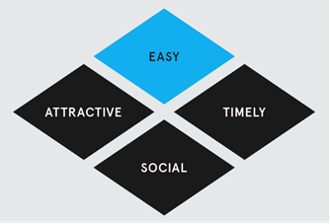

EAST image reproduced with permission from the Behavioural Insights Team

Examples of applying the EAST principles.  These are listed as: 
Easy - Language simple and specific about recommended actions; Personalised prescribing data for review; Links to resources to help GPs reduce their prescribing.
Attractive - Images, colour and bold text to draw attention to important information; Personalised messaging to make it easier to imagine the costs or benefits of a particular action and benefits salient; Consequences of behaviour highlighted by making the costs and benefits saliant. 
Social - Peer comparison feedback provided on GP prescribing rates compared to that of peers.
Timely - Recent prescribing data for review; GPs notified that prescribing would continue to be monitored; Prompts for immediate action.

In particular, the project drew on the following three behavioural insights principles:

**Messenger Effect** – Behavioural insights has shown that we are strongly influenced by who communicates information.[10] It was hypothesised that as a medical peer, the Chief Medical Officer would be a highly influential messenger for GPs.

**Highlighting Consequences** – The letter stated the potential negative consequences of continuing to prescribe opioids at a high rate – the potential harm to patients and referral to the Practitioner Review Program.[11] **[12]**

**Peer Comparison** – We are highly social and are influenced by the behaviour of others that we see as being similar to ourselves. This behavioural insights principle is the basis for the inclusion of the peer-comparison graphs in the letter.[13] It was expected that GPs in regional, rural and remote areas would identify less strongly with GPs in metropolitan areas, so percentiles were calculated and presented separately for these two groups of GPs.

## Calculation of standard dose and prescribing rate

The analysis compared the prescribing rate (the number of standard doses filled per consultation) for the treatment group and the control group over the 12 months following the letter, controlling for their regional location and their baseline prescribing rate.

#### Calculation of standard dose

For opioid medications, there are different PBS item numbers for the different types (e.g. morphine, oxycodone), amounts (in milligrams) and delivery methods (e.g. oral injection). To allow meaningful analysis of prescribing rates, each item was converted to a common scale of measurement – the oral-morphine equivalent dose, or OMED. GP prescribing rates were calculated based on a standard dose of 30mg OMED, allowing prescribing rates to be compared across different types of opioids.[14]

The prescribing rate for each GP was calculated as: Standard Doses / Consultations.

# Results

Overall, the trial resulted in:

* 90,453 fewer scripts filled
* 2,729,729 fewer standard doses
* 4% reduction in prescribing rate.

The graph below, of the mean prescribing rate over the 12 months before and the 12 months after the letter was sent, shows that GPs who received the letter decreased their prescribing rate compared to those who did not receive the letter:

In the year before the letters were sent the prescribing rates for the two groups were almost identical.

After the letters were sent the two groups diverge. The treatment group is consistently lower over the following 12 months.

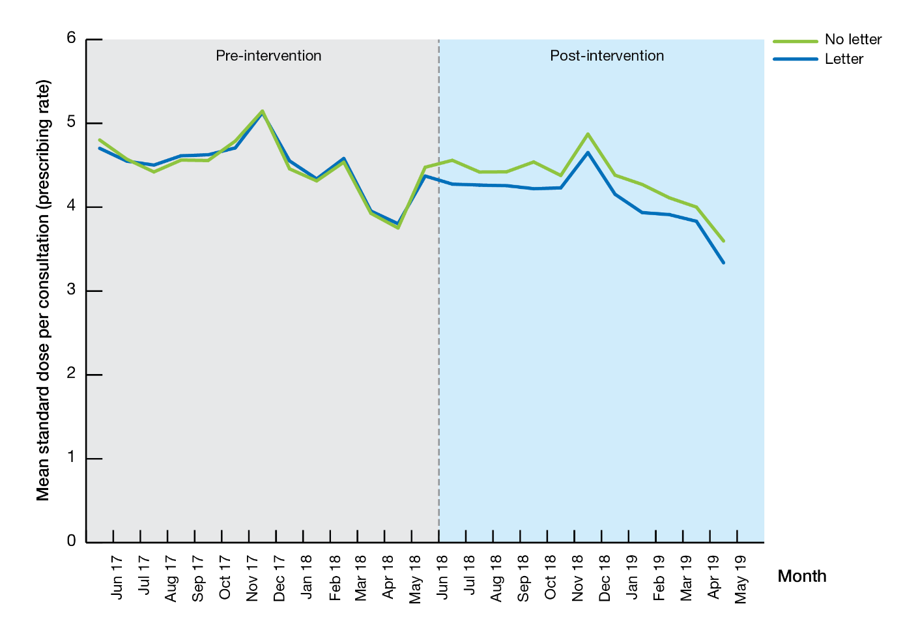

At each month (after the third month) after the letter was sent, the differences between the two groups are statistically significant, when controlling for their baseline prescribing.

### Socio-demographic characteristics

The graph below of prescribing rates, by the geographic location of the GPs’ primary practice for the treatment and control groups, shows the variation by practice location.

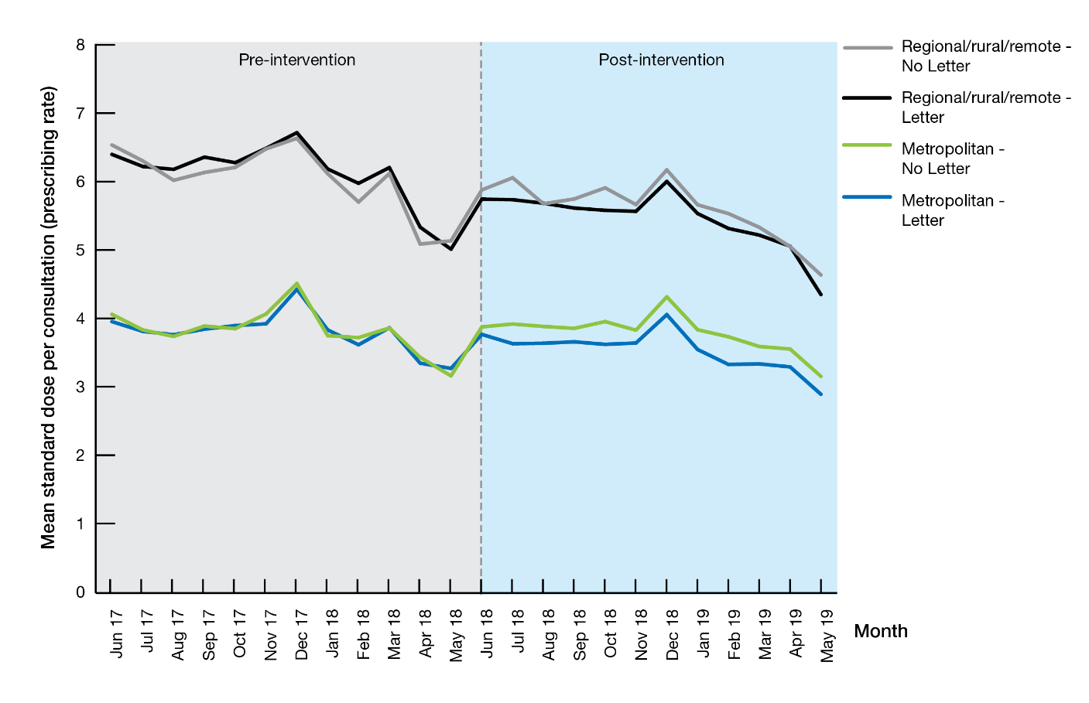

GPs in **regional, rural and remote areas** have a higher rate of prescribing. There was no significant difference between the treatment and control groups over the 12 months following the intervention.

Over the 12 months after the letter was sent, GPs in metropolitan areas who received the letter prescribed 4.7% fewer scripts, 4.4% fewer standard doses, and their prescribing rate was 5.7% lower than those who did not receive the letter. All of these differences were significant.

Results also varied by GP gender and age. Male GPs and GPs aged 55 years and over reduced their prescribing after receiving the letter. However, female GPs and those aged under 55 years did not significantly change their prescribing:

| **Change in treatment group compared to the no-letter control group over 12 months (%)** | | | | |
| --- | --- | --- | --- | --- |
|  | **Scripts** | **Standard doses** | **Prescribing rate** | **Number of observations** |
| Females | n.s. | n.s. | n.s. | 1,720 |
| Males | -5.40** | -5.69** | -6.53** | 3,742 |
| Aged under 55 years | n.s. | n.s. | n.s. | 2,755 |
| Aged 55 and over | -5.69** | -5.16** | -5.39** | 2,707 |

* p < 0.05; ** p < 0.01; n.s. not significant

### Opioid type

|  |  |  |  |  |  |
| --- | --- | --- | --- | --- | --- |
| Opioid type | **Strength relative to Morphine[15]** | **Indication[16]** | **Other features**[17] | | **Prescribing rate for letter vs no letter groups** |
| Tramadol | 0.20–0.24 | Short–term treatment of acute or chronic pain not responding to aspirin and/or paracetamol | Lower potential for misuse | n.s. | |
| Tapentadol | 0.4 | Chronic severe pain | Lower potential for misuse | -8.8% | |
| Morphine | 1.0–3.0 | Severe disabling pain (cancer, palliative care) and chronic severe pain | Widely used in acute, persistent and cancer pain | n.s. | |
| Oxycodone | 1.5–3.0 | Severe disabling pain and chronic severe pain | Increasing use in hospital and acute pain settings, and at discharge from day surgery | -5.6% | |
| Methadone | 4.7–13.5 | Chronic severe pain and opioid replacement therapy (ORT) | Commonly used for opioid addiction treatment and chronic pain | n.s. | |
| Hydromorphone | 5–15 | Severe disabling pain | Usually restricted to cancer pain or dialysis patients | n.s. | |
| Buprenorphine | 38.8–85.0 | Chronic severe pain and ORT | Commonly used for opioid addiction treatment and analgesia | n.s. | |
| Fentanyl | 100 | Severe disabling pain | Highly potent, used in cancer care, acute hospital settings, palliative care and for chronic pain | n.s. | |

The letter had a different impact on the prescribing rate for each of the eight opioid types considered in the trial (which have different strengths and indications).[18]

Tapentadol: p < 0.01; Oxycodone: p < 0.01; n.s. not significant

# Concluding points

Overall, the project resulted in a 4% reduction in prescribing for the treatment group compared to the control group. The project has demonstrated the effectiveness of a letter incorporating the three key elements of messenger, peer comparison and firm messaging in reducing prescribing of opioids by GPs.

The reduction in the prescribing of Oxycodone is notable as increases in prescribing of Oxycodone have accounted for the largest part of the rise in use of opioid medications in Australia over the past few years.[19] Oxycodone is commonly prescribed in hospital settings and at discharge, and guidelines recommend that GPs take care when continuing to prescribe Oxycodone in the community post discharge from hospital.[20]

The lack of impact of the letter in reducing opioid prescribing by GPs in rural, regional and remote locations highlights the need to understand the particular context of GPs working in these locations.

Some GPs who received the letter stated that a large proportion of their patients were elderly or receiving palliative care, highlighting the challenges of identifying and excluding GPs who are treating a higher proportion of patients receiving palliative care.

# Appendix A – GP Letter



**CHIEF MEDICAL OFFICER**

Your reference: <reference #

Dr <First_name> <Last_name>

<Address_Line_1>

<Address_Line_2>

<Suburb> <State> <Postcode>

< 00 Month 0000

Dear Dr

**You prescribe more opioid doses than <x%>of General Practitioners (GPs) working in a regional or rural location**

The rate of standard opioid doses (excluding codeine) you prescribed that were dispensed under the Pharmaceutical Benefits Scheme (PBS) between 1 December 2016 and 30 November 2017 are shown below.

**Number of standard opioid doses dispensed per consultation**

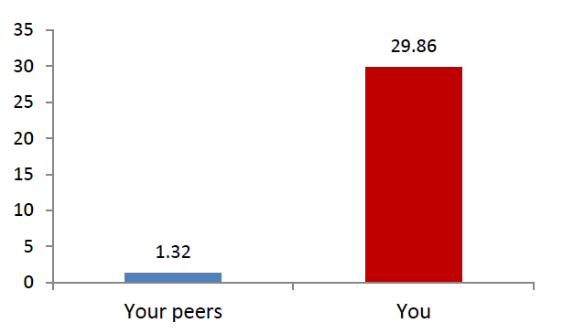

Further details are provided on the last page.

* Your prescribing may be appropriate for your patient group (e.g. if you treat palliative care patients). However, there may also be opportunities in your practice to reduce prescribing where clinically indicated.
* Over the next year, the Department of Health will be monitoring opioid prescribing by GPs.
* In limited cases where there are concerns of potential inappropriate practice, the Department of Health will consider referring practitioners to the Practitioner Review Program (PRP).
* PRP involves reviewing a practitioner’s servicing and prescribing behaviour in detail to assess whether inappropriate practice may have occurred. PRP offers an opportunity for doctors to provide any information that may address the concerns.

**Overdoses involving prescription opioids are at record levels in Australia**

Seventy per cent of all fatal opioid overdoses in Australia involve prescription opioids and pharmaceutical opioid deaths now exceed heroin deaths by a significant margin.

GPs are important partners in our efforts to minimise unnecessary harm or death from the inappropriate use of opioids by helping to limit prescribing to only those clinical situations where evidence shows opioids to be of proven value.

**Our understanding of how best to treat chronic pain has changed in recent years**

There is little evidence for the efficacy of long-term opioid use in persistent non-malignant pain. In trials (up to three months), many patients experienced adverse drug effects. However, opioid analgesics may be appropriate for a limited number of patients experiencing persistent non- malignant pain when other treatments have been inadequate.

It is important to remember that:

* Opioid dependence can develop quite rapidly, even over a brief course of treatment.
* The symptoms of opioid withdrawal can be mistaken for pain symptoms, leading to new prescriptions.
* Long-term use of opioids is associated with potentially serious adverse effects, including increased risk of fatal overdose, dependence or addiction.

If you believe that a patient may be opioid dependent, you should discuss options with them such as alternate pain management strategies, referral to specialist alcohol and drug services, opioid medication tapering or opioid substitution therapy.

**MORE INFORMATION**

The National Alcohol and Other Drugs Hotline (1800 250 015) can give you the contact details of specialist alcohol and drug services in your area.

The Department of Health has established an internet page with links to external web resources on appropriate prescribing of drugs of dependence at [www.health.gov.au/opioidprescribing](http://www.health.gov.au/opioidprescribing). These resources include peer reviewed advice provided by the Royal Australian College of General Practice (RACGP) and continuing professional development materials from the National Prescribing Service (NPS).

To discuss the contents of this letter please contact the Department of Health on 1800 316 386.

Yours sincerelySignature of Professor Brendan Murphy, Chiefe Medical officer

Professor Brendan Murphy

Chief Medical Officer

# Appendix B – Details of statistical analyses

Overview

This project was conducted as a randomised controlled trial (RCT). GPs who were ‘high prescribers’ of selected opioid medications relative to other GPs practising in a similar geographical region in the period from 1 December 2016 to 20 November 2017 were randomly allocated to two groups – a treatment group who received individually addressed letters, and a control group who did not receive a letter. The letters were sent to GPs on 8 June 2018, and the prescription rates for these two groups were then compared over the following 12 months until 8 June 2019.

Ethics approval

The project was approved through the University of Queensland Human Research Ethics Committee, which assessed the project as complying with the provisions contained in the *National Statement on Ethical Conduct in Human Research*.

Outcome

The key outcome explored was the ***rate*** of opioids prescribed (number of standard doses per consultation).

The dataset recorded the number of opioid scripts prescribed by GPs that were taken to a pharmacy and filled. The analysed data does not include non-PBS prescriptions, or prescriptions that were written by the GP but not filled by the patient.

Under the PBS, there are different item numbers for prescriptions of each of the different types (e.g. morphine, oxycodone), amount (in milligrams) and delivery method (e.g. oral, injection) of opioid medications. To allow meaningful analysis of prescribing rates, each item was converted to a common scale of measurement – the oral-morphine equivalent dose, or OMED. GP prescribing rates were then calculated based on a standard dose of 30mg OMED[21]. This allows us to compare a practitioner’s prescribing to others, even if they are prescribing different types of opioids.

Items for the following opioid types were included:

* Buprenorphine
* Fentanyl
* Hydromorphone
* Methadone
* Morphine
* Oxycodone
* Tapentadol
* Tramadol

Items for the following were excluded:

* codeine because of its recent re-scheduling; from 1 February 2018, low-dose codeine medications became no longer available over-the-counter at pharmacies and now require a prescription for supply;
* palliative care-specific items, to avoid targeting GPs who were working with a high number of palliative patients;
* opioids prescribed under the PBS for opioid replacement therapy (ORT), to avoid targeting GPs who were working with a high number of opioid-addicted patients; and
* data for GP consultations occurring in Residential Aged Care Facilities.

Population and sampling

The population of interest was GPs classified as ‘high prescribers’ of opioids relative to their peers. A ‘high prescriber’ was a GP in the top 20 per cent of opioid prescribers whose primary practice was in a similar geographic region, based on their prescription rate over the 12 month period before the trial. Regions were defined using the Modified Monash Model[22] (MMM), with the seven levels of the MMM dichotomised to metropolitan and regional/rural/remote.

In order to minimise the likelihood of including GPs who were on leave or who had recently retired or left the discipline, selected GPs were removed prior to calculating percentiles. GPs who had fewer than 1,000 MBS consultations during the 12 month period, or who had more scripts than consultations, were excluded, because this is considered a low level of activity for a GP.

Matching and randomisation

Randomisation occurred at the individual GP level and was conducted by block randomisation. GPs were grouped into blocks of five GPs, with one GP in each block randomly selected to the control group, and the remaining four in each block to the treatment group. This meant that each GP had a 20% chance of being selected into the control group, and an 80% chance of being selected into the treatment group. Blocks were generated to minimise differences in identified covariates – geographic location (based on the MMM), gender, age and professional class.

Analysis

The analysis compared the treatment and control group for each comparison. This was achieved by invoking a longitudinal analysis of covariance. The outcome variables were strongly skewed, so a log transformation was applied for each. A linear regression was used to estimate the effect of the intervention, as shown:

**loge (Yi,t + constant1) = β0 + β1Treatment + β2Location + β3loge (Yi,t–1 + constant2) + εi,t**

This regression model adjusts for baseline differences by adding the baseline prescribing rate as the lagged-dependent variable. This is considered critical because it (i) guards against regression-to-the-mean issues, and more importantly (ii) adjusts for confounding effects between the outcome and the lagged version of itself (baseline). Location was also included as a covariate. Regression results were back-transformed to the original units.

The table below presents the statistical details of the analyses presented in this report. For each comparison, the means of the two groups are estimated and compared using the regression model described above. The *p*-value of the treatment coefficient indicates whether the treatment group is significantly different to the control group – here, a *p*-value of less than 0.05 is considered statistically significant.

| Control  (mean) | | | Treatment group (mean) | | Treatment – Control percentage difference | *p*-value | |
| --- | --- | --- | --- | --- | --- | --- | --- |
| Overall (total 12 months) | | | | | | | |
| Scripts | 507.9 | 486.9 | | -4.12% | | | 0.0039 |
| Standard doses | 14,287.9 | 13,693.4 | | -4.12% | | | 0.0066 |
| Prescribing rate | 3.92 | 3.76 | | -4.07% | | | 0.0050 |
| Prescribing rate by month (cumulative) | | | | | | | |
| Month 1 | 3.63 | 3.52 | | -3.16% | | | 0.1482 |
| Month 2 | 3.84 | 3.70 | | -3.70% | | | 0.0400 |
| Month 3 | 3.89 | 3.77 | | -3.10% | | | 0.0604 |
| Month 4 | 3.95 | 3.83 | | -3.18% | | | 0.0461 |
| Month 5 | 3.96 | 3.81 | | -3.74% | | | 0.0175 |
| Month 6 | 3.96 | 3.82 | | -3.48% | | | 0.0245 |
| Month 7 | 4.04 | 3.91 | | -3.36% | | | 0.0279 |
| Month 8 | 4.07 | 3.91 | | -4.04% | | | 0.0066 |
| Month 9 | 4.02 | 3.84 | | -4.28% | | | 0.0045 |
| Month 10 | 3.99 | 3.82 | | -4.25% | | | 0.0045 |
| Month 11 | 3.96 | 3.81 | | -3.82% | | | 0.0092 |
| Month 12 | 3.92 | 3.76 | | -4.07% | | | 0.0050 |
| Metropolitan (total 12 months) | | | | | | | |
| Scripts | 462.22 | 440.75 | | -4.65% | | | 0.0062 |
| Standard doses | 14,003.75 | 13,386.73 | | -4.41% | | | 0.0104 |
| Prescribing rate | 3.22 | 3.04 | | -5.67% | | | 0.0010 |
| Regional/Rural/Remote (total 12 months) | | | | | | | |
| Scripts | 604.02 | 582.64 | | -3.54% | | | 0.1853 |
| Standard doses | 19,580.46 | 18,831.69 | | -3.82% | | | 0.1931 |
| Prescribing rate | 4.87 | 4.79 | | -1.45% | | | 0.5899 |

| Control  (mean) | | Treatment group (mean) | Treatment – Control percentage difference | p-value |
| --- | --- | --- | --- | --- |
| Female (total 12 months) | | | | |
| Scripts | 311.65 | 310.89 | -0.25% | 0.9361 |
| Standard doses | 9,716.08 | 9,781.37 | 0.67% | 0.8405 |
| Prescribing rate | 3.25 | 3.32 | 2.15% | 0.4698 |
| Male (total 12 months) | | | | |
| Scripts | 611.68 | 578.67 | -5.40% | 0.0011 |
| Standard doses | 18,346.01 | 17,302.20 | -5.69% | 0.0011 |
| Prescribing rate | 4.22 | 3.94 | -6.53% | 0.0001 |
| Aged under 55 years (total 12 months) | | | | |
| Scripts | 462.08 | 450.92 | -2.41% | 0.2682 |
| Standard doses | 14,615.31 | 14,153.41 | -3.16% | 0.1662 |
| Prescribing rate | 3.64 | 3.53 | -3.07% | 0.1707 |
| Aged 55 and over (total 12 months) | | | | |
| Scripts | 528.97 | 498.88 | -5.69% | 0.0046 |
| Standard doses | 15,690.51 | 14,881.27 | -5.16% | 0.0154 |
| Prescribing rate | 4.14 | 3.92 | -5.39% | 0.0056 |
| Prescribing rate by opioid type (total 12 months) | | | | |
| Buprenorphine | 0.21 | 0.21 | -1.29% | 0.6270 |
| Fentanyl | 0.30 | 0.30 | 0.56% | 0.8742 |
| Hydromorphone | 0.09 | 0.09 | 0.35% | 0.9547 |
| Methadone | 0.27 | 0.27 | -0.69% | 0.8876 |
| Morphine | 0.21 | 0.20 | -3.21% | 0.3338 |
| Oxycodone | 1.23 | 1.16 | -5.62% | 0.0062 |
| Tapentadol | 0.44 | 0.40 | -8.79% | 0.0017 |
| Tramadol | 0.54 | 0.52 | -3.49% | 0.0599 |

These estimates and p-values are from a linear regression model adjusted for GPs’ baseline prescription rate and location type. Regressions were estimated individually for each outcome measure / month / subgroup comparison.

1. Australian Commission on Safety and Quality in Healthcare. (2018). *The Third Australian Atlas of Healthcare variation 2018*. Sydney: ACSQHC.
2. Australian Commission on Safety and Quality in Healthcare. (2018). *The Third Australian Atlas of Healthcare variation 2018*. Sydney: ACSQHC.
3. The Royal Australian College of General Practitioners. (2017). *Prescribing drugs of dependence in general practice, Part C2: The role of opioids in pain management*. East Melbourne, Vic: RACGP. <https://www.racgp.org.au/download/Documents/Guidelines/Addictive-drugs/Addictive-drugs-guide-C1.pdf> [Retrieved June 2020]
4. Australian Institute of Health and Welfare. (2018). *Opioid harm in Australia and comparisons between Australia and Canada.* Cat. No. HSE 210. Canberra: AIHW.
5. Australian Institute of Health and Welfare. (2018). *Opioid harm in Australia and comparisons between Australia and Canada.*
6. Australian Institute of Health and Welfare. (2018). *Opioid harm in Australia and comparisons between Australia and Canada.*
7. Australian Institute of Health and Welfare. (2018). *Opioid harm in Australia and comparisons between Australia and Canada.*
8. Australian Institute of Health and Welfare. (2018). *Opioid harm in Australia and comparisons between Australia and Canada.*
9. The Behavioural Insights Team. 2014. *EAST: Four Simple Ways to Apply Behavioural Insights.* https://www.bi.team/wp-content/uploads/2015/07/BIT-Publication-EAST_FA_WEB.pdf [Retrieved June 2020]
10. UK Institute for Government. *MINDSPACE: Influencing behaviour through public policy*. <https://www.instituteforgovernment.org.uk/sites/default/files/publications/MINDSPACE.pdf> [Retrieved June 2020]
11. The Practitioner Review Program (PRP) monitors Medicare servicing data and PBS prescribing data to identify and examine variations which may be indicative of possible inappropriate practice.
12. The Behavioural Insights Team. 2014. *EAST: Four Simple Ways to Apply Behavioural Insights*. <https://www.bi.team/wp-content/uploads/2015/07/BIT-Publication-EAST_FA_WEB.pdf> [Retrieved June 2020]
13. Department of Health, Department of the Prime Minister and Cabinet. (2018). *Nudge vs Superbugs. A behavioural economics trial to reduce the overprescribing of antibiotics.* Canberra: Department of Health. <https://www1.health.gov.au/internet/main/publishing.nsf/Content/Nudge-vs-Superbugs-behavioural-economics-trial-to-reduce-overprescribing-antibiotics-June-2018> [Retrieved June 2020]
14. This methodology is from an Australian peer-reviewed academic paper: Gisev, N. et al. (2017). To what extent do data from pharmaceutical claims under-estimate analgesic utilisation in Australia? *Pharmacoepidemiology and Drug Safety*, Online article. [Retrieved February 2018].
15. Australian Institute of Health and Welfare. 2018. *Opioid harm in Australia and comparisons between Australia and Canada.* Cat. No. HSE 210. Canberra: AIHW. <https://www.aihw.gov.au/reports/illicit-use-of-drugs/opioid-harm-in-australia/data> [Retrieved June 2020]
16. The Royal Australian College of General Practitioners. (2017). *Prescribing drugs of dependence in general practice, Part C2: The role of opioids in pain management*. East Melbourne, Vic: RACGP. <https://www.racgp.org.au/download/Documents/Guidelines/Addictive-drugs/Addictive-drugs-guide-C1.pdf> [Retrieved June 2020]
17. The Royal Australian College of General Practitioners. (2017). *Prescribing drugs of dependence in general practice, Part C2: The role of opioids in pain management*. East Melbourne, Vic: RACGP. <https://www.racgp.org.au/download/Documents/Guidelines/Addictive-drugs/Addictive-drugs-guide-C1.pdf> [Retrieved June 2020]
18. Opioid Replacement Therapy (ORT) specific PBS items were excluded from the trial. While Methadone and Buprenorphine are used for ORT, these opioids are also used for other types of pain.
19. Nicholas, R. (2019). Pharmaceutical opioids in Australia: A double-edged sword. National Centre for Education and Training on Addiction (NCETA), Flinders University, Adelaide.
20. The Royal Australian College of General Practitioners. (2017). *Prescribing drugs of dependence in general practice, Part C2: The role of opioids in pain management*. East Melbourne, Vic: RACGP. <https://www.racgp.org.au/download/Documents/Guidelines/Addictive-drugs/Addictive-drugs-guide-C1.pdf> [Retrieved June 2020]
21. This methodology is from an Australian peer-reviewed academic paper: Gisev, N. et al. (2017). To what extent do data from pharmaceutical claims under-estimate analgesic utilisation in Australia? *Pharmacoepidemiology and Drug Safety*, Online article. [Retrieved February 2018].
22. https://www.health.gov.au/health-workforce/health-workforce-classifications/modified-monash-model [Retrieved February 2020]