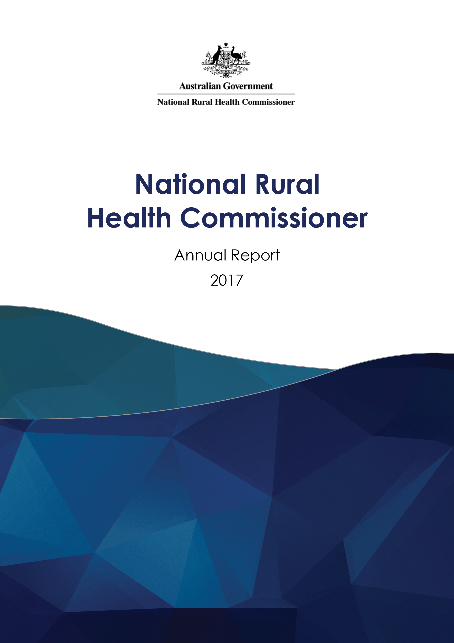National Rural Health Commissioner Annual Report 2017

ISSN: 2209-3621  
Online ISSN: 2209-363X

Publications Number: 12227

## Copyright

© 2018 Commonwealth of Australia as represented by the Department of Health

This work is copyright. You may copy, print, download, display and reproduce the whole or part of this work in unaltered form for your own personal use or, if you are part of an organisation, for internal use within your organisation, but only if you or your organisation:

1. do not use the copy or reproduction for any commercial purpose; and
2. retain this copyright notice and all disclaimer notices as part of that copy or reproduction.

Apart from rights as permitted by the Copyright Act 1968 (Cth) or allowed by this copyright notice, all other rights are reserved, including (but not limited to) all commercial rights.

Requests and inquiries concerning reproduction and other rights to use are to be sent to the Communication Branch, Department of Health, GPO Box 9848, Canberra ACT 2601, or via   
e-mail to NRHC@health.gov.au



Senator the Hon Bridget McKenzie

Minister for Sport  
Minister for Rural Health  
Minister for Regional Communications

Parliament House  
Canberra ACT 2600

Dear Minister

In accordance with section 79AM of the *Health Insurance Act 1973*, I present to you the Annual Report of the National Rural Health Commissioner covering the Commissioner’s activities during the previous calendar year from 11 November to 31 December 2017.

Yours sincerely

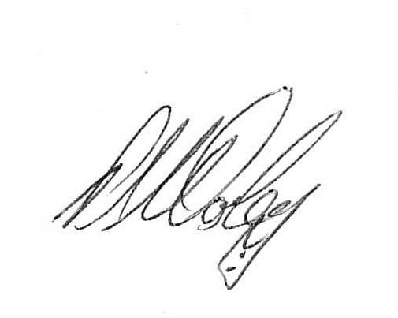

Emeritus Professor Paul Worley  
National Rural Health Commissioner

29 March 2018

# Overview

I am pleased to present the first Annual Report of the activities of the National Rural Health Commissioner. The Report covers the period from my appointment on 11 November 2017   
to 31 December 2017. I would like to acknowledge the foundational work of the Hon Dr David Gillespie MP, and the strong support of Senator the Hon Bridget McKenzie,   
the Minister for Rural Health, in the development of the Office of the Commissioner and its activities to date.

The statutory position was created to lead the development of the first ever National Rural Generalist Pathway, which will address rural health’s biggest issue – maldistribution of health professionals in rural, regional and remote Australia.

The success of the National Rural Health Commissioner’s role depends upon, and will operate within, a framework of independence and transparency.

The establishment of the role of the National Rural Health Commissioner is the culmination of the work of many champions who have come before me. In my role as National Rural Health Commissioner I will build on this history of care and commitment as a fearless and independent champion for the health of rural communities, and as a voice for all rural health stakeholders.

The proud legacy I inherit does not in any way diminish the historical significance of this appointment or the role of successive Federal Ministers in bringing it to fruition. The office of the National Rural Health Commissioner places the spotlight firmly and sharply on an aspect of Australian life that has required redress for decades. The role of the National Rural Health Commissioner is founded on, in the words of Assistant Minister Gillespie, “A deep-lying principle that every Australian should have the right to access a high quality standard of healthcare, no matter where they live”.

# Functions

The *Health Insurance Act 1973* (the Act) provides the legislative basis for the appointment and the functions of the National Rural Health Commissioner (the Commissioner).

In accordance with the Act, the functions of the Commissioner are to provide advice in relation to rural heath to the Minister responsible for rural health, including:

1. defining what it means to be a rural generalist;
2. developing a National Rural Generalist Pathway; and
3. providing advice to the Minister on the development and distribution of the rural workforce and on matters relating to rural health reform.

In performing these functions, the National Rural Health Commissioner must:

1. consult with health professionals in regional, rural and remote areas;
2. consult with States and Territories, and with other rural health stakeholders as the Commissioner considers appropriate;
3. consider appropriate remuneration, and ways to improve access to training for rural generalists; and
4. consider advice of the Rural Health Stakeholder Roundtable and the Rural Health Workforce Distribution Working Group.

# Office

## Vision

Equitable access to high quality locally delivered healthcare for all Australians.

## Role

To work with regional, rural and remote communities, the health sector, universities, specialist training colleges and across all levels of government to improve rural health policies, champion the cause of rural practice, and to build a National Rural Generalist Pathway that creates a sustainable locally trained medical workforce to meet the needs of regional, rural and remote communities across Australia.

## Activities

This Annual Report details the activities of the Commissioner, as per the reporting requirements in section 79AM of the Act. The Annual Report is a formal accountability document that summarises the performance of the Commissioner during the statutory reporting period.

This first annual report covers the period from my appointment on 11 November to   
31 December 2017, during which I:

* represented Australia at the World Health Organisation (WHO) Fourth Global Forum on Human Resources in Dublin to establish valuable relationships with decision-makers, leaders, and investors as well as explore innovations in policy, practice and research
* represented Australia at international meetings on rural generalism in the United Kingdom
* commenced stakeholder consultations
* established the Office of the Commissioner

## Next steps

Australians living in regional, rural and remote communities experience poorer health outcomes than those living in metropolitan centres. There is a correlation between poor health outcomes and access to appropriate health services. Australia currently faces a maldistribution of appropriate medical workforce in regional, rural and remote Australia.

In 2018 my focus is defining rural generalism, and developing a cohesive approach to training, attracting and retaining a Rural Generalist workforce with the right skills for their communities. This includes commencing the foundation work that will underpin a National Rural Generalist Pathway that maximises the value of the Pathway to learners, health services and rural communities.

I have invited the Australian College of Rural and Remote Medicine and the Royal Australian College of General Practitioners to work closely with me on the formation work of the National Rural Generalist Pathway, including the training, post graduate standards, curriculum and assessment frameworks, and industrial frameworks. These Colleges have been two of the leaders in establishing Rural Generalist practice to date, and they are also accountable to the Medical Board of Australia to each set standards and qualifications for the specialty of General Practice.

I will also develop a work plan that articulates the key tasks required to achieve these goals, the timeframes including key milestones, consultation requirements and implementation mechanisms.

I will continue to listen to the rural communities and rural health practitioners as I develop and implement a stakeholder engagement strategy that articulates the type and level of engagement, consultation, and discussion papers that will best inform my deliberations and advice to Government.

# Contacts

The Officer of the National Rural Health Commissioner can be contacted by:

**Telephone** ⎪+61 8 8237 8061

**Email** ⎪NRHC@health.gov.au

**Mail** ⎪National Rural Health Commissioner, Department of Health, GPO Box 9848,   
Adelaide SA 5001

Further information about the National Rural Health Commissioner can be found on the Commissioner’s website at [www.health.gov.au/national-rural-health-commissioner](http://www.health.gov.au/national-rural-health-commissioner)

## Enquiries

Enquiries about the *content* of this report may be directed to the Rural Policy Section,   
Health Workforce Division, Department of Health, or [NRHC@health.gov.au](mailto:NRHC@health.gov.au)

Enquiries regarding *any other use* of this publication should be addressed to the Branch Manager, Communication and Change Branch, Department of Health, GPO Box 9848,   
Canberra ACT 2601, or [copyright@health.gov.au](mailto:copyright@health.gov.au)

**www.health.gov.au/National-Rural-Health-Commissioner**