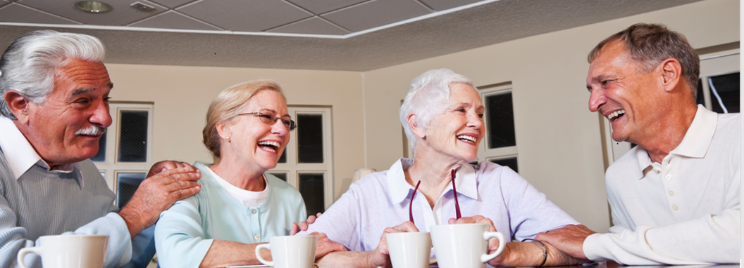Australian National Aged Care Classification (AN-ACC)

AN-ACC Reference Manual including

AN-ACC Assessment Tool (Appendix 1)

Publication date: 1 April 2021

**Acknowledgement**

The Department of Health (the Department) would like to acknowledge the University of Wollongong’s input in undertaking the Resource Utilisation and Classification Study, developing the Australian National Aged Care Classification (AN-ACC) system and the clinical training for the AN-ACC Assessment Tool.

The Department would also like to acknowledge La Trobe University’s analysis of assessor training provided during the 2019-20 trial of the AN-ACC Assessment Tool and the recommendations provided which have been incorporated into the AN-ACC Reference Manual.

© Commonwealth of Australia as represented by the Department of Health 2021

**Creative Commons Licence**

cid:image001.png@01D10CD1.33FE7F70

This publication is licensed under the Creative Commons Attribution 4.0 International Public License available from <https://creativecommons.org/licenses/by/4.0/legalcode> (“Licence”). You must read and understand the Licence before using any material from this publication.

Restrictions

The Licence may not give you all the permissions necessary for your intended use. For example, other rights (such as publicity, privacy and moral rights) may limit how you use the material found in this publication.

The Licence does not cover, and there is no permission given for, use of any of the following material found in this publication:

* the Commonwealth Coat of Arms. (by way of information, the terms under which the Coat of Arms may be used can be found on the Department of Prime Minister and Cabinet website <http://www.pmc.gov.au/government/commonwealth-coat-arms>);
* any logos and trademarks;
* any photographs and images;
* any signatures; and any material belonging to third parties.

The Department acknowledges IP ownership of the assessment methodologies within the AN-ACC Assessment Tool. The copyright attributions for the assessment methodologies within the AN-ACC assessment tool are as follows:

SECTION 1. Technical Nursing Requirements (TNR), SECTION 4. Palliative care (Pall Care) and SECTION 10. Behavioural Resource Utilisation assessment (BRUA): © Commonwealth of Australia 2020.

SECTION 2. Resource Utilisation Groups – Activities of Daily Living (RUG-ADL): The RUG-ADL items are provided under license to the Australian Government by interRAI.

SECTION 5: Rockwood Clinical Frailty Scale (CFS): Copyright © Dr Kenneth Rockwood – Clinical Frailty Scale – CFS ©

SECTION 6. Braden Scale: Copyright. Barbara Braden and Nancy Bergstrom, 1988. Reprinted with permission. All rights reserved

SECTION 7. De Morton Mobility Index (DEMMI): The De Morton Mobility Index (DEMMI) was created by Professor Keating, Megan Davidson and Dr Natalie De Morton and is used by the Australian Government with the permission of Professor Keating, Megan Davidson and Dr Natalie De Morton.

SECTION 8. Australian Functional Measure (AFM): Copyright © 2020 University of Wollongong and its third party licensors.

**Attribution**

* Without limiting your obligations under the Licence, the Department of Health requests that you attribute this publication in your work. Any reasonable form of words may be used provided that you:
* include a reference to this publication and where, practicable, the relevant page numbers;
* make it clear that you have permission to use the material under the Creative Commons Attribution 4.0 International Public License;
* make it clear whether or not you have changed the material used from this publication;
* include a copyright notice in relation to the material used. In the case of no change to the material, the words “© Commonwealth of Australia (Department of Health) 2021” may be used. In the case where the material has been changed or adapted, the words: “Based on Commonwealth of Australia (Department of Health) material” may be used; and
* do not suggest that the Department of Health endorses you or your use of the material.

**Enquiries**

Enquiries regarding any other use of this publication should be addressed to the Branch Manager, Communication Branch, Department of Health, GPO Box 9848, Canberra ACT 2601, or via e-mail to [copyright@health.gov.au](mailto:copyright@health.gov.au)

# Contents

Contents v

Acronyms vi

Purpose of the AN-ACC Reference Manual 1

The AN-ACC Assessment Tool 1

Assessment Sections 1

Assessment Details 1

Technical Nursing Requirements 2

Resource Utilisation Groups – Activities of Daily Living (RUG – ADL) 5

Australia-modified Karnofsky Performance Status (AKPS) 8

Palliative Care Details 10

Frailty – falls and weight loss 11

Rockwood Frailty Scale 13

Braden Scale for Predicting Pressure Sore Risk 15

De Morton Mobility Index (DEMMI) – Modified 17

Australian Functional Measure (AFM) 21

Behaviour Resource Utilisation Assessment (BRUA) 23

References 25

Appendices 27

Appendix 1: Australian National Aged Care Classification (AN-ACC) Assessment Tool 27

# Acronyms

| Acronyms | Description |
| --- | --- |
| AFM | Australian Functional Measure |
| AHPRA | Australian Health Practitioner Regulation Agency |
| AN-ACC | Australian National Aged Care Classification |
| DEMMI | De Morton Mobility Index-Modified |
| RACF | Residential Aged Care Facility |
| RUCS | Resource Utilisation and Classification Study |

# Purpose of the AN-ACC Reference Manual

The purpose of this manual is to provide a reference for Australian National Aged Care Classification (AN-ACC) Assessors to guide them to undertake AN-ACC Assessments using the AN-ACC Assessment Tool.

# The AN-ACC Assessment Tool

The AN-ACC Assessment Tool was developed in consultation with clinical experts in health and aged care.

The AN-ACC Assessment Tool focuses on the characteristics of residents that drive care costs in residential aged care. It is designed to be robust and concise and is able to be undertaken by an AN-ACC Assessor independent of a residential aged care facility (RACF) and who is not familiar with the resident.

The AN-ACC Assessment Tool includes the following assessment sections that need to be completed for each AN-ACC Assessment:

* Assessment details
* Technical Nursing Requirements
* Resource Utilisation Groups – Activities of Daily Living instrument (RUG-ADL)
* Australia-modified Karnofsky Performance Status (AKPS)
* Palliative Care details
* Palliative Care Phase
* Palliative Care Malignancy
* Frailty – falls and weight loss
* Rockwood Clinical Frailty Scale
* Braden Scale for Predicting Pressure Sore Risk
* De Morton Mobility Index (DEMMI) - modified
* Australian Functional Measure (AFM)
* Behaviour Resource Utilisation Assessment (BRUA).

# Assessment Sections

In this part of the AN-ACC Reference Manual, each assessment section is explained in detail including a general description, the assessment item, the scale, a detailed description and references.

## Assessment Details

AN-ACC Assessors are required to complete and confirm the identification of each resident before commencing an AN-ACC Assessment.

AN-ACC Assessors are required to enter:

* Assessor ID
* Facility ID
* Resident ID
* Place of Assessment (RACF, Hospital, Home, Other)
* Date of Assessment
* Start Time and End Time for Assessment.

## Technical Nursing Requirements

Eight complex nursing requirements have been addressed within the AN-ACC Assessment Tool due to their impact on cost of care. These are for medical conditions that would usually be undertaken by staff with nursing training. The complex nursing requirements are: need for oxygen; enteral feeding; tracheostomy, catheter and stoma care; peritoneal dialysis; daily injections; and, complex wound management. In some circumstances, personal care workers will undertake these tasks under the guidance of trained nursing staff and/or following a prescribed protocol. If this is the case, please include all that apply to the resident. However, do not include if only required by the resident occasionally. Include only if the resident requires the technical nursing case on a regular basis, i.e. most days.

An additional question is included regarding transfers and locomotion to address costs associated with bariatric residents.

### Assessment tool

Does the resident require three or more people for transfers and locomotion due to weight?

Yes  No

Does the resident require any of the following?

|  | Yes | No |
| --- | --- | --- |
| Oxygen |  |  |
| Enteral feeding |  |  |
| Tracheostomy |  |  |
| Catheter |  |  |
| Stoma |  |  |
| Peritoneal dialysis |  |  |
| Daily injections |  |  |
| Complex wound management |  |  |

### Assessment tool scale

‘Yes’ or ‘No’ response

### Detailed description of the assessment tool

If the provider advises the resident requires three or more people to transfer due to behavioural or other issues (not weight issue), then mark this question as ‘No’.

lf the provider advises that the resident requires three or more people for transfer due to weight issues (bariatric), then mark this question as ‘Yes’.

Bariatric is considered to be a person with a Body Mass Index (BMI) that exceeds 30.

**BMI** = weight (kg) ÷ height (m2)

For example, if a male resident is 120kg and height is 170 cm then BMI = 41.5 (Obese)

A description of examples for each type of technical nursing care is listed in the table below.

| Technical nursing care | Description of examples |
| --- | --- |
| Oxygen | Monitoring usage and supply oxygen.  Maintaining airways (suctioning). |
| Enteral feeding | Care of the stoma for PEG tubes and J tubes.  Ensuring the feeding tube flows freely.  Monitoring of hydration and bowel movements. |
| Tracheostomy care | Care of the stoma, keeping it clean and removing discharge or mucous to reduce risk of infection.  Maintaining skin integrity around the stoma and under the tape.  Ensuring the tube is correctly positioned and secured and free of obstruction. |
| Catheter care | Ensuring urine is flowing freely (no kinks or blockages in tubing).  Maintaining catheter hygiene.  Changing the catheter.  Securing catheter to prevent pulling, breaking and blockage.  Care of the stoma for suprapubic catheters. |
| Stoma care | Checking and maintaining skin integrity around the stoma.  Keeping the stoma area clean and dry.  Ensuring that the appropriate sized bag has been fitted to reduce the risk of leakage and skin integrity issues. |
| Peritoneal dialysis | Taking regular observations (temperature, pulse, blood pressure).  Measuring weight and girth daily.  Monitoring hydration and nutritional intake and urinary output.  Undertaking daily urinalysis. |
| Daily injections | Depending on medication may require one or two staff to check medication and oversee administration.  Monitor injection site/s and re-site if appropriate.  Monitor the resident to detect any adverse reactions. |
| Complex wound management | Management of a wound/s that is/are slow to heal due to exudate, comorbidities, infection or polypharmacy.  Provision of frequent wound care and additional monitoring of skin integrity for complex wounds.  Use of protective dressings and frames to promote healing.  Ensuring nutrition levels are maintained to promote skin health. |

## Resource Utilisation Groups – Activities of Daily Living (RUG – ADL)

### General description

The Resource Utilisation Groups – Activities of Daily Living (RUG-ADL) is a 4-item scale measuring motor function with activities of daily living for bed mobility, toileting, transfer and eating. It provides information about the resident’s functional status, the assistance they require to carry out these activities and the resources needed for the resident’s care.

### Assessment tool

**Resource Utilisation Group – Activities of Daily Living (RUG-ADL)**

|  | 1 | 2 | 3 | 4 | 5 |
| --- | --- | --- | --- | --- | --- |
| Bed mobility |  |  |  |  |  |
| Toileting |  |  |  |  |  |
| Transfer |  |  |  |  |  |
| Eating |  |  |  |  |  |

### Assessment tool scale

A score of 1 - is the highest level of independence.

The scale is not consistent across the domains:

* with bed mobility, toileting and transfer including scores of 1, 3, 4 and 5, but not 2.
* with eating including a score of 1, 2 or 3 but not including a score of 4 or 5.

### Detailed description of the assessment tool

A resident’s RUG-ADL score is an indication of the functional status and in most cases the amount of care and support required. It relates to ‘late loss’ activities of daily living – these are activities that we gain first as children and lose last in older age. The RUG-ADL score tells us the resources required to care for a resident.

#### Bed Mobility

Ability to move in bed after the transfer into bed has been completed.

| **RUG Item** | **Score** | **Definition** |
| --- | --- | --- |
| Independent or Supervision only | 1 | Able to readjust position in bed, and perform own pressure area relief through spontaneous movement around bed or with prompting from carer. No hands-on assistance required. May be independent with the use of a device. |
| Limited physical assistance | 3 | Able to readjust position in bed and perform area relief with the assistance of one person. |
| Other than two persons physical assist | 4 | Requires the use of a hoist or other assistive device to readjust position and provide pressure relief. Still requires the assistance of one person for task. |
| Two or more persons physical assist | 5 | Requires 2 or more assistants to readjust position in bed and perform pressure area relief. |

#### Toileting

Includes mobilising to the toilet, adjustment of clothing before and after toileting and maintaining perineal hygiene without the incidence of incontinence or soiling of clothes. **If level of assistance differs between voiding and bowel movement, record the lower performance.**

| RUG Item | Score | Definition |
| --- | --- | --- |
| Independent or Supervision only | 1 | Able to mobilise to toilet, adjust clothing, cleanse self and has no incontinence or soiling of clothing. All tasks are performed independently or with prompting from carer. No hands-on assistance required. May be independent with the use of a device. |
| Limited physical assistance | 3 | Requires hands-on assistance of one person for one or more of the tasks. |
| Other than two persons physical assist | 4 | Requires the use of a catheter/uridome/urinal and/or colostomy/bedpan/commode chair and/or insertion of enema/suppository. Requires assistance of one person for management of the device. |
| Two or more persons physical assist | 5 | Requires 2 or more assistants to perform any step of the task. |

#### Transfer

Includes the transfer in and out of bed, bed to chair, in and out of shower/tub. **Record the lowest performance of the day/night.**

| RUG Item | Score | Definition |
| --- | --- | --- |
| Independent or Supervision only | 1 | Able to perform all transfers independently or with prompting from carer. No hands-on assistance required. May be independent with the use of a device. |
| Limited physical assistance | 3 | Requires hands-on assistance of one person to perform any transfer of the day/night. |
| Other than two persons physical assist | 4 | Requires the use of a device for any of the transfers performed in the day/night. Requires only one person plus a device to perform the task. |
| Two or more persons physical assist | 5 | Requires 2 or more assistants to perform any transfer of the day/night. |

#### Eating

Includes the tasks of cutting food, bringing food to mouth and chewing and swallowing food. **Does not include preparation of the meal**.

| RUG Item | Score | Definition |
| --- | --- | --- |
| Independent or Supervision only | 1 | Once meal has been presented in the customary fashion, able to cut, chew and swallow food independently or with supervision. No hands-on assistance required. If individual relies on parenteral or gastrostomy feeding that he/she administers him/herself, then score 1. |
| Limited assistance | 2 | Requires hands-on assistance of one person to set up or assist in bringing food to the mouth and/or requires food to be modified (soft or staged diet). |
| Extensive assistance/total dependence/tube fed | 3 | Person needs to be fed meal by assistant, or the individual does not eat or drink full meals by mouth but relies on parenteral/gastrostomy feeding and does not administer feeds by him/herself. |

### Reference

Williams B, Fries B, Foley W, Schneider D and Gavazzi M Activities of Daily Living and Costs in Nursing Homes. Health Care Financing Review Summer 1994, Volume 15, Number 4, 117-135

## Australia-modified Karnofsky Performance Status (AKPS)

### General description

The Australia-modified Karnofsky Performance Scale (AKPS) is a measure of the resident’s overall performance status or ability to perform their activities of daily living.

### Assessment tool

**Australia-modified Karnofsky Performance Status (AKPS). Tick (1) box only**.

(100) Normal; no complaints; no evidence of disease

(90) Able to carry on normal activity; minor sign of symptoms of disease

(80) Normal activity with effort; some signs or symptoms of disease

(70) Cares for self; unable to carry on normal activity or to do active work

(60) Able to care for most needs; but requires occasional assistance

(50) Considerable assistance and frequent medical care required

(40) In bed more than 50% of the time

(30) Almost completely bedfast

(20) Totally bedfast and requiring extensive nursing care by professionals and/or family

(10) Comatose or barely rousable

### Assessment tool scale

The AKPS is a single score between 0 and 100 assigned by a clinician based on observations of a resident’s ability to perform common tasks.

A score of 100 signifies normal physical abilities with no evidence of disease.

Decreasing numbers indicate a reduced ability to perform activities of daily living.

### Detailed description of the assessment tool

To assist in determining the correct score, the following questions can be utilised as part of your assessment:

* Have there been any changes with the resident’s ability to attend to activities of daily living?
* Is the resident requiring more physical assistance today?
* How much time is the resident actually spending in bed?

Occasional assistance - The resident is able to carry on with his/her normal work or activity but needs occasional assistance (hands on) with grooming, food intake, dressing, other daily activities - but overall is able to care for most needs.

Considerable assistance - The resident needs considerable assistance (hands on) with grooming, food intake, dressing, and other daily activities and may be in bed less than 50% of the time. The resident may also have symptoms such as pain, loss/gain of weight, reduced energy.

### Reference

Abernethy AP, Currow DC, Shelby-James T, Fazekas BS & Woods D (2005) The Australia-modified Karnofsky Performance Status (AKPS) scale: A revised scale for contemporary palliative care clinical practice. BMC Palliative Care, 4 (1)

## Palliative Care Details

### General description

This tool determines whether the resident entered the facility for residential palliative care.

| Assessment tool |  |  |
| --- | --- | --- |
| Palliative Care Details | YES | NO |
| Did the resident enter the facility for residential palliative care? | □ | □ |

### Detailed description of the assessment tool

An active palliative care plan can be a formalised care plan or documentation in the resident's notes. A palliative care plan also includes documented instruction relating to palliation by GP or other health professional, e.g. commence medication, other end of life treatment.

## Frailty – falls and weight loss

### General description

Frailty is measured through the Rockwood Frailty Score and questions around falls and weight loss.

This tool is used to determine the degree of frailty, in particular falls risk, of the resident prior to completing the DeMorton Mobility Index (DEMMI) and Australian Functional (AFM) tool.

### Assessment tool

Has the resident fallen in the last 12 months?

Yes, once

In the last 4 weeks? Yes  No

Yes, more than once

How many time in the last 4 weeks? Click or tap here to enter text.

No

Has the resident lost more than 10% of their body weight in the last 12 months?

Yes No

### Assessment tool scale

The responses for falls are:

* ‘Yes’ or ‘No’,
* if ‘Yes’, indicating the timeframe for the fall/s.

The responses for weight loss are:

* ‘Yes’ or ‘No’

### Detailed description of the assessment tool

Frailty is a non-specific state of increasing risk, which reflects multisystem physiological change. It denotes a multidimensional syndrome of loss of reserves (energy, physical ability, cognition and health) that gives rise to vulnerability.

Frailty is characterised by the defining factors of:

* Significant **unintentional** weight loss (note: intentional weight loss for bariatric residents is **not** included)
* Self-reported exhaustion or low energy levels
* Decreased physical activity
* Slow ambulation
* Weakness (low grip strength).

The World Health Organization (WHO) definition of a fall is:

A fall is an event which results in a person coming to rest inadvertently on the ground or floor or other lower level. (www.who.int/violence_injury_prevention/other_injury/falls/en/)

Within the context of the AN-ACC assessment, the assessor needs to use their professional judgement regarding what constitutes a ‘fall’.

## Rockwood Frailty Scale

### General description

This scale is an effective, widely used measure of frailty. The Rockwood Frailty Scale is easy to use and does require assessors to make a clinical judgement regarding the resident’s capabilities.

### Assessment tool

Rockwood Frailty Scale (Select one)

| Image representing very fit: jogging person. | Very fit |
| --- | --- |
| Image representing fit: walking person. | Fit |
| Image representing managing well: standing person. | Managing well |
| Image representing living with very mild frailty: standing person with cane. | Living with very mild frailty |
| Image representing living with mild frailty: standing person with walker. | Living with mild frailty |
| Image representing living with very moderate frailty: standing person with walker and an assistant nearby. | Living with moderate frailty |
| Image representing living with severe frailty: person being pushed in a wheelchair. | Living with severe frailty |
| Image representing living with very severe frailty: person in bed. | Living with very severe frailty |
| Image representing terminally ill: person sitting in chair. | Terminally ill |

### Assessment tool scale

Select one only - the most appropriate description of the resident.

### Detailed description of the assessment tool

Below are the descriptors for each rating in the Rockwood Frailty Scale.

| Rating | Description |
| --- | --- |
| Very fit | People who are robust, active, energetic and motivated. These people commonly exercise regularly. They are among the fittest for their age. |
| Fit | People who have no active disease symptoms but are less fit than category 1 (Very fit). Often, they exercise or are very active occasionally, e.g. seasonally. |
| Managing well | People whose medical problems are well controlled, even if occasionally symptomatic, but often are not regularly active beyond routine walking. |
| Living with very mild frailty | Previously ‘vulnerable,’ this category marks early transition from complete independence. While not dependent on others for daily help, often symptoms limit activities. A common complaint is being ‘slowed up’ and/or being tired during the day. |
| Living with mild frailty | People who often have more evident slowing, and need help with high order instrumental activities of daily living (finances, transportation, heavy housework). Typically, mild frailty progressively impairs shopping and walking outside alone, meal preparation, medications and begins to restrict light housework. |
| Living with moderate frailty | People who need help with all outside activities and with keeping house. Inside, they often have problems with stairs and need help with bathing and might need minimal assistance (cuing, standby) with dressing. |
| Living with severe frailty | Completely dependent for personal care and approaching end of life. Typically, they could not recover even from a minor illness. |
| Living with very severely frail | Completely dependent, approaching the end of life. Typically, they could not recover even from a minor illness. |
| Terminally ill | Approaching the end of life. This category applies to people with a life expectancy <6 months, who are not otherwise living with severe frailty. (Many terminally ill people can still exercise until very close to death.) |

### Reference

Rockwood K, Song X, MacKnight C, Bergman H, Hogan DB, McDowell I & Mitnitski A (2005) A global clinical measure of fitness and frailty in elderly people. CMAJ, 173 (5) 489-495

## Braden Scale for Predicting Pressure Sore Risk

### General description

The Braden Scale assesses a resident’s risk of developing a pressure sore by examining six subscales.

The Braden Scale is included as residents with high risk for wounds have similar care needs to those who have wounds.

### General description

#### Braden Scale – Predicting pressure sore risk

| **Risk Factor** | **Description and score** | | | | | | | | |
| --- | --- | --- | --- | --- | --- | --- | --- | --- | --- |
| **1** | | | **2** | | **3** | | **4** | |
| Sensory perception |  |  | |  |  |  |  |  |  |
| Completely limited | | | Very limited | | Slightly limited | | No impairment | |
| Moisture |  |  | |  |  |  |  |  |  |
| Constantly moist | | | Often moist | | Occasionally moist | | Rarely moist | |
| Activity |  |  | |  |  |  |  |  |  |
| Bedfast | | | Chairfast | | Walks occasionally | | Walks frequently | |
| Mobility |  |  | |  |  |  |  |  |  |
| Completely immobile | | | Very limited | | Slightly limited | | No limitation | |
| Nutrition |  |  | |  |  |  |  |  |  |
| Very poor | | | Probably inadequate | | Adequate | | Excellent | |
| Friction and Shear |  | |  |  |  |  |  |  | |
| Problem | | | Potential problem | | No apparent problem | |  | |

### Assessment tool scale

Each category is rated on a scale of 1 to 4, excluding the ‘friction and shear’ category which is rated on a 1 to 3 scale.

### Detailed description of the assessment tool

The Braden Scale assessment tool consists of six risk factors.

| **Risk factors** | **Description** |
| --- | --- |
| Sensory perception | Resident’s ability to detect and respond to discomfort or pain that is related to pressure on parts of their body. The ability to sense pain itself plays into this category, as does the level of consciousness of a resident and therefore their ability to cognitively react to pressure-related discomfort. |
| Moisture | Excessive and continuous skin moisture can pose a risk to compromise the integrity of the skin by causing the skin tissue to become macerated and therefore be at risk for epidermal erosion. So this category assesses the degree of moisture the skin is exposed to. |
| Activity | Resident’s level of physical activity since very little or no activity can encourage atrophy of muscles and breakdown of tissue. |
| Mobility | The capability of a resident to adjust their body position independently. This assesses the physical competency to move and can involve the client’s willingness to move. |
| Nutrition | Resident’s normal patterns of daily nutrition. Eating only portions of meals or having imbalanced nutrition can indicate a high risk in this category. |
| Friction and Shear | The amount of assistance a resident needs to move and the degree of sliding on beds or chairs that they experience. This category is assessed because the sliding motion can cause shear which means the skin and bone are moving in opposite directions causing breakdown of cell membranes and capillaries. |

### Reference

Bergstrom NA, Braden BJB, Lacuzza AB, Holman VC (1987) The Braden scale for predicting pressure sore risk. Nursing Research 36 (4) 205-210

## De Morton Mobility Index (DEMMI) – Modified

### General description

The De Morton Mobility Index (DEMMI) - Modified is an instrument that measures the mobility of older people across clinical settings.

### Assessment tool

#### De Morton Mobility Index (DEMMI) - Modified

| **Bed** | | | |
| --- | --- | --- | --- |
| Bridge | unable | able |  |
| Roll onto side | unable | able |  |
| Lying to sitting | unable | min assist OR  supervision | independent |
| **Chair** | | | |
| Sit unsupported in chair | unable | 10 sec |  |
| Sit to stand from chair | unable | min assist OR  supervision | independent |
| Sit to stand without using arms | unable | able |  |
| **Static balance – no gait aid** | | | |
| Stand unsupported | unable | 10 sec |  |
| Stand feet together | unable | 10 sec |  |
| Stand on toes | unable | 10 sec |  |
| Tandem stand with eyes closed | unable | 10 sec |  |
| **Walking** | | | |
| Walking distance +/- gait aid | unable OR  5m | 10m OR  20m | 50m |
| Walking independence | unable OR  min assist OR  supervision | independent with gait aid | independent without gait aid |

### Assessment tool scale

There are 12 tasks in DEMMI—Modified, select one rating only for each of the twelve tasks that best matches the resident’s capabilities.

### Detailed description of the assessment tool

The DEMMI—Modified is an instrument that measures the mobility of older people across clinical settings.

It is preferably based on direct observation of the resident. However, it is not appropriate to ask a resident to complete tasks if there is a falls risk or risk of causing distress to the resident.

The four DEMMI domains are:

* bed mobility
* chair
* static balance (no gait aid)
* walking.

Each of these four domains include three or four tasks, and these tasks are described in the table below.

| **Bed** | |
| --- | --- |
| Bridge | Person is lying supine and is asked to bend their knees and lift their bottom clear of the bed. |
| Roll onto side | Person is lying supine and is asked to roll onto one side without external assistance. |
| Lying to sitting | Person is lying supine and is asked to sit up over the edge of the bed. |
| **Chair** | |
| Sit unsupported in chair | Person is asked to maintain sitting balance for 10 seconds while seated on the chair, without holding arm rests, slumping or swaying. Knees and feet are placed together and feet can be resting on the floor. |
| Sit to stand from chair | Person is asked to rise from sitting to standing using the arm rests of the chair. |
| Sit to stand without using arms | Person is asked to stand with their arms crossed over their chest. |
| **Static balance (no gait aid)** | |
| Stand unsupported | The person is asked if they can stand for 10 seconds without external support. |
| Stand feet together | The person is asked if, for 10 seconds, they can stand with their feet together. |
| Stand on toes | The person is asked if they can stand on their toes for 10 seconds. |
| Tandem stand with eyes closed | The person is asked to place the heel of one foot directly in front of the other with their eyes closed for 10 seconds. |
| **Walking** | |
| Walking distance +/- gait aid * | Persons will be asked to walk with their current gait aid to where they can without a rest. Testing ceases if the person stops to rest.  **\*** Gait aid: The person uses the gait aid that is currently most appropriate for them (nil/frame/stick/other). If either of two gait aids could be used, the aid that provides the person with the highest level of independence should be used. Testing ceases once the person reaches 50 metres. |
| Walking independence | Independence is assessed over the person’s maximum walking distance up to 50m (from item above ‘Walking distance +/- gait aid’). |

The domains and tasks are rated according to the following definitions:

* Minimal assistance – “hands-on” physical but minimal assistance, primarily to guide movement.
* Supervision – another person monitors the activity without providing hands-on assistance. May include verbal prompting.
* Independent – the presence of another person is not considered necessary for safe mobility.

### Reference

De Morton NA, Davidson M & Keating JL (2008) The de Morton Mobility Index (DEMMI): An essential health index for an ageing world. Health and Quality of Life Outcomes 86 (63)

## Australian Functional Measure (AFM)

### General description

The Australian Functional Measure (AFM) measures care burden. It is administered by direct observation and/or communication with the resident and/or carer.

Australian Functional Measure is based on the Functional Independence Measure (FIM).

### Assessment tool

#### Australian Functional Measure (AFM)

**Independent**

7 = Complete independence (timely, safely)

6 = Modified independence (device)

**Modified dependence**

5 = Supervision (subject = 100%+)

4 = Minimal assistance (subject = 75%+)

3 = Moderate assistance (subject = 50%+)

**Complete dependence**

2 = Maximal assistance (subject = 25%+)

1 = Total assistance (subject = less than 25%)

| Function | Score 1-7 |
| --- | --- |
| **Self-care** | |
| Eating |  |
| Grooming |  |
| Bathing |  |
| Dressing – Upper Body |  |
| Dressing – Lower Body |  |
| **Toileting** |  |
| Sphincter Control | |
| Bladder Management |  |
| Bowel Management |  |
| **Transfers** | |
| Bed, Chair, Wheelchair |  |
| Toilet |  |
| Tub or Shower |  |
| **Locomotion** | |
| Walk/Wheelchair (circle one) |  |
| Communication | |
| Comprehension |  |
| Expression |  |
| **Social Cognition** | |
| Social Interaction |  |
| Problem Solving |  |
| Memory |  |

### Assessment tool scale

The AFM uses an ordinal scale 1-7 for scoring each item, with 1 = Total Assistance, and 7 = Total Independence.

| AFM Scoring Levels | | |
| --- | --- | --- |
| **7** | Complete Independence (timely, safely) | **No Helper** |
| **6** | Modified Independence (device, increased time or safety concern) |
| **5** | Supervision (set-up, cueing, coaxing) | **Helper** |
| **4** | Minimal Assistance (resident = 75%+) |
| **3** | Moderate Assistance (resident = 50% - 74%) |
| **2** | Maximal Assistance (resident = 25% - 49%) |
| **1** | Total Assistance (resident = <25%) |

### Detailed description of the assessment tool

The AFM is administered by direct observation and/or communication with the resident and/or carer to measure care burden.

There are 17 items in the AFM - 12 physical items (stairs item has been removed) and 5 cognitive items measuring care burden.

This tool is designed to cover the core ADLs and reflect the degree of assistance a resident receives.

The AFM Motor items include:

Self-Care – Eating; Grooming; Bathing; Dressing-Upper; Dressing-Lower; and Toileting

Sphincter Control – Bladder Management; and Bowel Management

Transfers – Bed/Chair/Wheelchair; Toilet; and Bath/Shower

Locomotion – Walk/Wheelchair.

The AFM Cognitive items include:

Communication – Comprehension; and Expression

Social Cognition – Social Interaction; Problem Solving; and Memory.

### Reference

Centre for Functional Assessment Research, Uniform Data System for Medical Rehabilitation (1993) Guide for the Uniform Data Set for Medical Rehabilitation (Adult FIM), Version 4.0. Buffalo NY State University of New York, Buffalo

## Behaviour Resource Utilisation Assessment (BRUA)

### General description

The Behaviour Resource Utilisation Assessment (BRUA) tool is designed to capture the implications of the person’s behaviour for carers and service providers, in terms of the levels of monitoring and supervision required.

### Assessment tool

#### Behaviour Resource Utilisation Assessment (BRUA) (Tick one box per row)

|  |  | **1** | **2** | **3** | **4** |
| --- | --- | --- | --- | --- | --- |
| **Problem wandering or intrusive behaviour** | Includes day or night wandering and also refers to the person wandering, or attempting to abscond, from the facility or, while wandering in the facility, interfering with other people or their belongings. |  |  |  |  |
| **Verbally disruptive or noisy** | Includes abusive language and verbalised threats directed at family, carers, other people or a member of staff. It also includes a person whose behaviour causes sufficient noise to disturb other people. That noise may be either (or a combination of) vocal, or non-vocal noises such as rattling furniture or other objects. |  |  |  |  |
| **Physically aggressive or inappropriate** | Includes any physical conduct that is threatening and has the potential to harm another resident, a family member, a carer, a visitor or a member of staff. It includes, but is not limited to, hitting, pushing, kicking or biting and throwing furniture/damaging property. Also included is disinhibition i.e. inappropriate touching or grabbing of staff/other people. |  |  |  |  |
| **Emotional dependence** | Is limited to the following behaviour: (a) active and passive resistance other than physical aggression, (b) attention seeking, (c) manipulative behaviour, (d) withdrawal (including apathy), (e) depression, (f) anxiety, and (g) irritable. |  |  |  |  |
| **Danger to self or others** | Refers only to high-risk behaviour other than physical aggression. It includes behaviour requiring supervision or intervention and strategies to minimise danger. Examples of such behaviour include unsafe smoking habits, walking without required aids, climbing out of a chair/bed, hoarding, and self-harm or potential to try to die through suicide. It applies where there is an imminent risk of harm. |  |  |  |  |

### Assessment tool

Select one scoring option for each of the five BRUA items.

There are four scoring options for each of the five BRUA items:

| **1** | **Extensively** | Requires monitoring for recurrence and supervision |
| --- | --- | --- |
| **2** | **Intermittently** | Requires monitoring for recurrence and then supervision on less than a daily basis (during a twenty four hour period) |
| **3** | **Occasionally** | Requires monitoring but not regular supervision |
| **4** | **Not applicable** | Does not require monitoring (person has not engaged in the behaviour in the past) |

### Detailed description of the assessment tool

The Behaviour Resources Utilisation Assessment (BRUA) tool consists of five items covering wandering/intrusiveness; verbally disruptive or noisy; physically aggressive; emotional dependence; and danger to self or others.

The BRUA rates what the person **does (Do Do)**, rather than what they are capable of doing. E.g. the actual behaviours – current or usual state. What the person actually does – not that they have the potential to exhibit a particular behaviour.

**Scoring instructions:**

* Not applicable: means that you learn of no circumstances in which the resident has engaged in the behaviour in the past.
* Monitoring: means that you learn of circumstances in which the resident has engaged in the behaviour in the past. Current and future service providers will need to observe the resident, be aware when similar circumstances occur and take appropriate intervention to prevent the recurrence of the behaviour.
* Supervision: means that current or future service providers will need to ensure that specific situations or triggers which are likely to give rise to the behaviour do not occur, or are managed in ways to minimise the likelihood of occurrence.
* Daily: means during a twenty four hour period.

### Reference

Eagar K, Green J, Gordon R, Owen A, Masso M & Williams K (2006) Functional Assessment to Predict Capacity for Work in a Population of School‐leavers with Disabilities. International Journal of Disability, Development and Education, 53 (3) 331-349

# References

Abernethy AP, Currow DC, Shelby-James T, Fazekas BS & Woods D (2005), The Australia-modified Karnofsky Performance Status (AKPS) scale: A revised scale for contemporary palliative care clinical practice. BMC Palliative Care, 4 (1)

Bergstrom NA, Braden BJB, Lacuzza AB, Holman VC (1987) The Braden scale for predicting pressure sore risk. Nursing Research 36 (4) 205-210

Centre for Functional Assessment Research, Uniform Data System for Medical Rehabilitation (1993) Guide for the Uniform Data Set for Medical Rehabilitation (Adult FIM), Version 4.0. Buffalo NY, State University of New York, Buffalo

De Morton NA, Davidson M & Keating JL (2008) The de Morton Mobility Index (DEMMI): An essential health index for an ageing world. Health and Quality of Life Outcomes 86 (63)

Eagar K, Green J, Gordon R, Owen A, Masso M & Williams K (2006) Functional Assessment to Predict Capacity for Work in a Population of School‐leavers with Disabilities. International Journal of Disability, Development and Education, 53 (3) 331-349

Eagar K, McNamee J, Gordon R et al. (2019) The Australian National Aged Care Classification (AN-ACC). The Resource Utilisation and Classification Study: Report 1. Australian Health Services Research Institute, University of Wollongong. ISBN: 978-1-74128-295-5.

Eagar K et al (2019). Modelling the impact of the AN-ACC in Australia.The Resource Utilisation and Classification Study: Report 4. Australian Health Services Research Institute, University of Wollongong. ISBN: 978-1-74128-298-6

Eagar K et al. (2019) AN-ACC: A national classification and funding model for residential aged care: Synthesis and consolidated recommendations. The Resource Utilisation and Classification Study: Report 6. Australian Health Services Research Institute, University of Wollongong. ISBN: 978-1-74128-300-6

Loggie C et al. (2019) AN-ACC Technical appendices. The Resource Utilisation and Classification Study: Report 7. Australian Health Services Research Institute, University of Wollongong. ISBN: 978-1-74128-301-3

Masso M, Allingham SF, Banfield M, Johnson CE, Pidgeon T, Yates P and Eagar K (2015) Palliative Care Phase: reliability and acceptability in a national study. Palliative Medicine, 29(1): 22-30

McNamee J, Kobel C, and Rankin N (2019) Structural and individual costs of residential aged care services in Australia. The Resource Utilisation and Classification Study: Report 3. Australian Health Services Research Institute, University of Wollongong. ISBN: 978-1-74128-297-9.

McNamee J, Snoek M, Kobel C, Loggie C, Rankin R and Eagar K (2019) A funding model for the residential aged care sector. The Resource Utilisation and Classification Study: Report 5. Australian Health Services Research Institute, University of Wollongong. ISBN: 978-1-74128-299-3

Rockwood K, Song X, MacKnight C, Bergman H, Hogan DB, McDowell I & Mitnitski A (2005) A global clinical measure of fitness and frailty in elderly people. CMAJ, 173 (5) 489-495

Westera A et al. (2019) The AN-ACC assessment model. The Resource Utilisation and Classification Study: Report 2. Australian Health Services Research Institute, University of Wollongong. ISBN 978-74128-296-2

Williams B, Fries B, Foley W, Schneider D and Gavazzi M (1994) Activities of Daily Living and Costs in Nursing Homes. Health Care Financing Review Summer 1994, Volume 15, Number 4, 117-135

# Appendices

## Appendix 1: Australian National Aged Care Classification (AN-ACC) Assessment Tool

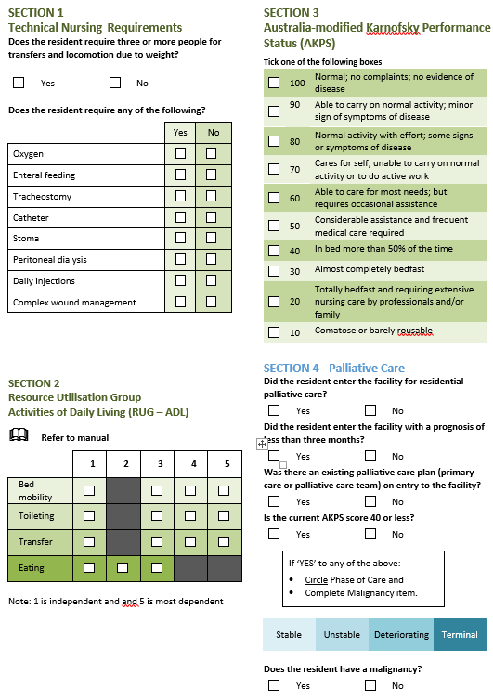

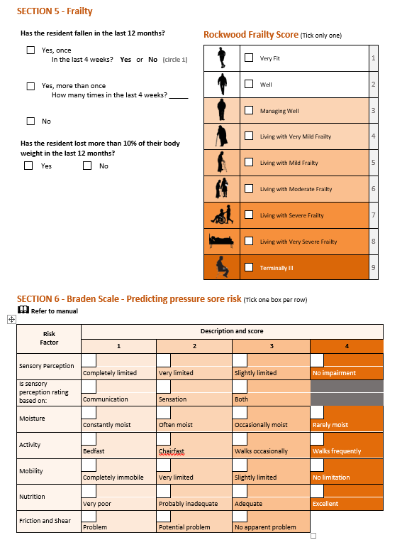

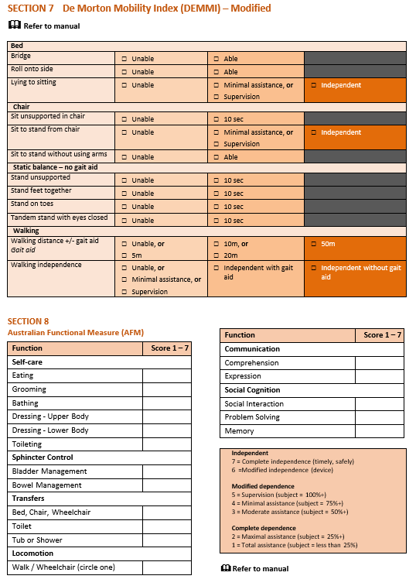

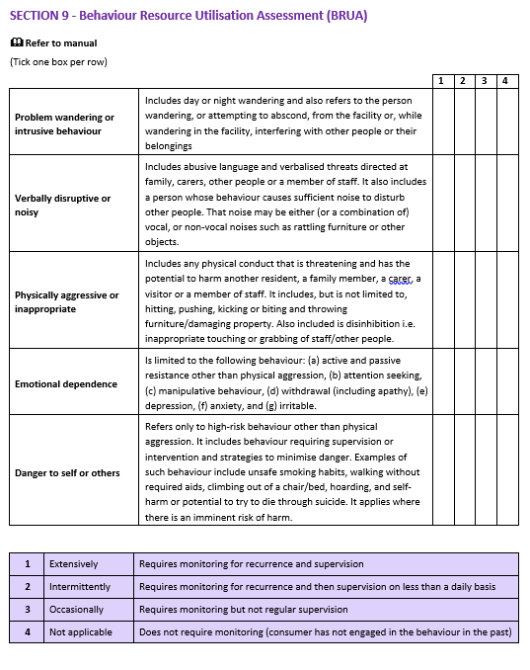

This page is intentionally blank.