Deloitte logoDecorative image

| Cover page with National Obesity Summit 15 February 2019 and logo |
| --- |

| Summary of Proceedings  Department of Health |
| --- |

Decorative image

Deloitte Access Economics logo

Contents

Glossary of acronyms i

Executive summary ii

Key conclusions and recommendations iii

1 Ministers’ welcome 4

1.1 Senator the Hon Bridget McKenzie, Deputy Leader of the Nationals, Minister for Regional Services, Sport, Local Government and Decentralisation 4

1.2 The National Obesity Strategy – The Hon Steven Miles MP, Queensland Minister for Health and Minister for Ambulance Services 6

2 What governments are doing, abroad and locally 10

2.1 Policy initiatives to tackle obesity in England – Professor Susan Jebb 10

2.2 The NSW experience: Premier’s priority to reduce childhood obesity – Dr Jo Mitchell 10

2.3 Local government and place-based approaches for primary prevention of obesity: lessons from Victoria – Dr Bruce Bolam 11

2.4 Discussion and feedback 11

3 Breakout sessions 13

3.1 Multidisciplinary care models and prevention (Lynne Pezzullo facilitating) 13

3.1.1 Obesity and chronic conditions – Prof Andrew Wilson 13

3.1.2 Obesity management: what primary care is doing well, and future opportunities – Dr Georgia Rigas 13

3.1.3 Genetics, epigenetics and obesity – Dr Peter Molloy 13

3.1.4 Discussion and feedback 14

3.2 Physical activity (Alice Morgan facilitating) 14

3.2.1 Physical activity/sport and mental health benefits – confident and resilient kids – Prof Adrian Bauman 14

3.2.2 The relative importance of energy intake and energy output in driving the body composition of 21st century children is an area of considerable debate – Prof Dick Telford 14

3.2.3 Behavioural change to increase physical activity – Ms Kate Palmer 15

3.2.4 Discussion and feedback 15

3.3 Food and diet (David Creelman facilitating) 16

3.3.1 Population diet solutions in retail settings – Professor Anna Peeters 16

3.3.2 The Four A’s of nutrition in regional Australia – Ms Nicole Turner 16

3.3.3 A food systems approach to addressing obesity – Dr Jessica Bogard 17

3.3.4 Discussion and feedback 17

3.4 Breakout sessions report back 18

4 Vicious circle: how do we break the perpetuating cycle? 19

4.1 Eating disorders and obesity: connections and controversies – Dr Susan Byrne 19

4.2 Obesity and the first 2000 days – Prof Louise Baur 19

4.3 Changing weight gain trajectories for young adults – Prof Wendy Brown 19

4.4 Discussion and feedback 20

5 Virtuous circle: what does the future look like? 22

5.1 What does the future look like for obesity prevention – Associate Professor Gary Sacks 22

5.2 New technologies, weight management and good health: opportunities and risks – Prof Deborah Lupton 22

5.3 The future of pharmacotherapy for obesity – Prof Joe Proietto 22

5.4 Discussion and feedback 23

6 Wrap up and closing discussion 25

6.1 Discussion and feedback 25

6.2 Close – Senator the Hon Bridget McKenzie 26

7 Key conclusions and recommendations 28

Limitation of our work 30

General use restriction 30

Charts

Chart 2.1 Menti.com feedback from first plenary session. Source: Deloitte Access Economics 12

Chart 4.1 Menti.com feedback from after-lunch plenary session. “What should the Australian Government prioritise to break the perpetuating cycle of obesity?” 20

Chart 5.1 Menti.com feedback from final plenary session, “What measures should the Australian Government prioritise to address obesity?” 23

Chart 6.1 Menti.com feedback from wrap up session, “Should a national obesity summit become an annual occurrence?” 25

Figures

Figure 2.1 Menti.com wordcloud from first plenary session 12

Figure 4.1 Menti.com wordcloud from after-lunch plenary session 21

Figure 5.1 Menti.com wordcloud from final plenary session 24

Figure 6.1 Menti.com wordcloud from wrap-up session 26

Glossary of acronyms

| BMI | body mass index |
| --- | --- |
| COAG | Council of Australian Governments |
| MBS | Medicare Benefits Schedule |
| NHMRC | National Health and Medical Research Council |
| OECD | Organisation for Economic Co-operation and Development |

1. Executive summary

The National Obesity Summit was held in Canberra on 15 February 2019, hosted by the Department of Health and facilitated by Deloitte Access Economics. The Summit brought together over 120 participants including academics, clinicians, policy makers, peak body leaders and industry representatives.

The Summit was opened by Senator the Hon Bridget McKenzie, Minister for Regional Services, Sport, Local Government and Decentralisation. The Hon Dr Steven Miles, MP, Minister for Health and Minister for Ambulance Services in Queensland was also a key speaker.

In addition, 18 further speakers presented on a range of topics covering what governments are doing abroad and locally to address the issue of obesity, three breakout sessions on specific topics, and further plenary sessions on the perpetuating cycle of obesity and what the future could look like drawing on newer types of interventions.

Participants provided comments and questions for speakers regarding their presentations and used an online ‘voting’ tool to provide real time feedback on the matters discussed. Copies of the presentations are available on the Department of Health’s website.

This document provides a brief summary of the proceedings and the themes from the online feedback. It is designed to be read in conjunction with the Summit Program which provides speaker biographies and a short summary of each presentation topic.

Key proceedings

Obesity is a complex condition, affected and influenced by multiple factors including:

* Inherited factors: genetics, food and physical activity attitudes and behaviours that are passed on from parents and socio-environmental factors;
* Individual factors: physiology, mental health, food and physical activity attitudes and behaviours that are developed by the individual through life; and
* Environmental factors: food availability, food marketing, social supports and negative influences (including how these structures benefit and disadvantage people differently), the built environment, service availability, technology and culture.

Different groups in society are disproportionately affected by obesity, including Aboriginal and Torres Strait Islander peoples and those from different socioeconomic situations, due to intersections with societal systems that disadvantage them.

The current policy and service delivery landscape and methods are struggling to contend with the multitude of factors that influence obesity. These factors each exert individual pressures on health outcomes but are also entangled with each other creating negative feedback loops that are extremely challenging to break.

Our models of care and service funding and provision were not designed for complex conditions such as obesity. There are tensions between different groups and poor alignment of systems that further discourage collaboration and team work across sectors.

Prevention is extremely important and requires more focus from all parties.

Many strategies to tackle obesity are being pursued by all levels of government, with different types of programs achieving different levels of success across different jurisdictions.

The solution to the obesity epidemic does not comprise any magic bullet, but requires a concerted long term approach across multiple fronts.

A coordinated approach is essential to position ourselves with the best chance of managing obesity in Australia. There was strong recognition of this fact and support for coordinated action, the most common question amongst the audience was how this can occur, including through the National Obesity Strategy.

## Key conclusions and recommendations

The key messages from the speaker and participant discussions throughout the day revealed some consistent priorities.

First, systems need to be created to accelerate collaboration and coordination between different parties.

* In the health system, reform is needed to realign and coordinate resources to manage the complex and long term nature of obesity treatment, and increase resourcing for prevention. This will need to include developing new models of care and funding structures to ensure all parties are incentivised to work together.

Second, food marketing is currently implemented differently across states and territories. Identifying and replicating successful approaches across jurisdictions is a good starting point. Some suggestions from voting included:

* Restrictions to food marketing
* Warning labels or taxes/regulations on unhealthy foods/drinks.

Finally, multiple organisations were identified that are working on tackling obesity including the National Obesity Collective and the Obesity Policy Coalition. Two actions developed in the breakout sessions include:

* Creation of a statutory body, with bipartisan support and secured funding to allow for long‑term investments. This body could drive policies such as a National Aboriginal and Torres Strait Islander Nutrition Policy; a consensus statement on obesity prevention; a National Food and Nutrition Policy; and a whole of system approach to food and nutrition policy.
* Development of a stand-alone, resourced Physical Activity Plan with long-term sustainable physical activity programs separate from nutrition, diet or obesity. Such a plan should embed physical activity over the longer term and be coordinated at Commonwealth, state and territory levels.

The National Obesity Strategy could assist to coordinate, consolidate and empower these organisations and future organisations to avoid duplication and better prioritise solutions to obesity going forward.

**Deloitte Access Economics**

# Ministers’ welcome

## Senator the Hon Bridget McKenzie, Deputy Leader of the Nationals, Minister for Regional Services, Sport, Local Government and Decentralisation

Good morning and welcome to the National Obesity Summit.

I will begin by acknowledging the traditional owners of this place, the Ngunnawal people, and by paying my respect to their elders, past and present and emerging.

I also want to thank all of you for taking the time to contribute to this Summit.

A special mention goes to Professor Jebb, who will be addressing us via Skype from the UK. Thank you for working overtime for us, literally, given the time difference.

I think it will be very interesting to hear about England’s experience.

This is a global issue—on the latest count by the World Health Organization, 1.6 billion adults around the world were overweight.

Obesity is certainly the health challenge of our time for many nations, including Australia.

We have the fifth highest rate of obesity for people aged 15 and over, in the OECD.

Australian Governments have taken this issue seriously.

We have committed, through the World Health Organization and again last year through the United Nations General Assembly, to take action to halt the rise of overweight and obesity, in particular childhood obesity.

And we have done that, at the state and federal levels, for at least 15 years. There has been some excellent work and some positive results in some areas.

But the evidence shows that overall, we are not succeeding.

Since the early 1990s, prevalence of overweight and obesity in Australian adults has increased from 56 per cent to 67 per cent.

The rate of obesity has grown even more—from less than 10 per cent in 1989-90, to 31.3 per cent.

It’s clear that this is a societal problem, not an individual problem.

And the consequences are also being felt across our society.

Overweight and obesity not only compromise quality of life, they are strongly linked to preventable chronic diseases—heart disease, diabetes, lung disease, certain cancers, depression and arthritis, among others.

The costs are great—for the individuals concerned, for the health system, and also for our economy.

This is why, last October, the COAG Health Ministers agreed it was time for a national approach and a national strategy on obesity.

This summit has been called as the first step in developing such a strategy.

Today we will consider, together, what actions Australian Governments can take to help people avoid or reverse weight gain and stay at a healthy weight.

I believe this is an important moment for Australians’ health.

It’s an opportunity to re-think our approach to obesity prevention and control.

What looks on the surface to be a simple problem, is in fact very complex.

Very few people become overweight by choice. They are pushed in that direction by a maze of interacting factors.

Genes are in there, but also a complex of social, economic and environmental factors, impacting at the individual, family, community and national levels.

I am sure all of us have felt these impacts at times.

We all have busy lives. I know I do. I know it can be hard to avoid “easy” but unhealthy food options, and to make time for physical activity.

So it’s not surprising that policy makers, here and overseas, have found it difficult to break the obesity maze.

But there are variations in overseas approaches, and results, which may be useful for us.

Obesity rates are on the rise worldwide, but some countries maintain obesity rates of less than 10 per cent according to the OECD Health Statistics 2017.

What is special about these countries?

Traditional Japanese and Korean diets are high in rice, vegetables, and fish, with very little fat. The food portions are generally much smaller than we expect here.

The Japanese are also more physically active than Australians, largely because they walk more.

They walk more because driving cars is expensive, and public transport is cheap and convenient.

Italy also has a low adult obesity rate.

Traditionally, Italians follow the Mediterranean diet, low in red meat and high in vegetables, fruits, whole grains, and seafood.

But food habits in Italy have changed, as they have here, and social habits have also changed.

While adults are largely within healthy weight parameters, Italian children now have one of the highest rates of obesity in the world.

It’s clear that obesity is not a single cause, single effect problem.

It’s related to multiple factors in our lives.

Without pre-empting our discussions, some areas where we might consider action include:

* the health system;
* the education sector;
* recreation, sport and physical activity;
* urban design and transport;
* work patterns;
* advertising and media; and of course;
* the packaged food, takeaway food and beverages industries.

I personally would like to see more interventions in three areas.

Maternal and early childhood health.

Encouraging people to be more physically active.

And, educating people about the need to follow the Australian Dietary Guidelines—i.e. to eat more fresh fruit and vegetables.

*Conclusion*

There is no magic, fat-busting policy pill.

We need multiple solutions to match the multiple causes.

If we can find the right policy mix, we will lift a huge burden off Australians, literally and metaphorically.

This is why we need a strategy, a nationally collaborative and cohesive approach to this issue.

Thank you in advance for what will be a hugely informative and challenging day.

I’d now like to hand over to Queensland Minister for Health, Dr Steven Miles, who will tell us more about the development of the National Obesity Strategy.

Thank you.

## The National Obesity Strategy – The Hon Steven Miles MP, Queensland Minister for Health and Minister for Ambulance Services

I’d like to acknowledge the traditional owners of the land on which we meet today and pay my respects to elders past and present.

I was very pleased Queensland was invited to co-host this obesity summit and I thank Senator McKenzie for her leadership in bringing us all here today.

While every now and then, there is much we disagree about, the obesity crisis facing Queensland has to be above politics.

Because for me it’s not about the costs to our health system and who should pay what - and it’s actually much more important than that.

It is how 1.26 million Queenslanders struggle to run around and play with their kids.

Unable to fit in an airline or a bus seat.

Many spend 3 half days a week strapped to a dialysis machine.

Really no way of living.

Some can’t find and maintain work.

Some have trouble finding or maintaining a relationship.

I represent many people like this.

When I visit my local shops, or medical centres, or schools I am struck by how being overweight or obese, impacts people’s lives every single day.

Not to mention the number of days they can expect to live.

I’m similarly struck by how the experiences of obesity might be very individual, the causes are not.

While it’s convenient to blame individuals for their weight. The personal responsibility frame absolves everyone else of their role.

It leads us to ignore the root causes. And worse still, the intentional actions that lead to people being unhealthy.

It lets governments of all levels off the hook.

It lets the fast food industry off the hook.

It lets planners and developers off the hook.

It lets schools and supermarkets, doctors and employers off the hook.

While I accept that every one of us has to take some responsibility for our own health, I have not seen any evidence anywhere at all that in recent decades waves of people wake up and decide one day they’d prefer to be fat.

People don’t wake up and decide they’d like to be less healthy.

Our society is doing that to them.

All of the social determinants of overall health and other illnesses people struggle with apply just as equally to obesity.

Poverty, poor housing, insecure and poorly paid work.

First Nations people are disproportionately affected - as they are in just about everything health related.

That’s why this summit and the development of a National Obesity Strategy are important. And why we need a comprehensive policy response beyond blaming individuals.

When I saw the agenda that had been put together I was pleased at how comprehensive it is. And how it really does attempt to look at all of the interventions that we could make.

Obesity has much in common with the other big health policy challenges we face - like smoking, skin cancer and drinking.

Everyone in this room, and many who aren’t, need to be part of the solution.

I want to touch briefly on what Queensland is doing. This might be good news but the data in Queensland suggests we may have actually stabilized the level of Queenslanders who are overweight and obese. The politician in me wants to take credit for that, and say that we’ve been highly successful.

It’s also entirely possible that we have led the nation and hit the tipping point at which a population cannot physically get any fatter.

We’ve tried many things, including menu labelling legislation, healthy tuckshop choices, school nutrition and physical activity programs, parent education, cooking programs, campaigns and workplace initiatives. Yesterday I launched our latest campaign, targeting young men on Valentine’s Day encouraging them to break up with their unhealthy relationship with something. In my case I broke up with chocolate thickshakes yesterday.

All of these have been well intentioned, but none of those have been perfectly implemented. Let me touch on the failings of two of them.

Menu labelling applies to fast food restaurants but not convenience stores, petrol stations or chain restaurants and pubs.

They provide a kilojoules intake amount, and reference an average daily adult kilojoules intake, relatively useless for children, or women for that matter.

Many menu items represent more than half this average daily adult kilojoules intake, suggesting it’s a pretty meaningless measure and isn’t changing eating habits too much.

Our healthy choices at tuckshops are voluntary, although more than 73% per cent of state schools, but that doesn’t mean that my 8-year old can’t eat 12 chicken nuggets for lunch every Tuesday, which he does.

Next parliamentary sitting week I will introduce new laws to create a new statewide health promotion agency, Health and Wellbeing Queensland – charged with place-focused, evidence based interventions.

Queensland’s new Sport and Active Recreation Strategy. Our new sport strategy has suggested something truly novel - that one of the ways we should assess the effectiveness of sport funding should be by whether it increased participation in sport.

We are also phasing out unhealthy drinks and food from our public hospitals.

Our flagship My Health for Life program in partnership with Diabetes Queensland has completed more than 121,000 risk assessments, but we are struggling to convert recruits to the full weight loss program.

And Deadly Choices, our flagship Indigenous health program is fantastic. It uses the power of the greatest game of all, rugby league, to get Aboriginal and Torres Strait Islander people to make healthier choices.

But that is very challenging, we can’t get clean water and fresh fruit and veggies into many of our remote communities.

We as a State have provided a limited number of Bariatric surgeries in our hospitals.

But because there are no federal funds we have to limit it to people with co-morbidities.

This is the equivalent of saying to a patient “we’ve found a tumour, but we won’t operate until it spreads”.

Bariatric surgery should be activity funded, like any other proven elective surgery intervention.

What I’m trying to say is, Queensland alone cannot change the lives of people enough, to help enough of them, lose weight.

One of the simplest things we could do is incentivise GPs to weigh their patients and talk to them about their weight.

Also, States, for example, have very limited pricing or taxing power, and that’s another reason why this strategy needs to be had at a national level.

As a state, Queensland will consider further advertising and sales regulation, if we have to.

We would, as always, prefer not to.

And this is where I’d like to challenge the industry representatives here. If you would prefer to avoid further regulation, and I assume you would, we need you to do more.

Public sympathy for multinational companies making big profits off the misery of fat Queenslanders won’t last forever.

There is ample evidence that with your marketing and your store placement some companies are exploiting the socio-economic status of some people for profit.

I welcome industry initiatives so far, the most recent being the announcement by drink manufacturers that they will reduce the average level of sugar in their drinks over time. And of course that is welcome.

But if you’ll allow me one little bugbear, at the same time, you have flooded our suburbs with $1 frozen drinks.

Within 500 metres of my house there are 3 outlets selling frozen soft drinks. One has 37 different flavours.

This is the sugar equivalent of flooding a neighbourhood with crack cocaine.

If you’ve seen my children after a red one - I’m not even joking.

I’ve only been a politician for 4 years. In that time I’ve seen 4 industries fail to heed public concerns about their business model, products or practices.

The two most recent, banks and the aged care sector.

Each was given a chance to voluntarily change. Lots of warnings from advocates, policy makers, media outlets. Each failed.

I hope that today we can start working together, industry, health promoters, state and federal governments, to stop forcing poor people and Indigenous people to be fat.

Because I believe if we can’t, then future governments won’t have a choice but to take much stronger policy action.

Not just for the costs to our health system, of diabetes, heart disease, stroke, kidney disease, back pain, osteoarthritis and many cancers. And not just because those motorised stretchers are much more expensive, and the bigger theatres we have to install are more expensive.

But for every one of the people who might suffer or die from them because of those choices.

And for the impact it will have on every single day of their life until then.

Thank you

# What governments are doing, abroad and locally

## Policy initiatives to tackle obesity in England – Professor Susan Jebb

The UK, like most developed countries is experiencing an increase in obesity prevalence amongst both adults and children. In addition to improving access to obesity treatment and weight management services, the UK has established a number of national strategies and action plans focused on prevention. The UK government is aware there is no one-size fits all approach and plans to use a mix of legislation, tax reform, marketing, national and local campaigns to address the issue.

One of the UK’s most innovative approaches to tackling obesity has been ‘Change4Life’ - England’s first ever national social marketing campaign focused on prevention and aiming to change the behaviours and circumstances that lead to weight gain, rather than being a weight-loss program for people with obesity.

The UK is also leading the way for easy to understand nutrition labelling, with two thirds of all pre-packaged foods using a voluntary traffic light system highlighting key nutritional data. A recent public consultation has just been completed to assess whether all vendors that serve food outside should be made to provide calorie information (many already provide this information voluntarily), the outcome of the consultation is expected later this year.

The UK government has been working closely with the food and drink industry, encouraging them to take more responsibility for their products. The Public Health Responsibility Deal encouraged organisations to commit to reducing salt content. This successful campaign has now resulted in specific targets being set by Public Health England for sugar (20% reduction by 2020) and calories (20% reduction by 2024) for certain foods, with the threat of stronger action if sufficient progress is not achieved. The food industry has responded by reformulating recipes and reducing portion sizes to create reduced fat and sugar versions of popular products. The UK also introduced a sugar tax, known as the Soft Drinks Industry Levy, in 2018 and will review its progress in the coming months/years.

## The NSW experience: Premier’s priority to reduce childhood obesity – Dr Jo Mitchell

The NSW Premier’s priority is to reduce the prevalence of childhood obesity by 5% by 2025, through state-wide support programs, clinical services, education campaigns and environments that support a healthy lifestyle. NSW’s response to the prevalence of obesity is multi-faceted, necessitating a cross-government approach due to the complex and sensitive nature of the topic.

All initiatives have been researched and designed using a strong evidence base. The government is hoping to accelerate the development of research and evidence translation through competitive funding schemes that focus on partnerships, capacity building and accountability. All initiatives are designed to be delivered at scale utilising existing delivery systems and centralised resources, training and implementation support. Strong engagement with data have enabled the government to assess system performance and support change. The Premier’s implementation unit have been rigorously monitoring programs and developing high impact, targeted interventions where required.

The design, delivery, scale up and monitoring of NSW’s program will create the infrastructure to support its citizens to live active and healthy lives.

## Local government and place-based approaches for primary prevention of obesity: lessons from Victoria – Dr Bruce Bolam

The Victorian government is supporting local governments to deliver place-based initiatives with a focus on prevention. Obesity prevention initiatives are being developed by local partners, working collaboratively to develop solutions affecting their region. A number of evidence based, locally led initiatives have been delivered in Victoria and the following key lessons have been learned:

* Investment – in resources, time, people and processes are required. ‘Healthy Together Victoria’ had demonstrated success and high levels of engagement, but was stopped as funding ceased.
* Reasonable expectations – place-based approaches can have a significant positive impact, but they are not a magic bullet. They must operate in tandem with state-based and national initiatives to tackle obesity.
* Supportive strategies – obesity is a public health epidemic, not an issue of individual will power. Strategies that are developed must not stigmatise individuals, but support the population.
* Evidence based – strategies must be designed using existing evidence bases and thorough research. Existing initiatives must be thoroughly evaluated and add to our growing evidence base.
* Scale and sustainability – all approaches must be designed with scale and sustainability in mind.

## Discussion and feedback

The audience was asked: “What do you think we should prioritise from England, NSW, or place-based approaches to apply more broadly across Australia?” and given the following options:

1. A “change for life” program
2. Front of pack labelling or product reformulation
3. A national child measurement program
4. Marketing restrictions or a soft drink levy similar to that in England
5. Cross-government prevention programs
6. Education and information at scale
7. More routine clinical advice and referral
8. More community-driven place-based actions.

They could then allocate 100 points across any number of options as desired; points can be thought of as any limited resource such as time or funding. Chart 2.1 shows the distribution of points that each option received at the end of voting, from 101 responses.

Menti.com feedback from first plenary session. 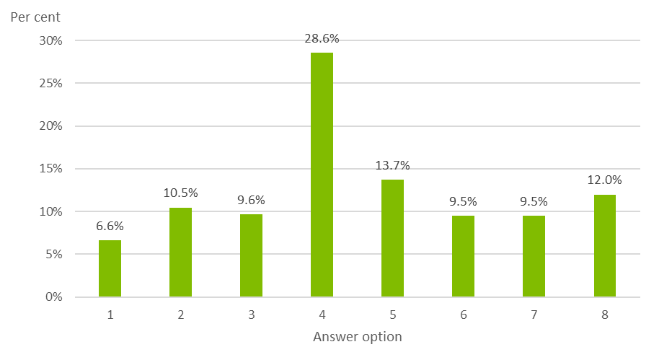Source: Deloitte Access Economics

Option 4, “Marketing restrictions or a soft drink levy similar to that in England”, was the most popular receiving just under one third of all points allocated. On average, each voter contributed 27 out of their 100 points to this option. The next highest “Cross-government prevention programs” receiving 13 points on average. In contrast to tax, the open response question showed education, leadership and active/activity as the salient themes.

Figure 2.1 Menti.com wordcloud from first plenary session. The audience was asked “In 3 words or less please list other priorities from what other governments are doing.”

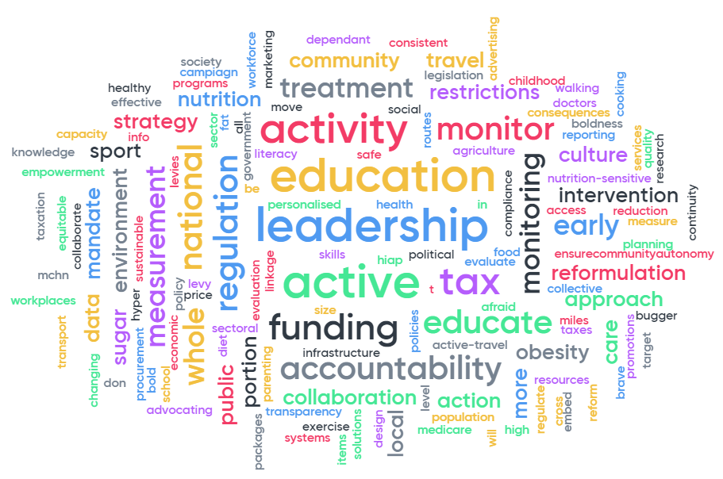

Source: Deloitte Access Economics

# Breakout sessions

## Multidisciplinary care models and prevention (Lynne Pezzullo facilitating)

### Obesity and chronic conditions – Prof Andrew Wilson

Prof Andrew Wilson outlined the increased prevalence of various conditions among those who are overweight and obese including: hypertension, arthritis and diabetes mellitus. These conditions are shared unequally amongst society, those from lower socioeconomic groups experience greater disease burden. Inadequate fruit and vegetable consumption and low physical activity overlap with obesity as risk factors for many chronic diseases.

There are multiple complex feedback loops between chronic conditions and obesity. Obesity is a risk factor for sleep apnoea; poor sleep can increase obesity. People with obesity are more likely to develop depression; some medications for treating mental illness have weight gain as a side effect.

Treating, controlling and managing obesity is a complex challenge. The health care system is not well set up for managing either obesity or other chronic conditions. A strategic response to obesity must recognise the important role of health care.

### Obesity management: what primary care is doing well, and future opportunities – Dr Georgia Rigas

Dr Georgia Rigas presented a Strengths, Weaknesses, Opportunities and Threats (SWOT) analysis, this included:

* Strength: GPs are well placed to intervene at key times in an individual’s life
* Weakness: less than 5% of patients had a documented waist circumference
* Opportunity: Indigenous and people in rural areas are overrepresented, there is an opportunity for further interventions/service improvements for these groups
* Threat: Systemic factors in how GP’s bill consultations are not well aligned for treating obesity.

Dr Rigas emphasised that GP management plans may be used for treating obesity (obesity was previously excluded). It is important to use people first language, “people with obesity” as opposed to “obese people”.

GP’s need to be supported to provide effective treatment. Clarification is needed about what MBS supported services people with obesity are entitled to, including the use of chronic care plans. Improved training and support, the development of shared care pathways and greater remuneration for longer consults will also contribute to improving how GP’s engage with the complexities of obesity and its comorbidities.

### Genetics, epigenetics and obesity – Dr Peter Molloy

Dr Molloy presented a summary of the current understanding of the relationship between genetics, epigenetics and obesity risk. Mutations in a small number of genes are associated with severe forms of obesity, these are a rare occurrence. Over 100 genes contribute to a person’s risk of a high BMI. Individually they have small effects, together they explain up to 20% of the risk of obesity.

In addition to genetic effects, the epigenome effects health outcomes. The epigenome is the interface between the environment and the genome. It includes characteristics that effect the expression of genes (on/off or more/less) in different circumstances. Environmental factors such as nutrition, hormones, smoking and alcohol during pregnancy and early development can impact the epigenome. This can influence conditions and diseases that manifest later in life, for example epigenetic marks detected at birth were correlated with larger BMIs at 5 years old.

### Discussion and feedback

Allied health and nursing staff provide key ongoing support to people with obesity but are not reimbursed in line with their contribution.

Our health systems ageing funding models were developed for conditions that are becoming much less prevalent and are not able to adequately provide for current and future challenges such as obesity. Further, the MBS single fee for service from a single practitioner does not work for multidisciplinary obesity treatment.

Obesity is difficult to treat once manifested, a greater emphasis and focus needs to be put on prevention.

Relapses, where weight is put back on, are common and there needs to be further strategies for maintenance both of healthy weight and after weight loss.

In a mouse model, six weeks of junk food can cause an epigenetic imprint that influences health outcomes. Ideally, there would be strategies to predict when conception may occur to optimise each partners’ health before conception. This is a challenging area for healthcare.

Waist circumference measurements need to be normalised across all patients as part of a routine check-up/patient expectation like blood pressure measurements are today. BMI may increase but body fat may not, we need to ensure we are measuring the right thing.

New models of care need to be developed that include a wide range of practitioners, including dietitians, and are variable and flexible to be effective for different patients in different situations such as metro or rural areas.

A National Obesity Strategy could begin the process of rethinking and restructuring how care is provided, coordinated and funded. Systemic change is vital to positioning our current resources to be most effective in tackling the complex challenge of obesity.

## Physical activity (Alice Morgan facilitating)

### Physical activity/sport and mental health benefits – confident and resilient kids – Prof Adrian Bauman

Prof Bauman provided an overview of levels of total physical activity in the Australian population, discussing both sport and other forms of activity, for both children and adults. Multiple strategies are needed to improve physical activity across all aspects of daily life, including sport and structured exercise. The risks of physical inactivity are substantial and there are clear reasons for getting Australia more active.

According to the World Health Organization, physical activity is the fourth leading risk factor for global mortality (above overweight and obesity, which is fifth highest). Physical inactivity has independent effects as well as being a significant contributor to obesity. While Australia has high research output in the field of physical activity, Australia has low active population prevalence and no physical activity plan.

While physical activity may represent only up to one third of the underlying ‘causes’ of obesity (nutrition being the main cause), it is still critical in contributing to solutions, and is an independent protective factor for cardiovascular and other health outcomes (at any weight). A major cross–sectoral effort is needed to encourage sufficient physical activity across populations and influence obesity levels.

### The relative importance of energy intake and energy output in driving the body composition of 21st century children is an area of considerable debate – Prof Dick Telford

Prof Telford, Research Director of the Australian Lifestyle of our Kids (LOOK) longitudinal project, presented Australian LOOK longitudinal research into the effects of physical activity and dietary intake on the per cent body fat of 730 healthy, community-based Australian children and adolescents. This research showed that overweight and obese children and adolescents did not consume more kilojoules, sugar, fat or carbohydrates than their leaner counterparts. This research showed that typical Australian children and adolescents with a higher percentage of body fat can be differentiated according to their physical activity and sedentary time. The study also highlighted the limitations of body mass index measurement as a proxy for adiposity in longitudinal studies, particularly in adolescent males. Community campaigns to reduce the prevalence of obesity in Australian youth might be better served by focussing even more strongly on reducing the high prevalence of insufficient physical activity.

Habitual diet and physical activity are the two prime determinants of how much fat we store. What is not well established is their relative impact on the body composition of Australian children. Valid and reliable measures of per cent body fat (DEXA), dietary intake (weekday, weekend “multi–pass” 24–hour recall accounting for under–reporting), physical activity and sedentary time (accelerometers) were obtained from 800 Australian children and adolescents. These data provide strong support for the premise that physical inactivity is the main driver of obesity in Australian youngsters, with strong implications for community campaigns.

### Behavioural change to increase physical activity – Ms Kate Palmer

Ms Palmer presented stories on how the sport and physical activity environment has changed over recent decades, what is now being done in this context in relation to addressing obesity and wellness, and how solutions in this domain fit within the multiplicity of potential contributors to making a difference to the obesity epidemic. She noted how initiatives for adults in different demographic situations (e.g. mothers of young children) differ from those for adolescents, what drives behavioural change, and how local champions or advocates can play a role.

### Discussion and feedback

Whilst interventions/programs in schools are important, some studies suggest that many children increase their weight during the summer holidays and there are noted variances between advantaged and disadvantaged groups.

After school programs can be useful in reducing sedentary behaviour outside of school hours and it is hoped that such programs instil long term behaviour change encouraging children to enjoy physical activity enough to do it outside structured environments.

Research suggests that mothers like the idea of playing with their kids but have lost the “art” of how to do this. Do parents understand their responsibility to keep kids active?

There was a suggestion for the need to “modernise” the concept of sport and perhaps consideration could be given to funding only those organisations which are willing to expand their horizons.

Accessibility was considered an important element to encourage participation. The National Obesity Strategy needs to include town planning/infrastructure to ensure there are “places to play”.

**What could be done to improve physical activity levels?**

* Improve infrastructure in and around open spaces, sporting fields/facilities to provide safe environments for which people can participate in physical activity. Some examples include more footpaths, improved lighting, and improved access from homes to physical activity venues.
* Improve urban development through integrated planning and encourage an environment where all Government sectors work together through highlighting co-benefits i.e. transport, health, urban design/planning/infrastructure.
* Develop a stand-alone, resourced Physical Activity Plan with long-term sustainable physical activity programs separate from nutrition, diet or obesity. It should embed physical activity over the longer term and be coordinated at Federal, State and Territory levels.
* Specific interventions that focus on the 20-50 year old age group need to be introduced at a national level.
* Embed common metric routine reporting around physical activity participation at a national level to ensure consistency and improve reporting and monitoring.

## Food and diet (David Creelman facilitating)

### Population diet solutions in retail settings – Professor Anna Peeters

Prof Peeters commenced her presentation by briefly outlining the levels at which population diet can be improved:

* policies at the *macrolevel*, for example nutrition labelling and food taxes/subsidies
* settings at the *mesolevel*, such as parenting practices and family structure
* interpersonal factors at the *microlevel*, such as the food and beverage environment of workplaces
* intrapersonal factors – also at the *microlevel* – such as individual motivation and attitudes.

The presentation focused on interpersonal factors at the microlevel, specifically the food retail environment, and the need to work with retailers as they are key gatekeepers to a healthier population diet through their ability to influence product, price, placement and promotion of food and drinks.

The results of a trial at the Alfred Hospital (Melbourne) were presented. The presentation focused on one aspect of the trial, whereby drink choices at the hospital cafeteria were influenced by removing all sugar-sweetened beverages (“red drinks”) from the fridge, leaving “amber drinks” and “green drinks” in the fridge. Red drinks were available on request, but this was not communicated to customers. Other parts of the trial included increasing the price of red drinks at vending machines and stores. In total, the trial was estimated to have reduced consumption of red drinks by 36,500 units in 12 months. However, total drink sales remained unchanged, with customers increasing their consumption of amber drinks, and to a lesser extent green drinks.

Prof Peeters identified four key approaches for successful retail environment policies: they are easy to implement and sustain, customers switch purchases to healthier items, customer satisfaction levels do not fall, and there is no revenue loss to retailers. The four key steps to increasing the scale of these interventions are to:

* build the evidence base – such as through the NHMRC Centre of Research Excellence in Food Retail Environments for Health (RE-FRESH)
* develop policy, incentives and support schemes to enable a level playing field and incentivise change
* create consistent and integrated information, supply and tools for retailers
* engage consumers and communities.

### The Four A’s of nutrition in regional Australia – Ms Nicole Turner

Ms Turner’s presentation highlighted the high rates of chronic disease in Aboriginal and Torres Strait Islander population groups, and identified four barriers to consumption of nutritious food in regional Australia:

* The *availability* of healthy food is limited by the food options in regional communities – both limited access to nutritious foods and easy access to foods with low nutritional value – a lack of access to fresh drinking water, and reliance on welfare cards for purchasing food and drink.
* Many people in regional communities are not able to *afford* nutritious food, as the transportation and refrigeration costs significantly increase the price, and many people in these communities are living on a low income.
* Nutritious food may not be *accessible*, as limited public transport and limited access to private vehicles mean that people may not be able to access retail environments where nutritious food is sold.
* Programs to improve nutrition in regional communities may not be *appropriate*, for example programs that are too short to achieve permanent improvement in behaviours, or a lack of engagement with communities prior to program delivery.

Ms Turner identified recommendations for improving nutrition in regional Australia, such as developing an Aboriginal and Torres Strait Islander food and nutrition policy, introducing more face to face programs in schools, conducting further consultation with Indigenous community members and utilising the National Obesity Collective for the purpose of raising awareness, to change the existing narrative from a focus on personal responsibility to collective responsibility, map activities and identify gaps across the system and establish more collaborative national approaches.

### A food systems approach to addressing obesity – Dr Jessica Bogard

Dr Bogard’s presentation summarised findings from the Lancet Commission on Obesity’s recent report, which identified the “global syndemic” of obesity, undernutrition and climate. These global issues co-exist, interact with each other, and have common drivers at the micro, meso and macro systems levels. Thus, addressing these common drivers could address all three parts of the global syndemic by maximising synergies and minimising trade-offs.

The presentation presented time series data from a recent Australian publication which identified that:

* Production of vegetables is below what is needed to meet recommended consumption, and actual consumption is below recommended consumption.
* Production of grains and meat exceeds recommended consumption, with actual consumption of grains approximately consistent with the recommended levels, and consumption of meat exceeding recommended levels.

An overview of the Rural Research and Development Corporations (RDC) model was presented, which funds agriculture R&D through 15 RDCs. Funding is generated via commodity levies, with matched funding from government. It is important to invest in R&D for nutritious food groups, as approximately 90% of food consumed in Australia is grown in Australia. However, in 2017-18 a significant amount of R&D funding was given to production of foods with low nutritional value, such as sugar ($24 million) and wine ($22 million) while less funding was provided to vegetables ($21 million) and eggs, poultry, fish and nuts/seeds combined ($15 million). .

The presentation concluded with three key messages:

* There is a clear need for a food systems approach to addressing obesity.
* There is potential to better align agricultural production with the food needs for a nutritious diet.
* A National Obesity Strategy would assist with designing and implementing a whole‑of‑system approach.

### Discussion and feedback

Three key themes emerged from the discussion.

1. The knowledge and expertise already exists in Australia to design and implement large scale interventions. There is a large body of existing evidence for interventions with demonstrated efficacy, and Australia are world leaders in evaluating large scale interventions.
2. There is a need for an improved approach to designing and implementing national policy, and this would be best supported through the creation of a statutory body, with bipartisan support and secured funding to allow for long-term investments. This body could drive policies such as a National Aboriginal and Torres Strait Islander Nutrition Policy; a consensus statement on obesity prevention; a National Food and Nutrition Policy; and a whole‑of‑system approach to food and nutrition policy.
3. There are targeted, efficacious interventions that could be used to improve nutrition, which include:
   1. Education at schools to improve nutrition knowledge and food preparation skills. This empowers children to make good nutrition choices, particularly in households where children may not learn about proper nutrition and/or where they do not learn how to prepare food.
   2. Working with retailers to nudge consumers towards the purchase of nutritious food, while ensuring that sales revenue is not adversely impacted.
   3. Restrictions on marketing of unhealthy food to children.

## Breakout sessions report back

Lynne, Prof Bauman and David reported back to the audience highlighting some of the points that are captured above. Further questions and comments discussed the following key points:

* Some audience members see an imbalance in the amount of time/effort that gets focused towards diet and nutrition over physical activity.
* A national physical activity body to coordinate physical activity policy, interventions and strategy is a good next step.
* A statutory body for national food and nutrition policy was called for in the audience and mentioned on twitter.
* Weight loss may not be the ultimate goal for some patients, in some cases maintenance of a healthy or regular weight may be appropriate. In these cases lifestyle intervention strategies can be effective.
* Language usage was raised, the audience was called upon to avoid using failure as an outcome of treatment and to support saying a patient has: responded or not responded, to an intervention.
* Climate change presents a large threat to the current food system and traditional agriculture. The disruption that it will cause may also present an opportunity to better align the food system with healthy outcomes.
* Community support for interventions may already be present in communities and require galvanising and utilising rather than building support or awareness.

# Vicious circle: how do we break the perpetuating cycle?

## Eating disorders and obesity: connections and controversies – Dr Susan Byrne

Obesity and eating disorders have traditionally been considered to be distinct conditions, with different origins, courses and approaches to prevention and treatment. Eating disorders tend to be treated as a psychiatric condition with treatments to encourage eating more, exercising less and improving body image. Obesity is treated as a medical condition with treatments to encourage eating less, exercising more and using dissatisfaction with body image as motivation to lose weight.

These classifications and separate treatment approaches fail to take into account that obesity and eating disorders often overlap and have shared risk factors – people can cross over from one to the other or they can occur simultaneously in the same individual. Dieting, body dissatisfaction, mood dysregulation and poor eating related behaviours are associated with both conditions.

We need to encourage interest amongst researchers and clinicians in using an integrated approach to the prevention and treatment of obesity and eating disorders. This will require attempts to balance the importance of adopting a healthy diet and appropriate physical activity with an acceptance of the huge range in body shape, height, and weight that exists in humans. A major obstacle to this remains our social norms that glorify thinness, stigmatise fatness and simultaneously promote both dietary indulgence and dietary restraint.

## Obesity and the first 2000 days – Prof Louise Baur

The biggest rise in the prevalence of overweight and obesity takes place between the ages of 0-3 and late adolescence/early adulthood. Interventions earlier in life are more likely to be effective than those starting in early childhood, making the first 2000 days of a person’s life the most important when targeting obesity interventions.

The World Health Organization’s Commission on ending childhood obesity identified six key areas of action, two of which focused on the first 2000 days:

1. Preconception and antenatal care – aiming to prevent maternal obesity prior to becoming pregnant and targeted care of high-risk women. These strategies must be culturally relevant and co-produced.
2. Early childhood – aiming to encourage healthy infant feeding and lifestyle behaviours.

It is important to note that a child’s family is only one area of influence when it comes to childhood obesity, the child’s community, society and political influences all have a role to play. These upstream drivers must also be tackled.

## Changing weight gain trajectories for young adults – Prof Wendy Brown

Data from the Australian Longitudinal Study of Women's Health has been collected to illustrate typical trajectories of weight gain in young adult women, and the social and behavioural factors associated with these. In 1996, over 40 000 women were grouped into age categories and surveyed every 3 years to collect height and weight information. An additional 30 000 women were added to the study in 2012 – these younger women were projected to weigh 10kg more than their older counterparts by the age of 33.

The survey found that 40% of women with a healthy BMI in 1996 were overweight or obese by 2012. It was identified that those women who were gaining weight at a rate of more than 500g per year were more likely to be at risk of becoming overweight or obese later in life. The survey outlined a number of factors that determined the rate of weight gain in women, including but not limited to whether they had a partner, children, amount of physical activity, education, paid work, smoking and their initial BMI.

In order to change these trajectories, a number of interventions have been recommended. Physical activity was identified as the strongest behavioural determinant of healthy weight maintenance, thus encouraging sustained participation in sport would be beneficial. Other smaller, effective interventions such as SMS reminders and simple health messages should be scaled up and weight gain prevention should be integrated into antenatal care.

## Discussion and feedback

There is an odd juxtaposition between a behaviour such as strict restriction of eating as it can be seen as a negative condition in the mental health space while at the same time be a treatment in the physical health space.

Stigmatisation was raised by multiple speakers, audience members and on twitter. It has far reaching negative impacts that contribute towards negative impacts on obesity. It needs to be proactively engaged with in society, policy and treatment contexts.

Treatment is extremely difficult when contending with the combined challenges of physiology and environmental factors.

Helping people recognise and contextualise weight gain is an important step in promoting informed lifestyle choices.

More longitudinal data is critical to better understanding different life trajectories.

Treatment Referral Programs are currently available which allow for greater resources to be directed to someone once they present with a condition. Why don’t we also have Treatment Prevention Plans to give people at risk the care they need *before* they manifest symptoms?

Menti.com feedback from after-lunch plenary session. “What should the Australian Government prioritise to break the perpetuating cycle of obesity?”

Menti.com feedback from after-lunch plenary session. “What should the Australian Government prioritise to break the perpetuating cycle of obesity?”

Source: Deloitte Access Economics

Voting on priorities, as seen in Chart 4.1, produced “Restrictions to food marketing” as the top priority.

Figure 4.1 Menti.com wordcloud from after-lunch plenary session. “In 3 words or less please list other priorities to break the cycle.”

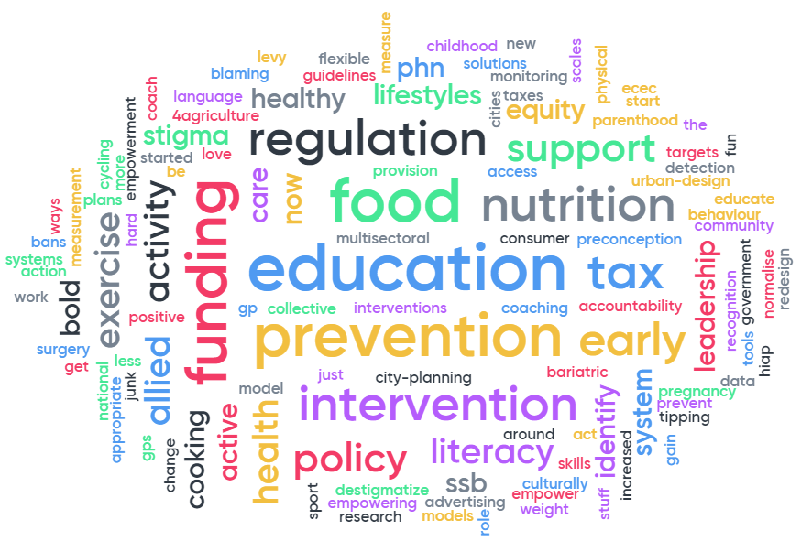

Source: Deloitte Access Economics

“Education” and “Prevention” featured prominently in this word cloud reflecting the immense challenges and complexity to obesity treatment raised by the speakers and in the discussion.

# Virtuous circle: what does the future look like?

## What does the future look like for obesity prevention – Associate Professor Gary Sacks

A comprehensive approach encompassing government, the food industry and society is required to tackle obesity. Within Australia and globally there is a good understanding of the actions that need to be taken and a growing body of evidence highlighting the interventions that can have the most impact.

A number of policy options for obesity prevention have been identified as highly cost-effective but levels of acceptability vary, for example, restricting price promotions and the sizes of sweetened beverages are highly cost-effective but have little support from the Australian Government, public or food industry. This has led to varying degrees of implementation across the states and territories, especially when compared to other countries such as Chile, Canada and the UK.

The food industry must take more responsibility for the health of the population – at present the commitment of Australian companies to tackle obesity varies significantly. Australian supermarkets have also been asked to address their role in the obesity epidemic with varying degrees of success. More must be done to incentivise businesses to change their policies and tackle the issue.

## New technologies, weight management and good health: opportunities and risks – Prof Deborah Lupton

Social media, apps, wearables and other new technologies have been embraced by the population in an effort to lose weight and improve overall health. Certain life events such as pregnancy and turning a something-0 age, like 30, can trigger health reflections on social media. Technology has the power to connect like-minded individuals to create communities of support, motivation and knowledge sharing and allow people to feel they are in control of their health outcomes.

Technology and social media also have their downsides including a loss of focus on the social determinants of health, an over-reliance on the technology and pathways for bullying and stigmatisation.

Ultimately, it is important to understand how these new technologies can be used effectively to encourage positive health behaviours at both preventive and interventive levels. Further development could consider issues such as specific measuring and data for different life stages, such as pregnancy, that have acceptable differences to a whole of population average.

## The future of pharmacotherapy for obesity – Prof Joe Proietto

Obesity is now recognised as a chronic disease that requires long-term medical management to achieve sustained weight loss and decrease associated morbidity and mortality. While short-term weight loss is readily achieved with diet and exercise, most individuals are unable to maintain the weight loss for an extended period. Avoiding weight regain is usually a challenge because physiological mechanisms, some poorly understood, promote weight regain. Up to 75% of dieters, especially people on very low calorie diets (400-800 kcal/day) regain much of the lost weight within 1 year.

As weight loss objectives are often not achieved through diet and behaviour modification alone, there remains a need for more efficacious approaches. Studies have shown that pharmacotherapy, when used in conjunction with a healthy lifestyle can reduce weight re-gain. Because weight is predominantly genetic, the hormonal and energy expenditure changes that occur after weight loss, designed to return the weight to its set point, are long lasting. It follows that drug use has to be long term (life-long). Without interventions to engage with these strong physiological feedback pathways, keeping weight off is extremely difficult.

## Discussion and feedback

Social media data and data from wearable devices, such as Fitbits, needs to be recognised and used as important data sources in the future.

Social media can act as both a social positive and negative and should be carefully considered.

The role and context of pharmaceuticals was broadly discussed including the perceptions of risk when the same drug is used in different contexts such as short term versus long term prescription schedules.

For obesity medication, the regulatory landscape is mainly focused on criteria achieving a percentage of weight loss over at least 6 months. However, drugs that affect weight management to keep the weight off once it is lost are also important. Regulatory and research hurdles for long-term usage need to be addressed.

The current funding systems and models of care have led to some tensions between GPs and specialists, such as the challenge around access to specialist services for getting the correct prescription in complex situations.

Menti.com feedback from final plenary session, “What measures should the Australian Government prioritise to address obesity?”

Menti.com feedback from final plenary session, “What measures should the Australian Government prioritise to address obesity?”

Source: Deloitte Access Economics

Warning labels or taxes on unhealthy foods was the most popular response receiving a quarter of the audiences’ voting points. Other food and nutrition actions at the population level came in second at just over 20%, together these indicate support for improvements to nutrition and food policy as a high priority.

Figure 5.1 Menti.com wordcloud from final plenary session, “In 3 words or less please state the most important initiative you would like to see arise from this Summit.”

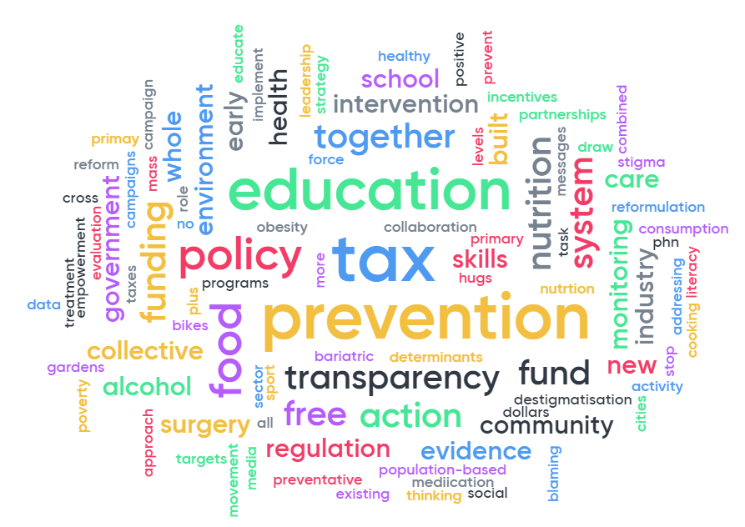Source: Deloitte Access Economics

The wordcloud from segment 4 continued the trend for “education” and “prevention” as important themes. “Tax” was again prominent for the audience, rounding out the top three key messages.

# Wrap up and closing discussion

## Discussion and feedback

The final discussion session saw the audience reflect on the day.

Previous industry success has included the elimination of trans-fat from the food supply chain.

Clearly there is a need to continue to intervene through multifaceted approaches including the National Obesity Strategy, across all levels of government, through population and targeted programs and across the clinical community.

The audience was very focussed on the need for action and coordination of next steps. Over half of the audience voted for the national obesity summit to become an annual occurrence.

Menti.com feedback from wrap up session, “Should a national obesity summit become an annual occurrence?”

Menti.com feedback from wrap up session, “Should a national obesity summit become an annual occurrence?”
Yes 37
No 16
Maybe 17

Source: Deloitte Access Economics

Chart 6.1 Menti.com wordcloud from wrap-up session. “In 3 words or less please list other priorities for the Australian Government to address obesity going forward.”

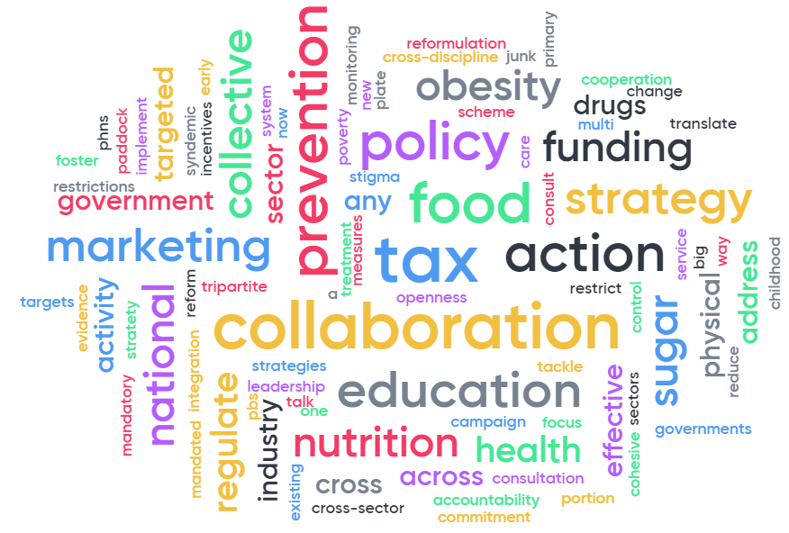

Source: Deloitte Access Economics

Further to a call for action amongst the audience, the discussion focussed on the need for all parties to be communicating and working together. This was highlighted in the word cloud that showed collaboration as a key theme. The audience reflected on the futility of working on obesity as individuals/alone and that a coordinated multidisciplinary approach would yield the most success.

## Close – Senator the Hon Bridget McKenzie

Thank you everyone for attending today.

I know this can be a difficult area to discuss. There are strong opinions from all quarters but what brings us together and why I wanted to call a summit like this is because ultimately we all want the same thing - and that is to bring down obesity rates in Australia.

In my opening remarks I identified three key areas

* maternal and early health;
* encouraging physical activity; and
* educating people to eat more healthy food.

Reflecting on those areas, today I have heard, and I know my staff have heard, some interesting facts about those priority areas.

Over half of all women who enter pregnancy are overweight or obese. This means, from the very first instant a person is born into Australia, we are setting them up to fail. We have to get nutrition right in the first 1000 - 2000 days.

I also note that the physical activity breakout session, which as the Minister for Sport I was particularly keen to see included today, clearly showed that physical activity has a larger role to play and this was reflected in Wendy Brown’s presentation.

Not only do we need to get people more active but we also need to coordinate this and I’m excited by the role that local governments and other place-based settings can play in this space.

Of course we need to continue our push to get people to eat well - less ‘sometimes food’ and more ‘all the time food’. This was also something I noted which came up in all the Menti sessions - the need for more education.

I’d also like to specifically pull out a theme that has come up many times today and that is the role of stigma. Clearly, this is not only contributing to an individual’s shame, stopping them getting help, but it’s also impacting the ability of our GPs to help people at that first instance. I thank Dr Georgia Rigas for her insight into this problem.

Whatever we do, we need to foster a culture where it’s ok to try, and maybe not succeed at weight loss the first time, but also one where primary care feels supported and enabled to help individuals when they are struggling with their weight.

We need to improve the way we deliver preventive health measures by including multi-factorial, multi-level interventions which involve GP’s, allied health, the fitness sector, digital health and education.

I thank Dr Susan Byrne for contributing some fresh thinking in regards to the linkages between eating disorders and obesity and how we may best treat them.

We also need to continually ensure we are striving for an evidenced based approach and developing robust monitoring and governance systems to ensure we are staying on track to achieve our goals.

I’d also like to quickly mention reformulation. I chair the Healthy Food Partnership and want to acknowledge that we are making good progress with industry in reformulation activities and we must all continue to work together.

So next steps? I’ll be extremely proud to present the outcomes from this event to COAG in March and look forward to Lynne’s team pulling together some workable options - noting of course to take heed from today and develop scalable interventions.

I look forward to driving change through COAG to get all the states and territories working together to create a healthier nation.

I’m sorry I couldn’t be here all day but be assured this is one of my key priorities.

I’d like to thank all our fabulous speakers for being so generous with their time and research, and everyone that came today. I’m really excited about the next steps.

Finally a big thank you to Lynne, Deloitte staff and everyone who helped me develop this Summit from concept to reality.

# Key conclusions and recommendations

Key proceedings

Obesity is a complex condition, affected and influenced by multiple factors.

Different groups in society are disproportionately affected by obesity, including Aboriginal and Torres Strait Islander peoples and those from different socioeconomic situations, due to intersections with societal systems that disadvantage them.

The current policy and service delivery landscape and methods are struggling to contend with the multitude of factors that influence obesity. Obesity overlaps with multiple other conditions, including an important relationship between mental and physical health. These factors each exert individual pressures on health outcomes but are also entangled with each other creating negative feedback loops that are extremely challenging to break.

Our models of care and service funding and provision were not designed for complex conditions such as obesity. There are tensions between different groups and poor alignment of systems that further discourage collaboration and team work across sectors.

A coordinated approach is essential to position ourselves with the best chance of managing obesity in Australia. There was strong recognition of this fact and support for coordinated action, the most common question amongst the audience was how this can occur, including through the National Obesity Strategy.

Key conclusions and recommendations

The key messages from the speaker and participant discussions throughout the day revealed some consistent priorities.

Targeted interventions

Early childhood and the antenatal period (i.e. before school age) are emerging as critical periods for obesity interventions, meaning that for some children, primary school programs may be too late to achieve optimal health outcomes. Attention needs to be focused on these early years in particular.

Early childhood centres, parents, and the relationships between primary schools and early year providers need to be included and prioritised. More interventions for children 0-2 years old to prevent progression towards obesity are required. Critically, these need to recognise the multiple factors that are outside of the capacity for parents to control and that ensure parental and cultural engagement.

For older children and adolescents, physical activity initiatives are at least as important as nutrition. There is a strong evidence base to support activity initiatives in this age group.

Aboriginal and Torres Strait Islander peoples are currently over-represented which signals an opportunity for more collaboration to target and co-design more effective interventions. This can include transport and distribution challenges in rural and remote areas for both getting fresh and nutritious foods to retail environments and members of the community.

Systems perspective

Systems need to be created to accelerate collaboration and coordination between different parties. In the health system, reform is needed to realign and coordinate resources to manage the complex and long term nature of obesity treatment, and increase resourcing for prevention. This will need to include developing new models of care and funding structures to ensure all parties are incentivised to work together.

Becoming overweight or obese can be a slow and gradual process that can be difficult to detect early on. Gaining more than 500 grams per year can lead to an increased risk of obesity, which is a surprisingly small amount. Systems that give people better, useable insights into their year on year weight gain may help individuals or health care providers better understand an individual’s obesity risk.

Regular waistline circumference measurements for people who are not currently obese can allow for earlier detection/ risk awareness. Embedding this practice as a more routine part of everyone’s regular GP check-ups may also help to reduce stigma around measurement, in turn helping reduce negative impacts such as embarrassment that prevent people from seeking help from health care professionals.

Food marketing is currently implemented differently across states and territories. Identifying and replicating successful approaches across jurisdictions is a good starting point. Some suggestions include restrictions to food marketing including tightening restrictions for advertising to children and young adults and warning labels or taxes/regulations on unhealthy foods/drinks.

Reframing success

For people with obesity, if there is significant weight loss, it is extremely difficult to maintain a healthy weight – there is a constant biological struggle with the body’s hormones “wanting” to put the weight back on. Multiple hormones that regulate our appetite and hunger cues put pressure on the body to regain the weight. Research into controlling these hormonal feedback pathways, either through pharmacotherapy or other avenues, is an important area for future research.

Achieving weight loss has potentially been used as an overly simple definition of success. As we develop strategies, there is scope to investigate and reframe the conversation towards weight management and achieving healthy wellbeing.

Working Together

Multiple organisations were identified that are working on tackling obesity including the National Obesity Collective, Early Prevention of Obesity in Childhood (EPOCH CRE) and the Obesity Policy Coalition. Two actions developed in the breakout sessions include:

* Creation of a statutory body, with bipartisan support and secured funding to allow for long‑term investments. This body could drive policies such as a National Aboriginal and Torres Strait Islander Nutrition Policy; a consensus statement on obesity prevention; a National Food and Nutrition Policy; and a whole of system approach to food and nutrition policy.
* Development of a stand-alone, resourced Physical Activity Plan with long-term sustainable physical activity programs separate from nutrition, diet or obesity. Such a plan should embed physical activity over the longer term and be coordinated at Commonwealth, state and territory levels.

The National Obesity Strategy could assist to coordinate, consolidate and empower these organisations and future organisations to avoid duplication and better prioritise solutions to obesity going forward.

Limitation of our work

General use restriction

This report is prepared solely for the use of the Australian Government Department of Health. This report is not intended to and should not be used or relied upon by anyone else and we accept no duty of care to any other person or entity. The report has been prepared to summarise issues discussed at the National Obesity Summit and inform potential initiatives to address the obesity epidemic in Australia

| Deloitte logo  Deloitte Access Economics Pty Ltd ACN 149 633 116  8 Brindabella Circuit Brindabella Business Park Canberra Airport Canberra, ACT, 2609 Australia  Phone: +61 2 6263 7000  +61 2 6263 7004+61 2 6263 7004  www.deloitte.com.au  Deloitte Access Economics is Australia’s pre-eminent economics advisory practice and a member of Deloitte's global economics group. For more information, please visit our website  [www.deloitte.com/au/deloitte-access-economics](http://www.deloitte.com/au/deloitte-access-economics)  Deloitte refers to one or more of Deloitte Touche Tohmatsu Limited, a UK private company limited by guarantee, and its network of member firms, each of which is a legally separate and independent entity. Please see www.deloitte.com/au/about for a detailed description of the legal structure of Deloitte Touche Tohmatsu Limited and its member firms.  The entity named herein is a legally separate and independent entity. In providing this document, the author only acts in the named capacity and does not act in any other capacity. Nothing in this document, nor any related attachments or communications or services, have any capacity to bind any other entity under the ‘Deloitte’ network of member firms (including those operating in Australia).  **About Deloitte**  Deloitte provides audit, tax, consulting, and financial advisory services to public and private clients spanning multiple industries. With a globally connected network of member firms in more than 150 countries, Deloitte brings world-class capabilities and high-quality service to clients, delivering the insights they need to address their most complex business challenges. Deloitte's approximately 244,000 professionals are committed to becoming the standard of excellence.  **About Deloitte Australia**  In Australia, the member firm is the Australian partnership of Deloitte Touche Tohmatsu. As one of Australia’s leading professional services firms. Deloitte Touche Tohmatsu and its affiliates provide audit, tax, consulting, and financial advisory services through approximately 7,000 people across the country. Focused on the creation of value and growth, and known as an employer of choice for innovative human resources programs, we are dedicated to helping our clients and our people excel. For more information, please visit our web site at www.deloitte.com.au.  Liability limited by a scheme approved under Professional Standards Legislation.  Member of Deloitte Touche Tohmatsu Limited  © 2019 Deloitte Access Economics Pty Ltd |
| --- |