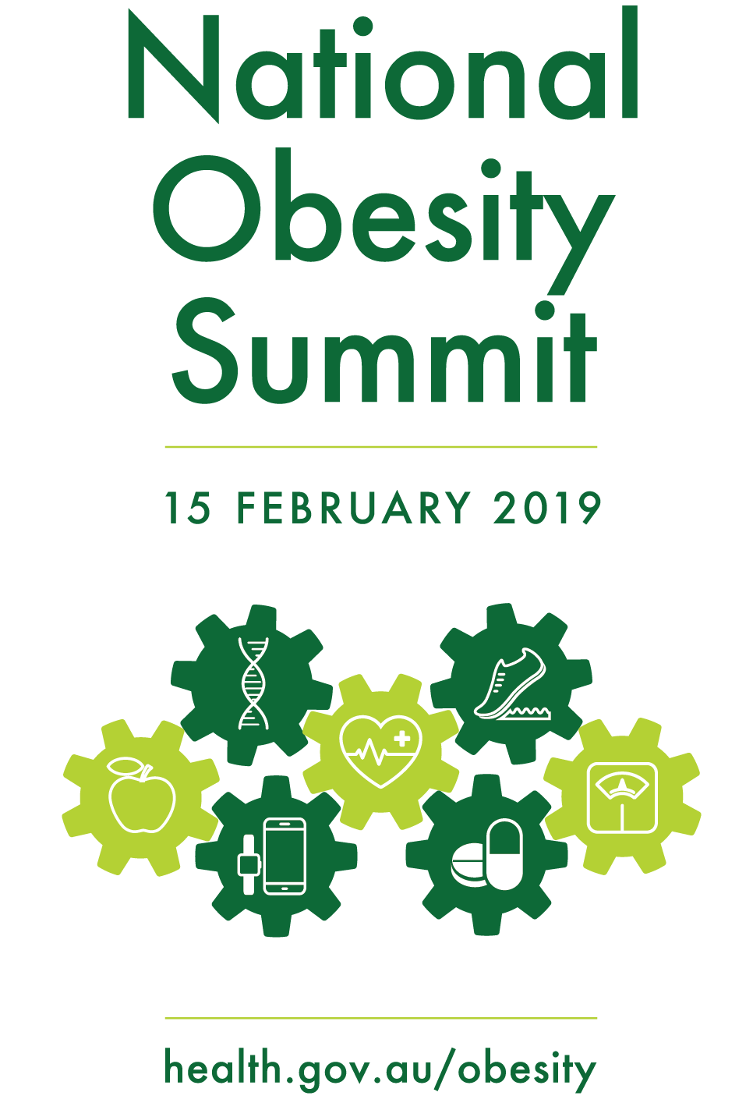

**#ObesitySummit19**

Program

| 8.30am | Registration – Hotel Realm | | |
| --- | --- | --- | --- |
| 8.45am | Welcome – Plenary Room (National Ballroom 1 & 2) | | |
|  | Senator the Hon Bridget McKenzie, Minister for Regional Services, Sport, Local Government and Decentralisation | | |
|  | The National Obesity Strategy | | |
|  | The Hon Dr Steven Miles, MP, Minister for Health and Minister for Ambulance Services, Qld | | |
| 9.05am | Segment 1 – What are governments doing, abroad and locally? | | |
|  | International experience, England | | |
|  | Dr Susan Jebb | | |
|  | The NSW experience: Premier’s priorities and wide scale program implementation | | |
|  | Dr Jo Mitchell | | |
|  | Local Government: Local place-based approaches: Healthy Together and Ararat | | |
|  | Dr Bruce Bolam | | |
| 10.10am | Q&A / discussion | | |
|  | Lynne Pezzullo | | |
| 10.30am | Morning Tea | | |
| 11.00am | Segment 2 – What have we learnt from the past? | | |
|  | Breakout 1 – National Ballroom 1 | Breakout 2 – National Ballroom 2 | Breakout 3 – National Ballroom 4 |
|  | Multidisciplinary care models and prevention | Physical Activity | Food and Diet |
|  | Prof. Andrew Wilson | Prof. Adrian Bauman | Prof. Anna Peeters |
|  | Dr Georgia Rigas | Prof. Dick Telford | Nicole Turner |
|  | Dr Peter Molloy | Kate Palmer | Dr Jessica Bogard |
|  | Q&A – Lynne Pezzullo | Q&A – Alice Morgan | Q&A – David Creelman |
| 12.00pm | Lunch | | |
| 12.45pm | Breakout sessions report back – Plenary Room (National Ballroom 1 & 2) | | |
|  | Lynne Pezzullo, Alice Morgan and David Creelman | | |
| 1.15pm | Segment 3 – Vicious circle: how do we break the perpetuating cycle? | | |
|  | Obesity and eating disorders: connections and controversies | | |
|  | Dr Susan Byrne | | |
|  | The importance of the first 1000 - 2000 days | | |
|  | Professor Louise Baur | | |
|  | Changing weight gain trajectories for young adults | | |
|  | Professor Wendy Brown | | |
| 2.00pm | Q&A / discussion | | |
|  | Lynne Pezzullo | | |
| 2.30pm | Afternoon Tea | | |
| 3.00pm | Segment 4 – Virtuous circle: what does the future look like? | | |
|  | Population health initiatives | | |
|  | Associate Professor Gary Sacks | | |
|  | New technologies, weight management and good health | | |
|  | Professor Deborah Lupton | | |
|  | The future of pharmacotherapy in weight loss | | |
|  | Professor Joe Proietto | | |
| 3.45pm | Q&A / discussion | | |
|  | Lynne Pezzullo | | |
| 4.15pm | Wrap up discussion | | |
|  | Lynne Pezzullo | | |
| 4.45pm | Close | | |
|  | Senator the Hon Bridget McKenzie | | |

Summit Facilitator, Lynne Pezzullo, Lead Partner, Health Economics & Social Policy, Deloitte Access Economics – Assisted by Associate Directors, David Creelman and Alice Morgan

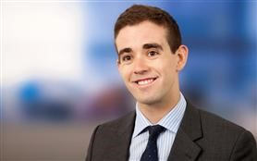_________________________________________________________________________________________

**8.30 – 8.45 – Registration**

### **8.45 – 8.55 – Welcome** – Plenary room (National Ballroom 1 & 2) – Senator the Hon Bridget McKenzie

### Deputy Leader of the Nationals, Minister for Regional Services, Sport, Local Government and Decentralisation



Photograph of Minister McKenzie

### **8.55 – 9.05 – The National Obesity Strategy** – The Hon Steven Miles MP

### Queensland Minister for Health and Minister for Ambulance Services

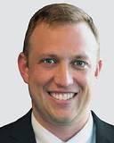

Photograph of Minister Miles

# **Segment 1 – What are other Governments doing abroad and locally?**

### **9.05 – 9.30 – International experience, England (via Skype)**

### Dr Susan Jebb – Professor of Diet and Population Health, University of Oxford

This Skype presentation by Dr Jebb will provide an overview of policy–led obesity initiatives in England over 15 years including: Change for life; Front of pack labelling; Product Reformulation; National Child Measurement Programme; and the Soft Drinks Industry Levy (SDIL) and current discussions about restrictions on marketing.

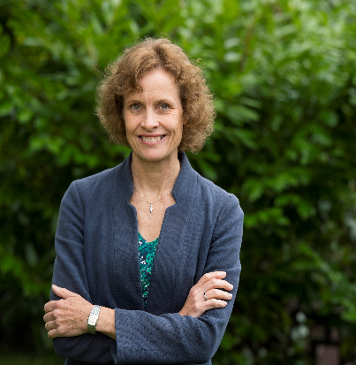Biography – Dr Susan Jebb is Professor of Diet and Population Health at the University of Oxford. Her research programme covers both individual treatment interventions to help people lose weight and population–level policy actions to prevent excess weight gain. She was seconded (0.2FTE) to the Department of Health as a science advisor on obesity and food policy (2007–2015), and worked on the Foresight obesity report, chaired the government Expert Advisory Group on Obesity and the Responsibility Deal Food Network, negotiating voluntary agreements with the food industry to improve health. She frequently appears in the media including a number of BBC science programmes on obesity.

### **9.30 – 9.55 – The NSW experience: Premier’s priorities and wide scale program implementation**

### Dr Jo Mitchell – A/Deputy Secretary, Population and Public Health, NSW Ministry of Health

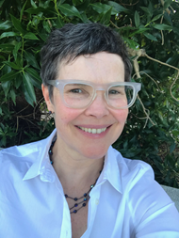Dr Jo Mitchell will present on the NSW Premier’s priorities to reduce childhood obesity. She will describe the cross–NSW Government approach which includes support programs for prevention, routine clinical advice and referral, food and physical activity environments and education and information to inform healthy choices.  She will discuss the NSW infrastructure for delivery at scale, the innovation pipeline that builds on established programs and tests new interventions and the mechanisms for monitoring implementation, all of which have helped contribute to success in NSW and could be applicable in other jurisdictions.

Biography– Jo Mitchell is the Executive Director, Centre for Population Health in the NSW Ministry of Health. In this role she is responsible for leading the development, implementation and evaluation of state–level policy, services and programs covering drug and alcohol, HIV and STIs, blood borne virus and harm reduction, tobacco control and overweight and obesity prevention. She has over twenty five years’ experience in population health at local and state levels and a doctorate in Public Health from Flinders University.

### **9.55 – 10.10 – Local Government: Local place-based approaches: Healthy Together and Ararat**

### Dr Bruce Bolam – Chief Preventive Health Officer, Victorian Department of Health and Human Services

Victoria has a long history of local, place-based action on overweight and obesity. This presentation will highlight community driven efforts to improve health and wellbeing, including both past and emerging initiatives, and focus on what we can learn from these experiences.

Biography– Dr Bruce Bolam is the Chief Preventive Health Officer in the Department of Health & Human Services, Victoria. He has extensive experience in public health and behavioural science, gained though senior roles in research, healthcare, government and non-government organisations in Australia and the UK. Passionate about behaviour change as a means of tackling the burden of chronic diseases such as cancer and stroke, Bruce was an inaugural Co-Director of the World Health Organization (WHO) Collaborating Centre for Leadership in Health Promotion hosted by the Victorian Health Promotion Foundation, VicHealth. Bruce is a Fellow of both the Public Health Association of Australia and the UK Faculty of Public Health of the Royal Colleges of Physicians, and holds several degrees in public health sciences.

Photograph of Dr Bruce Bolam

### **10.10 – 10.30 – Segment 1 - Q&A / discussion** – Lynne Pezzullo, Deloitte Access Economics

**10.30 – 11.00 – Morning Tea**

# **Segment 2 – What have we learnt from the past?**

## **Breakout Session 1** – National Ballroom 1**: Multidisciplinary care models and prevention**

### **11.00 – 11.07 – Links between obesity and chronic disease**

### Professor Andrew Wilson – Menzies Centre for Health Policy, University of Sydney

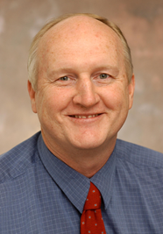Prof Wilson will provide a summary of evidence of the links between obesity and chronic conditions including T2DM, CVD, cancer, osteoarthritis, and the complex relationship between sleep and weight. He will also briefly touch on issues around mental wellness and obesity, noting that the range of different impacts and nature of the condition requires that a whole range of different specialties of care professionals need to be involved to provide multi–disciplinary treatment in order to optimise health outcomes. Prevention and earlier intervention in primary care are central to control of obesity (as discussed by following speakers) but bariatric surgery and other interventions also have key roles.

Biography: Professor Andrew Wilson is the co–Director of the Menzies Centre for Health Policy, University of Sydney and leads the Australian Prevention Partnership Centre. He chairs the Pharmaceutical Benefits Advisory Committee. His research interests concern the application of epidemiology to informing decision making in clinical medicine, public health, and health service policy and planning especially in chronic disease prevention and management.

### **11.08 – 11.15 – What’s working in primary care and opportunities for future developments**

### Dr Georgia Rigas – Chair, Royal Australian College of General Practitioners

Obesity is a complex condition with genetic, biologic and societal roots. People with obesity (PwO) may avoid healthcare if they feel shamed about their weight. General practice, as part of a primary care team, is foundational in managing chronic diseases in the Australian community and must be at the heart of efforts to address obesity. All obesity initiatives should work towards reducing health inequality, particularly for our Aboriginal and Torres Strait communities and those in rural/regional areas of Australia.

A multipronged approach is needed with a balanced combination of both individual and public health measures. GPs need to be supported to provide effective, evidence–based management to patients with obesity, including through population health guides, NHMRC Clinical Practice Guidelines and the RACGP Red Book for preventative activities which recommends measurement of BMI and WC, the 5As approach (Ask Assess Advise Agree Arrange), lifestyle programs, very low energy diets and bariatric surgery in some cases.  Other initiatives will also be discussed.

Biography: Dr Rigas is the Chair of the Royal Australian College of General Practitioners Obesity Management Specific Interest network, and has particular focus on obesity’s multi–generational effects.  She is Senior Bariatric Medical Practitioner at St George Private Hospital where she is also involved with anti–obesity therapy research projects in collaboration with other institutions such as the Garvan Institute and the University of Sydney. Her medical degree is from the University of New South Wales, where she is now a Conjoint Lecturer. Dr Rigas is committed to ongoing education in obesity management for medical students, health professionals (particularly GPs and their primary care teams), as well as the general community. She does advisory work and teaching for the Australian Ministry of Health and the Royal Australian College of General Practitioners, and is part of the Obesity Collective, which is advocating for shared responsibility for both the prevention and treatment of obesity.

### **11.15 – 11.22 – Genetics, epigenetics and obesity**

### Dr Peter Molloy – Senior Principal Research Scientist, CSIRO

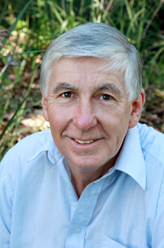Evidence from family and twin studies demonstrates that much of a person’s risk for becoming obese is inherited. However, except for rare cases, this risk is conferred by the small effects of hundreds of genes. Currently, genetic profiling to identify those at risk is not easily applied at a population level to help guide interventions. Dr Molloy will also speak about epigenetics, where environmental and genetic factors intersect, and the reality that alteration of the epigenome due to external factors can have lifelong impacts (noting the evidence here is correlative not causative). Examples include pregnancy and events in adolescence, where the potential to identify those most at risk of gestational diabetes and chronic disease such as T2D and CVD could lead to better targeted and effective intervention.

Biography: Dr Peter Molloy is Senior Principal Research Scientist in CSIRO Health and Biosecurity, Sydney. Dr Molloy has extensive experience in molecular and cell biology and genetics, with a particular focus on epigenetics and the regulation of gene expression in cancer and in metabolic health. Collaboration with local SME Clinical Genomics Pty Ltd has led to commercialisation of a blood–based test for bowel cancer recurrence after surgery. His recent research has focused on the role of epigenetics in contributing to development of obesity and its associated adverse health outcomes.

### **11.23 – 12.00 – Breakout 1, Q&A Discussion** - Lynne Pezzullo, Deloitte Access Economics

## **Breakout Session 2 –** National Ballroom 2: **Physical Activity**

### **11.00 – 11.07 – Physical activity, an overview**

### Professor Adrian Bauman – Public Health Physician, University of Sydney

Prof Bauman will provide a summary of Australian population levels of total physical activity, discussing both sport and other forms of activity, for both children and adults.  Multiple strategies are needed to improve physical activity across all aspects of daily life, including sport and structured exercise.  While physical activity may represent only up to one third of the underlying ‘causes’ of obesity (nutrition being the main cause), it is still critical in contributing to solutions, and is an independent protective factor for cardiovascular and other health outcomes (at any weight). A major cross–sectoral effort is needed to implement physical activity sufficiently well to reach whole populations and influence obesity levels.

Biography: Adrian Bauman is a public health physician and is the Sesquicentenary Professor of Public Health and theme leader for Physical Activity at the Charles Perkins Centre at Sydney University and co–directs the WHO Collaborating Centre on Physical Activity, Nutrition and Obesity. He works in chronic disease prevention and research translation. His research includes physical activity, epidemiological studies and the evaluation of population behaviour change programs for promoting activity and preventing obesity. He is well published and is named on the 2015, 2016, 2017 and 2018 Thompson–Reuter (Clarivate) lists of the most cited 1% of researchers in any discipline.

### **11.08 – 11.15 – Physical inactivity: new evidence of its role in childhood and adolescent obesity**

### Professor Dick Telford – Professional Fellow, Research Institute for Sport & Exercise, University of Canberra

Habitual diet and physical activity are the two prime determinants of how much fat we store. What is not well established is their relative impact on the body composition of Australian children. Valid and reliable measures of percent body fat (DEXA), dietary intake (weekday, weekend “multi–pass” 24–hour recall accounting for under–reporting), physical activity and sedentary time (accelerometers) were obtained from 800 Australian children and adolescents. These data provide strong support for the premise that physical inactivity is the main driver of obesity in Australian youngsters, with strong implications for community campaigns.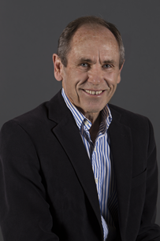Biography: Following his appointment as foundation scientist at the Australian Institute of Sport in 1981, Professor Dick Telford AM PhD has combined his research work in metabolic physiology, nutrition, and physical activity with hands–on elite level coaching. He has coached Australia’s only Olympic marathon medallist and six Commonwealth games gold medallists. His current research involves the effect of physical activity and nutrition on child development, and is Research Director of the Australian Lifestyle of our Kids (LOOK) longitudinal project, which in itself has produced 50 peer–reviewed publications to date. Dick is a Fellow of both the American College of Sports Medicine and Sports Medicine Australia. He was awarded Member of the Order of Australia (AM) in 1992. In 2014 he was named Athletics Australia Coach of the Year and inducted into the Australian Sporting Hall of Fame in the same year. Earlier this year he was recognised by Sport Australia in being presented with the prestigious AIS award for Services to Sport.

### **11.15 – 11.22 – Behavioural change to increase physical activity**

### Kate Palmer – Chief Executive Officer, Sport Australia

Kate will present stories on how the Sport and physical activity environment has changed over recent decades, what is now being done in this context in relation to addressing obesity and wellness, and how solutions in this domain fit within the multiplicity of potential contributors to making a difference to the obesity epidemic. She will note how initiatives for adults in different demographic situations (e.g. mothers of young children) differ from those for adolescents, what drives behavioural change, and how local champions or advocates can play a role.

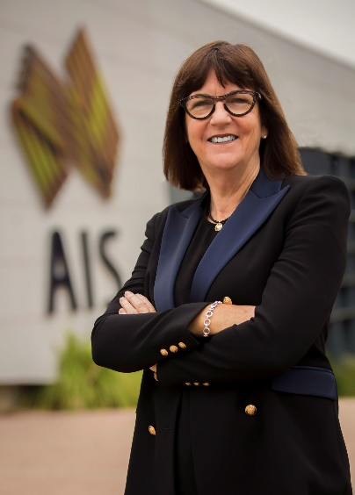Biography: Kate Palmer is the CEO of Sport Australia and is passionate about sport and believes unquestionably in the power of sport and physical activity to reflect the very best in our culture to be a powerful vehicle for change. Kate is driven by a shared purpose to contribute to improving the health and well-being of Australians and making communities stronger through sport and physical activity.

Kate is a transformational leader who has steered organisations to excel in delivering on strategic outcomes from high performance and growing community participation through to building capability of sport and international sporting success. Kate spent 10 years as Chief Executive Officer of Netball Australia, was Chair of the Victorian Institute of Sport, a Trustee of the MCG and CEO of Netball Victoria. Kate is a member of Chief Executive Women and has an Honours degree in Sport Science and a Masters in Sport Management.

### **11.23 – 12.00 – Breakout 2, Q&A / discussion** - Alice Morgan, Deloitte Access Economics

## **Breakout Session 3** –National Ballroom 4**: Food and diet**

### **11.00 – 11.07 – Population diet solutions in retail settings**

### Professor Anna Peeters – Director of the Institute for Health Transformation

Unhealthy diet is a leading modifiable risk factor for chronic disease worldwide. How is it possible that, despite global agreement on the now critical need to improve population diet, little progress has been made? At the core of the problem lies the fact that eating unhealthy food is now easier than eating healthily. Food retail environments, where citizens source most of the food they consume, currently incentivise and promote unhealthy food choices, leading directly to poor health outcomes. Global recommendations have typically paid little attention to the role of the retailer in creating environments that encourage healthy food purchases. This session will explore new solutions that are positioned within the reality of our large and complex food system, so as to be feasible for retailers while also improving population diets.

Biography: Professor Peeters is Director of the Institute for Health Transformation and Professor of Epidemiology and Equity in Public Health at Deakin University. She is Past President of the Australian and New Zealand Obesity Society and sits on national and international advisory boards and steering committees. In 2014 she was awarded the prestigious World Obesity Federation Andre Mayer Award for research excellence in obesity and a Churchill Award for innovative work in equity and population prevention. Professor Peeters graduated with a PhD in Virology from the University of Melbourne in 1997, followed by research positions at Monash University, Erasmus MC (the Netherlands), and the Baker Institute, before commencing at Deakin University in 2015. Anna held the positions of Associate Director of the Global Obesity Centre, and Deputy Director Centre for Population Health Research within the School of Health and Social Development before her appointment as Director of the Institute for Health Transformation in 2018. A public health researcher, she is particularly interested in the provision of information to facilitate objective and equitable choices in public health by policy makers, practitioners and the public.

### **11.08 – 11.15 – The 4 A’s of nutritious food in regional Australia**

### Ms Nicole Turner – Indigenous Allied Health Australia

Nicole will speak about Affordability, Availability, Accessibility and Appropriateness of the food environment and nutrition education programs in rural and remote parts of Australia.  Particular issues include the cost of freight, the additional need for preservatives, availability of electricity and power cards, and access to proper cooking facilities and refrigeration.  Noting the paucity of Indigenous nutritionists nationally, working in community to educate on good nutrition is also complex – programs exist but they need to be adapted for ATSI Australians to be culturally appropriate and delivered by local Indigenous people.

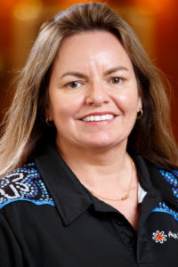Biography: Nicole Turner is a Kamilaroi woman who currently lives on the New South Wales coast. She is one of very few qualified Aboriginal community nutritionists in Australia, Nicole is chairperson of Indigenous Allied Health Australia (IAHA), and she is also an adjunct Professor of Nutrition and Dietetics at University of Canberra. Nicole has published numerous papers in international journals and presented at several conferences around Australia and overseas on a variety of topics, especially Indigenous health.

Nicole’s passion is nutrition and living a healthy lifestyle. She believes we need to give knowledge to our people about the importance of maintaining a healthy lifestyle and preventing chronic diseases. She is involved with many national, state and local committees and organisations.

### **11.15 – 11.22 – A food systems perspective for addressing obesity**

### Dr Jessica Bogard – Accredited Practicing Dietitian and Nutrition Systems Scientist, CSIRO

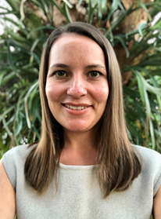This presentation will explore the role of a food systems approach to healthy diets. This includes how to more closely align different sectors involved in the food system including agriculture, environment, transport and retail, with nutrition outcomes, as discussed in the recently released Lancet Commission on Obesity report as the latest instalment of the Lancet series on obesity. The session will be solution focused and provide some global perspectives on the links between nutrition, obesity and climate change.

Biography**:** Dr Jessica Bogard is an Accredited Practicing Dietitian (APD) and Nutrition Systems Scientist with CSIRO Agriculture and Food, based in Brisbane. As a dietitian and public health nutritionist working outside the health sector, her research focuses on understanding how agriculture and food systems can be leveraged to improve nutrition, particularly among vulnerable population groups including women and young children. Jessica is also a fellow on the Lancet Commission on Obesity comprising 43 international experts across a variety of disciplines including public health, environment, food systems, economics and public policy.

### **11.23 – 12.00 – Breakout 3, Q&A / discussion** - David Creelman – Deloitte Access Economics

**12.00 – 12.45 – Lunch**

### **12.45 – 1.15 – Segment 2, Panel breakout sessions report back – Plenary Room (National Ballroom 1 & 2) - Lynne Pezzullo**

# **Segment 3 – Vicious circle: how do we break the perpetuating cycle? – Plenary Room (National Ballroom 1 & 2)**

### **1.15 – 1.30 – Obesity and eating disorders: connections and controversies**

### Dr Susan Byrne – Associate Professor, School of Psychological Science, University of Western Australia

Dr Byrne will discuss the psychological comorbidities associated with obesity with a particular focus on the increasing frequency of the dual diagnosis of obesity and binge eating disorder and the impact of stigmatisation in the context of perpetuating the negative cycle of obesity.

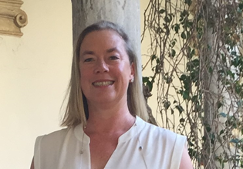Biography:Dr Susan Byrne is a Clinical Psychologist and Associate Professor at the University of Western Australia, School of Psychological Science. She has a Masters of Psychology (Clinical) and a PhD from UWA and she has also been awarded a Doctor of Philosophy from Oxford University. Dr Byrne has been involved with research and clinical practice in the field of eating disorders for over 25 years. She leads international and national research projects which aim to identify the causes of, and new treatments for, the whole range of eating and weight disorders. Dr Byrne is Clinical Director of the recently established Swan Centre in Perth, which is a specialist centre providing the most up–to–date evidence–based treatments for eating, weight and body image disorders in children, adolescents and adults.

### **1.30 – 1.45 – The importance of the first 1000 - 2000 days**

### Professor Louise Baur – Head of Child and Adolescent Health at the University of Sydney, Head of The Children’s Hospital at Westmead Clinical School

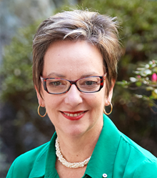This presentation will explore the critical period up to 5–6 years of life, including in–utero, but focusing on factors for young children. In our tricky obesogenic world, what interventions work to prevent obesity in this age group? Some Australasian initiatives in early childhood will be presented and compared, highlighting gaps where more could be done. The importance of the broader upstream environment, including built landscape, lifestyle/culture and food marketing, will also be discussed.

Biography: Louise Baur (AM, FAHMS) is the Professor and Head of Child & Adolescent Health at the University of Sydney and Head of The Children’s Hospital at Westmead Clinical School. Louise is also consultant paediatrician at the Sydney Children’s Hospitals Network where she is an active member – and former Head – of Weight Management Services, a multidisciplinary clinical service for children and adolescents affected by obesity. She is Director of the NHMRC Centre of Research Excellence in the Early Prevention of Obesity in Childhood (EPOCH) which brings together researchers from four Australian states and New Zealand.

### **1.45 – 2.00 – Changing Weight gain trajectories for young adults**

### Professor Wendy Brown – School of Human Movement & Nutrition Sciences, University of Queensland

In this presentation Professor Brown will identify life-stages when overweight and obesity increase significantly during adulthood in men and women. Data from the Australian Longitudinal Study of Women's Health will then be used to illustrate typical trajectories of weight gain in young adult women, and the social and behavioural factors associated with these. Ideas for how and when to intervene to change these trajectories will be proposed and audience members will be invited to add their own ideas during the interactive session.

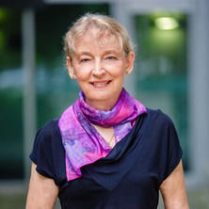

Biography: Wendy is Professor of Physical Activity and Health in the School of Human Movement and Nutrition Sciences at the University of Queensland.  She led the team that developed the new Australian Physical Activity Guidelines for Adults (2012-2014), and has been integrally involved with the Australian Longitudinal Study on Women's Health. Wendy has co-authored numerous articles in the academic and lay press, served in advisory roles for governments and NGOs, and chaired the NHMRC Translation Working Group Case for Action on Obesity in 2014. In 2015 Wendy was a member of the International Olympic Committee's expert panel on exercise during pregnancy, and is currently leading development of Australian guidelines in this field.

### **2.00 – 2.30 – Segment 3, Q&A / Discussion** **- Lynne Pezzullo**

**2.30 – 3.00 – Afternoon Tea**

# **Segment 4 – Virtuous circle: what does the future look like? – Plenary Room (National Ballroom 1 & 2)**

### **3.00 – 3.15 – Population health initiatives**

### Gary Sacks – Associate Professor, Global Obesity Centre at Deakin University

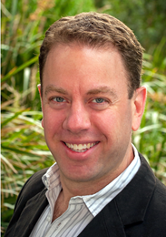Recommended food and nutrition actions at the population level will draw on innovative initiatives implemented internationally and the latest evidence of cost–effectiveness for Australia. From regulatory interventions in Chile (warning labels, taxes on unhealthy foods) to incentives for weight loss from health insurers in South Africa, this session will draw on global best practice. It will also show how scorecards that benchmark performance of different companies and different governments, can help lead to greater accountability and action.

Biography: Associate Professor Gary Sacks is a Heart Foundation Future Leader Fellow based at the Global Obesity Centre at Deakin University. Gary’s research focuses on policies for the prevention of obesity and related diseases. Gary has co–authored several international reports on obesity prevention, including the recently launched Lancet Commission on Obesity and the ACE–Obesity Policy study. He has also led studies to benchmark progress on obesity prevention by Australian governments and food companies.

### **3.15 – 3.30 – New technologies, weight management and good health**

### Professor Deborah Lupton – Faculty of Arts and Social Sciences, University of New South Wales

Prof Deborah Lupton will speak about her research regarding how people use social media, apps, wearables and other new technologies to learn about food–tracking and fitness and to monitor their bodies. While not directed at reducing obesity per se, it analyses qualitatively the value that people derive from these digital media and devices and also identifies barriers and limitations. Ultimately it is important to understand how these new technologies can be effective to encourage positive health behaviours at both preventive and interventive levels, and how less effective use could be improved in different sub–population groups.

Biography: Deborah Lupton is SHARP Professor in the Faculty of Arts and Social Sciences, University of New South Wales, Sydney, working in the Centre for Social Research in Health and the Social Policy Research Centre. She is the author/co–author of 16 books, the latest of which are Digital Sociology (Routledge, 2015), The Quantified Self (Polity, 2016), Digital Health (Routledge, 2017) and Fat, 2nd edition (Routledge, 2018). Her forthcoming book Data Selves will be published in late 2019. She is a Fellow of the Academy of the Social Sciences in Australia and holds an Honorary Doctorate of Social Science awarded by the University of Copenhagen.

### **3.30 – 3.45 – The future of pharmacotherapy in weight loss**

### Professor Joe Proietto – Professor Emeritus at the University of Melbourne, Head of the Weight control clinic at Austin Health

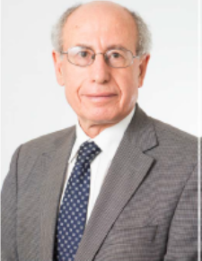Pharmacotherapy can be a necessary part of the solution mix for the obesity epidemic. This session explores why most people regain weight and how to address this through new classes of medicines. Ideal solutions for the future, including hormonal treatments, will also be covered.

Biography: Joseph Proietto is Professor Emeritus at the University of Melbourne in the Department of Medicine Austin Health. He is Head of the Weight Control Clinic at Austin Health. Professor Proietto was the inaugural Sir Edward Dunlop Medical Research Foundation, Professor of Medicine. He is currently on the executive of World Obesity and is Chair of the Clinical Care Committee. Professor Proietto has published over 200 articles and several book chapters on obesity and diabetes. He is the Author of “Body Weight Regulation: Essential Knowledge to lose weight and keep it off”.

### **3.45 – 4.15 – Segment 4, Q&A Discussion - Lynne Pezzullo**

# **Summary of Proceedings**

### **4.15 – 4.45 – Wrap up discussion - Lynne Pezzullo**

### **4.45 – 5.00 – Close - Senator the Hon Bridget McKenzie**

### Minister for Regional Services, Sport, Local Government and Decentralisation