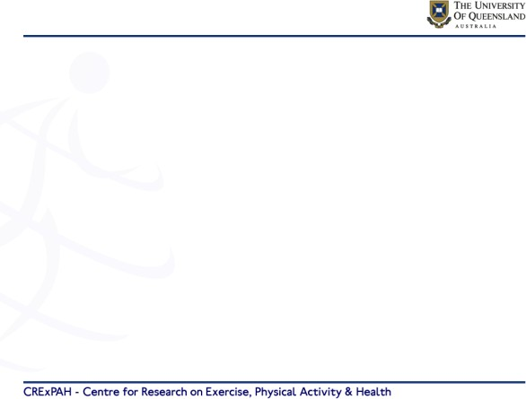

**% overweight and obese in Australia**

90 **men**

80

**women**

**31 35**

70

**20.0**

**33.8**

60

**31.9**

**24.3**

**17**

50

40

**17.3**

30

**7**

**8.5 8.6**

**7.5**

20

10

0

5-11 12-17 18-34 35-54 55-74 75+

5-11 12-17 18-34 35-54 55-74 75+

**AIHW 2014-2015**

**Percent overweight and obese**

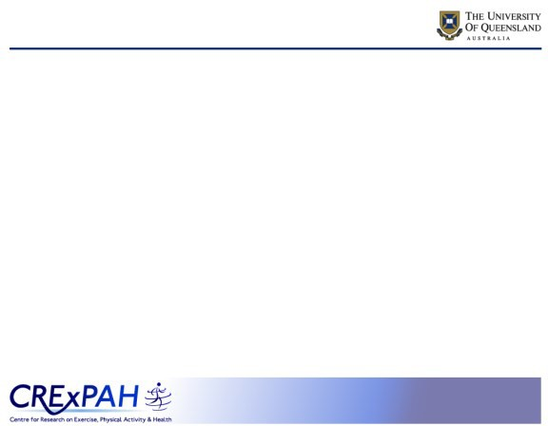

**Changing Weight Gain Trajectories**

**for Young Adults**

**Wendy J Brown**

**BSc (Hons) MSc PhD FASMF, FACSM**

**National Obesity Summit**

**Canberra**

**15th February 2019**

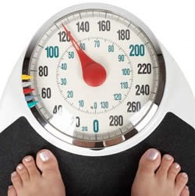

**Outline**

1. Overweight and obesity in Australian adults
2. Using data to inform prevention ideas - trajectories of weight change in the

Australian Longitudinal Study on Women’s Health

1. How and when to change the trajectories?



**Outline**

1. Using data to inform prevention ideas -

trajectories of weight change in the

Australian Longitudinal Study on Women’s Health

1. How and when to change the trajectories?

1. Overweight and obesity in Australian adults



**Outline**

1. Overweight and obesity in Australian adults

3. How and when to change the trajectories?

2. Using data to inform prevention ideas - trajectories of weight change in the

Australian Longitudinal Study on Women’s

Health

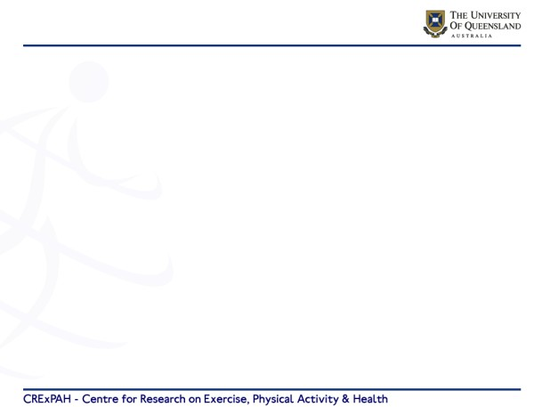

**The Australian Longitudinal Study of Women's Health**

1 2 3 4 5 6 7 8 9 10 11 12 13 14 15 16 17 18 19 20

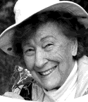

*The Australian Longitudinal Study on Women’s Health*

**ALSWH Cohorts**

**Born: 1973-78**

**1996: 18-23 y**

**N= 14,427**

**2019: 41-46 y**

**Born: 1921-26**

**Born: 1946-51**

**1996: 70-75 y**

**1996: 45-50 y**

**N= 12,432**

**N=13,715**

**2019: 93-98y**

**2019: 68-73**

**all surveyed in 1996 then at ≈3 year intervals**



*The Australian Longitudinal Study on Women’s Health*

**“new” young cohort established in 2012**

**Born: 1973-78**

**1996: 18-23 y**

**N= 14,427**

**2019: 41-46 y**

**1989-95**

**2013 – 18-23y**

**N= 17,011**

**2019: 26-29y**



**Methods – weight and height**

**At every survey:**

* Weight and height self- reported (women asked to check their

weight on a scale)

***Burton et al Aus NZ J Pub Health 2010***

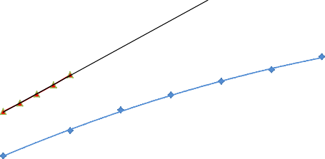

**Weight change young adult women**

**1996 –age 18-23 to 2015 age 40-45; N  7000**

**2012 – age 18-23 to 2017 age 23-28; N  8000**

80

78

76

74

72

70

68

800

g/year

**2015**

**2017**

66

64

62

60

**2013**

600

g/year

**1996**

21

25

28

31

34

37

40

**age**

**By age 33**

**10 kg heavier?**

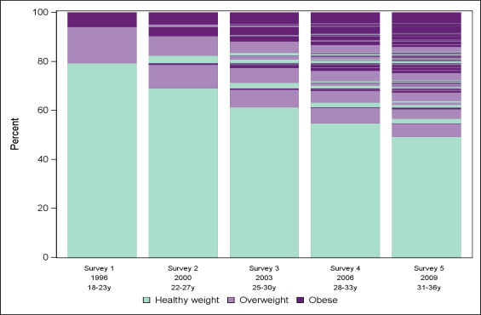

**Patterns of change in BMI**

32%

21%



**Patterns of change in BMI**

21% overweight/obese 45%

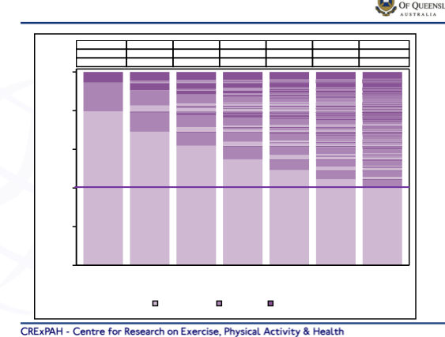

Obese

Overweight Healthy 100

5.6

14.9

79.6

9.0 12.2 14.6 17.7 19.9 23.7

18.8 20.4 23.8 25.0 26.9 27.2

72.2 67.3 61.6 57.3 53.3 49.1

80

60

40

1996 2000 2003 2006 2009 2012 2015

18-23y 22-27y 25-30y 28-33y 31-36y 34-39y 37-42y



**Determinants of 10 y weight gain**

* Average rate of gain 0.93% of initial weight/year
* 605g (580-635) per year for 65kg woman
* Partnered gained 1 kg more (than not)
* Partner + 1 baby gained 4kg more (than not)
* Physical activity, sitting time, energy intake

***Brown et al Am J Prev Med 2010***

Percent

|  |  |  |  |  |  |  |  |
| --- | --- | --- | --- | --- | --- | --- | --- |
|  |  |  |  |  |  |  |  |
|  |  |  |  |  |  |  |  |
|  |  |  |  |  |  |  |  |
|  |  |  |  |  |  |  |  |

|  |  |  |  |  |  |  |  |  |
| --- | --- | --- | --- | --- | --- | --- | --- | --- |
| 20 |  |  |  |  |  |  |  | * Education, hours paid work |
| 0 | Survey 1 | Survey 2 | Survey 3 | Survey 4 | Survey 5 | Survey 6 | Survey 7 | * Smoking, initial BMI |
|  |  |  |  |  |  |  |  |  |
|  |  |  |  |  |  |  |  |  |
|  |  |  | Healthy weight | Overweight | Obese |  |  |  |

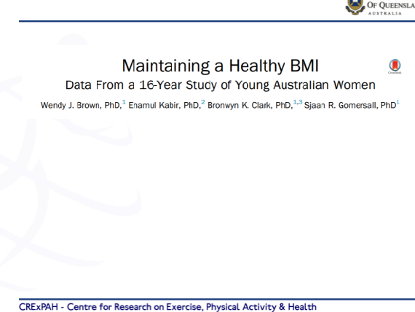

**Focusing on the healthy weight women**

4,881 women

healthy BMI at baseline (1996: 18-23y)

healthy, overweight, or obese BMI after 16-years

(2012: 34-39y)

**Brown et al American J Prev Med 2016**

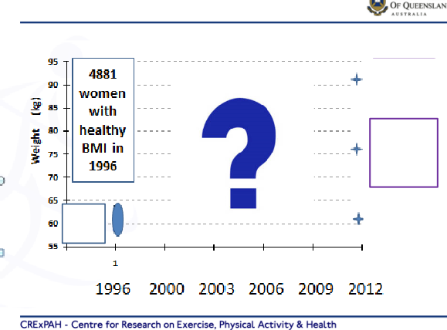

**Weight and time**

**59.7**

**kg**

**18-23 22-27 25-30 28-33 31-36 34-39**

**29%**

**over- weight**

**59%**

**healthy**

**11%**

**obese**

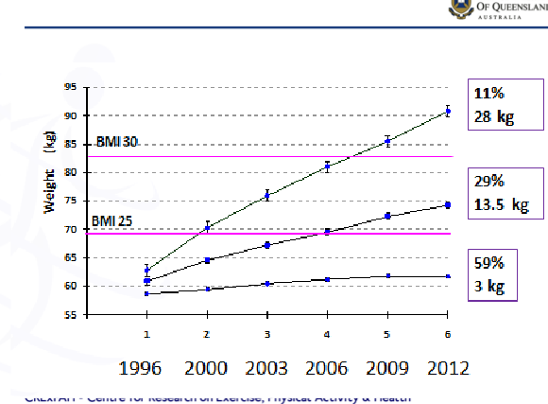

**Weight change over time**

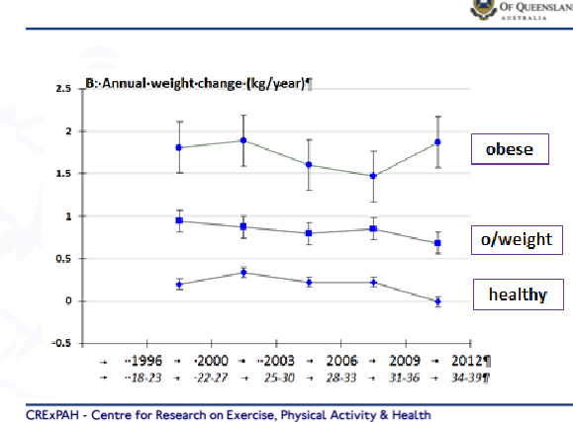

**Rates of weight change**

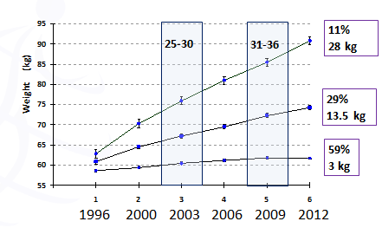

**Determinants assessed in 2003 and 2009**

**GEE (adjusted models)**



**ORs for maintaining healthy BMI**

**MORE LIKELY**

* University degree 1.50 (1.14-2.00)
* Low alcohol 1.25 (1.10-1.41)
* Physical activity mod 1.23 (1.03-1.47) 500-1000

high 1.44 (1.20-1.72) >1000

MET.min/week

***Brown et al Am J Prev Med 2016***



**ORs for maintaining healthy BMI**

**LESS LIKELY**

* Separated/ widowed 0.77 (0.66-0.89)
* Smokers 0.64 (0.50-0.81)
* Sitting time 5-8h 0.87 (0.77-0.99)

>8h 0.78 (0.68-0.91)

* Energy Intake >11200 0.76 (0.58-0.99)
* OCP 0.89 (0.80-0.99)

***Brown et al Am J Prev Med 2016***

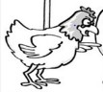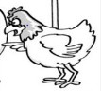

weight

gain

sitting

sitting

weight

gain

chronic

disease



* **High PA is the strongest behavioural determinant of healthy weight maintenance**

>1000 MET.min/week

50 mins x 5 days x 4 METs

25 mins x 5 days x 8 METs

16 mins x 5 days x 12 METS

(This is the upper end of current guidelines)



**Outline**

1. Overweight and obesity in Australian adults
2. Using data to inform prevention ideas - trajectories of weight change in the

Australian Longitudinal Study on Women’s Health

3. How and when to change the trajectories?

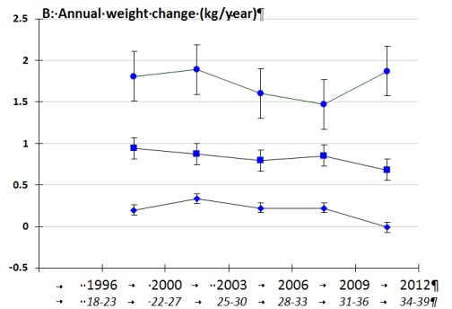

**Identify gainers early**

**weight gain should be limited to <0.5kg per year**

**assist with behaviour change**

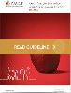

**Changing the trajectories?**

* **Primary Care**

Identify those with weight gain <500g/ 1kg/>1.5kg /year at age 18-20

Add to **RACGPs “red book”**

Develop accessible, culturally appropriate **resources and education/training** for all health professionals

Chronic Disease **Prevention** Scheme → 5 referrals to allied health professionals (Exercise and Nutrition)



**Changing the trajectories?**

* **Scale up effective interventions** (eg Help-her)

(non-prescriptive simple health messages, small changes to behaviour, low participant burden, group- based/individual/phone, SMS reminders etc)

* Integrate weight gain prevention into **routine antenatal care** (esp first birth at <26y) – incorporate AEPs and Nutritionist/Dietitians for management of gestational weight gain and post partum healthy weight
* **Sustain participation** in sport in the transition from school- tertiary education-work and families

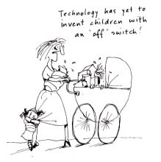

If eating and activity behaviours could be changed in women at this life stage . .

and if weight gain progression could be prevented . .

there would be potential for carry over to men and children as well.



[www.alswh.org.au](http://www.alswh.org.au/)