 



**Policy initiatives to tackle obesity**

**in England?**

Professor Susan Jebb

Nuffield Department of Primary Care Health Sciences and Senior Research Fellow, Jesus College,

University of Oxford

[www.phc.ox.ac.uk](http://www.phc.ox.ac.uk/)

## Declaration of interests



From 2005-2007 I was the lead Science Advisor to the Foresight obesity project From 2007-2011 I chaired the DH Expert Advisory Group on Obesity

From 2010-2015 I was Chair of the DH Public Health Responsibility Deal Food Network From 2013-18 I was Chair of the NICE Public Health Advisory Committee A

In 2018 I was appointed to the UK Scientific Advisory Committee on Nutrition

My research is primarily funded by the National Institute of Health Research (NIHR). Some of my research has been funded by companies providing weight management services (Weight Watchers, Cambridge Weight Plan). In other publically funded trials the treatment intervention is offered by the provider at no cost (Slimming World, Weight Watchers)



**e: He . · England**

 **In**

**Heal h Survey for England 9,**



■

**93 to** 20 1 51 **(thr,ee ye,ar ave·0 age**



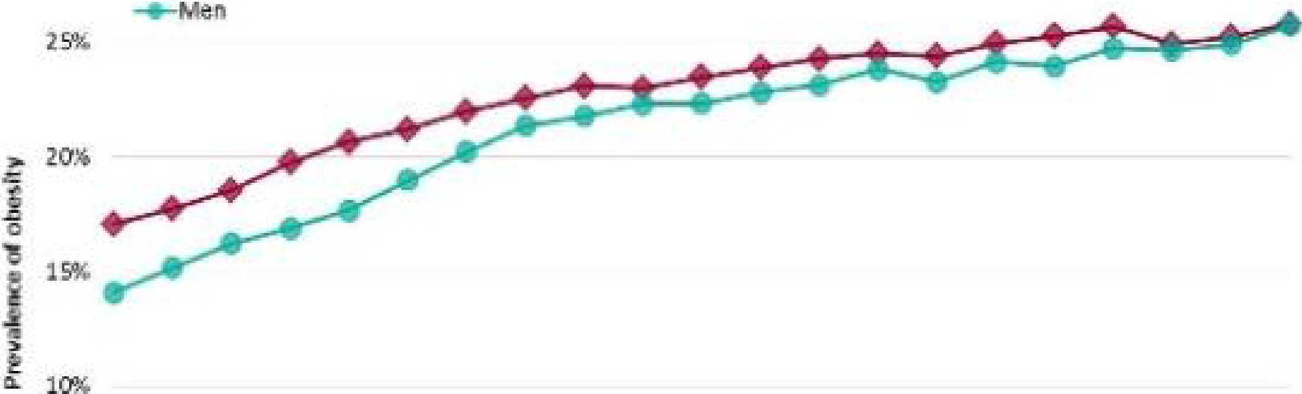



PHE Patterns and trends in adult obesity

NU FFIELD D E PARTM ENT OF

**PRIMARY CARE**

HEALTH SCIENCES

**2008**

**2011**

**2016**

**2018**

[,;¾

UNIVERSITY OF

**OXFORD**

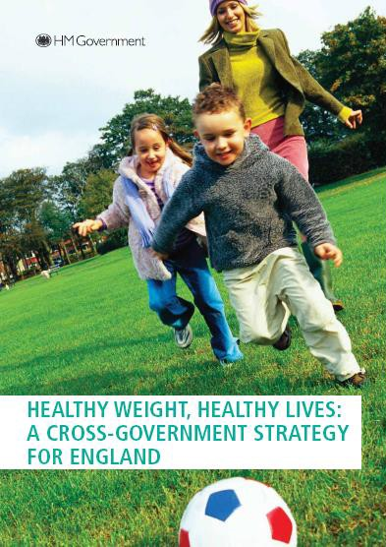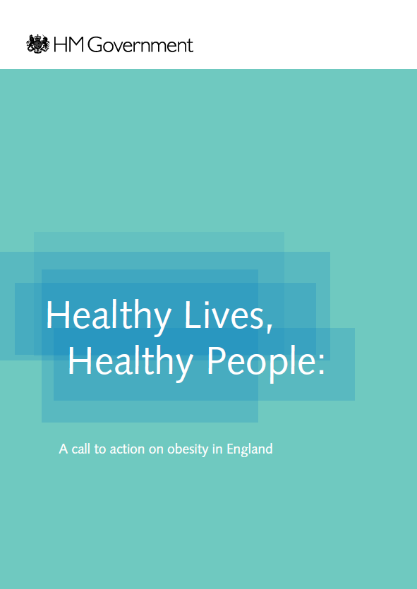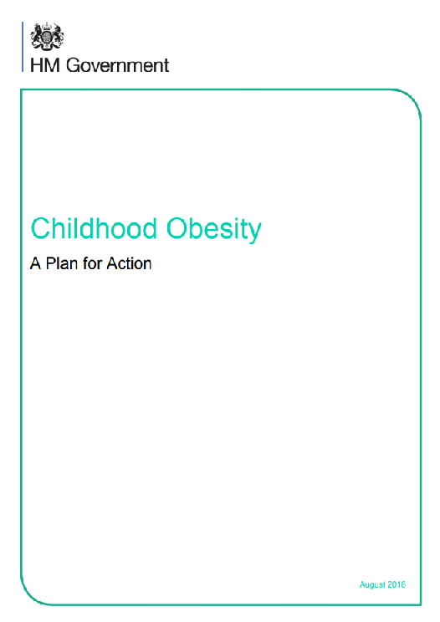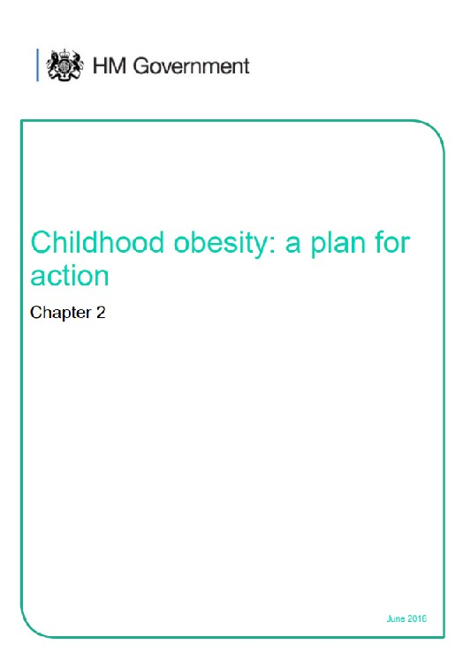

I

NUFFIELD D EP ARTM ENT OF

**PRIMARY CARE HEA LTH** SCIENCES

### Obesity prevalence by deprivation decile

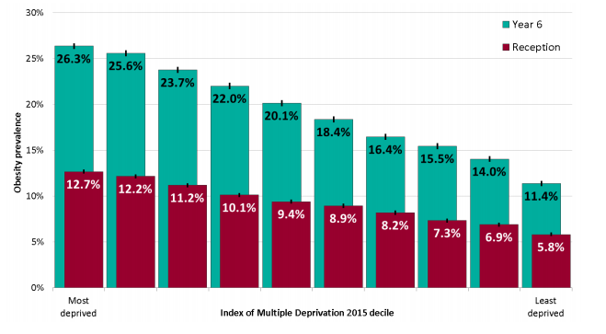

##### National Child Measurement Programme 2016/17(1)

Calorie reduction: the scope and ambition for action – March 2018



# Change4Life: a national social



**marketing campaign**

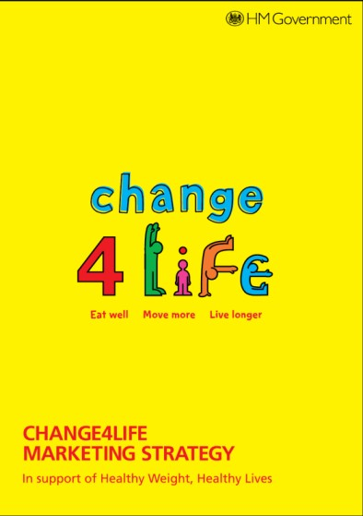



# Nutrition labelling

Around two thirds of pre- packaged food carry consistent colour-coded nutrition labelling

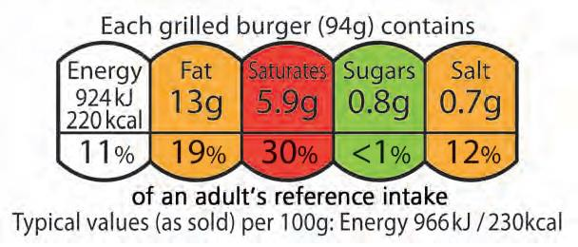

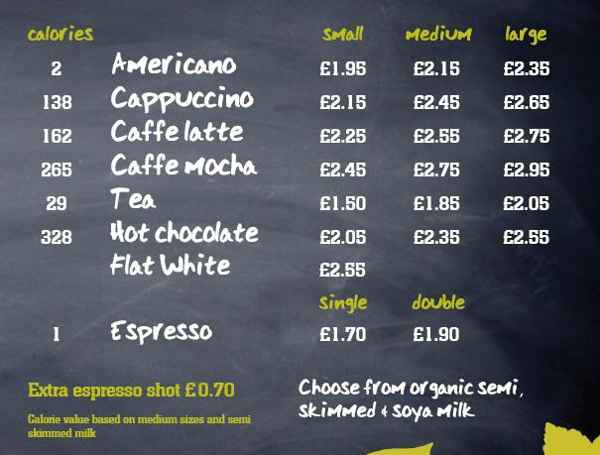Partial adoption of calorie- labelling on high street

Recent public consultation on mandatory labelling for all out of home food businesses





**Voluntary agreements with industry to**



**stimulate product renovation**

* Builds on successful salt reformulation programme
* Public Health Responsibility Deal initiated action on calories – voluntary pledges and self-reporting of progress
* Specific targets now set by Public Health England for sugar and calories
* Independent monitoring and annual reporting of progress
* Threat of stronger action if sufficient progress not achieved



BREN<FAST

CEREALS

YOGURTS ANO FROMAGC FRMS

SWEET

c rccnONARY

ORNINO

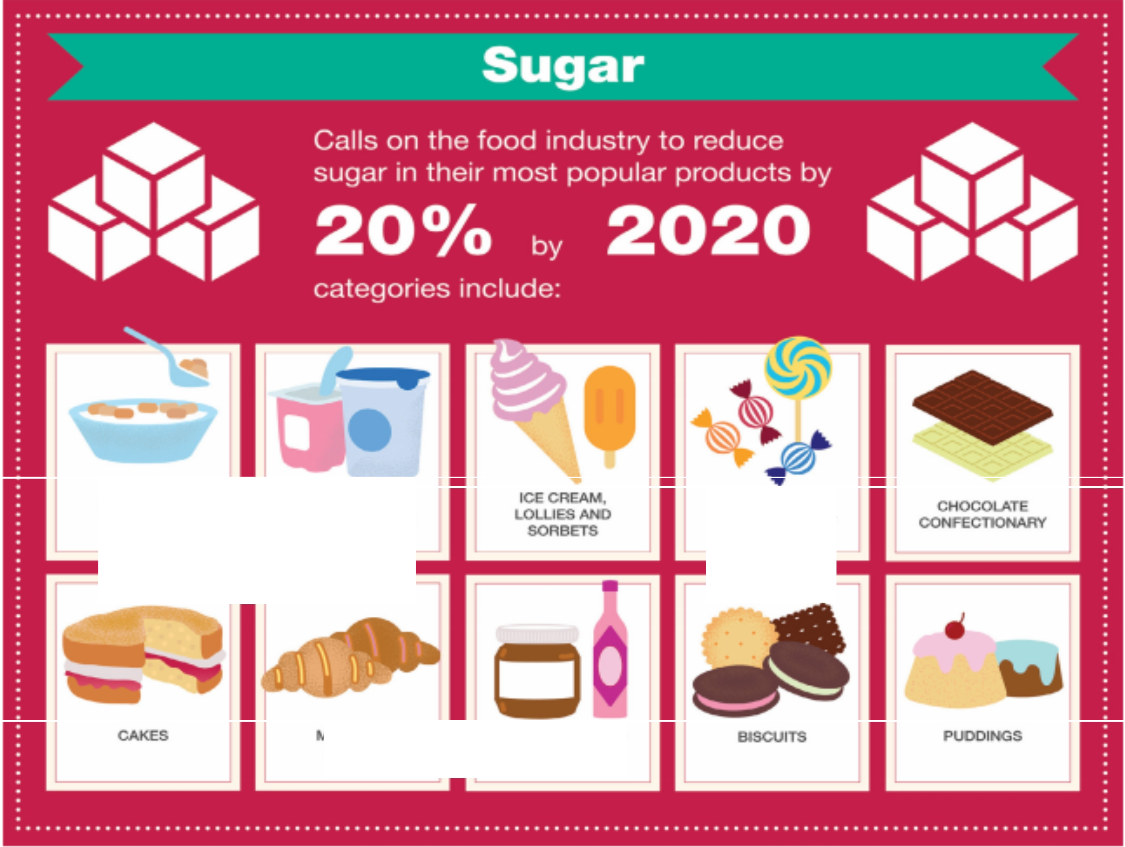

GOODS

SWC:CT SPRCADS ANO SAUCES

### Results after 1 year*:



##### 2% reduction overall (excluding drinks)

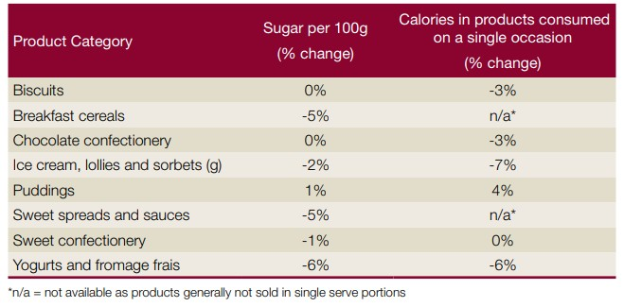

**\*2 year data expected next month**



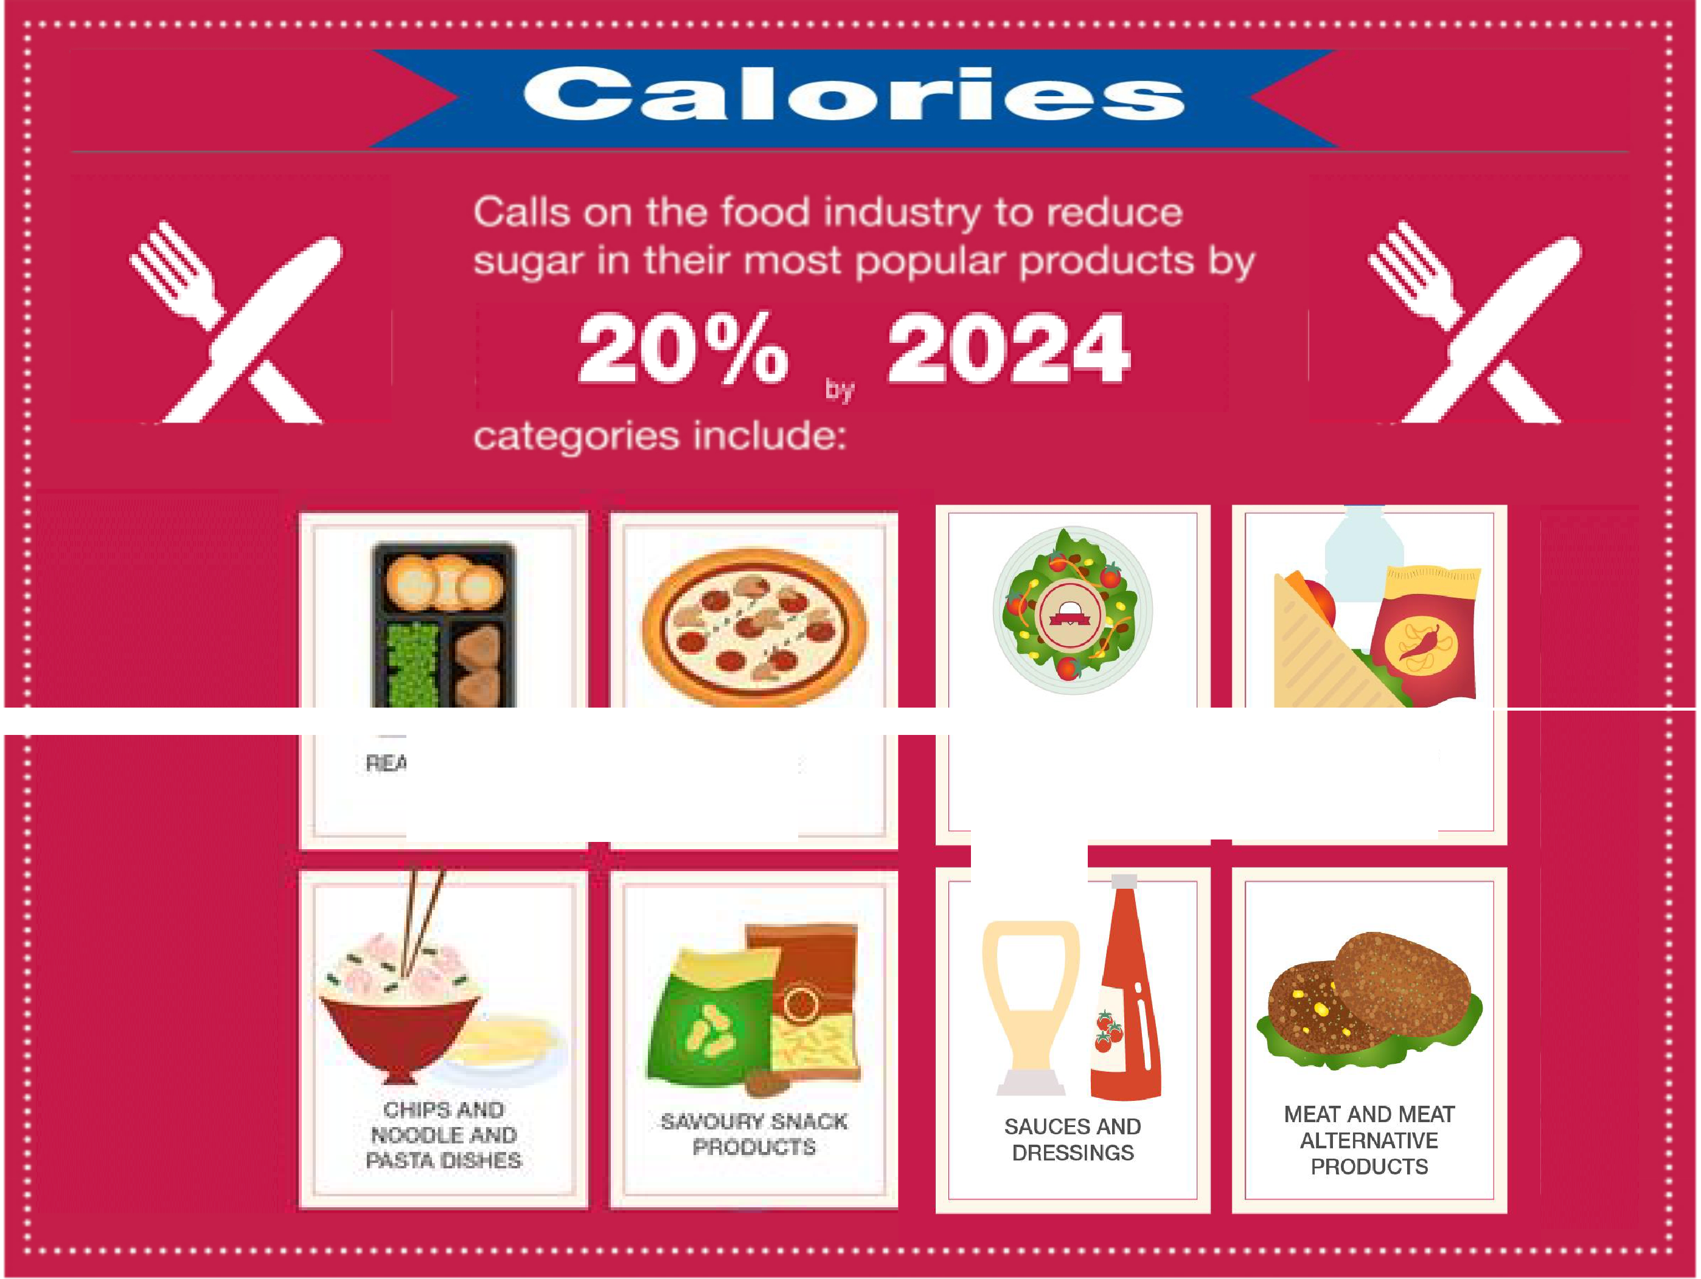

**tDY EALS**

**PIZZAS.**

"FOOD TO GO" E.G. PREPARED SANDWICHES, SALADS, ETC.

MEAL DEALS

**Calorie reduction* through smaller portions and reformulation**



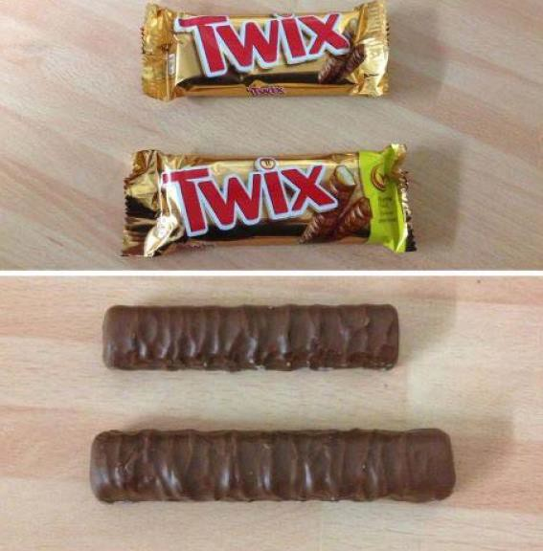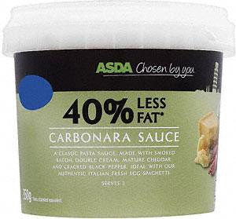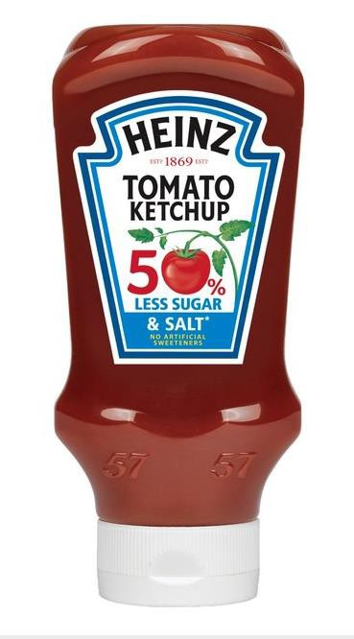

250 kcal cap on single bars of confectionery from Mars, Nestle and Mondelez

Reductions in fat and sugar across a range of products

**\*1 year progress report expected next month**

•

**TAXING SUGARY DRINKS AROUND THE**

**. !**

**DO TAXES REDUCE CONSUMPTIION?**

IN MEXI CO, IN ITS FIRST

**! ;: : : YR: l:: D** ,· ,·

**BY 7.6 % PER YEAR.**

OVER lO YE ARS THIS WIL L LEAD TOA

* 1. **4% REDUCTI ON** IN

**IMPLEMENTED SUGAR TAXES WORLDWIDE**

* + - USTS ACWRAT[ AT TIME or PROLIUCTIOH.

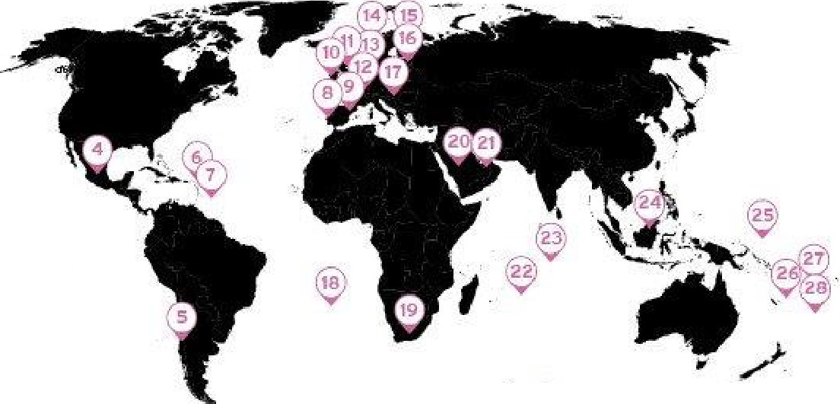1. COOK 1$1.,A.NDS

2:. KIR'IBATI

J. rn E;NC H POLYNESIA "4i. MEXICO -

$., 1'.;.H I L,f;

6 . DOMl ICA

7. BARBADOS

a . PMT\JM l

*9-* P AIN ((;.ATl;L ONh\ ),

1. IREl AND
2. U N IT l:;D KIN(,O,OM -...

**DO TAXES IMPACT RETAILERS?**

AFTER **1** YEAR, **IN** LOW-INCOME NEIGHBOURH OODS

**IN** BERKEL EY, USA, SUGARY DRINK CON SU M PTION

**DE•CLINED BY 21%,** HOWEVER, SALES **OF** UNTA XED BEVERA GES

IN BERKELEY

OBESITY AND

**nwms.**

**PUYENT 86-134,000 CASES OF**

1 . FRANC[

1 .J 8 EL G1,Ut fl

14, N0RWAY

1. rl N l,.AND

16.. l:STONIA

0 ROSE, SUCH

THAT **OVERALL**

**BEVERAGE SALES**

FRANCE SAW A **6.7% DECLINE** IN DEMAND FOR REGULAR COLA IN TH£ FIRST 2 YE ARS AFTER INTRODUCING A

**6.7%**

•

&

•

* 1. HUNG ARY f°0
  2. . ST tt[LEN 'y
  3. . SOIJTH AFRICA

2.<l. SAUDIA. ARABIA

2:1. IJNlTED ARAf3 l M IR'ATE:,.

22, MA'tJRITi lJS

23. :S EYCH[ l l [.5,

1. 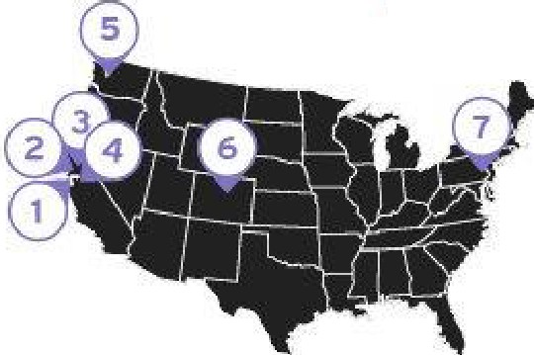. l:IRIJMEI 4S. l'tJA1J.RU 26.. F"IJ I
2. SAMOA
3. TONGA.

28 COUNTRIES &

7 US CITIES (so far...)*

1, $Atl t RAN c;.J CQ.CP.

2_ B KELEY, CA

J. AU ANY.C A

4 . 0AkLAftD, U

$,. S ATTL , WA

**ROSE.**

**THE WORLD HEALTH ORGAN IZAT I ON** RECO MMENDS SUGARY DR IN KS TAXE S AS AN EFFECTI VE MEASURE TO

SUGAR-SWF;l':fENED BEVERAGE TA)(.

* 1. . BOULOCR, CO
  2. Pl-lllA D[ LP'loilA , PA

1".'C"•'h""ra)L.lwf-ld!u; -IL"In :i!-11',l"l'lllffi:t! Of s RHp,:MCi"WoVNUAft r mMilllQA u-S.-Uf'll!!d Bewnqn ll HultbAMN"i,.¥0( 31§.,

Z.Blrrl lwrt .lan;:, uh 1!1.;i,l pc,d.ad lton Wel,;hl;IINO '-P'ctof1ha1- -{Jtq hl'to 5t!QWS- bt<wd B.vfflQU lnMiufco. E.,:1-. q,idrlqc,fi

1. f! J, et al '"1mpr,,,."t ot tN rt.el tlll:i,t, Tn on Sin u·SWcetimea.ae,, corr.;uml)lkWl,•, A4"1H11;til.Journ1c; ot Pltbk .,_,allh IOS. r,o, IO !Octa tr l, 2ot6}: j)Jl.11:!115-S,-11!-71.
2. st>.ml.D,e<a.!. illl -.consumlH"1J>tildlnQ.,M\llbtwniQ!" _.,\1&¥1ltr!!-Mnansu 1,.11*ne.ilbe'/-u.aqmfln1191:elw(,C11i11o,rfllao,US::A

|  |  |  |  |
| --- | --- | --- | --- |
| * r a1 kfc1 t-:raw. n lhc lonOIOOfKINllffJ,lfMtlllikal ;ui:}_• 1i11,ao¥.i.-Gurni.flt¥olliabk-1t ttirJ""'•- -i:r,:tpm*.iicn | | | |
| ,h5 too lll inlJlraijrt-1ood | 1M1or.Ralt;;cr | Tl!tflctntrltilld5:f.ll"0«11n{11mpat1trnmt:ss | fll'ldSlilstollniWIII lrlikr.itmlfokyCOrtsorllt |

1. 'l'l'l:,r1ant-.1/tb orq .
2. fOQo)t,a,;ts-ll"llll



lm

NUFFIELD D E PARTM ENT OF

**PRIMARY CARE**

HEALTH SCIENCES

### Reformulation: Total sugar content (g/100ml) of soft



**drink products on the market in 2015 and 2017**

Sales weighted average reduction of 11% (2015 and 2017)

Decrease of 6% in calories

consumed in a single occasion

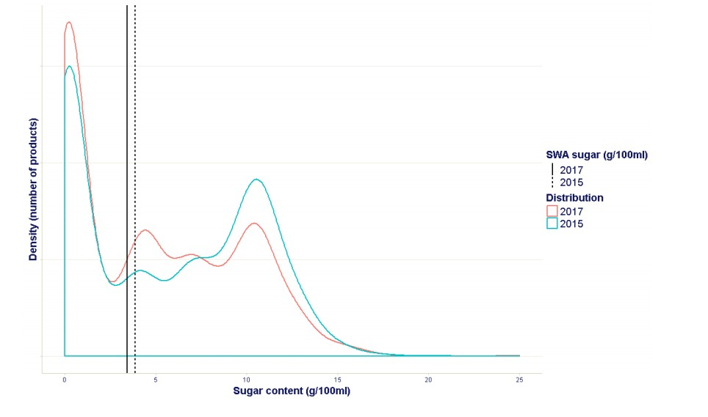5-8 g/100 ml: 18p/litre

>8 g/100 ml: 24p/litre

PHE Sugar reduction and wider reformulation programme: progress report towards 5% and next steps – May 2018

## Next steps



* + Updating school food standards, especially with respect to sugar content
  + Consultation on mandating consistent calorie labelling for OOH sector
  + Consultation on extending restrictions on TV advertising of HFSS foods
  + Consultation on legislation to ban price promotions of unhealthy food and drinks in retail and out of home sector
  + Review progress on SDIL and consider extending to sugary milk drinks
  + Consider further use of tax system to promote healthy food if reformulation programme does not deliver sufficient progress
  + Promote a national ambition for every primary school to adopt an active mile initiative
  + Develop a trail blazer programme with local authority partners to show what can be achieved to create a healthier food environment



*{***l'l) i)***Department*

**C** *ofHealth*

#### Improving access to obesity treatment

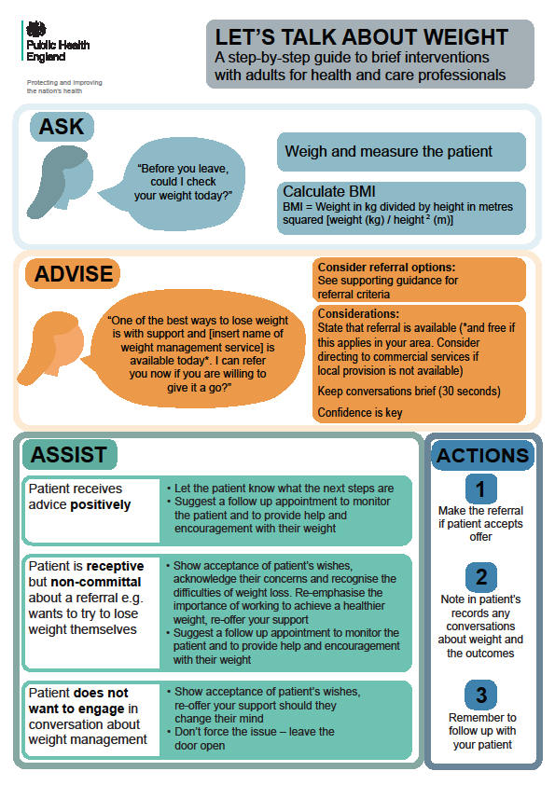

*Commissioning Board*

**Developing a specification fo lifestyle weight management services**

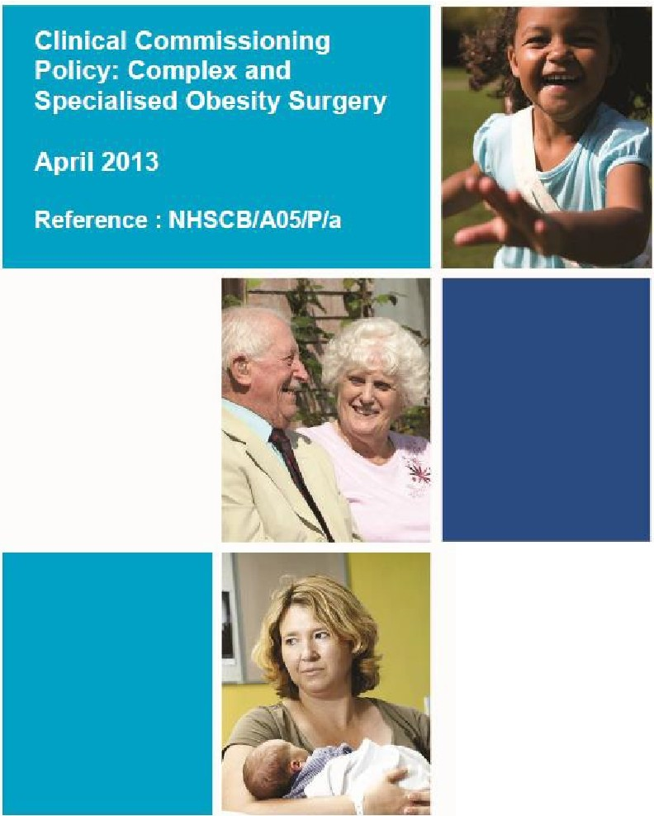

**1'1i'1'**

**THE NHS**

**CONSTIT\1T10N**

*Best p ractice guidance for tier 2 services*

NUFFIELD D EP ARTM ENT OF

**PRIMARY CARE**

HEALTH SCIENCES



#### New ambitions to increase access to weight management services:

* Doubling National Diabetes Prevention Programme (NDPP)
* Offering weight loss in primary care for people who are obese with diabetes or hypertension
* Piloting use of TDRs for inducing remission of diabetes



# Key challenges



* + To maintain momentum amidst Brexit (or other political upheaval)
  + To tackle inequity
  + To set clear governance frameworks, targets, monitoring and evaluation for food industry actions eg. reformulation
  + To take legislative action in parallel where policies need to be mandated to be effective eg. marketing
  + To integrate action at national level with devolved authorities/local government and communities
  + To embed obesity treatment as part of routine medical care
  + To build public mandate for intervention

