National Obesity Summit – February 2019

**Obesity and the first 2000 days**

## Louise A Baur

Discipline of Child & Adolescent Health, University of Sydney

The Children’s Hospital at Westmead

NHMRC Centre of Research Excellence in the Early Prevention of

Obesity in Childhood

Email: [louise.baur@health.nsw.gov.au](mailto:louise.baur@health.nsw.gov.au)

# The first 2000 days?

**Conception**

**Birth**

### From conception to age 5 years

**-9mo 0** **1y** **2y** **3y** **4y** **5y**



**Why is this period important?**



# Life course perspective

* 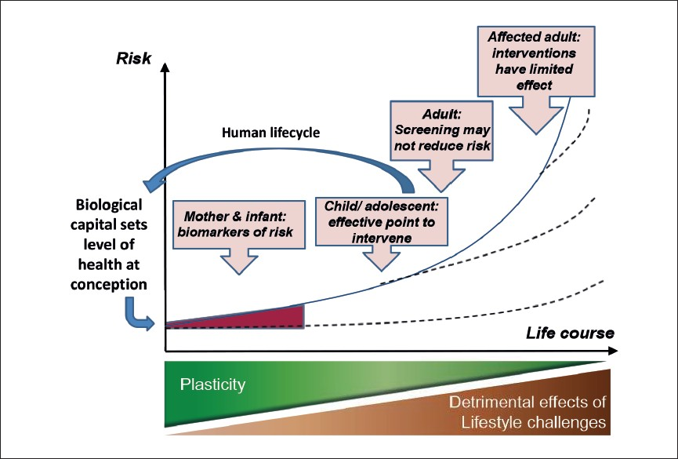**“****Pathway** **dependency****”:**

Health risk at one time-point is influenced by current health issues *and*previous health pathway for that individual

* **Interventions** **earlier in life** **likely to be more** **effective than** **those starting in** **adulthood**

***Hanson M. WHO 2013***

# While obesity interventions are needed across the life-course…the first 2000 days are especially important

**Pregnancy**

**Early childhood**

**Adolescence**

**Pregnancy**

**Workers**

**Infancy**

**Mid****-childhood**

**Young adults**

**Families** **Mid-****life …**



**The** ***antenatal period*****and later obesity?**

* + **Over one-****half of Australian women enter pregnancy**

**with overweight or obesity**

* + **Maternal *pre******-pregnancy obesity*****and** ***excessive*** ***gestational weight gain*****:**
    - **associated with increased risk of obesity (and other health** **risks) in the offspring in childhood, adolescence and** **young adulthood**
  + **Maternal** ***gestational diabetes:***
    - **associated with child and adolescent obesity**

McIntyre HD et al. MJA 2012; Yu Z et a;, PLoS One 2013; Eriksson JG et al. Annals of Medicine. 2014; Godfrey KM et al, Lancet Diabetes Endocrinol 2017; Mamun AA et al, Circulation 2009; Adane AA Int J Obesity 2018; Kim SY et al Curr Opin Obstet Gynecol 2012; Kawasaki M et al PLoS One 2018

***Early childho******o*d and later obesity?**

* + **Australia: 1:5 children** ***already*****affected by overweight &**

**obesity at school****-entry**

* + **Infant** **feeding practices, early dietary patterns and** **early** **sedentary/ screen** **behaviours →** **influence obesity** **onset**
  + **Excess weight and fast** **weight** **gain in early childhood**

**→ related to later weight status and health outcomes**

* + **Most excess weight gained** ***before puberty*****is gained** ***by*** ***5 years*****(i.e.** ***prior to school entry*****)**

Cunningham SA et al. N Engl J Med 2014; Stettler N, Iotova V. Opin Clin Nutr Metab Care 2010; Leunissen RWJ et al. JAMA 2009; Hesketh KD, Campbell KJ, Obesity 2010

# Prevalence of overweight & obesity by age, Australia 2011-12

**Prevalence of overweight and obesity by age,**

**Australia, 2011-12**

80

70

60

50

40

30

20

10

0

0 3 6 9 13 16 21 30 40 50 60 70 80 88

##### Age (years)

Source: Australian National Health Survey 2011-12

# Prevalence of overweight & obesity by age, Australia 2011-12

## The biggest rises in prevalence: First 3 years, and later adolescence/ young adulthood

**Prevalence of overweight and obesity by age,**

**Australia, 2011-12**

80

70

60

50

40

30

20

10

0

0 3 6 9 13 16 21 30 40 50 60 70 80 88

##### Age (years)

Source: Australian National Health Survey 2011-12

**WHO Ending Childhood Obesity** **Commission**



# World Health Organization

## Ending Childhood Obesity (ECHO) Commission

#### WHO 2017. ECHO

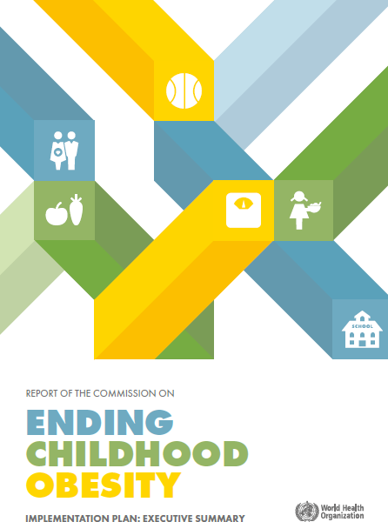

**Commission**

**Implementation Plan**



**WHO ECHO Commission:** ***Leadership for*** ***comprehensive, integrated, multisectoral action*** ***to end childhood obesity***

* + ***“No single intervention can halt the advance of the epidemic of obesity***



### To challenge obesity successfully requires countering the obesogenic environment and addressing vital elements in the life course through coordinated, multisectoral action that is held to account

* + ***Interventions to tackle obesity can be integrated into and build upon existing national plans, policies and programs”***

**WHO 2017. ECHO Commission Implementation Plan. P9**

**We have an opportunity today to** **provide some of this leadership**

### “No single intervention can halt the advance of the epidemic of obesity



* + ***To challenge obesity successfully requires*** ***countering the obesogenic environment and*** ***addressing vital elements in the life course through*** ***coordinated, multisectoral action that is held to*** ***account***

### Interventions to tackle obesity can be integrated into and build upon existing national plans, policies and programs”

**WHO 2017. ECHO Commission Implementation Plan. P9**

## Infographic for ending childhood obesityWHO ECHO

**Commission: *Six key areas of action***

WHO 2017. ECHO Commission Implementation Plan



## WHO ECHO

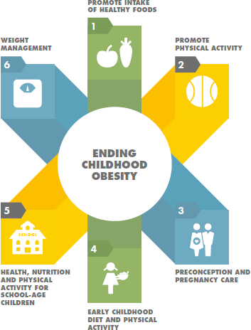

**Commission:** ***Six*** ***key areas of action***

WHO 2017. ECHO Commission Implementation Plan



**The preconception** **and antenatal period**



# Preconception and antenatal care

#### Preconception

o Aim to prevent maternal obesity *prior*to being pregnant and also in the inter-pregnancy period → evidence base for interventions still largely in development

* **Antenatal period**
  + Targeted care of high risk women:
    - **pre****-pregnancy obesity**
    - **excessive gestational weight gain**
    - **gestational diabetes**
* **Cultural adaptation and co-production**
  + Culturally relevant, and co-produced

Hanson M et al. Lancet Diabetes Endocrinol 2017; Harrison VL et al, Midwifery 2017

**0****-2 year age range**



# Early childhood

#### Encouraging evidence from 4 Australasian trials that started antenatally or in early infancy and targeted healthy infant feeding and lifestyle behaviours

* + **Different types of intervention –** **nurse home** **visiting, group programs**
  + **What can we learn from combining** ***individual*** ***participant data*****from these trials at age 18-****24** **months****?**

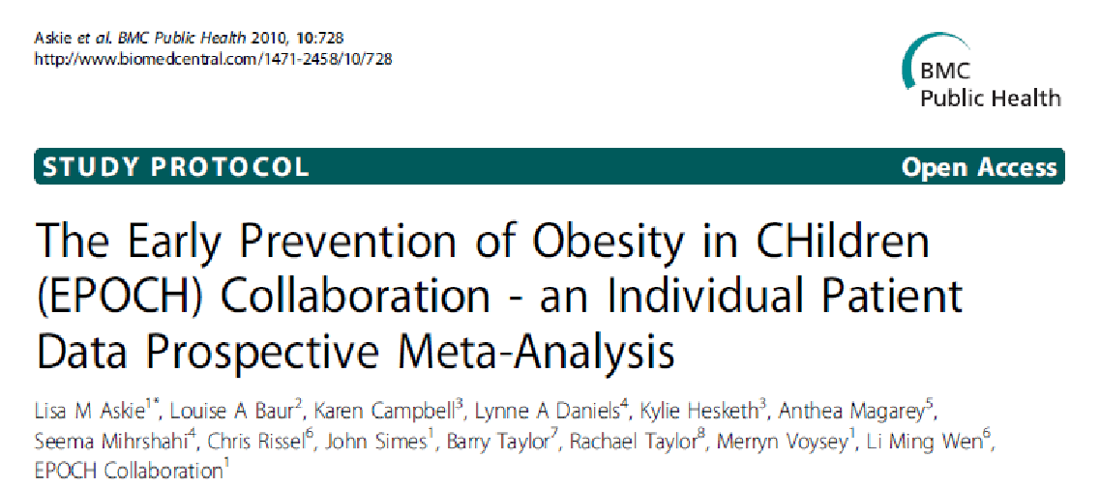

* + **Total n=2000**

*Askie L et al. BMC Public Health 2010; Wen* *LM et al. BMJ 2012; Daniels LA et al. Int J* *Obesity 2012; Campbell KJ et al. Pediatrics* *2013; Taylor RW et al. AJCN 2018*

# Results to date from combining the data

#### Interventions starting in the first few months can

**lead to:**

* + **Some reduction in BMI at 18-****24 months**
  + **Longer duration breast feeding**
  + **Reduction in TV viewing time**
  + **Reduction in some undesirable feeding** **practices**

Askie L et al. Manuscript submitted. Data presented at Eur Congress Obesity and at ANZ Obesity Society

# My recommendations for obesity prevention in the 0-2y age range

#### A range of strategies to promote breastfeeding, appropriate introduction of solids, and transition to healthy child & family lifestyle

* **High risk mothers & children:**
  + **s****ustained home visiting**

#### Most mothers & families:

* + **s****trengthen existing early childhood nurse support**
  + **mothers’ groups**
  + **phone coaching/ other e-****health support**

#### Cultural adaptation and co-production

* + **Culturally** **relevant, and co-produced**

**The preschool age period**



# The preschool age period

#### Early care and education settings

* **Are avenues for general obesity prevention**
* **Moderate evidence for interventions to improve obesity-**

conducive behaviours

* **Comprehensive, multi****-component, multi****-level** **interventions, with parental engagement are most** **effective**

#### Cultural adaptation and co-production

o Culturally relevant, and co-produced

Ward DS et al. Prev Med 2017

**But let’s think about the world in which** **young children live**



# Sectors of influence for childhood obesity prevention

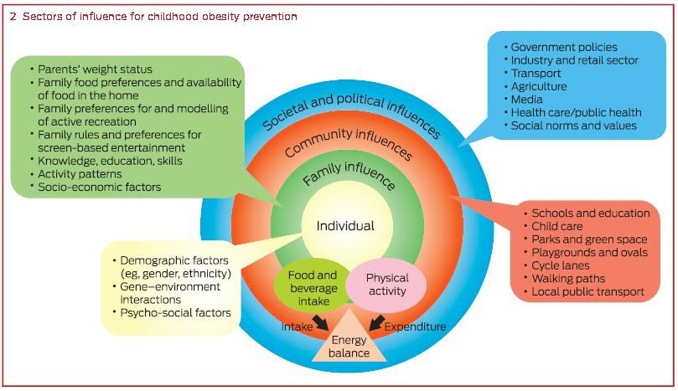

Mihrshahi, Gow & Baur. MJA 2018.

**Most of these sectors of influence lie beyond the** **capacity of the family or health sector to control**

Mihrshahi, Gow & Baur. MJA 2018.

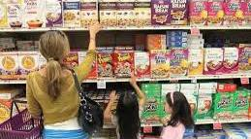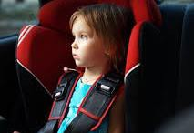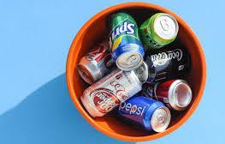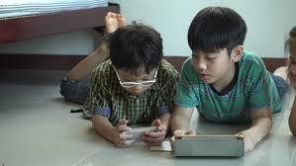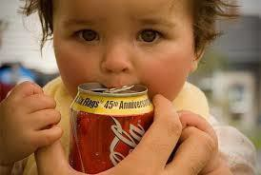

**The world in which young** **children live**

**How do we tackle these** **influences?**



# Obesity prevention in the first 2000 days

#### Specific interventions should be rolled out in:

* + - **antenatal period**
    - **0-****2 year period**
    - **preschool age group**

#### Must have cultural

**adaptation**

#### Must have co- production

* **How do we tackle the** **upstream drivers (outer** **sectors of influence)** **that are also at play?**
  + **Regulation of food** **marketing**
  + **Strategies to decrease** **sugar sweetened** **beverage consumption**
  + **Other influences….**



**Acknowledgements**

* **The Children’s Hospital at** **Westmead: Weight Management**
* **NHMRC EPOCH CRE members**
* **WHO ECHO Commission Working Gp**

**Services, Instit. of Endocrinology,**• **World Obesity Federation staff**

**Obesity Research Group**

* **Shirley Alexander, Adrian** **Bauman, Karen Campbell, Ian** **Caterson, Chris Cowell,** **Michelle** **Cretikos,** **Sarah Garnett, Tim Gill,** **Seema Mihrshahi, Chris Rissel,** **Kate Steinbeck, Len Storlien,** **Melissa Wake,** **Li Ming Wen,** **…**
* **University of Sydney: Prevention** **Research Collaboration, Boden** **Institute, Charles Perkins Centre**
* **NSW Ministry of Health staff**
* **Funders: NHMRC, ARC, Heart** **Foundation of Australia, Diabetes** **Australia Research Trust, Rotary** **Foundation, SU Medical Foundation,** **Financial Markets Foundation for** **Children, NSW Health …**

**Thank you!**



**[www.earlychildhoodobesity](http://www.earlychildhoodobesity.com/)****[.com](http://www.earlychildhoodobesity.com/)**