



The Future of Pharmacotherapy

for Obesity

Joe Proietto

Professor Emeritus University of Melbourne Head, Weight Control Clinic Austin Health

Chair, Clinical Care Committee World Obesity [j.proietto@unimelb.edu.au](mailto:j.proietto@unimelb.edu.au)



Disclosure

# JP was Chair of the Medical Advisory Board for Liraglutide 3 mg (Saxenda) in Australia for Novo Nordisk. He has also given lectures on management of obesity for iNova marketers of phentermine (Duromine) and naltraxone plus bupropion (Contrave).



**Why is pharmacotherapy necessary in** **the management of obesity?**

5



Very-low-calorie diet

Modified diet plus behaviour therapy

Very-low-calorie diet plus behaviour therapy

0

Weight change (kg)

-5

-10

-15

-20

intervention 1

2 3 4 5

Years after intervention



**Diet and behavioural intervention**



**Why do diets nearly always fail?**



**Why do diets nearly always fail?** **(and why have we failed to stem the** **obesity epidemic?)**



Regulation of body weight

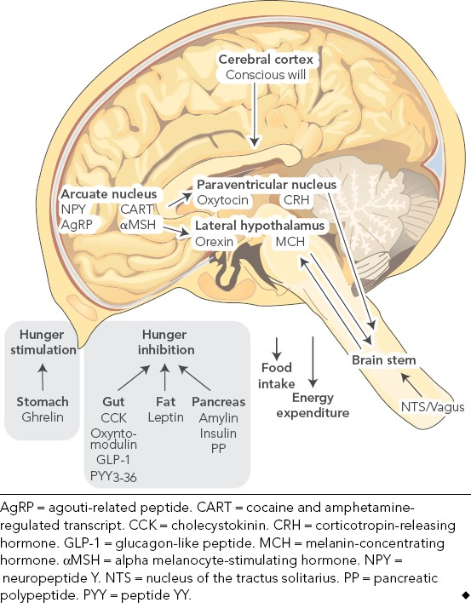**Diagram of the central** **regulation of body** **weight (from Proietto J.** **MJA 195:144-****146 2011)**



Changes in leptin levels with dieting

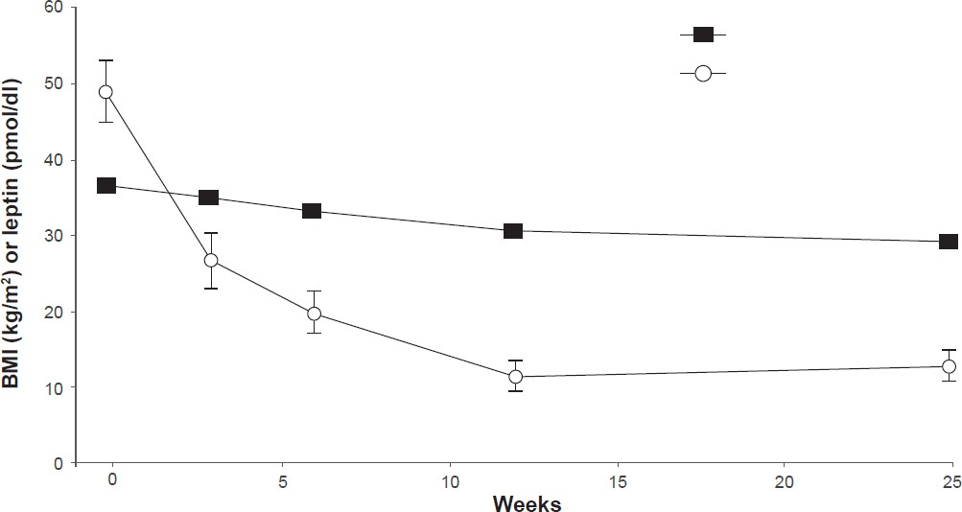

BMI

Leptin

Geldszus R et al. *Eur J Endocrinol*1996;135:659–62.



Ghrelin levels after diet-induced weight loss

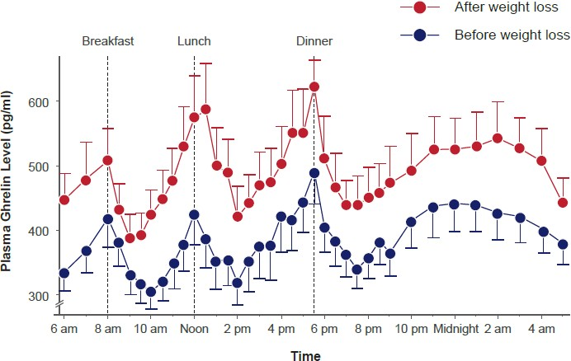

Cummings DE et al. *N Engl J Med*2002; 346:1623–30.



Body weight is defended

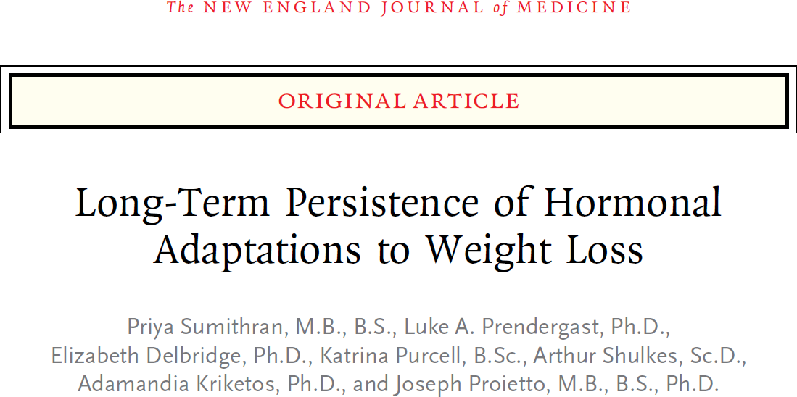

Sumithran P et al. *N. Engl J Med* 2011;365:1597–604.

Weight Leptin

*

*

95

*

90

Weight (kg)

85

80

0

0 8 10 18 26 36 44 52 62

Week

VLCD Follow-up

100

90



All patients (ITT)

*

*

*

Completers

% Fasting leptin compared to baseline

80

70

60

50

40

30

10 62

Week

VLCD Follow-up



Mean change in body weight and leptin levels from baseline to Week 62

*P<0.001 vs baseline (Week 0). Data presented are mean ± standard error of the mean.

VLCD = low energy dietary formulation (Optifast VLCD, Nestlé) and 2 cups of low-starch vegetables (500 to 550 kcal/day). ITT, intention-to-treat; VLCD, very low-calorie diet.

**Ghrelin**

Week 0 Week 10 Week 62

**PYY**

200



Ghrelin (pg/ml)

PYY (pg/ml)

60

100

0

0 30 60 120 180 240

Postprandial time (min)

**Amylin**

20

0

0 30 60 120 180 240

Postprandial time (min)

**Cholecystokinin**

200

Amylin (pg/ml)

100

0



0 30 60 120 180 240

Postprandial time (min)

4

3



CCK (fmol/ml)

2

1

0

0 30 60 120 180 240

Postprandial time (min)

Data presented are mean ± standard error of the mean. PYY, peptide YY.



Mean fasting and postprandial levels of ghrelin, peptide YY, amylin, and cholecystokinin

Week 0 Week 10 Week 62

**Hunger** **Desire to eat**

50



40

Hunger (mm)

30

20

10

0

0 30 60 120 180 240

Postprandial time (min)

50

40



Desire to eat (mm)

30

20

10

0

0 30 60 120 180 240

Postprandial time (min)



Fasting and postprandial ratings of hunger and desire to eat

Data presented are mean ± standard error of the mean.





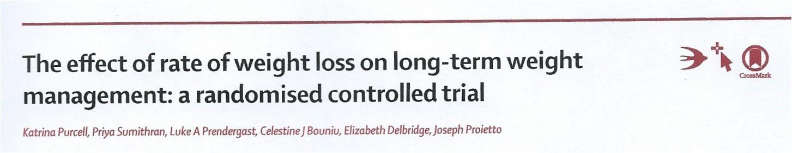

*The Lancet Diabetes and Endocrinol* *2: 954**-62 2014*



**Results**

* Mean weight change (% change, 95% CI) during phase 2 for study

completers

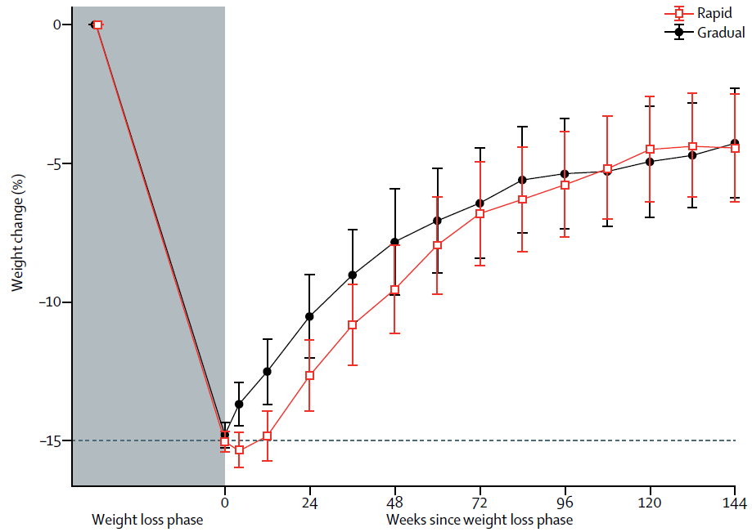

Gradual WL group regained 71.2%

Rapid WL

group regained 70.5%

*n=61 in rapid weight loss and n=43 in gradual weight loss group





Hormone changes at 3 year follow-up

* Despite the fact that most of the weight had been regained,
* Ghrelin was still 10% higher than at baseline 3 years after

weight loss and

* Leptin was still lower in the 25 % of individuals maitaining

the most weight loss off.

16





The defence of body weight also involves changes in energy expenditure



Changes in energy expenditure associated with weight change



Leibel et al. *N Engl J Med*1995;332:621–8

600

Return to

initial weight

10%

weight loss

20%

weight loss

Initial weight

10%

gain

Observed - predicted EE (kcal/day)

500

400

300

200

100

0

-100

-200

-300

-400

Mean (± standard deviation) observed-minus-predicted total energy expenditure based on the regression of total energy expenditure in a model with a variable combining fat-free mass and fat mass in the same subjects at their initial weight.

EE, energy expenditure.





Total (TEE), Resting (REE) and non-resting (NREE) Energy Expenditure

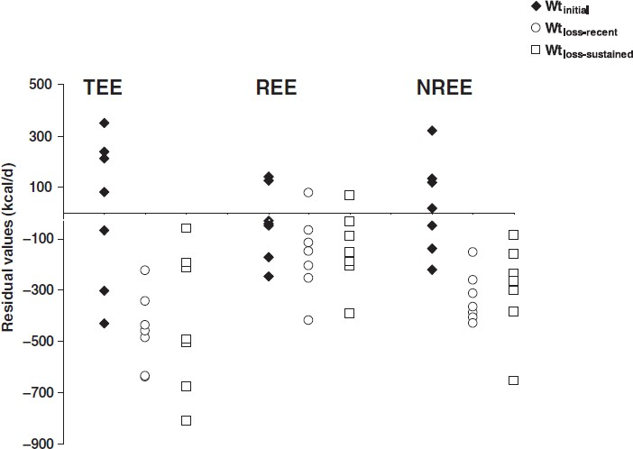

Rosenbaum M. et al. **Long-****term persistence of adaptive thermoge****nesis in subjects who have maintained a** **reduced body weight.***Am J Clin* *Nutr*2008 88:906-12

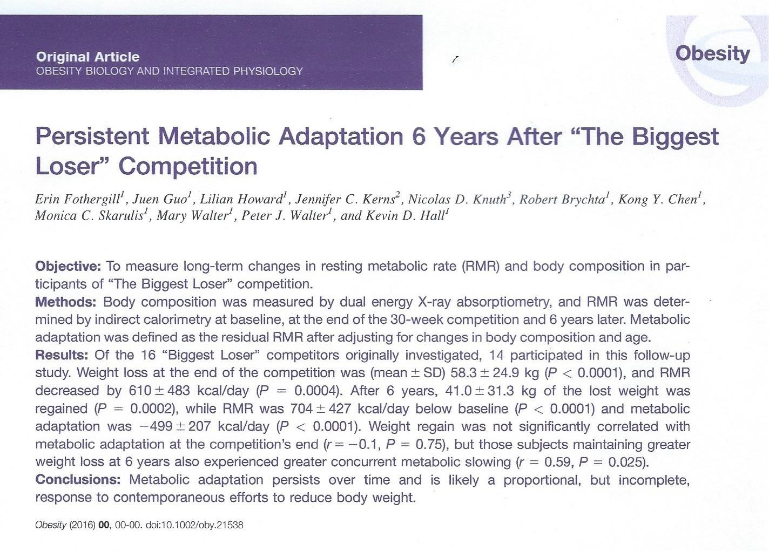

Obesity 24: 1612-1619 2016



**Leptin Levels**

|  |  |  |  |
| --- | --- | --- | --- |
|  | **Baseline** | **End of** **weight loss** **30 weeks** | **6 years after** **weight loss** |
| Leptin (ng/ml) | 41.1 ± 16.9 | 2.6 ± 2.2* | 27 .7 ± 17.5*#+ |

* P < 0.001 compared to baseline

# p = 0.013 compared to baseline

+ p < 0.001 compared to 30 weeks



What strategies should we adopt to help our patients to maintain weight loss  long term?



Lifestyle advice

* Healthy eating
* Regular Exercise
* Measure weight once weekly in the morning with an

empty bladder

* When there is 2 kg or weight regain, restart the intense

diet and continue it until they have lost the 2 kg.



Pharmacotherapy for obesity*

# Phentermine

1. [Topiramate]
2. Phentermine 7.5 or 15mg/ topiramate 50 or 100 mg combination

# Orlistat

1. **Liraglutide 3.0 mg**
2. Lorcaserin

# Naltraxone plus bupropion

* Each of these drug or drug combinations have been approved for use in different parts of the World



Medications under investigation

The following medications are under investigation, none have so far been approved for weight management:

* Semaglutide
* Amylin (pramlintide)
* Leptin (Metreleptin)
* Amylin/Leptin combination
* Beloranib
* Combination of gut hormones



Combination of hormones

Tan T et al. **The effect of a** **subcutaneous infusion of GLP- 1, OXM, and PYY** **on energy intake and expenditure in** **obese volunteers***J* *Clin* *Endocrinol* *and* *Metab*102: 2364- 2372 2017



Aim

The aim of this study was to investigate the effect of a continuous infusion of GLP-1, OXM, and PYY (GOP) on energy intake and expenditure in obese volunteers.



Methods

Obese volunteers were randomized to receive an infusion of GOP or placebo in a single-blinded, randomized, placebo- controlled crossover study for 10.5 hours a day.

This was delivered subcutaneously using a pump device, allowing volunteers to remain ambulatory. *Ad libitum*food intake studies were performed during the infusion, and energy expenditure was measured using a ventilated hood calorimeter.



Results

Postprandial levels of GLP-1, OXM, and PYY seen post RYGB were successfully matched using 4 pmol/kg/min, 4 pmol/kg/min, and 0.4 pmol/kg/min, respectively.

This dose led to a mean reduction of 32% in food intake. No significant effects on resting energy expenditure were observed.





Major Points about Weight loss medications:

* Nature combines nine gut and pancreatic hormones and several nutrients to suppress hunger so, it is better to use multiple drugs at their lowest doses to control hunger rather than just one drug at a high dose.
* Because weight is predominantly genetic, the hormonal and energy expenditure changes that occur after weight loss, designed to return the weight to its set point, are long lasting. It follows that drug use has to be long term (life-long).