New Technologies, Weight Management and Good Health:

Opportunities and Risks

Deborah Lupton Centre for Social Research in

Health/Social Policy Research Centre

Faculty of Arts & Social Sciences

UNSW Sydney

# Facebook

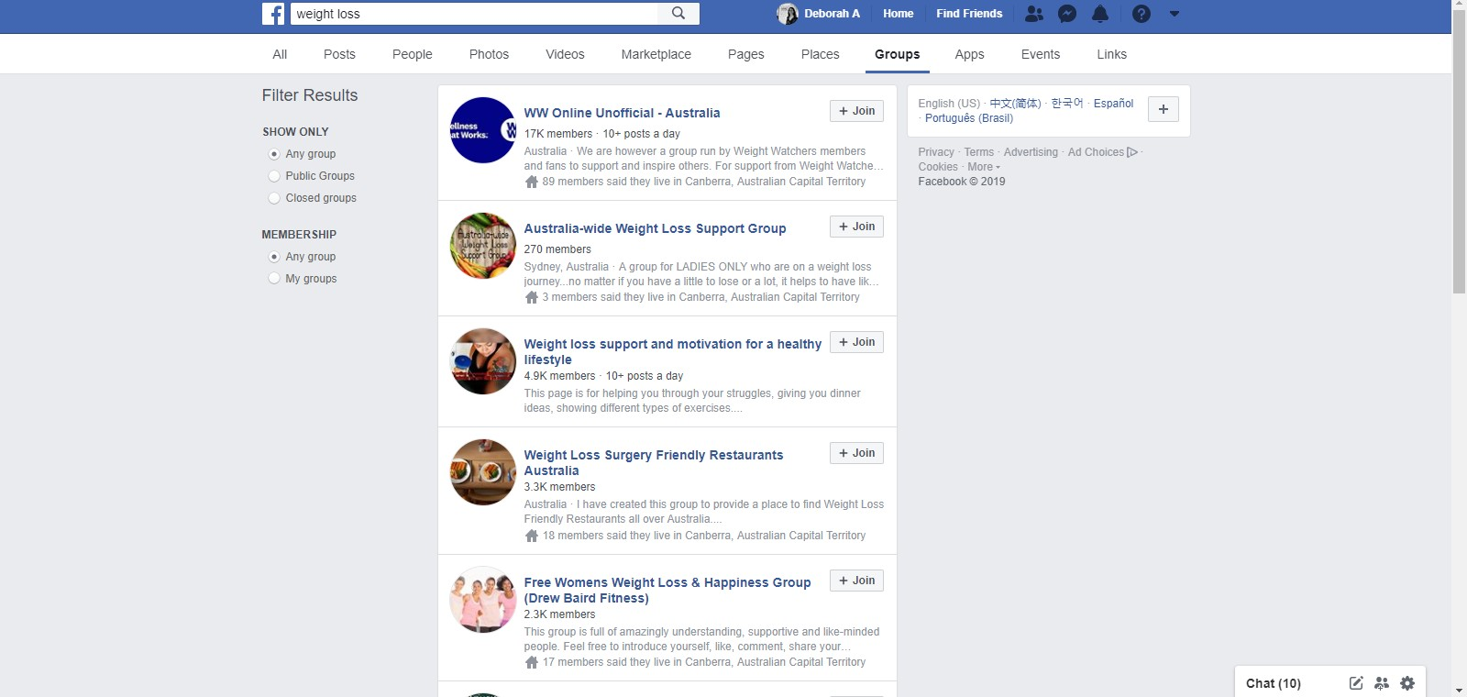

**Instagram**

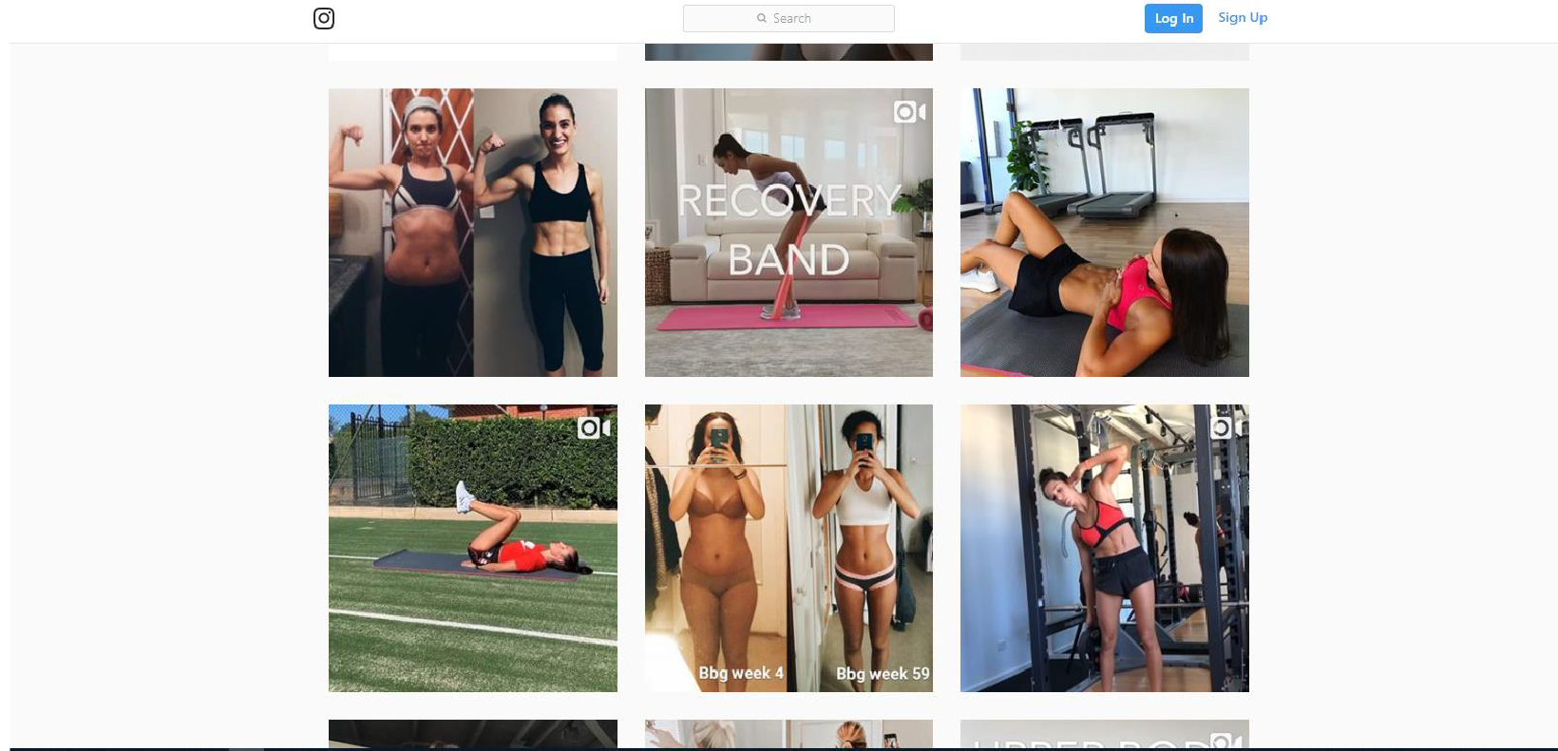

## Pinterest

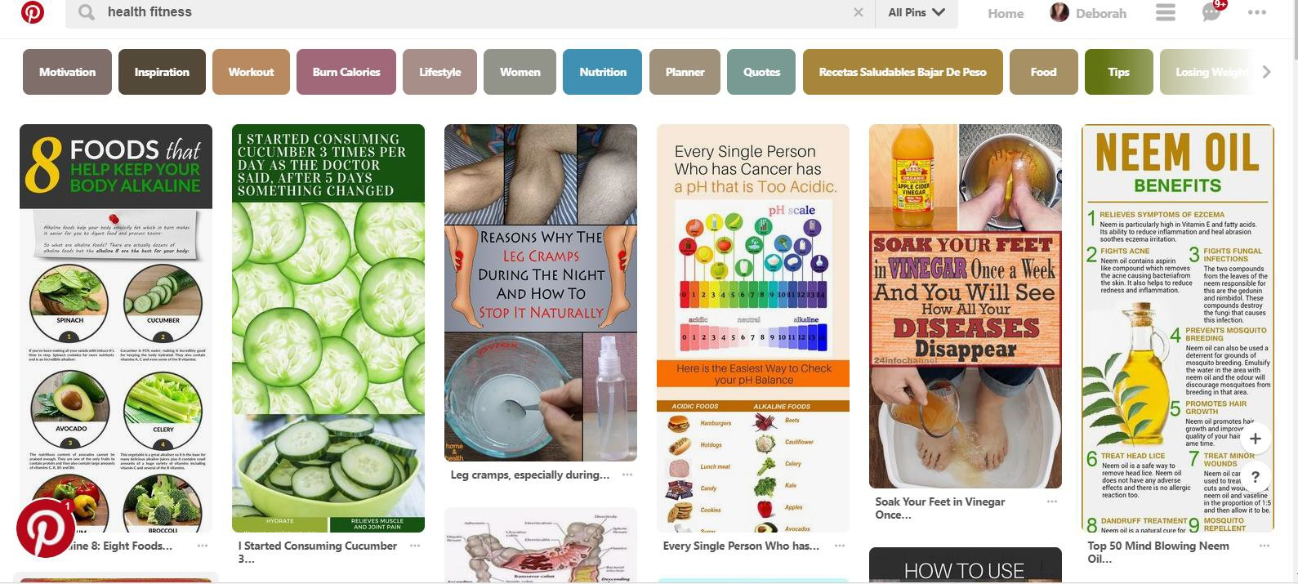

**Twitter**

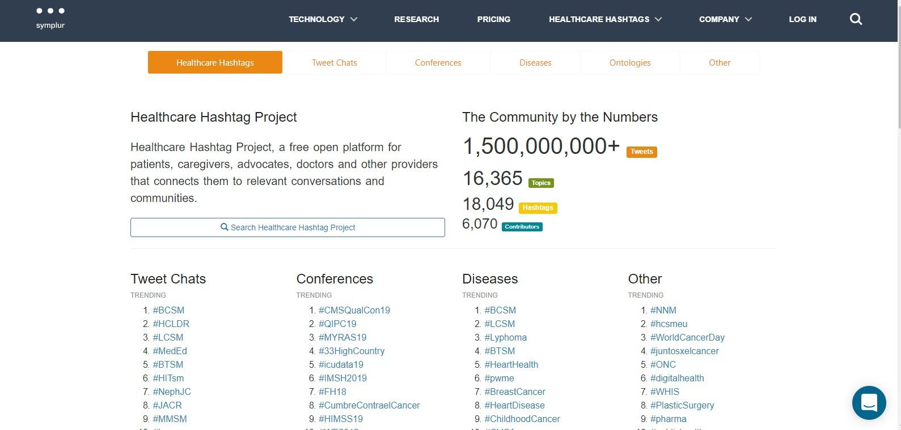

##### The influencers of #Obesity

Top **10** by Mentions Top 10 by Tweets

##### Latest Tweets

**@AlhassanAlnaamy 6 minutes ago**

RT @AlhassanAlnaamy '-'--oJI ..,.I.,,.J,u l:il...l ..,....,iI .:,. 11 IJ.iful' -'!"1.,.

II @TheLancel 1.469 @info_obesity 66

05400: **0** d.

•

_;_,,..,.ll ½>LI'd ..,...,...i J.a.]I ,,, ,,i J!Lu.,.ll .. +. ._.

**m** @Wo r1d0 bes i ty 366 @Za herToum I 65

i;: @a uckland uni 213 @ @We ightNoMo reDC 63

@GWpu blichealth 185 @obs muk 45

@OriginateHea lth 174 @Ne IIFloc hMD 40

@shelleypetersen 168 @D rPat ric iaMD 35

@S Ba rque ra 151 @lose_we1g h l 14 25

@Boy d Swi nburn 92 @H LBSu rgery 22

•

@coc acola 82 @p attyne ce 21

@CDCgov 76 @R nyreno 21

**@Laurettamylove 1 2 minutesago**

*(* RT @ H olistIc TIps 4U: Curious about #IntermittentFasting #lowc arb lifestyle? • FREE 30 minute interview on how two #Boomer gals reversed t " t.+ •

**@indiepub1 21 mmutes ago**

Consider #Ketogenic Diets for HOLY GRA IL OF #WEIGHT loss #obesity #Fitness #honesly hour #techhumor , #spbspalliance, #riddirnvybzk24, #my bb, #anc107, #pentagon, #lruefo rallmore4u,

https:/11.co /Ov hzeulvc q https:/l t.co/R7WiH4zRzm **"t. •**

**@pharmerfour 24 minutesago**

RT @KIdneyHealth: Large study reveals the impact of #obes ity on a person's kidneys **with** people **with** the m ost seve re obes ity being **twice as**

**+-.t..••**

**@ladykatrina3 35 mmutes ago**

RT @ D r N in a Ra dcliff So me strategies lo losing weight Dr Nina Radcliff I Co lu m ns I h ttps:ll t.co/DqiM5od Hto #weight #weightloss

**am am**

**lm:lm** Ge t true influencer lists ranked by the Symplu rRank

**Dt:**

#obes ity #h .. +. ._..

**@KidneyHealth** 36 minutes ago

Large study reveals the impact of #obes ity on a person's kidneys w i t h peop l e w it h t h e most severe obesity being twice as likely to

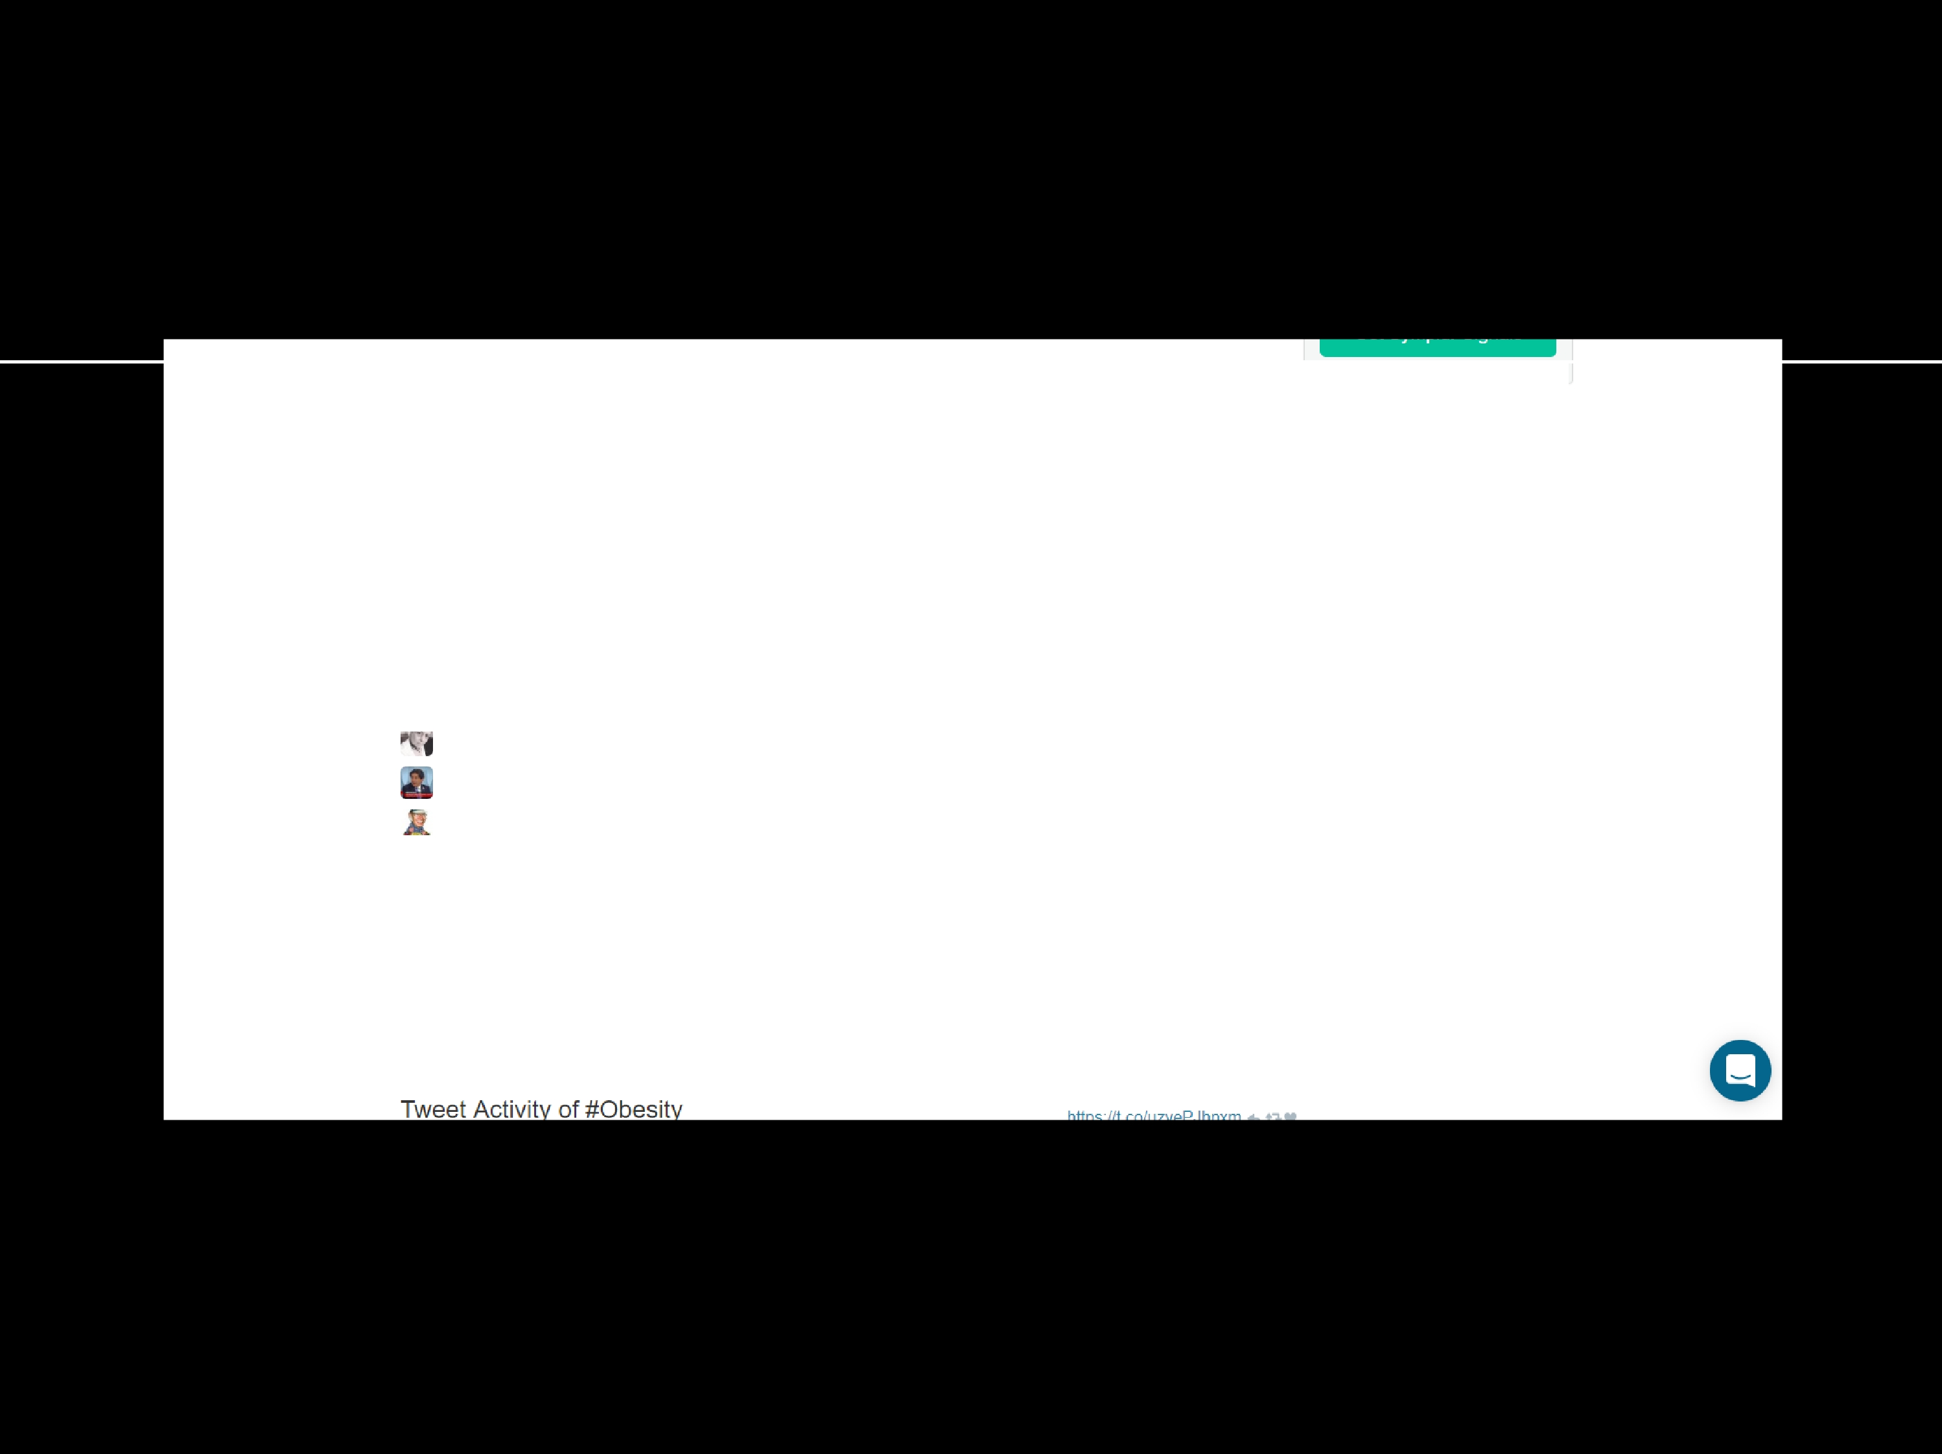**;;::r** deve l op i m pa i red #kidney funct on Reduce your risk of

#k idn ey disease, learn the risk factors: https://l co/sdctlgXDjt

# YouTube

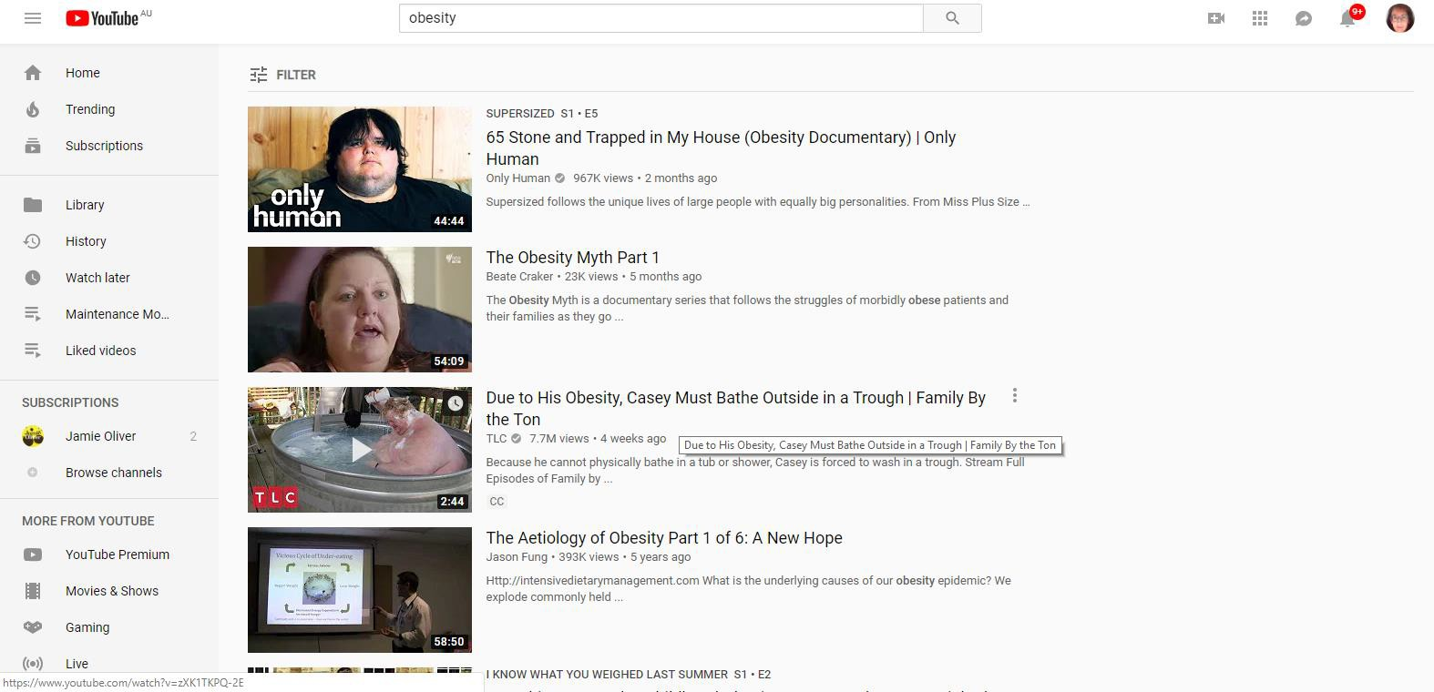

### Patient support platforms

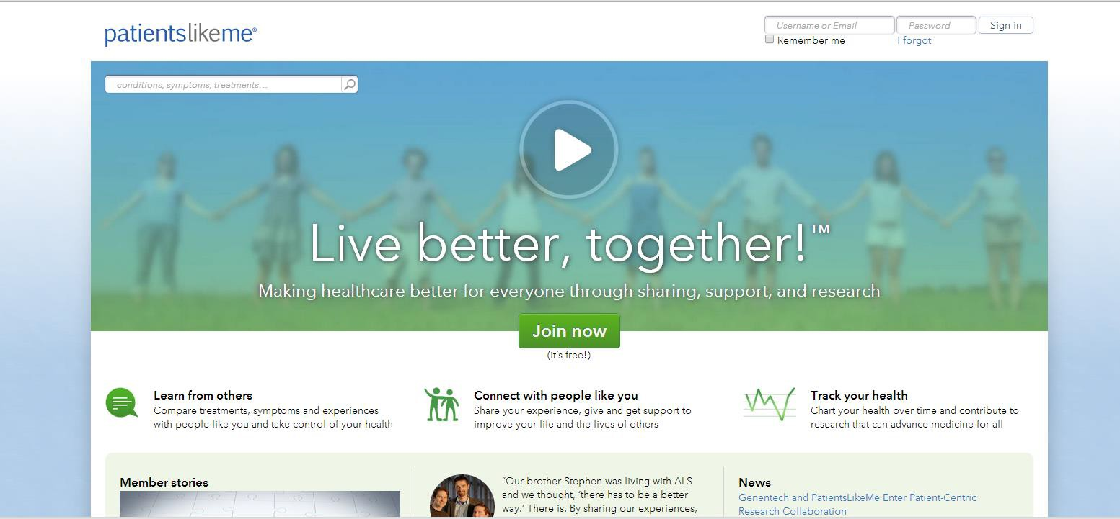

**Health and medical apps**

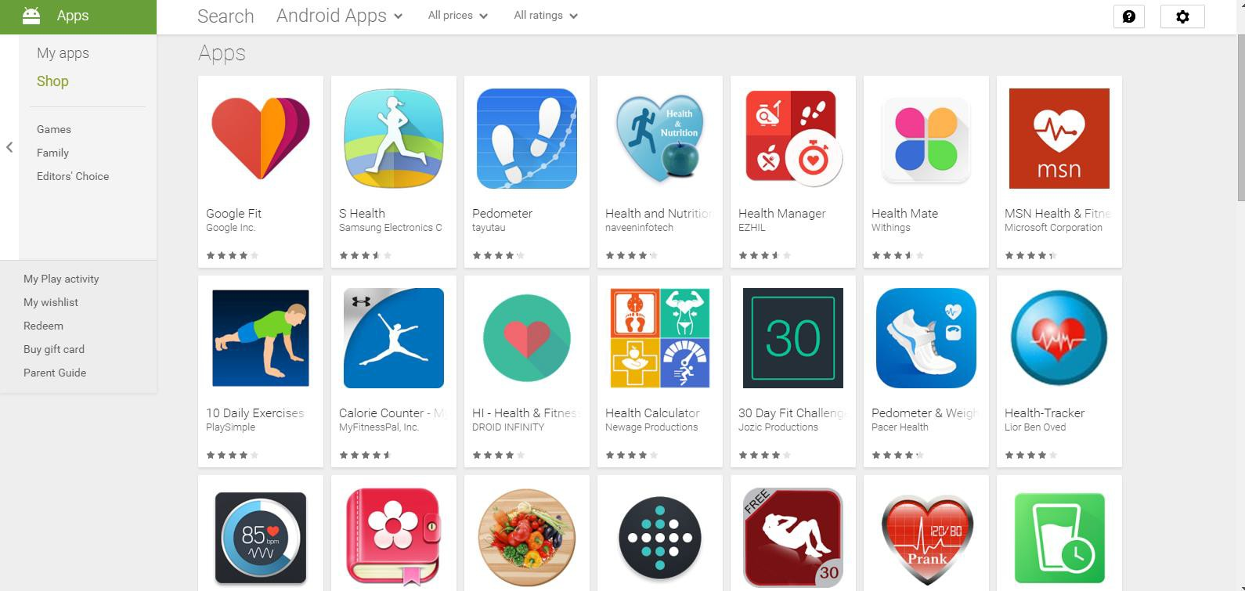

**Wearable devices**

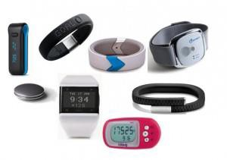

### smartwatches

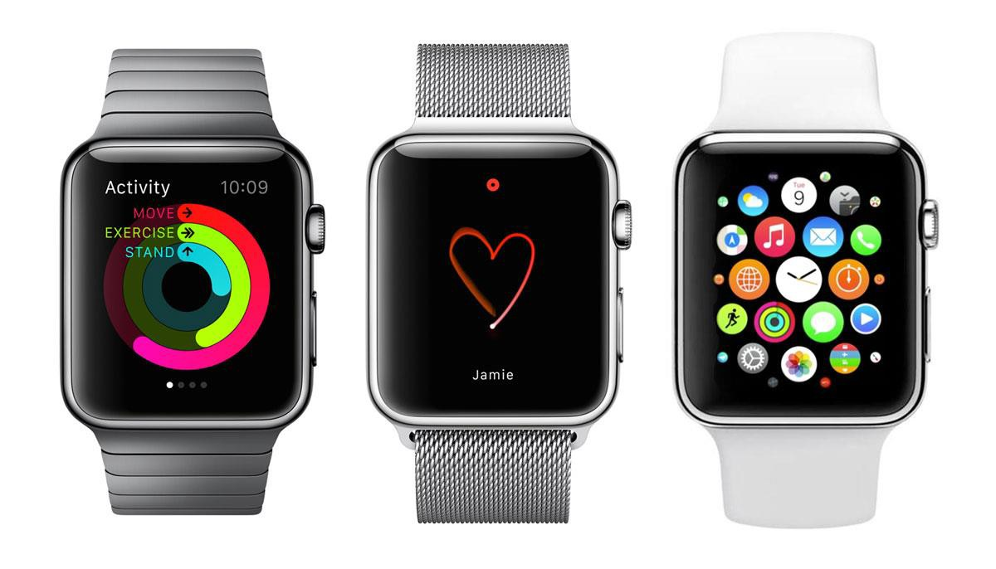

PROJECTS

1. Self-tracking cyclists (interviews and GoPro videos)
2. People who self-track for any purpose (interviews)
3. Women’s use of digital health (interviews and focus groups)
4. Young people’s use of digital health (interviews)
5. Sources of health information (story completion)

BENEFITS OF DIGITAL

* finding information instantly
* feeling more in control
* improving health and wellbeing
* fewer doctor visits
* feeling motivated
* social connections to others
* feeling less alone

#### RISKS/BARRIERS OF DIGITAL

* information overload
* digital inequalities
* poor design of devices/software
* personal data privacy and security
* loss of face-to-face support/expertise
* over-reliance on self-help and self- responsibility
* victim-blaming
* loss of focus on social determinants of health and social justice issues

**Story completion method**

Isabelle wants to improve her health and fitness but doesn't know how to go about this.

*What happens next? (Please write four or more sentences in the box provided below to finish this story.)*

**Word cloud – Isabelle’s story**

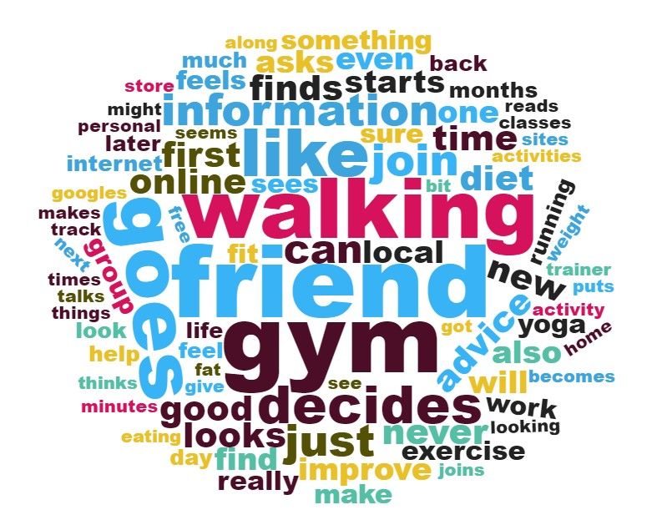

**Sketchnoting Isabelle’s story**

