

# Obesity and Chronic Conditions Professor Andrew Wilson

Ministerial Obesity Summit Canberra 2019

Line

LineOur Partners



Prevalence of chronic conditions in adults, by weight status, 2014–15

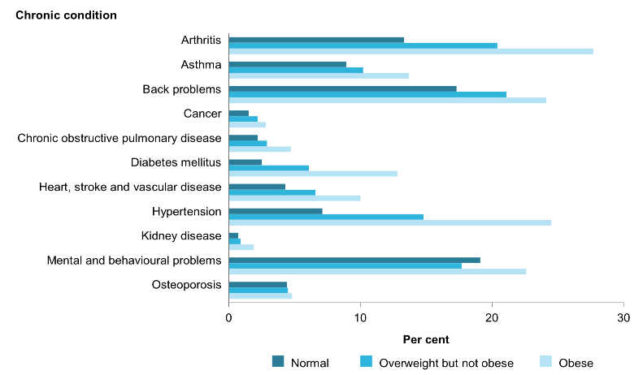

LineSource: AIHW 2018.Canberra.

## LineThe Australian Prevention Partnership Centre logoBurden attributable to overweight and obesity, by age and sex, 2011

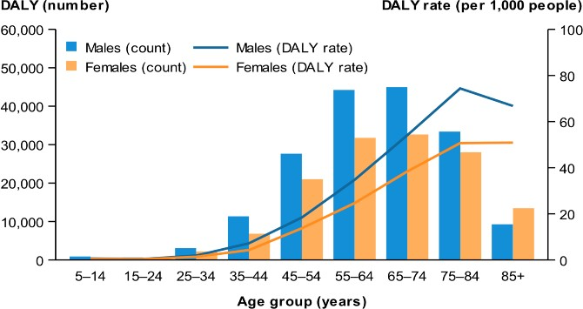

Source: AIHW analysis of burden of disease database, 2011.

DALY per 1,000 people for the top six diseases linked to overweight/obesity, 2003 and 2011

Source: AIHW 2017. Impact of overweight and obesity as a risk factor for chronic conditions: Australian Burden of Disease Study. Canberra: AIHW.

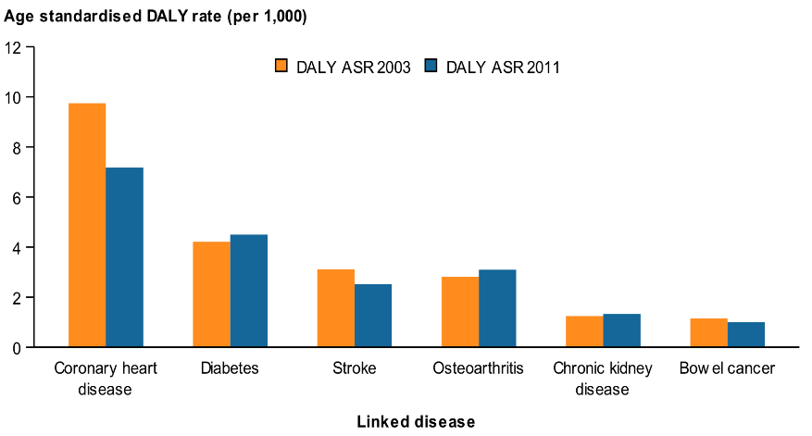

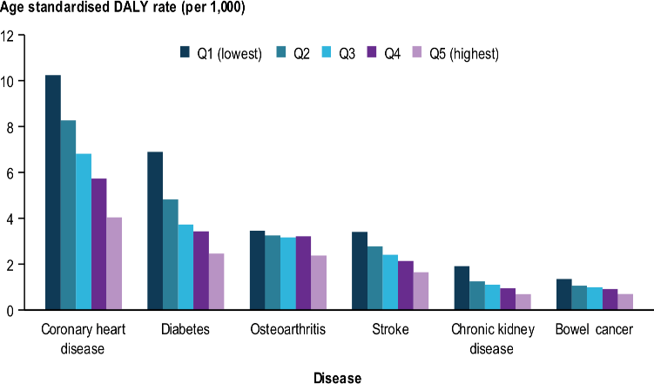Disability-adjusted life years due to overweight and obesity, by selected diseases and socioeconomic group, 2011

LineNote: Rates per 1000 people age-standardised to the 2001 Australian standard population.  Source: AIHW 2017a; Table S16.

Figure 4.4.2: Graphical representation of the overlap between selected risk factors for chronic disease, people aged 18 and over, 2011–12

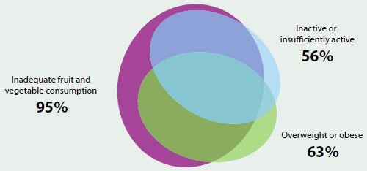

Source: AIHW. Australia’s Health 2016.

## Complex relationship of obesity and chronic conditions

### **Osteoarthritis**

* + Obesity strongly causally related to osteoarthritis
  + Obesity increases symptomatology
  + Loss of mobility associated with osteoarthritis can worsen weight gain (and limit weight loss)

### **Depression**

* + Depression is a risk factor for depression
  + People with obesity more likely to develop depression
  + Some mediations used in treatment of mental illness lead to weight gain

### The Australian Prevention Partnership Centre logo**Sleep**

* + Obesity is a risk factor for sleep apneoa
  + LinePoor sleep can increase of obesity

## Complex systems and wicked problems

* **Obesity prevention and control is a complex problem.**
* **No easy fix, no one strategy.**
* **Likely to be lots of “failures”, need to learn from failures as well successes.**
* **Need systematic and systemic approaches.**
* **Need persistence – how do we institutionalise ongoing action?**
* **Need to assess and minimise the potential for harm along the way.**

## Controlling overweight and obesity

### Prevent early weight gain – healthy environment

* Identify and intervene early

### Treat

* + Primary care – overweight and early obesity
  + Specialty care – obesity

### Manage relapses

Address social determinants Address system nihilism



LineAddress health care system preparedness

## Obesity and the health care system

### **Barriers in health care system for obesity common to chronic diseases particularly:**

* + Poor coordination of services
  + Poor resourcing for core capacities particularly in community settings
  + Lack of management accountability
  + Low managerial priority
  + Lack of funding mechanisms for multi-disciplinary care.

### **Additionally health care system issues for obesity include:**

* + Victim blaming
  + Therapeutic nihilism – ‘nothing works’
  + Normalisation of overweight – staff and patients have the problem
  + Responsibility not held by any one clinical profession
  + LineConcerns about stigmatizing through identification.

## LineAddressing obesity in health care: A systems approach

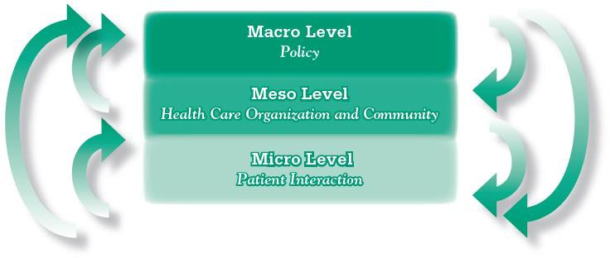

Source: WHO, 2002.



## Weight loss surgery in Australia, 2014–15

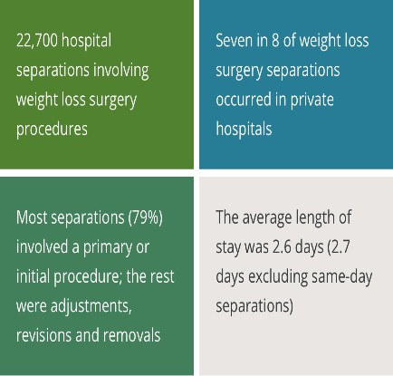

LineSource: AIHW 2017. Weight loss surgery in Australia 2014–15: Australian hospital statistics. Canberra: AIHW.

* Around 18,000 of weight loss surgery separations, or 79%, were for female patients.
* From 2005–06 to 2014–15, the total number of weight loss surgery separations more than doubled, from about 9,300 to 22,700.
* Major growth in non-surgical procedures for obesity.

# In conclusion

### Overweight/Obesity in combination with inappropriate nutrition and low physical activity is a major risk factor for many chronic conditions.

* + The relationship is complex.

### The health care system is not well set up for managing either obesity or chronic conditions.

* + A strategic response to overweight and obesity

### must recognize important role of health care.

* + LineThere will need to be system changes for the health care system to respond effectively and efficiently.