### Physical activity/sport and mental health benefits – confident and resilient kids

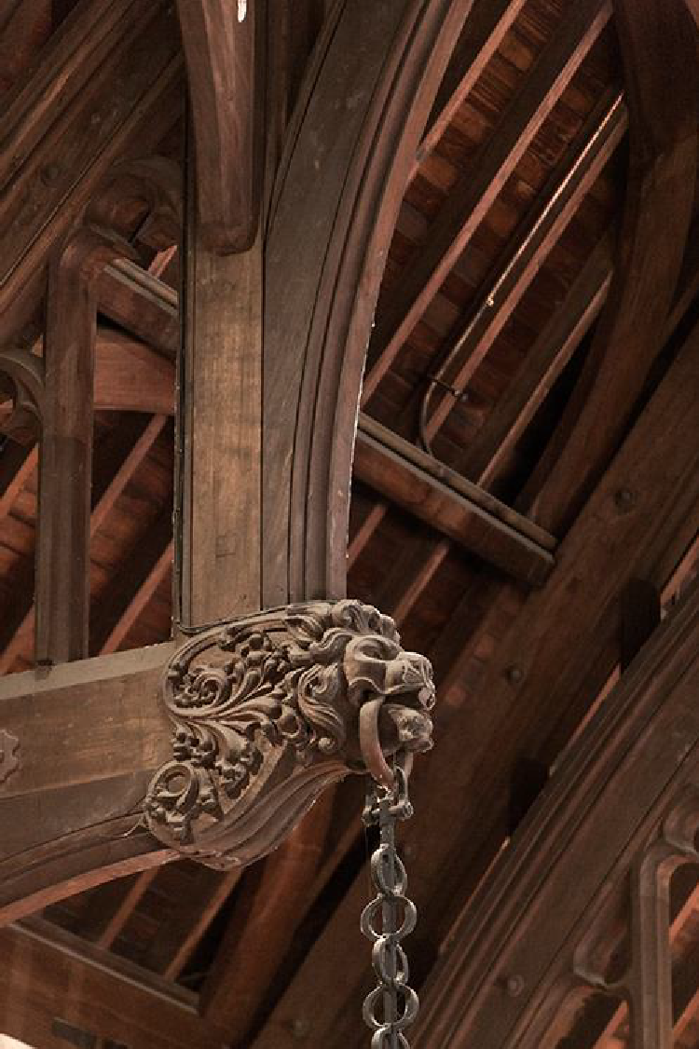

Adrian Bauman

School of Public Health and Charles Perkins Centre

SYDNEY UNIVERSITY AUSTRALIA

**A broader introduction** **to physical activity in** **Australia and its role in** **obesity prevention**

### But first – a definition

#### What is ‘physical activity’

* 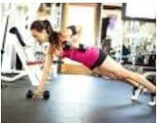‘exercise’

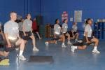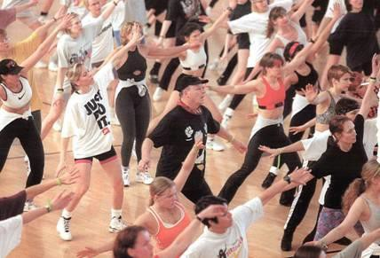

* 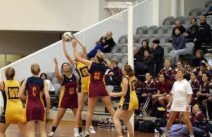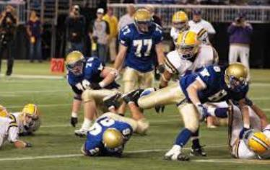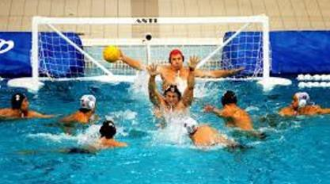Sport
* Physical activity

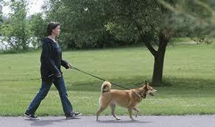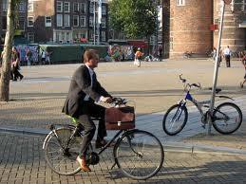

2

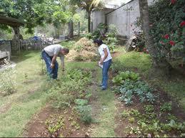

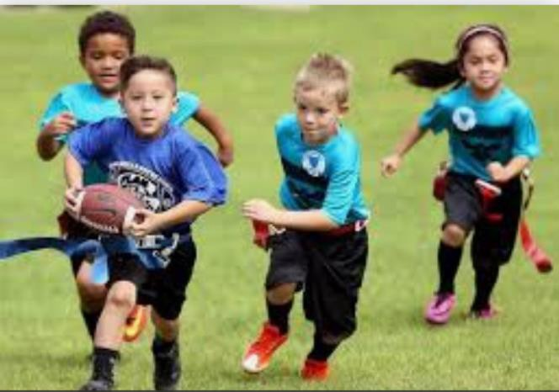What is children’s PA?

* Structured – **Sport**and PE: rules; may need location/equipment; training, skills development

#### Un-structured (non- organised) – free PLAY!

* 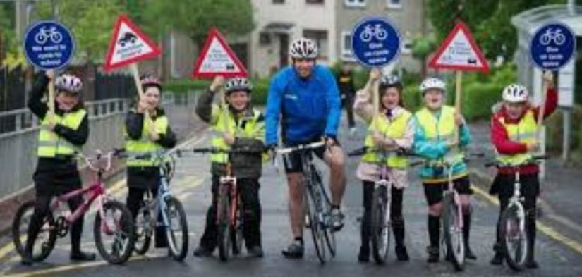Active transport (walking, cycling, scooting etc.) to get to places

#### THE NEW WHO GLOBAL ACTION PLAN

ON PHYSICAL ACTIVITY 2018 – 2030

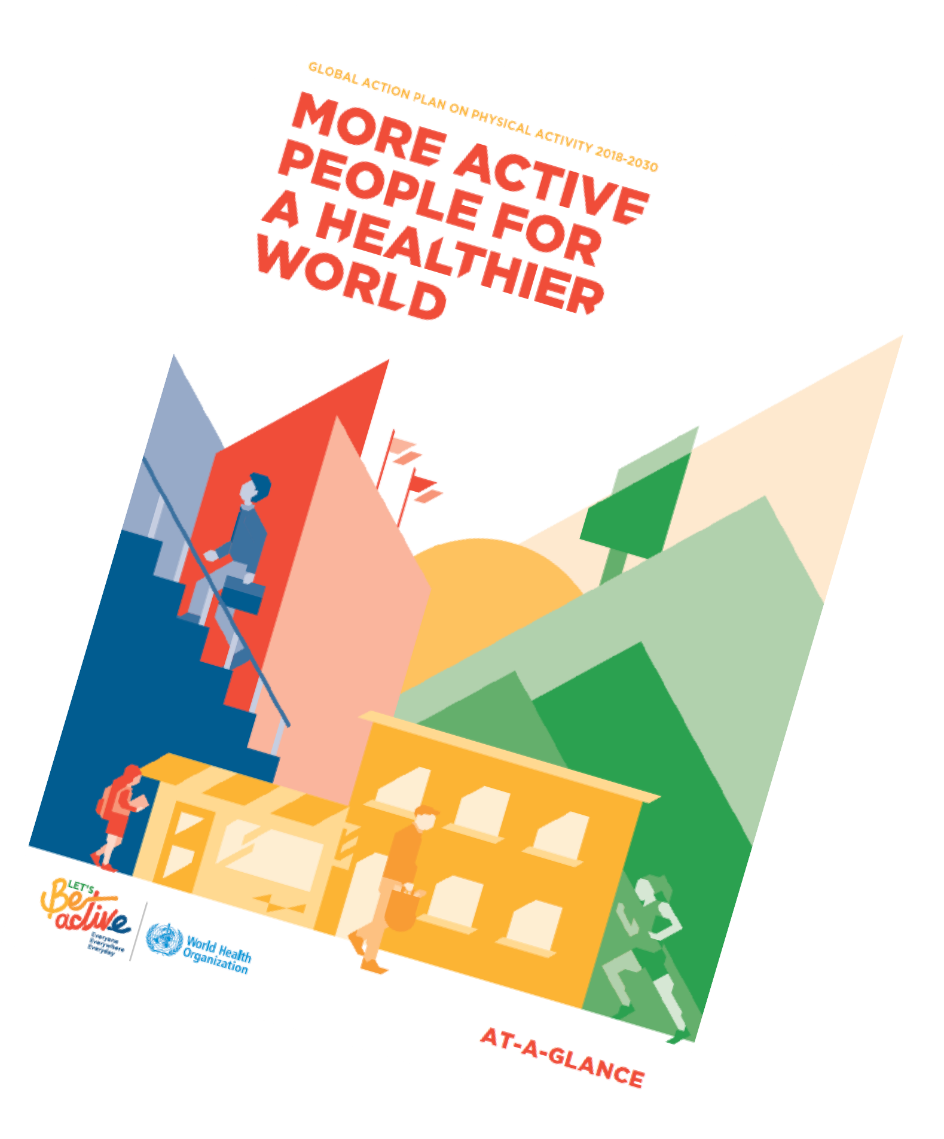

#GAPPA

#BEACTIVE

GLOBAL ACTION PLAN ON PHYSICAL ACTIVITY 2018-2030

**MOREACTIVE PEOPLE FOR A HEALTHIER WORLD**



* Everyone
* EverywherEveryday
* •

"!iJ.'

-Jr

WorId Heal th



organization **A T-A-GLANCE**



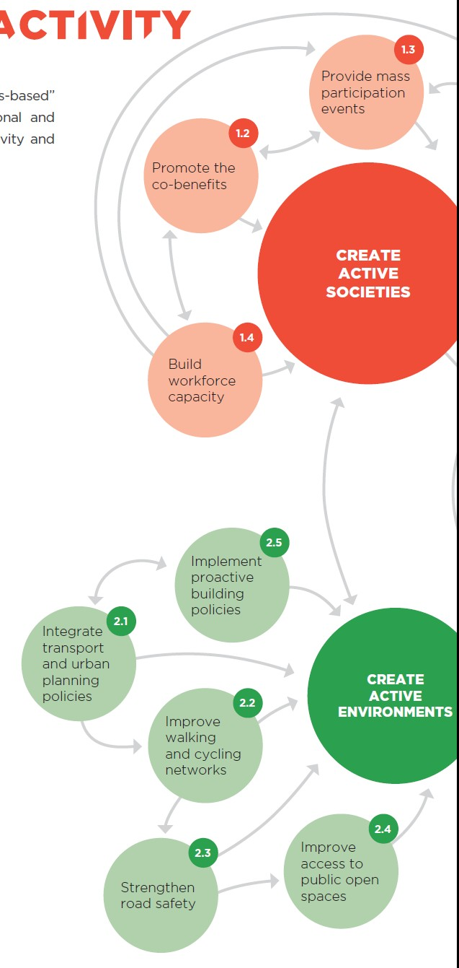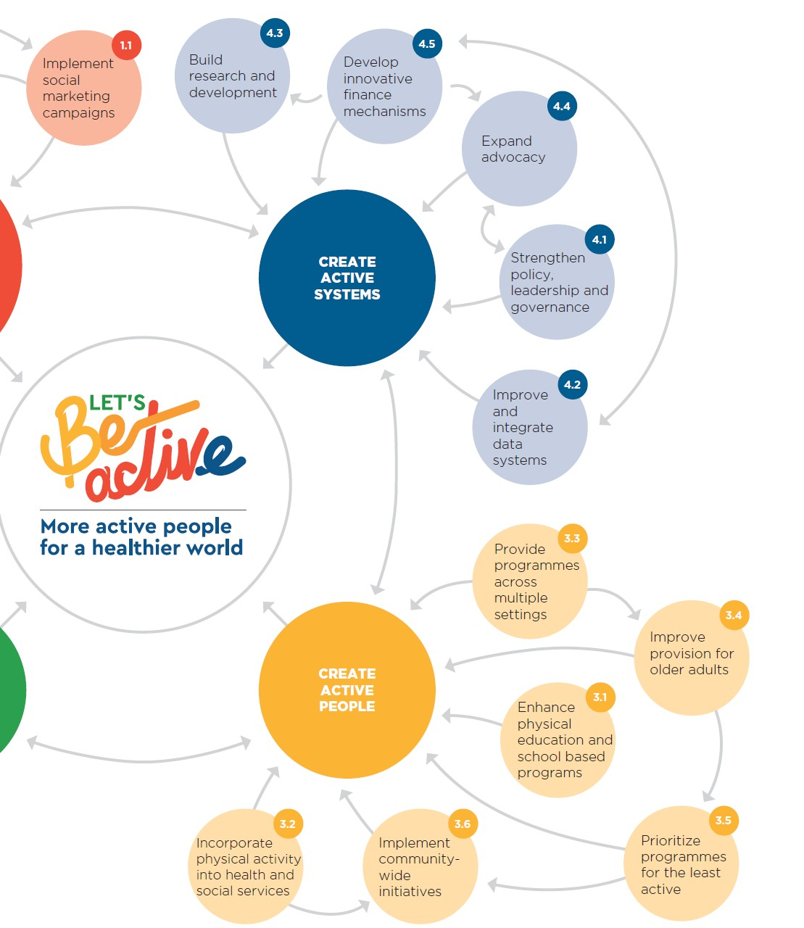

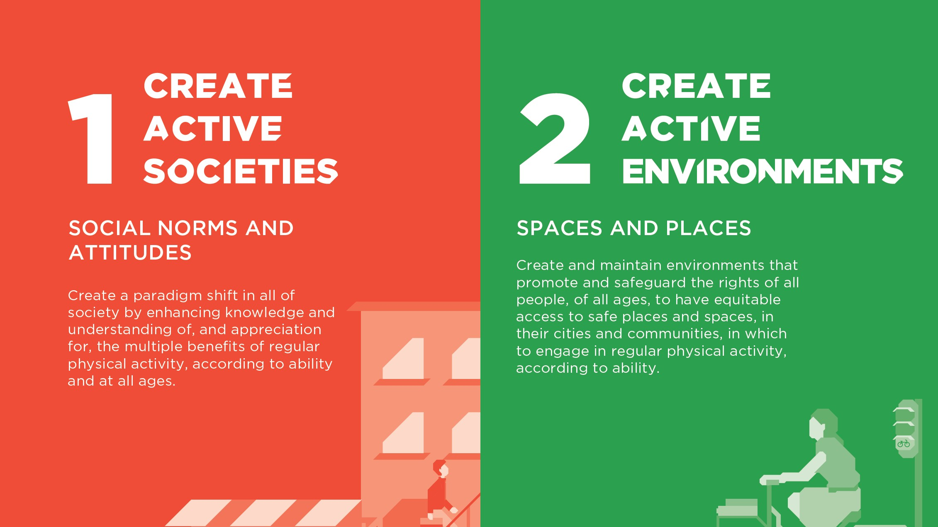

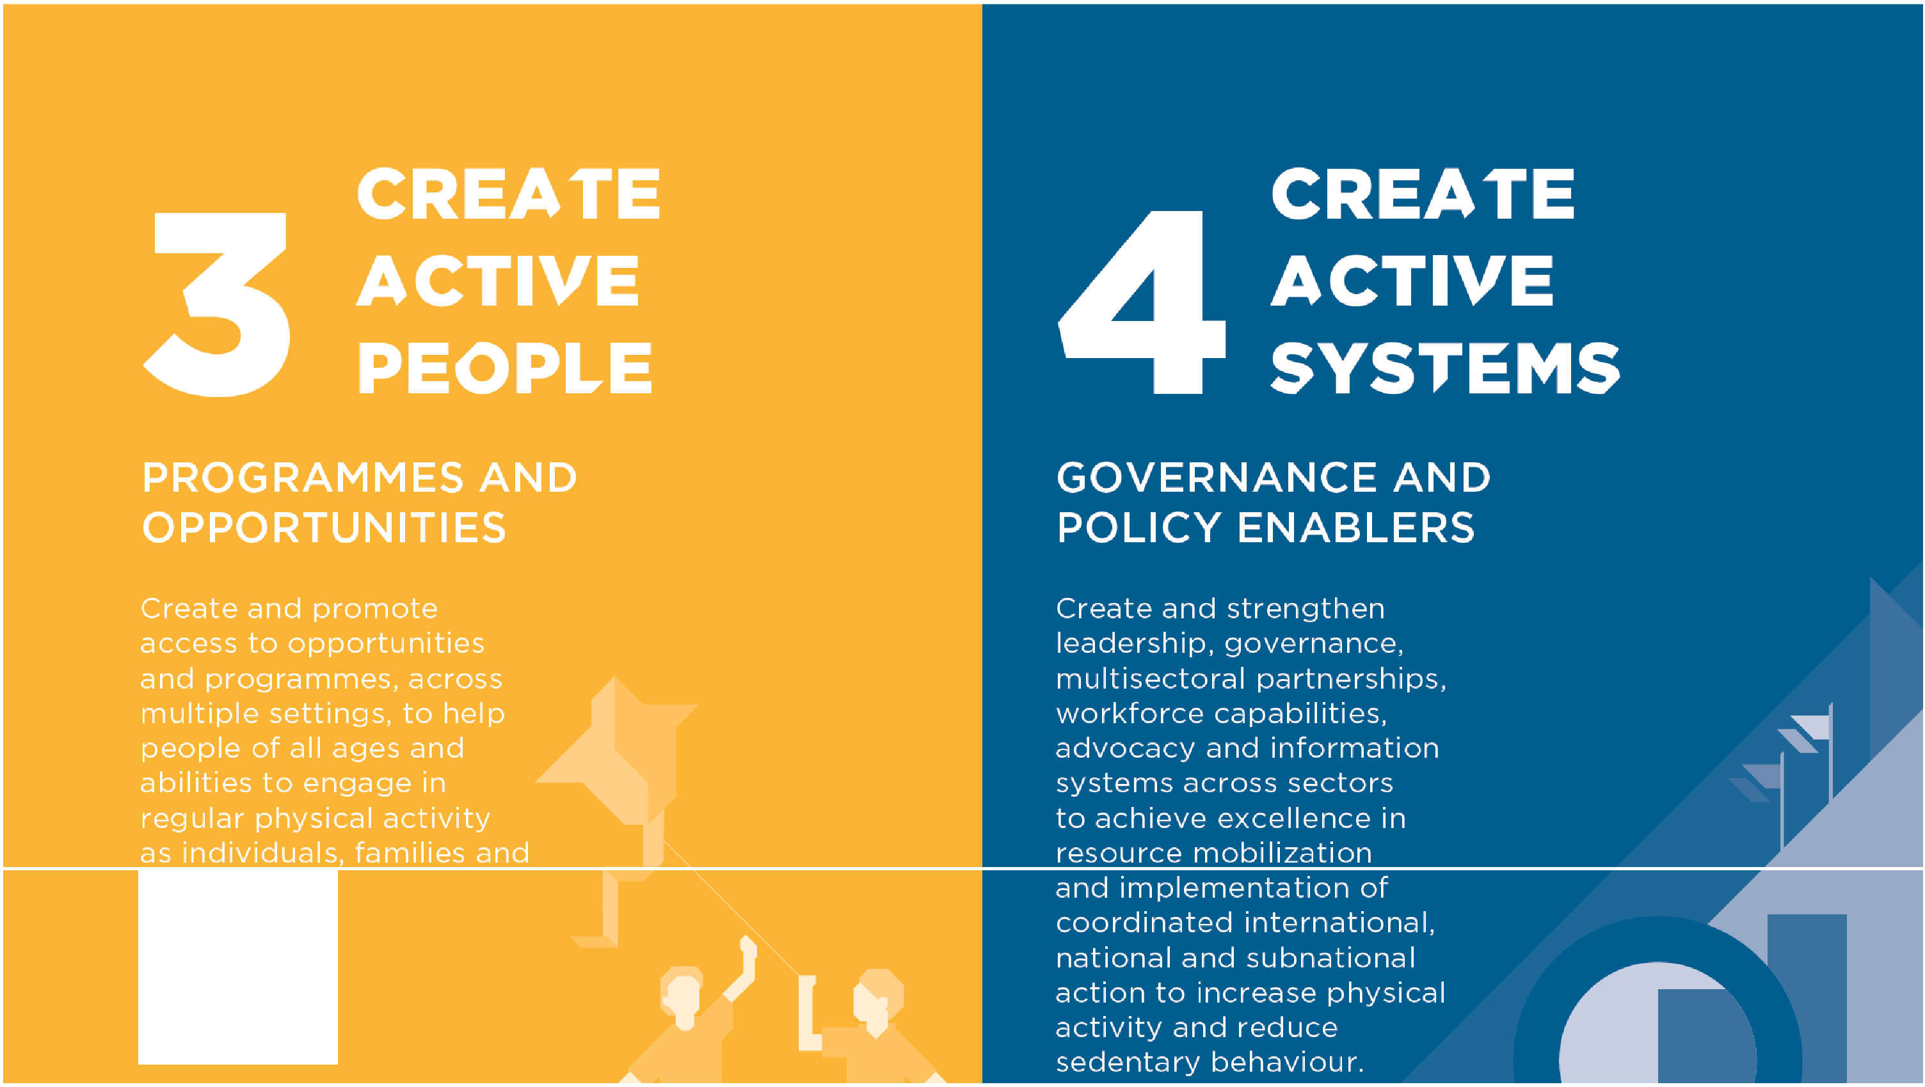commur.iities.

RISKS OF PHYSICAL INACTIVITY – independent effects in its own right as well as a significant **contributor to obesity**

**Clear** **reasons for** **“getting Australia** **more active”**

9

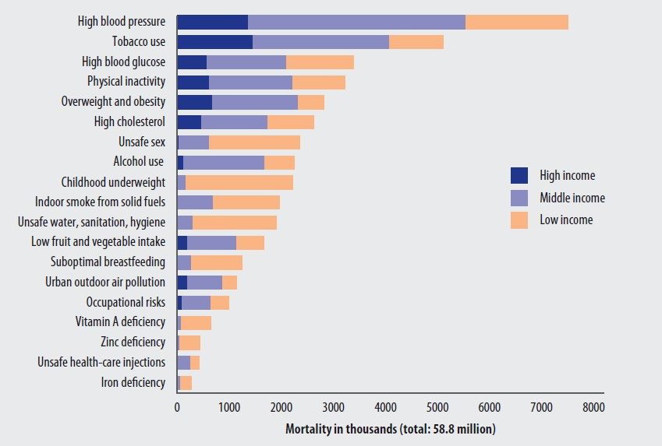

**4TH LEADING RISK FACTOR FOR GLOBAL**

**MORTALITY, WHO 2009; Lancet PA series 2012**

### Benefits of PA for children

###### Image result for kids at swimming lessonsDevelop the lifelong habit of being active

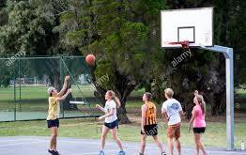**Social skills and integration,** **reduce isolation**

**Long term chronic disease** **prevention**

# How are we doing in physical activity in Australia overall ?

***Some*** ***“disconnections”*** ***emerged*** ***for*** ***me*** ***between*** ***PA*** ***research and*** ***policy*** ***outputs***

Consider the Global Atlas of physical activity : GoPA ! <http://www.globalphysicalactivityobservatory.com/>

The University of Sydney

Page 15

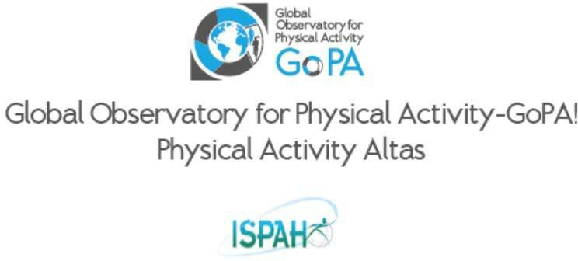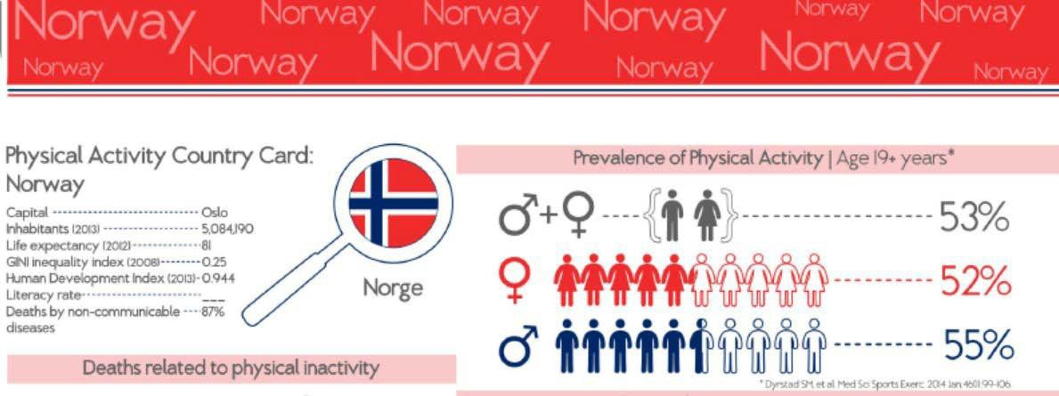

Page 13

The University of Sydney

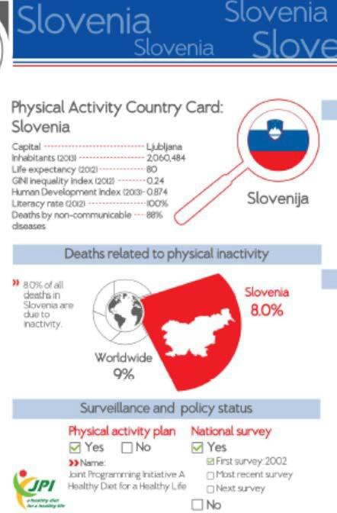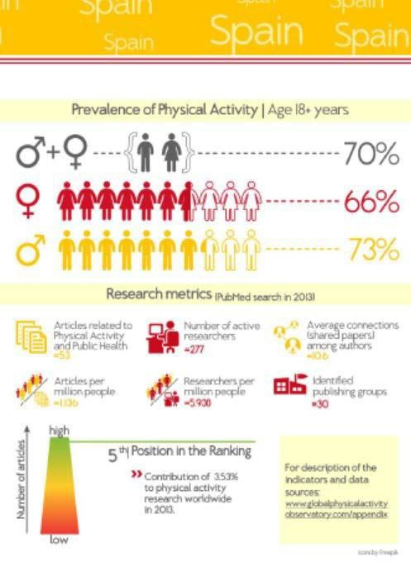

Page 14

The University of Sydney

###### Australia

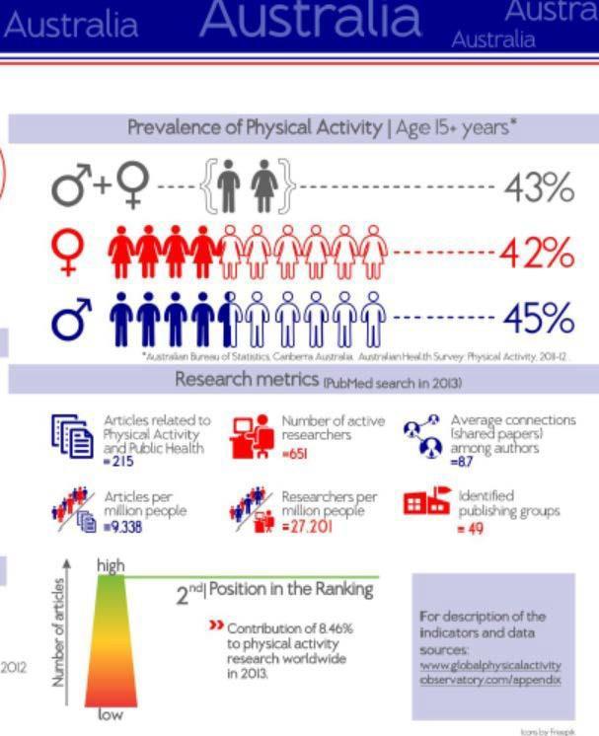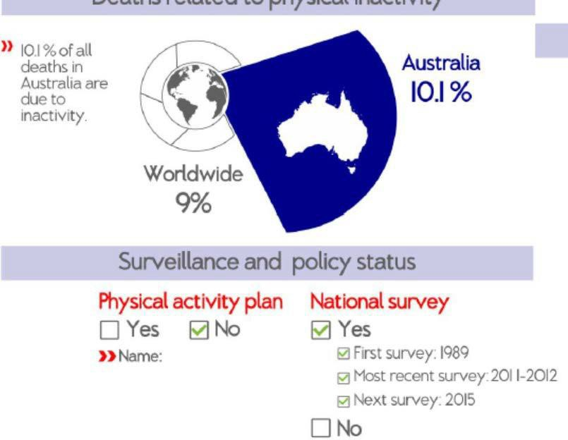

* + Low active population
  + **High research output**
  + No physical activity plan

The University of Sydney Page 18

**Australia** **–** **the land of** **disconnect** **…**

**PUBLISHING**

**Low active population**

**RESEARCH**

**PREVALENCE**

**High research output**

The University of Sydney

**No** **physica****l activit****y plan**

**P****O****L****I****CY**

Page 16



**22 year trends in leisure-****time** **physical activity in Australian** **adults**

**Chau J, et al 2017 ANZJPH**

**comparable NHS national** **surveillance data, 1989-****2011**

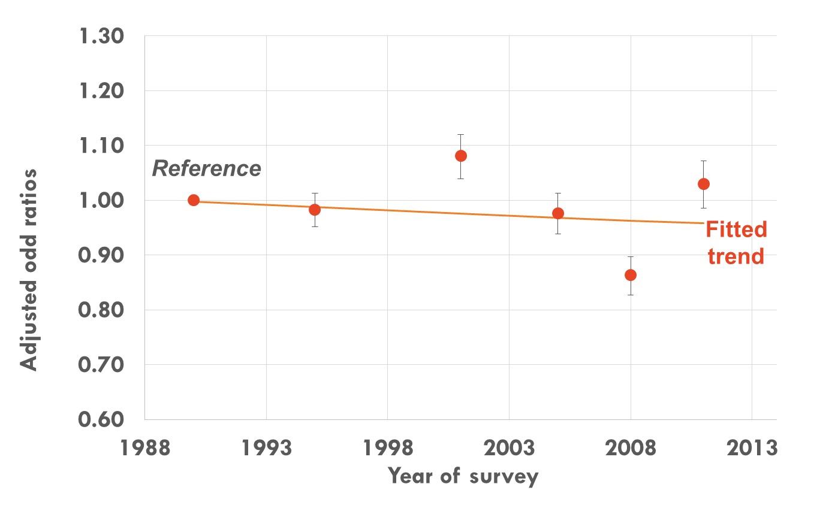Trends in prevalence of sufficient physical activity

**Overall fitted trend for years:**OR = 0.998; p=0.012

**Interpretation:**There was a 0.2% decrease per year over 22 years in

prevalence of sufficient physical activity

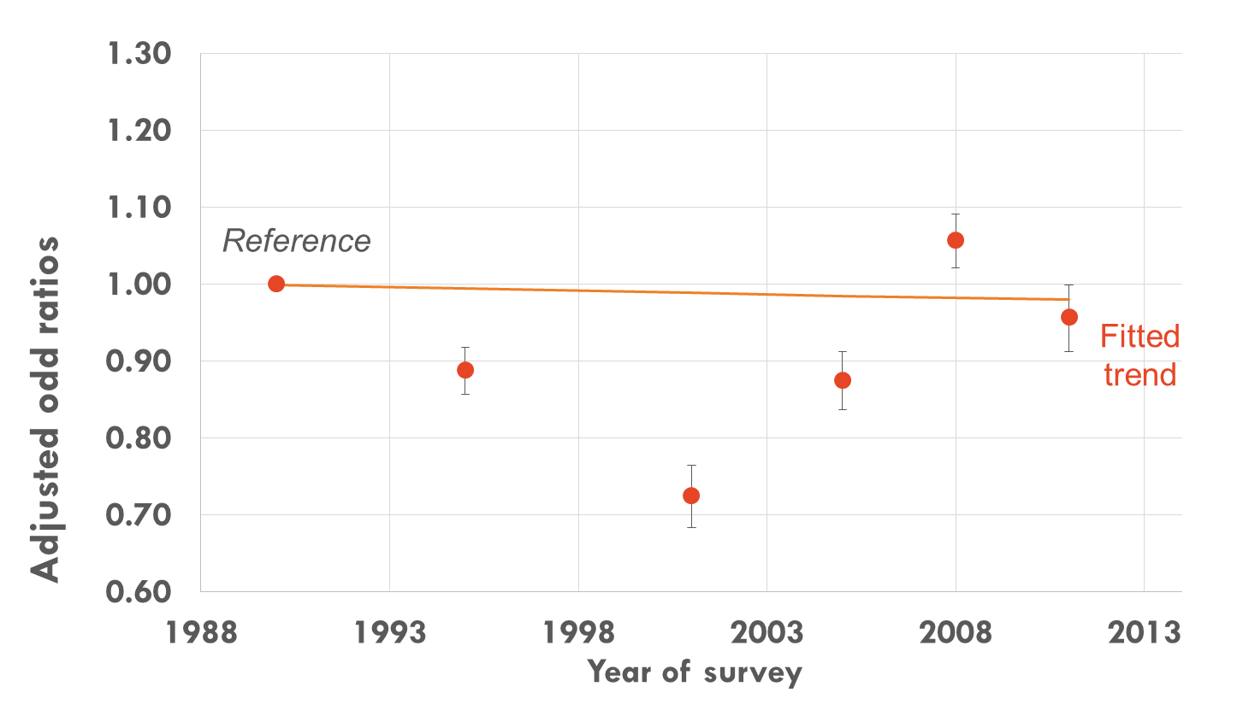Trends in physical inactivity [low-nil activity]

**Overall fitted trend for years: OR = 0.999; p=0.242**

**Interpretation: No change over 22 years in prevalence of inactivity**

# NO DEFINED SYSTEM OF PHYSICAL

ACTIVITY MONITORING FOR CHILDREN AND ADOLESCENTS

# IN AUSTRALIA

**Physical activity** **guideline : at least 60** **mins/day of** **moderate****-vigorous** **physical activity**

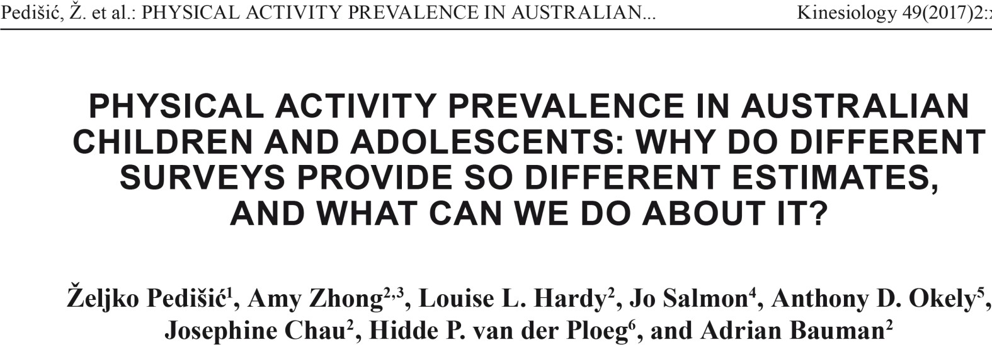

)>

r

a. CD

0 cc

- CD

CD :::J

eet ing PA recommendations (

N **w +S** GI O"l '-I 00

0 0 0 0 0 *0 0* 0 0

nCJ)

CD

:::J (")

.a..

-1- . -l- -1- I- .J.-

* !

'I I

'

*r-+* :::::f'

NTCHWS, 2004 (s -r)

' ! I ' I'

i [>

**CJ)** =.:

'I '

.

I a--,.

H KQS, 2006 (s-r) 7 '' D

***en* CD**

ANCNPAS, 2007 (s -r) I !◊ D

**CD :::J**

n

'I

"1 I

I

''I I

'

0 I CAPANS, 2008 (s-r) ' ' ◊ i □

:::J "'C

--, I

a. ::!.

3

--,

I I

'' I '

ACTPANS, 2009 (s -r) 'I ◊ d

'< ru

TasCHWS, 2009 (s- r) J ' ' D

--,

'' ' ◊ l

**CJ)** '<

ERASS, 2010 (s -r) ' ' ◊

'

◊

'

n *en*

'

::::r- n

--, '' □

0 :::::f'

**0 0**

n o

**:**-**::**·**::f'** n

**a.**

SPANS, 20 10 (s- r) I'

CHS, 2011 (s- r) j ''

' a

I

''

''

NNPAS, 2011/12 (s -r) j '

□ '

lO

'

'' **n**

'

**:::::f'**

--, =.:

**a.**

**CD**

**:::J** --,

'

AATSIHS, 2012/13 (s-r)

'

'

'

i : [>

'I

□

'

¢ :

--·

**tD**

**C.**

---***l***

**CD**

**:::J**

VCHWS, 2013 (s-r) 'I

''

**-*c*--l*.*o*.*.**-***.,l***

I (Jl

---lo. I

**CX) ---lo.**

'< I\.)

**CD**

HWSS, 2014 (s-r) VSHAWS, 2014 (s- r)

"1

SAMSS, 2014/ 15 (s- r) '

'

*t>* '

* □ :'

'' Ii>

'

''

**ru**

**CJ)** --,

SAPHaRI, 2014/15 (s-r)

-I

'' [>

''

□

**CJ)**

9, 0

HKQS, 2006 (ped) j ' ◊

'' ' '

ru ,

ANCNPAS, 2007 (pe d) j

' ' □ '' ◊

**cc ru**

**CD CC**

**0 CD**

--, **0**

***r-+*** --,

**:::::f'** ......

CAPANS,2008(ped) NNPAS, 2011/12 (ped)

' ,□ ◊

'' ' '

'

I

'' I

'

'

' I

I '

□

**CD ::::r-**

**::::r- CD**

cc·

o

H KQS, 2006 (s -r) ◊ 1

I'

ANCNPAS, 2007 (s-r) ;◊

I

': o-

:::::f' I

□

**CD CD**

**CJ) CJ)**

***r-+ r-+***

ru ru

**cc cc**

**CD CD**

n n

ru ru

CAPANS, 2008 (s-r) ◊

-I

'

HOWRU, 2009 (s -r) ◊ ! □

'

:□

NASSOA, 2009/ 10 (s- r) ◊

--,

***r-+ r-+***

**CD CD**

**cc cc**

ERASS, 2010 (s-r) ◊ []

'

* '

tb

**0**--, **0**--,

SPANS, 2010, summer (s-r) ◊ : □

'< '<

**:::::f' :::::f'**

'

SPANS, 2010, winter (s-r) )>

**C.**

**0**

**C**--**D**,

**C**--**D**,

ASSAD, 20 11 (s-r) 7

* tJ **tD**

**CD CD**

**tD**

**:::J :::J**

CHS, 20 11 (s- r)j ◊ □ **n**

**0 0**

**0 0** NNPAS, 2011/12 (s -r)

.' ,**::**.**J**..

<**CD** <**CD**

. [>

--, --,

'

ru r-u

1. **a.**

ru ru

AATSIHS, 2012/13 (s -r) l '

SSH BS, 2014 (s-r) ◊

□

-I

***r-+*** ......

ru ru

VSHAWS, 20 14 (s- r) ◊ □.

**C**--**D**, **C**--**D**,

SAMSS, 2014/ 15 (s-r) I>

**CD CD**

ru ru

r<u r<u

ANCNPAS,2007(ped) 7

CAPANS , 2008 (ped) .'

**0**

' ◊O

r-u- ru

-, ' '

C" C"

**CD CD**

NNPAS, 2011/12 (ped) [>

.._. ■ ...., ■

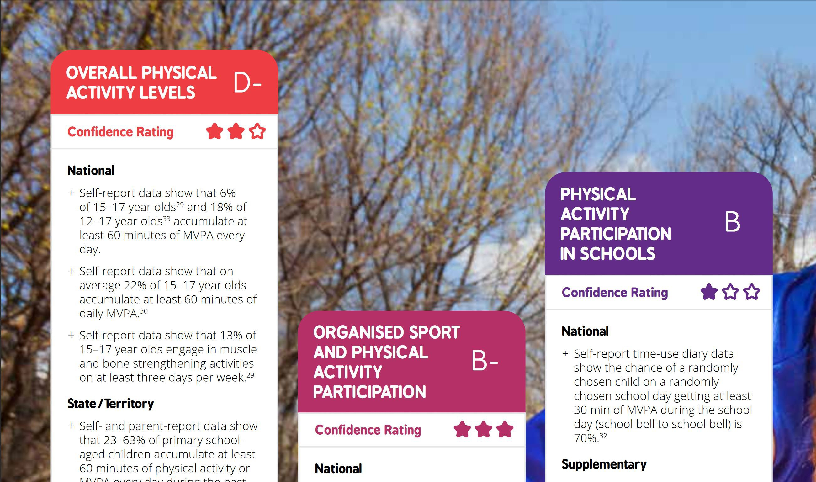

Australian kids PA report card 2018

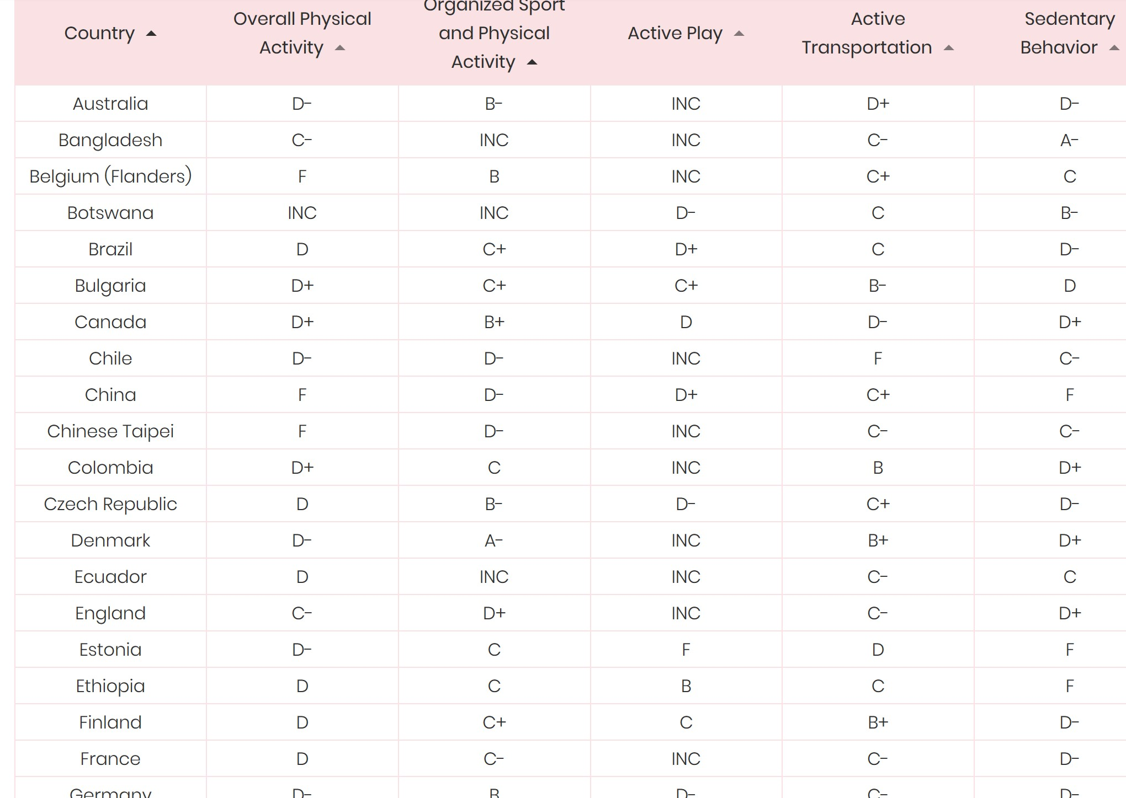

International report card on Children’s PA levels, programs and policies, 2018



**If we think of obesity as the result of energy** **imbalance….**

*Likely eating* *more*

*Likely*

*expending less ?*

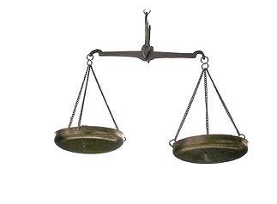

**Energy expended [total PA]**

**Energy Input [food]**

## ROLE IN OBESITY PREVENTION

**Diet OR physical activity in weight loss and** **weight loss maintenance ?**

##### Diet most important ?? 2/3 of the solution is dietary modification / restriction/ regulation

* **Physical activity important ? 1/3 of the solution**

##### But physical activity improves metabolic health at any weight [even in the absence of weight loss]

CONCLUSIONS

* 1. **Australia needs a standalone PA plan, resourced implementation strategy**
  2. **Subsuming PA under obesity strategies never realises sustained change in** **the cross****-agency work required to make a more “Active Australia”**
  3. **The National Sport Policy is a start, but only relates to one sector**
  4. **Leadership, taskforce, national steering processes with imprimatur to act** **remain absent for physical activity**
  5. **Offering a short term strategy is not delivering a** **longterm** **solution**
  6. **Only integrated and substantial effort on activating Australians would** **contribute to obesity prevention in meaningful ways**