

**OBESITY SUMMIT, FEB 2019**

Genetics, Epigenetics and Obesity

**Peter Molloy**

**CSIRO Health and Biosecurity**

## Genetics and Obesity Risk



1. Locke AE et al. Genetic studies of body mass index yield new insights for obesity biology. *Nature* **518**: 197-206 (2015)
2. Loos RJF. The genetics of adiposity. Curr Opinin in Genetics and Development 50:86–95 (2018)

* Mutations in a small number of genes are associated with severe forms of obesity - rare
* More generally – based on twin, family and population studies:
  + inherited contribution to Body Mass Index (risk of developing obesity) is estimated at 40-70%
  + large genetic studies have identified common variants (alleles) in more than 100 genes that contribute to a person’s risk of high BMI (similar for diabetes/cardiovcascular)
  + Effects of individual genetic variants are small
  + Top 100 genes only contribute about 4% to BMI-risk
  + Summed variants across the genome:
    - up to 20% of risk explained

## Genetics and Obesity Risk (2)

* Top 97 BMI risk alleles derived from meta-analysis of ~340,000 individuals
* In separate group of 8,164 individuals, mean BMI determined for groups of individuals carrying different numbers of risk alleles (right)
* 3.3 kg/m2 difference between those

carrying the least and most risk alleles

1600

1200

Number of individuals

800

400

200

**31**

**30**



Mean BMI (kg/m2)

|  |  |  |
| --- | --- | --- |
|  | .. |  |
|  |
|  |
|  |
|  |
|  |
|  |
|  |
|  |
|  |  |

**29**

**28**

**27**

<78

78-80

81-83

84-86

87-89

90-92

93-95

96-98

99-101

102-104

>104

**Number of BMI risk alleles**



Adapted from Nature: Extended data Fig2. Locke AE et al. Genetic studies of body mass index yield new

insights for obesity biology. *Nature* **518**: 197-206 © 2015.

* Measurable contribution,

but currently impractical to apply clinically

***“Epi”genome***

##### Closed: genes off

*Repressive*

*H3K9Me/H3K27Me3*

*closed*

*Permissive*

*H3K9Ac/H3K4Me3*

*open*

###### Set of marks that are added to DNA or associated proteins

* + *Marks allow or prevent genes being*

###### switched on

* + *Allows expression of specific genes in each cell type*

##### Open: genes on

###### Epigenome is “re-set’ in the early embryo

*and during formation of sperm and eggs*

###### Inherited through cell division

* *Effected by environment and modulated*

###### in disease

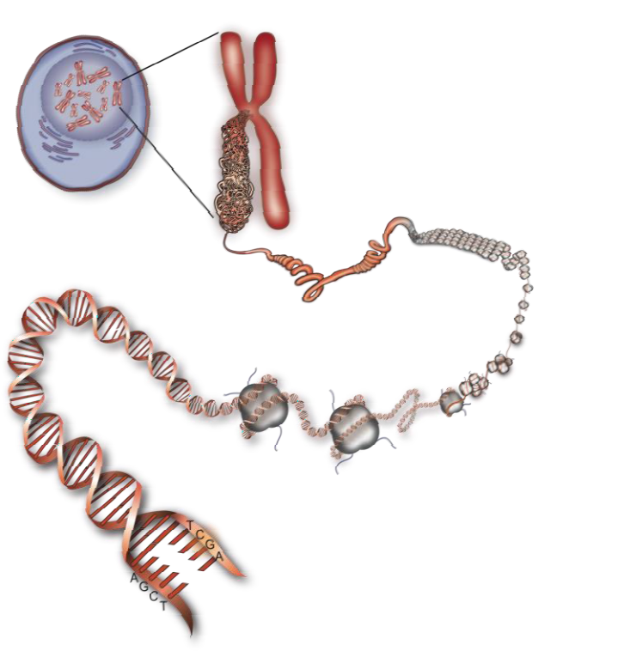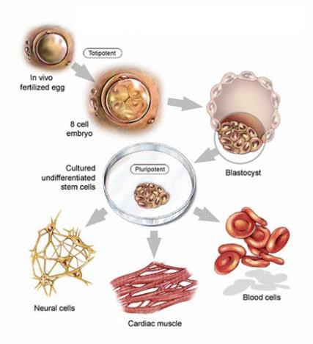

* + The epigenome is the interface between the environment and the genome

## Epigenome in health and disease throughout life



Peri-conception

In utero, neonatal Childhood/

adolescence

Adult

development

Aging

Preconception and early developmental environment/metabolism contributes to epigenomic factors that predispose to disease

Diseases may manifest later in life due

to early developmental exposure



# In utero and early life environment

effects on health role of epigenetics



Smoking, alcohol

Nutrition Macronutrients Micronutrients

Hormones

steroids VitD etc.

Signalling pathways



In utero, neonatal

Childhood/ adolescence

Adult

development Aging

Early developmental environment/metabolism contributes to epigenome changes and “Tuning”of epigenetic programs

Diseases may manifest later in life due to early developmental exposure



Early life (in utero) impacts on the health outcomes and the epigenome

Spurred by animal studies and human examples:

Mid to later life

Dutch “Hunger Winter” (1944/45)

Metabolic disorders Cardiovascular Schizophrenia

Population northern Netherlands subjected to starvation conditions near the end of World War 2

**?**

Epigenetic differences

DNA methylation measured at ~59 years



Tobi E et al. (2014) DNA methylation signatures link prenatal famine exposure to growth and metabolism. Nature Communications 5: 5592

* Health impacts and epigenetic differences seen in those in first trimester during famine.
* Challenging to determine if epigenetic changes cause or effect

#### Epigenome data and its application



quantifying patterns of DNA methylation

Reflecting the past Projecting future outcomes?

Epigenome

Obesity

Metabolic disorders Cardiovascular Cancer

...

Diet Smoking Stress Alcohol

...

(Genetics)

Cross sectional

Site-specific changes in DNA methylation correlate with many prior exposures

Obesity

type 2 diabetes lipids Cardiovascular

...

+many others

Two following examples where epigenetic marks associate with future outcomes

Difficult to disentangle cause and effect

**Risk of newly incident type 2 diabetes within five years**

##### (adults, 62 gene signature)

**Controls/cases *P P trend***

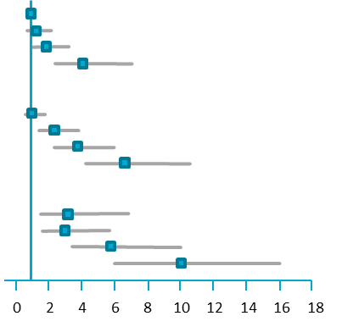

**Subjects at baseline:**

South Asian HbA1c <6%

Fasting glucose < 6mmol l-1

**Normal** (BMI 18.5 - 24.9)

Q1 144/29 3.85 x 10-1 Q2 141/32 4.97 X10-1

Q3 130/43 2.61 X10-2 Q4 106/69 1.89 X10-7

**Overweight** (BMI 25 – 29.9)

Q1 129/27 9.50 X10-1 5.66 x 10-19 Q2 185/78 7.70 X10-4

Q3 169/115 9.00 X10-8 Q4 301/321 4.00 X10-16

**Obese** (BMI >30)

Q1 27/17 2.50 X10-3 4.19 x 10-7 Q2 50/28 5.20 X10-4

Q3 59/61 5.10 X10-10 Q4 149/255 7.90 X10-22

P-interaction = 0.56



Adapted from Nature: Fig 4, Wahl S et al. Epigenome-wide

association study of body mass index, and the adverse outcomes

of adiposity. Nature 541:81-86 © 2017.

Odds ratio

***P***

***P trend***

significance relative to Normal BMI, Q1 epigenetic signature

significance of trend within each BMI group

Interaction P value

-interaction between adiposity and DNA methylation score in risk of T2D

* 62 gene epigenetic signature can predict risk of developing T2D
* Both on European and Indian cohorts
* Strong association with risk even after correcting for adiposity & glycaemic measures
* Applicable across weight range

### Epigenetic mark at birth associated with child BMI at 5 yrs

% carrying epigenetic mark

**16**

**18**

**24**

**29**

**35**

Newborns with epigenetic mark, twice as likely to be classified as overweight or obese at 5 years

BMI Quartile

1 2 3

4 **All**

(432)



van Dijk SJ et al. DNA methylation in blood from neonatal screening cards and the association with BMI and insulin sensitivity in early childhood. Int J Obes (Lond) 42:28-35 (2018).

# Summary



* Clear genetic contribution to obesity and associated metabolic disorders – but difficult to use

clinically at present

* Epigenetic data can integrate genetic and environmental inputs – early days, but showing some promise in predicting health outcomes
* Both data types are identifying targets for pharmacological intervention

Reflecting the past Projecting future outcomes?

Environ

ment/ diet

Epigenome

Phenotype

(obesity, T2D)

Genome