v

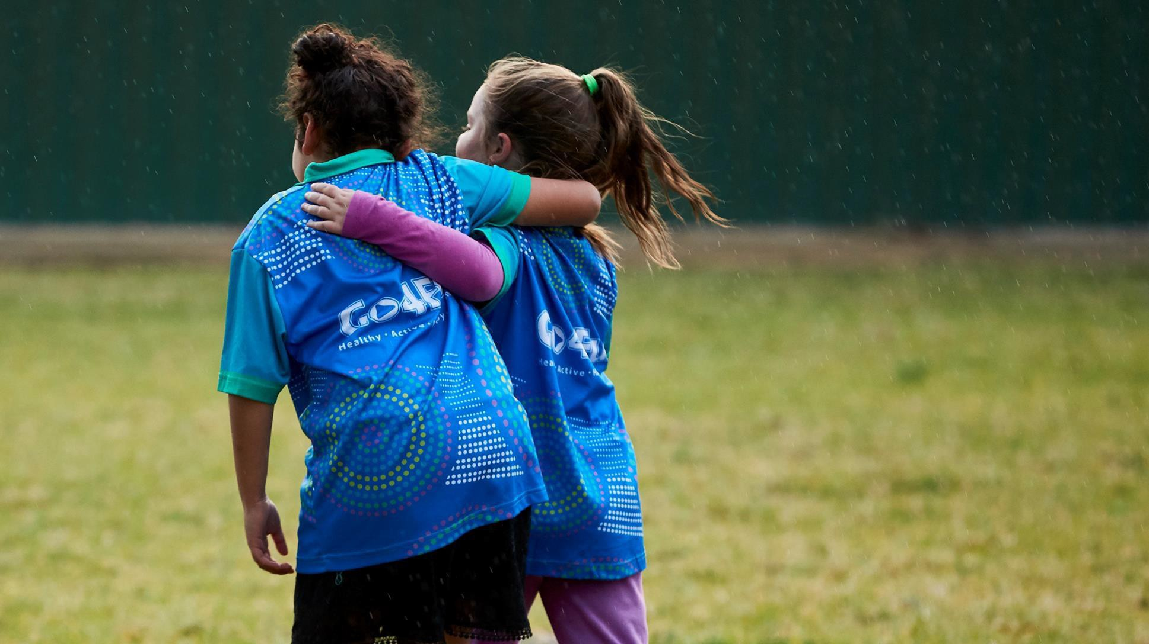

**Dr Jo Mitchell PSM**

Acting Deputy Secretary, Population and Public Health Division

NSW Ministry of Health

# The NSW experience – Premier’s priority to reduce childhood obesity

**National Obesity Summit 15 February 2019**

1

## Obesity is a complex, personal and sensitive issue

* Overweight and obesity is intensely

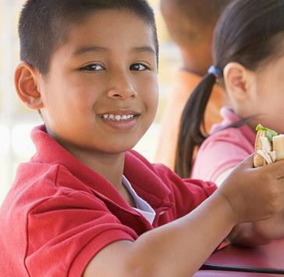

personal

* It is important that our initiatives do not contribute to stigmatisation of children who are above a healthy weight, or their families
* Our response emphasises the positive benefits from healthy eating and active living for all children, families and communities in NSW

2

## Premier’s priority is to reduce childhood overweight and obesity by 5%

NSW prevalence of childhood overweight and obesity was 21.4% in 2017 NSW Health is leading work to towards achieving the target

**Rate of overweight and obesity in NSW children (%)**

30



25

21.5 21.4

20

15

**Best case trajectory for current( planned ( ) activities**

**) and**

|  |  |  |  |
| --- | --- | --- | --- |
| **Baseline(2013)** | **21.5%** | Baseline | ***Approx. number of children impacted***  **~ 266,000** |
| **Current interventions** | **~ 3.3%\*** | Healthy Eating andActive Living Strategy, Healthy Canteens, ActiveKids | **~ 40,920** |
| **New**  **interventions** | **~ 1.7%\*\*** | Active Travel and Play,  Partnerships, Pregnancy | **~ 21,080** |
| **Premier’s target** | **= 16.5%** | Achieve a 5% reduction by 2025 | **62,000** |

Dot

18.2

16.5

10



In **2008**, the **economic impact****in NSW of obesity** alone was estimated by Access Economics to be **$19 billion**, this includes **$2.7 billion financial costs** including **productivity losses** and **$16.3 billion in costs of lost wellbeing.1** More recently PwC reported that a selected set of **obesity interventions** would be a **positive investment with a benefit to cost ratio of 1.7. 2**

Baseline 2017 Premier's Target

***Source:*** *NSW Population Health Survey (2007-2017). The target is measured using parent-reported survey responses.*

*1Deloitte Access Economics The growing cost of obesity, 2008*

*2PwC Weighing the cost of obesity: A case for action, 2015, According to the PWC report implementing a set of selected obesity inte**rvention**s would be a positive* *investment* *with a benefit cost ratio (BCR) of 1.7 in a conservative, ten year model resulting in a benefit of $2.1 billion for Australia. This modelling covers the adult population.*

*\*The first 3% of impact is evidenced by the evaluation of the Hunter New England ‘Good for Kids’ program.* 3

*\*\*This percentage generated by theoretical projection based on best available evidence.*



# The NSW portfolio of actions

4

## NSW Health has a comprehensive program of interventions across four

**strategic directions**



**NSW Healthy Eating and Active Living Strategy**

1. **State-wide** **support programs**

**Strategic Directions**

**Environments to** **support healthy eating and active living**

* + Active Kids

**Example interventions**

* + Live Life Well @ School
  + Munch & Move
  + Go4Fun • Advice and referral in clinical settings
    - Multi-disciplinary paediatric obesity clinics

families underway

|  |  |  |  |  |
| --- | --- | --- | --- | --- |
| **2.** | **Routine advice and clinical service delivery** | **3.** | **Education and information campaigns** | **4.** |
| • | Get Healthy in Pregnancy | • | Make Healthy Normal | • |
| • | Routine measurement of height and weight | • | Social marketing; formative research for children and | • |

Healthy School Canteens Strategy

Menu labelling initiative in quick serve restaurants

* Infrastructure to support Active Travel and Play

5

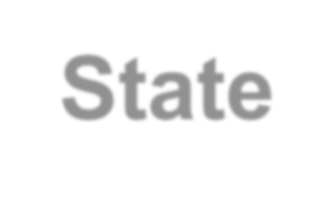

# State-wide programs

6

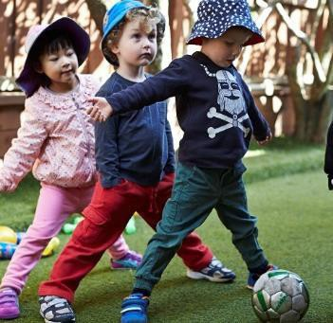

## Focus on early childcare, schools and community settings

* + There is strong and consistent evidence for a settings based approach in early childhood services and primary schools
  + Early childhood **89%** participation
  + Primary schools **83%** participation
  + Family day care, OOSH and supported playgroups
  + Junior sport clubs
  + Community treatment program

7

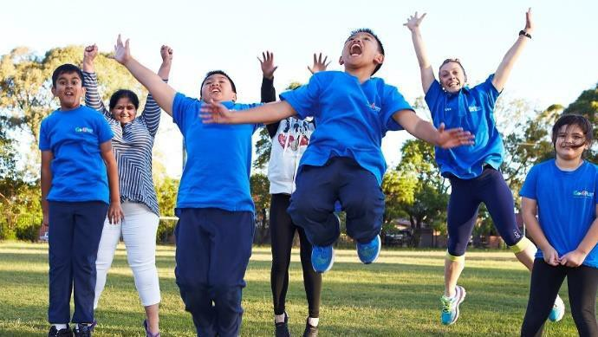

## Go4Fun community based treatment program

* Reach: >12,450 children and

their families

* Program outcomes:
  + BMI: -0.6 kg/m2;
  + waist circumference: -1.4 cm
* Program adaptation
  + From twice to once a week
  + Aboriginal G4F
  + G4F online

8

## Screenshot of 'Narrative review of models and success factors for scaling up public health interventions'Delivering at scale is key

Select effective and feasible interventions

* Conduct comprehensive formative research with target groups and implementers
* Understand the mechanisms that contribute to intervention success and failure

Identify sustainable delivery mechanisms and workforce from the start

* Integrate interventions into existing delivery systems where possible
* Provide centralised resources, training and implementation support
* Data is power! Utilise information systems that manage program data to support practice change and system performance

9 

## Much and Move logoA short history of scaling up

**Tooty Fruity Vegie**

*Local RCT*



**Good for Kids: Goodfor Life**

*scale across 1x region*

**ACTIVITY**

**DRIVER**

**Munch & Move** *Dissemination trial - Cluster RCT*

**State**

**priority**

**National funding boost**

**Munch & Move**

*State-wide*

**PHIMS**

**State funding** **boost**

**Local** **targets**

**Premier’s** **priority**

**Recurrent** **budget**

**FUNDING**

|  |  |  |  |  |  |  |
| --- | --- | --- | --- | --- | --- | --- |
| ***AUD pa*** | **Nil** **$3m** | **$2m $6m** **$8m** **$2m** **$14m** | | | **$17m** | **$19m** |
|  |  |  | ***(build*)** |  |  |  |
| **REACH** | **Nil** | **5%** | **35%** | **45%** | **85%** | **89%** |
|  |  |  | 10 |  |  |  |

**2010** **2011** **2012** **2013**

**2014**

**2015**

**2016**

**2017**



# Clinical support, education and environments

11

## NSW Health is working in partnership with health professionals, primary care and health clinics

* + Building strong partnerships with primary care providers, public dental services and child health nurses

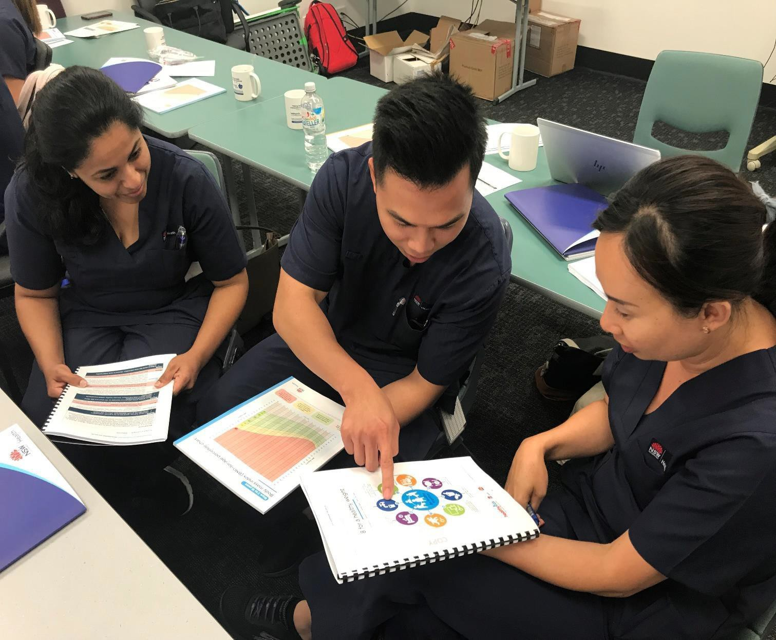

* + Supporting health professionals to routinely measure a child’s height and weight status and respond – Key Performance Indicator
  + Delivering training and resources to health professionals, including primary care providers
  + State wide scale up of Get Healthy in Pregnancy service to support women to achieve healthy gestational weight gain

12

## Make healthy normal logoDelivery of key messages and social marketing

|  |
| --- |
| What we are learning |
| * Our audience is aware obesity is a health issue, but parents’ recognition of their own child’s weight status is low * Our audience wants practical tools to help them make changes and encourage them to continue * Our technology needs to change to provide parents with the tools and support needed |

**1**

**2**

**3**

|  |
| --- |
| What we are doing |
| * Strengthening delivery of existing core messages until April 2019 * Updating website function and personalising social media output * Packaging proactive stories * Promoting content through   partners e.g. health insurers   * Engaging with LHDs |

|  |
| --- |
| What we are planning |
| * A strategy that clearly   segments target audiences   * A phase 3 campaign * A segmented understanding of our target audience * More engaging creative with   stronger calls to action |

 13

## Icon of Healthy food and drink in NSW health facilities for staff and visitors frameworkSupportive environments can influence healthier choices

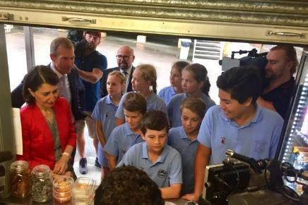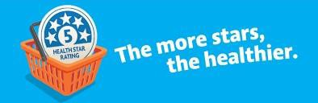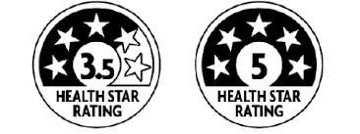

|  |
| --- |
| Healthy School Canteen  Strategy |
| * Requires all schools in NSW to have a Healthy School Canteen by the end of 2019 * 326 schools in NSW are verified as achieving the Strategy (as at 28 Jan 2019) * More than 105,948 students have access to a healthy school canteen (approx.) |

|  |
| --- |
| Menu labelling |
| * Kilojoule menu labelling in major cafes and fast food chains [www.8700.com.au](http://www.8700.com.au/) * Supporting the national Health Star Rating front-of- pack labelling system [www.healthstarrating.gov.au](http://www.healthstarrating.gov.au/) |

|  |
| --- |
| Healthy Food and Drink in  NSW Health Facilities |
| * NSW Health leading by example and has removed sugar-sweetened drinks from food outlets in health facilities * Increasing healthy food options to 75 per cent of the menu * Reducing portion size of unhealthy foods |

14

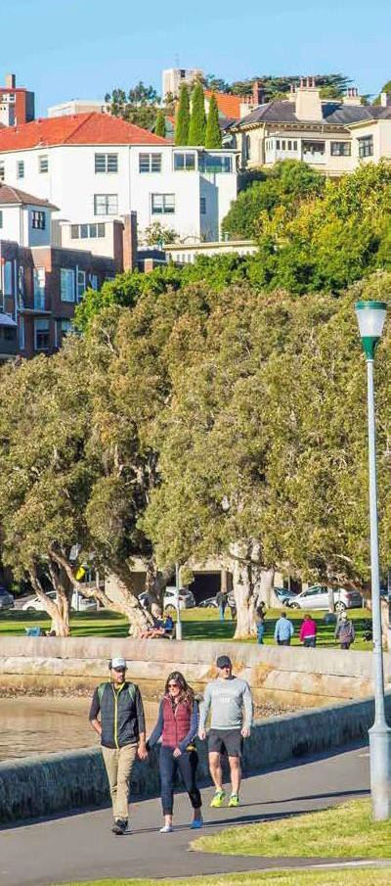

## Supportive environments can influence healthier choices

* Working with interagency partners to:
  + leverage Government infrastructure investment to prioritise

active travel and play

* + develop support strategies to increase use of existing andnew

infrastructure

* + embed active travel and play within enabling design guidelines
* Active Kids program - 671,320 vouchers were generated in 2018.
* Promoting active travel to school for children as part of the

Live Life Well @ School program

* The NSW Active Travel Charter for Children identifies strategies to help students, parents and teachers to achieve this

15



# Delivery and performance monitoring

16

## Premier’s Implementation Unit approach drives and sustain progress

Arrow downArrow downArrow downArrow down



**Use of Data**



**Fieldwork**



**Targeted**

**Actions**



**Routines**

**Anchor approach in data and evidence to focus implementation efforts**

**Talk to frontline**

**to ensure communication & accountabilities are effectively flowing down delivery chain**

**Targeted and high impact interventions**

**Use routines to ensure a focus on performance**

17

1

Healthy eating and physical activity learning experiences

PDHPE includes fundamental movement skills

Reports on LLW@S implementation

School plans incorporate LLW@S

Professional development of staff

Communicating with families

Healthy School Canteen Strategy

Supportive environment for healthy eating

Promoting active travel

Physical activity during breaks

Fruit, vegetables and water breaks

100%

90%

80%

70%

60%

50%

40%

30%

20%

10%

0%

LHD LHD LHD LHD LHD LHD LHD LHD LHD LHD LHD LHD LHD LHD LHD NSW

total

**Monitoring program fidelity and impact**

**Evidence-based with key practices required to achieve program fidelity**

**Adoption of Live Life Well @ School by LHD (%)**

100%

80%

60%

40%

20%

0%

**Encouraging healthy eating and physical** **activity**

**Professional development and monitoring**

**Curriculum**

18

## District performance summary for quarter 1 2018-19Making it count – monitoring performance

19

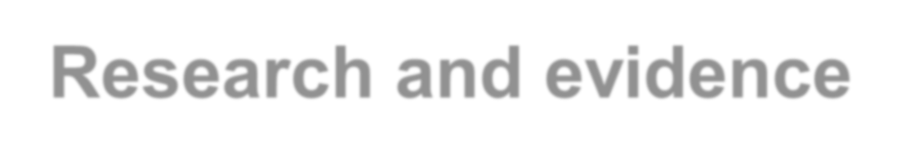

# Research and evidence

20

## Strategically investing in research to build the evidence base

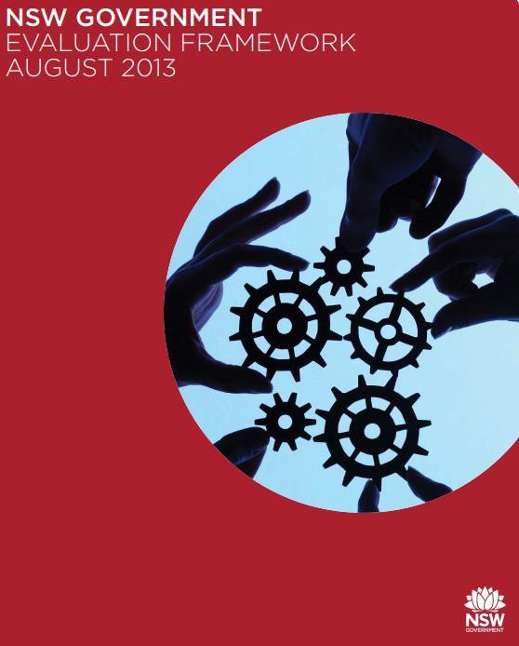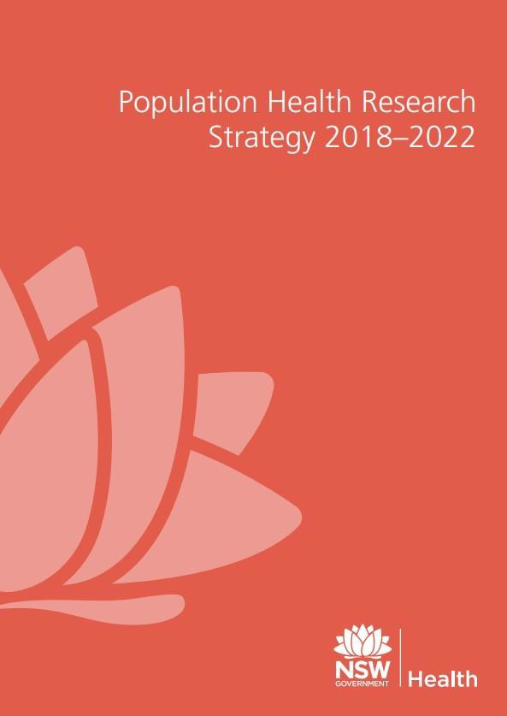

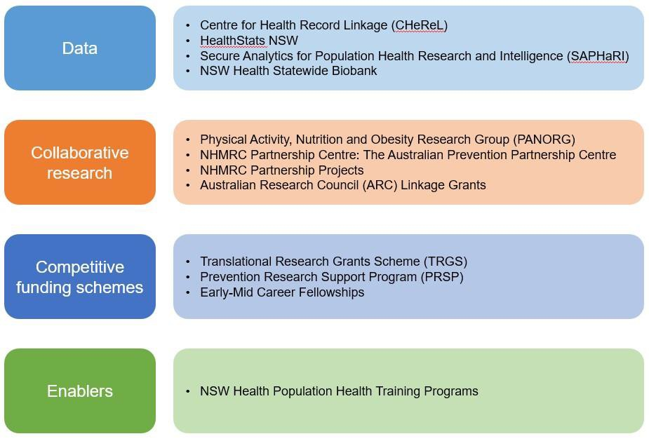

21

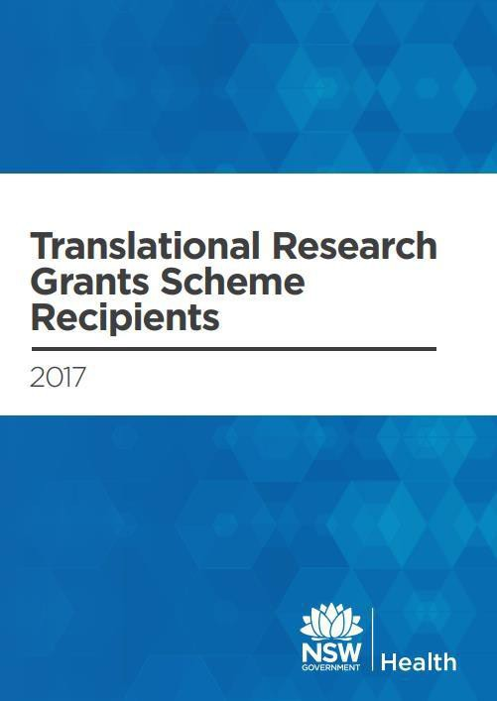

## Translational Research Grants Scheme

* + Competitive funding scheme to prioritise and generate rigorous evidence from the field
  + Accelerating the development of research capability and evidence translation within the NSW public health system
  + Focus on partnerships, capacity building and

accountability

22

## Current childhood overweight and

**obesity TRGS projects** **Hunter New England:** Physical Activity 4 Everyone (PA4E1) – physical

activity and nutrition program in high schools; and SWAP-It – healthy

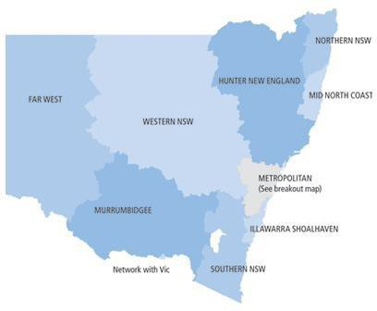lunchboxes

**Northern NSW:** Sweet smiles – brief oral health interventions to decrease children’s sugary drinkintake

**Central Coast**: Thirsty? Choose water! Behavioural interventions and water stations in secondaryschools

**Sydney**: Healthy beginnings – phone and SMS advice to parents of children 0-2 years

**South Western Sydney**: Campbelltown – Changing our future: a whole of system approach to childhoodobesity in South Western Sydney

**Sydney Children’s Hospital Network**: Secondary level child weight management services: the appropriateness, impact and effectiveness of new service models

**Murrumbidgee:** Time2BHealthy – on-line healthy eating and active living support program for parents of children 2-6 years

23



# Reflections

24

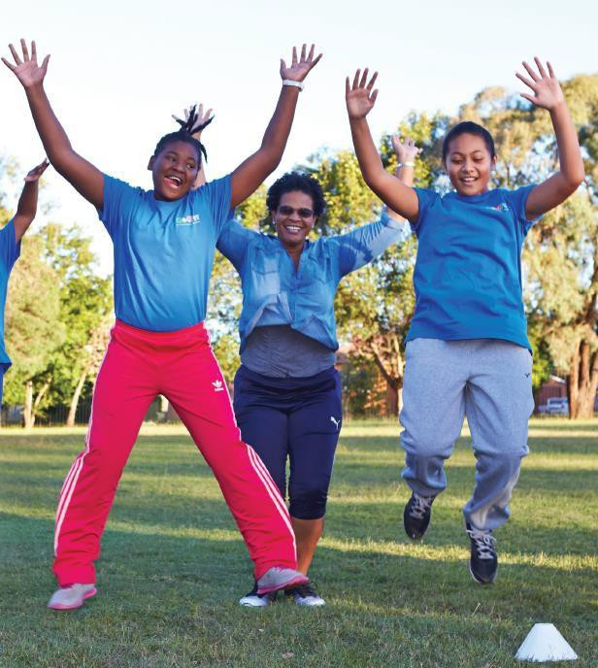

## Reflections from the NSW experience

* High level commitment and priority
* Comprehensive, cross government approach
* Delivery at scale
* Adaptation, innovation and evaluation
* A focus on delivery and performance monitoring
* A long-standing prevention infrastructure

25



# Thank you

26