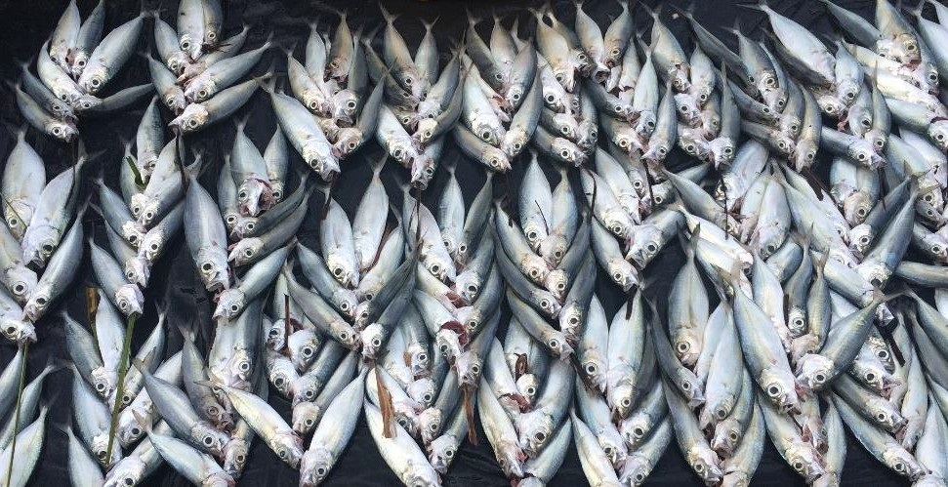

**A food systems approach to addressing obesity**

**Jessica Bogard**| Nutrition Systems Scientist 15th February 2019



**AGRICULTURE AND FOOD**

## Lancet commission on obesity

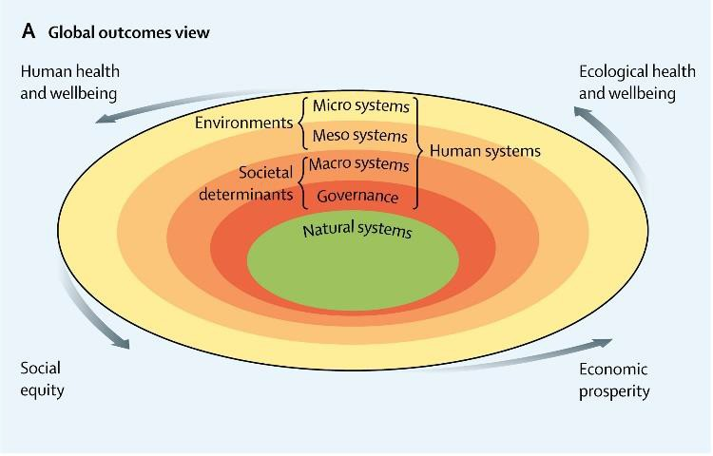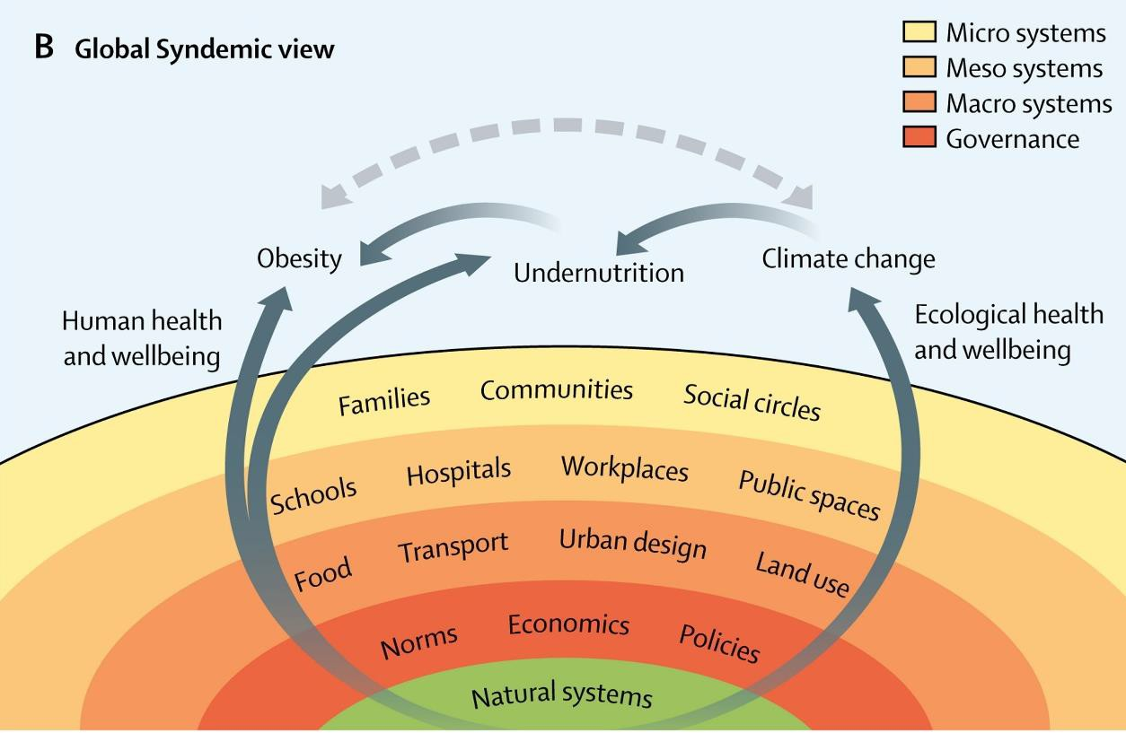

* ‘The Global Syndemic’ of obesity, undernutrition and climate change:
  + Co-exist
  + Interact with each other
  + Have common systematic drivers
* Underlying drivers exist within food and agriculture, transport, urban design and land use systems
* Systems level interventions could serve as double or triple duty solutions

(Swinburn et al, 2019, The Lancet)

2 | A food systems approach to addressing obesity | Jessica Bogard

# What is a food system?

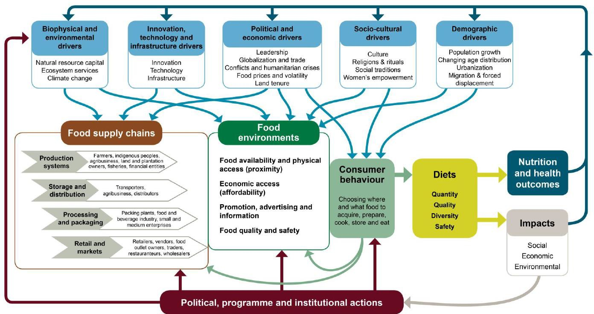

(HLPE report on Nutrition and Food Systems, 2017)

3 | A food systems approach to addressing obesity | Jessica Bogard

A food systems approach recognises all of the areas, people and linkages throughout the system, then actively seeks to maximise synergies and minimise trade-offs

**Does Australian agricultural production meet our**



(Ridoutt et al, 2017, Food Security)

4 | A food systems approach to addressing obesity | Jessica Bogard

**nutritional needs?**

Vegetables Grains Meat

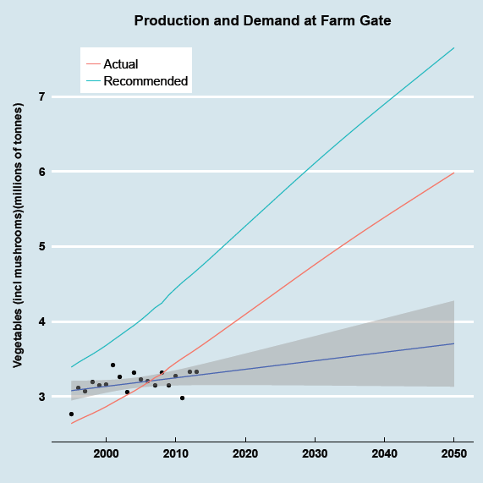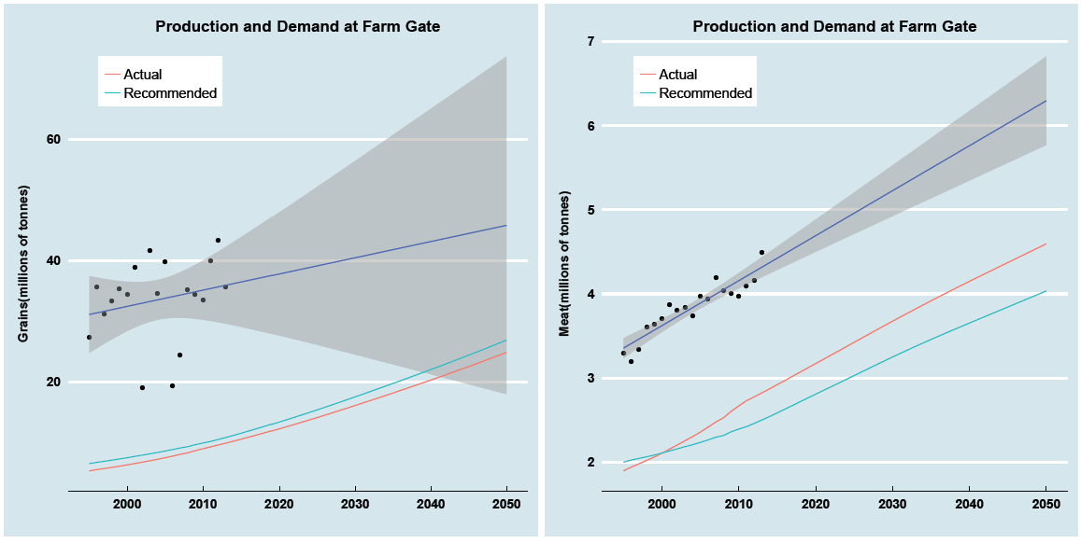

# The RDC model



**$524m**

**$840m**

**RDC**

**$316m**

(DAWR, Report to Levies Stakeholders, 2018)

5 | A food systems approach to addressing obesity | Jessica Bogard

|  |  |
| --- | --- |
| **Statutory RDCs** | |
| GRDC | Grains Research and Development Corporation |
| FRDC | Fisheries Research and Development Corporation |
| CRDC | Cotton Research and Development Corporation |
| WA | Wine Australia |
| RIRDC | AgriFutures (Rural Industries RDC) |
| **Industry RDCs** | |
| DA | Dairy Australia Limited |
| MLA | Meat and Livestock Australia |
| AECL | Australian Egg Corporation Limited |
| APL | Australian Pork Limited |
| SRDC | Sugar Research Australia Limited |
| HIA | Horticulture Innovation Australia |
| Livecorp | Australian Livestock Export Corporation Limited |
| AMPC | Australian Meat Processor Corporation |
| FWPA | Forest and Wood Products Australia |
| AWIL | Australian Wool Innovation Limited |

* Investment in agricultural R&D in Australia occurs largely via the Rural Research and Development Corporations (RDC) model
* 15 RDCs (5 statutory and 10 industry)
* Funding is via commodity levies with matched funding from Govt.

## Levies invested in agricultural



(DAWR, Report to Levies Stakeholders, 2018)

* 5.2% of these funds was spent on biosecurity and residue testing, though the breakdown of these by commodity is not available in the referenced report

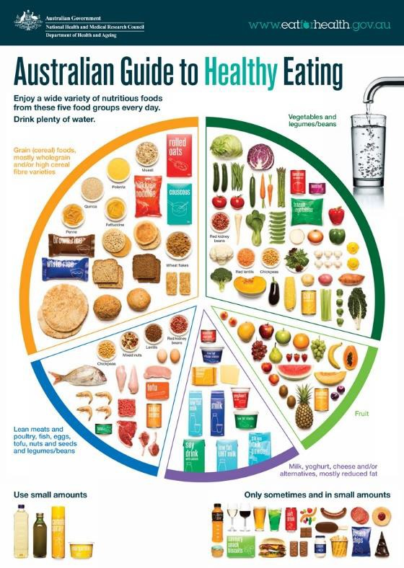

**R&D**\* **2017-18**

oils

Vegetables, $21m

Fruit, $37m

Grains, $88m

Nuts and seeds, $4m

Legumes/beans, $17m

Dairy, $33m

Poultry, $2m

Fish, $1m

Red meat, $160m

$18m fats and

Eggs, $8m

$24m sugar (and honey)

$22m wine

# Key messages



7 | A food systems approach to addressing obesity | Jessica Bogard

* Clear need for a ‘systems approach’ to address obesity (not only a health issue)
* Agriculture and food systems are a key entry point
  + Specifically, the need to align agricultural production with foods needed for healthy diets
* A National Obesity Strategy offers an opportunity embrace a whole of system approach to address the interlinked challenges of obesity, poor diets and sustainability of food systems with multiple benefits



**AGRICULTURE AND FOOD**

# Image of market Thank you

[**jessica.bogard@csiro.au**](mailto:jessica.bogard@csiro.au)

**Follow me on twitter: @bogard_jessica**

**Follow our group on twitter: @GlobalFoodTeam**

**Program website: https://research.csiro.au/agricultureglobalchange/**

**Group website: https://research.csiro.au/foodglobalsecurity/**