

Local government and place-based approaches for primary prevention of obesity – Lessons from Victoria

Dr Bruce Bolam

FPHAA, FFPH, PhD, MPH, MSc

Chief Preventive Health Officer

Department of Health and Human Services, Victoria



Summary

* Context and key facts
* The role of local government in place-based approaches to

primary prevention of obesity

* An overview of the Victorian experience
* Critical success factors
* Conclusions



Context and key facts

* With business as usual, there is an additional overweight or

obese Victorian child every 53 minutes

* We can’t treat our way out of this epidemic – primary prevention is needed to reduce the incidence of new cases
* This is a public health problem – not a question of individual willpower
* We need to change the environments where we live, learn,

work and play so its easier for people to eat more everyday

foods and less sometimes foods…(and move more and sit less)

* Evidence and public opinion shows we need **critical MaSS** –

action on **M**ultiple dimensions, **A**t **S**cale and **S**ustained



Beyond the spin, people are ready for change

VicHealth Citizen’s Jury was a deep dive with a representative

sample of Victorians, who said they wanted:

* Ongoing funding for community initiatives
* Healthy eating mandated in schools
* Public health campaigns
* Support for disadvantaged communities
* Restricted fast food and drink advertising to children
* A tax on sugary drinks
* Limitations on fast food outlets, including exclusion zones where

children spend their time



Place-based approaches

As part of the solution, not a magic bullet, these approaches

commonly share:

* **Leadership** - Clear governance and accountability
* **Partnership** - Bringing together diverse players
* **Community** - legitimacy, authenticity, empathy
* **Resourcing** - a ‘backbone’ agency, budget and workforce
* **Information** - data, evidence and evaluation to drive action

Local government has all these attributes…

But can’t do it alone.

**Be Active Eat Well 2003-2006**

**Healthy Together Victoria 2011-2015**

**Biggest Loser Ararat 2013**

**WHO STOPS 2015-2020**

**Healthy Heart for Loddon Campaspe 2018**

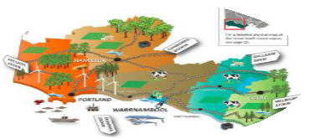

**Central Highlands Prevention Lab 2018**

**RESPOND**

**2019**



Victoria’s experience led by researchers, government and communities

**RESPOND**



Healthy Together Victoria operated across 14 local government areas – both regional and metro

Funded through National Partnership

Agreement on Preventive Health

Delivered multiple strategies, led through local government and community health partnership

At the 2 year mark:

* High levels of early childhood and primary school engagement
* 7,000+ people in healthy cooking classes
* Population exposure to LiveLighter campaign

But funding ceased



In Ararat, Healthy Together Victoria activity was supplemented by The Biggest Loser

* 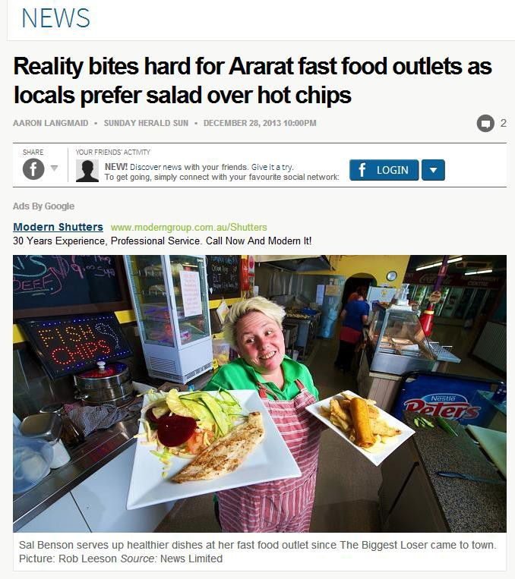Got the community excited about taking action together
* Boosted local efforts, shining a light on digital platforms for behaviour change





WHO STOPS - a community-based randomised controlled trial in Victoria’s Great South Coast led by Deakin University researchers

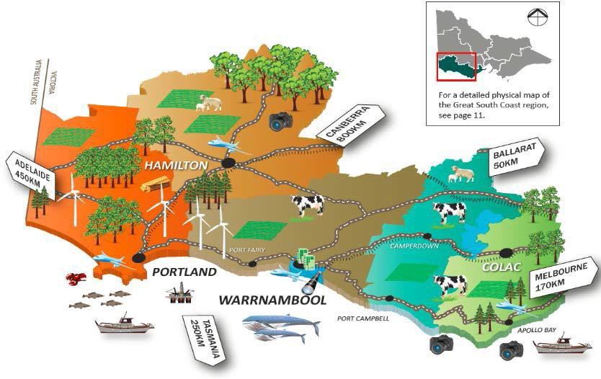



New place-based activities reflect the legacy of Healthy Together Victoria

Regional Partnerships identify priorities for their region and to develop collaborative solutions to local problems – obesity prevention initiatives are now emerging

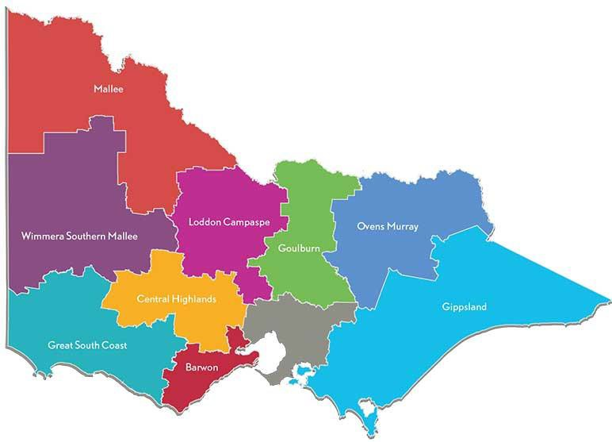

**Healthy Hearts for Loddon Campaspe**

**RESPOND**

**Central Highlands Prevention Lab**



Critical success factors

* + Investment - in resources, time, people and process
  + Reasonable expectations - place-based approaches are not a

magic bullet and do take time, but can leave a legacy

* + Supportive strategies - an epidemic requires action at the population level
  + A rigorous approach to evidence use and building
  + A clear approach to scale and sustainability



Conclusions

* + We must act and community is ready
  + Local government has a role to play in place-based approaches
  + We do need to build on existing evidence and sustain our effort
  + We don’t need to do this…

