# THE AMBER CATEGORY

Slide | 13



**SELECT CAREFULLY**

These foods contain some nutrients but are generally higher in saturated fat, salt and added sugar

* If eaten regularly or in large amounts, foods in the AMBER category may

contribute to excess energy being consumed

* Provide in smaller serve sizes
* “GREEN” these foods at every opportunity

# THE AMBER CATEGORY



## Some restrictions:

* Full-fat dairy foods: milk (plain and flavoured), yoghurt, custard, cheese
  + Coffee milk/soy drinks 375mL or less may be sold in secondary school
* Fruit and vegetable juice – no added sugar
  + At least 99% fruit juice, maximum 250mL serve size
* Dried fruit
  + Including 100% fruit leathers
* Ice slushies, fruit jellies – no added sugar
  + At least 99% fruit juice, maximum 200mL serve size
* Ice blocks – no added sugar
  + At least 99% fruit juice, maximum 125mL serve size
* Jam/honey/toppings/syrups
  + In small amounts

Slide | 14

# THE AMBER CATEGORY

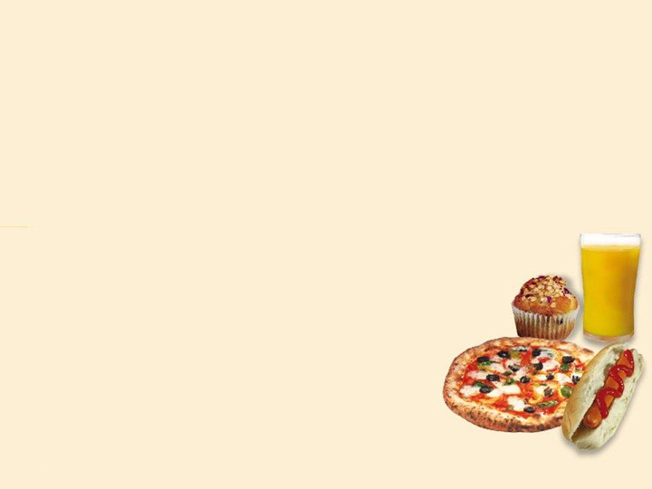

## Need to meet criteria:

* Lean processed meats
* Savoury pastry and bread products
* Ready-to-eat pasta/rice/noodle dishes
* Ready-to-eat hot mixed dishes
* Oven-baked potato products
* Snack food bars (breakfast bars, cereal bars, fruit filled bars)
* Some un-iced cakes, muffins, sweet biscuits
* Savoury snack foods, biscuits, crackers and crispbreads
* Low or reduced-fat ice creams, milk-based ices and dairy desserts

# THE RED CATEGORY

Slide | 16

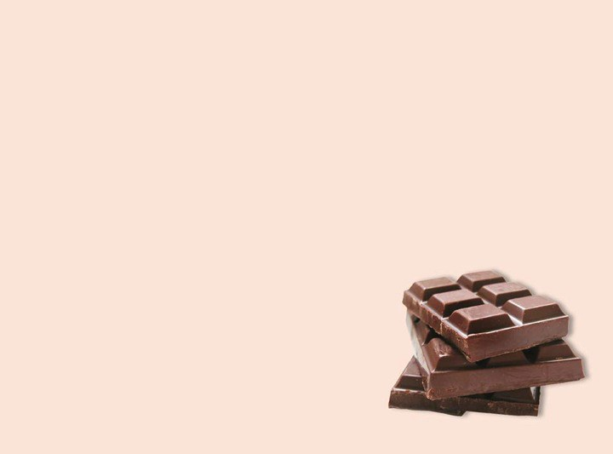

**NOT RECOMMENDED ON THE CANTEEN MENU**

* + Low in nutritional value
  + May contain excess energy, saturated fat, salt and sugar
  + Should not be sold in a healthy school canteen

# THE RED CATEGORY

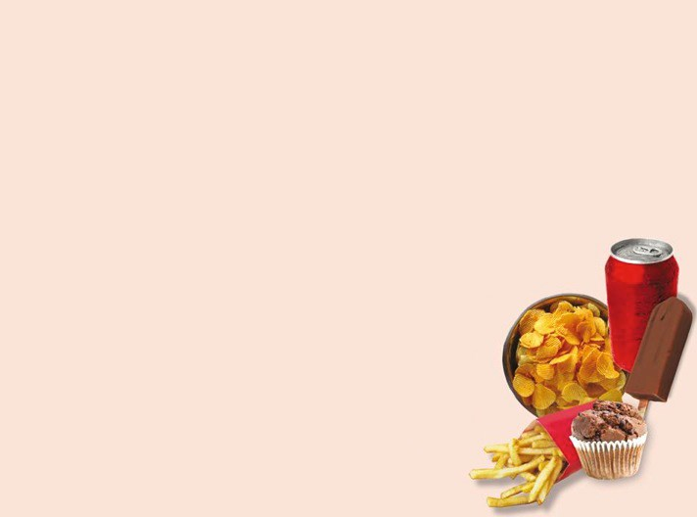

* Sugar sweetened drinks, soft drinks, fruit drinks, iced tea cordial, sports drinks, sports waters, flavoured mineral waters and energy drinks
* Intense (artificially) sweetened foods and drinks with the exception of milk, yoghurt and custard
* Products containing guarana or added caffeine. Coffee-style milk drinks may be sold in secondary school. Maximum 375mL serve size
* Fruit/vegetable juice, less than 99% juice, added sugar, greater than 250mL serve size
* Jelly desserts and ice crushes/slushies, less than 99% fruit, added sugar, greater than 200mL serve size
* Icy-poles and fruit ice blocks, less than

99% juice, added sugar, greater than 125mL serve size

Slide | 17

# THE RED CATEGORY

Slide | 18

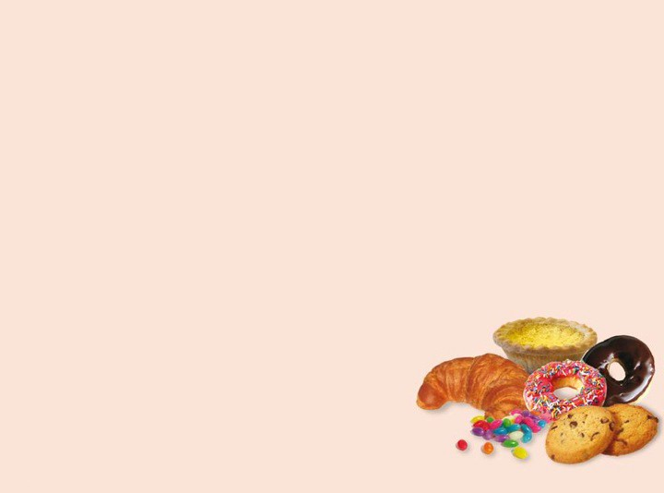

* Iced cakes and slices, doughnuts, Danishes, croissants, cream-filled buns/cakes
* All types: sold separately or added to products including; boiled lollies, carob, chocolate (including; boiled lollies, carob, chocolate (including choc chips and

chocolate-coated), chocolate spreads, cough lollies, 100s and 1000s, juice jellies, icing, liquorice, soft lollies, yoghurt/carob-coated

* Deep-fried foods
* Cream, coconut cream, coconut milk, butter, copha, ghee and lard

# DECIDING IF A FOOD OR DRINK IS SUITABLE FOR SALE



* Clearly fits the GREEN category – for sale
* Clearly fits the RED category – not for sale
* AMBER category – assess against Nutrient Criteria Hot Food and processed meats per 100 grams

Snack food items – per serve

* Some food and drinks categorised as AMBER have restrictions (for example: 99% fruit juice)

**NUTRIENT CRITERIA TABLES**



|  |  |  |  |
| --- | --- | --- | --- |
| **Table 1: Hot food items and processed meats assessed per 100g** | | | |
| **Category** | **Nutrient Criteria** | | |
|  | Energy (kJ) per 100g | Saturated fat (g) per 100g | Sodium (mg) per 100g |
| Savoury pastries, filled breads, pasta dishes, pizzas, oven-baked potato products, dim sims, spring rolls, rice and noodle dishes | 100kJ or less | 5g or less | 400mg or less |
| Meat products and alternatives crumbed and not-crumbed (burgers, patties, strips, balls or nuggets), sausages, frankfurts and saveloys, stews, casseroles and curries | 1000kJ or less | 5g or less | 450mg or less |
| Processed luncheon meats (fritz, devon, chicken loaf, free flow chicken products) and cured meats (for example: ham, bacon) | 1000kJ or less | 5g or less | 750mg or less |

|  |  |  |  |  |
| --- | --- | --- | --- | --- |
| **Table 2: Snack food items assessed per serve** | | | | |
| **Category** | **Nutrient Criteria** | | | |
|  | Energy (kJ) per serve | Saturated fat (g) per serve | Sodium (mg) Per serve | Fibre (g) per serve |
| Sweet snack food, bars and biscuits | 600kJ or less | 3g or less | - | 1g or more |
| Savoury snack food, biscuits, crispbreads and crisps | 600kJ or less | 2g or less | 200mg or less | - |
| --(Energy must be 1800kJ or less per 100g)-- | | | |
| Ice creams, milk-based ices and dairy desserts | 600kJ or less | 3g or less | - | - |
| --(Milk must be listed as first ingredient)-- | | | |
| Un-iced cakes, muffins and sweet pastries | 900kJ or less | 3g or less | - | 1.5g or more |



**SUPPORTING YOUR CANTEEN**

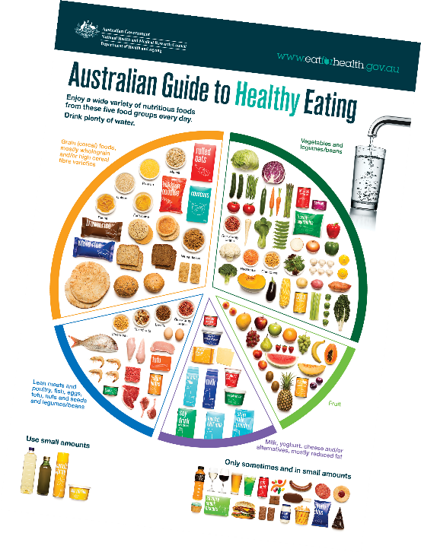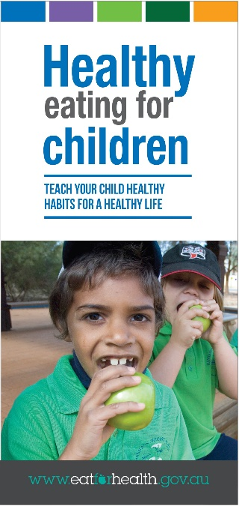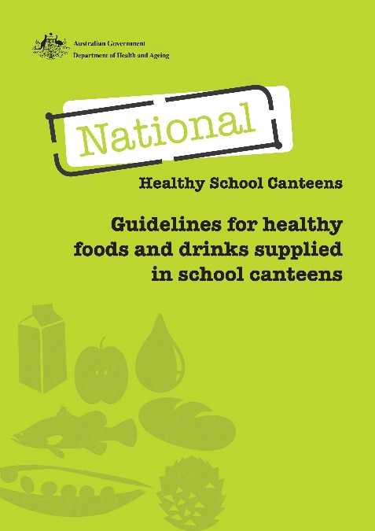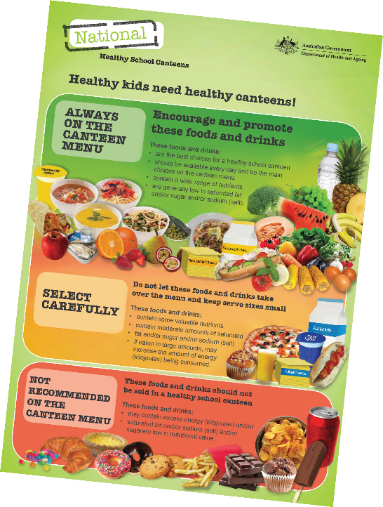

# HEALTHY YOUNG PEOPLE IN THE FUTURE

