Australian Government Department of Health logoBackground colour



National Healthy School

Canteens Project

# Training Program 1 Program Briefing



**PREVELANCE OF OVERWEIGHT AND OBESITY IN AUSTRALIAN CHILDREN**

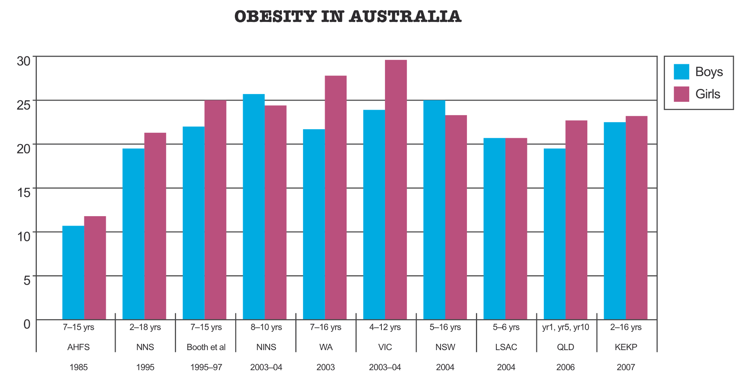Slide | 2

 

**CONTRIBUTING FACTORS**

* Changed diet
* Changed physical activity patterns





**IT’S ALL ABOUT BALANCE**

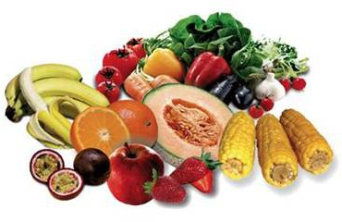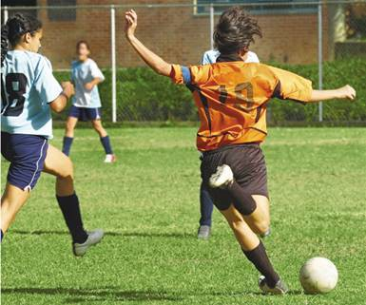

# Energy in = Energy out =

Food and drinks consumed Physical activity and

body functions



**2007 NATIONAL CHILDREN’S NUTRITION AND PHYSICAL ACTIVITY SURVEY1**

# Australian children aged 5-16 years

* Energy intake during school hours was 32% of total energy
* Fruit intake during school hours was 62% of total fruit consumed
* Vegetable intake during school hours was 17% of total vegetable consumed
* Calcium intake during school hours was 28% of total calcium

# Majority of children were of normal weight

* Prevalence of overweight ranged from 13-19% for boys and 15-23% for girls
* Girls in the age group of 9-13 years had the highest prevalence of overweight
* The prevalence of obesity was similar at 5-7% for both boys and girls

1 DoHA 2008. 2007 Australian National Children’s Nutrition and Physical Activity Survey, Main Findings, [http://www.health.gov.au/internetmain/publishing.nsf/Content/66596E8FC68FC68FD1A2570027DB86/$File/childrens-nuts-phys-survey.pdf](http://www.health.gov.au/internetmain/publishing.nsf/Content/66596E8FC68FC68FD1A2570027DB86/%24File/childrens-nuts-phys-survey.pdf)



**HEALTH PROMOTIONS SCHOOLS**

* School environment promotes health and wellbeing messages consistent with what is taught in the classroom
* Collaboration between schools, families and the wider community
* Support and involvement of school community members (including teachers and principals) in health programs and policies
* Working with food industry and local businesses and suppliers to develop and promote healthy food choices in school canteens

curriculum, teaching & learning



School organisation, ethos & environment

partnerships & services

Australian Health Promoting Schools Association 2010

[http://www.ahpsa.org.au](http://www.ahpsa.org.au/)

Slide | 6

**ROLE OF THE SCHOOL CANTEEN IN CONTRIBUTING TO A HEALTHY PROMOTING SCHOOL**

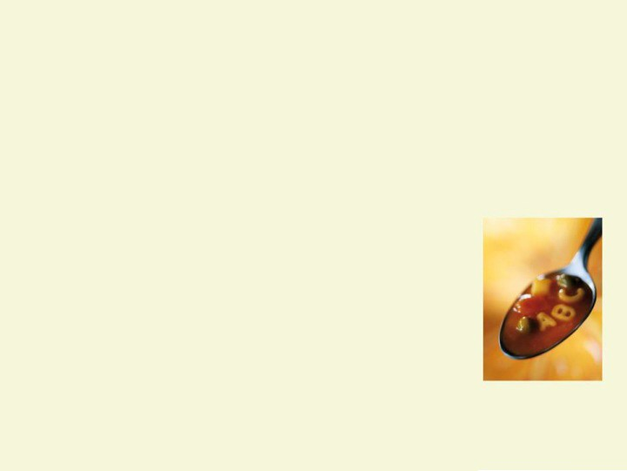

* Food intake and nutrition of students
* Reinforce classroom messages
* School culture of healthy eating



**NHSC FOOD CATEGORISATION SYSTEM**

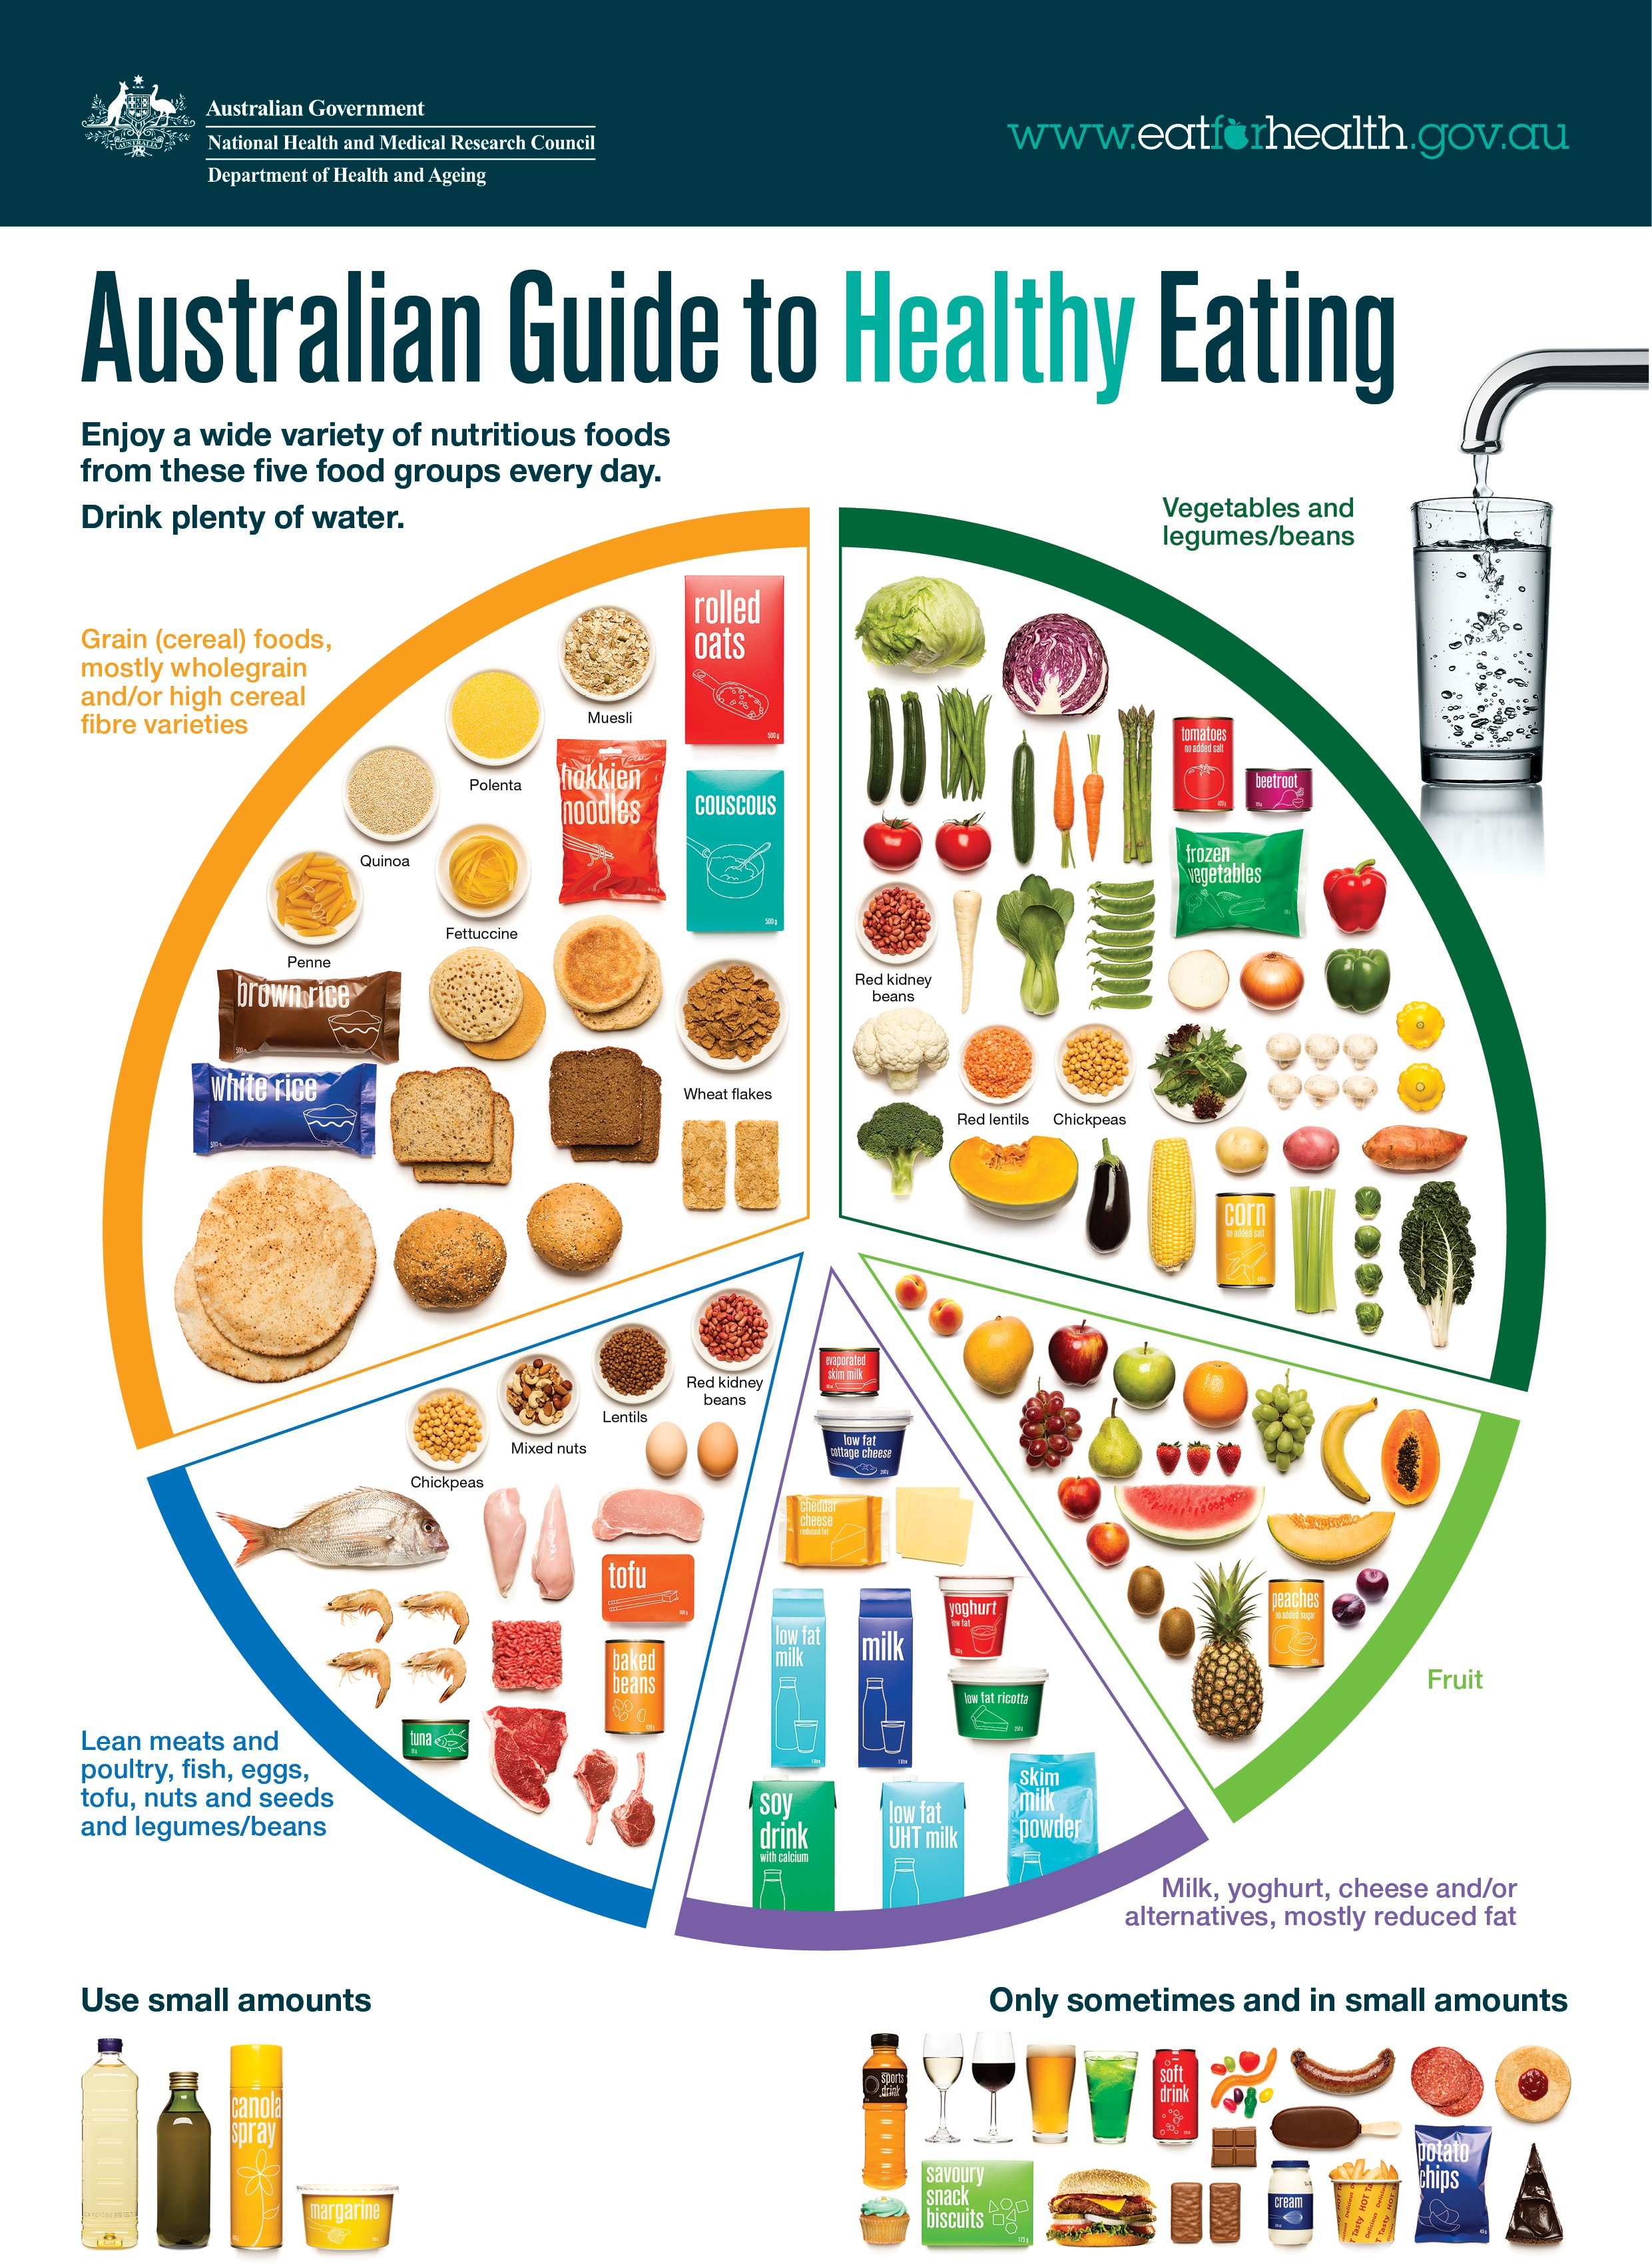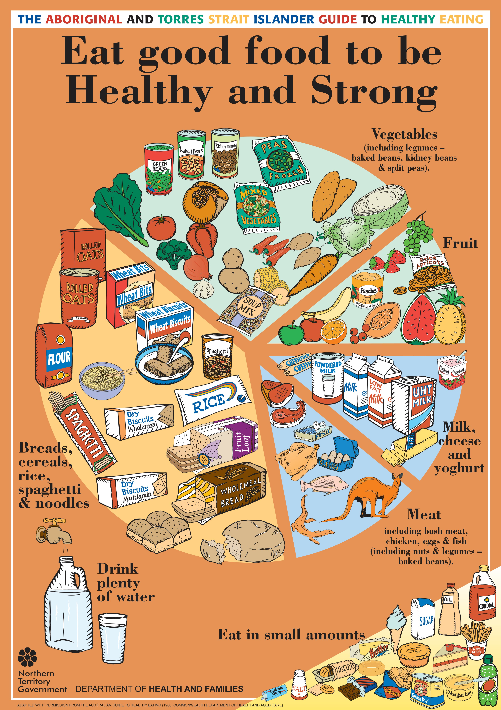**Purpose: *to assist canteen managers to make appropriate menu choices that encourage and reinforce the development of healthy eating patterns in schools.***

Consistent with:

* *The 2013 Australian Dietary Guidelines*
* *The Australian Guide*

*to Healthy Eating*

*The Australian Guide The Aboriginal and*

*to Healthy Eating 2013 Torres Straight Islander*

*Guide to Healthy Eating 2010* (Updated by NT Department of Health and Families

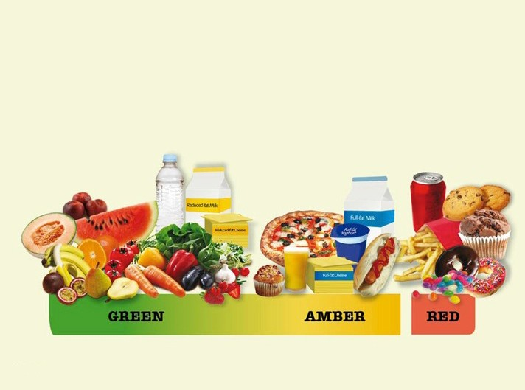 

Slide | 9

**BASIS FOR FOOD AND DRINK SELECTION**

Foods and drinks have been categorised as:



Encourage and promote these foods and drinks as

tasty, good value choices:

* Provide them every day
  + Present as the main choice

Because they:

**THE GREEN CATEGORY**

**ALWAYS ON THE CANTEEN MENU**

* + Offer a wide range of nutrients
  + Are generally low in saturated fats and/or added sugars and/or salt



Slide | 11

* Breads, wholegrain breakfast cereals (without

added confectionery), lower in added sugar, higher fibre

* + Dairy foods: low or reduced fat milk plain and flavoured, yoghurt, and cheese
  + Fruits (not dried); fresh, frozen or canned

**THE GREEN CATEGORY**

* + Vegetables (including legumes): fresh, frozen, canned



* Unprocessed lean meat and poultry, fish, eggs,

nuts*

* Rice, pasta, plain noodles
  + Water, plain and nothing added
    - Tap, spring, mineral or sparkling

**THE GREEN CATEGORY**

*Check your school policy regarding the use of nuts and products containing nuts

Slide | 12