

**Healthy School Canteens**

National

**Participant’s Workbook**

The *National Healthy School Canteens Project* is funded by the Australian Government Department of Health and Ageing.

###### National Healthy School Canteens Participant’s Workbook

ISBN: 978-1-74241-186-6 Online ISBN978-1-74241-187-3

Publications Approval Number 6500

###### Paper-based publications

© Commonwealth of Australia 2010

This work is copyright. Apart from any use as permitted under the *Copyright Act 1968*, no part may be reproduced by any process without prior written permission from the Commonwealth. Requests and inquiries concerning reproduction and rights should be addressed to the Commonwealth Copyright Administration, Attorney-General’s Department, Robert Garran Offices, National Circuit, Barton ACT 2600 or posted at <http://www.ag.gov.au/cca>

###### Internet sites

© Commonwealth of Australia 2010

This work is copyright. You may download, display, print and reproduce this material in unaltered form only (retaining this notice) for your personal, non-commercial use or use within your organisation. Apart from any use as permitted under the *Copyright Act 1968*, all other rights are reserved. Requests and inquiries concerning reproduction and rights should be addressed to Commonwealth Copyright Administration, Attorney-General’s Department, Robert Garran Offices, National Circuit, Barton ACT 2600 or posted at <http://www.ag.gov.au/cca>

**Participant’s Workbook**

# Table of Contents

Introduction 1

Learning objectives of the training 1

Workshop content 1

Workshop topics 1

Workshop activities 1

Workshop session plan 1

Participant resources 2

Icons used in this workbook 2

Formal Assessment: Vocational Education andTraining (VET) 3

Workplace Implementation Project 3

Introduction: The National Healthy School Canteens Training Program 4

Overview 4

Group discussion: Healthy school canteens 4

Web resources 5

Topic 1: Nutrition basics 6

Overview 6

Group discussion: Circumstances that affect eating habits 6

Activity: Nutrients of interest 7

Food labelling 8

Activity: Food label ingredient lists 8

Group discussion: Food label ingredient lists 9

Web resources 10

Topic 2: The NHSC food categorisation system 11

Overview 11

Activity: AGTHE activity 12

Activity: Sample menu – Sorting foods 13

Activity: Assessing menu items against NHSC criteria using provided food labels 14

Group discussion: Moving items categorised as AMBER towards the ‘GREEN’

end of the spectrum 14

Group discussion: Sodium content 14

Group discussion: School canteen menu 15

Topic 3: Special dietary and cultural needs 17

Overview 17

Group discussion: Role of the school canteen with regards to special dietary needs 17

Group discussion: Acknowledging cultural differences 17

Group discussion: Ethnic food days 17

Web resources 18

Summary 19

Appendix 1: National Healthy School Canteens Workplace Implementation Project 20

Objective 20

Why complete the Workplace Implementation Project? 20

Hints for developing the Project Report 20

The Workplace Implementation Project 21

Workplace Implementation Project Template 22

SITHCCC035A Develop menus to meet special dietary and cultural needs **25**

Unit descriptor 25

Employability skills 25

Prerequisite units 25

Application of the unit 25

Competency field 25

Sector 25

Elements and Performance Criteria 26

Required Skills and Knowledge 27

Range Statement 28

Evidence Guide 29

Web resources 30

Appendix 2: The FSANZ Nutrition Panel Calculator (Recipe Calculator) 31

Using the Nutrition Panel Calculator 32

Table 1: Weights and measures conversion table 47

Appendix 3: Example Student Survey Questionnaires 50

Example 1 50

Example 2 53

Acknowledgements 58

# Introduction

Welcome to the National Healthy School Canteens Workshop.

The aim of this training workshop is to provide you with the opportunity to develop the skills and understanding necessary to use the National Healthy School Canteens (NHSC) food categorisation system.

### Learning objectives of the training

When you have completed the workshop you will be able to:

* design a canteen menu in line with the NHSC food categorisation system, and
* assess individual manufactured food products against the nutrient criteria.

### Workshop content

The 3-hour workshop has three topics. Participant learning in each topic will be reinforced by a series of individual and group-based learning activities facilitated by the trainer during the workshop.

### Workshop topics

###### Topic 1: Nutrition basics

This is a basic introduction to the fundamentals of nutrition – nutrition is defined, key nutrients are identified and their roles discussed. The classification of foods according to *The Australian Guide to Healthy Eating* explained and explored.

###### Topic 2: The NHSC food categorisation system

The NHSC food categorisation system, based on *The Australian Guide to Healthy Eating* is described and explained and applied to menu items.

###### Topic 3: Special dietary and cultural needs

Special dietary and cultural needs are examined.

### Workshop activities

You will participate in a range of discussions and hands-on learning activities throughout the workshop. These activities are designed to help you apply healthy eating principles to canteen menu design and assess individual manufactured food products.

### Workshop session plan

The 3-hour workshop covers the theory and justification of the role of the school canteen in the health of

children and provides practical application in the planning of menus based on the nutrient criteria.

|  |  |
| --- | --- |
| **Activity** | **Time allocation** |
| Introduction | 20 minutes |
| Topic 1: Nutrition basics | 30 minutes |
| Break | 10 minutes |
| Topic 2: The NHSC food categorisation system | 60 minutes |
| Break | 10 minutes |
| Topic 3: Special dietary and cultural needs | 30 minutes |
| Summary | 20 minutes |

### Participant resources

* Participant’s Workbook
* NHSC *Guidelines for healthy foods and drinks supplied in school canteens*
* Poster (Healthy kids need healthy canteens!) x 3
* *The Australian Guide to Healthy Eating* (AGTHE) poster
* Quick Reference flip chart
* *Healthy Eating for Children* brochure
* Food labels
* Food Safety Fact Sheet

###### Additional materials to assist communicating changes to the school community

* Program briefing PowerPoint presentation and notes (CD)
* *Pocket Guide*

### Icons used in this workbook

Throughout this guide you will find icons representing various kinds of information to help you follow the

workshop activities.

Activities marked with this symbol involve brainstorming and group discussion.

Activities marked with this symbol involve group work and problem solving.



Website links for further reading at the end of each section.

# Formal Assessment:

**Vocational Education and Training (VET)**

### Workplace Implementation Project

Following the NHSC workshop, it is hoped you will review and update existing menus and recipes in your canteen to ensure they meet the NHSC guidelines.

To assist you with this process, a Workplace Implementation Project (the Project) has been developed (Appendix 1). The Project provides a framework and checklist to guide you through the implementation process.

It also allows you to document the skills you have already demonstrated over many years, as well as the new skills you have gained as a result of participating in the NHSC workshop.

An additional benefit is the option of obtaining a nationally recognised Statement of Attainment for the unit of competency SITHCCC035A *Develop menus to meet special dietary and cultural needs* if the evidence you supply meets the assessment requirements for that unit. The details for that unit of competency are included in the Project (Appendix 1).

Please note that if you wish to gain a Statement of Attainment for the unit you will need to contact a Registered Training Organisation (RTO) accredited to issue a Statement of Attainment for that unit. You will also need to meet that organisation’s assessment requirements.

A Statement of Attainment issued by an RTO is recognised nationally and contributes to several qualifications, including the Certificate III in Hospitality (Catering Operations), Certificate III in Hospitality (Commercial Cookery) and Certificate IV in Hospitality (Commercial Cookery).

Further information about SITHCCC035A *Develop menus to meet special dietary and cultural needs* can be found at the National Training Information Service website: http://www.ntis.gov.au/Default.aspx?/trainingpackage/SIT07

# Introduction: The National Healthy School Canteens Training Program

### Overview

The background to the development of the NHSC *Guidelines for healthy foods and drinks supplied in school canteens* is provided on page 1 of the *Guidelines for healthy foods and drinks supplied in school canteens*.

#### Group discussion: Healthy school canteens

What is a healthy school canteen?

#### Web resources

##### Australian Health Promoting Schools Association website

This website provides background information and resources on the health promoting schools approach. [http://www.ahpsa.org.au](http://www.ahpsa.org.au/)/

##### National Obesity Taskforce Paper: Healthy weight 2008: Australia’s Future: The National Action Agenda for Children and Young People and Their Families

This is the national plan to address the rising rates of overweight and obesity in a nationally coordinated approach.

<http://www.healthyactive.gov.au/internet/healthyactive/publishing.nsf/Content/publications-1>

##### Preventative Health Taskforce Strategy

This strategy has been developed to tackle the burden of chronic disease, including obesity in Australia, with the view of making Australia a healthier country by 2020.

<http://www.preventativehealth.org.au/internet/preventativehealth/publishing.nsf/Content/national>- preventative-health-strategy-1lp

##### 2007 Australian National Children’s Nutrition and Physical Activity Survey – Main Findings

This survey assessed the food, nutrient intake and physical activity levels of children aged 2-16 years in Australia. Every participant’s weight, height and waist circumference were also measured.

<http://www.health.gov.au/internet/main/publishing.nsf/Content/phd-nutrition-childrens-survey>

# Topic 1: Nutrition basics

### Overview

The training begins with some basic nutrition information so that everyone will have a similar understanding by the end of the day.

#### Group discussion: Circumstances that affect eating habits



What factors influence the requirements of canteen customers?

#### Activity: Nutrients of interest



What foods contain mostly saturated or unsaturated fats? Tick one or the other.

|  |
| --- |
| **Saturated Unsaturated** |
| Avocado |
| Butter |
| Canola oil |
| Cheese |
| Coconut cream |
| Coconut milk |
| Cream |
| Fatty meat |
| Fish |
| Game meat (for example, kangaroo, rabbit)  Margarine |
| Milk |
| Nuts |
| Olives |
| Olive oil |
| Palm oil |
| Seeds |
| Sunflower oil |
| Vegetable oil  (no specification) |

### Food labelling

#### Activity: Food label ingredient lists



Look at the labels below for strawberry yoghurt and cereal.

**Full-fat strawberry yoghurt**

**Ingredient List:** Low-fat **milk**, **milk** solids non fat, sugar, cream (contains **milk**), strawberries (min. 5%), fructose, thickener (1442), lemon juice, flavours, natural colours (120, 160b), preservative (200), live yoghurt cultures: s.thermophilus, l.acidophilus & bifidobacterium.

Is the first ingredient what you expected it to be?

What is the percentage of strawberries in this product?

What ingredients make this a full-fat product?

How many types of sweetening agents are listed?

Can you see the list of allergens? What are they?

**Breakfast cereal – ‘Grainburst’**

**Ingredient List:** Cereals (32%) (wheat flour, oatmeal, maize flour), choc compound (20%) (sugar, palm oil, whey powder, cocoa, emulsifier [soy lecithin], flavour [vanilla]), sugar, glucose, wheat gluten, glucose solids, fructose, dextrose, humectants (glycerol, sorbitol), vegetable oils (hydrogenated soyabean oil [antioxidant (320)], hydrogenated palm oil), treacle, barley malt extract, molasses, salt, mineral salt (sodium bicarbonate), natural colours (caramel III, paprika, turmeric), flavour, emulsifier (soy lecithin).

**Contains gluten containing cereals, milk and soy. May contain traces of peanuts and/or tree nuts.**

Is the first ingredient what you expected it to be?

What is the next ingredient?

What does that tell you?

How many types of sweetening agents are listed?

Can you see the list of allergens? What are they?

#### Group discussion: Food label ingredient lists

What claims do you look for on food packages when ordering for the school canteen?

#### Web resources

###### Australian Guide to Healthy Eating

The *Australian Guide to Health Eating* is a food selection guide which visually represents the proportion of the five food groups recommended for consumption each day. It reflects the multicultural nature of the population relevant for all sectors of the food and nutrition industry.

<http://www.eatforhealth.gov.au/guidelines/australian-guide-healthy-eating>

###### Children Nutrition Topics (Victorian Government Health Information)

This website provides fact sheets and information about nutrition for infants, toddlers, preschoolers and children at school.

<http://www.health.vic.gov.au/nutrition/child_nutrition/child_nutrition.htm>

2013 Australian Dietary Guidelines

*The 2013 Australian Dietary Guidelines* are based on the best available scientific evidence and provide information for health professionals and the general population about healthy food choices. The use of the guidelines will encourage healthy lifestyles that will minimise the risk of the development of diet-related diseases within the Australian population. <https://www.eatforhealth.gov.au/sites/default/files/files/the_guidelines/n55_australian_dietary_guidelines.pdf>

###### Dietitians Association of Australia (DAA) – Smart Eating For You: Nutrition A–Z

This guide covers nutrition information presented in an A–Z format. All material available on this website has been written and regularly reviewed by Accredited Practising Dietitians. <http://www.daa.asn.au/index.asp?PageID=2145842141>

###### Food Standards Australia New Zealand Government Website

The Food Matters part of this website contains information on reading food labels, food allergies, additives and other information in relation to food standards set in Australia and New Zealand. [http://www.foodstandards.gov.au](http://www.foodstandards.gov.au/)/

###### Fresh for Kids

This website, provided by the Sydney Markets, includes information on seasonal produce, as well as fun things for kids to do relating to healthy eating.

[http://www.freshforkids.com.au](http://www.freshforkids.com.au/)/

###### Healthy Weight Guide (Australian Government)

The Healthy Weight Guide is a comprehensive source of information which is available to the Australian public on how to achieve and maintain a healthy weight. The Healthy Weight Guide consists of an interactive website as well as printed materials for those who don’t have access to the internet, and provides: information about healthy weight, physical activity and healthy eating; tips and tools to assist with setting goals and planning healthy meals and physical activity; and a registered area where users can record and track their weight and progress.

[www.healthyweight.health.gov.au](http://www.healthyweight.health.gov.au/)

###### Health Insite – Food and Nutrition

An Australian Government Initiative, this website contains links to topics such as diet, family nutrition and key nutrients.

<http://www.healthinsite.gov.au/topics/Food_and_Nutrition>

###### Nutrient Reference Values for Australia and New Zealand

The Nutrient Reference Values (NRVs) are a set of recommendations for nutritional intake based on currently available scientific knowledge. On this page, you will find information on a wide variety of foods and the nutrients they contain. There is also a calculator for determining the nutrient recommendations for specific ages and genders.

[http://www.nrv.gov.au](http://www.nrv.gov.au/)/

# Topic 2: The NHSC food categorisation system

### Overview

This topic provides you with the skills required to assess foods and drinks against the NHSC food categorisation system.

The following table is the recommended serves for children based on *The Australian Guide to Healthy Eating* (AGTHE) and is provided for your information to assist you with answering the next question.

This information is also supplied in the NHSC *Guidelines for healthy foods and drinks supplied in school canteens* on pages 2-3.

|  |  |  |  |  |
| --- | --- | --- | --- | --- |
| **Food Groups** | **Number Of Serves** | | | |
| **Boys** | **4 – 8 years** | **9 – 11 years** | **12 – 13 years** | **14 – 18 years** |
| Vegetables | 4 ½ | 5 | 5 ½ | 5 ½ |
| Fruit | 1 ½ | 2 | 2 | 2 |
| Grain (cereal) | 4 | 5 | 6 | 7 |
| Lean meats and alternatives | 1 ½ | 2 ½ | 2 ½ | 2 ½ |
| Dairy and alternatives | 2 | 2 ½ | 3 ½ | 3 ½ |
| **Girls** | **4 – 8 years** | **9 – 11 years** | **12 – 13 years** | **14 – 18 years** |
| Vegetables | 4 ½ | 5 | 5 | 5 |
| Fruit | 1 ½ | 2 | 2 | 2 |
| Grain (cereal) | 4 | 4 | 5 | 7 |
| Lean meats and alternatives | 1 ½ | 2 ½ | 2 ½ | 2 ½ |
| Dairy and alternatives | 1 ½ | 3 | 3 ½ | 3 ½ |

**\*Note:** Additional serves of the five food groups or unsaturated spreads and oils or discretionary choices are needed only by children and

adolescent who are taller, more active or in the higher end of a particular age band, to meet additional energy requirements.

#### Activity: AGTHE activity



How many serves would the following be?

Use the serve size table below to work out the number of serves of different foods listed on slide 42.

|  |  |
| --- | --- |
| **Food Groups** | **Serve Size** |
| * ½ cup cooked green or orange vegetables (eg broccoli, spinach, carrots or   **Vegetables –** pumpkin)  **different types**  ½ cup cooked dried or canned , peas or lentils  **and colours, and**  **legume/beans**  1 cup green leafy or raw salad vegetables, ½ cup sweet corn, ½ medium potato or other starchy vegetables (sweet potato, taro or cassava), 1 medium tomato | |
| **Fruit** | * 1 medium apple, banana, orange or pear * 2 small apricots, kiwi fruits or plums * 1 cup diced or canned fruit (no added sugar) |
| * 1 slice bread, ½ medium roll or flat bread,   **Grain (cereal)**  ½ cup cooked rice, pasta, noodles, barley, buckwheat, semolina, polenta,  **foods, mostly** bulgur or quinoa  **wholegrain and/or**  **high in fibre**  ½ cup cooked porridge, 2/3 cup cereal flakes, ¼ cup muesli   * 3 crispbreads, 1 crumpet, 1 small English muffin or scone | |
| **Lean meats and poultry, fish, eggs, tofu, nuts and seeds, and legumes/beans** | * 65 g cooked lean red meats such as beef, lamb, veal, pork, goat or kangaroo (about 90-100 g raw) * 80 g cooked lean poultry such as chicken or turkey (100 g raw) * 100 g cooked fish fillet (about 115g raw) or one small can of fish * 2 large eggs (120 g), 1 cup (150 g) cooked or canned legumes/beans such as lentils, chick peas or split peas * 30 g nuts*, seeds, peanut* or almond butter *or tahini or other nut or seed paste |
| * 1 cup (250ml) milk, ½ cup (120 ml) evaporated milk, 2 slices (40 g) hard   cheese, such as cheddar  **Milk, yoghurt,**  **cheese and/or their**  ½ cup (120 g) ricotta cheese  **alternatives, mostly**  ¾ cup (200 g) yoghurt  **reduced fat**   * 1 cup (250ml) soy, rice or other cereal drink with at least 100mg of added   calcium per 100ml | |

*Check your school policy regarding the use of nuts and products containing nuts



**NHSC**

**The AGTHE - How much is a serve?**

**Healthy School Canteens**

How many serves would the following be? (Workbook, p.12)

**serve total**

2 apricots

1 cup of milk

1 beef sandwich with: 2 slices of bread 1 slice of beef 3 slices of tomato

¼ cup of cucumber and lettuce

2 teaspoons of margarine

National

#### Activity: Sample menu – Sorting foods



Decide if each of these foods and drinks may be sold in the school canteen.

Refer to pages 6, 7 and 8 in the *Guidelines for healthy foods and drinks supplied in school canteens* to determine if these items are categorised as **GREEN**, **AMBER** or **RED**. Place a tick in the appropriate column below. Items you are not sure about will be assessed using the Food Tables or Nutrient Criteria Tables later in the session.

**Item**

|  |  |  |  |  |
| --- | --- | --- | --- | --- |
|  | **Category (please tick one)** | | | |
|  | **GREEN** | **AMBER** | **RED** | **NOT SURE** |
| **Drinks** |  | | |  |
| Full-fat plain milk (375mL) |  |  |  |  |
| Iced tea |  |
| Low-fat flavoured milk |  |
| (375mL) |  |
| Water |  |
| Lemonade |  |
| Orange juice (200mL) |  |
| Apple juice (600mL) |  |
| **Snacks** |  | |  |
| Raisin toast |  |  |  |
| Icy-pole (lemonade) |  |
| Pizza flavoured snack biscuits |  |
| Doughnut |  |
| Cheese & crackers |  |
| Fresh fruit salad |  |
| Muesli bar |  |
| **Main meals** | |  | |  |
| Hamburger |  |  |  |  |
| Sushi |  |
| Two minute noodles |  |
| Ham sandwich |  |
| Pizza |  |
| Tuna sandwich with salad |  |
| Beef pie |  |

#### Activity: Assessing menu items against NHSC criteria using provided food labels



This activity will give you the opportunity to practise assessing commercial food items using the NHSC Nutrient Criteria Tables on pages 10 and 11 of the *Guidelines for healthy foods and drinks supplied in school canteens.*

Work in small groups with the food labels provided.

#### Group discussion: Moving items categorised as AMBER towards the ‘GREEN’ end of the spectrum

Brainstorm ideas about how you could move each of the menu items towards the ‘**GREEN**’ end of the spectrum.

#### Group discussion: Sodium content

How can you reduce the sodium content of dishes?

#### Group discussion: School canteen menu

Working in small groups, discuss how to maintain a balance of nutrition and variety in seasonal menus.

How do you incorporate variety into your canteen menu?

How can students be included in decisions regarding the school canteen menu?

What changes would you make to the sample menu on page 16 of your workbook?

SCHOOL CANTEEN MENU

**Sandwiches**

Cheese. $2.00

Egg & lettuce. $2.50

Tuna. $2.50

Ham. $3.00

Roast chicken. $3.00

Rainbow $3.00

*Carrot, beetroot, capsicum, lettuce and tomato*

Salad + meat. $4.00

*Ham, chicken, tuna*

Mini Salad Tub. $1.50

NHSC Wrap. $4.00

*Tortilla with salad plus your choice of*

*Chicken, Ham or Tuna with avocado, hommus or margarine*

## Snacks

Rice Cakes. $1.00

*BBQ or Chicken*

Popcorn $1.00

*BBQ, Chicken or Plain*

100% Fruit Juice Jelly Cup. $0.60

Cheese & Crackers. $1.20

100% Fruit Straps. $0.60

Raisin Toast. $2.00

Low-fat Yoghurt. $1.50

*Vanilla, Apricot or Strawberry*

## Drinks

Plain Milk (300mL). $1.00

Light Flavoured Milk. $1.60

*300mL Chocolate or Strawberry*

Water 400mL. $1.20

Juice – 100%. $1.20

*Apple/Blackcurrant, Apple, Orange*

DAILY SPECIALS

MONDAY TUESDAY

Page | **16**

WEDNESDAY THURSDAY FRIDAY

Grilled chicken burger with salad. $4.00

*Chicken pattie, lettuce & light mayo Vegie pattie, lettuce, tomato & sauce*

Sushi. $2.70

*Chicken or Vegetable*

Vegie pasta bake. $3.50

Baked potato and savoury mince. $3.50

Hokkien noodle stir-fry $3.00

# Topic 3: Special dietary and cultural needs

### Overview

This topic covers special dietary requirements that may concern the school canteen.

#### Group discussion: Role of the school canteen with regards to special dietary needs

What do you think the role of the school canteen is in regards to special dietary needs?

#### Group discussion: Acknowledging cultural differences

How many different cultures are represented at your school? Does your canteen menu cater for different cultures and cuisines? Why should you do this?

#### Group discussion: Ethnic food days

What foods could you cook on these days?

**Note:** Your trainer will provide you with a list of contacts (dietitians/nutritionists, medical specialists or other relevant people), who are able

to assist you to confirm and/or identify, where appropriate, the dietary and cultural requirements of different target groups.

#### Web resources

###### Children Nutrition Topics (Victorian Government Health Information)

This website provides fact sheets and information about nutrition for infants, toddlers, preschoolers and children at school.

<http://www.health.vic.gov.au/nutrition/child_nutrition/child_nutrition.htm>

###### Dietitians Association of Australia (DAA) – Smart Eating For You: Nutrition A–Z

This guide covers nutrition information presented in an A-Z format and includes information on vegetarian diets. All material available on this website has been written and regularly reviewed by Accredited Practising Dietitians.

<http://www.daa.asn.au/index.asp?PageID=2145842141>

###### Food Standards Australia New Zealand Government Website

The Food Matters section of this website contains information on food allergies, additives and other information in relation to standards set in Australia and New Zealand for food. The News Room link provides fact sheets, media releases, speeches and presentations. [http://www.foodstandards.gov.au](http://www.foodstandards.gov.au/)

###### Fresh for Kids

This website provided by the Sydney Markets, includes information on seasonal produce, as well as fun things for kids to do relating to healthy eating.

[http://www.freshforkids.com.au](http://www.freshforkids.com.au/)/

###### Go for 2&5

This website promotes the benefits of eating fruit and vegetables and gives loads of tips and recipes on

how to reach the recommended targets. [http://www.gofor2and5.com.au](http://www.gofor2and5.com.au/)/

###### Stephanie Alexander Kitchen Garden Foundation

This website provides inspiration and ideas for starting a kitchen garden in your school. [http://www.kitchengardenfoundation.org.au](http://www.kitchengardenfoundation.org.au/)/

###### The Australian Society of Clinical Immunology and Allergy

This is the peak professional body of Clinical Immunologists and Allergists in Australia and New Zealand. The website gives up-to-date information on allergy and immune diseases, including asthma. [www.allergy.org.au](http://www.allergy.org.au/)/

###### State and Territory Canteen Associations

These websites provide tips on how to successfully run a school canteen.

###### NSW School Canteen Association

[http://www.schoolcanteens.org.au](http://www.schoolcanteens.org.au/)/

**QLD Association of School Tucksho**ps [http://www.qast.org.au](http://www.qast.org.au/)/

**TAS School Canteen Associatio**n [http://www.tascanteenassn.org.au](http://www.tascanteenassn.org.au/)/

**VIC School Canteen Associat**ion [http://www.vsca.org.au](http://www.vsca.org.au/)/

**WA School Canteen Associatio**n <http://www.waschoolcanteens.org.au/default.htm>

# Summary

###### Today you should have:

* Gained a basic understanding of nutrition:
  + including the *2013 Australian Dietary Guidelines*
  + *The Australian Guide to Healthy Eating*
  + the importance of certain nutrients of interest, and
  + the NHSC *Guidelines for healthy foods and drinks supplied in school canteens*
* Developed the skills needed to apply these guidelines both by using the general principles of healthy eating and by reading food labels.
* Materials to take away:
  + *Guidelines for healthy foods and drinks supplied in school canteens*
  + *Quick Reference* flip chart
  + Poster *(Healthy kids need healthy canteens!)* x 3
  + Food Safety fact sheet
  + The *Australian Guide to Healthy Eating* poster
  + *Healthy Eating for Children* brochure

###### Additional materials that will be supplied to help you communicate the NHSC guidelines to your school community include:

* CD containing PowerPoint program briefing with presenter’s notes, and
* *Pocket Guide.*

# Appendix 1: National Healthy School Canteens Workplace Implementation Project

### Objective

The objective of the Workplace Implementation Project (the Project) is to develop a report providing evidence that, following the National Healthy School Canteens (NHSC) workshop, you have planned and implemented the *Guidelines for healthy foods and drinks supplied in school canteens* and demonstrated the competencies outlined in the Tourism, Hospitality and Events Training Package (SIT07) unit SITHCCC035A *Develop menus to meet special dietary and cultural needs*.

### Why complete the Workplace Implementation Project?

The project provides a framework and checklist that will guide you through the implementation process. It also allows you to document the skills you have already demonstrated over many years as well as the new skills you have gained as a result of participating in the NHSC workshop.

An additional benefit is the option of obtaining a nationally recognised Statement of Attainment for the unit of competency SITHCCC035A *Develop menus to meet special dietary and cultural needs* if the evidence you supply in the Project meets the assessment requirements. The details of that unit of competency are included at the end of Appendix 1.

Please note that if you wish to gain a Statement of Attainment, you will need to contact a Registered Training Organisation (RTO) accredited to issue a Statement of Attainment, for that unit. You will also need to meet that organisation’s assessment requirements. A Statement of Attainment issued by an RTO is recognised nationally and contributes to several qualifications, including the Certificate III in Hospitality (Catering Operations), Certificate III in Hospitality (Commercial Cookery) and Certificate IV in Hospitality (Commercial Cookery).

Further information about the Unit SITHCCC035A *Develop menus to meet special dietary and cultural needs* can be found at the National Training Information Service website: http://www.ntis.gov.au/Default.aspx?/trainingpackage/SIT07

### Hints for developing the Project Report

The development of the Project Report should be a relatively easy task once you have identified how the

skills gained in the National Healthy School Canteens workshop will be implemented.

You can use the Project template (pages 22-24 of your workbook) to assist you in implementing the changes required for your canteen to meet the guidelines. As you work through the implementation process, document each of the steps undertaken. By doing this you are able to achieve the objectives of the NHSC program, as well as the possible gaining of a Statement of Attainment for the unit SITHCCC035A *Develop menus to meet special dietary and cultural needs* as the documentation should provide most of the required evidence.

The evidence must demonstrate the process used to plan and implement the guidelines, including a continuous improvement strategy.

The evidence provided can include the following:

* An implementation plan
* Meeting minutes
* Menus and recipes
* Use of the recipe calculator (FSANZ Nutrition Panel Calculator, Appendix 2)
* The consultation process
* Data on student and staff population in relation to special dietary and cultural needs
* Student/staff/parent/guardian continuous improvement surveys, results and action plans (Example Student Survey Questionnaires, Appendix 3)
* Awards or recognition (including Certification) for meeting standards related to the *Guidelines for healthy foods and drinks supplied in school canteens*
* Confirmation from the person responsible for overseeing the canteen that the guidelines have

been met and that you demonstrate the competencies outlined in the

* SITHCCC035A *Develop menus to meet special dietary and cultural needs.*

### The Workplace Implementation Project

The Project should include the following content:

1. The special dietary and cultural needs of the customers of your canteen and how you obtained that information.
2. The method you used to take into consideration contemporary dietary trends when assessing dietary requirements of your customers.
3. The menus and recipes you have developed for your canteen that meet the requirements of:
   * the *Guidelines for healthy foods and drinks supplied in school canteens*
   * macro and micro nutrient balance
   * special dietary and cultural needs
   * good menu planning principles
   * texture, composition and portion size
   * sufficient menu choices.
4. The seasonal and special occasion menus you have developed to meet the requirements

identified in 3 above.

1. The review you undertook of current food preparation and cooking methods and the methods you have implemented to maximise the nutritional value of food available in your canteen.
2. The costing you completed for each menu to ensure that it complies with the costing standards for your canteen.
3. The evaluation strategy you developed to identify customer satisfaction.
4. The method you will use to adjust menus and recipes to address the findings of the customer satisfaction evaluations while still meeting special dietary and cultural needs and the *Guidelines for healthy foods and drinks supplied in school canteens.*
5. You will also need to summarise the communication process used to identify and implement

menus and recipes that meet the requirements identified in 3 above.

1. During the development of the Project report, and prior to submitting it, you need to review all steps to ensure that correct terminology has been used in the development, implementation and continuous improvement of menus and recipes to meet the requirements identified in 3 above.

### Workplace Implementation Project Template

The following table provides a template to assist you in developing and implementing the NHSC guidelines.

|  |  |  |
| --- | --- | --- |
| **Implementation Step** | **Action** | **Evidence** |
| **1. Identify the special dietary and cultural needs of the customers of your canteen.** | Use a survey or other means to identify Special Dietary and Cultural Needs of customers (students and staff). | The results of a survey or other method used to gain information on the range and demand for special dietary or cultural needs. |
|  | Hint: | Needs identified could include: |
|  | In developing the method of gathering the information, consider the range of factors that may be relevant to the group that makes up your customers. | Special dietary needs:   * Vegetarian * Vegan * Modified sodium or potassium |
|  | Factors to consider: | * Low-fat or low-cholesterol |
|  | * Age requirements * Lifestyle * Food preferences * Food restrictions or allergies * Physical condition * Nutritional requirements * Cultural or religious needs | * Lacto-ovo * High-fibre * Gluten-free * High or low-energy * Diabetic * Modified texture * High or low-protein * Fluids |
|  |  | * Exclusions for allergies and |
|  |  | * food intolerance |
|  |  | Cultural/religious needs: |
|  |  | * Kosher |
|  |  | * Halal |
|  |  | * Vegetarian |
| **2. Identify how you took** | Check with a dietitian to determine | Proof of the process used to identify |
| **into consideration** | the contemporary dietary trends | contemporary dietary trends and |
| **contemporary dietary trends** | and their compatibility with the | the consultation to ensure where |
| **when assessing dietary** | *Guidelines for healthy foods and* | the trends are compatible with the |
| **requirements of** | *drinks supplied in school canteens.* | *Guidelines for healthy foods and* |
| **your customers.** |  | *drinks supplied in school canteens.* |
| 1. **Develop menus and recipes for your canteen that meet the requirements of:**    * **the *Guidelines for healthy foods and drinks supplied in school canteens***    * **macro and micro nutrient balance** | Using the information, tools and skills gained in the NHSC workshop, develop menus that meet the requirements. | The resources and tools used to determine whether the menu and recipe ingredients meet the requirements: for example, evidence of the use of a recipe  calculator to determine if a menu meets the requirements. |
| * **special dietary and cultural needs** |  |  |
| * **good menu planning principles** |  |  |
| * **texture, composition and portion size** |  |  |
| * **sufficient menu choices.** |  |  |

|  |  |  |  |
| --- | --- | --- | --- |
| **4.** **Develop seasonal and special occasion menus to meet the requirements identified in**  **3 above.** | | Develop a process and methodology to make sure that any changes in menus or  recipe ingredients still meet the  requirements identified in 3 above. | Provide evidence of seasonal and special occasion menus and the process and methodology used to ensure the requirements identified in 3 above are maintained. |
| **5. Review current food preparation and cooking methods and identify and implement methods that maximise the nutritional value of food available in your canteen.** | | Review food preparation and cooking methods and implement methods that maximise the nutritional value of food available in the canteen. | Evidence of changes in food preparation and cooking methods and how the changes have improved the nutritional value of food available in the canteen. |
| **6.** | **Cost each menu to ensure** | Using the costing sheet/ | Evidence of the costing calculations |
|  | **that it complies with the** | methodology for your canteen, cost | for the menu that meets the |
|  | **costing standards for your** | the menus developed to meet the | requirements identified in 3 above. |
|  | **canteen.** | requirements in 3 above. |  |
| **7.** | **Develop an evaluation strategy to identify customer satisfaction.** | Develop a strategy to measure customer satisfaction. This can include a customer satisfaction survey, one-on-one interviews with customers with special dietary or cultural menu needs and feedback from stakeholders including parents, dietitians and staff. The strategy should identify the frequency of the evaluations and method used to assess and act on the results. | Evidence of the tools used to measure customer satisfaction, the results of the evaluation and action plan to make changes  where required. |
| **8.** **Adjust menus and recipes to**  **address the findings of**  **the customer satisfaction evaluation while still meeting special dietary and cultural needs and the *Guidelines***  ***for healthy foods and drinks supplied in school canteens*.** | | Based on the results of the customer satisfaction evaluation, adjust the menus and recipes.  Ensure that any adjustments still maintain the requirements of:   * the Healthy School Canteens guidelines * macro and micro nutrient balance * special dietary and cultural needs * good menu planning principles * texture, composition and   portion size   * sufficient menu choices. | Evidence of changes made to menus and recipes as a result of the evaluation. Methods used to ensure that the menu and recipe requirements are maintained following the changes. |

|  |  |  |
| --- | --- | --- |
| **9. Summarise the communication process used to implement menus** **and recipes that meet the** **requirements identified in 3 above.** | As you work through the process of developing new menus and recipes, document who you liaised with to identify the requirements  and how confirmation was gained that the menus and recipes meet the requirements. | Evidence can include:   * List of people/organisations from whom advice and assistance was received * Records of meetings * Emails |
|  |  | * Reports |
|  |  | Please note:  Wherever possible, keep records of both verbal and written communications. These prove valuable records that can be used by future canteen managers should you resign or be absent. |
| **10. Review all steps to ensure that correct terminology has been used in the**  **development, implementation and continuous improvement of menus and recipes to meet the requirements.** | Check all procedures and documentation to ensure that correct terminology has been used, particularly in compliance with the terminology used in the *Guidelines for healthy foods and drinks supplied in school canteens.* | The terminology used in actual menu and recipe descriptions and in evidence provided for the consultation/ communications process used. Evidence of confirmation by a qualified person (for example, dietitian) that the correct terminology has been used in all documentation and communication.  Please note:  The correct terminology should be adopted at the commencement of the implementation process rather than at the end. The final review should require few or no changes in terminology. |

### SITHCCC035A

***Develop menus to meet special dietary and cultural needs***

##### Unit descriptor

This unit describes the performance outcomes, skills and knowledge required to develop menus and meal plans for all Australians, including meeting specific dietary and cultural needs. The unit focuses on the knowledge and skills required to meet nutritional requirements in the preparation of meal plans, diets and menus. The menu may be developed with or without the direction of a dietician or medical specialist, depending on the job role. This unit does not cover preparation and cooking of food to meet dietary and

cultural needs which is addressed in SITHCCC029A *Prepare foods according to dietary and cultural needs.* Nor does it focus on general menu planning principles involving budgetary and marketing concerns, which are covered in SITHCCC040A *Design menus to meet market needs*. Evidence is required of knowledge and understanding of a range of different cultural, dietary and special requirements.

However, the focus of this range will vary according to the target markets of a particular workplace. Special dietary needs include therapeutic and contemporary regimes as well as customer requests. No licensing, legislative, regulatory or certification requirements apply to this unit at the time of endorsement.

##### Employability skills

The required outcomes described in this unit of competency contain applicable facets of employability skills. The Employability Skills Summary of the qualification in which this unit is packaged will assist in identifying employability skills requirements.

##### Prerequisite units

Nil

##### Application of the unit

This unit applies to those responsible for developing menus in all catering operations where food and related services are provided such as restaurants, educational institutions, health establishments, defence forces, cafeterias, kiosks, cafes, residential catering, in-flight and other transport catering, events catering and private catering. Those undertaking this role would be supervisors or managers and may be chefs or others such as catering managers.

##### Competency field

Commercial Cookery and Catering

##### Sector

Hospitality

##### Elements and Performance Criteria

Elements describe the essential outcomes of a unit of competency.

Performance criteria describe the required performance needed to demonstrate achievement of the element. Where ***bold italicised*** text is used, further information is detailed in the required skills and knowledge and/or the range statement. Assessment of performance is to be consistent with the evidence guide.

|  |  |
| --- | --- |
| **Element** | **Performance Criteria** |
| **1.** **Identify the dietary and** **cultural requirements of customers.** | 1.1 Identify the ***dietary*** and ***cultural requirements*** of different ***target groups*** through consideration of all appropriate ***factors***. |
|  | 1.2 Take into consideration ***contemporary dietary trends and regimes***  in assessing dietary requirements. |
|  | 1.3 Liaise with dieticians, medical specialists or other relevant people in  order to identify and confirm requirements, where appropriate. |
| **2.** **Develop menus and meal plans to meet dietary and** **cultural requirements.** | 2.1 Select a variety of suitable foods, meals and menus for specific requirements taking account of *Dietary Guidelines for Australians*and menu planning principles. |
|  | 2.2 Develop ***menus and meal plans*** that promote good health and reduce the incidence of dietrelated health problems, in consultation with relevant people and according to job role. |
|  | 2.3 Prepare cyclic menus when required and balance them in terms of nutritional requirements and variety. |
|  | 2.4 Recommend food preparation and cooking methods to maximise nutritional value of food. |
|  | 2.5 Identify appropriate combinations of food to meet macro and micro nutrient requirements. |
|  | 2.6 Take into consideration special needs, including texture, composition  and portion size. |
|  | 2.7 Incorporate sufficient choice of dishes into the menus. |
|  | 2.8 Cost menus to comply with costing constraints. 2.9 Use correct terminology in menus and meal plans. |
| **3. Evaluate meals and menus.** | 3.1 ***Evaluate*** meals and menus to ensure customer satisfaction |
|  | 3.2 Adjust menus as required to ensure dietary needs and goals are met. |

### Required Skills and Knowledge

This section describes the essential skills and knowledge and their level required for this unit. The following skills must be assessed as part of this unit:

* cookery techniques and recipe modification to suit special dietary requirements
* literacy skills to read and write menus and recipes
* communication skills to liaise with dieticians and relevant people, clarify requirements, provide information, and listen to and interpret information and non-verbal communication
* numeracy skills to calculate nutritional values of foods and menus and to calculate cost of menus.

The following knowledge must be assessed as part of this unit:

* basic principles and practices of nutrition, including:
  + nutrients and their food sources
  + influences on food choice
  + food labelling requirements and interpretation
  + food additives and preservatives
  + health implications of food choices
* *2013 Australian Dietary Guidelines*
* dietary sensitivities, including food allergies and intolerances, diabetes and other medical conditions
* existence of drug–food interactions, and the health and legal consequences of failing to address special requirements
* commodity knowledge of ingredients suitable for meeting basic nutritional and special dietary needs, and
* effects of various cooking methods and food storage on nutrients.

### Range Statement

The range statement relates to the unit of competency as a whole. It allows for different work environments and situations that may affect performance. ***Bold italicised*** wording in the performance criteria is detailed below.

|  |  |  |
| --- | --- | --- |
| ***Dietary requirements*** may include: |  | vegetarian |
|  |  | vegan |
|  |  | modified sodium or potassium |
|  |  | low-fat or low-cholesterol |
|  |  | lacto-ovo |
|  |  | high-fibre |
|  |  | gluten-free |
|  |  | high or low-energy |
|  |  | diabetic |
|  |  | modified texture |
|  |  | high or low-protein |
|  |  | fluids |
|  |  | exclusions for allergies and food intolerance. |
| ***Cultural requirements*** may include the dietary requirements or sanctions and cultural needs of any ethnic, cultural or religious group, including: |      | kosher halal vegetarian |
|  |  | Hindu. |
| ***Target groups*** refer to all sectors of the |  | infants |
| population and may include: |  | children |
|  |  | adolescents |
|  |  | athletes |
|  |  | the aged. |
| ***Factors*** to be considered when identifying |  | age requirements |
| the dietary and cultural needs of target groups may include: |    | lifestyle  food preferences |
|  |  | food restrictions or allergies |
|  |  | physical condition |
|  |  | nutritional requirements |
|  |  | those with varying nutritional and energy |
|  |  | requirements due to physical condition |
|  |  | cultural or religious needs. |
| ***Contemporary dietary trends and regimes***  may include current trends and fashions such as: |    | vegetarian  low-fat, low-carbohydrate or low-kilojoule |
|  |  | macrobiotic. |
| ***Menus and meal plans*** may be developed to address the requirements of individuals or larger target audiences, including: |      | daily meal plans  daily or weekly menus cyclic menus. |
| Methods used to ***evaluate*** diets and meal plans, |  | computer programs |
| and analyse foods may include: |  | customer feedback questionnaires |
|  |  | interviews with customers and health support |
|  |  | personnel |
|  |  | nutrition guides. |

### Evidence Guide

The evidence guide provides advice on assessment and must be read in conjunction with the performance criteria, required skills and knowledge, the range statement and the Assessment Guidelines for this Training Package.

|  |  |
| --- | --- |
| **Critical aspects for assessment and evidence required to demonstrate competency**  **Context of and specific resources for**  **assessment**  **Methods of assessment** | Evidence of the following is essential:   * ability to prepare a variety of menus and meal plans to meet different dietary and cultural needs * knowledge of commodities required to meet particular dietary and cultural needs * knowledge of the consequences of failing to address special dietary requirements * project or work activities that allow the candidate to develop menus to meet multiple and differing dietary and cultural needs. |
| Assessment must ensure:   * use of real customers with special dietary needs from different target markets. |
| A range of assessment methods should be used to assess practical skills and knowledge. The following examples are appropriate for this unit:   * evaluation of menus and meal plans prepared by candidate involving a variety of target markets and purposes * case studies to assess ability to develop menus and meal plans for different target groups and circumstances * written or oral questions to test knowledge of nutrition, cultural and dietary requirements * review of portfolios of evidence and third-party workplace reports of on-the-job performance by the candidate.   Holistic assessment with other units relevant to the industry sector, workplace and job role is recommended, for example:   * SITHCCC040A *Design menus to meet market needs*. |

### Web resources

##### Children Nutrition Topics (Victorian Government Health Information)

This website provides fact sheets and information about nutrition for infants, toddlers, preschoolers, and children at school.

<http://www.health.vic.gov.au/nutrition/child_nutrition/child_nutrition.htm>

##### Dietitians Association of Australia (DAA) – Smart Eating For You: Nutrition A–Z

This guide covers nutrition information presented in an A-Z format and includes information on vegetarian diets. All material available on this website has been written and regularly reviewed by Accredited Practising Dietitians.

<http://www.daa.asn.au/index.asp?PageID=2145842141>

##### Leaders Desktop

This is a website maintained by the Government of South Australia, Department of Education and Children’s Services. Detailed instructions and online tools are available to assist canteen managers to quickly and easily calculate the canteen finances, including stocktake, cost prices and mark-up.

<http://www.leadersdesktop.sa.edu.au/resource/default.asp?id=5999&navgrp=134>

##### National Training Information Services

This Website provides information about the unit of competency SITHCCC035A *Develop menus to meet special dietary and cultural needs*.

http://www.ntis.gov.au/Default.aspx?/trainingpackage/SIT07

# Appendix 2: The FSANZ Nutrition Panel Calculator (Recipe Calculator)

The Nutrition Panel Calculator (NPC) can be used to calculate the amount of energy, saturated fat and sodium provided by a serve of your recipe, in order to determine whether the recipe can be categorised as GREEN, AMBER or RED.

The NPC only includes data for nutrients prescribed to appear on a core nutrition information panel. Therefore, a limitation of the NPC is that it does not consider fibre. However, it remains a useful tool to monitor the kilojoules, sodium and saturated fat content of a food product made in the canteen.

###### Before you start to use the NPC you need to know:

1. What your ingredients are.
2. How much of each ingredient you need to add to make your recipe (in grams). Table 1 on page 47 lists common foods and will allow you to convert measures of standard foods into their gram weight equivalent.
3. The serve size (can be calculated as the final recipe weight divided by the number of servings the

recipe makes).

This tutorial is based on the following recipe:

**Fruit loaf**

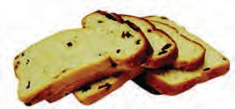*(makes 24 slices)*

###### Ingredients:

* + 1 cup of dried mixed fruit
  + 1 cup of brown sugar
  + 2 cups of self-raising flour
  + 2 cups of skim milk
  + 2 cups of processed bran cereal

### Using the Nutrition Panel Calculator

1. Begin by going to the web address: <http://www.foodstandards.gov.au/foodstandards/nutritionpanelcalculator>

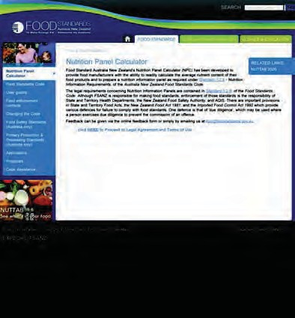Click on the ‘HERE’ link to enter the NPC website.

**example**

**only**

1. 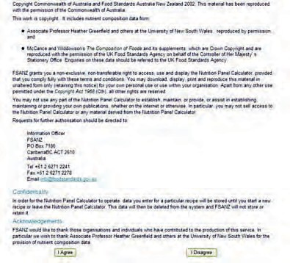Read the Legal Agreement and Terms of Use. If you agree to the Terms of Use, click the ‘I agree’ button at the bottom of the page.

**example**

**only**

*The Nutrition Panel Calculator is being revised, please check the FSANZ website for the latest version.* [*http://www.foodstandards.gov.au*](http://www.foodstandards.gov.au/)*/*

1. 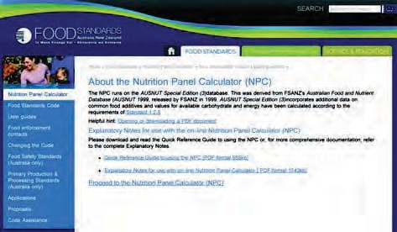Click on the link ‘Proceed to the Nutrition Panel Calculator’.

**example**

**only**

**only**

1. You should begin in the ‘News’ screen. If you do not, click on the ‘News’ tab. Once the ‘News’ screen, press the link, ‘Start a New Recipe’, to go to the main screen, the ‘Recipe’ screen.

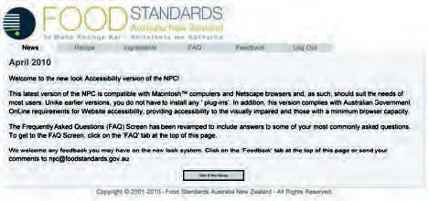

News tab

**example**

*The Nutrition Panel Calculator is being revised, please check the FSANZ website for the latest version.* [*http://www.foodstandards.gov.au*](http://www.foodstandards.gov.au/)*/*

1. An example of the ‘Recipe’ screen is shown below. It can be divided into three sections (labelled a-c).
2. Weights and servings

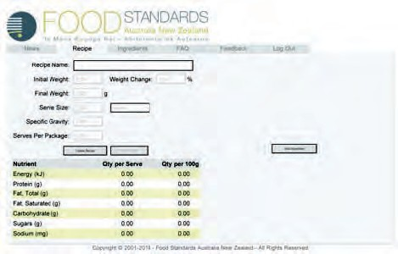

**example**

1. Nutrition information panel data
2. Ingredients list (not visible until an ingredient is added)

**only**

**only**

1. Begin by going to the ‘Ingredients’ tab (see below).

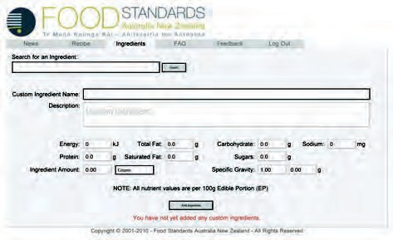

**example**

*The Nutrition Panel Calculator is being revised, please check the FSANZ website for the latest version.* [*http://www.foodstandards.gov.au*](http://www.foodstandards.gov.au/)*/*

1. Enter the first ingredient (dried fruit) into the search box and press ‘Search’.

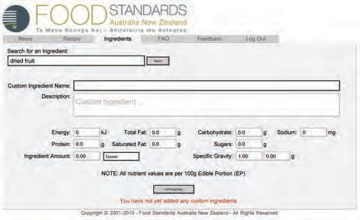

**example**

**only**

*The Nutrition Panel Calculator is being revised, please check the FSANZ website for the latest version.* [*http://www.foodstandards.gov.au*](http://www.foodstandards.gov.au/)*/*

1. A new screen will appear. Choose the appropriate type of ingredient. In this case, it is FRUIT, MIXED, DRIED. Double click on it.

**example**

**only**

***Note:*** *Foods on the NPC have been categorised as either 1 or 2, depending on their intended* *use. Category 1 foods are generally raw foods used as ingredients in recipes, whereas category 2 foods include finished products and meals.*

*It is recommended that category 1 foods be used wherever possible so that the recipe can be built ‘from scratch’ using the individual, raw ingredients. In the case of dried mixed fruit, there is no suitable category 1 food (as the food is already a ‘recipe’ because it is a combination of different dried fruits that have been mixed together), so we use the category 2 food.*

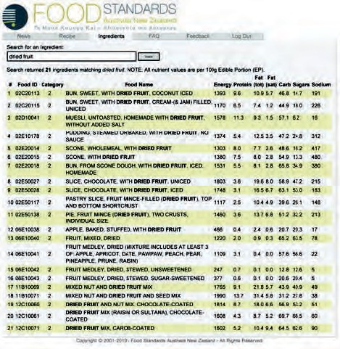

*The Nutrition Panel Calculator is being revised, please check the FSANZ website for the latest version.* [*http://www.foodstandards.gov.au*](http://www.foodstandards.gov.au/)*/*

1. The main Ingredients screen will then reappear with the nutrient information for this ingredient. Enter the amount of the ingredient (dried fruit) the recipe calls for. In this case, the recipe calls for 1 cup of dried fruit. By referring to Table1 (page 48 of this workbook) under ‘Fruit, dried or glace’, it can be seen that 1 cup is equal to 180g of dried fruit.

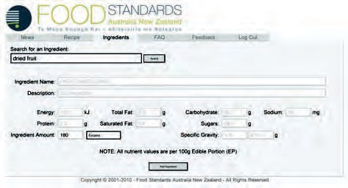

**example**

**only**

1. Click on ‘Add Ingredient’. A pop-up will appear saying ‘Using Category 2 ingredients is not recommended as standard recipes may not accurately reflect your product’. Click ‘OK’ (as previously mentioned, mixed dried fruit is only available as a category 2 product).

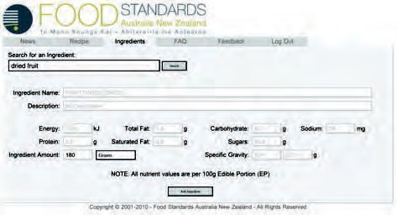

**only**

**example**

*The Nutrition Panel Calculator is being revised, please check the FSANZ website for the latest version.* [*http://www.foodstandards.gov.au*](http://www.foodstandards.gov.au/)*/*

1. You will now see your first ingredient (dried fruit) listed as the first ingredient.

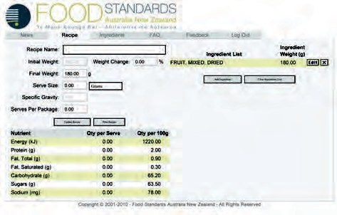

**example**

**only**

1. Now you are ready to add in the next ingredient. For the Fruit Loaf recipe, this is brown sugar. Click on ‘Add Ingredient’

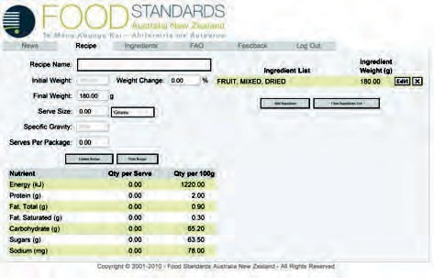

**only**

**example**

*The Nutrition Panel Calculator is being revised, please check the FSANZ website for the latest version.* [*http://www.foodstandards.gov.au*](http://www.foodstandards.gov.au/)*/*

1. Enter the next ingredient (brown sugar) into the search box. Click ‘Search’.

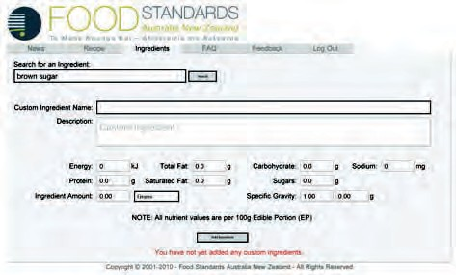

**example**

1. Choose the appropriate type of ingredient. In this case, it is SUGAR, BROWN. Double click on it.

**only**

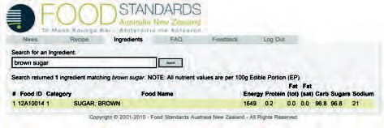

*The Nutrition Panel Calculator is being revised, please check the FSANZ website for the latest version.* [*http://www.foodstandards.gov.au*](http://www.foodstandards.gov.au/)*/*

1. The main ‘Ingredients’ screen will then reappear with the nutrient information for this ingredient. Enter the amount of the ingredient (brown sugar) the recipe calls for. In this case, the recipe calls for 1 cup of brown sugar. By referring to Table 1 (page 49 of this workbook), it can be seen that 1 cup is equal to 180g of brown sugar.

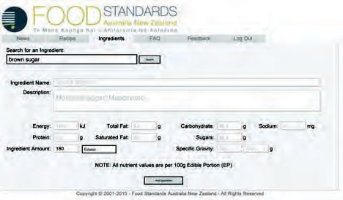

**example**

**only**

**only**

1. Click on ‘Add Ingredient’.

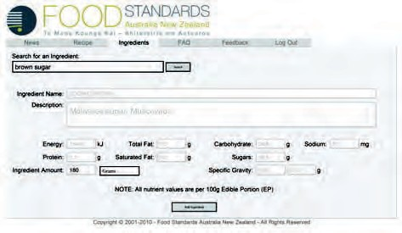

**example**

***The Nutrition Panel Calculator is being revised, please check the FSANZ website for the latest version.*** [***http://www.foodstandards.gov****.au*](http://www.foodstandards.gov.au/)***/***

1. You will now see your ingredient (brown sugar) listed as the second ingredient. Continue this process until all ingredients are listed.

**only**

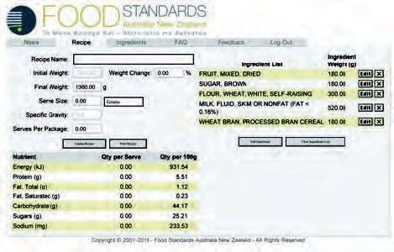

***Notes:*** *If you are having trouble finding an ingredient (for example, ‘bran’), type in ‘%’ before the food name (%bran) and the NPC will*

*retrieve any ingredients that contain the word ‘bran’* ***anywhere*** *in the food name (for example: wheat bran, processed bran cereal).*

*If one of the ingredients is a liquid (for example, skim milk), click the button next to the ‘Ingredient Amount’ box. This allows you to enter the amount of liquid in millilitres or litres, rather than grams. The NPC will automatically convert the liquid amount (millilitres) to a weight (grams) on the main ‘Recipe’ screen.*

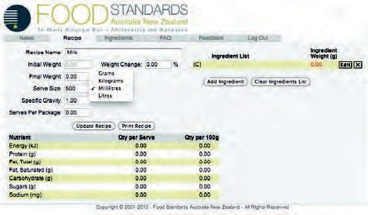

**example**

*The Nutrition Panel Calculator is being revised, please check the FSANZ website for the latest version.* [*http://www.foodstandards.gov.au*](http://www.foodstandards.gov.au/)*/*

1. Now all the ingredients are listed, the weight of a serve needs to be calculated. The Fruit Loaf recipe states that it makes 24 slices. In order to work out the weight per serve, divide the ‘Final Weight’ of 1360.0g (highlighted below) by 24 (number of serves). This shows a serve weight of 56.7g. Enter this into the ‘Serve Size’ box.

*For fruit loaf:*

Serve size = Final Weight/No of serves Serve size = 1360.0g/24 = 56.7g

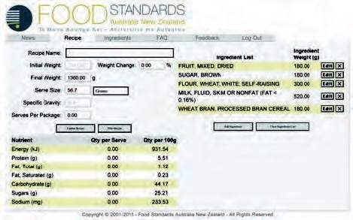

*The Nutrition Panel Calculator is being revised, please check the FSANZ website for the latest version.* [*http://www.foodstandards.gov.au*](http://www.foodstandards.gov.au/)*/*

1. Add in the number of serves provided by the recipe into the ‘Serves Per Package’ box. The Fruit Loaf recipe gives 24 serves.

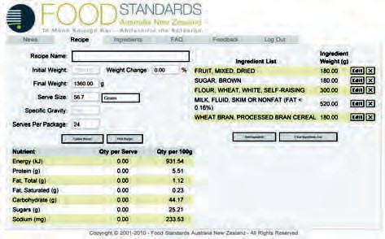

**example**

**only**

1. Enter the title of the recipe into the ‘Recipe Name’ box.

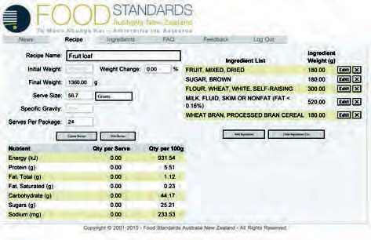

**only**

**example**

*The Nutrition Panel Calculator is being revised, please check the FSANZ website for the latest version.* [*http://www.foodstandards.gov.au*](http://www.foodstandards.gov.au/)*/*

1. Finally, click ‘Update Recipe’

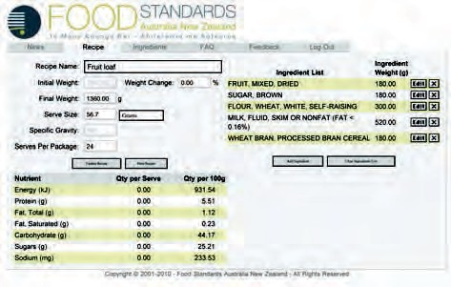

**example**

**only**

**only**

1. The words ‘Calculations Updated’ will appear in red underneath the nutrient panel information.

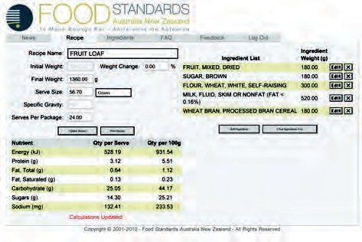

**example**

*The Nutrition Panel Calculator is being revised, please check the FSANZ website for the latest version.* [*http://www.foodstandards.gov.au*](http://www.foodstandards.gov.au/)*/*

1. A Nutrition Panel can then be printed from this information by clicking ‘Print Recipe’.

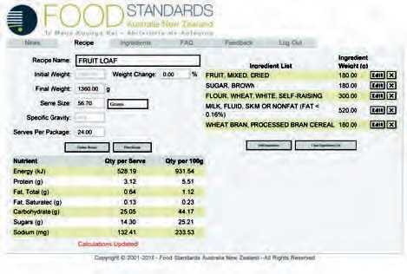

**example**

**only**

1. This is how the label will appear. Go to ‘Print’ under ‘File’ to print the label.

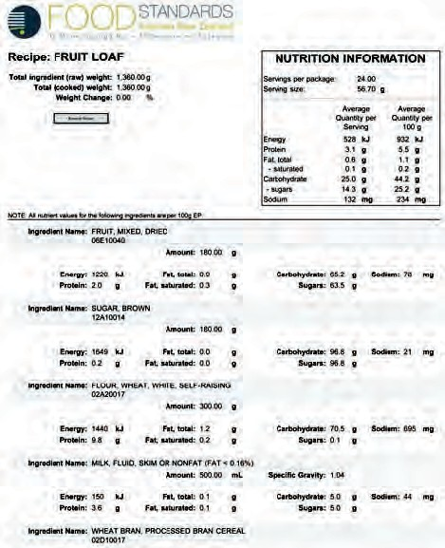

**only**

**example**

*The Nutrition Panel Calculator is being revised, please check the FSANZ website for the latest version.* [*http://www.foodstandards.gov.au*](http://www.foodstandards.gov.au/)*/*

1. From this label, it can be seen that the fruit loaf meets the **AMBER** criteria for cakes, muffins and

**example**

**only**

sweet pastries and may be sold in healthy school canteens.

***Note:*** *Even though fibre is not included in the Nutrition Information – a quick look on the back of the bran cereal pack reveals there is 40 grams of fibre in 2 cups (1.6 grams/slice of fruit cake); by itself this meets the NHSCP guidelines. There is a total of 2.5 grams fibre/serve in this recipe.*

**Troubleshooting**

See the FAQ tab (below) for common problems that may arise when using the NPC.

###### Reference

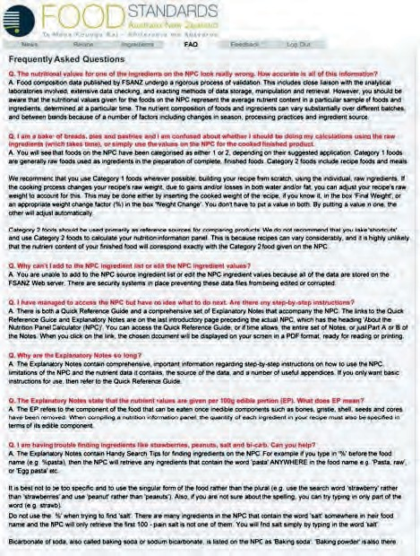

FSANZ 2004, Quick Reference Guide for Using the Nutrition Panel Calculator (NPC), HTML version 2.0, viewed 9 April 2010. <http://www.foodstandards.gov.au/_srcfiles/Quick_reference_guide_to%20_using_the_NPC>_ October_2004%20final.pdf

*The Nutrition Panel Calculator is being revised, please check the FSANZ website for the latest version.* [*http://www.foodstandards.gov.au*](http://www.foodstandards.gov.au/)*/*

###### Table 1: Weights and measures conversion table

|  |  |  |  |  |  |  |  |
| --- | --- | --- | --- | --- | --- | --- | --- |
| **Commodity** | **1tablespoon** | **1 cup** | **3/4 cup** | **2/3 cup** | **1/2 cup** | **1/3 cup** | **1/4 cup** |
| Almonds, ground | 10g | 100g | 75g | 65g | 50g | 40g | 25g |
| Apple (125g), puréed | 20g | 200g | 150g | 135g | 100g | 70g | 50g |
| Arrowroot | 10g | 130g | 100g | 90g | 65g | 45g | 35g |
| Bacon (50g rasher), chopped | 15g | 180g | 135g | 120g | 90g | 60g | 45g |
| Baking powder | 10g | 130g | 100g | 90g | 65g | 45g | 35g |
| Beans, dried | 15g | 200g | 150g | 135g | 100g | 70g | 50g |
| Beans, fresh | 10g | 120g | 90g | 80g | 60g | 40g | 30g |
| Bean shoots | 10g | 100g | 75g | 65g | 50g | 40g | 25g |
| Bicarbonate of soda | 10g | 130g | 100g | 90g | 65g | 45g | 35g |
| Biscuit crumbs | 10g | 120g | 90g | 80g | 60g | 40g | 30g |
| Bran | 10g | 90g | 65g | 60g | 45g | 35g | 25g |
| Breadcrumbs, dried | 10g | 90g | 65g | 60g | 45g | 35g | 25g |
| Breadcrumbs, fresh | 5g | 40g | 30g | 25g | 20g | 12g | 10g |
| Cabbage, shredded | - | 100g | 75g | 65g | 50g | 40g | 25g |
| Cake crumbs | 5g | 60g | 45g | 40g | 30g | 20g | 15g |
| Capsicum (125g whole), diced | 10g | 120g | 90g | 80g | 60g | 40g | 30g |
| Carrot (125g whole), diced | 12g | 150g | 110g | 100g | 75g | 50g | 40g |
| Cauliflower, florets | - | 120g | 90g | 80g | 60g | 40g | 30g |
| Celery (100g stalk), sliced | 12g | 150g | 110g | 100g | 75g | 50g | 40g |
| Cheese | 20g | 250g | 190g | 165g | 125g | 85g | 65g |
| Cheese, grated | 10g | 120g | 90g | 80g | 60g | 40g | 30g |
| Chicken, cooked, chopped | 12g | 150g | 110g | 100g | 75g | 50g | 40g |
| Chicken, uncooked, chopped | 20g | 220g | 165g | 160g | 110g | 80g | 55g |
| Chutney | 20g | 250g | 190g | 165g | 12g | 85g | 65g |
| Citric acid | 10g | 130g | 100g | 90g | 65g | 45g | 35g |
| Cocoa | 10g | 130g | 100g | 90g | 65g | 45g | 35g |
| Coconut | 8g | 90g | 70g | 60g | 45g | 30g | 25g |
| Corn, kernels | 12g | 150g | 110g | 100g | 75g | 50g | 40g |
| Cornflakes | 5g | 30g | 25g | 20g | 15g | 10g | 8g |
| Cornflour | 10g | 130g | 100g | 90g | 65g | 45g | 35g |
| Couscous | 15g | 200g | 150g | 135g | 100g | 70g | 50g |
| Cracked wheat | 8g | 90g | 65g | 60g | 45g | 35g | 25g |
| Cream cheese | 20g | 250g | 190g | 165g | 125g | 85g | 65g |

|  |  |  |  |  |  |  |  |
| --- | --- | --- | --- | --- | --- | --- | --- |
| **Commodity** | **1tablespoon** | **1 cup** | **3/4 cup** | **2/3 cup** | **1/2 cup** | **1/3 cup** | **1/4 cup** |
| Cream of tartar | 10g | 130g | 100g | 90g | 65g | 45g | 35g |
| Cucumber (200g whole), diced | 12g | 150g | 110g | 100g | 75g | 50g | 40g |
| Custard powder | 10g | 130g | 100g | 90g | 65g | 45g | 35g |
| Eggplant (200g whole) | 12g | 150g | 110g | 100g | 75g | 50g | 40g |
| Egg (60g) | 20g | 250g | 190g | 165g | 125g | 85g | 65g |
| Egg white (40g) | 20g | 250g | 190g | 165g | 125g | 85g | 65g |
| Egg yolk (20g) | 20g | 250g | 190g | 165g | 125g | 85g | 65g |
| Flour | 10g | 150g | 110g | 100g | 75g | 50g | 40g |
| Fruit, chopped or diced | 12g | 150g | 110g | 100g | 75g | 50g | 40g |
| Fruit, dried or glacé | 15g | 180g | 135g | 120g | 90g | 60g | 45g |
| Fruit purée | 20g | 200g | 150g | 135g | 100g | 70g | 50g |
| Gelatine | 12g | 150g | 110g | 100g | 75g | 50g | 40g |
| Glucose, liquid | 25g | 330g | 250g | 220g | 165g | 110g | 80g |
| Golden syrup | 20g | 300g | 225g | 200g | 150g | 100g | 75g |
| Honey | 20g | 300g | 225g | 200g | 150g | 100g | 75g |
| Jam | 20g | 300g | 225g | 200g | 150g | 100g | 75g |
| Leek (150g whole), diced | 10g | 120g | 90g | 80g | 60g | 40g | 30g |
| Lentils | 15g | 200g | 150g | 135g | 100g | 70g | 50g |
| Margarine | 20g | 250g | 190g | 165g | 125g | 85g | 65g |
| Mayonnaise | 20mL | 250mL | 190mL | 165mL | 125mL | 85mL | 65mL |
| Meat, cooked, chopped | 12g | 150g | 110g | 100g | 75g | 50g | 40g |
| Meat, uncooked, chopped | 20g | 220g | 165g | 160g | 110g | 80g | 55g |
| Milk | 20mL | 250mL | 190mL | 165mL | 125mL | 85mL | 65mL |
| Milk powder | 10g | 100g | 75g | 65g | 50g | 40g | 25g |
| Mushrooms, sliced | 10g | 100g | 65g | 75g | 50g | 40g | 25g |
| Nuts, chopped | 15g | 120g | 90g | 80g | 60g | 40g | 30g |
| Nuts, whole | 10g | 100g | 75g | 65g | 50g | 40g | 25g |
| Nuts, whole | 10g | 100g | 75g | 65g | 50g | 40g | 25g |
| Oil | 20mL | 250mL | 190mL | 165mL | 125mL | 85mL | 65mL |
| Onion (125g whole), diced | 12g | 150g | 110g | 100g | 75g | 50g | 40g |
| Parsnip (125g whole), diced | 12g | 150g | 110g | 100g | 75g | 50g | 40g |
| Pasta, cooked | 20g | 200g | 150g | 135g | 100g | 70g | 50g |
| Pasta, uncooked | 10g | 100g | 75g | 66g | 50g | 33g | 25g |
| Peas, dried | 15g | 200g | 150g | 135g | 100g | 70g | 50g |

|  |  |  |  |  |  |  |  |
| --- | --- | --- | --- | --- | --- | --- | --- |
| **Commodity** | **1tablespoon** | **1 cup** | **3/4 cup** | **2/3 cup** | **1/2 cup** | **1/3 cup** | **1/4 cup** |
| Peas, fresh | 12g | 150g | 100g | 100g | 75g | 50g | 40g |
| Peel, mixed | 12g | 150g | 110g | 100g | 75g | 50g | 40g |
| Polenta | 12g | 150g | 110g | 100g | 75g | 50g | 40g |
| Potato (150g whole), diced | 12g | 150g | 110g | 100g | 75g | 50g | 40g |
| Rice flour | 10g | 130g | 100g | 90g | 65g | 45g | 35g |
| Rice, uncooked | 15g | 200g | 150g | 135g | 100g | 70g | 50g |
| Rolled oats | 10g | 100g | 75g | 65g | 50g | 40g | 25g |
| Salt | 20g | 250g | 190g | 165g | 125g | 85g | 65g |
| Seafood, cooked, chopped | 12g | 150g | 110g | 100g | 75g | 50g | 40g |
| Seafood, uncooked, chopped | 12g | 220g | 165g | 160g | 110g | 80g | 55g |
| Sesame seeds | 12g | 150g | 110g | 100g | 75g | 50g | 40g |
| Snow peas | - | 100g | 75g | 65g | 50g | 40g | 25g |
| Spices | 10g | 130g | 100g | 90g | 65g | 45g | 35g |
| Sugar | 20g | 250g | 190g | 165g | 125g | 85g | 65g |
| Sugar, brown | 15g | 180g | 135g | 120g | 90g | 60g | 45g |
| Sugar, caster | 20g | 250g | 190g | 165g | 125g | 85g | 65g |
| Tartaric acid | 10g | 130g | 100g | 90g | 65g | 45g | 35g |
| Tomato (125g whole), diced | 20g | 200g | 150g | 135g | 100g | 70g | 50g |
| Tomato paste | 20g | 250g | 190g | 165g | 125g | 85g | 65g |
| Tomatoes, semi- dried | 12g | 150g | 110g | 100g | 75g | 50g | 40g |
| Vegetables, chopped or diced | 12g | 150g | 110g | 100g | 75g | 50g | 40g |
| Vegetables, mashed | 20g | 250g | 190g | 165g | 125g | 85g | 65g |
| Wheat germ | 10g | 90g | 65g | 60g | 45g | 35g | 25g |
| Yeast, compressed | 15g | 180g | 135g | 120g | 90g | 60g | 45g |
| Yeast, dried | 14g | 180g | 135g | 120g | 90g | 60g | 45g |
| Yoghurt | 20mL | 250mL | 190mL | 165mL | 125mL | 85mL | 65mL |
| Zucchini (100g whole), diced | 10g | 120g | 90g | 80g | 60g | 40g | 30g |

**Reference**

Cameron, S & Russell, S 2003, *Cookery the Australian Way*, 7th Edition, Macmillan Education Australia, South Yarra.

# Appendix 3: Example Student Survey Questionnaires

**example**

###### Example 1

Dear Teachers,

Please find attached the Canteen’s Winter Menu Survey for

your class.

This Friday, during the lunch break, a display of possible Winter Menu options will be set up on trestle tables outside the Canteen. Students will have an opportunity to look at and taste a few of the options available for the Winter Menu.

After seeing this display during Friday lunch break, would it be possible to get your students to vote on the options listed below, then return the completed survey to the front office, by the end of Friday?

This would be much appreciated as we are hoping to finalise the Winter Menu during Camp Week and have the menu ready to start by Week 4.

If you would like assistance with the survey, **[insert name of canteen staff]** is able to help between 2pm and 3pm on Friday. Just leave a message at the Canteen on Friday morning.

Thank you for your help.

Yours sincerely, Canteen Committee

**Example Survey Questionnaires**

Submitted by Helen Morris,

*Seaview Downs Primary School, SA*

To all classes,

The Winter Menu will start soon. Once again, feedback from students is a great help when planning the menu. If possible, could you take the time to vote on the questions below? Any other suggestions are very welcome.

Thank you, Canteen Committee

###### How many students in your class would prefer the following?

Stir-fry Noodles (This is a new item – as seen on the Look and Taste Table) 

OR instead

Cup of Noodles (currently on the menu) 

**example**

###### How many students in your class would prefer the following?

Beef Ravioli (currently on the menu) 

OR instead

Twirl Bolognaise 

###### How many of you would like to have the following on the menu?

You can vote for as many of these as you like.

###### Cottage Pie

(This is a new item – as seen on the Look and Taste Table: 

Bolognaise sauce, peas, carrots and corn, topped with mashed potato and melted cheese)

###### Hot Chicken Roll

(This was on the menu last winter: 

Hot roll with roast chicken meat, mayo and shredded lettuce)

###### Soup Deal

(This was on the menu last winter: Chicken and corn soup

with ½ cheese toastie and a muffin) 

###### Recess Specials

As usual, the Recess Specials on the Canteen Menu will change to suit the cooler weather. Below is a list of possible Recess Specials.

Some of them were on the menu last winter and most were on the Look and Taste Table. The most popular four will be put on the menu. As usual, Warm Chocolate Milk will be put on with some of the Recess Specials.

###### Please ask how many of the students in your class would like the following Recess Specials.

*(Each student can vote for more than one item – in fact, you can vote for all the items if you like.)*

###### Hot Bagels with low-fat cream cheese 

**Cheese Jaffles (½ cheese toastie)** 

###### Cup of Tomato and Noodle Soup with a hot mini roll 

**Mini Vegie Pizzas**

**example**

(a bread or muffin base, topped with a variety of vegetables and

melted cheese, as seen on the Look and Taste Table) 

###### Peachey Pancakes topped with maple syrup 

**Mini Hot Fruit Crumble** 

###### Apple and Custard Jaffles 

(½ toastie filled with stewed apple and custard)

###### Hot Muffins 

**Hot Crumpet Fingers topped with 100% fruit spread** 

###### Thank you!

Any other suggestions?

###### Example 2

**example**

Dear Teachers,

Please find attached the Canteen’s **Summer Menu Survey**

for your class.

Students will have seen and/or tasted most items in the survey through recent Canteen Specials and last year’s Summer Menu.

Would it be possible to get your students to vote on the options listed below and return the completed survey to the Canteen, by ***[nsert date]***?

We are hoping to finalise the menu by the end of Week 2 next

term, in order to have the menu ready to start by Week 4. Once again, thank you for your help.

Kind regards, Canteen Committee

**2009 Canteen Summer Menu Class Survey**

To all classes,

The Summer Menu will start Week 4 next term. Once again, feedback from students is a great help when planning the menu.

Menu items that will be returning for summer include:

* frozen grapes
* UFOs (frozen pineapple rings)
* a second flavour for the fruit slushies, and
* some extra fruit ice blocks.

If possible, could you take the time to vote on the questions below? Thank you.

###### How many students in your class would like the following items on the menu?

You can vote for as many of these items as you like.

You don’t have to have tasted the item to vote for it – although, it probably helps!

###### Kickin’ Chicken ‘n’ Rice

**example**

As trialled with the recent Show Week Meal Deal

(chicken with rice and vegies in a cheesy sauce) 

###### Very Vegie Curry with Rice

As trialled with the recent Show Week Meal Deal

(very mild curry with chickpeas, broccoli and rice) 

###### Spaghetti Bolognaise

As trialled with the recent Show Week Meal Deal 

###### Honey Soy Chicken Drumstick

As was on the menu last summer

(chicken leg – skinless – dipped in a honey-soy sauce and baked) 

###### Baked Potato

As was on the menu last summer 

Any suggestions for toppings for the Baked Potato?

###### Banana Ice Cream on a stick

(Banana flavoured reduced-fat milk, frozen) 

**Frozen Yoghurt** (frozen yoghurt stick) 

**Chocolate Stick** (frozen chocolate flavoured milk on a stick) 

###### Recess Specials

Below is a list of possible Recess Specials for summer.

Please ask how many of the students in your class would like the following Recess Specials.

*(Each student can vote for more than one item – in fact, you can vote for all the items if you like.)*

###### Strawberry Thick Shake 

(milk, strawberries and strawberry frozen yoghurt)

###### Tub of Fresh Fruit Salad 

**example**

(as is, or topped with yoghurt)

###### Mud-Hole with Berries 

(reduced-fat chocolate custard and mixed berries)

###### Star-Cake topped with Fruit and Yoghurt 

(cold pancake, freshly sliced strawberries, yoghurt)

###### Muffin with Chocolate Shake 

**Thank you!**

Any other suggestions?

Notes

Notes

# Acknowledgements

The *National Healthy School Canteens* Project is an initiative of the Australian Government and was developed by Flinders University, supported by Flinders Partners, a wholly owned subsidiary of Flinders University.

The Project Team would like to thank the National Healthy School Canteens Project Reference Group members, their education department colleagues, and the schools, canteen managers and students who participated in the development of the Project.

This project is funded by the Australian Government Department of Health and Ageing.

#### The National Healthy School Canteens Project Team

**Flinders University, South Australia**Lynne Cobiac (Project Manager) John Coveney

Claire Drummond

Lynn Field (Project Officer)

Gwyn Jolley Jane Scott

###### Southern Adelaide Health Service

Elizabeth Kellett

###### Flinders Partners

Julie Gardner

Nozomi Yamada