**THE RED CATEGORY**



**NOT RECOMMENDED ON THE CANTEEN MENU**

* Low in nutritional value
* May contain excess energy, saturated fat, salt and sugar
* Should not be sold in a healthy school canteen

**THE RED CATEGORY**



* Sugar sweetened drinks, soft drinks, fruit drinks, iced tea cordial, sports drinks, sports waters, flavoured mineral waters and energy drinks
* Intense (artificially) sweetened foods and drinks with the exception of milk, yoghurt and custard
* Products containing guarana or added caffeine. Coffee-style milk drinks may be sold in secondary school. Maximum 375mL serve size
* Fruit/vegetable juice, less than 99% juice, added sugar, greater than 250mL serve size
* Jelly desserts and ice crushes/slushies, less than 99% fruit, added sugar, greater than 200mL serve size
* Icy-poles and fruit ice blocks, less than

99% juice, added sugar, greater than 125mL serve size

**THE RED CATEGORY**



* Iced cakes and slices, doughnuts, Danishes, croissants, cream-filled buns/cakes
* All types: sold separately or added to products including; boiled lollies, carob, chocolate (including; boiled lollies, carob, chocolate (including choc chips and

chocolate-coated), chocolate spreads, cough lollies, 100s and 1000s, juice jellies, icing, liquorice, soft lollies, yoghurt/carob-coated

* Deep-fried foods
* Cream, coconut cream, coconut milk, butter, copha, ghee and lard



**DECIDING IF A FOOD OR DRINK MAY BE SOLD**

START – p.9 *Guidelines for healthy foods and drinks supplied in school canteens*

Does the item easily fit into the

GREEN or RED category ?

YES

No further assessment necessary. Which category does the item fit into?

Will need to be assessed

* + Food tables (pp. 6-8



*NHSC Guidelines*) NO • Nutrient Criteria (p. 10

*NHSC Guidelines*)

* + If it does not meet criteria the item is RED and should not be sold

#### GREEN

RED

NO YES

Item may be sold

#### GREEN

Item should not be sold

#### RED

Item may be sold

AMBER

# NUTRIENT CRITERIA TABLES



|  |  |  |  |
| --- | --- | --- | --- |
| **Table 1: Hot food items and processed meats assessed per 100g** | | | |
| **Category** | **Nutrient Criteria** | | |
|  | Energy (kJ) per 100g | Saturated fat (g) per 100g | Sodium (mg) per 100g |
| Savoury pastries, filled breads, pasta dishes, pizzas, oven-baked potato products, dim sims, spring rolls, rice and noodle dishes | 1000kJ or less | 5g or less | 400mg or less |
| Meat products and alternatives crumbed and not-crumbed (burgers, patties, strips, balls or nuggets), sausages, frankfurts and saveloys, stews, casseroles and curries | 1000kJ or less | 5g or less | 450mg or less |
| Processed luncheon meats (fritz, devon, chicken loaf, free flow chicken products) and cured meats (for example: ham, bacon) | 1000kJ or less | 5g or less | 750mg or less |

|  |  |  |  |  |
| --- | --- | --- | --- | --- |
| **Table 2: Snack food items assessed per serve** | | | | |
| **Category** | **Nutrient Criteria** | | | |
|  | Energy (kJ) per serve | Saturated fat (g) per serve | Sodium (mg) Per serve | Fibre (g) per serve |
| Sweet snack food, bars and biscuits | 600kJ or less | 3g or less | - | 1g or more |
| Savoury snack food, biscuits, crispbreads and crisps | 600kJ or less | 2g or less | 200mg or less | - |
| --(Energy must be 1800kJ or less per 100g)-- | | | |
| Ice creams, milk-based ices and dairy desserts | 600kJ or less | 3g or less | - | - |
| --(Milk must be listed as first ingredient)-- | | | |
| Un-iced cakes, muffins and sweet pastries | 900kJ or less | 3g or less | - | 1.5g or more |

**HOW TO APPLY THE GUIDELINES**

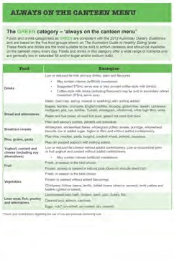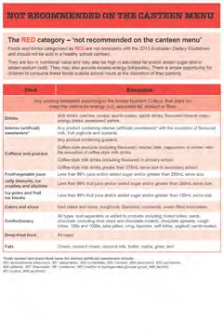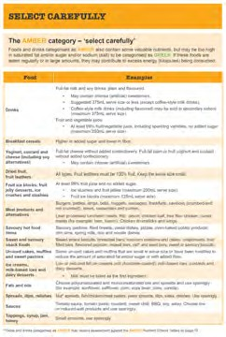

STEP 1

Using the tables in the NHSC Guidelines (pp 6-8), sort the foods and drinks on the next slide into 4 groups:

1. Items categorised as GREEN
2. Items categorised as RED
3. Items categorised as AMBER
4. Items you are ‘not sure’ about.

*These will need to be assessed using the food and drink tables and if necessary the nutrient criteria*

# SAMPLE MENU

**Sorting Foods**

**AMBER** RED **GREEN**



**GREEN** RED **AMBER** RED

# GREEN

## RED

**NOT SURE**

## RED

**NOT SURE GREEN NOT SURE**

**NOT SURE GREEN NOT SURE NOT SURE NOT SURE GREEN NOT SURE**

# ACTIVITY - HOW TO APPLY THE GUIDELINES



STEP 2

Using the Nutrient Criteria Tables, assess the foods you are not sure about and determine whether these foods are categorised as AMBER or RED

* The food is categorised as AMBER if **all** the values for:
  + energy, saturated fat and sodium (if applicable) are lower than the recommended value
  + **and** fibre is higher (if applicable)
* The food is categorised as RED if **one or more** of the values for:
  + energy, saturated fat and sodium (if applicable) is higher than the recommended value
  + **or** fibre is lower (if applicable)

# NUTRIENT CRITERIA



There are 2 tables for assessing AMBER foods

**1. Table 1 (NHSC *Guidelines*, p.10)**

* Assess hot food items and processed meats
* All foods in this category are assessed per **100g**
* If one criterion not met item is categorised as RED

**Table 1: Hot food items and processed meats assessed per 100g**

**Category Nutrient Criteria**

Energy (kJ) Saturated fat (g) Sodium (mg) per 100g per 100g per 100g

Savoury pastries, filled breads, pasta dishes, pizzas, oven-baked potato products, dim

sims, spring rolls, rice and noodle dishes 1000kJ or less 5g or less 400mg or less

Meat products and alternatives crumbed and not-crumbed (burgers, patties, strips,

balls or nuggets), sausages, frankfurts and saveloys, stews, casseroles and curries 1000kJ or less 5g or less 450mg or less

Processed luncheon meats (fritz, devon, chicken loaf, free flow chicken products) and

cured meats (for example: ham, bacon) 1000kJ or less 5g or less 750mg or less

# NUTRIENT CRITERIA



##### Table 2 (NHSC Guidelines, p.10)

* Assess snack foods.
* All foods in this category are assessed **per serve**
* If one criterion not met item is categorised as RED

|  |  |  |  |  |
| --- | --- | --- | --- | --- |
| **Table 2: Snack food items assessed per serve** | | | | |
| **Category** | **Nutrient Criteria** | | | |
|  | Energy (kJ) per serve | Saturated fat (g) per serve | Sodium (mg) Per serve | Fibre (g) per serve |
| Sweet snack food, bars and biscuits | 600kJ or less | 3g or less | - | 1g or more |
| Savoury snack food, biscuits, crispbreads and crisps | 600kJ or less | 2g or less | 200mg or less | - |
| --(Energy must be 1800kJ or less per 100g)-- | | | |
| Ice creams, milk-based ices and dairy desserts | 600kJ or less | 3g or less | - | - |
| --(Milk must be listed as first ingredient)-- | | | |
| Un-iced cakes, muffins and sweet pastries | 900kJ or less | 3g or less | - | 1.5g or more |

# EXAMPLE

## (NHSC Guidelines, page 12)

##### Crumbed chicken patty

ENERGY

Quantity per 100g

Quantity per Serving

**NUTRITION INFORMATION**

Servings per package: 60 Average serving size: 83g

* 1. Identify the correct food table.
  2. Find the 100g column
  3. Compare the 100g serve size to criteria

754kJ

PROTEIN

8.0

FAT

* total
* saturated

13.

2.4

CARBOHYDRATE

– sugars

6.7

1.2

909kJ

15.6g

2.9g

9.6g

8.1g

g g

0g g

g

1.4g

mg

256

SODIUM

308mg

**Table 1: Hot food items and pro**

**Category**

**sed per 100g**

**cessed meats asses**

ed fat (g) 100g

**iteria**

(kJ) 100g

Energy per

**Nutrient Cr**

Saturat per

Sodium (mg) per 100g

Savoury pastries, filled breads, pasta dishes, pizzas, oven-baked potato products, dim sims, spring rolls, rice and noodle dishes

Meat products and alternatives crumbed

1000kJ

or less

400mg

or less

5g

or less

and not-crumbed (burgers, patties, strips, balls or nuggets), sausages, frankfurts and saveloys, stews, casseroles and curries



Processed luncheon meats (fritz, devon, chicken loaf, free flow chicken products) and cured meats (for example: ham, bacon)

1000kJ or less 5g or less 450mg or less

1000kJ or less 5g or less 750mg or less

# GREEN, AMBER OR RED?

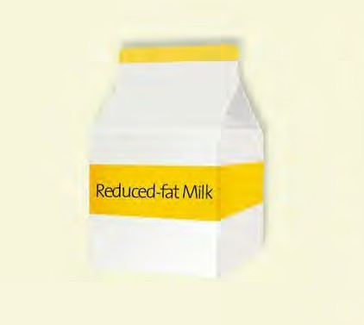

|  |  |  |
| --- | --- | --- |
| **Reduced-fat Milk**  Servings per package: 1 Average serving size: 250g | | |
|  | Quantity per Serving | Quantity per 100g |
| ENERGY | 500kJ | 263kJ |
| PROTEIN | 10.0g | 3.9g |
| FAT   * total * saturated | 2.5g  1.3g | 1.0g  0.5g |
| CARBOHYDRATE  – sugars | 15g 14.8g | 6.0g  5.9g |
| SODIUM | 135mg | 54mg |

**GREEN, AMBER OR RED?**



**Banana flavoured milk-based ice**

**Ingredients:** Reconstituted skim milk (70%), cane sugar, glucose syrup, vegetable oil, milk solids, maltodextrin, gelatine, emulsifier (471), flavours, colours (160b, 100)

Servings per package: 8 Average serving size: 68g

Quantity per Serving Quantity per 100g

ENERGY PROTEIN

**AMBER**

FAT

* total
* saturated

CARBOHYDRATE

* sugars SODIUM

462kJ

2.3g

3.6g

1.8g

16.9g

13.4g

31mg

680kJ

3.4g

5.3g

2.7g

24.8g

19.7g

46mg

**Table 2: Snack food items assessed per serve**

**Category Nutrient Criteria**

Energy (kJ) per serve

Saturated fat (g) per serve

Sodium (mg) Per serve

Fibre (g) per serve

Sweet snack food, bars and biscuits

600kJ or less

3g or less

- 1g or more

Savoury snack food, biscuits, crispbreads and

600kJ or less

2g or less

200mg or less -

crisps

Ice creams, milk-based ices and dairy desserts

Un-iced cakes, muffins and sweet pastries

--(Energy must be 1800kJ or less per 100g)--

600kJ or less 3g or less - -

--(Milk must be listed as first ingredient)--

900kJ or less 3g or less - 1.5g or more

# GREEN, AMBER OR RED?

**Fruit and Muesli Breakfast Bar**

Servings per package: 12 Average serving size: 13.3g

Quantity per Serving

Quantity per 100g

770kJ

3.7g

SODIUM

FIBRE

CARBOHYDRATE

– sugars

FAT

* total
* saturated

PROTEIN

ENERGY

8.3g

1710kJ

6.9g

0.7g

15.3g

1.6g

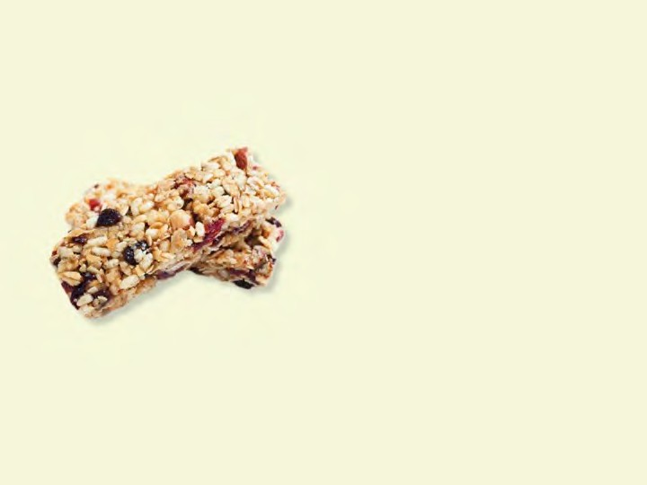

24.4g

9.0g

54.3g

19.9g

4.3g 0.6g

14mg

30mg

RED

**Table 2:**

**Snack food items assessed per se**

**rve**

**Category**

**Nutrient Crite**

**ria**

So

dium (mg) Per serve

Fibre per

(g) serve

600kJ or less

1.5g or more

--(Milk must be listed as first ingredient)--

3g or less

600kJ or less

Ice creams, milk-based ices and dairy desserts

--(Energy must be 1800kJ or less per 100g)--

200mg or less

2g or less

600kJ or less

Savoury snack food, biscuits, crispbreads and crisps

1g or more

3g or less

Sweet snack food, bars and biscuits

Saturated fat (g) per serve

(kJ)

rve

Energy per se

-

-

-

-

3g or less

900kJ or less

Un-iced cakes, muffins and sweet pastries

-

# GREEN, AMBER OR RED?

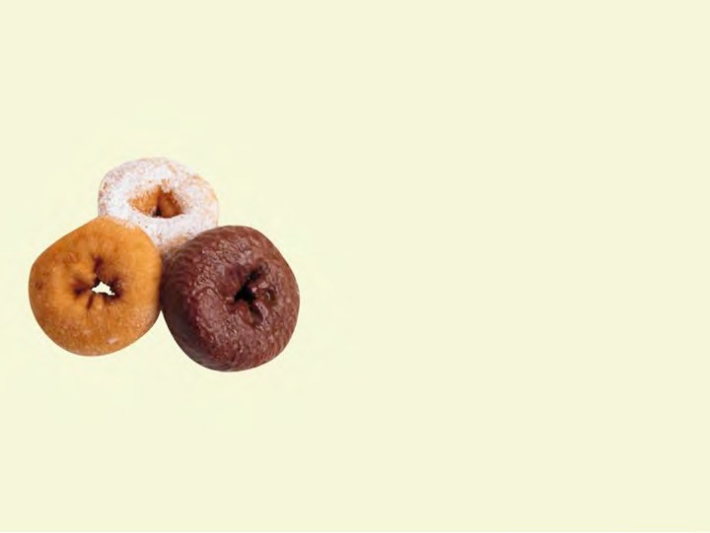

RED

|  |  |  |
| --- | --- | --- |
| **Doughnuts**  Servings per package: 6 Average serving size: 40g | | |
|  | Quantity per Serving | Quantity per 100g |
| ENERGY | 951kJ | 1510kJ |
| PROTEIN | 2.9g | 4.6g |
| FAT   * total * saturated | 7.9g  3.8g | 12.5g  6g |
| CARBOHYDRATE  – sugars | 35.3g  19.9g | 56g 31.6g |
| SODIUM | 289mg | 458mg |

**GREEN, AMBER OR RE**

**D?**

**Meat Pie**

Servings per package: 60

Average serving size: 83g

Quantity per Serving

Quantity per 100g

160 890kJ

15.0

g

SODIUM

CARBOHYDRATE

– sugars

FAT

* total
* saturated

PROTEIN

ENERGY

8.4g

0kJ

8.5g

g

15.4

7.4g

4.1g

43.3

<1g

g

24.3g

<1g

g

418m

232mg

**Table 1: Hot food items and proce**

**ssed meats asses**

Savoury pastries, filled breads, pasta dishes, pizzas, oven-baked potato products, dim sims, spring rolls, rice and noodle dishes

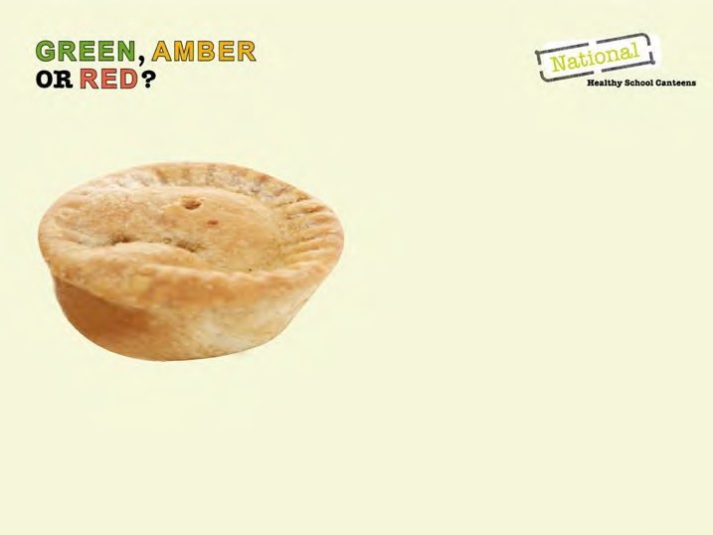

(mg) 100g

Sodium per

**sed per 100g**

d fat (g) 100g

Saturate per

**iteria**

(kJ) 100g

Energy per

**Nutrient Cr**

**Category**

**AMBER**

Meat products and alternatives crumbed and not-crumbed (burgers, patties, strips, balls or nuggets), sausages, frankfurts and saveloys, stews, casseroles and curries

Processed luncheon meats (fritz, devon, chicken loaf, free flow chicken products) and cured meats (for example: ham, bacon)

1000kJ or less 5g or less 400mg or less

1000kJ or less 5g or less 450mg or less

1000kJ or less 5g or less 750mg or less

# ACTIVITY



(Workbook, P.14)

Look at the nutrition information panels provided.

Do these examples meet the NHSC **AMBER** nutrient criteria? Should they be sold through the canteen?



# MOVING AMBER FOODS TOWARDS THE GREEN END OF THE SPECTRUM

Moving a Ham Sandwich from Amber to Green by adding tomato, lettuce, onion and carrot. 

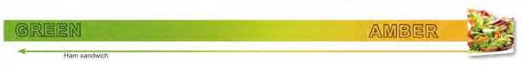

**MOVING AMBER FOODS TOWARDS THE GREEN END OF THE SPECTRUM**



STEP 3

**AMBER** foods and drinks can be made healthier and moved towards the **‘GREEN’** end of the spectrum by:

* Serving main meal items with salad or vegetables (and a lean protein source where appropriate)
* Serving snack foods with fruit and vegetables where possible
  + dips with vegetable sticks
  + reduced-fat custard with fruit
* Keeping the serve size small
* Serving with a small amount of low or reduced-fat or low or reduced-salt condiments (if any are to be used at all)
* Comparing products using information on labels
* Choosing healthier alternatives where possible (Table 3).

# MAKING A HEALTHIER CHOICE

**Tomato, vegetable and pasta soup**

Canned tomato, vegetable and pasta soup

SODIUM

CARBOHYDRATE

– sugars

FAT

* total
* saturated

4.5g

PROTEIN

157kJ

392kJ

ENERGY

Quantity per 100g

Quantity per Serving

Average serving size: 250g

Servings per package: 2

1.8g

0.5g

<0.1g

0.2g

<0.1g

7.0g

<1.6g

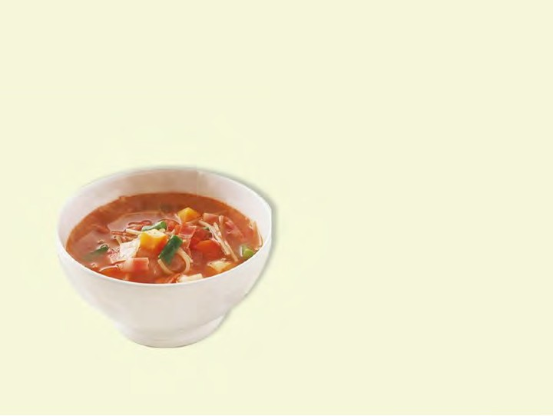

–

–

–

–

–

–

–

–

17.5g

4.0g

290mg

750mg or less

75mg or less

300mg or less

300mg or less

–

–

(mg) 100g

Sodium per

2g or less

2g or less

2g or less

2g or less

less

2g or

less

2g or

ed fat 100g

Saturat

(g) per

Mayonnaise and salad dressings

Dips (legume, dairy, vegetable or salsa)

Soups as prepared ready-to-eat (condensed, instant)

Pasta sauces and simmer sauces

Breakfast cereals containing dried fruit

Breakfast cereals not containing dried fruit

20g or less

20g or less

Sugar (mg) per 100g

5g or more

5g or more

Fibre (g) per 100g

**Nutrient Criteria**

**Category**

725mg

**HEALTHIER**

**CHOICE**

**Table 3: Healthi**

**er choices asses**

**sed per 100g**

# ACTIVITY



(Workbook, P.14)

Look at the nutrition information panels provided.

Do these examples meet the **‘making a healthier choice’**

nutrient criteria?

# MOVING AMBER FOODS TOWARDS THE GREEN END OF THE SPECTRUM

Using the examples below, **‘GREEN’** these **AMBER** menu items. (Workbook, P.14)

### Meals

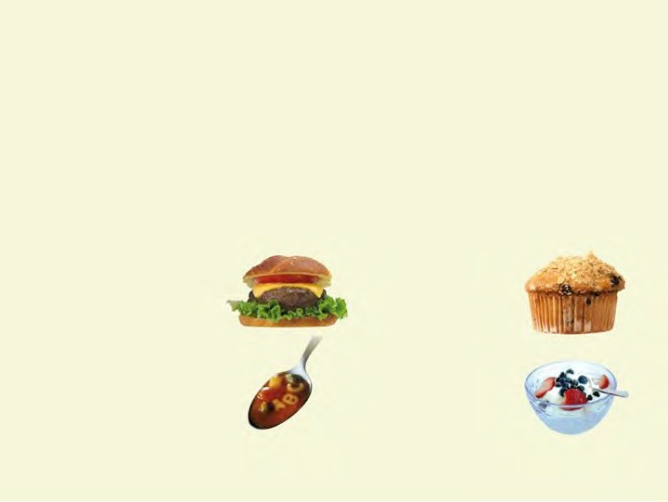

* Hamburger
* Lasagne
* Tomato soup and bread roll
* Pizza
* Sushi

### Snacks

* Muffins /slices
* Reduced-fat ice cream
* Garlic bread

# MOVING AMBER FOODS TOWARDS THE GREEN END OF THE SPECTRUM

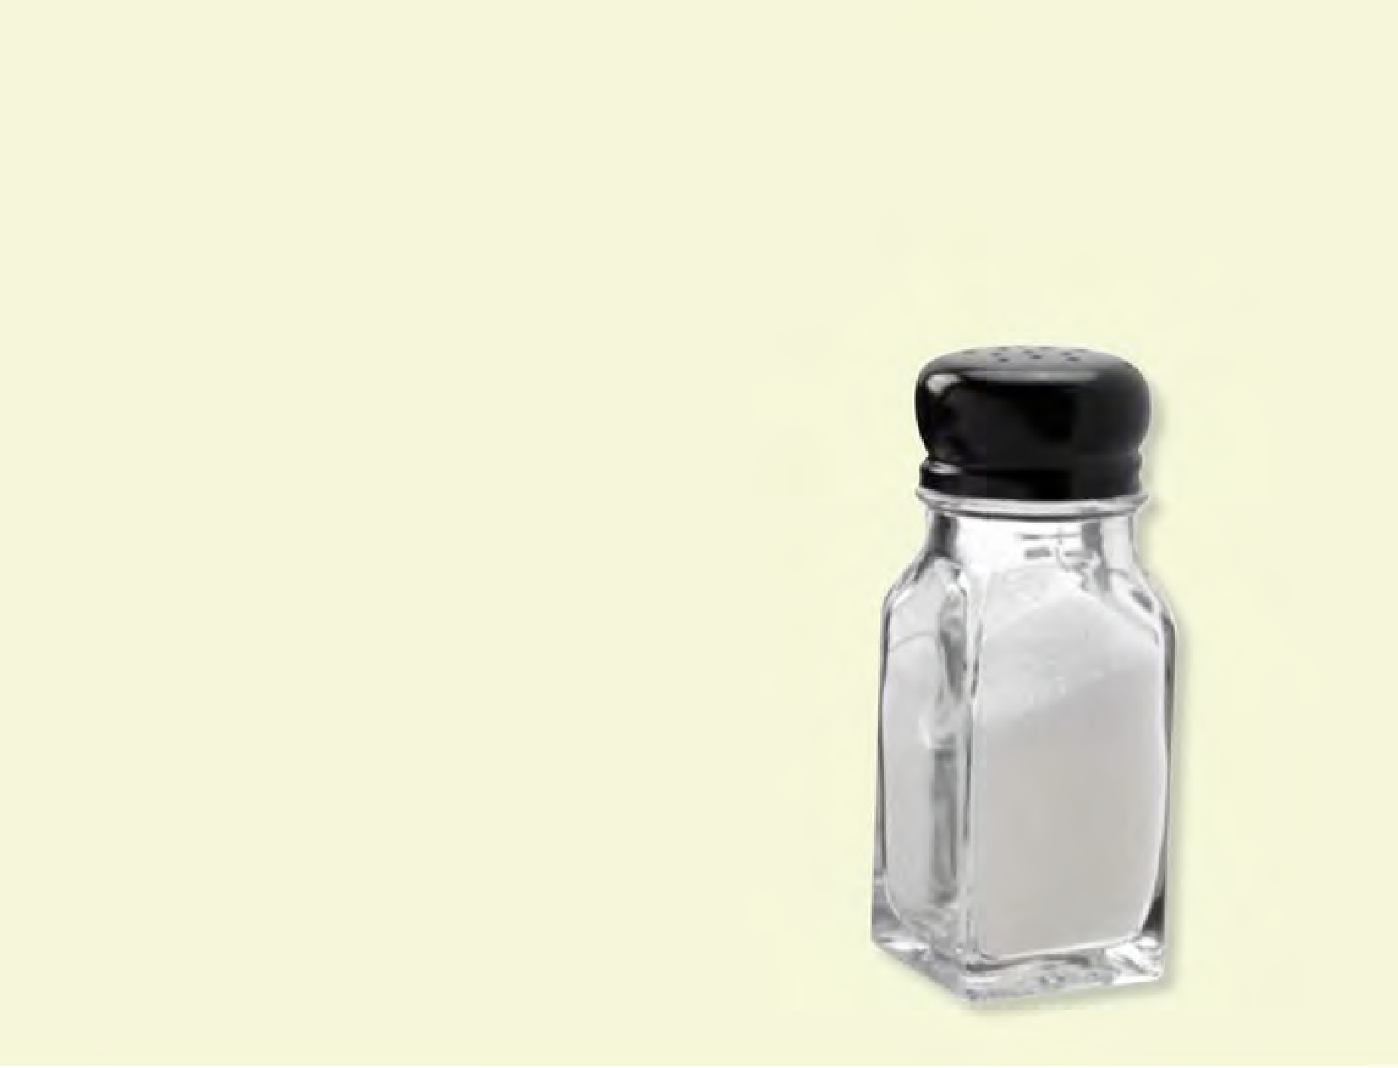

##### Group Discussion

How can you reduce the sodium content of dishes?

(Workbook, P.14)

**FOOD PREPARATION AND COOKING METHODS**

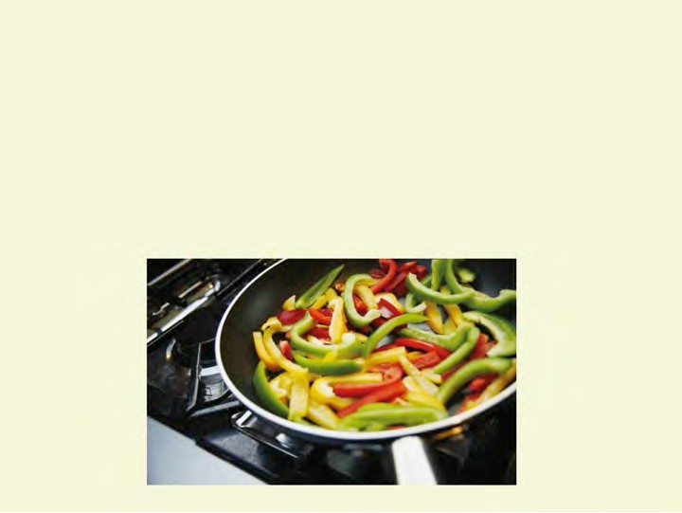

* + Trim visible fat • Steaming
  + Fresh, undamaged fruit • Frying/stir frying and vegetables • Baking/roasting
  + Minimise vitamin C loss • Microwaving

# EXAMPLE MENU



How do you incorporate variety into your canteen menu?

How can students be included in decisions regarding the school canteen menu?

(Workbook, pp. 15-161))

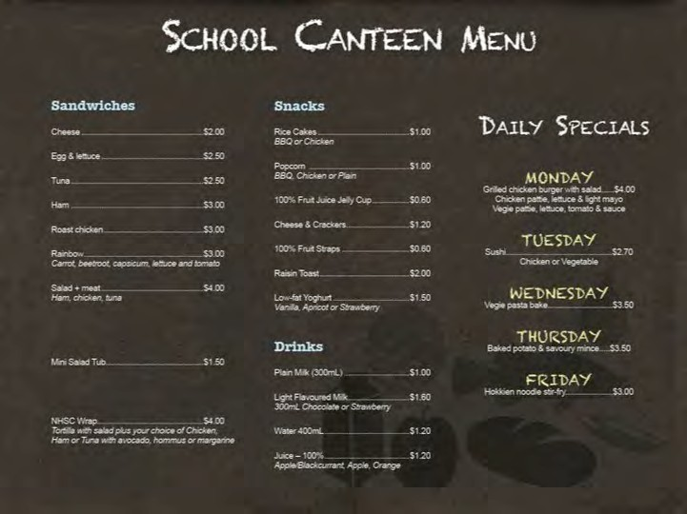

# SPECIAL DIETARY



**AND CULTURAL NEEDS**

* + - Allergies / food intolerances /sensitivities
    - Cultural and religious considerations

# SPECIAL DIETARY NEEDS



Food Allergies

An immune response to **protein** found in common foods

* Any amount will cause a reaction
* Reaction usually occurs within 30 minutes and can be life threatening (anaphylaxis)
* Epi-pen and action plan signed by doctor

##### Strict avoidance is extremely important

Food intolerance

Sensitivity to the chemicals found in food

* Naturally occurring **or** added in manufacturing
* Small amounts may be tolerated
* Reaction can take several days to appear
* **Diet modified to keep intake below threshold tolerated**

# SPECIAL DIETARY NEEDS

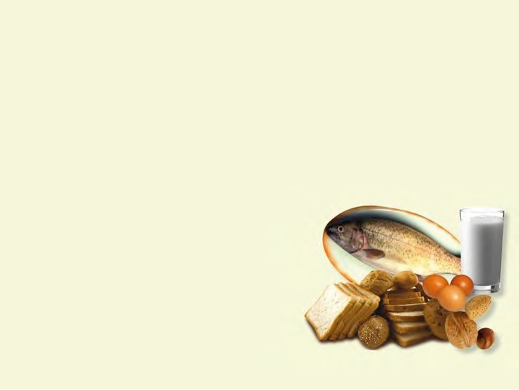

Most common food (protein) allergens:

* Peanuts (1 in 50 children)
* Tree nuts (for example; cashews, walnuts)
* Shellfish and fish
* Milk
* Eggs
* Sesame
* Soy
* Wheat

# SPECIAL DIETARY NEEDS



Coeliac disease – gluten intolerance

* 1 in 100 people
* Products containing wheat, oats, rye, barley and triticale
* Damages the lining of the gut
* Impairs ability to absorb nutrients
* Cross-contamination

##### Strict avoidance is extremely important

Lactose intolerance

* The ‘sugar’ found in milk
* Lack of the enzyme ‘lactase’
* Small amounts may be tolerated
* 5% Caucasian and up to 75% non-Caucasian living in Australia
* **Diet modified to keep intake below threshold tolerated**

**SPECIAL DIETARY NEEDS**



**Role of the school canteen**

What do you think the role of the school canteen is in regards to special dietary needs?

(Workbook, p.17)

**SPECIAL DIETARY NEEDS**



**Role of the school canteen**

Be aware of and adhere to any school policies.

* + For example, remove products containing nuts.

You may choose to stock certain foods if practical and if there is sufficient demand.

* + For example, use soy milk as an alternative to regular milk.

There is no clear role of the canteen or the canteen manager beyond these steps.

# ACKNOWLEDGING CULTURAL DIFFERENCES

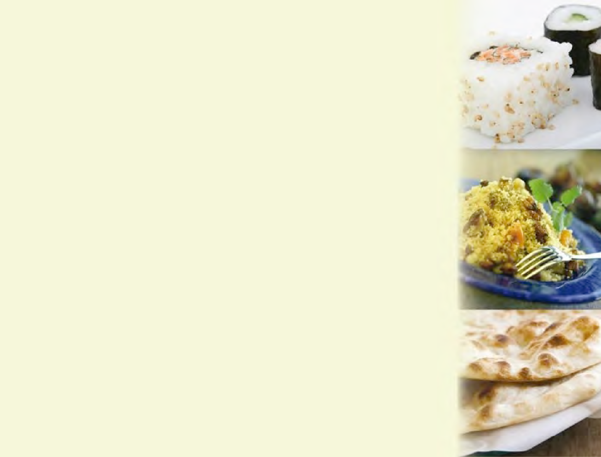

How many different cultures are represented at your school?

Does your canteen menu cater for different cultures? Why should you do this?

(Workbook, p.17)

# CULTURAL AND RELIGIOUS NEEDS



Cultural needs

* Indigenous Australians and Torres Straight Islanders
* Asian
* Indian
* Middle Eastern
* South European
* African

Religious needs

* Buddhism
* Hinduism
* Islamic
* Judaism
* Christianity

# CATERING FOR CULTURAL AND RELIGIOUS NEEDS



In schools with large ethnic populations

* Have 1 or 2 culturally appropriate items/dishes on the menu where possible

In schools with smaller numbers of culturally diverse groups

* Have special ‘ethnic’ days
* Recognise and honour other cultures
* For example: Asian, Indian, Middle Eastern and South European

What foods could you cook on these days? (Workbook, p.17)

# LOOKING AFTER OUR PLANET



Wherever possible, use seasonal produce Support local producers

School gardens

* + Stephanie Alexander Kitchen Garden Foundation [http://www.kitchengardenfoundation.org.au](http://www.kitchengardenfoundation.org.au/)

Where the range of fresh foods is insufficient, use frozen and canned produce.

# SUMMARY



Basic understanding of:

* Nutrition
* The nutritional basis of the NHSC *Guidelines*

How to apply the NHSC *Guidelines* using:

* General principles of healthy eating
* Food label reading skills

Materials to take away:

* *Guidelines for healthy foods and drinks supplied in school canteens*
* *Quick Reference*
* Poster (*Healthy kids need healthy canteens!*)
* Food Safety Fact Sheet
* *The Australian Guide to Healthy Eating* poster
* *Healthy Eating for Children* brochure

# FURTHER STUDY



Workplace Implementation Project

* Website links for further reading
* Nutritional Panel Calculator
* Costing tool

**Statement of Attainment**

Issued by Registered Training Provider

* *SITHCCC035A*

*Develop menus to meet special dietary and cultural needs*

* + *Cert III in Hospitality(Catering Operations), (Commercial Cookery)*
  + *Cert IV in Hospitality (Commercial Cookery)*

Training.gov.au (TGA) database on Vocational Education and Training (VET) in Australia

[http://www.training.gov.au](http://www.training.gov.au/)

Additional information on the *2013 Australian Dietary Guidelines*: [www.eatforhealth.gov.au](http://www.eatforhealth.gov.au/)



Thank You QUESTIONS?