



# National Healthy School

**Canteens Project**

### Canteen Manager Training

**Please turn off your mobile phone**



**INTRODUCTION**

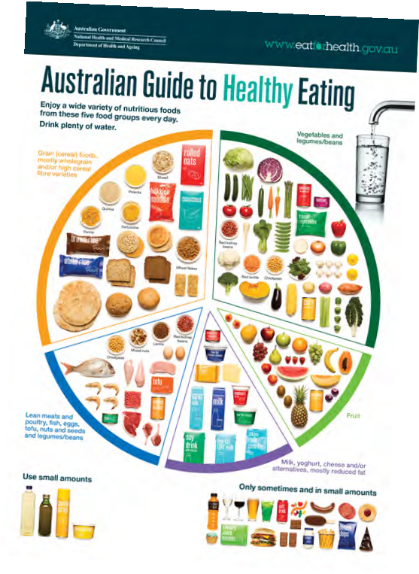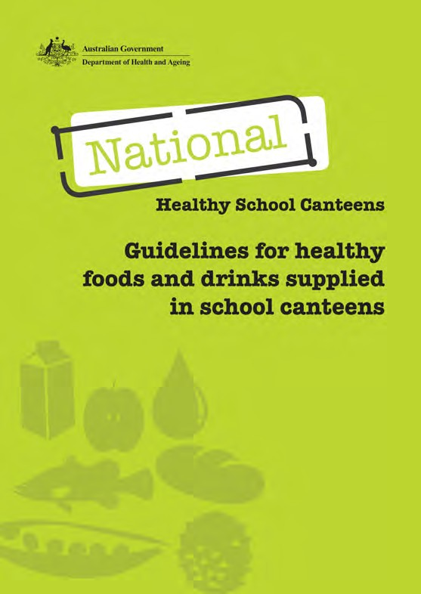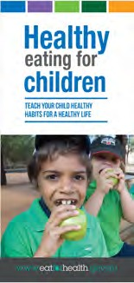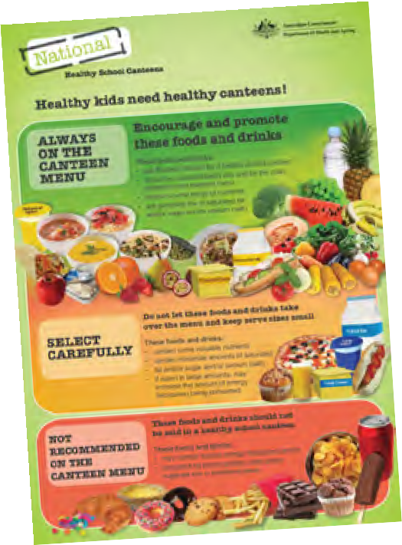

* Background
* Purpose of the course
* Nutrition basics
  + Reading a food label
  + *The Australian Guide to Healthy Eating*
* The NHSC food categorisation system
* Cultural and special dietary needs
* Where to from here



**MATERIAL**

Participant’s Workbook Group discussion



* + Can write in notebook

Written Activity Reference Material

* + NHSC Guidelines
  + *The Australian Guide to Healthy Eating* poster
  + *Healthy Eating for Children*

brochure

* + Poster (Healthy kids need healthy canteens!)
  + Food Safety fact sheet
  + Food labels
  + CD
  + Contact details for nutritional support

Evaluation forms

* + Fill in and leave with us

## BACKGROUND



**Purpose of this course**

* To provide you with the skills to use the National Healthy School Canteens food categorisation system.
* To meet the requirements for recognition towards the national unit of competency SITHCC035A *Develop menus to meet special dietary and cultural needs* if you decide in the future to enrol in a course from a recognised training organisation

## BACKGROUND



**Aim of the NHSC**

Aim of the NHSC Project

*Develop a food categorisation system and training resources to assist canteen managers to make appropriate menu choices that encourage the development and reinforcement of healthy eating patterns in schools.*



**BACKGROUND**

Mid-2004: Australian Health Ministers Council

* Support for school canteens in promoting healthy eating among children
* Health and industry sectors asked to work through the National Obesity Taskforce
* 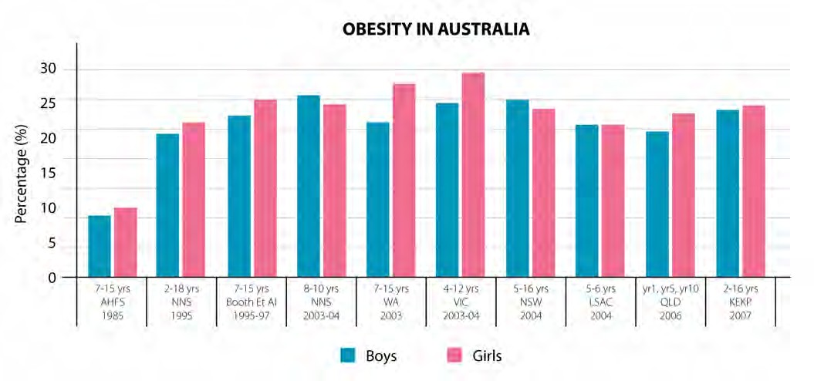Healthy Weight 2008 Australia’s Future: National Action Agenda – A plan to tack overweight and obesity

## BACKGROUND



Australian Better Health Initiative Implementation Plan (ABHI)

### Endorsed in 2006 by Australian Health Ministers

* Consistent national framework principles
* Included funding for the National Healthy School Canteens (NHSC) Project
  + Promote good health
  + Healthy eating
  + Reduce levels of childhood obesity
  + Chronic disease

Australian Better Health Initiative

* Strategy to improve the overall health of the school community

## BACKGROUND



Recent Australian data 1 for children aged 2-16 years

* 72% fall within the normal weight range
* 28% are outside the healthy weight range
  + 1 in 4 children are overweight or obese
  + Prevalence of obesity similar at 5-7% for both boys and girls
  + Girls in the age group 9-13 years had the highest prevalence of overweight
  + 5% were underweight

1 DoHA 2008, 2007 National Children’s Nutrition and Physical Activity Survey, Main Findings,

[*http://www.health.gov.au/internet/main/publishing.nsf/Content/66596E8FC68FD1A3CA2574D50027DB86/$File/childrens-nut-phys-survey.pdf*](http://www.health.gov.au/internet/main/publishing.nsf/Content/66596E8FC68FD1A3CA2574D50027DB86/%24File/childrens-nut-phys-survey.pdf)

## BACKGROUND

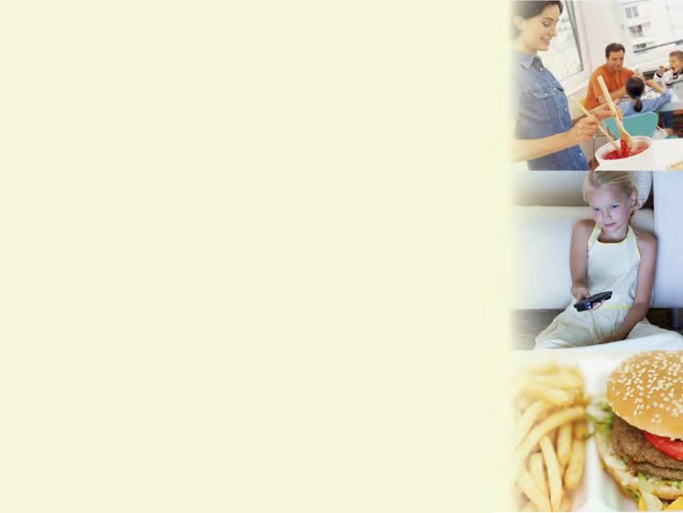

**Contributing factors**

### Changed eating patterns

* Increased use of convenience foods
* Fewer meals cooked from basic ingredients
* Less family time/fewer meals eaten together
* More food eaten away from home
* Larger serves of foods and drinks

### Decrease in physical activity

* Loss of secure play areas
* Increase in screen time
  + TV, movies, gaming, computers



**BACKGROUND**

**Recent Data**

### Australian children aged 5-16 years

* Energy intake during school hours was 32% of total energy
* Fruit intake during school hours was 62% of total fruit consumed
* Vegetable intake during school hours was 17% or total vegetables consumed
* Calcium intake during school hours was 28% of total calcium consumed

1 DoHA 2008, 2007 National Children’s Nutrition and Physical Activity Survey, Main Findings,

[*http://www.health.gov.au/internet/main/publishing.nsf/Content/66596E8FC68FD1A3CA2574D50027DB86/$File/childrens-nut-phys-survey.pdf*](http://www.health.gov.au/internet/main/publishing.nsf/Content/66596E8FC68FD1A3CA2574D50027DB86/%24File/childrens-nut-phys-survey.pdf)

**BACKGROUND**

**Health promoting school**

* School environment promotes health and wellbeing messages consistent with what is taught in the classroom
* Collaboration between schools, families and the wider community
* Support and involvement of school community members (including teachers and principals) in health programs and policies
* Working with food industry and local businesses and suppliers to develop and promote healthy food choices in school canteens

curriculum, teaching & learning



School organisation, ethos & environment

partnerships & services



Australian Health Promoting Schools Association 2010

[http://www.ahpsa.org.au](http://www.ahpsa.org.au/)

## ROLE OF THE SCHOOL CANTEEN IN CONTRIBUTING TO A HEALTHY PROMOTING SCHOOL

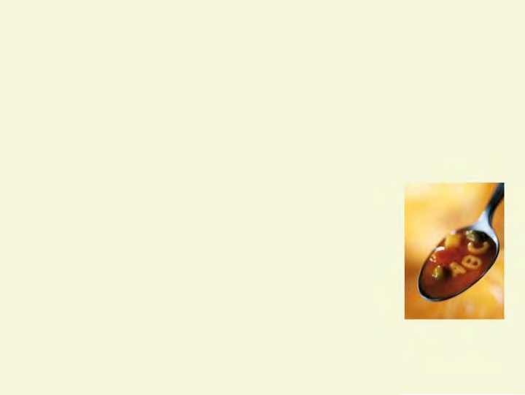

WA data suggests 45-46% of school children order lunch at school at least once per week 1

A study conducted in SA found:

* 13% of children ordered lunch, and
* 3% ordered recess on the day they were surveyed2

Canteen’s role:

* Model healthy eating
* Reinforce classroom messages
* School culture of healthy eating

1 Pettigrew et al 2009, *Addressing Childhood Obesity through School Canteens*, Report to the WA Department of Education and Training, UWA business School, the University of Western Australia, and the Centre for Behavioural Research in Cancer Control, Curtin University. Perth.

2 Jones et al 2008, Evaluation Report, Part 1: Baseline Data Collection, South Australian Department of Health, South Australia.

## DISCUSSION



What is a healthy school canteen? (Workbook, p.4)



## NUTRITION

### TOPICS:

* Defining nutrition
* Exploring the factors that affect food intake
* Classifying food according to *The Australian Guide to Healthy Eating* (AGTHE)
* Defining nutrients of interest
* Identifying the nutrients of particular relevance to children



**NUTRITION**

**Definition**

Nutrition is a 3-part process

* Food or drink is consumed
* The body breaks down the food or drink into nutrients
* The nutrients travel through the bloodstream to different parts

of the body where they are used as ‘fuel’ and for many other purposes

## NUTRITION



**Circumstances that affect eating habits**

What factors influence the requirements of canteen customers? (Workbook, p.6)



**NUTRITION**

**Food Classification**

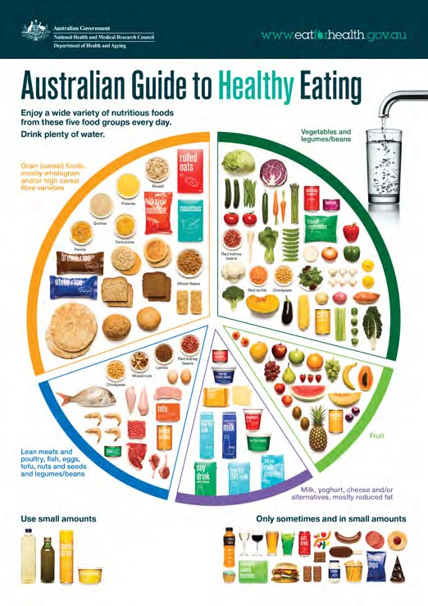Foods in Australia are classified according to *The Australian Guide to Healthy Eating* as:

* Vegetables and legumes
* Fruits
* Dairy and alternatives
* Meat and alternatives
* Grains and cereals

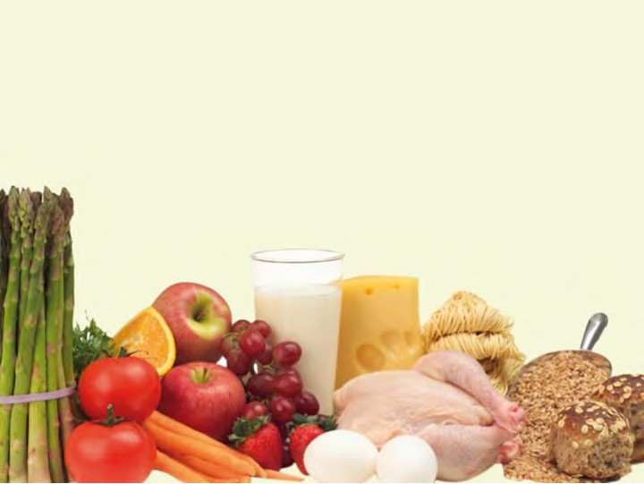

**NUTRITION**

**Nutrients**

Nutrients are substances that make up foods. There are 6 essential nutrients:

* + Proteins • Lipids (fats and oils) • Minerals
  + Carbohydrates • Vitamins • Water

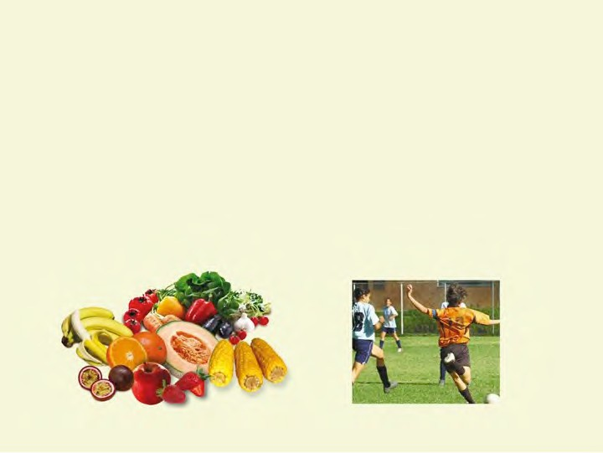

**NUTRITION**

**Energy**

Definition

* + Needed by the body to function and for physical activity
  + Obtained from food and drinks
  + To maintain weight

Energy In = Energy Out



**NUTRITION**

**Energy**

Energy in Australia is measured in kilojoules (kJ)

* Some countries around the world still use the calorie system (4.2 kJ ≈ 1 calorie)

Carbohydrates, fats/oils (lipids) and proteins are the nutrients that provide energy

A day’s intake is measured in thousands of kJs

* Children between the ages of 4-18 years require 6500 to 14000kJ per day depending on their age and level of physical activity1

1NHMRC 2005, Nutrient Reference Values for Australia and New Zealand,

<http://www.nrv.gov.au/>



**NUTRITION**

**Nutrients of Interest**

Some nutrients have been linked to chronic disease

* Saturated fat
* Sodium (salt)
* Dietary fibre (lack of)

Excess overall energy intake

* Excess added sugar and fats



**NUTRITION**

**Nutrients of Interest**

Carbohydrates

* Starchy foods that are good sources of energy and nutrients (bread, rice, pasta, grains, vegetables)
* Sugars in milk and fruit (lactose, fructose
  + Added sugar (for example: sucrose, glucose, maltose)

Dietary Fibre

* Is the part of plants that cannot be digested using normal digestive enzymes in the samll intestine. Broken down by bacteria in the large bowel.
* Fibre is essential to bowel health and can be found in fruits, vegetables, wholegrain/ wholemeal cereals and breads, legumes, nuts and seeds.

## NUTRITION

**Nutrients of Interest**

**Fats and oils (lipids)** – how they are classified

Fats and oils

Saturated

Unsaturated

Monounsaturated

Polyunsaturated

Omega 3 & Omega 6



**NUTRITION**

**Nutrients of Interest**

What foods contain mostly saturated or unsaturated fats?

|  |  |  |
| --- | --- | --- |
| **Food Saturated Unsaturated** | | |
| Avocado |  |  |
| Butter |  |  |
| Canola Oil |  |  |
| Cheese |  |  |
| Coconut Cream |  |  |
| Coconut Milk |  |  |
| Cream |  |  |
| Fatty meat |  |  |
| Fish |  |  |
| Game meat (e.g. kangaroo, rabbit) |  |  |
| Margarine |  |  |
| Milk |  |  |
| Nuts |  |  |
| Olives |  |  |
| Olive oil |  |  |
| Palm oil |  |  |
| Seeds |  |  |
| Sunflower oil |  |  |
| Vegetable oil |  |  |

(Workbook, p.7)

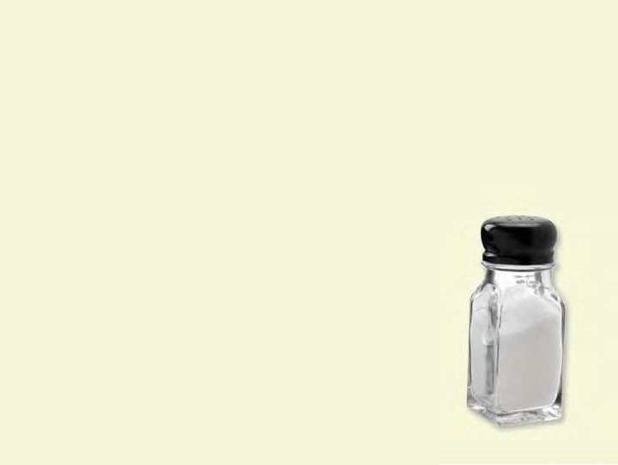

**NUTRITION**

**Nutrients of Interest**

Sodium (salt)

* Mostly found in processed foods and added ‘at the table’
* When used in excess, salt has been linked to loss of calcium and development of high blood pressure in adulthood1

1 DoHA 2008, 2007 National Children’s Nutrition and Physical Activity Survey, Main Findings,

[*http://www.health.gov.au/internet/main/publishing.nsf/Content/66596E8FC68FD1A3CA2574D50027DB86/$File/childrens-nut-phys-survey.pdf*](http://www.health.gov.au/internet/main/publishing.nsf/Content/66596E8FC68FD1A3CA2574D50027DB86/%24File/childrens-nut-phys-survey.pdf)

## NUTRITION

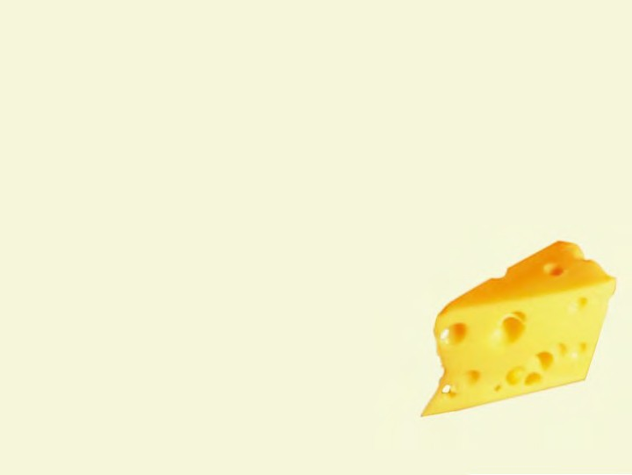

**Nutrients of Interest**

Calcium

* Is important for building strong, healthy bones and teeth
* Adequate intake sin childhood and adolescence protect against osteoprosis later in life
* Has been identifies as a nutrient at risk, especially in older children1
* Almost 90% of girls aged 12-13 years do not meet estimated requirements
* Dairy products (for example: milk, yoghurt and cheese) are the riches sources of calcium in the diet

1 DoHA 2008, 2007 National Children’s Nutrition and Physical Activity Survey, Main Findings,

[*http://www.health.gov.au/internet/main/publishing.nsf/Content/66596E8FC68FD1A3CA2574D50027DB86/$File/childrens-nut-phys-survey.pdf*](http://www.health.gov.au/internet/main/publishing.nsf/Content/66596E8FC68FD1A3CA2574D50027DB86/%24File/childrens-nut-phys-survey.pdf)



## FOOD LABELLING

### TOPICS:

* What is on a label?
* Reading food and drink labels:
  + Ingredients
  + Additives
  + Nutrient Information Panel (NIP)
  + Nutrient content claims

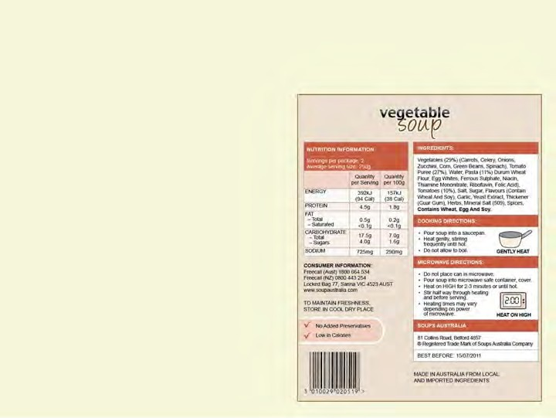

**FOOD LABELLING**

**What’s on the label?**

* Labels must tell the truth and be legible
* Name or description of the food
* Nutrition Information Panel (NIP)
* Ingredients list
  + Percentage labeling
  + Food additives
* Information for allergy sufferers
* Date marking
  + Best before
  + Use-by-date
* Directions for use and storage
* Country of origin
* Food recall information
* May contain nutrient claims
  + High in fibre
  + No added preservatives

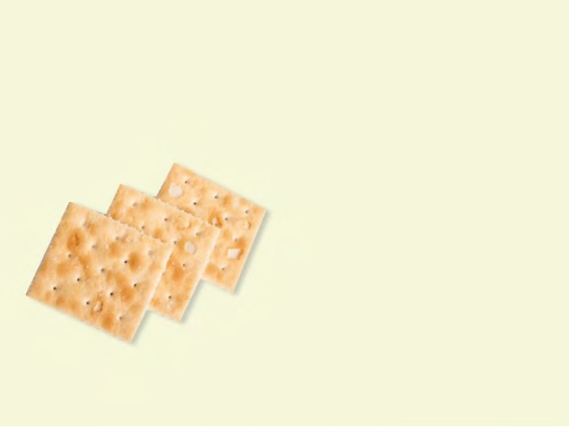

**FOOD LABELLING**

**Ingredients**

Are written in order of weight from the largest to the smallest

**Ingredients:** wheat flour, rye meal, rice flour, milk solids, salt, sugar

### May contain traces of nut, egg or seed

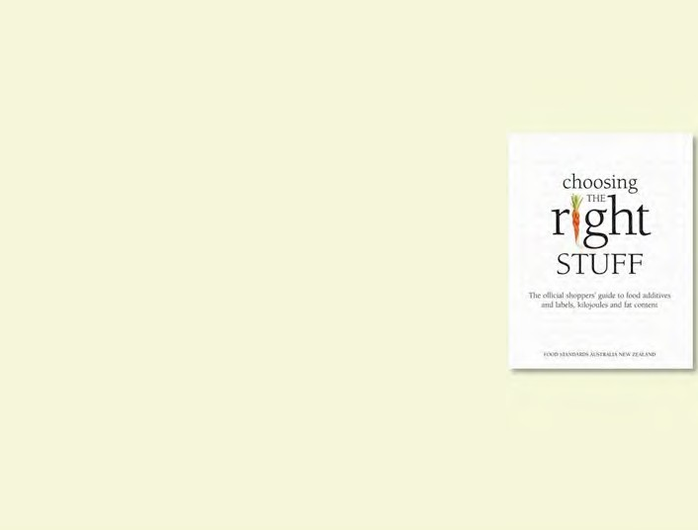

**FOOD LABELLING**

**Additives**

Are used:

* To preserve food
* Improve ‘keeping’ quality
* Improve taste or appearance.

Are grouped in categories – for example:

* emulsifiers
* colourings
* Sweeteners

Are listed by name and/or number on food labels

* For example, monosodium glutamate (621)

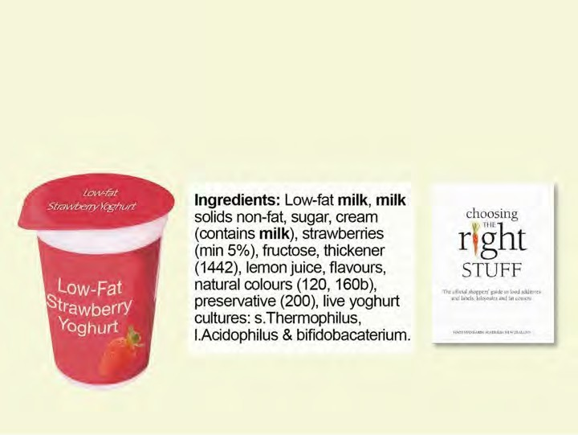

**FOOD LABELLING**

**Additives - Example**

Activity: Food label ingredient lists (Workbook, pp. 8-9)

**Ingredients:** Low-fat **milk**, **milk** solids non-fat, sugar, cream (contains **milk**), strawberries (min 5%), fructose, thickener (1442), lemon juice, flavours, natural colours (120, 160b), preservative (200), live yoghurt cultures; s.Thermophilus, l.Acidophilus & bifidobacaterium.



**FOOD LABELLING**

**Additives - Example**

Must appear on most food packages.

|  |  |  |
| --- | --- | --- |
| **NUTRITION INFORMATION**  Servings per package: 1 Average serving size: 250g | | |
|  | Average quantity per Serving | Average quantity per 100g |
| ENERGY | 658kJ | 263kJ |
| PROTEIN | 9.8g | 3.9g |
| FAT   * total * saturated | 3.5g  2.3g | 1.4g  0.9g |
| CARBOHYDRATE  – sugars | 21.3g  20.5g | 8.5g  8.2g |
| SODIUM | 160mg | 64mg |

Must contain information per serve and per 100g for:

* Energy (kJ)
* Protein (grams)
* Fat (grams total and saturated
* Carbohydrate (grams) total and sugar
* Sodium (milligrams).



**FOOD LABELLING**

**Nutrient content claims**

What claims do you look for on food packages when ordering for the school canteen?

(Workbook, p.9)

Statements about a specific nutrient in the food.

* + Examples: low-fat, lite, high in fibre.

The quantity of that nutrient must appear in the NIP.

FSANZ (Food Standards Australia New Zealand) is the government body that regulates those claims – each claim has a specific meaning.

* + For example, low-fat means the product contains less than 3g of fat per 100g of food or less than 1.5g of fat per 100mL of liquid.

## NATIONAL HEALTHY SCHOOL CANTEENS (NHSC)



**The NHSC food categorisation system**



**NATIONAL HEALTHY SCHOOL CANTEENS (NHSC)**

### Topics

* What is the NHSC food categorisation system?
* *The 2013 Australian Dietary Guidelines*
* *The Australian Guide to Healthy Eating*
* Applying the NHSC food categorisation system

## NATIONAL HEALTHY SCHOOL CANTEENS (NHSC)

**Canteens Project**

The food categorisation system is a ‘traffic light spectrum’ based on;

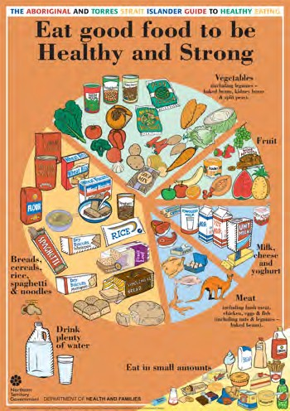

* *The 2013 Australian Dietary Guidelines*
* *The Australian Guide to Healthy Eating*

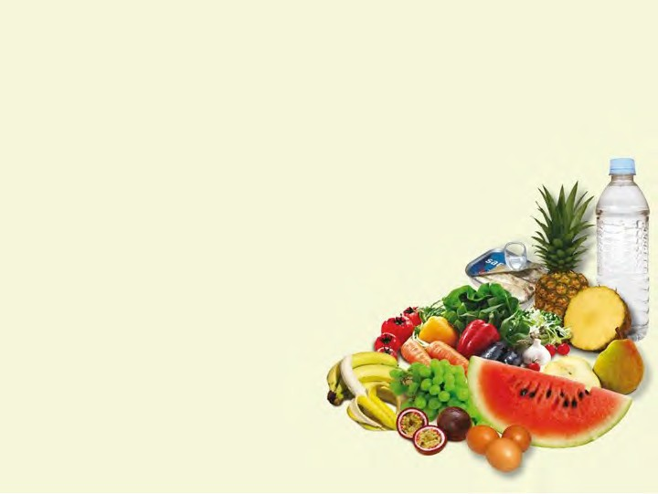

***2013 Australian Dietary Guidelines***

* + Enjoy a wide variety of nutritious foods from the five food groups every day:
    - Plenty of vegetables
    - Fruit
    - Grain (cereal) foods, mostly wholegrain and/or high cereal fibre varieties
    - Lean meats and poultry, fish,

eggs, tofu, nuts and seeds, and legumes/beans

* + - Milk, yoghurt, cheese and/or

their alternatives, mostly reduced fat

* + And drink plenty of water

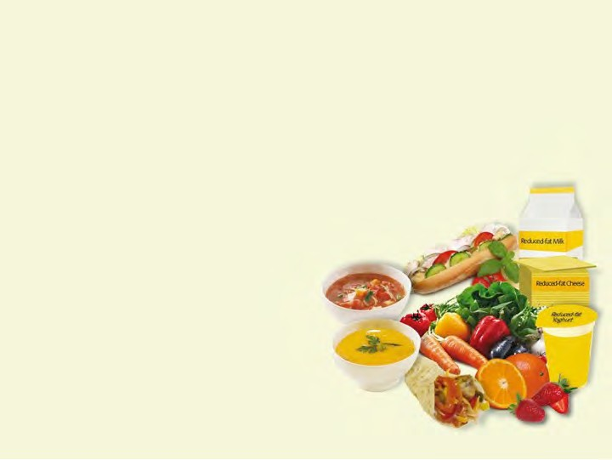

***2013 Australian Dietary Guidelines***

* + - Limit intake of foods high in saturated fat
    - Limit intake of foods and drinks containing added salt
    - Limit intake of foods and drinks containing

added sugar



**NHSC**

***The Australian Guide to Healthy Eating***

The Australian Guide to Healthy Eating is a food selection guide which visually represents the proportion of the five food groups recommended for consumption each day.



***2013 Australian Dietary Guidelines –***

**recommended number of serves**

The recommended serves for children are:

|  |  |  |  |  |
| --- | --- | --- | --- | --- |
| **Food Groups Number of Serves** | | | | |
| **Boys** | **4 – 8 years** | **9 – 11 years** | **12 – 13 years** | **14 – 18 years** |
| Vegetables | 4 ½ | 5 | 5 ½ | 5 ½ |
| Fruit | 1 ½ | 2 | 2 | 2 |
| Grain (cereal) | 4 | 5 | 6 | 7 |
| Lean meats and alternatives | 1 ½ | 2 ½ | 2 ½ | 2 ½ |
| Dairy and alternatives | 2 | 2 ½ | 3 ½ | 3 ½ |
| **Girls** | **4 – 8 years** | **9 – 11 years** | **12 – 13 years** | **14 – 18 years** |
| Vegetables | 4 ½ | 5 | 5 | 5 |
| Fruit | 1 ½ | 2 | 2 | 2 |
| Grain (cereal) | 4 | 4 | 5 | 7 |
| Lean meats and alternatives | 1 ½ | 2 ½ | 2 ½ | 2 ½ |
| Dairy and alternatives | 1 ½ | 3 | 3 ½ | 3 ½ |



**NHSC**

***The AGTHE – how much is a serve?***

How many serves would the following be?

|  |  |
| --- | --- |
| **Food Groups Serve Size** | |
| **Vegetables – different types and colours, and legume/beans** | * ½ cup cooked green or orange vegetables (eg broccoli, spinach, carrots or pumpkin) * ½ cup cooked dried or canned , peas or lentils * 1 cup green leafy or raw salad vegetables, ½ cup sweet corn, ½ medium potato or other starchy vegetables (sweet potato, taro or cassava), 1 medium tomato |
| **Fruit** | * 1 medium apple, banana, orange or pear * 2 small apricots, kiwi fruits or plums * 1 cup diced or canned fruit (no added sugar) |
| **Grain (cereal) foods, mostly wholegrain and/or high in fibre** | * 1 slice bread, ½ medium roll or flat bread, * ½ cup cooked rice, pasta, noodles, barley, buckwheat, semolina, polenta, bulgur or quinoa * ½ cup cooked porridge, 2/3 cup cereal flakes, ¼ cup muesli * 3 crispbreads, 1 crumpet, 1 small English muffin or scone |
| **Lean meats and poultry, fish, eggs, tofu, nuts and seeds, and legumes/beans** | * 65 g cooked lean red meats such as beef, lamb, veal, pork, goat or kangaroo (about 90-100 g raw) * 80 g cooked lean poultry such as chicken or turkey (100 g raw) * 100 g cooked fish fillet (about 115g raw) or one small can of fish * 2 large eggs (120 g), 1 cup (150 g) cooked or canned legumes/beans such as lentils, chick peas or split peas * 30 g nuts*, seeds, peanut* or almond butter *or tahini or other nut or seed paste |
| **Milk, yoghurt, cheese and/or their alternatives, mostly reduced fat** | * 1 cup (250ml) milk, ½ cup (120 ml) evaporated milk, 2 slices (40 g) hard cheese, such as cheddar * ½ cup (120 g) ricotta cheese * ¾ cup (200 g) yoghurt * 1 cup (250ml) soy, rice or other cereal drink with at least 100mg of added calcium per 100ml |

(Workbook, p.12)

*Check your school policy regarding the use of nuts and products containing nuts

**NHSC**

***The AGTHE – how much is a serve?***

How many serves would the following be? (Workbook, p.12)

How many serves would the following be? (Workbook, p.12)

2 apricots 1cup of milk



1 beef sandwich with:

* + - 2 slices of bread



* + - 1 slice of beef
    - 3 slices of tomato
    - 1/4 cup of cucumber and lettuce
    - 2 teaspoons of margarine

**SERVE**

**TOTAL:**



*Check your school policy regarding the use of nuts and products containing nuts

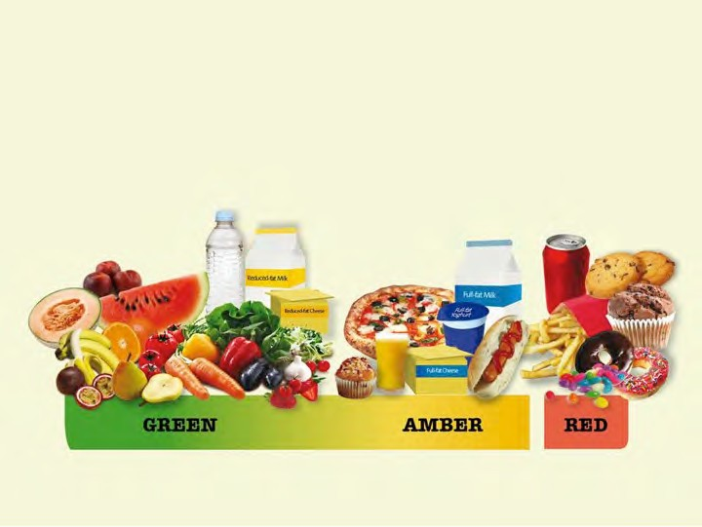

**NHSC**

***Food categorisation system***

Foods and drinks have been categorised as:



Encourage and promote these foods and drinks as

tasty, good value choices:

* Provide them every day
* Present as the main choice

**THE GREEN CATEGORY**

**ALWAYS ON THE CANTEEN MENU**

Because they:

* Offer a wide range of nutrients
* Are generally low in saturated fats and/or added sugars and/or salt

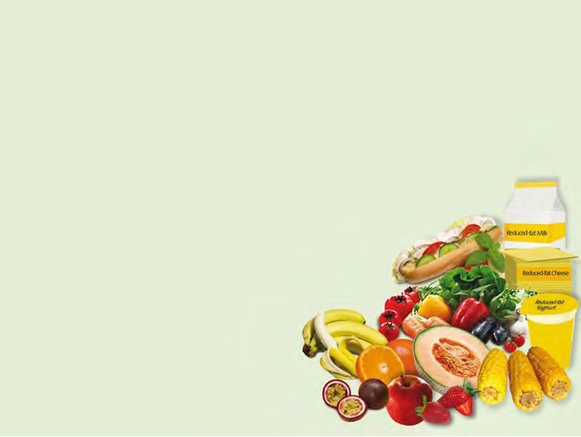

* Breads, wholegrain breakfast cereals (without

added confectionery), lower in added sugar, higher fibre

* Dairy foods: low or reduced fat milk plain and flavoured, yoghurt, and cheese

**THE GREEN CATEGORY**

* Fruits (not dried); fresh, frozen or canned
* Vegetables (including legumes): fresh, frozen, canned



* Unprocessed lean meat and poultry, fish, eggs,

nuts*

* Rice, pasta, plain noodles
* Water, plain and nothing added

**THE GREEN CATEGORY**

* + Tap, spring, mineral or sparkling

* Check your school policy regarding the use of nuts and products containing nuts.



# THE AMBER CATEGORY

**SELECT CAREFULLY**

These foods contain some nutrients but are generally higher in saturated fat, salt and added sugar

* If eaten regularly or in large amounts, foods in the AMBER category may

contribute to excess energy being consumed

* Provide in smaller serve sizes
* “GREEN” these foods at every opportunity



# THE AMBER CATEGORY

### Some restrictions:

* Full-fat dairy foods: milk (plain and flavoured), yoghurt, custard, cheese
  + Coffee milk/soy drinks 375mL or less may be sold in secondary school
* Fruit and vegetable juice – no added sugar
  + At least 99% fruit juice, maximum 250mL serve size
* Dried fruit
  + Including 100% fruit leathers
* Ice slushies, fruit jellies – no added sugar
  + At least 99% fruit juice, maximum 200mL serve size
* Ice blocks – no added sugar
  + At least 99% fruit juice, maximum 125mL serve size
* Jam/honey/toppings/syrups
  + In small amounts

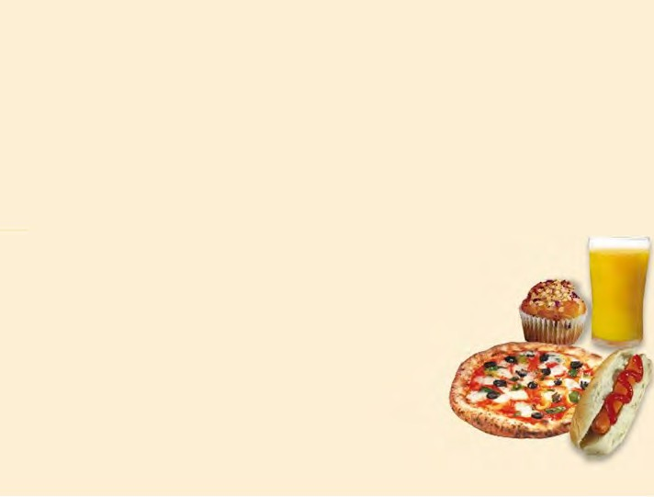

* Ready-to-eat pasta/rice/noodle dishes

**THE AMBER CATEGORY**

**Need to meet criteria:**

* Lean processed meats
* Savoury pastry and bread products
* Ready-to-eat hot mixed dishes
* Oven-baked potato products
* Snack food bars (breakfast bars, cereal bars, fruit filled bars)
* Some un-iced cakes, muffins, sweet biscuits
* Savoury snack foods, biscuits, crackers and crispbreads
* Low or reduced-fat ice creams, milk-based ices and dairy desserts