Department of Health

Australia’s Future Health Workforce – Emergency Medicine

**November 2017**

Contents

Executive Summary 1

Key considerations 1

Key findings 2

Supply and demand projections 2

Training program 3

Capacity and distribution for vocational training 3

Recommendations: 3

Overview 5

Background 6

Determining the Future Capacity for Training Needs 6

Introduction 8

Ongoing monitoring 9

Current workforce status 9

Registration, accreditation and specialty fields 9

Age and Gender 10

Growth 11

Distribution 12

Hours worked 14

Current trainee status 17

Fellowship program 17

Prevocational intentions 22

Summary of total workforce by remoteness classification 23

Workforce projections 24

Supply 24

Demand 24

Projection results 25

Sensitivity 25

Interpretation of results for workforce position 25

Scenarios 25

Scenario 1: Dynamic intake baseline scenario 25

Scenario 2: Static intake scenario 26

Scenario 3: FACEM rostering scenario 27

Scenario 4: Intentions to reduce hours and leave clinical practice 28

Training Analysis Pipeline (TAP) 28

Results of pipelining 31

Capacity and Distribution for Training 31

Results of consultation 32

Recommendations 33

Appendices 35

Appendix 1: Summary of modelling inputs 35

Appendix 2: Definition of a specialist (example for anaesthetist) 38

Appendix 3: Definition of hours worked 42

Appendix 4: Trainees and Intentions 44

Appendix 5: Data variables and sources 46

Appendix 6: Medical Practitioners survey 2015 47

Appendix 7: Guidelines on constructing/retaining Senior Emergency Medicine Workforce 52

Tables

Table 1: Definitions of the Modified Monash Model Categories 13

Table 2: Emergency medicine clinicians (headcount and sector: proportion of specialist clinical FTE in public and private) by state and territory 17

Table 3: Trainees (headcount) by training level, age group 19

Table 4: Trainees (headcount) by age (group), gender and training year (current year of training program) 19

Table 5: Trainee FTE (total hours) by training year and sector 21

Table 6: Summary of EM workforce (headcount and FTE) by MMM 24

Table 7: Dynamic intake baseline scenario 1 26

Table 8: Balancing dynamic intake baseline scenario 1 26

Table 9: Static intake scenario 2 27

Table 10: FACEM rostering demand scenario 3 27

Table 11: Reducing hours and intentions scenario 4 28

Table 12: TAP scenarios for new trainee intake 29

Table 13: TAP transition calculations 29

Table 14: Dynamic intake TAP, 2010 – 2030 30

Table 15: Static intake TAP, 2010 – 2030 30

Figures

Figure 1: Emergency medicine workforce by job role, 2015 10

Figure 2: Comparison of emergency medicine specialists that are registered, employed, working in EM and clinicians (headcount) by age group 11

Figure 3: Gender distribution of emergency medicine workforce, 2015 11

Figure 4: Employed emergency medicine specialists by gender, 2008 to 2015 12

Figure 5: Demographics of the emergency medicine workforce, 2015 12

Figure 6: Emergency medicine workforce (clinicians) by MMM, 2015 14

Figure 7: Average hours by total, clinical, specialist clinical and specialist total hours worked, 2015 14

Figure 8: Average total specialist hours and clinical specialist hours by gender and age group, 2015 15

Figure 9: Average total specialist hours by states and territories 16

Figure 10: Average total specialist hours by MMM 16

Figure 11: Distribution of emergency medicine trainees, 2015 20

Figure 12: Demographics of emergency medicine trainees in 2015 20

Figure 13: Trainees by state and territory and MMM 21

Figure 14: Proportion of trainee FTE by distribution (MMM) and sector 22

Figure 15: Characteristics of HNS who intend to undertake EM training 22

Figure 16: HNS who intend to undertake EM specialist training by position 23

Figure 17: Proportion of HNS intentions and trainees by geographic distribution 23

Figure 18: New Fellows dynamic pipeline projections 31

Figure 19: New Fellows static pipeline projections 31

Figure 20: Survey questions relating to Employment Status 38

Figure 21: Survey questions relating to clinician status 39

Figure 22: Survey questions relating to clinical and non-clinical hours 39

Figure 23: Survey questions relating to principal field of main specialties 40

Figure 24: Survey questions relating to training 41

Figure 25: Erroneous answer recorded in question 23 41

Figure 26: Hours worked as captured in the workforce survey. 42

Figure 27: Estimating total specialty hours 43

Figure 28: Total specialty hours used in modelling – example 43

Figure 29: Survey question related to current specialist training 44

Figure 30: Survey question relating to current year of training program 44

Figure 31: Survey questions relating to intending to train 45

# Executive Summary

The Australia’s Future Health Workforce – Doctors (AFHW Doctors) report published in December 2014 indicated that Australia’s health workforce is under pressure and must undergo significant transformation to meet future demands for health care. Despite the projected overall position of oversupply, imbalances within the medical specialty workforces currently exist and are projected to continue.

The development of the AFHW Doctors report was guided by the expert input of the National Medical Training Advisory Network (NMTAN), which has representation from all the key stakeholder groups in medical education, training and employment.

The report makes recommendations for future work including:

* updates to the workforce modelling results to determine requirements for future adjustments every two years; and
* prioritisation of future policy work to gain a better understanding of the prevocational years and overall capacity for and distribution of vocational medical training.

The NMTAN currently has two subcommittees that explore different aspects of medical training to inform workforce planning:

* employment patterns and intentions of prevocational doctors, and the development of fact sheets on supply and demand for each medical specialty; and
* the capacity for, and distribution of, medical training, including the geographic distribution of medical training and community needs.

The emergency medicine report is part of the first segment of analysis under the capacity and distribution work. This report involves updating the supply and demand projections previously completed by the former Health Workforce Australia (HWA) and published in Health Workforce 2025 - Medical Specialists Volume 3 (HW 2025 Vol 3).

# Key considerations

It is important to note the following regarding demand and supply modelling for all specialties:

* Supply only includes the hours worked by specialist clinicians in the specific speciality being modelled.
* For emergency medicine (EM) this means only the hours worked by emergency medicine specialists in emergency medicine contribute toward determining Full‑Time Equivalents (FTE). In particular, there are 113 emergency medicine specialists who work in emergency medicine AND another speciality – 42 percent of their FTE was spent working in emergency medicine while 58 percent of their FTE was spent working in other specialty. Only the hours worked in emergency medicine contribute toward the supply of FTE for emergency medicine.
* Projections
* The projections depend on a number of key assumptions which underpin each scenario.
* These scenarios are not predictions of what will happen in the future, but are intended to provide an estimate of the likely outcome given the set of conditions upon which it is based.

# Key findings

## Supply and demand projections

The results of the projections for all scenarios conducted reveal a substantial oversupply of emergency medicine specialists throughout the entire projection period.

### Scenario 1 – Dynamic intake baseline scenario

This scenario is based on the intake of new trainees increasing annually based on historical trends (4.4 percent per annum).

The projections indicate that the workforce would be in oversupply throughout the projection period. By 2030, this oversupply is in the magnitude of 2,328 headcount, which is approximately 102 percent of the required number.

In order for the gap between supply and demand to reduce by 2030, the dynamic intake baseline scenario is required to be balanced. The result is a reduction of new trainees into the training program, where the intake number of new trainees is drastically reduced by 19 percent per annum (approximately 133 new trainees from 2022). Despite the extreme reduction in new trainee intake, there would still be an oversupply of 1,383 trainees (or 60 percent) by 2030.

***This is the Department’s preferred scenario***

### Scenario 2 – Static intake scenario

This scenario assumes the emergency medicine trainee intake will remain constant over the projected period, based on an historical average for 2013-2015, or 355 per annum. Under this scenario, the oversupply reduces to 1,909 (83 percent), which is a decrease of 17 percent to the dynamic intake baseline scenario.

### Scenario 3 – Hospital rostering scenario

This scenario is based on the projected number of hospital separations for 294 emergency departments in Australia, then converting these hospital separations into the rostering system within the rostering guidelines for FACEMs. The guidelines are split up into the number of suggested FACEMs and non-FACEM Senior Decision Makers (SDMs) required respectively.

The resulting scenario shows a smaller oversupply compared to baseline (scenario 1) of 33 percent compared to 50 percent for the dynamic intake baseline scenario.

### Scenario 4 – Intentions to reduce hours and leave clinical practice

This scenario is based on survey results from the ACEM fellowship survey, which indicated reducing working hours of approximately 5.5 hours between 2016 and 2030. Coupled with a 34 percent of FACEMs indicating that they intend to exit the workforce within the next 10 years and, as a result, exit rates within the HWPT have been increased to reflect an additional exit rate of 3.4 percent per annum.

Under this scenario, the oversupply reduces to 1,221. The reduction in hours results in an FTE oversupply of 972 Fellows by 2030. The increased exit rates bring a reduction in supply to 3,749 (down from 4,616) by 2030 due to an increase in the exit rate.

Note: This scenario reflects stated intentions to retire and does not reflect actual retirements, as per the NHWDS. The Department does not support this scenario as the actual supply data in the modelling reflects the current trends of decreasing hours. Response to a survey question on intention to retire does not correlate to actual behaviours in the future.

## Training program

At this time, ACEM is not considering a limit to the total number of successful applicants that may enter the Emergency Medicine Specialist Training Program in any one year. However, ACEM is mindful of the results of this report and are in the process of considering mechanism to decrease future trainee numbers. The process will be aided by the ACEM commencing a standards-based entry process to actively select trainees into the ACEM Specialist Training Program as of 2018 (December 2018 for New Zealand and February 2019 for Australian applicants).

Other changes already in place or intended to come into effect for the FACEM Training Program will likely have effects on the number of Fellows graduating each year; however, the exact nature and/or magnitude of the effect(s) of any such changes will not be known until the changes take effect. For example, time limits for ACEM trainees to complete the Emergency Medicine Specialist Training Program and achieve election to Fellowship will come into practical effect from the beginning of 2018, while limitations on the number of examination attempts available to trainees will take effect at a later date.

## Capacity and distribution for vocational training

Key considerations for distributional challenges include:

* Recruitment and retention of EM specialists in regional and rural areas.
* Ongoing reliance on International Medical Graduates (IMGs) to staff emergency departments in these areas, despite an increase in FACEM numbers.
* The need to build capacity through sustainable FACEM cohorts in regional/rural settings.
* Support for more ACEM‑accredited regional and rural emergency departments to support registrar training in these areas.

# Recommendations:

* The supply and demand projection be closely monitored by NMTAN and updated every two years.
* The ACEM consider future decreases in the number of trainees through the process of the standards-based entry to actively select trainees into the ACEM Specialist Training Program. Following implementation of this revised selection process, ACEM is aware that the work described in this report may also necessitate the consideration of setting limits to its trainee intake numbers in the future. The ACEM recognises that this is a matter of significance and welcomes proactive discussions with jurisdictions in relation to this in the context of the overall emergency medicine workforce.
* The NMTAN to help facilitate dialogue between the ACEM and jurisdictional health departments to explore new initiatives such as networked accreditation, the Emergency Medicine Certificate and Diploma, and Emergency Medicine Education and Training (EMET), which may assist in developing and supporting the emergency medicine workforce needs, particularly in rural/regional settings.

# Overview

The Australia’s Future Health Workforce – Doctors (AFHW Doctors) report published in December 2014 indicated that Australia’s health workforce is under pressure and must undergo significant transformation to meet future demands for healthcare.

Despite the projected overall position of oversupply, imbalances within the medical specialty workforces currently exist and are projected to continue.

The medical workforce is a national resource; a resource that is valuable to the community, both in terms of the cost of training, which is substantially borne by the taxpayer, and in terms of the benefit derived by the community from a well-trained health workforce.

In the past, uncoordinated decision making in the absence of an active workforce planning mechanism has seen a “boom and bust” cycle in medical training and resulting doctor numbers. This has been at a cost to the community.

The AFHW Doctors report shows there are three key factors that underpin the importance of national workforce planning for doctors. First, there is an immediate need to deal with the significant increase in domestic medical students that has occurred over the last 10 years. This presents an opportunity to influence further training for medical students, to encourage doctors to move into the locations and specialties that will be needed in the future.

Second, due to the age demographic of the medical workforce, a number of doctors will retire from 2025. The length of time it takes to train a doctor means that short‑term changes in training levels are not an effective response to short‑term imbalances between supply and demand. This reinforces the need to plan over a medium‑term time horizon, and to minimise short‑term movements in medical intakes, which could be better dealt with using temporary migration.

Third, the report states there is a lack of coordination across the medical training pipeline. Between governments, universities, medical colleges and the various employers of doctors, there are hundreds of individuals making decisions on how many doctors and what type of doctors are trained in Australia. Ensuring these individual decisions are aligned to what Australia needs from doctors in the future is essential.

The development of the AFHW Doctors report was guided by the expert input of the National Medical Training Advisory Network (NMTAN) that has representation from all the key stakeholder groups in medical education, training and employment.

The report makes recommendations for future work including:

* updates to the workforce modelling results to determine requirements for future adjustments every two years; and
* prioritisation of future policy work to gain a better understanding of the prevocational years and overall capacity for and distribution of vocational medical training.

# Background

The establishment of the NMTAN was approved on 10 August 2012 by the then Standing Council on Health (SCOH) as a mechanism to enable a nationally coordinated medical training system in Australia. The NMTAN was established under the auspices of the former Health Workforce Australia (HWA) and held its first meeting in February 2014. Since August 2014, support to the NMTAN has been provided by the Australian Government Department of Health (the Department).

The NMTAN provides guidance in the development of a series of medical training reports to inform government, health and education sectors. In addition, the NMTAN provides policy advice about the planning and coordination of medical training in Australia, in collaboration with other networks involved in the medical training space.

The NMTAN currently has subcommittees that explore different aspects of medical training to inform future workforce planning. In addition to the policy-focussed subcommittees, a data subcommittee is responsible for supporting the production of an annual report on medical education and training, including undergraduate, postgraduate and vocational training projects. The functions of this subcommittee were transferred from the Medical Training Review Panel to the NMTAN in 2015.

This emergency medicine report is part of the first segment of analysis under the capacity and distribution subcommittee work. It involves updating the supply and demand projections previously completed by the former HWA and published in HW 2025 – Medical Specialists Volume 3 (HW 2025 Vol 3).

This work has been guided by the input of the NMTAN and has been completed in two stages:

* Stage 1: review and analysis of supply and demand through the modelling of the emergency medicine workforce, with projections to 2030 and analysis of current training capacity and identification of pipeline issues. This resulted in the development of an interim report for targeted consultation with NMTAN and relevant stakeholders/experts.
* Stage 2: consolidation of the feedback on the interim report to identify issues to develop training target ranges and policy recommendations for emergency medicine.

# Determining the Future Capacity for Training Needs

Australia’s medical training system is delivered through a complex interconnection of funding and organisation channels that span Commonwealth and state and territory governments, as well as private and non-government agencies. The cross-sectional nature of delivering and funding medical training in Australia makes workforce planning difficult for any particular agency or sector to deliver in isolation. There is also a risk there will be an ongoing mismatch between the medical workforce that is trained and that is required to deliver necessary services.

The pathway to independent practice as a vocationally‑recognised specialist is long, with multiple layers of investment in training; from university entrance to the completion of specialist vocational training. At the same time, there are numerous players involved in the training pathway, from universities to public and private hospitals and private medical practices.

The recent growth in the medical workforce is important in the calculated supply and demand for health services over the time period covered by the workforce modelling.

This increase in the number of medical students and graduates demonstrates a large increase in the inflows into the medical workforce over a short space of time. This has implications for clinical training capacity, initially at the university level but extending into the prevocational and vocational training years. This pressure has already been seen in the availability of intern training places, which, to date, has largely kept pace with the increasing number of graduates.

This pressure is now beginning to move into the next stages of the training pipeline. There has been an increase of almost 30 percent in vocational training positions with 15,478 in 2011 moving to 20,069 by 2015 with unclear links to future workforce requirements. Previous workforce modelling demonstrates an emerging mismatch between the number of trainees seeking a vocational training place and the availability of places based on community need. This mismatch emerges from around 2017 in the most recent modelling presented in the AFHW Doctors report and extends to approximately 1,000 places by 2030.

# Introduction

Emergency medicine is a field of practice based on the knowledge and skills required for the prevention, diagnosis and management of acute and urgent aspects of illness and injury affecting patients of all age groups. It covers a full spectrum of physical and behavioural disorders. It also includes understanding the development of pre-hospital and in-hospital emergency medical systems, and the skills necessary for this development[1].

Emergency medicine was selected as a medical specialty to be considered in the first segment of analysis by the NMTAN, largely due to concerns identified in HW 2025 Volume 3.

The focus in this report is the assessment of current EM specialists, projected requirements into the future under current utilisation patterns and the implications for training to achieve the best outcomes for patients and the community. The modelling shows a sizeable oversupply which provides an impetus to change the way the current training program is managed.

While the ACEM is moving to a more standards-based entry process to actively select trainees as of 2018, this is only the start of the process to address the current oversupply. The ACEM will need to look at ways in which to reduce their future intake numbers. As previously indicated, changes to the FACEM Training Program will mean that ACEM trainees will have limits on the amount of time available to achieve election to Fellowship from the date of commencement of training, as well as limitations on examination attempts available.

With these changes comes another potential workforce that results from those that do not successfully complete the training program within the given timeframe, but have substantial emergency medicine exposure that could contribute to the workforce as assistant/generalists with a lesser qualification from the college.

A number of scenarios have been considered in this report, these include:

* Scenario 1 – Dynamic intake baseline scenario
  + This scenario is based on the intake of new trainees to increase annually based on historical trends (4.4 percent per annum).
  + The balancing of the workforce assumes the number of new intake needs to decrease by 19 percent per annum or the equivalent of around 133 new entrants per annum from 2022.
* Scenario 2 – Static intake scenario
  + Assumes the intake of new trainees remain constant based on historical average between 2013-2015 of 355 per annum.
* Scenario 3 – hospital rostering scenario
  + The rostering scenario demand has been based on:
  + The projected number of hospital separations for 294 emergency departments in Australia;
  + Converting these hospital separations into the rostering system within the guidelines;
  + Converting these rosters into the aggregate demand for FACEMs.
* Scenario 4 – Intentions to reduce hours and leave clinical practice
  + Based on the Workforce Sustainability Survey conducted by the ACEM, this scenario shows a reduction of working hours of 5.5 hours between 2016 -2030.
  + 3.4 percent exit rate within 10 years to reflect those intending to leave clinical practice in the next 10 years as indicated in the survey.

A summary of the approved modelling inputs can be found in Appendix 1.

## Ongoing monitoring

The supply and demand projections are only the first step of the process in determining capacity for training. The next step is determining the training pathway and trajectory. The development of such a training plan begins to understand the issues and recognise the drivers and/or barriers that a long‑term plan will need to address in order to maintain adequate supply to meet demand in the future. This will also be closely monitored by continually adjusting the modelling projection to address policy changes and other government initiatives that are likely to impact on the supply and demand for emergency medicine specialists. However; it does not factor in unmet demand.

# Current workforce status

## Registration, accreditation and specialty fields

The Medical Board publishes quarterly statistics on Medical Practitioner Registrant Data[2]. In the September 2015 edition there were 1,760 registrants with a specialty of emergency medicine. According to the National Health Workforce Data Set (NHWDS), in 2015 there were 1,724 accredited emergency specialists with current medical registration in Australia; 36 fewer than reported in the Medical Board data. This is because the NHWDS is a snapshot at a point in time (as at the time of data extraction) and the figures only include medical practitioners with current registration. The Medical Board/AHPRA statistics report an annual figure and include medical practitioners who held a registration at some point in the year but may not have a current registration.

In the NHWDS, there were 17 emergency medicine specialists who did not renew their medical registration in 2015, resulting in a difference of 19 between the NHWDS and the Medical Board statistics.

As can be seen in Figure 1, of the 1,724 accredited emergency medicine specialists with current medical registration, 1,578 (92 percent) were employed in the medical workforce. While the majority (1,571) worked in emergency medicine, seven did not work in emergency medicine. Those who did work in emergency medicine were mostly clinicians (93 percent), with the remainder working as administrators, teachers/educators and researchers.

The NHWDS data is also relatively comparable to the ACEM members’ database[3]. In December 2015, ACEM reported 1,801 active FACEMs with 1,550 working in emergency medicine.

Eight percent (113) of emergency medicine specialist clinicians also worked in a specialty other than emergency medicine. The most common second specialties were: intensive care medicine (54), general practice (27) and paediatrics (19).

Figure 1: Emergency medicine workforce by job role, 2015

*Provides overall numbers of emergency medicine workforce including:

Total (1,741), not registered (17), registered (1,724), employed (1,578), employed in emergency medicene (1,571), Clinicians (1,456), administration (70), teacher/educator (24), researcher (11) and other (10).*

*Source: NHWDS, Medical Practitioner 2015*

## Age and Gender

The age distribution of emergency medicine specialists in Australia (Figure 2) show the majority are in the 35-59 year age groups for registered, employed, clinicians and those working in emergency medicine. The proportion of the registered, employed, clinicians and those working in emergency medicine were similar within each of these age groups. The largest single age group for emergency medicine specialists is 40-44 years, with the numbers in the workforce reducing significantly beyond 59 years of age.

Figure 2: Comparison of emergency medicine specialists that are registered, employed, working in EM and clinicians (headcount) by age group

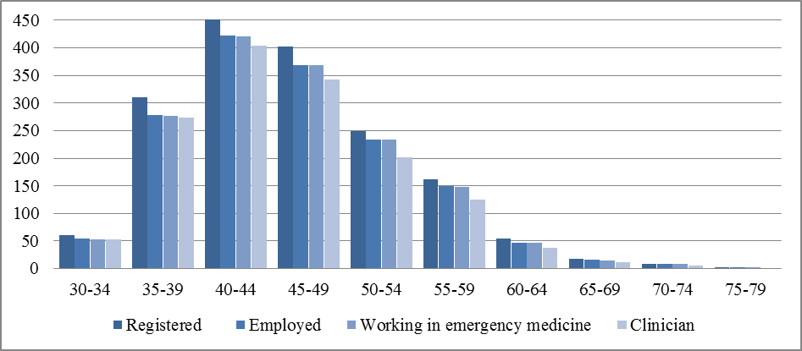

*Source: NHWDS, Medical Practitioner 2015*

The gender distribution of the emergency medicine workforce (

Figure 3) shows that the majority, about two thirds, are male across all groups: registered, employed, clinicians and those working in the field. This is comparable to the FACEM members’ database where 33 percent of active FACEMs were female.

Figure 3: Gender distribution of emergency medicine workforce, 2015

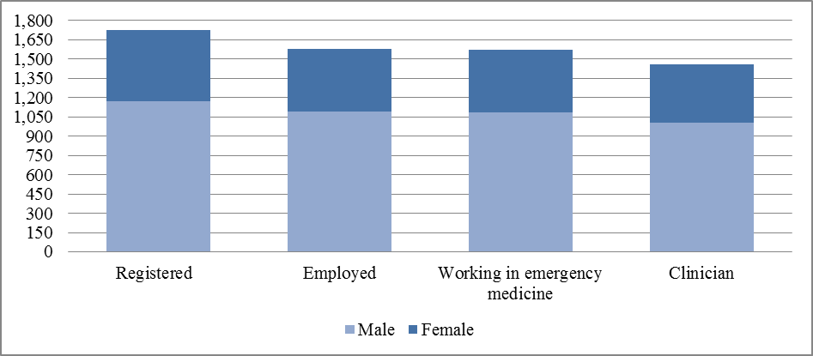

*Source: NHWDS, Medical Practitioner 2015*

## Growth

Figure 4 shows that the number of employed emergency medicine specialists has grown over the years (average annual growth of 7.4 percent), with female emergency medicine specialists experiencing the largest growth over the last five years – at an average annual rate of 11.5 percent, while males have only increased by 5.9 percent (average annual growth). The proportion of females has increased from 25 percent to 32 percent between 2008 and 2015.

Figure 4: Employed emergency medicine specialists by gender, 2008 to 2015

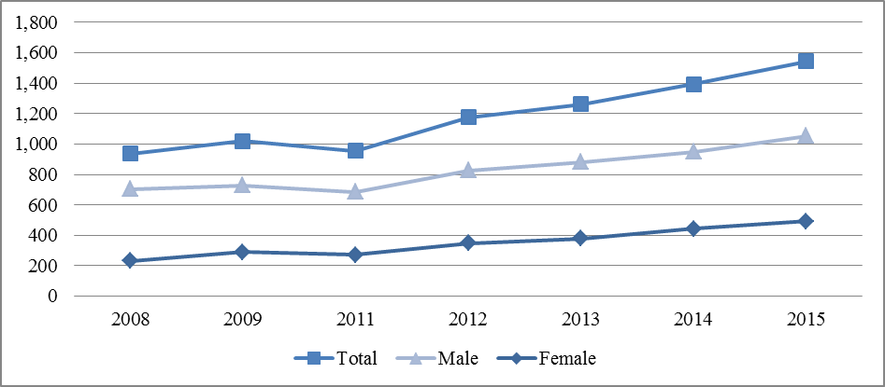

Data for 2010 has been omitted as it excludes Queensland and Western Australia due to their registration closing after the national registration deadline of 30 September 2010.

*Sources: AIHW medical workforce surveys 2008 and 2009; NHWDS: medical practitioners 2011 to 2015*

According to the 2015 NHWDS, there were 1,456 emergency medicine specialists who indicated they were employed and working as clinicians (emergency medicine workforce) with the following characteristics:

Figure 5: Demographics of the emergency medicine workforce, 2015

*The average age of emergency medicine specialists was 45 years.
There were 31% of emergency medicine specialists who were female.
Emergency medicine specialists averaged 38.8 total specialist hours, with females working 35.7 specialist hours.
Emergency medicine specialists aged 55 years and over represent 12% of the workforce, and tend to work 39.8 hours.
There were 51% of emergency medicine specialists located in NSW and VIC.
There were 81% of emergency medicine specialists located in Modified Monash Model Area 1.
There were 91% of emergency medicine specialists working in the public sector.*

*Source: NHWDS, Medical Practitioner 2015*

## Distribution

Figure 6 illustrates the Modified Monash Model and density of the emergency medicine workforce within these areas. The Modified Monash Model (MMM) is a classification system that categorises metropolitan, regional, rural and remote areas according to both geographical remoteness and town size.

The system was developed to recognise the challenges in attracting health professionals to more remote and smaller communities. MMM1 indicates major cities and progresses to MMM7, which indicates very remote Australia.

Table 1 below defines each of these MMM categories. As can be seen on the map (Figure 6), the emergency medicine workforce is located throughout Australia, but is concentrated mainly in Metropolitan areas (81 percent in MMM1). FACEM members’ data concurs with 17 percent indicating they were working in rural or regional localities. However, the distribution or maldistribution of emergency medicine specialists is inextricably tied to the location of public and private emergency departments.

The previous classification system was based on the Australian Standard Geographical Classification – Remoteness Area (ASGC-RA) system. The Australian Bureau of Statistics (ABS) has now replaced ASGC with the Australian Statistical Geography Standard (ASGS). The ASGS uses the latest residential population data to determine the five base categories. The MMM Model will overlay the ASGS for the purposes of administering some health workforce programs.

Table 1: Definitions of the Modified Monash Model Categories

| MMM categories | Definition |
| --- | --- |
| 1 | All areas categorised ASGS-RA1. |
| 2 | Areas categorised ASGS-RA 2 and ASGS-RA 3 that are in, or within 20km road distance, of a town with population >50,000. |
| 3 | Areas categorised ASGS-RA 2 and ASGS-RA 3 that are not in MMM2 and are in, or within 15km road distance, of a town with population between 15,000 and 50,000. |
| 4 | Areas categorised ASGS-RA 2 and ASGS-RA 3 that are not in MMM2 or MMM3, and are in, or within 10km road distance, of a town with population between 5,000 and 15,000. |
| 5 | All other areas in ASGS-RA 2 and 3. |
| 6 | All areas categorised ASGS-RA 4 that are not on a populated island that is separated from the mainland in the ABS geography and is more than 5km offshore. |
| 7 | All other areas – that being ASGS-RA 5 and areas on a populated island that is separated from the mainland in the ABS geography and is more than 5km offshore. |

*Source:* [*Doctor Connect*](http://www.doctorconnect.gov.au/)

Figure 6: Emergency medicine workforce (clinicians) by MMM, 2015

*The Modified Monash Model and density of the emergency medicine workforce within these areas. The Modified Monash Model (MMM) is a new classification system that better categorises metropolitan, regional, rural and remote areas according to both geographical remoteness and town size.*

*Source: NHWDS, Medical Practitioner 2015*

## Hours worked

Figure 7 on page 14 shows the difference between the hours worked by the emergency medicine workforce, by gender. Appendix 3 discusses the process that was used to determine the total hours, clinical hours and specialist clinical hours and then the total specialist hours. There is a clear difference between males and females. This difference ranges from 6.5 hours on average for total hours to just over three hours on average for specialist clinical hours; with females working fewer hours on average. As expected, for both males and females, the total hours are greater than the clinical hours and these are again greater than the specialist clinical hours.

Figure 7: Average hours by total, clinical, specialist clinical and specialist total hours worked, 2015

*Male Total  Hours - 43.7
Female Total  Hours - 37.2
Male Clinical Hours - 32.9
Female  Clinical  Hours - 27.9
Male Specialist Clinical Hours - 29.9
Female Specialist Clinical  Hours - 26.7
Male Total  Specialist Hours - 40.2
Female Total  Specialist  Hours - 35.7*

*Source: NHWDS, Medical Practitioner 2015*

The difference between the total specialist and specialist clinical hours highlights that there is a large component of clinical support (non-clinical) for the emergency medicine workforce. On average, 10 hours per week, or roughly one quarter of specialist’s time, is spent performing clinical support in emergency medicine. This is consistent with ACEMS ‘Guidelines on constructing and retaining a senior emergency medicine workforce’:

*Emergency physicians must have adequate time allocated to facilitate clinical support activities. These activities include the supervision of ED staff, the provision of leadership and mentoring to staff, professional development as well as the various quality improvement activities.*

*ACEM recommends that Emergency physicians are allocated a minimum of 25% clinical support time to undertake required clinical support activities listed in this section.*

Figure 8 below shows the difference between the total specialist hours and clinical specialist hours by gender and age group. A large gap can be seen between total specialist hours and clinical specialist hours in the 50-54 year age group for males and the 60-64 year age group for females. These age groups are spending more time undertaking clinical support than those in the other age groups.

Figure 8: Average total specialist hours and clinical specialist hours by gender and age group, 2015

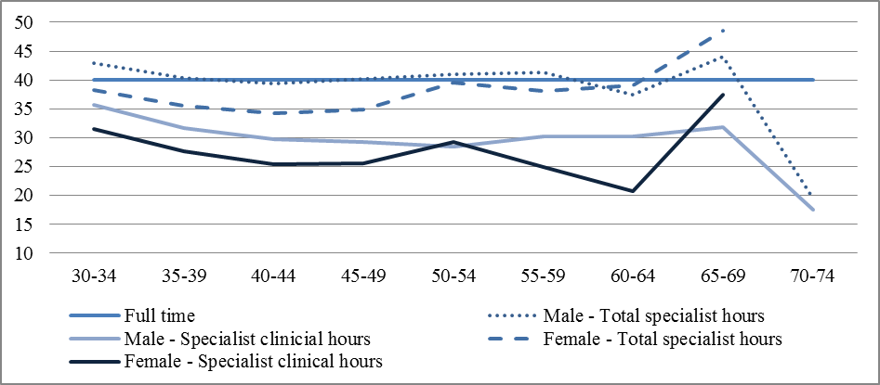

*Source: NHWDS, Medical Practitioner 2015*

The average total specialist hours worked, disaggregated by states and territories, is shown below (Figure 9). Emergency medicine specialists in the NT, QLD, ACT and SA tend to work more than the national average (38.8 hours), while those in TAS tend to work much less than the national average.

Figure 9: Average total specialist hours by states and territories

*The average total specialist hours worked, disaggregated by states and territories. Emergency medicine specialists in the NT, QLD, ACT and SA tend to work more than the national average (38.8 hours), while those in TAS tend to work much less than the national average.
NSW - 38.5
VIC - 37.9
QLD - 40.6
SA - 39.5
WA - 38.0
TAS - 32.5
NT - 41.2
ACT - 40.3*

*Source: NHWDS, Medical Practitioner 2015*

Figure 10 shows there are very small variations in the total specialist hours worked between MMM1 to MMM3 areas. The relatively few emergency medicine specialists working in more regional and remote areas (MMM4 to MMM7) have large variations in total specialist hours worked.

Figure 10: Average total specialist hours by MMM

*There are very small variations in the total specialist hours worked between MMM1 to MMM3 areas. The relatively few emergency medicine specialists working in more regional and remote areas (MMM4 to MMM7) have large variations in total specialist hours worked.
National average - 38.8
MMM1- 38.8
MMM2 - 38.2
MMM3 - 37.9
MMM4 - 33.7
MMM5 - 23.0
MMM6 - 46.7
MMM7 - 30.0

Figure 10 shows there are very small variations in the total specialist hours worked between MM1 to MM3 areas. The relatively few emergency medicine specialists working in more regional and remote areas (MM4 to MM7) have large variations in total specialist hours worked.
National average - 38.8
MM1- 38.8
MM2 - 38.2
MM3 - 37.9
MM4 - 33.7
MM5 - 23.0
MM6 - 46.7
MM7 - 30.0*

*Source: NHWDS, Medical Practitioner 2015*

Table 2 indicates emergency medicine specialists’ clinical workload between sectors and states. The data shows that nationwide the majority of emergency medicine specialists work in the public sector (91 percent), with 10 percent working in the private sector. This is in line with the FACEM members’ data which indicates nine percent were working in private settings in 2015.

At a minimum, 89 percent of emergency medicine specialists clinical FTE is spent in the public sector in all jurisdictions except QLD where 15 percent of the clinical FTE is in a private setting. The majority of emergency medicine specialists are located in the highly‑populated states of NSW, VIC and QLD and proportionally less in the lowest populous states and territories such as NT, ACT and TAS.

Table 2: Emergency medicine clinicians (headcount and sector: proportion of specialist clinical FTE in public and private) by state and territory

| State and Territory | Headcount | Specialist Clinical FTE % Public | Specialist Clinical FTE % Private |
| --- | --- | --- | --- |
| NSW | 376 | 96.3 | 4.1 |
| VIC | 368 | 89.3 | 10.9 |
| QLD | 343 | 85.6 | 14.8 |
| SA | 87 | 92.0 | 8.2 |
| WA | 178 | 88.6 | 11.6 |
| TAS | 42 | 88.8 | 11.6 |
| NT | 30 | 93.2 | 7.0 |
| ACT | 31 | 99.6 | 0.6 |
| Total | **1,456** | **90.5** | **9.7** |

*Source: NHWDS, Medical Practitioner 2015 * does not include unknown*

# Current trainee status

## Fellowship program

The Australasian College for Emergency Medicine (ACEM) is an incorporated educational institution whose prime objective is the training and examination of specialist emergency physicians for Australia and New Zealand.

A review of the ACEM Training Program concluded in 2011 and resulted in a set of recommendations for curriculum change.  The changes to ACEM Training were proposed to be implemented in phases over a period of at least five years (2012-2016). The revised training program was implemented in Australia in February 2015 and included new training and assessment requirements.

To be eligible to enter the Emergency Medicine Specialist Training program, medical practitioners must have completed 24 months in prevocational training (PGY1 and PGY2 years).

ACEM training comprises:

* Provisional training (12 months)
  + Including six months’ training in a single approved ED and six months’ other approved training (ED or non-ED)
* Advanced training (48 months)
  + Includes a minimum of six months in a major referral ED and a minimum of six months in an urban referral or rural/ regional ED
  + Early Phase (Junior registrar - 12 months’ approved ED training)
  + Late Phase (Registrar - 18 months’ approved ED training)
  + Critical Care (Senior registrar - six months in critical care (CICM-accredited Intensive Care Unit (ICU) or an ANZCA-accredited Anaesthetic department), six months’ non-ED, and six months’ discretionary)

There are limits on the time a trainee can take to complete training in emergency medicine. ACEM trainees have an overall 12-year period to complete the Emergency Medicine Specialist Training Program and achieve election to Fellowship from the date of commencement of training.

This includes:

* A maximum of five years may be taken to progress from Provisional Training to Advanced Training, and
* A maximum of 10 years may be taken to achieve election to Fellowship. However, this time period will be reduced if more than two years are spent in Provisional Training.

The Joint Training Program in paediatric emergency medicine (PEM) is administered by a Joint Training Committee consisting of both ACEM and RACP members. The PEM subspecialty training is available to advanced trainees from the ACEM and RACP Colleges. Stages 1 and 2 are completed through the parent college.

Successful completion of Stage 2 enables Fellowship at the parent college with the PEM subspecialty. Trainees may also continue on to stage 3, which takes a minimum of 12 months to complete. Prior to commencing stage 3, registration as a trainee with the other college is required. Upon completion, dual Fellowship of FACEM and FRACP is obtained with the PEM subspecialty.

### Trainee data

The NHWDS data is used here to describe trainees (those who have identified as specialist-in-training (SIT) (Appendix 4)). For the purposes of modelling, the Department has used a combination of data from the ACEM and the NHWDS: Medical Practitioner 2015 Workforce Survey, noting that there are variances between these data sources. This is largely due to the self-reported nature of the medical practitioner workforce survey data.

In comparison to the ACEM data, the 2015 medical practitioner workforce survey data reported 225 fewer (11 percent) emergency medicine trainees. There are a number of reasons for this, including: not every practitioner fills out the survey; they are not indicating that they are undertaking emergency medicine training; and each data set has a different collection time point/cut-off, which will affect the number of trainees counted in a given year.

The number of trainees by training level is also collected through the Medical Education and Training (MET) collection, formerly known as the Medical Training Review Panel (MTRP) which is longitudinal data collection from medical colleges and reported in the MTRP Report. There are differences in the numbers in this report and the MET, as the latter captures the number of trainees as at 30 June each year, whereas the report has collected the number of trainees and new fellows over an annual period.

### Trainee demographics

The following tables make comparisons with the data supplied from ACEM and that from the NHWDS. Data supplied by ACEM provides the total number of trainees by training level by state and territory for 2015.

Table 3 includes all trainees from provisional training to advanced training; in 2015 there were a total of 2,077 trainees.

Table 3: Trainees (headcount) by training level, age group

| Age | Provisional | Advanced | Total |
| --- | --- | --- | --- |
| 25-29 | 232 | 158 | 390 |
| 30-34 | 247 | 606 | 853 |
| 35-39 | 117 | 391 | 508 |
| 40-44 | 45 | 155 | 200 |
| 45-49 | 10 | 78 | 88 |
| 50-54 | 4 | 20 | 24 |
| 55+ |  | 6 | 6 |
| Unknown | 7 | 1 | 8 |
| Total | **662** | **1,415** | **2,077** |

*Source: ACEM, 2015*

In comparison, Table 4 details the trainees by age group, gender and self-reported training year according to the NHWDS. The main trend that can be seen is that trainees are predominantly in the 25-39 age groups (84 percent of total), and that there are a near equal number of female trainees (45 percent of total).

Table 4: Trainees (headcount) by age (group), gender and training year (current year of training program)

| Age | 1st | 2nd | 3rd | 4th | 5th | 6th | 7th | 8th | Unknown | Total |
| --- | --- | --- | --- | --- | --- | --- | --- | --- | --- | --- |
|  |  |  |  |  | **Male** |  |  |  |  |  |
| 25-29 | 68 | 34 | 23 | 18 | 9 | 1 | 2 | 0 | 2 | **157** |
| 30-34 | 53 | 48 | 84 | 89 | 60 | 30 | 20 | 8 | 5 | **397** |
| 35-39 | 19 | 20 | 34 | 47 | 45 | 47 | 40 | 29 | 6 | **287** |
| 40-44 | 7 | 4 | 8 | 19 | 14 | 14 | 8 | 28 | 6 | **108** |
| 45-49 | 2 | 4 | 4 | 5 | 6 | 9 | 5 | 10 | 2 | **47** |
| 50-54 | 1 | 2 | 0 | 1 | 1 | 2 | 1 | 8 | 1 | **17** |
| 55-59 | 0 | 1 | 0 | 0 | 2 | 0 | 1 | 4 | 1 | **9** |
| 60-64 | 0 | 0 | 0 | 1 | 0 | 0 | 0 | 0 | 0 | **1** |
| Total | **150** | **113** | **153** | **180** | **137** | **103** | **77** | **87** | **23** | **1,023** |
|  |  |  |  |  | **Female** |  |  |  |  |  |
| 25-29 | 78 | 54 | 30 | 19 | 8 | 3 | 0 | 0 | 0 | **192** |
| 30-34 | 44 | 48 | 48 | 84 | 64 | 31 | 19 | 10 | 1 | **349** |
| 35-39 | 11 | 21 | 21 | 35 | 29 | 22 | 14 | 20 | 3 | **176** |
| 40-44 | 10 | 4 | 8 | 15 | 6 | 10 | 4 | 16 | 1 | **74** |
| 45-49 | 2 | 1 | 5 | 8 | 2 | 5 | 2 | 5 | 0 | **30** |
| 50-54 | 2 | 0 | 0 | 1 | 1 | 0 | 0 | 2 | 0 | **6** |
| 55-59 | 0 | 0 | 0 | 0 | 0 | 0 | 0 | 1 | 0 | **1** |
| 60-64 | 0 | 0 | 0 | 0 | 1 | 0 | 0 | 0 | 0 | **1** |
| Total | **147** | **128** | **112** | **162** | **111** | **71** | **39** | **54** | **5** | **829** |
| Grand Total | **297** | **241** | **265** | **342** | **248** | **174** | **116** | **141** | **28** | **1,852** |

Unknown/not stated are included in these totals.

*Source: NHWDS, Medical Practitioner 2015*

The following map (Figure 11) gives a visual overview of the location of emergency medicine trainees at a point in time.

Figure 11: Distribution of emergency medicine trainees, 2015

The map gives a visual overview of the location of emergency medicine trainees at a point in time. 

*Source: NHWDS, 2015*

According to the 2015 NHWDS, there were 1,852 emergency medicine trainees in Australia, with the following characteristics:

Figure 12: Demographics of emergency medicine trainees in 2015

*59% of trainees were aged between 25-34 years.
45% of trainees were female.
77% of trainees were located in NSW, VIC and QLD. 
83% of trainees were located in Modified Monash Model Area 1.
92% of trainees were located in the public sector.*

*Source: NHWDS, Medical Practitioner 2015*

Figure 13 outlines the distribution of trainees and shows that the large majority of trainees (83 percent) are located in major cities (MMM1). The MMM2 category was the second largest; accounting for 10 percent of trainees. The state with the largest number of trainees within the MMM2 category is QLD; whereas NSW had the largest number of trainees in the MMM3 category.

Figure 13: Trainees by state and territory and MMM

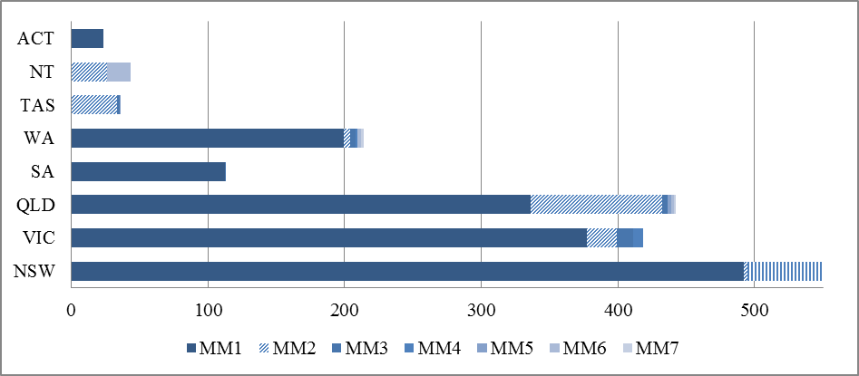

*Source: NHWDS, Medical Practitioner 2015*

Table 5 details the trainees (FTE) by location, current year of training and sector. Nationwide public sector based traineeships are still the dominant sector at 92 percent. FACEM members’ data shows that 95 percent of advanced trainees were working in a public hospital.

Table 5: Trainee FTE (total hours) by training year and sector

| State | Sector | 1st | 2nd | 3rd | 4th | 5th | 6th | 7th | 8th | * | Total |
| --- | --- | --- | --- | --- | --- | --- | --- | --- | --- | --- | --- |
| NSW | Public | 104.5 | 88.5 | 78.9 | 104.1 | 71.7 | 45.6 | 20.9 | 31.3 | 5.2 | 550.5 |
|  | Private | 1.0 | 1.1 | 3.3 | 5.0 | 2.0 | 0.0 | 0.0 | 0.0 | 1.0 | 13.3 |
|  | Both | 4.0 | 2.1 | 2.0 | 8.0 | 5.3 | 3.8 | 2.4 | 6.2 | 1.6 | 35.2 |
| VIC | Public | 73.5 | 48.2 | 61.7 | 67.5 | 60.2 | 44.3 | 22.6 | 26.2 | 6.7 | 410.7 |
|  | Private | 0.0 | 1.4 | 3.4 | 0.9 | 1.0 | 3.0 | 4.3 | 7.2 | 1.1 | 22.2 |
|  | Both | 0.0 | 2.4 | 1.2 | 3.9 | 2.9 | 2.2 | 4.6 | 1.0 | 0.0 | 18.2 |
| QLD | Public | 77.2 | 64.3 | 69.9 | 76.2 | 50.2 | 41.7 | 25.3 | 30.1 | 10.4 | 445.0 |
|  | Private | 1.2 | 2.1 | 3.2 | 3.6 | 3.2 | 2.3 | 1.0 | 0.8 | 0.0 | 17.2 |
|  | Both | 1.3 | 4.5 | 0.0 | 3.9 | 5.1 | 2.2 | 1.3 | 1.0 | 0.0 | 19.1 |
| SA | Public | 12.5 | 19.3 | 15.7 | 15.8 | 13.0 | 9.6 | 11.5 | 16.2 | 0.0 | 113.5 |
|  | Private | 0.0 | 0.0 | 0.0 | 0.0 | 0.0 | 0.0 | 1.0 | 1.0 | 0.0 | 2.0 |
|  | Both | 0.0 | 0.0 | 0.0 | 0.0 | 0.0 | 1.3 | 1.2 | 0.0 | 0.0 | 2.4 |
| WA | Public | 22.6 | 20.4 | 30.6 | 52.9 | 26.1 | 11.4 | 14.2 | 12.5 | 1.0 | 191.7 |
|  | Private | 5.3 | 2.0 | 0.0 | 8.7 | 2.9 | 1.1 | 0.5 | 0.0 | 0.0 | 20.6 |
|  | Both | 1.3 | 0.0 | 4.1 | 0.0 | 0.8 | 0.0 | 1.0 | 0.0 | 1.0 | 8.1 |
| TAS | Public | 7.3 | 2.3 | 7.5 | 5.0 | 4.7 | 7.7 | 2.1 | 1.4 | 0.0 | 38.0 |
|  | Private | 0.6 | 0.0 | 0.0 | 0.3 | 0.0 | 0.0 | 0.0 | 0.0 | 0.0 | 0.9 |
|  | Both | 0.0 | 0.0 | 2.4 | 0.9 | 0.0 | 0.0 | 0.0 | 0.0 | 0.0 | 3.3 |
| NT | Public | 1.9 | 8.0 | 5.1 | 10.2 | 5.8 | 6.3 | 4.2 | 1.0 | 1.4 | 43.6 |
|  | Private | 0.0 | 0.0 | 0.0 | 0.0 | 0.0 | 1.0 | 0.0 | 0.0 | 0.0 | 1.0 |
|  | Both | 1.1 | 0.0 | 0.0 | 0.0 | 0.0 | 0.0 | 0.0 | 0.0 | 0.0 | 1.1 |
| ACT | Public | 5.4 | 4.1 | 1.0 | 0.5 | 7.1 | 3.8 | 2.3 | 2.2 | 0.0 | 26.2 |
| Australia | % Public | 15.4 | 12.8 | 13.6 | 16.7 | 12.0 | 8.6 | 5.2 | 6.1 | 1.2 | 91.5 |
|  | % Private | 0.4 | 0.3 | 0.5 | 0.9 | 0.5 | 0.4 | 0.3 | 0.5 | 0.1 | 3.9 |
|  | % Both | 0.4 | 0.5 | 0.5 | 0.8 | 0.7 | 0.5 | 0.5 | 0.4 | 0.1 | 4.4 |

*Source: NHWDS, Medical Practitioner 2015*

The proportion of trainees by MMM (Figure 14) also adds to the view that public sector based training is dominant in all MMM categories. Private sector traineeships are mostly available in outer regional and remote areas.

Figure 14: Proportion of trainee FTE by distribution (MMM) and sector

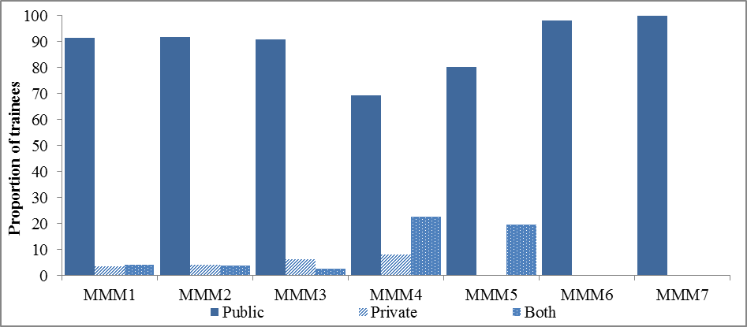

*Source: NHWDS, Medical Practitioner 2015*

## Prevocational intentions

In 2013, new questions were included in the Medical Practitioner Workforce Survey which identifies those who intend to undertake vocational training. The information collected from these questions form part of the future planning process providing an indicative number of the future intentions of trainees (Appendix 4).

Figure 15 details the demographics of the 416 hospital non-specialists (HNS) who indicated their intentions to undertake emergency medicine training, according to the 2015 NHWDS:

Figure 15: Characteristics of HNS who intend to undertake EM training

*75% of hospital non-specialists were aged between 25-34 years.
52% of hospital non-specialists s were female.
55% of hospital non-specialists were located in NSW, VIC 
57% of hospital non-specialists were Resident Medical Officers.*

*Source: NHWDS, Medical Practitioner 2015*

The primary group of HNS who intend to undertake emergency medicine training are resident medical officers, followed by registrars and hospital medical officers (Figure 16).

Figure 16: HNS who intend to undertake EM specialist training by position

*Source: NHWDS, Medical Practitioner 2015*

Similar to the location of trainees in Figure 11 and Figure 13, HNS with intentions of training in emergency medicine are located in areas similar to current trainees - primarily major cities (Figure 17). This may indicate limited opportunities to train in more remote locations.

Figure 17: Proportion of HNS intentions and trainees by geographic distribution

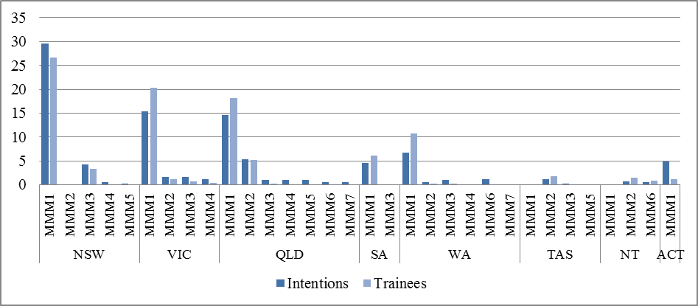

*Source: NHWDS, Medical Practitioner 2015*

## Summary of total workforce by remoteness classification

Table 6 is a broad summary of the population and remoteness characteristics of the emergency medicine workforce. As can be seen, the number of emergency medicine specialists and trainees per 100,000 population is 16.1 in MMM1 areas, 15.7 in MMM2 areas and 12.9 in MMM6 areas. The level in MMM5 areas is only 0.3, for MMM4 there is only 1.7 and only 1.8 emergency medicine specialists and trainees per 100,000 population in MMM7 categories.

Table 6: Summary of EM workforce (headcount and FTE) by MMM

| **Modified Monash Category** | **2015 population** | **Specialists and trainees (headcount)** | **Headcount per 100,000 population** | **Specialists and trainees (FTE)** | **FTE per 100,000 population** |
| --- | --- | --- | --- | --- | --- |
| 1 | 16,864,416 | 2,723 | 16.1 | 2,703.0 | 16.0 |
| 2 | 2,192,887 | 345 | 15.7 | 344.1 | 15.7 |
| 3 | 1,542,563 | 172 | 11.2 | 179.0 | 11.6 |
| 4 | 872,575 | 15 | 1.7 | 15.7 | 1.8 |
| 5 | 1,777,740 | 6 | 0.3 | 6.9 | 0.4 |
| 6 | 310,643 | 40 | 12.9 | 44.3 | 14.3 |
| 7 | 216,953 | 4 | 1.8 | 4.1 | 1.9 |
| **Grand Total\*** | **23,777,777** | **3,308** | **13.9** | **3,300.1** | **13.9** |

Note – Trainee FTE is based on clinical hours and specialist FTE is based on total specialist hours.

*Source: NHWDS, Medical Practitioner 2015 and Department Health 2015 *doesn’t include unknown*

# Workforce projections

## Supply

Health professionals who are registered as an emergency medicine specialist through the Australian Health Practitioner Regulation Agency (AHPRA) have been identified using the National Health Workforce Data Set (NHWDS), which includes registrant data and other characteristics obtained through the voluntary medical workforce survey as shown in the demographic data in the sections above.

In this analysis, only those who were registered/accredited, employed clinicians in 2015 are included (i.e. does not include those in the categories of administration, teacher/educator, researcher and ‘others’). Health professionals who are hospital non‑specialists (HNS) or specialists-in-training (SIT) with intentions of entering emergency medicine training, or working towards the specialisation, are excluded at this point of modelling. The hours they report working in the survey are used in the modelling and capture those that are full-time, part-time etc.

Additional information is in Appendices 1 – 4.

## Demand

The demand forecast for emergency medicine specialists has been estimated using an aggregate demand model based on per capita acute inpatient hospital data from 294 emergency departments in Australia for the period 2003 to 2015.

The utilisation rates are examined at the individual emergency department level and forecast using a series of exponential smoothing models. Forecasts for each individual department have been generated using the SAS statistical package.

Projected patient utilisation takes into account population growth and ageing, as well as clinical trends, by projecting separation services based on reported data. The historical data uses the number of separations per capita as a monthly time series and forecasts the resulting estimates multiplied by the estimated residential population[4]. While the current utilisation patterns are used and a certain level of constraints will be inbuilt in the historical data, it does not take into account unmet demand such as physical and logistical constraints.

Additional information is in Appendix 1.

# Projection results

The projections conducted in this section have five alternative scenarios. The scenarios presented for comparison utilise total specialist hours. Please refer to Appendix 3 for the discussion of the hours worked; which incorporates both clinical and clinical support (non-clinical) hours worked in emergency medicine.

The scenarios are based on changes to the training pipeline. The training analysis pipelining (TAP) can be found in Table 14 – 18 below.

The initial year for projections is 2016, with supply and demand assumed to be in balance for this year. The demand rate for emergency medicine is estimated to grow at 3.1 percent. The inflow of new Fellows uses the updated TAP methodology of the training pipeline, while the IMG new Fellows are assumed to remain fixed over the same time period (albeit a percentage of the total new Fellows).

## Sensitivity

The results presented are sensitive to changing assumptions; in particular, towards changes in the exit rate, hours worked and changes to the number of new college Fellows per annum.

Projections do not take into account supplier induced demand or demand generated for FACEMs due to any changes in workforce composition, which may increase the demand for FACEMs above current utilisation patterns.

## Interpretation of results for workforce position

It is acknowledged that projections and workforce supply and demand modelling are not an exact science and rely on various assumptions holding true, therefore it is recommended that the final workforce position be interpreted with an error margin of three percent. That is, if the workforce is projected to be in under or oversupply in the magnitude of three percent or less, then the workforce is considered to be in balance.

# Scenarios

Scenario modelling is used to demonstrate the impact of potential policy options on future workforce supply and demand. These ‘alternative futures’ are modelled and measured by varying input parameters. The general method used is to present a baseline scenario (dynamic intake baseline scenario). It is assumed the current trends will continue into the future, and used to compare a range of alternative scenarios. The alternative scenarios are generated by altering parameters in the model with the flow through effect to the future workforce measured through the impact relative to the baseline scenario.

## Scenario 1: Dynamic intake baseline scenario

The dynamic intake baseline scenario is constructed on the basis of the intake of new trainees increasing by 4.4 percent per annum (based on historical trends). The projections indicate that the workforce would be in oversupply throughout the projection period. By 2030, this oversupply is in the magnitude of 2,328 which is approximately 102 percent of the required number.

Table 7: Dynamic intake baseline scenario 1

|  | 2016 | 2018 | 2020 | 2025 | 2030 |
| --- | --- | --- | --- | --- | --- |
| Supply (headcount) | **1,653** | **2,048** | **2,442** | **3,470** | **4,616** |
| Supply (FTE) | **1,602** | **1,988** | **2,371** | **3,364** | **4,464** |
| *New Fellows* | 205 | 211 | 221 | 261 | 307 |
| *Overseas trained new Fellows* | 14 | 18 | 18 | 18 | 18 |
| *Exits (% of supply)* | 1.43% | 1.54% | 1.56% | 1.78% | 1.91% |
| Demand (headcount) | **1,653** | **1,741** | **1,830** | **2,058** | **2,288** |
| Demand (FTE) | **1,602** | **1,689** | **1,777** | **1,995** | **2,213** |
| Excess/Shortfall (headcount) | - | **307** | **612** | **1,413** | **2,328** |
| Excess/Shortfall (FTE) | - | **298** | **594** | **1,369** | **2,251** |

Headcount refers to the actual number of FACEMs produced by the college in combination with existing workforce dynamics; these will remain constant in all scenarios.

The HWPT assumes the hours worked by each age cohort remain unchanged over time. This means that as the workforce ages, the number of hours worked is assumed to change, resulting in a balancing of the projected headcount. Therefore the gap in FTE by 2030 is also included. The excess of emergency medicine specialists in 2030 is 2,251 FTE.

This is the Department’s preferred scenario – where current trends are assumed to continue into the future. The scenario was balanced which essentially assumes supply and demand must be equal by 2030. In order for this to be achieved, there needs to be a reduction of new trainees into the training program; the intake number of new trainees needs to be reduced by at least 19 percent per annum (approximately 133 new trainees from 2022).

Table 8 shows that, even with the reduction, there is still an oversupply of 1,383 Fellows (38 percent) by 2030.

Table 8: Balancing dynamic intake baseline scenario 1

|  | 2016 | 2018 | 2020 | 2025 | 2030 |
| --- | --- | --- | --- | --- | --- |
| Supply (headcount) | **1,653** | **2,048** | **2,442** | **3,266** | **3,668** |
| Supply (FTE) | **1,602** | **1,988** | **2,371** | **3,165** | **3,551** |
| *New Fellows* | 205 | 211 | 221 | 148 | 115 |
| *Overseas trained new Fellows* | 14 | 18 | 18 | 18 | 18 |
| *Exits (% of supply)* | 1.43% | 1.54% | 1.56% | 1.82% | 2.16% |
| Demand (headcount) | **1,653** | **1,741** | **1,830** | **2,058** | **2,287** |
| Demand (FTE) | **1,602** | **1,689** | **1,777** | **1,995** | **2,213** |
| Excess/Shortfall (headcount) | **-** | **307** | **612** | **1,208** | **1,383** |
| Excess/Shortfall (FTE) | **-** | **298** | **594** | **1,171** | **1,339** |

*Note that this scenario does not impact the estimates until 2022*

## Scenario 2: Static intake scenario

This scenario assumes the emergency medicine trainee intake number to remain constant over the projected period (based on historical average for 2013 – 2015) of 355 per annum.

Table 9: Static intake scenario 2

|  | 2016 | 2018 | 2020 | 2025 | 2030 |
| --- | --- | --- | --- | --- | --- |
| Supply (headcount) | **1,653** | **2,048** | **2,435** | **3,362** | **4,196** |
| Supply (FTE) | **1,602** | **1,987** | **2,364** | **3,259** | **4,059** |
| *New Fellows* | 205 | 209 | 212 | 218 | 220 |
| *Overseas trained new Fellows* | 18 | 18 | 18 | 18 | 18 |
| *Exits (% of supply)* | 1.43% | 1.54% | 1.56% | 1.80% | 2.00% |
| Demand (headcount) | **1,653** | **1,741** | **1,830** | **2,058** | **2,287** |
| Demand (FTE) | **1,602** | **1,689** | **1,777** | **1,995** | **2,213** |
| Excess/Shortfall (headcount) | - | **307** | **605** | **1,304** | **1,909** |
| Excess/Shortfall (FTE) | - | **298** | **587** | **1,264** | **1,847** |

When the intake of new trainees is assumed to be static; that is, to have zero growth, then the oversupply reduces to 1,909 (83 percent), which is a decrease of 17 percent to the dynamic intake baseline scenario.

## Scenario 3: FACEM rostering scenario

This scenario is based on the “*Guidelines on constructing and retaining a Senior Emergency Medicine Workforce G23 Nov 2015*” report which indicates the number of FACEMs and non-FACEM Senior Decision Makers (SDMs) recommended for emergency department rosters based on the number of separations in an emergency department. The guidelines are split up into the number of suggested FACEMs and SDMs required respectively.

This scenario attempts to forecast the number of emergency department separations as the baseline to determine demand based on the guidelines in the above-mentioned report. The demand modelling indicates that an increasing number of large emergency departments will have greater than 100,000 presentations per annum within five to10 years. This has been taken into account in the modelling.

For the full table breakdown of the guidelines, please refer to Appendix 7. The rostering scenario demand has been based on:

* The projected number of hospital separations for 294 EDs in Australia;
* Converting these hospital separations into the rostering system within the guidelines;
* Converting these rosters into the aggregate demand for FACEMs below.

The resulting scenario shows a smaller oversupply compared to baseline (scenario 1) (38 percent).

Table 10: FACEM rostering demand scenario 3

|  | 2016 | 2018 | 2020 | 2025 | 2030 |
| --- | --- | --- | --- | --- | --- |
| Supply (headcount) | **1,653** | **2,048** | **2,442** | **3,470** | **4,616** |
| Supply (FTE) | **1,602** | **1,988** | **2,371** | **3,364** | **4,464** |
| *New Fellows* | 205 | 211 | 221 | 261 | 307 |
| *Overseas trained new Fellows* | 14 | 18 | 18 | 18 | 18 |
| *Exits (% of supply)* | 1.43% | 1.54% | 1.56% | 1.78% | 1.91% |
| Demand (headcount) | **2,284** | **2,434** | **2,563** | **2,962** | **3,342** |
| Demand (FTE) | **2,240** | **2,386** | **2,512** | **2,904** | **3,277** |
| Excess/Shortfall (headcount) | **-632** | **-385** | **-120** | **508** | **1,274** |
| Excess/Shortfall (FTE) | **-638** | **-398** | **-141** | **460** | **1,187** |

## Scenario 4: Intentions to reduce hours and leave clinical practice

The ACEM recently completed a Workforce Sustainability Survey, which suggests a significant proportion of FACEMs and trainees looking to reduce clinical/working hours or leave clinical practice altogether in the next 10 years. This scenario shows:

* A reduction in working hours of approximately 5.5 hours between 2016 and 2030.
* 34 percent of FACEMs intend to exit the workforce within the next 10 years, and as a result exit rates within the HWPT have been increased to reflect an additional exit rate of 3.4 percent per annum.

The table below shows the results of the combined effect of reducing hours and increasing exits.

Table 11: Reducing hours and intentions scenario 4

|  | 2016 | 2018 | 2020 | 2025 | 2030 |
| --- | --- | --- | --- | --- | --- |
| Supply (headcount) | **1,614** | **1,921** | **2,215** | **2,949** | **3,749** |
| Supply (FTE) | **1,564** | **1,827** | **2,066** | **2,611** | **3,143** |
| *New Fellows* | 205 | 211 | 221 | 261 | 307 |
| *Overseas trained new Fellows* | 14 | 18 | 18 | 18 | 18 |
| *Exits (% of supply)* | 4.1% | 4.18% | 4.17% | 4.31% | 4.35% |
| Demand (headcount) | **1,614** | **1,727** | **1,846** | **2,169** | **2,528** |
| Demand (FTE) | **1,564** | **1,681** | **1,763** | **1,967** | **2,171** |
| Excess/Shortfall (headcount) | - | **194** | **369** | **780** | **1,221** |
| Excess/Shortfall (FTE) | - | **146** | **304** | **645** | **972** |

Under this scenario, the oversupply reduces to 1,221, the reduction in hour’s results in an FTE oversupply of 972 Fellows by 2030. Note: This scenario reflects stated intentions to retire and does not reflect actual retirements as per the NHWDS. This is based on a reduction in supply to 3,749 (down from 4,616) by 2030 due to an increase in the exit rate and a decrease in the supply of FTE due to a reduction in the average number of hours worked by 5.4 hours each week.

# Training Analysis Pipeline (TAP)

The purpose of the TAP is to project future vocational training numbers entering the training program as a basis for forecasting the number of domestic and SIMG new Fellows as inflows into the workforce projections.

Two TAP models have been constructed with different scenarios for the new intake of trainees:

1. Dynamic – intake increases annually based on historical trend,
2. Static – intake remains constant based on historical average.

The dynamic intake pipeline reveals what may occur under a business‑as‑usual model where intake into the training program is not regulated, whereas the static pipeline displays what may unfold if the intake were to remain constant (set at a three‑year average).

Table 12 shows the different intake methods for the two pipelines.

Table 12: TAP scenarios for new trainee intake

| Movements | New intake | Comments |
| --- | --- | --- |
| Dynamic | 4.4% | Percent increase on previous years intake (this is one third of the observed average annual increase from 2013-2015) |
| Static | 355 | Average observed from 2013-2015 |

Although the ACEM do not restrict the intake of new trainees, the intake in the dynamic pipeline has been limited to one third of the average annual increase from 2013-2015 to constrain the resulting unrealistically high intake.

Table 13 shows the predicted movement of trainees from entering the college training program through to becoming a new Fellow (domestic or SIMG) in the pipeline. The methodology focuses on moving through the training levels rather than on transitioning on a yearly basis. It is still based on historical movements that have been reported in the MTRP, combined with data requested from the ACEM to assist in more accurately determining the movements. It is anticipated that future training analysis pipelines will use the more detailed data obtained from ACEM. This will ensure a more accurate training pipeline is developed, with more time points, which will more accurately reflect movements of trainees rather than historical transitional trends that have been sourced through aggregated data from the MTRP reports.

The transition rates in Table 13 are data driven and calculated from the changes between two time points (2014 and 2015 ACEM data) in particular and earlier MTRP data. These rates are then consistently applied to pipeline trainees and SIMGs. The numbers on the SIMG pathway have been held constant at an historical average. The 10‑year through rate is relatively low for a couple of reasons:

* There is a high withdrawal rate during provisional training, with anecdotal evidence suggesting high numbers of ACEM trainees transfer to Anaesthesia or Intensive Care training programs.
* Trainees staying in the training program for an extended period of time, as there are no limits on the length of time in the training program or the number of attempts to sit the exams.

Domestic new Fellows take an average of just over seven years to complete the program (with 38 percent of new Fellows in 2015 taking eight years or longer) and over 21 percent of advanced trainees in 2015 had been in the training program for seven years or longer.

Table 13: TAP transition calculations

| Movements | Percent | Comments |
| --- | --- | --- |
| Provisional to provisional | 50% |  |
| Provisional to advanced | 37% |  |
| Advanced to advanced | 83% | Advanced training is 4 years |
| Advanced to new fellow | 14% |  |
| Retention rate | 86% | Provisional Training |
|  | 98% | Advanced Training |
| 10 year through rate | 79% | If everyone FT and complete in 60 months |
|  | 58-61% | Approx. actual (includes PT, interrupted etc.) |
| SIMG | 30 | ***Partially comparable*** (2013-2015 average) |
|  | 7 | ***Substantially comparable*** (2013-2015 average) |
| SIMG new fellow | 48% | Percent of SIMG in previous year |

Table 14 shows the results for the dynamic new intake each year. This TAP takes the average annual increase in the intake of new trainees and is projected forward. There are 2,535 total new Fellows in the target period (between 2022 and 2030). Although the intake has doubled over the pipelining period, the number of trainees and subsequently the number of new Fellows has not increased as dramatically due to the high withdrawal rate in Emergency Medicine training and the relatively long time period in which trainees complete the training program.

Table 14: Dynamic intake TAP, 2010 – 2030

| **Training program** | **2010** | **2011** | **2012** | **2013** | **2014** | **2015** | **2016** | **2017** | **2018** | **2019** | **2020** | **2021** | **2022** | **2023** | **2024** | **2025** | **2026** | **2027** | **2028** | **2029** | **2030** |
| --- | --- | --- | --- | --- | --- | --- | --- | --- | --- | --- | --- | --- | --- | --- | --- | --- | --- | --- | --- | --- | --- |
| **New intake** |  |  | 240 | 450 | 267 | 349 | 364 | 381 | 397 | 415 | 433 | 453 | 473 | 494 | 516 | 538 | 562 | 587 | 613 | 640 | 669 |
| Provisional trainees |  | **785** | **821** | 767 | **632** | **662** | **692** | **723** | **756** | **789** | **824** | **861** | **899** | **939** | **981** | **1024** | **1069** | **1117** | **1166** | **1218** | **1272** |
| Advanced trainees |  | 1090 | 1204 | 1339 | 1422 | **1415** | **1420** | **1436** | **1460** | **1492** | **1532** | **1577** | **1628** | **1685** | **1747** | **1813** | **1885** | **1961** | **2042** | **2127** | **2217** |
| Total trainees | 1684 | 1875 | 2025 | 2106 | 2054 | 2077 | 2113 | 2159 | 2216 | 2282 | 2356 | 2438 | 2527 | 2624 | 2727 | 2838 | 2954 | 3078 | 3208 | 3345 | 3489 |
| Substantially comparable |  |  |  | 21 | 1 | 0 | 7 | 7 | 7 | 7 | 7 | 7 | 7 | 7 | 7 | 7 | 7 | 7 | 7 | 7 | 7 |
| Partially comparable |  |  |  | 16 | 43 | 30 | 30 | 30 | 30 | 30 | 30 | 30 | 30 | 30 | 30 | 30 | 30 | 30 | 30 | 30 | 30 |
| Total SIMG pathway |  |  |  | 37 | 44 | 30 | 37 | 37 | 37 | 37 | 37 | 37 | 37 | 37 | 37 | 37 | 37 | 37 | 37 | 37 | 37 |
| Domestic new Fellows | 62 | 61 | 129 | 95 | 118 | **205** | **204** | **205** | **207** | **211** | **215** | **221** | **227** | **235** | **243** | **252** | **261** | **272** | **283** | **294** | **307** |
| SIMG new Fellows | 13 | 16 | 5 | 23 | 18 | 21 | 14 | 18 | 18 | 18 | 18 | 18 | 18 | 18 | 18 | 18 | 18 | 18 | 18 | 18 | 18 |
| Total new Fellows | 75 | 77 | 134 | 118 | 136 | 226 | 218 | 223 | 225 | 228 | 233 | 239 | 245 | 253 | 261 | 270 | 279 | 290 | 301 | 312 | 324 |

MTRP College data Calculated

Table 15 below shows the results of the TAP with an alternative (static) intake. In this pipeline the annual intake has been held constant at 355 (the average of 2013 – 2015) Fellows. This results in 2,118 new Fellows in the target period (between 2022 and 2030). Although the intake is static, the number of advanced trainees and new Fellows continues to experience minor increases. This is due to the extended time trainees stay in the program compared to the relatively short pipelining period.

Table 15: Static intake TAP, 2010 – 2030

| **Training program** | **2010** | **2011** | **2012** | **2013** | **2014** | **2015** | **2016** | **2017** | **2018** | **2019** | **2020** | **2021** | **2022** | **2023** | **2024** | **2025** | **2026** | **2027** | **2028** | **2029** | **2030** |
| --- | --- | --- | --- | --- | --- | --- | --- | --- | --- | --- | --- | --- | --- | --- | --- | --- | --- | --- | --- | --- | --- |
| **New intake** |  |  | 240 | 450 | 267 | 349 | 355 | 355 | 355 | 355 | 355 | 355 | 355 | 355 | 355 | 355 | 355 | 355 | 355 | 355 | 355 |
| Provisional trainees | **803** | **785** | **821** | 767 | **632** | **662** | **683** | **694** | **699** | **701** | **703** | **703** | **704** | **704** | **704** | **704** | **704** | **704** | **704** | **704** | **704** |
| Advanced trainees | 881 | 1090 | 1204 | 1339 | 1422 | **1415** | **1420** | **1432** | **1446** | **1460** | **1472** | **1483** | **1492** | **1499** | **1506** | **1511** | **1516** | **1519** | **1523** | **1525** | **1527** |
| Total trainees | 1684 | 1875 | 2025 | 2106 | 2054 | 2077 | 2103 | 2126 | 2145 | 2161 | 2175 | 2186 | 2195 | 2203 | 2210 | 2215 | 2220 | 2223 | 2226 | 2229 | 2231 |
| Substantially comparable |  |  |  | 21 | 1 | 0 | 7 | 7 | 7 | 7 | 7 | 7 | 7 | 7 | 7 | 7 | 7 | 7 | 7 | 7 | 7 |
| Partially comparable |  |  |  | 16 | 43 | 30 | 30 | 30 | 30 | 30 | 30 | 30 | 30 | 30 | 30 | 30 | 30 | 30 | 30 | 30 | 30 |
| Total SIMG pathway |  |  |  | 37 | 44 | 30 | 37 | 37 | 37 | 37 | 37 | 37 | 37 | 37 | 37 | 37 | 37 | 37 | 37 | 37 | 37 |
| Domestic new Fellows | 62 | 61 | 129 | 95 | 118 | **205** | **204** | **205** | **207** | **209** | **210** | **212** | **214** | **215** | **216** | **217** | **218** | **219** | **219** | **219** | **220** |
| SIMG new Fellows | 13 | 16 | 5 | 23 | 18 | 21 | 14 | 18 | 18 | 18 | 18 | 18 | 18 | 18 | 18 | 18 | 18 | 18 | 18 | 18 | 18 |
| Total new Fellows | 75 | 77 | 134 | 118 | 136 | 226 | 218 | 223 | 224 | 226 | 228 | 230 | 232 | 233 | 234 | 235 | 236 | 236 | 237 | 237 | 238 |

MTRP College data Calculated

## Results of pipelining

Figure 18 shows the historical number of domestic and SIMG new Fellows and the forecasted number of domestic and SIMG new Fellows, based on the dynamic intake of trainees.

Figure 18: New Fellows dynamic pipeline projections

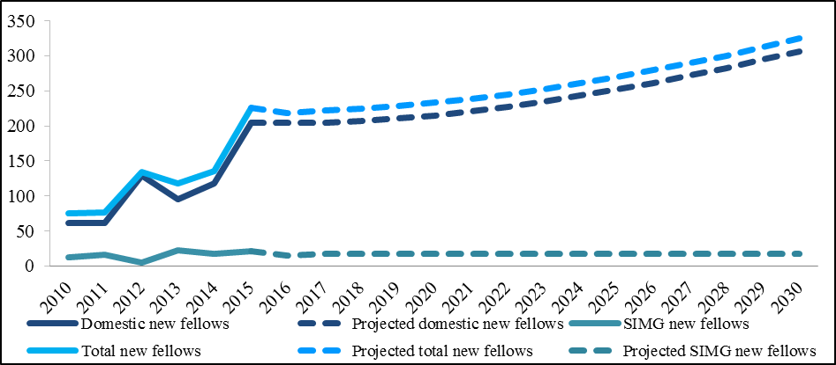

*Source: MTRP reports and TAP projections*

Figure 19 shows the results of the static pipeline. The intake of new trainees is constant at 355 per year and the transition, retention rates and SIMG are the same as above.

Figure 19: New Fellows static pipeline projections

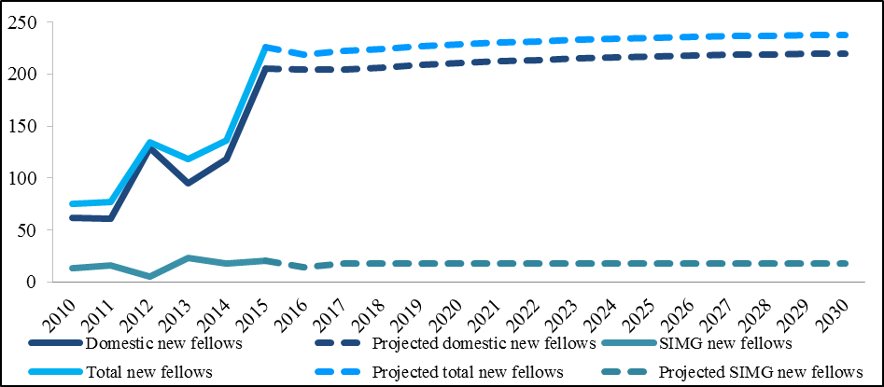

*Source: MTRP reports and TAP projections*

# Capacity and Distribution for Training

Vocational medical training is undertaken by most medical practitioners. The process of gaining a vocational training position is competitive, with training provided through the ACEM. The vocational medical training pipeline enables the number of training positions required under various scenarios to be modelled. It provides a representation of the medical workforce from the graduate level through to emergency medicine Fellowship. The TAP model draws together the known flows and inter-dependencies at each stage of the medical education and training pipeline in a dynamic, system‑wide projection of each component over the period to 2030.

Graduate numbers are only one component of the medical education pathway, with many medical practitioners choosing to pursue vocational training. The vocational medical training pipeline analysis highlights that, based on the existing demand for specialist services being carried forward (and other factors such as the number of expected graduates and a continued migration flow being held constant), there will be more medical practitioners seeking a vocational training position than places available.

Training capacity also impacts on vocational medical training. It recognises training capacity pressures are increasing as the larger cohorts of medial graduates move from intern to prevocational to vocational training positions. This is reflected in the 30 percent increase in vocational training positions from 15,478 in 2011, moving to 20,069 by 2015, with unclear links to future workforce requirements. The continued reliance on IMGs places additional burden on the training capacity of the system.

The Commonwealth has continued to support the initiative to expand training capacity through the commitment to continue funding for the Specialist Training Program (STP), which provides funding for specialist training positions in expanded settings for 900 training rotations a year in 2014 and to be continued to 2017.

However, the Department is only a small contributor to the overall number of training places nationally through funding of the STP posts. Responsibility for funding of and organising vocational training lies with many parties; jurisdictions for post-graduate and specialist training in the public sector, and Colleges, which operate Australia and New Zealand wide. To add to the complexity, medical practitioners will often cross jurisdictional, sectoral, specialty college and international boundaries throughout their training pathway. As a result of the division of responsibilities and the potential myriad of individual medical practitioner’s pathways, imbalances in the vocational TAP models are complex to manage and resolve, and will require partnerships between governments, employers, and the ACEM.

# Results of consultation

The following section presents the views of the ACEM. These different views below highlight the need to update the modelling on a regular basis to ensure the latest data and understanding of the workforce reflected in the study.

Overall, ACEM agrees with the Department’s supply projections outlined in the report in that, of the scenarios presented by the Department, the consistent outcome is that the emergency medicine workforce will be in oversupply by 2030.

ACEM does, however, remain cautious in relation to the demand projections supplied, which, as noted within the report, is dependent on a number of assumptions. For example, ACEM queries the core assumption on which the projections have been based that the current supply of emergency medicine specialists is ‘in balance’. As suggested by an analysis of current senior emergency department staffing against ACEM’s *G23 Guidelines for constructing and retaining a senior emergency medicine workforce,* there is a limited number of EDs with adequate on-the-floor FACEM coverage.

Furthermore, taking into account the continued changing demographics of the Australian population, and likely changes to health policy, health infrastructure, and rising costs in private health insurance, it is also possible that the growth in ED demand may exceed rates seen in the last 12 years.

Nevertheless, ACEM acknowledges that the consistent message obtained from all scenarios modelled indicates an increase over time in the supply of FACEMs relative to demand. As such, ACEM recognises the need for collaborative action to achieve an agreed approach to enabling the supply of an appropriately skilled emergency medicine workforce in Australia.

# Recommendations

ACEM supports the recommendations outlined in the report.

Projections reviewed every two years

ACEM supports a two-year timeframe for review of the projections.

A standards-based approach to selection

Regarding implementing a standards-based approach to selection of trainees in emergency medicine, ACEM has commenced work in this area. A *Selection into Fellowship Training* process is currently being developed, which is proposed to include an once‑per‑year application process.

Following implementation of this revised selection process, ACEM is aware that the work described in this report may also necessitate the consideration of setting limits to its trainee intake numbers in the future. The College recognises that this is a matter of significance and welcomes proactive discussions with jurisdictions in relation to this in the context of the overall emergency medicine workforce.

As noted, ACEM has introduced a number of changes to the FACEM Training Program, the effects of which will be seen from the beginning of the 2018 training year. These include an overall time limit for completion of the training program and election, as well as individual time limits for both Provisional and Advanced training. Further, restrictions will be placed on the number of attempts for both the Primary and Fellowship examinations, with trainees being limited to a total of three attempts at each College examination. How much of an impact these limitations have on trainee progression through the training program and the supply of new FACEMs exiting the training program is yet to be understood and this further supports the advisability of a review of the projections contained in this report over time.

Stakeholder collaboration to identify workforce needs

ACEM is committed to engaging with jurisdictions regarding their emergency medicine workforce needs. Noting that these requirements will differ across jurisdictions, ACEM considers it essential that:

1. the profile of each respective workforce is determined and clearly understood; and
2. stakeholders consider how ACEM training programs and workforce-related policies can be utilised to both meet the acute care needs of the community and also ensure appropriate training environments that equip trainees with the requisite skills are available. This will involve exploring the following options:

* Based on requirements, consideration of specific trainee numbers for each jurisdiction, with potential limiting of the number of FACEM training places at an accredited ACEM training hospital.
* The manner as to how ACEM’s non-specialist qualifications such as the Emergency Medicine Certificate and Emergency Medicine Diploma, can be utilised to up-skill doctors to an appropriate level in regions where there are unlikely to be high numbers of specialist emergency medicine physicians available.

# Appendices

## Appendix 1: Summary of modelling inputs

### Updating supply and demand

The supply side of the planning equation is determined using the characteristics of the known current workforce and projecting this forward with known and projected trainee inflows and exit trends from the workforce. The demand side uses historical service utilisation patterns and projects these forward based on population growth. It also relies on other factors that have shown to influence the utilisation patterns; for example, funding of specific programs that have either increased or decreased usage of services or seasonal patterns.

### Descriptive characteristics of the emergency medicine workforce

The demographic characteristics of the current emergency medicine workforce are outlined as well as describing the trainees and those intending to train. It is an important component in understanding the current supply and what is likely to be required in the future.

### Capacity

The rapid growth in domestic medical graduates will continue to place pressure on medical training capacity. A significant amount of work has occurred to expand clinical training capacity across professional entry, intern and vocational training levels and additional work is underway to explore internships; however, more needs to be done. While there have been recent expansions in medical training in alternative settings, medical training has traditionally been highly concentrated in public hospitals, particularly acute wards. It is important, as medical training requirements continue to grow, that capacity to expand medical training is considered.

### Distribution

The growth in domestically‑trained medical graduates also presents an opportunity to distribute domestically‑trained doctors more effectively, both geographically and into the traditionally less popular specialties. It has been argued that changing the distribution of medical training might contribute to an improvement in the distribution of the medical workforce. Based on evidence collected by Australian Rural Clinical Schools, it is proposed that if, in the course of their training, doctors could spend more time in rural locations or in primary care settings, they may be more likely to stay and practise in those settings.

### Modelling inputs

The following information details the inputs that will be used in undertaking the modelling for the emergency medicine workforce. The emergency medicine workforce is defined by those medical practitioners who have an accreditation in emergency medicine and have identified emergency medicine as one of their main specialties of practice by age, gender and average hours worked, along with the number of new Fellows and the number of active trainees by year of training.

The following parameters were specified as inputs for the projection modelling:

#### Flows in

* Workforce stock
* Domestic new Fellows
* International new Fellows
* Temporary migration (held at a constant total level)
* Skilled migration (exemptions)

#### Flows out

* Exits from the workforce include all permanent and temporary flows out of the workforce.

### Supply assumptions

* Medical practitioners who are registered as emergency medicine specialists through the Australian Health Practitioner Regulation Agency (AHPRA) have been identified through the use of the National Health Workforce Data Set (NHWDS), which includes registrants and the workforce survey.
* The emergency medicine workforce is defined as those that:
  + Are employed (excluding those on leave for more than three months)
  + Have clinician status
  + Have specialist accreditation in emergency medicine
  + Work the most or second most hours in the specialty field of emergency medicine.
* Inputs to the emergency medicine workforce are based on 2015 data and additional data from the ACEM, as required.
* The trainees that have been identified through the workforce survey have been defined through the following methodology, that assumes they:
  + Are employed (excluding those on leave for more than three months)
  + Currently undertaking specialist training in emergency medicine as their first field of training (excluding the second specialty field)
  + Include those who have transitioned from trainee to holding a specialist accreditation in emergency medicine due to timing issues of registration and workforce survey.
  + Includes those who were originally classified as intentions and trainees (due to AIHW imputation), these have been classified to be trainees only
  + Includes those who were originally classified as trainee and specialist clinicians, if:
    - They do not have specialist accreditation, or
    - If they do have specialist accreditation, but the principal area of their main job in medicine was not as a specialist
* International medical graduate specialists enter into the model through either the temporary or permanent migration streams. The inflow of emergency medicine specialists via migration is obtained from the Department of Immigration and Border Protection (DIBP) and reconciled with the ACEM data.
* Hours worked are calculated and applied separately for each age/gender cohort for emergency medicine specialists. The data from which hours worked is calculated is taken from the hours reported by emergency medicine specialists on the relevant workforce survey items for 2014.
* Exit rates are calculated on a unique basis for emergency medicine specialists for each five year age/gender cohort.
* Exit rates are calculated by carrying forward the current distribution of ages of the workforce and assuming the same distribution in the future. The rates are based on observed retirements over recent years, not on retirement intentions.
* Exit rates are a composite measure including all forms of removal from the workforce, permanent or temporary.
* All emergency medicine specialists are assumed to remain in the workforce, even in situations of oversupply. That is, exit rates are not adjusted to take account of possible movements away from a profession in an oversupply situation.

### Demand assumptions

* Demand for emergency medicine specialists has been estimated using an aggregate demand model based on per capita Acute Inpatient Hospital data from 294 Emergency departments in Australia.
* Projected patient utilisation takes into account population growth and ageing, as well as clinical trends, by projecting separations services based on reported data. The historical data uses the number of separations per capita as a monthly time series and forecasts the resulting estimates multiplied by the estimated residential population[5].
* The utilisation rates are examined at the individual emergency department level and forecast using a series of exponential smoothing models. Forecasts for each individual department have been generated using the SAS statistical package.
* Exponential smoothing has been chosen due to its successful use by the Department of Health at forecasting MBS services for financial modelling purposes.
* Demand and supply start from an ‘in balance’ position.
* The demand growth rate for emergency medicine is currently in the range of 3.1 per annum.

## Appendix 2: Definition of a specialist (example for anaesthetist)

There are two sources of information used to determine the current supply of specialists: the medical workforce survey data; and the AHPRA registration data. These two sources of information are combined by the AIHW into the *National Health Workforce Dataset: Medical Practitioners* (NHWDS). The NHWDS is used to determine whether a medical practitioner should be classified as a specialist (in up to two specialities). These classifications are used to determine supply for the purposes of modelling the medical workforce.

The Medical Workforce Survey provides a rich source of information regarding the current activities of medical practitioners. The answers to this survey are critical to ensure that that data remains an accurate snapshot of medical workforce trends.

The following example details the method for using the NHWDS data and associated survey questions to classify a medical practitioner as a specialist and therefore ‘supply’ in the specialty demand and supply modelling. This method applies to all specialities, but anaesthesia is used in this example.

In order to be classified as a specialist a record must pass three initial conditions.

* Be currently registered as a medical practitioner
* Be accredited as an anaesthetist
* Be currently employed in the medical profession
* Be currently working as a clinician

Current registration as a medical practitioner and specialist accreditation in anaesthesia are data items maintained by AHPRA.

The following survey questions relate to whether the medical practitioner is employed and working as a clinician. To be classified as a specialist, they must have answered that they are currently employed and working as a clinician.

Figure 20: Survey questions relating to Employment Status

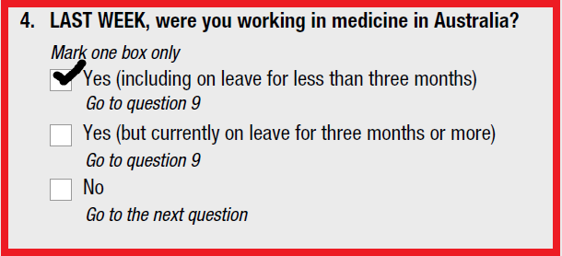

Figure 21: Survey questions relating to clinician status



In addition, medical practitioners are required to specify that they are working clinical hours. If the practitioner specifies that they are working only non-clinical hours, then they will not be counted.

Figure 22: Survey questions relating to clinical and non-clinical hours

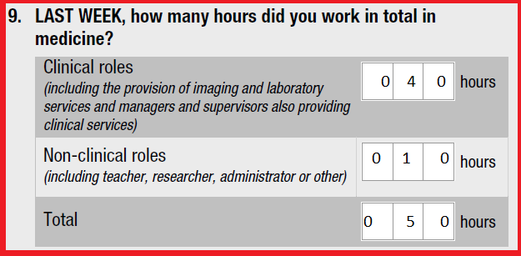

These conditions are applied initially to ensure a rigorous estimate of the current workforce based on the employment and accreditation status of medical practitioners. For example, to avoid counting medical practitioners who are in retirement the process checks to ensure that medical practitioners are currently employed and working as a clinician. This also avoids counting medical practitioners who are currently working as administrators and teachers.

The next step looks at the main area in which the medical practitioner is employed. This is the step where medical practitioners have the opportunity to specify on the survey, in which area of medicine they are currently employed. There is space to fill out *two* professions.

Figure 23: Survey questions relating to principal field of main specialties

Survey question twenty three asks In which specialty field(s) did you work the most hours, LAST WEEK?  Responders are asked to refer to specialty fields table on page five of the survey, find the relevant specialty and enter the corresponding number of each specialty field in the box.  Responders can list up to two speciality fields.

Survey question twenty four asks LAST WEEK, how many clinical hours did you work in each sector in your speciality field(s)?  Options include private hospitals, private rooms, private other, public hospitals - inpatients, public hospitals - outpatients and public other. Responders can list up to two speciality fields.


The above survey question is crucial to the inclusion of a medical practitioner as an anaesthetist. This question indicates that the medical practitioner will be classified as a specialist in the recorded specialty provided that all previous criteria have been met.

If the medical practitioner is currently registered and is:

* Employed;
* working as a clinician; and
* has accreditation with AHPRA in anaesthesia.

At this point they will be counted as an anaesthetist provided they have indicated so in question 23.

With the exception of three cases, that is the end of the classification process.

**Case 1: Specialist and trainee**

If the medical practitioner has also indicated that they are a current anaesthesia trainee and their year of completion is the year of the survey then they will be classified as a trainee and not a specialist. This can occur due to timing issues; the medical practitioner is in a training program on the date they complete the survey, however on the date of data extraction (which can be up to two months later) the medical practitioner has obtained Fellowship and AHPRA has recorded them as an accredited specialist. The decision was made to classify the medical practitioner according to the date of completion of the survey. In this instance the medical practitioner will be classified as an anaesthetist in the following year.

Figure 24: Survey questions relating to training

Under section D specialist training of survey question twenty five asks Are you in a specialty training program that will lead to fellowship of a college? Responder options include no or yes.

Question twenty six asks when you complete your training, in which specialty field(s) will you be qualified to practice?Responders are asked to refer to specialty fields table on page five of the survey, find the relevant specialty and enter the corresponding number of each specialty field in the box.  Responders can list up to two speciality fields. 

**Case 2 – Fails to answer question 23**

If the medical practitioner fails to answer question 23but currently is a registered medical practitioner and is:

* employed;
* working as a clinician;
* has accreditation with AHPRA in anaesthesia; and
* and has two or fewer specialities accredited with AHPRA,

Then their survey response to question 23 is imputed as anaesthesia (69) and they are counted as a specialist.

**Case 3 – Erroneous answer recorded in question 23**

The medical practitioner responds to the survey indicating that they are currently working as a vocationally‑registered GP. They do not currently have accreditation with APHRA as a GP but they do have current accreditation as an anaesthetist and are; currently registered as a medical practitioner, employed, and working as a clinician. The response to question 23 is imputed as anaesthesia (69) and they are classified as an anaesthetist.

Figure 25: Erroneous answer recorded in question 23

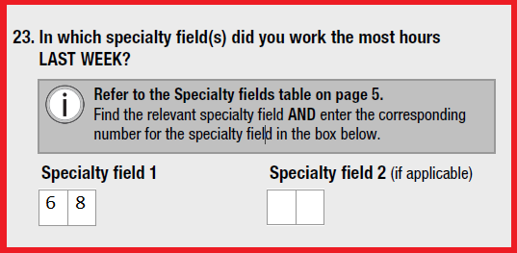

## Appendix 3: Definition of hours worked

The Medical Practitioner Workforce Survey (Appendix 5) captures the hours worked at three levels as shown in Figure 26 below. The first row (A) is where a practitioner identifies the total hours they worked in the previous week. They are asked to split their total hours into (B) time spent in clinical roles and non-clinical roles. Non-clinical is defined as “including teacher, researcher, administrator and other”. They are then asked to split their clinical hours into (C) time spent in up to two specialities (clinical hours in specialty 1 and clinical hours in specialty 2).

For example, 8 percent (113) of emergency medicine specialists worked hours in a specialty other than emergency medicine (most commonly intensive care medicine and paediatrics). For this group of dual specialists, 42 percent of their FTE was spent in emergency medicine, while 58 percent was spent in their other specialty.

The grey ‘unknown’ area in row C can occur when the hours reported in specialty 1 and specialty 2 do not add up to the clinical hours (B). The unknown clinical hours may be due to an error when completing the survey form (the medical practitioner miscalculates their hours) or it may represent time worked as a non-vocationally registered General Practitioner (VRGP) or in a third specialty. The unknown hours were not used in the modelling inputs. Furthermore, as can been seen in the grey ‘not asked in survey’ area in row C, the non-clinical hours worked in each specialty are not captured in the survey.

Figure 26 shows how the use of clinical hours (highlighted in row B) is flawed for the purposes of modelling individual medical specialties. The clinical hours (highlighted in row B) can be much higher than the individual specialist clinical hours (C) as clinical hours comprises unknown clinical hours and/or hours worked in another speciality (other than the one being modelled). When clinical hours are used for modelling, the FTE is overestimated by including hours worked in a specialty other than the one being modelled as well as unknown/unattributed clinical hours. It also underestimates supply by excluding the time spent in clinical support (non-clinical hours) for a specialty.

Figure 26: Hours worked as captured in the workforce survey.

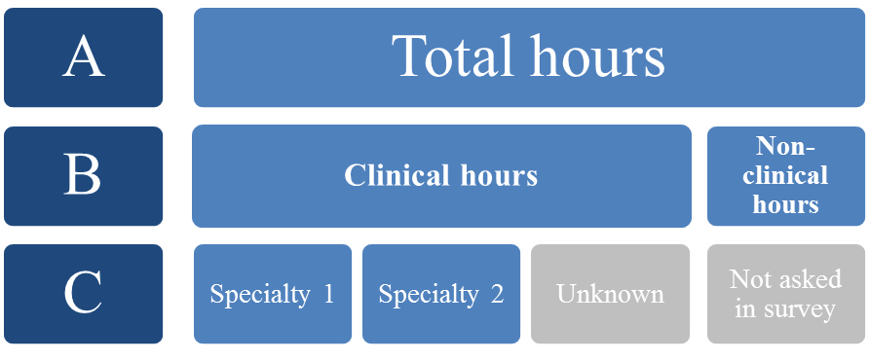

Figure 27 below shows how the hours for individual specialties have been estimated for modelling purposes in this report. In order to calculate (D), the total hours worked in the emergency medicine (clinical and non-clinical), the proportion of the clinical hours for each of the specialities were used to attribute non-clinical hours to the specialties to give an indication of the total specialist hours (clinical and non-clinical) a practitioner is working in a given speciality.

Figure 27: Estimating total specialty hours

Row A refers to total hours, row B refers to the breakdown of these hours into clincial and non clinical hours and row D provides further breakdown of clinical and non-clinical hours according to specialty.



Figure 28 below shows which hours contribute to supply in the projections utilising total specialist hours (‘total specialist hours scenario Table 26’).

In this example, if a practitioner indicated in specialty field 1 they worked in emergency medicine and in specialty field 2 they worked in intensive care medicine, then the clinical specialty 1 hours plus the non-clinical estimated specialty 1 hours (highlighted in black) are used in the modelling for emergency medicine.

Figure 28: Total specialty hours used in modelling – example

Row A refers to total hours, row B refers to the breakdown of these hours into clincial and non clinical hours and row D provides further breakdown of clinical and non-clinical hours according to specialty.

In this example, if a practitioner indicated in specialty field 1 they worked in emergency medicine and in specialty field 2 they worked in intensive care medicine, then the clinical specialty 1 hours plus the non-clinical estimated specialty 1 hours (highlighted in black) are used in the modelling for emergency medicine.

## Appendix 4: Trainees and Intentions

The classification of trainees and those intending to train is based on the medical workforce survey. To be classified as a trainee, the medical practitioner must answer survey question 26 indicating that they are a current anaesthesia trainee they must also be:

* registered as a medical practitioner; and
* employed as a medical practitioner. (see Figure 20).

The only exception is if they indicate on the survey that they are also intending to train. If they have a current training year, then they are classified as a trainee (see Figure 24).

Figure 29: Survey question related to current specialist training

Under section D specialist training of survey question twenty five asks Are you in a specialty training program that will lead to fellowship of a college? Responder options include no or yes.

Question twenty six asks when you complete your training, in which specialty field(s) will you be qualified to practise?Responders are asked to refer to specialty fields table on page five of the survey, find the relevant specialty and enter the corresponding number of each specialty field in the box.  Responders can list up to two speciality fields.


Figure 30: Survey question relating to current year of training program

Question tweny eight of survey asks What year of your training program(s) are you in?  The survey has options for two specialty fields including:
Speciality Field 1, 1st year, 2nd year, 3rd year, 4th year, 5th year, 6th year, 7th year, 8th year.
Speciality Field 2, 1st year, 2nd year, 3rd year, 4th year, 5th year, 6th year, 7th year, 8th year.


To be classified as intending to train, the medical practitioner needs to answer question 16 indicating that they are intending to undertake training as a specialist and answer question 17 to indicate that they intend to train as an anaesthetist.

Figure 31: Survey questions relating to intending to train

**Survey question sixteen asks Do you intend to undertake speciality training? Responder options include yes or no.
To be classified as intending to train the medical practitioner needs to answer question 16 indicating that they are intending to undertake training as a specialist and answer question 17 to indicate that they intend to train as an anaesthetist.**

## Appendix 5: Data variables and sources

| Data variables | Data sources |
| --- | --- |
| Geography | * 1270.0.55.003 - Australian Statistical Geography Standard (ASGS): Volume 3 - Non ABS Structures, July 2011 (State Suburbs ASGS Non ABS Structures Ed 2011 Digital Boundaries in ESRI Shapefile Format). * Geometric values – XY coordinates of the centroid using ABS digital boundaries. |
| Population | * Census of Population and Housing: Socio-Economic Indexes for Areas (SEIFA), Australia, 2011, ABS 2033.0.55.001 (datacube - SSC indexes). |
| Socio-Economic Indexes for Areas | * Census of Population and Housing: Socio-Economic Indexes for Areas (SEIFA), Australia, 2011, ABS 2033.0.55.001 (datacube - SSC indexes). |
| MBS services | * Australia Government Department of Health, Medical Benefits Division |
| Hospital Separations | * Australia Government Department of Health, Acute Care Division |
| Hospital Facilities | * Australia Government Department of Health, GIS server and included the category of facility by XY location. |
| Specialist Training Program (STP) posts | * Australia Government Department of Health, Health Training Branch |
| Trainees | * ACEM 2014 & 2015 and NHWDS medical practitioner 2015 |
| Supervisors | * ACEM 2014 & 2015 and NHWDS medical practitioner 2015 |
| Specialist clinicians | * NHWDS medical practitioner 2014 |
| International medical graduate specialists | * ACEM 2014 & 2015 and NHWDS medical practitioner 2015 |

## Appendix 6: Medical Practitioners survey 2015

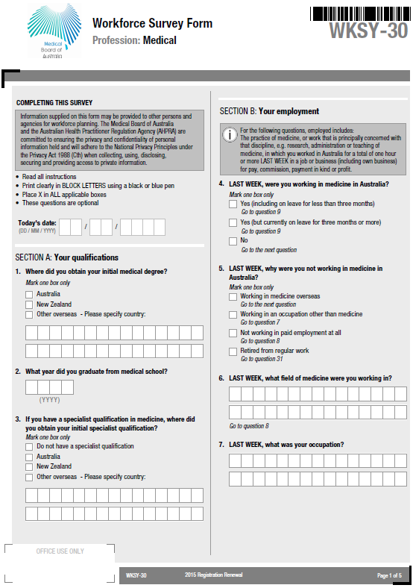

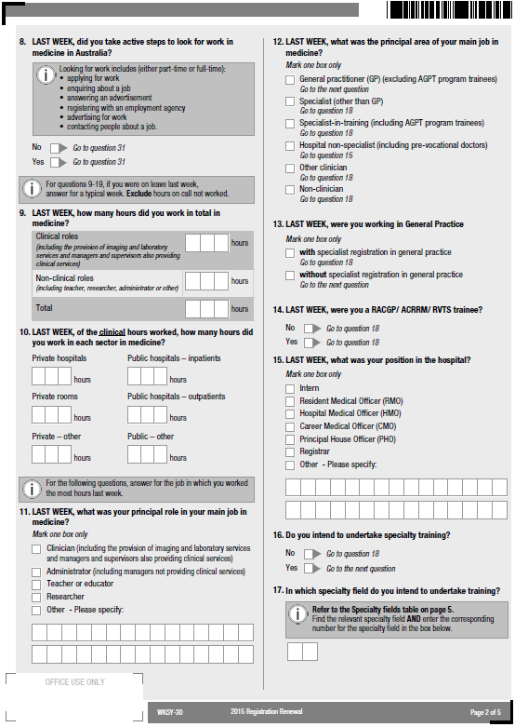

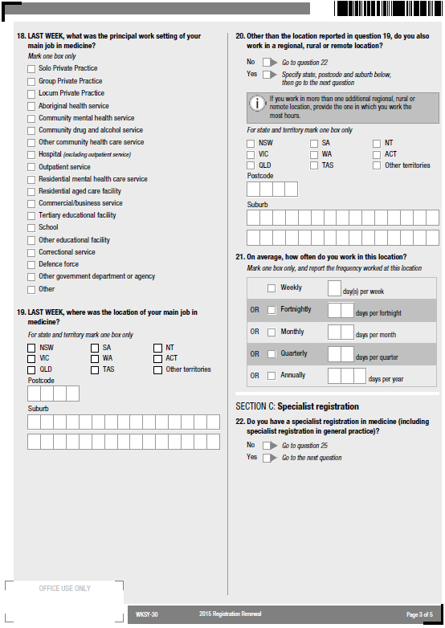

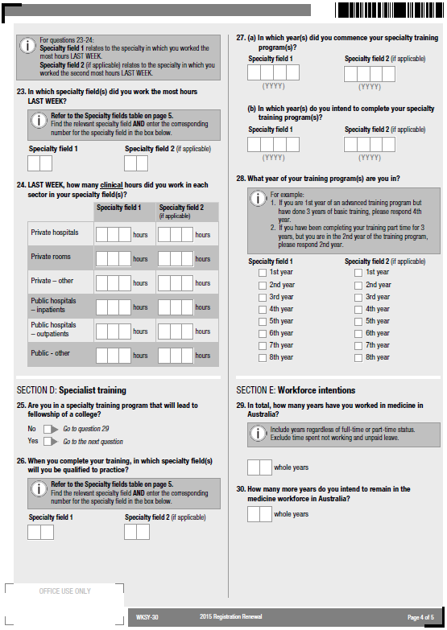

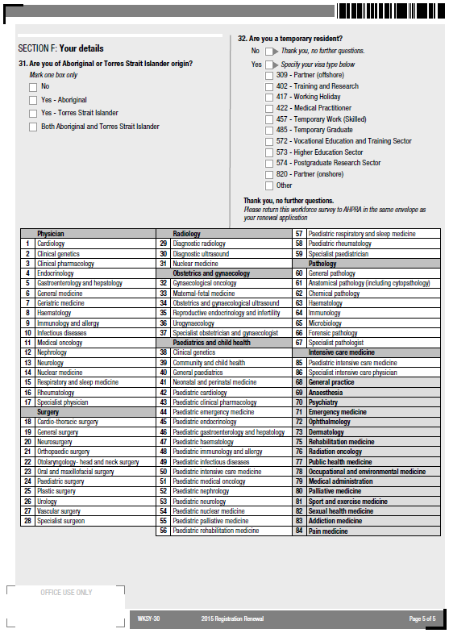

## Appendix 7: Guidelines on constructing/retaining Senior Emergency Medicine Workforce

The recommended minimum senior staff modelling for mixed emergency departments include:
For 15,000 presentations per year
Day shift - 1 x FACEM and 1 x non-FACEM Senior Decision Maker
Evening shift - 1 x FACEM and 1 x non-FACEM Senior Decision Maker
Night shift - 1 x on-call FACEM and 1 x non-FACEM Senior Decision Maker

For 15,000-30,000 presentations per year
Day shift - 1 x FACEM and 2 x non-FACEM Senior Decision Makers
Evening shift - 1 x FACEM and 2 x non-FACEM Senior Decision Makers
Night shift - 1 x on-call FACEM and 2 x non-FACEM Senior Decision Makers

For 30,000-45,000 presentations per year
Day shift - 2 x FACEM and 2 x non-FACEM Senior Decision Makers
Evening shift - 2 x FACEM and 3 x non-FACEM Senior Decision Makers
Night shift - 1 x on-call FACEM and 2 x non-FACEM Senior Decision Makers

For 45,000-60,000 presentations per year
Day shift - 2 x FACEM and 3 x non-FACEM Senior Decision Makers
Evening shift - 2 x FACEM and 4 x non-FACEM Senior Decision Makers
Night shift - 1 x on-call FACEM and 2 x non-FACEM Senior Decision Makers

For 60,000-75,000 presentations per year
Day shift - 3 x FACEM and 3 x non-FACEM Senior Decision Makers
Evening shift - 3 x FACEM and 4 x non-FACEM Senior Decision Makers
Night shift - 1 x on-call FACEM and 3 x non-FACEM Senior Decision Makers

For 75,000-90,000 presentations per year
Day shift - 4 x FACEM and 4 x non-FACEM Senior Decision Makers
Evening shift - 4 x FACEM and 6 x non-FACEM Senior Decision Makers
Night shift - 1 x on-call FACEM and 4 x non-FACEM Senior Decision Makers

Over 90,000 presentations per year
Day shift - 4 x FACEM and 6 x non-FACEM Senior Decision Makers
Evening shift - 4 x FACEM and 8 x non-FACEM Senior Decision Makers
Night shift - 1 x on-call FACEM and 5 x non-FACEM Senior Decision Makers

1. International Federation for Emergency Medicine, 1991
2. [Medical Board of Australia - Statistics](http://www.medicalboard.gov.au/News/Statistics.aspx)
3. [Australian College of Emergency Medicine- Specialist-Emergency-Medicine-Workforce-and-Training Statistics](https://acem.org.au/getattachment/ece2d0c7-0e39-4f96-a906-2e3e0ac49221/Specialist-Emergency-Medicine-Workforce-and-Tr-(1).aspx)
4. Forecast services use ABS catalogue 3222 Population Projections Series B.
5. Forecast services use ABS catalogue 3222 Population Projections Series B.