pos

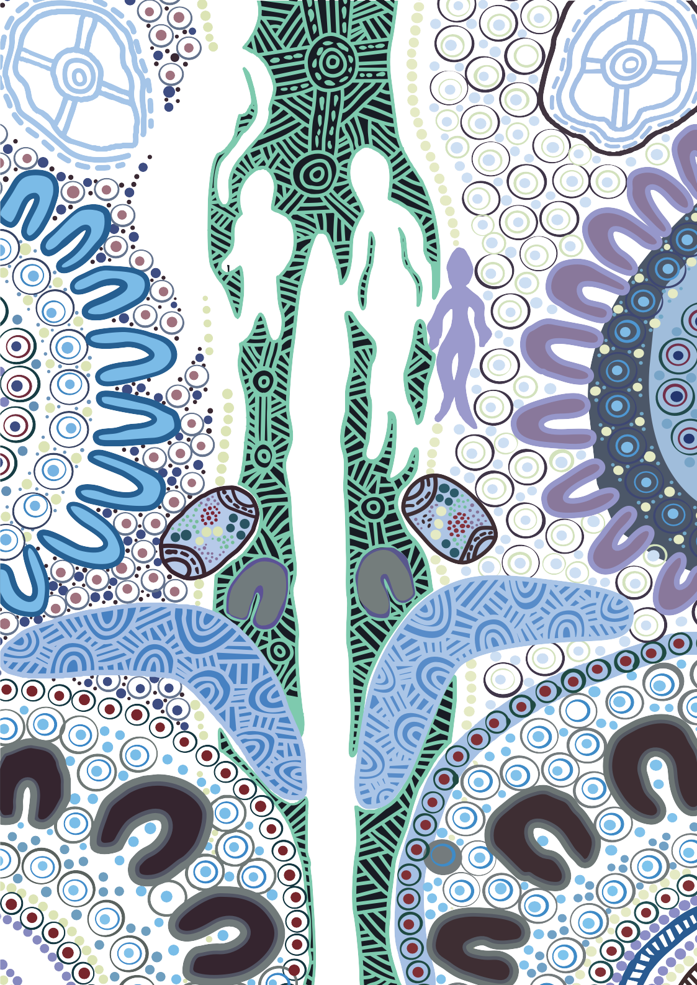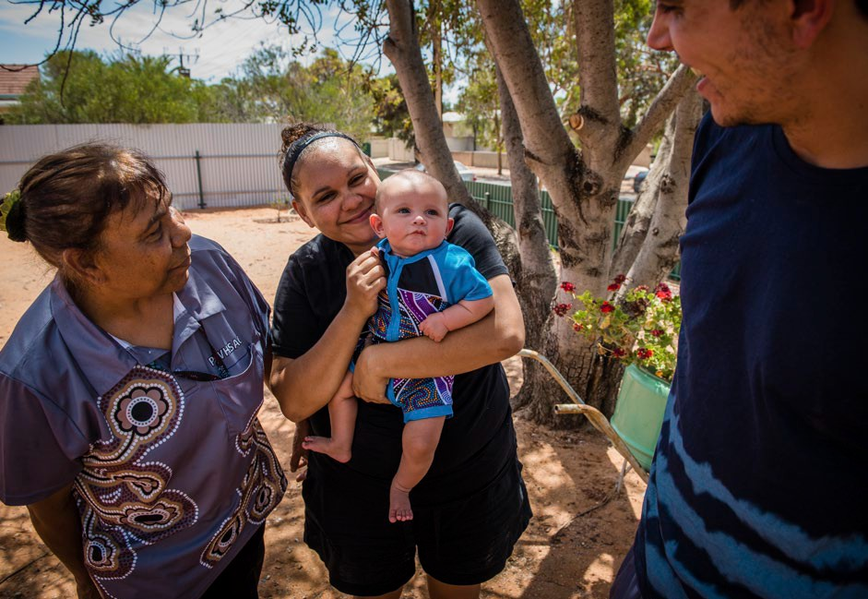

Your health is in your hands

BOOK YOUR ANNUAL **715 HEALTH CHECK** TODAY!

**It’s important to have a health check every year, even when you feel well, to stay healthy and strong.**

Having a regular health check provides important details to your Doctor to keep you and your family in good health.

All Aboriginal and Torres Strait Islander people are eligible for an annual health check. 715 health checks are free at Aboriginal Medical Services and bulk billing practices. If you are unsure whether it will be free at your local Doctor, give them a call to ask about the 715 health check before you book.

**Find out more:**

**Visit** [**www.health.gov.au/715-health-check**](http://www.health.gov.au/715-health-check) **or search #715healthcheck on social media**