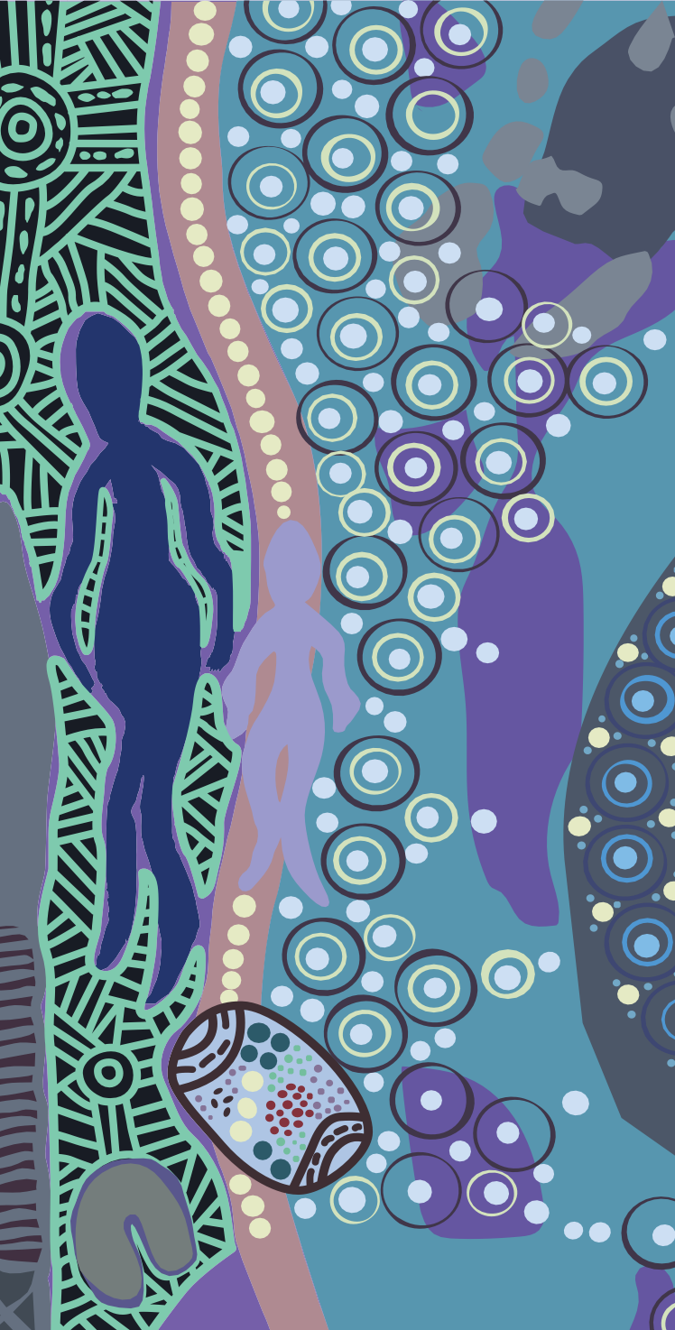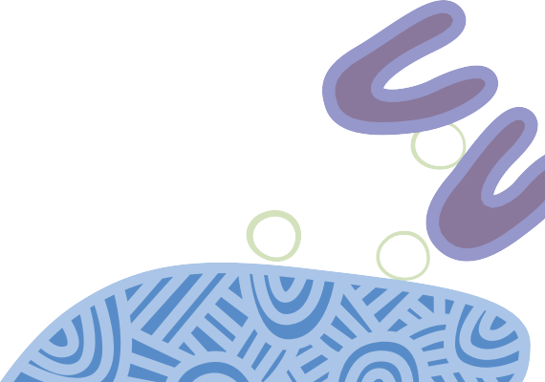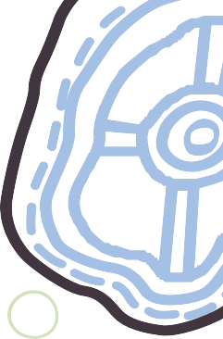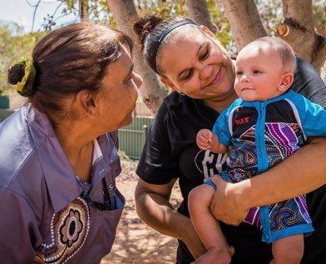

patient information

Your health is in your hands

## Have you had your 715 health check?

Torres Strait Islander flag

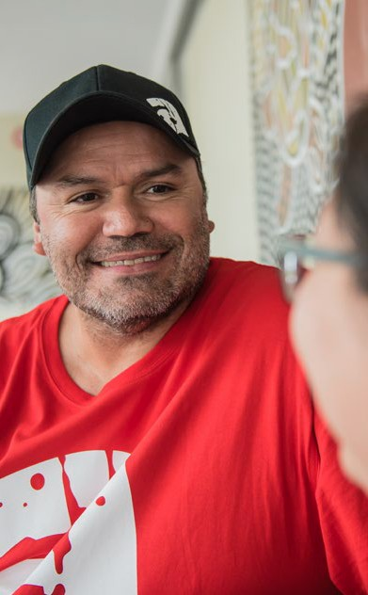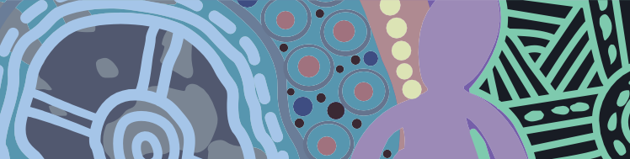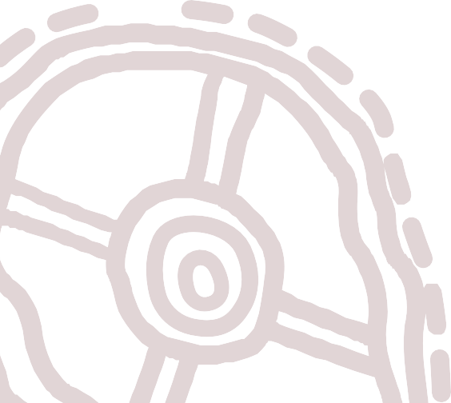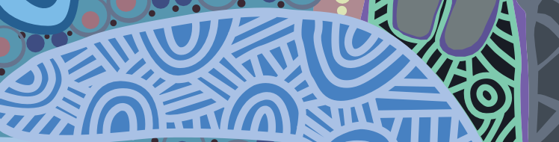

**We acknowledge that many individuals refer to themselves by their clan, mob and/or country. For the purposes of this document, we respectfully refer to Aboriginal and Torres Strait Islander people as Aboriginal and Torres Strait Islander throughout.**

# HAVE YOU HAD YOUR 715 HEALTH CHECK?

Aboriginal and Torres Strait Islander people can get a health check at your local Aboriginal Medical Service, general practice or health clinic. The 715 health check is free at Aboriginal Medical Services and bulk billing clinics. The 715 health check can help you better understand your health and help you access follow

up services to improve your health and wellbeing.

# YOUR HEALTH IS IN YOUR HANDS

A health check provides your Doctor with important information about how you’re traveling health wise. Without knowing these things, it’s hard to look after your health and the health of your family, in the right way.

# WHAT HAPPENS?

Health checks might be different depending on your age.

Having the health check should take between

40-60 minutes. A health practitioner might check your:

* blood pressure
* blood sugar levels
* height and weight

You might also a have blood test and urine test.

It’s also good to tell them about your family medical history or any worries you have about your health.



# FOLLOW UP CARE

Once you finish the check, the Practice Nurse, Aboriginal Health Worker or Doctor might tell you about other ways to help look after your health.

They might suggest services to help you with your:

* heart
* vision
* hearing
* movement
* mental health

You may also get help with free or discounted medicines you might need. Your Doctor can give you information about Closing the Gap scripts.

**It’s important to have a health check every year, even when you feel well, to stay healthy and strong.**

# WHY SHOULD I IDENTIFY?

It’s important to tell the Doctor if you are Aboriginal and/or Torres Strait Islander so that they can make sure you get access to what you might need.

Medicare can help record this for you.

Call the **Aboriginal and Torres Strait Islander Access line** on **1800 556 955**. Staff are culturally trained to help you.

# TELL YOUR FAMILY AND COMMUNITY ABOUT IT TOO.

Looking after your own health and wellbeing is important. It’s also important everyone in your family has a regular health check. You should try and do

it every year. Make sure you talk to your family so everyone can get their health checked too.

**For information about how a 715 health check can benefit your health visit** [**www.health.gov.au**](http://www.health.gov.au/)**/715-health-check or search #715healthcheck on social media.**



# FREQUENTLY ASKED QUESTIONS

**What are the benefits of having a health check?** Having a regular health check can keep your health heading in the right direction. It can help prevent small health problems becoming big ones. The information will help tell you and the Doctor about your health

and any help you might need. It’s not just about your health, but your family’s health too.

## How much does the health check cost?

The health check is free at your local Aboriginal Medical Service. It is also free at bulk billing health clinics. If you are unsure whether it will be free at your local Doctor, give them a call to ask about the 715 health check before you book.

## What happens to the information I give the Doctor? Who else can see it?

The Doctor and health workers will use the information you give them to help you manage your health. The Doctor and medical staff are bound to

confidentiality. That means they cannot share your information without your consent. They need to have

your permission before they give the information to anyone else.

## What if they make me go to hospital? I don’t want to leave my community.

In most cases your local health service will be able to support you to manage your health close to home.

Sometimes though, the help you need might be away from home. It’s important to get the best care you can, to help you stay healthy. Without this, your health

might get worse, which is not good for you, your family or community.

## The Doctor can’t do much if I’m already sick – what’s the point of a health check?

A chronic disease is an ongoing illness you have had for at least 6 months, or are at risk of getting. Some chronic diseases include asthma, cancer, heart disease, diabetes or arthritis. The information the Doctor collects at a health check can tell them if you might be at risk. They might suggest ways to help you before you get any sicker.

## Why should I have a health check on a regular basis?

The tests performed during a health check can tell the Doctor about the health of your body. For example, as you get older your blood pressure or sugar levels may increase. You are able to get a 715 health check every 9 months.

## Where can I get a 715 health check?

You can choose where you get your 715 health check. If you can, try to go to the same Doctor or clinic.

This helps make sure you are being cared for by people who know about your health needs.

**OUR HEALTH CHECK ARTWORK**

‘LET’S WALK AND TALK OUT BUSH’

**LUKE PENRITH**

PROUD ABORIGINAL MAN FROM BRUNGLE, HIS GREAT GRANDMOTHER’S COUNTRY.

CONNECTED CULTURALLY TO THE WIRADJURI, WOTJOBOLUK, YUIN

AND GUMBAYNGGIRR ABORIGINAL NATIONS.

**Walking and talking to family while doing physical exercise is deadly for the emotional wellbeing of First Nation peoples.**

**Going out bush walking with mob can benefit communities socially, culturally and does wonders for your mental health.**

**The two coolamons show abundance of bushtucker picked while out bush, the two boomerangs represents our past and our future, the six U symbols at the bottom**

**represents male and female leadership in our past, in**

**our present, and our emerging health leaders.**

**Women’s business and Men’s business is vital to our health**

**– engaging in these, ground in**

**communities, have health and cultural benefits.**

**Being active shows our children that it’s good to be outdoors learning culture and showing Yindyamarra (Respect) to Elders and ancestors while out bush.**

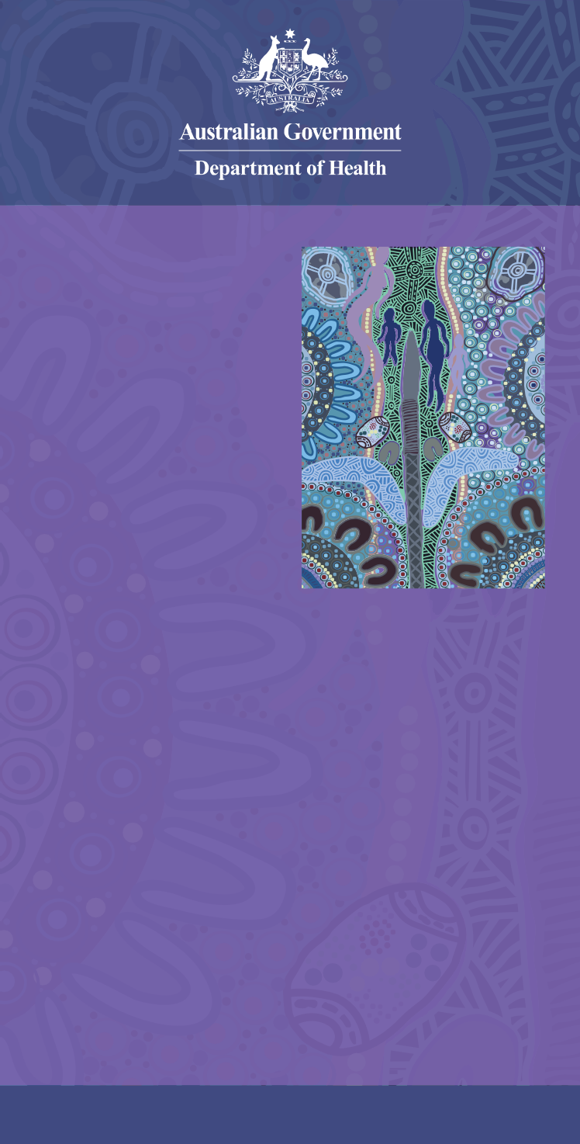

## [www.health.gov.au](http://www.health.gov.au/)/715-health-check