

Have you moved enough today?

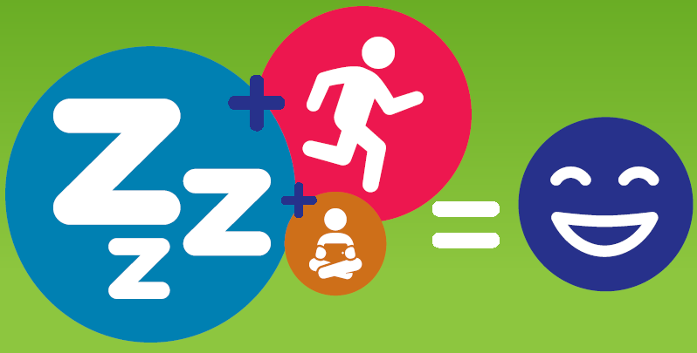

## Sleep

* 5–13 year olds need 9–11 hours per night.
* 14–17 year olds need 8–10 hours per night.

## Physical Activity

Aim for 60 minutes or more per day – the more you huff & puff the better!

## 24 hour movement guideliens iconInactivity

Move more & sit less in your spare time.

Find out more at<www.health.gov.au>

Children and young people (aged 5–17 years) should achieve the recommended balance of high levels of physical activity, low levels of sedentary behaviour, and sufficient sleep each day.

Australian 24-Hour Movement Guidelines for Children and Young People (5 to 17 years): An Integration of Physical Activity, Sedentary Behaviour, and Sleep