

Independent review of legislative provisions governing the use of restraint in residential aged care

Supplementary volume 2: methodology and results

December 2020



Acknowledgement of Country

In the spirit of reconciliation, the authors acknowledge and pay respect to the traditional custodians of Country, the Aboriginal and Torres Strait Islander peoples, and their continuing connection to land, waters, sea, and community.

AHA is located on the lands of the Kulin Nation. We pay our respects to Elders past and present.

Abbreviations

|  |  |
| --- | --- |
| Term | Definition |
| the Advisory Group | the Advisory Group convened for the review of the Restraints Principles |
| AGAC | Australian Guardianship and Administrative Council |
| AHA | Australian Healthcare Associates |
| AIHW | Australian Institute of Health and Welfare |
| BIDS | Department of Health Bulk Information Distribution Service |
| BPSD | Behavioural and psychological symptoms of dementia |
| the Commission | Aged Care Quality and Safety Commission |
| COVID‑19 | Coronavirus disease |
| the Department | the Australian Government Department of Health |
| HREC | Human Research Ethics Committee |
| NDIS | National Disability Insurance Scheme |
| PBS | Pharmaceutical Benefits Scheme |
| Provider | Approved residential aged care provider under the *Aged Care Act 1997* |
| PRN | pro re nata (as required) |
| Quality Indicator Program | National Aged Care Mandatory Quality Indicator Program |
| Restraints Principles | Part 4A of the Quality of Care Principles 2014 |
| the review | Independent review of legislative provisions governing the use of restraint in residential aged care |
| Royal Commission | Royal Commission into Aged Care Quality and Safety |

Contents

1 Introduction and background 1

1.1 Background 1

1.2 This document 2

2 Methodology 3

2.1 Project initiation 3

2.2 Literature and environmental scan 9

2.3 Conduct 10

2.4 Reporting 17

3 Consumer consultation results 18

3.1 Introduction 18

3.2 Awareness of the Restraints Principles 19

3.3 Experience of restraint 20

3.4 Interpretation of the Restraints Principles 21

3.5 How informed is informed consent? 22

3.6 Alternative strategies 22

3.7 Queries and concerns 23

3.8 Impact of COVID‑19 23

3.9 Good practice enablers 24

3.10 Conclusion 25

4 Provider survey results 26

4.1 The survey 26

4.2 Survey analysis 34

5 Analysis of secondary data sources 71

5.1 Physical restraint quality indicators 71

5.2 PBS dispensing data 74

5.3 Summary of data analysis 87

References cited 88

Appendix A Alt text long descriptions 89

Tables

Table 2‑1: Advisory group members 5

Table 1‑2: List of stakeholders consulted for the review 12

Table 3‑1: Consumer awareness of specific aspects of the Restraints Principles (n = 21) 19

Table 4‑1: Proportion of provider survey completed by respondents included in analysis 34

Table 4‑2: Proportion of provider survey respondents by role 35

Table 4‑3: Organisation ownership, by role category 36

Table 4‑4: Organisation structure, by role category 36

Table 4‑5: Organisation size, defined as number of beds 36

Table 4‑6: Provider awareness of the Restraints Principles 37

Table 4‑7: Provider awareness of specific aspects of the Restraints Principles 38

Table 4‑8: Responses to ‘Medications prescribed to treat a diagnosed mental health condition are not considered chemical restraint’, by respondent role 39

Table 4‑9: Level of agreement to the statement: I have a good understanding of what physical restraint means 39

Table 4‑10: Level of agreement to the statement: I have a good understanding of what chemical restraint means 39

Table 4‑11: Provider-reported challenges to putting the Restraints Principles into practice 40

Table 4‑12: Providers’ observations of restraint in the 7 days prior to completing survey 49

Table 4‑13: Provider perspectives of whether there been a reduction in the use of chemical restraint since the introduction of the Restraints Principles 50

Table 4‑14: Reasons there has been no reduction in the use of chemical restraint since the introduction of the Restraints Principles 50

Table 4‑15: Provider perspectives on whether there has there been a reduction in the use of physical restraint since the introduction of the Restraints Principles 52

Table 4‑16: Reasons there has been no reduction in the use of physical restraint since the introduction of the Restraints Principles 52

Table 4‑17: Do providers have policies and processes to prevent or minimise the need for restraint? 54

Table 4‑18: Do providers have internal policies and processes to manage the use of chemical restraint which meet all required steps outlined in the Restraints Principles? 54

Table 4‑19: Do providers have internal policies and processes to manage the use of physical restrain which meet all required steps outlined in the Restraints Principles? 54

Table 4‑20: Provider staff identifying unintended impacts of the Restraints Principles 55

Table 4‑21: Perceived impact of the COVID‑19 pandemic on use of chemical restraint 63

Table 4‑22: Perceived impact of the COVID-19 pandemic on use of physical restraint 64

Table 4‑23: Providers identifying a need to make changes to the Restraints Principles 65

Table 5‑1: Selected medications: key and other medications of interest 75

Figures

Figure 2‑1: Review methodology 4

Figure 2‑1: Program logic 7

Figure 4‑1: Provider survey data cleaning 34

Figure 5‑1: Intent to restrain & number of physical restraint devices observed 73

Figure 5‑2: Intent to restrain & number of physical restraint devices observed per 1,000 care days 73

Figure 5‑3: Study cohort – Risperidone 78

Figure 5‑4: Study cohort – Haloperidol 78

Figure 5‑5: Study cohort – Quetiapine 79

Figure 5‑6: Study cohort – Olanzapine 79

Figure 5‑7: Study cohort – Diazepam 80

Figure 5‑8: Study cohort – Oxazepam 80

Figure 5‑9: Case study cohort, all residents – Risperidone 81

Figure 5‑10: Case study cohort, all residents – Haloperidol 81

Figure 5‑11: Case study cohort, all residents – Quetiapine 82

Figure 5‑12: Case study cohort, all residents – Olanzapine 82

Figure 5‑13: Case study cohort, all residents – Diazepam 83

Figure 5‑14: Case study cohort, all residents – Oxazepam 83

Figure 5‑15: Case study cohort, residents diagnosed with dementia – Risperidone 84

Figure 5‑16: Case study cohort, residents diagnosed with dementia – Haloperidol 84

Figure 5‑17: Case study cohort, residents diagnosed with dementia – Quetiapine 85

Figure 5‑18: Case study cohort, residents diagnosed with dementia – Olanzapine 85

Figure 5‑19: Case study cohort, residents diagnosed with dementia – Diazepam 86

Figure 5‑20: Case study cohort, residents diagnosed with dementia – Oxazepam 86

# Introduction and background

The Australian Government Department of Health (the Department) engaged Australian Healthcare Associates (AHA) to conduct a legislated review (the review) of the effectiveness of Part 4A of the *Quality of Care Principles 2014* (Restraints Principles) in minimising the use of restraint in residential aged care. As required by the legislation, the review examined the Restraints Principles’ first year of operation (1 July 2019 to 30 June 2020).

The key findings and recommendations of the review are contained in the document Independent review of legislative provisions governing the use of restraint in residential aged care: Final report (final report). The review commenced in May 2020, with the final report required to be submitted to the Minister for Aged Care by 31 December 2020.

This supplement to the final report provides further information on the methodology and results of the review that may be of interest to the Department and decision makers. All critical information and findings are contained in the final report.

## Background

On 1 July 2019, specific responsibilities for residential aged care providers in relation to the use of physical and chemical restraint came into effect. These new requirements, for the first time, put explicit obligations on residential aged care providers in respect of the use of restraint.

The *Quality of Care Amendment (Minimising the Use of Restraints) Principles 2019* require providers to satisfy a number of conditions before using physical or chemical restraint, including conducting an appropriate assessment, obtaining informed consent for physical restraint or advising the resident’s representative of the use of chemical restraint.

The provider is also required to document alternatives to restraint that were considered or tried. The responsibility for seeking informed consent of the resident or their family for prescription medications, including psychotropics, rests with the medical practitioner (rather than the residential aged care provider). If restraint is used, the Restraints Principles specify that this must be for the minimum time necessary, and that the resident must be regularly monitored throughout.

The introduction of the Restraints Principles was widely regarded by the sector at the time as a positive step forward in the regulation of restraint practices. However, the Restraints Principles have been the subject of significant interest; in particular, issues have been raised in relation to human rights and informed consent.

These concerns culminated in 2 formal inquiries conducted by the Parliamentary Joint Committee on Human Rights (Parliamentary Joint Committee on Human Rights 2019) and the Senate Standing Committee on Regulations and Ordinances (Senate Community Affairs References Committee 2018).

In response to the recommendations of these 2 committees, a further amendment to the legislation – the *Quality of Care Amendment (Reviewing Restraints Principles) Principles* – was introduced on 29 November 2019. This amendment:

* Clarified that restraint must only be used as a last resort
* Referred to state and territory legislation regarding prescribers’ responsibilities in relation to informed consent
* Required a 12-month review of the Restraints Principles – this review.

## This document

This document comprises 4 chapters, providing detail on:

* Methodology of the review (Section 2)
* Provider survey results (Section 3)
* Consumer consultation results (Section 4)
* Data on the use of physical restraint and PBS medicine utilisation (Section 5)

# Methodology

The review of the Restraints Principles was conducted using a three-phase approach from 4 May 2020 to 30 November 2020. Figure 2‑1 provides a high-level overview of each phase, key review activities and timelines. Details of the review methodology are provided under the following headings:

* Project initiation
* Literature and environmental scan
* Conduct
* Reporting.

## Project initiation

Activities undertaken in the project initiation and planning phase of the review included:

* Project initiation meeting
* Consultation with the Advisory Group
* Development of project and evaluation plan
* Development of data collection and consultation tools
* Ethics application and approval.

Each is described in turn in the sections that follow.

### Project initiation meeting

An initial meeting with key personnel from the Department was held via teleconference on 6 May 2020. The following topics were discussed:

* Background to the development of the Restraints Principles and project aims
* Availability of, and access to, background documentation and data sets
* Preparation for the first Advisory Group meeting
* Deliverables and timelines.

AHA continued to meet with the Department over the following weeks, with a focus on:

* Preparing documents for the first Advisory Group meeting
* Addressing actions arising from the Advisory Group meetings, including development of a comprehensive list of stakeholders, and preparation of draft consultation tools for Department and Advisory Group review.

In addition, AHA met with representatives from the Aged Care Quality and Safety Commission (the Commission) to inform development of the evaluation framework and stakeholder consultation strategy.

Figure 2‑1: Review methodology

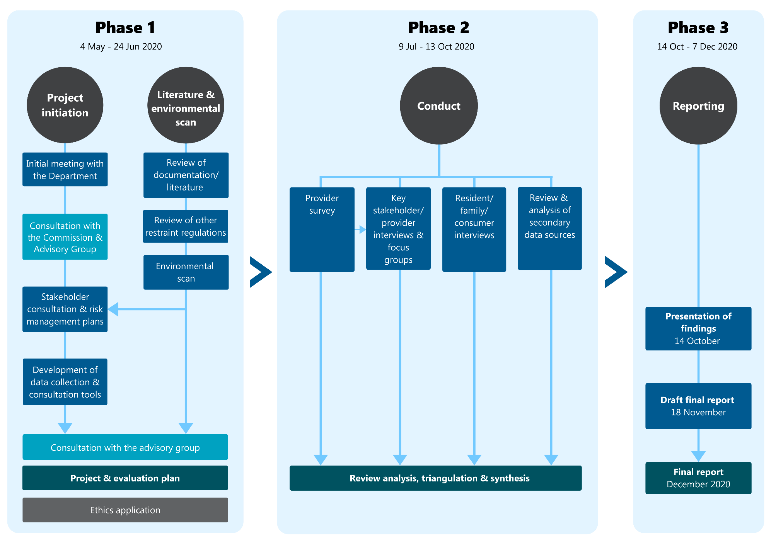

### Consultation with the Advisory Group

The Department convened an Advisory Group to provide advice on the review. Members of the Advisory Group are listed in Table 2‑1.

The group met 3 times over the period May to October 2020.

The first meeting of was held via teleconference on Tuesday 19 May 2020. The key outcomes of the meeting were:

* Confirmation of the Terms of Reference for the review
* Identification of key stakeholders to involve in the review
* Advice on proposed consultation methods.

The purpose of the second Advisory Group meeting on 17 June 2020 was to seek the group’s advice regarding the proposed consultation strategy and tools (interview guides and survey questions). Feedback from the Advisory Group was incorporated into the project and evaluation plan and consultation tools. Following this Advisory Group meeting several members provided further comment on revised questions for providers and consumers.

The purpose and outcomes of the third Advisory Group meeting on 14 October 2020 are detailed in Section 2.4.2.

Table 2‑1: Advisory group members

|  |  |
| --- | --- |
| Member name* | Member title |
| Christina Bolger | Executive Director, Aged Care Quality and Safety Commission |
| Ingrid Leonard/‌Josh Maldon | A/Assistant Secretary of Aged Care Quality Regulatory Design and Implementation Brand Department of Health |
| Melanie Wroth | Chief Clinical Advisor, Aged Care Quality and Safety Commission |
| Ian Yates | CEO, COTA Australia |
| Kaele Stokes | Executive Director, Advocacy and Research, Dementia Australia |
| Craig Gear | CEO, Older Persons Advocacy Network |
| Derek Dittrich | Senior Manager, Strategic Policy, Aged and Community Services Australia |
| Nicholas Brown | Executive Director, Operations, Aged Care Guild |
| Angela Raguz | General Manager of Residential Care, HammondCare |
| Debora Picone | CEO, Australian Commission on Safety and Quality in Health Care |
| Mary Burgess | Public Advocate, Office of the Public Advocate QLD |
| Deborah Booth | Chief Executive, St Andrews Village,  Representative of the Australian College of Nursing |
| Paul Miller | Director, Department of Social Services |
| Susan Kurrle | Professor, University of Sydney |
| Colm Cunningham | Director, Dementia Support Australia |
| Marlene Eggert | Senior Policy Advisor, Leading Age Services Australia |
| Malcolm Schyvens | Chair of the Australian Guardianship and Administration Council |

*Proxies attended for members as required

### Development of project and evaluation plan

The project and evaluation plan submitted to the Department on 30 June 2020 detailed the evaluation framework, project methodology, governance and management arrangements, risk management plan and stakeholder consultation plan. It also included the full suite of draft data collection and consultation tools.

#### Evaluation framework

The evaluation framework served to inform the planning of the review and support the development of data collection and consultation tools for the conduct of the review.

Program logic

The program logic included inputs, activities, outputs, outcomes and impacts of the Restraints Principles and is presented at Figure 2‑2. The program logic helped to understand the developments that led to the Restraints Principles as well as the expected outcomes and impacts of the Restraints Principles.

Components of the review and key review questions

AHA identified 8 key components related to the achievement of the outcomes identified through the program logic approach. These components were mapped to the 4 key review questions that had been determined by the Department:

1. Are the Restraints Principles effective in minimising the use of restraint?

Relevant components:

* + Effectiveness

1. To what extent have the Restraints Principles promoted the delivery of care in a restraint-free environment?

Relevant components:

* + Awareness
  + Understanding
  + Adherence
  + Challenges and enablers

1. Are there any unintended consequences arising from the implementation of the Restraints Principles?

Relevant component:

* + Unintended consequences

1. What are the opportunities to improve the Restraints Principles?

Relevant component:

* + Opportunities identified by stakeholders and from experiences of other jurisdictions

The key review questions and the components provided a framework to guide the project methodology including the data sources and the consultation questions.

Data sources

The primary data sources to inform the review included surveys, interviews and focus groups.

Secondary data sources (defined as existing data not collected by AHA) were identified through reviewing key documents and with input from the Department, the Commission and the Advisory Group. These data sources are detailed in Section 5.

Figure 2‑2: Program logic

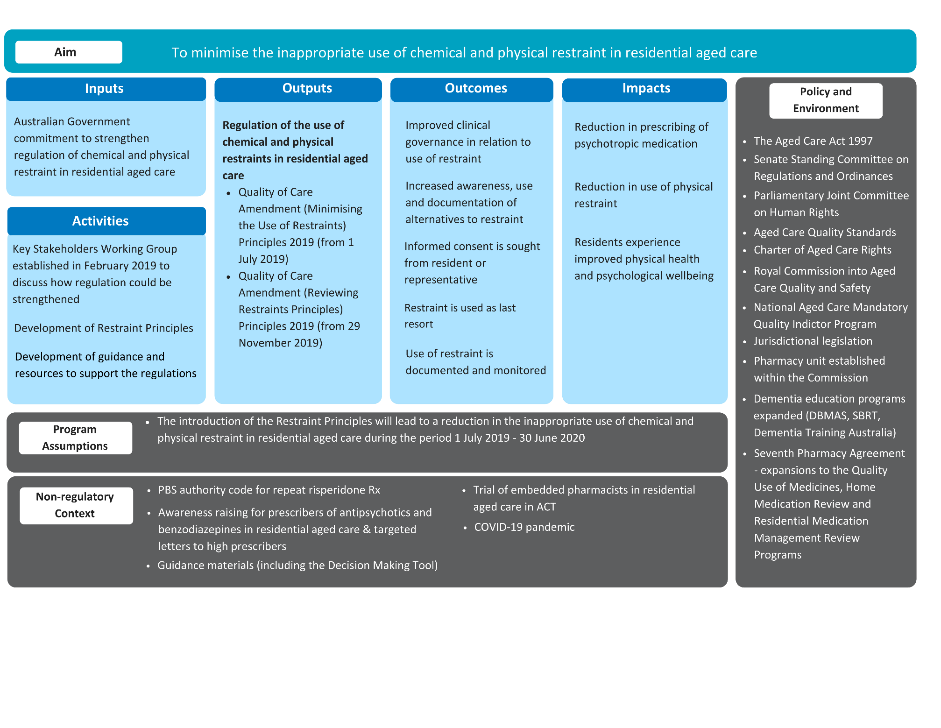

### Stakeholder consultation planning

Stakeholders were identified with input from the Advisory Group. For each stakeholder/stakeholder group, the consultation strategy identified the method of consultation, strategies for recruitment and engagement, support required from the Department or Advisory Group members to engage with stakeholders or promote the review and the timeframe for consultation.

#### Development of data collection and consultation tools

AHA developed the following data collection and consultation tools:

Interview guides for consultation with aged care residents/family members/consumers

Survey for provider staff

* Consultation guides for telephone interviews and online focus groups with key stakeholders (including providers).

Development of these tools considered the evaluation framework, input from the Department, the Commission and Advisory Group, and the preliminary findings of the literature and environmental scan.

To ensure the unique perspectives of each key stakeholder group were explored and captured, AHA developed 10 tailored consultation guides.

### Ethics application and approval

AHA conducted an internal ethics review in accordance with our internal ethics review policy and procedure. This internal review determined that the conduct of the project involved engagement with potentially vulnerable participants, requiring formal ethics review from an external Human Research Ethics Committee (HREC).

Potentially vulnerable participants to be invited to contribute to the review included people with a cognitive decline and impairment, such as an intellectual disability or a mental illness, Aboriginal and Torres Strait Islander peoples, and people from culturally and linguistically diverse communities. Even when capable of giving consent and actively participating, individuals from these population groups were considered to be at risk of discomfort and distress. As a result, the internal review process determined that the activities involving residents, family members, and consumers represent ‘greater than low risk’ from an ethical perspective.

AHA obtained HREC approval for the conduct of the review on 28 July 2020 from Bellberry Limited – a private, National Health and Medical Research Council registered ethics committee.

A number of safeguards were put in place to ensure ethical conduct of consumer consultations and minimise the potential for participants to become distressed. First, consultations were designed as a telephone interview, in order to allow AHA to respond to and support individuals for whom the content was distressing. A comprehensive participant information sheet was provided to prospective participants prior to their involvement in an interview. This document explained that participating in the project involved being asked about views and experiences of restraint, that participation was voluntary, and provided the contact details for national support lines for participants who required support to manage any distress the project raised.

AHA also aimed to reduce the likelihood of participants becoming distressed by focusing the interview on the processes around the use of restraint, rather than the experience of restraint itself. To ensure the interests and wellbeing of participants were protected, the interview guide was developed through extensive consultation with the Department and Advisory Group (see sections 2.1.2 and 2.1.4). AHA also developed a distress management protocol, which outlined steps for staff to take in the event of participants indicating distress, including maintaining records of any such events, and reporting these events to Bellberry Limited and the Department. No such events occurred during the review.

## Literature and environmental scan

A literature and environmental scan was undertaken in parallel to the project initiation stage and helped to inform the review, such as by identifying additional stakeholders for consultation. AHA continuously monitored relevant literature and activities throughout the life of the review, capture the ongoing work being undertaken to minimise restraint in aged care.

The literature and environmental scan involved:

* A preliminary review of data and documentation provided by the Department to inform decisions about data collection activities and guide development of the Project and Evaluation Plan.
* An environmental scan to understand the various factors that could impact the conduct of the review and interpretation of findings. This process included review and synthesis of key inquiries, policy settings and non-regulatory measures.
* A scan of national and international literature regarding other approaches to the regulation of restraints in residential aged care and related settings (e.g. within the disability sector). Literature describing both regulatory and non-regulatory approaches to managing the use of restraints practices were included.

## Conduct

Activities undertaken in the conduct phase of the review included the following, as detailed in sections 2.3.1 to 2.3.5:

* Consultation with aged care residents, family members, and consumers
* Survey for provider staff
* Interviews and focus groups with key stakeholders
* Secondary data analysis
* Analysis, triangulation, and synthesis.

### Consultation with aged care residents, family members, and consumers

AHA conducted telephone interviews with aged care residents, their family members or representatives, and other aged care consumers (referred to collectively in this section as consumers) following receipt of HREC approval. These stakeholders were consulted from 31 July – 7 September 2020.

Consumers were invited to take part in the review by contacting AHA to complete a telephone interview. The interview included both multiple choice and open-ended questions, and asked respondents about:

* What prompted them to take part in the review
* Awareness of the Restraints Principles prior to taking part in the review
* Experiences of restraint
* What could be improved based on their restraint experience
* What parts of their experience of restraint worked well (if any).

The following strategies were used to promote the consumer consultation and maximise engagement with this important group of stakeholders:

* A Department of Health Bulk Information Distribution Service (BIDS) notification was circulated on   
  6 August 2020 requesting residential aged care providers and peak bodies promote the consultation opportunity
* The consultation was advertised on the AHA website from late July 2020
* AHA provided standardised text to a number of Advisory Group members who had offered to promote the consultation through their networks in late July 2020. AHA sent a reminder to these organisations in mid-August 2020
* COTA Australia advertised the consultation in their e-newsletter on   
  6 August 2020 and promoted it through their social media channels
* The seventeen providers involved in the provider focus groups were asked to promote/display the consultation opportunity at their aged care homes
* The Commission put information about the consultation on their home page on 21 August 2020
* The members of the Older Person’s Reference Group were provided details of the consultation to circulate in their networks
* Dementia Australia promoted the consultation in their e-newsletter on   
  31 August 2020.

Findings from the consumer consultation are provided in Section 3.

### Survey for provider staff

An anonymous, online survey of residential aged care providers – targeting both management and direct-care staff – was conducted from 9 July to 14 August 2020.

The survey was designed to collect quantitative and qualitative data on:

* The respondent and their organisation
* Practice changes following the introduction of the Restraints Principles
* The effectiveness of the Restraints Principles in minimising restraint use
* Unintended consequences and opportunities for improvement.

The survey was promoted via the Department’s BIDS notification system, with the first notification published on   
21 July 2020 and a reminder notification published on 6 August 2020. The survey tool and detailed results are provided in Section 4.

The survey was also used to call for expressions of interest from provider management to participate in a focus group.

### Interviews and focus groups with key stakeholders

During the period 14 July to 7 September 2020, AHA conducted telephone interviews and online focus groups with 135 individuals representing 54 organisations, including 17 providers. In addition, unsolicited written submissions were received from 5 individuals.

AHA’s stakeholder consultation strategy was developed to provide a range of opportunities for stakeholders to be involved in the review, making it as accessible to stakeholders as possible. The order and timing of consultations was important in the conduct of this review, as findings and learnings from earlier consultations informed later consultations.

A complete list of stakeholders consulted is provided in Table 2‑2.

Table 2‑2: List of stakeholders consulted for the review

|  |  |  |  |  |
| --- | --- | --- | --- | --- |
| Group | Representatives | No. of  participants | Consultation  method | Date |
| The Commission | Executives | 5 | Interview | Tuesday 3 August |
| The Commission | Quality assessors and complaints officers | 15 | Focus group | Tuesday 14 July |
| Aged care advocates from National Aged Care Advocacy Program providers | Elder Rights Advocacy (Vic) | 1 | Focus group | Tuesday 21 July |
| Aged care advocates from  National Aged Care  Advocacy Program providers | Aged Rights Advocacy Service (SA) | 1 | Focus group | Tuesday 21 July |
| Aged care advocates from  National Aged Care  Advocacy Program providers | Aged and Disability Advocacy Australia (Qld) | 2 | Focus group | Tuesday 21 July |
| Aged care advocates from National Aged Care Advocacy Program providers | Advocare (WA) | 1 | Focus group | Tuesday 21 July |
| Aged care advocates from National Aged Care Advocacy Program providers | CatholicCare (NT) | 1 | Focus group | Tuesday 21 July |
| Aged care advocates from National Aged Care Advocacy Program providers | Seniors Rights Services (NSW) | 1 | Focus group | Tuesday 21 July |
| Aged care advocates from National Aged Care Advocacy Program providers | Aged and Disability Advocacy Australia (Qld) | 2 | Interview | Friday 7 August |
| Allied health industry  representatives | Occupational Therapy Australia | 1 | Focus group | Thursday 13 August |
| Allied health industry  representatives | Australian Music Therapy Association | 2 | Focus group | Thursday 13 August |
| Allied health industry representatives | Australian Psychological Society | 1 | Focus group | Thursday 13 August |
| Allied health industry representatives | Allied Health Professions Australia | 1 | Focus group | Thursday 13 August |
| Allied health industry representatives | Dietitians Association of Australia | 1 | Focus group | Thursday 13 August |
| Allied health industry representatives | Speech Pathology Australia | 1 | Focus group | Thursday 13 August |
| Allied health industry representatives | Australian Physiotherapy Association | 2 | Focus group | Thursday 13 August |
| Allied health industry representatives | Diversional and Recreational Therapy Australia | 2 | Focus group | Thursday 13 August |
| Allied health industry representatives | Other individuals (not representing one of the above organisations) | 2 | Focus group | Thursday 13 August |
| Consumer peak bodies and representatives | Carers Australia | 1 | Interview | Thursday 16 July |
| Consumer peak bodies  and representatives | Dementia Australia | 2 | Interview | Tuesday 14 July |
| Consumer peak bodies and representatives | Older Persons Advocacy Network | 1 | Interview | Wednesday 15 July |
| Consumer peak bodies and representatives | Partners in Culturally Appropriate Care | 6 | Focus group | Monday 20 July |
| Consumer peak bodies and representatives | COTA Australia | 1 | Interview | Tuesday 8 September |
| Consumer peak bodies and representatives | Older Person’s Reference Group | 7 | Focus group | Friday 28 August |
| Dementia Behaviour Management Advisory Service (DBMAS) & Severe Behaviour Response (SBRT) Teams | DBMAS and SBRT team members | 8 | Focus group | Wednesday 22 July |
| Medical representatives | Australian Medical Association | 1 | Focus group | Tuesday 11 August |
| Medical representatives | Royal Australian College of General Practitioners | 1 | Focus group | Tuesday 11 August |
| Medical representatives | Royal Australian and New Zealand College of Psychiatrists: Faculty of Psychiatry of Old Age | 1 | Focus group | Tuesday 11 August |
| Medical representatives | Australian and New Zealand Society for Geriatric Medicine | 2 | Focus group | Tuesday 11 August |
| Medical representatives | Other (not representing one of the above groups) | 1 | Focus group | Tuesday 11 August |
| Nursing peak bodies | Australian College of Nursing | 2 | Focus group | Thursday 13 August |
| Nursing peak bodies | Australian College of Nurse Practitioners | 1 | Focus group | Thursday 13 August |
| Nursing peak bodies | Australian Nursing and Midwifery Federation | 7 | Focus group | Thursday 13 August |
| Pharmacy representatives | Pharmaceutical Society of Australia | 2 | Focus group | Tuesday 11 August |
| Pharmacy representatives | Pharmacy Guild of Australia | 1 | Focus group | Tuesday 11 August |
| Pharmacy representatives | Australian Association of Consultant Pharmacy | 1 | Focus group | Tuesday 11 August |
| Pharmacy representatives | Other (not representing one of the above groups) | 1 | Focus group | Tuesday 11 August |
| Providers | Helping Hand (SA) | 1 | Focus group | Monday 10 August |
| Providers | Lutheran Services Qld (Qld) | 2 | Focus group | Monday 10 August |
| Providers | Western District Health Service (Vic) | 1 | Focus group | Monday 10 August |
| Providers | Alexander Aged Care Home (Vic) | 1 | Focus group | Tuesday 11 August |
| Providers | Cranbrook Care (NSW) | 1 | Focus group | Tuesday 11 August |
| Providers | Della Dale Aged Care (Vic) | 1 | Focus group | Tuesday 11 August |
| Providers | Parkview Nursing Home (Vic) | 1 | Focus group | Tuesday 11 August |
| Providers | Pathways Aged Care (NSW) | 1 | Focus group | Tuesday 11 August |
| Providers | Allambie Heights Residential Aged Care home (NSW) | 1 | Focus group | Wednesday 12 August |
| Providers | Ashfield Baptist Homes (NSW) | 1 | Focus group | Wednesday 12 August |
| Providers | Benevolent Living (Qld) | 1 | Focus group | Wednesday 12 August |
| Providers | Marco Polo Aged Care Services (NSW) | 1 | Focus group | Wednesday 12 August |
| Providers | Feros Care (NSW) | 1 | Focus group | Wednesday 12 August |
| Providers | Murrumbidgee Local Health District (NSW) | 1 | Focus group | Wednesday 12 August |
| Providers | Omeo District Health (Vic) | 1 | Focus group | Friday 14 August |
| Providers | Strathalbyn & District Aged Care Home (SA) | 1 | Focus group | Friday 14 August |
| Providers | Warramunda Village (Vic) | 1 | Focus group | Friday 14 August |
| Provider peak bodies | Aged Care Guild | 2 | Interview | Wednesday 29 July |
| Provider peak bodies | Aged Care Industry Association (ACIA) | 1 | Interview | Thursday 6 August |
| Provider peak bodies | Aged & Community Services Australia (ACSA) | 2 | Interview | Tuesday 28 July |
| Provider peak bodies | Leading Age Services Australia (LASA) | 2 | Interview | Tuesday 28 July |
| Public guardians, consumer advocates, and civil and administrative tribunals | Australian Guardianship and Administrative Council (AGAC) | 2 | Interview | Monday 27 July |
| Public guardians, consumer  advocates, and civil and administrative tribunals | Queensland Office of the Public Guardian | 1 | Focus group | Thursday 30 July |
| Public guardians, consumer advocates, and civil and  administrative tribunals | Queensland Civil and Administrative Tribunal | 2 | Focus group | Thursday 30 July |
| Public guardians, consumer advocates, and civil and administrative tribunals | Victorian Office of the Public Advocate | 1 | Focus group | Thursday 30 July |
| Public guardians, consumer advocates, and civil and administrative tribunals | Public Trustee and Guardian (ACT) | 1 | Focus group | Thursday 30 July |
| Public guardians, consumer advocates, and civil and administrative tribunals | Northern Territory Office of the Public Guardian | 1 | Focus group | Thursday 30 July |
| Public guardians, consumer advocates, and civil and administrative tribunals | Western Australian Office of the Public Advocate | 1 | Focus group | Thursday 30 July |
| Public guardians, consumer advocates, and civil and administrative tribunals | South Australian Office of the Public Advocate | 2 | Focus group | Thursday 30 July |
| Other key stakeholders and Advisory Group members | Australian Commission on Quality and Safety in Healthcare | 2 | Interview | Thursday 23 July |
| Other key stakeholders and  Advisory Group members | NDIS Quality and Safeguard Commission | 1 | Interview | Thursday 23 July |
| Other key stakeholders and Advisory Group members | Department of Social Services | 1 | Interview | Thursday 23 July |
| Other individuals and organisations | Medication management service provider | 2 | Interview | Wednesday 12 August |
| Other individuals and  organisations | Experts, Monash University | 4 | Interview | Thursday 27 August |
| Other individuals and organisations | Written submissions | 5 | Submissions | nil |

### Secondary data

The Review included data on the use of physical restraint and psychotropic medications that may be used for chemical restraint. The purpose was to consider whether there have been observed changes in these markers of restraint use since the introduction of the Restraints Principles.

#### Physical restraint Quality Indicator data for 2019-20

The Australian Institute of Health and Welfare (AIHW) is contracted to the Department to provide compilation and reporting services for the National Aged Care Mandatory Quality Indicator Program (Quality Indicator Program) and has reported data on its GEN aged care data website for the first three-quarters of the program (July 2019 to March 2020). For this review, a descriptive summary and analysis was undertaken using all publicly available Quality Indicator Program data. AIHW also provided the Department (and AHA) with a report that analysed physical restraint data for evidence of progressive change through the first three-quarters of the mandatory Quality Indicator Program. Details of the data and the results are provided in Section 5.1.

#### Pharmaceutical Benefits Scheme (PBS) dispensing data

To inform the review, AIHW undertook analyses of linked aged care and PBS data to describe the patterns of medications dispensed for selected nervous system medicines over time for people living in permanent residential aged care. The periods 2017–18 and 2018–19 were compared against the period 1 July 2019 to 31 March 2020 (i.e. before and after the introduction of the Restraints Principles legislation). AIHW provided the Department (and AHA) with aggregated data and supporting text.

Senior Department clinical advisors reviewed the data and provided a clinical interpretation of the results. A summary of the data and findings is provided in Section *5.3*.

#### Other secondary data sources

As outlined in Section 2.2, a literature and environmental scan was undertaken in parallel to the review –see *Supplementary volume 1: literature and environmental scan*. It identified relevant contextual information, including findings of the Royal Commission into Aged Care Quality and Safety (Royal Commission), other previous reviews and relevant research, that supported interpretation of the findings and recommendations presented in the final report for this review.

Other secondary data sources provided to AHA over the course of the project included case study data and the Commission non-compliance and complaints data.

Case study data

The following de-identified cases were provided to inform the review:

* Two case examples from Dementia Support Australia in relation to chemical restraint.
* Two cases of complaints from the Office of the Public Advocate to the Queensland Office of the Health Ombudsman. Both cases were regarding ongoing use of chemical restraint despite mental health advice otherwise.
* One case heard by the NSW Civil and Administrative Tribunal in August 2020, regarding consent and the definition of physical restraint.

The Commission non-compliance and complaints data

The Commission provided data on restraint-related Aged Care Quality Standards that were not met in performance assessment activities completed between 1 July 2019 and 30 June 2020.

### Analysis, triangulation and synthesis

Information was organised using the predefined components for the evaluation (effectiveness, awareness, understanding etc.). In addition, information was organised by key aspects of the legislation, such as physical restraint, chemical restraint, consent, monitoring, etc. Findings from the primary data sources were triangulated with secondary data and considered in context of the literature and environmental scan.

## Reporting

### Regular reporting to the Department

As detailed in Section 2.1.1, AHA and the Department met regularly during the project planning stage.

During the conduct and reporting phase of the review, AHA and the Department continued to meet on a regular (typically fortnightly) basis, to discuss key activities undertaken, project achievements, project risks and mitigation strategies and emerging review findings.

### Presentation of findings

AHA presented the review findings to the Advisory Group on 14 October 2020. The presentation provided a summary of:

* The number and type of consultations that informed the review
* Data on the use of physical and chemical restraint in residential aged care services
* Findings of the consultation process, including perceived benefits of the Restraints Principles and any unintended consequences
* Stakeholder perspectives on potential changes to the Restraints Principles and other non-regulatory opportunities.

Based on the findings presented, the Advisory Group discussed recommendations for key regulatory and non-regulatory actions going forward.

### Final report

The final report *Independent review of legislative provisions governing the use of restraint in residential aged care*, is supported by 2 supplementary documents:

* *Supplementary volume 1: literature and environmental scan*
* *Supplementary volume 2: methodology and results* (this document)

# Consumer consultation results

## Introduction

The consumer interview was designed for current or previous residents of aged care homes and their families, friends or carers to share their views and experiences of restraint since 1 July 2019; however, any interested consumers could participate. The interview was advertised through the Department, the Commission and consumer peaks, with interested individuals asked to contact AHA between 31 July and 31 August 2020. This closing date was subsequently extended to   
7 September to allow more opportunity for consumers to participate. The ethics approval process and the topic areas covered in the interview are outlined in Section 2.1.5.

A total of 23 people completed the telephone interview. A further 10 provided comments to AHA via email but did not respond to invitations to complete the interview, and 10 consumers inadvertently completed the online provider survey.[1] Thus, a total of 43 consumers contributed to the review. Most of these were family members, friends or representatives with a decision-making role (n = 19, 45%); 6 people (14%) indicated they were a family member or friend of an aged care resident without a decision-making role, while the decision-making status of 16 people (38%) was unclear. Only 2 participants indicated they were a current resident of an aged care home.

We did not identify marked differences in the feedback provided in different formats (interview, email, survey) or by different participant groups and therefore have collated the information from all 43 individuals in the summary below.

Twenty-three people provided information on the reason they decided to take part in the review; for around one-quarter, this was due to having a family member who had experienced restraint while in residential aged care. Other reasons for participation mentioned by more than one person included: receiving an invitation from the aged care home or consumer peak organisation they were associated with; interest in the topic (e.g. wanting to find out more about the Restraints Principles); or wanting to share their experiences of residential aged care more generally. Individual responses indicated a desire to participate due to concern about the direction aged care is heading, feeling that previous inquiries or complaints had not been heard.

## Awareness of the Restraints Principles

Interview and survey respondents were asked whether they had been aware, prior to participating in the review, of a law that aims to minimise the use of restraint in residential aged care. More than half of the 33 people for whom data was available indicated they had been aware (n = 19; 58%), with 12 people not previously aware of the Restraints Principles and 2 people unsure.

People who were aware of the Restraints Principles or unsure were asked to indicate their awareness of particular elements of the legislation. Generally speaking, awareness was high (Table 3‑1); however, respondents were least likely to have previously known that medication prescribed for the treatment of a diagnosed mental health condition does not constitute chemical restraint. Caution needs to be applied in interpreting the proportions in Table 3‑1given the low number of respondents.

Table 3‑1: Consumer awareness of specific aspects of the Restraints Principles (n = 21)

|  |  |  |  |
| --- | --- | --- | --- |
| Aspects of the Restraints Principles | Yes  n (%) | No  n (%) | Unsure  n (%) |
| Restraint can only be used after alternative strategies (other options) have been tried. | 17 (81) | 3 (14) | 1 (5) |
| Physical restraint must not be used unless a doctor, nurse practitioner, or nurse who has day-to-day knowledge of the resident has determined that restraint is required because the resident is at risk of hurting themselves or someone else. | 14 (67) | 4 (19) | 3 (14) |
| The resident (or their representative) must provide informed consent before physical restraint is used, except where its use is necessary in an emergency. | 14 (67) | 4 (19) | 3 (14) |
| If physical restraint is used, it must take the least restrictive form possible and be used for as little time as possible, reviewed over time, and the resident regularly monitored. | 16 (76) | 3 (14) | 2 (10) |
| Chemical restraint must not be used unless a doctor or nurse practitioner has assessed the resident and determined that restraint is required, and has prescribed medication for that reason. | 16 (76) | 4 (19) | 1 (5) |
| Medications prescribed to treat a diagnosed mental health condition are not considered chemical restraint. | 8 (38) | 8 (38) | 5 (24) |
| Informed consent must be obtained (from the resident or their representative) by the prescribing doctor or nurse practitioner before chemical restraint can be used. | 16 (76) | 4 (19) | 1 (5) |
| If restraint is used, staff at the home must regularly monitor the resident and record information in the resident's care and services plan. | 16 (76) | 3 (14) | 2 (10) |
| The resident's representative must also be told of the use of chemical restraint by the aged care home, before restraint is used, if it is practical to do so. Otherwise, the resident's representative must be told about the restraint as soon as possible after it is used. | 16 (76) | 2 (10) | 3 (14) |

## Experience of restraint

Twenty-three people responded to a question about the experience of restraint since 1 July 2019. Ten of these indicated that the resident they supported had been restrained in this time; 4 reported physical restraint, 5 had experienced chemical restraint, and 1 had experienced both. In all but one case, the resident had been diagnosed with dementia at the time of restraint. Respondents were asked to comment on particular aspects of their experience of restraint. Possibly due to the small number of responses, there was no real consensus in experiences of physical or chemical restraint although it appeared that physical restraint was better understood, consent was sought prior to any type of restraint being used in most cases, and most consumers reported that staff had explained the reasons for restraint.

However, there appeared to be scope to improve the transparency of monitoring once restraint was applied. A number of family members indicated they did not have access to documented evidence of restraint use and monitoring and therefore were not always confident that providers were complying with the terms of consent (e.g. that physical restraint was removed for 30 minutes every 2 hours).

Only 2 consumers provided examples where clear policies were in place for monitoring and review, such as the daughter of one resident who stated *‘*The use of the restraint is monitored daily and reviewed every three months which I am asked to sign off*’*. However, a handful of other consumers suggested that restraints were not appropriately reviewed until the family proactively requested this, or implemented their own strategies to improve monitoring such as putting up reminder signs for staff.

Consumer responses also indicated that more could be done to try alternatives before chemical and physical restraint, and to improve communication with family/ friends about what chemical restraint means.

### Effectiveness of the Restraints Principles

A number of participants provided comments relating to how the use of restraint may have changed since the Restraints Principles were introduced. Three commented specifically that they had observed a reduction in the use of restraint over the last 12 months; 3 others commented that they had never observed restraint used in the aged care home they were involved with.

Since the laws came in I have noticed they are very careful with the use of restraint. If the staff have serious concerns about a resident they are sent to hospital. [Everyone] is doing everything they can to lessen use of restraint.

– Current resident

The aged care home where my wife has been for 2-1/2 years … is first class and my wife has not complained once about any restraint or being abused by any of the staff. They don't talk about the good homes, the media seem to be focusing on the bad homes.

– Family member of a resident

Other consumers, however, suggested that the Restraints Principles had not affected the use of restraint in their aged care home or had simply resulted in more frequent use of some restraints to compensate for a ban on others.

As a regular carer, caring for my spouse with dementia, and visiting him in this home, I have observed no change in his care at all.

– Family member of a resident

## Interpretation of the Restraints Principles

An overarching concern for consumers was how the Restraints Principles were interpreted by providers. Two key themes emerged here; first, families and carers were strongly of the view that restraints should be used when required to protect the safety and wellbeing of the resident they supported, or those around them (including staff).

Over the past few years...it has become challenging for nursing homes to implement physical and chemical restraint. From the perspective of my mother, I see this as a negative thing, in particular for the wellbeing of the care staff at the home. I have observed first hand my mother’s behaviour causing physical harm to several staff and destruction of property. When she is in this state she risks harming herself and others. I see it as entirely appropriate that when a resident is in a state that is harmful to themselves or threatens the staff at the home there should be no question they should be able to use the means necessary to them to manage it. I care a lot about my mum but also about the care staff at the home and the tough job they have, they need the tools to support them to do their job and also policy change that doesn't see people thrown under the bus for making mistakes when reacting to violent or abusive behaviour.

– Family member of a resident

Second, consumers identified a need for **clarity** in terms of what is and is not restraint, and a need to consider restraint more holistically. They expressed concern over the prevalence of practices that may be considered environmental restraint in other sectors but are not addressed within the Restraints Principles (e.g. residents being left alone or in one area of the home for long periods of time). Conversely, a number of consumers worried that the legislation was being over-interpreted, and correctly argued that restraint for one person did not necessarily constitute restraint for another (e.g. for an ambulatory versus non-ambulatory resident). One participant also suggested a need to revisit the terminology used, as they perceived that ‘the term “restraint” is loaded’.

Two family members of current residents commented on the somewhat nebulous concept of **last resort**. They noted that the point of ‘last resort’ could differ according to the number and mix of staff available, their relationship to the resident in question, and the emotional charge of the situation.

Comments from consumers who provided details of their experiences of **physical restraint** further highlighted the difficulties associated with provider interpretation of the Restraints Principles. A common experience was that consumer choice was sacrificed as aged care homes focused on implementing restraint-free policies. Consumers provided examples of provider staff being either hesitant or refusing to accommodate requests for equipment (bed rails, attachable tray tables) to improve safety, wellbeing, or the quality of care. In some cases, this led to confusion and distress for residents who had access to these arrangements in acute care settings.

Of the handful of consumers who discussed the interpretation of the Restraints Principles in relation to **chemical restraint**, 2 family members called for greater clarity on the distinction between medication for the treatment of a mental health disorder and medication as chemical restraint. There was a sense that chemical restraint was somewhat invisible (‘They probably don’t call it restraint’) and could have serious consequences for recipients (‘If chemical restraint is mismanaged it is a worry’)*,* but could also improve resident outcomes when used safely and appropriately.

## How informed is informed consent?

The issue of informed consent was a critical one for around one-quarter of participants, who provided comments relevant to this aspect of the Restraints Principles across 2 key themes.

First, family members and representatives did not feel they were provided with **sufficient information** to be able to provide informed consent. Gaps included crucial topics such as the purpose of the restraint, the type of restraint being used and why that particular restraint was chosen over potential alternatives, possible side effects (particularly for chemical restraint), how long the restraint would be used for, and how the resident would be monitored while restrained. Of the 10 people who indicated a recent experience of restraint, only 5 agreed that they were provided with all the information they needed to make a decision about restraint use.

Second, consumers indicated that providers were not **appropriately informing them** of the use of restraint. A common experience amongst family members was that aged care homes were not proactively involving them in decisions about restraint; they found out about the use of restraint only after specifically requesting information or through involvement in subsequent care plan reviews. Other consumers reported that staff involved them in a way they were not comfortable with: *‘*basically the home had sprung a meeting on me. I attended the meeting but felt intimidated’.

In addition, comments suggested uncertainty over **who is responsible** for informing family members of the use of restraint, and who they should inform. Underpinning consumers’ concerns about staying informed and providing informed consent was a sense that providers lacked transparency and accountability. Families and carers appealed for more information on the consent processes and emphasised the importance of **written** documentation, including information about restraint, consent, and records of restraint use, monitoring, and review.

## Alternative strategies

Of the 10 respondents with specific experience of restraint since 1 July 2019, only 2 considered that nothing else could have been tried to manage the resident’s behaviour. Three were unsure, and 5 suggested that restraint could have been avoided if staff could spend more time with residents to monitor safety, provide emotional support or social interaction, or intervene before the situation reached crisis point. Another family member (who had not experienced restraint since the introduction of the Restraints Principles) reported that a holistic approach to care, reducing the need for restraint, was introduced only after he had advocated for and provided the resources to enable this.

A number of respondents provided general feedback in relation to the use of alternative strategies, including highlighting the diversional therapy programs in place in the aged care homes they were involved with, and providing general suggestions as to alternative strategies that providers could employ to reduce the need for restraint. Examples included a ‘best friends’ approach to provide friendship and security for residents without friends or relatives, and quiet rooms with distractions such as fish tanks, soft lighting, music.

## Queries and concerns

A handful of respondents indicated that they had raised concerns about restraint at the time it was used, with these concerns typically relating to chemical restraint (medication dosage, duration and side effects). Although a small number of people reported they had no concerns and were satisfied with the way restraint was used, the more common feedback was that families had questions but felt they had nowhere to turn. Complaining directly to the aged care home was perceived to either be ineffective (‘They will say they are just following government directions’) or to have negative consequences for the resident (‘If the family complained, the resident suffered’). This finding is somewhat surprising given that the Quality Standards require aged care homes to have a system to resolve complaints without fear of negative consequences for care recipients if concerns or complaints are raised.

There were calls for a central enquiry service for families to access information and ask questions about restraint, noting that not all enquiries were complaints but rather, that consumers needed support to interpret and understand the Restraints Principles. As stated by one consumer: *‘*A platform to help answer questions and provide information to family and friends in regards to [whether] the use of restraint is required (e.g. bed against the wall – is that actually a restraint?).

Only one consumer indicated awareness of the Commission, the national end-to-end regulator of aged care services and the primary point of contact for consumers and providers in relation to quality and safety. None indicated awareness of or having accessed the Older Persons Advocacy Network (OPAN), which supports consumers, their families and representatives to understand and exercise their rights, and to access and interact with Commonwealth-subsidised aged care services.

## Impact of COVID‑19

Most families and carers were unsure whether use of restraint changed during the early months of the COVID‑19 pandemic. However, a number of respondents did express concern that physical restraint had increased during this time, with residents restricted to their rooms and unable to interact with visitors or each other. Two people commented on the negative impact of this ‘imprisonment within imprisonment’ on residents’ mental health. On the other hand, several others indicated they were happy with the way the aged care home had handled COVID‑19, citing their proactive approach and ensuring opportunities for regular FaceTime.

## Good practice enablers

In addition to positive feedback on providers’ management of COVID‑19, a number of consumers reported positive experiences of residential aged care more broadly and worried that these were overshadowed by the current spotlight on poor practice. Though few provided specific examples of positive aspects of their restraint experience that other providers could learn from, most consumers identified one or more of the following interrelated areas as being important areas for future development.

#### Appropriate workforce

Participants commented on the importance of both the size and skill mix of the aged care workforce in ensuring behaviours are well-managed (including through prevention and early intervention), and ensuring there is sufficient supervision available to ensure resident safety. Specific recommendations included greater access to allied health professionals and specialists, targeted recruitment of staff with lived experience of having a parent or loved one in residential aged care, and developing a career pathway to attract and retain care providers.

Even as good as the staff are, there is usually not enough of them each shift to watch all the residents, thus falls and accidents happen, causing pain and misery.

– Current resident

#### Appropriate education

Consumers felt that education across the aged care sector was key to reducing the use of restraint, and that this needed to be available on an ongoing basis, making use of electronic and traditional training formats. Participants suggested a need for mandatory education on dementia care, culturally appropriate care, and medication, as well as on the Restraints Principles themselves. Several also identified that an important area for development was tailored education for staff from non-English speaking backgrounds, to support them to communicate effectively with residents with dementia.

#### A focus on person-centred care

As noted earlier, consumers identified person-centred care as a key ingredient to successfully reducing inappropriate restraint without compromising resident safety. They recognised that providing person-centred care was resource intensive and required an appropriately sized and educated workforce, as above.

## Conclusion

Although awareness of the Restraints Principles was high among consumers participating in this review, this level of awareness likely reflects the self-selection of people with particular interest in this topic taking part. The view of organisational stakeholders, including consumer peaks and advocacy services, is that more work needs to be done to enhance consumer awareness of restraint and the legislation. Respondents were least likely to have previously known that medication prescribed for the treatment of a diagnosed mental health condition does not constitute chemical restraint, which was also found among service provider staff, highlighting this knowledge gap as a focus for education strategies.

Overall, the feedback from residents’ families, friends, and representatives was consistent with that provided by other key stakeholder groups. In particular, this consultation process identified that meeting consumer need requires few changes to the Restraints Principles legislation itself, but rather to the materials supporting its implementation. Consumers expressed a strong desire for person-centred care, and were firmly of the opinion that restraint was sometimes necessary; they did not want the Restraints Principles to be interpreted to mean otherwise.

The consumers we spoke to sought greater clarity around key terms within the Restraints Principles, in order to support consistent interpretation of what is and is not restraint.

There was a strong sense that decision makers were not provided with sufficient information to make informed decisions about the use of restraint, and that the onus was on residents’ families to conduct their own research, request information from providers, and ensure restraint use was carefully monitored. This finding suggests scope for providers and prescribers to improve the transparency of processes and take a more proactive approach to engaging families, including through clear and comprehensive documentation.

Of course, it is also important to note that the experiences of consumers varied widely and only a small number reported any experience of restraint since the Restraints Principles were introduced. Further monitoring of resident and family experiences could be considered to assess the impact of the Restraints Principles over time.

# Provider survey results

## The survey

The provider survey was an anonymous online survey that was open to aged care provider staff from 9 July 2020 to 14 August 2020. The survey questions covered 4 areas:

* Staff role and type of aged care home or organisation
* Practice changes following the introduction of the Restraints Principles
* Effectiveness of the Restraints Principles in minimising restraint use
* Unintended consequences and opportunities for improvement.

The survey included a mix of multiple choice and free text responses. Questions were displayed according to the role selected at the start of the survey (question 1). For example, respondents in a management role were asked questions about implementation of the Restraints Principles including policies and processes; however direct care staff were not asked these questions. Some questions were only displayed if a particular response was provided for an earlier question.

### Survey questions

This section shows the survey questions and provides information on the display logic for the questions that had certain requirements. All other questions were available to all respondents.

#### About you and your aged care home/organisation

Which of the following best describes your role at the residential aged care home?

Head office manager or CEO

On-site manager

Staff manager or nurse unit manager

Nurse practitioner or advanced practice nurse

Registered nurse

Enrolled nurse

Personal care worker

Allied health worker

Other (please briefly provide more detail)

Which of the following best describes the type of residential aged care home you work in?

For profit

Not for profit

Government

Unsure

Is the home a standalone home or part of an organisation with multiple facilities?

Standalone home

Part of an organisation with multiple facilities

Unsure

This question was only displayed if Q1 = on-site manager OR staff manager OR nurse unit manager OR nurse practitioner or advanced practice nurse OR registered nurse OR enrolled nurse OR personal care worker OR allied health worker

What is the size (no. of beds) of the home you work in?

1 – 20 beds

21 – 40 beds

41 – 60 beds

61 – 80 beds

81 – 100 beds

101+ beds

Unsure

Were you aware (before this survey) that there is a law that aims to minimise the use of   
restraint in residential aged care?

Yes

No

Unsure

This question was only displayed if Q5 = Yes OR Unsure

Please respond to each of the following statements [response options are ‘yes’, ‘no’ or ‘unsure’]. Before this survey, I was aware that by law:

1. Restraint can only be used after all alternative strategies (other options) have been tried.
2. Physical restraint must not be used unless a doctor, nurse practitioner, or nurse who has day-to-day knowledge of the resident has determined that restraint is required because the resident is at risk of hurting themselves or someone else.
3. The resident (or their representative) must provide informed consent before physical restraint is used (except where its use is necessary in an emergency). Otherwise, the resident's representative must be told about the restraint as soon as possible after it is used.
4. If physical restraint is used, it must take the least restrictive form possible and be used for as little time as possible.
5. Chemical restraint must not be used unless a medical doctor or nurse practitioner has assessed the resident and determined that restraint is required and has prescribed medication for that reason.
6. Medications prescribed to treat a diagnosed mental health condition are not considered chemical restraint.
7. Informed consent must be obtained (from the resident or their representative) by the prescribing doctor or nurse practitioner before chemical restraint can be prescribed.
8. The resident's representative must also be told of the use of chemical restraint by the aged care home, before restraint is used, if it is practical to do so. Otherwise, the resident's representative must be told about the restraint as soon as possible after it is used.
9. If chemical restraint is used, the decision to use it must be recorded in the resident's care and services plan.
10. If restraint is used, staff at the home must regularly monitor the resident and record information in the resident's care and services plan.

Please indicate your agreement with each of the following statements [response options are ‘strongly disagree’, ‘disagree’, ‘neither agree nor disagree’, ‘agree’, or ‘strongly agree’]. Please think back to your knowledge before this survey.

1. I have a good understanding of what physical restraint means.

I have a good understanding of what chemical restraint means

#### Practice changes following the introduction of the Restraints Principles

This question was only displayed if Q1 = head office manager OR on-site manager OR staff manager or nurse unit manager AND if Q5 = Yes

We would like to know whether your organisation has experienced any challenges in putting the Restraints Principles into practice. Which, if any, of the following aspects has your organisation found challenging? (Please select one or more options)

Interpreting the Restraints Principles

Raising staff awareness of the Restraints Principles

Building staff understanding of the necessary practice changes

Developing staff skills in using alternative strategies in place of restraint

Developing the policies and processes to put the Restraints Principles into practice

Following the consent requirement

Unsure

No or minimal challenges

* Other (please specify)

This question was only displayed if Q8 = Interpreting the Restraints Principles

1. Please briefly describe the challenges that have been experienced in relation to interpreting the Restraints Principles. (Free text)

This question was only displayed if Q8 = Raising staff awareness of the Restraints Principles

1. Please briefly describe the challenges that have been experienced in relation to raising staff awareness of the Restraints Principles. (Free text)

This question was only displayed if Q8 = Building staff understanding of the necessary practice changes

1. Please briefly describe the challenges that have been experienced in relation to building staff understanding of the necessary practice changes. (Free text)

This question was only displayed if Q8 = Developing staff skills in using alternative strategies in place of restraint

1. Please briefly describe the challenges that have been experienced in relation to developing staff skills in using alternative strategies in place of restraint. (Free text)

This question was only displayed if Q8 = Developing the policies and processes to put the Restraints Principles into practice

1. Please briefly describe the challenges that have been experienced in relation to developing the policies and processes to put the Restraints Principles into practice. (Free text)

This question was only displayed if Q8 = Following the consent requirement

1. Please briefly describe the challenges that have been experienced in relation to following the consent requirements. (Free text)

This question was only displayed if Q1 = staff manager or nurse unit manager OR nurse practitioner or ‌advanced practice nurse OR registered nurse OR enrolled nurse OR personal care worker

1. [Response options are ‘never’, ‘rarely’, ‘sometimes’, ‘mostly’, ‘always’, or ‘unsure’] In practice, in the last 7 days that I was working in the home, I have observed that:
2. Physical restraint is used as a last resort.

Alternative strategies are tried before using physical restraint.

Residents are assessed by a medical practitioner, nurse practitioner or registered nurse before using physical restraint.

Consent is obtained before using physical restraint.

Residents that are physically restrained are regularly monitored.

Chemical restraint is used as a last resort.

Alternative strategies are tried before using chemical restraint.

Residents are assessed by a medical practitioner or nurse practitioner before using chemical restraint.

Residents that are chemically restrained are regularly monitored.

Residents (where possible), families and carers are involved in decision making about the use of physical and chemical restraint.

Information around the use of physical and chemical restraint is documented, including the behaviours that lead to the decision to restrain.

This question was only displayed if Q1 = staff manager or nurse unit manager OR nurse practitioner or ‌advanced practice nurse OR registered nurse OR enrolled nurse OR personal care worker

Were the responses to the previous questions in relation to an area of the home specifically to care for residents with dementia?

Yes

No, I was not working in a dedicated dementia area in the last 7 days

#### Effectiveness of the Restraints Principles in minimising restraint use

Please respond to each of the following statements in relation to your organisation [response options are ‘yes’, ‘no’ or ‘unsure’]:

1. There has been a reduction in the use of chemical restraint since the Restraints Principles were introduced on 1 July 2019 (pre-COVID‑19).

There has been a reduction in the use of physical restraint since the Restraints Principles were introduced on 1 July 2019 (pre-COVID‑19).

This question was only displayed if Q1 = head office manager OR on-site manager OR staff manager or nurse unit manager OR nurse practitioner or ‌advanced practice nurse OR registered nurse

Please respond to each of the following statements in relation to your organisation [response options are ‘yes’, ‘no’ or ‘unsure’]:

1. The organisation has policies and processes to prevent or minimise the need for restraint (for example, there are clear processes for assessing and managing behaviours associated with dementia).

The home has internal policies and processes to manage the use of chemical restraint which meet all required steps outlined in the Restraints Principles.

The home has internal policies and processes to manage the use of physical restraint which meet all required steps outlined in the Restraints Principles.

This question was only displayed if Q17a = No

Previously, you answered that there has been no reduction in chemical restraint since the Restraints Principles were introduced on 1 July 2019. What do you think is the reason for this? (Please select one or more options)

The organisation minimised the use of chemical restraint prior to 1 July 2019

The organisation is early in the process of making changes to minimise chemical restraint

Direct-care staff resistance to change

Management resistance to change

Unsure

* Other (please briefly provide more detail)

This question was only displayed if Q17b = No

Previously, you answered that there has been no reduction in physical restraint since the Restraints Principles were introduced on 1 July 2019. What do you think is the reason for this? (Please select one or more options)

The organisation minimised the use of physical restraint prior to 1 July 2019

The organisation is early in the process of making changes to minimise physical restraint

Direct-care staff resistance to change

Management resistance to change

Unsure

* Other (please briefly provide more detail)

This question was only displayed if Q18a = Yes

Previously, you answered that your organisation has policies and processes to prevent or minimise the need for restraint. Were these put in place (or revised) as a result of the introduction of the Restraints Principles?

Yes

No

Unsure

This question was only displayed if Q18b = Yes

Previously, you answered that the home has internal policies and processes to manage the use of chemical restraint. Were these put in place (or revised) as a result of the introduction of the Restraints Principles?

Yes

No

Unsure

This question was only displayed if Q18c = Yes

Previously, you answered that the home has internal policies and processes to manage the use of physical restraint. Were these put in place (or revised) as a result of the introduction of the Restraints Principles?

Yes

No

Unsure

#### Unintended consequences and opportunities for improvement

Have there been any unexpected impacts/outcomes of the Restraints Principles? By this, we mean any impacts or outcomes that were not anticipated by the introduction of the Restraints Principles. Unintended consequences can be negative or positive.

Yes

No

Unsure

This question was only displayed if Q24 = Yes

Please select one or more categories that the unexpected impacts/outcomes relate to.

Home operations

Staff resourcing

Care of residents with complex BPSD

Residents

Residents' families

Personal care workers

Nurses

Medical practitioners

Pharmacists

Work satisfaction

Reportable incidents

Size of organisation

Changes to the organisation's admission policies

Staff awareness or understanding of restraint

* Other (please specify)

Q26 and Q27 are displayed for each of the categories selected in Q25. The category text is shown in place of {text}

You mentioned that there were unintended impacts or outcomes in relation to {text}. Please briefly provide more detail about these impacts or outcomes below. (Free text)

Were the impacts or outcomes in relation to {text}?

Positive

Negative

Unsure

This question is only displayed if Q5 = Yes

Do changes need to be made to the Restraints Principles?

Yes (please comment on what those changes are?)

No

Unsure

Was there a change in how chemical restraint was used during the early stages of the COVID‑19 pandemic (March, April, May 2020)?

Yes, more chemical restraint was used during the early stages of COVID‑19 (please briefly provide more detail about your organisation's response)

Yes, less chemical restraint was used during the early stage of COVID‑19

No change

Unsure

Was there a change in how physical restraint was used during the early stages of the COVID‑19 pandemic (March, April, May 2020)?

Yes, more physical restraint was used during the early stages of COVID‑19 (please briefly provide more detail about your organisation's response)

Yes, less physical restraint was used during the early stages of COVID‑19

No change

Unsure

Is there anything else you would like to share with us about the use of restraint in residential aged care?

Yes (please briefly provide more detail)

No (end of survey)

## Survey analysis

A total of 694 survey responses were received between 9 September and 14 August 2020. During the data-cleaning process, 163 responses were removed for one of the following reasons (Figure 4‑1).

Survey completion rate was less than 30 per cent:

There were 147 responses with a completion rate of less than 30 per cent. These were not included in the analysis (see Figure 4‑1). This threshold was considered appropriate as any response that had a completion rate of less than 30 per cent had only completed up to Q4 (respondent demographic questions).

Respondent has previously completed the survey:

This survey was to be completed by a single respondent only once. There were 6 respondents that had previously completed the survey.

Respondent was a consumer rather than a provider:

This survey was publicly available and targeted at providers within the aged care sector. However, there was no way to stop consumers from completing the survey. There were 10 responses that were identified as being completed by a consumer. These were removed from this analysis (see Figure 4‑1) however, their responses were considered in the context of the consumer interview responses.

The remaining 531 participants were included in the analysis. The majority (80%) of these respondents completed the survey in its entirety (Table 4‑1).

Table 4‑1: Proportion of provider survey completed by respondents included in analysis

|  |  |  |
| --- | --- | --- |
| Proportion of survey completed | n | % |
| 30% – 49% | 24 | 4% |
| 50% – 74% | 32 | 6% |
| 75% – 99% | 51 | 10% |
| 100% | 424 | 80% |
| Total | 531 | 100% |

Note: % are rounded to nearest whole number for total to equal 100%

Figure 4‑1: Provider survey data cleaning

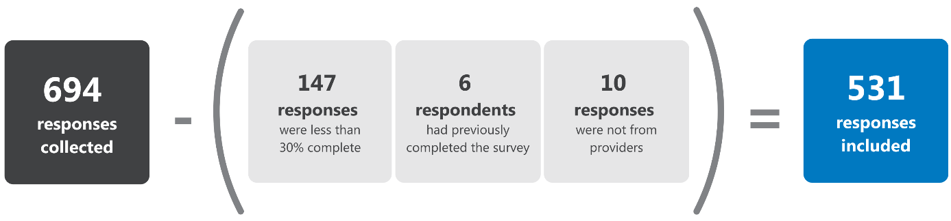

### About you and your aged care home/​organisation

#### Respondent demographics

Table 4‑2 shows the respondents that were included in analysis, by role. More than half (54%) of the respondents were in a management role, with those in a nursing (23%) or allied health or lifestyle role (11%) accounting for most of the remainder.

All respondents were asked to identify their organisation type, with the majority (60%) indicating they worked in a not-for-profit organisation (Table 4‑3), and the majority (67%) of respondents were from organisations that had multiple sites (Table 4‑4). Relative to all aged care homes in Australia, this represents a comparable proportion of not-for-profit organisations (60% compared to 55%), although representation of for-profit organisations was lower than would be expected based on national statistics (23% compared to 41%) and government organisations higher (13% compared to 4%).[2]

There was also a small number of respondents, with varied roles, who were unsure of the ownership (4%) and structure (3%) of their organisation.

Table 4‑2: Proportion of provider survey respondents by role

|  |  |  |
| --- | --- | --- |
| Respondent role | n | % |
| Management total | 288 | 54% |
| Head office manager/​CEO | 67 | 13% |
| On-site manager | 90 | 17% |
| Staff manager/​Nurse unit manager | 75 | 14% |
| Quality and Clinical Governance | 30 | 6% |
| Management – other* | 26 | 4% |
| Nursing total | 120 | 23% |
| Nurse practitioner/​Advanced practice nurse | 9 | 2% |
| Clinical nurse consultant | 2 | <1% |
| Nurse educator/‌advisor | 8 | 2% |
| Enrolled nurse | 23 | 4% |
| Registered nurse | 78 | 15% |
| Allied health/‌Lifestyle worker total | 58 | 11% |
| Allied health worker | 43 | 8% |
| Lifestyle staff | 15 | 3% |
| Personal care worker total | 43 | 8% |
| Other total | 22 | 4% |
| Advocate | 1 | <1% |
| Assessor | 1 | <1% |
| Consultant – unspecified | 3 | <1% |
| Trainer | 3 | <1% |
| Pharmacist | 3 | <1% |
| Professional peak body | 2 | <1% |
| Previously worked in an aged care home | 6 | 1% |
| Other | 3 | <1% |
| Grand total | 531 | 100% |

Note: % are rounded to nearest whole number for total to equal 100%

Table 4‑3: Organisation ownership, by role category

|  |  |  |  |  |  |
| --- | --- | --- | --- | --- | --- |
| Respondent broad role | Not-for-profit | For-profit | Gov | Unsure | Total |
| Management | 180  (63%) | 71  (25%) | 36  (13%) | 1 (5%) | 288 (100%) |
| Nursing | 76  (63%) | 19  (16%) | 18  (15%) | 7  (32%) | 120 (100%) |
| Personal care worker | 21  (49%) | 15  (35%) | 2  (5%) | 5  (23%) | 43  (100%) |
| Allied health/‌Lifestyle worker | 31  (53%) | 13  (22%) | 10  (17%) | 4  (18%) | 58  (100%) |
| Other | 11  (50%) | 3  (14%) | 3  (14%) | 5  (23%) | 22  (100%) |
| Total | 319  (60%) | 121  (23%) | 69  (13%) | 22  (4%) | 531 (100%) |

Table 4‑4: Organisation structure, by role category

|  |  |  |  |  |
| --- | --- | --- | --- | --- |
| Respondent broad role | Multi-site organisation | Standalone home | Unsure | Total |
| Management | 189 (66%) | 97 (34%) | 2 (1%) | 288 (100%) |
| Nursing | 82 (68%) | 33 (38%) | 5 (4%) | 120 (100%) |
| Personal care worker | 30 (70%) | 11 (36%) | 2 (5%) | 43  (100%) |
| Allied health/‌Lifestyle worker | 44 (76%) | 12 (21%) | 2 (3%) | 58  (100%) |
| Other | 13 (59%) | 2 (9%) | 7 (32%) | 22  (100%) |
| Total | 358 (67%) | 155 (29%) | 18 (3%) | 531 (100%) |

Respondents were asked to identify the number of beds in their aged care home. There were relatively few respondents from organisations with less than 20 beds, but otherwise the spread of respondents was balanced across the different categories of organisation size (Table 4‑5).

Table 4‑5: Organisation size, defined as number of beds

|  |  |  |  |  |  |  |
| --- | --- | --- | --- | --- | --- | --- |
|  | 1-20 beds | 21-60 beds | 61-100 beds | 101+ beds | Unsure | Total |
| Respondents (all roles) | 20 (6%) | 97 (27%) | 103 (29%) | 128 (36%) | 8 (2%) | 356 (100%) |

Excluded from the analysis:

* Respondents who opted not to answer this question (n=5)

#### Respondent awareness of Restraints Principles

The majority (96%) of survey respondents indicated they were aware of the Restraints Principles prior to undertaking the survey. A small proportion (3%) of respondents had no awareness of the Restraints Principles and very few respondents (1%) were unsure (Table 4‑6).

The respondents who indicated they were aware of the Restraints Principles or were unsure if they were aware, were then asked about specific aspects of the legislation.

Between 78 and 98 per cent of provider staff indicated awareness of the legislation. The aspect with the lowest level of respondent awareness was ‘Medications prescribed to treat a diagnosed mental health condition are not considered chemical restraint’. Respondents who identified as personal care workers or allied health/lifestyle workers were least likely to be aware of this detail (Table 4‑8).

In addition to indicating whether or not they were aware of each aspect of the Restraints Principles, respondents were asked to identify their level of agreement with statements regarding their understanding of the definition of restraint. Overall, most respondents agreed that they have good understanding of what physical (91%; Table 4‑9) and chemical (90%; Table 4‑10) restraint means, and the majority (95%) indicated an equal level of agreement for both types of restraint.

Table 4‑6: Provider awareness of the Restraints Principles

|  |  |  |  |  |
| --- | --- | --- | --- | --- |
| Respondent broad role | Yes | No | Unsure | Total |
| Management | 285 (99%) | 2 (1%) | 1 (<1%) | 288 (100%) |
| Nursing | 116 (97%) | 2 (2%) | 2 (2%) | 120 (100%) |
| Personal care worker | 37 (86%) | 4 (9%) | 2 (5%) | 43 (100%) |
| Allied health/‌Lifestyle worker | 51 (88%) | 5 (9%) | 2 (3%) | 58 (100%) |
| Other | 22 (100%) | 0 (0%) | 0 (0%) | 22 (100%) |
| Total | 511 (96%) | 13 (3%) | 7 (1%) | 531 (100%) |

Note: % are rounded to nearest whole number for total to equal 100%

Table 4‑7: Provider awareness of specific aspects of the Restraints Principles

|  |  |  |  |  |
| --- | --- | --- | --- | --- |
| Aspect of Restraints Principles | Yes | No | Unsure | Total |
| 1. Restraint can only be used after all alternative strategies (other options) have been tried. | 492 (95%) | 20 (4%) | 6 (1%) | 518 (100%) |
| 1. Physical restraint must not be used unless a doctor, nurse practitioner, or nurse who has day-to-day knowledge of the resident has determined that restraint is required because the resident is at risk of hurting themselves or someone else. | 473 (91%) | 28 (5%) | 17 (2%) | 518 (100%) |
| 1. The resident (or their representative) must provide informed consent before physical restraint is used (except where its use is necessary in an emergency). Otherwise, the resident's representative must be told about the restraint as soon as possible after it is used. | 494 (95%) | 15 (3%) | 9 (2%) | 518 (100%) |
| 1. If physical restraint is used, it must take the least restrictive form possible and be used for as little time as possible. | 505 (97%) | 7 (2%) | 6 (1%) | 518 (100%) |
| 1. Chemical restraint must not be used unless a medical doctor or nurse practitioner has assessed the resident and determined that restraint is required, and has prescribed medication for that reason. | 500 (97%) | 8 (1%) | 10 (2%) | 518 (100%) |
| 1. Medications prescribed to treat a diagnosed mental health condition are not considered chemical restraint. | 403 (78%) | 60 (12%) | 55 (10%) | 518 (100%) |
| 1. Informed consent must be obtained (from the resident or their representative) by the prescribing doctor or nurse practitioner before chemical restraint can be prescribed. | 492 (95%) | 13 (3%) | 13 (2%) | 518 (100%) |
| 1. The resident's representative must also be told of the use of chemical restraint by the aged care home, before restraint is used, if it is practical to do so. Otherwise, the resident's representative must be told about the restraint as soon as possible after it is used. | 486 (94%) | 17 (3%) | 15 (3%) | 518 (100%) |
| 1. If chemical restraint is used, the decision to use it must be recorded in the resident's care and services plan. | 508 (98%) | 4 (1%) | 6 (1%) | 518 (100%) |
| 1. If restraint is used, staff at the home must regularly monitor the resident and record information in the resident's care and services plan. | 508 (98%) | 7 (1%) | 3 (1%) | 518 (100%) |

Note: % are rounded to nearest whole number for total to equal 100%

Excluded from the analysis:

* Respondents who had no awareness of the Restraints Principles – n=13

Table 4‑8: Responses to ‘Medications prescribed to treat a diagnosed mental health condition are not considered chemical restraint’, by respondent role

|  |  |  |  |  |
| --- | --- | --- | --- | --- |
| Respondent role | Yes | No | Unsure | Total |
| Management | 250 (87%) | 24 (8%) | 12 (4%) | 286 (100%) |
| Nursing | 89 (75%) | 17 (14%) | 12 (10%) | 118 (100%) |
| Personal care worker | 19 (49%) | 6 (15% | 14 (36%) | 39 (100%) |
| Allied health/‌Lifestyle worker | 27 (51%) | 11 (21%) | 15 (28%) | 53 (100%) |
| Other | 18 (82%) | 2 (9%) | 2 (9%) | 22 (100%) |
| Total | 403 (78%) | 60 (12%) | 55 (10%) | 518 (100%) |

Note: % are rounded to nearest whole number for total to equal 100%

Table 4‑9: Level of agreement to the statement: I have a good understanding of what physical restraint means

|  |  |  |  |  |  |  |
| --- | --- | --- | --- | --- | --- | --- |
| Respondent role | Strongly disagree | Disagree | Neither agree nor disagree | Agree | Strongly agree | Total |
| Management | 12  (4%) | 0  (0%) | 6  (2%) | 116 (40%) | 154 (53%) | 288 (100%) |
| Nursing | 10  (8%) | 1  (1%) | 3  (3%) | 51 (43%) | 55  (46%) | 120 (100%) |
| Personal care worker | 2  (5%) | 2  (5%) | 6  (14%) | 22 (51%) | 11  (26%) | 43 (100%) |
| Allied health/‌Lifestyle worker | 0  (0%) | 0  (0%) | 2  (3%) | 32 (55%) | 24  (41%) | 58 (100%) |
| Other | 1  (5%) | 0  (0%) | 0  (0%) | 8 (36%) | 13  (59%) | 22 (100%) |
| Total | 25 (5%) | 3 (1%) | 17 (3%) | 229 (43%) | 257 (48%) | 531 (100%) |

Table 4‑10: Level of agreement to the statement: I have a good understanding of what chemical restraint means

|  |  |  |  |  |  |  |
| --- | --- | --- | --- | --- | --- | --- |
| Respondent role | Strongly disagree | Disagree | Neither agree nor disagree | Agree | Strongly agree | Total |
| Management | 12 (4%) | 0 (0%) | 7 (2%) | 130 (45%) | 139 (48%) | 288 (100%) |
| Nursing | 11  (9%) | 0  (0%) | 5 (4%) | 53 (44%) | 51 (43%) | 120 (100%) |
| Personal care worker | 2 (5%) | 3 (7%) | 8 (19%) | 21 (49%) | 9 (21%) | 43 (100%) |
| Allied health/‌Lifestyle worker | 0 (0%) | 0 (0%) | 5 (9%) | 30 (52%) | 23 (40%) | 58 (100%) |
| Other | 1 (5%) | 0 (0%) | 0 (0%) | 8 (36%) | 13 (59%) | 22 (100%) |
| Total | 26 (5%) | 3 (<1%) | 25 (5%) | 242 (46%) | 235 (44%) | 531 (100%) |

### Practice changes following the introduction of the Restraints Principles

#### Challenges

Respondents who identified as either head office manager or CEO, on-site manger, or staff manager or nurse unit manager were asked to identify challenges their organisation had experienced in putting the Restraints Principles into practice (n=227).

Respondents were able to select multiple challenges and/or outline challenges that were not identified in the survey (recorded as ‘other’). The challenges selected by the respondents are shown in Table 4‑11; the top 3 were:

1. Developing staff skills in using alternative strategies in place of restraint
2. Building staff understanding of the necessary practice changes
3. Raising staff awareness of the Restraints Principles.

Looking at the breakdown of challenges identified by organisational ownership, all types of organisations were aligned regarding the top 2 challenges. The third most commonly identified challenge for respondents from not-for-profit or for-profit organisations was ‘Raising staff awareness of the Restraints Principles’. However, for respondents from government organisations, ‘Following the consent requirements’ was the third most commonly selected challenge.

Almost a quarter of respondents identified no or minimal challenges in putting the Restraints Principles into practice. Of these 53 respondents, half (49%) identified as a Staff manager or nurse unit manager, with no clear difference between not-for-profit, for-profit and government organisations.

Respondents were invited to provide comments relating to each of the selected challenges. Key themes are summarised below for each challenge, except for the ‘other’ category, which echoed themes highlighted in other areas of the survey.

Table 4‑11: Provider-reported challenges to putting the Restraints Principles into practice

|  |  |  |
| --- | --- | --- |
| Challenges | n | %* |
| **Developing staff skills in using alternative strategies in place of restraint** | 105 | 46% |
| **Building staff understanding of the necessary practice changes** | 85 | 37% |
| **Raising staff awareness of the Restraints Principles** | 77 | 34% |
| **Interpreting the Restraints Principles** | 68 | 30% |
| **Following the consent requirement** | 56 | 25% |
| **Developing the policies and processes to put the Restraints Principles into practice** | 46 | 20% |
| **Unsure** | 5 | 2% |
| **No or minimal challenges** | 53 | 23% |
| **Other (please specify)** | 45 | 20% |

* Multiple options could be selected. Proportions are calculated using the total number of respondents who answered the question (n=227)

Excluded from the analysis:

* Respondents who submitted their survey before answering this question (completion rate <100%) – n=3
* Respondents who were not shown this question due to previous question response – n=2

Developing staff skills in using alternative strategies in place of restraint

Developing staff skills in using alternative strategies was the most common challenge selected by managers.

Comments highlighted that understanding of alternative strategies could be improved, including what is meant by the term ‘alternative strategies’, implementation of alternative strategies, and what to do when a strategy does not work.

Comments about lack of understanding related mostly to personal care workers (who do not get any training in alternative strategies through the Certificate III) but also to the variable skills of RNs.

Poor understanding by both RN and care level staff of behaviour management strategies, of understanding what a behaviour is, of understanding the types of interventions required to manage behaviours. Clinical RN skills are not as good as RNs trained in psychiatric medicine.

– Head office manager or CEO,   
not-for-profit organisation with   
multiple homes, number of beds unknown

One comment in response to this question suggests that management understand alternative strategies to mean offering alternative types of restraint.

Most of our physical restraint, e.g. bed rails and lap belts are requested by the family. We have offered the options of LoLo bed and crash mats, chair sensor mat but family still prefers bed rails and lap belts.

– On-site manager,   
not-for-profit organisation with   
multiple homes, 41‑60 beds

The 3 main issues raised as challenges to developing skills in alternative strategies included on the job training, staffing levels and staff attitudes.

Training

Many comments referred to challenges putting training in place in a time-poor environment with high staff turnover, a ‘fragmented workforce’, staff that have minimal formal training, and staff from different cultural subgroups. Feedback suggests that training needs to be frequent, fit within workers’ busy schedules, tailored to different types of staff, and provided in appropriate languages.

Some staff commented that both lack of education and lack of time contribute to less focus on alternative strategies, perhaps contributing to PRN (*pro ne rata* – as required) administration of medication.

Nurses are too quick to just give a PRN risperidone before attempting other strategies. I feel this comes down to regular staff education but also nurses don't necessarily have the time to spend on attempting other strategies first. Shifts are busy and nurses are regularly staying back in unpaid time to finish their work.

– Staff manager or nurse unit manager,   
for‑profit organisation with   
multiple homes, 101+ beds

Staffing levels

Many respondents said staff are overwhelmed with their usual workload and staffing levels are often inadequate to support alternative strategies.

Staff knowledge and willingness to practice these alternative strategies in place of restraint are directly affected by the resources of time which correlates with staffing levels.

– Head office manager or CEO,   
not-for-profit standalone organisation, number of beds unknown

Staff also said that planned rosters do not allow for staffing to be increased to provide 1:1 supervision for unpredictable changes in behaviour, especially on shifts with lower staffing levels. Access to clinical expertise to either help identify alternative strategies or for support was also a challenge.

Staff attitudes

A key challenge faced by managers is changing attitudes from being task oriented and choosing the ‘easiest’ option to a more person-centred approach. Culture and attitudes were recognised as being slow to change.

One respondent commented that care workers may not believe it is their role to think of alternative strategies (and instead refer to the lifestyle team) and it is a challenge to help staff understand that it is the role of all care, nursing and allied health staff.Overall, the responses indicate that alternative strategies are tried as a reaction to challenging behaviours, rather than a pro-active approach to avoid these behaviours. Many commented about the difficulty in de-escalating aggressive behaviour, which can lead to the use of chemical restraint.

When behaviour is escalating, ensuring all non-pharmacological interventions are trialled first is challenging as staff want the behaviour to de-escalate quickly, so tend to want to reach for medication.

– Head office manager or CEO,   
not-for-profit organisation with   
multiple homes, number of beds unknown

Raising staff awareness of the Restraints Principles and necessary practice changes

Raising staff awareness of the Restraints Principles and staff understanding of the practice changes had overlapping responses so are combined in the summary below.

While the importance of education and training was noted, the challenging logistics and practicalities of providing training for all staff – as well as cost – were frequently mentioned.

It’s very difficult to find time or funding to provide training for all the overwhelming changes in legislation, principles, standards, mandatory training etc and still find time to do the actual job of caring for residents.

– On-site manager, not-for-profit   
standalone home, 21-40 beds

Gathering all staff in order to train them or communicate changes in policy or practice in a timely manner was a key challenge, as was providing effective education to a diverse workforce – for example one that has a high proportion of individuals from culturally and linguistically diverse (CALD) backgrounds.

Most of our workforce is from a CALD background and do not fully grasp the intended principles even with education strategies in place. While staff may be able to speak English, their comprehension of complex concepts in English is very limited. It has taken months to educate on this matter and still it is difficult for staff to articulate the principles of restraint minimisation.

– Head office manager or CEO,   
not-for-profit standalone home

Providers also highlighted a lack of understanding amongst some staff of particular requirements outlined in the Restraints Principles, including the need for clear documentation of restraint use, the reasons for use, and alternatives tried.

They [staff] don't understand the whole concept so they don't get the process of trialling alternatives and documenting this before they administer medication. Again, they think task and not the holistic person and the management of that.

– Head office manager or CEO,   
not-for-profit organisation with   
multiple homes, number of beds unknown

Even with training, some respondents highlighted that staff attitudes can be difficult to influence, particularly when staff have been working in aged care for a long time. Staff may be used to being ‘task-orientated’,[3] or hold views that physical restraints (e.g. bed rails) keep residents safe or that chemical restraints, such as psychotropic medications for behavioural and psychological symptoms of dementia (BPSD), benefit patients.

The challenges are mainly due to staff who have worked in residential aged care for a long time having to re-program their thinking in line with the intent of the Restraints Principles.

– Head office manager or CEO,   
 government organisation with multiple homes

Staff feel that other interventions take time away from what they would normally do. They cannot see that, for example, spending time assisting a resident with a suitable activity will reduce wandering and ultimately prevent episodes of aggression and falling.

– Staff manager or nurse unit manager, for‑profit standalone home, 101+ beds

Interpreting the Restraints Principles

The vast majority of comments relating to interpretation of the Restraints Principles referred to a lack of clarity regarding the legislation. This led to confusion, ambiguity or ‘grey areas’ and differences in interpretation among staff, across the sector and between providers and assessors.

The principles seem to be vague and open to individual interpretation.

– Staff manager or nurse unit manager, for-profit standalone home, 21-40 beds

Although the legislation provides guidance … it doesn't cover the details and all aspects of restraint principles, leaving grey areas.

– Head office manager or CEO, for-profit organisation with multiple homes

In particular, ambiguity and/or confusion was noted around:

* The definition of physical restraint, particularly with respect to practices intended to increase resident safety or requested by residents and/or their families. For example, staff were unsure:
  + Whether a bed against a wall or locked doors (e.g. in a secure dementia unit) are restraint, and whether this is different for a resident who is immobile
  + How the legislation applies when there is no intent to restrain (e.g. the use of equipment such as lolo beds, water chairs etc.) that by nature reduce mobility but are not intended to restrict movement
  + When bed rails or half rails are restraint and when (if ever) they are not.

[There are] lots of different scenarios that are unclear in the legislation. For example, use of pillows for back support that also prevent rolling out of bed.

– Staff manager or nurse unit manager, government organisation with multiple homes, 21-40 beds

Which medications constitute chemical restraint:

* + Some medications were felt not to be reasonable examples of chemical restraint – staff commented that ‘the list of medications deemed chemical restraint has now pushed out to cover anti-emetics, which may only be used for nausea’ and that ‘the Commission is also inconsistent in defining psychotropic medications’
  + Staff felt that the Commission’s self-assessment tool to record all psychotropic medications has been difficult to understand and implement, and does not help to identify chemical restraint
  + There was uncertainty as to whether a medication can be defined as ‘restraint’ if a resident has been taking it for most of their lives

Which diagnoses are acceptable to justify the use of psychotropic medications:

* + Staff want more information about the diagnoses in which medications are/are not considered restraint
  + There was uncertainty whether psychotropic medications for symptoms of BPSD is restraint
  + Providers felt they do not have sufficient information about individual residents’ diagnoses to understand whether their medication is likely to constitute chemical restraint.

[There are] ongoing issues with identifying the use of chemical restraints for symptom management as opposed to treating a disease.

– On-site manager,  
not-for-profit organisation with multiple homes, 41-60 beds

There is no clarity from the Commission or other sources regarding BPSD – is it a valid indicator for use of psychotropic [medications] (e.g. risperidone) PRN? It is indicated for risperidone but this contradicts the restraint guidelines (using a medication to alter behaviour).

– Head office manager or CEO, for-profit organisation with multiple homes

Some of these challenges appear to have been particularly evident in the early days after the introduction of the Restraints Principles, with some improvement noted over time.

Initially there seemed some grey areas plus organisational directives conflicting with the Principles.

– On-site manager, not-for-profit organisation with multiple homes, 1‑20 beds

Chemical and physical restraint was unclear at beginning, has morphed over time, and seems more understandable now.

– Head office manager or CEO, not-for-profit organisation with multiple homes

Managers also reported other issues regarding medications and chemical restraint. These included the challenges of appropriately managing a resident entering the home on prescribed medications now considered restraint in the residential aged care setting. It was noted here and elsewhere throughout provider survey responses that providers perceived that the Restraints Principles appeared to place the onus of minimising chemical restraint on providers, when prescription of medication is the responsibility of the prescriber.

Following the consent requirement

Most comments provided in relation to this challenge related to difficulties engaging with residents’ families and representatives, or prescribers.

Respondents noted that, when engaging with families to obtain consent for restraint, issues included:

* Families having little understanding of the Restraints Principles/consent requirements, or of the need for restraint under some circumstances, or of the need to reduce/remove a medication deemed chemical restraint
* Families being unavailable to provide consent, and the time-consuming task of following them up
* Families having little interest in/forgetting which medications a resident is taking, and reporting being unaware even when the relevant conversation is documented
* Families requesting restraint (e.g. bed rails to avoid falls) or not wanting to allow restraint under any circumstances (e.g. even as a last resort, when alternative strategies have failed)
* Families not wanting to be contacted every time a chemical restraint is given, complaining about documentation requirements
* Families being distrustful of provider staff (e.g. based on negative media reports regarding restraint).

A number of respondents noted that GPs were not always cooperative in seeking, confirming and documenting consent, or in liaising with families where appropriate to gain consent. It is noted that inadequate communication between visiting GPs and aged care homes is an issue that existed prior to the introduction of the Restraints Principles.

The GPs do not contact the family or [enduring power of attorney] when commencing a chemical restraint, it is then left to the home to try and explain why a chemical restraint is required.

– Head office manager or CEO, for-profit organisation with multiple homes

Visiting medical officers prescribing chemical restraint were not informed and understanding of the new laws.

– On-site manager, not-for-profit home,   
standalone, 21-40 beds

[Obtaining consent] is overly onerous and difficult to maintain. Families don’t understand, GPs don’t understand, staff don’t understand.

– On-site manager,   
not-for-profit organisation with   
multiple homes, 101+ beds

Developing policies and processes to put the Restraints Principles into practice

Respondents who selected this category noted that policy development was time-consuming, and perceived that ambiguity in the Restraints Principles (as described above, relating to definitions and interpretations) compounded this.

I am always time poor. There is never enough time to participate in developing policies.

– Staff manager or nurse unit manager,   
not-for-profit organisation with   
multiple homes, 81-100 beds

Some respondents reported engaging external consultants to update policies, processes and tools to support the requirements of the Restraints Principles and noted the associated costs.

To meet best practice guidelines, we have had to invest in new tools to assist us with the compliance requirements of this, and also many other challenging changes. This has driven our compliance costs up significantly, with little to no noticeable improvement for residents as we are already ‘living’ by these new requirements.

– On-site manager, not-for-profit   
standalone home, 41-60 beds

Explaining new policies and procedures to staff and families was also noted to be difficult in some instances.

Recent review and modification of polices required additional training for staff to fully understand.

– Staff manager or nurse unit manager,   
not-for-profit organisation with   
multiple homes, 81-100 beds

Writing the policies and procedure was no problem. However, the constant documentation and recording of bed rails up/down as a restraint (part of the new process) was met with horror by staff.

– On-site manager, not-for-profit   
standalone home, 101+ beds

In regard to environmental restraint it can be challenging to ensure that residents and families understand the balance of allowing some risk while still ensuring safety. Putting that into simple language while still following legislative requirements can be difficult.

– Head office manager/CEO, for-profit organisation with multiple homes

#### Changes in practice

Respondents who identified as staff manager/‌nurse unit manager, nurse practitioner/‌advanced practice nurse, registered nurse, enrolled nurse or personal care worker were asked if they had observed different aspects of the Restraints Principles being used in practice in the 7 days prior to completing the survey (Table 4‑12).

Overall, respondents reported that aspects of the Restraints Principles were being used in practice either most of the time or always (69% – 89%). However, a third (32%, n=12) of personal care workers who responded to this question observed that in the 7 days prior to completing the survey, physical restraint that was used was not used as a last resort.

As there were a low number of responses from government and for-profit organisations in comparison to not-for-profit organisations, no comparisons were made across organisation type.

More than half (57%) of respondents advised these observations were in relation to an area of the home designated to care for residents with dementia; however, this had no clear effect on responses.

Table 4‑12: Providers’ observations of restraint in the 7 days prior to completing survey

|  |  |  |  |  |  |  |  |
| --- | --- | --- | --- | --- | --- | --- | --- |
| Aspect of Restraints Principles followed | Never | Rarely | Sometimes | Most of the time | Always | Unsure | Total |
| 1. Physical restraint is used as a last resort | 31 (16%) | 15 (8%) | 10 (5%) | 22 (11%) | 115 (58%) | 5 (2%) | 198 (100%) |
| 1. Alternative strategies are tried before using physical restraint | 6 (3%) | 6 (3%) | 12 (6%) | 26 (13%) | 143 (72%) | 5 (3%) | 198 (100%) |
| 1. Residents are assessed by a medical practitioner, nurse practitioner or registered nurse before using physical restraint | 6 (3%) | 5 (2%) | 8 (4%) | 15 (8%) | 151 (76%) | 13 (7%) | 198 (100%) |
| 1. Consent is obtained before using physical restraint | 4 (2%) | 7 (4%) | 6 (3%) | 24 (12%) | 145 (73%) | 12 (6%) | 198 (100%) |
| 1. Residents that are physically restrained are regularly monitored | 3 (2%) | 2 (<1%) | 6 (3%) | 20 (10%) | 152 (77%) | 15 (8%) | 198 (100%) |
| 1. Chemical restraint is used as a last resort | 6 (3%) | 5 (2%) | 15 (8%) | 36 (18%) | 128 (65%) | 8 (4%) | 198 (100%) |
| 1. Alternative strategies are tried before using chemical restraint | 2 (<1%) | 9 (5%) | 13 (7%) | 34 (17%) | 132 (67%) | 8 (4%) | 198 (100%) |
| 1. Residents are assessed by a medical practitioner or nurse practitioner before using chemical restraint | 2 (<1%) | 6 (3%) | 7 (4%) | 13 (7%) | 161 (81%) | 9 (5%) | 198 (100%) |
| 1. Residents that are chemically restrained are regularly monitored | 2 (<1%) | 5 (2%) | 9 (5%) | 25 (13%) | 148 (75%) | 9 (5%) | 198 (100%) |
| 1. Residents (where possible), families and carers are involved in decision making about the use of physical and chemical restraint | 2 (<1%) | 4 (2%) | 11 (6%) | 22 (11%) | 146 (74%) | 13 (7%) | 198 (100%) |
| 1. Information around the use of physical and chemical restraint is documented, including the behaviours that lead to the decision to restrain | 3 (1%) | 1 (<1%) | 8 (4%) | 27 (14%) | 150 (76%) | 9 (5%) | 198 (100%) |

Note: % are rounded to nearest whole number for total to equal 100%

Excluded from the analysis:

* Respondents who submitted their survey before answering this question (completion rate <100%) – n=26
* Respondents who opted not to answer this question – n=4

### Effectiveness of the Restraints Principles in minimising restraint use

#### Chemical restraint

Two-thirds (64%) of respondents believed there has been a reduction in the use of chemical restraint since the introduction of the Restraints Principles (Table 4‑13). The pattern of responses was similar for those across types of organisation.

The respondents who answered that there has been no reduction in the use of chemical restraint since the introduction of the Restraints Principles were asked why they believed this was the case*,* and were able to select multiple reasons for their answer.

As shown in Table 4‑14, the top 3 reasons were:

* Their organisation had already minimised the use of chemical restraint prior to the Restraints Principles being introduced.
* Other reasons not specified in the survey
* Resistance to change by either management or direct-care staff

Table 4‑13: Provider perspectives of whether there been a reduction in the use of chemical restraint since the introduction of the Restraints Principles

|  |  |  |  |  |
| --- | --- | --- | --- | --- |
| Respondent broad role | Yes | No | Unsure | Total |
| Management | 182 (71%) | 48 (19%) | 25 (10%) | 255 (100%) |
| Nursing | 71 (66%) | 15 (14%) | 22 (20%) | 108 (100%) |
| Personal care worker | 17 (46%) | 4 (11%) | 16 (43%) | 37 (100%) |
| Allied health/ Lifestyle worker | 31 (53%) | 7 (12%) | 20 (34%) | 58 (100%) |
| Other | 8 (36%) | 2 (9%) | 12 (55%) | 22 (100%) |
| Total | 309 (64%) | 76 (16%) | 95 (20%) | 480 (100%) |

Excluded from the analysis: Respondents who submitted their survey before answering this question (completion rate <100%) – n=51

Table 4‑14: Reasons there has been no reduction in the use of chemical restraint since the introduction of the Restraints Principles

|  |  |  |
| --- | --- | --- |
| Reason | n | %1 |
| **The organisation minimised the use of chemical restraint  prior to 1 July 2019** | 33 | 43% |
| **Other** | 31 | 41% |
| **Direct-care staff resistance to change** | 13 | 17% |
| **Management resistance to change** | 9 | 12% |
| **The organisation is early in the process of making changes  to minimise chemical restraint** | 8 | 11% |
| **Unsure** | 1 | 1% |

1 Multiple options could be selected. Proportions are calculated using the total number of respondents who answered the question (n=76)

Within the ‘other’ category of responses, providers most commonly indicated that chemical restraint has not reduced since the introduction of the Restraints Principles for reasons related to prescribers. In particular, it was noted that, whether appropriate or not, GPs and others (e.g. gerontologists, hospital-based clinicians) continue to prescribe medications that could be considered restraints, and this is out of the hands of staff working at residential aged care homes.

GPs still prescribe, families still request. Hasn't changed resident outcomes but created huge workload for aged care staff, who complete paperwork for GPs, to remain compliant.

– Quality and clinical governance representative, not-for-profit organisation with multiple homes

GPs over-prescribe psychotropic medication, as does the acute hospital sector. Aged care homes are left with the workload as a result – consent, chasing indications for use, dealing with the associated side effects and watching poor outcomes occur for our residents at times.

– Head office manager, not-for-profit organisation with multiple homes

Similarly, as noted above, providers indicated that many residents enter a home taking long-term psychotropic (or other) medications, the review and cessation of which presents a substantial barrier to reducing the apparent prevalence of chemical restraint.

Chemical restraint was not commonly used in our service. Most people come into care from the community on large amounts of psychotropic [medications] and addictions to prescribed medications. Aged care providers then have to deal with dependent residents and family.

– On-site manager, for-profit organisation with multiple homes, 81-100 beds

Others highlighted the issue of staffing levels/ratios to support the adoption of alternative strategies at their service.

Alternative strategies do NOT work when we are poorly staffed in aged care. How can we provide alternatives when the ratio is so POOR in aged care? When unable to manage residents’ behaviours, chemical restraint works perfectly – creating no harm to anyone.

– Staff manager or nurse unit manager, government organisation with multiple homes, 61-80 beds

In addition, reducing restraints in residential aged care was noted to be difficult because of increasing numbers of residents with high care needs and extreme/challenging behaviours associated with dementia.

Where medications were prescribed to alleviate the resident's experience of dementia, this is now classified as a restraint – hence the increase in numbers.

– On-site manager, not-for-profit organisation with multiple homes, 101+ beds

#### Physical restraint

Two-thirds (63%) of respondents believed there has been a reduction in the use of physical restraint since the introduction of the Restraints Principles (Table 4‑15). As with chemical restraint, the proportion of respondents who believed physical restraint has reduced was similar for those from government organisations (37/61=61%) and those from not-for-profit or for-profit organisations (257/400=64%).

The respondents who answered that there has been no reduction in the use of physical restraint since the introduction of the Restraints Principles were ask why they believed this was the case, with multiple responses permitted (Table 4‑16).

The top 3 reasons were:

Their organisation had already minimised the use of physical restraint prior to the Restraints Principles being introduced

Other reasons not specified in the survey

* Resistance to change by either management or direct-care staff

Table 4‑15: Provider perspectives on whether there has there been a reduction in the use of physical restraint since the introduction of the Restraints Principles

|  |  |  |  |  |
| --- | --- | --- | --- | --- |
| Respondent role | Yes | No | Unsure | Total |
| Management | 172 (67%) | 64 (25%) | 19 (7%) | 255 (100%) |
| Nursing | 71 (66%) | 14 (13%) | 23 (21%) | 108 (100%) |
| Personal Care Worker | 16 (43%) | 9 (24%) | 12 (32%) | 37 (100%) |
| Allied Health/‌Lifestyle Worker | 35 (60%) | 6 (10%) | 17 (29%) | 58 (100%) |
| Other | 8 (36%) | 2 (9%) | 12 (55%) | 22 (100%) |
| Total | 302 (63%) | 95 (20%) | 83 (17%) | 480 (100%) |

Excluded from the analysis: Respondents who submitted their survey before answering this question (completion rate <100%) – n=51

Table 4‑16: Reasons there has been no reduction in the use of physical restraint since the introduction of the Restraints Principles

|  |  |  |
| --- | --- | --- |
| Reason | n | %1 |
| The organisation minimised the use of physical restraint prior to 1 July 2019 | 56 | 59% |
| Other | 31 | 33% |
| Management resistance to change | 12 | 13% |
| Direct-care staff resistance to change | 10 | 11% |
| The organisation is early in the process of making changes to minimise chemical restraint | 8 | 8% |
| Unsure | 2 | 2% |

1 Multiple options could be selected. Proportions are calculated using the total number of respondents who answered the question (n=95)

‘Other’ reasons cited for the perceived lack of reduction in the use of physical restraint since the introduction of the Restraints Principles, included issues also noted in response to other survey questions, such as:

* Grey areas around the definition of physical restraint: ‘It's still too easy to bypass the law.’
* An ongoing need for restraint: ‘That’s what the dementia unit is; a physical restraint.’
* Residents and families wanting and requesting restraints (e.g. bed rails): ‘Families and residents have been adamant about wanting restraint, despite education and knowledge.’
* A significant proportion of high care consumers: ‘We have found that because of our cohort and the definition updates our use is stable: well considered and documented but stable. Over 80% of our residents across the organisation have a diagnosis of dementia so environmental restraint such as key pad secure units and locked gates keep this number stubbornly high.’
* A lack of staffing and a lack of support: ‘Care staff want the quickest and easiest solution. They cannot spend additional time looking after a patient with aggression or who is wandering. The hospitals do not want these people either. There is lack of access to dementia support and mental health services in this area.’

#### Changes to organisational policies and processes

Managers and registered nurses were asked whether their organisation has policies and processes to prevent or minimise the need for restraint (Table 4‑17). Almost all (93%) responded that this was the case; of these, two-thirds (67%) believe these policies and processes were put in place (or revised) as a direct result of the introduction of the Restraints Principles.

Managers and RNs were also asked whether their organisation has internal policies and processes to manage chemical (Table 4‑18) and physical restraint (Table 4‑19), which meet all required steps outlined in the Restraints Principles. Almost all the respondents advised that their organisation does have such policies and processes (94% for both chemical and physical restraint). Of these respondents, close to three-quarters believed that the internal policies and processes to manage the use of chemical (71%) and physical (76%) restraint had been developed in response to the introduction of the Restraints Principles.

Table 4‑17: Do providers have policies and processes to prevent or minimise the need for restraint?

|  |  |  |  |  |
| --- | --- | --- | --- | --- |
| Respondent role | Yes | No | Unsure | Total |
| Head office manager/​CEO | 55 (93%) | 2 (3%) | 2 (3%) | 59 (100%) |
| On-site manager | 74 (93%) | 4 (5%) | 2 (3%) | 80 (100%) |
| Staff manager/​Nurse unit manager | 60 (98%) | 1 (2%) | 0 (0%) | 61 (100%) |
| Nurse practitioner/​Advanced practice nurse | 5 (83%) | 1 (17%) | 0 (0%) | 6 (100%) |
| Registered nurse | 61 (91%) | 3 (4%) | 3 (4%) | 67 (100%) |
| Total | 255  (93%) | 1 (14%) | 7 (3%) | 273 (100%) |

Excluded from the analysis:

* Respondents who submitted their survey before answering this question (completion rate <100%) – n=43
* Respondents who chose not to answer this question – n=3

Table 4‑18: Do providers have internal policies and processes to manage the use of chemical restraint which meet all required steps outlined in the Restraints Principles?

|  |  |  |  |  |
| --- | --- | --- | --- | --- |
| Respondent role | Yes | No | Unsure | Total |
| Head office manager/​CEO | 48 (94%) | 2 (4%) | 1 (2%) | 51 (100%) |
| On-site manager | 60 (95%) | 0 (0%) | 3 (5%) | 63 (100%) |
| Staff manager/​Nurse unit manager | 45 (96%) | 2 (4%) | 0 (0%) | 47 (100%) |
| Nurse practitioner/​Advanced practice nurse | 3 60%) | 1 (20%) | 1 (20%) | 5 (100%) |
| Registered nurse | 45 (96%) | 1 (2%) | 1 (2%) | 47 (100%) |
| Total | 201 (94%) | 6 (3%) | 6 (3%) | 213 (100%) |

Excluded from the analysis:

* Respondents who submitted their survey before answering this question (completion rate <100%) – n=43
* Respondents who chose not to answer this question – n=63

Table 4‑19: Do providers have internal policies and processes to manage the use of physical restrain which meet all required steps outlined in the Restraints Principles?

|  |  |  |  |  |
| --- | --- | --- | --- | --- |
| Respondent role | Yes | No | Unsure | Total |
| Head office manager/​CEO | 47 (92%) | 2 (4%) | 2 (4%) | 51 (100%) |
| On-site manager | 60 (9%) | 1 (2%) | 2 (3%) | 63 (100%) |
| Staff manager/​Nurse unit manager | 46 (98%) | 1 (2%) | 0 (0%) | 47 (100%) |
| Nurse practitioner/​Advanced practice nurse | 3 (60%) | 1 (2%) | 1 (20%) | 5 (100%) |
| Registered nurse | 45 (96%) | 1 (20%) | 1 (2%) | 47 (100%) |
| Total | 201 (94%) | 6 (3%) | 6 (3%) | 213 (100%) |

Excluded from the analysis:

* Respondents who submitted their survey before answering this question (completion rate <100%) – n=43
* Respondents who chose not to answer this question – n=63

### Unintended impacts of the Restraints Principles

Overall, provider staff were more likely to consider that the Restraints Principles have had unintended consequences than not (Table 4‑20).

The 193 respondents who believed that there have been unintended impacts were asked to provide more information about the key impacts they had identified.

Analysis of their responses identified 5 key areas in which the Restraints Principles have had unexpected effects, described in the sections that follow:

* Resident care
* Staffing
* Family engagement
* Interaction with prescribers and pharmacists
* Aged care home operations.

Table 4‑20: Provider staff identifying unintended impacts of the Restraints Principles

|  |  |  |  |  |
| --- | --- | --- | --- | --- |
| Respondent broad role | Yes | No | Unsure | Total |
| Management | 109 (43%) | 105 (42%) | 37 (15%) | 251 (100%) |
| Nursing | 41 (39%) | 36 (34%) | 29 (27%) | 106 (100%) |
| Personal care worker | 14 (39%) | 2 (6%) | 20 (56%) | 36 (100%) |
| Allied health/Lifestyle worker | 22 (39%) | 7 (12%) | 28 (49%) | 57 (100%) |
| Other | 7 (32%) | 1 (5%) | 14 (64%) | 22 (100%) |
| Total | 193 (41%) | 151 (32%) | 128 (27%) | 472 (100%) |

Excluded from the analysis:

* Respondents who submitted their survey before answering this question (completion rate <100%) – n=59

#### Resident care

Many respondents were concerned that the manner in which the Restraints Principles were implemented in their service presented safety issues – for the resident with behavioural and psychological symptoms of dementia (BPSD), for other residents, and for staff. They cited, for example, increased aggression and inappropriate behaviours from residents with BPSD who had previously been restrained, as well as injuries from falls and other incidents.

The number of falls has increased, especially from bed.

– Registered nurse,  
not-for-profit standalone home, 61-80 beds

A significant number of provider staff also explained that for many residents with BPSD, medications now considered chemical restraint had contributed positively to their quality of life. Withdrawing these medications was not always seen to be in the best interests of the resident, or those around them. Some respondents also felt that medications may be inappropriately withheld. Further, when these medications were reduced, it does not appear to have been well managed as indicated in the quote below.

Reduction in these medications, in order to meet the criteria that has been put into place due to the Royal Commission [into aged care quality and safety], has meant that people with severe BPSD are no longer being well managed. This has created escalations in physical violence per these residents, put other residents at risk, and exposed staff and residents to injury. The sense of fear and hypervigilance from residents, their families/carers, and staff has become a significant concern. The one size fits all attitude is a blunt tool, and places many people at risk of harm. Many nursing homes are sending these people to hospital, and then declining to have them back at the home due to an inability to care for them safely.

– Nurse practitioner or advanced practice nurse, standalone government home,   
101+ beds

The residents receiving so-called chemical restraint, have in some instances become extremely agitated and distressed when these medications have been decreased and or ceased …we have watched people change and where before they were calm, able to enjoy activities, participate in the community, eat and drink on their own etc, their function changes and they are no longer able to participate in things that provide quality of life. This is extremely distressing.

– Nurse practitioner/Advanced practice nurse, standalone government home

Respondents also noted here and elsewhere in the survey that the need to manage more complex and challenging behaviours from some residents detracted from the care of others.

While more attention is being given to manage the residents that have issues, other residents are missing out. It is a staff resourcing issue.

*– Management representative, not-for-profit organisation with multiple homes*

The focus of care becomes on those who are no longer well managed, meaning that resources are tied up in caring for one individual at the expense of many others. Increased falls risk of other residents, decreased ability to manage basic care needs, and exposure to physical violence has made nurses feel inadequate resulting in resignations, increased sick leave, and very low morale.

*– Nurse practitioner/Advanced practice nurse, standalone government home, 101+ beds*

Reducing restraints for residents with dementia and or wandering tendencies has impacted our resources and demands staff (or multiple staff) away from direct care to managing challenging behaviours.

– *On-site manager, not-for-profit   
standalone home, 61-80 beds*

.Finally, a small number of positive impacts on resident care were noted by respondents, including the satisfaction that came with improved care of and interactions with residents with BPSD.

More creative, engaged staff led by carers who are ‘person first’ champions.

– On-site manager, for-profit organisation with multiple homes, 101+ beds

It's rewarding some of the creative ways we are approaching care now, a joy to see the carers in new ways, the residents’ joy and the families’ trust and joy in the new ways we facilitate meaningful engagement with their loved ones.

– On-site manager, for-profit organisation with multiple homes, 101+ beds

#### Staffing

Several staff highlighted the additional demands placed on aged care homes to ensure all staff are appropriately trained and have the knowledge and skills to comply with the Restraints Principles. This was perceived to have a number of impacts including those associated with making staff available for training (particularly problematic in the context of under-staffing), the cost of the training itself, and the time required to identify and engage appropriate educators.

On the other hand, a number of respondents noted the wider benefits of staff training, seeing that this not only supported implementation of the Restraints Principles but improved practice across all aspects of the aged care home’s operations.

We developed training in early 2019 that was rolled out to all staff that covered all restraint types and it was amazing how this affected their practice. Awareness was raised among all staff including kitchen, cleaners and nursing. Staff now do this training annually.

– Quality and clinical governance representative, not-for-profit organisation with multiple homes

Staff have upskilled in relation to Dementia care and BPSD a lot and this has been very advantageous.

– Head office manager or CEO, not-for-profit standalone home

Registered nurses have upskilled with dementia care and this is fabulous.

– Head office manager or CEO, not-for-profit standalone home, 41-60 beds

Access to appropriate training notwithstanding, the impact of implementing the Restraints Principles on an already overwhelmed workforce was a significant source of concern for many survey respondents. Providers reported burden and potential risks of working with residents with challenging behaviours.

Working with challenging behaviours and trying everything without success, leaving you feeling mentally, physically and emotionally drained.

– Allied health or lifestyle worker,   
not-for-profit standalone home

[It’s a] source of great stress and anxiety in the course of carrying out caring tasks: [we are] exposed to unbridled aggression; received bruises, scratches, pinches, spat at, punched, hair pulled, attempts at biting; broken lanyards; resident at safety risk during transfers due to lack of cooperation.

– Personal care worker, not-for-profit organisation with multiple homes, 81-100 beds

#### Family engagement

Providers identified that for many family members, the introduction of the Restraints Principles created significant confusion, highlighting a need to engage with residents and families around assessment and care planning. Issues and areas of confusion raised included:

* Why the care of their family member needed to change
* Why the care of other residents was changing, potentially to the detriment of the safety or comfort of their family member
* Why their choices regarding their family members’ care were no longer supported
* Why they needed to provide consent (in some cases frequently).

However, some provider staff also identified that the introduction of the Restraints Principles had prompted improved communication between families and themselves, and greater family participation and engagement in residents’ care; they felt that family members now had greater knowledge and trust in the aged care homes processes and the care provided. Further, several staff reported that the implementation of the Restraints Principles in their home had unexpectedly improved interactions between some residents and their families, following the removal of chemical restraint.

Families … become frustrated over signing consent for bedrails or medication.

– Registered nurse, not-for-profit standalone home, 61-80 beds

Some families requested in writing never to be contacted [to provide consent] for PRN usage.

– On-site manager, not-for-profit organisation with multiple homes, 101+ beds

#### Interaction with prescribers and pharmacists

Some providers reported that prescribers were unwilling to support providers to comply with the Restraints Principles, or are unwilling to change their practice in light of them. In some cases, the legislation was perceived to prompt prescribers’ exit from aged care entirely.

[There is] agitation from GPs regarding reviewing medications and signing restraint forms.

– Staff manager or nurse unit manager,   
for-profit standalone home, 61-80 beds

Medical practitioners do not understand the changing requirements – and many do not want to know (and are planning to cease aged care work as a consequence of increased requirements and scrutiny).

– Quality and clinical governance representative, not-for-profit organisation with multiple homes

[The requirements] places strain on the relationship and we see GPs more reluctant to take on Aged Care patients as a result.

– On-site manager, not-for-profit   
standalone home, 41-60 beds

A small number of providers identified that the Restraints Principles had led to greater collaboration with prescribers and pharmacists, and this was perceived to result in positive outcomes for residents. It is worth noting that where these positive interactions occurred, they were often in the context of systematic policies and procedures having been developed to support all parties fulfil their responsibilities.

We have worked closely with our visiting medical officers in developing their understanding and support for the chemical restraint laws and guidelines we need to abide by. We have established a robust monitoring and review schedule for residents on psychotropic medications which has facilitated [their engagement].

– On-site manager, not-for-profit standalone home, 21-40 beds

Pharmacists have really stepped up their support.

– Quality and Clinical Governance representative, not-for-profit organisation with multiple homes

Pharmacies have really added value by educating staff and providing data & reports that really helped identify areas for improvement.

– Head office manager or CEO, for-profit organisation with multiple homes

#### Aged care home operations

A substantial number of comments related to unintended workload and resourcing impacts associated with interpreting and complying with the Restraints Principles. It was often reported that complying with the Restraints Principles and the required documentation proved time-consuming and onerous for staff and the aged care home or organisation as a whole.

The chaotic process of the introduction and subtle changes to the principles, followed by introduction of self-assessment tools which were non-specific, followed by trial of mandatory reporting tool which was different again with no strong defined guidelines, just a series of suggestions which are being interpreted differently.

– Head office manager or CEO, for-profit organisation with multiple homes

With the changes that were implemented, the amount of documentation required has grown.

– Registered nurse, for-profit organisation with multiple homes, 101+ beds

Some provider staff indicated that as a result of the Restraints Principles, their organisation had changed its policies to prevent (or limit the number of) older people with complex needs being accepted into the home.

The home has now become very rigid in relation to what resident type is admitted as a result of poor disclosure about residents with BPSD from other aged care homes; we scrutinize things more as we don't want to admit a resident with challenging behaviour that has poor outcomes for the person and the family involved and [such scrutiny] is not fair.

– Staff manager or nurse unit manager, government organisation with multiple homes, 41-60 beds

Those with behaviours such as wandering or absconding, or frequent fallers are avoided due to the inability to use restraint.

– Allied health worker, not-for-profit organisation with multiple homes, 61-80 beds

Others simply noted that the admission process had been bolstered, for example to better identify and prepare for such residents.

A resident's current medications are more carefully reviewed prior to admission. Often, a new admission has been prescribed chemical restraint whilst at home. Chemical restraint will impact the Quality Indicator Program data & depending on timing, potentially is not ideal. We also prepare family & staff that first few weeks post-admission can be problematic whilst medications reviews and trials of changes are implemented.

– Head office manager or CEO, for-profit organisation with multiple homes

Positive consequences of the Restraints Principles in relation to the operating model of aged care homes included employment of more staff to support the delivery of quality care, and a general improvement in processes, monitoring and reporting which led to identification of other issues in residents’ care that had not been evident previously.

### Understanding the impact of COVID‑19 on use of restraint

All respondents were asked if they identified a change in the way restraint was used during the early stages of the COVID‑19 pandemic (March, April, and May 2020).

#### Chemical restraint

The majority of provider staff (70%) identified no change in the way chemical restraint was used during the COVID‑19 period (Table 4‑21). Only a small proportion (9%) identified a change (i.e. more [4%] or less [5%] chemical restraint being used). The remaining respondents (21%) were unsure of the impact of the COVID‑19 pandemic on the use of chemical restraint.

Among respondents who reported increased use of chemical restraint, reasons for this included:

* Increased behavioural issues among residents with cognitive impairment and/or increased distress or anxiety among residents who were unable to see family
* The practicalities of isolating residents when necessary (i.e. to prevent infection).

Table 4‑21: Perceived impact of the COVID‑19 pandemic on use of chemical restraint

|  |  |  |  |  |  |
| --- | --- | --- | --- | --- | --- |
| Respondent broad role | More chemical restraint used | Less chemical restraint used | No change | Unsure | Total |
| Management | 8 (3%) | 11 (5%) | 201 (86%) | 14 (6%) | 234 (100%) |
| Nursing | 4 (4%) | 8 (8%) | 68 (69%) | 18 (18%) | 98  (100%) |
| Personal care worker | 1 (3%) | 2 (6%) | 15 (44%) | 16 (47%) | 34 (100%) |
| Allied health/Lifestyle worker | 2 (4%) | 2 (4%) | 16 (34%) | 27 (57%) | 47 (100%) |
| Other | 3 (15%) | 0 (0%) | 3 (15%) | 14 (70%) | 20 (100%) |
| Total | 18 (4%) | 23 (5%) | 303 (70%) | 89 (21%) | 433 (100%) |

Excluded from the analysis:

* Respondents who submitted their survey before answering this question (completion rate <100%) – n=83
* Respondents who chose not to answer this question – n=15

#### Physical restraint

Similar to the responses regarding changes to the use of chemical restraint, the majority (73%) of respondents identified no change in the way physical restraint was used during the early stages of the COVID‑19 pandemic (Table 4‑22). However, even though the proportion of respondents who did identify change was still small (13%), there was a greater proportion who identified more (9%) physical restraint being used during the early stages of the COVID‑19 pandemic.

The vast majority of comments provided by this group related to environmental restraint, related for example to locking-down aged care homes when required in response to outbreaks and enforcing visitor access and ‘stay at home’ directives, as well as organisational policies regarding these.

Table 4‑22: Perceived impact of the COVID-19 pandemic on use of physical restraint

|  |  |  |  |  |  |
| --- | --- | --- | --- | --- | --- |
| Respondent broad role | More physical restraint used | Less physical restraint used | No change | Unsure | Total |
| Management | 25 (11%) | 7 (3%) | 190 (81%) | 12 (5%) | 234 (100%) |
| Nursing | 6 (6%) | 2 (2%) | 77 (79%) | 13 (13%) | 98 (100%) |
| Personal care worker | 2 (6%) | 3 (9%) | 19 (56%) | 10 (29%) | 34 (100%) |
| Allied health/Lifestyle worker | 1 (2%) | 5 (11%) | 27 (57%) | 14 (30%) | 47 (100%) |
| Other | 3 (15%) | 0 (%) | 2 (10%) | 15 (75%) | 20 (100%) |
| Total | 37  (9%) | 17  (4%) | 315  (73%) | 64  (15%) | 433 (100%) |

Excluded from the analysis:

* Respondents who submitted their survey before answering this question (completion rate <100%) – n=83
* Respondents who chose not to answer this question – n=15

### Suggestions for improvement and other comments

#### Changes to the Restraints Principles

At the end of the survey, respondents were asked if they believed changes need to be made to the Restraints Principles. Almost half (46%) agreed that changes are required (Table 4‑23), and were given the opportunity to comment on what those changes may look like. Unsurprisingly, the comments by survey respondents echoed the themes captured in responses to earlier survey questions. The majority of responses to this question were not related to changes to the Restraints Principles themselves, but rather wholesale changes to support the legislation or to improve care.

Table 4‑23: Providers identifying a need to make changes to the Restraints Principles

|  |  |  |  |  |
| --- | --- | --- | --- | --- |
| Respondent broad role | Yes | No | Unsure | Total |
| Management | 119 (51%) | 74 (32%) | 40 (17%) | 233 (100%) |
| Nursing | 42 (44%) | 23 (24%) | 31 (32%) | 96 (100%) |
| Personal care worker | 9 (30%) | 4 (13%) | 17 (57%) | 30 (100%) |
| Allied health/Lifestyle worker | 8 (19%) | 14 (33%) | 20 (48%) | 42 (100%) |
| Other | 16 (80%) | 1 (5%) | 3 (15%) | 20 (100%) |
| Total | 194 (46%) | 116 (28%) | 111 (26%) | 421 (100%) |

Excluded from the analysis:

* Respondents who submitted their survey before answering this question (completion rate <100%) – n=83
* Respondents who chose not to answer this question – n=14
* Respondents who were not shown this question due to previous question response – n=13

By far, the most common suggestions related to improving the clarity of the Restraints Principles (including definitions of chemical and physical restraint), and removing ambiguity and variation in interpretation within the aged care sector. Some suggestions included specific comments about different interpretations by quality assessors, potentially indicating the need for additional training.

Providers sought greater clarity about what constitutes physical and chemical restraint, with providers indicating uncertainty about whether specific circumstances met the definition of restraint. For example, questions raised included:

* What dose of medications might be considered chemical restraint (e.g. some noted that smaller doses of certain medications might be therapeutic, while larger doses might be considered restraint)
* How to consider medications that are on the chemical restraint register but used for indications such as pain relief
* What practices/devices constitute physical restraint (e.g. bed rails, a bed against a wall, use of lap sashes, applying wheelchair brakes when ‘parking’ a person at a table, concave mattresses, locked doors)
* In what circumstances a practice might be used as a falls prevention strategy, rather than to prevent the resident from moving about freely (e.g. acknowledging that, where a resident is not able to mobilise, safety devices should not be considered restraint)

Increased clarity around types of restraints, such as half bedrails, concave mattresses, the environment – entry, exit etc.

– Nurse practitioner or advanced practice nurse

The second most common theme related to medications/chemical restraint and prescribing. Some respondents suggested the legislation was influencing prescribers’ prescription of medications. It was also suggested that campaigns needed to be targeted at GPs to support with implementation of the Restraints Principles[4].

Improved education and monitoring of GPs many are not seeing this as their job re chemical restraint consent.

– Quality and clinical governance representative, for-profit organisation with multiple homes

A number of respondents felt that prescribing (and justifying the prescription) should remain firmly in the realm of the prescriber.

The responsibilities should be on doctors who prescribed medication for chemical restraint to specify it as restraint. It shouldn’t be left on [the] nursing home to determine if there is a diagnosis to support the medication. We can question, but the GP needs to take responsibility for reviewing psychotropic [medications].

– On-site manager, for-profit organisation with multiple homes, 101+ beds

A number of respondents noted that many older people entered residential aged care already taking long-term medications that may now be considered restraint, and reported concerns about inappropriate de-prescribing of medications, to the detriment of residents’ quality of life.

[We] really need to look and make sure people with mental health conditions are not taken off medication and have poor quality [care] because people are confused by what restraint is.

– On-site manager, not-for profit organisation with multiple homes, 41-60 beds

Other recommended changes related to achieving a balance in keeping residents and staff safe, through managing challenging behaviours of residents and preventing injuries (such as falls).

Many respondents offered responses that incorporated a number of these common themes, and highlighted a general desire for greater support in understanding and implementing the Restraints Principles and support in implementing alternative strategies.

#### Final comments

Respondents were given the opportunity to make final free-text comments about the use of restraint in residential aged care and 182 staff responded. There were a mix of topics raised, which reiterated comments raised in previous sections of the survey.

One quality and clinical governance manager captured key priorities, mentioned by many providers, in their suggestions to: ‘complete a comparison with the disability sector – to learn from their approach to supporting a person’s independence; provide more clarity about what constitutes chemical restraint, reduce documentation, and get GPs to take more responsibility’.

As previously mentioned, confusion around the interpretation of chemical and physical restraint were the most common themes raised. Respondents also noted that quality assessors can also have different interpretations of what constitutes restraint, particularly chemical restraint.

There should be education of and a common understanding of the definitions and the use of the medicines in relation to chemical restraint.

– Head office manager or CEO, not-for-profit organisation with multiple homes, number of beds unknown

The confusion around psychotropic vs anti-psychotic medications is inhibiting and there is no recognition by ACQSC that mental health disorders, anxiety and depression frequently require these medications to assist in improved quality of life.

– On-site manager, not-for-profit organisation with multiple homes, 81-100 beds

Aged care staff struggle with the concept that a bed against a wall with the other side available for residents to exit the bed is classed as restraint. We see this a reducing risk of falls strategy.

– Management, not-for-profit standalone home, number of beds unknown

The bed rails on both sides are considered as restraint. We have consumers requesting both rails up because they feel more secure. They are bedridden and we still need to treat that as a restraint. I would like to see more clear definition when bed rails are in use and what is considered restraint.

– Registered Nurse, for-profit standalone home, 21-40 beds

Staff expressed concern about resident safety and preventing falls, noting this as a motivating reason to use restraint. There was also the observation that there are competing rights, between the right to freedom of movement, safety and resident choice, which challenge staff. Resident choice was seen as an important motivator to use physical restraint.

I would like to state that the emphasis on resident choice throughout the Quality Standards is clear and yet if a resident who has good cognitive function and understanding of the risk of bedrails makes a choice to use them for safety they are still classified as a restraint device!!

– On-site manager, government standalone home, 81-100 beds

Despite education/explanation [provided] to resident/representatives, some of the residents/ representatives still requesting to have bedrails applied.

– On-site manager, for-profit organisation with multiple homes, 81-100 beds

Comments also highlighted that there are ongoing challenges minimising chemical restraint due to established habits, complexity of behaviour, as well as the lack of skill in using alternatives.

Further work needs to be done with providers, representatives and clients. There needs to be much stronger rules and restriction around prescription of olanzapine, risperidone and quetiapine as these are commonly commenced for BPSD that could be managed with non-pharmacological methods.

– On-site manager, for-profit organisation with multiple homes, 101+ beds

Introduction of the Restraints Principles and their precursor was a very positive step which changed aged care practice, but there are some difficult cases where BPSD can cause fear amongst staff and consumers alike, but there is no quick fix for these cases and chemical restraint, used judiciously, can be a useful tool in managing difficult behaviours in an environment where their behaviours impact considerably on other people.

– On-site manager, government organisation with multiple homes, 21-40 beds

As an embedded pharmacist in aged care, I feel that medicines (such as chemical restraint) are more accessible than alternatives (non-pharmacological strategies) and this is a major driver for the inappropriate use of chemical restraint and under use of first-line strategies.

– Pharmacist, government organisation with multiple homes, 41-60 beds

A number of responses related to the threat to staff safety due to unmanaged aggressive resident behaviour.

There needs to be a quicker procedure to allow staff to provide a safer environment for the resident and other residents. The safety and wellbeing of staff needs to be taken more seriously. I was punched in the jaw by a violent dementia resident and received no follow up call in regard to my health and wellbeing.

– Enrolled nurse, government organisation with multiple homes, 41-60 beds

Aggression is increasing within the dementia community and care homes alike. This issue is not being addressed and residents and staff are being both physically and verbally abused on a daily basis … Staff are tired of protecting residents and themselves with nothing being done; with no protection and no voice.

– Registered nurse, government standalone home, 21-40 beds

I’ve been in this industry for 30 years and it’s getting harder and harder as the behaviour of the residents is getting more difficult. People are coming into aged care later on in their disease so their behaviours are greater.

– Personal care worker, not-for-profit organisation with multiple homes, 61-80 beds

Several providers indicated the importance of focusing on resident needs. Their comments reflected that more emphasis is required on optimising health and wellbeing through careful assessment, care planning and use of alternative strategies.

We need to focus on quality of life more.

Head office manager or CEO, not-for profit standalone organisation, number of beds unknown

For very few residents, the use of chemical restraint is required to not only give them dignity, it is our duty of care as health workers to be able to assist them in living in a safe environment.

– Lifestyle staff, not-for-profit standalone home, number of beds unknown

Opening doors of the dementia units to the rest of the homes is having a negative effect on residents with complex dementia, as this 'outside' environment is overstimulating and causes severe anxiety resulting in agitation and then leading to increased use of PRN medication. The reason the household models of 10-12 residents work well, is the small numbers and less stimulating overall environment and the ability for staff to observe activities unobtrusively.

– Nurse practitioner or advanced practice nurse, no other information provided

[There needs to be] more consideration of the distress residents with dementia are often under. Simply reducing chemical restraint to make them more aware is not necessarily the happiest thing for them.

– Registered nurse, not-for-profit standalone organisation, 101+ beds

Finally, provider staff identified the following strategies as key to supporting their efforts to minimise restraint:

* Specific psychogeriatric care homes with specially trained staff to manage people with severe behaviours
* Clear definitions and guidance material to ensure consistency across providers and consistent interpretation by Commission assessors
* Education for medical practitioners on chemical restraints
* Clear expectations of medical practitioners and provider staff around monitoring and review
* Improved monitoring of chemical restraint by the provider
* Allocation of a pharmacist to monitor and audit/educate around the use of chemical restraints
* Training in behaviour management (from care team members to registered staff)
* Employment of more qualified staff to avoid the need for restraint.

If we want the best we need more staff and not just more, they need to be passionate and qualified and informed on care and care alternatives. Aged care is not attracting or retaining a quality workforce. Pay is not great for carers, staffing is not sufficient. Without the right people, short cuts are taken such as using chemical and physical restraint and taking us back to the dark ages.

– On-site manager, for-profit organisation with multiple homes, 101+ beds

# Analysis of secondary data sources

This section presents the results of analysis of the Quality Indicator Program and PBS dispensing data. This analysis was undertaken to assess whether there has been a reduction in the use of physical and/or chemical restraint since the introduction of the Restraints Principles and, in doing so, address the key review question – are the Restraints Principles effective in minimising the use of restraint?

There are several limitations to both datasets. More broadly, however, there are complex contextual factors that may influence the use and subsequent reporting of physical and chemical restraint that this analysis is unable to account for (e.g. the size, setting, funding structure and staffing levels of any given home, the care needs of residents, and staff understanding of restraint). These contextual factors are discussed in greater detail in other sections of this document and the final report.

## Physical restraint quality indicators

The Quality Indicator Program seeks to support continuous quality improvement of aged care through use of evidence-based performance measures. It was first introduced on a voluntary basis on 1 January 2016, and was made compulsory from 1 July 2019, requiring all Commonwealth-subsidised residential aged care services to report quarterly on 3 important factors related to residents’ health and wellbeing – pressure injuries, use of physical restraint, and unplanned weight loss. The Quality Indicator Program currently includes 2 categories of use of physical restraint:

* Intent to restrain – ‘the intentional restriction of a care recipient’s voluntary movement or behaviour by the use of a device, or removal of mobility aids, or use of physical force for behavioural purposes’
* Physical restraint devices – ‘counting all devices in use at the time of the assessments for any reason … these are to be counted whether they are being used to intentionally restrain a care recipient or not.’ (Australian Government Department of Health 2019)

Devices defined as constituting physical restraint under the Quality Indicator Program include bedrails, chairs with locked tables, seatbelts other than those used during active transport, safety vests, shackles, and manacles. Further detail on reporting requirements and formats are available in the National Aged Care Mandatory Quality Indicator Program Manual Version 1.0.

Data collection involves aged care homes counting the number of restraints in each of the above categories, on 3 days in each quarter. Quarterly reports are released by the Australian Institute of Health and Welfare (AIHW) quarterly through the GEN Aged Care Data Warehouse, with data currently available for 3 reporting periods:

* July to September 2019
* October to December 2019
* January to March 2020.

### Data considerations

Data quality, and more specifically, completeness, has fluctuated over the quarterly reporting periods. In the first quarter, June to September 2019, 90 per cent of residential aged care providers submitted quality indicator data. This rose to 94 per cent in the third quarter, January to March 2020. Technical notes supplied by AIHW for this review advise caution when interpreting quality indicator data trends due to:

* Data collection processes evolving over time and across jurisdictions as providers learn to report this new data
* An inability to verify the quality of data supplied by aged care homes
* A large proportion of aged care homes reporting no use of physical restraint.

Furthermore, providers have reported confusion around how to report restraint when a request for restraint use is made by a resident’s family or advocate (AIHW 2020a). In sum, AIHW ‘discourages giving credibility to apparent differences in indicator values between quarters or across geographical location’ (AIHW 2020b). Finally, since collecting physical restraint data only became mandatory on 1 July 2019, it is not possible to determine rates of physical restraint prior to the introduction of the Restraints Principles. Data presented below therefore should be interpreted with these data considerations in mind.

### Physical restraint data

This section presents the aggregate number of occasions of restraint, observed for the intent to restrain and physical restraint devices categories, across the 3 available reporting periods.

The number of physical restraint devices reported by providers has shown minimal variation, from a low of 60,804 devices in the second reporting period to a high of 63,217 in the first reporting period. Likewise, the number of observations of intent to restrain remained relatively stable (Figure 5‑1).

Analysis of the same data per 1,000 care days (which is a more meaningful measure because it adjusts for the number of residents) demonstrates there was an overall reduction of 4% between the first and third quarters for the physical restraint devices quality indicator (Figure 5‑2).

Overall, these data suggest that there is no evidence of progressive change in use of physical restraint in residential aged care services across the three quarters (July to September 2019, October to December 2019, January to March 2020).

Figure 5‑1: Intent to restrain & number of physical restraint devices observed

Figure 5‑2: Intent to restrain & number of physical restraint devices observed per 1,000 care days

## PBS dispensing data

The purpose of this analysis was to establish whether use of medications associated with chemical restraint had reduced since the introduction of the Restraints Principles.

The AIHW compiled data on 23 medications of interest (listed in Table 5‑1), dispensed between 1 July 2018 and 31 March 2020, for people living in permanent residential aged care.

Several datasets were linked by AIHW to facilitate this analysis, including people using residential aged care, PBS data, and the National Death Index. Analysis was conducted on 2 defined samples derived from the total residential aged care population of 350,594 people:

* Study cohort: residents who had at least one of the selected medications dispensed during the study period (n=193,705)
* Case study cohort: residents who had at least one of the selected medications dispensed during the study period, and who were in care for 9 months before and after the legislative change on 1 July 2019 (n=110,055). Of these 56,581 (51.4%) had been diagnosed with dementia.

Analysis focused on 6 key medications of interest (emphasis added in Table 5‑1), which represent those that are considered by the Australian Government’s Aged Care Clinical Advisory Committee as ‘the most commonly prescribed, and the most likely to be inappropriately used to treat behavioural and psychological symptoms of dementia’ (AIHW 2020c). Of the other medications of interest, only temazepam was dispensed to more than 2 per cent of the study cohort. We report on the proportion of people with at least one prescription dispensed – calculated by dividing the number of people with at least one prescription dispensed by the total number of people in permanent residential aged care

Table 5‑1: Selected medications: key and other medications of interest

|  |  |  |  |  |
| --- | --- | --- | --- | --- |
| Medication group | Medication type | Medication name | Key medication of interest | Other medication of interest |
| Antipsychotic | Antipsychotic | Amisulpride | no | yes |
| Antipsychotic | Antipsychotic | Aripiprazole | no | yes |
| Antipsychotic | Antipsychotic | Asenapine | no | yes |
| Antipsychotic | Antipsychotic | Brexpiprazole | no | yes |
| Antipsychotic | Antipsychotic | Chlorpromazine | no | yes |
| Antipsychotic | Antipsychotic | Clozapine | no | yes |
| Antipsychotic | Antipsychotic | Flupentixol decanoate | no | yes |
| Antipsychotic | Antipsychotic | Haloperidol | yes | no |
| Antipsychotic | Antipsychotic | Haloperidol decanoate | no | yes |
| Antipsychotic | Antipsychotic | Lurasidone | no | yes |
| Antipsychotic | Antipsychotic | Olanzapine | yes | no |
| Antipsychotic | Antipsychotic | Paliperidone | no | yes |
| Antipsychotic | Antipsychotic | Periciazine | no | yes |
| Antipsychotic | Antipsychotic | Quetiapine | yes | no |
| Antipsychotic | Antipsychotic | Risperidone | yes | no |
| Antipsychotic | Antipsychotic | Ziprasidone | no | yes |
| Antipsychotic | Antipsychotic | Zuclopenthixol decanoate | no | yes |
| Benzodiazepine derivative | Anxiolytic | Alprazolam | no | yes |
| Benzodiazepine derivative | Anxiolytic | Diazepam | yes | no |
| Benzodiazepine derivative | Anxiolytic | Oxazepam | yes | no |
| Benzodiazepine  derivative | Hypnotic and sedative | Nitrazepam | no | yes |
| Benzodiazepine derivative | Hypnotic and  sedative | Temazepam | no | yes |
| Benzodiazepine derivative | Antiepileptic | Clonazepam | no | yes |

### Data considerations

The AIHW has developed supporting documentation describing several limitations of the dataset:

1. The data cannot determine whether the use of the prescribed medicines is for the purpose of chemical restraint.
2. It is not possible to fully isolate changes in prescribing practice or culture from changes in people’s clinical needs. The use of nervous system medications may be more common at particular points in a person’s time in permanent residential aged care (for example, upon entry into care).
3. The date a prescription is dispensed may not correspond with the date a medication is used (and some medications may be dispensed but never used).
4. Only those prescriptions that were dispensed during an episode of permanent residential aged care were in scope for these analyses. People may have had a prescription dispensed prior to their time in permanent residential aged care. In these cases, the medication could be used while they are in permanent residential aged care, but as the dispensing date does not coincide with their use of permanent residential aged care, this is not included in these analyses.[5]
5. The data do not include information on the actual or intended use of the medication. For example, some medications are prescribed for particular indications, or directed to be taken ‘as required’ or for single dose only, rather than regularly.
6. Medications obtained through other channels (such as an inpatient in hospital) or purchased privately are not in scope, as these do not involve a transaction through the PBS system.
7. ‘Stockpiling’ can influence patterns of prescription dispensing over the course of a year – after reaching the Safety Net threshold for a calendar year, any further prescriptions dispensed in that year will be at a lower cost (and people with concession cards are dispensed prescriptions at no further cost for the remainder of that calendar year). People may bring forward some of their prescriptions to take advantage of these arrangements, meaning that there is a relative rise in the number of prescriptions dispensed towards the end of a calendar year, and a relative drop in the number of prescriptions dispensed at the start of a calendar year.

In addition to notes provided by AIHW, AHA and the Department consulted a clinical advisor with respect to the validity of trends observed in prescriptions over time. In addition to the limitations above, it was noted that the data do not show the actual dose that was prescribed, and therefore do not indicate whether prescribers have attempted to minimise psychotropic medication by reducing medication dose over time.

Overall, the analysis found that on average, 54 per cent of residents were dispensed at least one selected medication over the almost 3 years between 1 July 2017 and 31 March 2020. This proportion could indicate overprescribing, based on estimates submitted to the Royal Commission that as few as 10 per cent of psychotropic medication prescriptions are justified (e.g. prescribed for those with mental illness and some rare manifestations of dementia; Royal Commission into Aged Care Quality and Safety 2019).

The following section reports the linked PBS data for the 6 key medications of interest. In all figures, grey bars indicate data from before the introduction of the Restraints Principles, and blue bars indicate data reported after their introduction. Three analyses are included: study cohort, case study cohort – all residents and case study cohort – and residents diagnosed with dementia only.

Other medicines of interest – temazepam

The AIHW noted that temazepam was the only ‘other’ medication of interest dispensed to more than 2 per cent of the study cohort, with a higher proportion of those without dementia being prescribed the medication. Of those people in care before and after the legislative change, prescriptions of temazepam reduced from 11.2 per cent in the first quarter to 9.3 per cent in the most recent quarter.

### Study cohort

The only medication that showed a decrease of any magnitude since the introduction of the Restraints Principles was haloperidol, with 6.2 per cent of residents dispensed at least one prescription in the year 2017‑18, down to 4.1 per cent in the 9 months from 1 July 2019. All other medications either remained steady over time (risperidone, olanzapine and oxazepam), or marginally increased (quetiapine, diazepam).

Figure 5‑3: Study cohort – Risperidone

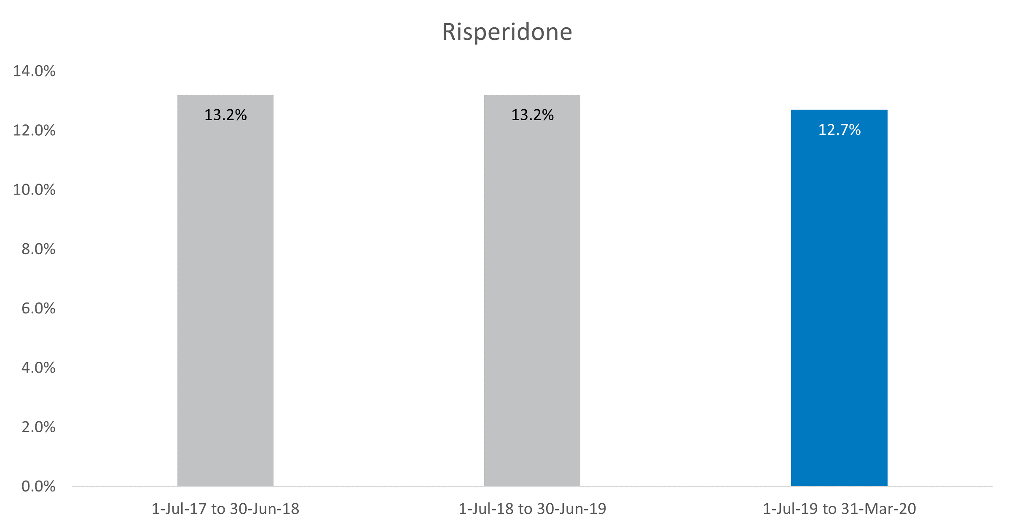

Figure 5‑4: Study cohort – Haloperidol

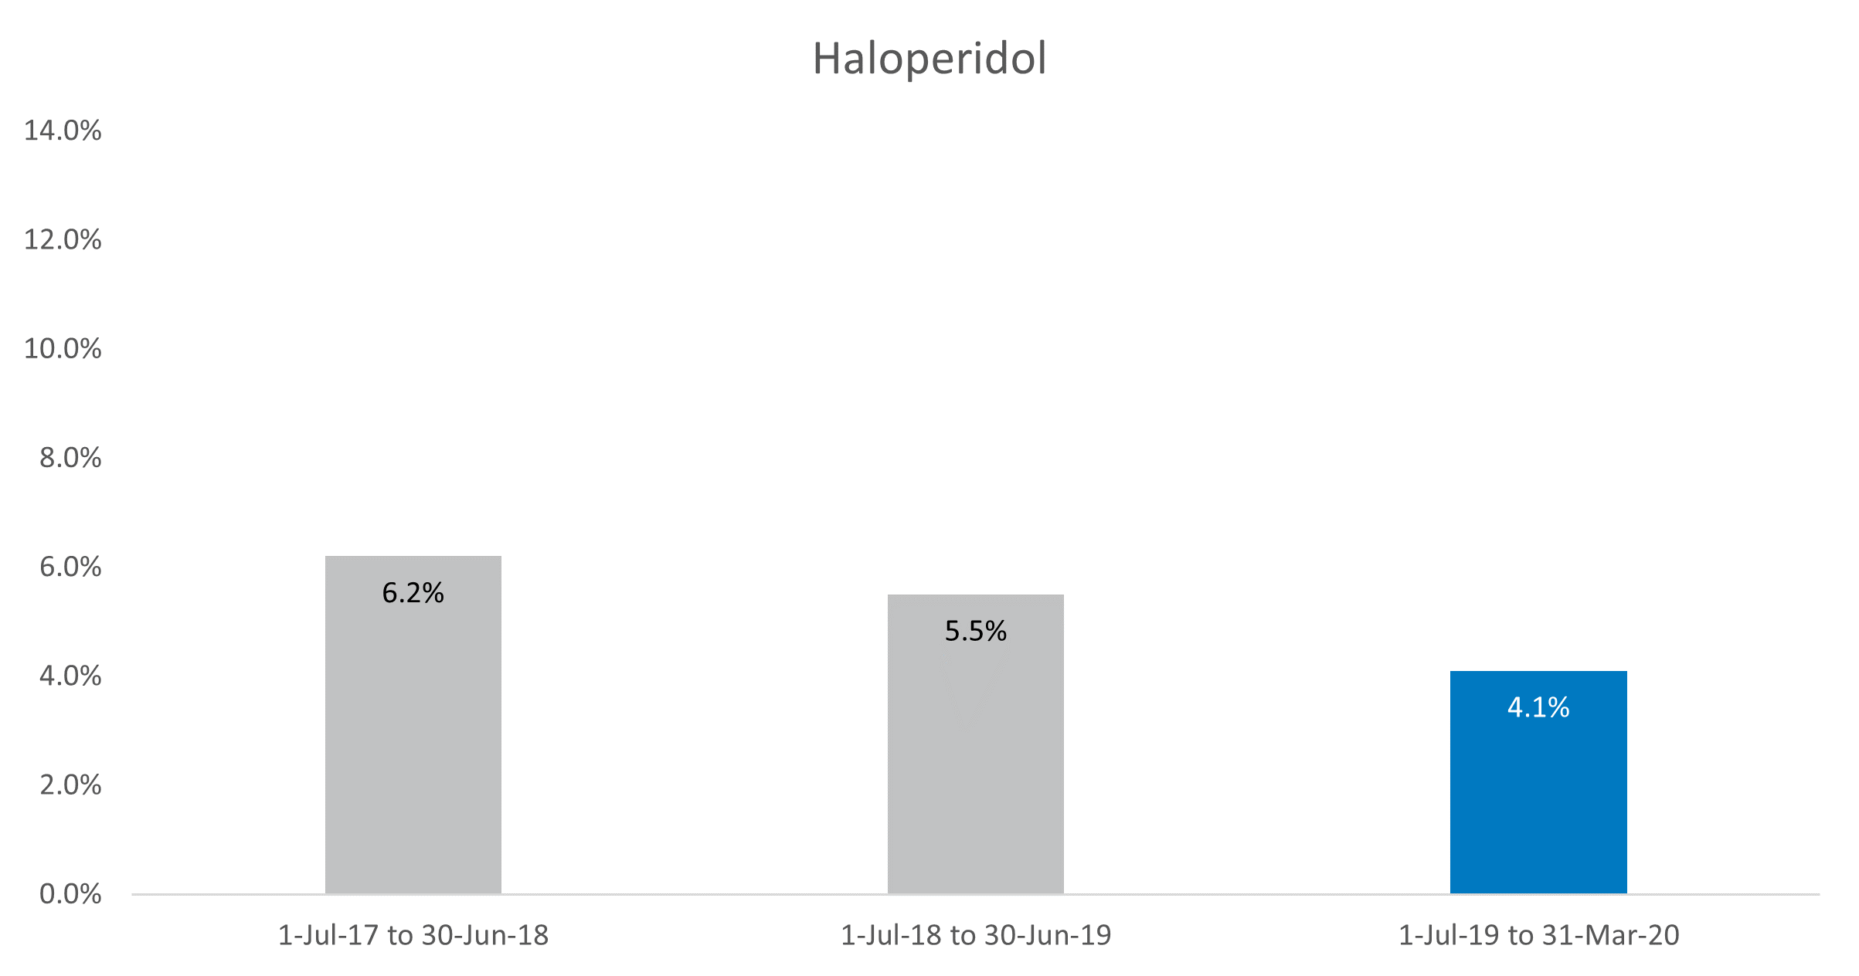

Figure 5‑5: Study cohort – Quetiapine

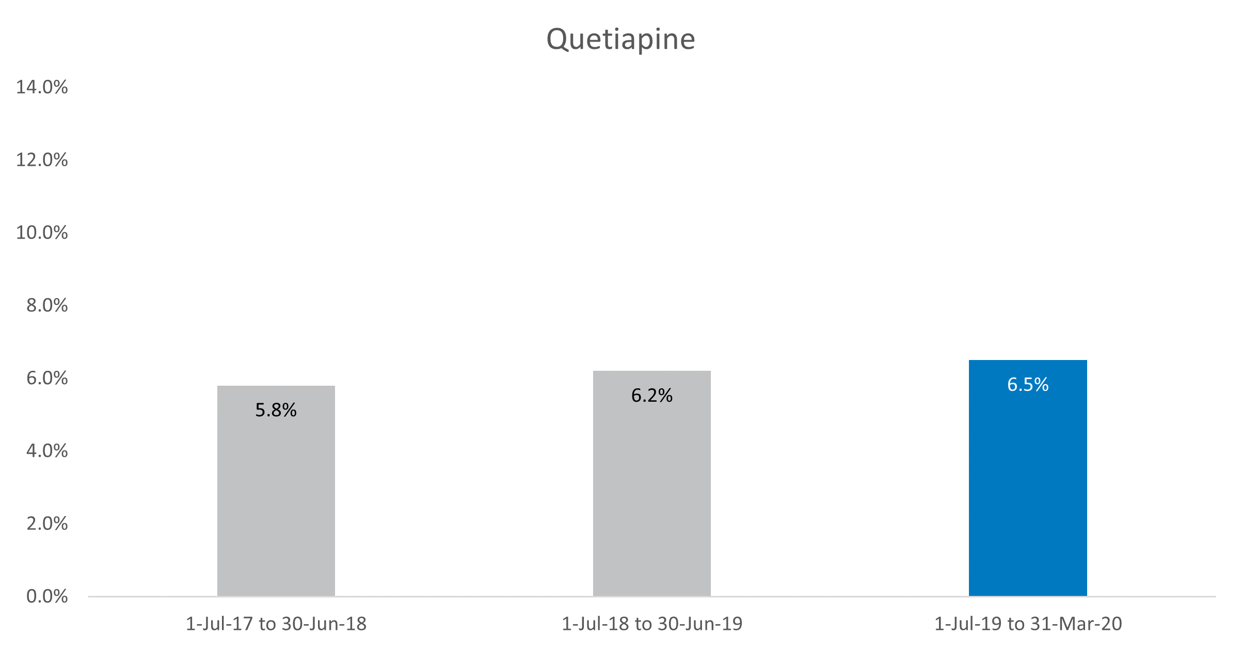

Figure 5‑6: Study cohort – Olanzapine

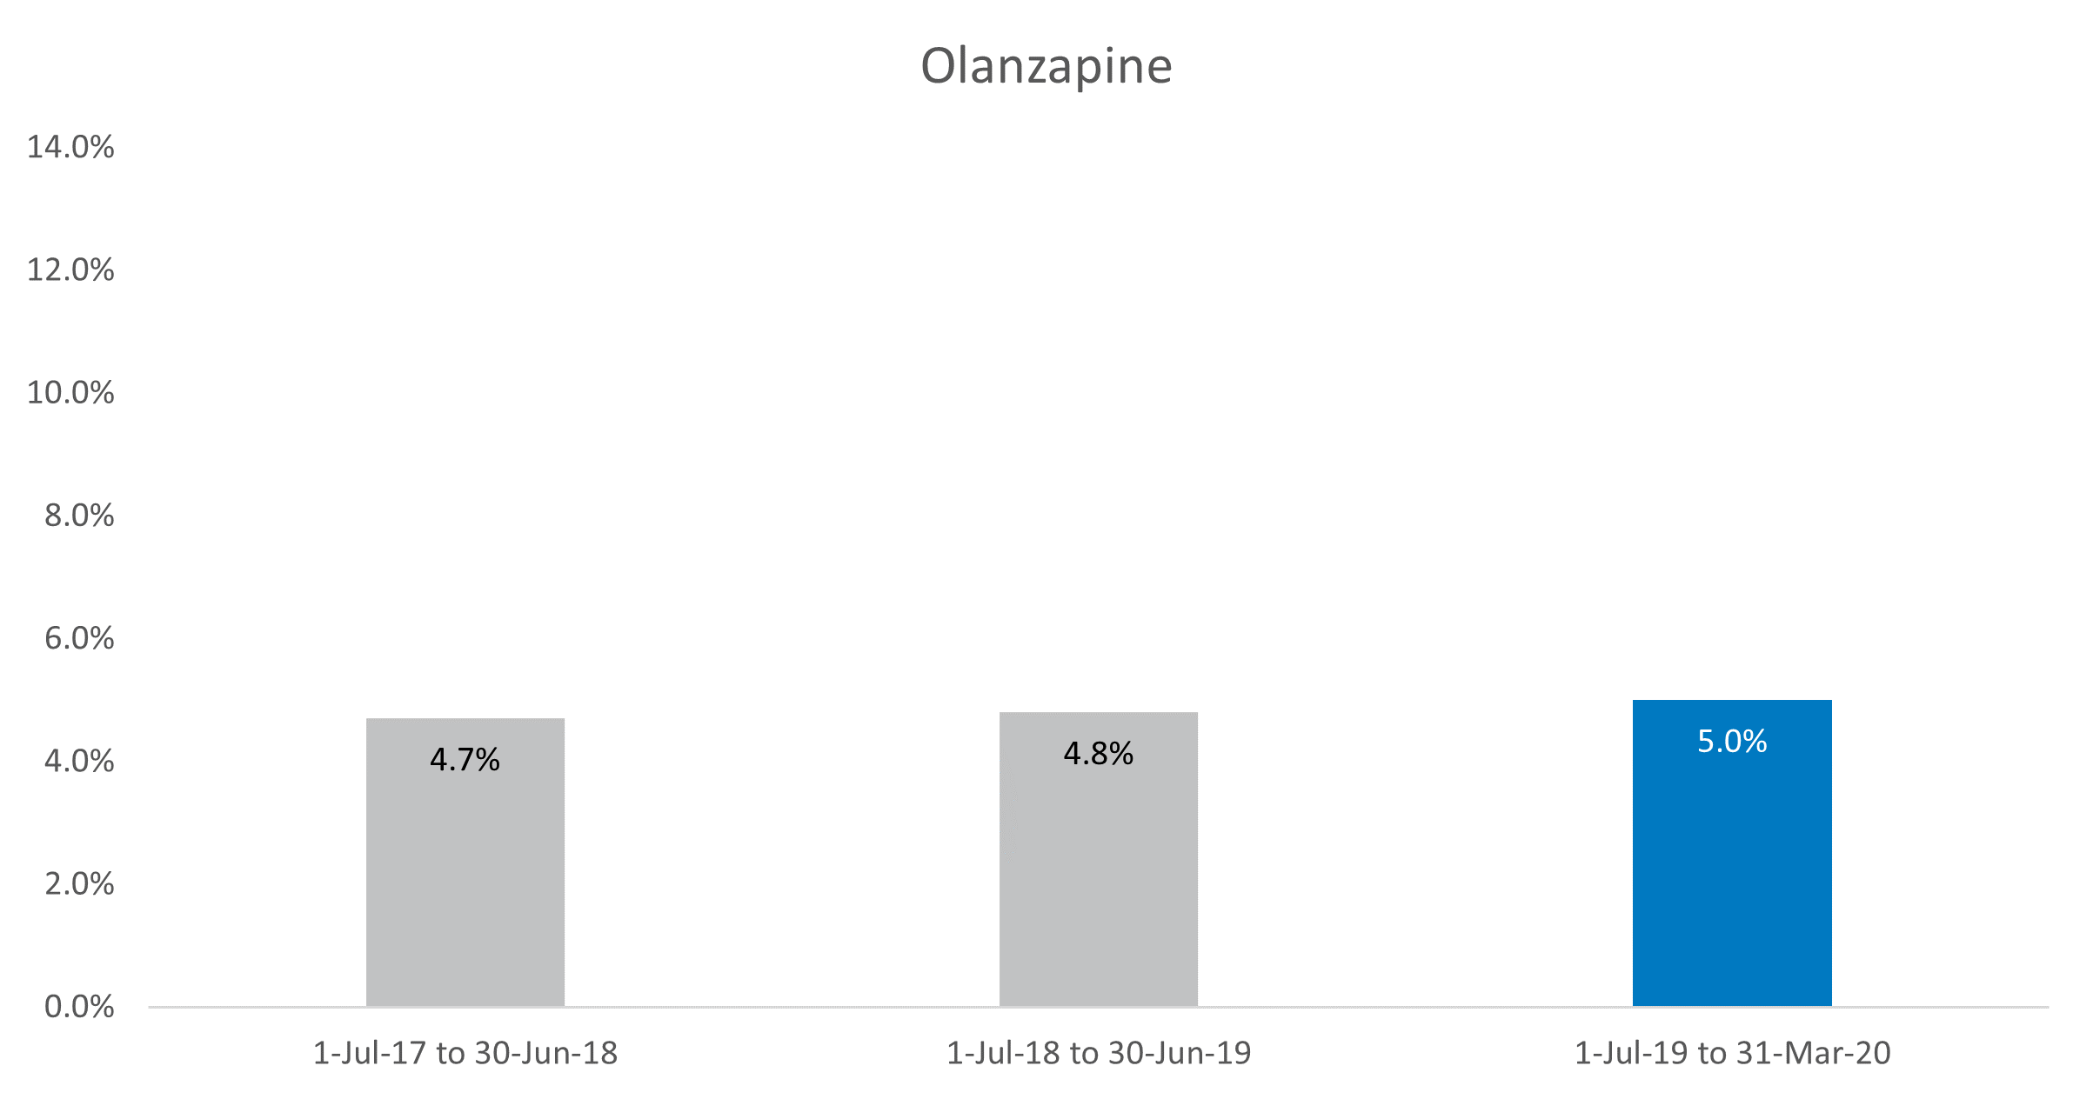

Figure 5‑7: Study cohort – Diazepam

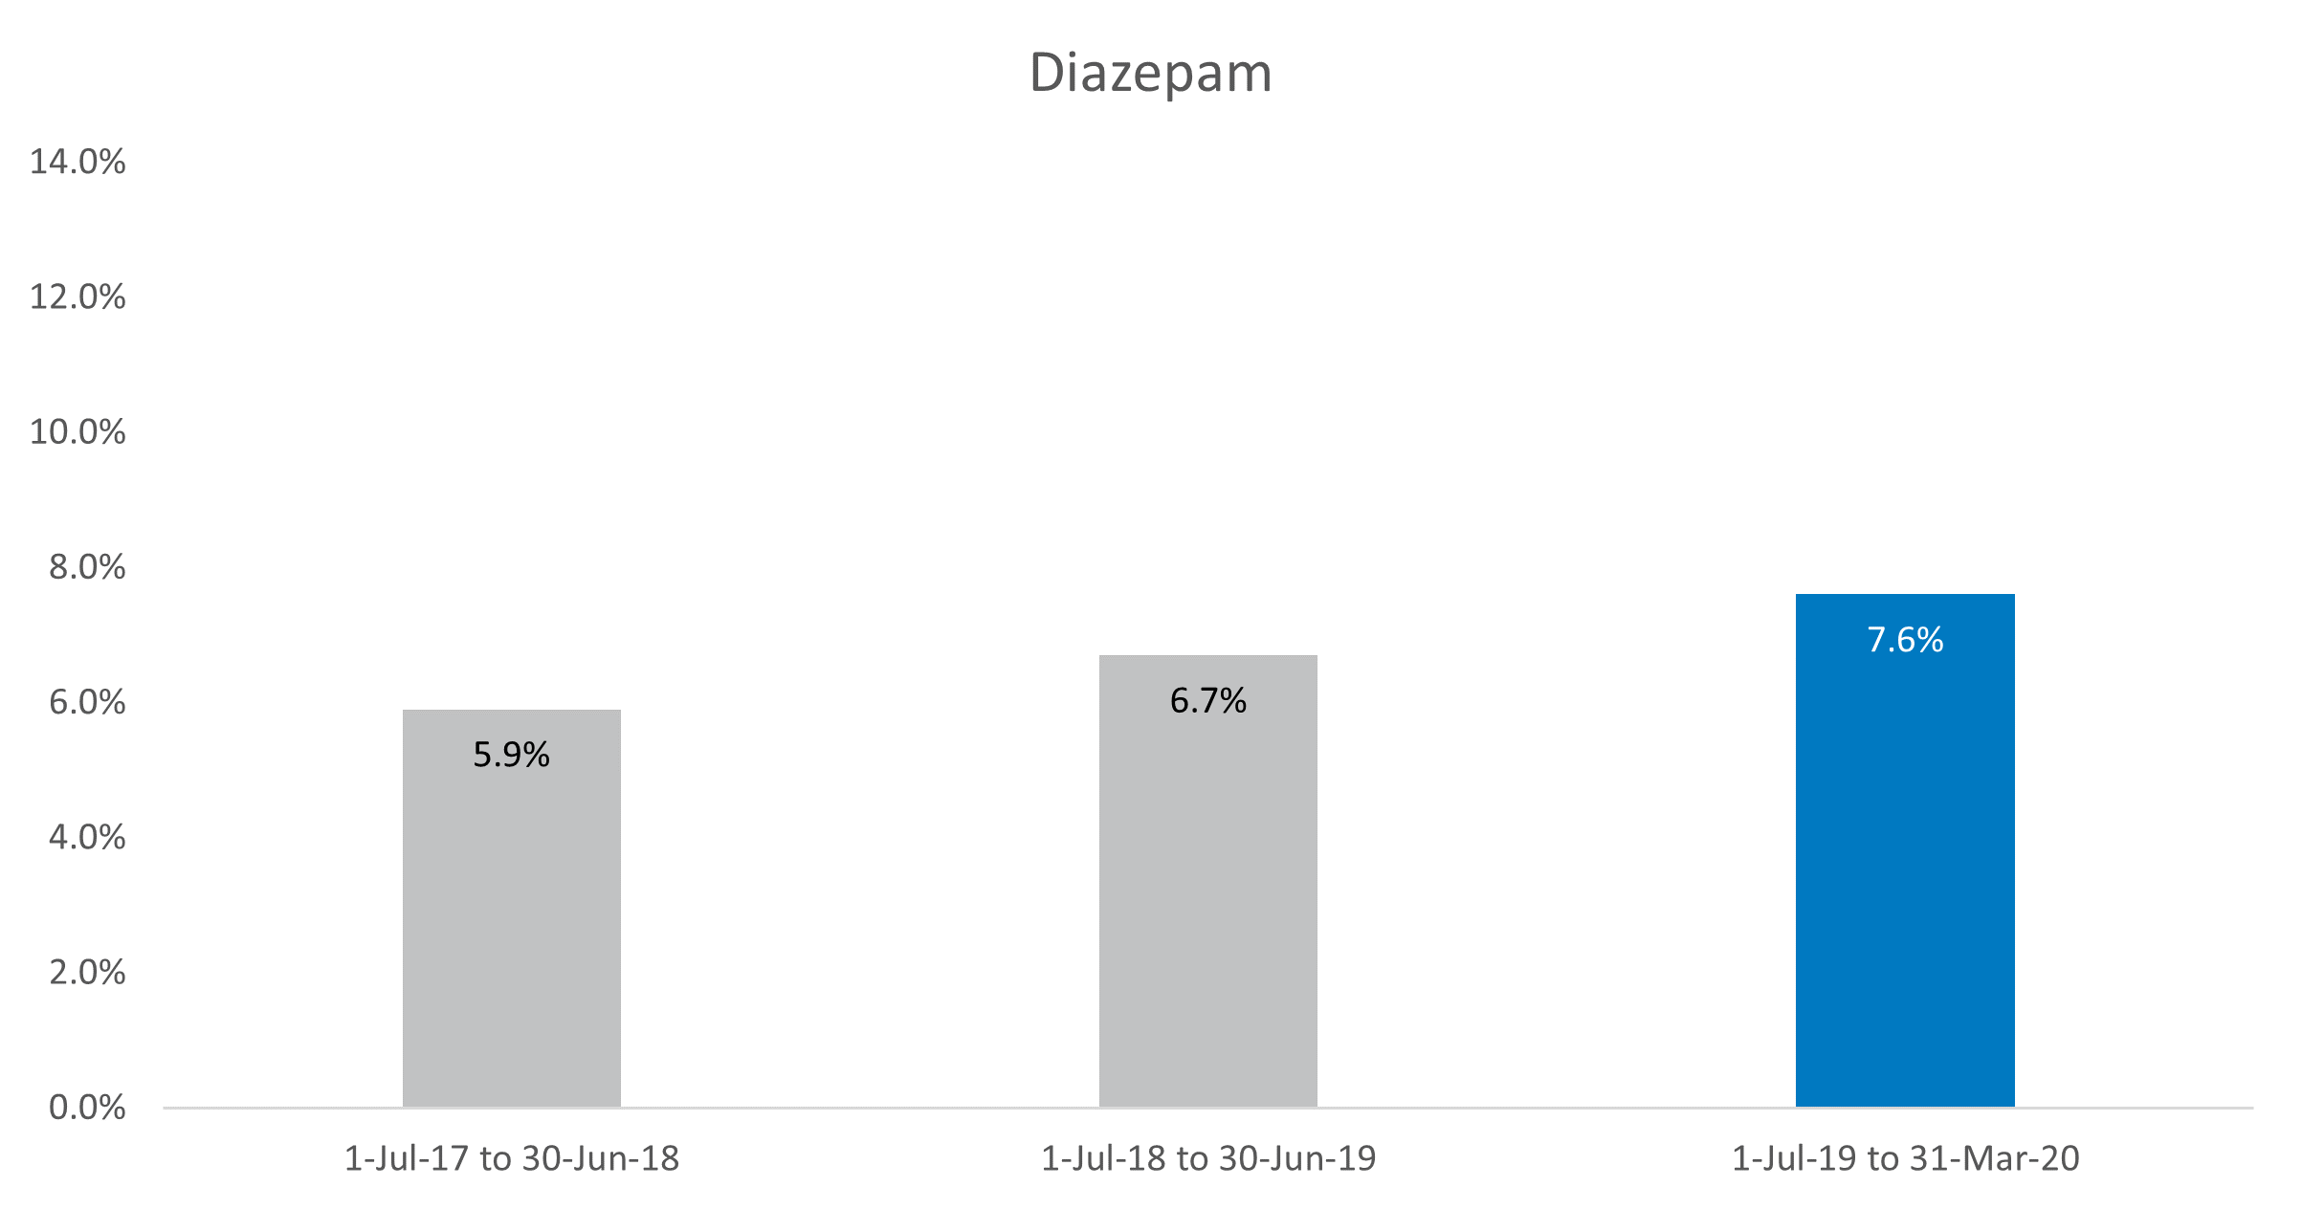

Figure 5‑8: Study cohort – Oxazepam

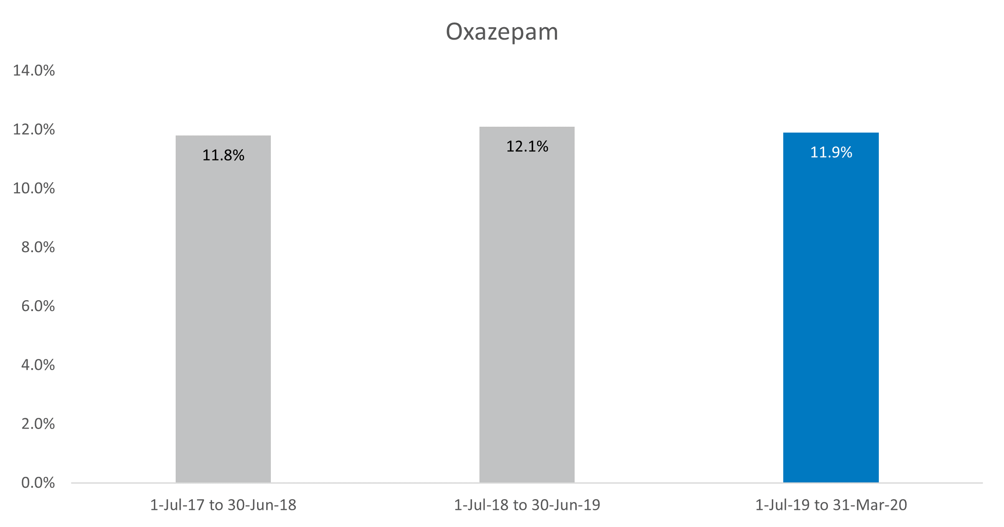

### Case study cohort – all residents

When considering only those who had resided in their aged care home for 9 months prior to and after the introduction of the Restraints Principles, the medication showing the greatest change in dispensing rates was risperidone – decreasing from 9.2 per cent in the 1 October 2018 quarter to 6.4 per cent in the 1 January 2020 quarter. All other medications evidenced smaller decreases over time in the case study cohort (except haloperidol which showed no change) (Figure 5‑9 and **Error! Reference source not found.**).

Figure 5‑9: Case study cohort, all residents – Risperidone

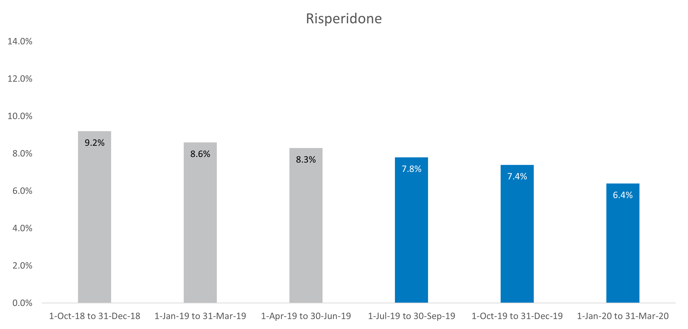

Figure 5‑10: Case study cohort, all residents – Haloperidol

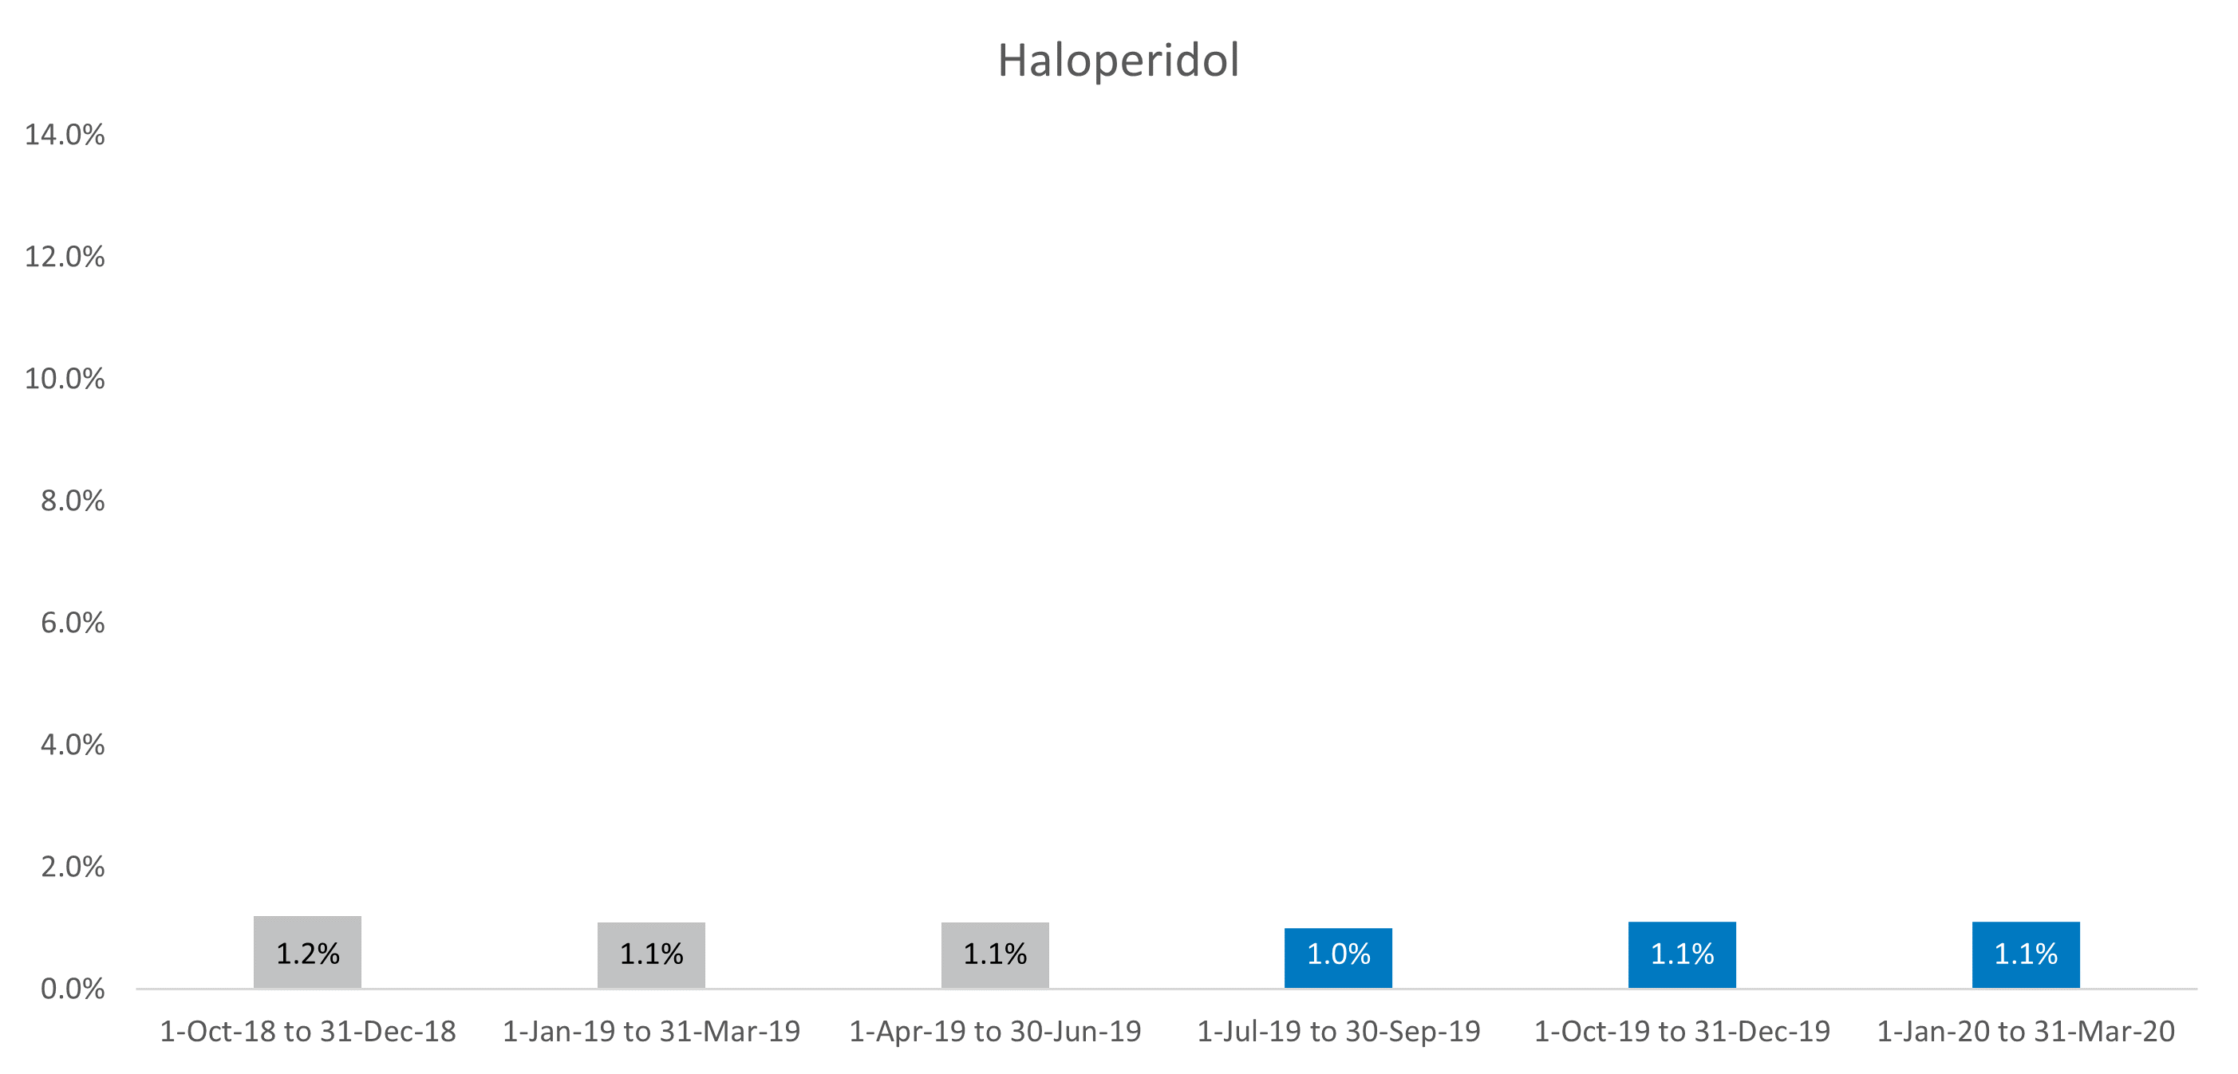

Figure 5‑11: Case study cohort, all residents – Quetiapine

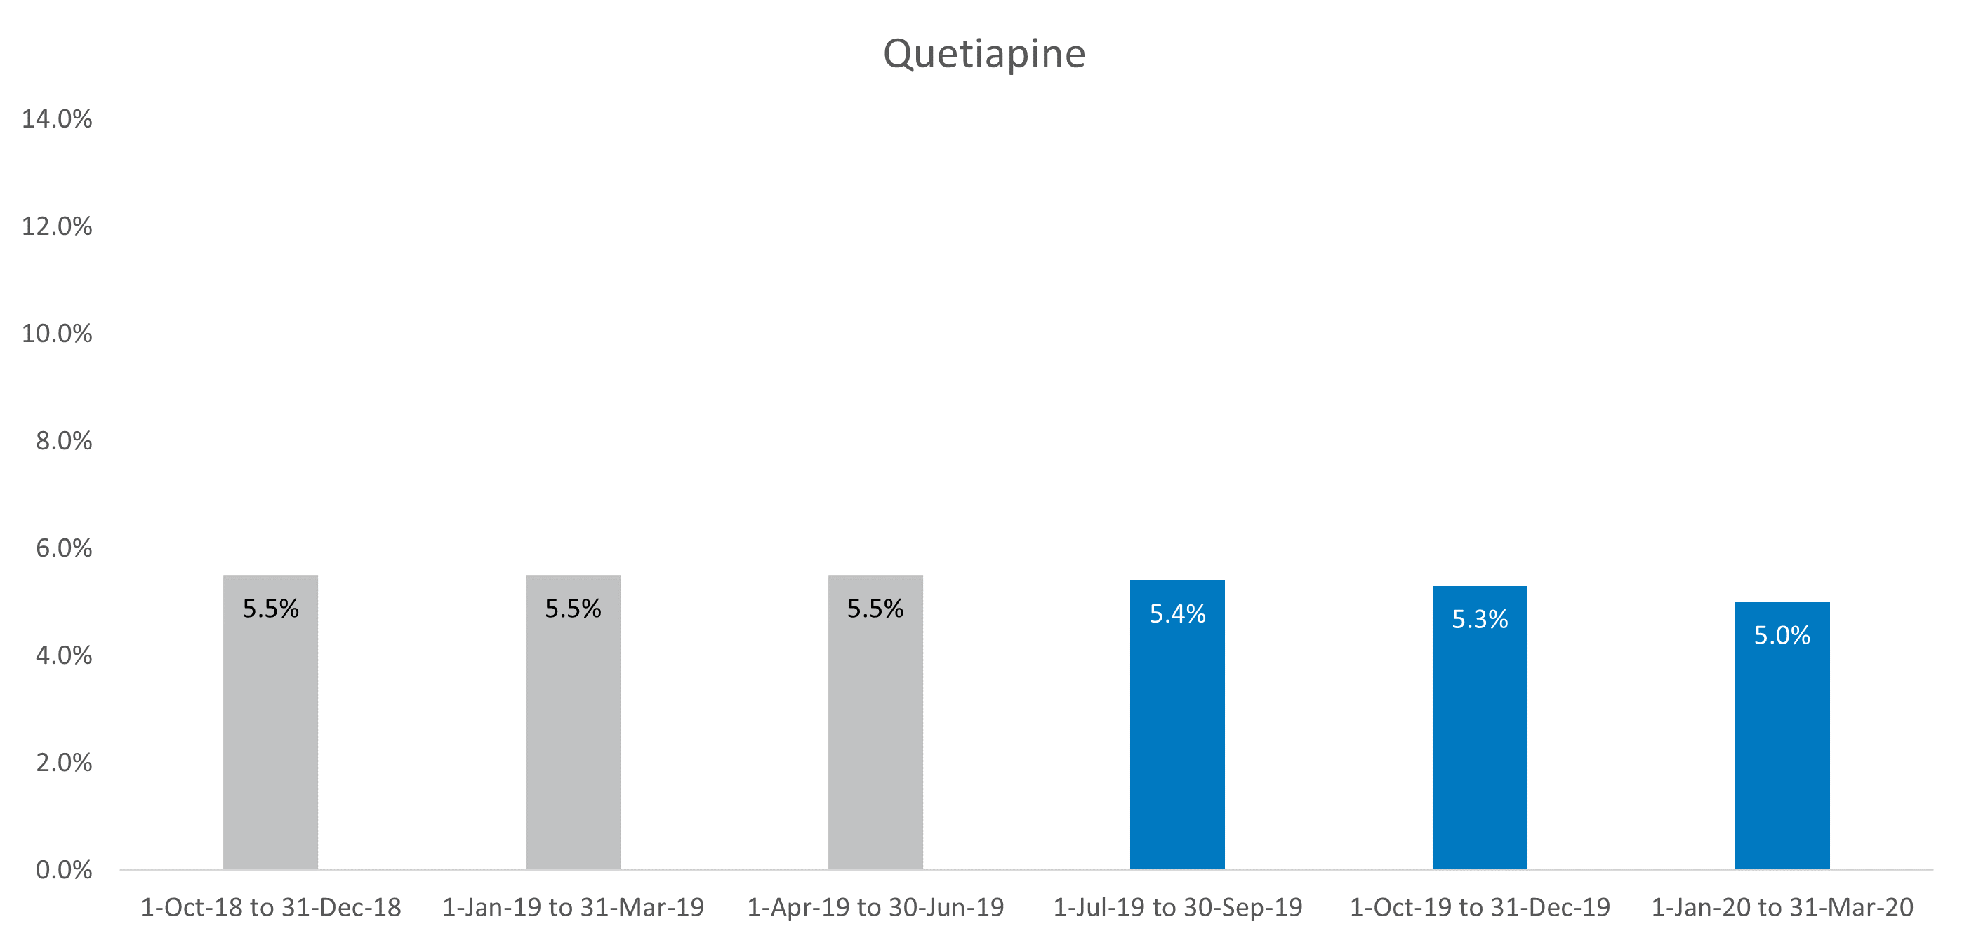

Figure 5‑12: Case study cohort, all residents – Olanzapine

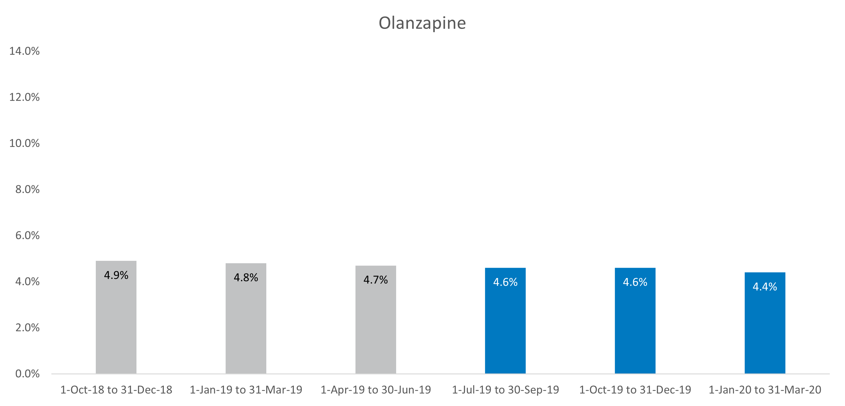

Figure 5‑13: Case study cohort, all residents – Diazepam

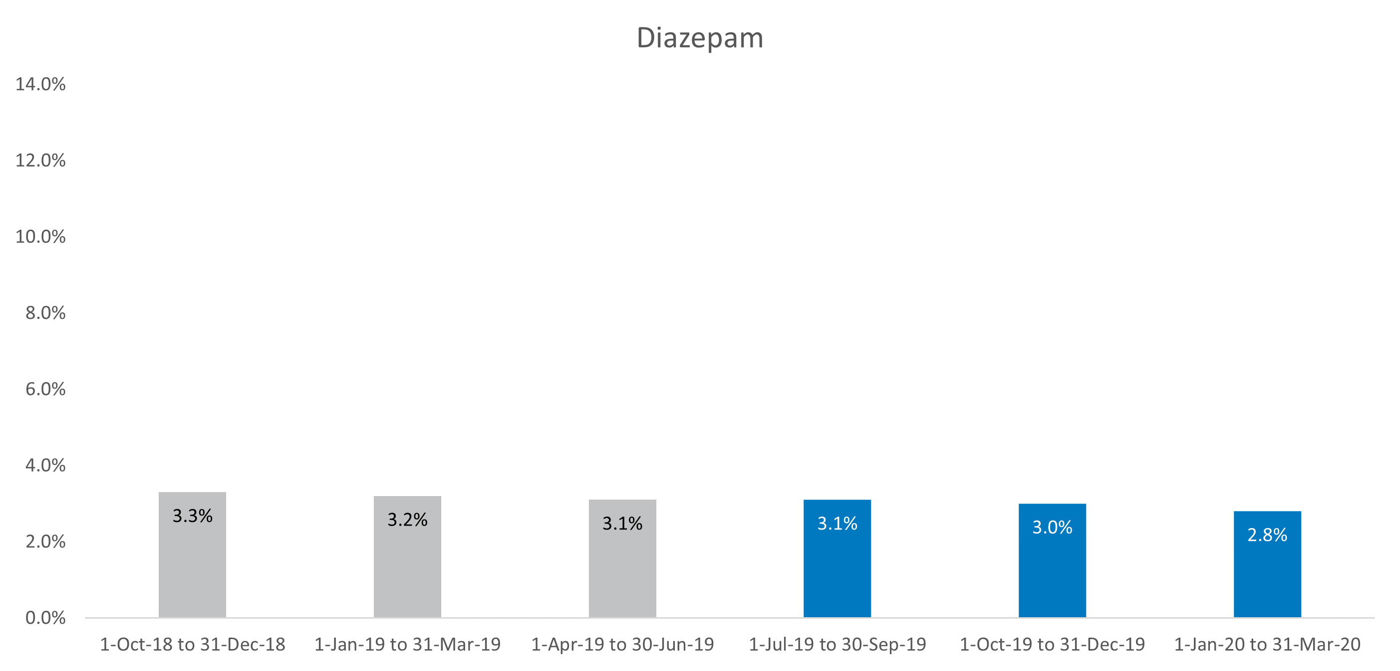

Figure 5‑14: Case study cohort, all residents – Oxazepam

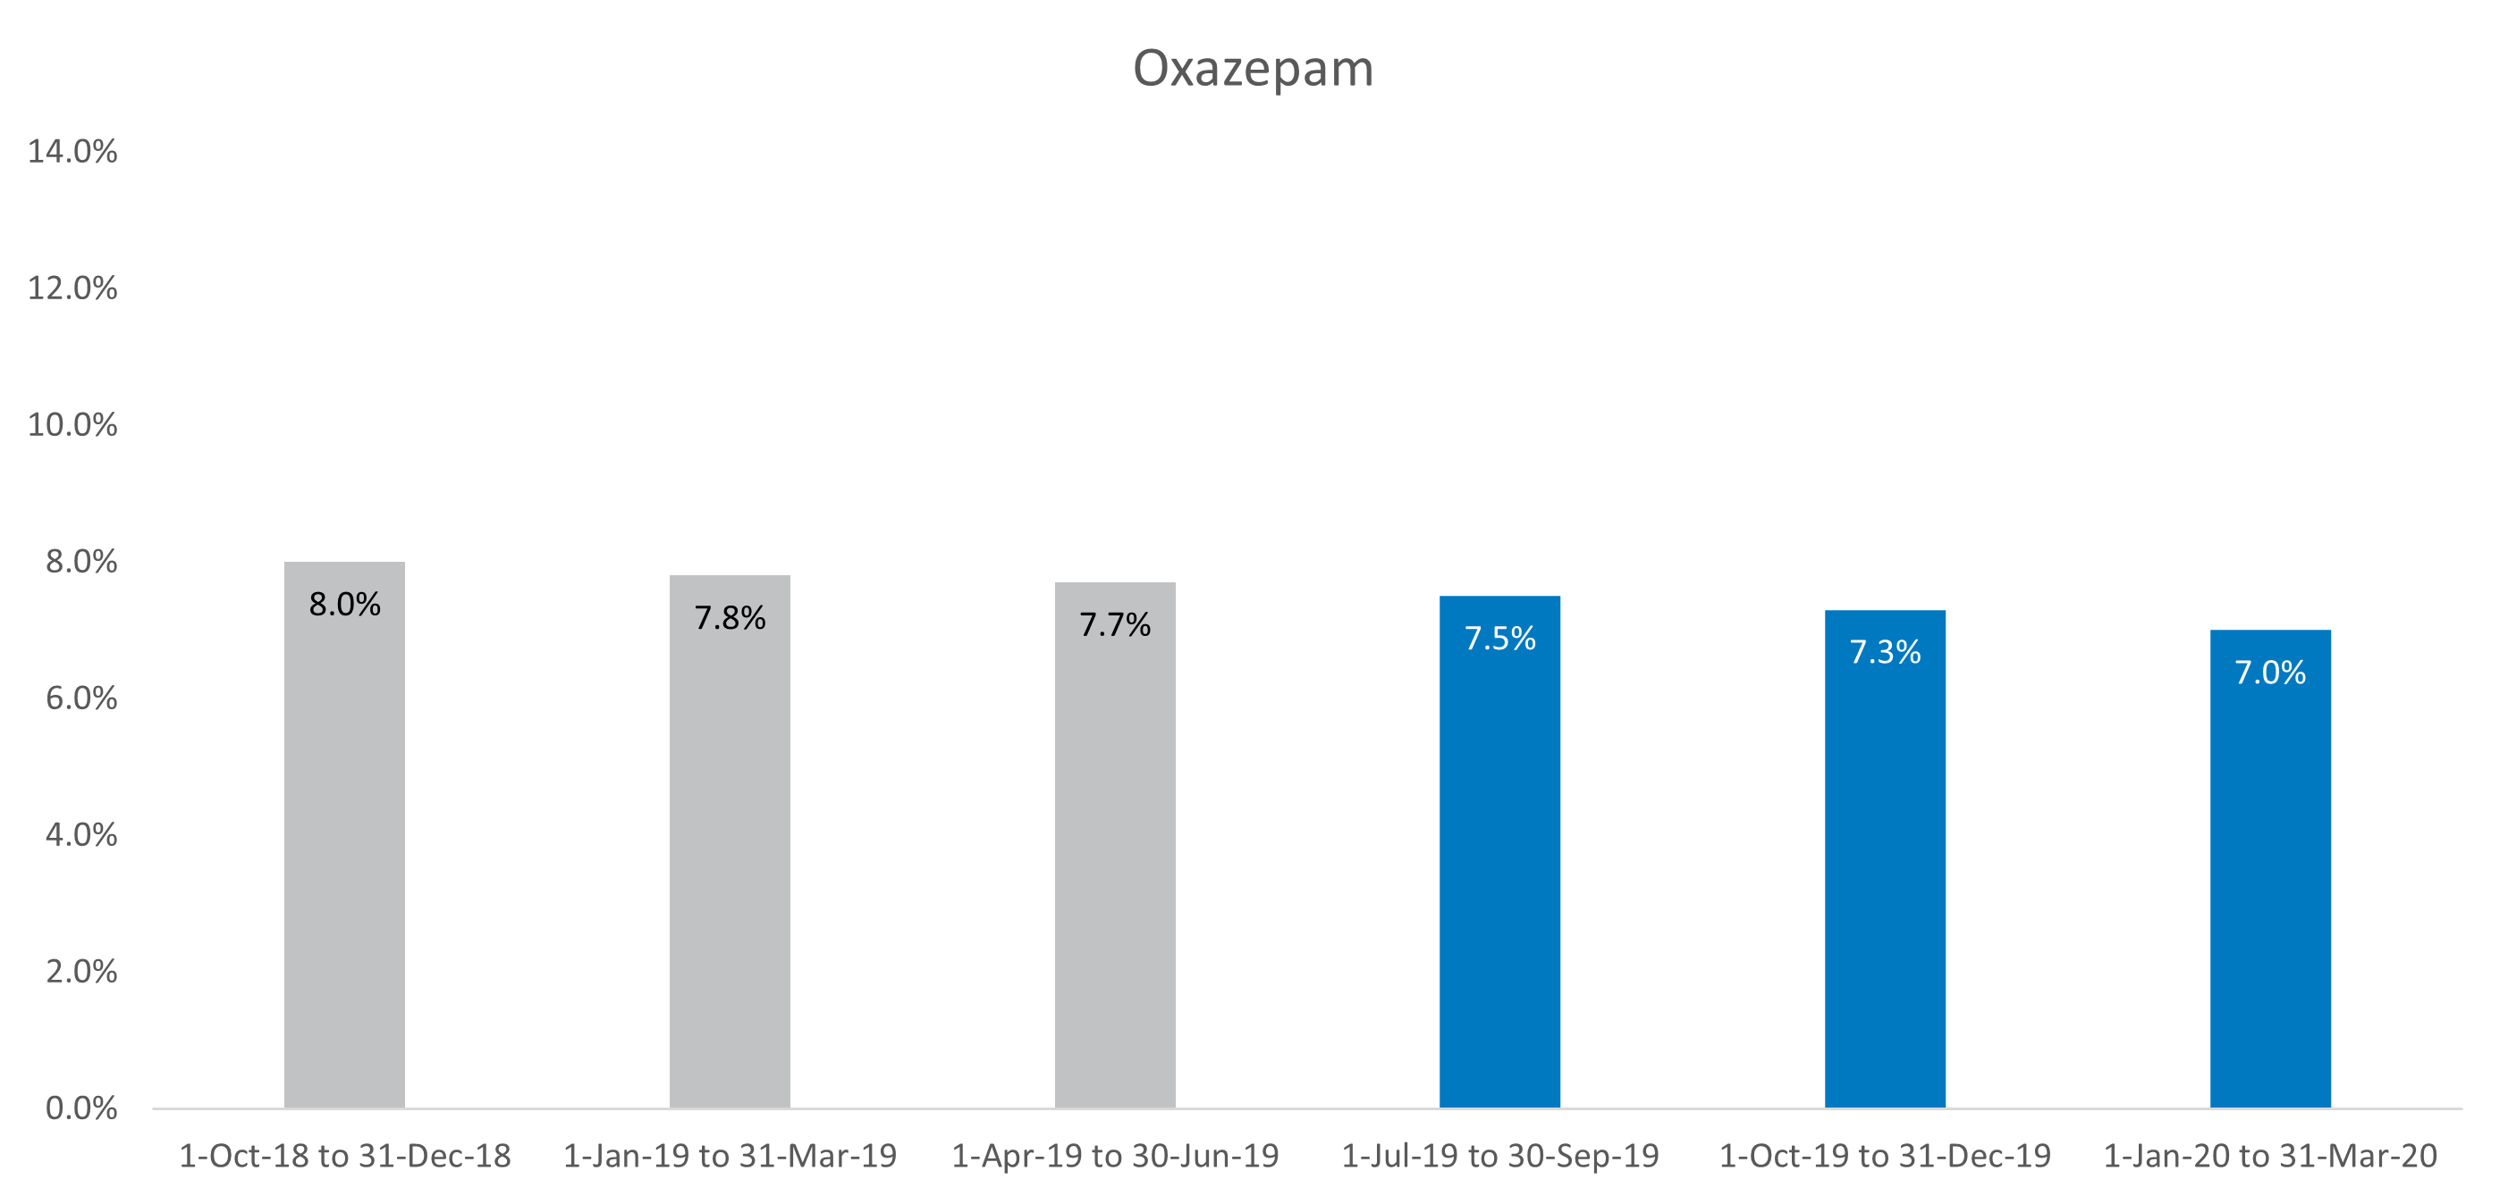

### Case study cohort – residents diagnosed with dementia

As expected, a greater proportion of the case study cohort diagnosed with dementia received prescriptions for the key medications of interest (Figure 5‑15 and Figure 5‑16). Reductions in dispensing rates over time largely mirrored those in the case study cohort – all residents. However, risperidone prescription rates reduced more substantially, from 13.8 per cent in the 1 October 2018 quarter to 9.1 per cent in the 1 January 2020 quarter – a reduction of 4.7 per cent.

Figure 5‑15: Case study cohort, residents diagnosed with dementia – Risperidone

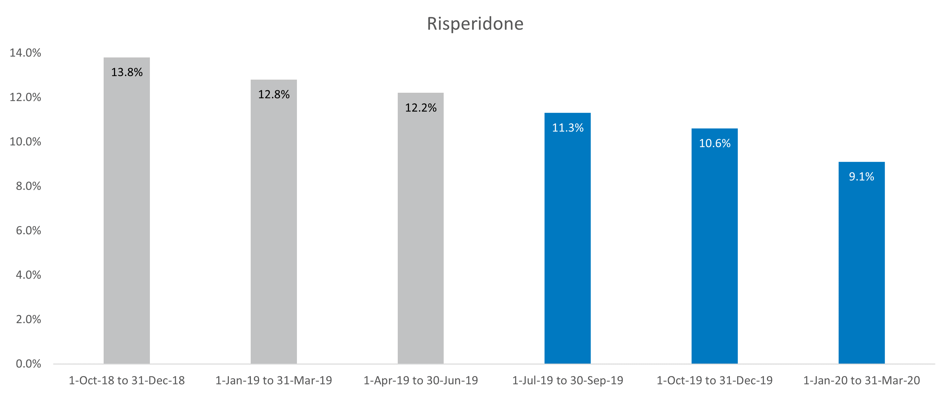

Figure 5‑16: Case study cohort, residents diagnosed with dementia – Haloperidol

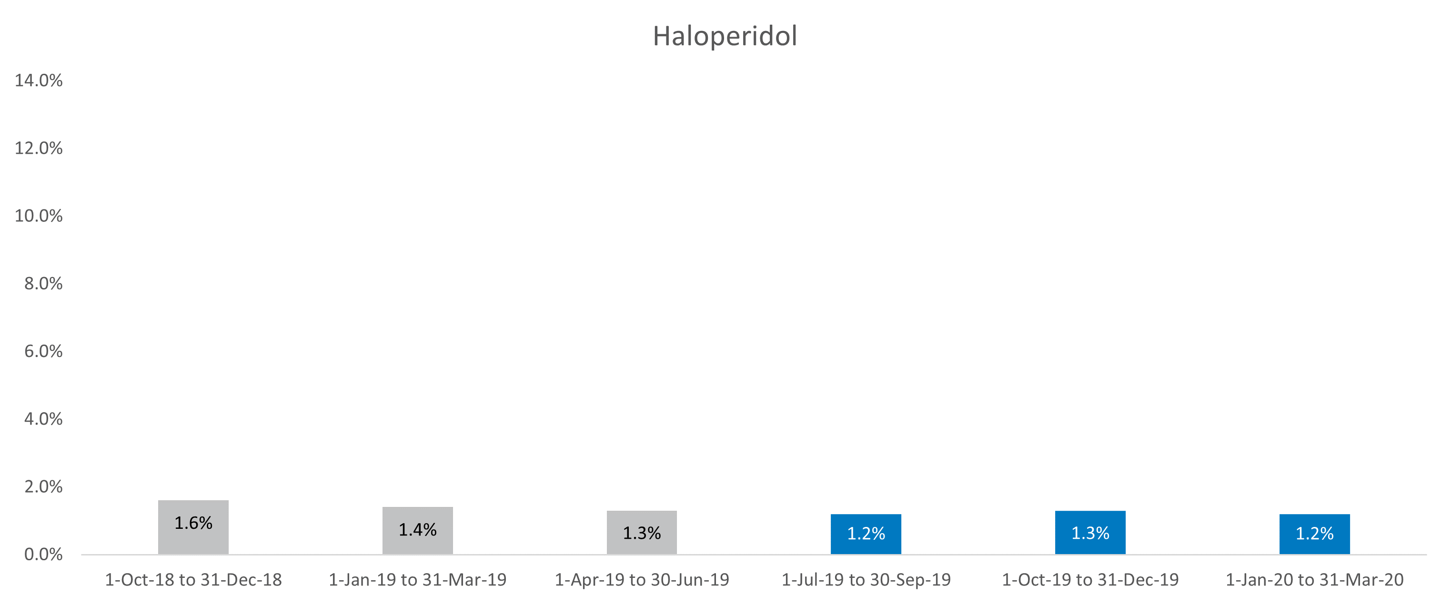

Figure 5‑17: Case study cohort, residents diagnosed with dementia – Quetiapine

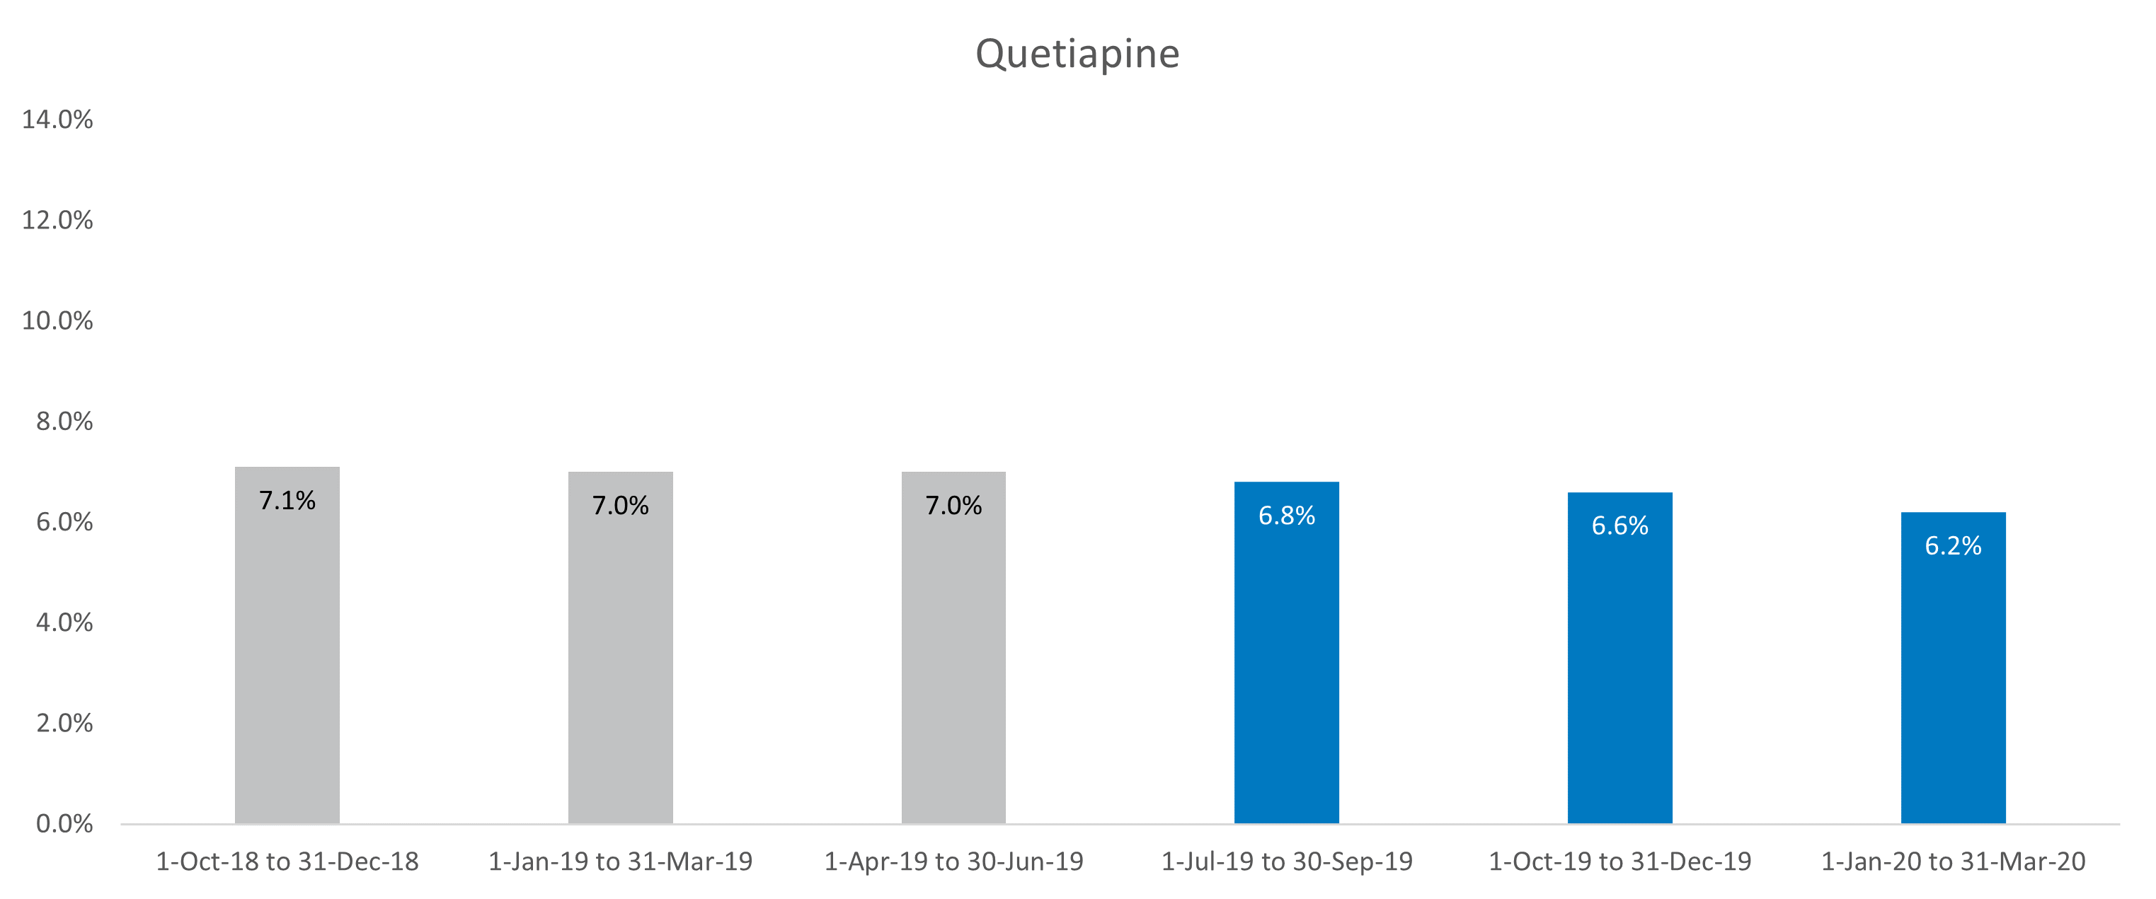

Figure 5‑18: Case study cohort, residents diagnosed with dementia – Olanzapine

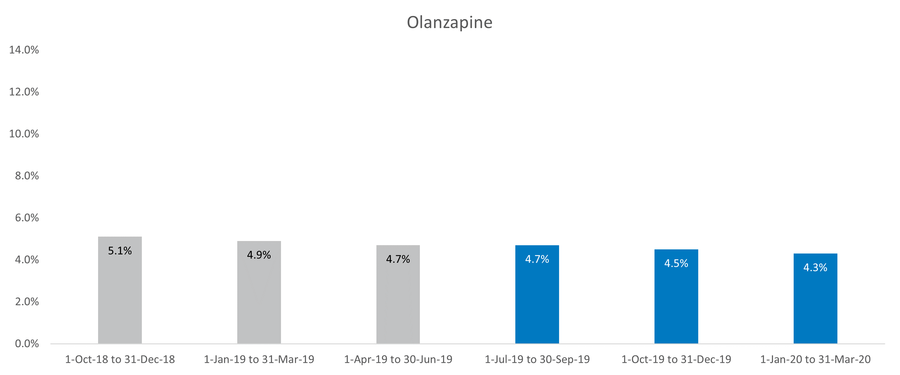

Figure 5‑19: Case study cohort, residents diagnosed with dementia – Diazepam

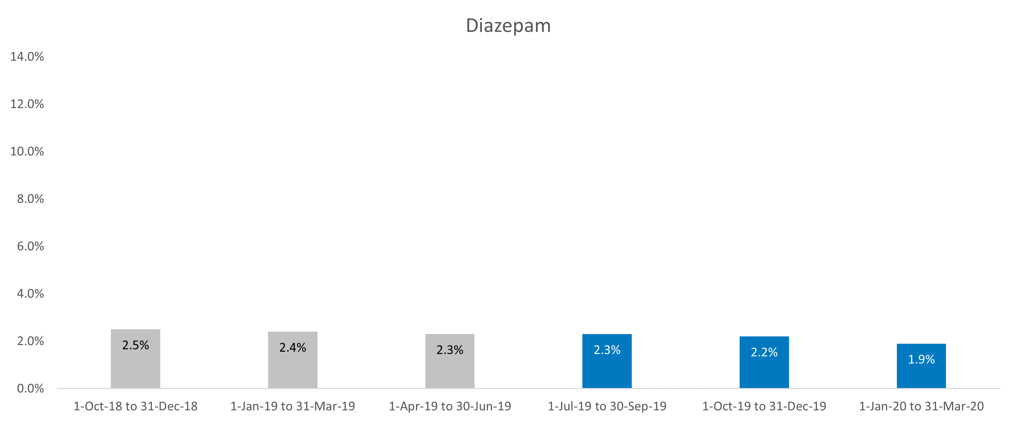

Figure 5‑20: Case study cohort, residents diagnosed with dementia – Oxazepam

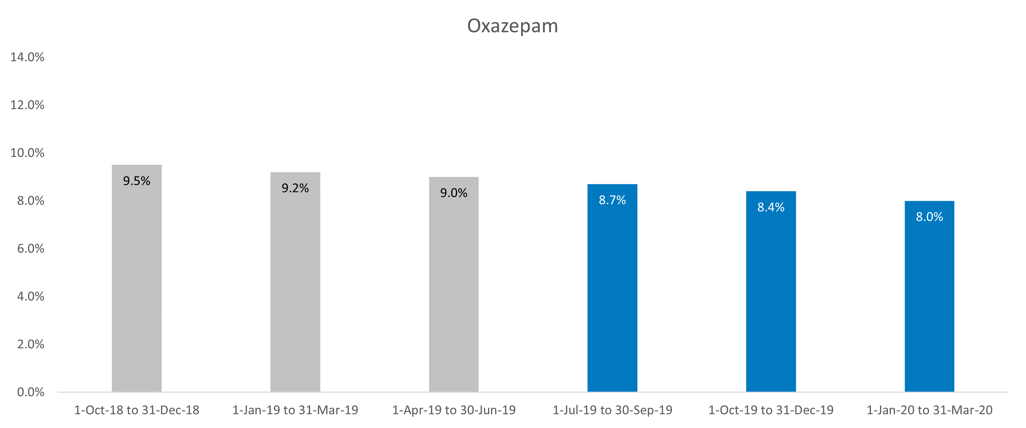

## Summary of data analysis

In summary, descriptive analyses of both medication dispensed under the PBS, and physical restraint utilisation, found there is no conclusive evidence of a change in restraint use following the introduction of the Restraints Principles. Several limitations within the data sources were highlighted, which limits interpretation of small fluctuations in the data. The overarching limitation is that the data represent a short time period since the Restraints Principles were introduced, reducing the potential for meaningful change. The analyses also do not consider the potential interrelationships between physical restraint use and psychotropic medication use, or within these categories, e.g. substitution of one type of restraint with another.

The proportion of people in residential aged care dispensed psychotropic medications could indicate utilisation is higher than would be considered clinically appropriate; however, as noted, this does not necessarily equate to the use of restraint. The data also clearly shows that a key factor in the decision to use psychotropic medications is the diagnosis of dementia. There is some suggestion from the PBS data, at least for long-term residents including those with dementia, that there may have been a gradual reduction in use of the 6 key medications of interest we reported on (as opposed to a distinct reduction due to regulatory change).

References cited

Australian Institute of Health and Welfare (2020a), National Aged Care Mandatory quality indicator program: Evidence of Progressive Change in Physical Restraint, Canberra: AIHW.

Australian Institute of Health and Welfare (2020b), Residential Aged Care Quality Indicators - October to December 2020. Canberra: AIHW

Australian Institute of Health and Welfare (2020c), Using PBS Data to Evaluate Changes to Chemical Restraint Practices in Permanent Residential Aged Care between 1 July 2017 and 31 March 2020, Canberra: AIHW.

Department of Health (2019), National Aged Care Mandatory Quality Indicator Program Manual 1.0, Australian Government, accessed 2 November 2020. . https://www.health.gov.au/sites/default/files/documents/2019/12/national-aged-care-mandatory-quality-indicator-program-manual.pdf

Harrison SL, Sluggett JK, Lang C, Whitehead C, Crotty M, Corlis M, Wesselingh S, and Inacio MC (2020a) 'The dispensing of psychotropic medicines to older people before and after they enter residential aged care', Medical Journal of Australia, 212(7): 309–313.

Harrison SL, Sluggett JK, Lang C, Whitehead C, Crotty M, Corlis M, Wesselingh S, and Inacio MC (2020b), 'Initiation of antipsychotics after moving to residential aged care facilities and mortality: a national cohort study', Aging Clinical and Experimental Research, March:1–10.

Parliamentary Joint Committee on Human Rights (2019) Quality of Care Amendment (Minimising the Use of Restraints) Principles Inquiry Report, accessed 15 November 2020. https://www.aph.gov.au/Parliamentary_Business/Committees/Joint/Human_Rights/QualityCareAmendment/Report

Royal Commission into Aged Care Quality and Safety (2019b) Interim Report: Neglect, Vol. 1, Royal Commission into Aged Care Quality and Safety, Australian Government, accessed 8 November 2020. https://agedcare.royalcommission.gov.au/publications/interim-report-volume-1

Senate Community Affairs References Committee (2018), Effectiveness of the Aged Care Quality Assessment and accreditation framework for protecting residents from abuse and poor practices, and ensuring proper clinical and medical care standards are maintained and practised, Parliament of Australia.

Legislation

*Quality of Care Amendment (Minimising the Use of Restraints) Principles 2019*

*Quality of Care Amendment (Reviewing Restraints Principles) Principles 2019*

##### Alt text long descriptions

This appendix contains text descriptions for figures that are too complex to be described in concise alt text. These descriptions are included to enhance the accessibility of this document and ensure compliance with WCAG 2.1.

###### Figure 2‑1: Review methodology

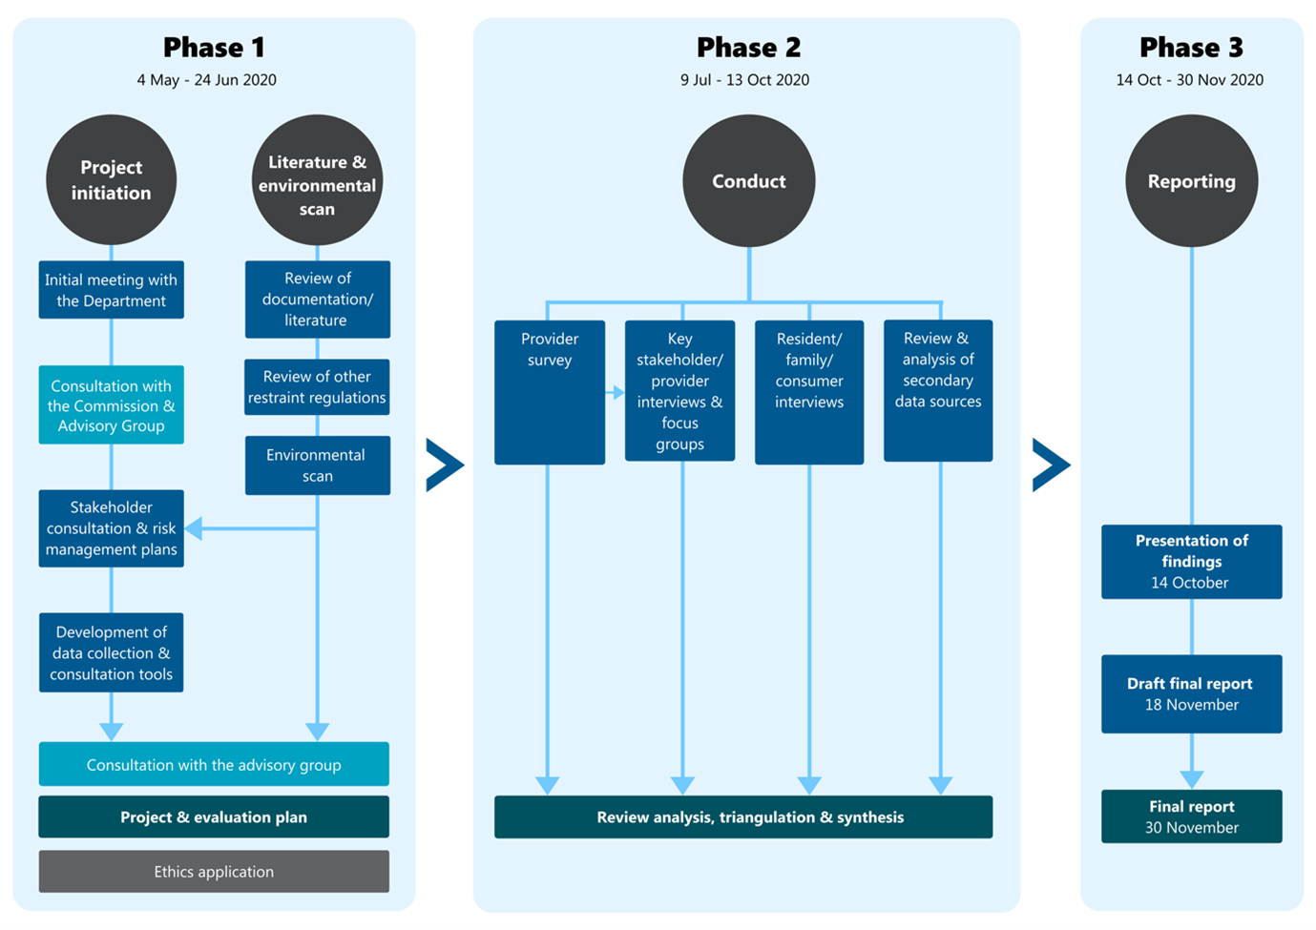

The diagram shows the three phases of the project.

**Phase 1** runs from 4 May to 24 Jun 2020. It contains the project initiation stage and, concurrently, the literature & environmental scan stage.

The first 4 consecutive steps in the project initiation stage are: Initial meeting with the Department; Consultation with the Commission & Advisory Group; Stakeholder consultation & risk management plans; and Development of data collection & consultation tools.

The first 3 consecutive steps in the literature and environmental scan stage are: Review of documentation/literature; Review of other restraint regulations; and Environmental scan. The information collected through these activities then informs the Stakeholder consultation & risk management plan step in the project initiation stage.

The project initiation stage and the literature and environmental scan stage then both proceed to 3 further shared steps: Consultation with the advisory group; Project & evaluation plan, and Ethics application.

**Phase 2: Conduct** runs from 9 Jul to 13 Oct 2020. It contains 4 concurrent steps: Provider survey; Key stakeholder/ provider interviews & focus groups; Resident/ family/ consumer interviews; and Review & analysis of secondary data sources. The Provider survey also feeds into the Key stakeholder/ provider interviews & focus groups. The 4 concurrent steps then lead to the final step in this phase of the project, namely Review analysis, triangulation & synthesis.

**Phase 3: Reporting** runs from 14 Oct to December 2020. It contains 3 consecutive steps: Presentation of findings (14 October); Draft final report (18 November); and Final report (December).

###### Figure 2‑2: Program logic

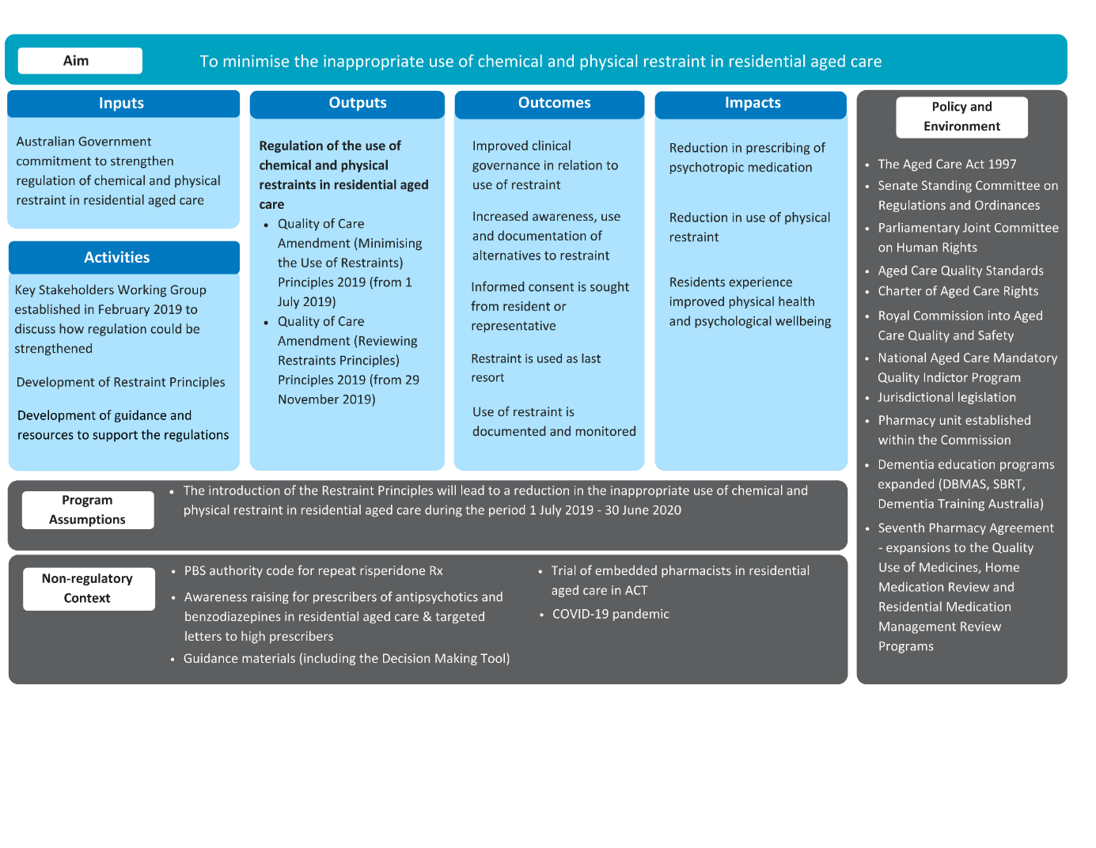This diagram provides the details of the aim, inputs, activities, outputs, outcomes and impacts of the Restraints Principles. It also gives details of the program assumptions, the non-regulatory context, and the policy and environment.

The **aim** is: To minimise the inappropriate use of chemical and physical restraint in residential aged care.

The **inputs** comprise Australian Government commitment to strengthen regulation of chemical and physical restraint in residential aged care.

There are 3 **activities**:

* Key Stakeholders Working Group established in February 2019 to discuss how regulation could be strengthened
* Development of Restraint Principles
* Development of guidance and resources to support the regulations.

The **outputs** comprise the regulation of the use of chemical and physical restraints in residential aged care, as reflected in the:

* *Quality of Care Amendment (Minimising the Use of Restraints) Principles 2019 (from 1 July 2019)*
* *Quality of Care Amendment (Reviewing Restraints Principles) Principles 2019 (from 29 November 2019).*

There are 5 **outcomes**:

* Improved clinical governance in relation to use of restraint
* Increased awareness, use and documentation of alternatives to restraint
* Informed consent is sought from resident or representative
* Restraint is used as last resort
* Use of restraint is documented and monitored.

There are 3 **impacts**:

* Reduction in prescribing of psychotropic medication
* Reduction in use of physical restraint
* Residents experience improved physical health and psychological wellbeing.

The **program assumptions** are that the introduction of the Restraint Principles will lead to a reduction in the inappropriate use of chemical and physical restraint in residential aged care during the period 1 July 2019 - 30 June 2020.

The **non-regulatory context** comprises the COVID-19 pandemic and 4 initiatives targeting restraint use in the aged care sector:

* PBS authority code for repeat risperidone Rx
* Awareness raising for prescribers of antipsychotics and benzodiazepines in residential aged care & targeted letters to high prescribers
* Guidance materials (including the Decision Making Tool)
* Trial of embedded pharmacists in residential aged care in ACT

The **policy and environment** comprises 11 components:

* The Aged Care Act 1997
* Senate Standing Committee on Regulations and Ordinances
* Parliamentary Joint Committee on Human Rights
* Aged Care Quality Standards
* Charter of Aged Care Rights
* Royal Commission into Aged Care Quality and Safety
* National Aged Care Mandatory Quality Indictor Program
* Jurisdictional legislation
* Pharmacy unit established within the Commission
* Dementia education programs expanded (DBMAS, SBRT, Dementia Training Australia)
* Seventh Pharmacy Agreement - expansions to the Quality Use of Medicines, Home Medication Review and Residential Medication Management Review Programs.

###### Figure 5‑1: Intent to restrain & number of physical restraint devices observed

This line graph shows that there has been minimal variation in the use of restraint. A full description, including statistics, is given below.


This line graph shows that there has been minimal variation in both the intent to restrain and the number of physical restraint devices observed over the three quarters from July 2019 to March 2020.

The number of **physical restraint devices** observed was:

* 63,217 in the first quarter (July to September 2019)
* 60,804 in the second quarter (October to December 2019)
* 62,962 in the third quarter (January to March 2020)

The number of observations of **intent to restrain** was:

* 25,101 in the first quarter (July to September 2019)
* 25,529 in the second quarter (October to December 2019)
* 26,332 in the third quarter (January to March 2020).

###### Figure 5‑2: Intent to restrain & number of physical restraint devices observed per 1,000 care days

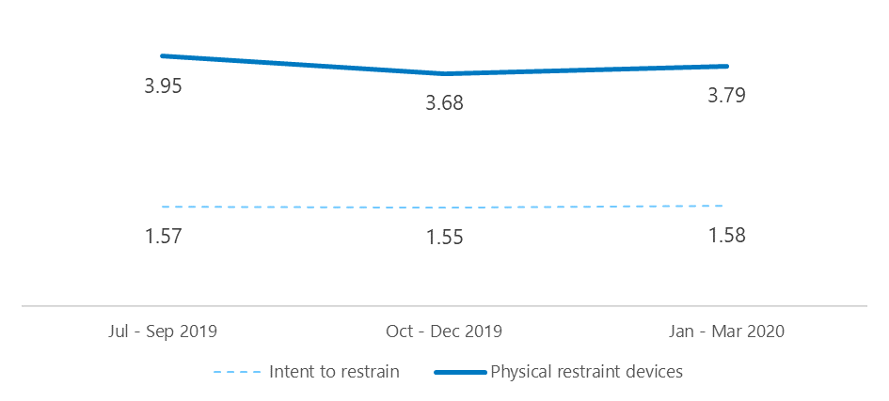

This line graph shows that there has been minimal variation in both the intent to restrain and the number of physical restraint devices observed over the three quarters from July 2019 to March 2020.

The number of **physical restraint devices** observed was:

* 3.95 in the first quarter (July to September 2019)
* 3.68 in the second quarter (October to December 2019)
* 3.79 in the third quarter (January to March 2020)

The number of observations of **intent to restrain** was:

* 1.57 in the first quarter (July to September 2019)
* 1.55 in the second quarter (October to December 2019)
* 1.58 in the third quarter (January to March 2020).

**Disclaimer:** Australian Healthcare Associates (AHA) has prepared this report on behalf of the Australian Government Department of Health (the Client).  
  
The report should not be used or relied upon for any purpose other than as an expression of the conclusions and recommendations of AHA to the Client as to the matters within the scope of the report. AHA and its officers and employees expressly disclaim any liability to any person other than the Client who relies on or purports to rely on the report for any other purpose.  
  
AHA has prepared the report with care and diligence. The conclusions and recommendations in this report are given in good faith and in the reasonable belief that they are correct and not misleading. The report has been prepared by AHA based on information provided by the client and other persons. AHA has relied on that information and has not independently verified or audited that information.

Suggested citation: Australian Healthcare Associates, 2020, Independent review of legislative provisions governing the use of restraint in residential aged care - Supplementary volume 2: methodology and results, Australian Government Department of Health, Canberra.

Logo: Australian Healthcare Associates

Level 6, 140 Bourke St, Melbourne VIC 3000

Locked Bag 32005, Collins Street East, VIC 8006

(03) 9663 1950

aha@ahaconsulting.com.au

www.ahaconsulting.com.au

1. Consumers providing input via unplanned channels (email or the provider survey) were provided with information about the project, including AHA contact details, and were informed that their submission was anonymous.
2. Source: Aged care data snapshot 2019, published on GEN-agedcaredata.gov.au
3. Task-oriented is interpreted as a traditional approach to care where the focus is on routine tasks, and contrary to an approach that is person-centred.

   https://www2.health.vic.gov.au/about/publications/researchandreports/workforce-responses-changing-aged-care-environment
4. The Department has implemented a range of measures to support reduction of inappropriate prescription of antipsychotic medications and benzodiazepines in residential aged care. https://www.health.gov.au/initiatives-and-programs/minimising-inappropriate-use-of-restraint-in-aged-care#initiatives-to-minimise-inappropriate-use-of-restraint
5. Research has shown that residents who first received prescriptions after entering residential aged care have higher prescription rates (Harrison et al. 2020a) and a higher risk of mortality (Harrison et al. 2020b).