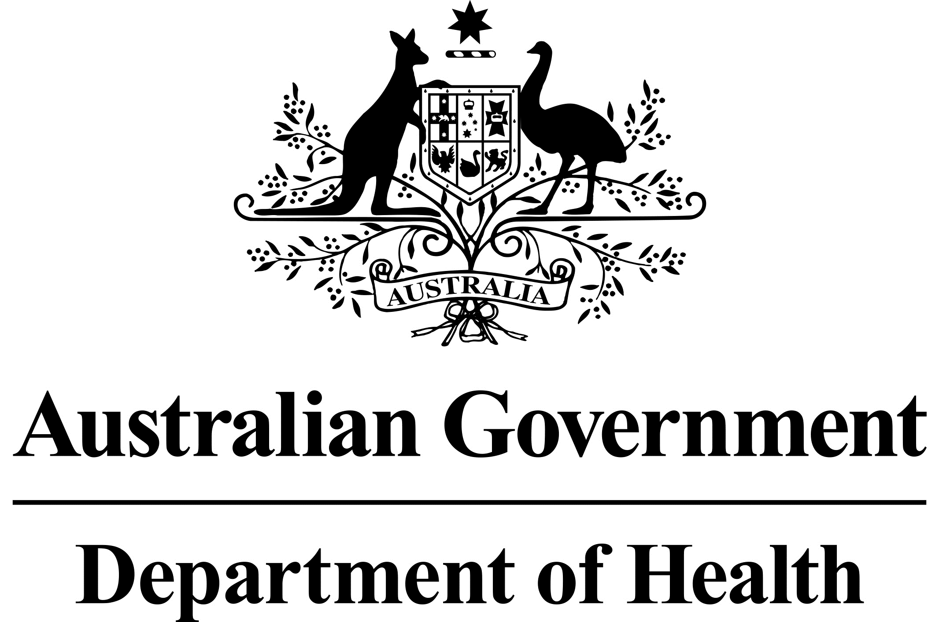

Allied Health Services in Residential Aged Care Facilities (RACFs) -

COVID Allied Health Package

Information for Residential Aged Care Facilities

The allied health group therapy program in RACFs aims to improve physical functioning of residents who are at risk of deconditioning due to COVID-19 lock downs in 2020. Funding is available for twice-weekly therapy for up to 26 weeks. Group therapy sessions will be led by a physiotherapist, occupational therapist or exercise physiologist.

PHNs will be commissioning allied health providers to do this work in late February or March 2021.

Funding will be provided to allied health professionals to conduct:

* + one initial meeting with the RACF (per professional group) to discuss the program;
  + one face-to-face initial consultation (per professional group) for each participant;
  + two hours of face-to-face group therapy per week per participant, over a minimum of two sessions (please note: this is not per professional group - a resident cannot participate in two hours per week with one profession and another two hours per week with a second profession); and
  + up to 26 weeks of therapy.

***Details on the program:***

* Group therapy will be led by a physiotherapist, occupational therapist or exercise physiologist. Allied health assistants, or student and/or RACF staff may also assist with program delivery.
* Before commencing the program, allied health professionals will visit the RACF to discuss logistics of the program with management.
* Group therapy will be delivered twice each week on non-consecutive days. Each session may last up to 1 hour.
* Group size is a maximum of 4 participants.
* The following link has all RACFs identified with COVID cases up until 23 October 2020. [www.health.gov.au/sites/default/files/documents/2020/10/covid-19-outbreaks-in-australian-residential-aged-care-facilities-23-october-2020_0.pdf](http://www.health.gov.au/sites/default/files/documents/2020/10/covid-19-outbreaks-in-australian-residential-aged-care-facilities-23-october-2020_0.pdf)

RACFs on this list are eligible for the program if they had 2 or more cases of COVID-19.

* All residents in identified RACFs can participate, if willing and deemed able to participate by the assessing allied health practitioner.

***PHNs:***

The eleven PHNs who will be commissioning the group therapy measure are:

*New South Wales*

* + Nepean Blue Mountains PHN
  + Northern Sydney PHN
  + South West Sydney PHN
  + Hunter New England and Central Coast PHN

*Victoria*

* + Murray PHN
  + North Western Melbourne PHN
  + Eastern Melbourne PHN
  + South Eastern Melbourne PHN
  + Gippsland PHN
  + Western Victoria PHN

*Tasmania*

* + Tasmania PHN