COVID‑19 outbreaks in Australian residential aged care facilities

# National snapshot

As at 8:00am on 5 February 2021 there are no active cases of COVID-19 related to aged care.

Table 1: Aged Care COVID-19 data as at 0800 on 5 February 2021

| Active outbreaks | 0 |
| --- | --- |
| Active resident cases | 0 |
| Active staff cases | 0 |
| Deaths | 678[1] |
| Total number of residential aged care facilities that have had an outbreak | 215 |
| Total number of outbreaks at residential aged care facilities | 221 |
| Number of residential aged care facilities with resolved outbreaks | 215 (221 outbreaks closed)[2] |
| Number of residential aged care facilities with only one case (resident or staff member) of COVID-19 | 95 |
| Total resident cases | 2,029 |
| Recovered resident cases | 1,351 |
| Total staff cases | 2,227 |
| Recovered staff cases | 2,227 |

# Analysis

## Current situation in Australia

In Australia, a total of 28,838 cases of COVID-19 have been reported, including 52 active cases and 909 deaths.

As at 5 February 2021, there are no active cases of COVID-19 in a staff member in a Commonwealth funded aged care service.

As at 8:00am on 5 February 2021, there are no active cases in residential aged care recipients.

The last new active case of COVID-19 in a residential aged care recipient was identified on 26 September 2020.

There have been no active cases of COVID-19 in aged care recipients since 28 October 2020.

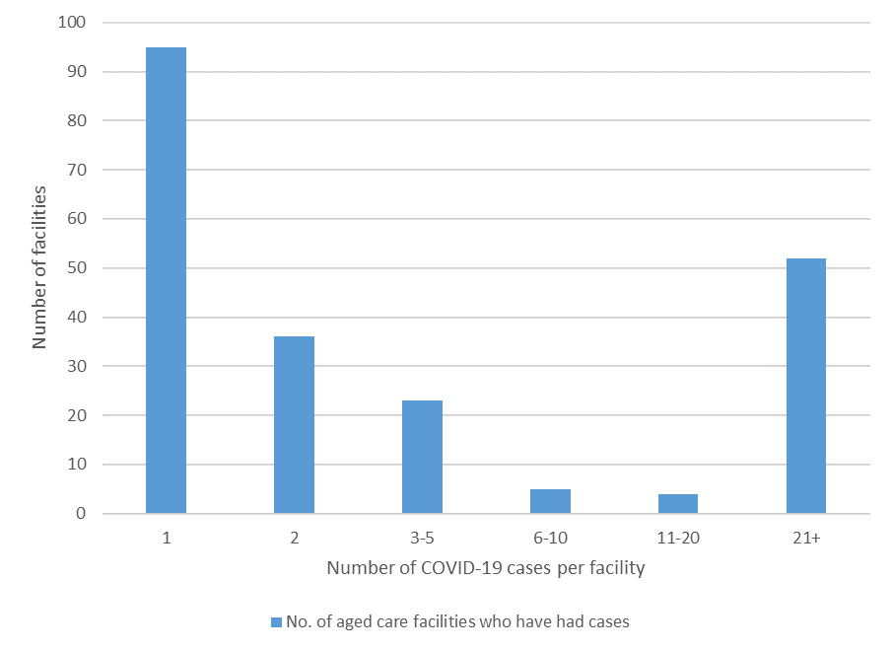Figure 1: Distribution of Australian residential aged care facilities by total number of cases of COVID-19 (includes staff and resident cases)

Of the 215 residential aged care facilities that have had a case(s) of COVID-19, 95 facilities (44 per cent) have had a single case of COVID-19.

**Figure 2: Number of daily reported COVID-19 cases in Australian residential aged care facilities overlayed with national locally acquired cases[3].** 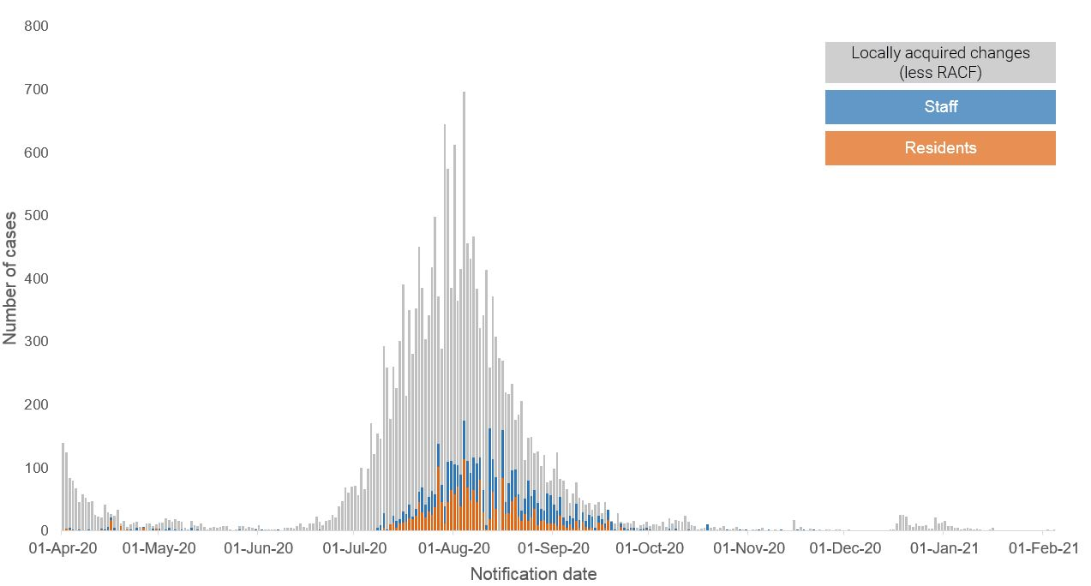

## International comparisons

During the COVID-19 pandemic, no country has been able to avoid outbreaks or deaths in residential aged care when there has been widespread community transmission.

The Australian death rate is 0.37 per cent (3.7 in 1,000) against the total number of residential aged care beds across the country.

By comparison, Canada has experienced approximately 20 times the number of deaths in care homes, than Australia as at 5 February 2021.

## Influenza cases and influenza-associated deaths

Sadly influenza kills many elderly Australians each year many of whom live in aged care facilities.

Influenza is an important issue in residential care. Residents, particularly the elderly, are often vulnerable to influenza due to co-morbidities and/or advanced age, and the environment of communal living facilitates the spread of respiratory agents[4].

Notification data for influenza by accommodation setting is not reported to the National Notifiable Disease Surveillance System (NNDSS).

The following data represents persons aged 65 and over for all accommodation settings. In those aged over 65 years, in the period 1 January to 31 December for each year*:

* The 2017 influenza calendar year data recorded the highest levels of influenza activity since 2009 swine flu pandemic with over 1,064 older Australians dying from influenza.
* In 2018, 115 older Australians died from influenza.
* In 2019, 839 older Australians died from influenza.
* In 2020, 28 older Australians died from influenza.

* The data provided were extracted from the NNDSS on 20 January 2021. NNDSS data is analysed and reported based on diagnosis date, which is the true onset date of a case if known, otherwise it is the earliest of the specimen date, the notification date or the notification received date. Due to the dynamic nature of the NNDSS, data in this extract is subject to retrospective revision and may vary from data reported in published NNDSS reports and reports of notification data by states and territories.

†No one single system, including notification data, provides the full picture on influenza, because influenza is a common disease and its presenting symptoms are non-specific, resulting in an under-representation of activity in national systems. The epidemiology of influenza is informed by a number of different systems, of which only one, national notification data, is presented here. Elements of the COVID-19 response, including social distancing measures, diversion of testing resources to COVID-19 diagnosis and resource implications of response activities, are affecting the number of notifiable disease cases notified to the NNDSS. Case numbers presented may not reflect actual notification trends. These effects may differ by jurisdiction

§Year on year comparisons of deaths in notified cases of influenza may not be reliable due to retrospective revision, variation across jurisdictions in methodology, representativeness and timeliness of death data. Further, cases’ outcome of infection may be retrospectively updated to “died” at a later point in the year.

## Workforce in active residential aged care outbreaks

As part of the aged care response, significant surge workforce assistance has been provided including by both State and National Aged Care Emergency Response (NACER) teams, with many workers deployed from interstate.

Table 2: Workforce resources supplied to residential aged care facilities

| Agency | Resources Supplied (as at 31 January 2021) |
| --- | --- |
| State and NACER (National Aged Care Emergency Response) Teams | Tasmanian Government: 7 clinical and 2 support staff.  Western Australian Government: 19 clinical personnel and 4 support staff.  South Australian Government: 18 clinical personnel and  4 support staff.  12 NACER teams (70 personnel) have been deployed.  The deployment of State and NACER teams is now complete. |
| AUSMAT | Completed 174 visits to 80 aged care facilities. |
| Australian Defence Force | Have visited 593 facilities conducting clinical screens, and conducted a total number of 679 preventative support visits. |
| Recruitment, Consulting, and Staffing Association (RCSA) | Staff supplied to fill 24,746 shifts. |
| Healthcare Australia | Staff supplied filled 5,249 shifts for workforce surge and  2,295 shifts for NACER teams. |
| Mable | Supplied 130 staff to fill 2,711 shifts. |
| Aspen Medical | Supplied 270 staff to fill 707 roles including clinical first responders. |
| Health X | Supplied 40 staff to fill 1,610 shifts. |
| Torrens Health | Supplied 1,208 shifts in surge workforce roles and 1,270 shifts as Residential Aged Care visitation Assistants (RACVAs). |
| Western Health | Visited 37 facilities to provide assistance. Agency is continuing to provide support to one aged care facility. |
| Residential Aged Care Assistants (RACA) | Supplied 54 RACAs to six facilities that have completed  832 shifts. |
| Residential Aged Care Safety Observers (RACSO) | Supplied 47 RACSOs to 18 facilities that have completed 1,346 shifts. |
| Residential Aged Care Visitation Assistant (RACVA) | RACVAs completed 1,205 shifts. |

## Provision of personal protective equipment (PPE)

A range of resources and online training on the use of PPE is available on the Department’s website for aged care workers.

Since March 2020, the Commonwealth Government has been working with state and territory governments to ensure aged care facilities have sufficient PPE. PPE is dispatched both directly from the National Medical Stockpile (NMS) and by jurisdictions on the NMS’ behalf, depending on the specific circumstances.

Over half a billion masks and approximately 53 million gowns, 164 million gloves, and 44 million goggles/face shields have been ordered for staggered delivery into the NMS through to 2021.

As at 2 February 2021, the NMS has provided aged care facilities with approximately:

* 20 million masks
* 5 million gowns
* 11 million gloves
* 4 million goggles and face shields
* 90,000 bottles of hand sanitiser
* 165,000 clinical waste bags.

The NMS remains well positioned to respond rapidly to critical shortages of PPE and other medical supplies anywhere in Australia. This includes a series of bulk dispatches of personal protective equipment (PPE) intended to avert any potential critical supply shortages, as well as urgent deployments to organisations and individuals at risk of exposure to COVID-19.

## Testing of aged care residents and staff

The Australian Government has engaged Sonic Healthcare to provide a dedicated pathology service for the testing of suspected cases of COVID-19 in residential aged care facilities. The service is intended to supplement existing public health pathology services in aged care through the provision of services from the private sector as required.

As at 26 January 2021, Sonic Healthcare has conducted 296,812 COVID‑19 tests at 2,330 unique residential aged care facilities nationally. This includes 247,986 COVID‑19 tests at 720 unique residential aged care facilities in Victoria.

Testing regimens for residents and staff at aged care facilities that experience a COVID-19 outbreak is based on advice from the relevant Public Health Unit.

To help the sector to drive down case numbers, the Australian Government has expanded capacity for testing of asymptomatic aged care workers in Victoria. Workers in residential aged care facilities are being tested fortnightly in metropolitan Melbourne, and monthly in regional Victoria. Since 19 October 2020, 3,716 coordinated asymptomatic testing visits have been conducted, and 72,803 tests conducted at aged care facilities in Victoria.

The Australian Government provided asymptomatic testing through SONIC to the   
31 residential aged care facilities in the Northern Beaches of NSW in December 2020 testing was offered to 89 RACFs in Sydney’s Inner West in January 2021. This testing program has concluded.

This testing service is intended to supplement existing public health pathology services in aged care through the provision of services from the private sector as required. The Australian Government is ready to provided asymptomatic testing support to facilities in Western Australia and Victoria following a community case in each jurisdiction.

Asymptomatic Testing in Western Australia have commenced on 4 February 2021 and is to be conducted at two aged care facilities per day for three days, for a total of six facilities.

## Infection control and audits

The Aged Care Quality and Safety Commission (Commission) is conducting an ongoing infection control monitoring program in all Australian jurisdictions, working in partnership with local health authorities. This program is in addition to the Commission’s usual assessment and auditing program, and includes spot checks to residential aged care services, without an outbreak, to check compliance with PPE and infection control arrangements.

The purpose of the visit is to observe infection control practices, to ensure that staff, management and visitors are adhering to safe personal protective equipment protocols and to safe infection control arrangements as required under the quality standards.

Between 1 March 2020 and 3 February 2021, the Commission undertook 3,005 unannounced visits and announced/short notice visits nationally. During this period 2,473 visits relating to infection control were made nationally.

All residential aged care facilities are required to engage an onsite clinical lead to provide leadership and increase capacity in relation to infection prevention and control. The Australian Government is providing a second payment of the COVID-19 supplement to assist facilities in meeting the additional costs of preparing for and responding to COVID-19.

In addition, under the Commonwealth-State Plan to boost aged care preparedness, states and territories are complementing the activity being undertaken by the Commission through additional site visits by state health services at the local level, which includes work relating to infection prevention and control (see Table 3 below). These visits are strengthening state health service relationships with local aged care services as part of the standing up of joint health aged care emergency response centres in each jurisdiction.

The Australian Government is working collaboratively with the states and territories to further bolster infection prevention and control through high quality face-to-face training in the aged care sector. In particular, the Government has committed $57.8 million to fund states and territories to deploy accredited infection prevention and control (IPC) experts into residential aged care facilities to provide training, and assist with the refinement of outbreak management plans where needed.

**Table 3: Total Quality Assessment and Monitoring Activities with residential services (including IPC), by type and month 1 March – to 3 February 2021**

| Regulatory Activities | Mar-20 | Apr- 20 | May-20 | Jun-20 | Jul- 20 | Aug-20 | Sep-20 | Oct-20 | Nov- 20 | Dec-20 | Jan-21 | Feb-21 | Total |
| --- | --- | --- | --- | --- | --- | --- | --- | --- | --- | --- | --- | --- | --- |
| Site visits | 97 | 12 | 94 | 115 | 132 | 329 | 580 | 485 | 329 | 362 | 293 | 36 | 2,864 |
| Non-site activities | 3,138 | 419 | 80 | 69 | 1,401 | 2,765 | 408 | 310 | 426 | 1065 | 134 | 254 | 10,469 |
| Total activities | **3,235** | **431** | **174** | **184** | **1,533** | **3,094** | **988** | **795** | **755** | **1,427** | **427** | **290** | **13,333** |

*Includes data up 3 February 2021.

# Appendix 1: National residential aged care services with two or more positive COVID-19 cases

Victorian data is from the Public Health Events Surveillance System (PHESS). Case data for residential aged care facilities in all states except Victoria is collected by the Commonwealth Government.[5]

| No | State | Residential Aged Care Facility | Total Cases | Resident total | Resident resolved | Staff total | Staff Resolved | Resident deaths[6] | Resolved / Active |
| --- | --- | --- | --- | --- | --- | --- | --- | --- | --- |
| 1 | NSW | Dorothy Henderson Lodge, BaptistCare | 22 | 17 | 11 | 5 | 5 | 6 | R |
| 2 | NSW | Newmarch House Aged Care Facility | 71 | 37 | 18 | 34 | 34 | 19 | R |
| 3 | NSW | Opal Aged Care Bankstown | 6 | 3 | 0 | 3 | 3 | 3 | R |
| 4 | NSW | Storm Village - Anglican Care | 2 | 0 | 0 | 2 | 2 | 0 | R |
| 5 | SA | Anglicare Brompton | 4 | 0 | 0 | 4 | 4 | 0 | R |
| 6 | TAS | Melaleuca Home For The Aged | 2 | 1 | 0 | 1 | 1 | 1 | R |
| 7 | VIC | Arcare Burnside | 5 | 0 | 0 | 5 | 5 | 0 | R |
| 8 | VIC | Arcare Craigieburn | 82 | 37 | 22 | 45 | 45 | 15 | R |
| 9 | VIC | Arcare Maidstone | 7 | 0 | 0 | 7 | 7 | 0 | R |
| 10 | VIC | Arcare Sydenham | 47 | 22 | 16 | 25 | 25 | 6 | R |
| 11 | VIC | Assisi Centre Aged Care | 3 | 0 | 0 | 3 | 3 | 0 | R |
| 12 | VIC | Aurrum Healesville | 2 | 0 | 0 | 2 | 2 | 0 | R |
| 13 | VIC | Aurrum Plenty | 83 | 47 | 34 | 36 | 36 | 13 | R |
| 14 | VIC | Aurrum Reservoir | 3 | 0 | 0 | 3 | 3 | 0 | R |
| 15 | VIC | Avonlea Grange Hostel | 2 | 0 | 0 | 2 | 2 | 0 | R |
| 16 | VIC | Baptcare Brookview Community | 21 | 10 | 9 | 11 | 11 | 1 | R |
| 17 | VIC | Baptcare Strathalan Community | 2 | 0 | 0 | 2 | 2 | 0 | R |
| 18 | VIC | Baptcare The Orchards Community | 2 | 0 | 0 | 2 | 2 | 0 | R |
| 19 | VIC | Baptcare Wyndham Lodge Community | 232 | 101 | 71 | 131 | 131 | 30 | R |
| 20 | VIC | Benetas St George's | 70 | 32 | 20 | 38 | 38 | 12 | R |
| 21 | VIC | Bill Crawford Lodge | 5 | 2 | 2 | 3 | 3 | 0 | R |
| 22 | VIC | BlueCross Autumdale | 54 | 24 | 11 | 30 | 30 | 13 | R |
| 23 | VIC | BlueCross Baradine | 2 | 0 | 0 | 2 | 2 | 0 | R |
| 24 | VIC | BlueCross Chelsea Manor | 5 | 0 | 0 | 5 | 5 | 0 | R |
| 25 | VIC | BlueCross Elly Kay | 2 | 1 | 0 | 1 | 1 | 1 | R |
| 26 | VIC | BlueCross Ivanhoe | 5 | 0 | 0 | 5 | 5 | 0 | R |
| 27 | VIC | BlueCross Riverlea (1st Outbreak) | 3 | 0 | 0 | 3 | 3 | 0 | R |
| 28 | VIC | BlueCross Riverlea (2nd Outbreak) | 1 | 0 | 0 | 1 | 1 | 0 | R |
| 29 | VIC | BlueCross Ruckers Hill | 108 | 48 | 36 | 60 | 60 | 12 | R |
| 30 | VIC | BlueCross Silverwood | 2 | 0 | 0 | 2 | 2 | 0 | R |
| 31 | VIC | BlueCross The Boulevard | 69 | 36 | 22 | 33 | 33 | 14 | R |
| 32 | VIC | BlueCross Westgarth | 32 | 14 | 8 | 18 | 18 | 6 | R |
| 33 | VIC | Boyne Russell House | 2 | 0 | 0 | 2 | 2 | 0 | R |
| 34 | VIC | Bupa Edithvale | 78 | 44 | 26 | 34 | 34 | 18 | R |
| 35 | VIC | Bupa Greensborough | 2 | 0 | 0 | 2 | 2 | 0 | R |
| 36 | VIC | Bupa Sunshine | 2 | 0 | 0 | 2 | 2 | 0 | R |
| 37 | VIC | Bupa Templestowe | 11 | 3 | 1 | 8 | 8 | 2 | R |
| 38 | VIC | Bupa Traralgon | 19 | 7 | 5 | 12 | 12 | 2 | R |
| 39 | VIC | Bupa Woodend | 4 | 1 | 1 | 3 | 3 | 0 | R |
| 40 | VIC | Campbell Place Aged Care Facility | 2 | 0 | 0 | 2 | 2 | 0 | R |
| 41 | VIC | Chomley House Hostel | 2 | 0 | 0 | 2 | 2 | 0 | R |
| 42 | VIC | Churches of Christ Care Arcadia Aged Care Service Essendon | 22 | 10 | 6 | 12 | 12 | 4 | R |
| 43 | VIC | Coppin Centre Melbourne | 2 | 0 | 0 | 2 | 2 | 0 | R |
| 44 | VIC | Craigcare Pascoe Vale | 94 | 47 | 31 | 47 | 47 | 16 | R |
| 45 | VIC | Cumberland Manor | 107 | 53 | 42 | 54 | 54 | 11 | R |
| 46 | VIC | Doutta Galla Footscray Aged Care Facility (1st Outbreak) | 1 | 0 | 0 | 1 | 1 | 0 | R |
| 47 | VIC | Doutta Galla Footscray Aged Care Facility (2nd Outbreak) | 56 | 30 | 21 | 26 | 26 | 9 | R |
| 48 | VIC | Doutta Galla Lynch's Bridge Aged Care Facility | 2 | 0 | 0 | 2 | 2 | 0 | R |
| 49 | VIC | Doutta Galla Woornack Aged Care Facility | 42 | 20 | 12 | 22 | 22 | 8 | R |
| 50 | VIC | Doutta Galla Yarraville Village Aged Care Facility | 86 | 42 | 25 | 44 | 44 | 17 | R |
| 51 | VIC | Edenvale Manor Aged Care Facility | 20 | 14 | 10 | 6 | 6 | 4 | R |
| 52 | VIC | Embracia in Reservoir (1st Outbreak) | 1 | 0 | 0 | 1 | 1 | 0 | R |
| 53 | VIC | Embracia in Reservoir (2nd Outbreak) | 1 | 0 | 0 | 1 | 1 | 0 | R |
| 54 | VIC | Embracia Moonee Valley | 61 | 26 | 17 | 35 | 35 | 9 | R |
| 55 | VIC | Epping Gardens | 190 | 103 | 65 | 87 | 87 | 38 | R |
| 56 | VIC | Estia Health Ardeer | 133 | 49 | 32 | 84 | 84 | 17 | R |
| 57 | VIC | Estia Health Glen Waverley | 6 | 2 | 2 | 4 | 4 | 0 | R |
| 58 | VIC | Estia Health Heidelberg West | 97 | 29 | 19 | 68 | 67 | 10 | R |
| 59 | VIC | Estia Health Keilor (1st Outbreak) | 4 | 2 | 2 | 2 | 2 | 0 | R |
| 60 | VIC | Estia Health Keilor (2nd Outbreak) | 42 | 24 | 18 | 18 | 18 | 6 | R |
| 61 | VIC | Estia Health Keysborough | 21 | 8 | 5 | 13 | 13 | 3 | R |
| 62 | VIC | Estia Health Ringwood (1st Outbreak) | 1 | 0 | 0 | 1 | 1 | 0 | R |
| 63 | VIC | Estia Health Ringwood (2nd Outbreak) | 1 | 0 | 0 | 1 | 1 | 0 | R |
| 64 | VIC | Florence Aged Care Facility | 46 | 28 | 20 | 18 | 18 | 8 | R |
| 65 | VIC | Fronditha Thalpori Aged Care Services - St Albans | 3 | 1 | 0 | 2 | 2 | 1 | R |
| 66 | VIC | Glendale Aged Care | 93 | 45 | 29 | 48 | 48 | 16 | R |
| 67 | VIC | Glenlyn Aged Care Facility | 63 | 40 | 36 | 23 | 23 | 4 | R |
| 68 | VIC | Grace Of Mary Greek Cypriot Elderly Hostel | 55 | 22 | 11 | 33 | 33 | 11 | R |
| 69 | VIC | Grant Lodge Aged Care Facility (1st Outbreak) | 1 | 0 | 0 | 1 | 1 | 0 | R |
| 70 | VIC | Grant Lodge Aged Care Facility (2nd Outbreak) | 1 | 0 | 0 | 1 | 1 | 0 | R |
| 71 | VIC | HammondCare - Caulfield Village Aged care Facility | 2 | 2 | 2 | 0 | 0 | 0 | R |
| 72 | VIC | Holloway Aged Care Services | 3 | 1 | 0 | 2 | 2 | 1 | R |
| 73 | VIC | James Barker House | 3 | 1 | 1 | 2 | 2 | 0 | R |
| 74 | VIC | Japara Central Park | 40 | 18 | 15 | 22 | 22 | 3 | R |
| 75 | VIC | Japara Elanora | 63 | 31 | 19 | 32 | 32 | 12 | R |
| 76 | VIC | Japara Goonawarra | 103 | 53 | 33 | 50 | 50 | 20 | R |
| 77 | VIC | Japara Millward | 36 | 19 | 15 | 17 | 17 | 4 | R |
| 78 | VIC | Japara The Regent | 42 | 21 | 18 | 21 | 21 | 3 | R |
| 79 | VIC | Kalyna Care | 101 | 57 | 31 | 44 | 44 | 26 | R |
| 80 | VIC | Kirkbrae Kilsyth Nursing Home | 115 | 61 | 40 | 54 | 54 | 21 | R |
| 81 | VIC | Liscombe House | 2 | 0 | 0 | 2 | 2 | 0 | R |
| 82 | VIC | Little Sisters of the Poor St Joseph's Home | 2 | 1 | 0 | 1 | 1 | 1 | R |
| 83 | VIC | Lynden Aged Care | 3 | 1 | 1 | 2 | 2 | 0 | R |
| 84 | VIC | Maculata Place Shepparton ViIllages | 3 | 1 | 1 | 2 | 2 | 0 | R |
| 85 | VIC | Martin Luther Homes The Basin | 2 | 0 | 0 | 2 | 2 | 0 | R |
| 86 | VIC | Mecwacare John Atchison Centre | 84 | 45 | 27 | 39 | 39 | 18 | R |
| 87 | VIC | Melbourne Hebrew Memorial Nursing Home (1st Outbreak) | 1 | 0 | 0 | 1 | 1 | 0 | R |
| 88 | VIC | Melbourne Hebrew Memorial Nursing Home (2nd Outbreak) | 1 | 0 | 0 | 1 | 1 | 0 | R |
| 89 | VIC | Menarock Life Emmavale Gardens | 4 | 1 | 1 | 3 | 3 | 0 | R |
| 90 | VIC | Menarock Life Essendon Aged Care | 47 | 20 | 13 | 27 | 27 | 7 | R |
| 91 | VIC | Menarock Life McGregor Gardens Aged Care | 4 | 1 | 1 | 3 | 3 | 0 | R |
| 92 | VIC | Menarock Life Rosehill Aged Care Facility | 82 | 51 | 34 | 31 | 31 | 17 | R |
| 93 | VIC | Mercy Place Dandenong | 21 | 13 | 10 | 8 | 8 | 3 | R |
| 94 | VIC | Mercy Place Montrose | 2 | 0 | 0 | 2 | 2 | 0 | R |
| 95 | VIC | Mercy Place Parkville | 97 | 58 | 36 | 39 | 39 | 22 | R |
| 96 | VIC | Mercy Place Templestowe | 2 | 1 | 1 | 1 | 1 | 0 | R |
| 97 | VIC | Mercy Place Wyndham | 5 | 2 | 1 | 3 | 3 | 1 | R |
| 98 | VIC | Mitchell House Hostel Morwell | 2 | 1 | 1 | 1 | 1 | 0 | R |
| 99 | VIC | Montefiore Homes Community Residence Jewish Care Hannah and Daryl Cohen Centre Windsor Aged Care Facility | 67 | 33 | 31 | 34 | 34 | 2 | R |
| 100 | VIC | Opal Hobsons Bay Altona North | 37 | 22 | 13 | 15 | 15 | 9 | R |
| 101 | VIC | Opal South Valley | 56 | 32 | 24 | 24 | 24 | 8 | R |
| 102 | VIC | Outlook Gardens Aged Care | 99 | 41 | 28 | 58 | 58 | 13 | R |
| 103 | VIC | Point Cook Manor Aged Care | 2 | 0 | 0 | 2 | 2 | 0 | R |
| 104 | VIC | Princeton View | 71 | 28 | 19 | 43 | 43 | 9 | R |
| 105 | VIC | Rathdowne Place Carlton | 9 | 1 | 1 | 8 | 8 | 0 | R |
| 106 | VIC | Regis Brighton | 67 | 24 | 13 | 43 | 43 | 11 | R |
| 107 | VIC | Regis Cranbourne | 2 | 0 | 0 | 2 | 2 | 0 | R |
| 108 | VIC | Regis Fawkner | 5 | 4 | 3 | 1 | 1 | 1 | R |
| 109 | VIC | Regis Macleod | 2 | 0 | 0 | 2 | 2 | 0 | R |
| 110 | VIC | Regis Macleod (2nd Outbreak) | 2 | 0 | 0 | 2 | 2 | 0 | R |
| 111 | VIC | Riddell Gardens Hostel | 2 | 2 | 0 | 0 | 0 | 2 | R |
| 112 | VIC | Royal Freemasons Gregory Lodge | 66 | 39 | 24 | 27 | 27 | 15 | R |
| 113 | VIC | Royal Freemasons Monash Gardens Hostel | 2 | 0 | 0 | 2 | 2 | 0 | R |
| 114 | VIC | Sheridan Aged Care (Kyabram District Health Service) | 3 | 0 | 0 | 3 | 3 | 0 | R |
| 115 | VIC | St Basil's Homes for the Aged in Victoria | 191 | 94 | 49 | 97 | 97 | 45 | R |
| 116 | VIC | St Vincent's Care Services Eltham - Eltham Lodge | 2 | 0 | 0 | 2 | 2 | 0 | R |
| 117 | VIC | Sutton Park Assisted Aged Care | 77 | 46 | 39 | 31 | 31 | 7 | R |
| 118 | VIC | Twin Parks Aged Care Centre | 125 | 79 | 57 | 46 | 46 | 22 | R |
| 119 | VIC | Uniting AgeWell Box Hill | 2 | 0 | 0 | 2 | 2 | 0 | R |
| 120 | VIC | Uniting AgeWell Kingsville | 2 | 0 | 0 | 2 | 2 | 0 | R |
| 121 | VIC | Uniting AgeWell Preston (1st Outbreak) | 1 | 0 | 0 | 1 | 1 | 0 | R |
| 122 | VIC | Uniting AgeWell Preston (2nd Outbreak) | 2 | 0 | 0 | 2 | 2 | 0 | R |
| 123 | VIC | Villa Maria Catholic Homes Berwick Aged Care Residence | 8 | 5 | 5 | 3 | 3 | 0 | R |
| 124 | VIC | Villa Maria Catholic Homes Corpus Christi Aged Care Residence | 3 | 0 | 0 | 3 | 3 | 0 | R |
| 125 | VIC | Villa Maria Catholic Homes St Bernadette's Aged Care Residence | 17 | 4 | 1 | 13 | 13 | 3 | R |
| 126 | VIC | Village Glen Aged Care Residences - Mornington | 38 | 21 | 16 | 17 | 17 | 5 | R |
| 127 | VIC | Westernport Nursing Home | 2 | 0 | 0 | 2 | 2 | 0 | R |

1. The figure for deaths in RACFS excludes 7 cases that were identified in transition care services.
2. Some residential aged care facilities have had more than one outbreak.
3. National daily cases sourced from NNDSS data as at 4 February 2021 and are filtered to locally acquired cases. Case numbers reflect the date of reporting which may differ to diagnosis date. Residential aged care facility staff and resident data sourced from the Department of Health Aged Care COVID Liaison Team. Totals reflect the date of case report and may be affected by delayed reporting.

   ‘RACF’ refers to cases in residential aged care facilities (staff and residents)
4. Reference: Guidelines for the Prevention, Control and Public Health Management of Influenza Outbreaks in Residential Care Facilities in Australia
5. The Victorian Department of Health and Human Services has undertaken a retrospective review of COVID-19 Cases linked to RECFs. As a result, on 20 January 2020 there were cases linked and unlinked to outbreaks in Victorian RACFs.
6. In Victoria, a death is reported when a person with COVID-19 dies during an active outbreak at an aged care facility, irrespective of the cause of death.