An approach to Supporting overall wellness

MORE GOOD DAYS Wellness WhEel

What does wellness mean to your client?
How do you know you are helping them improve their wellness?
More Good Days is a technique that can help you understand what wellness and wellbeing means to your client
Wellness means different things to different people. There is no one-size-fits-all approach. Understanding what wellness means for each client is the first step in developing personalised service goals and delivering a wellness and reablement approach. This can be as simple as understanding what a good day looks like for someone. By identifying the things your client loves doing, you can deliver support in a way that helps them keep doing those things which matter most to them.

More good days WELLNESS WHeel
The More Good Days Wellness Wheel is a tool that helps you understand what is important to your client, what gives their life meaning, where they currently are, and where they want to be. From there (and with the information gathered from the support plan), you can work with your clients to develop an individualised care plan.
A whole of person approach to wellness means that you not only understand your client’s current situation and their circumstances, but you understand what holistic wellness looks like for them across three areas: mind, body, and social connectedness (Figure 1).


Mind wellness

refers to thoughts, feelings, and behaviours. Mind wellness is about how people are feeling, their state of mind, and what mental activities stimulate their mind.


Body wellness

refers to a person’s physical health. A person’s body wellness can be improved or maintained through a nutritious diet, various forms of physical activity and healthy lifestyle choices.

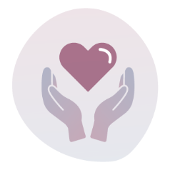
Social connectedness

is important to maintain as it keeps people engaged with their relationships, such as family and friends, the community, and other social groups. Strong social connectedness with people and environments gives people coping mechanisms to draw on when needed. It also improves people’s sense of wellbeing. This is particularly important when people are in a state of aged-related decline
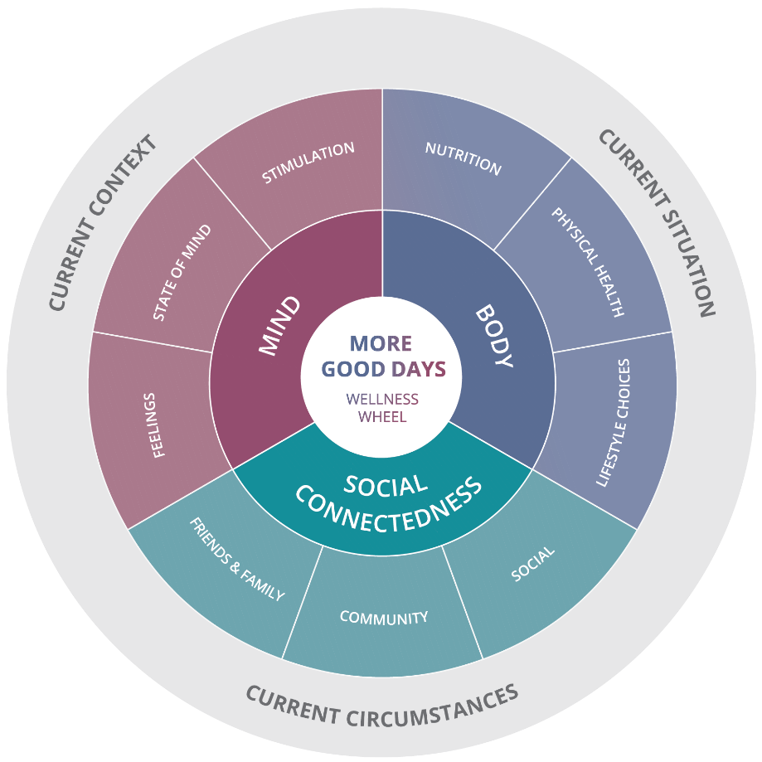
Figure 1: More Good Days Wellness Wheel

Applying the more good days wellness wheel
Using the More Good Days Wellness Wheel as a tool will help you to understand what a good day looks like for your client. It will help you develop a holistic care plan aimed at supporting your client to achieve overall wellness.
The More Good Days Wellness Wheel has been designed to:
- Understand what holistic wellness means to your client
- Develop a personalised care plan
- Guide support workers to deliver tailored and individualised support to clients
- Motivate clients to achieve their goals and participate in their wellness journey

1. UNDERSTAND WHAT HOLISTIC WELLNESS MEANS TO YOUR CLIENT
The RAS support plan provides you with a foundational understanding of your client and what wellness means to them. The More Good Days Wellness Wheel helps you have personalised conversations with your client on their current situation and what wellness and well-being looks like to them.
When having conversations with your client, it is important that you focus on your client’s strengths and what they can do, rather than on what they cannot do. Figure 2 provides a guide on some key questions which can be considered when understanding what wellness means to your client. The questions align to each of the sections of the More Good Days Wellness Wheel.
Note: the list of questions
the below questions act as a guide to help facilitate a discussion with your client to understand their situation and what is important to them. You are not expected to ask them every question, it is not a prescriptive list. It is important your client does not feel like they are going through another assessment. Use the questions to guide your conversation with the client to inform their individualised care plan.

 | Elements of wellness | Example questions for determining wellness
CURRENT SITUATION / CONTEXT / CIRCUMSTANCE | Situation | What are you currently doing for yourself?  What is working well for you at the moment?  What does a good day look like? What makes it a good day?
CURRENT SITUATION / CONTEXT / CIRCUMSTANCE | Resources | Are there things you use which makes things easier for you?  Do you have any equipment/aids that help you?  How do you get by managing your ‘problem areas’?
MIND | Feelings | How do you feel you are managing?  What are you feeling good about?  What is something that you do to feel good?  What is working well at the moment?
MIND | State of mind | What is your favourite part of the day? Why?  What do you like to do/achieve?  How do you feel when you wake up in the morning?  How do you feel when you go to bed at night?  Do you feel like you get enough sleep?
MIND | Stimulation | What activities stimulate your mind?  Is there something new that you would like to try?  When was the last time you learnt something new/re-learnt something?
BODY | Nutrition | Do you feel like you are eating well?  What do you like eating?  Has your diet changed at all recently?  Is there a reason for the change?  Are you managing cooking for yourself?  Are you managing shopping?
BODY | Physical activity | What do you enjoy doing to stay active?  On a good day, what kinds of activities have you been involved in doing?  What support/equipment do you have to help you remain active?  Do you prefer to be active with a group or alone?
BODY | Lifestyle choices | What do you enjoy doing?  What do you do to relax?  What excites you?  What makes you feel satisfied?  What are your interests?  How do you like to spend your time?
SOCIAL CONNECTEDNESS | Family & friends | Who is important to you? Why?  Who supports you in your daily life?  Who do you support? And what role do you have?  How often do you see your friends or family?
SOCIAL CONNECTEDNESS | Social | What social activites do you like?  Do you have various social groups/clubs you enjoy?
SOCIAL CONNECTEDNESS | Community | What do you like to do in the community?  What communities do you see yourself part of?

Example questions for determining individual wellness

2. DEVELOP A PERSONALISED CARE PLAN
Person-centred and goal directed care planning is critical to the success of wellness and reablement. The More Good Days Wellness Wheel helps you understand what gives your client’s life meaning, which is a solid foundation for developing a person-centred and goal directed care plan.
Developing goals that are meaningful and achievable, aimed at helping people achieve more good days and maximise their independence and autonomy will encourage participation from clients and help support workers deliver wellness and reablement focused support.

3. GUIDE SUPPORT WORKERS TO DELIVER TAILORED SUPPORT TO CLIENTS
The More Good Days Wellness Wheel is a powerful tool for assessing wellness and wellbeing and informing client goals and care plans. It is an equally powerful tool for support workers who need to deliver tailored support to the clients, which focuses on building their wellness and maximising their independence and autonomy.
We know that wellness is unique to the individual and there is no one-size-fits all approach for clients. The same goes for service delivery. Outcomes from the More Good Days Wellness Wheel must inform and support the support worker to deliver wellness and reablement focused support.
Figure 3 depicts how outputs from the wheel can connect the care coordinator/facilitator and support worker to assist the client to meet their wellness goals.
Figure 3. More Good Days Wellness Wheel in practice

4. MOTIVATE CLIENTS TO ACHIEVE THEIR GOALS AND PARTICIPATE IN THEIR WELLNESS JOURNEY
Not only does the More Good Days Wellness Wheel help service providers, it can help clients by including an element of the wheel in their care plan. This will paint a holistic picture and motivate the client by showing them what gives their life purpose and meaning, and how their support worker is going to help them achieve their goals.
This More Good Days Wellness Wheel is a reminder to the client about what they are working towards and why this is so important for them to commit it; they want more good days, and this is how they will get there.

