A TOOLKIT FOR EMBEDDING  
WELLNESS AND REABLEMENT INTO YOUR ORGANISATION

**COMMONWEALTH HOME SUPPORT PROGRAMME (CHSP)  
SERVICE PROVIDERS**

# Contents

Contents 1

ABOUT THIS TOOLKIT 1

INTRODUCTION 1

understanding the policy context 1

understanding the Ageing journey 1

UNDERSTANDING WELLNESS AND REABLEMENT 1

Benefits of a wellness and reablement approach 1

Moving towards ‘*More Good Days’* 1

Your wellness and reablement obligations 1

Stage 1: prepare 1

Stage 2: Implement 1

Stage 3: Evaluate 1

# ABOUT THIS TOOLKIT

The *Toolkit for Embedding Wellness and Reablement into your Organisation* (the Toolkit) was developed to provide Commonwealth Home Support Programme (CHSP) service providers with the information and tools needed to **prepare**, **implement** and **evaluate** the embedding of wellness and reablement in their organisation.

**Wellness and reablement are the cornerstone of how aged care support is provided for older Australians. Many CHSP service providers understand and believe in the philosophy of wellness and reablement but have asked for support in applying it practically within their organisation.**

The Toolkit and the subsequent support tools help managers fulfil their CHSP requirements and embed wellness and reablement into their organisation practices. This Toolkit is supported by a ***Practical Guide for Embedding Wellness and Reablement***, which provides practical guidance for employees on embedding wellness and reablement into their service delivery practices.

The Toolkit has been designed to suit the diverse needs of service provider organisations to:

* **develop** a shared understanding of wellness and reablement across the aged care sector
* **identify** the level of maturity in embedding wellness and reablement
* **understand** the practices which will assist in developing maturity in embedding wellness and reablement
* **how to evaluate and review** wellness and reablement practices to ensure the correct behaviours and high-quality practices are implemented

## Who is this Toolkit for?

This Toolkit has been designed to assist managers of CHSP service provider organisations to practically embed, review and continuously improve wellness and reablement in their organisation.

CHSP organisational practices, activities, as well as staffing size and service offerings differ widely. This Toolkit is intended to be used and applied flexibly by service providers. It acts as a guide, providing support to organisations on how change can be introduced, and how wellness and reablement can be implemented.

## How to use THIS Toolkit

The Toolkit has been divided into four sections to provide a guide for organisations to effectively implement wellness and reablement:

### Introduction

This section provides overarching **information** on the aged care policy context and wellness and reablement to provide the right foundations for implementing wellness and reablement within your organisation. All service providers/employees are recommended to be familiar with this section.

### Graphic showing three stages: Stage 1: Prepare, stage 2: Implement, stage 3: Evaluate*Stage 1: Prepare*

This section provides guidance and tools for **assessing** your organisation’s maturity for implementing wellness and reablement, and better **prepare** your organisational structures to better suit wellness and reablement practices.

### *Stage 2: Implement*

This section provides guidance and tools for **implementing** wellness and reablement within your organisation, specifically, your people, processes, and systems.

### *Stage 3: Evaluate*

This section provides guidance on how your organisation can **evaluate** and improve on wellness and reablement practices and policies.

## Navigating this Toolkit

This Toolkit has been designed to guide and support people through the implementation process.  
Case studies, definitions, helpful tips, and tools are featured throughout the Toolkit and can be found  
using the following icons:



**PRACTICAL EXAMPLES**



**DEFINITION**



**HELPFUL TIPS**



**TOOLS**

INTRODUCTION

# Understanding the policy context

The aged care sector is characterised by change and is continuously evolving to meet the needs of older Australians. People are living longer, have more complex care needs and want to live independently in their homes for as long as possible.

As a result, the aged care sector has moved away from a dependency-based service delivery model (‘doing for’) towards a model that supports wellness and independence (‘doing with’ and ‘alongside’).

## The future of aged care policy

Ongoing aged care reforms aim to improve the way older Australians access, receive and experience aged care services. To remain eligible for government funding, CHSP service providers are required to adopt and embed wellness and reablement into their organisational practices and service delivery. Those organisations who are actively delivering wellness and reablement-focused services are better positioned to respond to changing needs of aged care policy and older people’s desire for greater independence.

## Ageing population is growing

The ageing population is rapidly growing. Over the last 20 years, the proportion of people aged 65 years and over has increased from 12.3% to 15.9%[1]. By 2060, around one in four Australians will be aged 65 years or over[2]. As the population changes, so do people’s needs. Traditional dependency-based service models are outdated and not sustainable. Research shows this type of service model contributes to a faster decline in the independence and ability of older people[3]. With more people living longer, it is critical that people are encouraged and empowered to remain mobile, independent, and socially active.

## Desire for independence

Older Australians have a greater desire than ever before to age in their own home. Over the years, government spending for home care has increased at a greater rate than spending on residential aged care, further supporting people’s desire for independence.  As a result, older Australians are in search of **tailored support** that **maximises their strengths** and **enables them to maintain/regain independence**.

# Understanding the Ageing journey

*The aged care sector is continuously changing to meet the needs of older Australians. People are living longer, have more complex care needs and want to live in their homes for as long as possible. Over the past decade, emerging research has demonstrated the benefits of focusing on client independence. Traditional models of service delivery that focus on what a client can’t do rather than what they can, tend to lead to an over-reliance on services by clients, which has been linked with accelerated functional decline.*

Research suggests that the largest influencer in age-related decline is not genetics, but rather lifestyle choices. People who continue to do things for themselves tend to remain independent and live better, longer. Professor Peter Gore of the Institute of Ageing at Newcastle University in the United Kingdom (UK) has developed a framework to understand age-related decline[4]. The framework, called the Life Curve, looks at the impact of maintaining independence on quality of life and the rate of age-related functional decline. It illustrates that the sooner someone stops performing certain tasks for themselves, the faster they tend to lose their functional ability. The aim is to assist people to perform these daily tasks independently for as long as possible, so they maintain the ability to maximise independence and autonomy. Retaining physical ability helps people to continue doing the things they enjoy for longer.

The Life Curve is shown at Figure 1. The vertical axis lists activities of daily living that older people generally lose over time, in the order in which they tend to be lost, from top to bottom. The timeframe for this decline is variable and can be influenced by behaviour and interventions. Difficulty cutting toenails is typically seen as an early indicator that intervention may be needed. The graph shows two trajectories – a sub-optimal life curve with a fast early decline, and an optimal life curve in which the early decline is slowed down to give people more good days before losing the ability to undertake the activities like walking, shopping and personal care.

Supporting clients to continue doing everyday activities means you are not only delivering high quality care; you are empowering them to have ***more good days doing the things they love***.

# A picture containing screenshot Description automatically generatedFigure 1: The Activity of Daily Living Life Curve[5]

# UNDERSTANDING WELLNESS AND REABLEMENT

*Wellness and reablement are related concepts, often used together to describe an overall approach to service delivery. Wellness and reablement approaches are based on the idea that, even with frailty, chronical illness or disability, most people want and are able to improve their physical, social, and emotional wellbeing, to live autonomously and as independently as possible.*

Wellness and reablement approaches work with older people to maximise their independence and enable them to remain living safely in their own homes and communities. To incorporate wellness and reablement approaches in your service delivery practices, you first need to understand the principles and benefits.

The following principles underpin a wellness and reablement approach:

* **Promote Independence** – people value their independence; loss of independence can have a devastating effect, particularly for older people who may find it more difficult to regain
* **Identify clients’ goals** – a person’s independence requires more than just services to help them remain in their home and maintain their current capacity. Service delivery should focus on supporting the client to actively work towards their goals and improved independence wherever possible
* **Consider physical and psychological needs** – independence is not limited to physical function; it includes both social and psychological function
* **Encourage client participation** – being an active participant, rather than a passive recipient of services, is an important part of being physically and emotionally healthy. Service delivery should focus on assisting a person to complete tasks, not taking over tasks that a person can do for themselves
* **Focus on strengths** - the focus should be on what a person can do, rather than what they can’t. Wherever possible, services should aim to retain, regain, or learn skills rather than creating dependencies
* **Support clients to reach their potential** – help clients to maintain and extend their activities in line with their capabilities
* **Individualised support** – service delivery should be individualised and suited to the goals, aspirations and needs of the individual.
* **Regular review** – client assessment should be ongoing, not one-off. It should focus on progress towards client goals and consider the support and duration of services required to meet these goals

The ***Wellness and Reablement Principles tool*** has been developed for service providers as a reference point and support for their employees. It could be printed and posted around your office and/or included in internal training and communication.

Wellness and Reablement Principles tool



## time-limited support

Reablement often involves time-limited support. Time-limited support aims to address a client’s **specific barriers to independence and support them getting back to doing things for themselves**. This involves a targeted timeframe, developed with the client, for achieving their goals.

Understanding what a good day looks like for a client and how it relates to their individual goals and outcomes is important for determining short-term support needs. This could be maintaining a level of activity or independence or working towards regaining it. Time-limited reablement support tends to be delivered **within a 12-week period** with the aim to wrap up support when the client has met their goal or specific outcome.

Time-limited reablement may involve **restorative care services** where the client has the potential to make a functional gain. These interventions may be delivered as one-to-one or group services and may involve a multi-disciplinary approach that goes beyond CHSP services, for example, involving primary health care providers. These services are coordinated by providers of allied health and therapy services based on clinical assessments of the clients.

Other time-limited reablement support could include:

* training in a new skill, ability, or activity/function, or actively working to regain or maintain an existing skill, ability, or activity/function
* modification to a person’s home environment
* having access to equipment or assistive technology.

**DEFINITION:** **REstorative care**

Restorative care involves the delivery of evidence-based interventions led by an allied health worker or health professional that allows a person to make a functional gain or improvement after a setback, or in order to avoid a preventable injury.

# Benefits of a wellness and reablement approach

*Older Australians are not the only ones who benefit from wellness and reablement. Evidence suggests there are also significant benefits to service provider organisations, families and carers and the broader community.*



practical example   
wellness and REABLEMENT IN ACTION

Robert is an 89-year-old man who has been referred for meals’ services. Robert’s wife passed away several months ago and he has been struggling with the adjustment as she used to do all the shopping and cooking. Using the wellness approach, the service provider works with Robert to identify his strengths, what’s important to him and what he wants to achieve over the 8-week reablement period. For Robert, he would love to be able to cook his own meals but just doesn’t know where to start.

Khan, the service provider, works with Robert to develop a care plan that aligns to his strengths, goals, and aspirations. Khan identifies that Robert is going to need intensive support initially to help him gain new skills and confidence in performing them independently. Robert’s goal is to be able to shop and cook his own meals. Khan and Robert decide for the first three weeks, Lily, the support worker will visit Robert for two days a week for three hours, with the aim of developing new skills for Robert such as, picking recipes, writing a shopping list, going shopping, and preparing and cooking meals. The remaining weeks of the reablement-period will focus on developing Robert’s confidence in performing these tasks independently.

During the initial weeks of Robert’s reablement-period, Lily offers Robert helpful tips to build his knowledge in understanding of nutrition and cooking to increase his confidence. Together they perform the tasks until Robert feels comfortable performing them on his own. By the end of the three-week period, Robert feels comfortable selecting his recipes and going shopping, however he still gets overwhelmed at the shops by forgetting what he needs to buy, and still requires support in cooking. As a result, Lily slowly stops helping Robert select recipes but continues to help Robert navigate the shops and prepare his meals. Lily suggests Robert to go to the shops often, so he only has to get a few things each time, lessening him feeling overwhelmed and forgetting things.

As the remaining weeks progress, Lily supports Robert in cooking, offering him tips and encouraging his participation. Robert’s skills significantly improve as does his confidence. By the end of the reablement period, Robert has a shopping and cooking routine, is able and feels confident navigating the shops and preparing his own meals.

**Reflection**

Does your organisation provide training and/or resources about reablement to educate you employees about how to effectively deliver a reablement approach?

Do your employees understand the short-term approach of “do with, not for” and the long-term benefits?

How does your organisation communicate the value both clients and employees will receive from reablement services? Implementing a wellness and reablement approach at the earliest opportunity, focusing on maintaining or regaining functional capacity and social connectedness can have significant long-term benefits for clients including:

**REDUCTION** **IN SERVICE DELIVERY NEEDS**

**INCREASED** **ABILITY TO REMAIN LIVING TRULY INDEPENDENT AND SAFELY IN THEIR OWN HOME FOR LONGER**

**INCREASED** **ability to remain living truly independent and safely in their own home for longer**

**IMPROVED SENSE OF PURPOSE, AUTONOMY, AND SELF-WORTH**

**IMPROVED** **PHYSICAL AND EMOTIONAL HEALTH AND WELLBEING**

**GREATER QUALITY OF LIFE AND RETENTION OF PRIDE AND DIGNITY**

**REDUCED** **STRAIN ON FAMILY AND CARER RELATIONSHIPS**

**IMPROVED** **CONNECTION WITH COMMUNITY**

## Benefits for service provider organisations

Those organisations who have implemented wellness and reablement have identified significant benefits for their staff, business model, organisational processes, and their clients such as:

**SUPPORTS YOUR COMPLIANCE**

**with meeting your CHSP requirements and Aged Care Quality Standards**

**BETTER ALIGNED TO AGED CARE REFORM INITIATIVES**

**Improving preparedness to respond to future changes in aged care policy**

**OPPORTUNITY TO BROADEN CLIENT BASE**

**by offering more shorter-term reablement support**

**GREATER JOB SATISFACTION**

**from actively helping clients achieve their goals and become more independent**

**REPEAT CUSTOMERS**

**If/when care needs change and people require ongoing services - providing person-centred care and achieving quality outcomes result in repeat customers**

**REDUCED ADMINISTRATIVE OVERHEADS**

**Less time dealing with client complaints and a reduced wait times**

**IMPROVED REPUTATION AND REPEAT BUSINESS**

**based on providing person-centred support, focused on client goals**

**BETTER UTILISATION OF RESOURCES**

**as support workers are able to focus on more complicated tasks can’t perform for themselves, which means more meaningful and fulfilling work for staff**

## Benefits for families and carers

Wellness and reablement approaches may have significant benefits for family members and carers, including:

**AN OPPORTUNITY TO BE INVOLVED**

**in supporting their loved one to reach their outcomes**

**PeaCE OF MIND**

**knowing their loved one is retaining or regaining their independence, improving their wellbeing and quality of life**

**REDUCED WORRY AND CONCERN**

**Over their loved ones along with reduced strain and pressure due to a decrease in caring requirements**

# Moving towards ‘*More Good Days’*

*Providing wellness and reablement-focused services to clients starts with understanding their goals and motivations. The ‘More Good Days’ concept has been developed to help CHSP service providers identify client’s goals and motivations and apply them to their service delivery. The approach works as a* ***tool*** *to help you understand the principles and benefits of wellness and reablement, and as a* ***technique*** *to help you to have meaningful conversations with your clients.*

## More Good Days as a **tool**

As a tool, the ‘*More Good Days’* concept will help you understand the philosophy of wellness and reablement. The benefits of wellness and reablement can be more easily understood when we understand how they lead to more good days for clients. Working with clients by focusing on individual client goals and developing tailored approaches to reach these outcomes, means providers are ‘doing with’ – **empowering your clients to have more good days by doing the things they love.**





## *More Good Days* as a **technique**

*‘More Good Days’* as a technique helps you understand what is important to your client and what they need, to feel happy and fulfilled.

Helping your clients have more good days means understanding what a good day is for them and linking that to how you develop a care plan and deliver support. Sometimes, someone’s bad day can be as important (if not more important) to understand because it can also act as a self-motivator. People can be driven and wish to participate in their care if it means they have more good days and are able to avoid the bad days. Making tangible goals with a client that helps them avoid bad days and have more good days, means you are encouraging them to participate in some things and encouraging them to do more of what they’re already doing.

Ensuring the support being provided to clients is person-centred is at the foundation of *‘More Good Days’.* Person-centred support is about being responsive to the needs and values of the individual, personalising the approach and outcomes they are working towards. ‘*More Good Days*’ is designed to be delivered flexibly to meet the diverse needs of your clients and provide them with autonomy and choice in how they are supported.

The idea is to take these broad goals and break them down into achievable steps, using innovative strategies that are personalised to your client and focus on **‘doing with’** and not **‘doing for’**, because people who continue doing everyday tasks remain independent and live better longer.

Refer to the ***Practical Guide for Embedding Wellness and Reablement*** for more information on how to use the ‘*More Good Days’* technique to inform your wellness and reablement approach in service delivery.



# Your wellness and reablement obligations

## *As part of applying a wellness and reablement approach to service delivery, service providers are required to:[6]*

* **ensure services are targeted towards assisting clients to achieve their agreed goals as outlined in the assessment support plan**
* **apply a 'doing with' approach across service delivery**
* **offer time-limited interventions where appropriate**
* **monitor changes in client needs and regularly review support services**
* **comply with wellness and reablement reporting requirements**
* **have an implementation plan outlining their service’s approach to embedding wellness and reablement in service delivery**
* **comply with the Aged Care Quality Standards**

## SUPPORT TO HELP YOU ACHIEVE YOUR OBLIGATIONS

This **Toolkit** and the **Practical Guide for Embedding Wellness and Reablement,** and all additional supporting tools,have been developed to help you reach your obligations and continue to embed wellness and reablement in practice. Following the guidance outlined in these materials will be better prepare you to respond to the annual Wellness and Reablement Report. In addition, the **Living well at home: CHSP Good Practice Guide and the CHSP Manual 2020-2022**, provides guidance in how to adopt a wellness and reablement approach into service delivery.

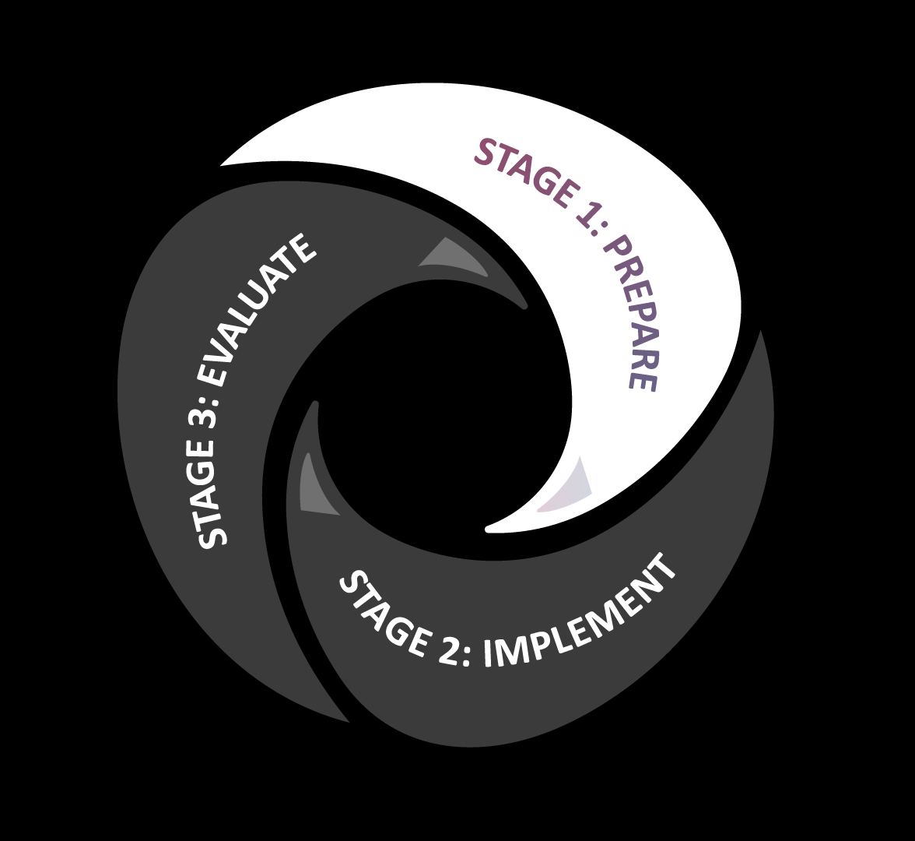Stage 1: prepare

# Stage 1: PRepare

The first step in implementing wellness and reablement in your organisation is to **prepare**.

This section of the Toolkit helps you assess your organisation’s maturity to identify the level of understanding, commitment, and what processes you already have in place and what you need to develop and/or improve.

**THIS SECTION OF THE TOOLKIT WILL HELP YOU:**

* **assess and determine your organisational maturity in embedding wellness and reablement**
* **prepare your organisation and employees for the change**
* **communicate the change**

## Assessing your organisational readiness

Organisational readiness is about determining how well prepared and positioned your organisation is to embed wellness and reablement.

The purpose of undertaking an organisational readiness assessment is to identify the level and type of organisational change management required. It also provides a baseline measure to compare against future assessments, allowing you to measure the success of your organisational change management strategy and activities.

The ***Self-assessment Tool*** helps providers assess their organisational maturity for wellness and reablement. The Tool provides a framework to assess readiness against several organisational elements such as, culture, leadership, people, process, and systems. Some organisations may wish to use this tool as a quick reference to assess readiness. Alternatively, some organisations may wish to use the **Aged & Community Services Australia (ACSA)** [Wellness and Reablement Roadmap](https://www.acsa.asn.au/ACSA/media/General/Documents/W-R-Roadmap-flyer-2-0-20200116.pdf). It is a more comprehensive tool to support service providers in embedding positive practices of wellness and reablement.

Once you have a better understanding of what changes your organisation needs to make to better support wellness and reablement, you can use the ***change management step-by-step guide*** to introduce and drive changes through your organisation.



Change management   
step-by-step guide



Wellness and reablement  
self-assessment tool

## Preparing your organisation

Once you understand your readiness to embed wellness and reablement, it is important to prepare your organisation for the changes required to develop and continue to develop your organisation’s maturity.

### Embedding the right culture Organisational culture

**Helpful Tip**

Review your current policies and practices to assess if they are supporting a culture which embeds wellness and reablement approaches. The ***Wellness and Reablement Self-assessment Tool***will help you identify where you need to make improvements and this guidance provided in this Toolkit, will help you introduce and communicate change.



To effectively embed wellness and reablement within service delivery, your organisation needs to firstly incorporate these approaches into its culture and ensure the right attitudes and behaviours are encouraged and reinforced.

Organisational culture is a combination of values, beliefs, underlying assumptions, attitudes, and behaviours. It is shaped by leaders and what employees are thinking and how they are behaving. In order to successfully embed wellness and reablement into your culture, consider the following factors.

**Organisational culture is driven from the top down**

The leaders in your organisation will set the expectations for how employees should think and behave.

**Helpful Tip**

Review if and how clients are being supported to meet their wellness and reablement outcomes, by following up with front-line employees and reviewing the client’s record regularly. Promote and offer training and advice where necessary to improve how employees are interacting with and supporting clients.



**Helpful Tip**

Have senior leadership conduct an organisation wide briefing about **why** and **how** they support wellness and replacement approaches and follow this up with communication activities to reinforce the messaging across all levels of the organisation.



**Your employees will be guided by processes and practices**

It is important your business model is set up to support the delivery of time-limited support, as well as wellness outcomes.

Organisational culture checklist tool



**Behaviours and attitudes are a representation of your organisational culture**

How your employees are delivering wellness and reablement approaches and interacting with your clients need to be reviewed and improved where relevant to ensure they reflect your organisation’s vision and best practice approaches.

The ***Organisational Culture Checklist tool*** has been developed to assist you in embedding an organisational culture that supports wellness and reablement.

Changing attitudes and beliefs

For some organisations, embedding wellness and reablement approaches will require a significant shift in attitudes and beliefs, specifically the way support is delivered to older Australians.

Traditionally, service delivery has been based on a dependency model, where services are delivered to clients, with little to no involvement from them. Considering the **Life Curve** explained on page 7, we now know the ‘do for’ approach to service delivery contributes to a quicker decline for people.

Shifting attitudes and behaviours means that we do not make assumptions that older people are frail and unable to help themselves. Nor do we make assumptions about the level of care they need and how it should be delivered. While these beliefs and attitudes are often unconscious and unintentional, it is important to recognise if these behaviours and attitudes exist in your organisation, what supports them, and how to correct them.

This Toolkit will provide you with useful guidance on how to change attitudes and behaviours within your organisation and promote a culture conducive to wellness and reablement.

**Helpful Tip**

The beliefs and attitudes your employees exhibit reflect the culture your organisation maintains. It is of high importance to ensure your culture supports and promotes wellness and reablement to correct any dependency-focused attitudes and beliefs.



### Reflecting wellness and reablement in your organisation’s vision

Reflecting wellness and reablement in your organisation’s mission statement shows your commitment to embedding it in your organisational culture. Your organisation’s mission statement provides your employees and your clients (and future clients) an understanding of what your organisation stands for. For your employees, it ensures they understand the organisation’s commitment, and guides their behaviour and the way they deliver services. Ensuring your organisation’s mission statement and vision complement each other will drive employees to embed wellness and reablement in their attitudes and behaviours.

### Having an appropriate governance structure

Having a good governance framework is important for your organisation to ensure there is appropriate oversight over all organisational practices, including the implementation and review of wellness and reablement practices. Good governance maximises the potential for your organisation to perform at an efficient level, achieve your objectives and enhance confidence in your organisational practices.

Having appropriate governance structures and guidelines in place ensure there is:

* a single point of **accountability**
* an effective **issue management and resolution** mechanism
* an avenue for **information distribution** and **clear communication**
* well defined and understood **roles, relationships, and responsibility** among leadership and all other employees

developing your governance structure and guidelines

Every organisation has its own unique circumstances and needs; therefore, your governance framework and guidelines will reflect the uniqueness of your organisation.

When thinking of governance structures and guidelines, there are key elements that make an effective governance framework:

**An effective board and leadership team**

Having a board/leadership team provides a clear vision, strategic guidance and encourages and enforces the necessary rules and regulations while simultaneously acknowledging and promoting employee and organisation achievements.

*Purpose and focus*:

* Culture
* Vision
* Forward planning
* Recruitment
* Evaluation

**Appropriate membership and participation**

Having an appropriate membership group that meets regularly and has effective participation, fosters inclusion and collaboration where employees (regardless of job title/role) feel a part of the decision-making process and shaping of organisational practices.

*Purpose and focus*:

* Decision-making authority
* Accountability
* Equality and inclusivity
* Diversity of views

**Clearly defined policies and procedures**

Policies and procedures need to reflect your organisation’s vision and approach to wellness and reablement. They need to be clear, concise, and easy to understand. Clearly defined policies guide behaviours through an agreed process strengthening consistency, efficiency, and performance.

*Purpose and focus:*

* Policies and procedures
* Checks and balances
* Planning and implementation
* Review and continuous improvement

**Transparency and responsiveness**

Being responsive to needs and making decisions in a timely manner while being open and transparent about the action and decisions made.

*Purpose and focus:*

* Reinforcing culture and behaviours
* Rights and responsibilities
* Connection to organisation
* Open and accountable

**Well-developed roles and responsibilities**

Clearly defined, well-articulated roles and responsibilities that are easy to understand strengthen operations and decision-making processes. They ensure the right people are making the right decisions at the right time, strengthening quality of service and improving employee performance.

*Purpose and focus:*

* Compliance
* Reporting
* Roles and duties

See **helpful hint** to understand how the roles in your organisation contribute to strengthening wellness and reablement approaches.

**Well-developed roles and responsibilities**

Helpful hint

Central to any governance framework is clearly defined roles and responsibilities that are understood by all. Every employee has a role to play in embedding wellness and reablement approaches and should understand what their responsibilities is to deliver high quality support in line with your organisation’s vision for wellness and reablement

| - | Role | Responsibilities |
| --- | --- | --- |
| Senior management | Sets **strategic direction** of wellness and reablement for the organisation | Sets the strategic agenda. Provides clear wellness and reablement expectations for the organisation and models and promotes the correct behaviours |
| Middle management | **Drives the importance** of wellness and reablement approaches and **sets the policy and procedure** for its practical application | Proactively promotes wellness and reablement messages from leadership, through the design and delivery of wellness and reablement policies and practices to guide front-line support employees |
| Front-line delivery employees | **Works with clients** to deliver wellness and reablement support to clients | Works with clients, supporting them to develop and achieve their wellness and reablement goals, with support from middle- management. Also reporting on client outcomes and best practice approaches |

Preparing your employees

Helpful hint

Wellness and  
reablement messaging example

*“We understand that supporting our clients with wellness and reablement focused services allows them to remain more independent for longer.”* **(Why)**

*“Over the next four weeks we will be adapting the way deliver services to ensure our focus is doing with not for****.****”***(What the change is & when it is happening)**

*“Next week we will be running a workshop to provide you with more information about the changes and what it will mean for you.”* **(How will the change be implemented & what does it mean for me)**

*We have been working to develop our wellness and reablement capabilities within our organisation, in order to assist you, our employees, to embody this approach when delivering services to our valued clients.*

*Over the coming weeks, you will see changes to our systems, process and the supports available to you, to ensure you are prepared and empowered”*



Strong leadership builds the foundations of culture. It empowers employees to achieve organisational goals and helps them realise how vital their contributions are in advancing those goals. For wellness and reablement to be successful, it needs to be **embraced, led, and practiced** from the top by executives and managers, and be visible at all levels of the organisation.

### Effective communication

Communication plays an important role in driving and embedding cultural change. While change needs to be initiated and driven from the top of an organisation, it needs to be reinforced through middle managers. Employees need to know when changes are being made in an organisation. They need the opportunity to understand the change and clarify what it means for them.

To effectively communicate changes with employees, you should understand what they need to know (**message**), when they need to know it (**timing**) and how they should receive the information (**channel**).

#### Messaging

Developing clear and concise messages before you begin to communicate will ensure everyone receives the right message at the right time.  
It limits the misinformation that occurs when people receive not enough, or inconsistent information. When developing messages for employees you should consider:

* **what** the change is
* **why** the change is happening
* what does the change **mean** for them
* **when** is the change happening/**how** will the change be implemented

#### Timing

People need to understand changes before they can implement them. Employees should be informed of changes before they are implemented to give them the opportunity to understand how it will affect them, and what their responsibilities are. The timing may change depending on the employee and their role in implementing the change.

While its important communication happens before the change is implemented, it also needs to be consistent during and after the change is implemented. Communicating with employees during implementation will provide updates on progress and reassurance progress is being made. It also provides an opportunity to celebrate successes or address issues in real-time, as they occur.

Communication after the change is implemented provides reinforcement. It reminds employees of their ongoing responsibilities. It provides the opportunity to gather and promote success stories and to continuously improve services and processes.

#### Channels

Every organisation has its own unique system of communicating. Communication comes from a range of channels including:

* **Formal communication channels** – scheduled emails/newsletters, intranet (internal website) and regular briefings
* **Informal channels** – team meetings, conversations between employees

Consider how these channels can be used to get your message out. Formal communication channels are good at ensuring everyone has the same message at the same time. Informal and face-to-face channels are good at providing employees an opportunity to ask questions and understand how the change will affect them.

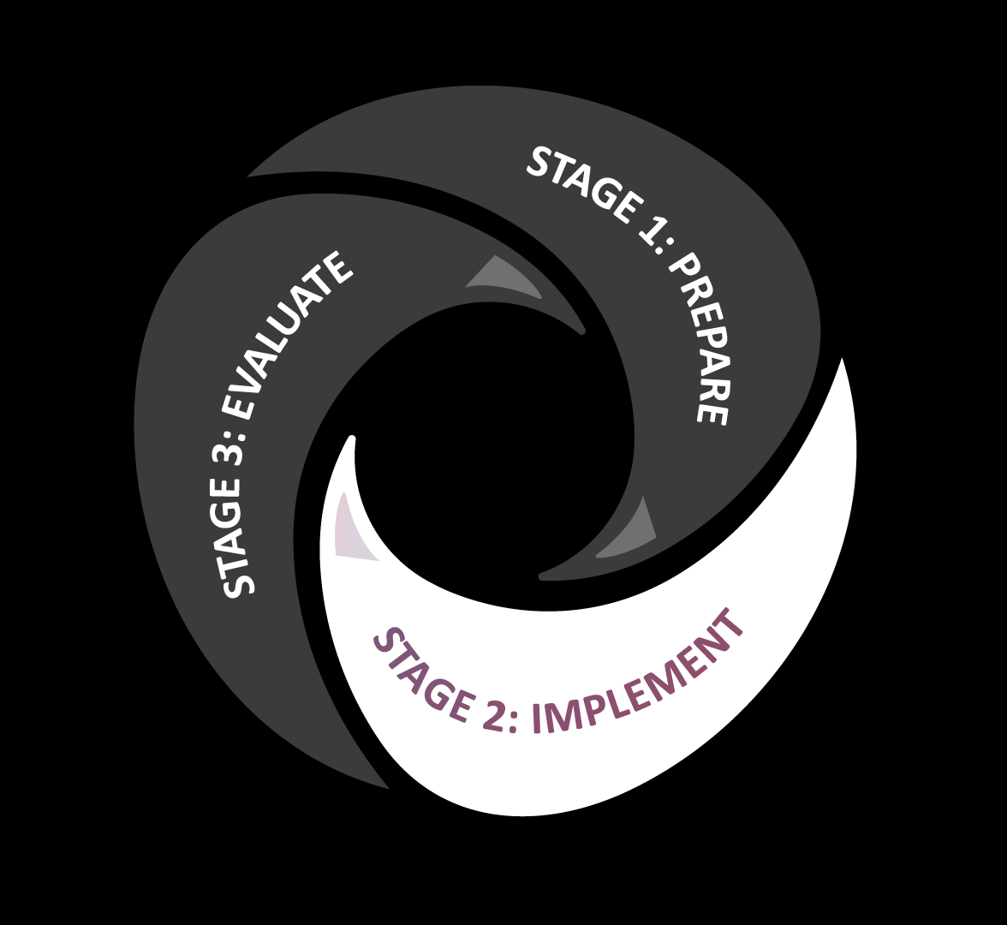Stage 2: Implement

# Stage 2: Implement

Change management   
step-by-step guide



Now that you understand the principles of wellness and reablement and your organisation is prepared to receive the change, the next step is to develop a clear change plan to **implement** across your organisation.

**THIS SECTION OF THE TOOLKIT WILL HELP YOU:**

* **introduce and drive change through your organisation**
* **identify the skills, capability, and requirements of your employees**

## Introducing and driving change

Change management plans help organisations to capture and share their change goals, approach, activities, and deliverables in order to achieve  
their vision.

A wellness and reablement***change management step-by-step guide*** has been developed to assist your organisation to capture the detail of how wellness and reablement practices will be embedded. Developing the change plan will ensure you have a planned approach and shared understanding of how you will shift your organisation towards a deeper level of wellness and reablement maturity.

To effectively implement change within your organisation, you must consider the following factors:

* What capabilities and tools do your  
  **people** need?
* How are your **processes** designed to support this change?
* Do your **systems** support you to report your wellness and reablement outcomes?

All three of these factors need careful consideration during implementation to ensure success. (Figure 2).

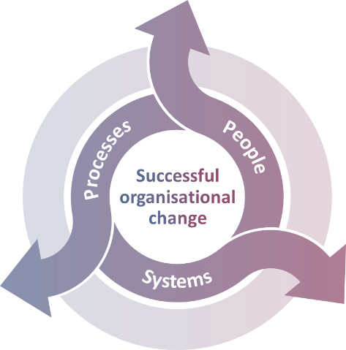Figure 2: Successful implementation

People

### Essential to every business is its people. In order to achieve effective wellness and reablement outcomes, your people:

### need to be supported

### have the appropriate tools, knowledge, skills, and capability

### need the rights skills to implement change and review and evaluate processes

### Ensuring employees are trained, empowered, and have the desire to deliver wellness and reablement outcomes for clients, will improve your organisation’s maturity in delivering wellness and reablement.

#### Training

Developing employee understanding of wellness and reablement in both theory and practice is key to delivering effective and appropriate wellness and reablement-focused support and better outcomes for your clients.

Effective wellness and reablement focused training will support employees to implement concepts within their role, embed the correct behaviours and attitudes across the organisation, and deliver support to clients that meet their goals  
and outcomes.

In 2020 as part of the ***Promoting Independent Living Budget Measure*,** wellness and reablement training has been developed to help service providers further embed wellness and reablement approaches in their organisation and service delivery practices.

Practical Guide for Embedding Wellness and Reablement



The training will consist of online learning and a downloadable toolkit version for workplace trainers to train employees when it suits them. Employees will be able to access this training free of charge, however subscriptions are limited.

Those who complete the training will receive a Certificate of Achievement upon successful completion of online learning.

Promoting and encouraging your employees to complete this training is critical in helping them understand how to operationalise concepts of wellness and reablement in their work with clients.

#### Skills

Traditionally, the delivery of service to clients has been transactional and focused on ‘doing for’ and ‘to’. Under CHSP, you are required to use a wellness and reablement approach to maximise people’s independence, giving them greater fulfillment and autonomy.

It is important now more than ever, that CHSP service providers emphasise the importance of ‘doing with’ and ‘alongside’, as opposed to ‘doing for’ and ‘to’.

This type of service support requires a well-developed skillset and capability to form strong relationships with clients and to understand their goals, tailor their support to their situation and to encourage their participation.

The ***Practical Guide for Embedding Wellness and Reablement*** has been developed to help service providers practically implement wellness and reablement into their service delivery practices.

Helpful TIP

Wellness and reablement employee skills checklist

Ensuring your current and prospective employees have the correct skills, capabilities, and motivation to deliver on organisational objectives is key to the success of a business. In delivering support, your organisation’s reputation and success is largely dependent on how your employees conduct themselves and interact with clients to achieve their outcomes. Delivering wellness and reablement focused support that is person-centred and tailored to individual needs requires certain skills and expertise. Feedback from service providers suggest the skills employees should have, and the organisation should be recruiting for, to deliver wellness and reablement-focused support include:

**CORE SKILLS**

* Experience working in a care/support role
* Problem solving
* Critical thinking
* Integrity
* Professionalism and collaboration
* Effective communication
* Understanding tone and body language
* Experience or training in negotiation with clients and/or family members
* Proven understanding of wellness and reablement
* Proven ability to apply an outcome-focused approach to working with clients to achieve their goals

**DESIRABLE SKILLS**

* Understanding of the aged care system
* Qualifications in aged care support
* Experience in reviewing and assessing client’s care plans
* Experience using the My Aged Care Provider Portal

#### Support

People need to be supported through change, especially if concepts are new and unfamiliar.  
This is particularly important for front line staff who are used to traditional models of service delivery (‘do for’ instead of ‘do with’). In implementing wellness and reablement across your organisation,  
it is important your employees are aware of the support mechanisms which can assist them in meeting individual and organisational expectations.

#### Individual support

Individual support is critical during times of change, evaluation, and continuous improvement, to ensure the correct practices, attitudes and behaviours are being embedded and improved where necessary.

Ongoing feedback loops are an opportunity for your employees to engage with each other regularly to support them to meet organisational expectations. Figure 3 highlights a high-level structure for a continuous feedback loop.

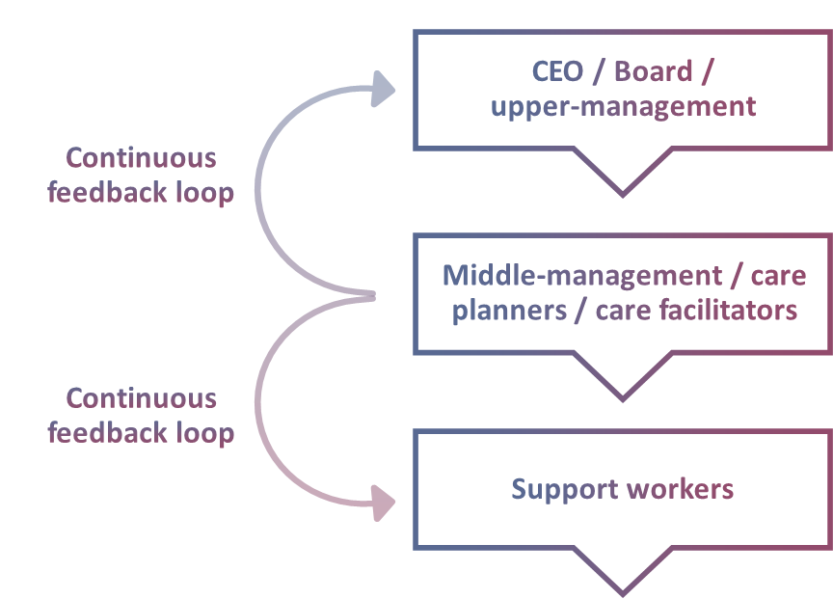Figure 3: Continuous feedback loop structure

Regular feedback across all levels within your organisation strengthens your organisational practices, empowers your employees, and improves overall performance. Feedback channels provide an avenue for employees to address issues, seek advice and ensure continued development in their understanding and practical application of wellness and reablement.

#### Organisational Support

Organisational level support is also required  
to assist service providers to develop and maintain appropriate wellness and reablement practices.

The ***More Good Days*** ***Community of Practice (CoP)*** is a platform through which service provider organisations can seek support and information from their peers and collaborate to increase knowledge sharing and quality of service. The CoP will be released later in the year. It is encouraged that all CHSP service providers engage with the platform and actively participate in sharing good news stories and best practice approaches to help improve the quality of support for older Australians.

*Support and collaboration between businesses have proven to increase innovation within organisations by openly sharing knowledge about challenges and best practices.  
The outcome is improved operating procedures and client outcomes[7].*

## Processes

Effective processes guide how people within  
an organisation operate. Streamlined processes provide efficiency, quality, and consistency.  
To accelerate organisational and client outcomes, and bring consistency to how employees operate, processes need to be well defined and understood.

Updating your organisational processes to greater reflect wellness and reablement, shows your organisational commitment, and empowers and enables your employees to deliver wellness and reablement-focused services.

### Organisational processes

Standard operating procedures (SOPs) are valuable organisational tools that set expectations about the process’s employees should engage with in their day-to-day role. They ensure the same approaches are followed by everyone in the organisation.

Key to embedding wellness and reablement within organisations is ensuring all employees are actively adopting and practicing wellness and reablement consistently and following the correct principles. SOPs are a support tool to assist with this and drive the behaviours aligned to your wellness and reablement objectives and vision.

SOPs should be designed to embed the correct behaviours and attitudes to deliver wellness and reablement in services but not restrictive so that they stifle employee’s creativity in developing innovative ways to work with clients.

A ***Standard Operating Procedure*** ***Template*** has been developed to help your organisation develop robust wellness and reablement focused procedures for certain functions within your organisation such as:

* Intake
* Care planning
* Working with clients
* Reviewing client outcomes/cases
* Feedback and sharing stories amongst employees

Standard Operating Procedure template



## Systems

Having appropriate and fit-for-purpose systems enables your organisation to work effectively in changing environments and monitor and reporting progress.

Those organisations that have separate client management systems must ensure client information is accurately recorded in both the organisation’s system and **My Aged Care**.

### Capturing information

The wellness and reablement philosophy must be included in your organisational systems. Having the ability to capture wellness and reablement information against a client record (whether in **My Aged Care** or your internal systems), will help you plan and tailor services, inform employees and plan and report accordingly.

### Recording outcomes

Under your **CHSP Grant Agreement**, you are required to report on your progress in adopting a wellness approach to service delivery to your clients[8].

Designing or updating your systems to accurately capture key wellness information, through consistent and clear reporting guidelines will improve your ability to report on progress and help you meet your requirements. It is important your systems are designed to report on client wellness and reablement outcomes, not just on service delivery output. This will also assist your organisation in recording your service information in My Aged Care client records, which is a CHSP funding requirement.

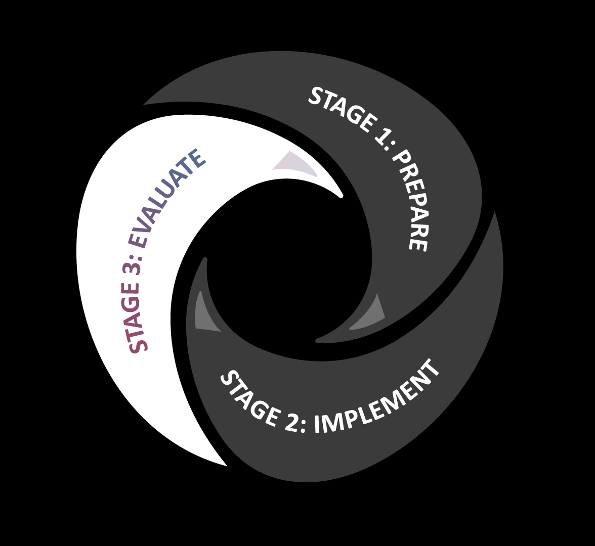Stage 3: Evaluate

# Stage 3: Evaluate

Embedding wellness and reablement within your organisation is an ongoing process. Implementing a framework that focuses on evaluation and improvement provides a structured approach to quality assurance and continuous improvement.

Incorporating these measures into your practices makes you more responsive in identifying potential barriers and finding ways to fix them. Small changes made over time can dramatically improve the quality of organisational and service delivery practices.

**THIS SECTION OF THE TOOLKIT WILL HELP YOU:**

* **assess the effectiveness of your implementation and practices**
* **identify opportunities for future improvements**
* **plan to make improvements  
  to practices**

As per the **CHSP Manual 2020-2022**, CHSP service providers are required to submit an annual **Wellness and Reablement Report**, which includes reporting on examples of how they have embedded wellness and reablement within their organisation[9].

By engaging mechanisms to evaluate and review your organisation’s internal and service delivery practices, you will be better equipped to respond and report to the department on your wellness and reablement maturity and outcomes, as well as ensuring your compliance to the **Aged Care Quality Standards.**

## Continuous Improvement

Continuous improvement is critical to ensuring your organisation’s policies and procedures remain accurate and fit-for-purpose. Organisation’s should work adopt a continuous improvement framework that focuses on:

* **reviewing** implemented processes and practices
* **identifying** areas for improvements
* **planning** for updates to be made
* **deploying** updated practices shows your commitment to quality and continuous improvement (see Figure 4).

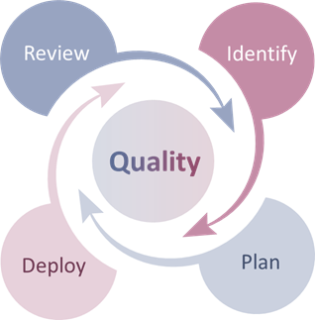Figure 4: Continuous improvement framework

Identifying success stories, learnings and communicating findings with your employees is equally important during a continuous improvement process. Sharing findings throughout the organisation shows your ongoing commitment to quality and continuous improvement, boosting team morale and job satisfaction. A ***Continuous Improvement Template*** has been developed to help organisations introduce/maintain A close up of a logo
improvements to policies and procedures.

Continuous improvement template tool

When released, the ***CoP Platform*** can be engaged with to share your learnings and best practice to assist other organisations in understanding what practices have been effective, and also the positive outcomes it has for the client, your organisation, and your employees.

## Communicate your learnings/improvements

When practices are reviewed and further developed to improve organisational outcomes, these changes must be communicated to employees so they can adopt the new practices to continue to embed wellness and reablement.

As discussed in the **Prepare**section, communication plays a pivotal role in both driving and embedding cultural change, and therefore the same communication considerations for; **messaging**, **timing** and **channels**, should be adopted to ensure changes from evaluating your organisation’s wellness and reablement maturity have an impactful and positive effect on your organisation.

### Messaging

Ensure your messages about the change are clear and concise. The messaging should include:

* what was the change
* what was the desired outcome, was it achieved?
* what the employee’s role in the change was
* celebrate success, acknowledge failure, commit to continuous improvement.

This will assist your employees in enthusiastically adopting the improvement.

### Timing

Ensuring the timing of communication provides your employees with adequate time to prepare for, understand and embed the change.

### Channels

It is important to use the correct channel to communicate the improvement, ensuring the changes are reaching the relevant audiences.

See the **Helpful Hint** on the following page for examples of how changes can be communicated to your employees.



Helpful hint

Wellness and  
reablement **messaging** example

*“Twelve months ago, we made changes to provide our clients with services aimed at improving their independence and wellness.* **(The change and the desired outcome)**

---

*Since then, we have seen a huge increase in positive outcomes for our clients and positive feedback from clients and their families.* **(The outcome)**

---

*The success of these changes is due to the ongoing commitment from each of you.* **(The employees’ role)**

---

*We continue to seek feedback from each of you so we can continue to adjust and improve our approach.* **(Continuous improvement)**

1. Australian Bureau of Statistics. 2019
2. Australian Productivity Commission, *An Ageing Australia Research Report.* 2013
3. Victorian Government Department of Human Services. *Improving care for older people.* 2003.
4. ADL Smartcare. *Life Curve.* 2020.
5. ADL Smartcare. *LifeCurve.* 2020.
6. Department of Health. *Current CHSP Manual.*
7. Roberts N. *Wicked Problems and Network Approaches to Resolution*. 2000
8. Department of Health. *CHSP Manual 2020–2022*. July 2020
9. Department of Health. *Current CHSP Manual*.