**SUMMARY**

Privacy Impact Assessment – National Data Exchange component of the National Real Time Prescription Monitoring System

17 September 2020

# Background

* 1. The Department of Health (**Health**) commissioned a privacy impact assessment (**PIA**) in April 2020 to ensure that the National Data Exchange (**NDE**) component of the National Real Time Prescription Monitoring (**RTPM**) system contains the appropriate privacy obligations and protections.
  2. The Commonwealth of Australia (represented by Health), States and Territories are working together to implement the RTPM system. The RTPM system will provide information to medical practitioners (**prescribers**) and pharmacists (**dispensers**) about a patient’s use of controlled medicines, when they are considering prescribing or dispensing these medicines to that patient.
  3. The States and Territories will remain responsible for the management of controlled medicines, and all parties intend that Health will not have any access or control over information in the NDE. However, as an entity providing funding for the implementation of the NDE, Health wished to ensure that the privacy of Australians has been properly considered and addressed during that implementation, including as a result of a PIA process.
  4. Accordingly, the PIA:

1.4.1 assessed the risks to individual privacy presented by the NDE (but did not consider the RTPM system in its entirety and only considers the provisions of NDE that relate to privacy);

1.4.2 considered the roles of Health, the States and Territories, FredIT as the service provider of ICT services, prescribers, and dispensers, in the delivery of the NDE, and the privacy impacts associated with the implementation and operation of the NDE;

1.4.3 set out the applicable information flows;

1.4.4 considered compliance with the *Privacy Act 1988* (Cth) (**Privacy Act**), including the Australian Privacy Principles (**APPs**) and examines the potential privacy impacts that should be considered in implementing and operating the NDE;

1.4.5 acknowledged that States and Territories may be required to undertake their own Privacy Impact Assessments to ensure that the integration of their regulatory systems to the NDE meet any jurisdictional privacy requirements; and

1.4.6 may serve to inform stakeholders about the management of the NDE, and illustrate the focus and value being placed on privacy risks and risk mitigation by Health.

# Overview of the NDE

* 1. In Australia, medicines are classified into Schedules and listed in the Poisons Standard according to the level of regulatory control over the availability of the medicine or poison required to protect public health and safety.[1] Controlled medicines are regulated and the supply of controlled medicines are authorised under State and Territory legislation.[2] All States and Territories regulate Schedule 8 medicines (e.g. morphine, oxycodone, fentanyl). Some jurisdictions regulate Schedule 4 medicines (e.g. benzodiazepines, codeine) as well. As required by relevant State or Territory law, before prescribing a controlled medicine, prescribers must obtain permission to do so through the relevant State or Territory regulator. Information collected, disclosed and generated through this process, including patients’ personal information, is currently held within State and Territory regulatory systems.
  2. The Commonwealth wishes to support the States and Territories in achieving improved management of controlled medicines, by facilitating the implementation of RTPM system and associated ICT systems.
  3. RTPM will be a national system under which each State or Territory will remain responsible for managing and regulating controlled medicines within their jurisdiction.
  4. The goals for the RTPM system include ensuring there are systems that will support the States and Territories achieving improved:

2.4.1 identification of patients who are at risk of harm due to dependence or misuse of controlled medicines (through prescribers and dispensers being provided with alerts and being able to access certain patient history information about the prescribing and dispensing of controlled medicines, including across jurisdictional borders, to better inform the clinical and professional decision-making process around access to high-risk medicines);

2.4.2 identification of patients who may be diverting these controlled medicines (e.g. by selling controlled medicines on the ‘black market’);

2.4.3 restriction of ‘prescription shopping’ (which is a practice where patients seek prescriptions of the same or similar controlled medicine from different prescribers); and

2.4.4 access to data which is needed to detect prescribers who are not complying with relevant regulations.

* 1. The RTPM system will include two components:

2.5.1 a National Data Exchange (**NDE**) – an ICT system which will capture, process and store information received from State and Territory regulatory systems, from the prescribing and dispensing software of prescribers and dispensers, and from a range of other external data sources; and to make some of that information available to the relevant State and Territory prescribers and dispensers, in order to achieve the goals of the RTPM system; and

2.5.2 regulatory systems within each State or Territory - these will continue to manage the authorities or permits for controlled medicines in each State or Territory.

* 1. The NDE is a key piece of technical infrastructure that will enable the RTPM system to operate. The NDE comprises of:

2.6.1 a **NDE Repository** – this repository will be an electronic storage facility that will house patient histories about controlled medicine authorities and permits. It will house separate databases for information received from each State and Territory jurisdiction, based on logical separation;

2.6.2 a **Health Practitioner Portal** (including the **NDE Registration Portal**) – this portal will allow prescribers and dispensers to view controlled medicine history, and alerts, in relation to a patient; and

2.6.3 a **NDE Management Portal** – this portal will allow authorised users from the State and Territory regulators to manage the rules for the operation of NDE in relation to their State or Territory, to manage the access by users within their jurisdiction, and to generate reports about activity for their jurisdiction.

* 1. At a high level, the NDE will:

2.7.1 facilitate the transfer and processing (i.e., collection, use, disclosure and storage) of prescription information in relation to patients in real time, across State and Territory jurisdictional boundaries;

2.7.2 leverage information already contained within the regulatory systems currently operated by the various State and Territory jurisdictions; and

2.7.3 enable real time monitoring to take place, receive and process data feeds from a number of other sources, such as prescribing and dispensing systems, Prescription Exchange Services and the Australian Health Practitioner Regulation Agency (**AHPRA**).

* 1. The NDE consists of shared infrastructure and dedicated components deployed and administered by each State and Territory to accommodate their specific RTPM system requirements. This means that each State and Territory will have their own portals and dedicated database mentioned in paragraph 2.6.
  2. Health has engaged an ICT service provider, FredIT, to build the NDE in order to host and store data collected as part of the NDE. FredIT has entered into a range of agreements with other participants mentioned above, in order to ensure that the effective operation of the NDE. In particular, FredIT has contracted Microsoft to provide the infrastructure and associated support services required for the NDE platform, as a cloud service (a Microsoft Azure PaaS solution).
  3. This means that FredIT will have access to the NDE for the purposes of providing ICT support services. FredIT’s subcontractors, including Microsoft, may also have access for the purpose of providing ICT support services for cloud services (and underlying infrastructure) on which the NDE is based.
  4. Health, each State and Territory, and FredIT, will enter into tripartite agreements, in relation to the integration of the NDE with arrangements for its operation in each jurisdiction (**Tripartite** **Agreements**). At the time of preparing the PIA, Tripartite Agreements covering ACT, QLD, SA, NT and VIC have been executed. Through the Tripartite Agreements, States and Territories can seek additional functionality from FredIT as required for their jurisdiction.
  5. Health does not intend that it will have any access to the NDE, or that it will have any ownership of the information stored in the NDE or be the data custodian of that data (it intends that the States and Territories will remain as the responsible entities for data relating to their jurisdiction). Rather, Health intends that its role will simply be that of the entity providing the funding for the ICT systems comprising the NDE, which will be made available for exclusive use by the States and Territories.
  6. The RTPM system involves a number of participants and interactions – the information flows relating to the NDE are shown at a high level in the diagram in Error! Reference source not found.. This diagram shows the information flows in and out of the NDE component of the RTPM system (which were within the scope of the PIA), and information flows that occur before or after personal information is transferred into or out of the NDE (which were outside the scope of the PIA).

# Recommendations made in the PIA

## The PIA made a number of recommendations to which Health provided the following responses:

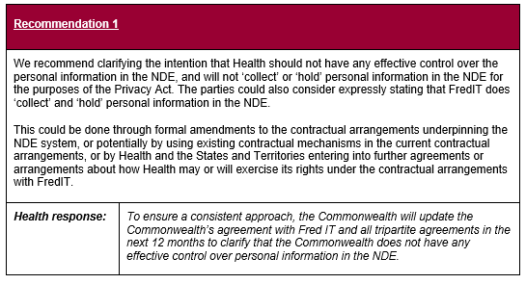

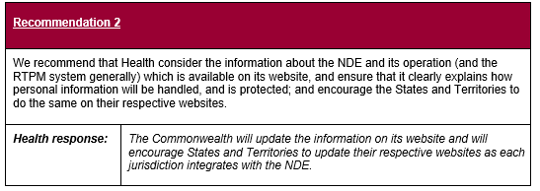

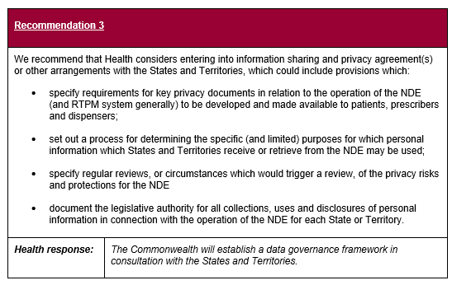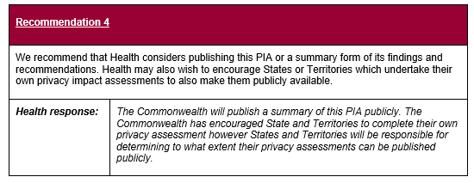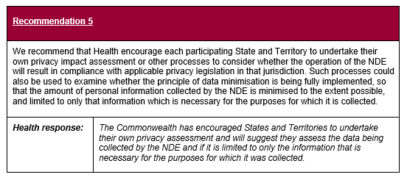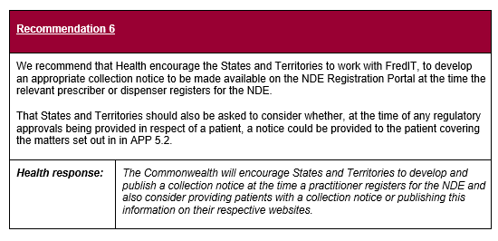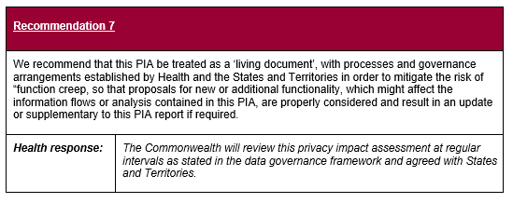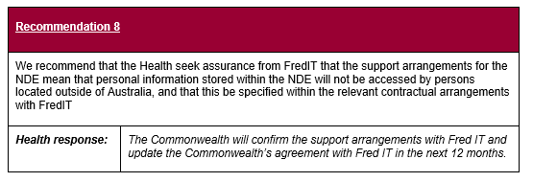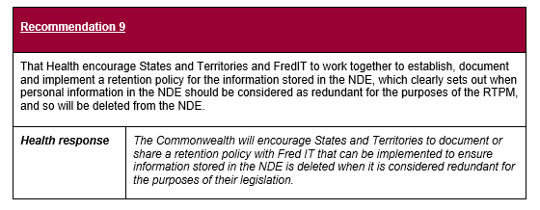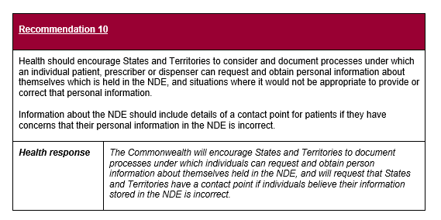

1. Diagram of Information flows

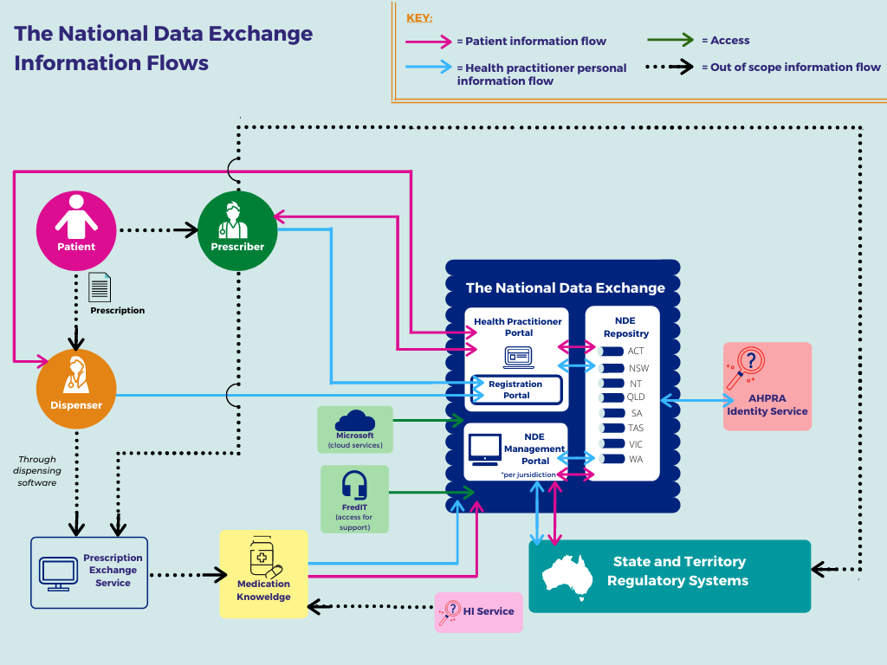

1. These medicines are listed in the *Poisons Standard (Standard for the Uniform Scheduling of Medicines and Poisons)* as Schedule (S) 2, 3, 4, 5, 6, 7, 8 and 9 poisons. The TGA is responsible for the Poisons Standard.
2. While the Commonwealth is responsible for identifying and classifying controlled medicines and poisons, it does not have responsibility for regulating these medicines, which is a specific State/Territory function. The Commonwealth also does not receive/have access to any health information about patients which is collected via State/Territory regulatory systems.