**A PRACTICAL GUIDE** FOR   
EMBEDDING WELLNESS AND REABLEMENT INTO SERVICE DELIVERY

**COMMONWEALTH HOME SUPPORT PROGRAMME (CHSP)  
SERVICE PROVIDERS**

# Contents

Contents 1

ABOUT THIS guide 1

INTRODUCTION 1

understanding the agEing journey 1

UNDERSTANDING WELLNESS AND REABLEMENT 1

Benefits of a wellness and reablement approach 1

Moving towards ‘*More Good Days’* 1

Stage 1: Intake 1

Stage 2: Care plan 1

Stage 3: service delivery 1

Stage 4: review 1

# About this guide

The *Practical Guide for Embedding Wellness and Reablement* into service delivery (the Guide) has been developed to provide Commonwealth Home Support Programme (CHSP) service providers with the practical information and tools needed to embed wellness and reablement approaches in their service delivery approach.

Wellness and reablement are the cornerstone of how aged care support is provided for older Australians. Many CHSP service providers understand and believe in the philosophy of wellness and reablement but have asked for support in applying it practically within their organisation.

The Guide will encourage you to think differently about the way you provide services by focusing on client’s strengths and the things they can do, rather than their weakness and what they find difficult or are unable to do.

The Guide will provide practical advice and tools to consider:

* The importance of accepting and reviewing referrals during the intake stage
* Promoting your organisation’s approach to wellness and reablement in the interactions you have with clients and potential clients
* short-term support as the first point of consideration, rather than ongoing care
* Your role in developing the care plan, ensuring it is aligned to the Regional Assessment Service (RAS) assessor’s support plan, and developed with the client to support them to achieve more good days
* How you can apply wellness and reablement approaches to support your clients
* How reflecting on your interactions with the client during and after service delivery can help you measure outcomes and better inform your approach in the future

The Guide is designed to be used to support and in conjunction with both the Department of Health’s (the department) [CHSP Manual](https://www.health.gov.au/resources/publications/commonwealth-home-support-programme-chsp-manual) and [Living Well at Home – CHSP Good Practice Guide.](https://www.health.gov.au/resources/publications/living-well-at-home-chsp-good-practice-guide)The Guide will provide you with additional support and practical tools but is not a replacement for either of these resources.

## Who is this guide for?

The services offered by CHSP service providers vary significantly across the sector. This Guide is intended to provide practical guidance to help all service providers to embed wellness and reablement approaches into their service delivery, regardless of the type of service they offer.

While this guide can be used by all CHSP service provider employees, it has been developed primarily for front-line employees to support them in effectively delivering wellness and reablement approaches to their clients. This Guide can also be used by organisations as a resource to inform internal training practices and/or service delivery processes.

The guide helps those in an organisation who manage the intake process, develop care plans with clients and their family/carer, and who deliver support to clients. These functions are represented through three key roles, corporate, care coordinator/facilitator and the support worker.

## Why use this guide?

The Guide is a primary support mechanism to help you:

* meet your CHSP requirements
* input into your annual wellness and reablement report
* comply with the Aged Care Quality Standards
* continue to develop your organisational practices to suit essential wellness and reablement practices
* understand best-practice processes
* adopt wellness and reablement concepts into your organisational practices and service delivery
* deliver better outcomes for your clients and their families

## How do I use this guide?

The Guide has been divided into **four sections** to help you understand the principles of wellness and reablement and how they apply to each element of support for your clients.

### Introduction

This section provides overarching **information** on wellness and reablement to give you the right foundations for embedding wellness and reablement approaches. All service providers and their employees should be familiar with this section.

#### Stage 1: Intake

This section provides an overview of the key wellness and reablement considerations and practices which should be implemented when receiving a referral for services and communicating with clients and potential clients on your organisation’s approach.

#### Stage 2: Care Plan

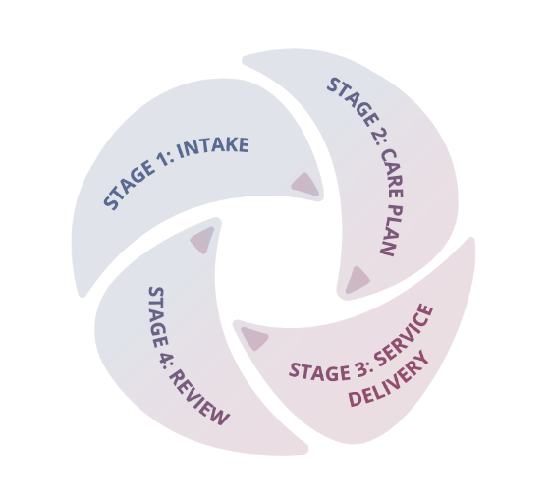This section outlines the responsibility and practical tools the care coordinator/facilitator can leverage to develop the care plan with the client based on their strengths, aligning it to the support plan.

#### Stage 3: Service Delivery

This section provides tangible tools to empower support workers to work with clients using wellness and reablement approaches to ensure a specific goal or outcome is achieved.

#### Stage 4: Review

This section provides an overview of the importance of reviewing how your wellness and reablement approaches have been delivered, if and how your client met their outcomes, if your approaches to working with the client were effective, what can be learned from them and how to share these with your peers and organisation.

## Navigating this guide

Case studies, definitions, helpful tips and tools are featured throughout the Guide and can be found using the following icons:

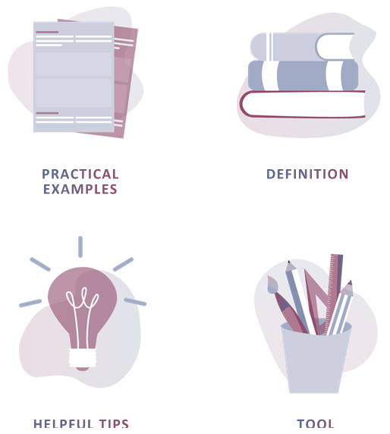

INTRODUCTION

## Understanding the ageing journey

*The aged care sector is continuously changing to meet the needs of older Australians. People are living longer, have more complex care needs and want to live in their homes for as long as possible. Over the past decade, emerging research has demonstrated the benefits of focussing on client independence. Traditional models of service delivery that focus on what a client can’t do rather than what they can, tend to lead to an over-reliance on services by clients, which has been linked with accelerated functional decline.*

Research suggests that the largest influencer in age-related decline is not genetics, but rather lifestyle choices. People who continue to do things for themselves tend to remain independent and live better, longer. Professor Peter Gore of the Institute of Ageing at Newcastle University in the United Kingdom (UK) has developed a framework to understand age-related decline[1]. The framework, called the Life Curve, looks at the impact of maintaining independence on quality of life and the rate of age-related functional decline. It illustrates that the sooner someone stops performing certain tasks for themselves, the faster they tend to lose their functional ability. The aim is to assist people to perform these daily tasks independently for as long as possible, so they maintain the ability to maximise independence and autonomy. Retaining physical ability helps people to continue doing the things they enjoy for longer.

The Life Curve is shown at Figure 1. The vertical axis lists activities of daily living that older people generally lose over time, in the order in which they tend to be lost, from top to bottom. The timeframe for this decline is variable and can be influenced by behaviour and interventions. Difficulty cutting toenails is typically seen as an early indicator that intervention may be needed. The graph shows two trajectories – a sub-optimal life curve with a fast early decline, and an optimal life curve in which the early decline is slowed down to give people more good days before losing the ability to undertake activities like walking, shopping and personal care.

Supporting clients to continue doing everyday activities means you are not only delivering high quality care; you are empowering them to have ***more good days doing the things they love***.

 Figure 1: The activities of daily living curve

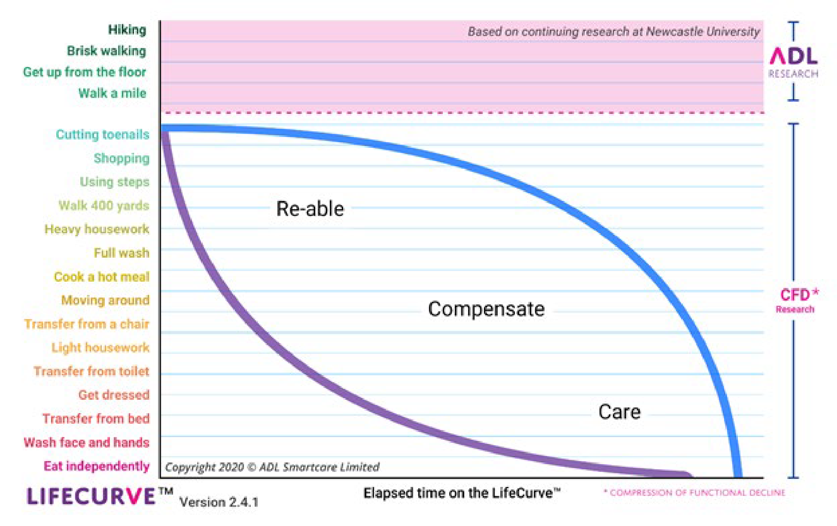

## UNDERSTANDING WELLNESS AND REABLEMENT

*Wellness and reablement are related concepts, often used together to describe an overall approach to service delivery. Wellness and reablement approaches are based on the idea that, even with frailty, chronical illness or disability, most people want and are able to improve their physical, social, and emotional wellbeing, to live autonomously and as independently as possible.*

Wellness and reablement approaches work with older people to maximise their independence and enable them to remain living safely in their own homes and communities. To incorporate wellness and reablement approaches in your service delivery practices, you first need to understand the principles and benefits.

The following principles underpin a wellness and reablement approach:

* **Promote Independence** – people value their independence; loss of independence can have a devastating effect, particularly for older people who may find it more difficult to regain
* **Identify clients’ goals** – a person’s independence requires more than just services to help them remain in their home and maintain their current capacity. Service delivery should focus on supporting the client to actively work towards their goals and improved independence wherever possible
* **Consider physical and psychological needs** – independence is not limited to physical function; it includes both social and psychological function
* **Encourage client participation** – being an active participant, rather than a passive recipient of services, is an important part of being physically and emotionally healthy. Service delivery should focus on assisting a person to complete tasks, not taking over tasks that a person can do for themselves
* **Focus on strengths** - the focus should be on what a person can do, rather than what they can’t. Wherever possible, services should aim to retain, regain, or learn skills rather than creating dependencies
* **Support clients to reach their potential** – help clients to maintain and extend their activities in line with their capabilities
* **Individualised support** – service delivery should be individualised and suited to the goals, aspirations and needs of the individual.
* **Regular review** – client assessment should be ongoing, not one-off. It should focus on progress towards client goals and consider the support and duration of services required to meet these goals

The ***Wellness and Reablement Principles tool*** has been developed for service providers as a reference point and support for their employees. It could be printed and posted around your office and/or included in internal training and communication.

Wellness and Reablement Principles tool



### Time-limited support

Reablement often involves time-limited support. Time-limited support aims to address a client’s **specific barriers to independence and support them getting back to doing things for themselves**. This involves a targeted timeframe, developed with the client, for achieving their goals.

Understanding what a good day looks like for a client and how it relates to their individual goals and outcomes is important for determining short-term support needs. This could be maintaining a level of activity or independence or working towards regaining it. Time-limited reablement support tends to be delivered **within a 12-week period** with the aim to wrap up support when the client has met their goal or specific outcome.

Time-limited reablement may involve **restorative care services** where the client has the potential to make a functional gain. These interventions may be delivered as one-to-one or group services and may involve a multi-disciplinary approach that goes beyond CHSP services, for example, involving primary health care providers. These services are coordinated by providers of allied health and therapy services based on clinical assessments of the clients.

Other time-limited reablement support could include:

* training in a new skill, ability, or activity/function, or actively working to regain or maintain an existing skill, ability, or activity/function
* modification to a person’s home environment
* having access to equipment or assistive technology.

DEFINITION: RESTORATIVE CARE

Restorative care involves the delivery of evidence-based interventions led by an allied health worker or health professional that allows a person to make a functional gain or improvement after a setback, or in order to avoid a preventable injury.

| illustration of worksheetspractical example  wellness and reablement IN ACTION  Robert is an 89-year-old man who has been referred for short-term support to assist him in learning new skills to become more independent with his cooking. Robert’s wife died a couple of months ago and he has been struggling with the adjustment as she used to do all the shopping and cooking. The service provider works with Robert to identify his strengths, what’s important to him and what he wants to achieve over the 8-week reablement period. For Robert, he would love to be able to cook his own meals but just doesn’t know where to start.  Khan, the service provider, works with Robert to develop a care plan that aligns to his strengths, goals and aspirations. Using the support plan, Khan identifies that Robert is going to need intensive support initially to help him gain new skills and confidence in performing them independently. Robert’s goal is to be able to shop and cook his own meals. Khan and Robert decide for the first three weeks, Lily, the support worker will visit Robert for two days a week for three hours, with the aim of developing new skills for Robert such as, picking recipes, writing a shopping list, going shopping, and preparing and cooking meals. The remaining weeks of the reablement-period will focus on developing Robert’s confidence in performing these tasks independently.  During the initial weeks of Robert’s reablement-period, Lily offers Robert helpful tips to build his knowledge in understanding of nutrition and cooking to increase his confidence. Together they perform the tasks until Robert feels comfortable performing them on his own. By the end of the three-week period, Robert feels comfortable selecting his recipes and going shopping, however he still gets overwhelmed at the shops by forgetting what he needs to buy, and still requires support in cooking. As a result, Lily slowly stops helping Robert select recipes but continues to help Robert navigate the shops and prepare his meals. Lily suggests Robert to go to the shops often, so he only has to get a few things each time, so he doesn’t feel as overwhelmed.  As the remaining weeks progress, Lily supports Robert in cooking, offering him tips and encouraging his participation. Robert’s skills significantly improve as does his confidence. By the end of the reablement period, Robert has a shopping and cooking routine, is able and feels confident navigating the shops and preparing his own meals. As a result, Robert exits the short-term service will full capability and confidence to prepare and cook his own meals.  **Reflection time**  Do your employees understand the short-term approach of “do with, not for” and the long-term benefits?  How does your organisation communicate the value both clients and employees will receive from reablement approaches? |
| --- |

## Benefits of a wellness and reablement approach

*Older Australians are not the only ones who benefit from wellness and reablement. Evidence suggests there are also significant benefits to service provider organisations, families and carers and the broader community.*

### Benefits for Consumers

Implementing a wellness and reablement approach at the earliest opportunity, focusing on maintaining or regaining functional capacity and social connectedness can have significant long-term benefits for clients including:

**REDUCTION** **IN SERVICE DELIVERY NEEDS**

**INCREASED** **ABILITY TO REMAIN LIVING TRULY INDEPENDENT AND SAFELY IN THEIR OWN HOME FOR LONGER**

**INCREASED** **ability to remain living truly independent and safely in their own home for longer**

**IMPROVED SENSE OF PURPOSE, AUTONOMY, AND SELF-WORTH**

**IMPROVED** **PHYSICAL AND EMOTIONAL HEALTH AND WELLBEING**

**GREATER QUALITY OF LIFE AND RETENTION OF PRIDE AND DIGNITY**

**REDUCED** **STRAIN ON FAMILY AND CARER RELATIONSHIPS**

**IMPROVED** **CONNECTION WITH COMMUNITY**

### Benefits for service provider organisations

Those organisations who have implemented wellness and reablement have identified significant benefits for their staff, business model, organisational processes, and their clients such as:

**SUPPORTS YOUR COMPLIANCE**

**with meeting your CHSP requirements and Aged Care Quality Standards**

**BETTER ALIGNED TO AGED CARE REFORM INITIATIVES**

**Improving preparedness to respond to future changes in aged care policy**

**OPPORTUNITY TO BROADEN CLIENT BASE**

**by offering more shorter-term reablement support**

**GREATER JOB SATISFACTION**

**from actively helping clients achieve their goals and become more independent**

**REPEAT CUSTOMERS**

**If/when care needs change and people require ongoing services - providing person-centred care and achieving quality outcomes result in repeat customers**

**REDUCED ADMINISTRATIVE OVERHEADS**

**Less time dealing with client complaints and a reduced wait times**

**IMPROVED REPUTATION AND REPEAT BUSINESS**

**based on providing person-centred support, focused on client goals**

**BETTER UTILISATION OF RESOURCES**

**as support workers are able to focus on more complicated tasks can’t perform for themselves, which means more meaningful and fulfilling work for staff**

### Benefits for families and carers

Wellness and reablement approaches may have significant benefits for family members and carers, including:

**AN OPPORTUNITY TO BE INVOLVED**

**in supporting their loved one to reach their outcomes**

**PeaCE OF MIND**

**knowing their loved one is retaining or regaining their independence, improving their wellbeing and quality of life**

**REDUCED WORRY AND CONCERN**

**Over their loved ones along with reduced strain and pressure due to a decrease in caring requirements**

## Moving towards ‘More Good Days’

*Providing wellness and reablement-focused services to clients starts with understanding their goals and motivations. The ‘More Good Days’ concept has been developed to help CHSP service providers identify client’s goals and motivations and apply them to their service delivery. The approach works as a* ***tool*** *to help you understand the principles and benefits of wellness and reablement, and as a* ***technique*** *to help you to have meaningful conversations with your clients.*

### *More Good Days as a* **tool**

As a tool, the ‘*More Good Days’* concept will help you understand the philosophy of wellness and reablement. The benefits of wellness and reablement can be more easily understood when we understand how they lead to more good days for clients. Working with clients by focusing on individual client goals and developing tailored approaches to reach these outcomes, means providers are ‘doing with’ – **empowering your clients to have more good days by doing the things they love.**

### *More Good Days* as a **technique**

*‘More Good Days’* as a technique helps you understand what is important to your client and what they need, to feel happy and fulfilled.

Helping your clients have more good days means understanding what a good day is for them and linking that to how you develop a care plan and deliver support. Sometimes, someone’s bad day can be as important (if not more important) to understand because it can also act as a self-motivator. People can be driven and wish to participate in their care if it means they have more good days and are able to avoid the bad days. Making tangible goals with a client that helps them avoid bad days, and have more good days, means you are encouraging them to participate in some things and encouraging them to do more of what they are already doing.

The ***More Good Days Wellness Wheel*** has been developed to support you to have meaningful conversations with your clients.

More Good Days   
Wellness Wheel



Ensuring the support being provided to clients is person-centred is at the foundation of *‘More Good Days’.* Person-centred support is about being responsive to the needs and values of the individual, personalising the approach and outcomes they are working towards. ‘*More Good Days*’ is designed to be delivered flexibly to meet the diverse needs of your clients and provide them with autonomy and choice in how they are supported.

The idea is to take these broad goals and break them down into achievable steps, using innovative strategies that are personalised to your client and focus on **‘doing with’** and not **‘doing for’**, because people who continue doing everyday tasks remain independent and live better longer.

Stage 1: Intake

# Stage 1: Intake

A corporate role would usually be responsible for this stage and the associated administrative tasks. This section provides guidance for corporate officers in managing incoming referrals and enquiries.

Implementing a wellness and reablement approach starts before service delivery. Every interaction with a client, or a potential client is an opportunity to promote your wellness and reablement approach. Speaking about your approach from the beginning helps set the right expectations with your clients from the outset.

**Helpful Tip**

**Include your corporate team in training** on wellness and reablement.

**Ensure your corporate team remain updated on service delivery approaches** so they can confidently talk about it with clients and future clients

**Share your good news stories with your corporate team** so they are aware of the benefits and great outcomes



**THIS SECTION OF THE GUIDE WILL HELP YOU:**

* **Communicate your wellness and reablement approach in your enquiry process**
* **Tailor your intake process towards wellness and reablement**
* **Understand the importance by raising awareness and reinforcing messages on wellness and reablement from initial contact**

## Enquiries

Enquiries are often the first point of contact a client will have with your organisation. It is important that those working in the office and who speak to clients, understand wellness and reablement. Every conversation with a client or a potential client is an opportunity to talk about how your organisation works with people. This better prepares clients and their families for what to expect. If clients are aware of wellness and reablement from their outset, they are more likely to be supportive of the approach.

## Intake processes

### Referral management

Traditionally, service providers have favoured accepting ongoing service referrals over short-term, time-limited referrals. Given that clients want to remain living in the community independently, wellness and reablement has never been more important.

Service delivery approaches that are aimed at helping people regain/maintain a level of independence are well placed to help clients achieve their goals. The organisations who have implemented wellness and reablement effectively have identified significant benefits for their staff, business model, organisational processes, and their clients.

### Reviewing and accepting referrals

When reviewing incoming referrals, it is important that your intake team/officer reviews the outcomes of a client’s RAS assessment and support plan to determine whether your organisation has the:

* **capacity and** **availability** to deliver the support as outlined in the client’s support plan
* **appropriate skill and capability** to deliver support appropriate to the client’s needs (especially important if the client’s case is complex)
* **processes and structures** in place to manage reablement referrals e.g. does the business model support the delivery of time-limited intensive service support?

### Connecting with the RAS assessor

Service providers should contact the RAS assessor if the assessment and/or support plan:

* does not provide adequate information
* requires further clarification

This will help you make an accurate decision on whether your organisation has the capacity, availability, capability, and skill to accept the referral.

The assessment, support plan and any subsequent information you receive from the RAS assessor will help you determine what service delivery strategies may be utilised. This builds strong working relationships with the assessor, and it will achieve better outcomes for the client.

## Initial contact with the client

Many clients and their families are still unfamiliar with wellness and reablement and its benefits. The initial contact with the client is a great opportunity to promote your organisation’s approach to wellness and reablement, setting the right expectations with the client. Outlining the benefits of your approach will better prepare the client for what to expect. Raising awareness in the beginning of the process increases understanding and support and reduces the likelihood of clients or their families/carers objecting to the concept later. You need to use the right language to set expectations which promote a wellness mindset from the start.

**Things to consider in the initial contact with the client and/or their family/carer:**

* Provide information on the services you offer and that your organisation uses a wellness and reablement approach
* Introduce the *More Good Days* concept *from* the very start (refer to page **15** of this guide).
* Explain that your organisation’s service delivery approach is geared towards working with people to help them have more good days, doing the things that they love.
* Encourage them to nominate other people they would like to have involved in their care planning and decision-making process. This ensures that you can educate both the client and key people in their life on the importance of wellness and reablement focused services.

Stage 2: Care plan

# Stage 2: Care plan

The **care co-ordinator/facilitator** is primarily the person who develops the client’s care plan. This section of the toolkit provides guidance for **care coordinator/facilitator** This section of the toolkit provides guidance on best-practice approaches to care planning.

Now that you have accepted your service referral, you need to understand your client. Find out what is important to them and what gives their life meaning to develop a personalised care plan. This will help motivate your client to participate in their care and achieve their goals.

**THIS SECTION OF THE GUIDE WILL HELP YOU:**

* **Understand how the support plan informs your care plan**
* **Understand what wellness means to your client**
* **Develop meaningful and achievable goals**
* **Develop and document person-centred and goal directed care plans**

## HOW THE **SUPPORT PLAN** INFORMS THE **CARE PLAN**

A wellness and reablement approach requires you to understand your client, their strengths and capabilities and what wellness means to them.

### The importance of the RAS assessment and support plan

The information collected at the time of assessment and included in the client’s support plan, provide valuable insights into the client, their current situation, and requirements. The information includes the client’s:

* current situation/circumstance
* level of support (formal and informal) and engagement
* carer/support availability and sustainability
* health concerns and priorities
* functional abilities/capabilities
* psychosocial and psychological concerns
* home and personal safety considerations

You will use the information in the assessment and support plan to develop a personalised care plan with the client.

**Helpful Tip**

You need to check the support plan for whether a client has been identified for time-limited support. Assessors may include review dates on the client’s support plan to review the client’s progress towards their goals and desired outcomes. In these circumstances, you are required to provide time-limited support in line with the support plan.



### How to use the support plan

It is important you not only review the client’s support plan, but you use the information to inform how you approach care planning with your client. The intent is to use the support plan to work in partnership with the client to identify strategies and solutions to achieve their goals.

### Use the support plan to **inform** but **not to** **judge**

**Helpful Tip**

Consider the **support plan** as the ‘**what’** – it captures **what** the client’s circumstances, needs, strengths and goals are and recommends **what** service/support they require and over **what** period in order reach their desired outcomes.

Consider the care plan as the **‘how’** – it outlines **how** the services/support will be delivered over the specified time period, **how** the client will be involved and **how** the support worker will help the client achieve their goals.



While the assessment and support plan will give you valuable information about a client, it is important not to use the information to draw ***negative*** conclusions about the client.

Common misunderstandings are that old people are frail and unable to help themselves. As a result, people tend to make assumptions about what level of care they need. These beliefs and attitudes can lead to focusing on what older people can’t do, rather than on what they can. This results in a dependency where support workers do more than what they should for people. We know now that this type of care contributes to a quicker decline in older people.

This stereotyping is often unconscious and unintentional. Try and recognise and correct assumptions when considering client circumstances and needs. This includes considering other aspects that make up a person, such as their beliefs and cultural background. Those from diverse backgrounds may have more complex or different needs which should be considered during care planning.

Wellness and reablement approaches recognise that people’s circumstances are unique and no one approach will be the same. Support is focused on the areas people have difficulty in. The aim is to improve/regain function and independence in the areas they require assistance, while promoting continuation of the tasks they can do.

It is important to view the support plan with an open mind. Try not to draw conclusions on the client until you have met them and understand their situation.

### Instances where the support plan lacks the necessary detail

There are going to be occasions where the client’s support plan does not provide you with adequate information to work with the client during the care planning process.

**Helpful Tip**

Avoid making the client feel like they are going through another assessment just to clarify information they feel they have already provided. Where possible seek additional information/clarification from the RAS assessor, or identify the additional information you require from the client and incorporate it into your care planning practices.



If the My Aged Care provider portal lacks the appropriate information also, it is important to contact the RAS to clarify. This is a useful strategy especially when the client has been referred for time-limited support. The RAS will most likely have scheduled review dates with the client to check their progress on achieving their goals. By working together, you will achieve better outcomes for the client.

The next section of the guide helps service providers understand holistic wellness and how to develop person-centred care plans with clients. While understanding holistic wellness is the role of the assessor, the concepts are essential for service providers too. Knowing what is important to your client, helps you:

* break down broader goals down into specific goals which encourage and empower people to participate in their own care
* develop individualised wellness and reablement strategies and support solutions
* support clients to work towards their determined outcome if it is a short-term service period

## **HAVING CONVERSATIONS WITH** your client

Whether your organisation has its initial conversation with a client over the phone or face-to-face, it is important to ensure the timing and the method of contact best suit the situation. A face-to-face consultation with the client, at a time convenient to them, may be more ideal than a telephone conversation.

It is critical to the success of care planning that you understand your client and you represent them in the care plan you develop with them. This section guides you through the types of things you can discuss with your client to better understand them, their goals, and their aspirations.

### Wellness is **unique to the individual**

Understanding what wellness means to a client is critical for a RAS at the time of assessment. It is also important for the service providers. It helps you develop meaningful care plans that motivate and encourage participation from your client.

Wellness relates to a person’s desire and capacity to have control over their own lives. Even those who are frail, chronically ill, or disabled want to be independent and make choices for themselves. That said, wellness means different things to different people. People have different:

* desires
* capacity
* capability
* ability
* motivations
* strengths
* interests

A wellness approach recognises that wellness is unique to the person. For a person to be motivated and empowered to take responsibility for achieving their goals, **they need to see themselves in the care plan.**

### Defining what **wellness means to your client**

There are many tools and techniques that can be used to determine what wellness means to someone, some of which the RAS assessors will use at the time of assessment. These can include having conversations with clients that are:

* **Focused on what a good day looks like** – understanding what a good day looks like for your client and what their expectations are, helps you understand what is important to them and what gives their life meaning
* **Outcomes focused** – considers the client’s goals which helps identify what their motivations are
* **Person-centred** – focused on the client’s individual needs, empowering them to make choices and be actively involved in making decisions about how they achieve their goals
* **Strength-based** – draws on an individual’s strengths, capabilities, and capacity which helps identify what they can do and what they may need help with

In order to break down broad goals into structured and achievable steps, you need to have a sense of what is meaningful to your client and to capture it in the care plan. This will encourage your client to take ownership and responsibility for achieving their goals. This will help you frame conversations about what wellness means to them.

logo of a lightbulbHelpful Tip

These conversations are especially important for a reablement period. A client needs to see themselves represented in the care plan in order to be motivated to participate when the support worker is there, but also when they are not.

**Understanding** holistic wellness

The ***More Good Days Wellness Wheel*** has been developed to help paint a holistic picture of what wellness means to your client (Figure 2). It helps you understand what is important to your client, what gives their life meaning, where they currently are and where they want to be. From there, you can work with your clients to develop an individualised care plan.

Understanding holistic wellness

**Mind wellness** refers to thoughts, feelings, and behaviours. Mind wellness is about how people are feeling, their state of mind, and what mental activities stimulate their mind.

**Body wellness** refers to a person’s physical health. A person’s body wellness can be improved or maintained with nutritious diet, various forms of physical activity and healthy lifestyle choices.

**Social connectedness** is important to maintain as it keeps people engaged with their relationships with family and friends, the community, and other social groups. Strong social connections with people and environments give people coping mechanisms to draw on when needed. It also improves on people’s sense of wellbeing, which is particularly important when people are in a state of age-related decline.

Figure 2. More Good Days Wellness Wheel

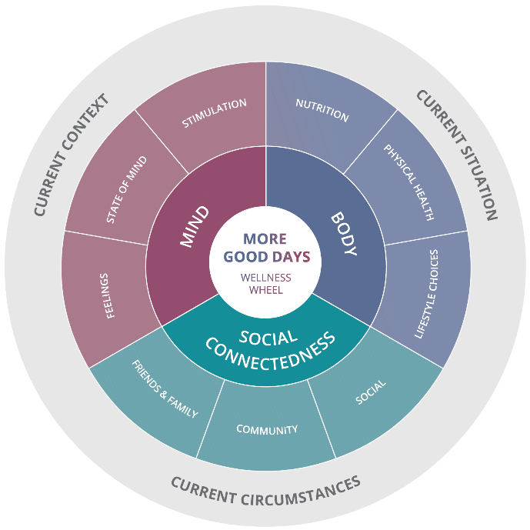

#### Applying the More Good Days Wellness Wheel

**Helpful Tip**

You should always use the RAS support plan to provide you with a foundational understanding of your client and what wellness means to them. The conversations you have with clients around *‘what wellness means to them’* should be for the purpose of understanding what gives their life meaning and purpose and ensuring it is adequately reflected in their care plan.



Using the More Good Days Wellness Wheel as a tool guides you to have conversations with clients to understand what a **good day looks like** for them. This will help you develop a holistic care plan aimed at supporting a client achieve overall wellness.

The More Good Days Wellness Wheel has been designed to:

1. Understand what **holistic wellness means to your client**
2. Develop a **personalised care plan**
3. **Guide support workers** to deliver tailored support to clients
4. **Motivate clients to achieve their goals and participate** in their wellness journey

Refer to the ***More Good Days Wellness Wheel*** tool for more information on how to practically apply it to your service delivery practices.

More Good Days Wellness Wheel Tool



## Illustration of person with a halo of lines around the head **Motivation** through **conversation**

Conversational Tips Tool



Every conversation with your client is an opportunity to motivate your clients to engage with wellness and reablement. To develop an accurate and relatable care plan, you first need to develop a relationship with your client. Building trust will help you have meaningful conversations with clients about their needs and goals.

A useful conversational technique you can use to facilitate this is OARS. OARS involves:

* **O**pen questions
* **A**ffirmation
* **R**eflective listening
* **S**ummarising

OARS is effective during the initial stages of developing a relationship. It invites your client to share their story, in their own words, without any influence/direction from the you.

The information is therefore likely to be a true and accurate representation of their daily experience. This will assist you in developing a more accurate care plan. For more information, see ***Conversational Tips Tool.***

**Helpful Tip**

Service providers have indicated that clients and their families do not respond to the concept of ‘goal setting’. Use alternative techniques with clients to determine goals such as ‘what does a good day look like?’ ‘what do you hope to do again?’, or ‘what do you hope to achieve?’



**DEVELOPING MEANINGFUL AND ACHIEVABLE GOALS**

Using a wellness approach, you will work directly with clients to break down the broader goals in their support plan. Together you will develop achievable steps and strategies to help them reach their goals.

**Helpful Tip**

A broad goal might be ***‘increase social activities’***

An actionable goal might be ***‘meet with friend for a tea and cards once a week’***

An example of a service delivery strategy may be to ***‘transportation for the client to and from friend’s house, to meet this goal.***



For a goal to meaningful and achievable, it needs to use the client’s motivations, desires, strengths, and needs. It also needs to focus on what will help them regain or maintain their independence.  
  
This section provides guidance and practical examples for developing meaningful and achievable goals with your clients.

### Person-centred goals

It is important you use the client’s goals in the support plan as a foundation when you are developing service specific goals with your client. Breaking broad goals down into actionable steps is critical to the success of implementing wellness and reablement.

**Developing person-centred goals** means that you:

* Understand your client’s needs and priorities
* Identify your client’s strengths, abilities, resources, supports and relationships
* Recognise the potential barriers and challenges to care
* Understand what is important to your client and what motivates them

**Developing goals involves three steps:**

1. Identify an end point or desired state
2. Work out the tangible steps to reach the end point or desired state
3. Establish what support is required to help someone reach their goal

#### time-limited specific goals

Creating goals that are focused on time-limited support is no different to setting holistic wellness goals. They need to be personalised and consider what is important to the client as mentioned above. With time-limited support goals it is important that goals are aimed at helping clients regain function and/or learn/re-learn new skills. This includes clearly defining the support the client will receive from the support worker versus what they will do themselves.

SMARTA stands for:

***Specific*** *–* Be as specific as possible, because the more precisely you can describe the goal, the clearer the client will be on what they are striving for, and what their role is in achieving it

***Measurable*** *–* Always include a measurable way to monitor and track progress for each goal you set

***Achievable*** *–* For a goal to be achievable it must be about something of interest to the client, realistic to achieve and also challenging

***Relevant*** *–* Goals need to be relevant to client. This means they have to be meaningful and align with what the client needs and wants

***Time-limited*** - All goals require a timeframe or else there is no urgency or motivation to achieve it

***Agreed –*** goals must be co-developed and collectively agreed to by both the care planner and the client

Without a specified time limit it is easy for time-limited support to fall into a more traditional dependency style relationship, making the reablement process pointless. A time-limit often results in a higher frequency of service and more regular reviews to monitor the client’s progress and adjust services as needed.

**Helpful Tip**

It is also important to remember that reablement specific goals require suitable review points to reduce and/or realign support to accommodate client progress. *Can you set up system reminders to help you keep on track of client review points?*



#### SMARTA GOALS

SMARTA is a useful framework to help you develop person-centred goals

**Helpful Tip**

SMARTA acts as a good framework but it is important to remember that goals must be person-centred and encourage as much client participation as possible.



For more information on how to develop meaningful and achievable SMART goals, refer to the ***Principles for goal-setting tool***

Principles for goal setting tool



## DEVELOP A PERSONALISED CARE PLAN

**Focus on the support your organisation can provide**, not the service you deliver

**Focus on the outcome** the client wants to achieve

**Keep your client’s strengths at the heart** of the care plan, focus on what they can do, not on what they can’t

**Involve the client and their family/carer** in the identification of appropriate wellness and reablement solutions and strategies

Use wellness and reablement strategies that focus on **‘doing with’** and **‘alongside’**, rather than **‘doing for’** and **‘to’**

**Encourage clients** to be involved in the decision-making process

**Clearly state what the client will do** and what the support worker will do to support them

**Include regular review and realign strategies/approaches** if a client’s circumstances change

Outline **how, when and the frequency** the support will be provided

**Have a clearly defined end date and plan for exiting support**, especially for reablement-focused support

**The plan should be written clearly and easy to understand**, free from jargon

Care planning involves working with your client to develop and document how you will support them over a period of time to achieve their goals.

The care plan should outline the wellness and reablement strategies the support worker will use to support the client to achieve outcomes that improve their overall wellbeing and maintain/regain their independence.

### Principles for **effective care planning**

Care planning is unique to each organisation. Many organisations have their own processes and templates to develop person-centred and goal orientated care plans. Although there is no standardised tool for effective care planning, there are certain principles that should guide the process.

The following list highlights some of the things you should consider when developing care plans with clients.

### Promoting choice and managing risk

It is important that you promote choice for your clients. They have the right to make decisions on how their care is delivered. This means that when developing a care plan with the client, you need to consider what is an acceptable risk.

As a care coordinator/facilitator and a support worker, it is important you create an environment where the client feels safe. This involves supporting clients to reach their goal in a safe and controlled environment.

**Helpful Tip**

A client (and their family/carer) should be able to see themselves in their support plan. It should reflect the outcome the client wishes to see and represent an achievable pathway for them to get there. They should understand the benefit this journey will have on their wellness and well-being and be motivated to take steps to achieve greater independence and autonomy in their life.



The client may choose a goal with an approach which bears an element of risk. The client is well within their right to do this and it is your responsibility to review this and address the risk in the care plan by:

1. ***Identifying any risks*** to the approach/goals the client has chosen and discuss it with them
2. ***Assess any identified risks*** to understand their likelihood, potential outcome, and any associated impacts
3. ***Develop risk management/mitigation strategies*** with the client to provide them with every possible opportunity to pursue their goal

### Involving clients and their family/carer in the process

A client’s family, carer and/or support network should be involved in the client’s care planning process. Sometimes families/carers play an active role in helping a client regain/maintain their independence. Especially on the days when the support worker is not there.

It is important families and carers are aware of how support will be delivered. This is critical to the success of wellness and reablement as well as clients play a more active role in achieving their goals. Additionally, families/carers can also add unique insights into their loved one, meaning you can develop a meaningful care plan.

Documenting any family/carer support or involvement in the client’s care is critical for the support worker. This way the support worker is aware and can adjust their approach accordingly.

### Documenting the care plan

A care plan documents the client’s current situation and circumstances, their ideals for wellness and wellbeing and their goals. It also outlines how you will work with them and what actions you will take together to achieve their goals. This including the specific steps towards reablement and the time limits associated with this process.

Care plans are developed and shared with clients and where appropriate, their family/carer. A good care plan is an effective tool to:

* Excite, empower, and motivate clients to actively participate in their care and achieve their goals
* Generate buy-in and support for wellness and reablement approaches with the client, their family/carer
* Create strong and trusted relationships between support workers and clients and family/carers
* Monitor and track client progress against wellness and reablement outcomes

It is important care plans able to be easily understood by the client, their family and carers, and support worker. Therefore, in developing the care plan with the client, ensure you follow these guidelines:

* Use clear and concise language, free from jargon the client will not understand
* Make sure the information you are recording is accurate and free from bias
* Ensure the care plan provides an accurate picture of the client’s context, lifestyle, and needs
* Uses strength-based and respectful language, to promote positivity and motivate the client

For more information on how to develop and document person-centred, and goal directed care plans, refer to the ***Care Planning Checklist Tool.***

Care Planning Checklist Tool



**Helpful Tip**

Remember that for reablement, regular review points are required to reflect client progress. This is also important for if/when a RAS assessor will contact either the client or the service provider to check on a client’s progress against the support plan. Encourage support workers to regularly update care plans with client progress to help inform conversations with the RAS.



Prepare and inform the support worker

Depending on how your organisation operates, the care coordinator/facilitator is usually the person who develops the care plan with the client. Then the support worker is responsible for implementing the care plan with the client. For some smaller organisations these roles may be the same person.

For those organisations who have distinct roles with separate people performing the care coordinator/facilitator and support worker roles, it is important to have channels for the sharing of information.

One of the biggest challenges service provider organisations face is the transfer of information effectively between the care coordinator/facilitator and the support worker roles. Many organisations have a mix of employees which include, full-time, part-time, and volunteers.

Support workers should be well supported, adequately prepared, and have the necessary information to effectively implement the care plan. It is also critical for support workers to be familiar with wellness and reablement and have a strong understanding of the care plan and how their practices can help a client achieve their goals. This is to ensure that those who are actually working with the client can effectively support the client on their wellness and reablement journey.

Consider the following to ensure a smooth transition for the client from when their care plan is developed to when they are provided support:

* How is the care plan provided to the support worker? Are they provided the plan in writing only or are they given a verbal handover? Or both?
* Where is the care plan stored? How will the support worker and care coordinator/facilitator access the plan once it’s finalised and being implemented?
* How can the support worker clarify information in the care plan? What will they do if the client’s circumstances change?

**Helpful Tip**

Use the *More Good Days Wellness Wheel* as a way of transferring meaningful information about your client to the support worker. If the support worker understands what is important to the client or areas where some additional encouragement is required, they can alter their support practices to align better to client circumstances and motivations.



**Helpful Tip**

For short-term reablement referrals, it is recommended a review is conducted during the ***first*** ***3 to 4 weeks***.

For ongoing referrals, a review should be conducted within the ***first 3 months***.



### **Reviewing** the care plan

Your client and their situation are dynamic. Circumstances can change quickly. This means it is extremely important you are conducting regular reviews on how your client is progressing in terms of their care plan.

Reviews are a requirement outlined in the CHSP manual and should be regular and ongoing. This assists you in understanding how your client’s needs have changed, and if adjustments are required to the referral.

Ongoing reviews are a great opportunity to engage in consistent evaluation of how the care plan is currently meeting the client’s needs. If any improvements/changes should be made to help clients reach their goals and greater independence and confidence.

Reviews are recommended to be coordinated through the collection of relevant data from the client, support worker and RAS assessor, as well as any other individuals involved in your client’s journey.

Reviewing and auditing your client’s progress towards their wellness and reablement goals will assist you in complying with the Aged Care Quality Standards and improve how you are working with them.

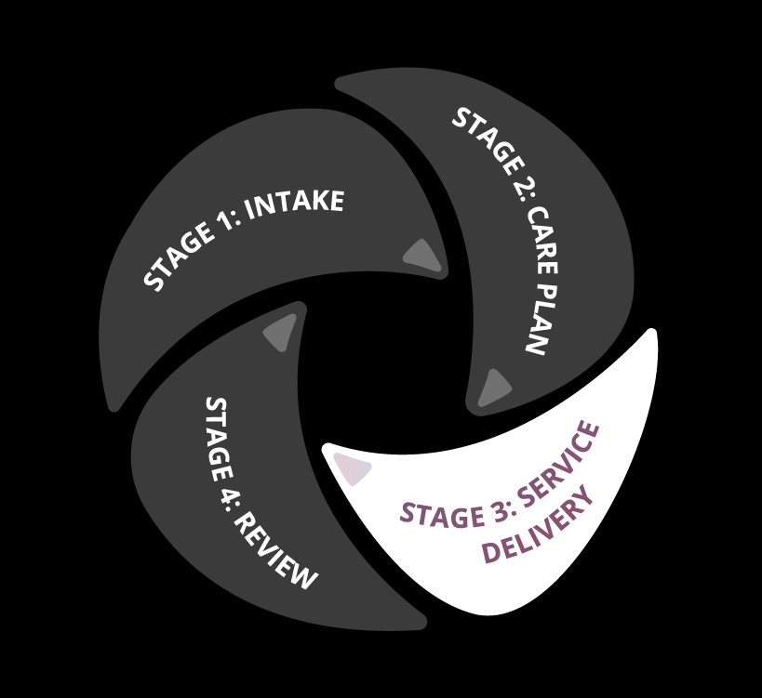

Stage 3: Service delivery

# Stage 3: Service delivery

The support worker is responsible for working with the client to reach their goals and outcomes. This section of the toolkit provides information for **support worker** on how to deliver wellness and reablement approaches with their client.

**THIS SECTION OF THE GUIDE WILL HELP YOU:**

* **understand the importance of working with your clients**
* **interpret the care plan**
* **assist you to have conversations about wellness and reablement**
* **identify opportunities for reablement**
* **put your skills to practice**
* **successfully end the reablement period**

Now the care plan has been developed, the support worker must review and ensure they have the necessary information. This includes understanding the client’s situation, and the support required to help them achieve their wellness and reablement goals.

## Reflecting on your service delivery practices

Before you start delivering support to your clients, it is important that you reflect on your practices. Many people believe that to help an older person, they must do things for them. However, we now know that this approach can contribute to a faster decline in someone’s abilities. Common misunderstandings are that old people are frail and unable to help themselves. As a result, people can make assumptions about what level of care older people need and how it should be delivered. Some clients can also view themselves this way too, limiting their potential.

These beliefs and attitudes are often unconscious and not intentional. As a support worker, it is important to reflect on how you work with your clients. Rather than focusing on what people can't do, support workers should focus on what they can do and support clients through involving them.

Considering the Life Curve explained on page 7 and 8, you should consider how the services you provide can either support a client to maintain or regain independence or contribute to their decline.

Encouraging clients to participate in their care means they will maintain their ability to do everyday activities for themselves for longer. It empowers clients to engage positively with how ageing is affecting them.



**‘Doing for’** versus **‘doing with’**

practical Example

You are working with Fay, who hurt her wrist in a fall while she was cleaning the kitchen. She has since lost strength in her hand and the confidence to clean her house. The RAS has referred Fay to your organisation to provide her with time-limited support to regain her confidence in cleaning her home over a 6-week period.

**Dependency model approach**

**an example that shows the effects of ‘doing for’**

You (as the support worker) start delivering services to Fay by cleaning her kitchen for her. She is very appreciative to have someone do the cleaning because she has not been able to for quite some time. Fay always engages with you while you clean, and the two of you enjoy having a good chat. Despite Fay’s recovery, she never participates in the cleaning and you never ask or encourage her because you enjoy helping her.

At the end of the 6-week period, Fay has been idle and not moving or participating in regular activity as much as she would have usually. She has now lost more strength in her arms and legs and is feeling unsteady on her feet. She feels deflated and is anxious that you won’t be helping her with the cleaning. Fay now has no confidence and feels less capable than what she did at the beginning of the reablement period.

Fay is offered continued service to help her keep her house clean. During the extended service period, you’re reluctant to encourage Fay to participate thinking it will cause her more damage and angst. Plus, you’re there to help her, not cause her more stress. As time goes on Fay now needs assistance getting up from her chair and looking after herself, so you recommend additional services to help her with personal care. As a result, Fay has now further declined on the Life Curve, requiring more assistance with daily tasks and depends on two service providers.

**Wellness and reablement approach**

**an example that shows the benefits of doing with and alongside**

As a support worker, you start with the ***More Good Days wellness wheel*** and the care plan, working with Fay to understand her goals, the kinds of things she would like to return to doing and what gives her life meaning and enjoyment. You ask Fay strength-based questions such as *‘what are you currently doing independently?’*, *‘what is working well for you at the moment?’*, or *‘what does a good day look like for you?’* to gain an understanding on what Fay can do and what she likes to do.

Through that discussion you identify that Fay does not mind cleaning and she has been managing ok but following her fall, she has lost the confidence or has noticed she gets tired more quickly. As you asked Fay what is important to her, she said she loves to walk in the morning and usually does a little bit of tidying up and cleaning before doing her cross-word puzzle and sitting down to eat her lunch over the midday movie.

Now you understand Fay’s strengths and what she enjoys doing, you can work with her to develop personalised goals that motivate Fay to participate in her care in order to regain independence, keeping her doing the things she loves. Using the care plan as a guide, you begin the reablement period for the first couple of visits by undertaking the harder tasks such as sweeping, mopping, and cleaning the wet areas, while Fay focuses on lighter tasks such as dusting and wiping down the surfaces. This will help Fay regain confidence, while not impacting her injury. You will also be providing her with guidance on safe movements to clean.

As the reablement period progresses you encourage Fay to continue to walk, even prompting her to do that on the days you do not visit. You start to recognise an improvement in Fay’s confidence and function, so you encourage her to do the mopping one day. You continue to alter your approach, encouraging Fay to gradually do more and more.

By the end of the 6 weeks, Fay’s confidence has returned, and she can clean the kitchen herself. She has also increased her strength and has started walking more often, giving her greater fulfilment and enjoyment. Fay now sits higher on the Life Curve and has returned to living independently, no longer needing you to help her clean her home. You end the reablement period and review how you helped Fay reach her wellness and reablement goals, reflecting on the joy Fay experienced when she was able to be independent again. You feed this information back through the care coordinator/facilitator as a quality client and service outcome which can be used to inform future approaches.

## INTERPRETING THE CARE PLAN

Care coordinators/facilitators are encouraged to adequately prepare support workers by providing as much information on the care plan as possible. This is especially critical for those organisations who have a varied workforce with little to no face-to-face time with their support workers.

For some support workers, all the information they have on a client, their circumstance, motivations, and the chosen service delivery format, comes from the care plan. It is critical that support workers take the time to understand the care plan prior to visiting the client.

**Helpful Tip**

It is important not to treat a care plan as a tick in a box activity. The care plan should become the foundation for informing your support approach with the client.



Every client is different and, as a support worker, you should be familiar with client’s individual needs. These include the client’s circumstances, their goals, the actions, or strategies they would like to use and how frequently the support worker will complete those actions. This is extremely important for a reablement period where short-term, time-limited services are required to be provided.

### Leaving pre-conceived ideas behind

It is also important to leave any pre-conceived ideas and stereotypes behind. Stereotypical beliefs impact your ability to deliver wellness and reablement goals. They also reinforce the idea that older people are unable to move in a positive direction in this stage of their life. This can affect their wellbeing and lead to further negative health issues. For example, if you believe that a client can’t learn a new skill, you will not actively work with them to help them achieve their potential. You may even reinforce that in subtle ways. Keep in mind, the client may themselves also hold this pre-conceived idea. As a support worker you should encourage them to overcome these ideas and attitudes and see the work you do as a way of helping them to maintain or regain their independence.

That is not to say you should simply direct the client to do everything and follow your orders. That could be equally counterproductive. The goal is to focus on what the client can already do and progressively work with them to do more activities by themselves until they have achieved the goals as per the care plan.

**Helpful Tip**

Where this is uncertainty on an approach, the support worker is encouraged to use the feedback loops suggested in the Review Section of this guide to seek clarification and guidance.



### Person-centred support

Your service delivery practices need to be person-centred. Person-centred care can be defined as “…a foundation to safe, high-quality healthcare. It is care that is respectful of, and responsive to, the preferences, needs and values of the individual patient.” Key dimensions of person-centred care include:

* Respect
* Emotional support
* Physical comfort
* Information and communication
* Continuity and transition
* Care coordination
* Involvement of families/carers
* Access to care[2]

It is critical that the client is involved and has choice and control in their care. When delivering wellness and reablement, all aspects of a person and their circumstances are considered in how you work with them. This means you need to be aware of the ***diversity of your client’s characteristics context, needs and expectations***.

### Having conversations about wellness and reablement

Clients are sometimes reluctant to participate in their care. This can be because they are unaware of wellness and reablement and its benefits, or they believe they are entitled to the delivery of services without their participation.

Similarly, a client’s family, may or may not understand wellness and reablement or its benefits. These perspectives come from a lack of awareness and understanding about wellness and reablement.

It is important to communicate the concepts of wellness and reablement in a way that is easy for clients, their families and carers to understand and that highlights benefits. You can take the following steps to ensure the messages of wellness and reablement are clearly communicated:

**Step 1: Define your delivery approach to set the right expectations**

Advise your client of how you will work with them. Focus on the areas you will be working on, and how you intend to involve them. For example, how you will help them in the tasks they have difficultly doing, while they focus on the activities they can do.

Explaining your approach and their involvement sets the right expectation. It also prepares people, their families and carers to participate.

**Step 2: Use examples to illustrate your approach**

Providing clear examples or scenarios to demonstrate how wellness and reablement approaches work in practice. This really helps people realise the benefits.

Explain how you will help them over the service period. Explain what will change through using this approach. For example, how this approach will help them regain a level of independence or do more of the activities that are important to them.

Consider what approaches will work well with your client, are there approaches and solutions that worked well in other instances that could be applied here?

**Step 3: Relate it to how your client will benefit from your approach**

People have the most success implementing wellness and reablement when they outline the benefits and how they can help the client. You need to provide clear examples of the benefits of wellness and reablement approaches and how they help clients to regain/maintain independence as well as improving their overall wellbeing.

The ***Conversational Tips tool*** has been developed to help support workers talk to clients and their families/carers about wellness and reablement.

**Helpful Tip**

Spending some quality time getting to know your client when you first start working with them will help to develop a trusting relationship. For example, start by having a cup of tea together or use the *More Good Days* approach and ask them what they enjoy doing, or what their good day looks like.



Conversational Tips Tool



## Putting your skills and expertise to practice

The support workers primary guide when working with the client is the care plan. It outlines the steps and tasks you will follow with the client to support them to achieve their wellness and reablement goals. You should use your skills and expertise to consider different ways to support your client to reach their goals.

Delivering wellness and reablement approaches that are person-centred and tailored to individual clients, require certain skills and expertise. You should apply the skills you have developed through training and experience to consider how to support your client in different situations.

### Develop a good rapport

Once the care coordinator/facilitator has worked with the client to develop the care plan, you are now the primary contact between the client and your organisation. You are responsible for delivering wellness and reablement approaches to the client.

Your success will depend largely on the relationship you have with the client and the degree to which you can positively guide, encourage, and empower them to engage with wellness and reablement. You need to spend time developing a strong and trusting relationship with the client, so they understand you are working with them to achieve their goals.

Understanding tone and body language

In developing rapport with your client, it is important you are aware of and can understand the meaning behind tone and body language. This can help you to understand when your client is struggling physically and emotionally or requires extra support or a helping hand. You may also notice improvements in their function and capability. Meaning you may be able to reduce the level of your support, maximising your client’s independence.

**Helpful Tip**

Sometimes people do not communicate verbally, and their body language and tone can indicate their level of comfort and safety.



Problem solving and critical thinking

The environment you are working in is unpredictable and can change quickly. As the success of your delivery of wellness and reablement approaches will depend on the client. You need to able to identify changes in circumstances and adjust your approach accordingly.

**Helpful Tip**

It is important you are flexible, responsive, and proactive when working with your clients, so you can adapt effectively to changes and challenges you are not used to!



Negotiation

Clients and their loved ones/carers play a pivotal role in how actively the client participates in wellness and reablement. There can be instances where either the client, their loved ones, or both, are resistant to adopting a wellness and reablement approach.

To work through this situation, it is important you use your strong negotiation skills, so you are able to:

* **Understand** why the client/family/carer is resistant to wellness and/or reablement approaches by actively listening to concerns
* **Identify** what information they need to actively support and commit to wellness and reablement approaches
* **Communicate** clearly the benefits of wellness and reablement approaches and why it is in the client’s best interest for them to actively participate where they can. Respectfully inviting your client to communicate and work with you to overcome any barriers will assist you in negotiating a good outcome for both of you.

**Helpful Tip**

Negotiation is about listening, analysing and understanding. Everyone has their own perception of the world. You need to take time to communicate clearly about your approach, its benefits and how they will be involved.

It helps if you can use their personal situation and goals to explain your approach. Consider the outcome they want and communicate how the approach you developed together will help them reach their desired goal. Explain that you can change and alter the approach to align to new and improved goals if/when they come up.

This will assist in addressing any behavioural or attitudinal challenges, as in these situations, it is important you understand you are ***handling the problem, not the person***.



### Identifying opportunities for time-limited approaches

Reablement is often seen as a short-term intensive approach, using strategies, assistive technology, and/or equipment to help improve independence. Reablement practices can also be used **as a technique to promote wellness and empower people to do more everyday tasks for themselves**

When you consider the aims of reablement, coupled with your well-developed skills and expertise, you can start to see how reablement can be used as a technique in everyday service delivery practices to achieve better outcomes for your clients.

The ***Identifying Opportunities for Reablement Tool*** has been developed to help support workers identify opportunities to inject reablement approaches into their service delivery practices. This tool will help show you that reablement is not just a dedicated referral from a RAS, it is an approach that should be used as best practice.

Identifying Opportunities for Reablement Tool



**Aims of Reablement**

* learning re-learning new skills, abilities or behaviours
* maintaining/regaining independence
* improving confidence
* increasing motivation
* increase function
* increasing autonomy

### Understanding risk and choice

Sometimes, you will be working with your client to reach particular wellness and reablement goals, in which the client may choose an approach which has an element of risk or their pathway to greater independence may carry an element of risk. Key to wellness and reablement approaches is ensuring the client has choice and control in how you work with them.

You are empowered to use your expertise and judgement when working with your client to understand what an acceptable risk is. Remember that the client has the choice to engage in these activities and that your role is to facilitate them to become more confident in a safe way.

This should be facilitated by initially engaging with the care coordinator/facilitator about the best approach to supporting the client to manage the risk and support them to reach their goals confidently.

**Helpful Tip**

Supporting your client’s choices to take reasonable risks to progress them towards their goals and enjoy a good quality of life, is a key tenant of the Aged Care Quality Standards. Supporting your client to do this will ensure you and your organisation are complying with these standards.



### Using your judgement

Working with your clients to meet their wellness and reablement goals requires you to exercise your judgement. A client’s context and health can change dramatically in a very short period and you need to use your judgement in these circumstances to adapt to your approach to client’s context and needs. When working with clients, your judgement should be guided by the following principles:

* know the limits of your knowledge
* consider acceptable risk
* know when it is appropriate to seek support and advice
* ensure you are able to practice mindfulness to remain calm and focused, particularly in these circumstances which are complex and unpredictable

There may be circumstances when you are unable to follow the care plan, due to changes in a client’s circumstances. In these instances, it is important that you use your judgement and consider adjusting the support to meet the client’s new needs by seeking advice from your care coordinator/facilitator and discussing these changes with your client where appropriate.

***It is important to know when you need to escalate your client’s situation to the care coordinator/facilitator***, as they will be able to review how your current approach to working with the client may need to be altered.



Helpful TIP

Using your judgement

Working with clients, you will experience a few situations in which the care plan is unable to provide guidance for. It is important you use your judgement with compassion and an understanding of the client’s current context/circumstance/situation.

| The client is sick on the day of your visit and can’t safely participate. | You identify it is in your client’s best interest for them to rest while you perform the tasks alone for this session  You report this to the care coordinator/facilitator for their records and record on the care plan |
| --- | --- |
| You identify continuous dis-engagement and a growing reluctance to participate | Ask the client if they are ok. Use your communication skills to see if you can re-engage them through tasks you know motivate them or use your strong negotiation skills to see if you can encourage participation (if safe to do so)  Use feedback loop to advise and consult with the care coordinator/facilitator to address the situation |
| Your client loses motivation | Using judgement, begin by sitting down with the client to understand what is impacting their motivation. Consider whether you need to develop new goals to re-motivate them  Advise/consult with the care coordinator/facilitator to develop a wellness-focused action plan to re-motivate the client to participate |
| Your client is unable to continue to work towards the outcomes/goals originally set with care coordinator/facilitator | Talk to the client about what this will mean for the future of them working together, reassuring them they can still have more good days  Advise and consult with the care coordinator/facilitator |

### Looking after your own wellness

As a support worker, you have a very important and valuable job. While the primary function of your role is to support older people to achieve their wellness and reablement goals, it is equally as important to ensure ***you are caring for and looking after your own wellness too.***

The environment you are working in can at times be stressful. Due to the nature of your work, you will experience change and potentially challenging circumstances. Therefore, it is important that you also look after yourself. Engaging with your colleagues and supervisors about how you are feeling is a useful way to ensure you are connected with the appropriate level of support.

Consider the ***More Good Days Wellness Wheel*** and ask yourself what wellness means to you. This can be an important exercise in gauging if you are looking after yourself. Consider what gives energy and value and make sure you are getting what you need to stay happy and healthy. This will make you a better support for yourself, your organisation, and your clients.



Figure 2. More Good Days Wellness Wheel

### Exiting a reablement client

When your organisation receives and accepts a reablement referral, the RAS assessor will have identified a date by which the client should return to independence by. You need to do everything you can to help your client reach their goals and achieve their desired level of independence and autonomy.

While the RAS assessor is responsible for reviewing a client’s progress through their necessary review points, it is also your responsibility to work with the client through service delivery to achieve their goals. You should be repeatedly reviewing your clients progress and adapt your support to ensure that at the end of the reablement period, the client is able to manage independently without ongoing assistance.

By formally exiting your client from short-term services, you are acknowledging that the client has met their goals and has maximised their independence, feeling confident and capable in their function and ability.

**You can confidently exit a reablement client when:**

* The client’s outcomes/goals have been reached
* Your client is reabled and no longer requires your services

### The benefits of concluding a reablement period

When a reablement period works well, your client will be able to do things for themselves. Or be able to do things they may not have been able to do before or things they struggled with at the beginning of the reablement period.

Helping your client gain or regain function, independence and/or confidence is rewarding not only for your client, but for you too. Seeing your client with newfound confidence and motivation shows the benefit of your hard work and theirs. It improves their quality of life and motivates them to continue to maintain their independence for as long as possible.

### Where ongoing support is identified and how that support **should** be delivered

At the end of the reablement period a client may be assessed as needing ongoing support. They will need to have their support plan reviewed by a RAS assessor who will review the client’s capability/capacity and re-assess their ongoing needs.

If services continue at the end of a reablement period, services should continue to provide support in a way that maintains the progress the client has already made. This means that service provider organisations should adapt their service to support the aims of reablement, while building on the progress made. Ongoing support should focus solely on client outcome and continue to support them in maximising their ability to achieve a level of independence.



Stage 4: Review

# Stage 4: Review

This section of the toolkit provides guidance to both the care coordinator/facilitator and support worker in reviewing and improving their approaches.

Both the care coordinator/facilitator or the support worker work directly with the client. Therefore, these roles are best placed and most informed to review client experiences and success. Reviewing approaches and client outcomes is essential to quality and continuous improvement. Undertaking regular reviews ensure that you and your organisation continues to deliver high-quality and outcomes-focused support to clients.

**THIS SECTION OF THE GUIDE WILL HELP YOU:**

* **Review the client’s journey, during and after service delivery**
* **Review and communicate how processes and approaches can be improved to assist you in service delivery**

Approach review from multiple perspectives

Reviewing your approach can be assessed through analysis of different perspectives; yours, as an employee, and your client’s.

**Employee**: identify how service delivery practices and support help clients to understand and apply wellness and reablement approaches.

**Client**: understand if and how wellness and reablement approaches to service delivery are client focused and meeting   
client goals.

## Reviewing your service delivery

Reviewing your client’s progress during and after service delivery will make sure the support you provided aligned to wellness and reablement approaches and achieved client outcomes.

Under the CHSP, a wellness and reablement approach is expected to underpin all aspects of the client journey from the initial assessment and support planning stages through to service delivery and ***regular reviews*** *[3]*.

The frequency of reviews will depend on your client, their needs, goals, and the type of referral. Regardless of these factors, all client cases require close attention and follow up, especially reablement.

**Helpful Tip**

It is also important to remember that reablement periods require suitable review points to reduce and/or realign support to accommodate client progress.



### Iterative reviews

Continuously reviewing your client’s journey during the delivery of support is essential. This will ensure the care plan and the goals you are working towards are still relevant to your client’s needs and contexts.

Iterative reviews are reviews that happen regularly to assess your client’s progress and adjust your support to match. During these reviews you will look at the tasks outlined in the care plan and consider whether they are still supporting you and your client to reach their goals.

A client’s needs and context can change dramatically in a short period it is important the support worker is:

*consistently recording their interactions with the client and how they are progressing in their journey.*

This allows for the support worker to review and consider if any changes need to be made to the plan and the outcomes you are supporting the client to achieve. These changes could be made to the care plan itself and when providing a formal review through My Aged Care.

**Helpful Tip**

Reviewing the ‘how” will assist your organisation in understanding what approaches have been effective and should be shared with the rest of the organisation, and what practices should be curbed.



**Helpful Tip**

At the end of each session with your client, make time to record your experiences with them, as well as your reflections on how the client is progressing.



### Reviewing your client’s journey

The effectiveness of wellness and reablement approaches is that they can be reviewed and measured by looking at whether client outcomes are met and how. Client outcomes are at the centre of wellness and reablement approaches, and every decision and action, by both the service provider and client, **should aim to meet these.**

When you review client cases, it is important to assess **if the client’s goals have been met**, and if so, how.

### Reflection

When you review how you worked with your client to deliver wellness and reablement, it is important to reflect on your perception of success for meeting the client’s outcomes, as well as how you felt during the process.

Understanding if you have succeeded in a task will help you to continually improve your practices and behaviours and avoid repeating the bad ones.

A ***Service Delivery Reflection***template has been developed to assist you to review your current service delivery practices. It can be used to review your approach to every client journey, from intake, to care planning, through to service delivery and review.

The template also offers an opportunity for you to reflect on your own experiences working with the client and how you believe your wellness is being supported. Reviewing your own experiences can help your organisation understand what practices can be improved or developed to better support their employees.

This tool is ideal for the sharing your experiences. It will help you and your organisation work towards a best practice approach to wellness and reablement. You can share your experiences and learnings with peers, management, and other organisations, to improve the overall quality and standard of service delivery and your experience at work.

**Helpful Tip**

It is also useful for support workers to reflect on what wellness and reablement strategies and practices work well and identify if the same approaches would work well for any of their other clients.

Service delivery reflection template Tool

### Sharing learnings

Sharing good and bad examples of service delivery practices and client outcomes will reinforce good attitudes and behaviours within your organisation.

Sharing lessons, challenges, best practices, and areas for improvement will help you and your organisation deliver wellness and reablement approaches in and effective and consistent way.

#### Lessons Learned

Sharing lessons learned provide an opportunity for you and your colleagues to continuously improve by reviewing how you are delivering services and working with your clients.

Lessons learned can be developed through the process of ***identify***, ***record***, ***share*** and ***leverage***.

1. **Identify:** using your service delivery reflection template, you will be able to assess if there are any practices/experiences that should be shared within your organisation to support employees in understanding how to deliver wellness/reablement to your clients.
2. **Record:** clearly document lesson learned, including what, why and how.
3. **Share:** share lessons with relevant groups and people, through *feedback**loops* and *case**conferencing*.
4. **Leverage:** regularly engage with lessons learned and use them to improve practices and change behaviours.

Feedback loop

Helpful Tip

Feedback loop discussion

*I have a client who was really engaged in their reablement journey early on, however I have noticed their willingness to participate has dropped off.*

*I explain the benefits of reablement and outline how this journey will help them reach their goals, but I am not having much luck.*

*How do I know when to push the client to work with me, and when to pull back?*



Ongoing feedback loops are an opportunity for employees to engage with one another and share stories, seek advice and work through challenges.

The ***Service Delivery Reflection*** template can guide discussions amongst employees across all levels within your organisation.

Regular feedback will help you to identify and address issues, seek advice and ensure continued development in your understanding and practical application of wellness and reablement. Feedback loops are an opportunity for you to engage with your supervisor, manager and care coordinator to:

* Ensure your understanding of wellness and reablement **aligns with business objectives**
* Provide **feedback on the opportunities and challenges** in delivering wellness and reablement to your clients
* Discuss **innovative ways** to reable clients and manage challenging situations
* **Change behaviours and attitudes** that do not support a wellness and reablement culture
* A close up of a logo

  Description automatically generatedEnsure **care plans align to the practical** requirements of delivering wellness and reablement.

Service Delivery Reflection Template

#### Case conferencing

Case conferencing refers to the sharing of experiences between employees in your organisation or between different organisations. The purpose is to discuss how client’s needs have been met through a planned and coordinated approach.

Case conferencing within your organisation is an important tool to ensure:

correct practices and approaches are being used

issues/challenges are addressed

complex cases/ circumstances   
can be discussed

feedback and advice can be sought



##### Within your organisation

Case conferencing can be conducted between your colleagues to share the similarities and differences between your experiences, and how individualised approaches have benefitted the client.

Sharing reflections and lessons learned are useful for peer-to-peer feedback. They help to develop a collaborative workforce. Being able to connect with and learn from your colleagues is useful, particularly when working in a challenging context.

Case conferencing can also occur between employees and their manager/supervisor, who can provide their advice and offer guidance. This is a useful opportunity for employee development and can also improve the quality of service delivery.

##### Within the aged care sector

Case conferencing between organisations can be done through the [More Good Days Community of Practice](https://www.more-good-days.com.au/). Sharing cases between organisations can help improve the quality of service delivery across the aged care sector.

Organisations can use the community of practice to share how they have been able to embed wellness and reablement in their business, and in service delivery. Use the community of practice to share what you’ve learned from embedding wellness and reablement. It will help assist other organisations in understanding the practices which have been effective, and also the positive outcomes it has for both the client and for you as an employee.

**Helpful Tip**

Reflecting and reviewing how you have delivered support to you clients and if their outcomes were met is of high importance. It helps you to contribute effectively to your CHSP reporting requirements.



1. ADL Smartcare. *Life Curve.* 2020.
2. [Australian Commission on Safety and Quality in Healthcare, person centred care](https://www.safetyandquality.gov.au/our-work/partnering-consumers/person-centred-care)
3. Department of Health. *CHSP Manual 2020–2022*. July 2020