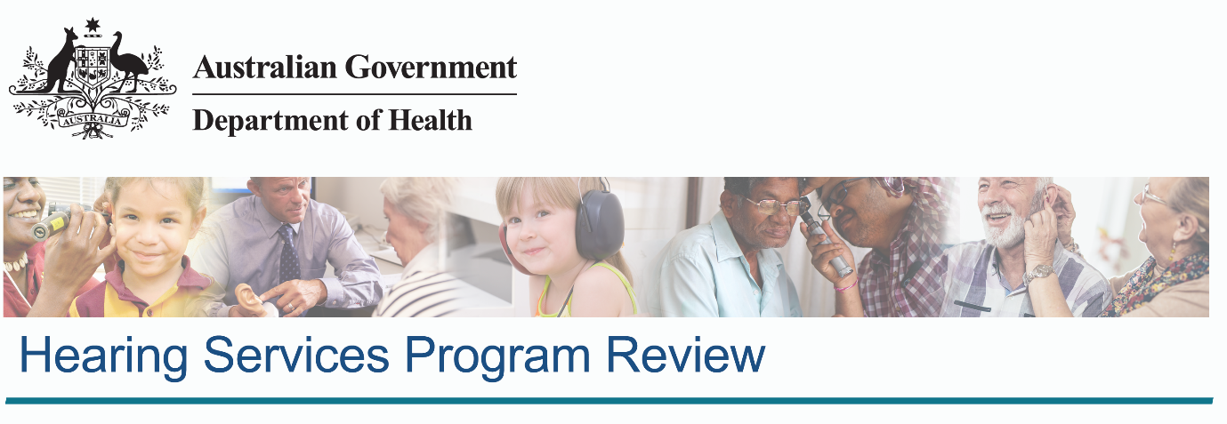

Interim Advice to Government – Implementation of Hearing Services Program Changes

November 2020

Interim Advice to Government – Implementation of Hearing Services Program Changes

List of Figures 3

List of Tables 3

Executive Summary 4

Key messages 4

Background 5

Purpose of this paper 5

Hearing loss in Australia 5

The Hearing Services Program 6

FY2020-21 Federal Budget announcements 7

Overview 7

Regulation Impact Statement: expected impacts on the Program 8

Summary of the potential impacts on particular stakeholders of the Voucher Scheme 8

Consumers 8

Providers 8

Manufacturers 9

Practitioners 9

Implementation issues 10

Rural and remote consumers 10

Analysis of providers operating in rural and remote areas 12

Data limitations 13

Options to support consumers affected by Program changes 14

Program design considerations 14

Options analysis 14

Option #1 – Rural and Remote loading on services 14

Option #2 – Rural and Remote loading on providers or sites 15

Option #3 – Loading on small and medium providers 16

Option #4 – Expanded teleaudiology offering 17

Option #5 – Hub and spoke model 18

Conclusion 20

Bibliography 21

Appendix A – Stakeholders 23

Appendix B - Rural and remote consumers 25

How geographic data is captured 25

Conversion of data between SA-2, postcode, and MM geographic regions 26

Communities dependent on a single provider 27

# List of Figures

Figure 1: Estimated prevalence of hearing loss by age (Davis, 1995). 5

Figure 2: Estimated Australian population by age (grey line), estimated population with hearing loss by age (orange line). The blue bars are those consumers that have received hearing services in the Voucher scheme in the last five years 6

Figure 3. Index of relative socio-economic advantage and disadvantage quintiles for local government areas 12

Figure 4: Sites by level of Voucher Scheme revenue (by provider) and MM region. Note that (a) Franchises, and (b) Hearing Australia have been separated out in this analysis. This data includes all Voucher Scheme sites (permanent and visiting) in the three financial years of FY2017-18, FY2018-19, and FY2019-20 13

Figure 5: Map of postcode 2325 - located to the west of Newcastle, New South Wales 27

# List of Tables

Table 1: Estimated Australian population by Modified Monash Model (MM) classification. Variances in the prevalence values are due to the age distribution of the population in those areas 10

Table 2: Voucher Scheme consumers in the last five years (FY2015-16 to FY2019-20), by the Modified Monash Model region of consumers 11

Table 3: Summary of options suggested to support the implementation 14

Table 4: Summary of Modified Monash Model (MM) classifications (Department of Health, 2019) 25

Table 5: Three sample suburbs within the 2325 postcode 27

Table 6: 51 communities identified as being dependent on a single provider in FY2019-20. Note that St Helens (TAS) and Karratha (WA) had two sites from the same provider, and hence these 51 communities represent 53 individual sites 28

# Executive Summary

On 14 August 2019, the Hon Mark Coulton MP, Minister for Regional Health, Regional Communications and Local Government (the Minister) announced the establishment of an Independent Panel to review the Hearing Services Program.

At the request of the Minister on 16 October 2020, the Panel is providing this Interim Advice regarding the implementation of the Government’s changes to the Hearing Services Program’s (the Program) Voucher Scheme, announced in the October 2020 Federal Budget. The changes included extending the Voucher period to five years, removing the 12 month warranty period maintenance payment, and replacing the annual maintenance payment in advance with quarterly payments in advance.

This Interim Advice assesses potential implementation impacts and provides three policy approaches which could be applied during the implementation period. Each approach is aimed at supporting ongoing consumer access to the Voucher Scheme by maintaining a viable provider sector. Impacts on consumers and providers in rural and remote areas are included in the analysis.

The Panel will provide final advice on each of these approaches to the Government in March 2021 through the Draft Report into the Hearing Services Program, following consultation with the sector and community.

It should be noted that the analysis provided in this Interim Advice is limited to the data available from the Program – essentially data on clients, service site locations and payments to providers. Many providers source income from outside the Program. Detailed analysis of service provider finances and the impact of the Budget changes on provider income and expenses would require a range of other data not available to this Review.

However, there is sufficient evidence to show that revenue from the Program will decrease over the first two years by around 19 percent each year, and will have greatest impact on those providers who are most dependent on Program revenue (Hearing Services Program, 2020).

## Key messages

The Panel’s Interim Advice is that that the Government consider the following three policy approaches to maintain a viable service provider sector, and in turn to support ongoing consumer access to hearing services during the adjustment period that commences from 1 July 2021:

1. Provide a loading on service items delivered in rural and remote areas (MM3-7)
2. Provide a loading on service items delivered by small and medium service providers
3. Expand teleaudiology services available through the Program.

The Panel will provide final advice on each of these approaches to the Government in March 2021.

Analysis shows that the impact of the Government’s changes will be most pronounced during the period 1 July 2021 to June 2023. This is primarily due to the impact on Program revenue from the move from a three to five year period for the Voucher. Hence the implementation of any of these approaches is proposed for two years.

The Panel will undertake further consultation on these approaches, prior to proposing any new policy changes for the Program.

The Panel is separately considering potential long-term changes to the Program. Following the receipt of submissions in response to the consultation paper that was released on 30 October 2020, subsequent meetings with stakeholders (including on matters contained in this Interim Advice) and its own analysis of evidence, the Panel will release a draft report by March 2021, and a final report in July 2021.

# Background

## Purpose of this paper

On 14 August 2019, the Hon Mark Coulton MP, Minister for Regional Health, Regional Communications and Local Government (the Minister) announced the establishment of an Independent Panel to review the Hearing Services Program.

At the request of the Minister on 16 October 2020 the Panel is providing this Interim Advice regarding implementation of the Government’s changes to the Hearing Services Program’s (the Program) Voucher Scheme announced in the October 2020 Federal Budget.

This Interim Advice assesses potential implementation impacts and provides three policy approaches which could be applied during the implementation period. Each approach is aimed at supporting ongoing consumer access to the Voucher Scheme by maintaining a viable provider sector. Impacts on consumers and providers in rural and remote areas are included in the analysis. The identified policy approaches should be explored through further analysis and consultation with the sector and community.

The Panel will provide final advice to the Government in March 2021 through the Draft Report into the Hearing Services Program, following consultation with the sector and community.

## Hearing loss in Australia

One in six Australians are living with a degree of hearing loss. Hearing loss can reduce a person’s capacity to communicate and participate in social situations and can affect their education and employment opportunities. While hearing loss can affect anyone, prevalence rates for hearing loss rise quickly for people reaching their late 50s and the decades beyond (Figure 1).

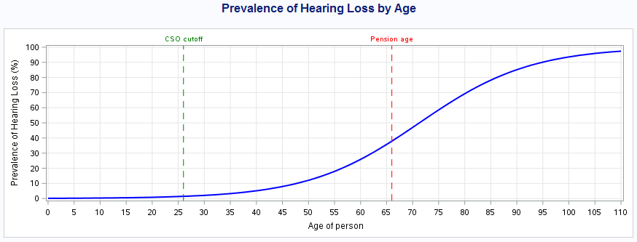

Figure 1: Estimated prevalence of hearing loss by age (Davis, 1995).

The Department of Health (the Department) estimates that there are 3.7 million Australians living with age-related hearing loss. Many people are affected by the significant social stigma attached to hearing loss (David, 2015). This can lead to anxiety, social exclusion, and barriers to accessing hearing services and devices that could improve their hearing outcomes.

Hearing loss has a significant impact on individuals and the wider economy, estimated at $33.3 billion in 2017 (Hearing Care Industry Association, 2017). This represents the combined effects of financial costs ($15.9 billion) and the value of lost wellbeing ($17.4 billion). While older Australians represent the majority of the population with hearing loss (Figure 2), it affects all age groups, demographics, and the full range of socio-economic status.

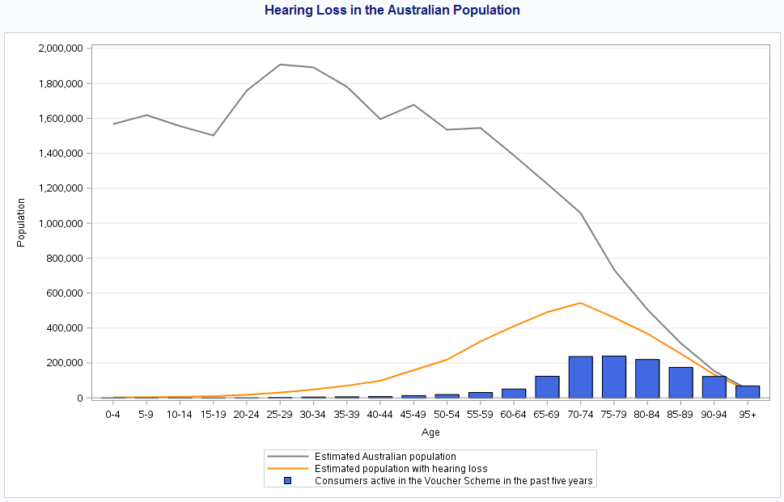

Figure 2: Estimated Australian population by age (grey line), estimated population with hearing loss by age (orange line). The blue bars are those consumers that have received hearing services in the Voucher scheme in the last five years[1].

Consumers often choose not to seek professional support to address hearing loss and, in particular, can be reluctant to acquire a hearing device (Fischer, 2011). Reasons include a perception that the hearing aid was unnecessary, the cost and inconvenience of a hearing aid, and the poor experience reported by their peers with the use of hearing aids. Many aspects of using hearing aids can be difficult for older adults, including changing the battery, cleaning the ear mould, and inserting the aid into the ear. Other factors have included cognitive and functional limitations, poor benefit, discomfort with background noise, discomfort in noisy situations and poor fit (Fischer, 2011).

## The Hearing Services Program

The Department is responsible for managing and administering the Program. The Voucher Scheme, as part of the Program, aims to reduce the consequences of hearing loss in the Australian community through the provision of access to high quality hearing services and devices, with a particular focus on improving accessibility for the most vulnerable people in society. The Program:

* provides subsidised services and devices to eligible consumers (for the Voucher Scheme this is predominantly Pensioner Concession Card holders)
* provides Program eligibility confirmation service and support
* investigates and resolves complaints
* provides information on the location of sites and practitioners
* undertakes contract development, compliance checks and audits, Program management and support for manufacturers, providers and agencies (for example telephone advice on issues such as managing services during the COVID-19 pandemic)
* supports linkages between the Program and the National Disability Insurance Scheme (NDIS)
* provides strategic policy and program advice to Government.

As part of the Program, the Department also manages the Community Service Obligations Scheme (CSO), which provides specialised hearing services to children and young adults, Aboriginal and Torres Strait Islander people 0-26 years old and from 50 years and over and people living in remote areas. The Program also funds research on strategies through the National Acoustic Laboratories to prevent hearing loss or lessen its impact (Hearing Services Program, 2020). However, this research is applied at a population level and is not linked directly to the Voucher Scheme.

In FY2019-20 (Hearing Services Program, 2020) the Voucher Scheme;

* delivered 1,436,291 services to 751,052 Australian consumers, including fitting consumers with 392,598 devices (hearing aids)
* delivered services through 292 providers (businesses), across 3,204 sites (clinics) in every state and territory.

The focus of this Interim Advice is on the implementation of the October 2020 Budget changes to the Voucher Scheme.

## FY2020-21 Federal Budget announcements

### Overview

The Government announced several changes to the Voucher Scheme in the October 2020 Budget. These reflect the extended lifespan of hearing aid devices (now being a minimum of five years) and improved efficiency in the way maintenance payments are made under the Program.

These measures will take effect from 1 July 2021, and include;

* Moving from a three year to a five year Voucher period with existing Vouchers extended by two years, and new Vouchers to be current for five years. This will align the Voucher period to the expected lifespan of a hearing aid and prevent unnecessary device refits.
* The Government ceasing payment for hearing device maintenance and repairs during the manufacturers’ minimum warranty period of 12 months.
* Maintenance and repair payments being made quarterly in advance per device, instead of the current annual in advance payment.
* Consumers who are not fitted with a device being entitled to an annual review to enable their hearing to be monitored over time and improve their access to hearing services. This will align with the entitlements of those who are fitted with a device.
* Additional resources being made to the Program administrators for monitoring, compliance and audit activities in the initial implementation phase (Hearing Services Program, 2020).

In addition to the changes to the Program, the Government also announced $5.4 million for a national awareness campaign on hearing loss. This campaign will raise awareness of hearing loss and its prevention as well as the support that is available for groups who are likely to suffer from hearing loss. This campaign will raise the profile of the Program with targeted hearing loss groups and will assist services in the adjustment period of the Voucher Scheme changes.

## Regulation Impact Statement: expected impacts on the Program

The Regulation Impact Statement (RIS) for these changes is available through the Office of Best Practice Regulation. The RIS report incorporates a detailed analysis of the expected impacts on the Program. The impacts and amelioration measures include:

1. Appropriate safeguards to ensure that consumers with exceptional clinical need requiring an earlier refit of a hearing device can receive this service.
2. An expected decline of 76,000 unnecessary device refits across FY2021-22 and FY2022-23.
3. An acknowledgement of the potential for larger impacts in rural and remote areas that may result in the consolidation of some providers and limitations on access to hearing services for consumers.

As noted earlier, a concern for this Interim Advice relates to how consumers and providers in rural and remote markets could be supported following the implementation of the above changes. Further analysis on the impacts of the changes can be found in the [Regulation Impact Statement](https://ris.pmc.gov.au/2020/10/22/ensuring-sustainable-hearing-services-program) (Office of Best Practice Regulation, 2020).

## Summary of the potential impacts on particular stakeholders of the Voucher Scheme

### Consumers

* Safeguards have been put in place to ensure consumers who require hearing devices and services will continue to receive them.
* Some consumers who may have expected to receive new devices every three years will now need to wait an additional two years. However, this does not apply to those (a) with a clinical need for a new device, and (b) where their current device is not functioning to specifications. In addition, consumers who have not been fitted with a device will now be entitled to an annual review to enable their hearing to be monitored over time and improve their access to hearing services.
* Some consumers may find it convenient to have a new device every five rather than three years.
* Consumers may be affected by providers’ operational decisions regarding the number of clinic sites and types of service delivery channels they continue to operate.

### Providers

* This is a combination of manufacturers directly owning providers, and independent providers, including those who have preferred manufacturers for the devices that they fit to consumers based on commercial agreements. The latter includes where negotiated device pricing provides an incentive to fit one manufacturer’s devices over and above others.
* Voucher Scheme revenue is expected to decrease by about 19 percent in FY2021-22, 18 percent in FY2022-23, and 10 percent in FY2023-24. This is predominantly the result of (a) a reduction in unnecessary refitting services caused by the extension of the Voucher duration, and (b) new restrictions on maintenance payments.
* Some providers may mitigate this decrease in revenue by increasing their marketing and targeting of Australians with hearing loss who do not currently engage with the Program.
* Some providers may aim to sell more partially subsidised hearing devices to consumers in the Voucher Scheme, or increase the price of partially subsidised devices, to compensate for the decrease in revenue.
* Some providers that have a business model based on early refitting of devices and are currently marginally economically viable, may exit the market as a result of these changes.
* Others may elect to restrict services (e.g. close some sites) or otherwise alter their operations.

### Manufacturers

* A decrease in unnecessary fittings in the first two years post-implementation of the changes will impact manufacturer revenue derived from the Australian market. There will also be ongoing impacts from the change to a five-year voucher, wherein re-fittings of devices between three and five years old will be further limited.
* Most manufacturers are large multinationals, with Australia representing only a small proportion of their sales. There is only a small risk that some manufacturers may elect to exit the Australian market as a result of these changes.
* There is a significant level of formal and informal integration between providers and manufacturers, and hence there are overlapping impacts as a result of this change.

### Practitioners

* As practitioners (audiologists and audiometrists) are either owners or employees of service providers, they are exposed to the impacts on providers.
* Further information about these stakeholder groups can be found in Appendix A – Stakeholders.

# Implementation issues

## Rural and remote consumers

The Panel is particularly concerned about the potential impact of these budget announcements on consumers living in rural and remote areas of Australia. As this measure will affect provider revenue, those geographic areas that may be of borderline economic viability may be particularly vulnerable to the Program changes.

There is an estimated population of more than five million Australians living in rural and remote areas (Modified Monash Model regions 3-7). Based on age demographics and modelled incidence of hearing loss, an estimated 17.6 per cent of this population (0.96 million people) experience levels of age-related hearing loss (Table 1).

Table 1: Estimated Australian population by Modified Monash Model (MM) classification. Variances in the prevalence values are due to the age distribution of the population in those areas.

| **Region** | **Estimated resident population**  **(Jun-2019)** | **Estimated population with age-related hearing loss** | **Estimated prevalence of age-related hearing loss** |
| --- | --- | --- | --- |
| Whole-of-Australia | 25,360,928 | 3,718,203 | 14.66% |
| MM 1 | 17,199,809 | 2,362,090 | 13.73% |
| MM 2 | 2,690,594 | 392,958 | 14.60% |
| Rural and Remote (MM 3-7 inclusive) | 5,470,525 | 963,155 | 17.61% |
| MM 3 | 1,317,415 | 228,896 | 17.37% |
| MM 4 | 647,121 | 120,580 | 18.63% |
| MM 5 | 2,656,180 | 486,434 | 18.31% |
| MM 6 | 456,066 | 75,264 | 16.50% |
| MM 7 | 393,743 | 51,981 | 13.20% |

A total of 83,430 consumers in these areas received services through the CSO Scheme in the last five years (Table 1), noting that this number includes those who are eligible for that scheme and may have received a service, such as a hearing assessment, but may not be experiencing hearing loss[2].

Penetration of the Voucher Scheme is highest in MM 1-4, and tails off significantly in regions   
MM 5-7 (Table 2). While this pattern is not fully understood, it is believed to be influenced by increasing delivery of the CSO Scheme in more remote areas[3], increased geographic distances creating barriers to access, and smaller populations impacting provider viability. However, it is noted that these are hypotheses and evidentiary data is scarce.

Table 2: Voucher Scheme consumers in the last five years (FY2015-16 to FY2019-20), by the Modified Monash Model region of consumers[4].

| **Region** | **Total consumers in Voucher Scheme** | **Penetration of Voucher Scheme (percentage of estimated population with hearing loss)** |
| --- | --- | --- |
| Australia (all regions) | 1,706,302 | 45.89% |
| MM 1 | 1,092,940 | 46.27% |
| MM 2 | 211,167 | 53.74% |
| Rural and Remote (MM 3-7 inclusive) | 402,195 | 41.76% |
| MM 3 | 157,191 | 68.67% |
| MM 4 | 101,845 | 84.46% |
| MM 5 | 128,860 | 26.49% |
| MM 6 | 11,075 | 14.71% |
| MM 7 | 3,224 | 6.20% |

In summary, rural and remote consumers form a thin market, due to: small consumer populations and lack of economies of scale; limited professional workforce availability; higher operating costs in rural and remote areas; consumer barriers to access (such as the costs and time of travel); and a lack of choice of providers. In terms of access, there are at least 51 communities that are dependent on a single provider to deliver hearing services[5] (see Appendix B).

In addition, the age profile and health status (Australian Institute of Health and Welfare, 2020) of the rural and remote population means that people in these areas are more likely to experience hearing loss than people in metropolitan areas. The Australian Bureau of Statistics (ABS) has identified that local government areas which have the highest proportion of disadvantage tend to be in rural and remote areas[6]. (Australian Bureau of Statistics, 2018) (Figure 3).

Hearing loss is more broadly associated with low educational attainment and even after controlling for education and important demographic factors, hearing loss is independently associated with economic hardship, including both low income and unemployment/underemployment (Emmett SD, 2015). Research also suggests the use of hearing aids is lower among men in the lowest socio-economic population (Scholes S, 2018). Access to hearing services can also be impacted by socio-economic factors. These factors can be separate from, though in many cases intertwine with, living in rural and remote areas.

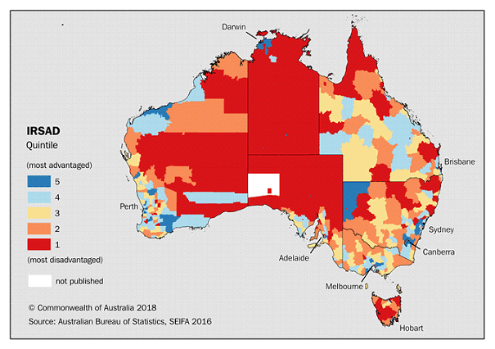

Figure 3. Index of relative socio-economic advantage and disadvantage quintiles for local government areas.

### Analysis of providers operating in rural and remote areas

Over the past three financial years (FY2017-18, FY2018-19, and FY2019-20), consumers in rural and remote areas have not been found to be particularly dependent on either very large providers with national reach, or very small providers operating as single sites.

Figure 4 demonstrates that, with the exception of remote and very remote communities (MM 6 and MM 7) which are predominantly serviced by Hearing Australia and several large or very large providers) there is no significant difference in the distribution of provider sites by level of Voucher Scheme revenue of providers.

This demonstrates that rural and remote areas are broadly serviced by the same types of providers as metropolitan areas. However, given the market realities of these areas, the Panel acknowledges that many clinics operating in these areas are likely to have a greater viability impact as a result of the FY2020-21 Federal Budget announcements.

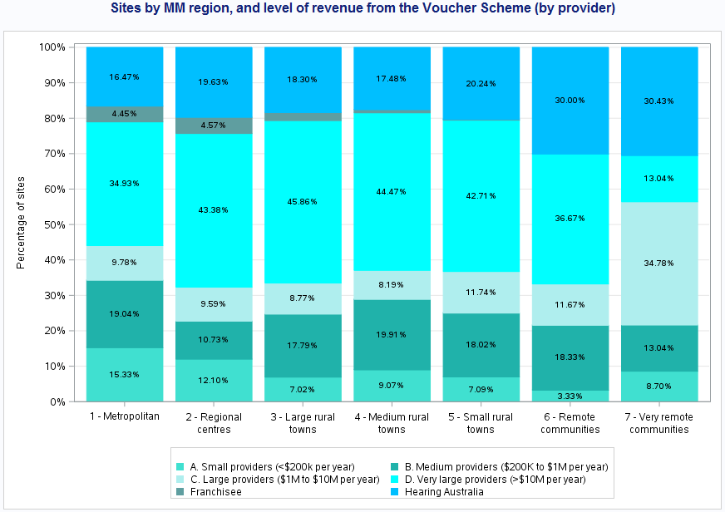

Figure 4: Sites by level of Voucher Scheme revenue (by provider) and MM region. Note that (a) Franchises[7], and (b) Hearing Australia have been separated out in this analysis. This data includes all Voucher Scheme sites (permanent and visiting) in the three financial years of FY2017-18, FY2018-19, and FY2019-20.

### Data limitations

The Program does not have access to reliable data on the overall profitability of providers or of individual clinics operated by providers, or of revenue generated outside the Program. As a result, the Panel is unable to quantify the impact of the FY2020-21 Federal Budget announcements on the viability of those businesses. Some industry feedback suggests that overall, the Program is responsible for up to 80 percent of the hearing sector’s revenue. Other provider revenue sources include:

* The private market for hearing services (primarily adults over the age of 26 who are not Pensioner Concession Card holders or are otherwise eligible under the Program)
* State government schemes (e.g. Deadly Ears in Queensland)
* Workers compensation schemes
* Other Commonwealth Agencies, such as the NDIS, or the Department of Veteran Affairs

Given these limitations, this Interim Advice has based its assessments solely on the detail available to this Program. That is, by quantifying the impact to providers’ Voucher Scheme revenue and not attempting to model the impact on businesses viability or on their exposure in rural and remote areas. These limitations to the analysis need to be considered in assessing the options presented in this paper.

# Options to support consumers affected by Program changes

## Program design considerations

In developing and presenting options the following principles have been be used to assess and inform the acceptability of a range of options for further consideration by Government:

1. Is the proposed option **Effective**?
   * Does it support Program effectiveness, in that the services result in an outcome of improved hearing for the targeted consumers?
2. Is the proposed option **Efficient**?
   * Is it an appropriate use of taxpayer funds, leading to best delivery of services for a given level of public funding?
3. Is the proposed option **Equitable**?
   * Does the option unfairly bias against some consumers, providers, or other stakeholders?
4. Is the proposed option **Sustainable**?
   * Is the option able to be implemented, and maintained, into the future?

## Options analysis

The Panel has undertaken a primary analysis of five possible policy approaches based on research and data available from the administration of the Program. In the broad they either provide financial incentives to industry, or on establishing new service delivery channels to consumers. The five approaches are summarised in Table 3, noting that the implementation approaches presented may not be mutually exclusive.

Table 3: Summary of options suggested to support the implementation.

| **Option ID** | **Details** |
| --- | --- |
| 1 | Loading on service items (claims) delivered in rural and remote areas |
| 2 | Loading on providers and/or sites operating in rural and remote areas |
| 3 | Additional loading paid annually to support small and medium providers |
| 4 | Some rules relating to teleaudiology were relaxed in response to COVID-19. These could be continued, or expanded upon, to enhance the offering of teleaudiology services |
| 5 | Partner with existing allied health providers (e.g. bush nurses, pharmacists) to have them trained to deliver audiology through a ‘hub and spoke’ model into rural and remote areas |

### Option #1 – Rural and Remote loading on services

This option provides additional loading payments to be applied to Voucher Scheme claim payments where the location of the services is in targeted regions (MM 3 – MM 7). The loading would provide a financial incentive for services to remain in, or be newly delivered in, these markets, which may not otherwise continue to be financially viable. This option is broadly similar to the Workforce Incentive Program (Australian Government Department of Health, 2019), which provides targeted financial incentives to encourage doctors to deliver services in rural and remote areas.

If this option were to be implemented, it may also encourage major providers with national reach and economies of scale to move into rural and remote areas to compete against existing providers in these markets. There is a balance between the benefits to consumers from having increased choices of providers compared to having access to smaller and more agile providers.

**Assessment of Option #1 – Rural and Remote loading on services**

Option 1 would be an effective means of ensuring that, in the light of the FY2020-21 Federal Budget announcements, there is ongoing access to hearing services for consumers in rural and remote areas. However, it may impact on the business models of some providers in terms of metropolitan versus regional service delivery unless the rules and policies are carefully calibrated and maintained.

There are similar issues with regards to the equity and sustainability of this option – it would introduce some inequity in order to offset the disadvantages of providing services in these geographic areas. Administering the loading would require further overheads for implementation and maintenance, and also to complete the necessary audit and compliance activities inherent to the Program.

The efficiency of this option would be dependent upon the precise nature of the implementation. It is expected that appropriate loading incentives would be calculated to efficiently balance public health outcomes and fiscal costs.

### Option #2 – Rural and Remote loading on providers or sites

Rather than placing a loading on service items (refer Option #1 – Rural and Remote loading on services), a second option is to apply loadings on either (a) service providers, or (b) provider sites operating in particular locations.

Broadly, this option has the same positive and negative traits as Option #1 – Rural and Remote loading on services. The key difference is that the incentives would be based on service availability rather than service volumes. There may need to be mitigation strategies established to ensure that market participants are unable to ‘game’ the system, such as by opening multiple ‘visiting’ sites in regional areas in order to meet the minimum requirements for realising the loading payment. Such activity may not lead to best community health outcomes.

Any loading would require careful design and implementation to ensure that it encourages desired behaviours and community health outcomes. This complexity would necessitate additional administrative overheads, including audit and compliance activities, because of the requirements to validate and audit location data relating to providers and sites during the operational period of the loading[8].

**Assessment of Option #2 – Rural and Remote loading on providers or sites**

Overall, the effectiveness of this option is highly dependent upon the precise details and implementation. However, at a high level, this could be an effective way of ensuring access to hearing services.

This option has the same outcomes in terms of equity as in Option #1 – Rural and Remote loading on services, in that it may introduce some inequity in order to offset the disadvantages of providing services in these areas. Similarly, by introducing differential payments there would be additional administrative overheads to implement this option, and its sustainability would be dependent on the design and rollout.

The efficiency of this option is less certain, in that applying the loading to sites rather than services is a less precise targeting of funding to the intended beneficiaries – that is consumers of services in these areas.

### Option #3 – Loading on small and medium providers

A third option is to apply an annual loading to support small and medium sized providers who, in the main, may be more affected by the Program changes. This would protect the viability of these businesses during the first two years post-implementation where the impact on provider revenue is most concentrated. It would not be a permanent support mechanism, but instead be a focussed and time-bound support measure to defend small and medium enterprises through an adjustment period.

The hearing services market is relatively concentrated, with the top ten providers by Voucher Scheme revenue representing 78.9 percent of the total Program revenue in FY2019-20 (Hearing Services Program, 2020). This means that there is a long tail of relatively small providers, such as the 81 providers who received less than $10,000 of revenue each from the Program in FY2019-20.

Nevertheless, providing a targeted loading to support small and medium businesses would be aligned with other government programs and act as a form of risk mitigation against the impact of the changes on these enterprises. There are some risks, such as those large businesses that operate a franchisee model being unduly affected, and the potential for other businesses to restructure in order to maximise their loading payments. However, these challenges are not insurmountable and can be addressed through Program policy and operational settings.

**Assessment of Option #3 – Loading on small and medium providers**

Providing a loading to specifically support small and medium providers would be an effective means of supporting these enterprises through the most significant period of adjustment post-implementation. Given the relatively small market share of these providers, a modest loading would also be an efficient use of taxpayer resources, and would come at a relatively modest fiscal cost.

This proposal would create some level of inequality in the Program, mostly between the larger businesses not eligible for the loading, and the others who are. This may create some unexpected behaviour as businesses change structures and operations in order to maximise their payments, and has the possibility to create inequalities between similar services.

There are some additional challenges in terms of the sustainability of this proposal, given that it would create a new payment mechanism between the Program and those qualifying providers. The proposed short-term nature of the loading would limit the ability to automate these payments. However, these are not insurmountable issues and could be overcome with appropriate resourcing, policy settings, and operational implementation.

### Option #4 – Expanded teleaudiology offering

**Current status of teleaudiology**

In March 2020, the Departmental Program administrators notified providers of a relaxation of Program rules in response to the COVID-19 pandemic to allow certain services to be provided by telehealth. Teleaudiology included hearing aid fittings, rehabilitation services and annual client reviews. Some services, such as assessments – which is the testing of the consumer’s hearing in a clinical setting – were not permitted to be carried out via telehealth.

Teleaudiology was made available to all providers, noting that it may have a particular benefit for consumers in thin markets such as rural and remote locations or other consumers with particular needs or preferences which may not be able to be met by their nearby providers.

**Feedback from providers**

The feedback from providers regarding the costs and benefits of teleaudiology included the following:

* Providers find being able to provide services via teleaudiology gives them flexibility to meet consumers’ needs. They would like teleaudiology to stay in place post the Program’s response to COVID-19.
* Infrastructure can be a barrier to the provision of services via teleaudiology – particularly in rural and remote areas where internet connection can be poor.
* Not all services can be provided via teleaudiology. This may be due to:
  + The nature of the service – e.g. clinical level assessments are currently not approved for provision via teleaudiology
  + The hearing device the client has will not allow connectivity to support remote programming – this can be particularly true of many fully subsidised devices
  + The consumer preferring face-to-face services
  + The consumer having particular needs which are not well met through teleaudiology
  + Smaller providers not being able to make full use of teleaudiology due to the required investment and training in equipment and technology. Further feedback will be obtained from providers regarding teleaudiology through submissions to the [Hearing Services Review Consultation Paper](https://consultations.health.gov.au/hearing-and-program-support-division/hsp-review-consultation) (submissions close 4 December 2020), a teleaudiology survey the Department has partially funded, and other engagements with the sector.

**Need for teleaudiology standards**

There is currently no industry accepted set of teleaudiology standards. The Government is supporting industry to develop standards by funding an initial scoping study. Furthermore, the 2020‑21 Federal Budget included $400,000 in funding for the development and adoption of new teleaudiology standards for the hearing services sector.

Whilst teleaudiology will not always be the best option for a client, or be suitable for all services, retaining it as a service delivery option will enable greater flexibility to meet consumers’ needs. With appropriate infrastructure, teleaudiology can be used to break down barriers for accessing services by consumers who are unable to attend the clinic due to issues such as distance, inability, or difficulty leaving a care facility, not having an appropriate clinic nearby or being immunocompromised.

**Assessment of Option #4 – Expanded teleaudiology offering**

Expanding the use of teleaudiology to deliver services in the Program would be an effective means of improving access to services for the majority of consumers and particularly those in thin markets, and would assist in addressing the revenue impacts from the 2020-21 Federal Budget measures. The precise details of the implementation, and particularly the applicable fees and quality controls, would impact on the efficiency of this option in terms of value to taxpayers. However, a well-designed proposal could deliver the desired effectiveness in an efficient manner.

As some teleaudiology services are already in place, expanding this offering could be undertaken in a sustainable manner, both in terms of implementation and ongoing maintenance and quality control. It would also help to address equity concerns, particularly for those consumers who are particularly vulnerable and for their providers who may be unduly impacted by the 2020-21 Budget measures.

### Option #5 – Hub and spoke model

Current service delivery channels under the Program are focussed on a one-to-one interaction between a consumer and their practitioner. In rural and remote areas, this can be ineffective due to geographic distances, limited skilled practitioner workforce, or similar barriers to accessing hearing services. This option proposes establishing a new ‘hub and spoke’ service delivery channel through which local allied health providers (such as bush nurses or pharmacists) could facilitate hearing services delivery with an audiology practitioner providing guidance and direction remotely, such as through a teleaudiology service.

Under this proposed channel, a provider may reach out directly to other health professionals or be assigned a catchment area[9] where they would be able to partner with existing on the ground allied health services. Providers could reach new markets and consumer segments that are not currently viable, providing hearing services to these currently underserviced groups.

This option would require additional financial support to be viable, given the cost of equipment, training (for on the ground allied health staff), and to ensure that best clinical outcomes for consumers are protected. It is also likely that this option would take significant time to implement. Thus, given that the new changes will be implemented in July 2021 it is not practical to address the early impact of the budget changes through this option.

**Assessment of Option #5 – Hub and spoke model**

This option may not be an effective means of extending access to hearing services to address the time-specific impacts of the FY2020-21 Federal Budget announcements which are concentrated in the first two years post-implementation. This is primarily due to the requirement to locate, contract, upskill, and equip the on-the-ground allied health staff to facilitate with the consumers in person. In a longer term context this option may be effective as most areas already have some form of other allied health services targeted to those groups. However, the efficiency of using this proposed new channel is less clear with it being likely that this option would increase provider costs[10].

The equityof this option would also be dependent on the specific design of the new channel, but broadly it is likely that any services would be equitable to all consumers as the model does not introduce new biases.

Finally, the sustainability of this option for the longer term may be of concern, depending on the additional costs of service delivery and the benefits that would be realised.

# Conclusion

In summary, this advice confirms the drop in Voucher Scheme revenue for some service providers as a result of the implementation of the Government’s 2020 Budget decisions will impact services and consumers. The Panel has found that the two years from the start of the implementation of changes will have the largest impact with respect to Program revenue for service providers, which could lead to the loss of access to services for consumers. The potential for this impact is higher in rural and remote areas where access to alternative services is likely to be lowest.

Without detailed data on financial viability for service providers, it is not possible to draw any conclusive view of the impact of the Budget changes in these markets. However, to ensure that consumers continue to have access to hearing services, in line with their clinical needs, the Panel suggests it undertake some further analysis and consultation with the sector and community on the following policy approaches:

1. Provide a loading on service items delivered in rural and remote regions (MM 3-7)
2. Provide a loading on service items delivered by small and medium service providers
3. Expand teleaudiology services available through the Program

These options would provide varying levels of adjustment support to the hearing services market and help mitigate the impacts of the FY2020-21 Federal Budget announcements on providers and therefore their consumers, for the two year period of FY2021-22 and FY2022-23.

The policy approaches set out in this advice are preliminary and need further exploration and consultation. This is planned for later 2020 and early 2021. It is anticipated that further discussion and feedback through the submission to the review will help inform further advice from the Panel to Government in March 2021.

# Bibliography

Australian Bureau of Statistics. (2018, March 27). *Census of Population and Housing: Reflecting Australia - Stories from the Census 2015 - Socio-Economic Advantage and Disadvantage.* Retrieved November 17, 2020, from abs.gov.au: https://www.abs.gov.au/ausstats/abs@.nsf/Lookup/by%20Subject/2071.0~2016~Main%20Features~Socio-Economic%20Advantage%20and%20Disadvantage~123

Australian Government Department of Health. (2019, October). *Workforce Incentive Program (WIP).* Retrieved November 10, 2020, from Department of Health: https://www1.health.gov.au/internet/main/publishing.nsf/Content/2B5AFC2D41B4C6C3CA2583840075D4A3/$File/Factsheet%20-%20WIP%20-%20October%202019.pdf

Australian Institute of Health and Welfare. (2020, July 23). *Rural and Remote Health*. Retrieved from Australian Government - Australian Institute of Health and Welfare: https://www.aihw.gov.au/reports/australias-health/rural-and-remote-health

David, D. a. (2015, December 7). Stigma Regarding Hearing Loss and Hearing Aids: A Scoping Review. *Stigma and Health*. doi:10.1037/sah0000022

Davis, A. (1995). *Hearing in Adults: The Prevalence and Distribution of Hearing Impairment and Reported Hearing Disability in the MRC Institute of Hearing Research's National Study of Hearing.* Whurr.

Department of Health. (2019, June 28). *Modified Monash Model - fact sheet .* Retrieved from Australian Government - Department of Health: https://www.health.gov.au/resources/publications/modified-monash-model-fact-sheet

Department of Health. (2020, November 6). *Workforce Incentive Program Factsheet.* Retrieved November 10, 2020, from Australian Government - Department of Health: https://www1.health.gov.au/internet/main/publishing.nsf/Content/work-pr-wip-factsheet

Department of Health. (n.d.). *Rural Bulk Billing Incentives.* Retrieved from Australian Government - Department of Health: https://www.health.gov.au/sites/default/files/download-pdf.pdf

Department of Health. (n.d.). *The Bonded Medical Program New Arrangement*. Retrieved from Australian Government - Department of Health: https://www1.health.gov.au/internet/main/publishing.nsf/Content/reformed-bonded-programs

Emmett SD, F. H. (2015, March). The socioeconomic impact of hearing loss in U.S. adults. *Otol Neurotol, 36*(3), 545-550. doi:10.1097/MAO.0000000000000562.

Fischer, M. C. (2011, August). Determinants of hearing aid acquisition in older adults. *American journal of public health, 101*(8), 1449-1455. doi:https://dx.doi.org/10.2105%2FAJPH.2010.300078

Hearing Care Industry Association. (2017). *The Social and Economic Cost of Hearing Loss in Australia.* Retrieved from http://www.hcia.com.au/hcia-wp/wp-content/uploads/2015/05/Social-and-Economic-Cost-of-Hearing-Health-in-Australia_June-2017.pdf

Hearing Services Program. (2020, November 10). *About the Program*. Retrieved from Hearing Services Program, Department of Health: www.hearingservices.gov.au/wps/portal/hso/site/about/whoarewe/about_aghsp/

Hearing Services Program. (2020, November 10). *Annual Program Statistics 2019-2020*. Retrieved from Hearing Services Program, Department of Health: www.hearingservices.gov.au/wps/portal/hso/site/about/program_stats/annual-program-stats/

Hearing Services Program. (2020). *Ensuring a Sustainable Hearing Services Program: Regulation Impact Statement - Department of Health.* Department of the Prime Minister and Cabinet, Australian Government. Retrieved from https://ris.pmc.gov.au/2020/10/22/ensuring-sustainable-hearing-services-program

Hearing Services Program. (2020, November 10). *Provider Factsheet - Government Announcement of Changes to the Hearing Services Program*. Retrieved from Hearing Services Program, Department of Health: http://www.hearingservices.gov.au/wps/wcm/connect/hso+content/public/home/hearing_professionals/deliveringservices/provider_factsheets/government+announcement+of+changes+to+the+hearing+services+program

Office of Best Practice Regulation. (2020, October 22). *ENSURING A SUSTAINABLE HEARING SERVICES PROGRAM.* Retrieved from ris.pmc.gov.au: https://ris.pmc.gov.au/2020/10/22/ensuring-sustainable-hearing-services-program

Scholes S, B. J. (2018, February 1). Socioeconomic differences in hearing among middle-aged and older adults: cross-sectional analyses using the Health Survey for England. *British Medical Journal, 8*. doi:10.1136/bmjopen-2017-019615

Specsavers. (2020, November 17). *Joint venture partnership*. Retrieved from Specsavers: https://join.specsavers.com/uk/explore-careers/partnership-at-specsavers/

# Appendix A – Stakeholders

**Consumers**

* People who are experiencing hearing loss. In general, these consumers receive a hearing assessment and may be fitted with a hearing device if sufficient hearing loss is present.
* There are an estimated 3.7 million Australians with hearing loss. While approximately 4.5 million Australians are eligible to receive services, only about 25 percent of those people access services. In FY2019-20, the Program delivered services to 751,052 consumers.

**Practitioners**

* There are two categories of allied health professionals who deliver services to consumers through the Program - audiologists and audiometrists. Practitioners must be linked to a provider to be able to deliver services.
* Audiologists are required to hold a Masters Degree in Audiology. Audiometrists are required to complete a diploma course in hearing aid prescription and evaluation.
* All practitioners using the Program must hold an appropriate membership with an approved practitioner professional body (PPB) that requires engagement with a continuing education program.
* Under the current Program settings, there is very little difference in the services offered by audiologists and audiometrists.
* In FY2019-20, services were delivered by 2,413 practitioners (1,914 audiologists and 499 audiometrists).

**Providers**

* Program services are delivered by a network of businesses (providers) in addition to Hearing Australia, which is the ‘public provider’[11]. Providers may operate one or more sites (clinics), including both permanent and visiting locations.
* Since the inception of the Voucher Scheme in November 1997, when Hearing Australia had 100 percent of the market, the provider focus has shifted from a clinical care business model to a retail business model. In FY2019-20, 292 providers delivered services through the Program. The market is quite centralised into a small number of major providers with a national reach – the top ten providers have approximately 80 percent market share between them.

**Manufacturers**

* Businesses who build and market hearing devices (hearing aids). The Program does not explicitly support manufacturers, as all payments are funnelled through providers.
* There is a significant level of integration between manufacturers and providers, which can take the form of ownership, or contractual obligations and preferred pricing arrangements.
* In FY2019-20, devices from 17 manufacturers were fitted to clients.

**Consumer advocacy, community, and education groups**

* Groups created to lobby on behalf of consumers and the wider community. These groups give voice and representation to consumers, who at the individual level have low levels of influence. There are multiple groups in this category, although none have a financial relationship with the Program’s normal operations.

**Professional bodies**

* Represent the practitioners. They ensure practitioners within the Program are engaging in continuing education. Program requirements that practitioners be a member of one of the Practitioner Professional Bodies, provides a level of surety to the Program given audiology is a non-regulated industry.

**Researchers**

* Researchers, and research organisations that operate in the hearing sector. This includes universities, and the National Acoustic Laboratories (NAL). The NAL has been funded as a part of the Program since its inception and is used to complete research into areas relevant to the Program and the hearing health outcomes of Australians.
* In addition to the Program, funding for hearing research is sourced through National Health and Medical Research Council (NHMRC), private organisations, and foundations.

# Appendix B - Rural and remote consumers

Regionality, in the context of the Program, is determined by the Modified Monash Model (MM). The model was developed to better target health workforce programs to attract health professionals to more remote and smaller communities. The MM classifies metropolitan, regional, rural and remote areas according to geographical remoteness, as defined by the Australian Bureau of Statistics (ABS), and town size. The MM is used to determine eligibility for a range of health workforce programs, such as rural Bulk Billing Incentives (Department of Health), Workforce Incentive Program (Department of Health, 2020), and Bonded Medical Program (Department of Health, n.d.).

Table : Summary of Modified Monash Model (MM) classifications (Department of Health, 2019)

| **Modified Monash  Category (MM 2019)** | **Description (including the Australian Statistical Geography Standard – Remoteness Area (2016)** |
| --- | --- |
| MM 1 | **Metropolitan areas:** Major cities accounting for 70% of Australia’s population. All areas categorised ASGS-RA1. |
| MM 2 | **Regional centres:** Inner (ASGS-RA 2) and Outer Regional (ASGS-RA 3) areas that are in, or within a 20km drive of a town with over 50,000 residents.  For example: Ballarat, Mackay, Toowoomba, Kiama, Albury, Bunbury. |
| MM 3 | **Large rural towns:** Inner (ASGS-RA 2) and Outer Regional (ASGS-RA 3) areas that are not MM 2 and are in, or within a 15km drive of a town between 15,000 to 50,000 residents.  For example: Dubbo, Lismore, Yeppoon, Busselton. |
| MM 4 | **Medium rural towns:** Inner (ASGS-RA 2) and Outer Regional (ASGS-RA 3) areas that are not MM 2 or MM 3, and are in, or within a 10km drive of a town with between 5,000 to 15,000 residents.  For example: Port Augusta, Charters Towers, Moree. |
| MM 5 | **Small rural towns:** All remaining Inner (ASGS-RA 2) and Outer Regional  (ASGS-RA 3) areas.  For example: Mount Buller, Moruya, Renmark, Condamine. |
| MM 6 | **Remote communities:** Remote mainland areas (ASGS-RA 4) AND remote islands less than 5kms offshore. For example: Cape Tribulation, Lightning Ridge, Alice Springs, Mallacoota, Port Hedland. Additionally, islands that have an MM 5 classification with a population of less than 1,000 without bridges to the mainland will now be classified as MM 6.  For example: Bruny Island. |
| MM 7 | **Very remote communities:** Very remote areas (ASGS-RA 5). For example: Longreach, Coober Pedy, Thursday Island and all other remote island areas more than 5kms offshore. |

The Hearing Review Panel considers, for the purposes of this analysis, Modified Monash Model categories 3 to 7 inclusive to be within the scope of the ‘Rural and Remote’ thin market.

## How geographic data is captured

Within this analysis, regionality and Modified Monash Model categories are determined based on postcodes. As a part of submitting claims through the Hearing Services Portal, address data – including postcodes – are captured. These are mapped to Modified Monash Model regions using existing Departmental datasets.

The Program’s Hearing Services Portal, captures postcode data for each consumer, each provider (based on their postal address), and each site (clinic). Unless explicitly stated otherwise, all analysis of regionality is based on the client data, rather than provider or clinic locations. This rule ensures that the analysis is based on consumers, and recognises that there is often significant geographic distance between a consumer’s home, the location of their clinic, and the head office of the provider.

## Conversion of data between SA-2, postcode, and MM geographic regions

The Australian Bureau of Statistics (ABS) provides population projections based on Statistical Area 2 (SA-2) regions. These regions have a complex, many-to-many relationship with postcodes, which is the primary geographic information that is collected by the Program. This difference in geographic layer causes some issues for the analysis herein, wherein total populations are available only in SA2 sizes, but Program-based populations are available only in postcode sizes[12].

To address this issue, and in particular where these two data sources interact (Figure 2, Table 1), all geographic data layers in this analysis have been mapped to Modified Monash Model regions. This presents the analysis in a consistent form that is aligned with the best practices within the Department.

As with the other geographic layers, there is no one-to-one relationship between MM regions and either SA-2 or postcode layers. There are many instances where one postcode maps to more than one MM region, or where one SA-2 area maps to multiple MM regions. To address this, all of the analysis in this report maps both postcodes and SA-2 areas to the most regional MM region that applies to that area.

As an example of this, consider postcode ‘2325’ which is located to the west of Newcastle in New South Wales (Figure 5). This single postcode encompasses suburbs that are in MM 2, MM 3, and MM 5 regions (Table 5). Because postcode data is used to classify locations, all consumers with this postcode (2325) have been mapped to MM 5 as the most regional value within this area.

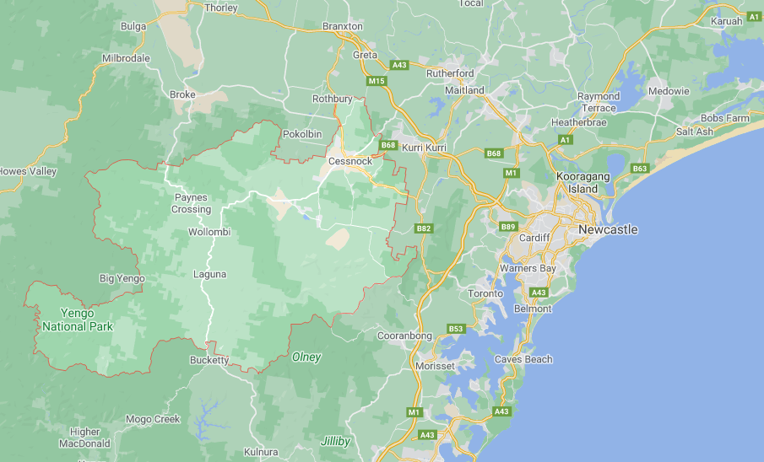

Figure 5: Map of postcode 2325 - located to the west of Newcastle, New South Wales.

Table : Three sample suburbs within the 2325 postcode

| **Postcode** | **Suburb** | **MM region** |
| --- | --- | --- |
| 2325 | Lovedale | 2 |
| 2325 | Ellalong | 3 |
| 2325 | Laguna | 5 |

## Communities dependent on a single provider

Analysis of Program claims data in FY2019-20 has identified 51 communities that are dependent upon a single provider for hearing services. This analysis explicitly excludes Hearing Australia sites, as these often service CSO clients and are not a like-for-like comparator for commercial providers, nor direct competitors for the same market of consumers. Note that visiting sites tend to operate from temporary accommodation and are not open for full business hours.

For the purposes of this analysis, a community is determined to be dependent on a single provider based on the following conditions;

* For each site (clinic) that delivered services in FY2019-20, we calculate the geographic distance to all other sites (given the same criteria)
  + Excluding all sites (clinics) from Hearing Australia
  + Excluding sites from the same provider
* If the nearest site that meets these criteria was more than 50km from the site, then that site’s location was determined to be a community dependent on a single provider.

The 51 communities in this group are summarised in Table 6.

Table : 51 communities identified as being dependent on a single provider in FY2019-20. Note that St Helens (TAS) and Karratha (WA) had two sites from the same provider, and hence these 51 communities represent 53 individual sites.

| **State** | **Suburb** | **Postcode** | **Site Type** | **Provider name** |
| --- | --- | --- | --- | --- |
| NSW | Balranald | 2715 | Visiting | Sunraysia Hearing Clinic Pty Ltd |
| NSW | Barraba | 2347 | Visiting | Sharon King Hearing Centres Pty Ltd |
| NSW | Bingara | 2404 | Visiting | Sharon King Hearing Centres Pty Ltd |
| NSW | Bombala | 2632 | Visiting | Audika Australia Pty Ltd |
| NSW | Cobar | 2835 | Visiting | Sonova Audiological Care Australia Pty Ltd |
| NSW | Condobolin | 2877 | Permanent | National Hearing Centres P/L Atf Nhc Unit Trust |
| NSW | Gilgandra | 2827 | Visiting | Graham Rathbone Pty Ltd |
| NSW | Quirindi | 2343 | Visiting | Audika Australia Pty Ltd |
| NSW | Walcha | 2354 | Visiting | Sharon King Hearing Centres Pty Ltd |
| NSW | Warialda | 2402 | Visiting | Sharon King Hearing Centres Pty Ltd |
| NT | Alice Springs | 0870 | Permanent | Desert Ear Pty Ltd |
| NT | Katherine | 0850 | Permanent | National Hearing Centres P/L Atf Nhc Unit Trust |
| QLD | Barcaldine | 4725 | Visiting | Clarity Hearing Solutions Pty Ltd |
| QLD | Charleville | 4470 | Visiting | Clarity Hearing Solutions Pty Ltd |
| QLD | Collinsville | 4804 | Visiting | Clarity Hearing Solutions Pty Ltd |
| QLD | Cunnamulla | 4490 | Visiting | Clarity Hearing Solutions Pty Ltd |
| QLD | Hughenden | 4821 | Visiting | Clarity Hearing Solutions Pty Ltd |
| QLD | Inglewood | 4387 | Visiting | Kendan Pty Ltd |
| QLD | Longreach | 4730 | Visiting | Clarity Hearing Solutions Pty Ltd |
| QLD | Mitchell | 4465 | Visiting | Clarity Hearing Solutions Pty Ltd |
| QLD | Mundubbera | 4626 | Visiting | Bay Audio Pty Ltd |
| QLD | Quilpie | 4480 | Visiting | Clarity Hearing Solutions Pty Ltd |
| QLD | Richmond | 4822 | Visiting | Clarity Hearing Solutions Pty Ltd |
| QLD | Roma | 4455 | Visiting | Clarity Hearing Solutions Pty Ltd |
| QLD | St George | 4487 | Visiting | Kendan Pty Ltd |
| QLD | Theodore | 4719 | Visiting | Active Hearing Pty Ltd |
| SA | Ceduna | 5690 | Visiting | Hearing Matters Pty Ltd |
| SA | Cleve | 5640 | Visiting | Active Hearing Pty Ltd |
| SA | Cowell | 5602 | Visiting | Active Hearing Pty Ltd |
| SA | Elliston | 5670 | Visiting | Eyre Hearing Pty Ltd Atf Eyre Hearing Trading Trust |
| SA | Lameroo | 5302 | Visiting | Active Hearing Pty Ltd |
| SA | Lock | 5633 | Visiting | Active Hearing Pty Ltd |
| SA | Streaky Bay | 5680 | Visiting | Active Hearing Pty Ltd |
| SA | Wudinna | 5652 | Visiting | Eyre Hearing Pty Ltd Atf Eyre Hearing Trading Trust |
| TAS | St Helens* | 7216 | Visiting | Aaron Sph Pty Ltd |
| VIC | Casterton | 3311 | Visiting | All Digital Hearing Pty Ltd |
| VIC | Corryong | 3707 | Visiting | Essence Audiology Pty Ltd |
| VIC | Edenhope | 3318 | Visiting | Active Hearing Pty Ltd |
| VIC | Mallacoota | 3892 | Visiting | Audika Australia Pty Ltd |
| VIC | Nhill | 3418 | Visiting | Active Hearing Pty Ltd |
| VIC | Ouyen | 3490 | Visiting | Sunraysia Hearing Clinic Pty Ltd |
| VIC | Robinvale | 3549 | Visiting | Sunraysia Hearing Clinic Pty Ltd |
| VIC | Sea Lake | 3533 | Visiting | Syanda Pty Ltd Atf N & M Transton Family Trust |
| VIC | Warracknabeal | 3393 | Visiting | Active Hearing Pty Ltd |
| VIC | Woomelang | 3485 | Visiting | Syanda Pty Ltd Atf N & M Transton Family Trust |
| WA | Broome | 6725 | Visiting | Audika Australia Pty Ltd |
| WA | Corrigin | 6375 | Visiting | Waves Hearing Pty Ltd |
| WA | Karratha* | 6714 | Visiting | Hearing And Audiology Pty Ltd |
| WA | Lancelin | 6044 | Visiting | Ear Science Institute Australia Incorporated |
| WA | Port Denison | 6525 | Visiting | Sonova Audiological Care Australia Pty Ltd |
| WA | Walpole | 6398 | Visiting | Biota Pty Ltd Atf The Norgaard Family Trust |

1. Note that this data includes some consumers who have since deceased. The Program does not complete any data matching to account for mortality.
2. For example, a First Nations Australian aged 52 years old is eligible for the CSO Scheme. They may receive a hearing assessment, which determines that they do not have any hearing loss. In this instance, they would be counted in the total consumer figures.
3. The Program also notes that some consumers are eligible for both the Voucher and CSO Schemes (e.g. a First Nations Australian who is also a DVA Gold cardholder). In those instances, consumers may receive their devices through either of the CSO or Voucher Schemes.
4. Consumer’s regions are based on the postcode that is entered in their client record in the Hearing Services Online (HSO) portal. Postcodes are checked for validity, but are not audited.
5. Defined as only having one provider organisation who delivered hearing services in the Voucher scheme, at any point in the FY2019-20 year, within a 50km distance. Note that this excludes Hearing Australia sites but includes private provider visiting sites, and (in some cases) multiple sites within that distance from the same provider. See Communities dependent on a single provider.
6. This doesn’t mean that all people living in disadvantaged rural and remote local government areas have a low socio-economic status.
7. At the time of analysis, ‘franchises’ refers to sites operated by Specsavers. This provider has a different operating model to the other large providers, in that it does not operate as a conglomerate and hence does not cross-subsidise across site locations (Specsavers, 2020).
8. Some of these issues may be addressed in policy and solution design, but at a minimum there would be a requirement for additional verification of address data, and spot-checks of service delivery, relating to all services that attract the loading payment.
9. Possibly based on the locations of their traditional sites (clinics), although this is one of several potential options.
10. Due to the additional layer of the other allied health professional, and the need to financially support this additional layer.
11. Hearing Australia is now a Statutory Body. It was previously a public provider with sole ownership of the publicly subsidised hearing services market.
12. Noting that the Program does capture address data, but that investigations have demonstrated that this information is of variable quality and not suited for this analysis.