Embedding wellness and reablement within your organisation is an ongoing process. To ensure your processes are effective, relevant and help people, you need to continuously review and update.

Continuous improvement template

The continuous improvement template provides guidance on how to incrementally review, plan and deploy improvements within your organisation.

Continuous improvement is cyclical, and any changes made to processes should be continuously reviewed and evaluated to ensure they are fit-for-purpose and meet the needs of your employees (Figure 1).

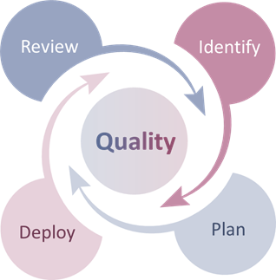

*Figure 1: Continuous improvement framework*

| **Step one – Review** | | |
| --- | --- | --- |
| **Review processes, practices to identify areas of improvement and/or success stories** | Review **existing** processes/practices to identify if they have **barriers and blockages** |  |
| Review processes/practices to identify that are **effective and efficient** and/or are **working well** |  |
| Review outcomes of processes/practices to identify good news stories |  |
| Review if **previously** implemented practices should be **evaluated and improved** |  |
| **Step two – Identify** | | |
| **Identify the processes and/or practices that require improvements/updating and what the updates are** | Identify what needs updating |  |
| Identify the level of updating required (minor or major)  *Note: minor tweaks could be made immediately – larger tweaks will follow the remaining process* |  |
| Identify owner, subject matter expert of the people who may be required to assist with changes |  |

| **Step three – Plan** | | |
| --- | --- | --- |
| **Plan the best way to have the process/practice updated** | Meet with the appropriate people to discuss changes |  |
| Determine appropriate changes |  |
| Test and validate updates with management and/or experts |  |
| Schedule when updated policies/processes will be deployed |  |
| **Step four – Deploy** | | |
| **Deploy the updated policies and practices and ensure changes are communicated to employees** | Deploy the successful changes |  |
| Communicate the changes with employees and encourage use |  |
| Monitor the performance of updated processes/practices |  |