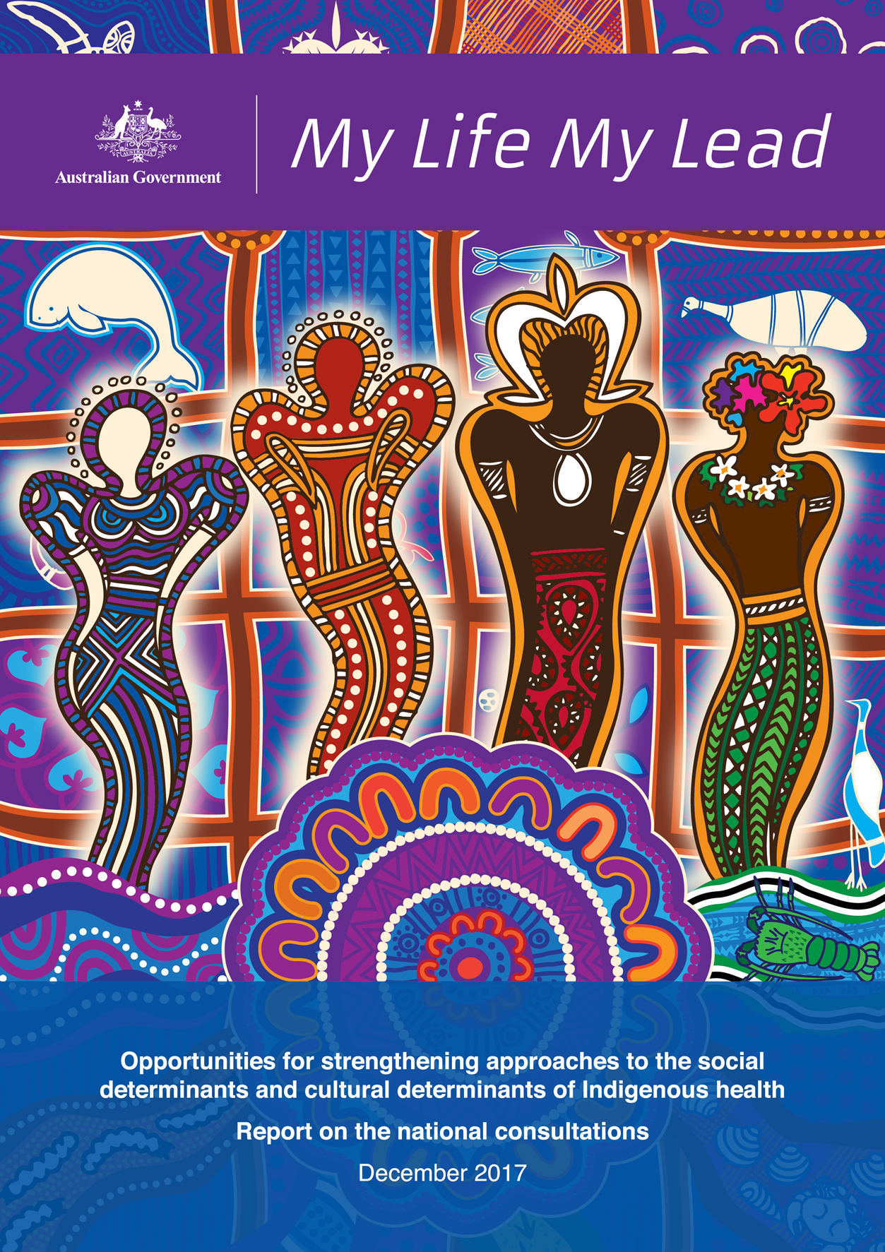
My Life My Lead - Opportunities for strengthening approaches to the social determinants and cultural determinants of Indigenous health: Report on the national consultations December 2017

My Life My Lead - Opportunities for strengthening approaches to the social determinants and cultural determinants of Indigenous health: Report on the national consultations December 2017.
Copyright
© 2017 Commonwealth of Australia as represented by the Department of Health
This work is copyright. You may copy, print, download, display and reproduce the whole or part of this work in unaltered form for your own personal use or, if you are part of an organisation, for internal use within your organisation, but only if you or your organisation:
- do not use the copy or reproduction for any commercial purpose; and
- retain this copyright notice and all disclaimer notices as part of that copy or reproduction.
Apart from rights as permitted by the Copyright Act 1968 (Cth) or allowed by this copyright notice, all other rights are reserved, including (but not limited to) all commercial rights.
Requests and inquiries concerning reproduction and other rights to use are to be sent to the Communication Branch, Department of Health, GPO Box 9848, Canberra ACT 2601, or via
e-mail to copyright@health.gov.au

Attribution
This publication should be attributed as follows: Commonwealth of Australia, Department of Health, My Life My Lead - Opportunities for strengthening approaches to the social determinants and cultural determinants of Indigenous health: Report on the national consultations December 2017.

Acknowledgement of Gilimbaa
The original artwork was produced by Gilimbaa. Gilimbaa is an Indigenous creative agency accredited by Supply Nation.

Please be aware that this document may contain the images of Aboriginal and Torres Strait Islander people who may have passed away.

Images have been provided courtesy of the Department of the Prime Minister and Cabinet.

TABLE OF CONTENTS
INTRODUCTION 4
WHY IS A SOCIAL DETERMINANTS AND CULTURAL DETERMINANTS TO HEALTH APPROACH NEEDED? 6
WHAT MAKES THIS APPROACH DIFFERENT? 7
PRIORITY AREA 1: CULTURE AT THE CENTRE OF CHANGE 9
PRIORITY AREA 2: SUCCESS AND WELLBEING FOR HEALTH THROUGH EMPLOYMENT 11
PRIORITY AREA 3: FOUNDATIONS FOR A HEALTHY LIFE 14
PRIORITY AREA 4: ENVIRONMENTAL HEALTH 17
PRIORITY AREA 5: HEALTHY LIVING AND STRONG COMMUNITIES 20
PRIORITY AREA 6: HEALTH SERVICE ACCESS 23
PRIORITY AREA 7: HEALTH AND OPPORTUNITY THROUGH EDUCATION 26
NEXT STEPS 29
REFERENCES 30

INTRODUCTION
Between March and May 2017, the Australian Government Department of Health, in conjunction with the Advisory Group on the Implementation Plan for the National Aboriginal and Torres Strait Islander Health Plan 2013-2023 (Implementation Plan), led an extensive consultation process (My Life My Lead) across Australia to listen to people share their stories and experiences. This is part of the ongoing commitment under the Implementation Plan to consider the social determinants and cultural determinants of Indigenous health.
The consultations examined the integral and supportive role culture plays, and analysed how social factors such as education, employment, justice, income and housing impact on a person’s health and wellbeing at each stage of life.
The learnings from the My Life My Lead consultations are summarised in this Report and will guide the ongoing development, implementation and delivery of future policy and programs, and support the ongoing commitment from the Australian Government to Closing the Gap.
It is expected that Australian governments will undertake nationwide consultations to inform the Closing the Gap refresh. This Report is an important contribution to this process. To make inroads, all levels of government need to work together. The Closing the Gap refresh provides an opportunity to identify shared areas for collaboration.
The Report will also inform the development of the next iteration of the Implementation Plan that is due to be released in 2018. This presents an opportunity to consider new ways of working that take into account the impacts of social determinants and cultural determinants of health for Aboriginal and Torres Strait Islander people.
My Life My Lead consultations reinforced that governments cannot ignore factors such as the home environment, school and educational attainment, employment, community and experiences of social institutions and systems, and their corresponding influences on a person’s health.
Evidence indicates that at least 34.4 per cent of the health gap for Aboriginal and Torres Strait Islander people is linked to social determinants. This rises to 53.2 per cent when combined with behavioural risk factors.
My Life My Lead conducted thirteen face-to-face consultations across every state and territory, reaching approximately 600 participants. The Department of Health also received 102 written submissions providing evidence and insights on the many factors that contribute to improved health outcomes throughout the life course and highlighting the role of many sectors and players outside the health system.

The following four themes were consistent features of the verbal and written feedback provided:
- Culture is central to Aboriginal and Torres Strait Islander wellbeing and needs to be embraced and embedded across a range of Aboriginal and Torres Strait Islander and mainstream services—both as a protector and enabler of health and wellbeing.
- Racism within health and other systems must be addressed to remove barriers to better outcomes in health, education and employment.
- The impacts of trauma across generations of Aboriginal and Torres Strait Islander people must be acknowledged and addressed.
- Governments need to support long-term, coordinated, placed-based approaches that honour community priorities and embed participation.
The My Life My Lead Consultation Report is an account of what was heard from participants and contributors about the factors impacting on health, and is further informed by literature and research on the identified priority areas. There was strong support for an approach to improving health that accounted for the social determinants that frequently contribute to poor health and the cultural determinants that can potentially be enormously positive for health.
This Report captures the seven key priorities raised by consultation participants and in written submissions. These priority areas encompass a range of sectors and areas, including, but not limited to, health, education, housing, employment and justice. The report also notes where there is need for further work and exploration.
A social determinants and cultural determinants approach to health also supports the Australian Government’s commitment to a range of international treaties and obligations, including our commitments under the 2030 Agenda for Sustainable Development and its seventeen Sustainable Development Goals.
The Department of Health would like to thank the members of the Implementation Plan Advisory Group and the National Health Leadership Forum for their leadership and advice throughout the consultation process. The Department also acknowledges those who attended the consultation forums, including the many participants who travelled long distances, and the organisations and individuals who provided submissions.

WHY IS A SOCIAL DETERMINANTS AND CULTURAL DETERMINANTS TO HEALTH APPROACH NEEDED?
Poor health impacts negatively on wellbeing. It may limit participation in daily activities, or prevent people from living a meaningful life and reduce a person’s sense of fulfilment and purpose. Conversely, good health builds the foundations for a good life and supports greater opportunities and wellbeing over the life course. A healthy child is more likely to engage at school. Those who have completed secondary school are more likely to be employed. Those who are employed have a regular source of income and are therefore more likely to live in a house in good repair.
Aboriginal and Torres Strait Islander people generally have poorer health outcomes than non-Indigenous Australians, with a shorter life expectancy, a higher child mortality rate and a greater burden of chronic disease.
As displayed in Figure 1, at least 34.4 per cent of the health gap between Aboriginal and Torres Strait Islander people and non-Indigenous Australians is linked to social determinants, which rises to 53.2 per cent when combined with behavioural risk factors, such as tobacco use, alcohol use, dietary factors and physical inactivity. Consideration of the cultural determinants of health is just as important for Aboriginal and Torres Strait Islander people, as a strong connection to culture is strongly correlated with good health, through strengthened identity, resilience and wellbeing.
Figure 1: Proportion of health gap explained by social determinants of health 2011-13
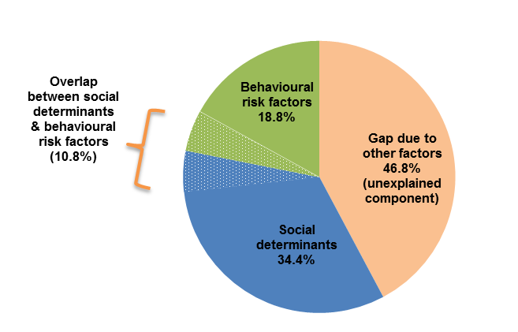
There is already extensive work underway across governments on a shared Closing the Gap agenda, with efforts spanning across health, infancy and early childhood, education, employment and economic development. While significant improvements in health outcomes for Aboriginal and Torres Strait Islander people have been made over the last twenty years, these gains are in danger of flat-lining and the gap in life expectancy is not on track to be closed by 2031.
A social determinants of health approach entails consideration of both health and wellbeing through a holistic, whole-of-life lens. Health is a holistic concept that incorporates the physical, social, emotional and cultural wellbeing of individuals and their communities.
The cultural determinants of health encompass the cultural factors that promote resilience, foster a sense of identity and support good mental and physical health and wellbeing for individuals, families and communities. While the cultural determinants of health is a less understood concept compared to the social determinants of health, there is strong evidence emerging around the various ways that culture can support better health outcomes.
Cultural Determinants originate from and promote a strength based perspective, acknowledging that stronger connections to culture and Country build stronger individual and collective identities, a sense of self-esteem, resilience, and improved outcomes across the other determinants of health including education, economic stability and community safety.
Aboriginal and Torres Strait Islander cultures are the oldest living cultures in the world, which exemplify the dynamic and adaptive nature of these cultures. Cultural determinants are enabled, supported and protected through traditional cultural practice, kinship, connection to land and Country, art, song and ceremony, dance, healing, spirituality, empowerment, ancestry, belonging and self-determination. While many Aboriginal and Torres Strait Islander people, families and communities that reside in metropolitan and regional areas are separated from their Country and kin, strong cultural determinants of health can still be enabled and maintained through languages, relationships, customs and community networks.

WHAT MAKES THIS APPROACH DIFFERENT?
A social determinants and cultural determinants approach will build upon existing efforts to enable more culturally-capable and responsive services and systems for Aboriginal and Torres Strait Islander people. This involves better planning and coordination between governments, communities and service sectors—including mainstream services—to meet the needs of the person, and in the context of their family and community, and respond to these unimpeded by organisational and service silos. This also involves consideration and planning for how the health of Aboriginal and Torres Strait Islander people may be impacted at every stage of policy and program design, implementation and evaluation, regardless of whether the program is explicitly health-focussed.
During the My Life My Lead consultations, stakeholders emphasised overwhelmingly that, if real change is to be achieved, future effort should be informed and underpinned by the following principles:
- Strong connections to culture and family are vital for good health and wellbeing: Policies, programs and services must ensure a strengths-based approach that acknowledges the importance of culture and family for Aboriginal and Torres Strait Islander people and builds capacity of individuals and communities to exercise choice and control, contributing to greater resilience and wellbeing.
- The best results are achieved through genuine partnerships with communities: Flexible approaches that deliver the Prime Minister’s commitment to “do things with, not to” Aboriginal and Torres Strait Islander people and their communities must be a high priority. This includes working with community-controlled organisations and providing opportunities for meaningful input from community members into service delivery at the local level.
- The impacts of trauma on poor health outcomes cannot be ignored: Significant health impacts result from displacement from family, Country, institutionalisation, racism, abuse and neglect. This has led to increasingly high rates of incarceration and juvenile detention, suicide, family violence, children being taken into care, and poor physical and mental health outcomes.
- Systemic racism and a lack of cultural capability, cultural safety and cultural security remain barriers to health system access: Racism makes people sick and constructive action that addresses its causes and effects will have significant positive impacts on health and broader life outcomes.
The report outlines seven priority areas that participants indicated are key and should be addressed to set the foundations for longer term, intergenerational change. Addressing these priority areas will require targeted strategies and meaningful partnerships with Aboriginal and Torres Strait Islander people. Consultations emphasised that future efforts should be progressed through the ongoing development, implementation and delivery of future policy and programs, including the Closing the Gap refresh and the development of the next iteration of the Implementation Plan, and in partnership with key stakeholders across governments and within the health sector.
Figure 2: Priority areas to address the social determinants and cultural determinants of health
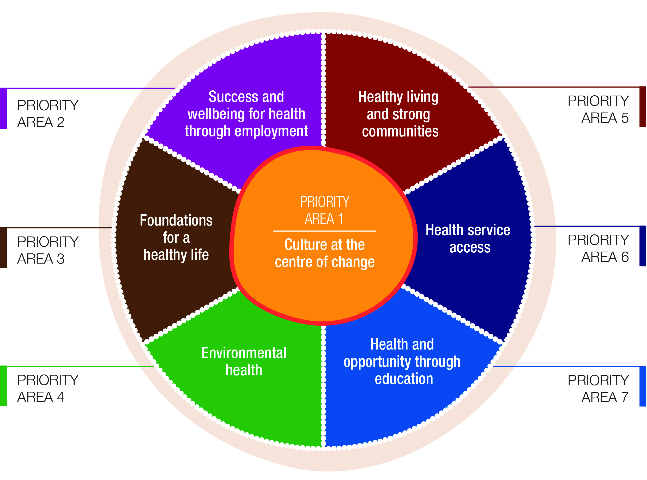

PRIORITY AREA 1: CULTURE AT THE CENTRE OF CHANGE
The importance of culture underpins the value that Aboriginal and Torres Strait Islander people place on continuing to practice ways of knowing and being, which are embodied in Country, family, ancestors, language, art, dance, songs and ceremony.
Aboriginal and Torres Strait Islander cultures are diverse and continue to thrive across metropolitan, regional and remote areas of Australia. In 2016, over one-third of the Aboriginal and Torres Strait Islander population reported living in capital city areas, with a contemporary sense of belonging, along with traditional ties, reinforced through kinship and family networks.
Practising culture can involve a living relationship with ancestors, the spiritual dimension of existence, and connection to Country and language. Individual and community control over their physical environment, dignity and self-esteem, respect for Aboriginal and Torres Strait Islander people’s rights and a perception of just and fair treatment are also important to social and emotional wellbeing.
Consultations and online submissions emphasised that culture needs to be at the centre of policies and programs. The Australian Government is also committed to addressing the ongoing barriers that impede access to health, education, employment and other essential services.
From a systems lens, government programs and policies must also acknowledge and respond to the impacts of racism in the health system, and intergenerational trauma to support access and quality within broader service systems, and improve the evidence-base that informs government and community action.
Progress against this priority area can be made by building on existing effort to improve how governments engage with and respond to the needs of Aboriginal and Torres Strait Islander communities. The Empowered Communities initiative establishes a new way for Aboriginal and Torres Strait Islander communities and governments to work together. This approach puts Aboriginal and Torres Strait Islander culture and participation front and centre of government decision-making.
Furthermore, all governments have agreed to embed cultural respect and responsiveness across all health systems through the Cultural Respect Framework for Aboriginal and Torres Strait Islander Health 2016–2026. An innovative and strategic approach across government will ensure efforts to support the social determinants and cultural determinants of health are pursued systematically and collaboratively with a broader focus on outcomes.

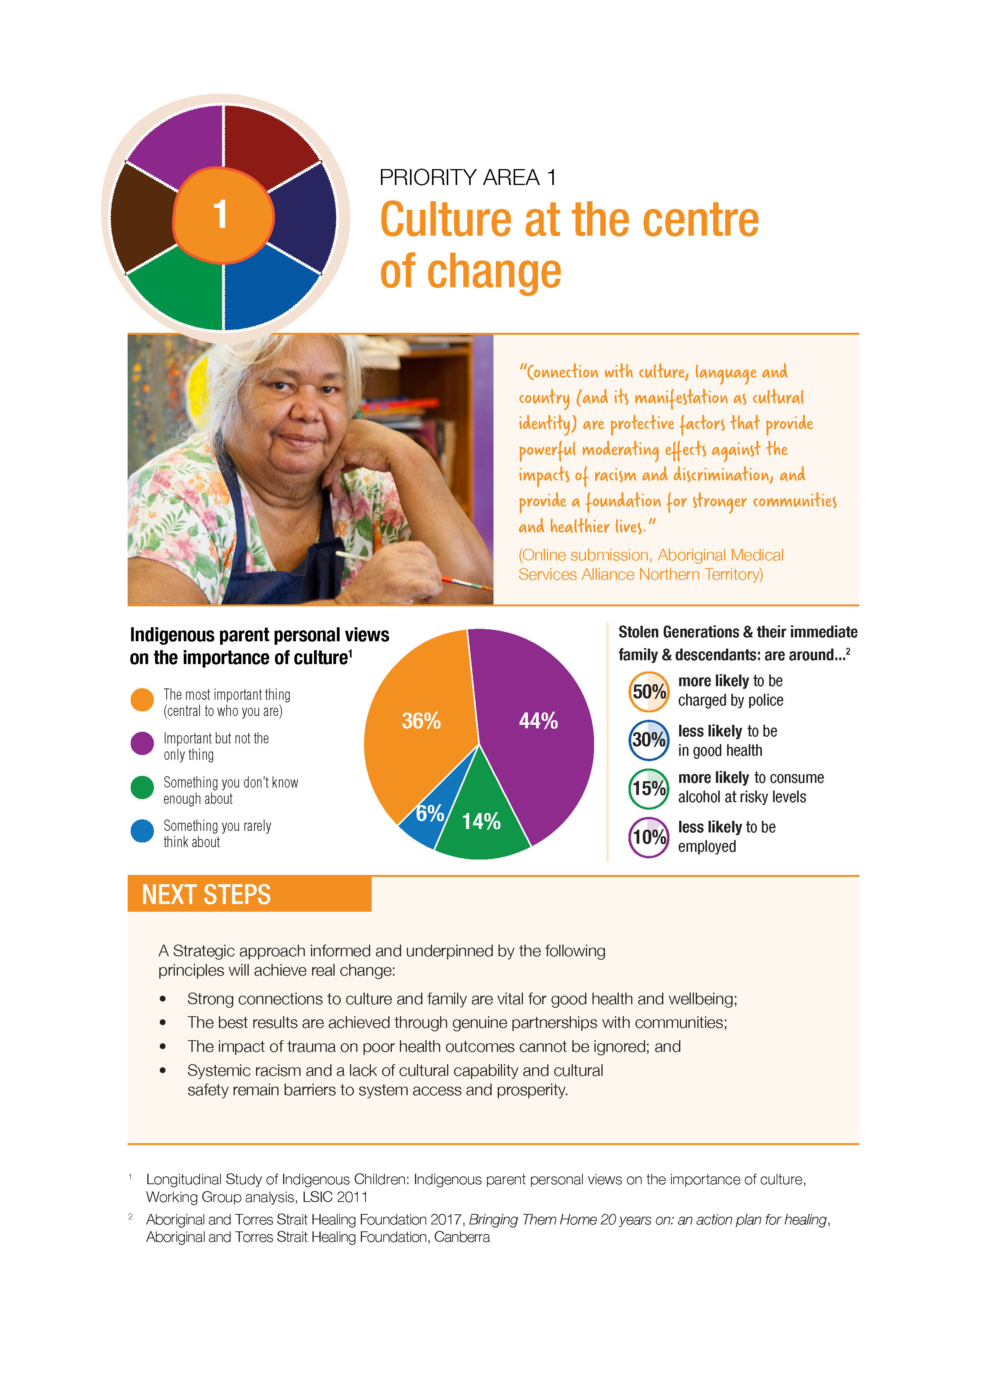

PRIORITY AREA 2: SUCCESS AND WELLBEING FOR HEALTH THROUGH EMPLOYMENT
Employment status is a strong determinant of individual and family health outcomes, with unemployment, underemployment and precarious work associated with poorer health status. Conversely, chronic health problems can limit participation in the workforce, which can have adverse impacts. Poor health explains 42.7 per cent of the known gap in labour force participation for Aboriginal and Torres Strait Islander males and 13.9 per cent for females in non-remote locations. People who lack job security or who are unemployed consistently report the lowest levels of self-rated health and subjective wellbeing.
Community-driven, place-based initiatives have been proven to be successful in engaging Aboriginal and Torres Strait Islander people in meaningful employment and equipping them with transferable skills. Participants at the forums emphasised that programs linked with Country and culture also strengthen resilience in young people, helping build a better understanding and connection with identity. At the community level, these programs cement broader capacity and sustainability, setting up opportunities for future generations.
The Australian Government’s Indigenous Procurement Policy, launched in July 2015, was designed to give Indigenous businesses greater opportunity at winning Commonwealth contracts. This policy has exceeded expectations in its first 18 months. It has resulted in 708 Indigenous businesses winning over $434 million worth of contracts. Similar efforts in developing Indigenous Grant Guidelines and an Indigenous Business Strategy are also expected to increase economic opportunities for Indigenous businesses and communities.
Jobactive is the Commonwealth employment service for urban and regional centres connecting jobseekers with employers and is delivered by a network of jobactive providers. Since the commencement of jobactive in July 2015, around 72,000 job placements have been achieved for Indigenous Australians. While this is a positive achievement, more needs to be done to close the employment gap. To accelerate progress towards achieving parity in employment outcomes for Indigenous Australians, the Australian Government recently announced an additional $55.7 million investment in the Closing the Gap – Employment Services package. The measures announced as part of this package enhance the ability of employment services (jobactive and Transition to Work) to place more Indigenous job seekers into work.
In addition, Our North, Our Future: White Paper on Developing Northern Australia identifies opportunities through education, job creation and economic development including through infrastructure and sustainable development. The Northern Australia Roads Programmes Indigenous Framework, which is expected to be finalised shortly, includes Indigenous employment and supplier-use targets that seek to balance the need to improve the participation of Indigenous people and current market conditions.
The rollout of national projects, such as the National Disability Insurance Scheme (NDIS) and the National Broadband Network (NBN), provide significant opportunities and should guide skills development to support career pathways for Aboriginal and Torres Strait Islander people.
More needs to be done to support employment pathways and opportunities that will lead to better health and other social outcomes for Aboriginal and Torres Strait Islander people. While gains have been made since 1994, the Closing the Gap target of halving the gap in employment outcomes within a decade is not on track to be achieved. In 2014–15, the Indigenous employment rate was 48.4 per cent, down from 53.8 per cent in 2008. The non-Indigenous employment rate also declined from 75.0 per cent in 2008 to 72.6 per cent in 2014-15. The gap has not changed significantly (21.2 percentage points in 2008 and 24.2 percentage points in 2014-15).
With stark figures showing the huge impact of poor health on labour force participation, a health-focussed approach is the obvious next step to take in building the capacity of employment services to support job seekers to access supports that address their health related barriers to employment.
Part of the solution is strengthening connections between the employment and health sectors—particularly with Aboriginal Controlled Community Health Services (ACCHSs) and Aboriginal Medical Services (AMS)—to support a more holistic, connected and culturally competent system. This includes both culturally-specific and mainstream employment services. A majority of Aboriginal and Torres Strait Islander people receive employment services through mainstream programs, such as jobactive, Disability Employment Services and the Community Development Program. In parallel, continued support for increased economic participation by Aboriginal and Torres Strait Islander people and organisations is needed.

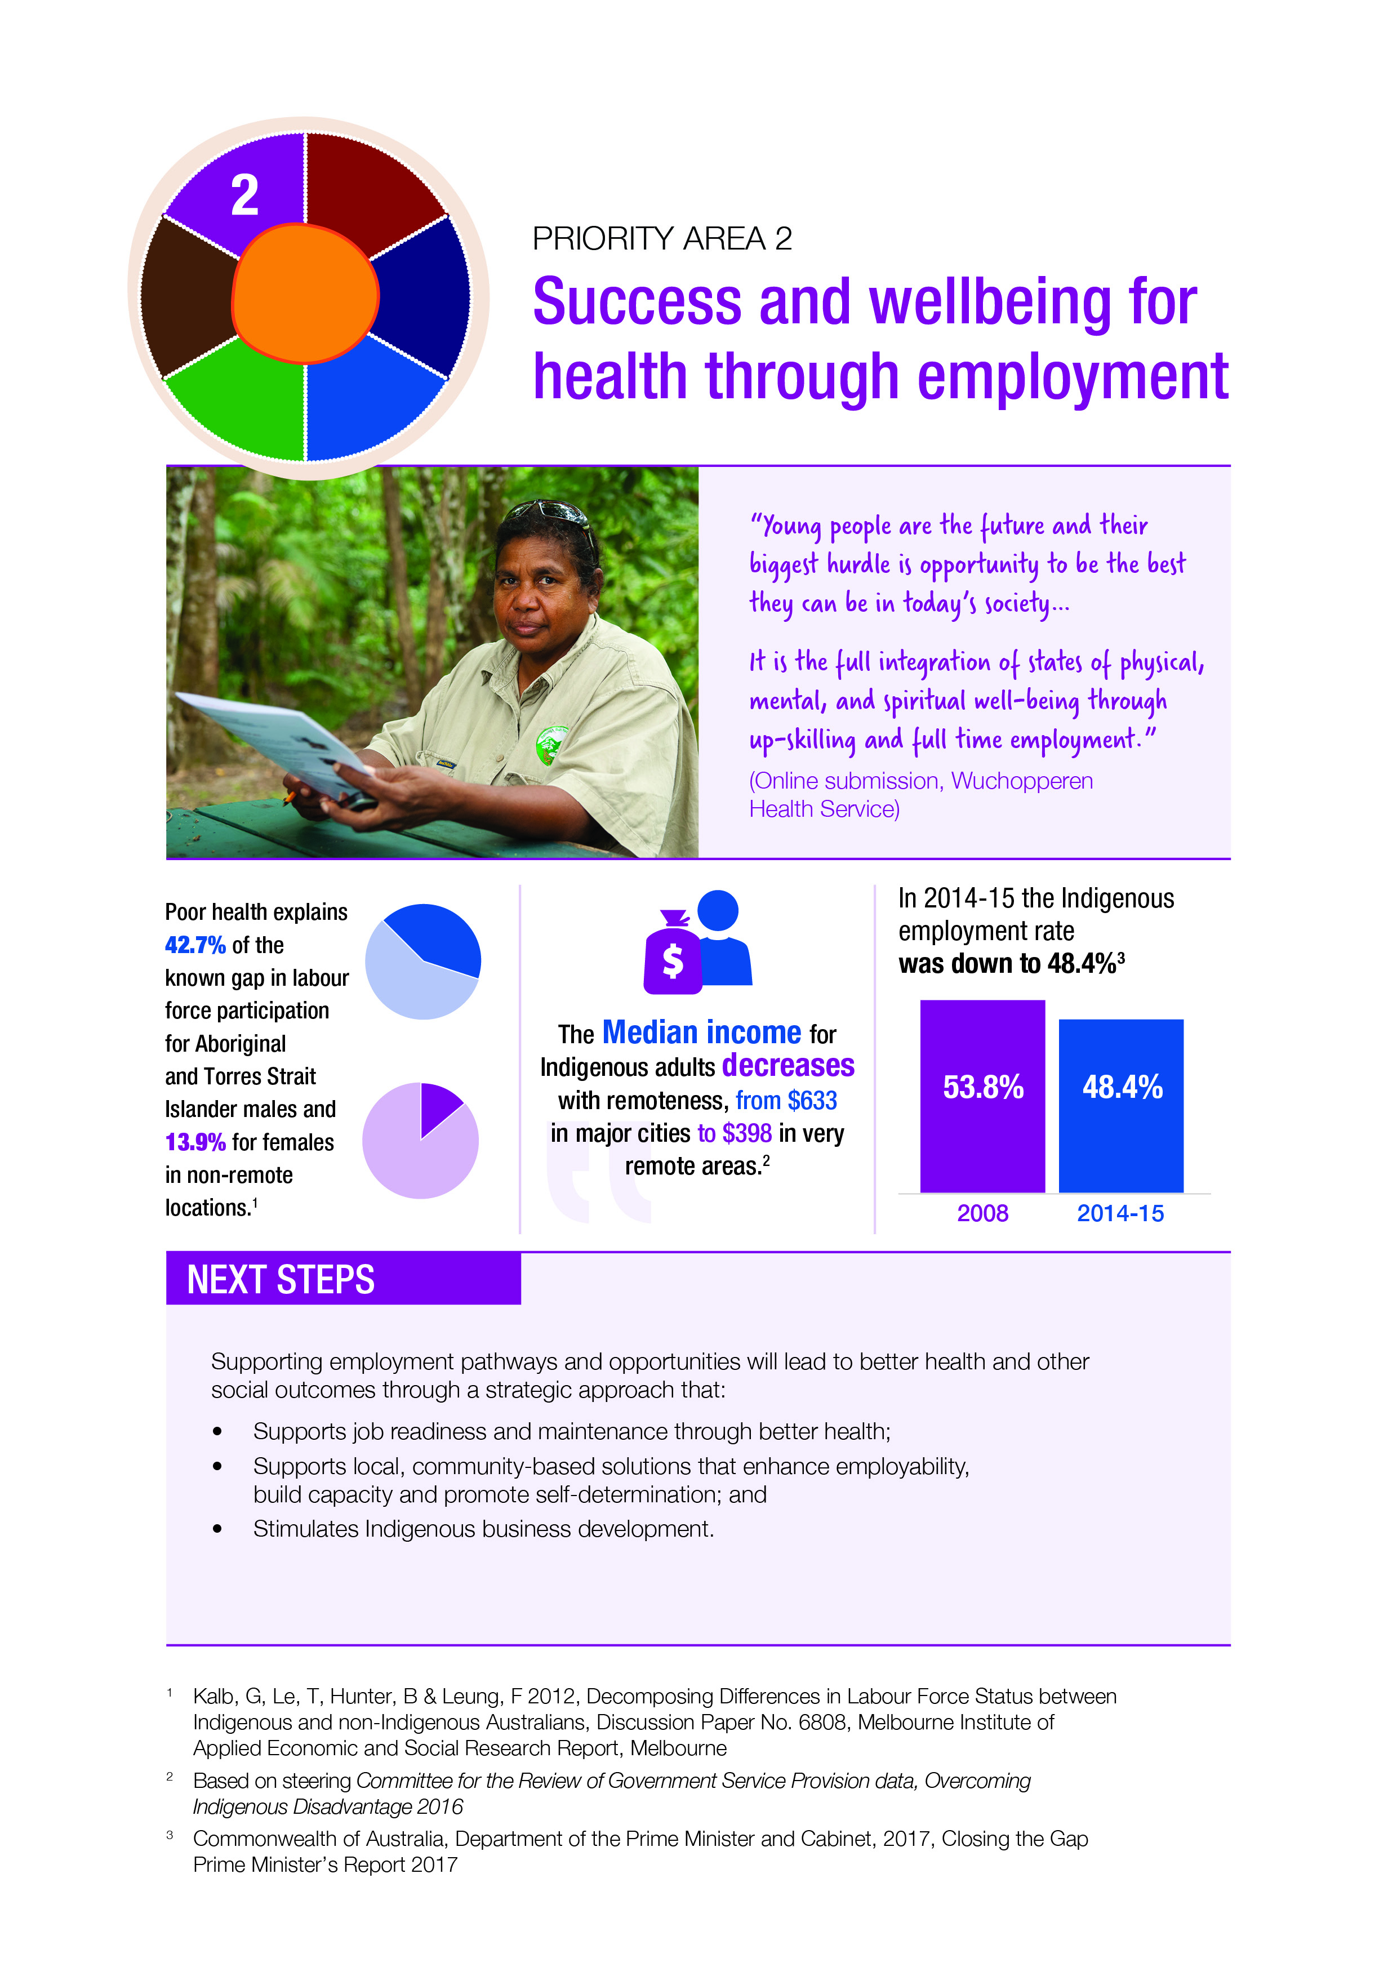

PRIORITY AREA 3: FOUNDATIONS FOR A HEALTHY LIFE
Healthy development during gestation and early in life has long-lasting consequences, these early days are a crucial window of opportunity to set children up for a healthy, prosperous life. This is the period when the foundations are established for children to develop physically and cognitively, form secure attachments and build healthy social, emotional and communication skills. While the gap in child mortality has been reduced by 33 per cent for Aboriginal and Torres Strait Islander children, the mortality rate for children aged up to four remains more than twice the rate of non-Indigenous children in the same age range.
From 2011 to 2015, over half of the deaths of Aboriginal and Torres Strait Islander children aged zero to four were caused by conditions originating in the perinatal period, such as birth trauma, fetal growth disorders, complications of pregnancy, and respiratory and cardiovascular disorders specific to the perinatal period. In Aboriginal and Torres Strait Islander children aged one to four years, injury accounted for half of the deaths.
As noted earlier, participants in My Life My Lead raised the need to address the impacts of trauma. There is strong evidence that unresolved intergenerational trauma is linked to a number of key health and wellbeing outcomes for Aboriginal and Torres Strait Islander people—including interaction with the child protection system, family violence and the incarceration of young people.
The Global Access Partners Taskforce Report on Early Childhood Education identified that an integrated approach to childhood services is more effective in supporting developmentally vulnerable children, maximising the opportunity for families to access the right services at the right time. This involves service collaboration at the local level to provide holistic, wrap around support to strengthen families. In this area, consultation participants strongly advocated for key engagement with Indigenous communities and service providers in the NDIS roll-out.
In 2014, the Forrest Review – Creating Parity recommended that all governments prioritise progressive investment to implement the integration of early childhood services and to dramatically improve school attendance. This approach has already been adopted by governments to better target investment in improving early childhood health. For example, the Connected Beginnings program is being piloted to support more effective, joined up services on the ground, and support children to be happy, healthy and ready for school.
The Third Action Plan 2015-2018 of the National Framework for Protecting Australia’s Children 2009-2020 (Third Action Plan) presents an opportunity for governments to work together to address the over-representation of Aboriginal and Torres Strait Islander children in the child protection system. Opportunities include a greater focus on prevention and early intervention programs and policy reform to reunification and permanency. The Third Action Plan makes a strong commitment to improving outcomes for Aboriginal and Torres Strait Islander children and families.
In acknowledging that participation in early childhood education is linked to academic success, all levels of government are investing in early childhood programs that recognise Aboriginal and Torres Strait Islander people as a priority group. A particularly important plank is the 2018 extension to the National Partnership Agreement on Universal Access to Early Childhood Education.
Under the partnership, all Aboriginal and Torres Strait Islander children will have access to an affordable quality preschool education. The 2018 agreement will bring the total level of Australian Government investment in preschool to $3.2 billion since 2008. The National Partnership Agreement includes a focus on increasing the participation of Aboriginal and Torres Strait Islander children, with a target of 95 per cent of children enrolled in the year before full-time school.
The need to include Aboriginal and Torres Strait Islander languages, history and cultures in early childhood education programs was a dominant theme of the My Life My Lead consultation process. Language immersion from a young age plays a strong role in this cultural context, as does bi-lingual education and participation in cultural arts activities. Children for whom English is not their first language benefit from a foundation in their first language to prepare them for the acquisition of English as a Second Language.
Continuing efforts to support perinatal and early childhood health is fundamental to bringing about the sustained improvements needed to meet the Closing the Gap targets. Building on these efforts, future investment must consider opportunities to embed an integrated service framework, ensuring a holistic approach to supporting and strengthening families, with a focus on supporting children to develop the foundations for a happy, healthy life.
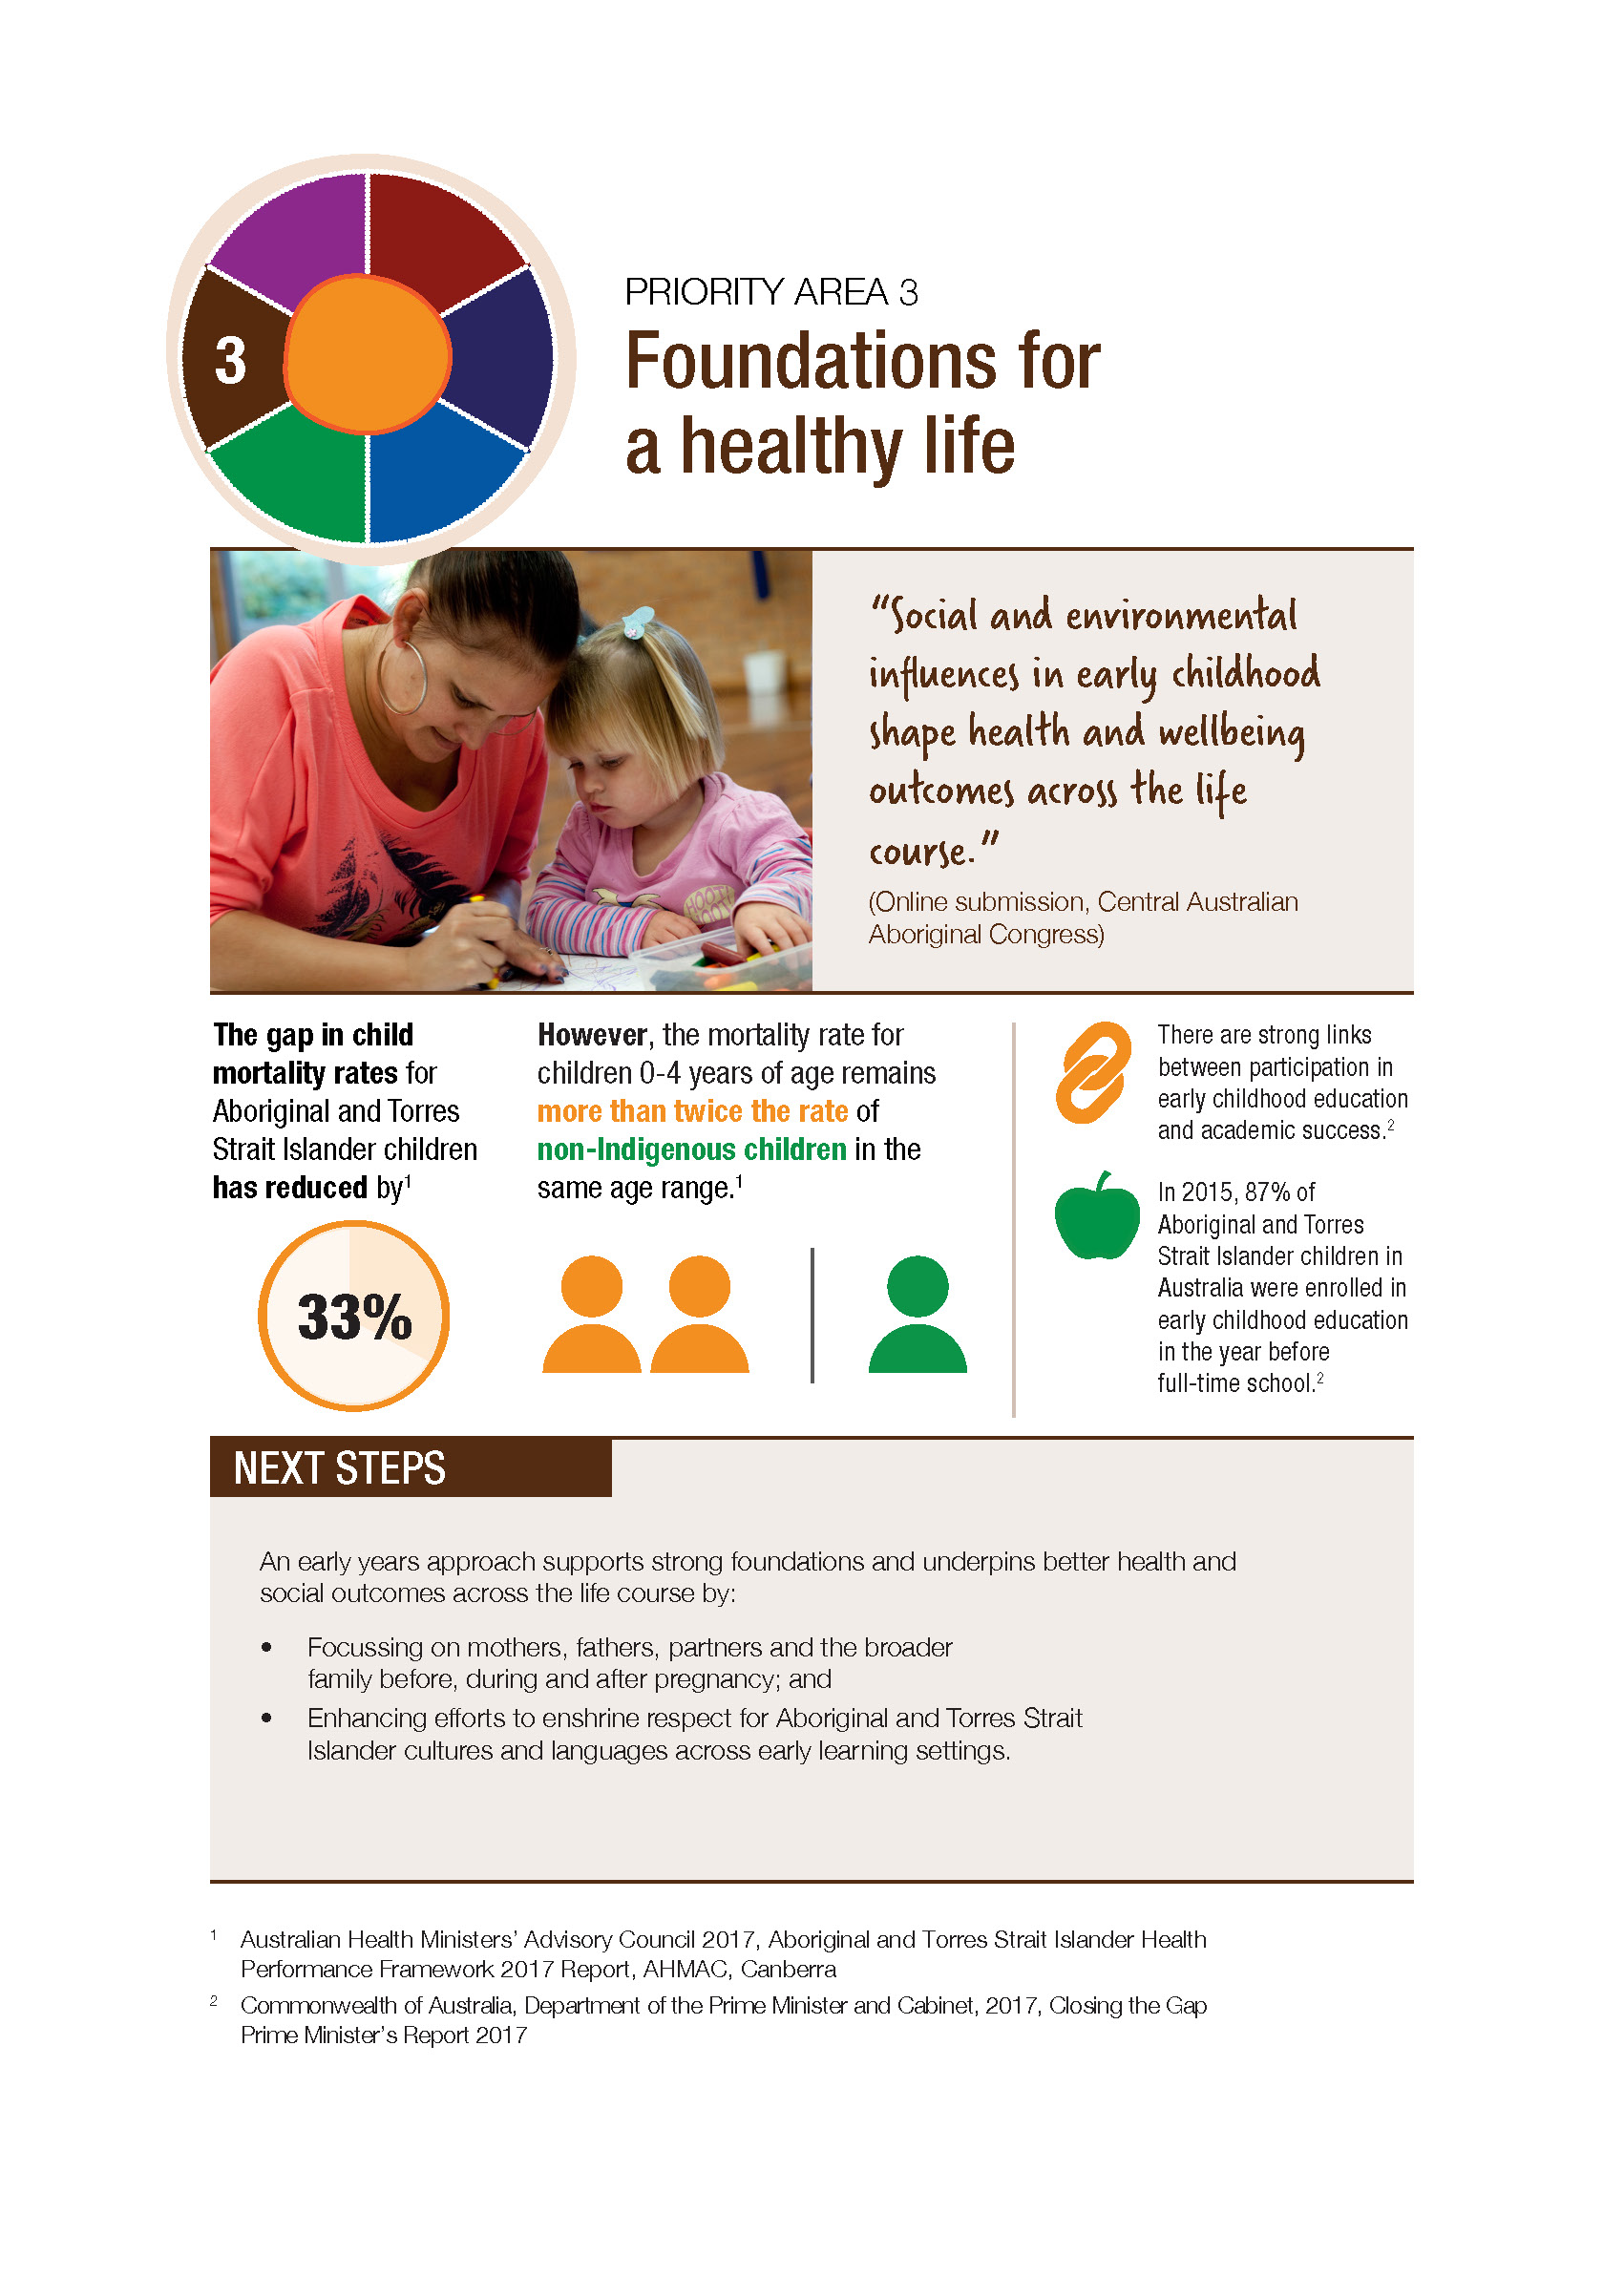

PRIORITY AREA 4: ENVIRONMENTAL HEALTH
Social determinants influence both the exposure to and impact of environmental risks that lead to infection, disease and poor health. A myriad of diseases are directly linked to poor environmental health, including respiratory infections, gastroenteritis, trachoma, skin disease and middle ear infection.
These diseases have the potential to cause long-term health problems and disabilities that adversely affect a person’s ability to learn and engage fully in education and employment. The link between the high burden of infectious diseases in children and chronic disease in later life is also well established.
Aboriginal and Torres Strait Islander people are more likely to experience environmental conditions in their home and surroundings that directly contribute to poor health outcomes. The numbers for overall admissions to hospital for conditions attributable to poor environmental conditions increased between 2007 and 2014-15. In the same period, hospitalisations for infectious diseases for Aboriginal and Torres Strait Islander people were at least 1.5 times the rate of hospitalisations for the non-Indigenous population in all geographical categories, with hospitalisations in remote and very remote areas four times higher.
During the My Life My Lead consultation process, stakeholders raised concerns that inconsistent hygiene messaging is hampering prevention activities with regard to the spread of trachoma, otitis media, scabies and acute rheumatic fever.
Stakeholders working on trachoma prevention have indicated that an approach that delivers a broad health hygiene message should deliver improvements and help reduce illnesses and infections across a range of health conditions such as trachoma, ear disease, respiratory infections, tooth and gum disease, gastric conditions, skin infections, rheumatic heart disease.
Australia is on track to eliminate trachoma as a public health problem by 2020. The prevalence of trachoma has decreased from 14 per cent in 2009 to 4.6 per cent in 2015. The 2016 trachoma prevalence rate is expected to continue to be less than five per cent. The single hygiene message would be based on improving understanding of germ theory and its relation to infectious diseases.
A lack of adequate and functional housing and overcrowding also remains a significant impediment to improving all aspects of Aboriginal and Torres Strait Islander health. In 2014-15, around one quarter of dwellings in which Aboriginal and Torres Strait Islander people resided had major structural problems.
Furthermore, in remote areas, one in six households did not have working facilities for preparing food and 15 per cent did not have facilities for washing clothes and bedding—double the rate of non-remote areas.
Despite only making up three per cent of the Australian population, one in four clients of specialist homelessness services (24 per cent) in 2015-16 were Aboriginal or Torres Strait Islander. In addition, homelessness, inadequate housing and overcrowded housing have the potential to contribute to higher rates of Aboriginal and Torres Strait Islander people in incarceration, further exacerbating the cycle of disadvantage.
Both the My Life My Lead consultations and current evidence strongly indicates that addressing environmental health, including housing, is fundamental to improving health outcomes for Aboriginal and Torres Strait Islander people. This is an area where all levels of government can enhance their collaborative efforts to effect sustained change, thereby accelerating broader improved health outcomes.
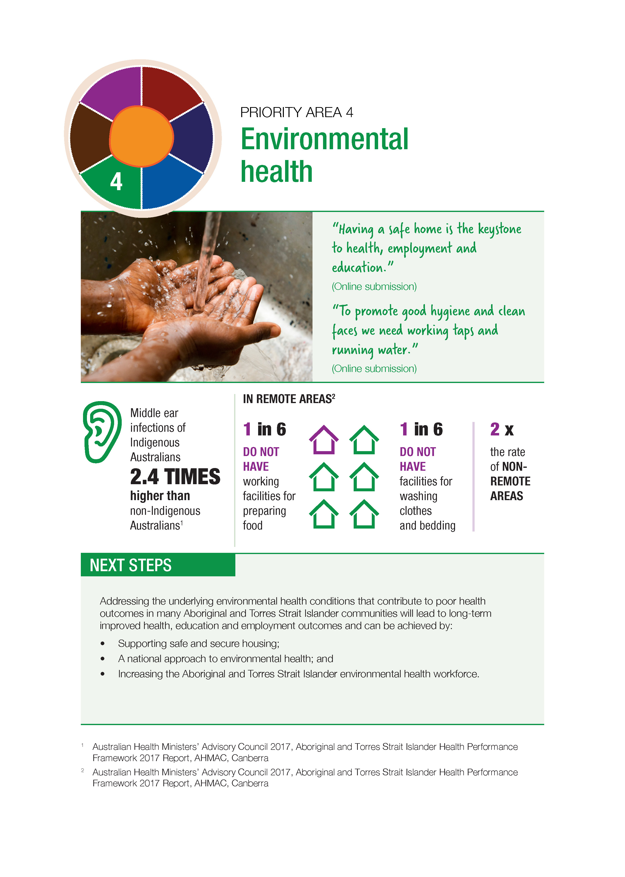

PRIORITY AREA 5: HEALTHY LIVING AND STRONG COMMUNITIES
The family, community and environment where a person lives establish the foundations for their physical, mental and emotional wellbeing. The My Life My Lead consultations clearly outlined that to support healthy living, people must feel enabled and empowered to make choices that reinforce and maintain good health. Stressors, such as racism, trauma, low income, family violence, and poor housing disempower individuals and are major barriers to making healthy choices.
Governments and the Primary Health Care sector are already working on multiple levels to reduce the burden of disease for Aboriginal and Torres Strait Islander people through supporting the provision of targeted prevention, early intervention and support activities. Significant improvements have been achieved, with the mortality rate from chronic disease declining by 19 per cent between 1998 and 2015 (six per cent since 2006). Over the period from 1998 to 2015, there was a 43 per cent decline in the mortality rate from circulatory disease and a 24 per cent decline in the Indigenous mortality rate from respiratory disease. From 2006 to 2015, there has been a 47 per cent decline in the Indigenous kidney disease mortality rate—a substantial improvement over a relatively short period of time.
Aboriginal and Torres Strait Islander people experience more than twice the burden of disease and injury of non-Indigenous Australians, and this burden of disease is highest in the most socio-economically disadvantaged areas. The four leading behavioural risk factors for the burden of disease are: tobacco use (12 per cent of the total burden); alcohol use (eight per cent); high body mass (eight per cent); and physical inactivity (six per cent). My Life My Lead contributors noted that recent investment in targeted Indigenous smoking programs is making a difference to community attitudes, particularly in young age groups where there are promising signs of reduced take-up. These anecdotal reports are backed by evidence that there has been a nine per cent decline in smoking rates for Aboriginal and Torres Strait Islander people between 2002 and 2014-15, although smoking rates remain 2.7 times the non-Indigenous rate.
Much of this burden of disease is preventable. Risk behaviours, such as tobacco smoking, poor diet, unsafe sex, excessive alcohol consumption, illicit drug use and physical inactivity affect not only the individual, but also unborn children, household members and the wider community. Access to the prerequisites that support healthy living and the reduction of chronic disease, such as nutritious food, safe sex products and a safe physical environment that supports physical activity, remain a challenge for many Aboriginal and Torres Strait Islander families and communities.
A message presented throughout the My Life My Lead consultations was that in order to change how governments work with Aboriginal and Torres Strait Islander people and communities to support healthy living and strong communities, there needs to be an acknowledgement of the continued impact of trauma and genuine steps taken to address trauma as an underlying cause of poor health. While recognising there are many different types of trauma, and that the concepts are continuing to evolve, trauma and dysfunction have become so common in some families and communities that it is now normalised. Evidence about the biological impact of stress and trauma on physical health is growing and work on trauma-informed service approaches is developing in some areas. It is vital that the negative cycle of intergenerational and contemporary trauma is understood across service systems and steps taken to address it through culturally-informed and strengths-based approaches. These approaches must recognise the unique history across communities and cultures, and that the impact of trauma will be different depending on this history.
Adolescence is a time of change with Aboriginal and Torres Strait Islander youth experiencing particular challenges that impact their capacity to engage fully with education. High levels of psychological distress are apparent and in recent youth-focussed consultations, young people shared that being positive about their own personal health and that of friends and family is important to them whilst they are also completely impacted by the levels of violence, illness, substance misuse, access to services and other community level concerns that surround them.
Food security is a key issue influencing health outcomes for Aboriginal and Torres Strait Islander people, and was discussed at both metropolitan and regional consultation forums. Many of the principal causes of poor health, such as heart disease, Type 2 diabetes and renal disease, are nutrition related. Sugar consumption is also a key risk factor for dental care. Barriers to food security in remote regions include weather, road conditions, inadequate food storage/preparation facilities and high costs associated with transport expenses. Food security is also an issue that affects Aboriginal and Torres Strait Islander people living in regional and metropolitan areas due to low incomes, household infrastructure and overcrowding, limited access to transport and limited storage and cooking facilities.
Feedback from the My Life My Lead forums mirrors the growing body of evidence demonstrating the links between positive health outcomes and caring for Country. The Australian Government’s Indigenous Rangers – Working on Country Program (Rangers Program) creates meaningful employment, training and career pathways for Aboriginal and Torres Strait Islander people in land and sea management, and supports Aboriginal and Torres Strait Islander people to combine traditional knowledge with conservation training to protect and manage their land, sea and culture. Participants have reported better outcomes across a number of social determinants, including reduced contact with the justice system, better family relationships, and reduced consumption of alcohol. Programs that support connectedness through arts, languages, culture, music and broadcasting have also had some success in improving outcomes across social determinants.
Embedding and building upon these improvements requires a concerted effort to address the underlying social and structural factors that are contributing to the higher burden of disease for Aboriginal and Torres Strait Islander people. Changing health behaviours requires a range of elements working together, across multiple and different settings and life stages, with the interaction of environmental and personal factors.

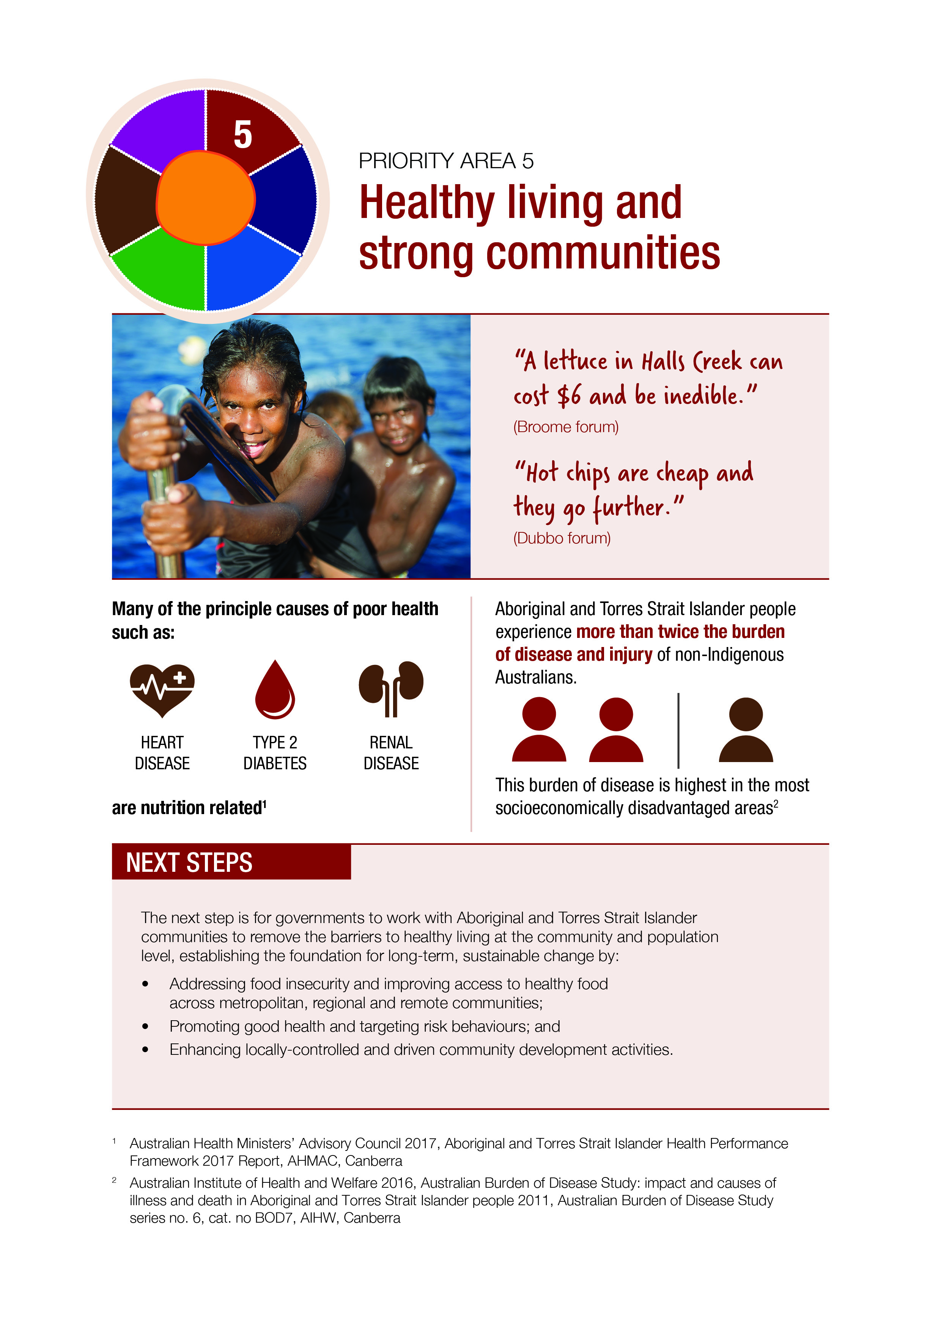

PRIORITY AREA 6: HEALTH SERVICE ACCESS
The My Life My Lead consultation forums highlighted that there have been significant health gains made for Aboriginal and Torres Strait Islander people over the last generation. This is supported in the most recent Aboriginal and Torres Strait Islander Health Performance Framework 2017, which shows that Government investment in targeted activities has delivered significant improvements reducing the burden of disease across a range of areas.
Despite these improvements, poor access to health and effective ‘wrap around’ services contributes to the significant health inequities still experienced by Aboriginal and Torres Strait Islander people. Factors such as cost, cultural security, safety and capability, racism, gender, remote location, health service availability, lack of transport, poor health literacy, the need for interpreting and other language services, and difficulty navigating system pathways all represent barriers to access.
While ACCHSs and AMSs deliver holistic and culturally appropriate primary and community health care in locations across the country, many Aboriginal and Torres Strait Islander people must, or choose to, access health care through mainstream services. While health assessment rates more than tripled between 2009 and 2016, there is evidence that many Aboriginal and Torres Strait Islander people do not or cannot access the medical care they need, with 30 per cent reporting that they did not access a health service when they needed to in 2012-13.
Key factors influencing choice and access to health services include availability, affordability, appropriateness and acceptability. Culturally valid understandings must shape the provision of services and guide assessment, care and management of Aboriginal and Torres Strait Islander people’s health. This is particularly important for the provision of mental health services. Inpatient and specialist services were identified by My Life My Lead contributors as often being seen as the least culturally safe for Aboriginal and Torres Strait Islander people. Fear of accessing inpatient services is often compounded by people having a lack of support due to dislocation from family and Country.
There is a marked disparity in oral health for Aboriginal and Torres Strait Islander people compared to the non-Indigenous population, with poor access to dental services a barrier to good health. In 2012-13, 21 per cent of Aboriginal and Torres Strait Islander people aged 15 years and over reported having problems accessing dentists, while 14 per cent reported having never seen a dentist. In addition, access to ear health and hearing services is another key issue. Hearing loss is more widespread among Aboriginal and Torres Strait Islander people than the non-Indigenous population, with otitis media a significant cause of hearing loss among Aboriginal and Torres Strait Islander children.
Consultation participants noted that solutions to health access need to look beyond the traditional health system. Aboriginal and Torres Strait Islander people experience higher rates of arrest and incarceration than non-Indigenous Australians, with prison populations demonstrating an overrepresentation of mental health and substance use problems, cognitive impairment, hearing loss, learning difficulties and histories of physical and sexual abuse.
My Life My Lead forums and current evidence recognises Fetal Alcohol Spectrum Disorder as a contributing factor to incarceration rates in Aboriginal and Torres Strait Islander communities. Given the complexity of the problems and comorbidities among the prison population, strong linkages between the health and justice system are imperative to breaking the cycle of disadvantage. This is particularly the case for young people—on an average day in 2014-15, 43 per cent of young people under youth justice supervision were Aboriginal and Torres Strait Islander, with large portions also represented in the child protection system.
Participants also noted there is an opportunity to support access to health and other services in regional and remote areas in conjunction with existing program rollouts and enhancement of information technology infrastructure. For example, the rollout of the NBN will support improvements in digital health technology. There are further opportunities to build upon the NDIS rollout and other large infrastructure projects to enhance the availability of integrated services.

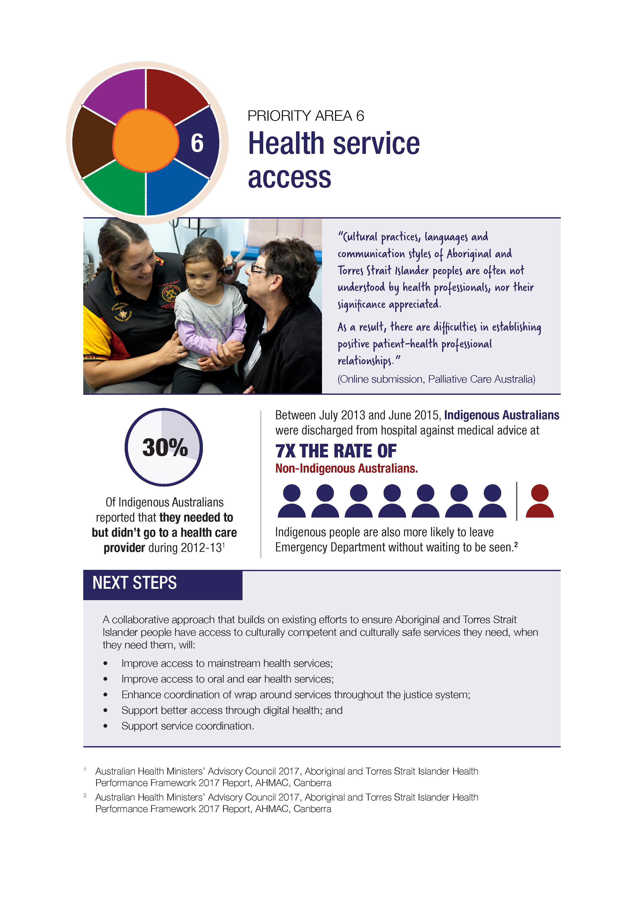

PRIORITY AREA 7: HEALTH AND OPPORTUNITY THROUGH EDUCATION
Education epitomises the role of social determinants and cultural determinants of health. Health challenges directly impede educational attainment; and better educational outcomes provide the opportunities and skills necessary to achieve better health. Aboriginal and Torres Strait Islander 15 year olds are two-and-a-third years behind in literacy and numeracy compared to their non-Indigenous peers.
My Life My Lead participants provided feedback that many teenagers are leaving school ill-equipped to compete in the labour market. The evidence also shows that increased education leads to people managing their own health more effectively (for example, higher education levels are correlated with lower rates of smoking and obesity) and equips them to be more active and informed consumers of health services. There is a strong link between education and employment with the employment gap narrowing significantly as the level of education increases.
There are already some notable achievements in education, and the Closing the Gap target to halve the gap in Year 12 attainment by 2020 is currently on track. This provides an important platform from which further improvements can be leveraged. Because the gains made in education have a multiplying effect in so many areas that directly and indirectly contribute to better health, an ongoing commitment in this critical area is required.
Opportunities for further improvement centre on the role of culture in supporting educational outcomes and the importance of effective transitions over the life course as young people move between different components of the education system and into the workplace. This supports the emerging focus on considering education needs throughout the birth to adulthood continuum holistically in policy design and implementation.
A recurring theme throughout the consultation process was the need to include parents, Elders and communities in learning to maintain Aboriginal and Torres Strait Islander peoples’ connection to family, Country and culture. This need was identified across the continuum of early childhood education and schooling.
There is strong evidence that language has a significant influence on wellbeing, self-worth and identity formation and how these foundational attributes impact throughout a person’s life. In 2014–15, around one-third of Aboriginal and Torres Strait Islander children aged 4–14 years spoke an Indigenous language—this increased to two-thirds in remote areas. For Aboriginal and Torres Strait Islander children, bilingual education not only helps children maintain their spoken language, but also harnesses respect for Aboriginal and Torres Strait Islander culture within the school.
All Education ministers have endorsed the Framework for Aboriginal Languages and Torres Strait Islander Languages, which caters for foundation to Year 10. The Framework is designed to be flexible in use for developing language-specific curricula and programs.
It is intended to be used by jurisdictions, schools and communities to develop language-specific curricula and programs in partnerships with local communities in the teaching of Indigenous language.
The ‘middle years’—typically between Year 5 and Year 8 of school—are emerging as a period where a greater focus is needed. During this time, young people experience dynamic physical and psychological development. Feedback from the My Life My Lead consultation process revealed that career planning and preparation to move from school to vocational or higher education needs to commence during these middle years, as many have already ‘fallen through the cracks’ by the time they are eligible for vocational education training.
Studies have found that offering students Vocational Educational Training (VET) in the senior school years tends to increase school attendance and completion and improve the labour market outcomes of school completers. A range of VET options, including school-based apprenticeships and traineeships, is an important strategy in secondary schools for building stronger engagement and rates of completion.
Consultation participants agreed that Aboriginal and Torres Strait Islander cultures need to be recognised, celebrated and normalised in the mainstream, and that it is important for Aboriginal and Torres Strait Islander languages and culture to be included in the Australian curriculum and early childhood education programs. Evidence from the Longitudinal Study of Indigenous Children that children attending schools using the Aboriginal and Torres Strait Islander histories and cultures cross-curriculum priority have higher than average literacy scores compared to children in schools that do not.
The cultural capability of the education workforce is also critical in ensuring that Aboriginal and Torres Strait Islander students feel safe and supported at school and in care. This includes respect for culture and language, particularly for young children who speak a language other than English at home as they benefit from a foundation in their first language to prepare them for the acquisition of English. The Respect, Relationships, Reconciliation resources have been developed by the Australian Institute for Teaching and School Leadership, in collaboration with the Australian Council of Deans of Education and Aboriginal and Torres Strait Islander people, to support cultural capability in Aboriginal and Torres Strait Islander education.
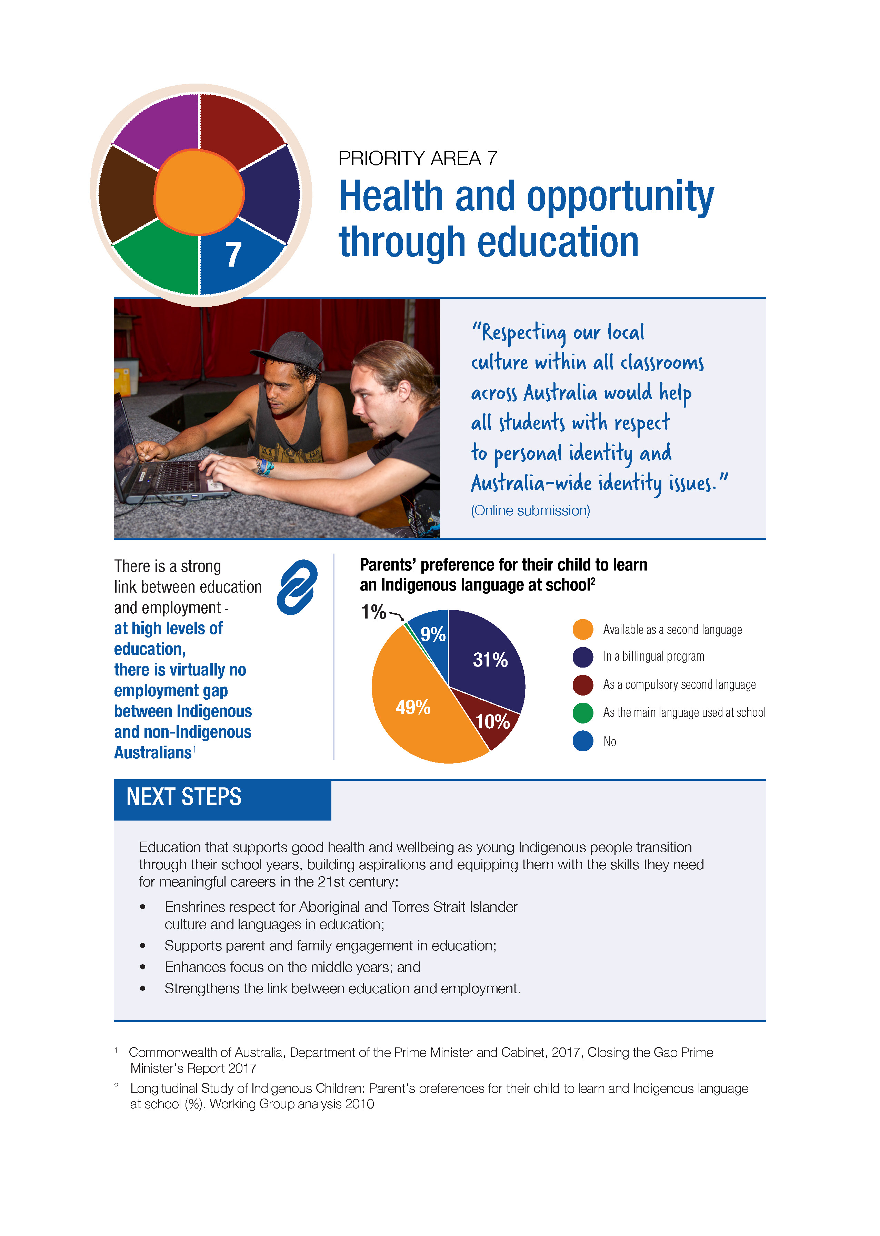

NEXT STEPS
The Council of Australian Governments (COAG) Closing the Gap Strategy is the overarching framework that guides collective action to improve the wellbeing and life outcomes of Aboriginal and Torres Strait Islander people. In December 2016, COAG committed governments to work together and with Aboriginal and Torres Strait Islander leaders, organisations and communities to refresh the Closing the Gap agenda with renewed emphasis on collaborative effort and evaluation to build on what works in each jurisdiction.
The priorities set out in My Life My Lead will directly support the Closing the Gap refresh agenda, offering critical stakeholder insights into the required approach and how it can be realised. While health solutions remain vital to efforts to reduce health disparities, this must be in concert with coordinated strategic activity across education, employment, infrastructure, environment and justice to address the underlying causes of poor health for Aboriginal and Torres Strait Islander people.
Reducing social and economic disadvantage will support a better quality of life for Aboriginal and Torres Strait Islander people, leading to a reduction in the burden of disease and improved health outcomes. This, in turn, will contribute to improvements across the spectrum, including economic opportunities and safe communities.
The Closing the Gap Strategy also sets the platform for the National Aboriginal and Torres Strait Islander Health Plan 2013-2023, with its Implementation Plan containing actions for both community-controlled and mainstream health systems and services. The Implementation Plan will be revised in 2018, informed by the direction outlined within this Report and the outcomes of the Closing the Gap refresh agenda.
In developing the next Implementation Plan, strategies will focus on addressing the importance of culture, healthy lives and empowering the next generation, economic opportunities and engagement in education, healthy homes and strong communities, as well as improving access to services through addressing systemic racism and enhancing cultural competency. This will involve collaboration across portfolios, Indigenous health leaders and other key stakeholders in recognition of the essential role of these partnerships in delivering the next Implementation Plan. There is an opportunity to continue to pick up key themes raised through the My Life My Lead consultations that are aligned to the broad priorities outlined in this report. Government has also established an Interdepartmental Committee to prioritise and refine a work-plan as work continues towards the next Implementation Plan for 2018-2023.
State and territory governments have agreed to contribute to the development of the next iteration of the Implementation Plan. A key component of this will be to reflect their existing plans, efforts and achievements and identify activities that support shared agendas to improve Indigenous health outcomes, in line with the Closing the Gap refresh agenda.

REFERENCES

The 2018 extension of the National Partnership on Universal Access to Early Childhood Education is yet to be agreed with the states and territories.
Australian Health Ministers’ Advisory Council 2017, Aboriginal and Torres Strait Islander Health Performance Framework 2017 Report, AHMAC, Canberra.
Marmot, M, 2015,,The Health Gap: The Challenge of an Unequal World, Bloomsbury Publishing: Great Britain, cited in Australian Health Ministers’ Advisory Council 2017, Aboriginal and Torres Strait Islander Health Performance Framework 2017 Report, AHMAC, Canberra.
Australian Health Ministers’ Advisory Council 2017, Aboriginal and Torres Strait Islander Health Performance Framework 2017 Report, AHMAC, Canberra.
Australian Health Ministers’ Advisory Council 2017, Aboriginal and Torres Strait Islander Health Performance Framework 2017 Report, AHMAC, Canberra..
Department of the Prime Minister and Cabinet 2017, Closing the Gap Prime Minister’s Report 2017, Commonwealth of Australia, Canberra.
Department of Health and Ageing, National Aboriginal and Torres Strait Islander Health Plan 2013-2023, Commonwealth of Australia, Canberra.
Commonwealth of Australia, Department of the Prime Minister and Cabinet, National Strategic Framework for Aboriginal and Torres Strait Islander Peoples’ Mental Health and Social and Emotional Wellbeing 2017-2023.
Prof. Ngiare Brown (undated), cited in The Lowitja Institute – Cultural Determinants Roundtable, Melbourne 26th November 2014, Background Paper, online: http://www.lowitja.org.au/sites/default/files/docs/Cultural-Determinants-Roundtable-Background-Paper.pdf.
Van der Kolk, B 2014, The Body Keeps the Score: Mind, Brain and Body in the Healing of Trauma, Viking Penguin, New York.
Priest, Naomi, 2016, ‘Research reveals what racism can do to a child’s body’, UNICEF, 24/11/2016. Viewed 21 July 2017, https://www.unicef.org.au/blog/news-and-insights/november-2016/research-reveals-what-racism-can-do-to-a-childs-body.
Paradies, Y, Harris, R & Anderson, I 2008, The Impact of Racism on Indigenous Health in Australia and Aotearoa: Towards a Research Agenda, Discussion Paper No. 4, Cooperative Research Centre for Aboriginal Health, Darwin, https://www.lowitja.org.au/sites/default/files/docs/Racism-Report.pdf.
Australian Bureau of Statistics 2017, 2016 Census Data Summary: Aboriginal and Torres Strait Islander Population, Commonwealth of Australia.
Behrendt 2006, cited in Scrimgeour, M. & Scrimgeour, D. 2008, Health Care Access for Aboriginal and Torres Strait Islander People Living in Urban Areas, and Related Research Issues: A Review of the Literature, Cooperative Research Centre for Aboriginal Health, Casuarina.
Aboriginal and Torres Strait Islander Mental Health and Suicide Prevention Advisory Group (2016) National Strategic Framework for Aboriginal and Torres Strait Islander Peoples’ Mental Health and Social and Emotional Wellbeing 2017-2023 Commonwealth of Australia.
Commission on Social Determinants of Health 2008, ‘Closing the gap in a generation: Health equity through action on the social determinants of health, CSDH, World Health Organization, Geneva.
Commonwealth of Australia 2013, Australia's domestic response to the World Health Organization's (WHO) Commission on Social Determinants of Health report "Closing the gap within a generation", Senate Community Affairs Committee, Commonwealth of Australia, Canberra.
Kalb, G, Le, T & Leung, F 2011, Decomposing differences in labour force status between Indigenous and non-Indigenous Australians, Melbourne Institute of Applied Economic and Social Research Report, Melbourne.
Cummins, RA, Woerner, J, Tomyn, A, Gibson, A & Knapp, T 2006, Australian Unity Wellbeing Index Survey 16: “The Wellbeing of Australians – Mortgage Payments and Home Ownership”, Australian Centre on Quality of Life, Deakin University, Melbourne.
Department of the Prime Minister and Cabinet 2017, Closing the Gap Prime Minister’s Report 2017, Commonwealth of Australia, Canberra.
Emerson, L., Fox, S. & Smith, C. 2015, Good Beginnings: Getting it right in the early years, The Lowitja Institute, Melbourne.
Australian Health Ministers’ Advisory Council 2017, Aboriginal and Torres Strait Islander Health Performance Framework 2017 Report, AHMAC, Canberra.
Aboriginal and Torres Strait Healing Foundation 2017, Bringing Them Home 20 years on: an action plan for healing, Aboriginal and Torres Strait Healing Foundation, Canberra.
Global Access Partners Taskforce on Early Childhood Education 2016, Final Report, Global Access Partners Pty Ltd, Sydney.
Simpson, J, Caffery, J, & McConvell, P 2009, Gaps in Australia’s Indigenous language policy: dismantling bilingual education in the Northern Territory, AIATSIS Research Discussion Paper No. 24, AIATSIS, Canberra, https://aiatsis.gov.au/sites/default/files/products/discussion_paper/simpson-caffery-mcconvell-dp24-indigenous-language-policy_0.pdf.
New South Wales Department of Health 2010, Closing the Gap: 10 Years of Housing for Health in NSW; An evaluation of a healthy housing intervention, Aboriginal Environmental Health Unit, Population Health Division, NSW Department of Health, Sydney.
Steering Committee for the Review of Government Service Provision 2016, Overcoming Indigenous Disadvantage: Key Indicators 2016 Report, Productivity Commission for the SCRGSP, Commonwealth of Australia, Canberra.
Australian Medical Association 2017, Australian Medical Association Submission to the Implementation Plan Advisory Group Consultation 2017 on the development of the next iteration of the Implementation Plan for the National Aboriginal and Torres Strait Islander Health Plan 2013-2023, Canberra.
Australian Health Ministers’ Advisory Council 2017, Aboriginal and Torres Strait Islander Health Performance Framework 2017 Report, AHMAC, Canberra.
Finance and Public Administration References Committee 2016, Aboriginal and Torres Strait Islander experience of law enforcement and justice services, Commonwealth of Australia, Canberra.
Department of the Prime Minister and Cabinet 2017, Closing the Gap Prime Minister’s Report 2017, Commonwealth of Australia, Canberra.
Anda, RF, Felitti, VJ, Bremner, JD, Walker, JD, Whitfield, C, Perry, BD, Dube, SR & Giles, WH 2006, ‘The enduring effects of abuse and related adverse experiences in childhood: A convergence of evidence from neurobiology and epidemiology’, European Archives of Psychiatry and Clinical Neuroscience, vol. 256, no. 3, pp. 174-186.
Atkinson, J 2013, Trauma-informed services and trauma-specific care for Indigenous Australian children, Resource sheet no. 21. produced for the Closing the Gap Clearinghouse, Australian Institute of Health and Welfare, Canberra & Australian Institute of Family Studies, Melbourne, http://www.aihw.gov.au/uploadedFiles/ClosingTheGap/Content/Publications/2013/ctg-rs21.pdf.
Van der Kolk, B 2006, ‘Develop Aboriginal and Indigenous Community Health’, vol. 4, no. 2, pp. 118-136.
Australian Health Ministers’ Advisory Council 2017, Aboriginal and Torres Strait Islander Health Performance Framework 2017 Report, AHMAC, Canberra.
Moynihan, PJ, Kelly SA 2014, Effect on caries of restricting sugars intake: systematic review to inform WHO guidelines Pub Med J Dent Res. 2014 Jan;93(1):8-18. Epub 2013 Dec 9.
Sheiham, A, James, WPT (2015) ‘Diet and Dental Caries the Pivotal Role of Free Sugars Reemphasised’ Journal of Dental Research Volume: 94 issue: 10.
Browne J, Laurence S, Thorpe S, (2009), Acting on food insecurity in urban Aboriginal and Torres Strait Islander communities: Policy and practice interventions to improve local access and supply of nutritious food.
Muriuki G, Schubert L, Hussey K and Roitman S, (2017), Urban Food Systems – a renewed role for local governments in Australia: A discussion paper of the Global Change Institute, University of Queensland, Brisbane.
Thurber KA, Bagheri N, and Banwell C, (2014), Social determinants of sugar-sweetened beverage consumption in the Longitudinal Study of Indigenous Children, Family Matters 96, 51-61.
Burgess, C., Johnston, F., Berry, H., McDonnell, J., et al, 2009, “Healthy country, health people: the relationship between Indigenous health status and “caring for country”, in Medical Journal of Australia, Vol.190, No. 10.
Kanyirninpa Jukurrpa (Martu) Rangers’ presentation to Department of the Prime Minister and Cabinet, 2015.
Pikora T, Christian H, Trapp G, Villanueva K., 2016, Chronic disease prevention interventions in children and young adults: A rapid review prepared for the Australian Government Department of Health on behalf of The Australian Prevention Partnership Centre.
Australian Health Ministers’ Advisory Council 2017, Aboriginal and Torres Strait Islander Health Performance Framework 2017 Report, AHMAC, Canberra.
Department of the Prime Minister and Cabinet 2017, Closing the Gap Prime Minister’s Report 2017, Commonwealth of Australia, Canberra.
Australian Health Ministers’ Advisory Council 2017, Aboriginal and Torres Strait Islander Health Performance Framework 2017 Report, AHMAC, Canberra.
Ware, V 2013, Improving the accessibility of health services in urban and regional settings for indigenous people, Australian Institute of Health and Welfare, Canberra, A.C.T.
Aboriginal and Torres Strait Islander Mental Health and Suicide Prevention Advisory Group (2016) National Strategic Framework for Aboriginal and Torres Strait Islander Peoples’ Mental Health and Social and Emotional Wellbeing 2017-2023 Commonwealth of Australia.
Australian Health Ministers’ Advisory Council 2017, Aboriginal and Torres Strait Islander Health Performance Framework 2017 Report, AHMAC, Canberra.
Burns & Thomson 2013; Darwin Ottis Guidelines Group et al. 2010, in Australian Health Ministers’ Advisory Council 2017, Aboriginal and Torres Strait Islander Health Performance Framework 2017 Report, AHMAC, Canberra.
Jervis-Bardy et al. 2014, in Australian Health Ministers’ Advisory Council 2017, Aboriginal and Torres Strait Islander Health Performance Framework 2017 Report, AHMAC, Canberra.
Heffernan et al. 2012; Levy 2005; AMA 2015 in Australian Health Ministers’ Advisory Council 2017, Aboriginal and Torres Strait Islander Health Performance Framework 2017 Report, AHMAC, Canberra.
Finance and Public Administration References Committee 2016, Aboriginal and Torres Strait Islander experience of law enforcement and justice services, Commonwealth of Australia, Canberra.
Australian Health Ministers’ Advisory Council 2017, Aboriginal and Torres Strait Islander Health Performance Framework 2017 Report, AHMAC, Canberra.
Shankar, J, Ip, E, Khalema, E, Couture, J, Tan, S, Zulla, RT & Lam, G 2013, ‘Education as a Social Determinant of Health: Issues Facing Indigenous and Visible Minority Students in Postsecondary Education in Western Canada’, International Journal of Environmental Research and Public Health, vol. 10, no. 9, pp. 3908–3929.
Zimmerman, EB, Woolf, SH & Haley, A 2015, ‘Understanding the Relationship Between Education and Health: A Review of the Evidence and an Examination of Community Perspectives’, Agency for Healthcare Research and Quality, Rockville, Maryland.
Australian Bureau of Statistics Census of Population and Housing 2011. In: Department of the Prime Minister and Cabinet 2017, Closing the Gap Prime Minister’s Report 2017, Commonwealth of Australia, Canberra.
Australian Bureau of Statistics 2016, National Aboriginal and Torres Strait Islander Social Survey, 2014-15, Commonwealth of Australia.
Simpson, J, Caffery, J, & McConvell, P 2009, Gaps in Australia’s Indigenous language policy: dismantling bilingual education in the Northern Territory, AIATSIS Research Discussion Paper No. 24, AIATSIS, Canberra.
Bishop J & Mane F 2004. The impacts of career-technical education on high school labor market success. Economics of Education Review 23:381–402.
Lamb S 2008. Alternative pathways to high school graduation: an international comparison report for the California Dropout Research Project report no. 7. Santa Barbara: University of California.
Skelton, F 2015, Increased literacy scores for Indigenous children in schools using the cross-curriculum priority, Research summary: No.4, National Centre for Longitudinal Data, Department of Social Services, Commonwealth of Australia, Canberra.
Simpson, J., Caffery, J., & McConvell, P. 2009, Gaps in Australia’s Indigenous Language Policy: Dismantling Bilingual Education in the Northern Territory, AIATSIS, Canberra.

