**MULTIJURISDICTIONAL SYPHILIS OUTBREAK   
SURVEILLANCE REPORT: FEBRUARY 2019**

**This surveillance report has been authorised by Health Departments in outbreak affected jurisdictions and the Office of Health Protection.**

The Multijurisdictional Syphilis Outbreak (MJSO) Working Group was formed by the Communicable Diseases Network of Australia (CDNA) in April 2015, in response to an ongoing outbreak of infectious syphilis among Aboriginal and Torres Strait Islander people living largely in remote and rural areas of northern Australia. Increased notifications associated with the outbreak in northern Australia were first reported in January 2011 in northwest Queensland (Qld), followed by the Northern Territory (NT) in July 2013, and the Kimberley region of Western Australia (WA) in June 2014. In March 2017, South Australia (SA) declared an outbreak in the Far North and Western and Eyre regions from November 2016. In August 2018, WA declared that the outbreak had spread to the Pilbara region with the first syphilis notification in this region in February 2018. In January 2019, SA declared the outbreak had spread to Adelaide with the first notification in this region reported in February 2018.

This surveillance report summarises the outbreak epidemiological data as of 31 January 2019 (current status).

**Please note:** the MJSO Surveillance Report was formerly known as the MJSO Communique. Historical epidemiological data and MJSO activities are published in earlier MJSO Communiques available at *http://www.health.gov.au/internet/main/publishing.nsf/Content/ohp-infectious-syphilis-outbreak.htm*

**Current status**

Outbreak data to 31 January 2019ȶ are summarised in Figure 1, Table 1 and Table 2 below.

Outbreak cases are reported as either category 1 or category 2: category 1 cases include Aboriginal and Torres Strait Islander people residing in an outbreak declared regionβ at the time of diagnosis, and; category 2 cases include people who are a sexual contact of a confirmed outbreak case which includes Aboriginal and Torres Strait Islander people who do not reside in an outbreak area at the time of diagnosis and non-Indigenous people regardless of where they reside.

Between 1 – 31 January 2019ȶ, there were 57 outbreak cases (category 1 and 2 cases) reported from the four outbreak affected jurisdictions: 18 in Queensland; 23 in the Northern Territory; 14 in Western Australia and; 2 in South Australia (Figure 1, Table 1 and Table 2). From the commencement of the outbreak to 31 January 2019 ȶ, there were a total of 2559 outbreak cases (category 1 and 2 cases) reported across the four outbreak affected jurisdictions: 1271 in Queensland (from January 2011); 967 in the Northern Territory (from July 2013); 253 in Western Australia (from June 2014), and; 68 in South Australia (from November 2016) (Table 1 and 2).

**Figure 1**. Epidemic curve showing category 1 infectious syphilis α outbreak cases notified in Aboriginal and Torres Strait Islander people residing in affected regionsβ of Queensland, the Northern Territory, Western Australia and South Australia from commencement of the outbreak in each jurisdiction to 31 January 2019ȶ ᵞ

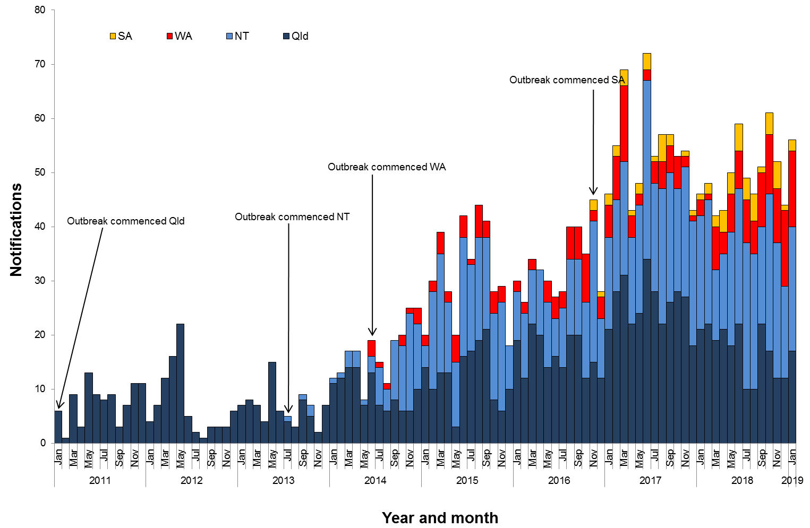

**Table 1**.Characteristics of category 1 infectious syphilisα outbreak cases notified in Aboriginal and Torres Strait Islander people residing in affected regionsβ of Queensland, the Northern Territory, Western Australia and South Australia, to   
31 January 2019 ȶ ᵞ

|  | **North Qld** (four HHSsβ) | **NT**  (seven regions β) | **WA**  (two regions β) | **SA**  (three regions β) |
| --- | --- | --- | --- | --- |
| **Situation to-date, 31 January 2019** |  |  |  |  |
| Outbreak commencement month/year | January 2011 | July 2013 | June 2014 | November 2016 |
| Total number of casesα | 1242 | 959 | 253 | 66 |
| % Male / % Female | 47% / 53% | 46% / 54% | 43% / 57% | 52% / 48% |
| % 15-29 year age group | 66% | 63% | 70% | 50% |
| Congenital cases, confirmed (probable)« | 4 (5) | 2 (3) | 0 (0) | 1 (0) |
| -number of deaths in congenital cases, confirmed (probable) | 3 (4) | 0 (0) | 0 (0) | 0 (0) |
| **Last reporting month, 1 – 31 January 2019** | | | | |
| Number of casesα | 17 | 23 | 14 | 2 |
| % Male / % Female | 47% / 53% | 57% /43% | 43% / 57% | 100% / 0% |
| % 15-29 year age group | 53% | 48% | 71% | 0% |

**Table 2.** Number of category 2 infectious syphilisα cases, to 31 January 2019 ȶ ᵞ

|  | **North Qld** (four HHSsβ) | **NT** (seven regions β) | **WA**  (two regions β) | **SA**  (three regions β) |
| --- | --- | --- | --- | --- |
| **Situation to-date, 31 January 2019** | | | | |
| Outbreak commencement month/year | January 2011 | July 2013 | June 2014 | November 2016 |
| Aboriginal and Torres Strait Islander people§ | 12 | 2 | - | - |
| Non-Indigenous peopleµ | 17 | 6 | - | 2 |
| **Last reporting month, 1 -31 January 2019** | | | | |
| Aboriginal and Torres Strait Islander people§ | 1 | - | - | - |
| Non-Indigenous peopleµ | - | - | **-** | - |

**Notes:**

ȶ ‘Diagnosis date’ was used to define the period of analysis. This date represents either the onset date or where the date of onset was not known, the earliest of the specimen collection date, the notification date, or the notification receive date.

**α** Cases defined as per the MJSO syphilis outbreak case definition:

Nationally, an infectious syphilis outbreak case is defined as: any person who is newly diagnosed with confirmed or probable infectious syphilis according to the CDNA national surveillance case definition for infectious syphilis, **AND**, is an Aboriginal or Torres Strait Islander person who resides in any of the following outbreak declared regions as defined and documented by that jurisdiction, at or after the dates indicated: ***Qld*** - North West Hospital and Health Service area (from 1 January 2011); Torres and Cape Hospital and Health Service area (from 1 December 2012); Cairns and Hinterland Hospital and Health Service area(from1 August 2013); Townsville Hospital and Health Service area (from 1 January 2014); ***NT*** - Alice Springs Rural and Urban or Barkly district (from 1 July 2013); Katherine district (from 1 May 2014); East Arnhem district (from 1 November 2015); Darwin Rural and Urban (from 1 January 2017); ***WA*** - Kimberley region (from 1 June 2014) and Pilbara region (from 1 February 2018); ***SA***  - Far North and Western and Eyre regions (from 15 November 2016); Adelaide (from 1 February 2018) (category 1 outbreak cases) **OR**, is a sexual contact of a confirmed outbreak case (category 2 outbreak cases).

**β**Affected regions include Torres and Cape, Cairns and Hinterland, North West, and Townsville Hospital and Health Services in Queensland; Alice Springs Urban, Alice Springs Rural, Barkly, East Arnhem, Katherine, Darwin Urban and Darwin Rural regions in the Northern Territory; Kimberley and Pilbara regions in Western Australia, and; Far North, Western and Eyre and Adelaide regions in South Australia.

« Cases defined as per the MJSO syphilis outbreak case definition: any newly diagnosed case of confirmed or probable congenital syphilis that meets the CDNA national surveillance case definition whose mother’s syphilis infection prior to or during pregnancy meets the infectious syphilis outbreak case definition.

§ Aboriginal and Torres Strait Islander people who are sexual contacts of a confirmed outbreak case and reside outside an outbreak declared region at the time of diagnosis.

µ Non-Indigenous people who are sexual contacts of a confirmed outbreak case and reside in or out of an outbreak declared region at the time of diagnosis.

**ᵞ** Please note that **all data are provisional** and subject to change due to ongoing case investigation.

**MULTIJURISDICTIONAL SYPHILIS OUTBREAK   
SURVEILLANCE REPORT: MARCH 2019**

**This surveillance report has been authorised by Health Departments in outbreak affected jurisdictions and the Office of Health Protection.**

The Multijurisdictional Syphilis Outbreak (MJSO) Working Group was formed by the Communicable Diseases Network of Australia (CDNA) in April 2015, in response to an ongoing outbreak of infectious syphilis among Aboriginal and Torres Strait Islander people living largely in remote and rural areas of northern Australia. Increased notifications associated with the outbreak in northern Australia were first reported in January 2011 in northwest Queensland (Qld), followed by the Northern Territory (NT) in July 2013, and the Kimberley region of Western Australia (WA) in June 2014. In March 2017, South Australia (SA) declared an outbreak in the Far North and Western and Eyre regions from November 2016. In August 2018, WA declared that the outbreak had spread to the Pilbara region with the first syphilis notification in this region in February 2018. In January 2019, SA declared the outbreak had spread to Adelaide with the first notification in this region reported in February 2018.

This surveillance report summarises the outbreak epidemiological data as of 28 February 2019 (current status).

**Please note:** the MJSO Surveillance Report was formerly known as the MJSO Communique. Historical epidemiological data and MJSO activities are published in earlier MJSO Communiques available at *http://www.health.gov.au/internet/main/publishing.nsf/Content/ohp-infectious-syphilis-outbreak.htm*

**Current status**

Outbreak data to 28 February 2019ȶ are summarised in Figure 1, Table 1 and Table 2 below.

Outbreak cases are reported as either category 1 or category 2: category 1 cases include Aboriginal and Torres Strait Islander people residing in an outbreak declared regionβ at the time of diagnosis, and; category 2 cases include people who are a sexual contact of a confirmed outbreak case which includes Aboriginal and Torres Strait Islander people who do not reside in an outbreak area at the time of diagnosis and non-Indigenous people regardless of where they reside.

Between 1 – 28 February 2019ȶ, there were 47 outbreak cases (category 1 and 2 cases) reported from the four outbreak affected jurisdictions: 18 in Queensland; 20 in the Northern Territory; 9 in Western Australia and; 0 in South Australia (Figure 1, Table 1 and Table 2). From the commencement of the outbreak to 28 February 2019 ȶ, there were a total of 2603 outbreak cases (category 1 and 2 cases) reported across the four outbreak affected jurisdictions: 1289 in Queensland (from January 2011); 990 in the Northern Territory (from July 2013); 257 in Western Australia (from June 2014), and; 67 in South Australia (from November 2016) (Table 1 and 2).

**Figure 1**. Epidemic curve showing category 1 infectious syphilis α outbreak cases notified in Aboriginal and Torres Strait Islander people residing in affected regionsβ of Queensland, the Northern Territory, Western Australia and South Australia from commencement of the outbreak in each jurisdiction to 28 February 2019ȶ ᵞ

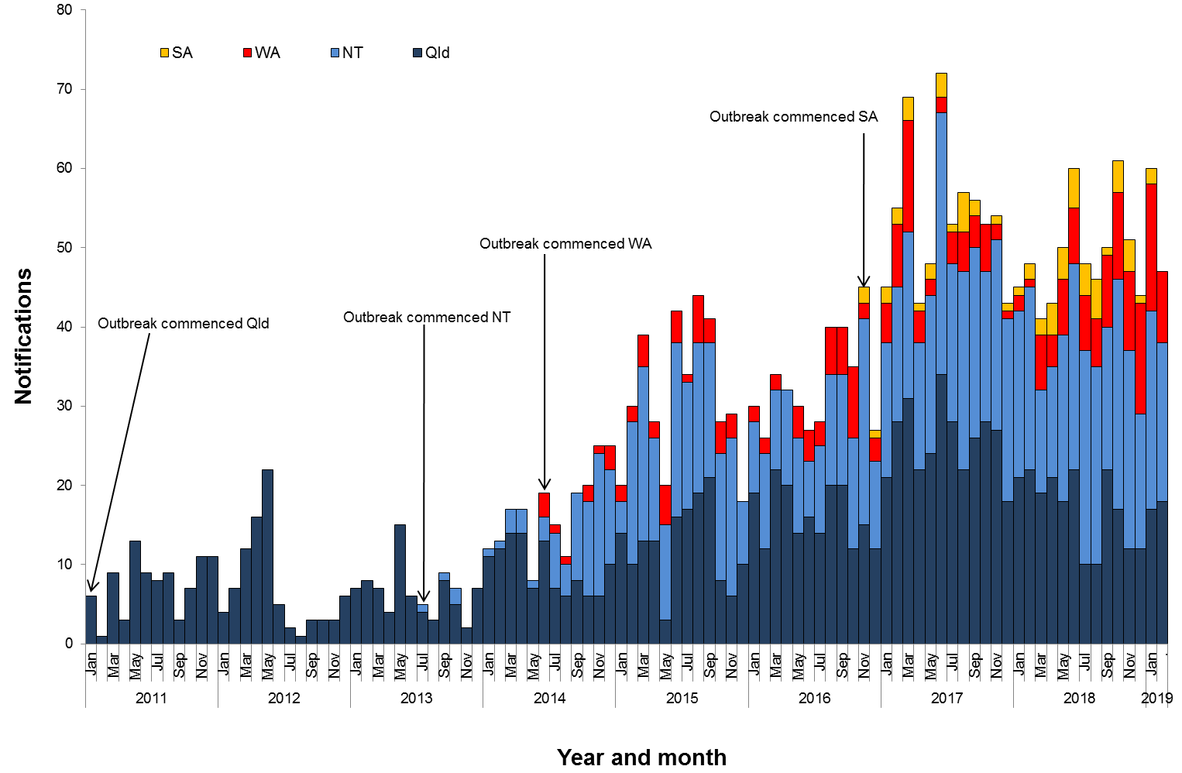

**Table 1**.Characteristics of category 1 infectious syphilisα outbreak cases notified in Aboriginal and Torres Strait Islander people residing in affected regionsβ of Queensland, the Northern Territory, Western Australia and South Australia, to   
28 February 2019 ȶ ᵞ

|  | **North Qld** (four HHSsβ) | **NT**  (seven regions β) | **WA**  (two regions β) | **SA**  (three regions β) |
| --- | --- | --- | --- | --- |
| **Situation to-date, 28 February 2019** |  |  |  |  |
| Outbreak commencement month/year | January 2011 | July 2013 | June 2014 | November 2016 |
| Total number of casesα | 1260 | 982 | 257 | 65 |
| % Male / % Female | 47% / 53% | 46% / 54% | 40% / 60% | 52% / 48% |
| % 15-29 year age group | 66% | 63% | 70% | 49% |
| Congenital cases, confirmed (probable)« | 4 (5) | 2 (3) | 0 (0) | 1 (0) |
| -number of deaths in congenital cases, confirmed (probable) | 3 (4) | 0 (0) | 0 (0) | 0 (0) |
| **Last reporting month, 1 –28 February 2019** | | | | |
| Number of casesα | 18 | 20 | 9 | 0 |
| % Male / % Female | 39% / 61% | 60% /40% | 33% / 67% | 0% / 0% |
| % 15-29 year age group | 67% | 60% | 70% | 0% |

**Table 2.** Number of category 2 infectious syphilisα cases, to 28 February 2019 ȶ ᵞ

|  | **North Qld** (four HHSsβ) | **NT** (seven regions β) | **WA**  (two regions β) | **SA**  (three regions β) |
| --- | --- | --- | --- | --- |
| **Situation to-date, 28 February 2019** | | | | |
| Outbreak commencement month/year | January 2011 | July 2013 | June 2014 | November 2016 |
| Aboriginal and Torres Strait Islander people§ | 12 | 2 | - | - |
| Non-Indigenous peopleµ | 17 | 6 | - | 2 |
| **Last reporting month, 1 -28 February 2019** | | | | |
| Aboriginal and Torres Strait Islander people§ | - | - | - | - |
| Non-Indigenous peopleµ | - | - | **-** | - |

**Notes:**

ȶ ‘Diagnosis date’ was used to define the period of analysis. This date represents either the onset date or where the date of onset was not known, the earliest of the specimen collection date, the notification date, or the notification receive date.

**α** Cases defined as per the MJSO syphilis outbreak case definition:

Nationally, an infectious syphilis outbreak case is defined as: any person who is newly diagnosed with confirmed or probable infectious syphilis according to the CDNA national surveillance case definition for infectious syphilis, **AND**, is an Aboriginal or Torres Strait Islander person who resides in any of the following outbreak declared regions as defined and documented by that jurisdiction, at or after the dates indicated: ***Qld*** - North West Hospital and Health Service area (from 1 January 2011); Torres and Cape Hospital and Health Service area (from 1 December 2012); Cairns and Hinterland Hospital and Health Service area(from1 August 2013); Townsville Hospital and Health Service area (from 1 January 2014); ***NT*** - Alice Springs Rural and Urban or Barkly district (from 1 July 2013); Katherine district (from 1 May 2014); East Arnhem district (from 1 November 2015); Darwin Rural and Urban (from 1 January 2017); ***WA*** - Kimberley region (from 1 June 2014) and Pilbara region (from 1 February 2018); ***SA***  - Far North and Western and Eyre regions (from 15 November 2016); Adelaide (from 1 February 2018) (category 1 outbreak cases) **OR**, is a sexual contact of a confirmed outbreak case (category 2 outbreak cases).

**β**Affected regions include Torres and Cape, Cairns and Hinterland, North West, and Townsville Hospital and Health Services in Queensland; Alice Springs Urban, Alice Springs Rural, Barkly, East Arnhem, Katherine, Darwin Urban and Darwin Rural regions in the Northern Territory; Kimberley and Pilbara regions in Western Australia, and; Far North, Western and Eyre and Adelaide regions in South Australia.

« Cases defined as per the MJSO syphilis outbreak case definition: any newly diagnosed case of confirmed or probable congenital syphilis that meets the CDNA national surveillance case definition whose mother’s syphilis infection prior to or during pregnancy meets the infectious syphilis outbreak case definition.

§ Aboriginal and Torres Strait Islander people who are sexual contacts of a confirmed outbreak case and reside outside an outbreak declared region at the time of diagnosis.

µ Non-Indigenous people who are sexual contacts of a confirmed outbreak case and reside in or out of an outbreak declared region at the time of diagnosis.

**ᵞ** Please note that **all data are provisional** and subject to change due to ongoing case investigation.

**MULTIJURISDICTIONAL SYPHILIS OUTBREAK   
SURVEILLANCE REPORT: APRIL 2019**

**This surveillance report has been authorised by Health Departments in outbreak affected jurisdictions and the Office of Health Protection.**

The Multijurisdictional Syphilis Outbreak (MJSO) Working Group was formed by the Communicable Diseases Network of Australia (CDNA) in April 2015, in response to an ongoing outbreak of infectious syphilis among Aboriginal and Torres Strait Islander people living largely in remote and rural areas of northern Australia. Increased notifications associated with the outbreak in northern Australia were first reported in January 2011 in northwest Queensland (Qld), followed by the Northern Territory (NT) in July 2013, and the Kimberley region of Western Australia (WA) in June 2014. In March 2017, South Australia (SA) declared an outbreak in the Far North and Western and Eyre regions from November 2016. In August 2018, WA declared that the outbreak had spread to the Pilbara region with the first syphilis notification in this region in February 2018. In January 2019, SA declared the outbreak had spread to Adelaide with the first notification in this region reported in February 2018.

This surveillance report summarises the outbreak epidemiological data as of 31 March 2019 (current status).

**Please note:** the MJSO Surveillance Report was formerly known as the MJSO Communique. Historical epidemiological data and MJSO activities are published in earlier MJSO Communiques available at *http://www.health.gov.au/internet/main/publishing.nsf/Content/ohp-infectious-syphilis-outbreak.htm*

**Current status**

Outbreak data to 31 March 2019ȶ are summarised in Figure 1, Table 1 and Table 2 below.

Outbreak cases are reported as either category 1 or category 2: category 1 cases include Aboriginal and Torres Strait Islander people residing in an outbreak declared regionβ at the time of diagnosis, and; category 2 cases include people who are a sexual contact of a confirmed outbreak case which includes Aboriginal and Torres Strait Islander people who do not reside in an outbreak area at the time of diagnosis and non-Indigenous people regardless of where they reside.

Between 1 – 31 March 2019ȶ, there were 62 outbreak cases (category 1 and 2 cases) reported from the four outbreak affected jurisdictions: 21 in Queensland; 24 in the Northern Territory; 17 in Western Australia and; 0 in South Australia (Figure 1, Table 1 and Table 2). From the commencement of the outbreak to 31 March 2019 ȶ, there were a total of 2668 outbreak cases (category 1 and 2 cases) reported across the four outbreak affected jurisdictions: 1310 in Queensland (from January 2011); 1015 in the Northern Territory (from July 2013); 276 in Western Australia (from June 2014), and; 67 in South Australia (from November 2016) (Table 1 and 2).

**Figure 1**. Epidemic curve showing category 1 infectious syphilis α outbreak cases notified in Aboriginal and Torres Strait Islander people residing in affected regionsβ of Queensland, the Northern Territory, Western Australia and South Australia from commencement of the outbreak in each jurisdiction to 31 March 2019ȶ ᵞ

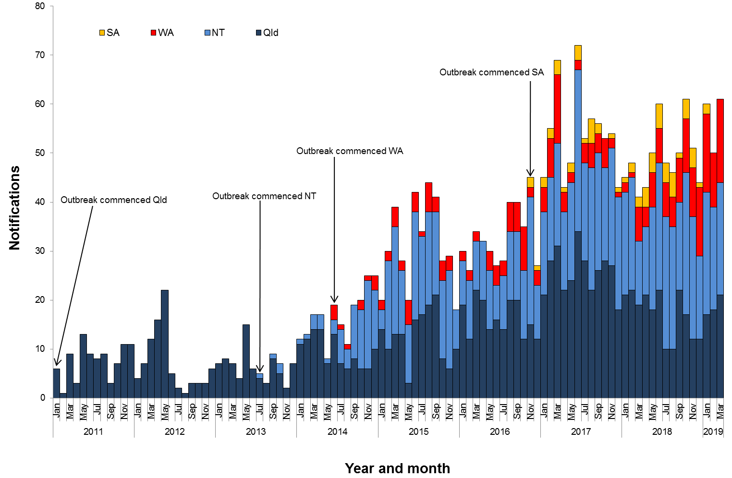

**Table 1**.Characteristics of category 1 infectious syphilisα outbreak cases notified in Aboriginal and Torres Strait Islander people residing in affected regionsβ of Queensland, the Northern Territory, Western Australia and South Australia, to   
31 March 2019 ȶ ᵞ

|  | **North Qld** (four HHSsβ) | **NT**  (seven regions β) | **WA**  (two regions β) | **SA**  (three regions β) |
| --- | --- | --- | --- | --- |
| **Situation to-date, 31 March 2019** |  |  |  |  |
| Outbreak commencement month/year | January 2011 | July 2013 | June 2014 | November 2016 |
| Total number of casesα | 1281 | 1006 | 276 | 65 |
| % Male / % Female | 47% / 53% | 46% / 54% | 41% / 59% | 52% / 48% |
| % 15-29 year age group | 66% | 62% | 71% | 49% |
| Congenital cases, confirmed (probable)« | 4 (5) | 2 (3) | 0 (0) | 1 (0) |
| -number of deaths in congenital cases, confirmed (probable) | 3 (4) | 0 (0) | 0 (0) | 0 (0) |
| **Last reporting month, 1 –31 March 2019** | | | | |
| Number of casesα | 21 | 23 | 17 | 0 |
| % Male / % Female | 57% /43% | 43% /57% | 53% / 47% | 0% / 0% |
| % 15-29 year age group | 67% | 39% | 77% | 0% |

**Table 2.** Number of category 2 infectious syphilisα cases, to 31 March 2019 ȶ ᵞ

|  | **North Qld** (four HHSsβ) | **NT** (seven regions β) | **WA**  (two regions β) | **SA**  (three regions β) |
| --- | --- | --- | --- | --- |
| **Situation to-date, 31 March 2019** | | | | |
| Outbreak commencement month/year | January 2011 | July 2013 | June 2014 | November 2016 |
| Aboriginal and Torres Strait Islander people§ | 12 | 2 | - | - |
| Non-Indigenous peopleµ | 17 | 7 | - | 2 |
| **Last reporting month, 1 -31 March 2019** | | | | |
| Aboriginal and Torres Strait Islander people§ | - | - | - | - |
| Non-Indigenous peopleµ | - | 1 | **-** | - |

**Notes:**

ȶ ‘Diagnosis date’ was used to define the period of analysis. This date represents either the onset date or where the date of onset was not known, the earliest of the specimen collection date, the notification date, or the notification receive date.

**α** Cases defined as per the MJSO syphilis outbreak case definition:

Nationally, an infectious syphilis outbreak case is defined as: any person who is newly diagnosed with confirmed or probable infectious syphilis according to the CDNA national surveillance case definition for infectious syphilis, **AND**, is an Aboriginal or Torres Strait Islander person who resides in any of the following outbreak declared regions as defined and documented by that jurisdiction, at or after the dates indicated: ***Qld*** - North West Hospital and Health Service area (from 1 January 2011); Torres and Cape Hospital and Health Service area (from 1 December 2012); Cairns and Hinterland Hospital and Health Service area(from1 August 2013); Townsville Hospital and Health Service area (from 1 January 2014); ***NT*** - Alice Springs Rural and Urban or Barkly district (from 1 July 2013); Katherine district (from 1 May 2014); East Arnhem district (from 1 November 2015); Darwin Rural and Urban (from 1 January 2017); ***WA*** - Kimberley region (from 1 June 2014) and Pilbara region (from 1 February 2018); ***SA***  - Far North and Western and Eyre regions (from 15 November 2016); Adelaide (from 1 February 2018) (category 1 outbreak cases) **OR**, is a sexual contact of a confirmed outbreak case (category 2 outbreak cases).

**β**Affected regions include Torres and Cape, Cairns and Hinterland, North West, and Townsville Hospital and Health Services in Queensland; Alice Springs Urban, Alice Springs Rural, Barkly, East Arnhem, Katherine, Darwin Urban and Darwin Rural regions in the Northern Territory; Kimberley and Pilbara regions in Western Australia, and; Far North, Western and Eyre and Adelaide regions in South Australia.

« Cases defined as per the MJSO syphilis outbreak case definition: any newly diagnosed case of confirmed or probable congenital syphilis that meets the CDNA national surveillance case definition whose mother’s syphilis infection prior to or during pregnancy meets the infectious syphilis outbreak case definition.

§ Aboriginal and Torres Strait Islander people who are sexual contacts of a confirmed outbreak case and reside outside an outbreak declared region at the time of diagnosis.

µ Non-Indigenous people who are sexual contacts of a confirmed outbreak case and reside in or out of an outbreak declared region at the time of diagnosis.

**ᵞ** Please note that **all data are provisional** and subject to change due to ongoing case investigation.

**MULTIJURISDICTIONAL SYPHILIS OUTBREAK   
SURVEILLANCE REPORT: MAY 2019**

**This surveillance report has been authorised by Health Departments in outbreak affected jurisdictions and the Office of Health Protection.**

The Multijurisdictional Syphilis Outbreak (MJSO) Working Group was formed by the Communicable Diseases Network of Australia (CDNA) in April 2015, in response to an ongoing outbreak of infectious syphilis among Aboriginal and Torres Strait Islander people living largely in remote and rural areas of northern Australia. Increased notifications associated with the outbreak in northern Australia were first reported in January 2011 in northwest Queensland (Qld), followed by the Northern Territory (NT) in July 2013, and the Kimberley region of Western Australia (WA) in June 2014. In March 2017, South Australia (SA) declared an outbreak in the Far North and Western and Eyre regions from November 2016. In August 2018, WA declared that the outbreak had spread to the Pilbara region with the first syphilis notification in this region in February 2018. In January 2019, SA declared the outbreak had spread to Adelaide with the first notification in this region reported in February 2018.

This surveillance report summarises the outbreak epidemiological data as of 30 April 2019 (current status).

**Please note:** the MJSO Surveillance Report was formerly known as the MJSO Communique. Historical epidemiological data and MJSO activities are published in earlier MJSO Communiques available at *http://www.health.gov.au/internet/main/publishing.nsf/Content/ohp-infectious-syphilis-outbreak.htm*

**Current status**

Outbreak data to 30 April 2019ȶ are summarised in Figure 1, Table 1 and Table 2 below.

Outbreak cases are reported as either category 1 or category 2: category 1 cases include Aboriginal and Torres Strait Islander people residing in an outbreak declared regionβ at the time of diagnosis, and; category 2 cases include people who are a sexual contact of a confirmed outbreak case which includes Aboriginal and Torres Strait Islander people who do not reside in an outbreak area at the time of diagnosis and non-Indigenous people regardless of where they reside.

Between 1 – 30 April 2019ȶ, there were 46 outbreak cases (category 1 and 2 cases) reported from the four outbreak affected jurisdictions: 13 in Queensland; 19 in the Northern Territory; 12 in Western Australia and; 2 in South Australia (Figure 1, Table 1 and Table 2). From the commencement of the outbreak to 30 April 2019 ȶ, there were a total of 2715 outbreak cases (category 1 and 2 cases) reported across the four outbreak affected jurisdictions: 1324 in Queensland (from January 2011); 1034 in the Northern Territory (from July 2013); 288 in Western Australia (from June 2014), and; 69 in South Australia (from November 2016) (Table 1 and 2).

**Figure 1**. Epidemic curve showing category 1 infectious syphilis α outbreak cases notified in Aboriginal and Torres Strait Islander people residing in affected regionsβ of Queensland, the Northern Territory, Western Australia and South Australia from commencement of the outbreak in each jurisdiction to 30 April 2019ȶ ᵞ

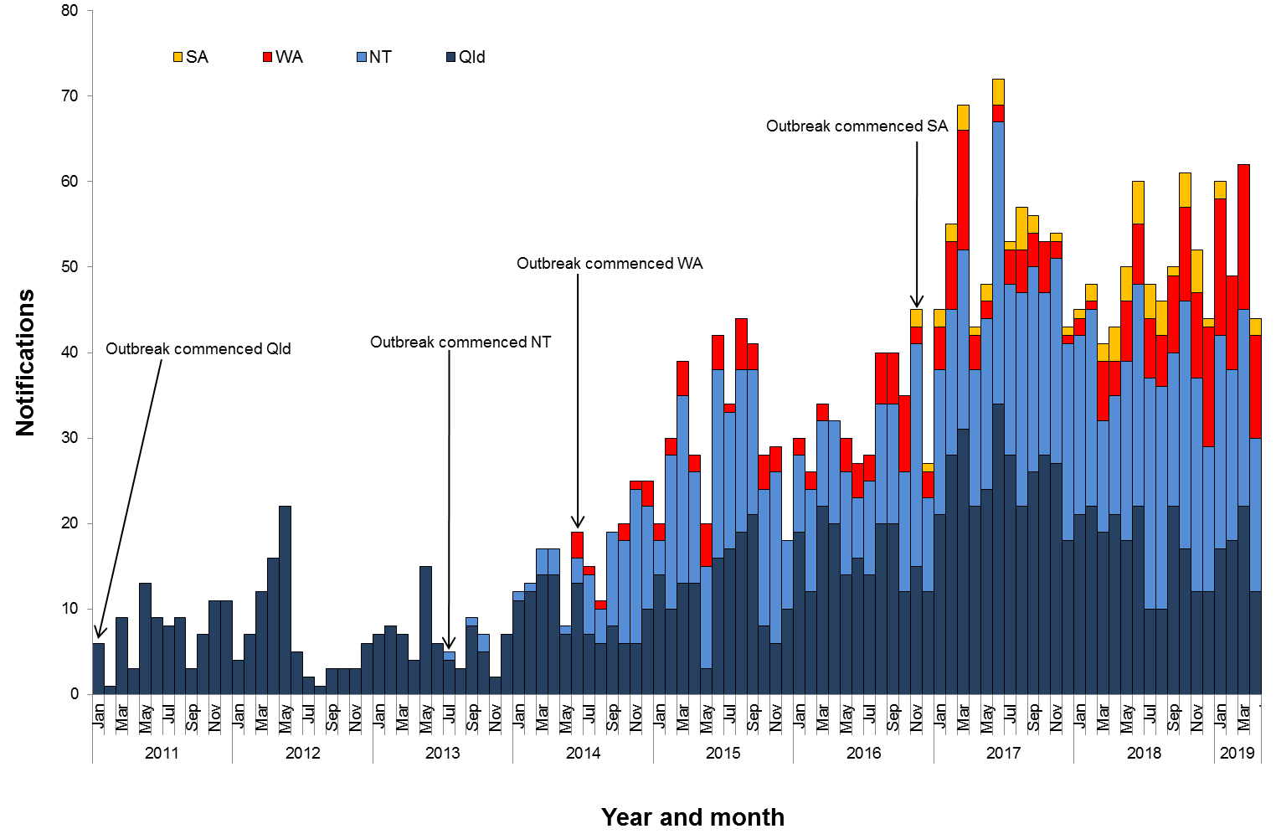

**Table 1**.Characteristics of category 1 infectious syphilisα outbreak cases notified in Aboriginal and Torres Strait Islander people residing in affected regionsβ of Queensland, the Northern Territory, Western Australia and South Australia, to   
30 April 2019 ȶ ᵞ

|  | **North Qld** (four HHSsβ) | **NT**  (seven regions β) | **WA**  (two regions β) | **SA**  (three regions β) |
| --- | --- | --- | --- | --- |
| **Situation to-date, 30 April 2019** |  |  |  |  |
| Outbreak commencement month/year | January 2011 | July 2013 | June 2014 | November 2016 |
| Total number of casesα | 1294 | 1024 | 288 | 67 |
| % Male / % Female | 47% / 53% | 46% / 54% | 41% / 59% | 54% / 46% |
| % 15-29 year age group | 66% | 62% | 72% | 48% |
| Congenital cases, confirmed (probable)« | 4 (5) | 2 (3) | 1 (0) | 1 (0) |
| -number of deaths in congenital cases, confirmed (probable) | 3 (4) | 0 (0) | 0 (0) | 0 (0) |
| **Last reporting month, 1 –30 April 2019** | | | | |
| Number of casesα | 12 | 18 | 12 | 2 |
| % Male / % Female | 75% /25% | 28% /72% | 33% / 67% | 100% / 0% |
| % 15-29 year age group | 58% | 56% | 100% | 0% |

**Table 2.** Number of category 2 infectious syphilisα cases, to 30 April 2019 ȶ ᵞ

|  | **North Qld** (four HHSsβ) | **NT** (seven regions β) | **WA**  (two regions β) | **SA**  (three regions β) |
| --- | --- | --- | --- | --- |
| **Situation to-date, 30 April 2019** | | | | |
| Outbreak commencement month/year | January 2011 | July 2013 | June 2014 | November 2016 |
| Aboriginal and Torres Strait Islander people§ | 12 | 2 | - | - |
| Non-Indigenous peopleµ | 18 | 8 | - | 2 |
| **Last reporting month, 1 -30 April 2019** | | | | |
| Aboriginal and Torres Strait Islander people§ | - | - | - | - |
| Non-Indigenous peopleµ | 1 | 1 | **-** | - |

**Notes:**

ȶ ‘Diagnosis date’ was used to define the period of analysis. This date represents either the onset date or where the date of onset was not known, the earliest of the specimen collection date, the notification date, or the notification receive date.

**α** Cases defined as per the MJSO syphilis outbreak case definition:

Nationally, an infectious syphilis outbreak case is defined as: any person who is newly diagnosed with confirmed or probable infectious syphilis according to the CDNA national surveillance case definition for infectious syphilis, **AND**, is an Aboriginal or Torres Strait Islander person who resides in any of the following outbreak declared regions as defined and documented by that jurisdiction, at or after the dates indicated: ***Qld*** - North West Hospital and Health Service area (from 1 January 2011); Torres and Cape Hospital and Health Service area (from 1 December 2012); Cairns and Hinterland Hospital and Health Service area(from1 August 2013); Townsville Hospital and Health Service area (from 1 January 2014); ***NT*** - Alice Springs Rural and Urban or Barkly district (from 1 July 2013); Katherine district (from 1 May 2014); East Arnhem district (from 1 November 2015); Darwin Rural and Urban (from 1 January 2017); ***WA*** - Kimberley region (from 1 June 2014) and Pilbara region (from 1 February 2018); ***SA***  - Far North and Western and Eyre regions (from 15 November 2016); Adelaide (from 1 February 2018) (category 1 outbreak cases) **OR**, is a sexual contact of a confirmed outbreak case (category 2 outbreak cases).

**β**Affected regions include Torres and Cape, Cairns and Hinterland, North West, and Townsville Hospital and Health Services in Queensland; Alice Springs Urban, Alice Springs Rural, Barkly, East Arnhem, Katherine, Darwin Urban and Darwin Rural regions in the Northern Territory; Kimberley and Pilbara regions in Western Australia, and; Far North, Western and Eyre and Adelaide regions in South Australia.

« Cases defined as per the MJSO syphilis outbreak case definition: any newly diagnosed case of confirmed or probable congenital syphilis that meets the CDNA national surveillance case definition whose mother’s syphilis infection prior to or during pregnancy meets the infectious syphilis outbreak case definition.

§ Aboriginal and Torres Strait Islander people who are sexual contacts of a confirmed outbreak case and reside outside an outbreak declared region at the time of diagnosis.

µ Non-Indigenous people who are sexual contacts of a confirmed outbreak case and reside in or out of an outbreak declared region at the time of diagnosis.

**ᵞ** Please note that **all data are provisional** and subject to change due to ongoing case investigation.

**MULTIJURISDICTIONAL SYPHILIS OUTBREAK   
SURVEILLANCE REPORT: JUNE 2019**

**This surveillance report has been authorised by Health Departments in outbreak affected jurisdictions and the Office of Health Protection.**

The Multijurisdictional Syphilis Outbreak (MJSO) Working Group was formed by the Communicable Diseases Network of Australia (CDNA) in April 2015, in response to an ongoing outbreak of infectious syphilis among Aboriginal and Torres Strait Islander people living largely in remote and rural areas of northern Australia. Increased notifications associated with the outbreak in northern Australia were first reported in January 2011 in northwest Queensland (Qld), followed by the Northern Territory (NT) in July 2013, and the Kimberley region of Western Australia (WA) in June 2014. In March 2017, South Australia (SA) declared an outbreak in the Far North and Western and Eyre regions from November 2016. In August 2018, WA declared that the outbreak had spread to the Pilbara region with the first syphilis notification in this region in February 2018. In January 2019, SA declared the outbreak had spread to Adelaide with the first notification in this region reported in February 2018. In May 2019, WA declared the outbreak had spread to the Goldfields region with the first notification in this region reported in January 2019.

This surveillance report summarises the outbreak epidemiological data as of 31 May 2019 (current status).

**Please note:** the MJSO Surveillance Report was formerly known as the MJSO Communique. Historical epidemiological data and MJSO activities are published in earlier MJSO Communiques available at *http://www.health.gov.au/internet/main/publishing.nsf/Content/ohp-infectious-syphilis-outbreak.htm*

**Current status**

Outbreak data to 31 May 2019ȶ are summarised in Figure 1, Table 1 and Table 2 below.

Outbreak cases are reported as either category 1 or category 2: category 1 cases include Aboriginal and Torres Strait Islander people residing in an outbreak declared regionβ at the time of diagnosis, and; category 2 cases include people who are a sexual contact of a confirmed outbreak case which includes Aboriginal and Torres Strait Islander people who do not reside in an outbreak area at the time of diagnosis and non-Indigenous people regardless of where they reside.

Between 1 – 31 May 2019ȶ, there were 60 outbreak cases (category 1 and 2 cases) reported from the four outbreak affected jurisdictions: 13 in Queensland; 21 in the Northern Territory; 22 in Western Australia and; 4 in South Australia (Figure 1, Table 1 and Table 2). From the commencement of the outbreak to 31 May 2019 ȶ, there were a total of 2786 outbreak cases (category 1 and 2 cases) reported across the four outbreak affected jurisdictions: 1337 in Queensland (from January 2011); 1056 in the Northern Territory (from July 2013); 320 in Western Australia (from June 2014), and; 73 in South Australia (from November 2016) (Table 1 and 2).

**Figure 1**. Epidemic curve showing category 1 infectious syphilis α outbreak cases notified in Aboriginal and Torres Strait Islander people residing in affected regionsβ of Queensland, the Northern Territory, Western Australia and South Australia from commencement of the outbreak in each jurisdiction to 31 May 2019ȶ ᵞ

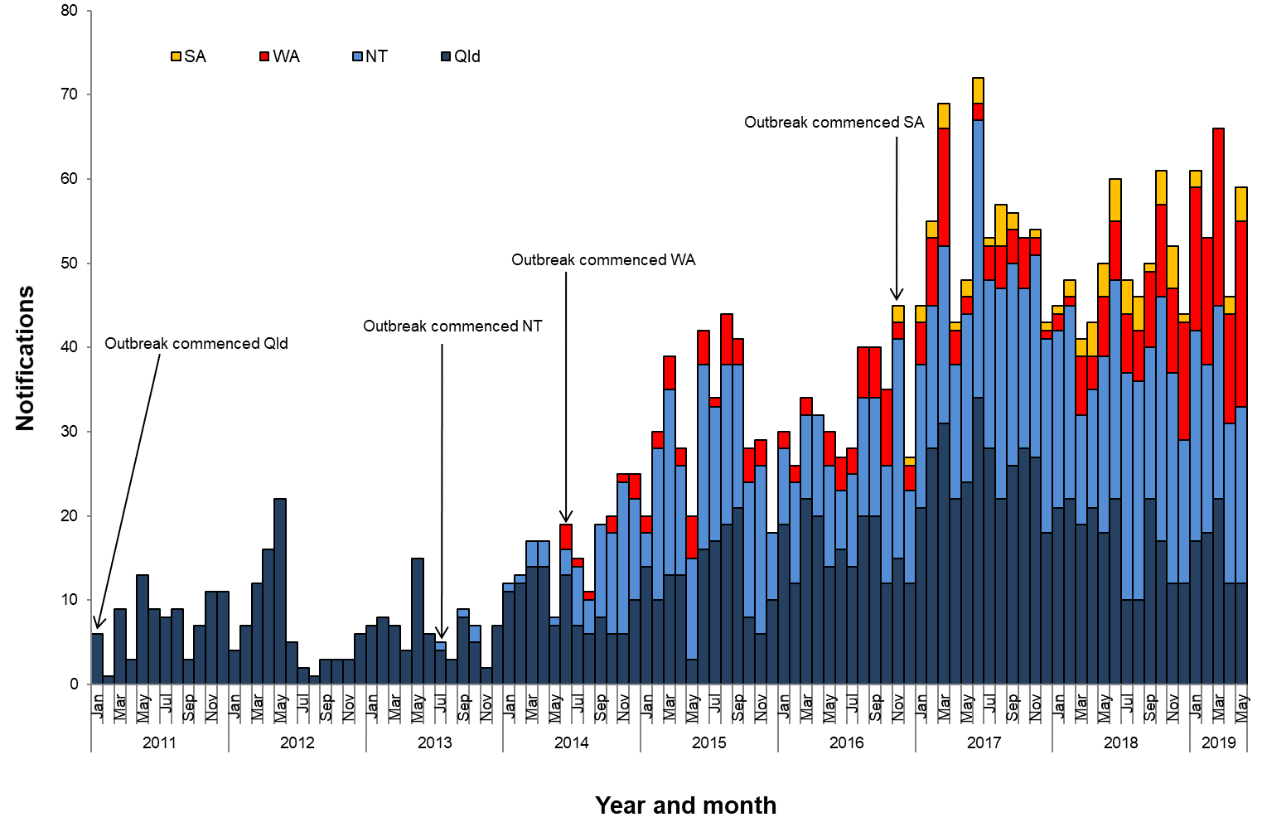

**Table 1**.Characteristics of category 1 infectious syphilisα outbreak cases notified in Aboriginal and Torres Strait Islander people residing in affected regionsβ of Queensland, the Northern Territory, Western Australia and South Australia, to   
31 May 2019 ȶ ᵞ

|  | **North Qld** (four HHSsβ) | **NT**  (seven regions β) | **WA**  (three regions β) | **SA**  (three regions β) |
| --- | --- | --- | --- | --- |
| **Situation to-date, 31 May 2019** |  |  |  |  |
| Outbreak commencement month/year | January 2011 | July 2013 | June 2014 | November 2016 |
| Total number of casesα | 1306 | 1046 | 320 | 71 |
| % Male / % Female | 47% / 53% | 46% / 54% | 42% / 58% | 52% / 48% |
| % 15-29 year age group | 66% | 62% | 70% | 47% |
| Congenital cases, confirmed (probable)« | 4 (5) | 2 (3) | 1 (0) | 1 (0) |
| -number of deaths in congenital cases, confirmed (probable) | 3 (4) | 0 (0) | 0 (0) | 0 (0) |
| **Last reporting month, 1 –31 May 2019** | | | | |
| Number of casesα | 12 | 21 | 22 | 4 |
| % Male / % Female | 50% / 50% | 43% / 57% | 55% / 45% | 25% / 75% |
| % 15-29 year age group | 58% | 48% | 64% | 25% |

**Table 2.** Number of category 2 infectious syphilisα cases, to 31 May 2019 ȶ ᵞ

|  | **North Qld** (four HHSsβ) | **NT** (seven regions β) | **WA**  (three regions β) | **SA**  (three regions β) |
| --- | --- | --- | --- | --- |
| **Situation to-date, 31 May 2019** | | | | |
| Outbreak commencement month/year | January 2011 | July 2013 | June 2014 | November 2016 |
| Aboriginal and Torres Strait Islander people§ | 13 | 2 | - | - |
| Non-Indigenous peopleµ | 18 | 8 | - | 2 |
| **Last reporting month, 1 -31 May 2019** | | | | |
| Aboriginal and Torres Strait Islander people§ | 1 | - | - | - |
| Non-Indigenous peopleµ | - | - | **-** | - |

**Notes:**

ȶ ‘Diagnosis date’ was used to define the period of analysis. This date represents either the onset date or where the date of onset was not known, the earliest of the specimen collection date, the notification date, or the notification receive date.

**α** Cases defined as per the MJSO syphilis outbreak case definition:

Nationally, an infectious syphilis outbreak case is defined as: any person who is newly diagnosed with confirmed or probable infectious syphilis according to the CDNA national surveillance case definition for infectious syphilis, **AND**, is an Aboriginal or Torres Strait Islander person who resides in any of the following outbreak declared regions as defined and documented by that jurisdiction, at or after the dates indicated: ***Qld*** - North West Hospital and Health Service area (from 1 January 2011); Torres and Cape Hospital and Health Service area (from 1 December 2012); Cairns and Hinterland Hospital and Health Service area(from1 August 2013); Townsville Hospital and Health Service area (from 1 January 2014); ***NT*** - Alice Springs Rural and Urban or Barkly district (from 1 July 2013); Katherine district (from 1 May 2014); East Arnhem district (from 1 November 2015); Darwin Rural and Urban (from 1 January 2017); ***WA*** - Kimberley region (from 1 June 2014); Pilbara region (from 1 February 2018); Goldfields region (from 1 January 2019); ***SA***  - Far North and Western and Eyre regions (from 15 November 2016); Adelaide (from 1 February 2018) (category 1 outbreak cases) **OR**, is a sexual contact of a confirmed outbreak case (category 2 outbreak cases).

**β**Affected regions include Torres and Cape, Cairns and Hinterland, North West, and Townsville Hospital and Health Services in Queensland; Alice Springs Urban, Alice Springs Rural, Barkly, East Arnhem, Katherine, Darwin Urban and Darwin Rural regions in the Northern Territory; Kimberley, Pilbara and Goldfield regions in Western Australia, and; Far North, Western and Eyre and Adelaide regions in South Australia.

« Cases defined as per the MJSO syphilis outbreak case definition: any newly diagnosed case of confirmed or probable congenital syphilis that meets the CDNA national surveillance case definition whose mother’s syphilis infection prior to or during pregnancy meets the infectious syphilis outbreak case definition.

§ Aboriginal and Torres Strait Islander people who are sexual contacts of a confirmed outbreak case and reside outside an outbreak declared region at the time of diagnosis.

µ Non-Indigenous people who are sexual contacts of a confirmed outbreak case and reside in or out of an outbreak declared region at the time of diagnosis.

**ᵞ** Please note that **all data are provisional** and subject to change due to ongoing case investigation.

**MULTIJURISDICTIONAL SYPHILIS OUTBREAK   
SURVEILLANCE REPORT: JULY 2019**

**This surveillance report has been authorised by Health Departments in outbreak affected jurisdictions and the Office of Health Protection.**

The Multijurisdictional Syphilis Outbreak (MJSO) Working Group was formed by the Communicable Diseases Network of Australia (CDNA) in April 2015, in response to an ongoing outbreak of infectious syphilis among Aboriginal and Torres Strait Islander people living largely in remote and rural areas of northern Australia. Increased notifications associated with the outbreak in northern Australia were first reported in January 2011 in northwest Queensland (Qld), followed by the Northern Territory (NT) in July 2013, and the Kimberley region of Western Australia (WA) in June 2014. In March 2017, South Australia (SA) declared an outbreak in the Far North and Western and Eyre regions from November 2016. In August 2018, WA declared that the outbreak had spread to the Pilbara region with the first syphilis notification in this region in February 2018. In January 2019, SA declared the outbreak had spread to Adelaide with the first notification in this region reported in February 2018. In May 2019, WA declared the outbreak had spread to the Goldfields region with the first notification in this region reported in January 2019.

This surveillance report summarises the outbreak epidemiological data as of 30 June 2019 (current status).

**Please note:** the MJSO Surveillance Report was formerly known as the MJSO Communique. Historical epidemiological data and MJSO activities are published in earlier MJSO Communiques available at *http://www.health.gov.au/internet/main/publishing.nsf/Content/ohp-infectious-syphilis-outbreak.htm*

**Current status**

Outbreak data to 30 June 2019ȶ are summarised in Figure 1, Table 1 and Table 2 below.

Outbreak cases are reported as either category 1 or category 2: category 1 cases include Aboriginal and Torres Strait Islander people residing in an outbreak declared regionβ at the time of diagnosis, and; category 2 cases include people who are a sexual contact of a confirmed outbreak case which includes Aboriginal and Torres Strait Islander people who do not reside in an outbreak area at the time of diagnosis and non-Indigenous people regardless of where they reside.

Between 1 – 30 June 2019ȶ, there were 61 outbreak cases (category 1 and 2 cases) reported from the four outbreak affected jurisdictions: 19 in Queensland; 20 in the Northern Territory; 21 in Western Australia and; 1 in South Australia (Figure 1, Table 1 and Table 2). From the commencement of the outbreak to 30 June 2019 ȶ, there were a total of 2852 outbreak cases (category 1 and 2 cases) reported across the four outbreak affected jurisdictions: 1356 in Queensland (from January 2011); 1078 in the Northern Territory (from July 2013); 343 in Western Australia (from June 2014), and; 75 in South Australia (from November 2016) (Table 1 and 2).

**Figure 1**. Epidemic curve showing category 1 infectious syphilis α outbreak cases notified in Aboriginal and Torres Strait Islander people residing in affected regionsβ of Queensland, the Northern Territory, Western Australia and South Australia from commencement of the outbreak in each jurisdiction to 30 June 2019ȶ ᵞ

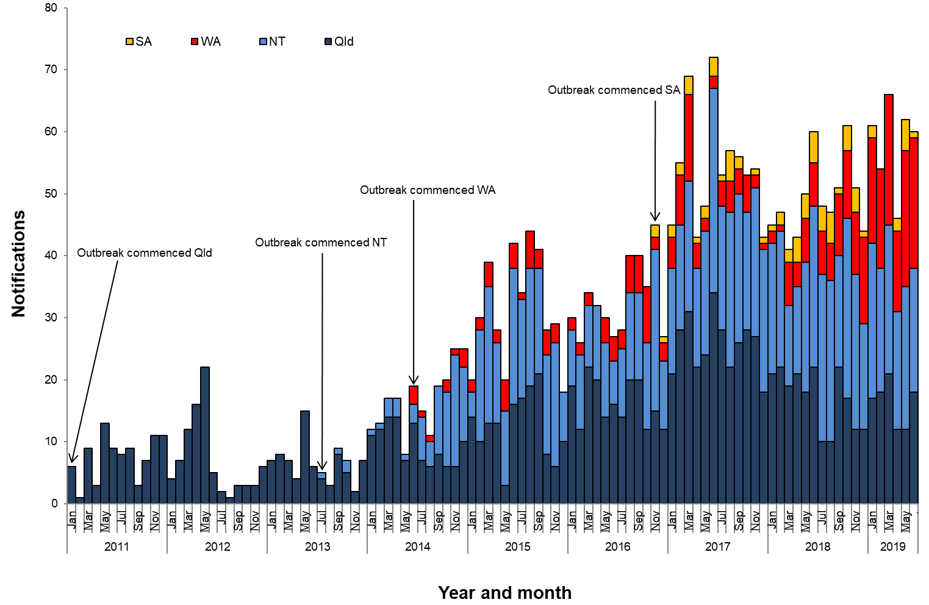

**Table 1**.Characteristics of category 1 infectious syphilisα outbreak cases notified in Aboriginal and Torres Strait Islander people residing in affected regionsβ of Queensland, the Northern Territory, Western Australia and South Australia, to   
30 June 2019 ȶ ᵞ

|  | **North Qld** (four HHSsβ) | **NT**  (seven regions β) | **WA**  (three regions β) | **SA**  (three regions β) |
| --- | --- | --- | --- | --- |
| **Situation to-date, 30 June 2019** |  |  |  |  |
| Outbreak commencement month/year | January 2011 | July 2013 | June 2014 | November 2016 |
| Total number of casesα | 1323 | 1068 | 343 | 73 |
| % Male / % Female | 47% / 53% | 46% / 54% | 42% / 58% | 53% / 47% |
| % 15-29 year age group | 66% | 61% | 69% | 48% |
| Congenital cases, confirmed (probable)« | 4 (5) | 2 (3) | 1 (0) | 1 (0) |
| -number of deaths in congenital cases, confirmed (probable) | 3 (4) | 0 (0) | 0 (0) | 0 (0) |
| **Last reporting month, 1 – 30 June 2019** | | | | |
| Number of casesα | 18 | 20 | 21 | 1 |
| % Male / % Female | 33% / 67% | 40% / 50% | 57% / 43% | 100% / 0% |
| % 15-29 year age group | 78% | 45% | 43% | 0% |

**Table 2.** Number of category 2 infectious syphilisα cases, to 30 June 2019 ȶ ᵞ

|  | **North Qld** (four HHSsβ) | **NT** (seven regions β) | **WA**  (three regions β) | **SA**  (three regions β) |
| --- | --- | --- | --- | --- |
| **Situation to-date, 30 June 2019** | | | | |
| Outbreak commencement month/year | January 2011 | July 2013 | June 2014 | November 2016 |
| Aboriginal and Torres Strait Islander people§ | 13 | 2 | - | - |
| Non-Indigenous peopleµ | 20 | 8 | - | 2 |
| **Last reporting month, 1 – 30 June 2019** | | | | |
| Aboriginal and Torres Strait Islander people§ | - | - | - | - |
| Non-Indigenous peopleµ | 1 | - | **-** | - |

**Notes:**

ȶ ‘Diagnosis date’ was used to define the period of analysis. This date represents either the onset date or where the date of onset was not known, the earliest of the specimen collection date, the notification date, or the notification receive date.

**α** Cases defined as per the MJSO syphilis outbreak case definition:

Nationally, an infectious syphilis outbreak case is defined as: any person who is newly diagnosed with confirmed or probable infectious syphilis according to the CDNA national surveillance case definition for infectious syphilis, **AND**, is an Aboriginal or Torres Strait Islander person who resides in any of the following outbreak declared regions as defined and documented by that jurisdiction, at or after the dates indicated: ***Qld*** - North West Hospital and Health Service area (from 1 January 2011); Torres and Cape Hospital and Health Service area (from 1 December 2012); Cairns and Hinterland Hospital and Health Service area(from1 August 2013); Townsville Hospital and Health Service area (from 1 January 2014); ***NT*** - Alice Springs Rural and Urban or Barkly district (from 1 July 2013); Katherine district (from 1 May 2014); East Arnhem district (from 1 November 2015); Darwin Rural and Urban (from 1 January 2017); ***WA*** - Kimberley region (from 1 June 2014); Pilbara region (from 1 February 2018); Goldfields region (from 1 January 2019); ***SA***  - Far North and Western and Eyre regions (from 15 November 2016); Adelaide (from 1 February 2018) (category 1 outbreak cases) **OR**, is a sexual contact of a confirmed outbreak case (category 2 outbreak cases).

**β**Affected regions include Torres and Cape, Cairns and Hinterland, North West, and Townsville Hospital and Health Services in Queensland; Alice Springs Urban, Alice Springs Rural, Barkly, East Arnhem, Katherine, Darwin Urban and Darwin Rural regions in the Northern Territory; Kimberley, Pilbara and Goldfield regions in Western Australia, and; Far North, Western and Eyre and Adelaide regions in South Australia.

« Cases defined as per the MJSO syphilis outbreak case definition: any newly diagnosed case of confirmed or probable congenital syphilis that meets the CDNA national surveillance case definition whose mother’s syphilis infection prior to or during pregnancy meets the infectious syphilis outbreak case definition.

§ Aboriginal and Torres Strait Islander people who are sexual contacts of a confirmed outbreak case and reside outside an outbreak declared region at the time of diagnosis.

µ Non-Indigenous people who are sexual contacts of a confirmed outbreak case and reside in or out of an outbreak declared region at the time of diagnosis.

**ᵞ** Please note that **all data are provisional** and subject to change due to ongoing case investigation.

**MULTIJURISDICTIONAL SYPHILIS OUTBREAK   
SURVEILLANCE REPORT: AUGUST 2019**

**This surveillance report has been authorised by Health Departments in outbreak affected jurisdictions and the Office of Health Protection.**

The Multijurisdictional Syphilis Outbreak (MJSO) Working Group was formed by the Communicable Diseases Network of Australia (CDNA) in April 2015, in response to an ongoing outbreak of infectious syphilis among Aboriginal and Torres Strait Islander people living largely in remote and rural areas of northern Australia. Increased notifications associated with the outbreak in northern Australia were first reported in January 2011 in northwest Queensland (Qld), followed by the Northern Territory (NT) in July 2013, and the Kimberley region of Western Australia (WA) in June 2014. In March 2017, South Australia (SA) declared an outbreak in the Far North and Western and Eyre regions from November 2016. In August 2018, WA declared that the outbreak had spread to the Pilbara region with the first syphilis notification in this region in February 2018. In January 2019, SA declared the outbreak had spread to Adelaide with the first notification in this region reported in February 2018. In May 2019, WA declared the outbreak had spread to the Goldfields region with the first notification in this region reported in January 2019.

This surveillance report summarises the outbreak epidemiological data as of 31 July 2019 (current status).

**Please note:** the MJSO Surveillance Report was formerly known as the MJSO Communique. Historical epidemiological data and MJSO activities are published in earlier MJSO Communiques available at *http://www.health.gov.au/internet/main/publishing.nsf/Content/ohp-infectious-syphilis-outbreak.htm*

**Current status**

Outbreak data to 31 July 2019ȶ are summarised in Figure 1, Table 1 and Table 2 below.

Outbreak cases are reported as either category 1 or category 2: category 1 cases include Aboriginal and Torres Strait Islander people residing in an outbreak declared regionβ at the time of diagnosis, and; category 2 cases include people who are a sexual contact of a confirmed outbreak case which includes Aboriginal and Torres Strait Islander people who do not reside in an outbreak area at the time of diagnosis and non-Indigenous people regardless of where they reside.

Between 1 – 31 July 2019ȶ, there were 58 outbreak cases (category 1 and 2 cases) reported from the four outbreak affected jurisdictions: 17 in Queensland; 24 in the Northern Territory; 16 in Western Australia and; 1 in South Australia (Figure 1, Table 1 and Table 2). From the commencement of the outbreak to 31 July 2019 ȶ, there were a total of 2909 outbreak cases (category 1 and 2 cases) reported across the four outbreak affected jurisdictions: 1373 in Queensland (from January 2011); 1102 in the Northern Territory (from July 2013); 358 in Western Australia (from June 2014), and; 76 in South Australia (from November 2016) (Table 1 and 2).

**Figure 1**. Epidemic curve showing category 1 infectious syphilis α outbreak cases notified in Aboriginal and Torres Strait Islander people residing in affected regionsβ of Queensland, the Northern Territory, Western Australia and South Australia from commencement of the outbreak in each jurisdiction to 31 July 2019ȶ ᵞ

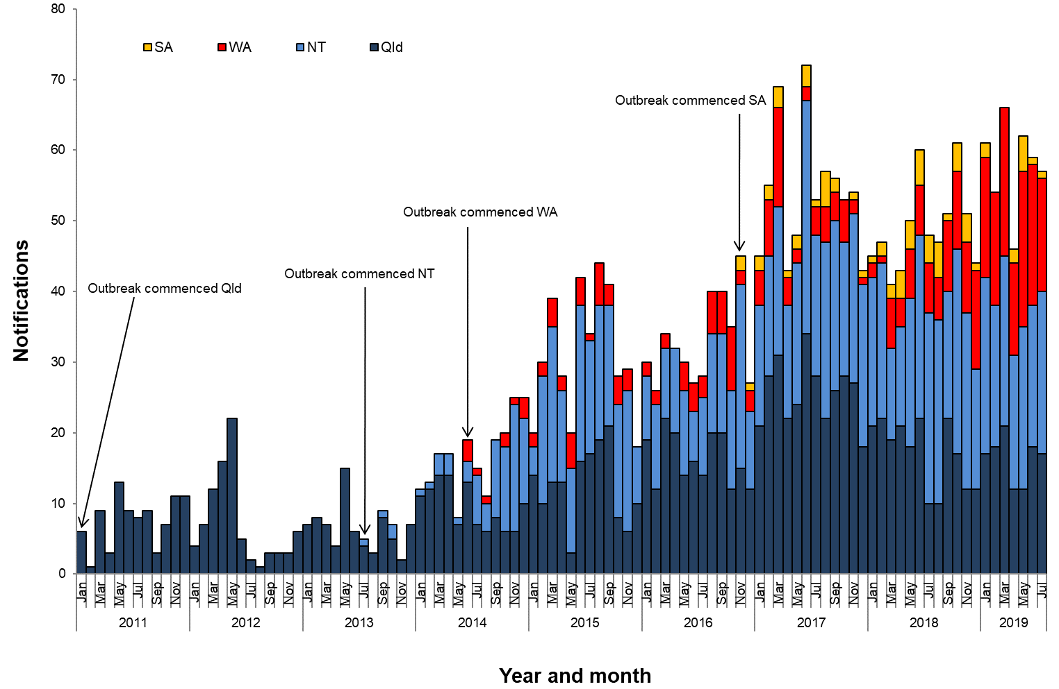

**Table 1**.Characteristics of category 1 infectious syphilisα outbreak cases notified in Aboriginal and Torres Strait Islander people residing in affected regionsβ of Queensland, the Northern Territory, Western Australia and South Australia, to   
31 July 2019 ȶ ᵞ

|  | **North Qld** (four HHSsβ) | **NT**  (seven regions β) | **WA**  (three regions β) | **SA**  (three regions β) |
| --- | --- | --- | --- | --- |
| **Situation to-date, 31 July 2019** |  |  |  |  |
| Outbreak commencement month/year | January 2011 | July 2013 | June 2014 | November 2016 |
| Total number of casesα | 1340 | 1091 | 358 | 74 |
| % Male / % Female | 47% / 53% | 46% / 54% | 42% / 58% | 54% / 46% |
| % 15-29 year age group | 66% | 61% | 68% | 47% |
| Congenital cases, confirmed (probable)« | 4 (5) | 2 (3) | 1 (0) | 1 (0) |
| -number of deaths in congenital cases, confirmed (probable) | 3 (4) | 0 (0) | 0 (0) | 0 (0) |
| **Last reporting month, 1 – 31 July 2019** | | | | |
| Number of casesα | 17 | 23 | 16 | 1 |
| % Male / % Female | 35% / 65% | 39% / 61% | 31% / 69% | 100% / 0% |
| % 15-29 year age group | 41% | 39% | 63% | 0% |

**Table 2.** Number of category 2 infectious syphilisα cases, to 31 July 2019 ȶ ᵞ

|  | **North Qld** (four HHSsβ) | **NT** (seven regions β) | **WA**  (three regions β) | **SA**  (three regions β) |
| --- | --- | --- | --- | --- |
| **Situation to-date, 31 July 2019** | | | | |
| Outbreak commencement month/year | January 2011 | July 2013 | June 2014 | November 2016 |
| Aboriginal and Torres Strait Islander people§ | 13 | 2 | - | - |
| Non-Indigenous peopleµ | 20 | 9 | - | 2 |
| **Last reporting month, 1 – 31 July 2019** | | | | |
| Aboriginal and Torres Strait Islander people§ | - | - | - | - |
| Non-Indigenous peopleµ | - | 1 | **-** | - |

**Notes:**

ȶ ‘Diagnosis date’ was used to define the period of analysis. This date represents either the onset date or where the date of onset was not known, the earliest of the specimen collection date, the notification date, or the notification receive date.

**α** Cases defined as per the MJSO syphilis outbreak case definition:

Nationally, an infectious syphilis outbreak case is defined as: any person who is newly diagnosed with confirmed or probable infectious syphilis according to the CDNA national surveillance case definition for infectious syphilis, **AND**, is an Aboriginal or Torres Strait Islander person who resides in any of the following outbreak declared regions as defined and documented by that jurisdiction, at or after the dates indicated: ***Qld*** - North West Hospital and Health Service area (from 1 January 2011); Torres and Cape Hospital and Health Service area (from 1 December 2012); Cairns and Hinterland Hospital and Health Service area(from1 August 2013); Townsville Hospital and Health Service area (from 1 January 2014); ***NT*** - Alice Springs Rural and Urban or Barkly district (from 1 July 2013); Katherine district (from 1 May 2014); East Arnhem district (from 1 November 2015); Darwin Rural and Urban (from 1 January 2017); ***WA*** - Kimberley region (from 1 June 2014); Pilbara region (from 1 February 2018); Goldfields region (from 1 January 2019); ***SA***  - Far North and Western and Eyre regions (from 15 November 2016); Adelaide (from 1 February 2018) (category 1 outbreak cases) **OR**, is a sexual contact of a confirmed outbreak case (category 2 outbreak cases).

**β**Affected regions include Torres and Cape, Cairns and Hinterland, North West, and Townsville Hospital and Health Services in Queensland; Alice Springs Urban, Alice Springs Rural, Barkly, East Arnhem, Katherine, Darwin Urban and Darwin Rural regions in the Northern Territory; Kimberley, Pilbara and Goldfield regions in Western Australia, and; Far North, Western and Eyre and Adelaide regions in South Australia.

« Cases defined as per the MJSO syphilis outbreak case definition: any newly diagnosed case of confirmed or probable congenital syphilis that meets the CDNA national surveillance case definition whose mother’s syphilis infection prior to or during pregnancy meets the infectious syphilis outbreak case definition.

§ Aboriginal and Torres Strait Islander people who are sexual contacts of a confirmed outbreak case and reside outside an outbreak declared region at the time of diagnosis.

µ Non-Indigenous people who are sexual contacts of a confirmed outbreak case and reside in or out of an outbreak declared region at the time of diagnosis.

**ᵞ** Please note that **all data are provisional** and subject to change due to ongoing case investigation.

**MULTIJURISDICTIONAL SYPHILIS OUTBREAK   
SURVEILLANCE REPORT: SEPTEMBER 2019**

**This surveillance report has been authorised by Health Departments in outbreak affected jurisdictions and the Office of Health Protection.**

The Multijurisdictional Syphilis Outbreak (MJSO) Working Group was formed by the Communicable Diseases Network of Australia (CDNA) in April 2015, in response to an ongoing outbreak of infectious syphilis among Aboriginal and Torres Strait Islander people living largely in remote and rural areas of northern Australia. Increased notifications associated with the outbreak in northern Australia were first reported in January 2011 in northwest Queensland (Qld), followed by the Northern Territory (NT) in July 2013, and the Kimberley region of Western Australia (WA) in June 2014. In March 2017, South Australia (SA) declared an outbreak in the Far North and Western and Eyre regions from November 2016. In August 2018, WA declared that the outbreak had spread to the Pilbara region with the first syphilis notification in this region in February 2018. In January 2019, SA declared the outbreak had spread to Adelaide with the first notification in this region reported in February 2018. In May 2019, WA declared the outbreak had spread to the Goldfields region with the first notification in this region reported in January 2019.

This surveillance report summarises the outbreak epidemiological data as of 31 August 2019 (current status).

**Please note:** the MJSO Surveillance Report was formerly known as the MJSO Communique. Historical epidemiological data and MJSO activities are published in earlier MJSO Communiques available at *http://www.health.gov.au/internet/main/publishing.nsf/Content/ohp-infectious-syphilis-outbreak.htm*

**Current status**

Outbreak data to 31 August 2019ȶ are summarised in Figure 1, Table 1 and Table 2 below.

Outbreak cases are reported as either category 1 or category 2: category 1 cases include Aboriginal and Torres Strait Islander people residing in an outbreak declared regionβ at the time of diagnosis, and; category 2 cases include people who are a sexual contact of a confirmed outbreak case which includes Aboriginal and Torres Strait Islander people who do not reside in an outbreak area at the time of diagnosis and non-Indigenous people regardless of where they reside.

Between 1 – 31 August 2019ȶ, there were 58 outbreak cases (category 1 and 2 cases) reported from the four outbreak affected jurisdictions: 4 in Queensland; 32 in the Northern Territory; 20 in Western Australia and; 2 in South Australia (Figure 1, Table 1 and Table 2). From the commencement of the outbreak to 31 August 2019 ȶ, there were a total of 2974 outbreak cases (category 1 and 2 cases) reported across the four outbreak affected jurisdictions: 1379 in Queensland (from January 2011); 1136 in the Northern Territory (from July 2013); 381 in Western Australia (from June 2014), and; 78 in South Australia (from November 2016) (Table 1 and 2).

**Figure 1**. Epidemic curve showing category 1 infectious syphilis α outbreak cases notified in Aboriginal and Torres Strait Islander people residing in affected regionsβ of Queensland, the Northern Territory, Western Australia and South Australia from commencement of the outbreak in each jurisdiction to 31 August 2019ȶ ᵞ

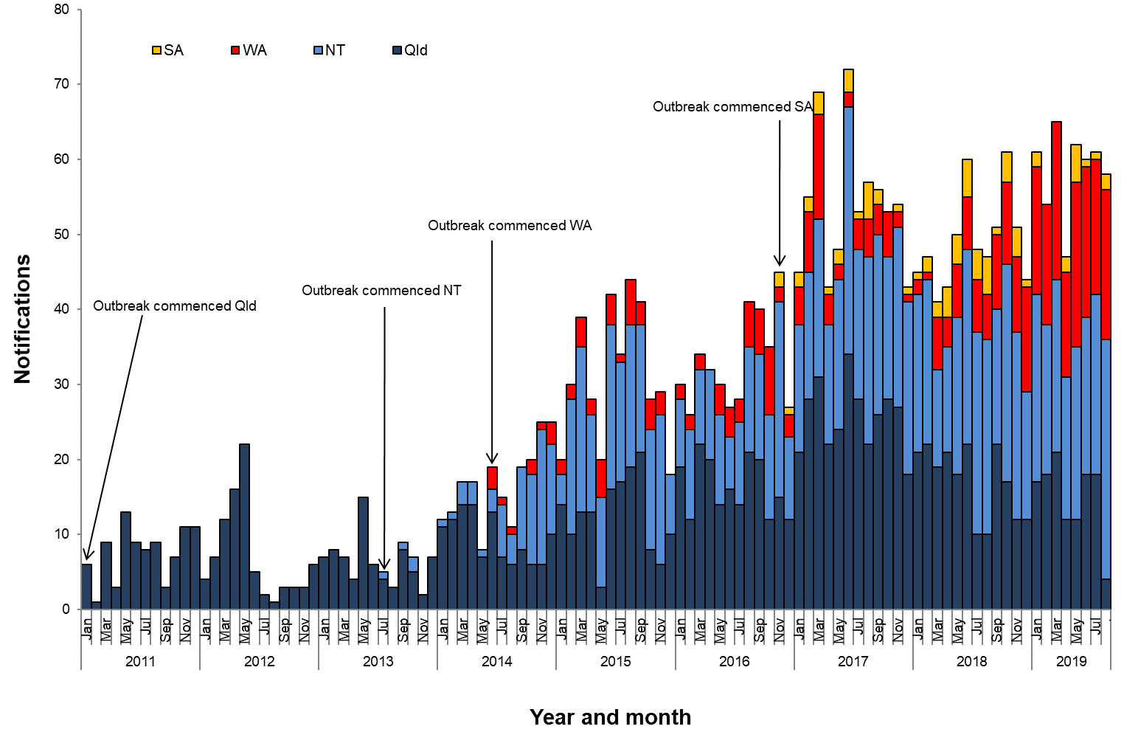

**Table 1**.Characteristics of category 1 infectious syphilisα outbreak cases notified in Aboriginal and Torres Strait Islander people residing in affected regionsβ of Queensland, the Northern Territory, Western Australia and South Australia, to   
31 August 2019 ȶ ᵞ

|  | **North Qld** (four HHSsβ) | **NT**  (seven regions β) | **WA**  (three regions β) | **SA**  (three regions β) |
| --- | --- | --- | --- | --- |
| **Situation to-date, 31 August 2019** |  |  |  |  |
| Outbreak commencement month/year | January 2011 | July 2013 | June 2014 | November 2016 |
| Total number of casesα | 1346 | 1124 | 381 | 76 |
| % Male / % Female | 47% / 53% | 45% / 55% | 41% / 59% | 53% / 47% |
| % 15-29 year age group | 66% | 61% | 67% | 49% |
| Congenital cases, confirmed (probable)« | 4 (5) | 2 (3) | 1 (0) | 1 (0) |
| -number of deaths in congenital cases, confirmed (probable) | 3 (4) | 0 (0) | 0 (0) | 0 (0) |
| **Last reporting month, 1 – 31 August 2019** | | | | |
| Number of casesα | 4 | 32 | 20 | 2 |
| % Male / % Female | 50% / 50% | 47% / 53% | 35% / 65% | 0% / 100% |
| % 15-29 year age group | 50% | 56% | 55% | 100% |

**Table 2.** Number of category 2 infectious syphilisα cases, to 31 August 2019 ȶ ᵞ

|  | **North Qld** (four HHSsβ) | **NT** (seven regions β) | **WA**  (three regions β) | **SA**  (three regions β) |
| --- | --- | --- | --- | --- |
| **Situation to-date, 31 August 2019** | | | | |
| Outbreak commencement month/year | January 2011 | July 2013 | June 2014 | November 2016 |
| Aboriginal and Torres Strait Islander people§ | 13 | 2 | - | - |
| Non-Indigenous peopleµ | 20 | 10 | - | 2 |
| **Last reporting month, 1 – 31 August 2019** | | | | |
| Aboriginal and Torres Strait Islander people§ | - | - | - | - |
| Non-Indigenous peopleµ | - | - | **-** | - |

**Notes:**

ȶ ‘Diagnosis date’ was used to define the period of analysis. This date represents either the onset date or where the date of onset was not known, the earliest of the specimen collection date, the notification date, or the notification receive date.

**α** Cases defined as per the MJSO syphilis outbreak case definition:

Nationally, an infectious syphilis outbreak case is defined as: any person who is newly diagnosed with confirmed or probable infectious syphilis according to the CDNA national surveillance case definition for infectious syphilis, **AND**, is an Aboriginal or Torres Strait Islander person who resides in any of the following outbreak declared regions as defined and documented by that jurisdiction, at or after the dates indicated: ***Qld*** - North West Hospital and Health Service area (from 1 January 2011); Torres and Cape Hospital and Health Service area (from 1 December 2012); Cairns and Hinterland Hospital and Health Service area(from1 August 2013); Townsville Hospital and Health Service area (from 1 January 2014); ***NT*** - Alice Springs Rural and Urban or Barkly district (from 1 July 2013); Katherine district (from 1 May 2014); East Arnhem district (from 1 November 2015); Darwin Rural and Urban (from 1 January 2017); ***WA*** - Kimberley region (from 1 June 2014); Pilbara region (from 1 February 2018); Goldfields region (from 1 January 2019); ***SA***  - Far North and Western and Eyre regions (from 15 November 2016); Adelaide (from 1 February 2018) (category 1 outbreak cases) **OR**, is a sexual contact of a confirmed outbreak case (category 2 outbreak cases).

**β**Affected regions include Torres and Cape, Cairns and Hinterland, North West, and Townsville Hospital and Health Services in Queensland; Alice Springs Urban, Alice Springs Rural, Barkly, East Arnhem, Katherine, Darwin Urban and Darwin Rural regions in the Northern Territory; Kimberley, Pilbara and Goldfield regions in Western Australia, and; Far North, Western and Eyre and Adelaide regions in South Australia.

« Cases defined as per the MJSO syphilis outbreak case definition: any newly diagnosed case of confirmed or probable congenital syphilis that meets the CDNA national surveillance case definition whose mother’s syphilis infection prior to or during pregnancy meets the infectious syphilis outbreak case definition.

§ Aboriginal and Torres Strait Islander people who are sexual contacts of a confirmed outbreak case and reside outside an outbreak declared region at the time of diagnosis.

µ Non-Indigenous people who are sexual contacts of a confirmed outbreak case and reside in or out of an outbreak declared region at the time of diagnosis.

**ᵞ** Please note that **all data are provisional** and subject to change due to ongoing case investigation.

**MULTIJURISDICTIONAL SYPHILIS OUTBREAK   
SURVEILLANCE REPORT: OCTOBER 2019**

**This surveillance report has been authorised by Health Departments in outbreak affected jurisdictions and the Office of Health Protection.**

The Multijurisdictional Syphilis Outbreak (MJSO) Working Group was formed by the Communicable Diseases Network of Australia (CDNA) in April 2015, in response to an ongoing outbreak of infectious syphilis among Aboriginal and Torres Strait Islander people living largely in remote and rural areas of northern Australia. Increased notifications associated with the outbreak in northern Australia were first reported in January 2011 in northwest Queensland (Qld), followed by the Northern Territory (NT) in July 2013, and the Kimberley region of Western Australia (WA) in June 2014. In March 2017, South Australia (SA) declared an outbreak in the Far North and Western and Eyre regions from November 2016. In August 2018, WA declared that the outbreak had spread to the Pilbara region with the first syphilis notification in this region in February 2018. In January 2019, SA declared the outbreak had spread to Adelaide with the first notification in this region reported in February 2018. In May 2019, WA declared the outbreak had spread to the Goldfields region with the first notification in this region reported in January 2019. In September 2019, Queensland declared the outbreak had spread to Central Queensland with the first notification in this region reported in June 2017.

This surveillance report summarises the outbreak epidemiological data as of 30 September 2019 (current status).

**Please note:** the MJSO Surveillance Report was formerly known as the MJSO Communique. Historical epidemiological data and MJSO activities are published in earlier MJSO Communiques available at *http://www.health.gov.au/internet/main/publishing.nsf/Content/ohp-infectious-syphilis-outbreak.htm*

**Current status**

Outbreak data to 30 September 2019ȶ are summarised in Figure 1, Table 1 and Table 2 below.

Outbreak cases are reported as either category 1 or category 2: category 1 cases include Aboriginal and Torres Strait Islander people residing in an outbreak declared regionβ at the time of diagnosis, and; category 2 cases include people who are a sexual contact of a confirmed outbreak case which includes Aboriginal and Torres Strait Islander people who do not reside in an outbreak area at the time of diagnosis and non-Indigenous people regardless of where they reside.

Between 1 – 30 September 2019ȶ, there were 67 outbreak cases (category 1 and 2 cases) reported from the four outbreak affected jurisdictions: 20 in Queensland; 32 in the Northern Territory; 12 in Western Australia and; 3 in South Australia (Figure 1, Table 1 and Table 2). From the commencement of the outbreak to 30 September 2019 ȶ, there were a total of 3090 outbreak cases (category 1 and 2 cases) reported across the four outbreak affected jurisdictions: 1445 in Queensland (from January 2011); 1169 in the Northern Territory (from July 2013); 394 in Western Australia (from June 2014), and; 82 in South Australia (from November 2016) (Table 1 and 2).

**Figure 1**. Epidemic curve showing category 1 infectious syphilis α outbreak cases notified in Aboriginal and Torres Strait Islander people residing in affected regionsβ of Queensland, the Northern Territory, Western Australia and South Australia from commencement of the outbreak in each jurisdiction to 30 September 2019ȶ ᵞ

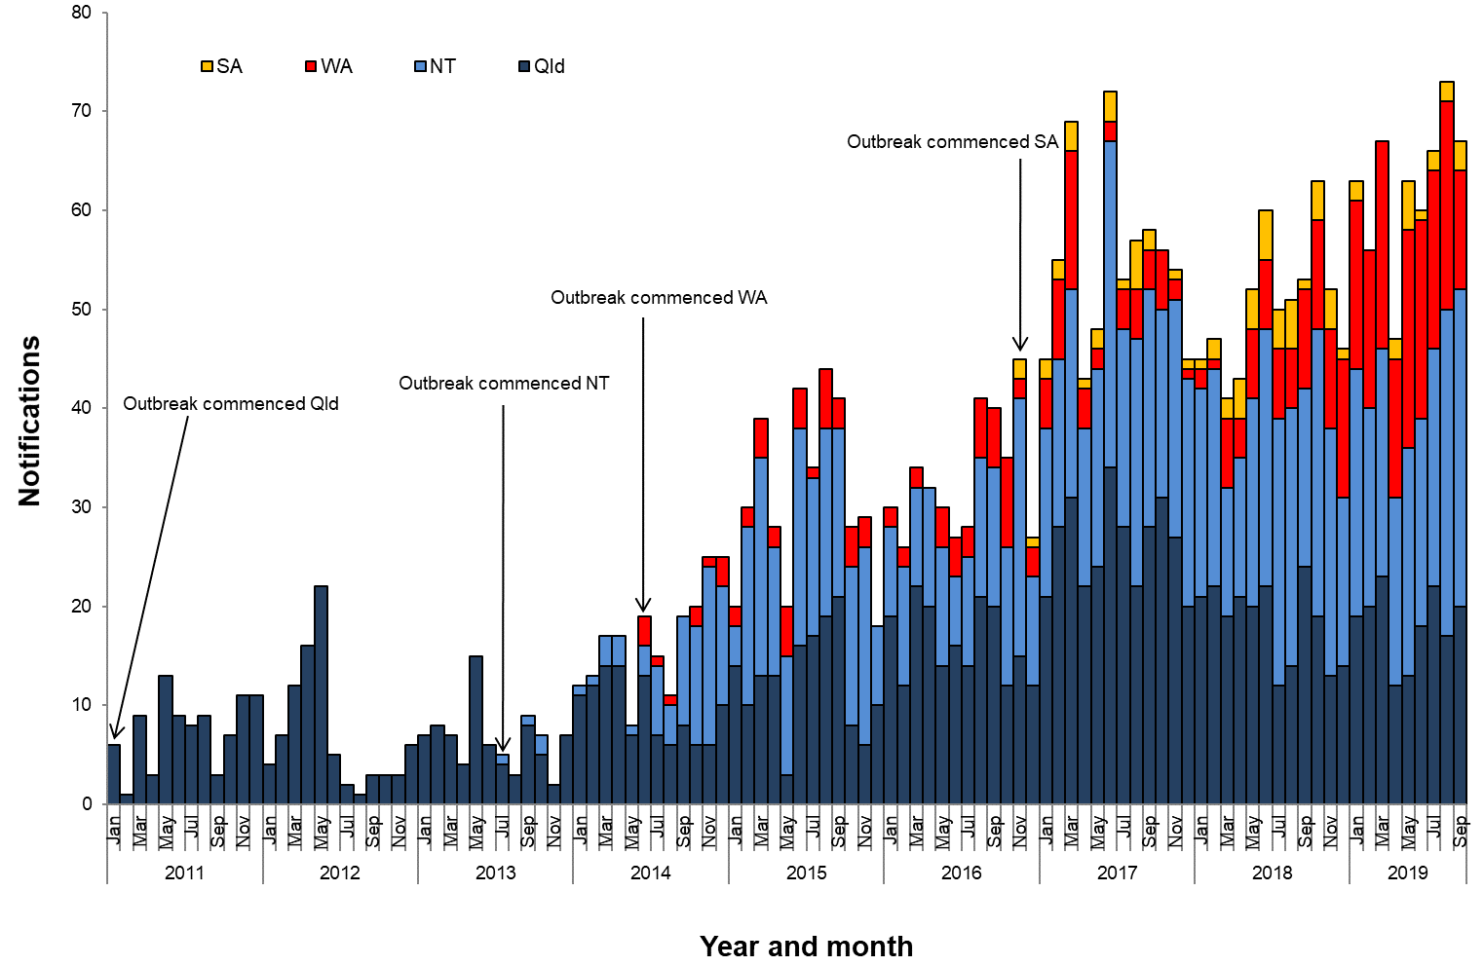

**Table 1**.Characteristics of category 1 infectious syphilisα outbreak cases notified in Aboriginal and Torres Strait Islander people residing in affected regionsβ of Queensland, the Northern Territory, Western Australia and South Australia, to   
30 September 2019 ȶ ᵞ

|  | **North Qld** (five HHSsβ) | **NT**  (seven regions β) | **WA**  (three regions β) | **SA**  (three regions β) |
| --- | --- | --- | --- | --- |
| **Situation to-date, 30 September 2019** |  |  |  |  |
| Outbreak commencement month/year | January 2011 | July 2013 | June 2014 | November 2016 |
| Total number of casesα | 1412 | 1157 | 394 | 80 |
| % Male / % Female | 47% / 53% | 46% / 54% | 42% / 58% | 54% / 46% |
| % 15-29 year age group | 65% | 61% | 67% | 49% |
| Congenital cases, confirmed (probable)« | 4 (5) | 2 (3) | 1 (0) | 1 (0) |
| -number of deaths in congenital cases, confirmed (probable) | 3 (4) | 0 (0) | 0 (0) | 0 (0) |
| **Last reporting month, 1 – 30 September 2019** | | | | |
| Number of casesα | 20 | 32 | 12 | 3 |
| % Male / % Female | 35% / 65% | 53% / 47% | 50% / 50% | 67% / 33% |
| % 15-29 year age group | 45% | 53% | 75% | 67% |

**Table 2.** Number of category 2 infectious syphilisα cases, to 30 September 2019 ȶ ᵞ

|  | **North Qld** (five HHSsβ) | **NT** (seven regions β) | **WA**  (three regions β) | **SA**  (three regions β) |
| --- | --- | --- | --- | --- |
| **Situation to-date, 30 September 2019** | | | | |
| Outbreak commencement month/year | January 2011 | July 2013 | June 2014 | November 2016 |
| Aboriginal and Torres Strait Islander people§ | 13 | 2 | - | - |
| Non-Indigenous peopleµ | 20 | 10 | - | 2 |
| **Last reporting month, 1 – 30 September 2019** | | | | |
| Aboriginal and Torres Strait Islander people§ | - | - | - | - |
| Non-Indigenous peopleµ | - | - | **-** | - |

**Notes:**

ȶ ‘Diagnosis date’ was used to define the period of analysis. This date represents either the onset date or where the date of onset was not known, the earliest of the specimen collection date, the notification date, or the notification receive date.

**α** Cases defined as per the MJSO syphilis outbreak case definition:

Nationally, an infectious syphilis outbreak case is defined as: any person who is newly diagnosed with confirmed or probable infectious syphilis according to the CDNA national surveillance case definition for infectious syphilis, **AND**, is an Aboriginal or Torres Strait Islander person who resides in any of the following outbreak declared regions as defined and documented by that jurisdiction, at or after the dates indicated: ***Qld*** - North West Hospital and Health Service area (from 1 January 2011); Torres and Cape Hospital and Health Service area (from 1 December 2012); Cairns and Hinterland Hospital and Health Service area (from1 August 2013); Townsville Hospital and Health Service area (from 1 January 2014); Central Queensland Hospital and Health Service area (from 1 June 2017) ***NT*** - Alice Springs Rural and Urban or Barkly district (from 1 July 2013); Katherine district (from 1 May 2014); East Arnhem district (from 1 November 2015); Darwin Rural and Urban (from 1 January 2017); ***WA*** - Kimberley region (from 1 June 2014); Pilbara region (from 1 February 2018); Goldfields region (from 1 January 2019); ***SA***  - Far North and Western and Eyre regions (from 15 November 2016); Adelaide (from 1 February 2018) (category 1 outbreak cases) **OR**, is a sexual contact of a confirmed outbreak case (category 2 outbreak cases).

**β**Affected regions include Torres and Cape, Cairns and Hinterland, North West, Townsville and Central Queensland Hospital and Health Services in Queensland; Alice Springs Urban, Alice Springs Rural, Barkly, East Arnhem, Katherine, Darwin Urban and Darwin Rural regions in the Northern Territory; Kimberley, Pilbara and Goldfield regions in Western Australia, and; Far North, Western and Eyre and Adelaide regions in South Australia.

« Cases defined as per the MJSO syphilis outbreak case definition: any newly diagnosed case of confirmed or probable congenital syphilis that meets the CDNA national surveillance case definition whose mother’s syphilis infection prior to or during pregnancy meets the infectious syphilis outbreak case definition.

§ Aboriginal and Torres Strait Islander people who are sexual contacts of a confirmed outbreak case and reside outside an outbreak declared region at the time of diagnosis.

µ Non-Indigenous people who are sexual contacts of a confirmed outbreak case and reside in or out of an outbreak declared region at the time of diagnosis.

**ᵞ** Please note that **all data are provisional** and subject to change due to ongoing case investigation.

**MULTIJURISDICTIONAL SYPHILIS OUTBREAK   
SURVEILLANCE REPORT: NOVEMBER 2019**

**This surveillance report has been authorised by Health Departments in outbreak affected jurisdictions and the Office of Health Protection.**

The Multijurisdictional Syphilis Outbreak (MJSO) Working Group was formed by the Communicable Diseases Network of Australia (CDNA) in April 2015, in response to an ongoing outbreak of infectious syphilis among Aboriginal and Torres Strait Islander people living largely in remote and rural areas of northern Australia. Increased notifications associated with the outbreak in northern Australia were first reported in January 2011 in northwest Queensland (Qld), followed by the Northern Territory (NT) in July 2013, and the Kimberley region of Western Australia (WA) in June 2014. In March 2017, South Australia (SA) declared an outbreak in the Far North and Western and Eyre regions from November 2016. In August 2018, WA declared that the outbreak had spread to the Pilbara region with the first syphilis notification in this region in February 2018. In January 2019, SA declared the outbreak had spread to Adelaide with the first notification in this region reported in February 2018. In May 2019, WA declared the outbreak had spread to the Goldfields region with the first notification in this region reported in January 2019. In September 2019, Queensland declared the outbreak had spread to Central Queensland with the first notification in this region reported in June 2017.

This surveillance report summarises the outbreak epidemiological data as of 31 October 2019 (current status).

**Please note:** the MJSO Surveillance Report was formerly known as the MJSO Communique. Historical epidemiological data and MJSO activities are published in earlier MJSO Communiques available at *http://www.health.gov.au/internet/main/publishing.nsf/Content/ohp-infectious-syphilis-outbreak.htm*

**Current status**

Outbreak data to 31 October 2019ȶ are summarised in Figure 1, Table 1 and Table 2 below.

Outbreak cases are reported as either category 1 or category 2: category 1 cases include Aboriginal and Torres Strait Islander people residing in an outbreak declared regionβ at the time of diagnosis, and; category 2 cases include people who are a sexual contact of a confirmed outbreak case which includes Aboriginal and Torres Strait Islander people who do not reside in an outbreak area at the time of diagnosis and non-Indigenous people regardless of where they reside.

Between 1 – 31 October 2019ȶ, there were 52 outbreak cases (category 1 and 2 cases) reported from the four outbreak affected jurisdictions: 12 in Queensland; 23 in the Northern Territory; 12 in Western Australia and; 5 in South Australia (Figure 1, Table 1 and Table 2). From the commencement of the outbreak to 31 October 2019 ȶ, there were a total of 3146 outbreak cases (category 1 and 2 cases) reported across the four outbreak affected jurisdictions: 1460 in Queensland (from January 2011); 1193 in the Northern Territory (from July 2013); 406 in Western Australia (from June 2014), and; 87 in South Australia (from November 2016) (Table 1 and 2).

**Figure 1**. Epidemic curve showing category 1 infectious syphilis α outbreak cases notified in Aboriginal and Torres Strait Islander people residing in affected regionsβ of Queensland, the Northern Territory, Western Australia and South Australia from commencement of the outbreak in each jurisdiction to 31 October 2019ȶ ᵞ

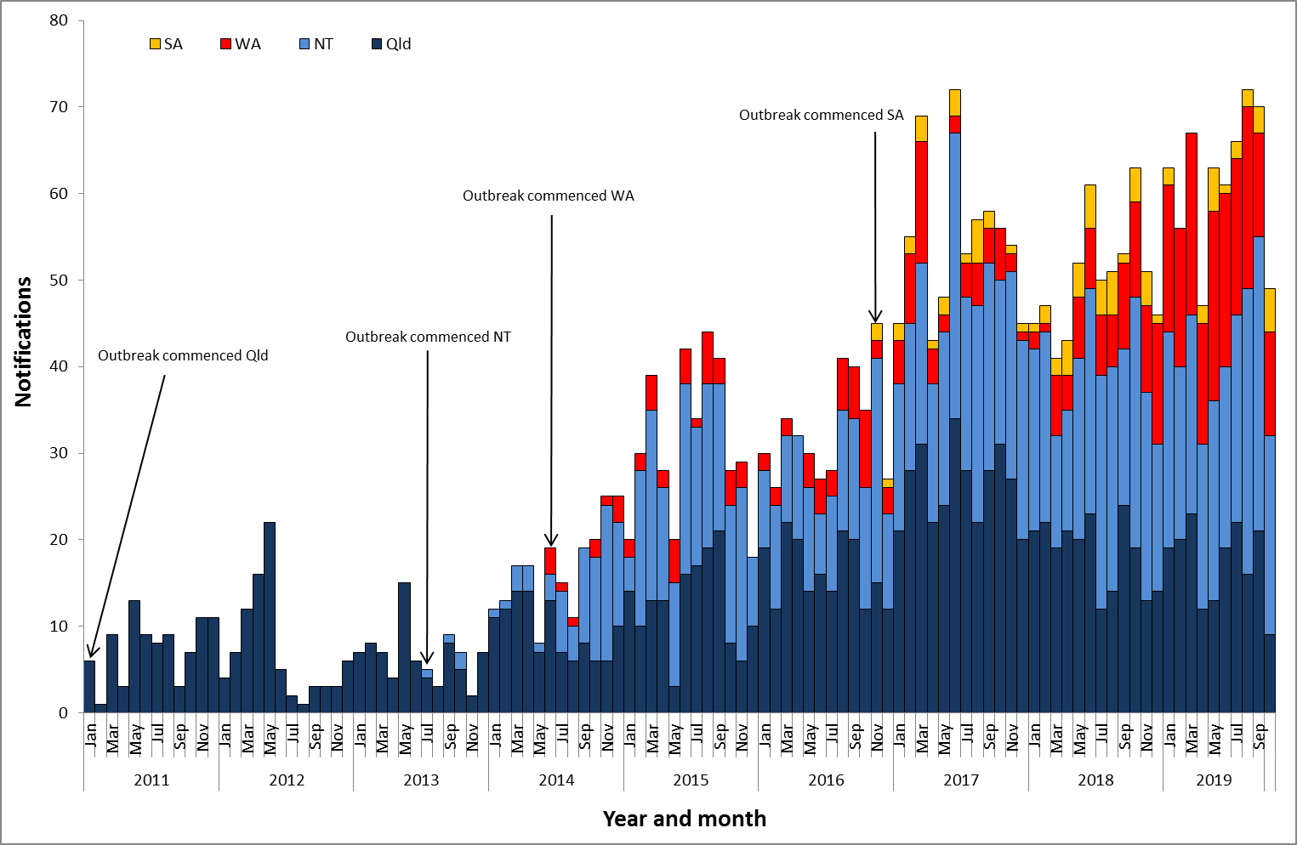

**Table 1**.Characteristics of category 1 infectious syphilisα outbreak cases notified in Aboriginal and Torres Strait Islander people residing in affected regionsβ of Queensland, the Northern Territory, Western Australia and South Australia, to   
31 October 2019 ȶ ᵞ

|  | **North Qld** (five HHSsβ) | **NT**  (seven regions β) | **WA**  (three regions β) | **SA**  (three regions β) |
| --- | --- | --- | --- | --- |
| **Situation to-date, 31 October 2019** |  |  |  |  |
| Outbreak commencement month/year | January 2011 | July 2013 | June 2014 | November 2016 |
| Total number of casesα | 1423 | 1181 | 406 | 85 |
| % Male / % Female | 47% / 53% | 45% / 55% | 41% / 59% | 54% / 46% |
| % 15-29 year age group | 65% | 61% | 70% | 48% |
| Congenital cases, confirmed (probable)« | 4 (5) | 2 (3) | 1 (0) | 1 (0) |
| -number of deaths in congenital cases, confirmed (probable) | 3 (4) | 0 (0) | 0 (0) | 0 (0) |
| **Last reporting month, 1 – 31 October 2019** | | | | |
| Number of casesα | 9 | 23 | 12 | 5 |
| % Male / % Female | 44% / 56% | 35% / 65% | 33% / 67% | 60% / 40% |
| % 15-29 year age group | 67% | 65% | 67% | 40% |

**Table 2.** Number of category 2 infectious syphilisα cases, to 31 October 2019 ȶ ᵞ

|  | **North Qld** (five HHSsβ) | **NT** (seven regions β) | **WA**  (three regions β) | **SA**  (three regions β) |
| --- | --- | --- | --- | --- |
| **Situation to-date, 31 October 2019** | | | | |
| Outbreak commencement month/year | January 2011 | July 2013 | June 2014 | November 2016 |
| Aboriginal and Torres Strait Islander people§ | 14 | 2 | - | - |
| Non-Indigenous peopleµ | 23 | 10 | - | 2 |
| **Last reporting month, 1 – 31 October 2019** | | | | |
| Aboriginal and Torres Strait Islander people§ | 1 | - | - | - |
| Non-Indigenous peopleµ | 2 | - | **-** | - |

**Notes:**

ȶ ‘Diagnosis date’ was used to define the period of analysis. This date represents either the onset date or where the date of onset was not known, the earliest of the specimen collection date, the notification date, or the notification receive date.

**α** Cases defined as per the MJSO syphilis outbreak case definition:

Nationally, an infectious syphilis outbreak case is defined as: any person who is newly diagnosed with confirmed or probable infectious syphilis according to the CDNA national surveillance case definition for infectious syphilis, **AND**, is an Aboriginal or Torres Strait Islander person who resides in any of the following outbreak declared regions as defined and documented by that jurisdiction, at or after the dates indicated: ***Qld*** - North West Hospital and Health Service area (from 1 January 2011); Torres and Cape Hospital and Health Service area (from 1 December 2012); Cairns and Hinterland Hospital and Health Service area (from 1 August 2013); Townsville Hospital and Health Service area (from 1 January 2014); Central Queensland Hospital and Health Service area (from 1 June 2017) ***NT*** - Alice Springs Rural and Urban or Barkly district (from 1 July 2013); Katherine district (from 1 May 2014); East Arnhem district (from 1 November 2015); Darwin Rural and Urban (from 1 January 2017); ***WA*** - Kimberley region (from 1 June 2014); Pilbara region (from 1 February 2018); Goldfields region (from 1 January 2019); ***SA***  - Far North and Western and Eyre regions (from 15 November 2016); Adelaide (from 1 February 2018) (category 1 outbreak cases) **OR**, is a sexual contact of a confirmed outbreak case (category 2 outbreak cases).

**β**Affected regions include Torres and Cape, Cairns and Hinterland, North West, Townsville and Central Queensland Hospital and Health Services in Queensland; Alice Springs Urban, Alice Springs Rural, Barkly, East Arnhem, Katherine, Darwin Urban and Darwin Rural regions in the Northern Territory; Kimberley, Pilbara and Goldfield regions in Western Australia, and; Far North, Western and Eyre and Adelaide regions in South Australia.

« Cases defined as per the MJSO syphilis outbreak case definition: any newly diagnosed case of confirmed or probable congenital syphilis that meets the CDNA national surveillance case definition whose mother’s syphilis infection prior to or during pregnancy meets the infectious syphilis outbreak case definition.

§ Aboriginal and Torres Strait Islander people who are sexual contacts of a confirmed outbreak case and reside outside an outbreak declared region at the time of diagnosis.

µ Non-Indigenous people who are sexual contacts of a confirmed outbreak case and reside in or out of an outbreak declared region at the time of diagnosis.

**ᵞ** Please note that **all data are provisional** and subject to change due to ongoing case investigation.

**MULTIJURISDICTIONAL SYPHILIS OUTBREAK   
SURVEILLANCE REPORT: DECEMBER 2019**

**This surveillance report has been authorised by Health Departments in outbreak affected jurisdictions and the Office of Health Protection.**

The Multijurisdictional Syphilis Outbreak (MJSO) Working Group was formed by the Communicable Diseases Network of Australia (CDNA) in April 2015, in response to an ongoing outbreak of infectious syphilis among Aboriginal and Torres Strait Islander people living largely in remote and rural areas of northern Australia. Increased notifications associated with the outbreak in northern Australia were first reported in January 2011 in northwest Queensland (Qld), followed by the Northern Territory (NT) in July 2013, and the Kimberley region of Western Australia (WA) in June 2014. In March 2017, South Australia (SA) declared an outbreak in the Far North and Western and Eyre regions from November 2016. In August 2018, WA declared that the outbreak had spread to the Pilbara region with the first syphilis notification in this region in February 2018. In January 2019, SA declared the outbreak had spread to Adelaide with the first notification in this region reported in February 2018. In May 2019, WA declared the outbreak had spread to the Goldfields region with the first notification in this region reported in January 2019. In September 2019, Queensland declared the outbreak had spread to Central Queensland with the first notification in this region reported in June 2017.

This surveillance report summarises the outbreak epidemiological data as of 30 November 2019 (current status).

**Please note:** the MJSO Surveillance Report was formerly known as the MJSO Communique. Historical epidemiological data and MJSO activities are published in earlier MJSO Communiques available at *http://www.health.gov.au/internet/main/publishing.nsf/Content/ohp-infectious-syphilis-outbreak.htm*

**Current status**

Outbreak data to 30 November 2019ȶ are summarised in Figure 1, Table 1 and Table 2 below.

Outbreak cases are reported as either category 1 or category 2: category 1 cases include Aboriginal and Torres Strait Islander people residing in an outbreak declared regionβ at the time of diagnosis, and; category 2 cases include people who are a sexual contact of a confirmed outbreak case which includes Aboriginal and Torres Strait Islander people who do not reside in an outbreak area at the time of diagnosis and non-Indigenous people regardless of where they reside.

Between 1 – 30 November 2019ȶ, there were 67 outbreak cases (category 1 and 2 cases) reported from the four outbreak affected jurisdictions: 23 in Queensland; 22 in the Northern Territory; 14 in Western Australia and; 8 in South Australia (Figure 1, Table 1 and Table 2). From the commencement of the outbreak to 30 November 2019 ȶ, there were a total of 3224 outbreak cases (category 1 and 2 cases) reported across the four outbreak affected jurisdictions: 1494 in Queensland (from January 2011); 1215 in the Northern Territory (from July 2013); 420 in Western Australia (from June 2014), and; 95 in South Australia (from November 2016) (Table 1 and 2).

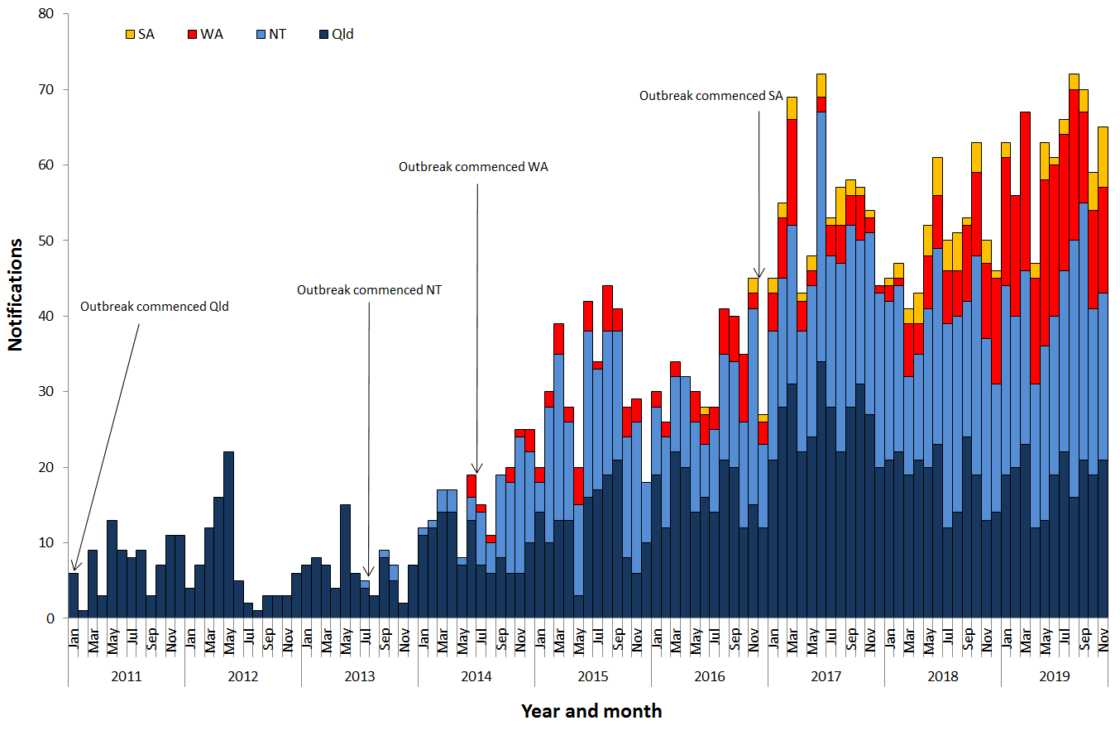**Figure 1**. Epidemic curve showing category 1 infectious syphilis α outbreak cases notified in Aboriginal and Torres Strait Islander people residing in affected regionsβ of Queensland, the Northern Territory, Western Australia and South Australia from commencement of the outbreak in each jurisdiction to 30 November 2019ȶ ᵞ

**Table 1**.Characteristics of category 1 infectious syphilisα outbreak cases notified in Aboriginal and Torres Strait Islander people residing in affected regionsβ of Queensland, the Northern Territory, Western Australia and South Australia, to   
30 November 2019 ȶ ᵞ

|  | **North Qld** (five HHSsβ) | **NT**  (seven regions β) | **WA**  (three regions β) | **SA**  (three regions β) |
| --- | --- | --- | --- | --- |
| **Situation to-date, 30 November 2019** |  |  |  |  |
| Outbreak commencement month/year | January 2011 | July 2013 | June 2014 | November 2016 |
| Total number of casesα | 1454 | 1203 | 420 | 93 |
| % Male / % Female | 47% / 53% | 46% / 54% | 41% / 59% | 55% / 45% |
| % 15-29 year age group | 65% | 61% | 70% | 48% |
| Congenital cases, confirmed (probable)« | 4 (5) | 2 (3) | 1 (0) | 1 (0) |
| -number of deaths in congenital cases, confirmed (probable) | 3 (4) | 0 (0) | 0 (0) | 0 (0) |
| **Last reporting month, 1 – 30 November 2019** | | | | |
| Number of casesα | 21 | 22 | 14 | 8 |
| % Male / % Female | 52% / 48% | 55% / 45% | 43% / 57% | 63% / 38% |
| % 15-29 year age group | 52% | 64% | 43% | 50% |

**Table 2.** Number of category 2 infectious syphilisα cases, to 30 November 2019 ȶ ᵞ

|  | **North Qld** (five HHSsβ) | **NT** (seven regions β) | **WA**  (three regions β) | **SA**  (three regions β) |
| --- | --- | --- | --- | --- |
| **Situation to-date, 30 November 2019** | | | | |
| Outbreak commencement month/year | January 2011 | July 2013 | June 2014 | November 2016 |
| Aboriginal and Torres Strait Islander people§ | 15 | 2 | - | - |
| Non-Indigenous peopleµ | 25 | 10 | - | 2 |
| **Last reporting month, 1 - 30 November 2019** | | | | |
| Aboriginal and Torres Strait Islander people§ | 1 | - | - | - |
| Non-Indigenous peopleµ | 1 | - | **-** | - |

**Notes:**

ȶ ‘Diagnosis date’ was used to define the period of analysis. This date represents either the onset date or where the date of onset was not known, the earliest of the specimen collection date, the notification date, or the notification receive date.

**α** Cases defined as per the MJSO syphilis outbreak case definition:

Nationally, an infectious syphilis outbreak case is defined as: any person who is newly diagnosed with confirmed or probable infectious syphilis according to the CDNA national surveillance case definition for infectious syphilis, **AND**, is an Aboriginal or Torres Strait Islander person who resides in any of the following outbreak declared regions as defined and documented by that jurisdiction, at or after the dates indicated: ***Qld*** - North West Hospital and Health Service area (from 1 January 2011); Torres and Cape Hospital and Health Service area (from 1 December 2012); Cairns and Hinterland Hospital and Health Service area (from 1 August 2013); Townsville Hospital and Health Service area (from 1 January 2014); Central Queensland Hospital and Health Service area (from 1 June 2017) ***NT*** - Alice Springs Rural and Urban or Barkly district (from 1 July 2013); Katherine district (from 1 May 2014); East Arnhem district (from 1 November 2015); Darwin Rural and Urban (from 1 January 2017); ***WA*** - Kimberley region (from 1 June 2014); Pilbara region (from 1 February 2018); Goldfields region (from 1 January 2019); ***SA***  - Far North and Western and Eyre regions (from 15 November 2016); Adelaide (from 1 February 2018) (category 1 outbreak cases) **OR**, is a sexual contact of a confirmed outbreak case (category 2 outbreak cases).

**β**Affected regions include Torres and Cape, Cairns and Hinterland, North West, Townsville and Central Queensland Hospital and Health Services in Queensland; Alice Springs Urban, Alice Springs Rural, Barkly, East Arnhem, Katherine, Darwin Urban and Darwin Rural regions in the Northern Territory; Kimberley, Pilbara and Goldfield regions in Western Australia, and; Far North, Western and Eyre and Adelaide regions in South Australia.

« Cases defined as per the MJSO syphilis outbreak case definition: any newly diagnosed case of confirmed or probable congenital syphilis that meets the CDNA national surveillance case definition whose mother’s syphilis infection prior to or during pregnancy meets the infectious syphilis outbreak case definition.

§ Aboriginal and Torres Strait Islander people who are sexual contacts of a confirmed outbreak case and reside outside an outbreak declared region at the time of diagnosis.

µ Non-Indigenous people who are sexual contacts of a confirmed outbreak case and reside in or out of an outbreak declared region at the time of diagnosis.

**ᵞ** Please note that **all data are provisional** and subject to change due to ongoing case investigation.

**MULTIJURISDICTIONAL SYPHILIS OUTBREAK   
SURVEILLANCE REPORT: JANUARY 2020**

**This surveillance report has been authorised by Health Departments in outbreak affected jurisdictions and the Office of Health Protection.**

The Multijurisdictional Syphilis Outbreak (MJSO) Working Group was formed by the Communicable Diseases Network of Australia (CDNA) in April 2015, in response to an ongoing outbreak of infectious syphilis among Aboriginal and Torres Strait Islander people living largely in remote and rural areas of northern Australia. Increased notifications associated with the outbreak in northern Australia were first reported in January 2011 in northwest Queensland (Qld), followed by the Northern Territory (NT) in July 2013, and the Kimberley region of Western Australia (WA) in June 2014. In March 2017, South Australia (SA) declared an outbreak in the Far North and Western and Eyre regions from November 2016. In August 2018, WA declared that the outbreak had spread to the Pilbara region with the first syphilis notification in this region in February 2018. In January 2019, SA declared the outbreak had spread to Adelaide with the first notification in this region reported in February 2018. In May 2019, WA declared the outbreak had spread to the Goldfields region with the first notification in this region reported in January 2019. In September 2019, Queensland declared the outbreak had spread to Central Queensland with the first notification in this region reported in June 2017.

This surveillance report summarises the outbreak epidemiological data as of 31 December 2019 (current status).

**Please note:** the MJSO Surveillance Report was formerly known as the MJSO Communique. Historical epidemiological data and MJSO activities are published in earlier MJSO Communiques available at *http://www.health.gov.au/internet/main/publishing.nsf/Content/ohp-infectious-syphilis-outbreak.htm*

**Current status**

Outbreak data to 31 December 2019ȶ are summarised in Figure 1, Table 1 and Table 2 below.

Outbreak cases are reported as either category 1 or category 2: category 1 cases include Aboriginal and Torres Strait Islander people residing in an outbreak declared regionβ at the time of diagnosis, and; category 2 cases include people who are a sexual contact of a confirmed outbreak case which includes Aboriginal and Torres Strait Islander people who do not reside in an outbreak area at the time of diagnosis and non-Indigenous people regardless of where they reside.

Between 1 – 31 December 2019ȶ, there were 54 outbreak cases (category 1 and 2 cases) reported from the four outbreak affected jurisdictions: 20 in Queensland; 19 in the Northern Territory; 13 in Western Australia and; 2 in South Australia (Figure 1, Table 1 and Table 2). From the commencement of the outbreak to 31 December 2019 ȶ, there were a total of 3294 outbreak cases (category 1 and 2 cases) reported across the four outbreak affected jurisdictions: 1530 in Queensland (from January 2011); 1234 in the Northern Territory (from July 2013); 434 in Western Australia (from June 2014), and; 96 in South Australia (from November 2016) (Table 1 and 2).

**Figure 1**. Epidemic curve showing category 1 infectious syphilis α outbreak cases notified in Aboriginal and Torres Strait Islander people residing in affected regionsβ of Queensland, the Northern Territory, Western Australia and South Australia from commencement of the outbreak in each jurisdiction to 31 December 2019ȶ ᵞ

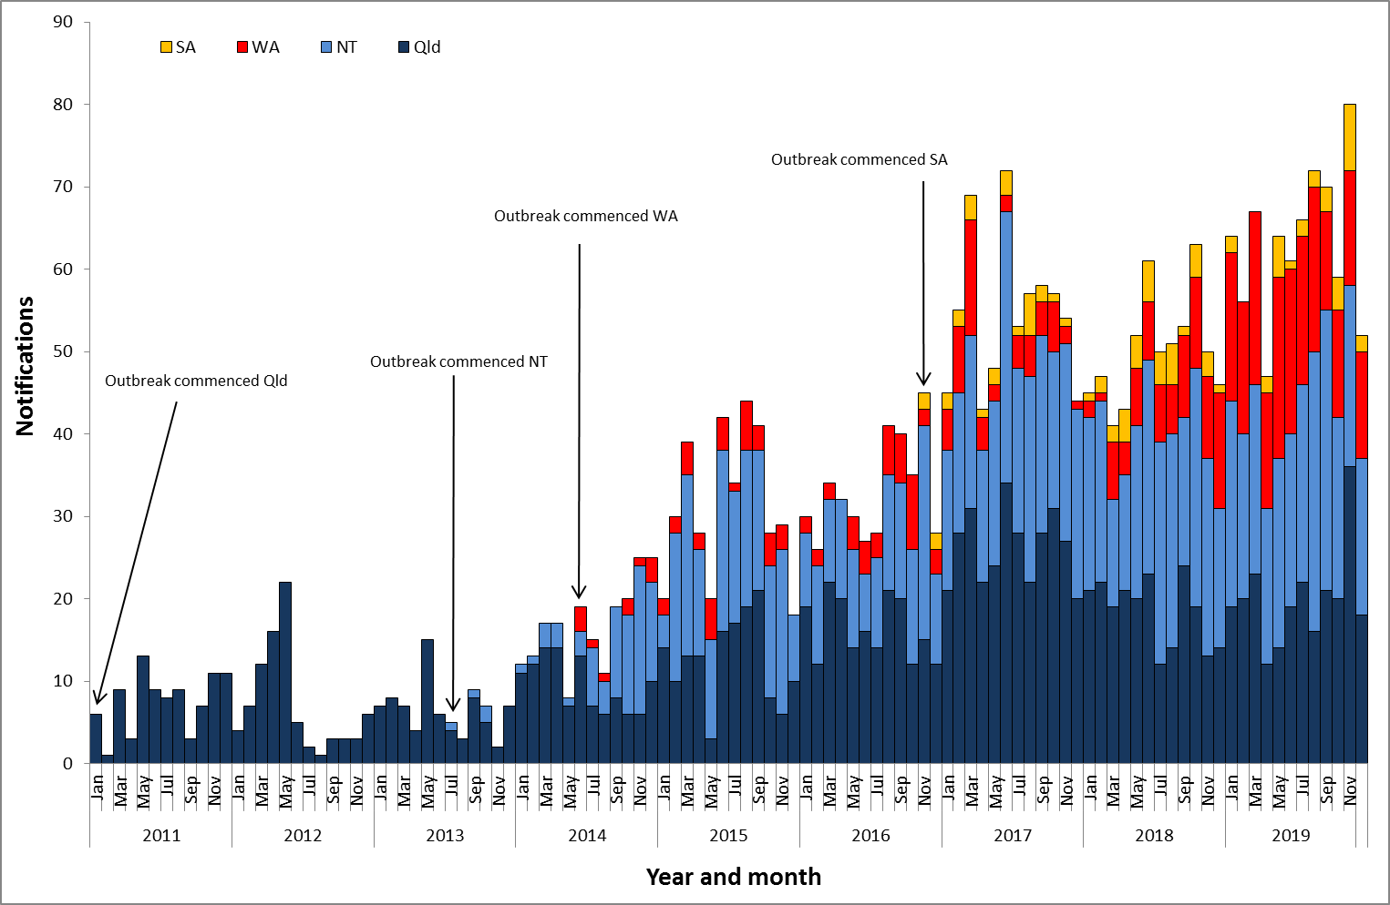

**Table 1**.Characteristics of category 1 infectious syphilisα outbreak cases notified in Aboriginal and Torres Strait Islander people residing in affected regionsβ of Queensland, the Northern Territory, Western Australia and South Australia, to   
31 December 2019 ȶ ᵞ

|  | **North Qld** (five HHSsβ) | **NT**  (seven regions β) | **WA**  (three regions β) | **SA**  (three regions β) |
| --- | --- | --- | --- | --- |
| **Situation to-date, 31 December 2019** |  |  |  |  |
| Outbreak commencement month/year | January 2011 | July 2013 | June 2014 | November 2016 |
| Total number of casesα | 1489 | 1222 | 434 | 94 |
| % Male / % Female | 46% / 54% | 46% / 54% | 42% / 58% | 54% / 46% |
| % 15-29 year age group | 65% | 61% | 69% | 46% |
| Congenital cases, confirmed (probable)« | 4 (5) | 2 (3) | 1 (0) | 1 (0) |
| -number of deaths in congenital cases, confirmed (probable) | 3 (4) | 0 (0) | 0 (0) | 0 (0) |
| **Last reporting month, 1 – 31 December 2019** | | | | |
| Number of casesα | 18 | 19 | 13 | 2 |
| % Male / % Female | 46% / 54% | 58% / 42% | 54% / 46% | 100% / 0% |
| % 15-29 year age group | 78% | 63% | 31% | 0% |

**Table 2.** Number of category 2 infectious syphilisα cases, to 31 December 2019 ȶ ᵞ

|  | **North Qld** (five HHSsβ) | **NT** (seven regions β) | **WA**  (three regions β) | **SA**  (three regions β) |
| --- | --- | --- | --- | --- |
| **Situation to-date, 31 December 2019** | | | | |
| Outbreak commencement month/year | January 2011 | July 2013 | June 2014 | November 2016 |
| Aboriginal and Torres Strait Islander people§ | 13 | 2 | - | - |
| Non-Indigenous peopleµ | 28 | 10 | - | 2 |
| **Last reporting month, 1 – 31 December 2019** | | | | |
| Aboriginal and Torres Strait Islander people§ | 1 | - | - | - |
| Non-Indigenous peopleµ | 1 | - | **-** | - |

**Notes:**

ȶ ‘Diagnosis date’ was used to define the period of analysis. This date represents either the onset date or where the date of onset was not known, the earliest of the specimen collection date, the notification date, or the notification receive date.

**α** Cases defined as per the MJSO syphilis outbreak case definition:

Nationally, an infectious syphilis outbreak case is defined as: any person who is newly diagnosed with confirmed or probable infectious syphilis according to the CDNA national surveillance case definition for infectious syphilis, **AND**, is an Aboriginal or Torres Strait Islander person who resides in any of the following outbreak declared regions as defined and documented by that jurisdiction, at or after the dates indicated: ***Qld*** - North West Hospital and Health Service area (from 1 January 2011); Torres and Cape Hospital and Health Service area (from 1 December 2012); Cairns and Hinterland Hospital and Health Service area (from 1 August 2013); Townsville Hospital and Health Service area (from 1 January 2014); Central Queensland Hospital and Health Service area (from 1 June 2017) ***NT*** - Alice Springs Rural and Urban or Barkly district (from 1 July 2013); Katherine district (from 1 May 2014); East Arnhem district (from 1 November 2015); Darwin Rural and Urban (from 1 January 2017); ***WA*** - Kimberley region (from 1 June 2014); Pilbara region (from 1 February 2018); Goldfields region (from 1 January 2019); ***SA***  - Far North and Western and Eyre regions (from 15 November 2016); Adelaide (from 1 February 2018) (category 1 outbreak cases) **OR**, is a sexual contact of a confirmed outbreak case (category 2 outbreak cases).

**β**Affected regions include Torres and Cape, Cairns and Hinterland, North West, Townsville and Central Queensland Hospital and Health Services in Queensland; Alice Springs Urban, Alice Springs Rural, Barkly, East Arnhem, Katherine, Darwin Urban and Darwin Rural regions in the Northern Territory; Kimberley, Pilbara and Goldfield regions in Western Australia, and; Far North, Western and Eyre and Adelaide regions in South Australia.

« Cases defined as per the MJSO syphilis outbreak case definition: any newly diagnosed case of confirmed or probable congenital syphilis that meets the CDNA national surveillance case definition whose mother’s syphilis infection prior to or during pregnancy meets the infectious syphilis outbreak case definition.

§ Aboriginal and Torres Strait Islander people who are sexual contacts of a confirmed outbreak case and reside outside an outbreak declared region at the time of diagnosis.

µ Non-Indigenous people who are sexual contacts of a confirmed outbreak case and reside in or out of an outbreak declared region at the time of diagnosis.

**ᵞ** Please note that **all data are provisional** and subject to change due to ongoing case investigation.