

Indigenous Australians’ Health Programme Primary Health Care Funding Model Technical Factsheet

Location

**Purpose**

This Factsheet provides technical details on how clinic location is used to estimate increased cost of service delivery in the Indigenous Australians’ Health Programme (IAHP) Primary Health Care Funding Model.

## Overview

The cost of delivering health services is affected by the location of the health clinic. This includes commercial rental, building and maintenance costs, staffing costs and consumables.

To account for the effect of location on the cost of service delivery, each clinic of an Aboriginal Community Controlled Health Service (ACCHS) in the IAHP Primary Health Care Funding Model (the Funding Model) is assigned a multiplier based on the location in which services are delivered. For more information on model calculation and the effect of multipliers, see the **Funding Model Technical Factsheet – Overview and calculation steps**.

Locations are assigned to one of five categories based on the Australian Bureau of Statistics’ (ABS) Australian Statistical Geography Standard (ASGS) Remoteness Areas.

## Location categories

The location categories used are the five ABS ASGS Remoteness Areas created based on the 2016 Census of Population and Housing (catalogue number 1270.0.55.005). The are Major Cities, Inner Regional areas, Outer Regional areas, Remote areas and Very Remote areas. The Remoteness Areas (Figure 1, overleaf) define relative access to services such as health, education and retail services.

Figure 1. Map of the 2016 Remoteness Areas for Australia

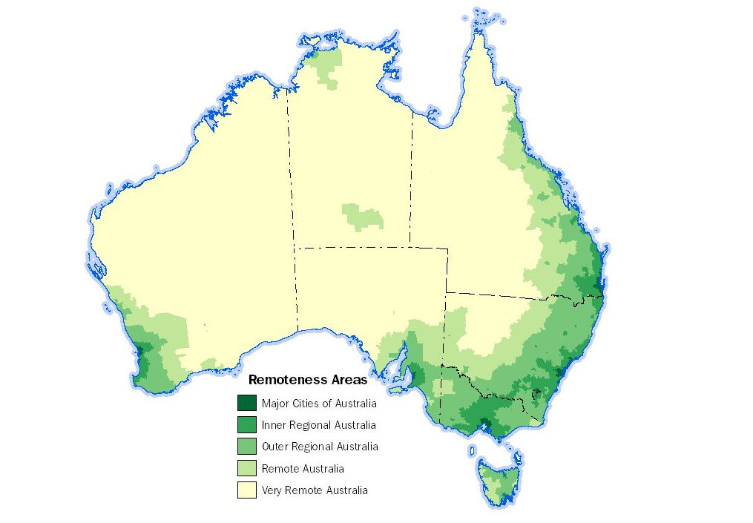

To account for the cost associated with location, multipliers are allocated at the clinic level. An ACCHS that operates from multiple locations receives a different multiplier for each location category in which it delivers services. For this reason, ACCHS with clinics in multiple locations are asked to provide activity data (number of clients and Episodes of Care) for each clinic location.

Table 1 shows the five categories and the proportion of clinic locations of ACCHS in the Funding Model that are classified in each.

Table 1. Service locations by category

|  | % |
| --- | --- |
| Major Cities of Australia | 13% |
| Inner Regional Australia | 20% |
| Outer Regional Australia | 21% |
| Remote Australia | 10% |
| Very Remote Australia | 35% |

### Outreach services

Outreach or mobile services are delivered across a range of areas, and may include locations in more than one location category. Where this occurs, outreach services are assigned the category where the majority of services are delivered (i.e. number of clients and Episodes of Care).

## Elements of cost

Location multipliers are calculated to take into account four elements of cost. These elements were chosen in collaboration with stakeholders through the Funding Model Working Group to represent the main costs associated with distance from a major city. The elements are:

* Wages. This element considers the wages of health and medical staff.
* Building repairs and maintenance. Note that this element does not include the cost of major capital works, as these activities are not funded under the Primary Health Care component of the IAHP.
* Consumables. This element considers the cost of medical and other consumables but does not consider medicines covered by the Pharmaceutical Benefits Scheme.
* Population dispersion. This element is included to account for potential underutilisation of GPs in areas of low population.

Each of these elements is discussed in more detail below.

### Wages

Research into actual wage costs across a range of Australian locations was undertaken for the following medical and health professions:

* Aboriginal and Torres Strait Islander Health Practitioner
* Aboriginal Health Worker
* Dental assistant
* Dentist
* Doctor (GP)
* Medical specialist
* Mental Health Counsellor
* Nurse Practitioner
* Radiographer

These professions were chosen to represent a range of health and medical professions at different salary points. It should be noted that the relevant information from this research is the difference in salary between locations and not the value of the salaries.

The resulting wage factors are displayed in Table 2. These factors indicate that a health or medical worker in a remote area typically attracts a wage 50% higher than for a comparable position in a major city.

Table 2. Wage factors by Remoteness Area

| Remoteness Area | Wage Factor |
| --- | --- |
| Major Cities of Australia | 1.00 |
| Inner Regional Australia | 1.08 |
| Outer Regional Australia | 1.25 |
| Remote Australia | 1.50 |
| Very Remote Australia | 1.50 |

As wages typically account for a large proportion of total costs for a health service, wage factors account for 80% of the location factor.

### Building repairs and maintenance

The cost of building repairs and maintenance were estimated based on the Rawlinsons Construction Cost Guide (2019) which provides regional indices for all States/Territories. A selection of locations in each State/Territory and Remoteness Area were compared to determine the average cost differential between Remoteness Areas. This resulted in the factors displayed in Table 3. This shows that, on average, building repairs and maintenance is least expensive in inner regional areas and most expensive in very remote areas.

Table 3. Building repairs and maintenance factors by Remoteness Area

| Remoteness Area | Building repairs and maintenance factor |
| --- | --- |
| Major Cities of Australia | 1.03 |
| Inner Regional Australia | 0.93 |
| Outer Regional Australia | 1.07 |
| Remote Australia | 1.16 |
| Very Remote Australia | 1.26 |

Building repair and maintenance costs account for 10% of the location factor.

### Consumables

The differential cost of medical and other consumables in various locations was estimated using the National Disability Insurance Scheme Price Guide (February 2019). This guide provides pricing for a wide range of health-related consumables including price variance between locations.

Table 4. Consumables factors by Remoteness Area

| Remoteness Area | Consumables factor |
| --- | --- |
| Major Cities of Australia | 1.00 |
| Inner Regional Australia | 1.00 |
| Outer Regional Australia | 1.00 |
| Remote Australia | 1.20 |
| Very Remote Australia | 1.25 |

The cost of consumables accounts for 10% of the location factor.

### Population dispersion

As noted by stakeholders during Funding Model Working Group meetings, GPs servicing smaller populations are more likely to face underutilisation. This was modelled using GP to patient ratios as published by the Australian Institute of Health and Welfare (AIHW). Assuming GPs in major cities are fully utilised, the underutilisation rate is calculated as the proportional difference in GP to population ratio for each Remoteness Area.

Table 5. GP numbers and underutilisation rate

| Remoteness Area | 1 GP per population | Underutilisation rate |
| --- | --- | --- |
| Major Cities of Australia | 925.93 | 1.00 |
| Inner Regional Australia | 884.96 | 1.05 |
| Outer Regional Australia | 884.96 | 1.05 |
| Remote Australia | 769.23 | 1.20 |
| Very Remote Australia | 769.23 | 1.20 |

## Final location multipliers

The final location multipliers are calculated as a weighted contribution of wages, building repairs and maintenance and consumables, multiplied by the underutilisation rate. This is represented in the following formula:

$$\left(wage ×80\%+building ×10\%+consumables ×10\%\right)×underutilisation=location factor$$

The location multipliers used in the Funding Model are displayed in Table 6.

Table 6. Final location multipliers

| Remoteness Area | Location multiplier |
| --- | --- |
| Major Cities of Australia | 1.00 |
| Inner Regional Australia | 1.11 |
| Outer Regional Australia | 1.26 |
| Remote Australia | 1.73 |
| Very Remote Australia | 1.75 |

**Who do I contact for more information?**

For further information about the IAHP Funding Model, please email [IAHPFundingModel@health.gov.au](mailto:xx@health.gov.au).